Delta Neutral Complex Orders for Hybrid

Overview

Current processing
Currently regular complex orders are accepted by HybridTradeServer. Regular complex orders do not accept price per leg, these orders only have an overall price.

New requirement
Delta Neutral Complex Orders have to be accepted by the system, which require specifying price per leg. The conditions that determine a delta neutral complex order are :-
- At least one leg should be Equity
- Price on all the legs must be specified
- There should be no price specified on the overall order.

Implementation

Validation of Delta Neutral orders.
- Add a new method to OrderValidationDefaultStrategy, overridden in OrderValidationOpenOutcryStrategy, which determines delta neutral orders and throws DataValidationException exception on error conditions on any of the below conditions.
  - For strategies where one leg is Equity and all the other legs are options
    - Overall spread order price is not specified and price is specified only on some of the legs.
    - Overall spread order price is not specified and price is not specified on any of the legs.
    - Overall spread order price is specified and price is specified on all legs.
    - Overall spread order price is specified and price is specified on some of the legs
  - For strategies where all the legs are options [Only an overall spread price can be speicifed]
    - Overall spread order price is not specified.
    - Overall spread order price is speicified and price is specified on legs.
- If the order is determined as Delta Neutral, check the execution instruction for the length. Execution instruction can only have a maximum of 24 characters.

Execution instruction
- New class OptionalDataHelper added to com.cboe.domain.util package, GUI can invoke the same static methods,
  - To extract Execution Instruction.

TPFAdapter message format.

Execution instruction
  - When new orders are received, Execution Instruction is sent in the optional data field.
    - Prefixed by ‘X:’ and with semicolon ‘;’ as the delimiter.
    - Prefixed by ‘X:’ and without a suffix [in this case the entire string after X: is the execution instruction].
  - When sending Execution Instruction to TPF, it is parsed out from optional data and 24 bytes are set from the offset for Execution instruction in the message.
    - If the data is empty 24 bytes of space is filled.
    - If the data is less than 24 bytes, rest of the bytes are space filled.

b. Overall Order and Leg Price.
  - For regular orders
    - The overall order price is set to the price specified on the order. [12 bytes]
    - Price per leg is space filled.
  - If the order is a Delta Neutral Order,
    - The overall order price is set to character zeros [12 bytes]
    - Price per leg has to be set to price specified on the leg for the order. [12 bytes].

c. New order, Cancel order, Cancel-Replace orders to TPF.
- For Delta neutral complex orders,
    - 1 byte for delta neutral indicator ‘N’ has been added to end of message at offset 834 [829 + offset] sent to TPF.
    - 24 bytes for Execution Instruction have been added to end of message at offset 835 [830 + offset] sent to TPF.
  - Before sending out the message to TPF, check to see if the order is a Delta Neutral Order
    - If yes, then send ‘N’ in delta neutral indicator in the byte array at byte 834 [829 + offset], else send space.
    - If yes, To send execution instructions, parse it from the optional data field and put it in the byte array at byte 835 [829 + offset], else send spaces.
  - Added new methods in TPFOrderMessage to,
    - Check if an order is a delta neutral order.
    - To set the new [25] bytes at end of message sent to TPF.
  - The new order message length is changed to represent the new length [854]. Total length of message sent [854] + 22 byte header + 5 byte header = 881.
  - Cancel and Cancel/Replace messages are also the same length.
  - Since TPFOrderMessageFactory uses the constants defined in the respective classes for new, cancel and cancel/replace order to create the byte array, there are no changes here, so all the messages created will be allocated correct message length.
  - The cancel order message is changed to add the delta neutral information to TPF.
  - The new message length will break the cancel-replace order, the new fields should be placed at the same offset for new, cancel or cancel-replace messages, but current implementation breaks this.
    - A cancel-replace message is constructed as, cancel order data length [0-151] + new order offset starts from 152, so the bytes to write the Delta neutral indicator [834 [829 + offset]] and Execution instruction [835 [829 + offset]] is displaced from the actual position, this causes the message length stretching up to 1032, which is greater than 1K, which will cause the router to drop the Order service.
    - So we have to format the code for cancel/replace to set the 25 bytes at the right offset.
  - There is a bug in TPFNewComplexOrderMessage for setting the common fields [153 space filled spare and 1byte Bart id], Since they were being set in the common area, it will fail for cancel and cancel-replace messages.
    - The reason being the cancel and cancel/replace byte array is now 859 bytes long only, when we try to set the fields beyond 859, it will fail with ArrayIndexOutOfBoundException.
    - So had to set these fields in another method and invoke it separately for new, cancel and cancel-replace messages.

d. Delta Neutral orders from TPF.
  - Delta neutral orders are not routed to SBT from TPF, hence no new delta neutral orders are received by SBT.

e. Regular Complex orders to/from TPF.
  - Regular complex orders should work like before

f. Canel Report and Fill Report from TPF.
  - There are no message format changes for fill reports.
  - There are no message format changes for cancel reports.

Scripts
- None

Database
- None

SetContext
- None

XML/DTD
- None

Homes/Services
- None

ImplPlan
- TPF needs to be rolled out before SBT
- GC will be rolled out first and then BC’s
- GCB should also be rolled out before any BC is rolled out to handle GC failover.

PerformanceTestingProcedure
- None

TestingProcedure
- Reference : /vobs/documents/sbt/Coats5b/Coats5bTestPlan.doc.

OperatorProcedure
- Describe how to enter Delta Neutral Orders in the operator procedure document.

Fallback/Failover
- Fallback to previous release.

GUI Overview
The enhancements to be implemented in the SBT Trader GUI for COATS5b is:
- Allowing users to enter a price for each leg of a strategy order
- Allow users to see these prices they entered in the various order information windows
- Allowing users to enter execution instructions in the Optional Data field of an order

Users should now be able to enter price per leg for Delta Neutral Orders. This will require changes to the GUI’s order entry screens. The screens that supply order prices will be modified to allow users to specify the price on each leg of the strategy. For example, the new Add New Order window now has two tabs, the Order tab and a Set Leg Prices tab:

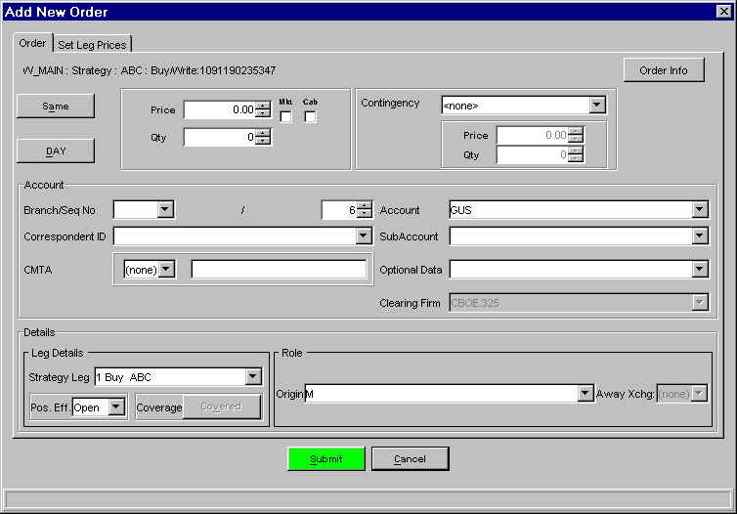

New “Add New Order” window – Order Tab

The second tab, “Set Leg Prices” optionally allows the entry of prices for each leg of the strategy order. If desired, the then-current market price for each leg can be retrieved by clicking on the “Retrieve market prices” button. Currently, equity prices are not available in SBT, so equity leg prices will appear as zero when this button is pressed. The user should then enter the price he wants to pay for that equity leg. Note that the “Retrieve market prices” button retrieves only the current market price at the instant it is queried, and works differently from the “take market” checkbox available on the Order tab for the order’s overall price. The “Clear leg prices” button will make each leg price zero (or more specifically, No Price). This is useful if the user enters leg prices, but then realizes the kind of strategy requires an overall order price on the Order tab. It is an error if the user enters individual leg prices without providing values for all of them. (The error will be displayed when the Submit button is pressed to submit the order.)

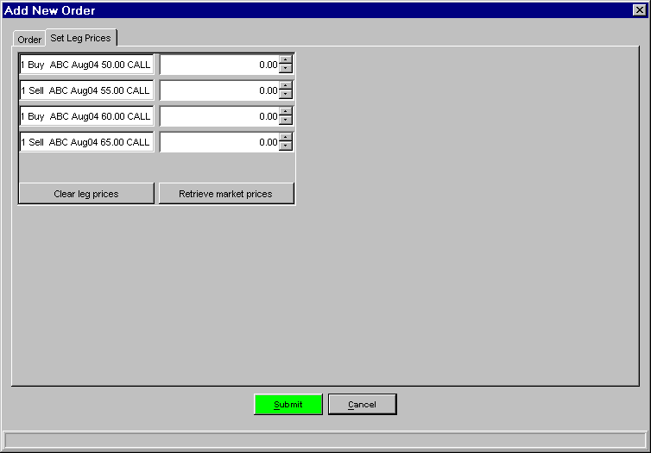

New “Add New Order” window – Set Leg Prices Tab

Similar changes with appropriate behavior will be made for the Cancel/Replace order entry window. It was found, upon coding, that if the user tried to change the product using the product selector in the Cancel/Replace window for a strategy, an exception occurred, and this functionality did not work. Therefore the product selector was disabled for strategies in this window.
The Order History window will be modified because whenever the overall order price was not supplied, it displayed “NP”. This was changed to display “No Price”:

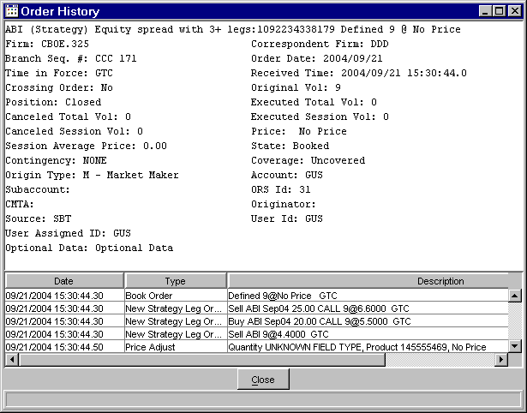

Order History window

The Order Information window will be modified to list the individual leg prices, if entered, after each leg product in the left text box. The pay amount in the right text box was calculated from these leg prices if they were supplied instead of the overall order price. Since the SBT GUI cannot obtain a market price for any equity legs of a strategy, the two calculated quantities at the bottom of the Order Information screen display “Unknown” in such cases.

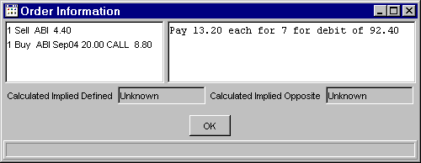

Order Information window – with leg prices

The Order Status window will be modified to display a tooltip for strategy orders with an overall price of zero. This tooltip will display a table of each leg product and its price similar in format to the tooltip for the Series column of the Order Status window.

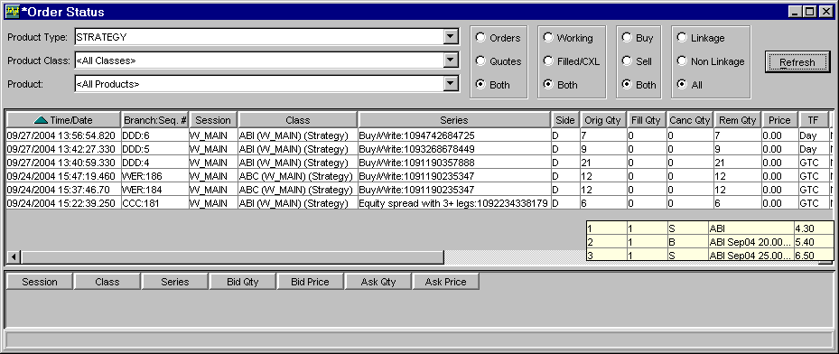

Order Status window – with price tooltip

Order validation logic will be added to the submit button processing for execution instructions entered as part of the Optional Data field of each order. This logic will utilize the helper methods implemented and used in the server code for its validation. This order validation will also be modified to allow the overall order price to be No Price if all the leg mustUsePrices have been supplied.

