Infrastructure: Systems Management Service
System Configuration Guides

This document was last updated: Friday, April 30, 1999
Copyright © Chicago Board Options Exchange, 1999. All rights reserved.

Table of Contents
1. Purpose 2
2. Introduction 2
2.1 Prerequisites 2
2.2 Related Documents 2
3. Configuration Diagram 2
4. Property File Location 3
5. Usage 3
6. Configuration Property Name 3
7. Appendix 3

1. Purpose
This document outlines the configuration and usage of the Infrastructure Systems Management Service. The Systems Management Service managed objects for increment 2 are designed to be used for configuring/controlling the infrastructure services using the Java Dynamic Management Kit (JDMK) version 3.0. The RMI adapter will be used for communications between a management agent and any outside clients, such as the foundation framework. The HTML adapter will be used as the user interface into the agent.

2. Introduction
The Infrastructure Systems Management Service has no properties objects.

2.1 Prerequisites

Item | Version
JDMK | 3.0
JDK | 1.1.6
OrbixWeb† | 3.1c

2.2 Related Documents
see Increment 2 Release Notes

3. Configuration Diagram

The figure below shows how the key pieces for the Java Dynamic Management Kit fit together, relating to an agent and a manager.

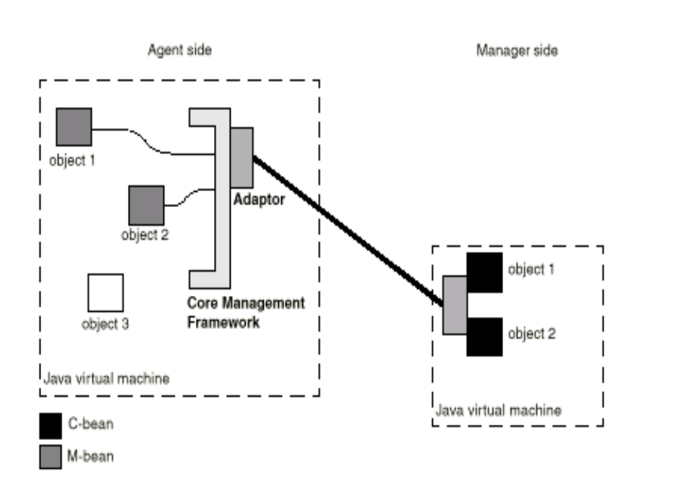

4. Property File Location
not applicable

5. Usage
Again, see Increment 2 Release Notes for extended usage guides, one for each infrastructure service. In general, an agent is created by starting a new Java process (JVM). The command line to use is:

java com.cboe.systemsManagementService.managementFramework.agent.Agent

The administrative interface into the agent is accomplished via a browser such as Netscape Navigator or Microsoft Internet Explorer. To access the agent, go to a browser and open the URL http://host:8082/, replacing host with the hostname of the agent’s machine. The default URL provides a listing of all managed objects currently residing in the agent.

6. Configuration Property Name
not applicable (see Release Notes)

7. Appendix

Glossary of terms

In the definitions below, “framework” refers to the JDMK framework, not the SBT Foundation Framework.

adaptor An adaptor connects the framework to external applications. It provides a view through a specific protocol of m-beans instantiated and registered with the framework.

base agent The base agent is a container in which m-beans are instantiated and run. A base agent consists of a framework that is initialized with the base services and at least one adaptor.

c-bean A client bean, or c-bean, is a stub object that represents a remote m-bean to a manager developed with the adaptor client API. Like an m-bean, a c-bean is a JavaBeans component. The manager accesses an m-bean by performing operations on the c-bean, which are propagated to the m-bean. Events emitted by the m-bean are propagated to the c-bean. A c-bean is generated from its m-bean by using the mogen compiler.

m-bean A managed bean, or m-bean, is a Java object that can be registered with the framework. An m-bean conforms to design patterns derived from the JavaBeans component model and additional design patterns specific to the m-bean model. The additional patterns are defined to ease the interaction between objects and the framework.

mogen The mogen compiler takes the compiled Java class of an m-bean and generates the Java interface and Java stubs of a c-bean. The Java stubs consist of Java source code that implements the interface. To develop a Java manager with code generated by mogen, you use the adaptorMO interface. This ensures that the behavior of the stubs is the same on any adaptor client, provided that it also implements the adaptorMO interface.

object name An object name uniquely identifies an m-bean within a framework. Management applications use object names to identify the m-beans on which to perform management operations. If you do not specify the object name explicitly, the Java Dynamic Management Kit assigns a default object name to the object.

repository service The repository service stores m-beans that are registered with the framework as normal Java objects. For an m-bean, the repository service stores and retrieves the m-bean attribute values and the association between the m-bean and its object name. An M-bean can only be managed if it is registered with an object name in the repository.

This document resides online in Clear Case at: \\documents\sbt\Config_Guides\SysMgmtConfigGuide

† this dependency will be eliminated in increment three

