Early Close by Product

Overview:
Objectives
Selectively close specific products within a class based on the expiration date of the product.

Current processing
- CBOE has cash settled index options that have PM settlement such as Quarterly and Weekly options. These options normally trade until 3:15 pm. This can cause problems for those options on their expiration date.
- Currently the Help Desk either manually halts these options at 3 pm or support must run a script. This is a time consuming activity and is prone to errors. If the series is not halted and a trade can occur at a bad price and it must be busted.
New requirement
- Create a Timer which gets triggered at 3.00pm for closing the product who are expiring on the current business date while settlements.
- Check the individual product expiration date against the current business date. If they are the same then close the product.

Existing Flow:
Timer Initialize and Register
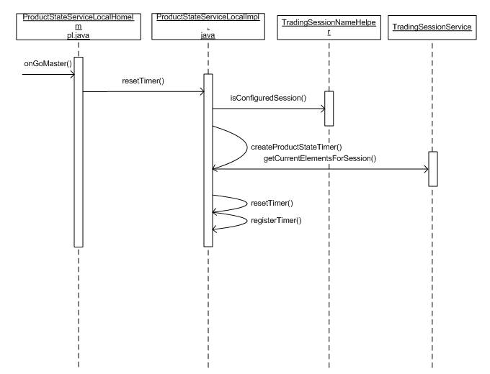

- ProductStateServiceLocalHomeImpl.java initialization occurs on goMaster of the trade server which internally calls resetTimer() method of the ProductStateServiceLocalImpl
- ProductStateServiceLocalImpl.java is the service which performs all product state changes and initialization of the timers. This service will look up the configured session and collect all the trading classes and registers the timer to kick off at a specified time
- TradingSessionService.java provides the session and classes configured for that sessions information

Timer Expire Processing
Below is the flow for Product state processing once timer is expire.
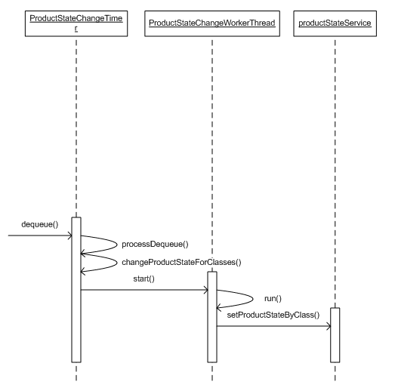

- ProductStateChangeTimer.java – The timer is created on go Master of the process, which will be triggered ata specified time, for example product close at 15:00 hrs and will start processing the Product states for an early close.
- ProductStateChangeWorkerThread.java is spawned from the timer to process multiple classes simultaneously. These threads will change the product state for a product class, which is done in Product state service.
- ProductStateService transitions the product states and publishes it on the event channel.

Implementation Approach:
Adding ‘Early Close Time’ on GC:
- Add holder for ‘early close time’ on Trading Session Element.
- Modify existing table Trading_Session_Element to add new columns,
  - prod_earlyclose_time
  - Extensions
- Add new TradingSessionElementStructV2 to hold the ‘early close time’ to session.idl
struct TradingSessionElementStructV2
{
TradingSessionElementStruct tradingSessionElementStruct;
cmiUtil::DateTimeStruct productEarlyCloseTime;
string extensions;
};
typedef sequence <TradingSessionElementStructV2> TradingSessionElementStructV2Sequence;

struct TradingSessionElementTemplateStructV2
{
TradingSessionElementTemplateStruct tsElementTemplateStruct;
boolean autoEarlyCloseProducts;
cmiUtil::TimeStruct productEarlyCloseTime;
string extensions;
};
typedef sequence <TradingSessionElementTemplateStructV2> TradingSessionElementTemplateStructV2Sequence;

- Add new method in consumers.idl to publish the new V2Struct on the event channel
void acceptTradingSessionElementUpdateV2( in session::TradingSessionElementStructV2 sessionElement);

- Add new methods in TradingSessionMaintenanceService.idl
session::TradingSessionElementStructV2Sequence createElementsForSessionV2(
in cmiSession::TradingSessionName sessionName,
in cmiUtil::DateStruct businessDay)
raises (
exceptions::DataValidationException,
exceptions::CommunicationException,
exceptions::SystemException,
exceptions::TransactionFailedException,
exceptions::AuthorizationException
);

void modifyTradingSessionElementV2(in session::TradingSessionElementStructV2 newElement)
raises (
exceptions::DataValidationException,
exceptions::CommunicationException,
exceptions::SystemException,
exceptions::TransactionFailedException,
exceptions::AuthorizationException
);
- Add new methods in TradingSessionService.idl
session::TradingSessionElementStructV2Sequence getCurrentTradingSessionElementsV2()
raises(
exceptions::SystemException,
exceptions::CommunicationException,
exceptions::AuthorizationException
);

session::TradingSessionElementStructV2Sequence getCurrentElementsForSessionV2(in cmiSession::TradingSessionName sessionName)
raises(
exceptions::SystemException,
exceptions::CommunicationException,
exceptions::AuthorizationException,
exceptions::DataValidationException
);

session::TradingSessionElementStructV2Sequence getElementsForSessionV2(
in cmiSession::TradingSessionName sessionName,
in cmiUtil::DateStruct businessDay)
raises(
exceptions::SystemException,
exceptions::CommunicationException,
exceptions::AuthorizationException,
exceptions::DataValidationException
);

session::TradingSessionElementStructV2 getElementByKeyV2(in session::TradingSessionElementKey elementKey)
raises(
exceptions::SystemException,
exceptions::CommunicationException,
exceptions::AuthorizationException,
exceptions::DataValidationException,
exceptions::NotFoundException
);

session::TradingSessionElementStructV2Sequence getElementsForTemplateV2(in string templateName)
raises(
exceptions::SystemException,
exceptions::CommunicationException,
exceptions::AuthorizationException,
exceptions::DataValidationException
);

session::TradingSessionElementTemplateStructV2Sequence getAllTemplatesV2()
raises(
exceptions::SystemException,
exceptions::CommunicationException,
exceptions::AuthorizationException
);

session::TradingSessionElementTemplateStructV2Sequence getTemplatesForSessionV2(in cmiSession::TradingSessionName sessionName)
raises(
exceptions::SystemException,
exceptions::CommunicationException,
exceptions::AuthorizationException,
exceptions::DataValidationException
);

session::TradingSessionElementTemplateStructV2 getTemplateV2(in string templateName)
raises(
exceptions::SystemException,
exceptions::CommunicationException,
exceptions::AuthorizationException,
exceptions::DataValidationException,
exceptions::NotFoundException
);

Add Trading Property:
- Add a new trading property to the product class that indicates the class is eligible for early closing of a product on its expiration date.
- Change TradingParameter.java files to add trading property constant and initialization part
private volatile boolean enableEarlyClose = false;
public boolean getTradingPropertyEnableCPSBooking()
{
if (enableCPSbookingReinitNeeded)
{
initializeEnableCPSBooking();
}
return enableCPSbooking;
}

private void initializeEnableCPSBooking()
{
TradingPropertyType tpt = TradingPropertyTypeImpl.ENABLE_EARLY_CLOSE;
……………..
…………..
}

Timer Initialization:
- On the startup trade server will create timer and register it to trigger it at specified time.
- Time will read from TradingSessionElementV2.
DateTimeImpl dateTime = new DateTimeImpl(productEarlyCloseTime);
long time = dateTime.getTimeInMillis();

timer = new
ProductStateChangeTimer(this,earlyCloseProductMap,BusinessDayListener.PRODUCT_EARLY_CLOSE_TIMER_TYPE,dateTime,numberOfClassStateChangePerThread,maximumClassStateChangeThread);

registerTimer(timer,BusinessDayListener.PRODUCT_EARLY_CLOSE_TIMER_TYPE,earlyCloseProductMap,time);

- When instantiating the timer, a Map will be created for the configured class whose products are expiring on same day as the current business date.
Public HashMap createEarlyCloseProductMap()
{
getConfiguredGroup();
getTradingClassesFromGroup();
getTradingProductFromClasses();
addProductToEarlyCloseMap();
}
- Early Close Timer for product state change is registered on startup of the trade server on BC to get triggered at the configured early close time.

Timer Expiring Processing:
- Early Close Timer will be trigger at specified configured time and will start processing the Product state to close.
- Trading Property Early Close will be verified against the trading Classes register with the Timer. If trading property is configured to process early close then it will get the list of products from the Map and process the product state change to close
- Worker threads will be used to process multiple classes registered with the timer simultaneously.
- ProductStateService transitions the product states and publishes it on the event channel.

Scripts
- appSQL.txt
- TradingSessionElement.sql
- alterTradingSessionElement.sql
- TradingSessionElementTemplate.sql
- alterTradingSessionTemplate.sql

Database
- alter table TRADING_SESSION_ELEMENT to add 3 new columns
prod_earlyclose_time number(20),
auto_earlyclose_prod_ind char(1),
extensions varchar2(128).
- alter table TRADING_SESSION_TEMPLATE to add 3 new columns
prod_earlyclose_time number(20),
auto_earlyclose_prod_ind char(1) not NULL,
extensions varchar2(128)

SetContext
- Add a new system property -DdoublePublishTSElementUpdate=true in
  - setContext.main
  - setContext.main.c2
- This flag can be turned off once all components have been rolled out and the new struct (TradingSessionElementStructV2) is used by everyone.

XML/DTD

Homes/Services

Implementation Plan
- Need to recreate TradingSession channel for the interface to pick up new method/s

