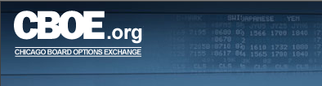

CBOE Back Office Monitor
User’s Guide
Version 1.0

Disclaimer

Copyright © 2006 Chicago Board Options Exchange. All rights reserved.
The information contained in this document constitutes confidential and/or trade secret information belonging to CBOE. This document is provided "As Is" with all faults and without warranty of any kind, either expressed or implied.

Change Notices

The following change notices are provided to assist users of the CBOE Back Office Monitor system in determining the impact of changes to their processing.
If you have any questions or review comments about this document, please contact Odalys Castro at (312) 786-8817.

Date | Version | Description of Change
10/25/06 | 1.0 | New document

Table of Contents
Table of Contents iii
Introduction iv
Purpose iv
Intended Audience iv
Note About Displayed Screens iv
Conventions Used in this Guide iv
Section 1: CBOE Back Office Monitor 5
Getting Started 6
Login 6
Application Log Details 7
Filtering Mechanism 9
Filter by Application Name 9
Filter by Message Type 10
Filter by Instance Name 11
Filter by Support Group 12
Filter by a Specific Date 13
Filter by Script Name 14
Filter by Message Description 14
Sorting Functionality 15
Table Statistics 16
Filtering Mechanism 18
Filter by Table Name 18
Filter by Database Name 18
Filter by Status Indicator 19
Filter by a Process Date 19
Application Statistics 21
Filtering Mechanism 23
Filter by Application Name 23
Filter by Database Name 23
Filter by Status Indicator 24
Filter by a Process Date 24
Exit the System 26
Logout 26
Section 2: Reference Guide 27
Customize and Export Windows 28
Exporting Data 28
Export to CSV Format 28
Export to Excel 30
Sizing Windows 30

Introduction

Purpose | This user guide was written to assist users in utilizing the Back Office Monitor features using a web browser. The system is used to monitor messages in the production environment for real-time replication, data warehouse, market regulations and back office.
Intended Audience | This user guide is intended for CBOE personnel interested in monitoring back office production data.
Note About Displayed Screens | An attempt is made to show the current look and format of screens that are included in this document. However, the displays here may not reflect recent changes to these browser screens. Also, information displayed on the screens may not reflect true production data.
Conventions  Used in this Guide | The Back Office Monitor system was designed so that you can perform all of your functions from a web browser.  Section 1 of the document illustrates how to perform the necessary back office functions. Additional information about window configuration and sizing can be found in Section 2: Reference Guide.  There are conventions used throughout this guide to help trigger important information:
 | Bolding | Used to highlight menu selections (e.g., Login) and button names (e.g., Update)
 |  Note: | This notation is used to indicate important information you should note when performing the associated function.

 | Section 1:  CBOE Back Office Monitor

This section of the user guide will direct you through all the functions of CBOE’s Back Office Monitor system using a web browser.

Getting Started

The links are available for Production, Assurance and Test Backoffice monitor applications in the intranet at http://intranet/departments/EDMG/EDMGAppMon.html.

The following login window will display.
 | 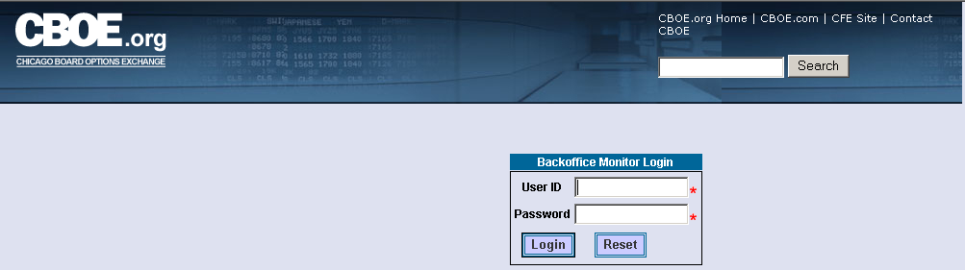
Login | Enter your User ID and Password.
 | 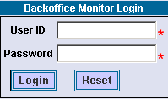
If you incorrectly typed in your User ID or Password, click Reset. The login window will clear. Re-enter your User ID and Password.
Click Login. The Application Log window displays with three sections: (1) Backoffice Monitor Criteria, (2) Backoffice Monitor Results and (3) Other Links.
 | 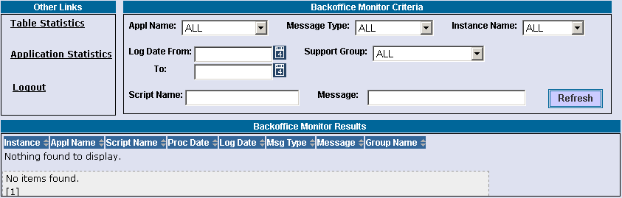
 | You are now ready to monitor back office production log messages.

 | Application Log Details
 | The Backoffice Monitor Criteria section of the Application Log window allows you to monitor production log messages for all back office applications.
At the initial opening of the window, the APPL Name, MessageType, Instance Name and Support Group fields default to ALL.
To generate log messages for these filters, click Refresh.
 | 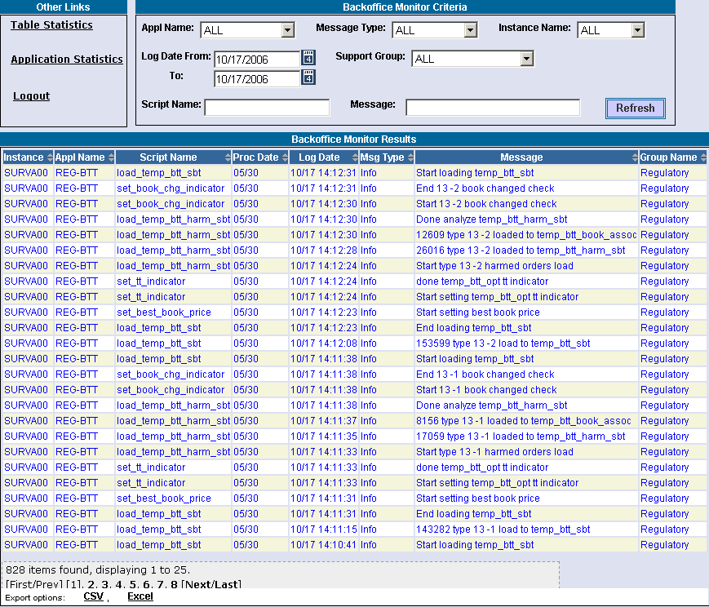
 | The Backoffice Monitor Results section of the window displays the results of the chosen criteria. Below is a description of each column.
- Instance: the name of the database instance
- Appl Name: the application name
- Script Name: the name of the script
- Proc Date: the date the log message occurred
- Log Date: the date the specific criteria was requested. If no date is specified in the criteria selection, the default is the current business day. The log date/time displays in descending order.
- Msg Type: the message type
- Message: the message description
- Group Name: the name of the back office department that the message pertains to (i.e. Data Warehouse)
The total number of items found in this search is 1,328. The window displays upto 25 rows.
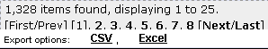
 | To view additional data rows or previously viewed data rows, click First/Prev, Next/Last or the corresponding page number (i.e. 1, 2, etc.).
 | Clicking on the Export option links on the botton of the page will fill a form with data from the screen in the selected format. For instructions on exporting data to CSV or Excel format, refer to the section Customize and Export Windows, page 30.
Filtering Mechanism | You can filter the Application Log messages by the criteria: Application Name, Message Type, Log Date, Instance Name and Support Group or a combination of each.  - Note: The drop down lists are searchable. Type in the first letter of the process name in the drop down box. The system will scroll down to the processes beginning with that letter. Continue to press the first letter of the process name on your keyboard until you reach your item in the list.  Click Refresh at anytime to update your results.

Filter by Application Name
To filter the messages by application name:
- Select the application name from the Appl Name drop down list.
- Click Refresh. The following results will display.
 | 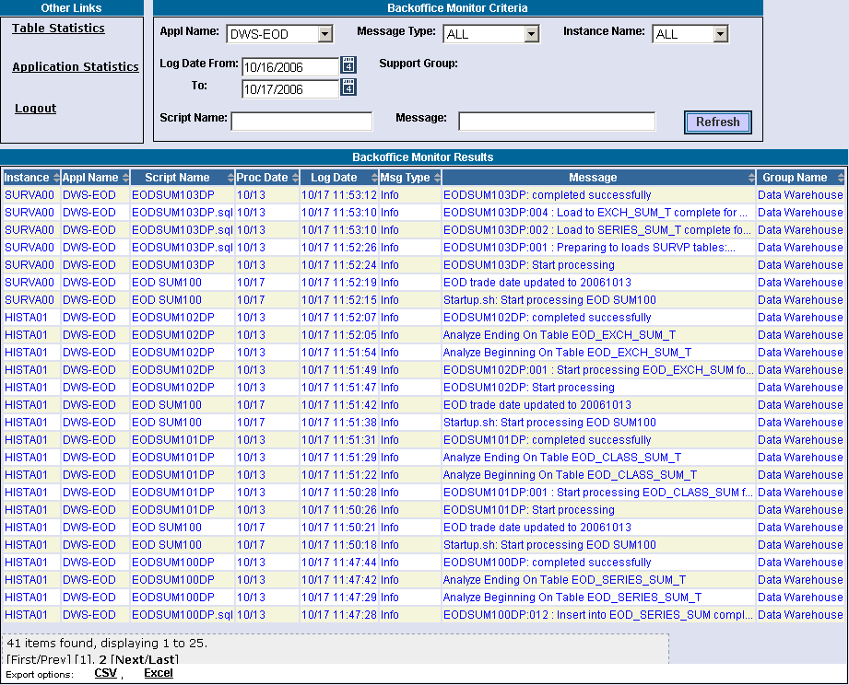
 | In the example above, data is displayed of Log Date descending order. The results display production log messages for application DWS-EOD for all message types, all instance names and all support groups from 10/16/2006 to 10/17/2006.

Filter by Message Type
To filter the log messages by message type:
- Select the Message Type from the drop down list.
- Click Refresh. The following results will display.
 | 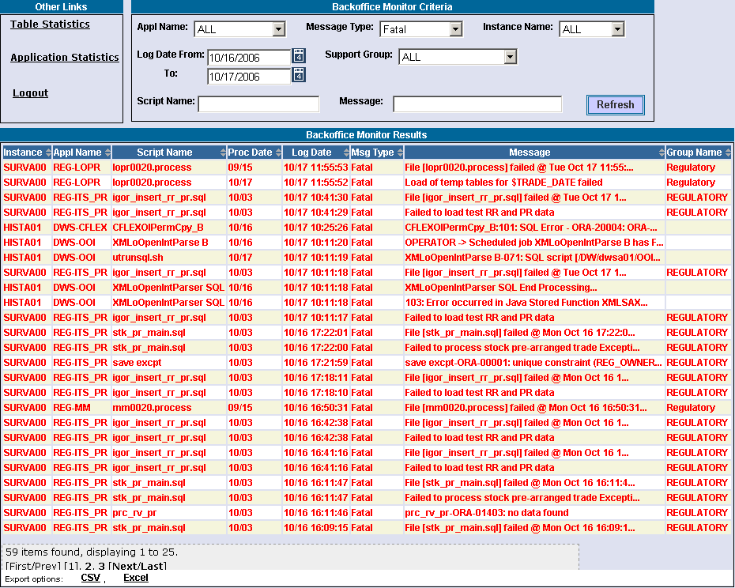
 | In the example above, data is displayed of Log Date descending order. The results display production log messages for message type Fatal for all application names, all instance names and all support groups from 10/16/2006 to 10/17/2006.

Filter by Instance Name
To filter by a specific database name:
- Select the Instance Name from the drop down list.
- Click Refresh. The following results will display.
 | 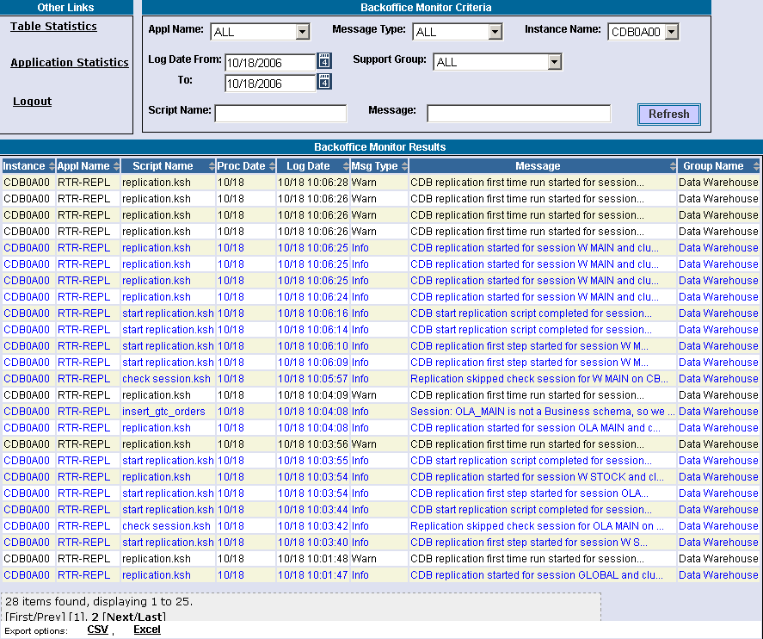
 | In the example above, data is displayed of Log Date descending order. The results display production log messages for database instance CDBOA00 for all application names, all message type and all support groups on 10/18/2006.

Filter by Support Group
To filter by group:
- Select the Support Group from the drop down list.
- Click Refresh. The following results will display.
 | 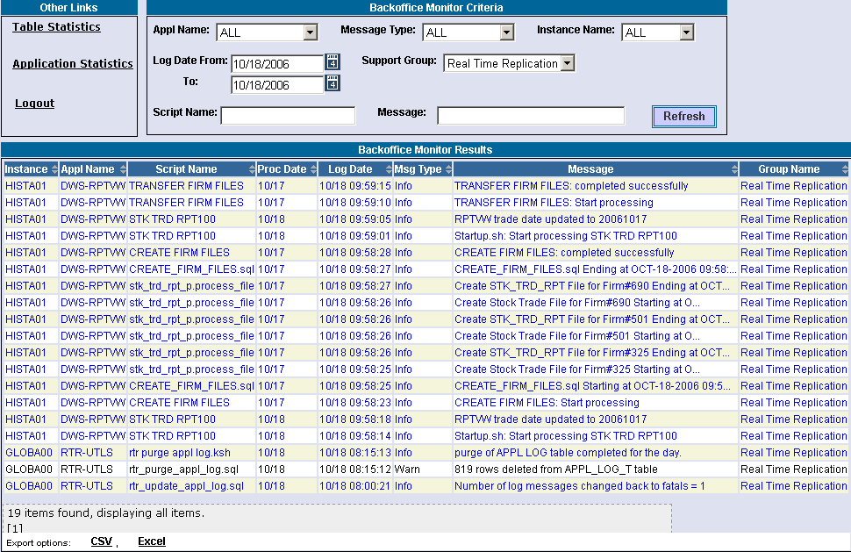
 | In the example above, data is displayed of Log Date descending order. The results display production log messages for group Real Time Replication for all application names, all message type and all instance names on 10/18/2006.

Filter by a Specific Date
To filter by date:
- Click on the calendar button to select the Log Date. Or, you can manually enter the dates in the text box using the format 10/18/06 or 10/18/2006.
- Click to exit the calendar.
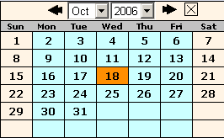
- Click Refresh. The following results will display.
 | 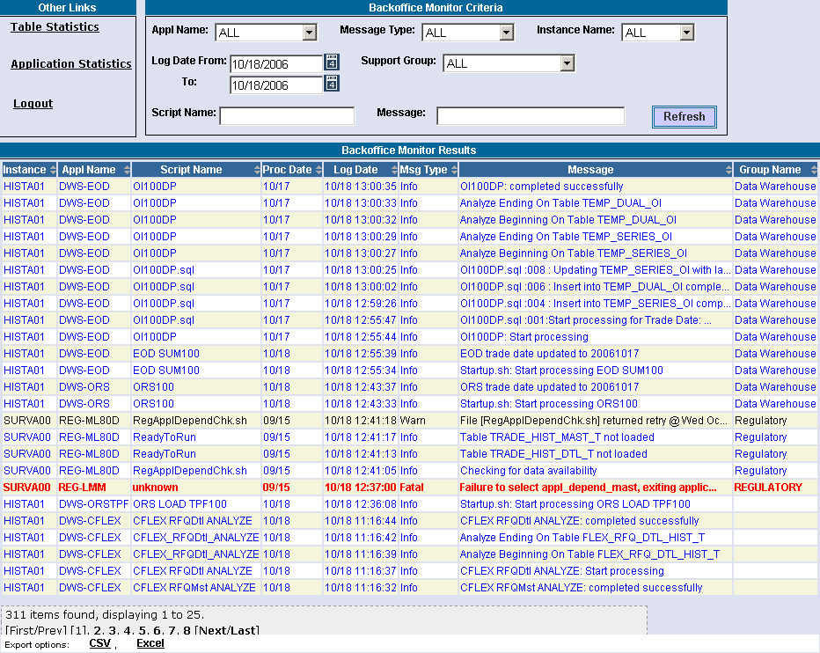
In the example above, data is displayed of Log Date descending order. The results display production log messages for log date of 10/18/06 for all application names, all message type, all support groups and all instance names.
- Note: You can also filter for a specific date range (i.e. from 10/17/06 to 10/19/06).

Filter by Script Name
To filter by script name:
- Enter the Script Name in the text field.
- Click Refresh. The following results will display.
 | 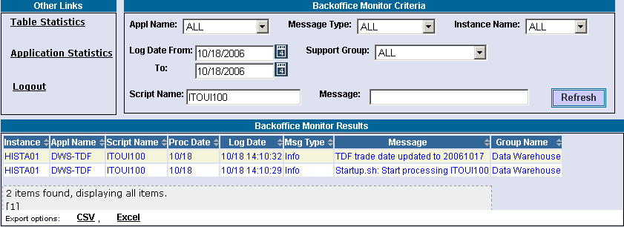
 | In the example above, data is displayed of Log Date descending order. The results display production log messages for script name ITOU100 for all application names, all message type and all instance names on log date 10/18/2006.

Filter by Message Description
To filter by message description:
- Enter the message description in the Message text field.
- Note: Filtering of messages is not case sensitive.
- Click Refresh. The following results will display.
 | 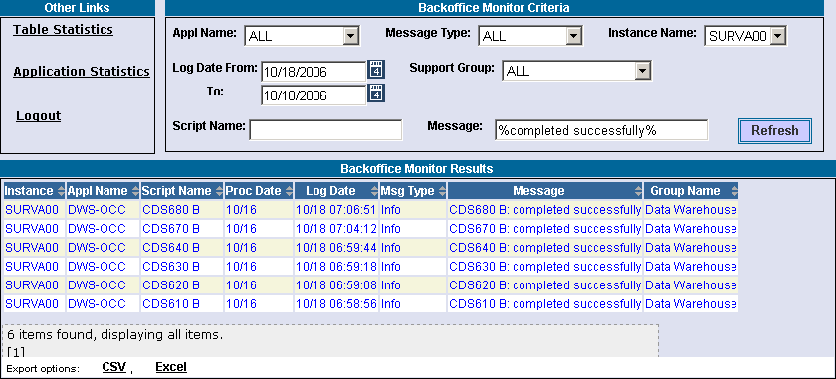
In the example above, data is displayed of Log Date descending order. The results display production log messages for message description completed successfully for all application names, all message type and all instance names on log date 10/18/2006.
- Note: If you don’t know the exact message description to filter, use the Oracle LIKE character of "%" before and after partial verbage.

Sorting Functionality | Data columns that display the up/down arrows can be sorted. Click on the column name to perform an ascending or descending sort. This only sorts data last retrieved into the current screen.
 | 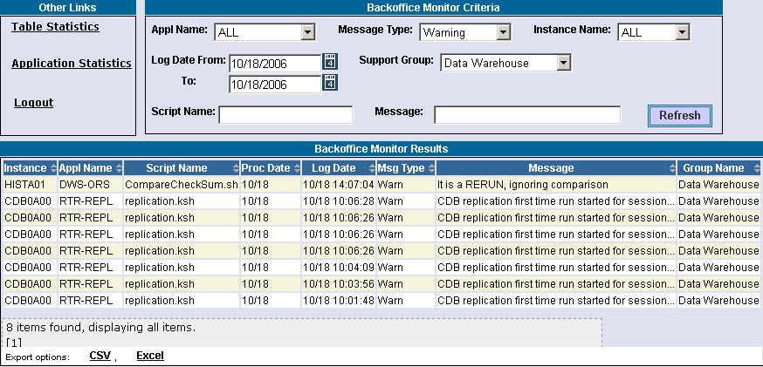
 | In the example below, the Log Date column was originally in descending order. After the sort, it is in ascending order.
 | 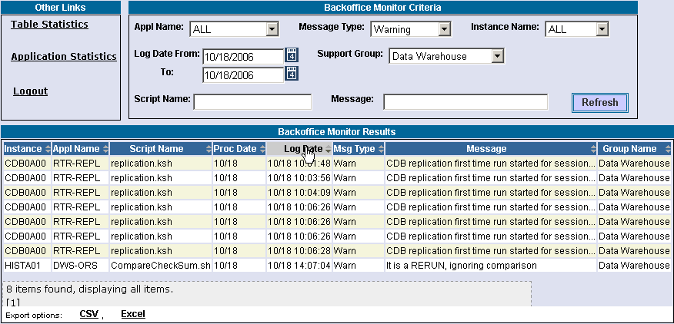

Table Statistics

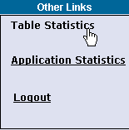 | The Table Statistics window enables you to view, in alphabetical and descending order, how many records have been received and processed, errors received and the table completion status.  To view database table statistics, click the Table Statistics link in the Other Links section of the monitor. The Table Statistics Results window will display.
 | 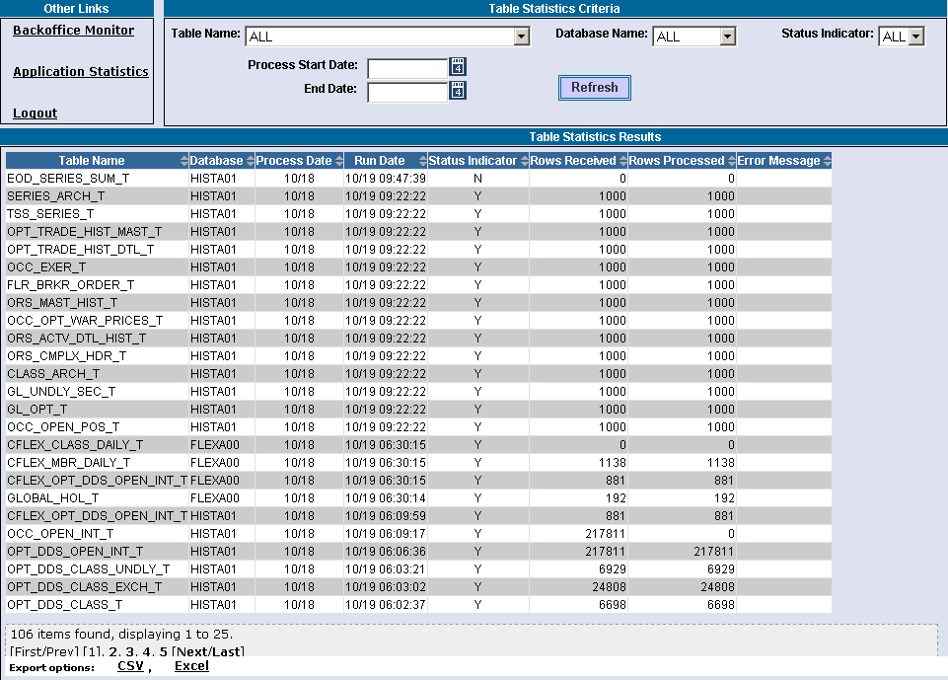
 | Initially, the table statistics window defaults to ALL table names, ALL database names and ALL status indicators.
 | The Table Statistics Results section of the window displays the results of the chosen criteria. Below is a description of each column.
- Table Name: the name of the database table
- Database: the database name
- Process Date: the trade date on which the load was processed for. If left blank, the process date defaults to the last load process date.
- Run Date: the date on which the processing was done. If no date is specified in the criteria selection, the default is the current business day. The date/time displays in descending order.

- Status Indicator: completion indicator for the process: Y=process was completed. N=process was not completed
- Rows Received: the number of records that were received for load processing
- Rows Processed: the number of records that were actually inserted during the load processing
- Error Message: the number of Oracle generated SQL error code and error messages created by the process failure
The total number of items found in this search is 109. The window displays upto 25 rows.
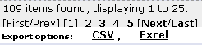
 | To view additional data rows or previously viewed data, click First/Prev, Next/Last or the corresponding page number (i.e. 1, 2, etc.).
 | Clicking on the Export option links on the botton of the page will fill a form with data from the screen in the selected format. For instructions on exporting data to CSV or Excel format, refer to the section Customize and Export Windows, page 30.
 | Data columns that display the up/down arrows can be sorted. Click on the column name to perform an ascending or descending sort. This only sorts data last retrieved into the current screen. For details, refer to the Sorting Functionality section on page 16.
Filtering Mechanism | You can filter the Table Statistics messages by the following criteria: Table Name, Database Name, Process Data and Status Indicator or a combination of each.  - Note: The drop down lists are searchable. Type in the first letter of the process name in the drop down box. The system will scroll down to the processes beginning with that letter. Continue to press the first letter of the process name on your keyboard until you reach your item in the list.  Click Refresh at anytime to update your results.

Filter by Table Name
To filter by table name:
- Select the table name from the Table Name drop down list.
- Click Refresh. The following results will display.
 | 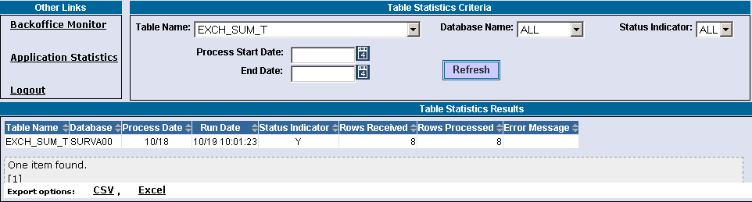
 | In the example above, the results display messages for table name EXCH_SUM_T for all database names and all status indicator types. The process date was left blank, defaulting to the last load process date.

Filter by Database Name
To filter by database name:
- Select the database name from the Database Name drop down list.
- Click Refresh. The following results will display.
 | 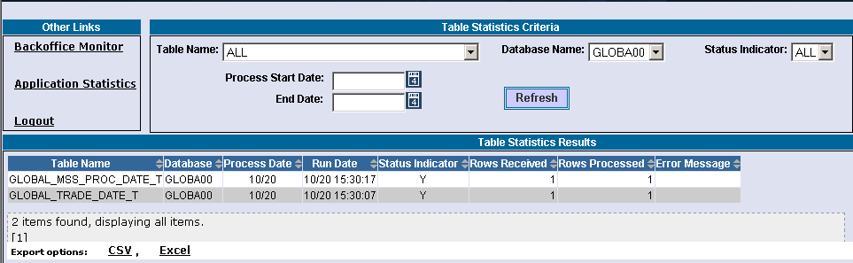
 | In the example above, the results display messages for database name GLOBA00 for all table names and all status indicator types. The process date was left blank, defaulting to the last load process date.

Filter by Status Indicator
To filter by status indicator:
- Select the indicator type from the Status Indicator drop down list.
- Click Refresh. The following results will display.
 | 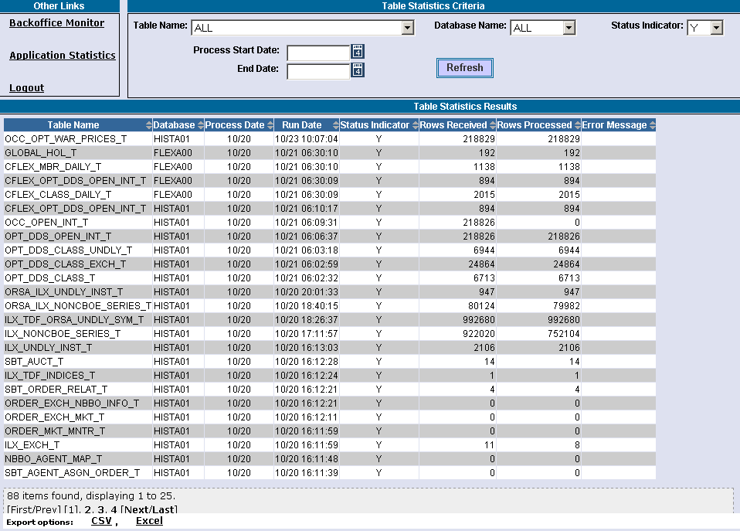
 | In the example above, the results display messages for status indicator type Y for all table names and all database names. The process date was left blank, defaulting to the last load process date.

Filter by a Process Date
To filter by process date:
- Click on the calendar button to select the Process Date. Or, you can manually enter the dates in the text box using the format 10/18/06 or 10/18/2006.
- Click to exit the calendar.
- Click Refresh. The following results will display.
 | 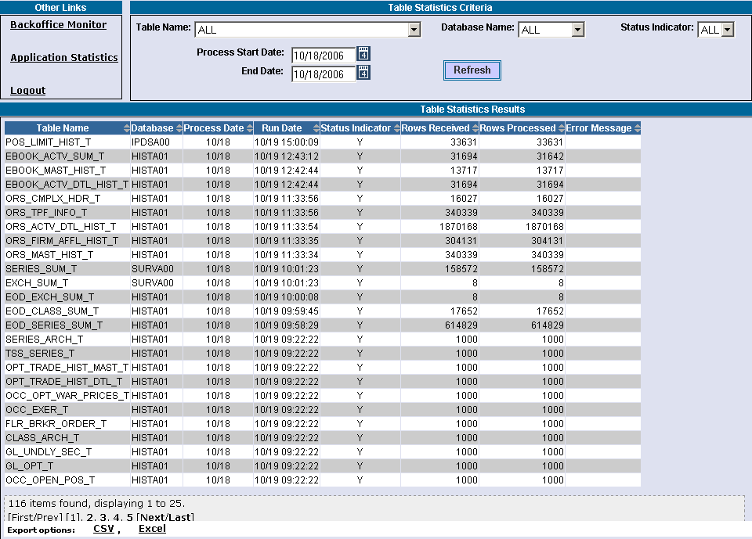
In the example above, the results display messages for process date of 10/18/06 for all table names, all database names and all status indicator types.
- Note: You can also filter for a specific date range (i.e. from 10/18/06 to 10/19/06).

Application Statistics

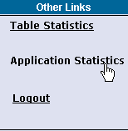 | The Application Statistics window displays the statistics of all the applications that are processed or processing.  To view application statistics, click the Application Statistics link in the Other Links section of the monitor. The Application Statistics Results window will display.
 | 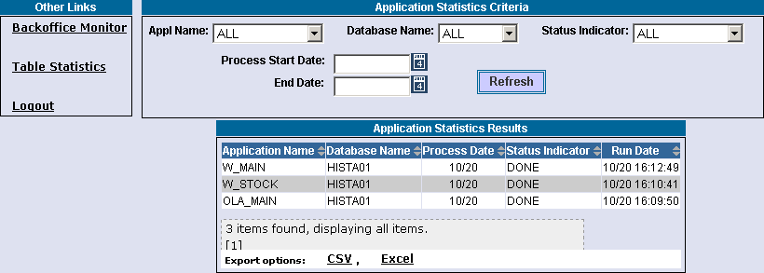
 | Initially, the table statistics window defaults to ALL application names, ALL database names and ALL status indicators for the last load process date.
 | The Application Statistics Results section of the window displays the results of the chosen criteria. Below is a description of each column.
- Application Name: the name of the database application
- Database Name: the database name
- Process Date: the trade date on which the load was processed for. If left blank, the process date defaults to the last load process date.
- Status Indicator: indicates the status of the application.
- Run Date: the date on which the processing was done. If no date is specified in the criteria selection, the default is the current business day. The date/time displays in descending order.
Three items were found in this search. The window can display upto 25 rows.
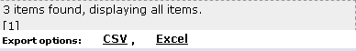
 | To view additional data rows or previously viewed data, click First/Prev, Next/Last or the corresponding page number (i.e. 1, 2, etc.).
 | Clicking on the Export option links on the botton of the page will fill a form with data from the screen in the selected format. For instructions on exporting data to CSV or Excel format, refer to the section Customize and Export Windows, page 30.
 | Data columns that display the up/down arrows can be sorted. Click on the column name to perform an ascending or descending sort. This only sorts data last retrieved into the current screen. For details, refer to the Sorting Functionality section on page 16.

Filtering Mechanism | You can filter the Application Statistics data by the following criteria: Application Name, Database Name, Process Data and Status Indicator or a combination of each.  - Note: The drop down lists are searchable. Type in the first letter of the process name in the drop down box. The system will scroll down to the processes beginning with that letter. Continue to press the first letter of the process name on your keyboard until you reach your item in the list.  Click Refresh at anytime to update your results.

Filter by Application Name
To filter by application name:
- Select the application name from the APPL Name drop down list.
- Click Refresh. The following results will display.
 | 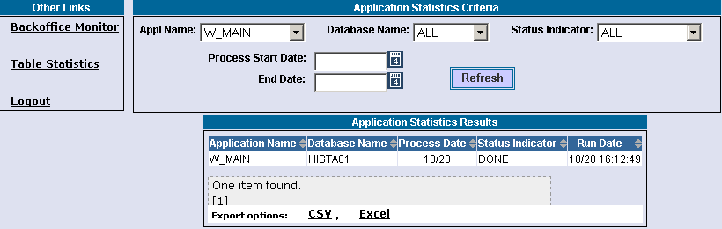
 | In the example above, the results display messages for application W_MAIN for all database names and all status indicator types. The process date was left blank, defaulting to the last load process date.

Filter by Database Name
To filter by database name:
- Select the database from the Database Name drop down list.
- Click Refresh. The following results will display.
 | 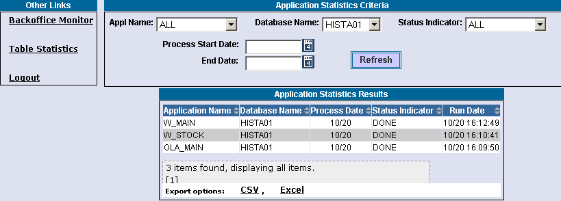
 | In the example above, the results display messages for database name HISTA01 for all application names and all status indicator types. The process date was left blank, defaulting to the last load process date.

Filter by Status Indicator
To filter by status indicator:
- Select the indicator type from the Status Indicator drop down list.
- Click Refresh. The following results will display.
 | 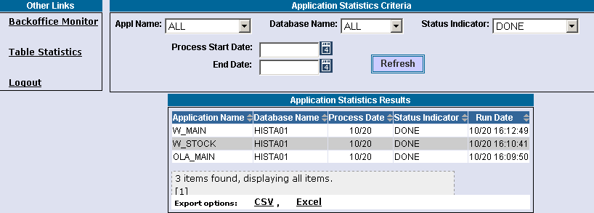
 | In the example above, the results display messages for status indicator DONE for all application names and all database names. The process date was left blank, defaulting to the last load process date.

Filter by a Process Date
To filter by process date:
- Click on the calendar button to select the Process Start and End Dates. Or, you can manually enter the dates in the text box using the format 10/18/06 or 10/18/2006.
- Click to exit the calendar.
- Click Refresh. The following results will display.
 | 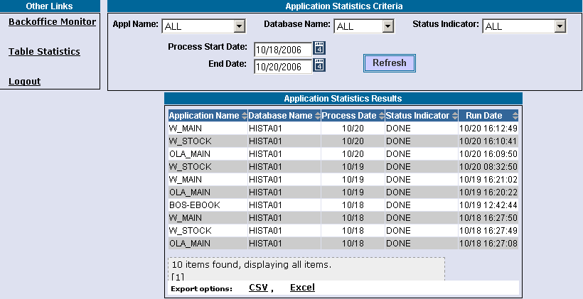
 | In the example above, the results display messages from 10/18/06 through 10/20/06 for all application names, all database names and all status indicator types.

Exit the System

 | You can log out and exit the system at any time during the day.
Logout | To exit the system, click on the Logoff link in the Other Links section of the monitor. You will be logged out of the application and will be returned to the Back Office Monitor login window.
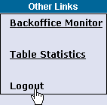

◻ | Section 2:  Reference Guide

Customize and Export Windows

Exporting Data | Windows that exhibit data in column format can be exported to different file formats.

Export to CSV Format
- Click CSV (Comma Separated Values). The File Download window will display.
 | 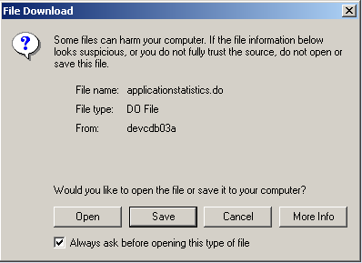
- Click Save. The Save As window displays.
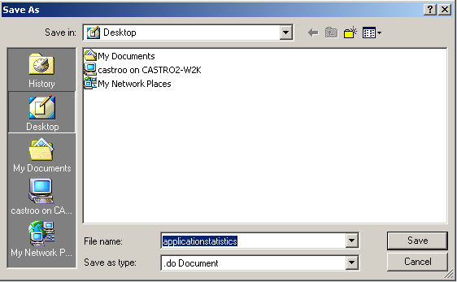
- Select the location where you want to save the file and enter the file name.
- Click Save. Your file will be saved in CVS format.
- To exit the window without saving, click Cancel.
To open the file from the current location:
- Click on the corresponding radio button. The Open With window displays.
 | 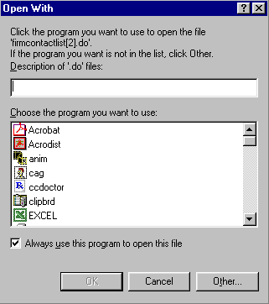
- Select the program in which to display the data.
- Click OK.
- Click Cancel to exit the window.

Export to Excel
If you wish to export the data to an Excel spreadsheet, click Excel. The system will open an Excel window and export the data.
 | 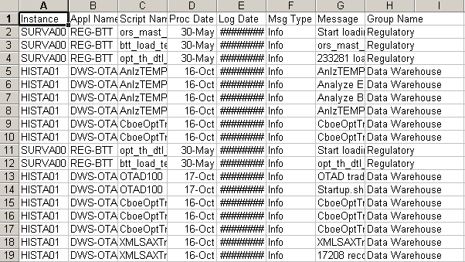
Sizing Windows | The windows are only as sizable as the browser allows.
Resizing a window on the corner will expand or contract it in both directions (i.e. up and down and side-to-side). Resizing it on the side or top/bottom will expand or contract the window only in that one direction.
Windows can also be resized using the center glyph in the upper right corner of the window.
 |  | Click the left button () to minimize the window. Click the right button () to close the window. The center button is used for sizing.
If  is displayed, clicking it will increase the window size to a full-screen display.
If  is displayed, clicking it will return the window to its default size.

