

CBOE:C2 Trader's User Guide
Version 1.1

Disclaimer

Copyright © 2011 Chicago Board Options Exchange. All rights reserved.
The information contained in this document constitutes confidential and/or trade secret information belonging to CBOE. This document is made available to CBOE members and member firms for use with CBOEdirect. This document is provided "As Is" with all faults and without warranty of any kind, either express or implied.

Change Notices

The following change notices are provided to assist users of the CBOEdirect screen-based trading system in determining the impact of changes to their processing.
If you have any questions or review comments about this document, please contact Odalys Castro at (312) 786 8817.

Date | Version | Description of Change
5/26/11 | 1.1 | Market Display updates
10/29/10 | 1.0 | New document

Table of Contents
Table of Contents 4
Introduction 8
Purpose 8
Intended Audience 8
Support and Questions 8
Conventions Used in this Guide 9
Section 1: Screen-Based Trading 10
Getting Started 11
Login 11
Set User Preferences 12
Miscellaneous Preferences 12
Global Preferences 14
Clearing Preferences 14
Send a Message 16
Open a New Market Display Window 16
Opening a Trading Session 17
Market Display Window 17
Select Product Classes 17
At-the-Money (ATM) 17
Add Custom Tab 18
Remove a Tab 18
Modify a Tab 18
Ticker/Recap 18
Side-by-Side Display 20
Side-by-Side Display with Multiple Product Classes 20
Single Row Display 21
Strategy Display 21
Sizing the Market Display Window 21
Displaying Products for Trading 22
Customize Market Display 22
Setting Row and Column Preferences 22
Row Preferences 22
Column Preferences 24
Display 26
Data Highlights 27
Colors 28
Show all Rows / Show all Columns 29
Grow / Shrink 29
Side by Side / Single Row Formats 30
Save Customized Defaults 30
Quotes 31
Enter Quote 31
Locked Market 31
Crossed Quotes 31
Quote Entry 31
Update an Existing Quote 31
Updating One Side of a Quote 33
Cancel Quote 34
Cancel All Quotes 34
Request for Quote 35
Orders 36
Add New Order 36
Contingency Orders 37
Hit the NBBO Bid—Add Sell Order 37
Take the NBBO Offer—Add Buy Order 37
Hit the Bid—Add Sell Order 37
Take the Offer—Add Buy Order 38
Enter a Qualified Contingent Cross Order 39
Enter a Cross Order 40
Order and Quote Status 40
Update 41
Cancel 41
Cancel Replace 41
Order History 41
Edit Preferences 41
Viewing Status 42
My Trades Log 42
Activity Log 42
Market History 43
Book Depth 43
Display Pending Price Adjustments 43
Express Market Display 43
Closing a Trading Session 44
Get Out of the Market 44
Logout 44
Exit the System 44
Section 2: Detailed Reference Guide 46
Task Toolbar 47
About CBOEdirect 47
Open Tasks 47
Resize 47
Saving the Configuration for Windows Other Than the Market Display 48
Apply Default Preferences 48
Saving the Configuration for a Market Display Window 49
Session Information 50
Logout 50
Change Password 50
Main Window Settings 50
Window Control 50
Start Menu 52
Book Depth 52
Edit Column Preferences 53
Express Market Display 53
Edit Column Preferences 55
History 55
Activity Log 55
Edit Column Preferences 56
Market History 56
Print Market Data History Table 59
Edit Column Preferences 59
Trades Log 60
Edit Column Preferences 60
Locked Market Status 61
Market Display 62
Message Center 62
Montage 64
Order Status 65
Edit Column Preferences 65
Pending Price Adjustment 66
Pending RFQs 66
Preferences 67
Miscellaneous Preferences 68
Global Preferences 69
Quote Preferences 70
Restore Preferences 73
Configuration Maintenance 74
User Information 74
Product Lookup 77
Lookup by Selector 77
Lookup by Key 78
QRM 79
QRM Maintenance 79
Reporting 80
Class Volume 80
Display Series Price Details 81
Status Window 82
Ticker Display 83
Ticker Configuration 83
Open Console Window 89
Order Menu 90
Add New Order 90
Order and Quote Status 92
Order History 92
Edit Preferences 93
Add Qualified Contingent Cross Order 94
Execute Menu 96
Hit the Bid 96
Take the Offer 97
Hit the NBBO Bid 99
Take the NBBO Offer 100
Quote Menu 103
Enter Quote 103
Cancel Quote 104
Cancel All Quotes 104
Quote Request 105
View Pending RFQs 106
Ticker Menu 107
Recap / Ticker 107
Recap 107
Ticker 107
Edit Preferences 108
Recap Enablements 108
Ticker Enablements 109
Display 110
View Menu 114
Add Class 114
Add Custom Tab 115
Remove a Tab 116
Modify a Tab 116
Multi Class Tabs 116
View Type 117
Table 117
Window Menu 118
My Trades Log 118
Edit Column Preferences 119
Activity Log 119
Edit Column Preferences 120
Market History 121
Market History 121
Priority Market History 121
Print Market Data History Table 123
Edit Column Preferences 123
Book Depth 124
Display Pending Price Adjustments 125
Express Market Display 126

Introduction

Purpose | This user guide was written to assist users in utilizing all of the features of the CBOEdirect screen-based trading system for CBOE2. It provides comprehensive information on trading activity and suggests how to customize your trading environment for optimal use.
Intended Audience | This user guide is intended for anyone interested in CBOEdirect's screen-based trading functions for CBOE2.
Support and Questions | Questions regarding this document can be directed to The Chicago Board Options Exchange at (312) 786 7300 or via email at api@cboe.com.

Conventions  Used in this Guide | The CBOEdirect system was designed so that you can perform all of your market maker activities from the Market Display window. Therefore, you should be aware that the active trading fields for a product are sensitive to both right and left mouse clicks. Many functions can also be activated from the Menu Bar and using keyboard commands.  In order to streamline Section 1 of the documentation, we will illustrate the most efficient ways to perform a function. Additional information about each of the Menu Bar options can be found in Section 2: Reference Guide.  There are several conventions used throughout this guide to help trigger important information:
 | Bolding | Used to highlight menu selections (e.g., Login) and button names (e.g., RFQ)
 | Brackets [ ] | Used to highlight keyboard commands (e.g., [Alt]-[O]). Note that when [Alt] or [Ctrl] are used in conjunction with another key, hold down the first key while pressing the second.  Most menu and button functions can be executed through keyboard commands. Hold down the [Alt] key and press the keyboard character of the underlined letter in the command. For example:  [Alt]-[O] displays the Order Menu  [Alt]-[T] gets you out of the market—Out button
 | n(10) | This notation is used to designate values when the value in parentheses is indicative and will be specified in the future.
 |  Note: | This notation is used to indicate important information you should note when performing the associated function.
 | 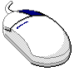 | This mouse graphic with the right mouse button highlighted will appear in the margin when accompanying instructions relate to functions activated by clicking the right mouse button.  All other mouse commands (such as double clicking to display a window) refer to a normal left mouse click.
 | Express Trading | This graphic will appear in the margin whenever accompanying instructions illustrate a trading shortcut that enables you to execute an activity without going through the menu options.
 | Special Situations | This graphic will appear in the margin when there is information relating to special trading situations.
 | Broker-Only Function | This graphic will display in the margin whenever the trading feature being described is a Broker-only function.
 | Market Maker-Only Function | This graphic will display in the margin whenever the trading feature being described is a Market Maker-only function.

 | Section 1:  Screen-Based Trading

This section of the user guide introduces all functions of the CBOEdirect Trader Workstation for CBOE2.

Getting Started

 | When you launch the CBOEdirect Screen-Based Trading application for CBOE2, the following login window will display.
Login | CBOEdirect allows you to login as a Primary or Secondary user. You can use your Primary or Secondary login to login with another application while using the CBOEdirect Screen-Based Trading application.  Multiple primary and secondary logins are allowed using the same User ID. Primary logins are subject to a forced logout by the system. Secondary logins are not monitored for application termination. However, if the system forces the logout of a user, all primary and secondary login sessions for that User ID will be terminated. A Secondary login does not require a Primary login session to be active.  To login, enter your User ID and Password. Both User ID and Password are case sensitive. Select if your login is Primary or Secondary by clicking the appropriate radio button.  Click Settings, to change your login mode. The Session Settings window will display.
 | 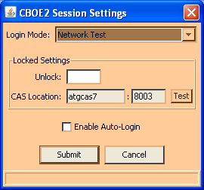
 | Select your login setting from the drop down list. To change your CAS location, enter your password in the Unlock field and enter the new CAS location. Click Test to check your setting. To facilitate auto-login into the system, select the Enable Auto-Login checkout. Click Submit, Confirm. If you decide you do not wish to change your login mode, click Cancel. The system will return to the menu window. Click Login.
 | Once you are logged into the system, the Open Tasks toolbar will display in the CBOEdirect window. From this window you can open tasks, set your user preferences and open a trading session. Click the Up and Down arrows to view session information and perform window controls. For more details, see Section 2: Reference Guide (Task Toolbar), page 45.
Set User Preferences | The system allows you to set user preferences to customize your trading session. Values set through this function will become the default values. All values can be changed manually during trading, however, these values will set your beginning parameters.  To display the Preferences menu, click the Start button on the CBOEdirect window and select Preferences, Miscellaneous Preferences. From this menu, you have options to set up defaults for order entry, execution, alarms and sequence numbers.
➢ | Miscellaneous Preferences  For each class you trade, you can set order and execution defaults. The Default tab will set base values for all trading classes.
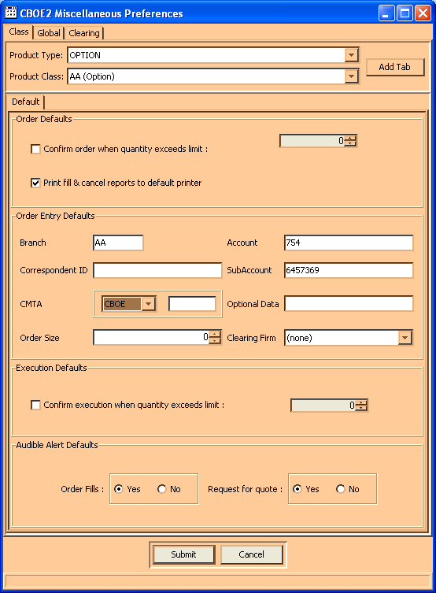

If you want some trading classes to have different defaults, you can select the class and set specific values and settings. For more details, see Section 2: Reference Guide (Miscellaneous Preferences, page 66).
Click Submit, and then click Confirm.

➢ | Global Preferences  General GUI preferences are set from the Global tab. You can set your Trader GUI to a side by side market display, elect to receive pop-up notification for text messages and set sequence numbers.
 | 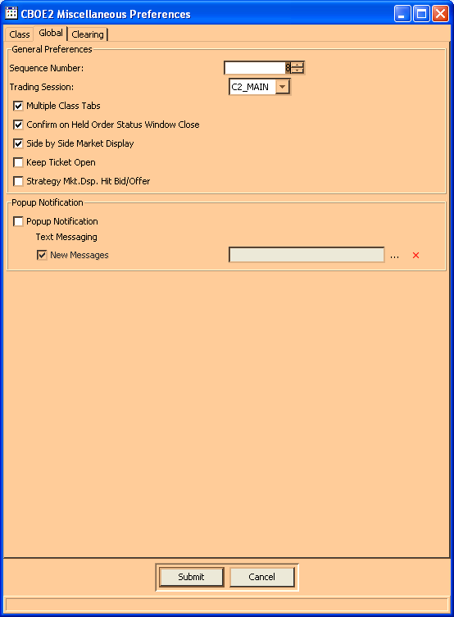
Click Submit, and then click Confirm.
For more details, see Section 2: Reference Guide (Quote Preferences, page 69).

➢ | Clearing Preferences  For each class you trade, you can set your clearing preferences defaults. The Clearing tab will set base values for all trading classes. These are the values that will automatically be used for trade clearing.  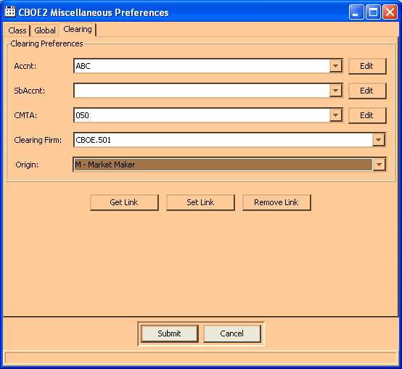
Enter your default clearing values for account, subaccount, CMTA, clearing firm and origin.
Click Submit to save your values.
To withdrawal your settings, click Cancel.
Send a Message | If you need to send a message to the CBOEdirect help desk, select the Message Center option from the Start Menu, then select Send Message to Help Desk. Enter your message, and then click Send Message.
Open a New Market Display Window | From the Start Menu, select Market Display, and then select Create New Window. A new Market Display window will open and a Market Display window task button will appear on the Open Tasks toolbar. You are ready to begin trading.  CBOEdirect allows you to open—and trade from—only one Market Display window. You can change the default window name of your Market Display from the Open Tasks Toolbar.  From the task button on the Market Display, perform a right mouse click and select Save Configuration. The Save Configuration window will display. Select the Save Configuration radio button. Type the new Configuration Name. Click Submit. Click Confirm. The Market Display window task button will display with the new window name.  The preferences described in the previous section will apply to your Market Display window during your trading session.   Note: There are a variety of function and activity windows that open during the course of a trading session. Most trading function windows can remain open during trading. This documentation will provide notes regarding the windows that must be closed before trading can resume.

 | Opening a Trading Session
Market Display Window | When you select Market Display, Create New Window from the Start Menu, the Market Display window will appear.  Initially, the window will be blank. Press F9 on your keyboard. The Add Class window will display. From this window, you will select the product classes to add to your trading session.  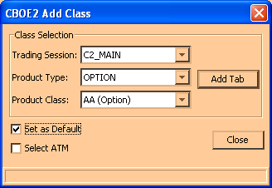
Press F5, the Add Class window defaults to an option class selection.
Press F6, the Add Class window defaults to a strategy class selection.

To quickly add a class, type the class name in the Class text field, select the session and click Add. The class tab will appear on the Market Display window.
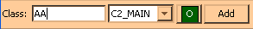

Select Product Classes
Select the trading session and product class from the drop down list boxes. For each product class, select the valid product type(s).
Select the Set as Default checkbox to retain the Trading Session and Product Type settings. The next class selection will automatically display with these values so you need only define the product class.
Click Add Tab. The system will display a tabbed window listing all of the series in the class with related market data.
Note: Only three product class tabs are allowed on the Market Display.
Option classes default to display in side-by-side format. Other types of product classes will display only in single row format.

At-the-Money (ATM)
By selecting the Select ATM checkbox in the Add Class window, CBOEdirect will calculate the at-the-money series for your product class selection. When you click Add Tab, the at-the-money series displays in the center of the Market Display window for that class.
The at-the-money series is calculated based on the underlying value. If there is no underlying value available, the previous day's closing stock price will be used to determine the value. You can highlight the at-the-money series from anywhere on the Market Display window by pressing F11 anytime during your trading session.

Add Custom Tab
CBOEdirect allows you to create custom tabs that contain multiple product classes. A tab can only contain classes of the same session and product type. From the Market Display window, press F12 on you keyboard. The Add Tab window will display.
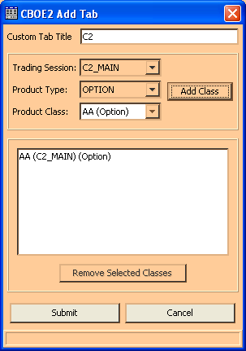
To add multiple product classes to a tab:
- Select a trading session from the Trading Session drop down box.
- Select a product type from the Product Type drop down box.
- Select a product class. Click Add Class. The product class will display in the text box section of the window. You can continue to add product classes to the tab as long as the classes are of the same session and product type.
  - Note: There are limits for the number of product classes of each product type that can be added to a single tab.
- An Option or Strategy tab can only contain one product class

- When you select your first product class, the system defaults to set the name of the product class as the Custom Tab Title. You can override the default setting by entering a custom title for your tab in the Custom Tab Title text box.
- If you wish to remove a product class from your selection, select the product class from the text box and click Remove Selected Classes. The product class will be removed from the text box.
- To remove multiple product classes, hold down the Shift key on your keyboard and select the product classes. Click Remove Selected Classes. The product classes will be removed from the text box.
- To create your custom tab, select Submit. Click Confirm. The system will display a tabbed window on the Market Display listing all the series for the product classes with related market data.
- If you decide not to create a custom tab, click Cancel.

Remove a Tab
To remove a tab from the Market Display, right mouse click on the tab and select Remove.

Modify a Tab
To modify product classes for a tab on the Market Display, right mouse click on the tab and select Modify. The Modify Tab window displays.
From this window, you can add or remove product classes and edit the title. Click Submit. Click Confirm. The modified tab will display on the Market Display window.
Note: If all the product classes are removed and you try to Submit the changes, the system will prompt you that if the changes are finalized, the tab would be empty, and therefore removed from the Market Display window.

Ticker/Recap
To view ticker or recap information, press [Alt]-[K] at any time from anywhere on the Market Display window and select your option. The ticker or recap information will display in the frame below the trading information section of the window.
 | Below are examples of the Market Display window for options in side-by-side and single row formats.
 | Side-by-Side Display
 | 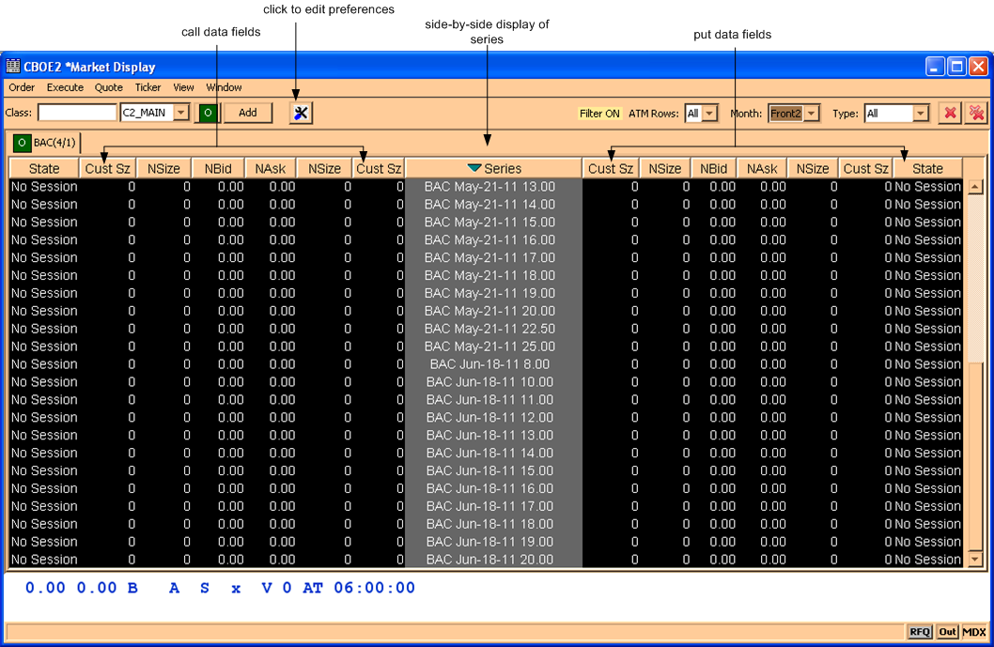
 | There are a number of data fields for each series. To view the fields off the right of the window, slide the scroll bar (below the data fields) to the right or left.
 | Side-by-Side Display with Multiple Product Classes
 | 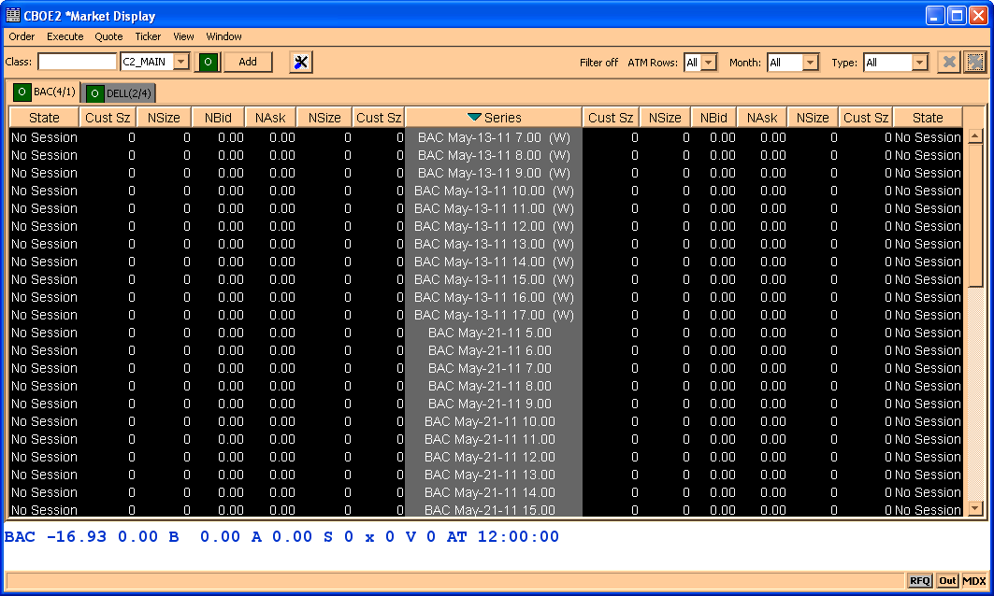
 | Single Row Display
 | 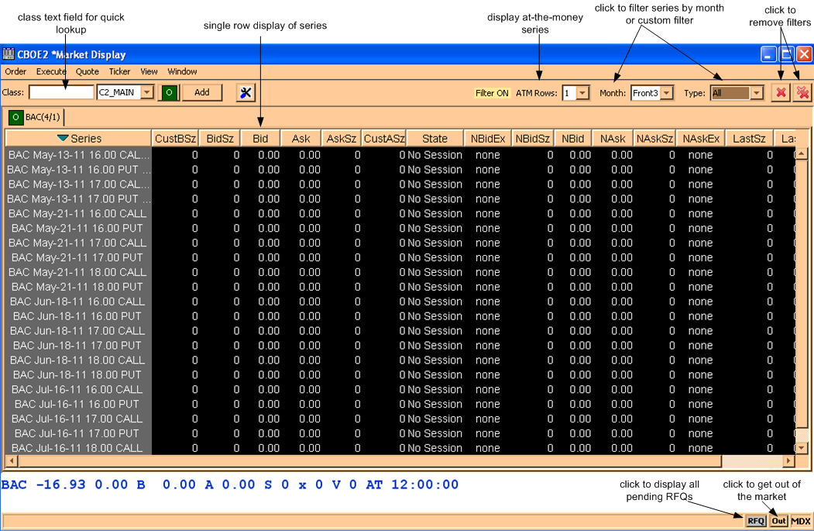

Strategy Display
Not currently supported
➢ | Sizing the Market Display Window  The Market Display windows are sizable. That is, they can be resized on the screen to make viewing information easier for you.
 | 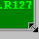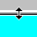 | Place the mouse on any edge of the window until it becomes a two-sided arrow. Hold the left mouse button down and move it to the desired size.
Resizing a window on the corner will expand or contract it in both directions (i.e. up and down, side to side). Resizing it on the side or top/bottom will expand or contract the window only in that one direction.
Windows can also be resized using the center glyph in the upper right corner of the window.
 |  | Click the left button () to minimize the window. Click the right button () to close the window. The center button is used for sizing.
If  is displayed, clicking it will increase the window size to a full-screen display.
If  is displayed, clicking it will return the window to its default size.

Displaying Products for Trading

Customize Market Display | From the Market Display window, press F9 or click the View Menu and select Add Class. The Add Class window will display.  Select the trading session, product type and product class you wish to display. Click Add Tab. A tabbed window will display for each class selection. If you wish to retain the trading session and product type values for additional class selections, click the Set as Default checkbox. Click Close to exit the window.  Refer to the Market Display window sample on the previous page to review what data is displayed for each class.  By clicking on the tab, you bring the Current Selected Product Class to the front of the window. These fields are now active for trading.  To remove a product class display, right mouse click on the selected class tab. Select Remove Tab. The product class is removed from the Market Display window.
Setting Row and Column Preferences | 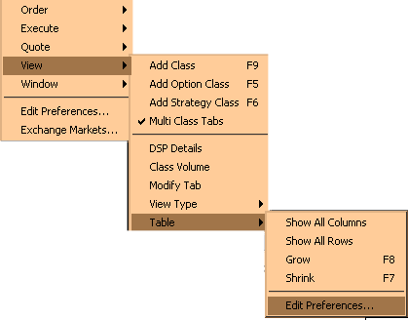
You can refine your Market Display window by selecting or deselecting specific series in each class. If there is a series that you are not interested in trading and don't want the data displayed on your Market Display window, you can deselect it.
To filter products on your Market Display window, right mouse click on any series. Select View, Table, Edit Preferences. The Edit Column Preferences window will display.

➢ | Row Preferences  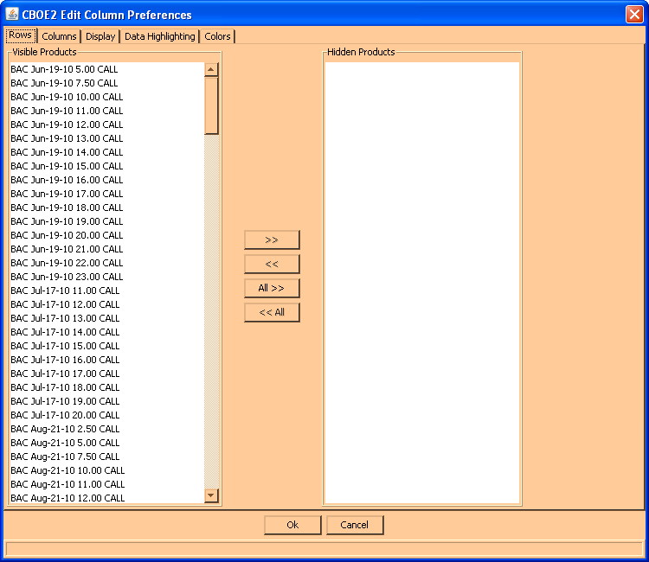
If there are series data you do not wish to view:
- Select the series from the Visible Products list box.
- Click >> to move the series data to the Hidden Products list box.
- Click Ok to update the product selection.
- If you decide to retain the default layout, click Cancel.
To hide all series data:
- Highlight all the series in the Visible Products list box.
- Click All>> to move all the series to the Hidden Products list box.
- Click Ok to update the product selection.
- If you decide to retain the default layout, click Cancel.
To display hidden series data:
- Select the series from the Hidden Products list box.
- Click << to move the series to the Visible Products list box.
- Click Ok to update the product selection.
- If you decide to retain the default layout, click Cancel.
To display all hidden series:
- Highlight all the series from the Hidden Products list box.
- Click <<All to move all the series the Visible Products list box.
- Click Ok to update the product selection.
- If you decide to retain the default layout, click Cancel.
➢ | Column Preferences
 | 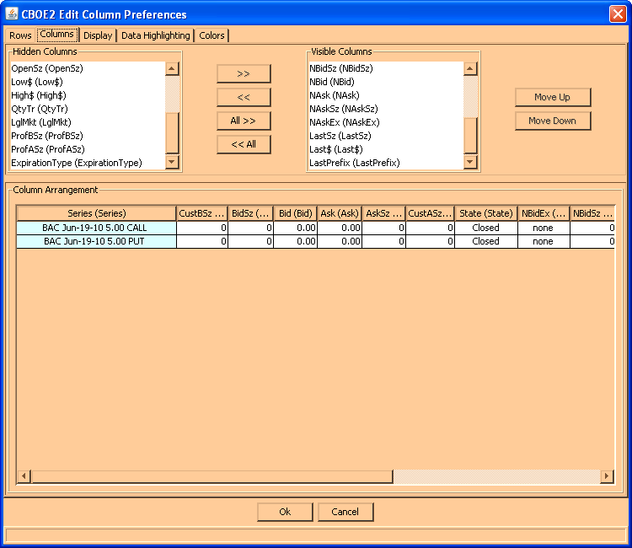
If there is a data column you do not wish to view:
- Select the column name in the Visible Columns list box. To select a continuous range of multiple columns, hold down the Shift key and highlight the column names. Hold down the Ctrl key to select individual, non-continuous column names.
- Click << to move the column name to the Hidden Columns list box.
- Click Ok to update the column arrangement.
- If you decide to retain the default layout, click Cancel.
To hide all columns:
- Click <<All to move all the column names in the Visible Columns to the Hidden Columns list box.
- Click Ok to update the column arrangement.
- If you decide to retain the default layout, click Cancel instead of Ok.
  - Note: If you hide all columns, you will subsequently have to make some columns visible before the update will take effect.

To display a hidden column:
- Select the column name(s) from the Hidden Columns list box.
- Click >> to move the selected column name(s) to the Visible Columns list box.
- Click Ok to update the column arrangement.
- If you decide to retain the default layout, click Cancel instead of Ok.
To display all hidden columns:
- Click All>> to move the column names to the Visible Columns list box.
- Click Ok to update the column arrangement.
- If you decide to retain the default layout, click Cancel instead of Ok.
To facilitate trading, you may prefer to view data columns in a different order than the default display.
To move a column:
- Highlight the column name from the Visible Columns list box.
- Click Move Up or Move Down until you reach the new column location.
- Click Ok to update the column arrangement.
- If you decide to retain the default layout, click Cancel.
 | An alternate way of re-ordering columns can be done in the Market Display window itself by clicking on a column header and moving the column to a new position.
From the Column Arrangement section of the window, the columns can be resized to make viewing information easier for you.
To resize a column:
- Place the mouse on the right edge of the column header (where the column titles are displayed) until it becomes a two-sided arrow.
- Hold the left mouse button down and move it to the desired size.
- Click Ok to save the new column size.
- If you decide to retain the default column size, click Cancel instead of Ok.
➢ | Display
 | 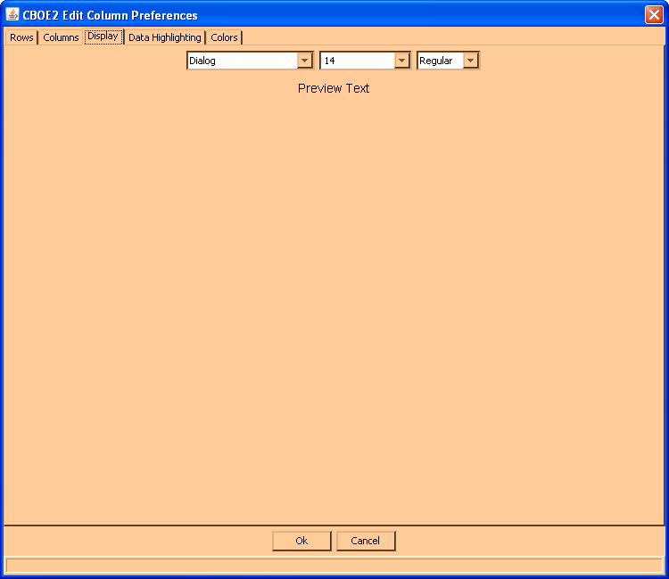
From the Display tab, you can modify the font type, size and style by selecting the new settings from the drop down lists. The new font will display in the Preview Text section of the window.
- Click Ok to update the font display.
- Click Cancel to retain the default settings.
➢ | Data Highlights
 | 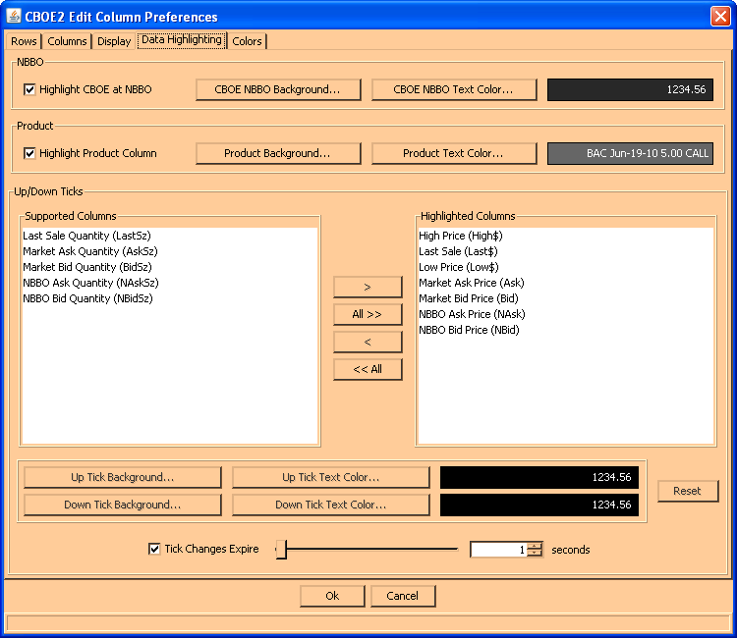
From the Data Highlighting tab, you can set the background and text color for Product data rows and when CBOE is the NBBO. In addition, the up/ down tick movement can be color coded.
To set your color choices for the NBBO price, click on the CBOE NBBO Background and CBOE NBBO Text Color buttons. Refer to the Colors section below for color selection navigation.
 | To set your color choices for the Product data rows, click on the Product Background and Product Text Color buttons. Refer to the Colors section below for color selection navigation.
The Up/Down Ticks section of the window allows you to select which columns will display price tick movement. Up and down tick movement can be set to display in color. In the example above, when the price of the product goes up the text color displays in green font for 1 second. When the price of the product goes down the text color displays in red for 1 second.
You can change the colors of the tick movement my clicking on the corresponding Up/Down Tick Background and Up/Down Tick Text Color buttons. Click Reset to set the colors to the default settings.
Click on the Tick Changes Expire checkbox to set the expiration time for a price tick.
Click Ok to save your changes. Click Cancel to close the window and return to the Market Display.
➢ | Colors
 | 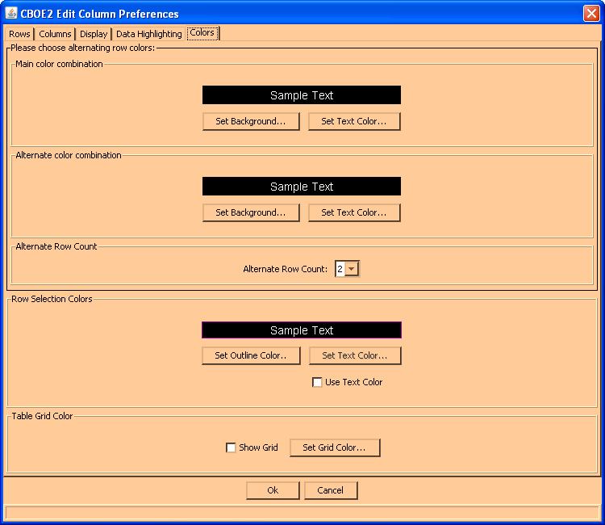
 | From the Colors tab, you can set the background and text color of each market display row. Click on the Set Background button to display the color choices.
 | 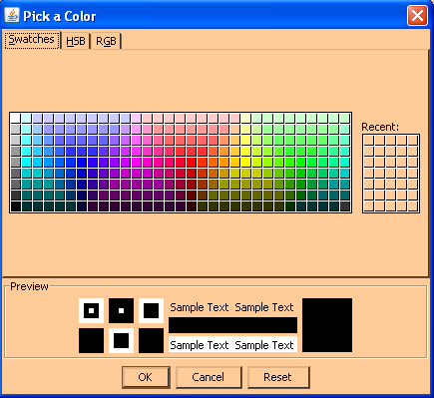
- Click on your desired color and view it in the Preview section of the window. Perform the same functions in the HSB and RGB tabs.
- Click Reset to clear your color choice.
- Click Ok to update the color/font display.
- Click Cancel to retain the default settings.
 | 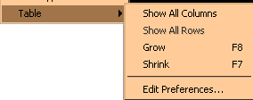
➢ | Show all Rows / Show all Columns  - To display all the data columns, highlight Show All Columns. The data columns will appear on the Market Display.  - To display all the series, select Show All Rows. All the series will become visible on the Market Display.  - Note: Show All Rows is not currently supported.
➢ | Grow / Shrink  - To increase the size of the data rows and columns, highlight Grow or press F8 from anywhere on the window.  - To decrease the size of the data rows and columns, highlight Shrink or press F7 from anywhere on the window.
 | 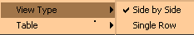
➢ | Side by Side / Single Row Formats  To facilitate trading, you have the option to view the Market Display trading data by single row or side-by-side formats. Highlight your preferred choice. CBOEdirect will rearrange the display of the trading data.  Note: Only option classes will display in both side-by-side and single row formats. Other product types will display only in single row format.
➢ | Save Customized Defaults  If you want the Market Display window changes to be saved and automatically open with your customized defaults, be sure to save the configuration on the Open Tasks toolbar.  To save customization:  - Right mouse click on the corresponding Market Display window task button.  - Select Save Configuration. The Save Configuration window will display.  - Click Submit. Click Confirm.  - If you decide you do not wish to save the new configuration, click No. Click Cancel.  To further customize (i.e. font size, etc.) your Market Display window, refer to the Saving the Configuration for a Market Display Window, page 47.

Quotes

Market Maker-Only Function | Market Makers can enter quotes in two ways: manually, by keying in quotes at a keyboard, or automatically, by generating quotes through an autoquote system and submitting them through a CBOEdirect API.  Only one quote is allowed from a Market Maker for a product (series), but submitting a quote does not preclude you from entering orders for the same series.  Quotes will be automatically canceled when the Market Maker logs off, either normally, or due to a system failure. The log off will not cancel the Market Maker's orders.  Quote functions are performed on an individual series. To select a series, click it once to highlight it. The Quote Menu can be displayed from the Menu Bar or by right mouse clicking on the series you wish to trade to display the Quote Shortcut Menu.
Enter Quote | 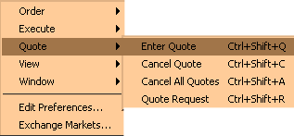
When you select Enter Quote, the Quote Entry window will display. The fields automatically display with the product and series you are trading.
- Enter the bid and ask prices and quantity. If you already have an existing quote, the fields will be automatically filled with your existing quote prices and quantities.
- If you wish to take the market prices for your quote, click Take Mkt. The system will automatically fill the fields with the Mkt Bid and Mkt Ask prices.
- As a default, the system will set the Ask Qty to match the value in the Bid Qty field. If you do not wish to link the quantities, deselect the Link Quantity checkbox.
- Click Submit.
If you decide you do not wish to proceed with the quote, click Exit to close the Quote Entry window.
  - Note: Two users with the same acronym cannot quote the same class. For example,
- User ID1 and user ID2 share the same acronym
- User ID1 is quoting class, IBM. User ID2 tries to quote IBM but the quote is rejected.
- If user ID1 logs off and all quotes are cancelled, user ID2 will be able to quote IBM.
- If user ID1 cancels all his/her quotes, without logging off, user ID2 will be able to quote IBM.
Once you have confirmed your quote, the system submits it for trading. The system displays your quote in your MybP$ (your Bid) and MyaP$ (your Ask) fields, if they are your best bid and offer, and, in the Mktb$ (Bid) and Mkta$ (Ask) fields, if they are the best in the market.

Special Situations | Locked Market  The system will notify participating Market Makers if a quote entry causes a locked market. The notification will be sent immediately after the quote lock occurs and is displayed in the Locked Market Status window. Market Makers will then have n(10) seconds to respond to the locked quote. After the n(10) seconds, the remaining quotes will trade.  Quote Lock Example  MM1 sends quote 1.00 – 1.20 100x100  MM2 sends quote 1.20 – 1.40 200x200  The system will send a locked market notification when MM2 enters his/her quote.  There are a few important things to note about quote locks.  - If a non-Market Maker order comes in and crosses the book, it will be traded immediately against the quotes.  - If a Market Maker updates his/her quote and the updated quote results in a locked market again, a new quote lock will start.  - The quote-locked message will contain the acronyms of the Market Makers involved in the quote lock. It is possible to appear in the list or on both sides if the Market Maker has both I-orders and quotes involved in the lock.

Crossed Quotes
Crossed quote notification is reported by the system in the same manner as locked quotes with the exception that incoming quotes will be widened to create a locked quote, rather than a crossed quote.
Crossed Quote Lock Example
MM1 send quote 1.00 – 1.20 100x100
MM2 sends quote 1.25 – 1.40 200x200
MM2’s quote is widened by the system to 1.20 – 1.40 200x200, creating a locked quote.
Express Trading | Quote Entry  To quickly enter a quote or update an existing quote, click on either the MybP$ (your Bid) or MyaP$ (your Ask) fields of the series you selected. The Quote Entry window will display with the price and quantity fields defaulting to your existing quote.  Adjust values, if necessary. If you wish to link the quantities, click the Link Quantity checkbox. The system will set the MyaQty to match the value in the MybQty field.  Click Submit.  If you decide you do not wish to proceed with the quote, click Exit to close the Quote Entry window.

Update an Existing Quote
When you click on any MybP$ (your Bid) and MyaP$ (your Ask) field on a series, the Quote Entry window will display. The fields automatically display with the product and series selected and the price and quantity values of your outstanding quote, if you have submitted one.
- Change the bid and ask prices and quantities, as needed.
- The new quote will be processed as a cancel/replace of the old quote.
If you decide you do not wish to proceed with the quote, click Exit to close the Quote Entry window.
Depending on how you modify the quote, its position relative to other orders in the book may change as follows:
- If the price is changed (either increased or decreased), the changed side loses position and the order goes behind all orders at the new price.
- If the quantity is decreased, the order retains position.
- If the quantity is increased, the order loses position and goes behind all orders at the same price.
- If only one side's quantity is changed, the unchanged side retains position.
Special Situations | Updating One Side of a Quote  In the case where you have half a quote in the market (the bid or ask has been hit) and you want to keep the remaining side, the system will allow you to replace the missing side of the quote.  In the case where you are updating only one side of a quote, the system will allow you to enter a quote with one side updated and the other side unchanged, and the system will update only the changed side, thus preserving your position for the unchanged side.
Cancel Quote | 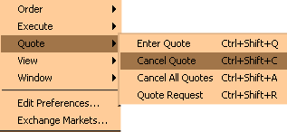
To cancel a quote, highlight the series and select Cancel Quote. The Quote Cancel window will display with the data for your quote. Verify that this is the quote you wish to cancel and click Submit.
The system will delete the buy and sell order pair for the quote as follows.
- If one side of the quote has already been executed, the system will delete the remaining side and notify you that it was too late to cancel the executed side.
- If one or both sides of the quote have been partially executed, the system will cancel the remainder and notify you that it was too late to cancel the filled quantity.
Cancel All Quotes | 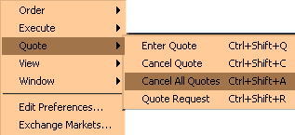
To cancel all quotes you've submitted, highlight any series for a class and select Cancel All Quotes. The Cancel All Quotes window will display with the Current Selected Product Class highlighted.
- To cancel all quotes for the Current Selected Product Class, click CXL.
- To cancel all quotes for several product classes, hold down the [Ctrl] key and highlight each of the classes where you have quotes to be canceled. Click CXL.
- To cancel all quotes for all classes, click Select All. All classes will automatically be highlighted. Click CXL.
- If you do not wish to cancel all quotes, click Exit.
Express Trading | Out of the Market / Inactivate All Quotes  To quickly cancel all of your quotes in all classes, click Out on the Market Display window.  You will be prompted to verify that you wish to cancel all quotes. Click Yes.  Inactivation temporarily removes your quotes from the book without deleting them. The system keeps the orders available for a specified time for "activation" or resubmission to the book without manual re-entry. (Not currently supported)
Request for Quote | 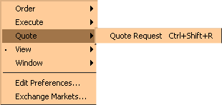
Any user may initiate a Request for Quote (RFQ).
When you select Quote Request, the Quote Request window will display. The fields automatically display with the product and series currently highlighted or selected.
- Enter the quantity (optional).
- Click Submit.
The system will automatically send the RFQ to all Market Makers assigned to that class and to other Market Makers who are required to receive RFQs for that class or who are currently quoting that class.
 Note: The system will send out multiple RFQs (RFQs for a product for which an RFQ is outstanding).
If you decide you do not wish to proceed with the request for quote, click Exit to close the Quote Request window.

Orders

Order functions are entered manually on a selected series in a class. To select a series, click it once to highlight it. The Order Menu can be displayed from the Menu Bar or by right mouse clicking on the series you wish to trade to display the Order Shortcut Menu.
Note: The ability to pass orders from one session to another is not currently supported.
Add New Order | 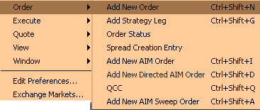
When you select Add New Order, the Add Order window will display. The fields will automatically display with the product and series selected. The fields default to a buy, day order.
- Click the corresponding buttons to change to a sell or good till cancel order.
- Enter the price and quantity of the order by clicking on the up and down arrow counters or by highlighting the price and quantity values and keying over them with new values.
- If you wish to enter the order as a market order, click the Mkt field to fill the checkbox.
- If you are placing a contingency order, select an applicable contingency from the drop down list. For a Stop, Stop LMT, and MIN order, enter the stop price and minimum quantity of the contingency order.
- Update the Account and Details fields as needed.
- Note: The subaccount field is required for Futures and can include up to 10 alphanumeric characters. Firms that do not have subaccounts can enter their account information in this field after confirmation from their clearing firm.
For trade clearing purposes, the Optional Data field should be populated for Market Maker (M origin) and Market Maker Away (N origin) orders. Orders will not be rejected if you leave the field blank. For details, refer to the Add New Order section, page 88.
Firms that want to give one DPM priority in participating in a trade populate the Optional Data field by specifying P:FIRM, FIRM being the CBOE Firm acronym.

- Click Submit. Click Confirm.
- If you decide you do not wish to proceed with the order, click Cancel to close the Add Order window.

Special Situations | Contingency Orders  The market's best bid and best offer quantity fields normally contain only limit orders. In the case where contingency orders are present at the best bid or offer, the system will display:  - aggregate quantity of limit orders, including IOC (immediate or cancel) orders  - aggregate quantity of FOK (fill or kill), AON (all or none) and MIN (minimum) orders  - indicator of more than one FOK, AON, or MIN order  - aggregate quantity of STP (Stop) and Stop Limit (STP Limit)  - smallest quantity of the minimums of the MIN orders, if any  in the format L+C*(M), where  L = quantity of limit orders, including IOC  + = indicates the presence of contingency orders  C = quantity of FOK, AON, and MIN contingency orders  * = indicates there is more than one FOK, AON, or MIN order  M = the smallest minimum of the MIN orders  Because of the preset length of the display field, not all of the characters may be displayed at once. If this occurs, hover the mouse over the field without clicking it. The tool tip function will display the full field information.
Express Trading | Hit the NBBO Bid—Add Sell Order  To Hit the NBBO Bid when CBOE is part of the bid and quickly place a sell order, click on either the NbQty (NBBO Bid Qty) or Nb$ (NBBO Bid Price) fields of the series you wish to trade. The Hit the NBBO Bid window will display with the price and quantity fields defaulting to the NBBO Bid Qty and NBBO Bid Price values. Adjust values, if necessary, indicate whether the order is a day order or an immediate or cancel order, and click Submit. CBOEdirect will submit the order to the CBOE based on the NBBO price.

Take the NBBO Offer—Add Buy Order
To Take the NBBO Offer when CBOE is part of the offer and quickly place a buy order, click on either the NaQty (NBBO Ask Qty) or Na$ (NBBO Ask Price) fields of the series you wish to trade. The Take the NBBO Offer window will display with the price and quantity fields defaulting to the NBBO Ask Qty and NBBO Ask Price values. Adjust values, if necessary, indicate whether the order is a day order or an immediate or cancel order, and click Submit. CBOEdirect will submit the order to the CBOE based on the NBBO price.
 | If you decide you do not wish to proceed with the order, click Cancel to close the window.

Express Trading | Hit the Bid—Add Sell Order  To Hit the Bid and quickly place a sell order, click on either the MktbQty (Mkt Bid Qty) or Mktb$ (Mkt Bid Price) fields of the series you wish to trade. The Hit the Bid window will display with the price and quantity fields defaulting to the Mkt Bid Qty and Mkt Bid Price values. Adjust values, if necessary, indicate whether the order is a day order or an immediate or cancel order, and click Submit.  If you change the price or quantity of the order, the following results will occur if the bid is available for trading:
 | Price | Quantity | Results
 | Same | Same | Full execution of bid order at bid price
 | Same | Lower | Partial execution of bid order at bid price
 | Same | Higher | Full execution of bid order at bid price and book new order to sell at bid price with remaining quantity
 | Lower | Same | Full execution of bid order at bid price
 | Lower | Lower | Partial execution of bid order at bid price
 | Lower | Higher | Full execution of bid order at bid price and new order to sell with remaining quantity that could either execute against lower bid orders, if any, or be booked
 | Higher | Any | No execution, book new order to sell
 | If the bid is no longer available for trading, the system will book the full order as a day or IOC order.

Take the Offer—Add Buy Order
To take the Offer and quickly place a buy order, click on either the MktaQty (Mkt Ask Qty) or Mkta$ (Mkt Ask Price) fields of the series you wish to trade. The Take the Offer window will display with the price and quantity fields defaulting to the Mkt Ask Qty and Mkt Ask Price values. Adjust values, if necessary, indicate whether the order is a day order or an immediate or cancel order, and click BUY.
If you change the price or quantity of the order, the following results will occur if the offer is available for trading:
 | Price | Quantity | Results
 | Same | Same | Full execution of offer order at offer price
 | Same | Lower | Partial execution of offer order at offer price
 | Same | Higher | Full execution of offer order at offer price and book new order to buy at offer price with remaining quantity
 | Higher | Same | Full execution of offer order at offer price
 | Higher | Lower | Partial execution of offer order at offer price
 | Higher | Higher | Full execution of offer order at offer price and new order to buy with remaining quantity that could either execute against higher offer orders, if any, or be booked
 | Lower | Any | No execution, book new order to buy
If the offer is no longer available for trading, the system will book the full order as a day or IOC order.
If you decide you do not wish to proceed with the order, click Cancel to close the window.

Enter a Qualified Contingent Cross Order | 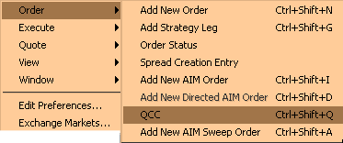
 | Qualified contingent cross orders can be entered through the Order menu. Select QCC from the Order menu, the Enter Qualified Contingent Cross Order window will display. The fields will automatically display with the product and series selected. The fields default to a buy, day order for the Primary order and sell, day order for the Matched order.
- Click the corresponding buttons to change to a sell/buy or good till cancel order.
- Enter the price and quantity of the Primary order by clicking on the up and down arrow counters or highlighting the price and quantity values and keying over them with new values.
- If you wish to enter the order as a market or cabinet order, click the Mkt or Cab field to fill the checkbox.
- If you are placing a contingency order, select an applicable contingency from the drop down list. For a Stop, Stop LMT, and MIN order, enter the stop price and minimum quantity of the contingency order.
- Select the Match Order Type from the drop down list.
- Enter the Branch ID.
- Update the Account and Details fields as needed.

- Note: The subaccount field is required for Futures and can include up to 10 alphanumeric characters. Firms that do not have subaccounts can enter their account information in this field after confirmation from their clearing firm.
Optional Data:
Enter A:AIQ as the first characters in the primary order to instruct CBOE to treat the paired orders as Qualified Contingent Trade orders.
Firms that want to give one DPM priority in participating in a trade populate the Optional Data field by specifying P:FIRM, FIRM being the CBOE Firm acronym.
- Follow the above steps to populate the fields for the Matched Order.
- Click Submit. Click Confirm. The order will appear in the Auction Display window for a configurable amount of time to allow Traders to participate in the auction.
- If you decide you do not wish to proceed with the order, click Cancel to close the order window.
Enter a Cross Order | 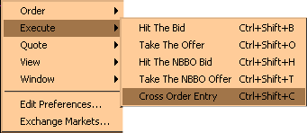
A Cross order contains two order sides (a buy and a sell). Two Cross orders can be submitted at the same time through the Cross Order entry window. To enter a Cross order, select Cross Order Entry from the Execute menu.
- Note: Cross product spread orders (one leg is Stock and other leg is Option; or one leg is Option of a certain underlying and other leg is Option of a different underlying) are not accepted.

- Select the trading session from the Trading Session drop down list.
- Select the Product Type, Product Class and Product from the corresponding drop down lists.
- From the Buyer tab:
- Enter the Buy Side Price and Quantity.
- Select the type of Cross order from the Contingency drop down list.
- Note: The contingency must be the same for both the Buy side and Sell side of the cross order.
- Update the Account and Details fields as needed.
- From the Seller tab, update the Sell Side of the order.
- Note: The contingency must be the same for both the Buy side and Sell side of the cross order.
- Click Submit. Click Confirm.
- If you decide you do not wish to proceed with the order, click Cancel to close the Add Order window.
Order  and Quote Status | 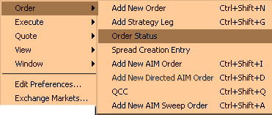
You can display the status of your orders by selecting Order Status from the Order Menu. A separate Order Status window will open.
The Order Status window will maintain ongoing status of all of your working orders as well as orders completely filled or cancelled. This window can remain open during further trading or click the  button in the upper right corner to close.
➢ | Update  To update order information for an unfilled order, highlight the order and select Update. The Update Order window will display.
➢ | Cancel  To cancel an unfilled portion of an order, highlight the order and select Cancel. The Cancel Order window will display. Adjust the quantity that you wish to cancel and click Submit.
➢ | Cancel Replace  To cancel an unfilled order and replace it with a new order, highlight the order to be canceled and click Cancel/Replace. The Cancel Replace Order window will display. Enter the new order information for the series and click Submit.
➢ | Order History  To display the history for an order, highlight the order and select Order History. The Order History window will display.
➢ | Edit Preferences  To edit preferences for an order or quote, highlight the order or quote and select Edit Preferences. The Edit Preferences window will display.

Viewing Status

 | Trading activity status can be viewed at any time during an open trading session. Each of the functions opens a separate activity window. Multiple activity windows can be opened during a trading session. To access an activity status function, display the Window Menu from the Menu Bar or right mouse click on any series in your Current Selected Product Class.
 | 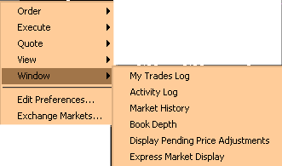
My Trades Log | To view your trades, highlight a series on the Market display window and select My Trades Log from the View Menu. The Trades Log window will open for the selected series. The window will automatically update as orders are executed.  - You can change the display to view any or all classes and/or series by clicking the Class/Product Selection button and selecting the items from the list boxes.  - Trades are listed by date/time stamp from the most recent to the earliest trade in the current trading session.
Activity Log | To view the activity log, highlight a series on the Market display window and select Activity Log from the View Menu. The Activity Log window will display for the Current Selected Product Class.  - Set the date and time selection fields to the point when you wish to begin viewing activity. Click Submit.  - You can change the display to view a different product type or class by clicking the Class/Product Selection button and selecting the items from the list boxes.  - Select the product and activity you wish to view from the list boxes. The display will refresh for the currently selected product and activity.
Market History | To view the chronological list of quotes and trades disseminated to the internal network during the trading day for a selected product, select Market History from the View Menu. The Market History window will open for the Current Selected Product Class and series.  - Based on your enablements setup, you have the ability to view market history details.  - You can change the display to view another class and/or series by selecting the Trading Session, Product Type, Product Class and Product from the Query section of the window.  - The date and time fields default to the current date and time. Update as desired.  - The display defaults to both quotes and trades. Quotes and trades are listed by date/time stamp from the most recent to the earliest trade in the current trading session.  - Click Submit to update selection criteria and refresh the display.
Book Depth | To view the book depth, highlight a series on the Market Display window and select Book Depth from the View Menu. The Book Depth window will open for the Current Selected Product Class and series. Real-time updates are provided for the first five levels of market depth.  - You can change the display to view another class and/or series by selecting the items from the list boxes.  - To obtain the most current data, click Refresh.
Display Pending Price Adjustments | For orders that do not get filled the same day they're placed, you may wish to review pending price adjustments as a result of stock splits, dividends, etc.  Select Display Pending Price Adjustments from the View menu. The Pending Price Adjustments window will open. At this window, you can view:  - order submit date and price adjustment effective date  - outstanding order quantity and new price effect each outstanding order for each of your Current Selected Product Classes.
Express Market Display | To monitor market data for a specific product, highlight the series on the Market Display window and select Express Market Display from the View Menu. The Express Market Display window will appear. From this window, you can view current market data, recap/last sale information and ticker data for the selected product.

Closing a Trading Session

 | You can close down all or part of your trading activity at any time during the day. You can get out of the market, yet remain on-line, or you can end your trading session by logging out and exiting the system.
Get Out of the Market | If you wish to get out of the market immediately, click the Out button on the Market Display window or press [Alt]-[T] from anywhere on the window. You will be prompted to verify that you wish to cancel all quotes. Click Yes. The system will immediately cancel all quotes.  You can then log out of the trading session and exit the system.
Logout | To log out of the trading system, select Logout from the Session Information toolbar. You will be prompted to verify that you wish to close all windows, cancel all quotes, and logout. Click Yes.
Exit the System | To exit the CBOEdirect screen-based trading system, select Exit from the Start Menu You will be prompted to verify that you wish to close all windows, cancel all quotes, and logout. Click Yes. The application will be closed and you will be returned to your system desktop.

◻ | Section 2:  Detailed Reference Guide

Task Toolbar

When you log into the CBOEdirect Screen-Based Trading application, The Open Tasks toolbar will display on the CBOEdirect window. From this window you can open tasks, view session information and perform window controls.
The Start Menu, which is executed from the toolbar, will be addressed in the Start Menu section (Start Menu, page 50) of the Reference Guide.
Note: The toolbar remains active during the trading session.
About CBOEdirect | To display system information about CBOEdirect, click . The About window will display.
 | 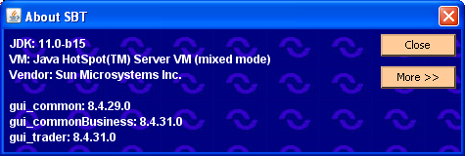
To view specific configuration information, click More. Detailed system information will display.
To exit the window, click Close.
Open Tasks | Initially, the Open Tasks toolbar will be empty. For each window you create, a task button will appear on the toolbar. From the task button, you can resize or change the configuration name of each window.  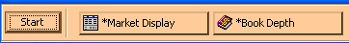  To resize the window or to change the default configuration name, click on the window task button. The active window will display. Right mouse click on the task button for the corresponding window. The resize and configuration menu will display.  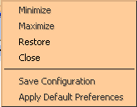
➢ | Resize  To resize a window:  - Highlight the resize choice or  - Hold down the [Alt] key and press the character of the underlined letter in the command.
➢ | Saving the Configuration for Windows Other Than the Market Display  CBOEdirect allows you to retain window configurations. Most of the CBOEdirect window configurations can be saved using the Book Depth example below. Saving the configuration for the Market Display window is explained in the next section.  To save the configuration for a Book Depth window:  - Right mouse click on the window’s task button and select Save Configuration. The Save Configuration window will display.  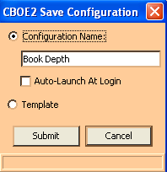  - Select the Configuration Name radio button. The text box displays in editable format.  - Enter the configuration name for the Book Depth window. In the example above, the Book Depth window name will be changed to “Book Depth RTH”.  - To submit your configuration without setting a template, click Submit. Click Confirm. The system will save the configuration for the window and the task button will display with the new Book Depth configuration name.  - To set this configuration to be the default configuration for all Book Depth windows, select the Template radio button. Click Submit. Click Confirm.  - If you decide not to change the default configuration, click Cancel instead of Submit.
➢ | Apply Default Preferences  CBOEdirect allows you to apply a default preference template to a window that has been already created.  For example, if you previously saved the configuration for a Book Depth window, right mouse click on the new Book Depth window task button and select Apply Default Preferences. The Book Depth window settings will be changed to the default preferences for all Book Depth windows.
➢ | Saving the Configuration for a Market Display Window  To save the configuration for a Market Display window:  - Right mouse click on the Market Display window task button and select Save Configuration. The Save Configuration window will display.  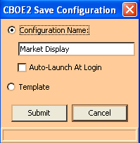  - Select the Configuration Name radio button. The text box displays in editable format.  - Enter the configuration name for the Market Display window. In the example above, the Market Display window name will be changed to “Market Display RTH”.  - To submit your configuration without changing the template settings, click Submit. Click Confirm. The system will save your configuration and the task button will display with the new Market Display configuration name.  - If you decide not to change the default configuration, click Cancel instead of Submit.
To save window and table preferences for the Market Display:
- Select the Template radio button. Choices for default table preferences will display.
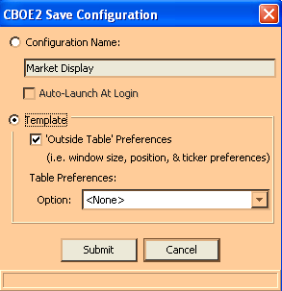
- To save the window size, position and ticker preferences, select the ‘Outside Table’ Preferences check box.
- You can save table (column, row, etc.) preferences for a type of product that has been defined in the Market Display window. In the example above, Future and Options products have been defined.
- From the Future drop down list, the settings for HOB have been selected as the table preferences for Futures.
- Option product table preferences will not be saved, therefore, the Table Preferences selection is set to <None> from the Option drop down list.
- If you are satisfied with your choices, click Submit. Click Confirm. Your preferences will be saved and the task button will display with the new Market Display window name. New Future products that are created on the Market Display will display with the saved table preferences.
- If you decide not to change the default configuration name, click Cancel instead of Submit.
Session Information | From the Open Tasks toolbar, click the button to display the Session Information toolbar.
 | From this toolbar, you can view your user name and Id, role and session information. You also have the ability to logout of the system or to change your password.
➢ | Logout  To logout of the trading system, click Logout. You will be prompted to verify that you wish to close all windows, cancel all quotes, and logout. Click Yes. If you do not wish to logout of the system, click No.
➢ | Change Password  To change your password, click Change Password. The Change Password window will display.  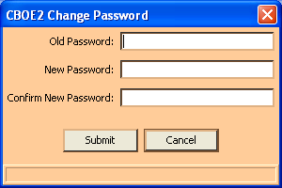
Enter your Old Password. Enter and confirm your New Password. Click Submit. Click Confirm.
If you decide not to change your password, click Cancel.
Main Window Settings | The system allows you to save your window preferences. From the Session Information toolbar, click the button. The Main Window Settings toolbar will display.
 | From this window you can save your window preferences. Click Save Preferences. The system will store your window configuration.
Window Control | The system allows you to organize your Market Display windows. From the Main Window Settings toolbar, click the button. The Window Control toolbar will display.
You have the ability to minimize, restore, cascade or close your Market Display windows.
- To minimize all your Market Display windows, click Minimize All or hold down the [Alt] key and press "M" on your keyboard.
- To restore all your Market Display windows, click Restore All or hold down the [Alt] key and press "R" on your keyboard.
- To cascade all your Market Display windows, click Cascade All or hold down the [Alt] key and press "D" on your keyboard.
- To close all your Market Display windows, click Close All or hold down the [Alt] key and press "C" on your keyboard.

Start Menu

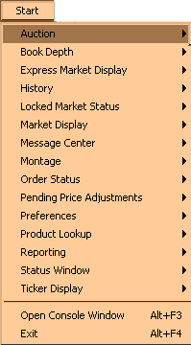 | The Start Menu allows you to quickly create new windows for various CBOEdirect functions.  To display the Start Menu:  - Click the Start button on the CBOEdirect Screen-Based Trading window or  - Press [Alt]-[S] from anywhere on the window.  The Start choices will display. If a menu option is unavailable, it will display grayed out and no action will take place when the option is selected.
Book Depth | Select Book Depth from the Start Menu, and then highlight Create New Window to open a new Book Depth window.
 | 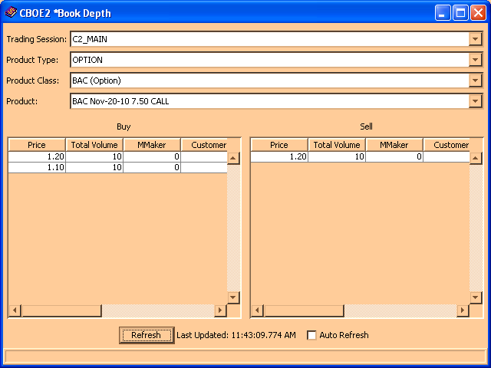
At first, the window will be blank. Select the trading session, product type, class and series you wish to display. Click Submit. CBOEdirect will display the aggregate orders in the book at various price levels at the time of the Book Depth request. The Total Volume column displays the total volume of contracts at a price level. The Limit, AON, FOK and IOC columns display the portion of the volume that comes from contingency orders.

- Real-time updates are provided for the first five levels of market depth. To obtain updated book depth data, click Refresh.
- To have the window refresh automatically, click the Auto Refresh check box.

Edit Column Preferences
You can customize your Book Depth window by selecting or deselecting specific columns to display. To filter columns, right mouse click on a data row. Select Edit Preferences. The Edit Column Preferences window will display.
- Select or deselect columns for viewing and modify column arrangement as desired.
- To save your changes, click Ok.
- If you wish to retain the default settings, click Cancel.
For instructions on screen customization, refer to the Customize Market Display, page 21.
 | - Note: Multiple Book Depth windows can be created during a trading session. Each Book Depth window configuration can be saved using the Task Toolbar. For detailed information, see the Task Toolbar section (Task Toolbar, page 45) of the Reference Guide.
Express Market Display | The Express Market Display is CBOE’s market data feed that supports the reporting of quotes, trades, and other information for options, stocks and futures. If your user enablements are setup for express market data, you will be able to monitor market data for a specific product.  To open the Express Market Display window, select Express Market Display, Create New Window from the Start Menu.
 | 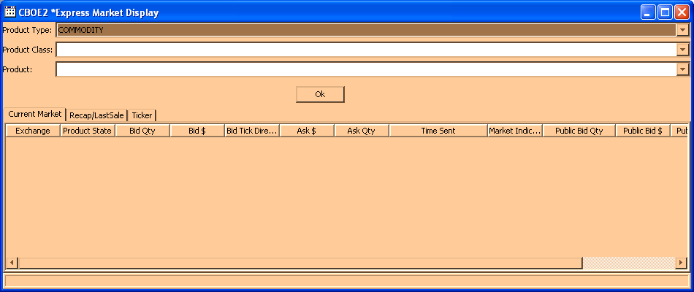
- Initially the window will be blank. Select the Product Type, Product Class and Product from the drop down lists.
- Click OK. Current market, recap/last sale and ticker information will display for the selected product.

 | The Current Market tab displays the bid/ask price and quantity, the state of the product and public bid/ask information.
 | 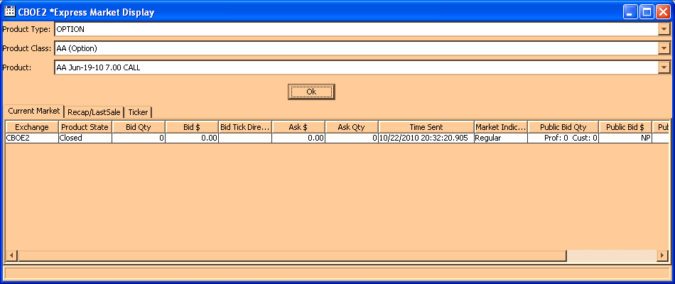
 | The Recap/Last Sale tab shows the opening price, the high and low prices for the product and last sale information.
 | 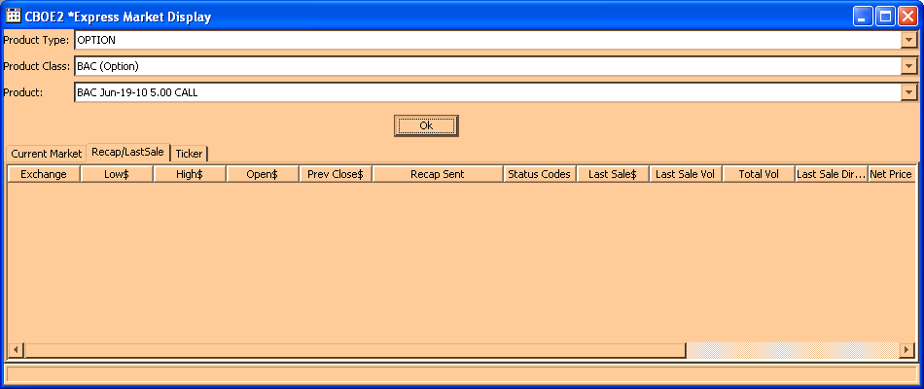
 | Click on the Ticker tab to display trade information.
 | 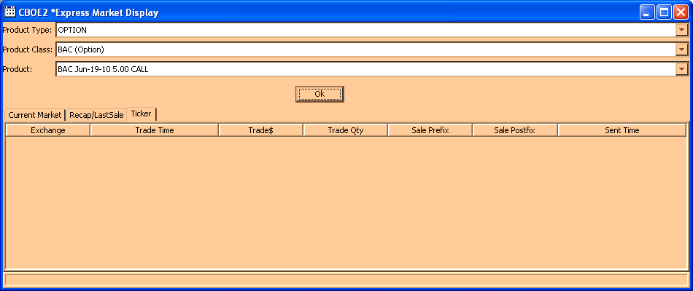
 | - Note: Multiple Express Market Display windows can be created during a trading session. Each window configuration can be saved using the Task Toolbar. For detailed information, see the Task Toolbar section (Task Toolbar, page 45) of the Reference Guide.

Edit Column Preferences
You can customize your Express Market Display window by selecting or deselecting specific columns to display. To filter columns, right mouse click on a data row. Select Edit Preferences. The Edit Column Preferences window will display.
- Select or deselect columns for viewing and modify column arrangement as desired.
- To save your changes, click Ok.
- If you wish to retain the default settings, click Cancel.
For instructions on screen customization, refer to the Customize Market Display, page 21.
History  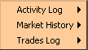 | The History option on the Start Menu gives you three ways to view trading information; Activity Log, Market History and Trades Log.

Activity Log
To view the Activity Log, select History from the Start Menu. From the sub-menu select Activity Log, Create New Window. The Activity Log window will display.
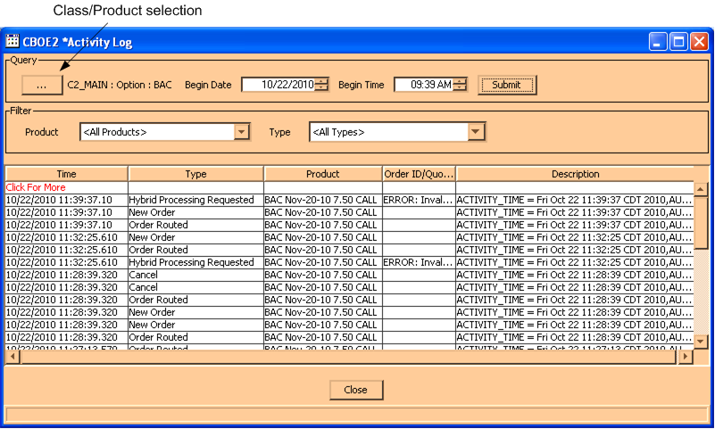

Initially, the window will be blank. To select the trading session, product type and product class you wish to display, click the Class/Product Selection button in the Query section of the window. The Class/Product Selection window will display.
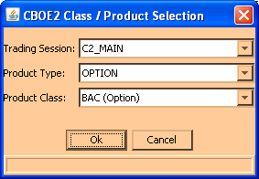

- Select the Trading Session, Product Type and Product Class from the drop down lists. Click Ok.
- The date field defaults to the current date. Click the up/down arrows to select the desired date.
- The time field defaults to the current time. Update as desired. Click Submit.
- The system defaults to query for all products and all types for the selected product class. If you wish to filter the product class activity by a specific product or activity type, select the product or type from the box lists in the Filter section of the window.
- All activity for the selected product class will display from the most recent to the earliest trade set by the date/time selection.
- Click Close to exit the display.

Edit Column Preferences
You can customize your Activity Log window by selecting or deselecting specific columns to display. To filter columns, right mouse click on a data row. Select Edit Preferences. The Edit Column Preferences window will display.
- Select or deselect columns for viewing and modify column arrangement as desired.
- To save your changes, click Ok.
- If you wish to retain the default settings, click Cancel.
For instructions on screen customization, refer to the Customize Market Display, page 21.
 | - Note: Multiple Activity Log windows can be created during a trading session. You can save the configuration of each window from the Task Toolbar. For detailed information, see the Task Toolbar section (Task Toolbar, page 45) of the Reference Guide.

Market History
To create a new Market History window, select History from the Start Menu, and then select Market History, Create New Window. A blank Market History window will display.
If your user enablements are set to the system default, your Market History window will only display the Time, Type, Price, Prefix, Quantity and Underlying columns (see below for a description of each column and its value).
 | 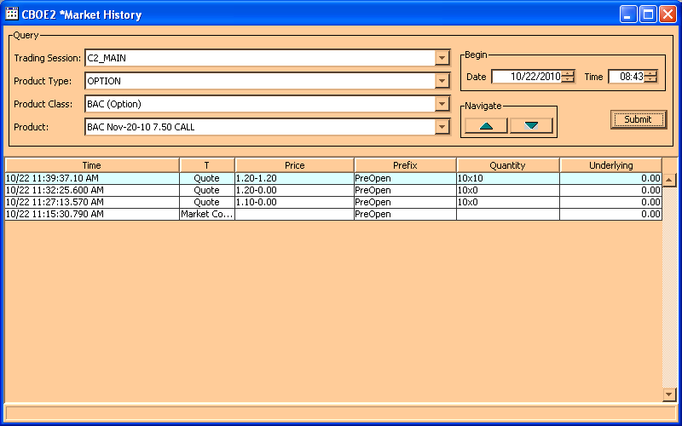
To query by product:
- From the Product tab, select the trading session, product type, product class, and product to display.
- The date/time fields default to the current date and time. Click the up and down arrows to select the desired date and time for the query.
- Click Submit.
- The default Market History window displays quotes, trades and various market conditions. Quotes and trades are listed by date/time stamp from the most recent to the earliest trade in the current trading session.
- To scroll through the display, click the up/down arrows .
- Click Submit to update selection criteria and refresh display.
- Click Close to exit the display.

Place your cursor over the column headings for complete column names.
See below for a description of the data represented in each column.
Column Name | Description | Values
Time | Date and time the event occurred | 3/22 08:26:00.900AM
T | “Type” of event | Quote = ‘Q’  Trade (Last Sale) = ‘L’  Market Condition (Product State) = ‘M’  EOP = ‘E’
Price | Bid and Ask price of the quote or trade | 1.20-1.40
Prefix | The state of the product | Closed  PreOpen  Opening Rotation  Open  Halted  Fast Market  No Session  On Hold  Ending Hold  Suspended  FTAO = First Trade At Open
Quantity | Quantity for the Bid and Ask | 13x3
BKR | The acronym of the Broker involved in the transaction | BAC  XXH = Unknown Broker (i.e. more than 15 Brokers)
CBK | The acronym of the Contr Broker involved in the transaction | ABC  XXH = Unknown Broker (i.e. more than 15 Brokers)
E | Override indicator – last sale from TPF | Linkage = ‘L’  Book Override = ‘B’  Offer Override = ‘O’  Supervisory Override = ‘X’ or ‘S’
Underlying | The underlying price of the product. This information comes from TIPS | 38.00
BidEx | The Exchange representing the NBBO Bid price. There can be more than one Exchange at the NBBO Bid price. | CBOE = ‘C’  AMEX = ‘A’  PSE = ‘P’  PHLX = ‘X’  BSE = ‘B’  ISE = ‘I’

Column Name | Description | Values
NBBid | NBBO Bid price | 1.20
NBAsk | NBBO Ask price | 1.40
AskEx | The Exchange representing the NBBO Ask price. There can be more than one Exchange at the NBBO Ask price. | CBOE = ‘C’  AMEX = ‘A’  PSE = ‘P’  PHLX = ‘X’  BSE = ‘B’  ISE = ‘I’
TT | “Trade Through” indicator – indicates a trade through occurred at an away market | A checkbox is marked when a trade through occurred at an away market.
C A P X B I | Exchange Indicator  CBOE = ‘C’  AMEX = ‘A’  PSE = ‘P’  PHLX = ‘X’  BSE = ‘B’  ISE = ‘I’ | Clear = ‘ ‘  Halted = ‘H’  Fast Market = ‘F’  Opening Rotation = ‘O’  Data not received from Exchange = ‘?’
IP Address | Internet Protocol address of the TNT | 123.555.66.234

Print Market Data History Table
To print the Market Data History table, right mouse click on a data row and select Print Table.
 | 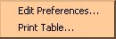
Select the desired printer and page setup. Click Print.
To cancel the print request, click Cancel.

Edit Column Preferences
You can customize your Market History window by selecting or deselecting specific columns to display. To filter columns, right mouse click on a data row. Select Edit Preferences. The Edit Column Preferences window will display.
- Select or deselect columns for viewing and modify column arrangement as desired.
- To save your changes, click Ok.
- If you wish to retain the default settings, click Cancel.
For instructions on screen customization, refer to the Customize Market Display section, page 21.
 | - Note: Multiple Market History windows can be created during a trading session. Each window configuration can be saved using the Task Toolbar. For detailed information, see the Task Toolbar section (Task Toolbar, page 45) of the Reference Guide.

Trades Log
To create a new Trades Log window, select History from the Start Menu, and then select Trades Log, Create New Window. The Trades Log window will display.
 | 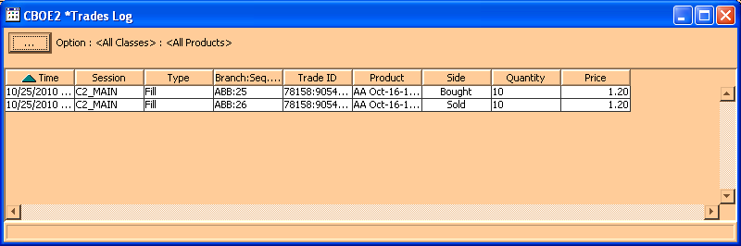
 | Initially, the window will be blank. Click the Class/Product Selection button to select the product type, class and series you wish to display. Click Ok.
 | 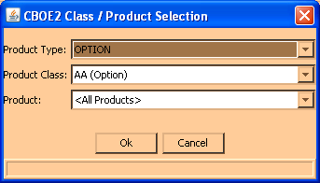
 | Trades are listed by date/time stamp from the most recent to the earliest trade in the current trading session.

Edit Column Preferences
You can customize your Trades Log window by selecting or deselecting specific columns to display. To filter columns, right mouse click on a data row. Select Edit Preferences. The Edit Column Preferences window will display.
- Select or deselect columns for viewing and modify column arrangement as desired.
- To save your changes, click Ok.
- If you wish to retain the default settings, click Cancel.
For instructions on screen customization, refer to the Customize Market Display section, page 21.
 | - Note: You can create multiple Trades Log windows during a trading session. Each window configuration can be saved using the Task Toolbar. For detailed information, see the Task Toolbar section (Task Toolbar, page 45) of the Reference Guide.
Locked Market Status | CBOEdirect provides a locked market notification when two or more In-crowd Market Makers participate in a locked quote/order scenario. The locked market notification is displayed in the Locked Market Status window.  From the Start Menu, select Locked Market Status, and then select Create New Window. The Locked Market Status window will display with the locked quote/order information.  This window can remain open during your trading session.
 | 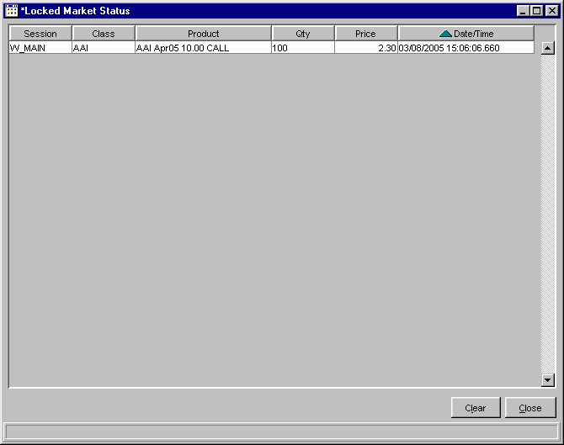
The system will notify the participating Market Makers immediately after the market lock occurs. Locked quotes/orders display in this window for n (10) seconds. Market Makers have n (10) seconds to remove the lock. After n (10) seconds, any remaining locked quotes/orders will trade.
To clear the locked quote information, click Clear.
To close the window, click Close.
 | - Note: Multiple Locked Market Status windows can be created during a trading session. Each Locked Market Status window configuration can be saved using the Task Toolbar. For detailed information, see the Task Toolbar section (Task Toolbar, page 45) of the Reference Guide.
Market Display | Select Market Display from the Start Menu, and then highlight Create New Market Display to open a new trading window.
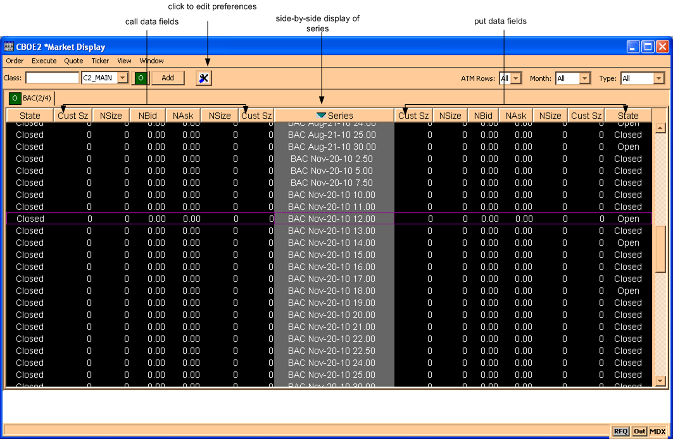
CBOEdirect allows you to open—and trade from—only one Market Display window. Only three class tabs are allowed on the Market Display. Any preferences you set up will apply to the open Market Display window during your trading session.
Refer to Section 1 (Market Display Window, page 16) in this guide for a description of the fields on the Market Display window and instructions for customizing it for your use.
Message Center | If you need to send a message to the CBOEdirect Help Desk, click Message Center and highlight, Message Center. A Message Center window will display.
 | 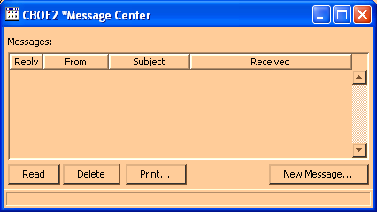
From this window, you can view, reply, delete and print your messages.
To send a new message to the Help Desk representative, click New Message. The New Message window will display.
 | 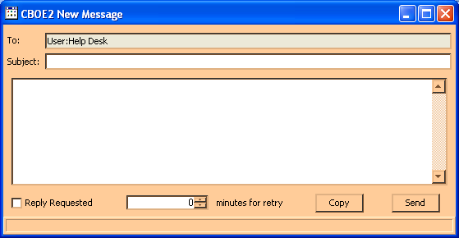
 | Enter the Subject and the text of your message. Click Send. The email will be automatically routed to the Help Desk representative. To copy your message to the clipboard, click Copy. If you would like the Help Desk to reply to your message, select the Reply Requested checkbox.
 | - Note: Multiple Message Center windows can be created during a trading session.
Montage | CBOEdirect links to several major U.S Stock Exchanges for the purpose of choosing the best market.  From the Start Menu, click Montage, Create New Window. The Montage window will display.
 | 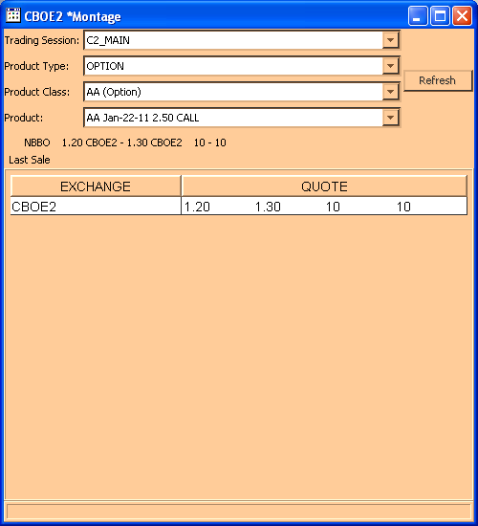
 | The example above displays the NBBO for option class DELL, series DLQ Jul08 22.00 CALL.
Order Status | You can create a new Order Status window from the Start Menu. Select Order Status, Create New Window. A blank Order Status Window will display.
 | 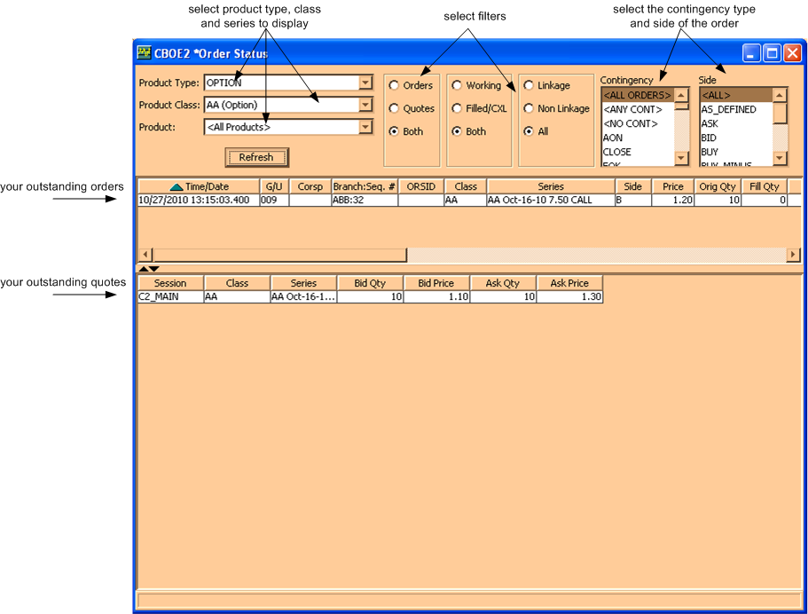
At this window you can view orders and/or quotes, buy and/or sell orders, Linkage and/or Non-Linkage orders and working and/or completely filled/cancelled orders. Select the product type, class and series you wish to view from the list boxes. Select the appropriate radio buttons, and then click Refresh.
- Note: Currently, Linkage and Non-Linkage filters apply to equity trading only.
To update order information, refer to the Order Status window in the Order Menu section, page 90.

Edit Column Preferences
You can customize your Order Status window by selecting or deselecting specific columns to display. To filter columns, right mouse click on a data row. Select Edit Preferences. The Edit Column Preferences window will display.
- Select or deselect columns for viewing and modify column arrangement as desired.
- To save your changes, click Ok.
- If you wish to retain the default settings, click Cancel.
For instructions on screen customization, refer to the Customize Market Display, page 21.
 | - Note: Multiple Order Status windows can be created during a trading session. Each window configuration can be saved using the Task Toolbar. For detailed information, see the Task Toolbar section (Task Toolbar, page 45) of the Reference Guide.
Pending Price Adjustment | Price adjustments on orders are caused by changes in the underlying security, such as stock splits, stock dividends, etc.  To view the effects of pending price adjustments on your outstanding orders:  Highlight Pending Price Adjustments, Create New Window. The Pending Price Adjustment window will open.
 | 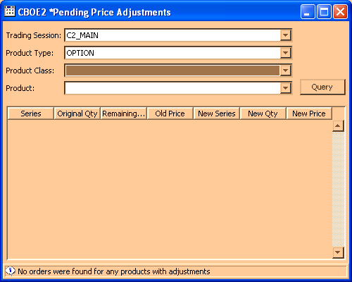
Select the trading session, product type, product class and product from the drop down lists. Click Query. For the selected product, you can view:
- original and new series
- original and new quantity
- remaining and new quantity
- old and new price
Pending RFQs | You can view pending RFQs for all products for which you are assigned by selecting Pending RFQ from the Start Menu, then selecting Create New Window.
 | 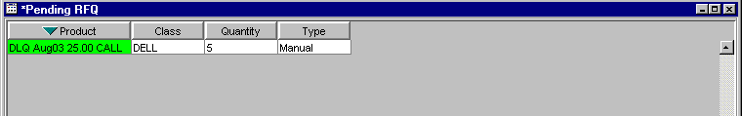
 | RFQs display on this window for n (30) seconds. The RFQ will display in green for the first n (10) seconds; in yellow for the second n (10) seconds; then in red for the last n (10) seconds. After n (30) seconds, the RFQ will disappear from the window.
 | 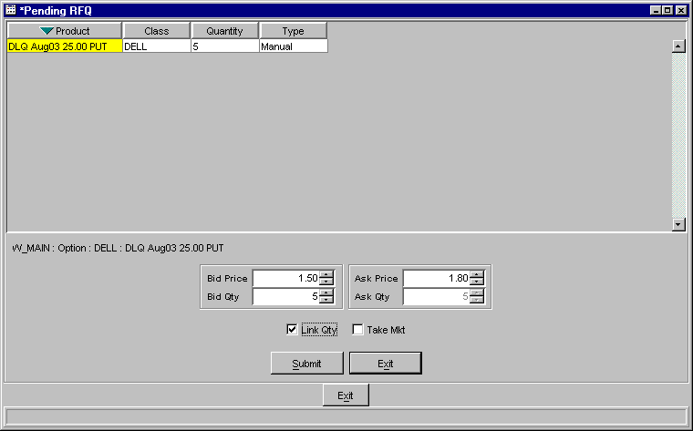
- If an RFQ is pending, you can respond to the RFQ by clicking on it. The Quote Entry window will display at the bottom of the Pending RFQ window.
- Enter quote information and click Submit to send the quote. (See Enter Quote, page 101 in the Quote Section of the Reference Guide).
- If you decide you do not wish to proceed with the quote, click Exit to close the Quote Entry window.
Preferences | The system gives you the ability to tailor your trading sessions to your trading style by setting session defaults for quotes and orders.  Multiple preference windows can be created during a trading session.
 | 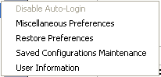 | From the Start Menu, select Preferences, and then highlight the option you want to display. Values set using these functions will become the default values for new trades and trading sessions.

➢ | Miscellaneous Preferences  From the Class tab, this window enables you to set order and execution defaults for all classes or specific classes.  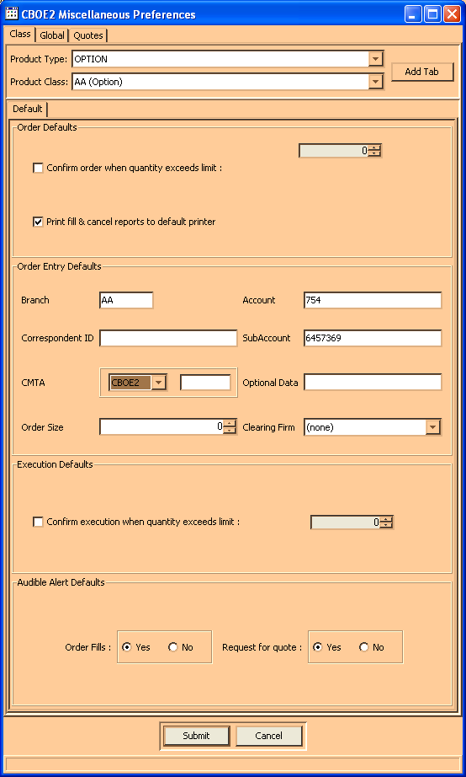
- To set defaults for all orders:
- To set an order size confirmation default, fill the checkbox and enter the order size limit for confirmations.
- If you want fill reports to print, fill the checkbox.
- To set order entry default information enter:
- Branch
- Account - this field is the OCC-recognized account ID and is limited to three characters.
- Correspondent ID
- Subaccount - this field is required for Futures and is limited to ten characters.
- CMTA
- Order size
- Optional data - For trade clearing purposes, the Optional Data field should be populated for Market Maker (M origin) and Market Maker Away (N origin) orders. Orders will not be rejected if you leave the field blank. For details, refer to the Add New Order section, page 88.
- To set an execution (hit the bid or take the offer) confirmation default, fill the checkbox and enter the order size limit for confirmations.
- To set audible alerts:
- If you would like the system to audibly prompt you for order fills, cross notification, or RFQs, select the appropriate radio buttons.
- CBOEdirect currently allows users to display only one Market Display window and a maximum of three class tabs within the window. If you wish to display only one class tab during your trading session, deselect the Multiple Class Tabs checkbox.
- Note: If your trading session is configured to display multiple class tabs and you decide to switch to single tab format during the trading session, the current class tabs will remain in the window until you attempt to add a new class. At that time, the system will remove the class tabs from the window.
- To set order defaults for a specific class:
- Select the product type from the drop down list.
- Select the class from the drop down list, click Add Tab.
- Follow the steps above for setting default values.
When you have set or updated your order defaults, click Submit. You will be prompted to confirm. Click Confirm. Your preferences will be saved immediately.
If you wish to close the window without saving your settings or changes, click Cancel.

➢ | Global Preferences  From the Global tab, you can set your order sequence number, choose how to view your Market Display and order windows and elect to receive pop-up notifications for text messages.
 | 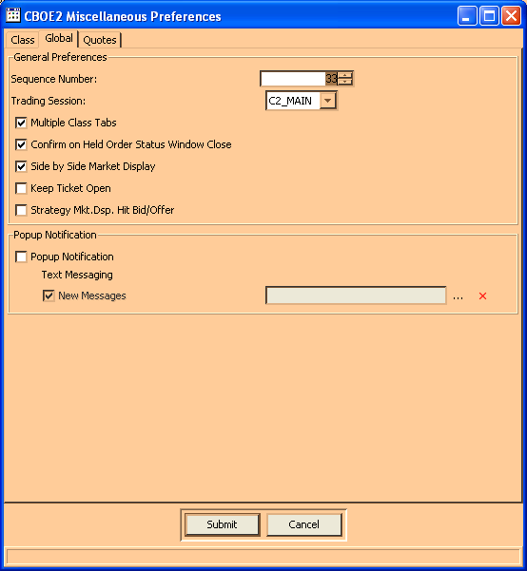
To set the sequence number for order entry:
- Enter the desired number in the Sequence Number box.
- The number you set is saved as the next increment to use for order entry. This is a global setting for all classes.
- The sequence number automatically increments by one for each order submitted.
- The sequence number you set cannot be a previously used number.
To display more than one tab on your Market Display window, select the Multiple Class Tabs checkbox.
- The checkbox to Confirm on Held Order Status Window is not currently supported.
- From the Popup Notification section of the window, click on the Popup Notification and New Messages checkboxes to receive announcement that a new text message has arrived.

➢ | Quote Preferences  The Quotes tab enables you to set defaults for all quotes or quotes for specific classes.  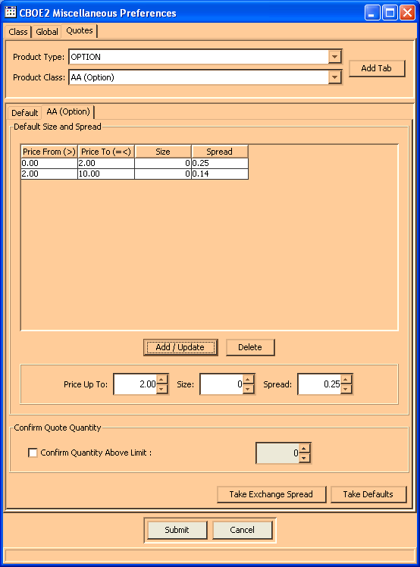
- Set defaults for all quotes:
- To add a setting, enter the price, size, and spread values. Click Add/Update.
- To change a setting, highlight the setting, update the price, size, and/or spread values. Click Add/Update.
- To delete a setting, highlight the setting, click Delete.
- To set the system to prompt you for a quote size confirmation, fill the checkbox and enter the quote limit for confirmations.
- To set quote defaults for a specific class:
- Select the product type from the drop down list.
- Select the class from the drop down list, click Add Tab.
- Follow the steps above for setting default values. If you wish to use your global defaults as the basis for these settings, click Take Defaults. The fields will fill with your default values.
- To take the exchange spread as your default, click Take Exchange Spread. The fields will fill with the default size and spread values.
- To change a setting, highlight the setting, update the price, size, and/or spread values. Click Add/Update.
When you have set or updated your quote defaults, click Submit. You will be prompted to confirm. Click Confirm. Your preferences will be saved immediately.
If you wish to close the window without saving your settings or changes, click Cancel.

➢ | Restore Preferences  The Restore Preferences option allows you to reinstate your previous Business and GUI configuration. From the Preferences menu, select Restore Preferences. The Restore Configuration window will display.  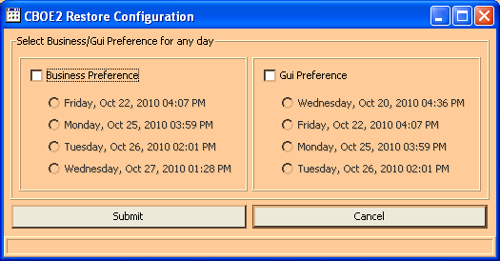
- To restore your business preferences, select the Business Preference checkbox. Click Submit, Confirm. Your business preferences will be restored.
- To restore your GUI preferences, click on the GUI Preference checkbox. Click Submit, Confirm. Your GUI preferences will be restored.
- Click Cancel to withdrawal your restore configuration request.

➢ | Configuration Maintenance  Window configurations from previous versions of CBOEdirect are saved in the Saved Configurations Maintenance window.  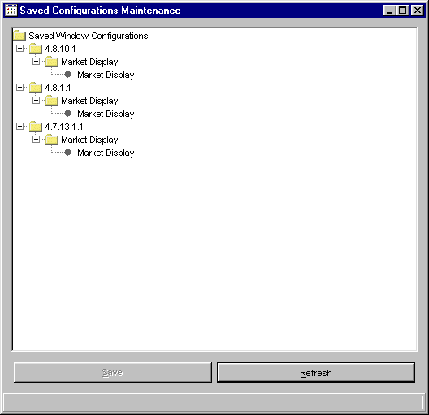
 | From this window, you can apply your previously defined named configurations and default template preferences to the current version of CBOEdirect. For example, to apply the default configurations for the Market Display from version 4.8.1.1 to version 4.8.10.1, double-click on the folder labeled 4.8.1.1. Click on the Market Display folder. After the folder is highlighted, drag and drop it with your mouse onto the folder labeled Market Display under version 4.8.10.1. The system will prompt you to confirm the conversion.
Click Yes to perform the conversion. CBOEdirect will apply the configuration to your Market Display window.
Click Save to apply the configuration.
If you decide not to apply the configuration, click No.
Click Refresh to condense the Saved Window Configurations directory tree.

➢ | User Information  The User Information Preferences window allows you to view the data that is setup for you in CBOEdirect.  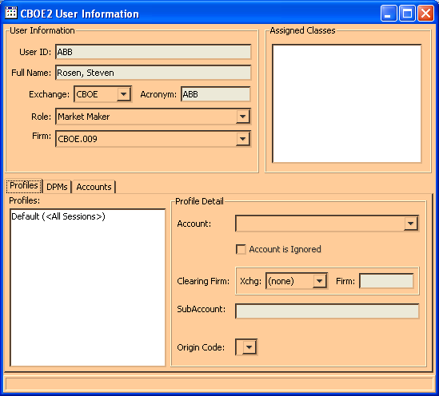
The User Information section of the window displays your User ID, Name, Acronym, Role, Firm and Exchange information.
The Profiles tab shows your Profiles Account, Clearing Firm, SubAccount and Origin Code details.
The DPMs tab displays assigned DPMs and DPM classes.
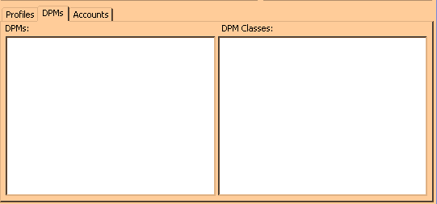

The Accounts tab display all your accounts with the Exchange and Firm information.
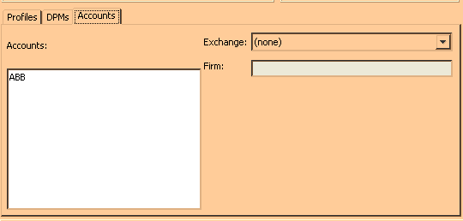
Product Lookup | CBOEdirect has the functionality to search for specific product information. From the Start Menu, select Product Lookup, Create New Window. The Product Lookup window will display.  From this window, you can retrieve product information by product type and class, or by key reference number.
➢ | Lookup by Selector  From the Lookup by Selector section of the window, CBOEdirect allows you to retrieve detailed product information for a particular product or for all products related to a product class.  To request product information for a particular product class:  - Select the Product Type and Product Class from the corresponding drop down lists.  - Select the product from the Product drop down list and click on the Lookup button. The product information will display in the Details section of the window. Use the up/down arrows to scroll through the text box for additional system details about the product.
 | 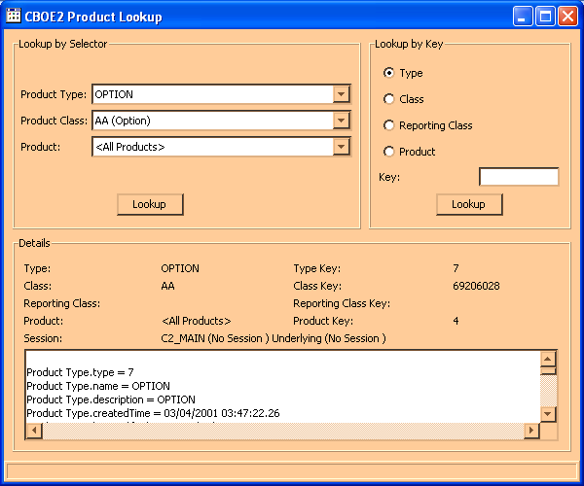
To request product information for all products pertaining to a product class:
- Select the Product Type and Product Class from the corresponding drop down lists.
- Select the All Products option from the Product drop down list box. The products common information will display in the Details section of the window. Use the up/down arrows to scroll through the text box for additional system details about all products in the product class.

Lookup by Key
You can quickly lookup product information by type, class, reporting class or product if you have the Key reference number.
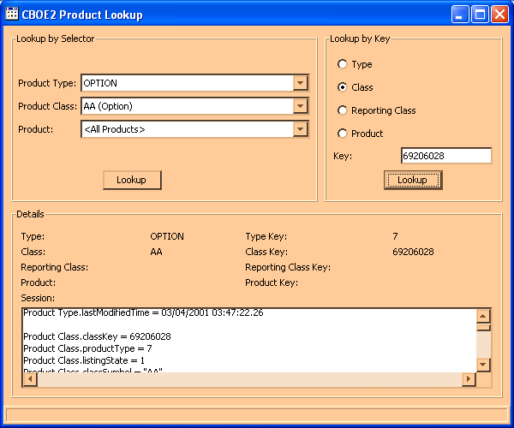

For example, to lookup product information by the key reference number, select the Product radio button in the Lookup by Key section of the window. Enter the key reference number in the Key text box and click Lookup. In the example window above, the product with key number 69206028 displays in the Details section of the window. Use the up/down arrows to scroll through the text box for system details about the product.
Follow the steps detailed above to lookup class, type or reporting class information by the key reference number.
QRM | The system gives you the ability to tailor your trading sessions to your trading style by setting session defaults from the Quote Risk Manager.  QRM is setup at the acronym level, therefore, multiple users that share the same acronym and exchange will be sharing the same QRM values. For example,  - User ID1 and user ID2 are sharing acronym ABC  - User ID1 is quoting IBM  - User ID2 changes QRM on his/her CBOEdirect trading system for IBM  - User ID1’s QRM values will change to reflect the changes made by User ID2  From the Start Menu, select QRM, and then highlight QRM Maintenance. Values set using this function will become the default values for new trades and trading sessions.
➢ | QRM Maintenance
This window enables you to set QRM defaults for each class quoted.
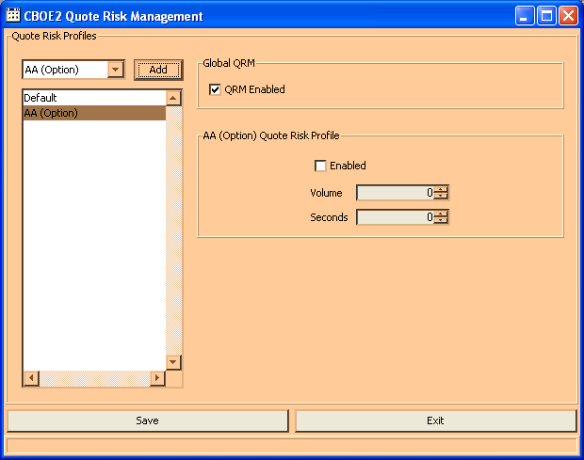
To add a new class to the Quote Risk Monitor:
- Select a class from the drop down list box and click Add.
To set defaults:
- Highlight the class, fill the appropriate checkboxes, and set the volume and seconds levels.
When you have set or updated your QRM defaults, click Save. The system will save your changes and will update all users that share the same acronym to these settings.
Click Exit to close the window.
 | - Note: Multiple QRM windows can be created during a trading session.
Reporting | The Reporting windows allow you to create reports by class volume or product series price.

Class Volume
From the Start menu, select Reporting and then select Class Volume. The following window will display.
 | 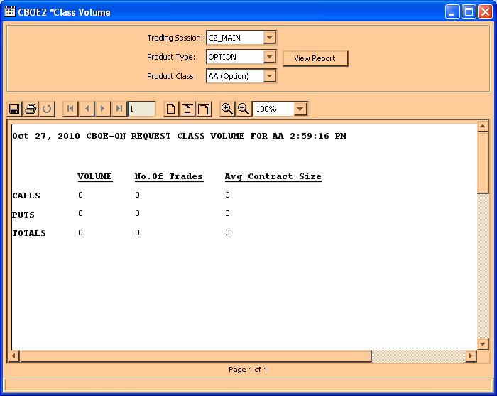
- To create a report by class volume, choose the Trading Session, Product Type and Product Class from their corresponding drop down lists.
- Click View Report. The class volume report for the selected product class will display. In the example above, the total Volume, Number of Trades and Average Contract Size display for product class A (option) calls and puts.
- To save the report, click on the save icon, . Enter the file name and click Save. Click Cancel to withdrawal the save request.
- To print the report, click on the print icon, . Select your printer destination and click Ok. Click Cancel to remove the print request.

Display Series Price Details
Product series price details can be displayed, saved and printed from the Display Series Price (DSP) Details window.
From the Start menu, click Reporting and then select DSP Details. The following window will appear.
 | 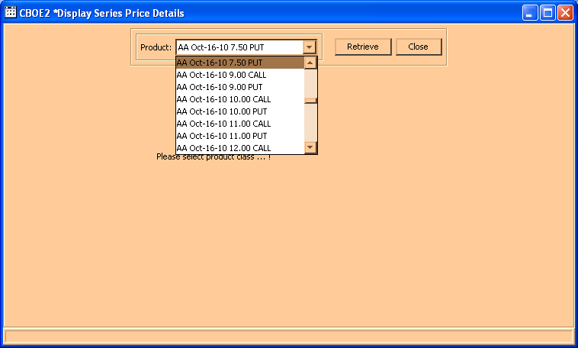
- Select the Product from the corresponding drop down list.
- Click Retrieve. The product series price details display. In the example above, series price and market details are available for IBM Jul08 65.00 Calls.
- Click Close to exit the window.
- To save the series price report, click on the save icon, . Enter the file name and click Save. Click Cancel to withdrawal the save request.
- To print the report, click on the print icon, . Select your printer destination and click Ok. Click Cancel to remove the print request.
Status Window | Select Status Window from the Start Menu to open a new system status window. The configuration of the Status window can be saved using the Task Toolbar. For detailed information, see the Task Toolbar section (Task Toolbar, page 45) of the Reference Guide.  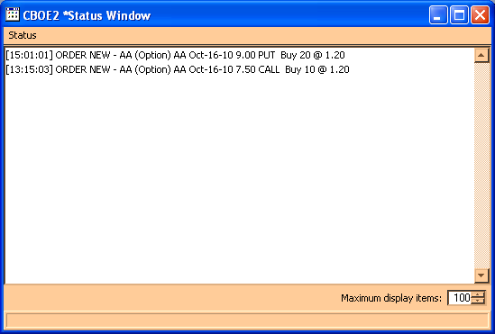
 | The Status Window will open displaying a maximum number of 100 items. CBOEdirect allows a maximum of 100 items to be displayed on the Status Window. To increase or decrease the number of items to display, click the Up or Down arrows until the desired number is reached.
- For detailed information, right mouse click to highlight the order and select Details. You can also select Details from the Status menu or press [Alt]-[D] from anywhere on the window.
- To print status information, select Print from the right mouse click menu or from the Status menu. You can also press [Alt]-[P] from anywhere on the window. The print window will display.
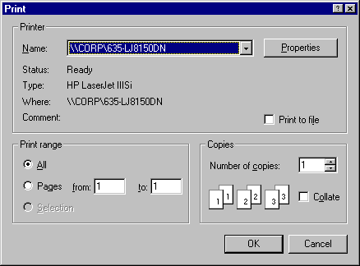
- To clear the status information, select Clear from the right mouse click menu or from the Status menu. You can also press [Alt]-[C] from anywhere on the window.
Ticker Display | CBOEdirect allows you to view underlying security market data by displaying ticker and recap information. From the Start Menu, select the Ticker Display option, then select Create New Window. The Ticker Display window will open.  You can create multiple Ticker Display windows during a trading session. Each window configuration can be saved using the Task Toolbar. For detailed information, see the Task Toolbar section (Task Toolbar, page 45) of the Reference Guide
 | 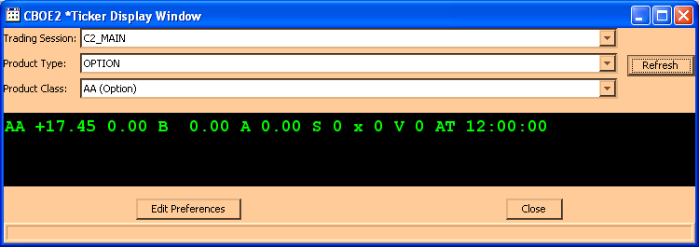
 | Initially, the window will be blank.
From the drop down lists, select the trading session, product type and product class you wish to view. Click Refresh. Ticker and recap information will display for the selected product class.
If you decide you do not wish to view ticker information for a product class, click Close.

Ticker Configuration
You can define the ticker and recap information you wish to display by placing your mouse on the ticker portion of the window and performing a right mouse click. Select Edit Preferences. The Ticker Configuration window displays.
 | 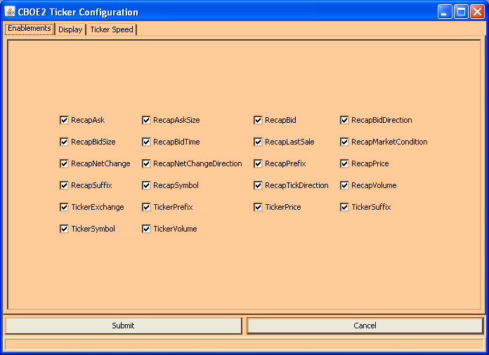
This window displays three tabs: Enablements, Display and Ticker Speed. The Enablements tab defaults to display ticker and recap information. You can choose the ticker and recap information you would like to display by selecting/deselecting the appropriate check boxes.
- To save your configuration, click Submit. Click Confirm.
- If you decide to retain the default settings, click Cancel.
To further define your ticker display, select the Display tab. From this window, you can set a new font type and color for your display.
- To select a new font, select the type, size and style from the drop down lists. The new font will display in the Preview Colors section of the screen.
- From the Swatches tab, click on the color you wish to display. The new color is viewable in the Preview Colors section of the screen.
 | 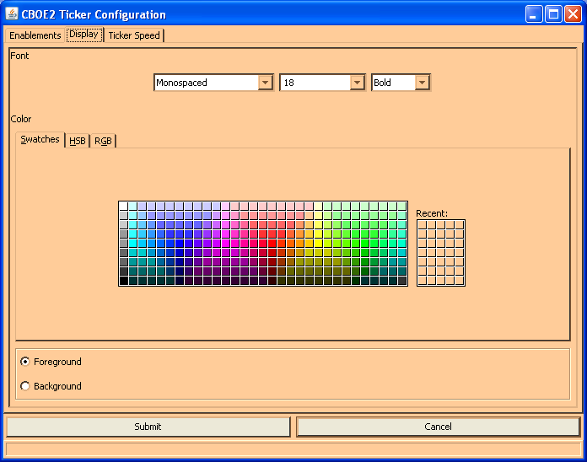
- To save the configuration, click Submit. Click Confirm.
- To retain the default settings, click Cancel.
 | - Click the HSB tab to set your hue, saturation and brightness. Place your mouse on the scroll bar button and adjust your color preference. Select the Foreground or Background by clicking on the corresponding radio button.
 | 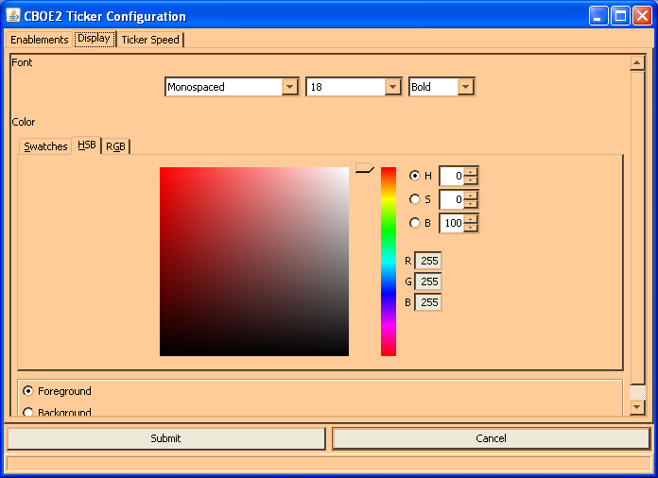
- To save the configuration, click Submit. Click Confirm.
- To retain the default settings, click Cancel.
 | - Click the RGB tab to set your red, green and blue color model. Place your mouse on the side scroll bar and adjust your color preference. Select the Foreground or Background by clicking on the corresponding radio button.
 | 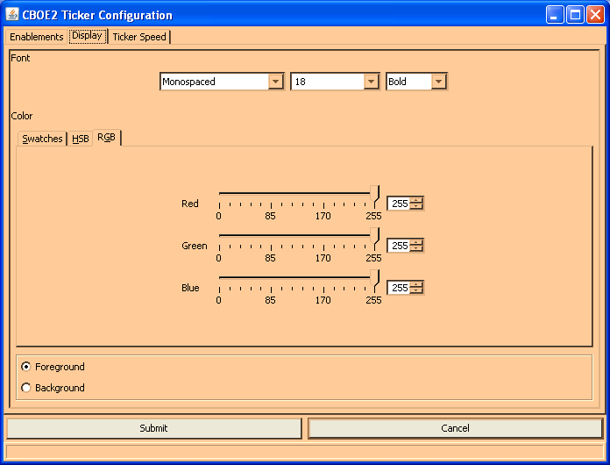
- To save the configuration, click Submit. Click Confirm.
- To retain the default settings, click Cancel.
 | - Click the Ticker Speed tab to set the rate of the ticker movement and the block size. Place your mouse on the vertical scroll bar and adjust your speed preference.
 | 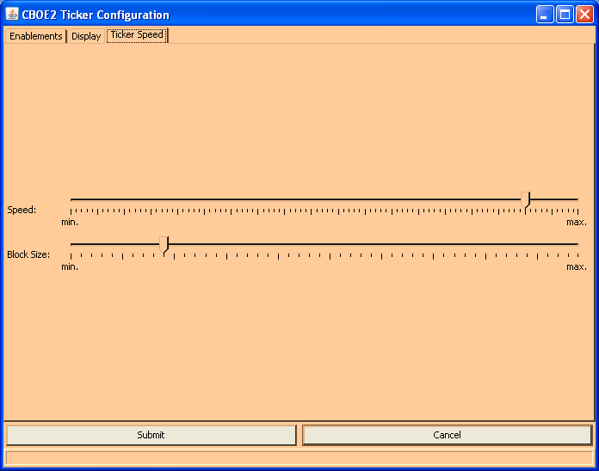
- To save the configuration, click Submit. Click Confirm.
- To retain the default settings, click Cancel.
Open Console Window | CBOEdirect allows you to view system messages that are generated by the functions you perform. To view the messages, select Open Console Window from the Start Menu. The Console Window will display.
 | 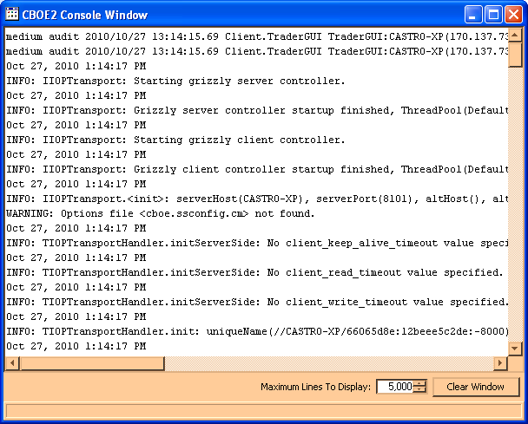
The information in this window can be copied to the CBOEdirect Message Center. To copy text from this window,
- place the cursor on the line you which to copy and using your mouse highlight the text.
- press Ctrl C on your keyboard to copy the text.
- open CBOEdirect Message Center window and place your cursor in the text entry area.
- press Ctrl V on your keyboard. The text is copied in the window.

Order Menu

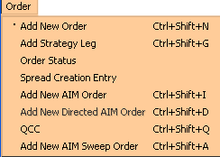 | To display the Order Menu:  - Click Order on the Menu Bar on the Market Display window, or  - Right mouse click on the series you wish to trade and select Order, or  - Press [Alt]-[O] from anywhere on the window.  The order options will display. If a menu option is unavailable, it will display grayed out and no action will take place if the option is selected.
Add New Order | Highlight a product, then select Add New Order from the Order Menu or press [Ctrl]+[Shift]+[N] from anywhere on the window. The Add Order window will display. There are two versions of this window: Buy and Sell. Buy is the default order option. Time in force defaults to Day.
 | 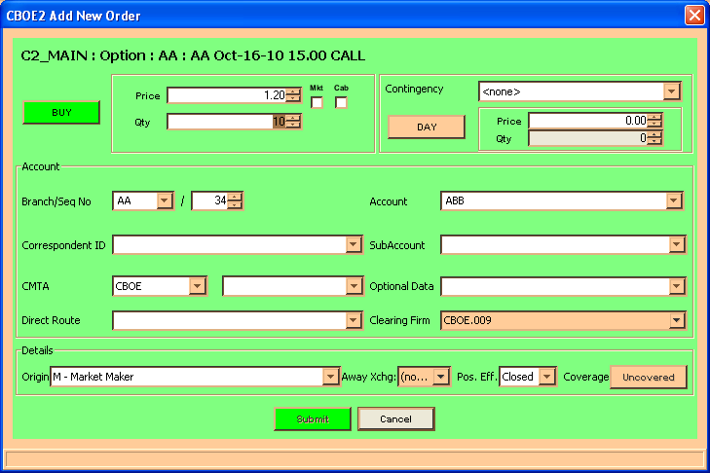
- Select if the order will be a BUY or SELL order by clicking the corresponding button.
- The system defaults to a day order. To enter a good till canceled order, click on the DAY button. The button displays as GTC.
- Enter the price and quantity of the order. If you wish to place a market order, click the Mkt checkbox (the checkbox will fill and the Price field will then be grayed out).
- If this is a contingency order, select one of the available contingencies from the drop down list box.
- If the order is a Stop or Stop Limit order, enter the price and minimum quantity.
- The Account section of the window displays order account fields. Update the fields as required.
- The branch ID defaults to the branch ID set in your preferences; sequence number increments to the next order entry number or the number you set in your preferences; account defaults to the user acronym (limited to three characters); give up firm defaults to the set user give up firm.
- Two or more CBOEdirect users for the same firm cannot utilize the same branch ID and sequence number. The CBOEdirect Help Desk can assist users in setting up unique branch IDs and sequence numbers.
- Improper logout from CBOEdirect prevents the order sequence number from being saved. When you login again, the sequence number will begin at the same number as your previous login session.
- The subaccount field is required for Futures and can include up to 10 alphanumeric characters. Firms that do not have subaccounts can enter their account information in this field after confirmation from their clearing firm.
- The Direct Route field applies to Order Maintenance Terminal (OMT) users. Non-OMT users should leave the field blank to submit an order.
- The Details section of the window displays order detail fields. Update fields as needed.
- Select the order origin from the Origins drop down list.
- Note: For trade clearing purposes, the Optional Data field should be populated for Market Maker (M origin) and Market Maker Away (N origin) orders. Orders will not be rejected if you leave the field blank. The 15 character format is as follows:
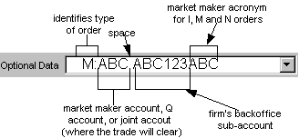

- Firms that want to give one DPM priority in participating in a trade populate the Optional Data field by specifying P:FIRM, FIRM being the CBOE Firm acronym.
- Buy orders have an unspecified coverage type. Sell orders can be either Covered or Uncovered, the default is Uncovered.
- To process the order, click Submit.
- To exit without processing the order, click Cancel.
Order  and Quote  Status | To view the status of your orders, select Order Status from the Order Menu. The Order Status window will open as a separate display. This window can be kept open while working on the Market Display window.
At this window, you can filter the orders to be viewed. Select the appropriate radio buttons, and then click Refresh. Orders display at the top of the window. You can adjust the display to fit your trading activity.
This window can remain open during further trading or click the  button in the upper right corner to close.
➢ | Order History  To display the history of an order, highlight the order, right mouse click to display the Order Status Menu, and select Order History. The Order History window will display.  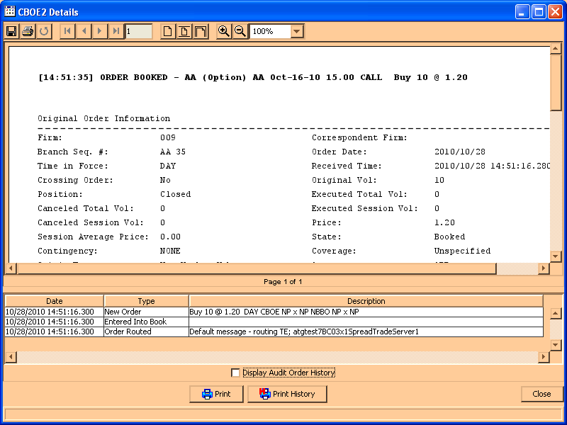
➢ | Edit Preferences  To edit preferences for an order or quote, highlight the order or quote, right-mouse click and select Edit Preferences. The Edit Preferences window will display.  For instructions on screen customization, refer to the Customize Market Display section, page 21.  - Update row or column preferences and click Ok.  - To exit without changing preferences, click Exit.

Add Qualified Contingent Cross Order | Qualified Contingent Trade (QCT) orders are supported in the CBSX session of CBOEdirect. QCT orders provide an efficient process for trading options tied to a separate stock transaction if they conform to the rules defined for the Qualified Contingency Trade exemption. The objective is to allow hedged order pairs to cross immediately, ahead of any resting customer orders for QCT orders.  To enter QCT orders, highlight the product data row on the Market Display and select Order, QCC. The Enter Qualified Contingent Cross Order window will display.
 | 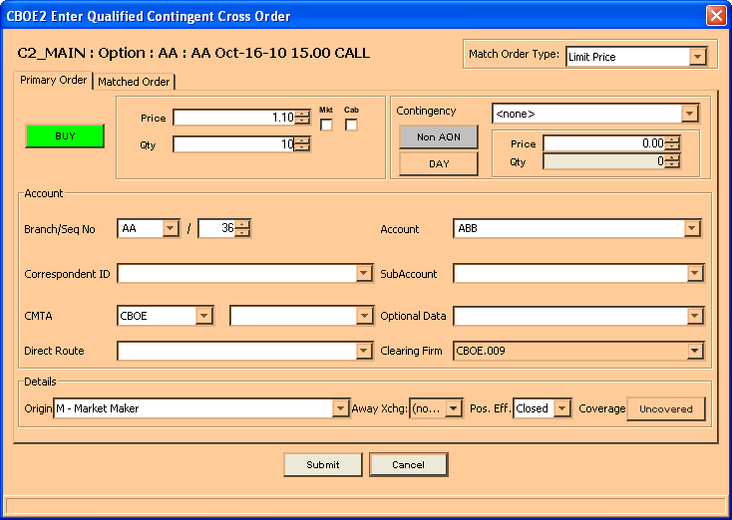
 | The fields will automatically display with the product and series selected. The fields default to a buy, day order for the Primary order and sell, day order for the Matched order. The Match Order Type defaults to Limit Price.
- Click the corresponding buttons to change to a sell/buy or good till cancel order.
- Enter the price and quantity of the Primary order by clicking on the up and down arrow counters or highlighting the price and quantity values and keying over them with new values.
- If you wish to enter the order as a market or cabinet order, click the Mkt or Cab field to fill the checkbox.
- If you are placing a contingency order, select an applicable contingency from the drop down list. For a Stop, Stop LMT, and MIN order, enter the stop price and minimum quantity of the contingency order.
- Select the Match Order Type from the drop down list. Currently, only the limit price and auto match types are supported.
- The Account section of the window displays order account fields. Update the fields as required.
- The branch ID defaults to the branch ID set in your preferences; sequence number increments to the next order entry number or the number you set in your preferences; account defaults to the user acronym (limited to three characters); give up firm defaults to the set user give up firm.
- Two or more CBOEdirect users for the same firm cannot utilize the same branch ID and sequence number. The CBOEdirect Help Desk can assist users in setting up unique branch IDs and sequence numbers.
- Improper logout from CBOEdirect prevents the order sequence number from being saved. When you login again, the sequence number will begin at the same number as your previous login session.
- The subaccount field is required for Futures and can include up to 10 alphanumeric characters. Firms that do not have subaccounts can enter their account information in this field after confirmation from their clearing firm.
- Optional data:
- Enter A:AIQ as the first characters in the primary order to instruct CBOE to treat the paired orders as Qualified Contingent Trade orders.
- Firms that want to give one DPM priority in participating in a trade populate the Optional Data field by specifying P:FIRM, FIRM being the CBOE Firm acronym.
- Note: For trade clearing purposes, the Optional Data field should be populated for Market Maker (M origin) and Market Maker Away (N origin) orders. Orders will not be rejected if you leave the field blank. The 15 character format is as follows:

- For Non-OMT users, the Direct Route field defaults to null.
- The Details section of the window displays order detail fields. Update fields as needed.
- Select the order origin from the Origins drop down list.
- Buy orders have an unspecified coverage type. Sell orders can be either Covered or Uncovered, the default is Uncovered.
- Follow the above steps to populate the fields for the Matched Order.
- Click Submit. Click Confirm. The order will be submitted into the system.
If you decide you do not wish to proceed with the order, click Cancel to close the window.

Execute Menu

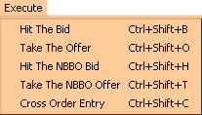 | To display the Execute Menu:  - Click Execute on the Menu Bar on the Market Display window or  - Press [Alt]-[E] from anywhere on the window.  The execution options will display. If a menu option is unavailable, it will display grayed out and no action will take place if the option is selected.
Hit the Bid | Highlight a product, then select Hit the Bid from the Execute Menu or click on the Mkt Bid Qty or Mkt Bid Price field of the series you wish to trade. The Hit the Bid window will display. You can also display the window by pressing Ctrl+Shift+B.
 | 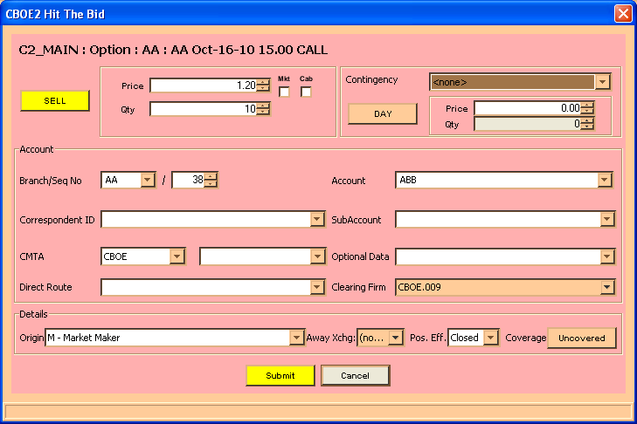
- The price and quantity will default to the Mkt Bid values displayed on the Market Display window for the series. The order defaults to a Day order. If you wish to adjust the numbers, click on the up and down arrow counters or highlight the price and quantity values and key over them with new values.
- Indicate whether the order is for the Day or Immediate or Cancel (IOC) by clicking on the appropriate button.
- The Account section of the window displays order account fields. Update the fields as required.
- The branch ID defaults to the branch ID set in your preferences; sequence number increments to the next order entry number or the number you set in your preferences; account defaults to the user acronym (limited to three characters); give up firm defaults to the set user give up firm.

- Two or more CBOEdirect users for the same firm cannot utilize the same branch ID and sequence number. The CBOEdirect Help Desk can assist users in setting up unique branch IDs and sequence numbers.
- Improper logout from CBOEdirect prevents the order sequence number from being saved. When you login again, the sequence number will begin at the same number as your previous login session.
- For Non-OMT users, the Direct Route field defaults to null.
- The subaccount field is required for Futures and can include up to 10 alphanumeric characters. Firms that do not have subaccounts can enter their account information in this field after confirmation from their clearing firm.
- The Details section of the window displays order detail fields. Update fields as needed.
- Select the user role from the Origins drop down list.
- Note: For trade clearing purposes, the Optional Data field should be populated for Market Maker (M origin) and Market Maker Away (N origin) orders. Orders will not be rejected if you leave the field blank. For details, refer to the Add New Order section, page 88.
- Note: Firms that want to give one DPM priority in participating in a trade populate the Optional Data field by specifying P:FIRM, FIRM being the CBOE Firm acronym.
- Select the order's coverage type by clicking on the corresponding button.
- To process the order, click Submit.
- To exit without processing the order, click Cancel.
Take the Offer | Highlight a product, then select Take the Offer from the Execute Menu or click on the Mkt Ask Qty or Mkt Ask Price field of the series you wish to trade. The Take the Offer window will display. You can also display the window by pressing Ctrl+Shift+O.
 | 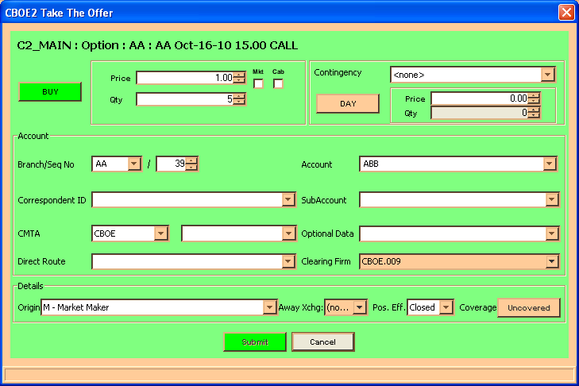
- The price and quantity will default to the Mkt Ask values displayed on the Market Display window for the series. The order defaults to a Day order. If you wish to adjust the numbers, click on the up and down arrow counters or highlight the price and quantity values and key over them with new values.
- Indicate whether the order is for the Day or Immediate or Cancel (IOC) by clicking on the appropriate button.
- The Account section of the window displays order account fields. Update the fields as required.
- The branch ID defaults to the branch ID set in your preferences; sequence number increments to the next order entry number or the number you set in your preferences; account defaults to the user acronym (limited to three characters); give up firm defaults to the set user give up firm.
- Two or more CBOEdirect users cannot utilize the same branch ID and sequence number. The CBOEdirect Help Desk can assist users in setting up unique branch IDs and sequence numbers.
- Improper logout from CBOEdirect prevents the order sequence number from being saved. When you login again, the sequence number will begin at the same number as your previous login session.
- For Non-OMT users, the Direct Route field defaults to null.
- The subaccount field is required for Futures and can include up to 10 alphanumeric characters. Firms that do not have subaccounts can enter their account information in this field after confirmation from their clearing firm.

- The Details section of the window displays order detail fields. Update fields as needed.
- Select the user role from the Origins drop down list.
- Note: For trade clearing purposes, the Optional Data field should be populated for Market Maker (M origin) and Market Maker Away (N origin) orders. Orders will not be rejected if you leave the field blank. For details, refer to the Add New Order section, page 88.
- Note: Firms that want to give one DPM priority in participating in a trade populate the Optional Data field by specifying P:FIRM, FIRM being the CBOE Firm acronym.
- The order's coverage type defaults to Uncovered.
- To process the order, click Submit
- To exit without processing the order, click Cancel.
Hit the NBBO Bid | To hit the NBBO bid when CBOE is part of the bid, highlight a product, then select Hit the NBBO from the Execute Menu or click on the NBBO Bid Qty or NBBO Bid Price field of the series you wish to trade. The Hit the NBBO Bid window will display. Pressing Ctrl+Shift+H will also open the window.
 | 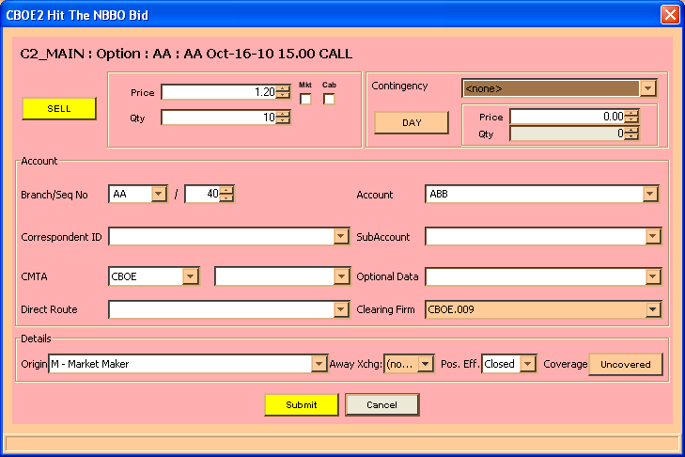
- The price and quantity will default to the NBBO Bid values displayed on the Market Display window for the series. The order defaults to a Day order. If you wish to adjust the numbers, click on the up and down arrow counters or highlight the price and quantity values and key over them with new values.
- Indicate whether the order is for the Day or Immediate or Cancel (IOC) by clicking on the appropriate button.
- The Account section of the window displays order account fields. Update the fields as required.
- The branch ID defaults to the branch ID set in your preferences; sequence number increments to the next order entry number or the number you set in your preferences; account defaults to the user acronym (limited to three characters); give up firm defaults to the set user give up firm.
- Two or more CBOEdirect users cannot utilize the same branch ID and sequence number. The CBOEdirect Help Desk can assist users in setting up unique branch IDs and sequence numbers.
- Improper logout from CBOEdirect prevents the order sequence number from being saved. When you login again, the sequence number will begin at the same number as your previous login session.
- For Non-OMT users, the Direct Route field defaults to null.
- The subaccount field is required for Futures and can include up to 10 alphanumeric characters. Firms that do not have subaccounts can enter their account information in this field after confirmation from their clearing firm.

- The Details section of the window displays order detail fields. Update fields as needed.
- Select the user role from the Origins drop down list.
- Note: For trade clearing purposes, the Optional Data field should be populated for Market Maker (M origin) and Market Maker Away (N origin) orders. Orders will not be rejected if you leave the field blank. For details, refer to the Add New Order section, page 88.
- Note: Firms that want to give one DPM priority in participating in a trade populate the Optional Data field by specifying P:FIRM, FIRM being the CBOE Firm acronym.
- Select the order's coverage type.
- To process the order, click Submit. CBOEdirect will submit the order to the CBOE based on the NBBO price.
- To exit without processing the order, click Cancel.
Take the NBBO Offer | To take the NBBO offer when CBOE is part of the offer, highlight a product, then select Take the NBBO Offer from the Execute Menu or click on the NBBO Ask Qty or NBBO Ask Price field of the series you wish to trade. The Take the NBBO Offer window will display. The window will also display by pressing Ctrl+Shift+T.
 | 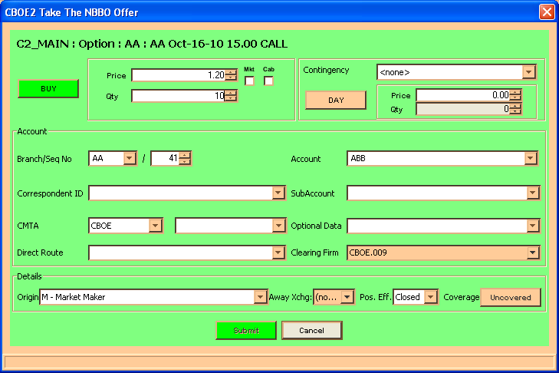
- The price and quantity will default to the NBBO Ask values displayed on the Market Display window for the series. The order defaults to a Day order. If you wish to adjust the numbers, click on the up and down arrow counters or highlight the price and quantity values and key over them with new values.
- Indicate whether the order is for the Day or Immediate or Cancel (IOC) by clicking on the appropriate button.
- The Account section of the window displays order account fields. Update the fields as required.
- The branch ID defaults to the branch ID set in your preferences; sequence number increments to the next order entry number or the number you set in your preferences; account defaults to the user acronym (limited to three characters); give up firm defaults to the set user give up firm.
- Two or more CBOEdirect users cannot utilize the same branch ID and sequence number. The CBOEdirect Help Desk can assist users in setting up unique branch IDs and sequence numbers.
- Improper logout from CBOEdirect prevents the order sequence number from being saved. When you login again, the sequence number will begin at the same number as your previous login session.
- For Non-OMT users, the Direct Route field defaults to null.
- The subaccount field is required for Futures and can include up to 10 alphanumeric characters. Firms that do not have subaccounts can enter their account information in this field after confirmation from their clearing firm.
- The Details section of the window displays order detail fields. Update fields as needed.
- Select the user role from the Origins drop down list.
- Note: For trade clearing purposes, the Optional Data field should be populated for Market Maker (M origin) and Market Maker Away (N origin) orders. Orders will not be rejected if you leave the field blank. For details, refer to the Add New Order section, page 88.
- Note: Firms that want to give one DPM priority in participating in a trade populate the Optional Data field by specifying P:FIRM, FIRM being the CBOE Firm acronym.
- The order's coverage type defaults to Uncovered.
- To process the order, click Submit. CBOEdirect will submit the order to the CBOE based on the NBBO price.
- To exit without processing the order, click Cancel.
- Select the W_STOCK trading session from the Trading Session drop down list.
- Select the Product Type, Product Class and Product from the corresponding drop down lists.
- From the Buyer tab:
- Enter the Buy Side Price and Quantity.
- Select the type of Cross order from the Contingency drop down list.
- Note: The contingency must be the same for both the Buy side and Sell side of the cross order.
- The Account section of the window displays order account fields. Update the fields as required.
- The branch ID defaults to the branch ID set in your preferences; sequence number increments to the next order entry number or the number you set in your preferences; account defaults to the user acronym (limited to three characters); give up firm defaults to the set user give up firm.
- Two or more CBOEdirect users cannot utilize the same branch ID and sequence number. The CBOEdirect Help Desk can assist users in setting up unique branch IDs and sequence numbers.
- Improper logout from CBOEdirect prevents the order sequence number from being saved. When you login again, the sequence number will begin at the same number as your previous login session.
- For Non-OMT users, the Direct Route field defaults to null.
- The subaccount field is required for Futures and can include up to 10 alphanumeric characters. Firms that do not have subaccounts can enter their account information in this field after confirmation from their clearing firm.

Quote Menu

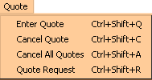 | To display the Quote Menu:  - Click Quote on the Menu Bar on the Market Display window, or  - Right mouse click on the series you wish to trade and select Quote, or  - Press [Alt]-[Q] from anywhere on the window.  The quote options will display. If a menu option is unavailable, it will display grayed out and no action will take place if the option is selected.
Enter Quote | Highlight a product, then select Enter Quote from the Quote Menu or click on any of the My Bid or My Ask fields on the series. The Quote Entry window will display. Pressing Ctrl+Shift+Q will also open the window.
 | 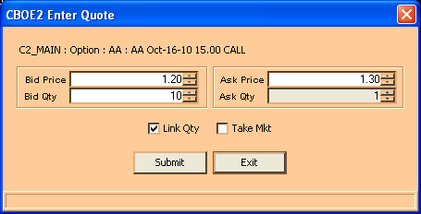
- Enter the bid and ask price and quantity. As a default, the quantities will be linked. The system will set the Ask Qty to match the value in the Bid Qty field. If you wish to unlink the quantities, click the Link Quantity checkbox to remove the check mark.
- If you wish to take the market prices for your quote, click Take Mkt. The system will automatically fill the fields with the Mkt Bid and Mkt Ask prices. Adjust the quantity.
- Click Submit.
- If you decide you do not wish to proceed with the quote, click Exit to close the Quote Entry window.
  - Note: Two users with the same acronym cannot quote the same class. For example,
- User ID1 and user ID2 share the same acronym
- User ID1 is quoting class, IBM. User ID2 tries to quote IBM but the quote is rejected.
- If user ID1 logs off and all quotes are cancelled, user ID2 will be able to quote IBM.
- If user ID1 cancels all his/her quotes, without logging off, user ID2 will be able to quote IBM.

Cancel Quote | Highlight the product that you quoted, then select Cancel Quote from the Quote Menu or press Ctrl+Shift+C. The Quote Cancel window will display.
 | 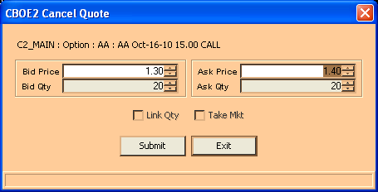
- The window will automatically display the data for the untraded portion of your quote.
- Confirm that this is the quote you wish to cancel and click Submit.
- If you decide you do not wish to cancel the quote, click Exit to close the Quote Cancel window.
Cancel All Quotes | To cancel all quotes you've submitted, highlight any series for a class and select Cancel All Quotes from the Quote Menu or press Ctrl+Shift+A. The Cancel All Quotes window will display with the Current Selected Product Class.
 | 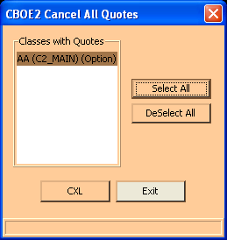
- To cancel all quotes for the Current Selected Product Class, click CXL.
- To cancel all quotes for several product classes, hold down the [Ctrl] key and highlight each of the classes where you have quotes to be canceled. Click CXL.
- To cancel all quotes for all classes, click Select All. All classes will automatically be highlighted. Click CXL.
- If you do not wish to cancel all quotes for all classes, click DeSelect All to remove the selection.
- If you decide you do not wish to cancel all quotes, click Exit to close the Cancel All Quotes window.
Quote Request | To request a quote, highlight any series for a class and select Quote Request or press Ctrl+Shift+R. The Quote Request window will display.
 | 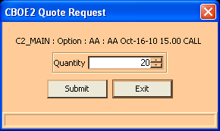
- Enter the quantity.
- Click Submit. The series requested for quote will display in red on the Market Display window.
- If you decide you do not wish to proceed with the quote request, click Exit to close the Quote Request window.
View Pending RFQs | To view pending RFQs, click the RFQ button on the Market Display window. The Pending RFQ window will open and pending RFQs for all products for which you are responsible will display.
 | RFQs display on this window for n (30) seconds. The RFQ will display in green for the first n (10) seconds; in yellow for the second n (10) seconds; then in red for the last n (10) seconds. After n (30) seconds, the RFQ will disappear from the window.
- You can respond to an RFQ by double clicking on it. The Quote Entry window will display at the bottom of the Pending RFQ window.
- Enter quote information and click Submit to send the quote. (See Enter Quote, page 101.)
- Click Confirm.
- If you decide you do not wish to proceed with the quote, click Exit to close the Quote Entry window.

Ticker Menu

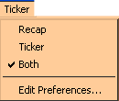 | To display the Ticker Menu:  - Click Ticker on the Menu Bar on the Market Display window, or  - Press [Alt]-[K] from anywhere on the window.  The ticker options will display. If a menu option is unavailable, it will display grayed out and no action will take place if the option is selected.
Recap / Ticker | CBOEdirect allows you to view underlying security market data in the Ticker frame of the Market Display window. Click on a class tab and select the Recap, Ticker, or Both options from the Ticker Menu. Recap and ticker data will display in the frame below the trading information section of the Market Display window.

Recap
From the recap line you can view a snapshot of the day's transactions for the underlying security of the class as well as any indicators of news alerts.

Ticker
The sliding ticker line displays sales and transactions for the underlying security.
 | You can only view recap and ticker data for the selected product tab.
Edit Preferences | You can choose the ticker and recap information you wish to view by selecting Edit Preferences from the Ticker Menu. The Ticker Configuration window displays corresponding with the selected Recap or Ticker option.

Recap Enablements
The enablements tab defaults to display all recap information. You can choose the recap information you wish to display by selecting/deselecting the appropriate check boxes.
- To save your configuration, click Submit. Click Confirm.
- If you decide to retain the default settings, click Cancel.

Ticker Enablements
The enablements tab defaults to display all ticker information. You can choose the ticker information you wish to display by selecting/deselecting the appropriate check boxes.
 | 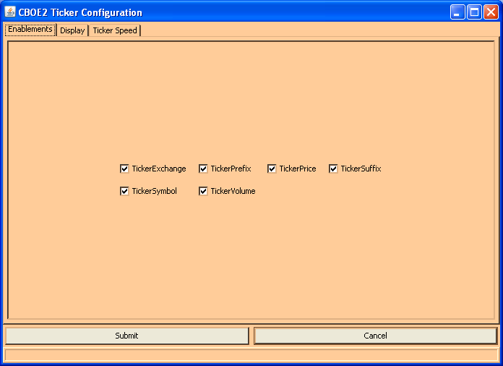
- To save your configuration, click Submit. Click Confirm.
- If you decide to retain the default settings, click Cancel.

Display
To further define your ticker display, select the Display tab. From this window, you can set a new font type and color for your display.
- To select a new font, select the type, size and style from the drop down lists. The new font will display in the Preview Colors section of the screen.
- To change the foreground or background color of the ticker, select the appropriate radio button.
- From the Swatches tab, click on the color you wish to display. Select the Foreground or Background by selecting the appropriate radio button.
- To save the configuration, click Submit. Click Confirm.
- To retain the default settings, click Cancel.
 | - Click the HSB tab to set your hue, saturation and brightness. Place your mouse on the scroll bar button and adjust your color preference. Select the Foreground or Background by selecting the appropriate radio button.
- To save the configuration, click Submit. Click Confirm.
- To retain the default settings, click Cancel.
 | - Click the RGB tab to set your red, green and blue color model. Place your mouse on the side scroll bar and adjust your color preference. Select the Foreground or Background by selecting the appropriate radio button.
- To save the configuration, click Submit. Click Confirm.
- To retain the default settings, click Cancel.
 | - Click the Ticker Speed tab to set the rate of the ticker movement and the block size. Place your mouse on the vertical scroll bar and adjust your speed preference.
- To save the configuration, click Submit. Click Confirm.
- To retain the default settings, click Cancel.

View Menu

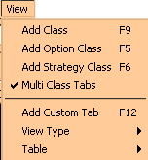 | To display the View Menu:  - Click View on the Menu Bar on the Market Display window, or  - Right mouse click on the series you wish to trade and select View, or  - Press [Alt]-[V] from anywhere on the window.  The view options will display. If a menu option is unavailable, it will display grayed out and no action will take place if the option is selected.
Add Class | The Add Class option is used to display all product type classes for trading on CBOEdirect. From the View Menu, select Add Class or press F9 from anywhere on the window. To specifically add an option class, select Add Option Class or press F5 from anywhere on the window. To specifically add a strategy class, select Add Strategy Class or press F6 from anywhere on the window. The Add Class window will display.
Select the trading session, product type and product class from the drop down lists. Click Add Tab. The selected class will appear on the Market Display window.
Note: CBOEdirect currently allows users to display only one Market Display window and a maximum of three class tabs within the window.
If you would like CBOEdirect to retain the trading session and product type settings, select the Set as Default checkbox. The next class selection will automatically display with these values so you need only define the product class.
If you would like CBOEdirect to select the at-the-money series for the product class, select the Select ATM checkbox. CBOEdirect will highlight the ATM series on the Market Display.
To exit the Add Class window, click Close.
Add Custom Tab | The Add Custom Tab option is used to create custom tabs that contain multiple product classes for trading on CBOEdirect. From the View Menu, select Add Custom Tab or press F12 from anywhere on the window. The Add Tab window will display.
 | 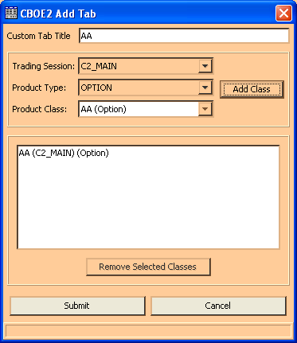
To add multiple product classes to a tab:
- Select a trading session from the Trading Session drop down box.
- Select a product type from the Product Type drop down box.
- Select a product class. Click Add Class. The product class will display in the text box section of the window. You can continue to add product classes to the tab as long as the classes are of the same session and product type.
  - Note: There are limits for the number of product classes of each product type that can be added to a single tab.
    - An Option tab can only contain one product class
- When you select your first product class, the system defaults to set the name of the product class as the Custom Tab Title. You can override the default setting by entering a custom title for your tab in the Custom Tab Title text box.
- If you wish to remove a product class from your selection, select the product class from the text box and click Remove Selected Classes. The product class will be removed from the text box.

- To remove multiple product classes, hold down the Shift key on your keyboard and select the product classes. Click Remove Selected Classes. The product classes will be removed from the text box.
- To create your custom tab, select Submit. Click Confirm. The system will display a tabbed window listing all the series for the product classes with related market data.
- If you decide not to create a custom tab, click Cancel.
To view a custom tab example, refer to the Market Display Window section, page 16.

Remove a Tab
To remove a tab, right mouse click on the tab and select Remove.

Modify a Tab
To modify product classes for a tab, right mouse click on the tab and select Modify. The Add Tab window displays.
From this window, you can add or remove product classes and edit the title. Click Submit. Click Confirm. The modified tab will display on the Market Display window.
Note: If all the product classes are removed and you try to Submit the changes, the system will prompt you that if the changes are finalized, the tab would be empty, and therefore removed from the Market Display window.
Multi Class Tabs | CBOEdirect defaults to allow you to view Multiple Class Tabs on the Market Display window. If you wish to view only one class tab on the Market Display, deselect the Multi Class Tabs option from the View Menu.  Note: CBOEdirect currently allows users to display only one Market Display window and a maximum of three class tabs within the window  For examples of multi class and single class tabs, refer to the Market Display Window, page 16.
 | To remove the filtering function, deselect the Volume option. All Strategy products will appear in the Market Display window, regardless of market volume.
 | Select the Refresh option or click F5 on your keyboard to update the filtering mechanism in the Market Display.
View Type | For ease of trading, you have the option to view the Market Display trading data by single row or side-by-side formats. From the View Menu, select View Type, and then select your display choice.
 | 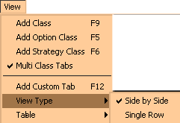
CBOEdirect will rearrange the Market Display data to your viewing preference.
Note: Only option classes will display in both side-by-side and single row formats. Other product types will only display in single row format.
For examples, refer to the Market Display Window, page 16.
Table | There are several ways to customize your Market Display. From the View Menu, select Table. From this window, you can display all data columns and rows, grow or shrink the window and edit column and row preferences.
 | 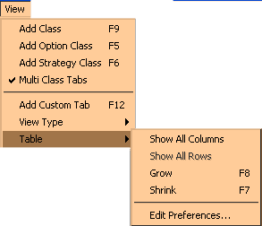
- To display all the data columns, highlight Show All Columns. All the data columns will appear on the Market Display.
- To display all the series, select Show All Rows. All the series will become visible on the Market Display.
- To increase the size of the data rows and columns, highlight Grow or press F8 from anywhere on the window.
- To decrease the size of the data rows and columns, highlight Shrink or press F7 from anywhere on the window.
For instructions on screen customization, refer to the Customize Market Display section, page 21.

Window Menu

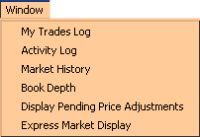 | To display the Window Menu:  - Click Window on the Menu Bar on the Market Display window, or  - Right mouse click on the series you wish to trade and select Window, or  - Press [Alt]-[W] from anywhere on the window  The window options will display. If a menu option is unavailable, it will display grayed out and no action will take place if the option is selected.
My Trades Log | To view the Trades Log, highlight a series on the Market Display window and select My Trades Log from the Window Menu. The Trades Log window will open for the selected series. The window will automatically update as your orders are executed.
- To change the display to view a different class and/or series or all classes and series, click on the Class/Product Selection button. The Class/Product Selection window will open.
- Select the product type, product class and product series from the box lists.
- Click Ok.
- If you decide you do not want to change the Class/Product selection, click CANCEL to close the Class/Product selection window.
Trades are listed by date/time stamp from the most recent to the earliest trade in the current trading session.

Edit Column Preferences
You can customize your Trades Log window by selecting or deselecting specific columns to display. To filter columns, right mouse click on a data row. Select Edit Preferences. The Edit Column Preferences window will display.

- Select or deselect columns for viewing and modify column arrangement as desired.
- To save your changes, click Ok.
- If you wish to retain the default settings, click Cancel.
For instructions on screen customization, refer to the Customize Market Display section, page 21.
 | - Note: Multiple Trades Log windows can be created during a trading session. You can save the configuration of each window from the Task Toolbar. For detailed information, see the Task Toolbar section (Task Toolbar, page 45) of the Reference Guide.
Activity Log | Highlight a series and select Activity Log from the Window Menu. The Activity Log window will display for the Current Selected Product Class.
- To view the activity log for another class:
- Click the Class/Product Selection button. The Class/Product Selection window will open.
- From the box lists, select the trading session, product type and product class to display. Click Ok.
- If you decide you do not wish to change the selection, click Cancel.
- The date field defaults to the current date. Click the Calendar button or the up and down arrows to select the desired date.
- The time field defaults to the current time. Update as desired.
- Select the product and activity type you wish to display from the list boxes in the Filter section of the window.
- Click Submit.
- All activity for the selected product class will display from the most recent to the earliest set by the date/time selection.
- Click Submit to update the selection criteria and/or refresh the display.
- Click Close to exit the display.

Edit Column Preferences
You can customize your Activity Log window by selecting or deselecting specific columns to display. To filter columns, right mouse click on a data row. Select Edit Preferences. The Edit Column Preferences window will display.
- Select or deselect columns for viewing and modify column arrangement as desired.
- To save your changes, click Ok.
- If you wish to retain the default settings, click Cancel.
For instructions on screen customization, refer to the Customize Market Display section, page 21.
 | - Note: Multiple Activity Log windows can be created during a trading session. You can save the configuration of each window from the Task Toolbar. For detailed information, see the Task Toolbar section (Task Toolbar, page 45) of the Reference Guide.
Market History | Market History  To create a new Market History window, select Market History from the Window menu. A blank Market History window will display.  If your user enablements are set to the system default, your Market History window will only display the Time, Type, Price, Prefix, Quantity and Underlying columns (see below for a description of each column and its values).
To query by product:
- From the Product tab, select the trading session, product type, product class, and product to display.
- The date/time fields default to the current date and time. Click the up and down arrows to select the desired date and time for the query.
- Click Submit.
- The default Market History window displays quotes, trades and various market conditions. Quotes and trades are listed by date/time stamp from the most recent to the earliest trade in the current trading session.
- To scroll through the display, click the up/down arrows .
- Click Submit to update selection criteria and refresh display.
- Click Close to exit the display.

Priority Market History
If your user enablements are setup to view priority market history data, your Market History window will display with the default data, NBBO information and Broker/Contra Broker fields.
If your enablements are setup to view detailed market history data, your display will generate default data and NBBO information.

Place your cursor over the column headings for complete column names.
See below for a description of the data represented in each column.
Column Name | Description | Values
Time | Date and time the event occurred | 3/22 08:26:00.900AM
T | “Type” of event | Quote = ‘Q’  Trade (Last Sale) = ‘L’  Market Condition (Product State) = ‘M’  EOP = ‘E’
Price | Bid and Ask price of the quote or trade | 1.20-1.40
Prefix | The state of the product | Closed  PreOpen  Opening Rotation  Open  Halted  Fast Market  No Session  On Hold  Ending Hold  Suspended  FTAO = First Trade At Open
Quantity | Quantity for the Bid and Ask | 13x3
BKR | The acronym of the Broker involved in the transaction | BAC  XXH = Unknown Broker (i.e. more than 15 Brokers)
CBK | The acronym of the Contr Broker involved in the transaction | ABC  XXH = Unknown Broker (i.e. more than 15 Brokers)
E | Override indicator – last sale from TPF | Linkage = ‘L’  Book Override = ‘B’  Offer Override = ‘O’  Supervisory Override = ‘X’ or ‘S’
Underlying | The underlying price of the product. This information comes from TIPS | 38.00
BidEx | The Exchange representing the NBBO Bid price. There can be more than one Exchange at the NBBO Bid price. | CBOE = ‘C’  AMEX = ‘A’  PSE = ‘P’  PHLX = ‘X’  BSE = ‘B’  ISE = ‘I’

Column Name | Description | Values
NBBid | NBBO Bid price | 1.20
NBAsk | NBBO Ask price | 1.40
AskEx | The Exchange representing the NBBO Ask price. There can be more than one Exchange at the NBBO Ask price. | CBOE = ‘C’  AMEX = ‘A’  PSE = ‘P’  PHLX = ‘X’  BSE = ‘B’  ISE = ‘I’
TT | “Trade Through” indicator – indicates a trade through occurred at an away market | A checkbox is marked when a trade through occurred at an away market.
C A P X B I | Exchange Indicator  CBOE = ‘C’  AMEX = ‘A’  PSE = ‘P’  PHLX = ‘X’  BSE = ‘B’  ISE = ‘I’ | Clear = ‘ ‘  Halted = ‘H’  Fast Market = ‘F’  Opening Rotation = ‘O’  Data not received from Exchange = ‘?’
IP Address | Internet Protocol address of the TNT | 123.555.66.234

Print Market Data History Table
To print the Market Data History table, right mouse click on a data row and select Print Table.
 | 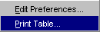
Select the desired printer and page setup. Click Print.
To cancel the print request, click Cancel.

Edit Column Preferences
You can customize your Market History window by selecting or deselecting specific columns to display. To filter columns, right mouse click on a data row. Select Edit Preferences. The Edit Column Preferences window will display.
- Select or deselect columns for viewing and modify column arrangement as desired.
- To save your changes, click Ok.
- If you wish to retain the default settings, click Cancel.
For instructions on screen customization, refer to the Customize Market Display section, page 21.
 | Note: Multiple Market History windows can be created during a trading session. You can save the configuration of each window from the Task Toolbar. For detailed information, see the Task Toolbar section (Task Toolbar, page 45) of the Reference Guide.
Book Depth | Highlight a series and select Book Depth from the View Menu. The Book Depth window will display the Selected Product Class and series for the current session. Book depth information is updated in real-time.
- Real-time updates are provided for the first five levels of market depth. To obtain updated book depth data, click Refresh.
- To have the window refresh automatically, select the Auto Refresh check box.
 | Note: Multiple Book Depth windows can be created during a trading session. Each Book Depth window configuration can be saved using the Task Toolbar. For detailed information, see the Task Toolbar section (Task Toolbar, page 45) of the Reference Guide.
Display Pending Price Adjustments | Price adjustments on orders are caused by changes in the underlying security, such as stock splits, stock dividends, etc.  To view the effects of pending price adjustments on your outstanding orders:  - Highlight Display Pending Price Adjustments from the View Menu or  - Right mouse click on a series and select Display Pending Price Adjustments from the View Menu.  The Pending Price Adjustment window will open.
Select the trading session, product type, product class and product from the drop down lists. Click Query. For the selected product, you can view:
- original and new series
- original and new quantity
- remaining and new quantity
- old and new price

Express Market Display | The Express Market Display is CBOE’s market data feed that supports the reporting of quotes, trades, and other information for options, stocks and futures. If your user enablements are setup for express market data, you will be able to monitor market data for a specific product.  Highlight Express Market Display from the View Menu. The following window will display.
- Initially the window will be blank. Select the Product Type, Product Class and Product from the drop down lists.
- Click OK. Current market, recap/last sale and ticker information will display for the selected product.

 | The Current Market tab displays the bid/ask price and quantity, the state of the product and public bid/ask information.
 | The Recap/Last Sale tab shows the opening price, the high and low prices for the product and last sale information.
 | Click on the Ticker tab to display trade information.

