

CBOE Trade Match (CTM-I)
Broker User’s Guide
Version 2.0

Disclaimer

Copyright © 2006-2011 Chicago Board Options Exchange. All rights reserved.
The information contained in this document constitutes confidential and/or trade secret information belonging to CBOE. This document is provided "As Is" with all faults and without warranty of any kind, either expressed or implied.

Change Notices

The following change notices are provided to assist users of the CBOE Trade Match system in determining the impact of changes to their processing.
If you have any questions or review comments about this document, please contact Odalys Castro at (312) 786-8817. For help with the CTMI (Trade Match) system, contact David Glover at (312) 786-7957.

Date | Version | Description of Change
3/16/11 | 2.0 | New Trade Checking Query user interface  Updated CBOE logo
3/25/10 | 1.0 | New document

Table of Contents
Table of Contents iii
Introduction iv
Purpose iv
Intended Audience iv
Window Settings iv
Note About Displayed Screens iv
Conventions Used in this Guide iv
Section 1: CBOE Trade Match 5
Getting Started 6
Functionality Restrictions 6
Login 6
Trade Query 7
Functionality Restrictions 7
Trade Entry 7
Enter a Trade 7
Broker Query 11
Query Options Trade Data 11
Options Trade Correction 13
Options Trade Allocation 15
Data Errors 16
Trade CheckingQuery 16
Add Opposite Side of Trade 17
Order Query 20
Functionality Restrictions 20
Order Allocation 21
App Support 23
Audit Query 23
Exit the System 25
Exit the System 25
Section 2: Reference Guide 26
Customize and Export CTM Windows 27
Exporting CTM Data 27
Export to CSV Format 27
Export to Excel 28
XML Conversion 30
Sizing CTM Windows 30

Introduction

Purpose | This user guide was written to assist Brokers in utilizing the CBOE Trade Match (CTM) features using a web browser.  The CTM system combines the basic functions of the Intra-day Trade Processing (ITP) and Real Time Trade Communication (RTC) systems.
Intended Audience | This user guide is intended for Brokers, associated with CBOE Options Member Firms, interested in the Trade Match administrator and data entry functions.
Window Settings | The recommended resolution to view CTM windows is 1280 x 1024 pixels. If your desktop display is set to a lower resolution, you will have to use the scroll bar to view CTM windows in their entirety.  CTMI functionality is designed to work with Internet Explorer Version 6.x or greater. Using a different browser or version may have unpredictable results.
Note About Displayed Screens | An attempt is made to show the current look and format of screens that are included in this document. However, the displays here may not reflect recent changes to these browser screens. Also, information displayed on the screens may not reflect true production data.
Conventions  Used in this Guide | The CBOE Trade Match system was designed so that you can perform all of your administrative functions from a web browser. All web browser functionality applies to the CTM system.  Section 1 of the document illustrates how to perform the necessary Broker functions. Additional information about window configuration and sizing can be found in Section 2: Reference Guide.  There are conventions used throughout this guide to help trigger important information:
 | Bolding | Used to highlight menu selections (e.g., Login) and button names (e.g., Update)
 |  Note: | This notation is used to indicate important information you should note when performing the associated function.

 | Section 1:  CBOE Trade Match

This section of the user guide will direct you through all the Broker functions of CBOE’s Continuous Trade Match system using a web browser.
- Note: On most screens, if there is only one action button, pressing the Enter key on your keyboard will accomplish the same process as clicking a highlighted button with the mouse.

Getting Started

 | To launch the CTM application, open an Internet browser window and enter URL: https://tradematch.cboe.com. The following login window will display.
 | 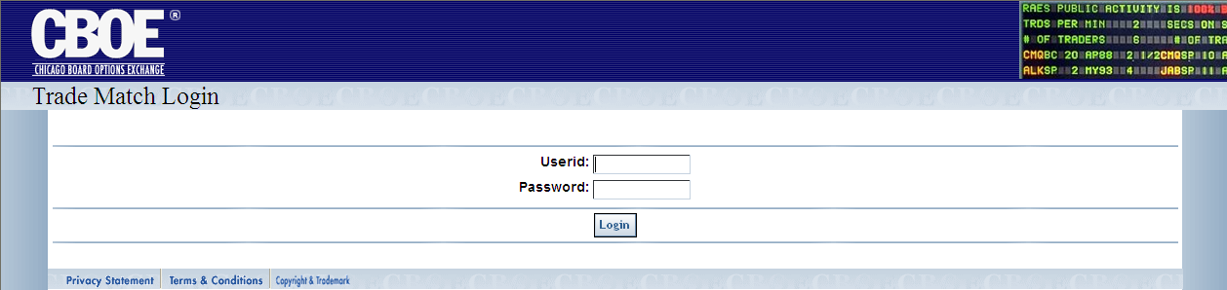
Functionality Restrictions | Functionality restrictions apply based on your User ID, Password and Role.
Login | Enter your User ID and Password. Neither User ID nor Password is case sensitive. If you are setup to use RSA token, in the Password field, type in your password followed by your RSA token value. Do not enter a space between the password and token value.
 | 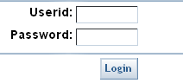
 | Click Login.
The CTM Welcome window will display the Trade Query, Order Query, App Support and Logoff tabs.
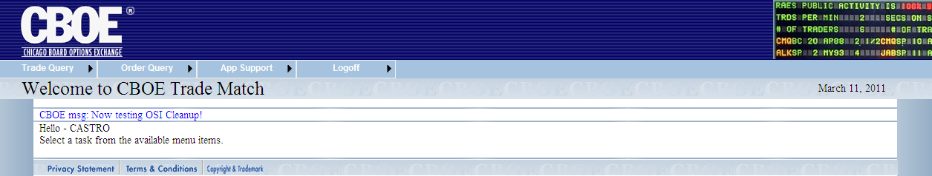
 | You are now ready to perform CTM functions.

 | Trade Query
From the Trade Query tab, you can enter trades into the system and query trade messages by broker group. Click on the Trade Query tab to display the sub-menus for these functions.
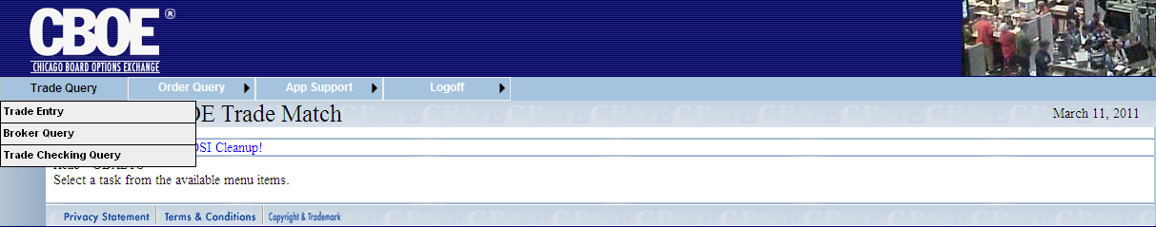

Functionality Restrictions | Broker role: allowed to query trades, enter trades, correct trades and allocate trades.
Trade Entry | This Trade Entry window is used to enter trades directly into Trade Match without coming from another data input system. As a Broker, you are allowed to enter trades for any executing firms in your Broker Group, who have allowed Add privileges.  To open the Trade Entry window, click Trade Query and then select Trade Entry.
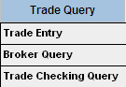 | 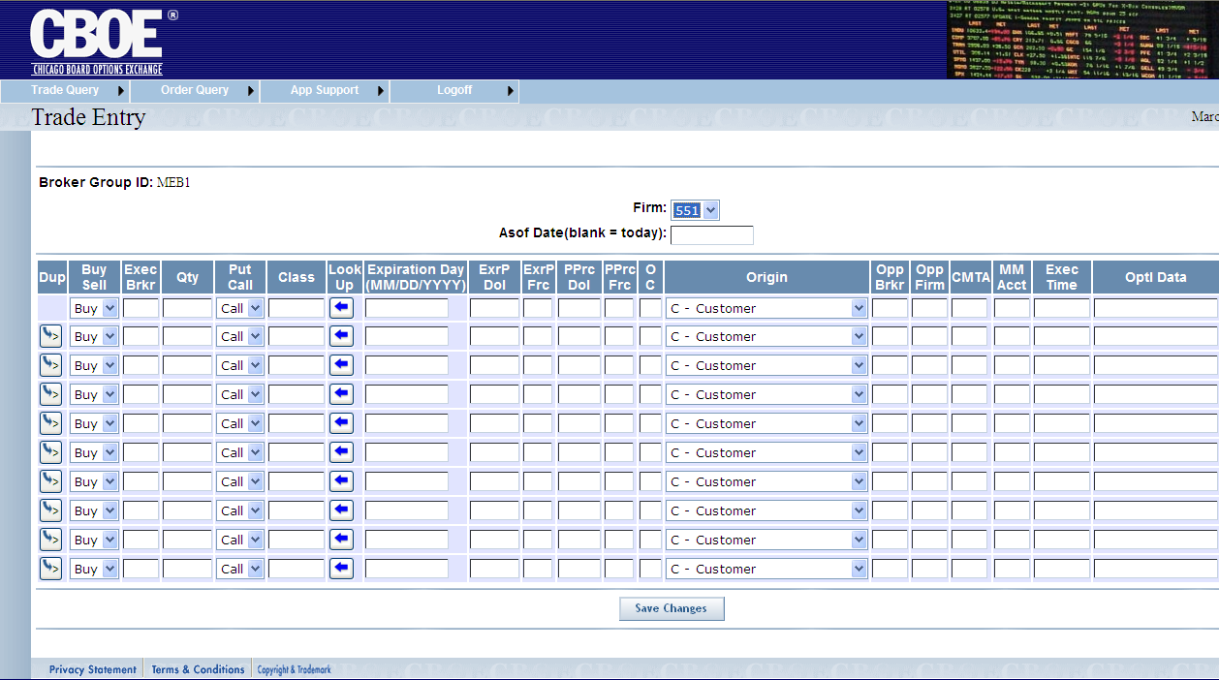

Enter a Trade
- Select the Firm number from the dropdown list.
- Click on the Asof Date text box and a calendar will display. Alternately, you may type in the Asof (trade) date in format mm/dd/yyyy (03/11/2011).
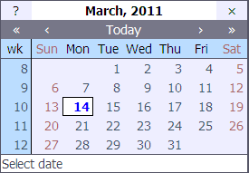
- Select the Asof date you wish to use. If this field is left blank, the data will default to the current day.
- Key in the required trade information. Required fields include: Put/Call, Buy/Sell, Execution Time, Class, Expiration Day (MMDDYYYY), Exercise Price, Premium Price, Open/Close, Origin, Opposite Firm (Opp Firm) and Opposite Broker (Opp Brkr).
 |  Note: The calendar will display when you click on the Expiration Day field.
 | 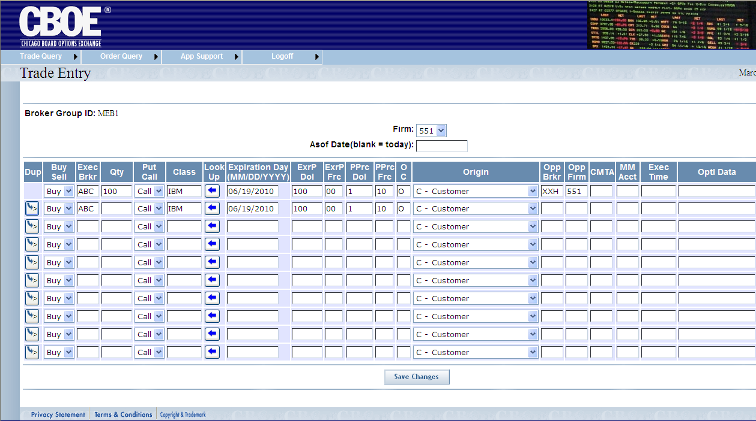
 | You can predefine the trade entry product information by clicking . The Product Lookup window will display.
 | 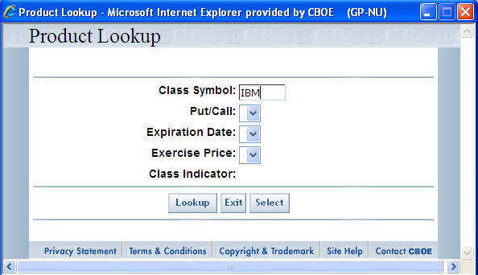
 | Enter the Class Symbol and click Lookup.
 | 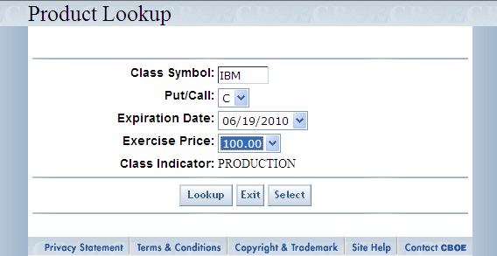
The window display choices for Put/Call, Expiration Date and Exercise Price. Make your product selections from the drop down lists. The Class Indicator defaults to Production.
Click Exit to close the Product Lookup window.
Click Select to copy your selection to the Trade Entry window.
 | 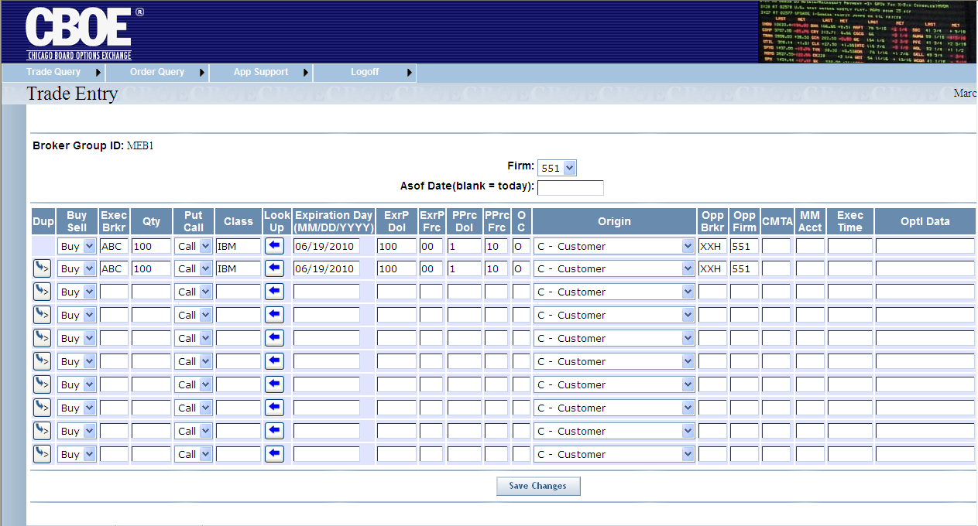
Click to duplicate trade data from previous line. This will not copy quantity, opposite firm and opposite broker.
Click Save Changes. The trades are entered in the system.
The Override button will appear if there are ‘soft’ field errors. ‘Hard’ errors must be fixed. There are invalid Class, invalid Executing Firm and invalid Opposite Firm.
Trades that contain edit errors are returned to the screen with the error fields highlighted. These erroneous trades may either be corrected or reentered, or their rejection may be overridden. An invalid OPPOSITE BROKER can be overridden by clicking Override. This will not work for all field errors. The trade will have a status of Error.

- Note: This should only be used to force in a trade if the user plans to go back later and correct the fields in error.
 | All valid trades should have been added and will not be re-displayed at this point. A message will show the number of trades that were added.
Broker Query | The CTM broker query functionality allows you to display trade information based on the filters you provide. Based on your Broker profile, trades will display that match on Executing Broker or Correspondent Firm, for a given authorized Executing Firm. To display the Broker Query window, click on the Trade Query tab and then select Broker Query. The following window will display.
 | 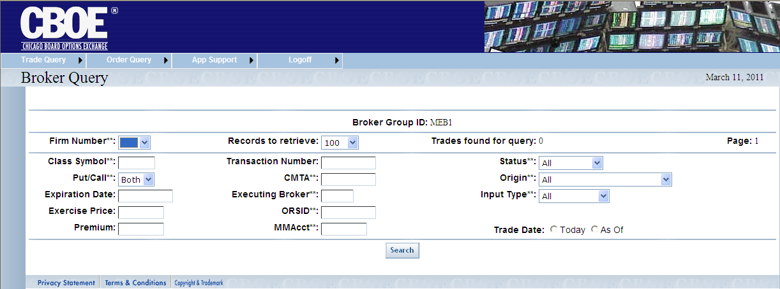

Query Options Trade Data
CTM trade data is queried by using combinations of the fields in the Broker Query window. Below is a description of each field. Fields that have astericks (**) are used for exact match search criteria.
- Firm Number**: refers to the executing Firm’s (EXEC Firm) number. The Firm number is selected from the drop down list.
- Class Symbol**: this is a text field and allows you to enter the class symbol you wish to query (i.e. IBM).
- Put/Call**: refers to the type of option. You can elect to query by Call, Put or Both by making your selection from the dropdown list. The default is Both.
- Expiration Date: this is a text field that allows you to enter the date the security will expire. The allowable format is (MMDDYYYY), or click on the field to display the calendar option.
- Exercise Price: allows you to enter the expiration price of the security. The allowable format is: 42.444 (three decimal places).
- Premium: this is a text field that can be used to enter the premium price of the security. The allowable format is: 72.65.
- Records to retrieve: you can select the number of data rows to display on the window from this dropdown list. The default is 100 rows.
- Transaction Number: trade identification number
- CMTA**: Clearing Member Trade Agreement provides non-member firms (who have clearing numbers with the OCC) a way to trade at the Exchange through member firms who contractually agree to submit trades for them.
- Note: Enter ‘*’ in the CMTA field to query trades with no CMTA.
- Executing Broker**: the acronym of the broker executing the trade.
- ORSID: identification number from the ORS system.
- MM Account**: allows you to query trades by Market Maker Account.
- Status**: allows you to query by matched or unmatched trades, trades with errors or all trades. Make your selection from the dropdown list.
- Origin**: account type that identifies the type of trade origin. E.g. customer, firm, market maker, etc. Make your selection from the dropdown list.
- Input Type**: the system where the trade was entered.
- Trade Date: to choose the current business day for your query, click Today. To display all trades previous to the current business day, click As of. If neither radio button is selected, both current and As of trades are retrieved.
In the Options example above, the data request is filtered based on Firm 501 for both Puts/Calls for all trades for the current business day. The Status, Origin and Input Types are set to All. The query will display up to 100 records per window.
Click Search. Your query will display.
 | - Note: Some trades returned to the screen may have data errors. Errors by trade will be given in a box in the upper left part of the screen. For details, refer to the Data Errors section, page 17.
 | 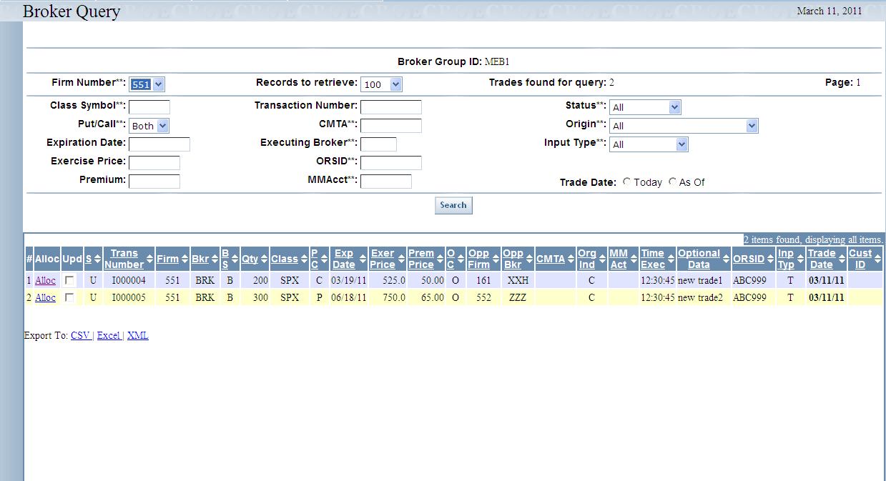
 | Trades found for query shows the count of all stored trades that satisfy the query. However, the window only displays up to the number selected by the Records to retrieve drop-down list.
To view additional trades, click Next Trades.
Click Search at anytime to refresh the window for the current query.
To view trades that were earlier displayed, click Previous Trades.
 | Data columns that display the up/down arrows can be sorted. Click on the column name to perform an ascending or descending sort. This only sorts data last retrieved into the current screen.
 | Clicking on the Export To links on the botton of the page will fill a form with data from the screen in the selected format. For instructions on exporting CTM data to CSV, Excel or XML format, refer to the section Customize and Export CTM Windows, page 28.

Options Trade Correction
Based on your permissions setup, you can make corrections to trade data by selecting the Upd (Update) checkbox for a particular data row. To select multiple trades for correction, select the Upd (Update) checkbox for each data row to correct.
If 200 or fewer trades are returned from a query, Select All and Clear All buttons are enabled.
- Click Select All to choose all the Upd (Update) checkboxes.
- Click Clear All to deselect all the Upd (Update) checkboxes.
- Note: Data errors will be shown in a box at the top of the screen. Partial trade corrections are allowed but won’t match and clear. For details, refer to the Data Errors section, page 17.
Click the Update Trades button at the bottom of the screen. The Trade Correction window will display.
 | 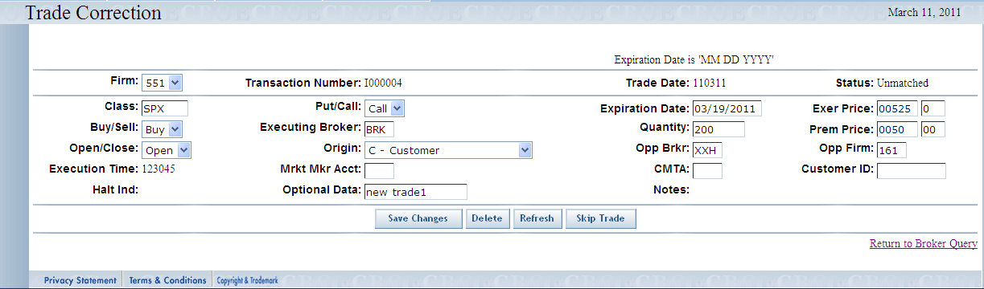
Transaction Number, Trade Date, Status and Execution Time cannot be changed.
- Note: The Execution Time can only be changed for terminal entered trades (“T”) or batch trades (“B”).
- Click Refresh at anytime to bring back original values for the displayed trade.
- Make corrections to the desired fields. Click Save Changes. The corrections will be saved in the system.
- Clicking Override allows you to update the trades in the CTM system with invalid or missing fields.
- Note: If you selected multiple trades for correction from the Broker Query window, the next trade will automatically display. If you wish to skip the trade without making corrections, click Skip Trade.
- If you wish to delete the trade displayed for corrections, click Delete. The trade will be removed from the system.
  - Note: The Delete button only appears if permissions have been setup this way for the Broker Group.
- Click Return to Broker Query link to exit the Trade Correction window.
 | The Bulk Update feature on the Broker Query window allows you to apply the same corrections to multiple trades at one time.
 | 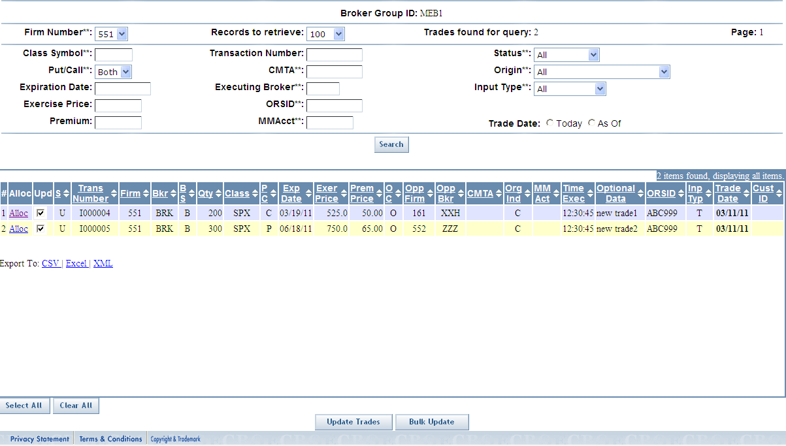
- Click the Select All button or select the Upd checkboxes of the trades you wish to correct.
- Click Bulk Update. The following window will display.
 | 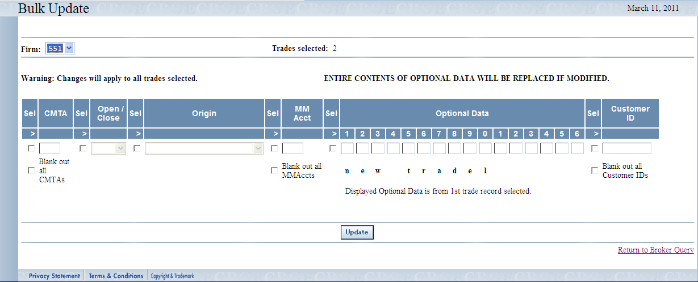
 | Corrections that you make on the Bulk Update screen will apply to the trades you selected on the Broker Query screen. Depending on Broker Group permissions, modifiable fields include: CMTA, Open/Close, Origin, MM Acct, Executing Firm and Optional Data.
- A checkbox must be selected for each field to be edited. If you decide not to edit the field, deselect the checkbox.
- The CMTA and MM Acct fields have special checkboxes that indicate those fields will be blanked out on the trades.
- The Optional Data field remains as 16 characters. The field has been split into 16 separate text boxes to help you enter data in specific columns; any columns left empty will be filled with blank spaces. Changing even one column in Optional Data will cause the entire 16 character field to be replaced in all trades selected. There are no partial field updates.
- Click Update to enter your changes. The system will display a message text box showing how many successful and unsuccessful updates there were for the selected trades. For any unsuccessful updates another message box will identify those trades and the problem with each of them.
 | 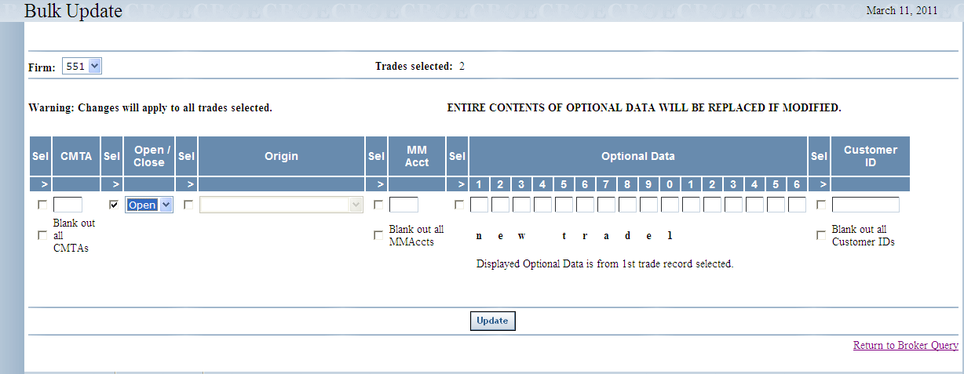
 | You can return to the Broker Query window at any time by clicking, Return to Broker Query.

Options Trade Allocation
The allocation window allows you to split a contract quantity on a previously entered trade between two or more CMTA Firms. From the Broker Query window, click the Allocation link in the Action column. The following window will display.
- Note: If a trade quantity equals 1, the allocation will not be displayed. Instead, go to Trade Correction to identify a CMTA Firm.
- Note: Data errors will be shown in a box at the top of the screen. For details, refer to the Data Errors section, page 17.
 | 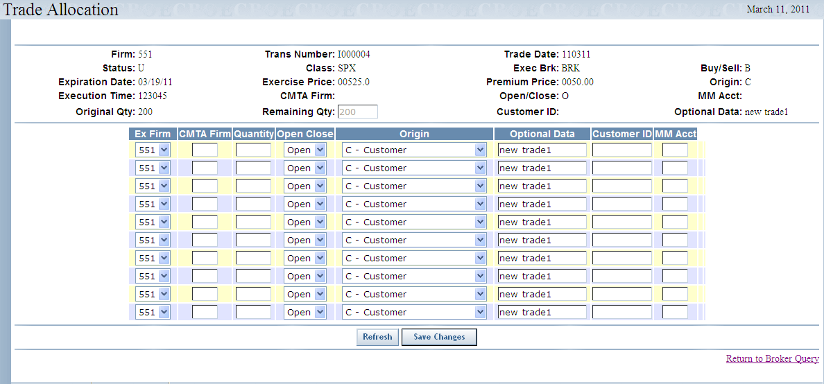
All allocations will initially default to the Open/Close, Origin, and Optional Data values of the original trade. The editable allocation fields depend on the Broker Group setup.
- Enter the CMTA Firm number.
- Enter the quantity you want to allocate to the CMTA Firm. The entire original trade quantity must be allocated.
- Select Open or Close from the drop down list. You may leave this blank, which is treated like Open.
- You can click Refresh at anytime to clear the data you have entered.
- Click Save Changes. The trade quantity will be allocated to the chosen CMTA Firms.
- If at anytime you wish to return to the Trade Query window, click Return to Broker Query.
 | - Note: Options trades can be allocated even if the original trade has errors.
Data Errors | Data errors for Broker Query windows will be shown in a box at the top of the window. The error box lists all the corrections that need to be made to the identified trade. Partial trade corrections are allowed but won’t match and clear. All errors must be corrected before a trade can be matched.
 | 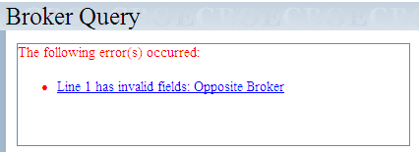
 | Click on the link for a particular error (i.e. Line 1 has invalid fields: Opposite Broker). The system will bring you to the selected line in the query. In this example, the Executing Broker field needs to be corrected for the first four errors.
Trade CheckingQuery | The CTM trade checking query allows you to display trade information for your Broker group. To display the Trade Checking Query window, click on the Trade Query tab and then select Trade Checking Query. The following window will display.
 | 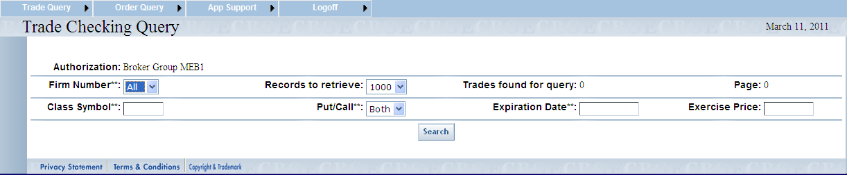
The Authorization field defaults to your Broker Group. You can filter your query by Firm Number, Class Symbol, Put/Call, Expiration Date or Exercise Price. The query will display up to 1000 records per window.
The above filter is set to query for all Firm numbers in the Broker group and for both puts and calls. Click Search. The following window will display.
 | 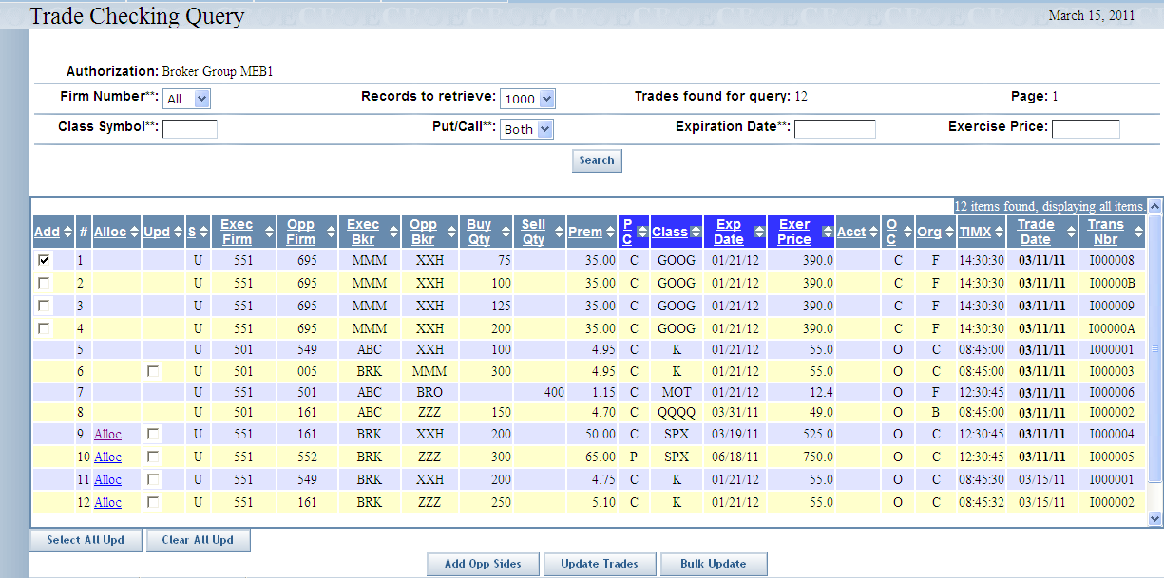
Trades found for query shows the count of all stored trades that satisfy the query. However, the window only displays up to the number selected by the Records to retrieve drop-down list.
Click Search at anytime to refresh the window for the current query.
 | Data columns that display the up/down arrows can be sorted. Click on the column name to perform an ascending or descending sort. This only sorts data last retrieved into the current screen.

Add Opposite Side of Trade
The trade checking query window allows you to add the opposite side of a trade on a previously entered trade. From the Trade Checking Query window, click the checkbox in the Add column. The following window will display.
 | 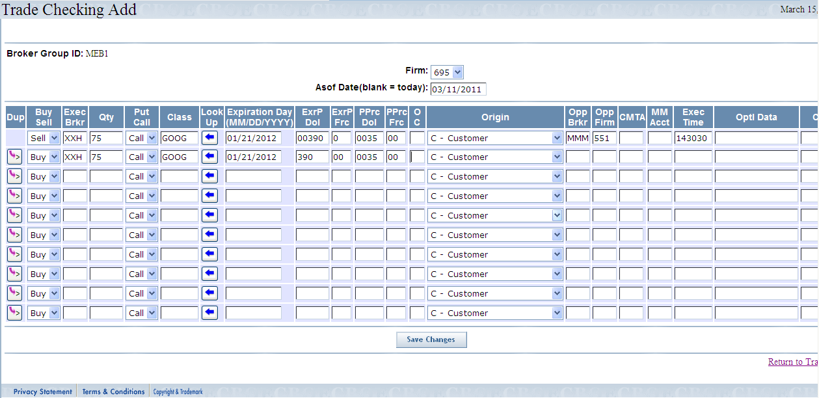
The original trade displays on the top row.
- Select the Firm number from the dropdown list.
- Click on the Asof Date text box and a calendar will display. Alternately, you may type in the Asof (trade) date in format mm/dd/yyyy (03/11/2011).
- To enter the opposite side of the trade:
  - Click to duplicate trade data from previous line. This will not copy quantity, opposite firm and opposite broker.
  - Or, key in the required trade information. Required fields include: Exec Broker, Quantity, Put/Call, Buy/Sell, Execution Time, Class, Expiration Day (MMDDYYYY), Exercise Price, Premium Price, Open/Close, Origin, Opposite Firm (Opp Firm) and Opposite Broker (Opp Brkr).

 | You can predefine the trade entry product information by clicking . The Product Lookup window will display.
 | Enter the Class Symbol and click Lookup.
The window display choices for Put/Call, Expiration Date and Exercise Price. Make your product selections from the drop down lists. The Class Indicator defaults to Production.
Click Exit to close the Product Lookup window.
Click Select to copy your selection to the Trade Checking Add window.
 | From the Trade Checking Add window, click Save Changes. The opposite trades are entered in the system.
 | Based on your permissions setup, you can make corrections to trade data from the Trade Checking Query window. For trade correction instructions, refer to the Options Trade Correction section above.
 | The allocation window allows you to split a contract quantity on a previously entered trade between two or more CMTA Firms. From the Trade Checking Query window, click the Allocation link in the Alloc column. For instructions on how to perform trade allocations, refer to the Options Trade Allocation section above.

Order Query

 | The Order Query window allows you to search for orders pertaining to your Broker Group.
Functionality Restrictions | Broker role: Order Query, Order Allocation
 | The CTM order query functionality allows you to display information on executed orders based on the filters you provide. To display the Order Query window, click on the Order Query option. The following window will display.
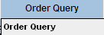 | 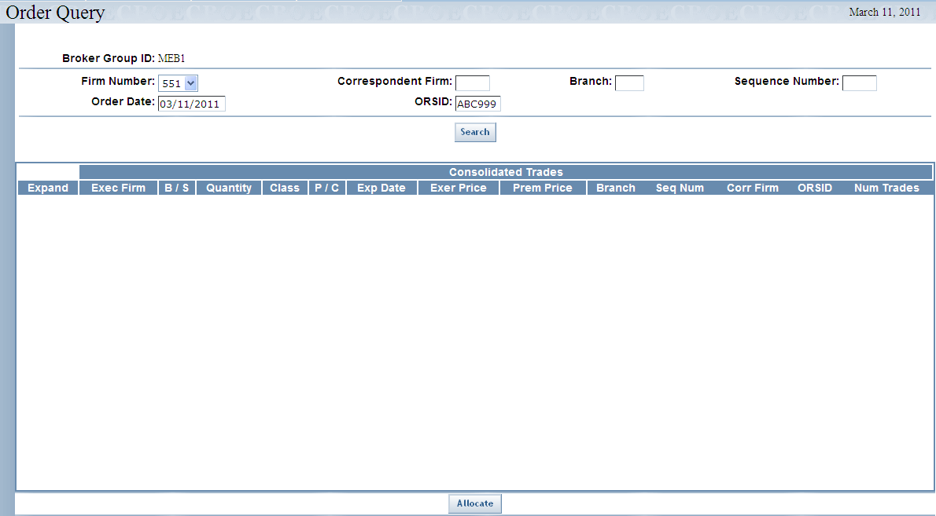
When you initially open the Order Query window, your Broker Group ID is the only field that is populated. In order to display order information, you must select your Firm number and then the Order Date and then the ORSID or Correspondent Firm, Branch and Sequence Number.
- Note: Data errors will be shown in a box at the top of the screen.
- Note: Click on the Order Date field to display the date calendar. If this field is left empty, the search will default to the order date being the current business day.
Click Search. Consolidated Trade information will display.
- Note: An order is based on identical Executing Firm, Order Data and either ORSID or Correspondent Firm, and Sequence Number. A Consolidated Trade is trade information in common for a group of executed trades within an order. To be included in a Consolidated Trade, the individual trades must have the same Buy/Sell, Class Symbol, Put/Call, Expiration Date, Exercise Price, and Premium Price. An order can be comprised of one or more Consolidated Trades.
 | 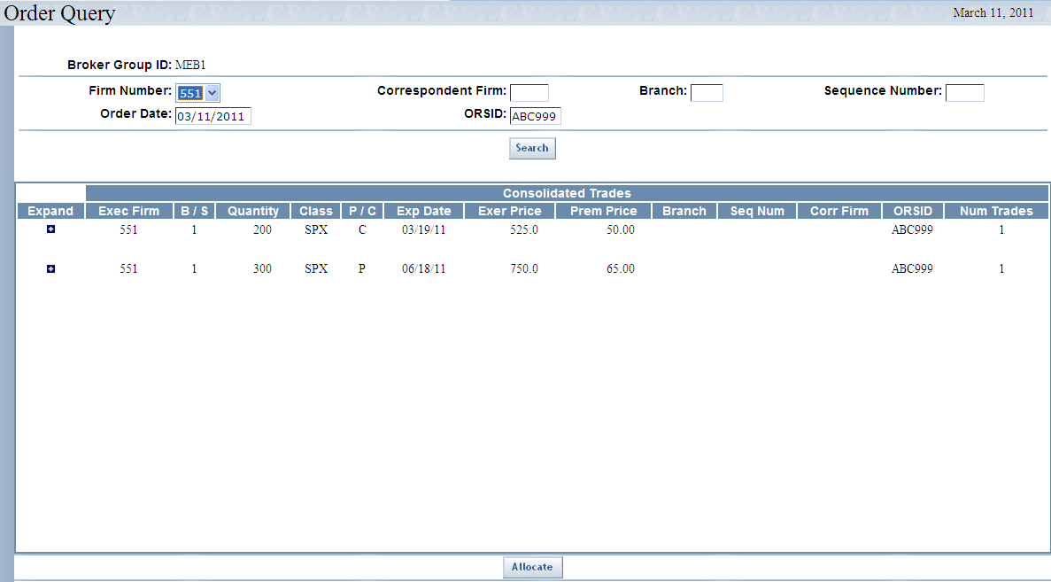
The example above shows the Firm Number: 551 and ORSID: ABC999.
If you click on the Expand icon (+/-) you can see details of individual trades rolled into the Consolidated Trade.

 | 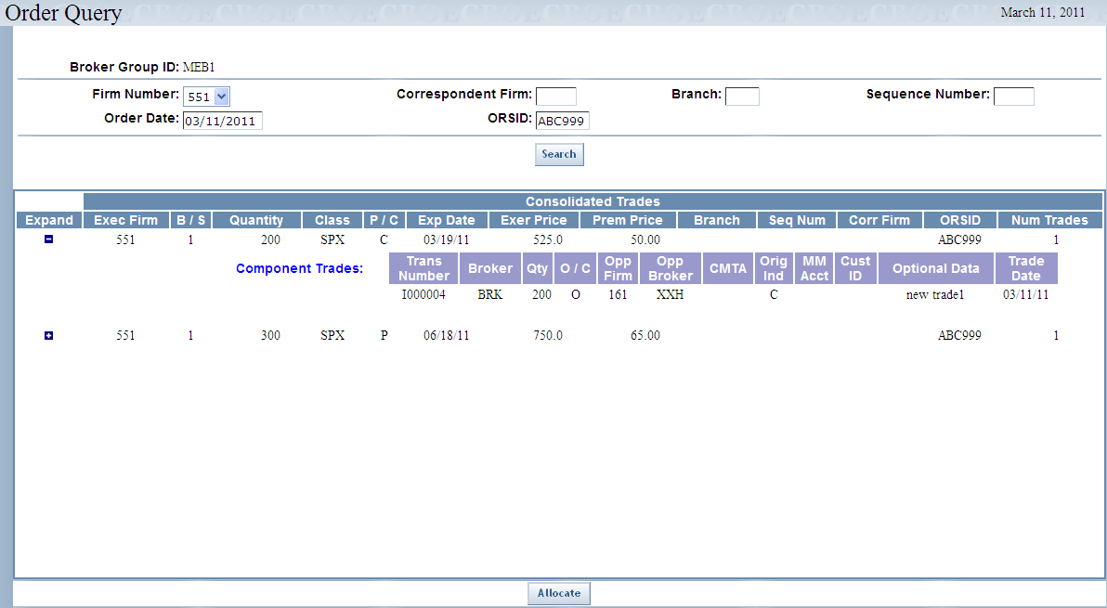

Order Allocation
From the Order Query window, you can split an order quantity on a previously entered order between two or more CMTA Firms. From the Order Query window, click the Allocate button. The following window will display.
 | 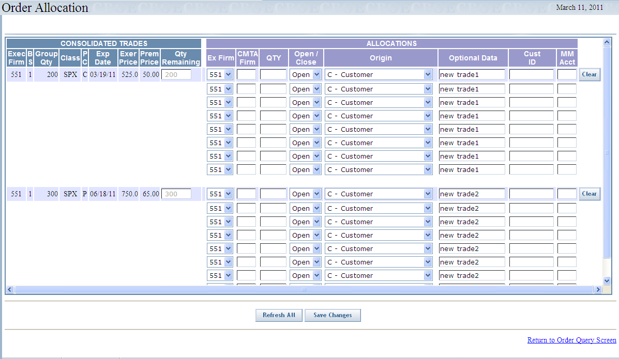
All allocations will initially default to the Open/Close, Origin, Optional Data, Customer ID and MM Account values of the first trade in the rolled-up consolidated trade.
- Based on your setup, you may be allowed to change the Executing Firm field. The Ex Firm drop-down list displays a list of Give-up Firms defined for your Broker Group.
- Enter the CMTA Firm number.
- Enter the quantity you want to allocate to the CMTA Firm. The entire original order quantity must be allocated. If you cannot immediately allocate the entire original quantity, the system will allow you to enter a quantity for CMTA Firm “000” that you can correct later.
- Note: If the order origin is M (Market Maker) or N (Non-CBOE Market Maker), the MM Acct field must have a value.
- Click Clear to remove the data from the text boxes in the allocation section of the screen. Clicking Clear will not remove the initial values of the trade for Open/Close, Origin, Optional Data, Customer ID and MM Account.
- Select Open or Close from the drop down list. You may leave this blank, which is treated like Open.
- You can click Refresh at anytime to bring back the original values in all consolidated groups.
- Click Save Changes. The order quantity will be allocated to the chosen CMTA Firms.
- If at anytime you wish to return to the Order Query window, click Return to Order Query Screen. This will also run a re-query.

App Support

 | The APP Support window allows you to audit changes made by Firm associates or Brokers to exising trades for the current business day.
Audit Query | The Audit Query window allows you to examine changes made to existing trades for your Broker group for the current business day.  To display the Audit Query window, click APP Support and then select Audit Query. The following window will display.
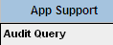 | 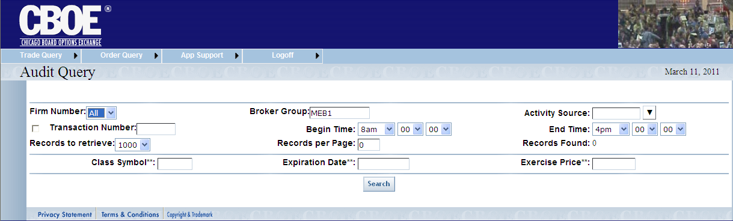
You can generate an audit query by Firm, Broker Group, Transaction Number or Activity Source.
- Select the number of records you would like to retrieve from the Records to retrieve drop down list.
- Enter the number of records to display per page in the Records per Page text field.
- You can also limit the trades to display by Begin Time and End Time.
- After your filters are set, click Search. Your query results will display.

In the example below, the system displays the trade for Transaction Number I000004 pertaining to Firm 551.
 | 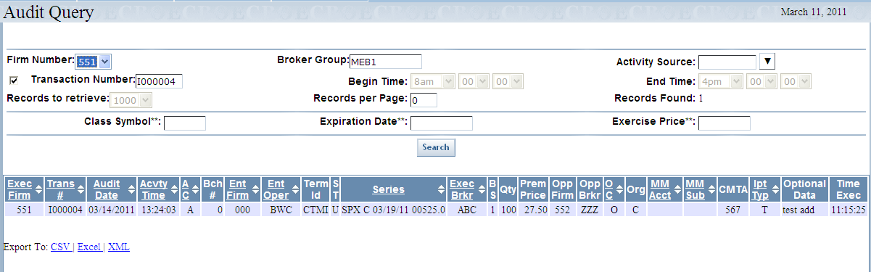
The Records Found field indicates the number of trades found.
Click Next to view the additional trades, if available.
Click Previous to display previously viewed trades.

Exit the System

 | You can log out and exit the system at any time during the day.
Exit the System | To exit the CTM system, click on the Logoff tab and select Logoff CTM. You will be logged out of the application and will be returned to the CTM Login window.
 | - Note: The CTMI system has a timer that inactivates a user who has not recently clicked the mouse or typed on a screen. This requires the user to log back into the system. This insures that displayed data is not too old, and frees up CTMI web resources.

◻ | Section 2:  Reference Guide

Customize and Export CTM Windows

Exporting CTM Data | CTM windows that exhibit data in column format can be exported to different file formats.

Export to CSV Format
- Click CSV (Comma Separated Values). The File Download window will display. The window defaults to Save this file to disk.
 | 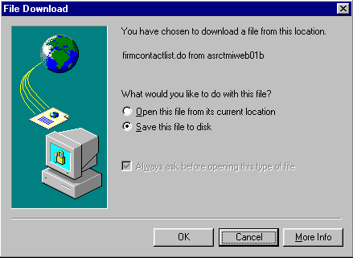
- Click OK. The Save As window displays.
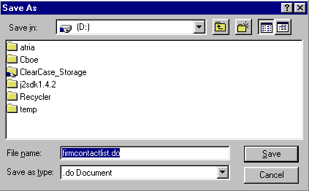
- Select the location where you want to save the file and enter the file name.
- Click Save. Your file will be saved in CVS format.
- To exit the window without saving, click Cancel.
To open the file from the current location:
- Click on the corresponding radio button. The Open With window displays.
 | 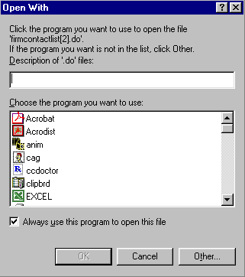
- Select the program in which to display the data.
- Click OK.
- Click Cancel to exit the window.

Export to Excel
If you wish to export the data to an Excel spreadsheet, click Excel. The system will open an Excel window and export the data.
 | 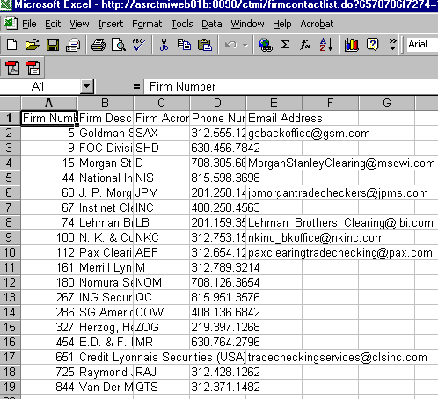

XML Conversion
To convert the data to XML, click XML. A new browser window will open and the data will display in XML format.
 | 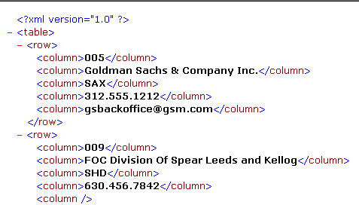
 | Click the right button (X) in the uppder right corner of the window to close the window and return to CTM system.
Sizing CTM Windows | The CTM windows are only as sizable as the browser allows.
 | 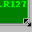 | Place the mouse on any edge of the window until it becomes a two-sided arrow. Hold the left mouse button down and move it to the desired size.
Resizing a window on the corner will expand or contract it in both directions (i.e. up and down and side-to-side). Resizing it on the side or top/bottom will expand or contract the window only in that one direction.
Windows can also be resized using the center glyph in the upper right corner of the window.
 |  | Click the left button () to minimize the window. Click the right button () to close the window. The center button is used for sizing.
If  is displayed, clicking it will increase the window size to a full-screen display.
If  is displayed, clicking it will return the window to its default size.

