

CBOE Trade Match (CTM-I) Member Firms User’s Guide
Version 2.0

Disclaimer

Copyright © 2006-2011 Chicago Board Options Exchange. All rights reserved.
The information contained in this document constitutes confidential and/or trade secret information belonging to CBOE. This document is provided "As Is" with all faults and without warranty of any kind, either expressed or implied.

Change Notices

The following change notices are provided to assist users of the CBOE Trade Match system in determining the impact of changes to their processing.
If you have any questions or review comments about this document, please contact Odalys Castro at (312) 786-8817. For help with the CTMI (Trade Match) system, contact David Glover at (312) 786-7957.

Date | Version | Description of Change
3/21/11 | 2.0 | Captured new screens to support the latest web design.  Updated the CBOE logo.
1/27/10 | 1.4 | Updated all screens to capture the new Audit Query tab  New Audit Query functionality
12/02/08 | 1.3 | New section for Deferred Trades  New Order Query interface
8/15/07 | 1.2 | Included Bulk Update functionality in the Trade Query screen
6/12/07 | 1.1 | Updated Trade Query and Trade Correction screens
12/06/06 | 1.0 | Updated snapshot of Trade Entry screen
10/26/06 | 1.0 | New document

Table of Contents
Table of Contents iii
Introduction v
Purpose v
Intended Audience v
Window Settings v
Note About Displayed Screens v
Conventions Used in this Guide v
Section 1: CBOE Trade Match 6
Getting Started 7
Functionality Restrictions 7
Login 7
Trade Query 8
Functionality Restrictions 8
Options Trade Query 8
Query Options Trade Data 8
Options Trade Correction 10
Options Trade Allocation 13
Data Errors 14
Trade Entry 14
Enter a Trade 15
Trade Message 16
View Fatal Messages 18
Delete a Message 18
Deferred Trades 19
View Deferred Trade Messages 19
Delete a Message 20
Trade CheckingQuery 20
Add Opposite Side of Trade 21
Order Query 24
Functionality Restrictions 24
Order Allocation 25
Firm Maintenance 27
Functionality Restrictions 27
Firm Authorization 27
Firm TCP/IP Socket Password 29
Firm Statistics 31
ORS Correspondent Conversion 31
APP Support 33
Functionality Restrictions 33
Audit Query 33
Security 35
Functionality Restrictions 35
User Maintenance 35
Search Features 35
Add New User 36
Update an Existing User 37
Exit the System 38
Exit the System 38
Section 2: Reference Guide 39
Customize and Export CTM Windows 40
Exporting CTM Data 40
Export to CSV Format 40
Export to Excel 41
XML Conversion 43
Sizing CTM Windows 43

Introduction

Purpose | This user guide was written to assist Member Firms in utilizing the CBOE Trade Match (CTM) features using a web browser.  The CTM system combines the basic functions of the Intra-day Trade Processing (ITP) and Real Time Trade Communication (RTC) systems.
Intended Audience | This user guide is intended for CBOE Options Member Firms interested in the Trade Match administrator and data entry functions.
Window Settings | The recommended resolution to view CTM windows is 1280 x 1024 pixels. If your desktop display is set to a lower resolution, you will have to use the scroll bar to view CTM windows in their entirety.  CTMI functionality is designed to work with Internet Explorer Version 6.x. Using a different browser or version may have unpredictable results.
Note About Displayed Screens | An attempt is made to show the current look and format of screens that are included in this document. However, the displays here may not reflect recent changes to these browser screens. Also, information displayed on the screens may not reflect true production data.
Conventions  Used in this Guide | The CBOE Trade Match system was designed so that you can perform all of your administrative functions from a web browser. All web browser functionality applies to the CTM system.  Section 1 of the document illustrates how to perform the necessary Member Firm functions. Additional information about window configuration and sizing can be found in Section 2: Reference Guide.  There are conventions used throughout this guide to help trigger important information:
 | Bolding | Used to highlight menu selections (e.g., Login) and button names (e.g., Update)
 |  Note: | This notation is used to indicate important information you should note when performing the associated function.

 | Section 1:  CBOE Trade Match

This section of the user guide will direct you through all the Member Firm functions of CBOE’s Continuous Trade Match system using a web browser.
- Note: On most screens pressing the Enter key on your keyboard will accomplish the same process as clicking a highlighted button with the mouse.

Getting Started

 | To launch the CTM application, open an Internet browser window and enter URL: https://tradematch.cboe.com. The following login window will display.
 | 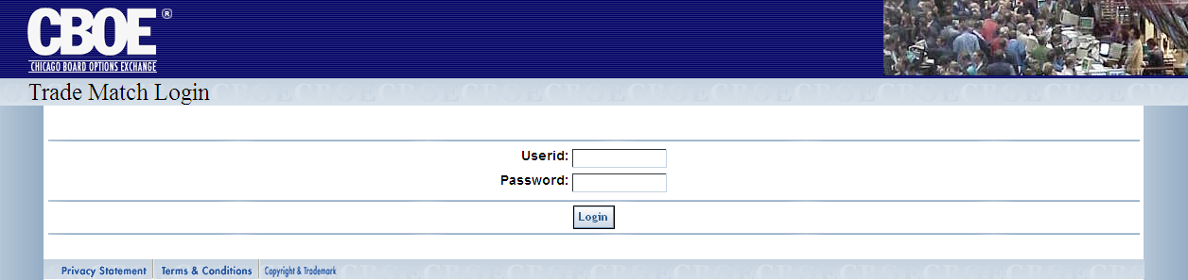
Functionality Restrictions | Functionality restrictions apply based on your User ID, Password and Role.
Login | Enter your User ID and Password. Neither User ID nor Password is case sensitive. If you are setup to use RSA token, in the Password field, type in your password followed by your RSA token value. Do not enter a space between the password and token value.
 | 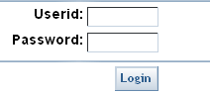
 | Click Login.
The CTM Welcome window will display the TradeQuery, OrderQuery, Firm Maintenance, App Support, Security and Logoff tabs.
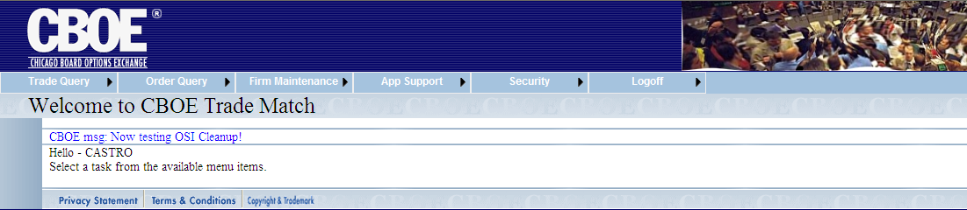
 | You are now ready to perform CTM functions.

 | Trade Query
 | From the Trade Query tab, you can query trades, browse trade messages and enter trades into the system. Click on the Trade Query tab to display the sub-menus for these functions.
Functionality Restrictions | ENTRY level: query trades, correct trades, allocate trades, browse trade messages, reprocess trade messages, enter trades  CONTROL level: browse trade messages, administer firm authorizations, view firm statistics, maintain users and passwords  ALL level: all functions above
Options Trade Query | The CTM trade query functionality allows you to display trade information based on the filters you provide. To display the Trade Query window, click on the Trade Query option. The following window will display.
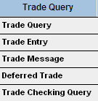 | 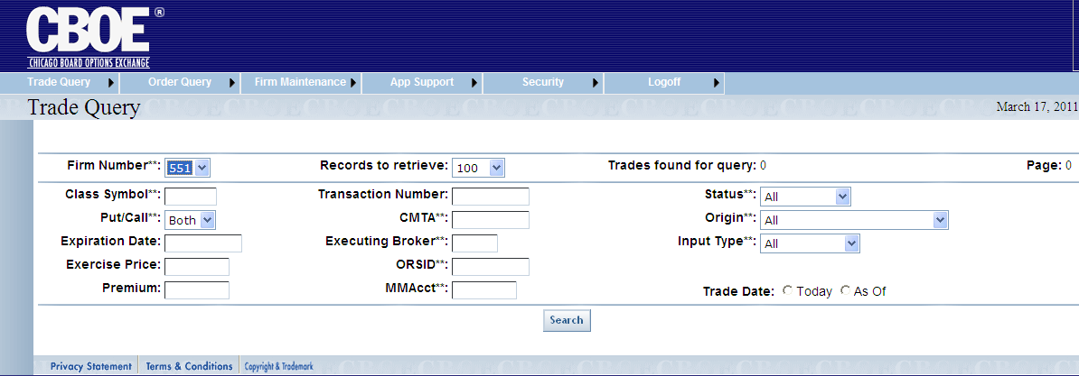

Query Options Trade Data
CTM trade data is queried by using combinations of the fields in the Trade Query window. Below is a description of each field. Fields that have astericks (**) are used for exact match search criteria.
- Firm Number**: refers to the executing Firm’s (EXEC Firm) number. The Firm number is selected from the drop down list.
- Class Symbol**: this is a text field and allows you to enter the class symbol you wish to query (i.e. IBM).

- Put/Call**: refers to the type of option. You can elect to query by Call, Put or Both by making your selection from the dropdown list. The default is Both.
- Expiration Date: this is a text field that allows you to enter the date the security will expire. The allowable format is (MMDDYYYY), or click on the field to display the calendar option.
- Exercise Price: allows you to enter the expiration price of the security. The allowable format is: 42 4 (42<space>4).
- Premium: this is a text field that can be used to enter the premium price of the security. The allowable format is: 72.65.
- Records to retrieve: you can select the number of data rows to display on the window from this dropdown list. The default is 100 rows.
- Transaction Number: trade identification number
- CMTA**: Clearing Member Trade Agreement provides non-member firms (who have clearing numbers with the OCC) a way to trade at the Exchange through member firms who contractually agree to submit trades for them.
- Note: Enter ‘*” in the CMTA field to query trades with no CMTA.
- Executing Broker**: the acronym of the broker executing the trade.
- ORSID: identification number from the ORS system
- MM Account**: allows you to query trades by Market Maker Account.
- Status**: allows you to query by matched or unmatched trades, trades with errors or all trades. Make your selection from the dropdown list.
- Origin**: account type that identifies the type of trade origin. E.g. customer, firm, market maker, etc. Make your selection from the dropdown list.
- Input Type**: the system where the trade was entered.
- Trade Date: to choose the current business day for your query, click Today. To display all trades previous to the current business day, click As of. If neither radio button is selected, both current and As of trades are retrieved.
In the Options example above, the data request is filtered based on Firm 551 for both Puts/Calls for all trades for the current business day. The Status, Origin and Input Types are set to All. The query will display up to 100 records per window.
Click Search. Your query will display.
 | - Note: Some trades returned to the screen may have data errors. Errors by trade will be given in a box in the upper left part of the screen. For details, refer to the Data Errors section, page 15.
 | 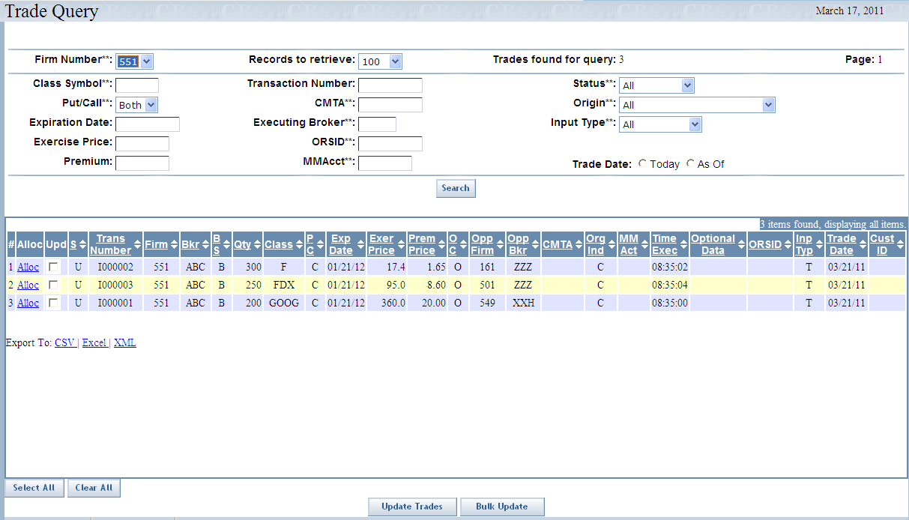
 | Trades found for query shows the count of all stored trades that satisfy the query. However, the window only displays up to the number selected by the Records to retrieve drop-down list.
To view additional trades, click Next Trades.
Click Search at anytime to refresh the window for the current query.
To view trades that were earlier displayed, click Previous Trades.
 | Data columns that display the up/down arrows can be sorted. Click on the column name to perform an ascending or descending sort. This only sorts data last retrieved into the current screen.
 | Clicking on the Export To links on the botton of the page will fill a form with data from the screen in the selected format. For instructions on exporting CTM data to CSV, Excel or XML format, refer to the section Customize and Export CTM Windows, page 43.

Options Trade Correction
You can make corrections to trade data by selecting the Upd (Update) checkbox for a particular data row. To select multiple trades for correction, select the Upd (Update) checkbox for each data row to correct.
If 200 or fewer trades are returned from a query, Select All and Clear All buttons are enabled.
- Click Select All to choose all the Upd (Update) checkboxes.
- Click Clear All to deselect all the Upd (Update) checkboxes.

- Note: Data errors will be shown in a box at the top of the screen. No partial trade corrections are allowed; all errors must be corrected. For details, refer to the Data Errors section, page 15.
Click the Update Trades button at the bottom of the screen. The Trade Correction window will display.
 | 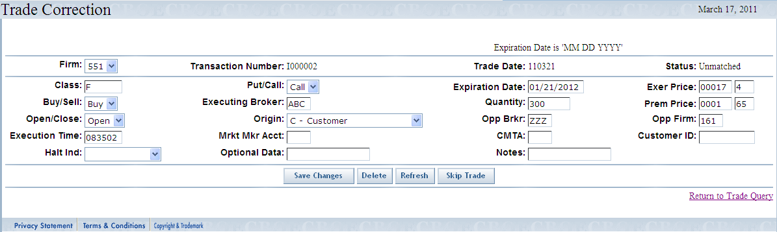
The Firm, Transaction Number, Trade Date, Status and Execution Time cannot be changed.
- Note: The Execution Time can only be changed for terminal entered trades (“T”) or batch trades (“B”).
- Click Refresh at anytime to bring back original values for the displayed trade.
- Make corrections to the desired fields. Click Save Changes. The corrections will be saved in the system.
- Clicking Override allows you to enter the trades into the CTM system with invalid or missing fields.
- Note: If you selected multiple trades for correction from the Trade Query window, the next trade will automatically display. If you wish to skip the trade without making corrections, click Skip Trade.
- If you wish to delete the trade displayed for corrections, click Delete. The trade will be removed from the system.
- Click Return to Trade Query link to exit the Trade Correction window.
 | The Bulk Update feature on the Trade Query window allows you to apply the same corrections to multiple trades at one time.
 | 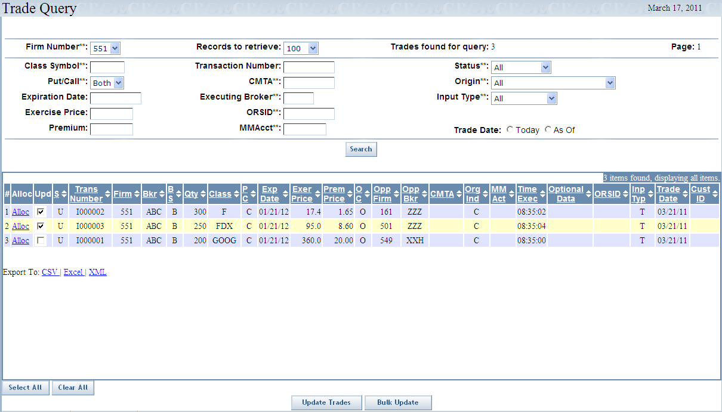
- Click the Select All button or select the Upd checkboxes of the trades you wish to correct.
- Click Bulk Update. The following window will display.
 | 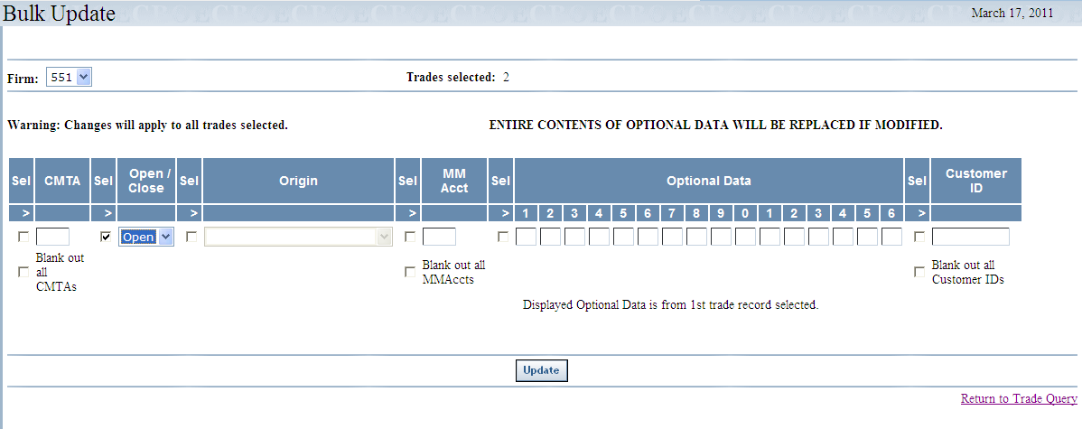
 | Corrections that you make on the Bulk Update screen will apply to the trades you selected on the Trade Query screen. Modifiable fields include: CMTA, Open/Close, Origin, MM Acct and Optional Data.
- A checkbox must be selected for each field to be edited. If you decide not to edit the field, deselect the checkbox.
- The CMTA and MM Acct fields have special checkboxes that indicate those fields will be blanked out on the trades.
- The Optional Data field remains as 16 characters. The field has been split into16 separate text boxes to help you enter data in specific columns; any columns left empty will be filled with blank spaces. Changing even one column in Optional Data will cause the entire 16 character field to be replaced in all trades selected. There are no partial field updates.
- Click Update to enter your changes. The system will display a message text box showing how many successful and unsuccessful updates there were for the selected trades. For any unsuccessful updates another message box will identify those trades and the problem with each of them.
 | 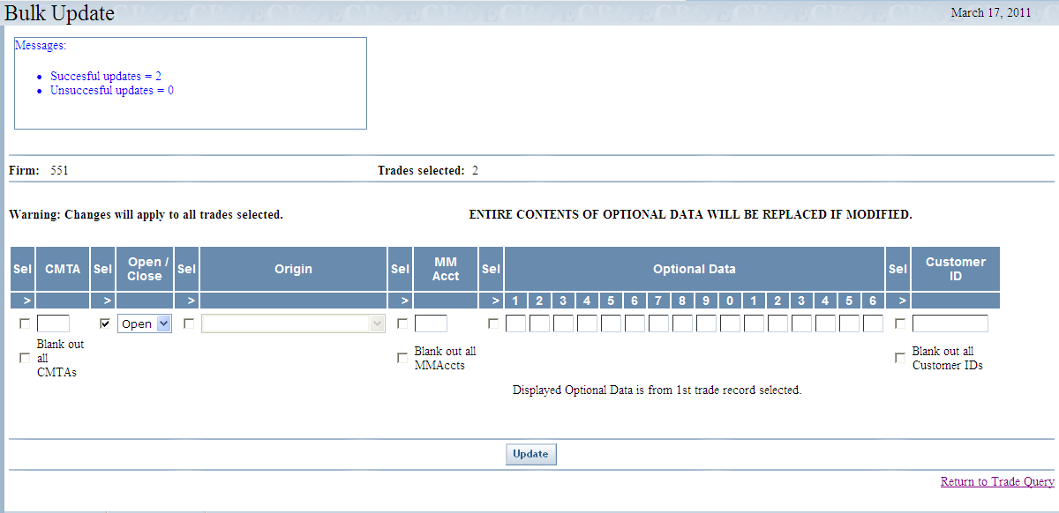
 | - You can return to the Trade Query window at any time by clicking, Return to Trade Query.

Options Trade Allocation
The allocation window allows you to split a contract quantity on a previously entered trade between two or more CMTA Firms. From the Trade Query window, click the Allocation link in the Action column. The following window will display.
- Note: Data errors will be shown in a box at the top of the screen. For details, refer to the Data Errors section, page 15.
 | 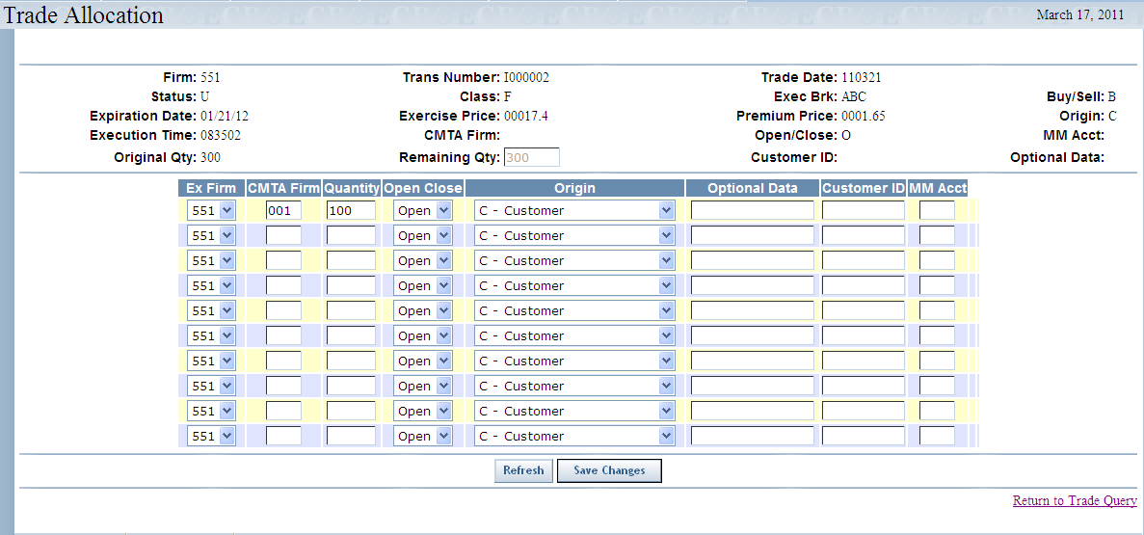
All allocations will initially default to the Open/Close, Origin, and Optional Data values of the original trade.
- Enter the CMTA Firm number.
- Enter the quantity you want to allocate to the CMTA Firm. The entire original trade quantity must be allocated.
- Select Open or Close from the drop down list. You may leave this blank, which is treated like Open.
- You can click Refresh at anytime to clear the data you have entered.
- Click Save Changes. The trade quantity will be allocated to the chosen CMTA Firms.
- If at anytime you wish to return to the Trade Query window, click Return to Query Screen.
 | - Note: Options trades can be allocated even if the original trade has errors.
Data Errors | Data errors for Trade Query windows will be shown in a box at the top of the window. The error box lists all the corrections that need to be made to the identified trade. No partial corrections for a trade will be accepted until all errors are corrected for that trade. All errors must be corrected before a trade can be matched.
 | 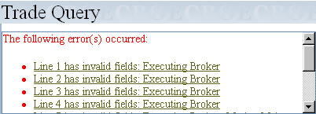
 | Click on the link for a particular error (i.e. Line 1 has invalid fields: Executing Broker). The system will bring you to the selected line in the query. In this example, the Executing Broker field needs to be corrected for the first four errors.
Trade Entry | This Trade Entry window is used to enter trades directly into Trade Match without coming from another data input system.  To open the Trade Entry window, click Trade Query and then select Trade Entry.
 | 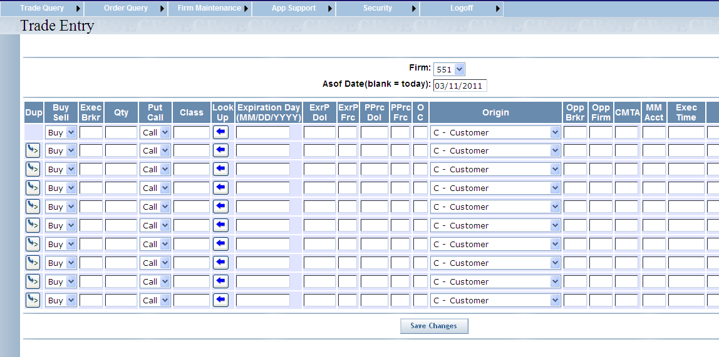

Enter a Trade
- Select the Firm number from the dropdown list.
- Click on the Asof Date text box and a calendar will display. Alternately, you may type in the Asof (trade) date in format mm/dd/yyyy (03/14/2011).
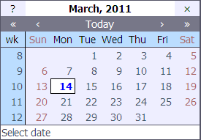
- Select the Asof date you wish to use. If this field is left blank, the data will default to the current day.
- Key in the required trade information. Required fields include: Class, Expiration Month (MM), Expiration Year (YY), Exercise Price, Premium Price, Open/Close, Origin, Opposite Firm (Opp Firm) and Opposite Broker (Opp Brkr).
 | 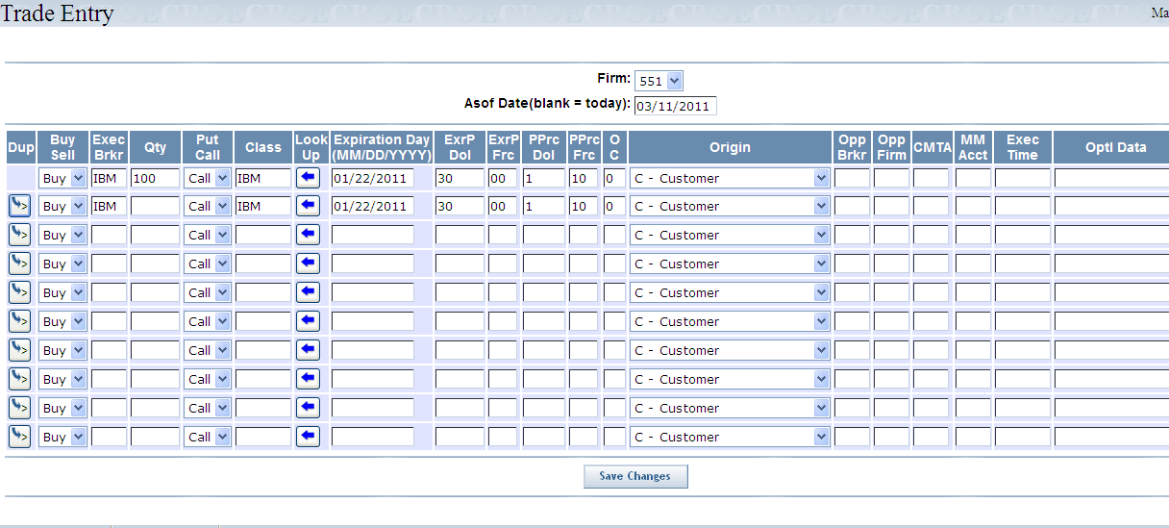
Click to duplicate trade data from previous line. This will not copy quantity, opposite firm and opposite broker.
Click Save Changes. The trades are entered in the system.
The Override button will appear if there are field errors.
Trades that contain edit errors are returned to the screen with the error fields highlighted. These erroneous trades may either be corrected or reentered, or their rejection may be overridden. An invalid OPPOSITE BROKER can be overridden by clicking the Save Changes button a second time. This will not work for other field errors. The trade will have a status of Error.
- Note: This should only be used to force in a trade if the user plans to go back later and correct the fields in error.
 | 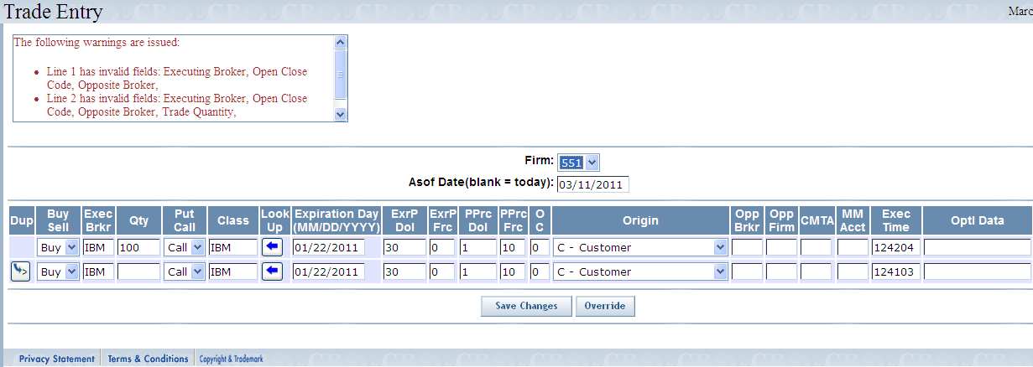
 | All valid trades should have been added and will not be re-displayed at this point. A message will show the number of trades that were added.
Trade Message | The Trade Message window allows you to browse messages for your receiving or sending Firms.  To display the Trade Message window, click on the Trade Query tab and then select Trade Message. The following window will display.
 | 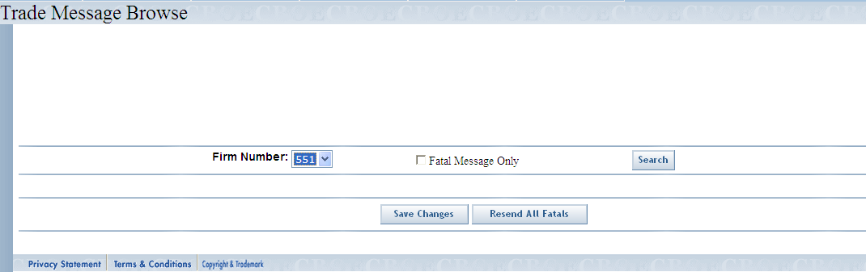
To browse messages for a particular Firm:
- Select the Firm Number from the dropdown list box.
- Click Search. The following window will display.
 | 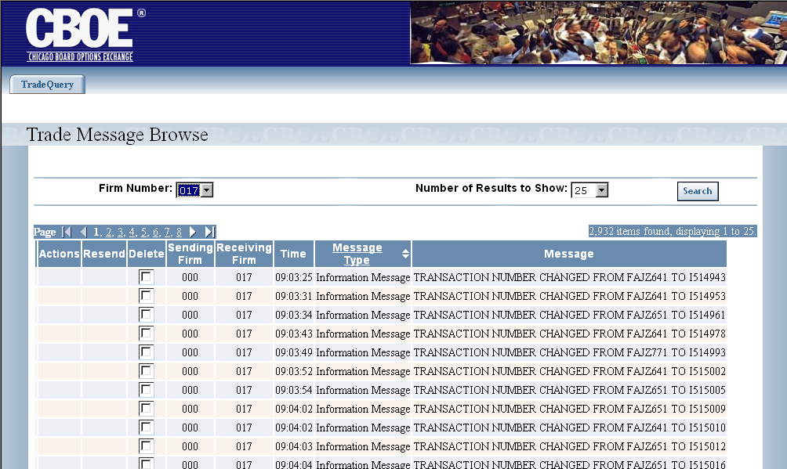
From the Trade Message Browse window you can view the time the message was created along with a description of the message type and the actual message text.
Click the in Message Type column to perform a column sort.

 | To view another page, click on a page number and scroll through the window.
 | 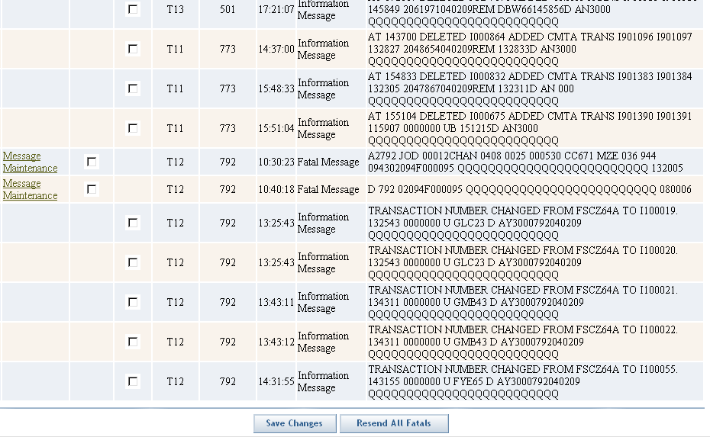
 | To resend fatal messages, click Resend All Fatals. This attempts to take trade fatal messages and add them as new trades.
 | You can select specific Fatal messages to resend by selecting the associated Resend box and clicking on the Save Changes button.

View Fatal Messages
Messages that have serious errors display as Fatal Message types in the Trade Message Browse window.
To view the fatal message and make corrections, click Message Maintenance in the Action column. The following window will display.
 | 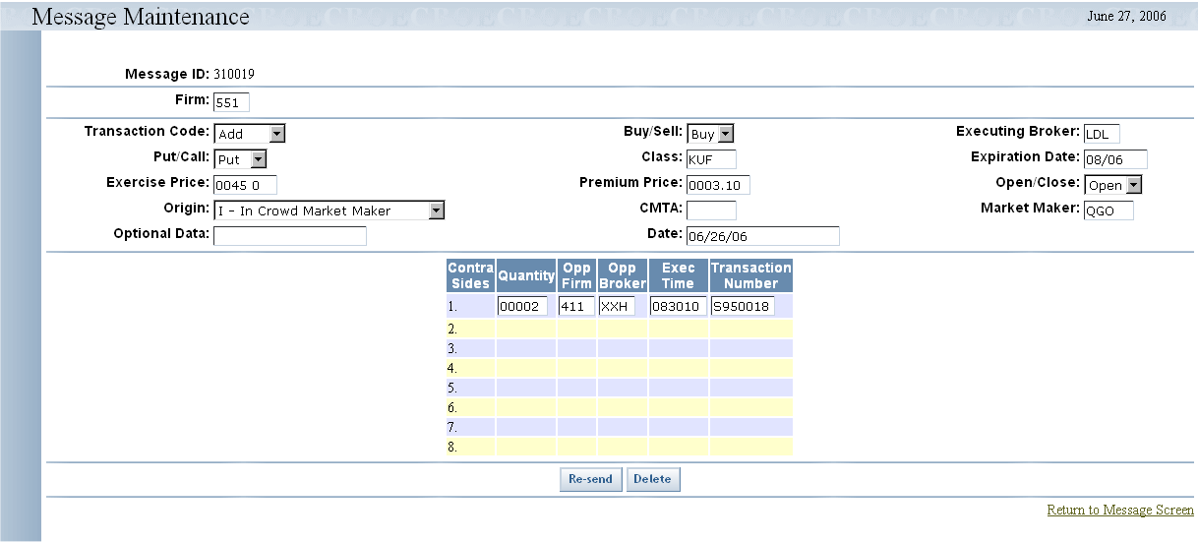
- Select your action from the Transaction Code drop down list. You have the option of adding, changing or deleting trade data.
- Overtype the data fields as required.
- Enter the Contra Sides information, if required.
- Click Re-send. The trade will be resubmitted to CTM for validation.
- Click Return to Message Screen to exit the Message Maintenance window.

Delete a Message
The system allows you to delete informational messages from the Trade Message browser screen.
To delete a message:
- Click on the Delete column check box pertaining to the data row you wish to delete.
- Click Save Changes.
 | Fatal messages can be deleted from the Message Maintenance window by clicking on the Delete button.
Deferred Trades | Certain trades originating in OHS can be marked as ‘deferred,’ which allows them to be reprocessed in CTMi/CTMr so that they can exist as executed trades. These messages are displayed in the Deferred Trade Browse window.  To display the Deferred Trade Browse window, click on the Trade Query tab and then select Deferred Trade. The Deferred Trade Browse window will display. You can browse deferred trades by executing Firms.
To browse deferred trades for a particular Firm:
- Select the Firm Number from the dropdown list box.
- Click Search. The deferred trades will display. By default, all deferred trades are initially displayed if you have full system security access.
 | 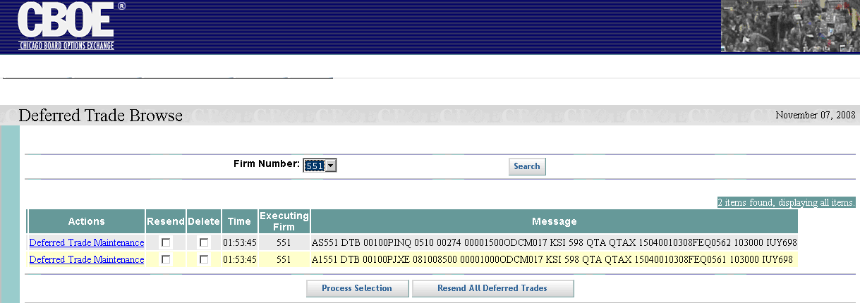
 | From the Deferred Trade window you can view the time the message was created and the actual message text.
 | To resend all deferred trade messages, click Resend All Deferred Trades. This attempts to take deferred trades messages and add them as new trades.
 | You can select specific messages to resend by selecting the associated Resend box and clicking on the Process Selection button.

View Deferred Trade Messages
To view the deferred trades and make corrections, click Deferred Message Maintenance in the Action column. The following window will display.
 | 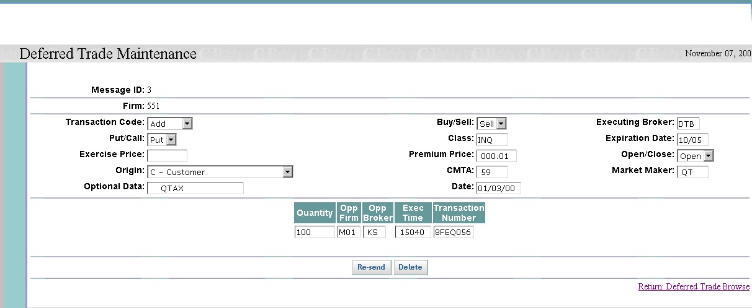
- Select your action from the Transaction Code drop down list. You have the option of adding, changing or deleting trade data.
- Overtype the data fields as required.
- Enter the Contra Side (opposite) information, if required.
- Click Re-send. The trade will be resubmitted to CTM for validation.
- Click Delete if you wish to remove this trade message from the system. You will be prompted to verify the delete request.
- Click Return: Deferred Trade Browse to exit the Deferred Trade Maintenance window.

Delete a Message
The system allows you to delete deferred trade messages from the Deferred Trade Browse screen.
To delete a message:
- Click on the Delete column check box pertaining to the data row you wish to delete.
- Click Process Selection. You will be prompted to verify the delete request.
 | Deferred Trade messages can be deleted from the Deferred Trade Maintenance window by clicking on the Delete button.
Trade CheckingQuery | The CTM trade checking query allows you to display trade information for your Firm. To display the Trade Checking Query window, click on the Trade Query tab and then select Trade Checking Query. The following window will display.
 | 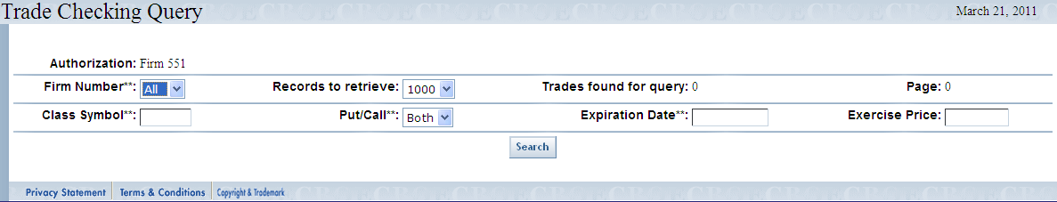
The Authorization field defaults to your Firm. You can filter your query by Firm Number, Class Symbol, Put/Call, Expiration Date or Exercise Price. The query will display up to 1000 records per window.
The above filter is set to query for all Firms and for both puts and calls. Click Search. The following window will display.
 | 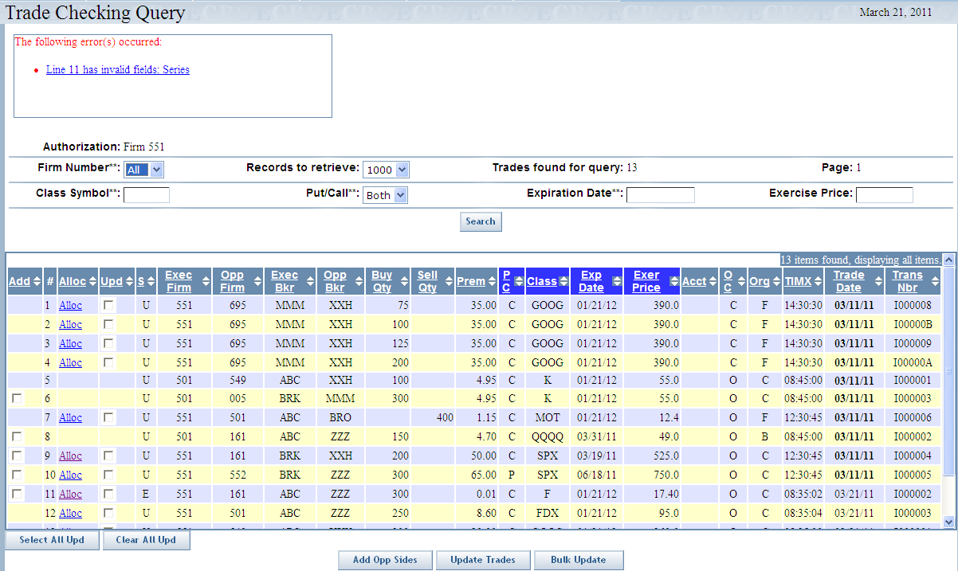
Trades found for query shows the count of all stored trades that satisfy the query. However, the window only displays up to the number selected by the Records to retrieve drop-down list.
Click Search at anytime to refresh the window for the current query.
 | Data columns that display the up/down arrows can be sorted. Click on the column name to perform an ascending or descending sort. This only sorts data last retrieved into the current screen.

Add Opposite Side of Trade
The trade checking query window allows you to add the opposite side of a trade on a previously entered trade. From the Trade Checking Query window, click the checkbox in the Add column. The following window will display.
 | 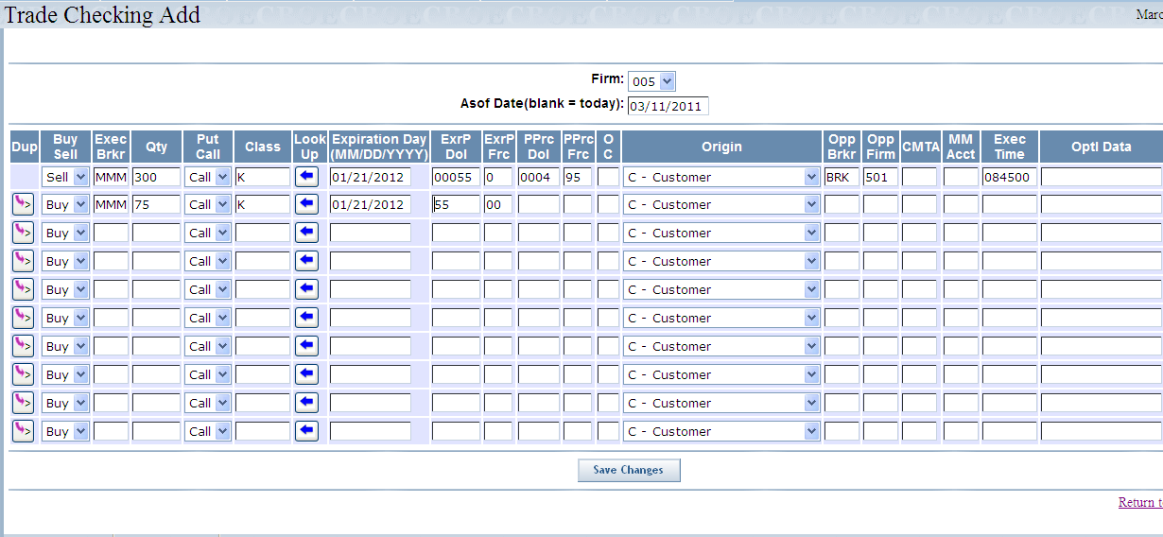
The original trade displays on the top row.
- Select the Firm number from the dropdown list.
- Click on the Asof Date text box and a calendar will display. Alternately, you may type in the Asof (trade) date in format mm/dd/yyyy (03/11/2011).
- To enter the opposite side of the trade:
  - Click to duplicate trade data from previous line. This will not copy quantity, opposite firm and opposite broker.
  - Or, key in the required trade information. Required fields include: Exec Broker, Quantity, Put/Call, Buy/Sell, Execution Time, Class, Expiration Day (MMDDYYYY), Exercise Price, Premium Price, Open/Close, Origin, Opposite Firm (Opp Firm) and Opposite Broker (Opp Brkr).

 | You can predefine the trade entry product information by clicking . The Product Lookup window will display.
 | 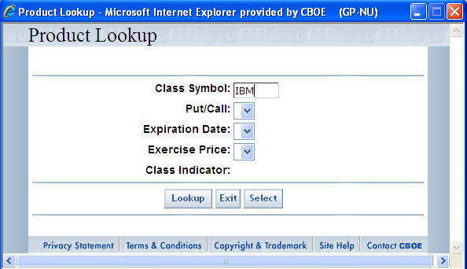
 | Enter the Class Symbol and click Lookup.
 | 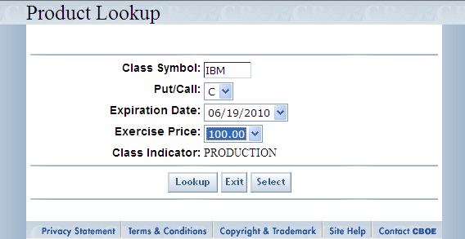
The window display choices for Put/Call, Expiration Date and Exercise Price. Make your product selections from the drop down lists. The Class Indicator defaults to Production.
Click Exit to close the Product Lookup window.
Click Select to copy your selection to the Trade Checking Add window.
 | From the Trade Checking Add window, click Save Changes. The opposite trades are entered in the system.
 | Based on your permissions setup, you can make corrections to trade data from the Trade Checking Query window. For trade correction instructions, refer to the Error: Reference source not found section above.
 | The allocation window allows you to split a contract quantity on a previously entered trade between two or more CMTA Firms. From the Trade Checking Query window, click the Allocation link in the Alloc column. For instructions on how to perform trade allocations, refer to the Error: Reference source not found section above.

Order Query

 | The Order Query window allows you to search for your individual Firm orders and related member Firms.
Functionality Restrictions | ENTRY level: Order Query, Order Allocation  CONTROL level: N/A  ALL level: Order Query, Order Allocation
 | The CTM order query functionality allows you to display information on executed orders based on the filters you provide. To display the Order Query window, click on the Order Query option. The following window will display.
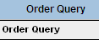 | 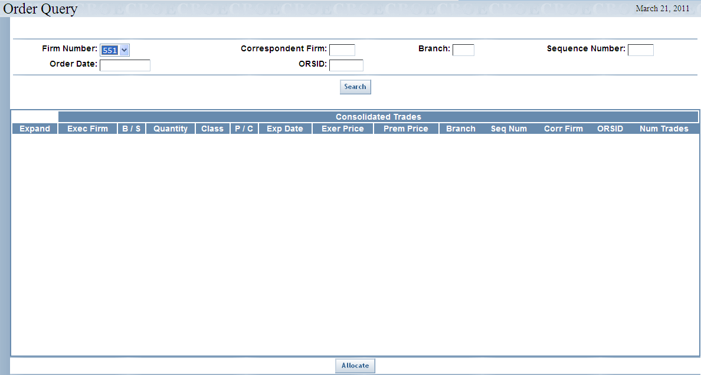
When you initially open the Order Query window, your Firm number is the only field that is populated. In order to display order information, you must enter the Order Date and ORSID or the Order Date, Correspondent Firm, Branch and Sequence Number.
- Note: Data errors will be shown in a box at the top of the screen.
- Note: Click on the Order Date field to display the date calendar.
Click Search. Consolidated Trade information will display.
- Note: An order is based on identical Executing Firm, Order Data and either ORSID or Correspondent Firm, and Sequence Number. A Consolidated Trade is trade information in common for a group of executed trades within an order. To be included in a Consolidated Trade, the individual trades must have the same Buy/Sell, Class Symbol, Put/Call, Expiration Date, Exercise Price, and Premium Price. An order can be comprised of one or more Consolidated Trades.
 | 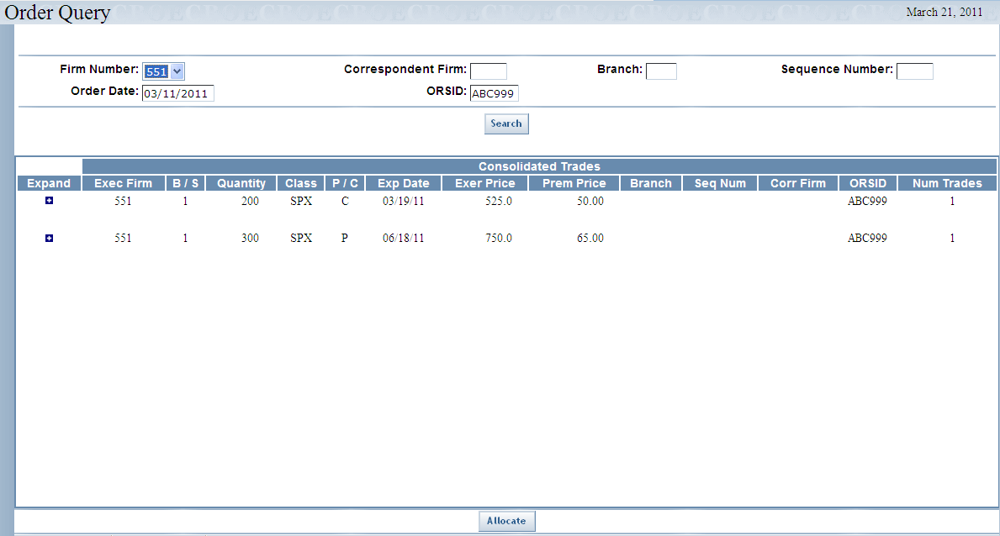
The example above shows Firm Number: 551 and ORSID: ABC999.
If you click on the Expand icon (+/-) you can see details of individual trades rolled into the Consolidated Trade.

 | 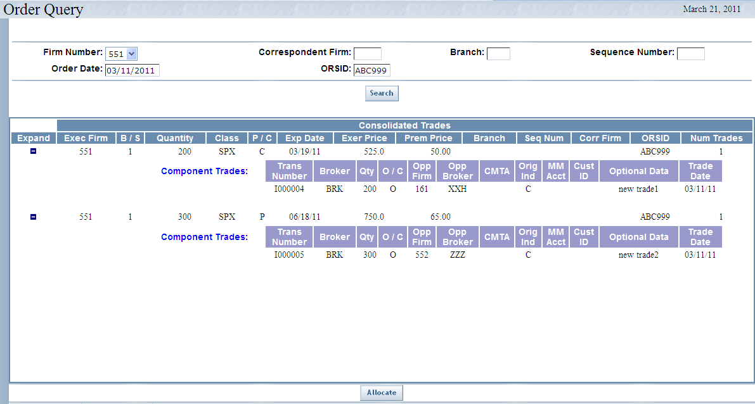

Order Allocation
From the Order Query window, you can split an order quantity on a previously entered order between two or more CMTA Firms. From the Order Query window, click the Allocate button. The following window will display.
 | 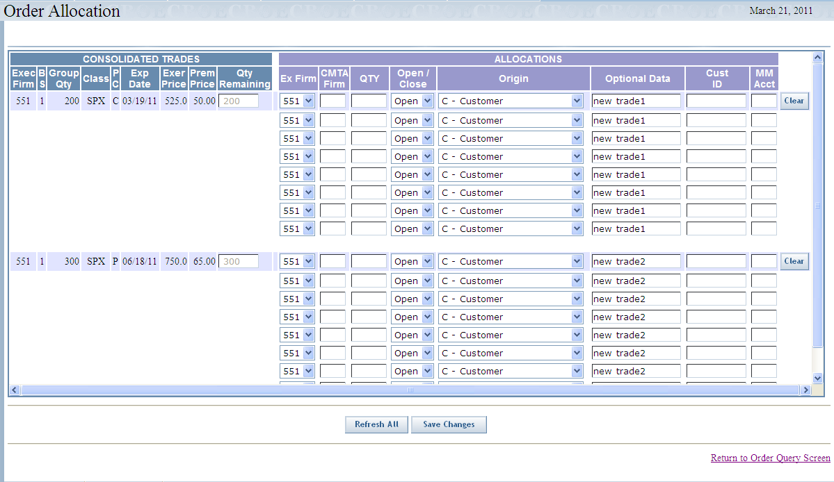
All allocations will initially default to the Open/Close, Origin, Optional Data, Customer ID and MM Account values of the original trade.
- Enter the CMTA Firm number.
- Enter the quantity you want to allocate to the CMTA Firm. The entire original order quantity must be allocated. If you cannot immediately allocate the entire original quantity, the system will allow you to enter a quantity for CMTA Firm “000” that you can correct later.
- Note: If the order origin is M (Market Maker) or N (Non-CBOE Market Maker), the MM Acct field must have a value.
- Click Clear to remove the data from the text boxes in the allocation section of the screen. Clicking Clear will not remove the initial values of the trade for Open/Close, Origin, Optional Data, Customer ID and MM Account.
- Select Open or Close from the drop down list. You may leave this blank, which is treated like Open.
- You can click Refresh at anytime to bring back the original values in all consolidated groups.
- Click Save Changes. The order quantity will be allocated to the chosen CMTA Firms.
- If at anytime you wish to return to the Order Query window, click Return to Order Query Screen. This will also run a re-query.

Firm Maintenance

 | The Firm Maintenance window enables you to perform maintenance functions for your individual Firm and related member Firms.
Functionality Restrictions | ENTRY level: N/A  CONTROL level: Firm Authorization, Firm Statistics, ORS Correspondent Conversion  ALL level: Firm Authorization, Firm TCP/IP Socket Password, Firm Statistics, ORS Correspondent Conversion
Firm Authorization | The Firm Authorization window allows you to view which Firms are authorized to perform entry, maintenance or reporting functions for their Firms. Firm operators can also add and delete authorizations for their Firms.  Click Firm Maintenance and then select Firm Authorization. The Firm Authorization window will display.
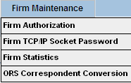 | 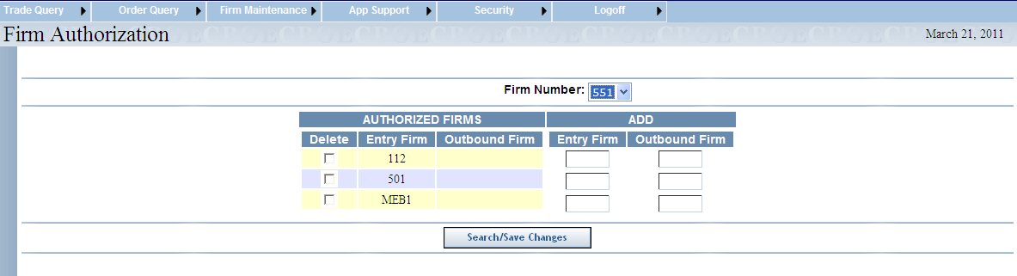
To display Firms that are currently authorized to perform CTM functions:
- Select the Firm Number from the dropdown list box.
- Click Search/Save Changes. The authorized Firms will display.
To authorize a new Firm to enter, correct or allocate trades:
- Enter the Firm’s entry clearing number in the Entry Firm text box.
- Enter the Firm’s outbound clearing number in the Outbound Firm text box to receive outbound trade data and reports.
- Click Search/Save Changes. The new authorized Firm will display in the Authorized Firms column.
 | 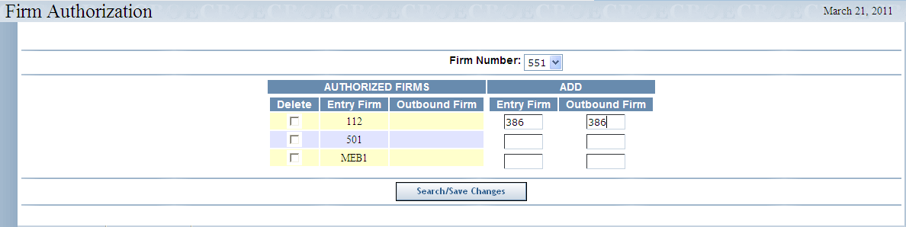
If you wish to remove a Firm’s authorization:
- Select the Delete check box for the desired Firm from the Authorized Firms column.
- Click Search/Save Changes.
 | 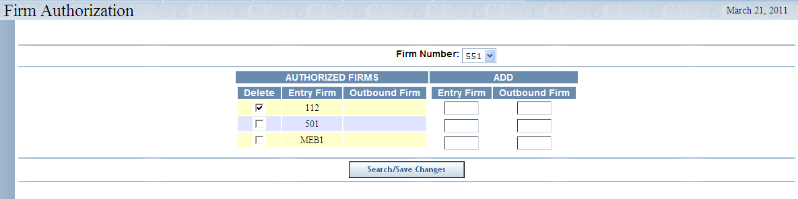
 | The system will prompt you to verify you wish to delete the Firm’s authorization.
 | 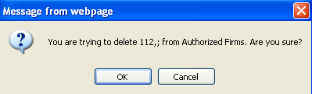
Click OK to proceed with the deletion.
If you decide not to remove the Firm’s authorization, click Cancel.
Firm TCP/IP Socket Password | This CTM application allows you to set TCP/IP (RTC) socket passwords.  Click Firm Maintenance and then select Firm TCP/IP Socket Password. The following window will display.
 | 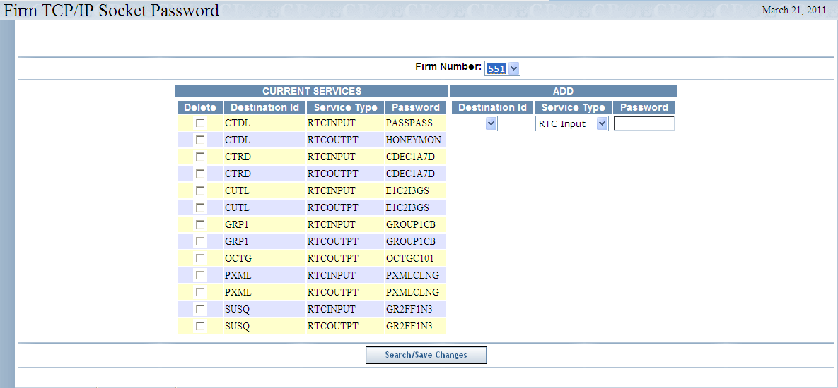
To display the current services:
- Select the Firm Number from the dropdown list.
- Click Search/Save Changes. The services for the selected Firm will display in the Current Services column.
 | 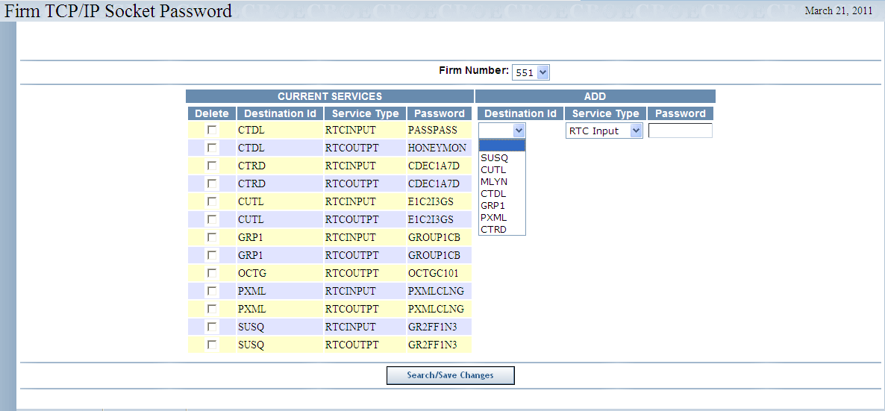
To add a new service:
- From the Add column, select the Destination ID and Service Type from the corresponding dropdown lists.
- Enter the password in the Password text box. To change the password, you must delete it and then re-add the new password.
  - Note: The password must be eight characters.
- Click Search/Save Changes. The new service will display in the Current Services column.
 | 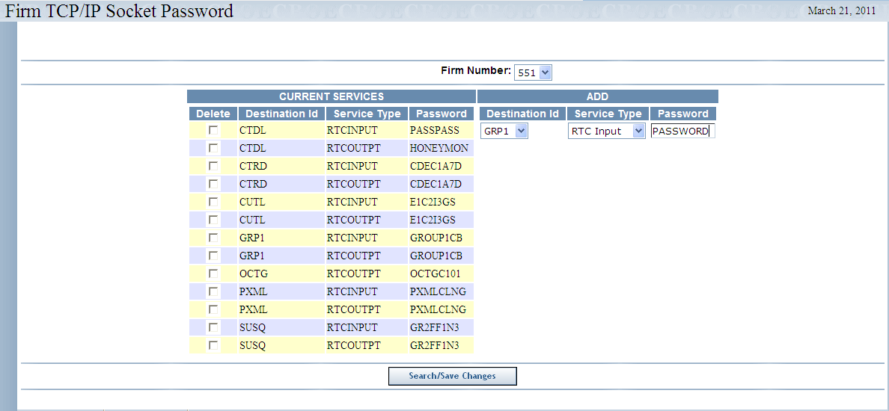
To delete a current service:
- From the Current Services column, select the Delete check box for the service you wish to remove.
- Click Search/Save Changes.
 | 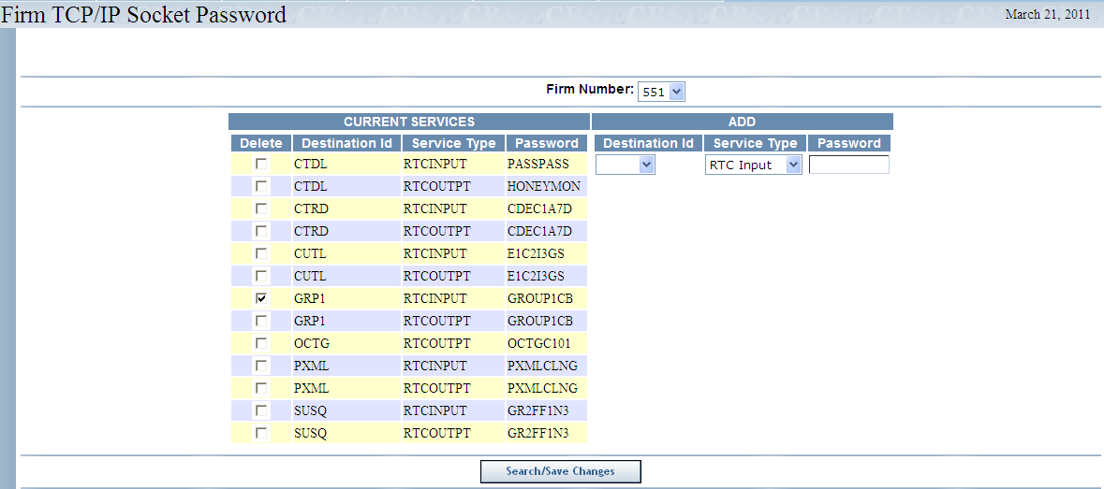
 | The system will prompt you to confirm your delete request.
 | 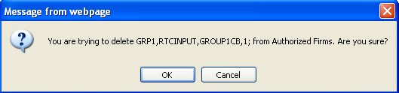
- Click OK to proceed with the delete.
- Click Cancel to remove your request.
Firm Statistics | This window allows you to view the number of records and contracts that have been entered into the CTM system associated with your Firm.  To display the Firm Statistics window, click Firm Maintenance and then select Firm Statistics.
 | 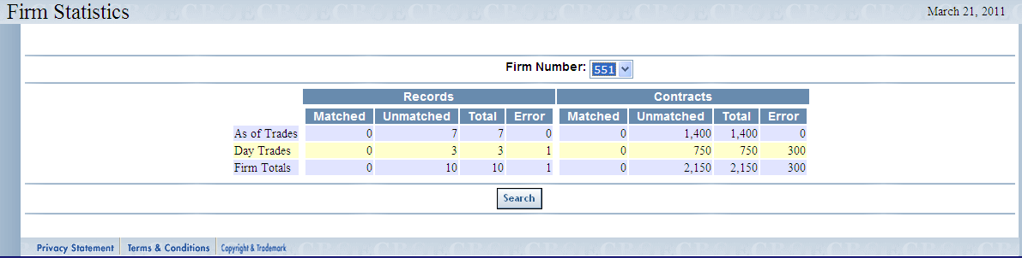
- Select your Firm’s number from the Firm Number dropdown list.
- Click Search. The number of records and contracts that were entered into the CTM system for your Firm will display.
ORS Correspondent Conversion | The ORS Correspondent Conversion window displays the list of certain customers with which the Executing Firm has a current trading agreement. This window allows you to add or delete CMTA information.  Click Firm Maintenance and then select ORS Correspondent Conversion. The following window will display
 | 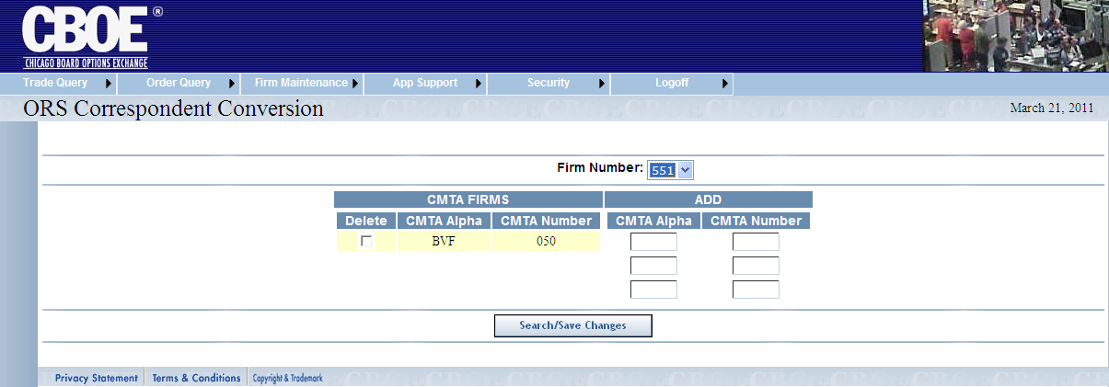
To view the list of CMTA Firms that require an alpha-to-numeric conversion:
- Select your Firm Number from the drop down list.
- Click Search/Save Changes. Eligible customer acronyms and CMTA numbers will display in the CMTA Firms column.

To add a new CMTA customer:
- Enter the customer’s acronym in the CMTA Alpha text box in the Add column.
- Enter the customer’s CMTA Number in the corresponding text box in the Add column. In the example below, 002 was entered as the CMTA Number. If you enter “2” instead of “002”, CTM will accept the number as valid.
- Click Search/Save Changes.
  - Note: Duplicate entries are not allowed.
 | 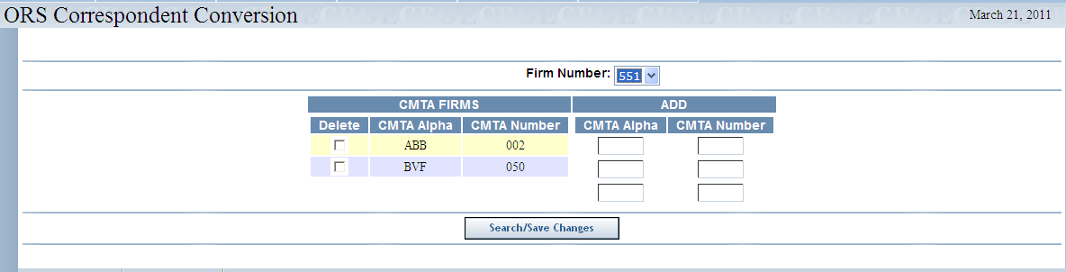
 | The new customer’s acronym and CMTA number will display in the CMTA Firms column.
To remove a CMTA Firm:
- Select the Delete check box for the chosen Firm.
- Click Search/Save Changes.
 | 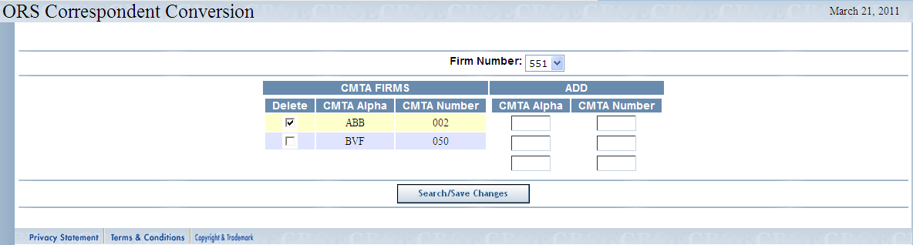
 | The system will prompt you to confirm your delete request.
 | 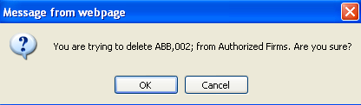
- Click OK to proceed with the delete.
- Click Cancel to remove your request.

APP Support

 | The APP Support window allows you to audit changes made by Firm associates or Brokers to exising trades for the current business day.
Functionality Restrictions | ENTRY level: N/A  CONTROL level: authorized to perform data security control functions only for your Firm and associated Firms. These functions include setting users and passwords.  ALL level: access to all functions authorized Firm access.
Audit Query | The Audit Query window allows you to examine changes made to existing trades for your Firm for the current business day.  To display the Audit Query window, click APP Support and then select Audit Query. The following window will display.
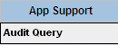 | 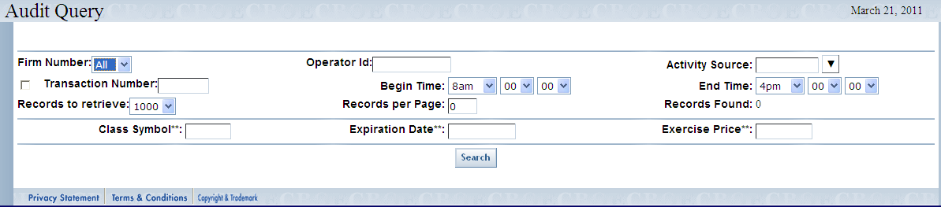
You can generate an audit query by Firm, Operator ID, Transaction Number or Term ID (Terminal ID, interface for trade modification).
- Valid values for the Term ID include:
  - CTMi - change through online CTMi
  - BRKR - online changes by a broker
  - BTCH - changes through a batch load
  - MMHH - changes from the Market Maker handheld system
  - ctmi - changes from FIX interface
  - SB02 (etc.) - changes (particularly adds) from CBOEdirect
  - FOCO (etc.) - changes from RTC input (marked by destination ID)
- Select the number of records you would like to retrieve from the Records to retrieve drop down list.
- Enter the number of records to display per page in the Records per Page text field.
- You can also limit the trades to display by Begin Time and End Time.
- After your filters are set, click Search. Your query results will display.
In the example below, the system displays all the trades pertaining to Firm 551 on 3/21/2011 (current business day) between the hours of 8a.m. and 4p.m.

 | 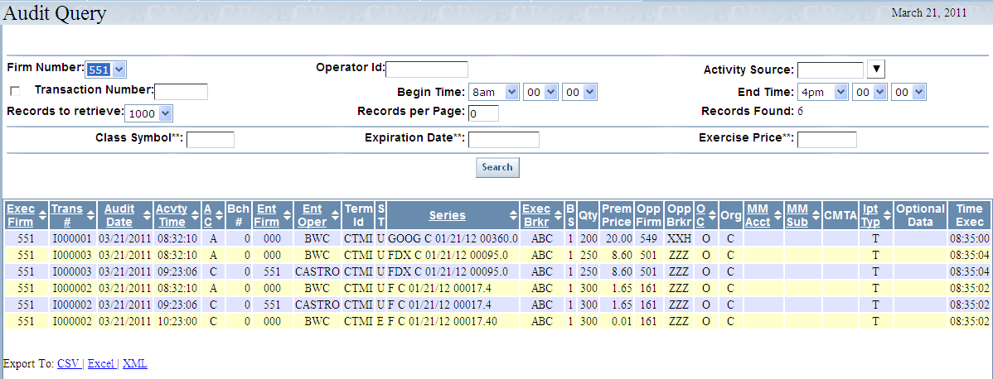
The Records Found field indicates the number of trades found.
Click Next to view the additional trades, if available.
Click Previous to display previously viewed trades.

Security

 | The Security window allows you to perform data security functions for your Firm and associated Firms.
Functionality Restrictions | ENTRY level: N/A  CONTROL level: authorized to perform data security control functions only for your Firm and associated Firms. These functions include setting users and passwords.  ALL level: access to all functions authorized Firm access.
User Maintenance | From the User Maintenance window, you can perform searches for existing users, add new users and update existing users.  Click Security and then select User Maintenance.
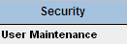 | 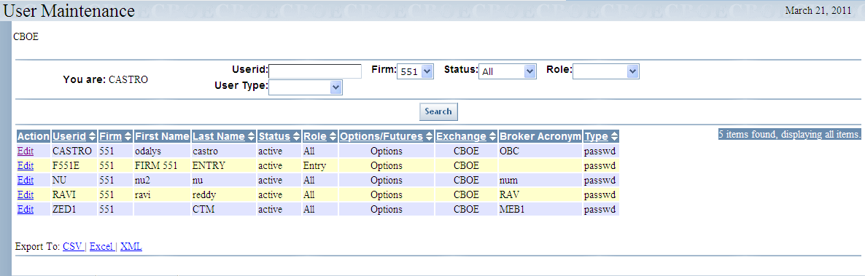
 | The User Maintenance window displays with your Firm’s users information. The window above shows users for Firm 551.

Search Features
To search by Userid:
- Enter the user’s ID with the prefix CTM_ in the Userid text box. For example, if you want to search for user CASTRO, you must enter CTM_CASTRO in the Userid text field.
- The Firm number defaults to your Firm.
- Click Search. The user with the corresponding User ID will display.
 | 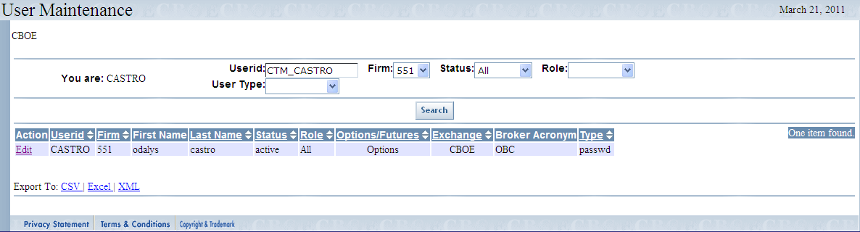
To search by status:
- Select the user’s Status from the dropdown list.
- The Firm number defaults to your Firm.
- Click Search.
 | 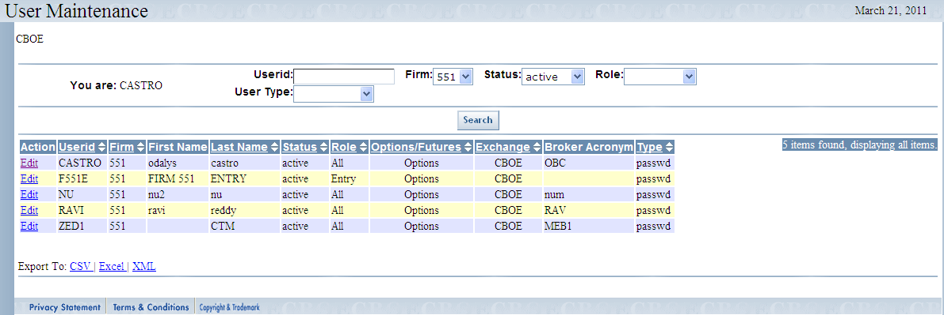
To search by role:
- Select the user’s Status from the dropdown list.
- The Firm number defaults to your Firm.
- Choose the user’s Role from the dropdown list.
- Click Search.
 | 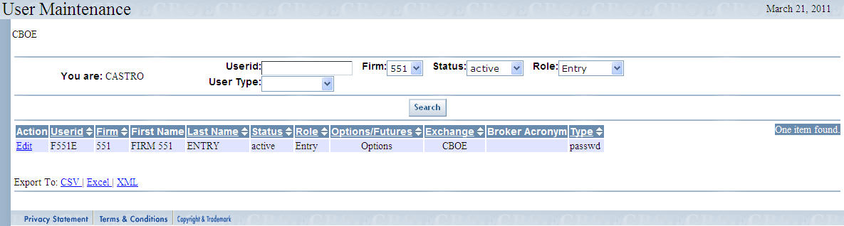

Add New User
To add a new Firm user, click Add User. The User Edit window will display.
 | 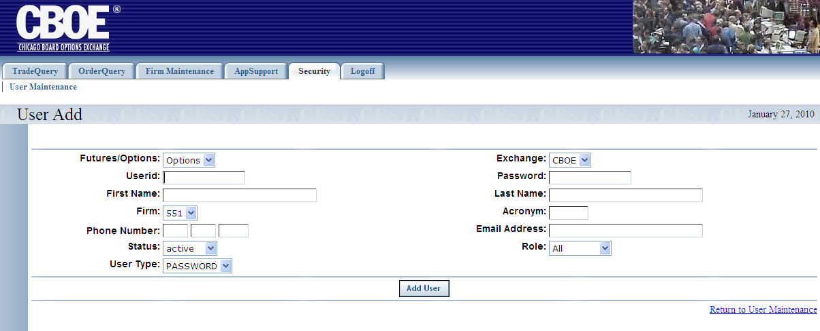
- The window defaults to Options, your Firm number, a Status of active, Exchange equal to CBOE and Role set to All.
- Select Firm from the dropdown list.
- Enter the Userid and Password in the corresponding text fields.
- Insert the user’s First Name and Last Name, Acronym, Phone Number (optional) and Email address (optional).
- Select if the user is active or disabled from the Status dropdown list.
- Enter the user’s security Role.
- Click Save Changes.
- To view the new user addition, click Return to User Maintenance. The system will return to the User Maintenance window displaying the new user’s information.

Update an Existing User
To update an existing user, click the Edit link in front of the user’s name. The User Edit window will display the user’s information.
 | 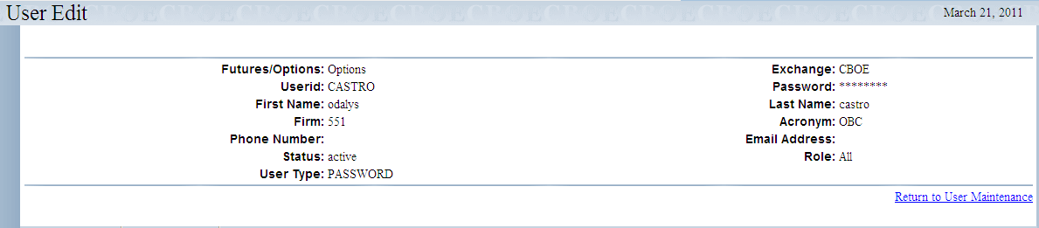
- Change any of the information as you desire.
- Click Save Changes.
- To view the updated user information, click Return to User Maintenance. The system will return to the User Maintenance window displaying the updated user’s information.
 | - Note: The Password is encrypted and cannot be displayed. If a password is forgotten someone with proper authority can change it. Unused or unneeded user IDs should be set to disabled status and a request should be made to have it deleted.

Exit the System

 | You can log out and exit the system at any time during the day.
Exit the System | To exit the CTM system, click on the Logoff tab and select Logoff CTM. You will be logged out of the application and will be returned to the CTM Login window.
 | - Note: The CTMI system has a timer that inactivates a user who has not recently clicked the mouse or typed on a screen. This requires the user to log back into the system. This insures that displayed data is not too old, and frees up CTMI web resources.

◻ | Section 2:  Reference Guide

Customize and Export CTM Windows

Exporting CTM Data | CTM windows that exhibit data in column format can be exported to different file formats.

Export to CSV Format
- Click CSV (Comma Separated Values). The File Download window will display. The window defaults to Save this file to disk.
 | 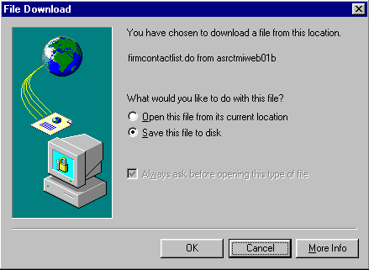
- Click OK. The Save As window displays.
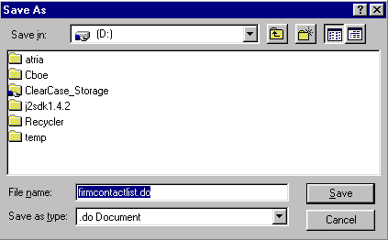
- Select the location where you want to save the file and enter the file name.
- Click Save. Your file will be saved in CVS format.
- To exit the window without saving, click Cancel.
To open the file from the current location:
- Click on the corresponding radio button. The Open With window displays.
 | 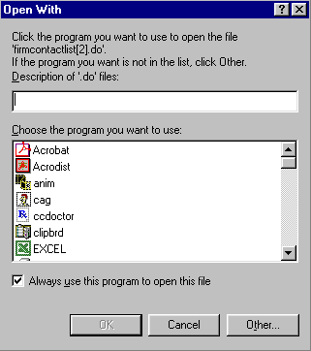
- Select the program in which to display the data.
- Click OK.
- Click Cancel to exit the window.

Export to Excel
If you wish to export the data to an Excel spreadsheet, click Excel. The system will open an Excel window and export the data.
 | 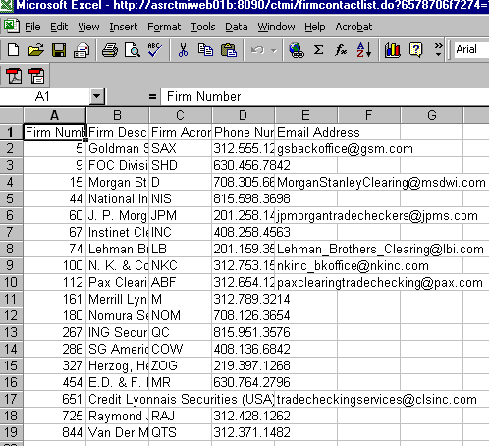

XML Conversion
To convert the data to XML, click XML. A new browser window will open and the data will display in XML format.
 | 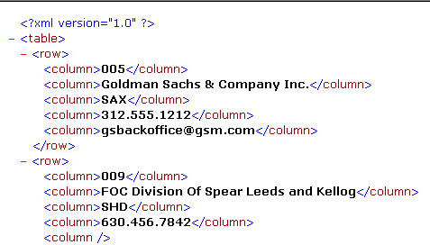
 | Click the right button (X) in the uppder right corner of the window to close the window and return to CTM system.
Sizing CTM Windows | The CTM windows are only as sizable as the browser allows.
 | 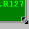 | Place the mouse on any edge of the window until it becomes a two-sided arrow. Hold the left mouse button down and move it to the desired size.
Resizing a window on the corner will expand or contract it in both directions (i.e. up and down and side-to-side). Resizing it on the side or top/bottom will expand or contract the window only in that one direction.
Windows can also be resized using the center glyph in the upper right corner of the window.
 |  | Click the left button () to minimize the window. Click the right button () to close the window. The center button is used for sizing.
If  is displayed, clicking it will increase the window size to a full-screen display.
If  is displayed, clicking it will return the window to its default size.

