

CTM-I
OneChicago Member Firms Post Trade Processing (PTP) User’s Guide
Version 1.2

Disclaimer

Copyright © 2006-2007 Chicago Board Options Exchange. All rights reserved.
The information contained in this document constitutes confidential and/or trade secret information belonging to CBOE. This document is provided "As Is" with all faults and without warranty of any kind, either expressed or implied.

Change Notices

The following change notices are provided to assist users of the CBOE Trade Match system in determining the impact of changes to their processing.
If you have any questions or review comments about this document, please contact Odalys Castro at (312) 786-8817. For help with the OneChicago System, contact OneChicago at (312) 424-8500.

Date | Version | Description of Change
8/16/07 | 1.2 | No changes
6/12/07 | 1.1 | Updated Futures Trade Query screens
10/24/06 | 1.0 | New document

Table of Contents
Table of Contents ii
Introduction ii
Purpose ii
Intended Audience ii
Window Settings ii
Note About Displayed Screens ii
Conventions Used in this Guide ii
Section 1: OneChicago Post Trade Processing 2
Getting Started 2
Functionality Restrictions 2
Login 2
Trade Query 2
Functionality Restrictions 2
Futures Trade Query 2
Query Futures Trade Data 2
Futures Trade Allocation 2
Futures Trade Correction 2
Firm Release Request 2
Firm Release Accept 2
Data Errors 2
Firm Maintenance 2
Functionality Restrictions 2
Firm Authorization 2
Security 2
Functionality Restrictions 2
User Maintenance 2
Search Features 2
Add New User 2
Update an Existing User 2
Exit the System 2
Exit the System 2
Section 2: Reference Guide 2
Customize and Export Windows 2
Exporting Data 2
Export to CSV Format 2
Export to Excel 2
XML Conversion 2
Sizing Windows 2

Introduction

Purpose | This user guide was written to assist Member Firms in utilizing CBOE’s OneChicago PTP system features using a web browser.  This web-based application interface replaces the CICS version of OneChicago Post Trade Processing.
Intended Audience | This user guide is intended for OneChicago Member Firms interested in the post-trade processing administrator and data entry functions.
Window Settings | The recommended browser resolution is 1280 x 1024 pixels. If your desktop display is set to a lower resolution, you will have to use the scroll bar to view the windows in their entirety.
Note About Displayed Screens | An attempt is made to show the current look and format of screens that are included in this document. However, the displays here may not reflect recent changes to these browser screens. Also, information displayed on the screens may not reflect true production data.
Conventions  Used in this Guide | The OneChicago PTP system was designed so that you can perform all of your administrative functions from a web browser. All web browser functionality applies this system.  Section 1 of the document illustrates how to perform the necessary Member Firm functions. Additional information about window configuration and sizing can be found in Section 2: Reference Guide.  There are conventions used throughout this guide to help trigger important information:
 | Bolding | Used to highlight menu selections (e.g., Login) and button names (e.g., Update)
 |  Note: | This notation is used to indicate important information you should note when performing the associated function.

 | Section 1:  OneChicago Post Trade Processing

This section of the user guide will direct you through all the Member Firm functions of CBOE’s OneChicago PTP system using a web browser.
- Note: On most screens pressing the Enter key on your keyboard will accomplish the same process as clicking a highlighted button with the mouse.

Getting Started

 | To launch the OneChicago PTP application, open an Internet browser window and enter URL: https://tradematch.cboe.org. The following login window will display.
 | 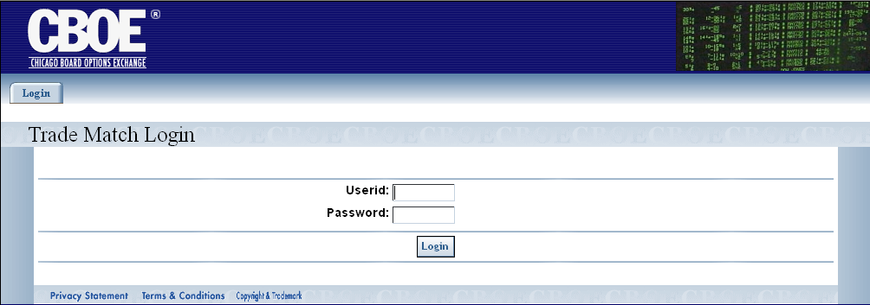
Functionality Restrictions | Functionality restrictions apply based on your User ID and Password. There are three Roles (restriction types) that pertain to Member Firm users.  - Entry: allows data entry and browse functions only  - Control: authorized to perform data security control functions only. These functions include setting passwords and firm authorizations.  - All: access to all functions authorized Firm access
Login | Enter your User ID and Password. Neither User ID nor Password is case sensitive.
 | 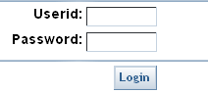
 | Click Login.
The CTM Welcome window will display the TradeQuery, Firm Maintenance and Security tabs.
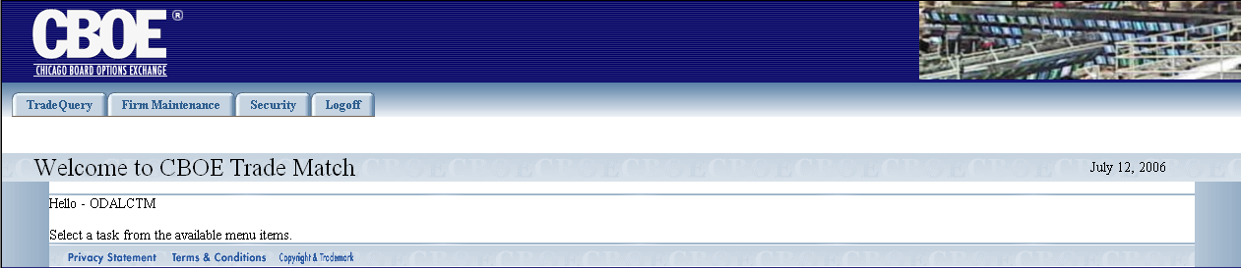
 | You are now ready to perform post-trade processing functions.

 | Trade Query
From the Trade Query tab, you can query trades in the system. Click on the Trade Query tab to display the sub-menu for this function.
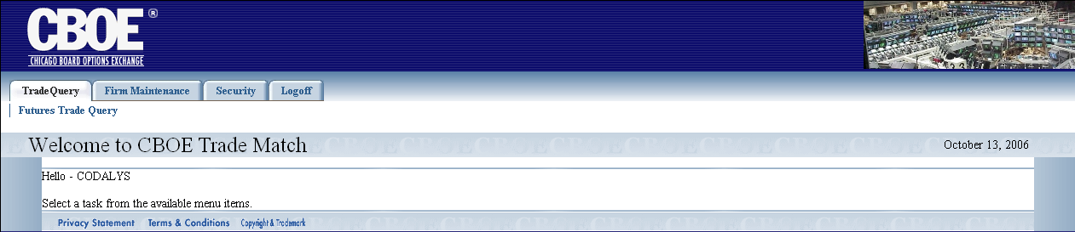

Functionality Restrictions | ENTRY level: trade query  CONTROL level: trade query  ALL level: access to all functions authorized Firm access
Futures Trade Query | The OneChicago PTP (via CTMI) system allows access for a Firm to browse and change their OneChicago Futures trades. However, examining and changing Options and Futures trades require separate logins, with different user IDs.  If you are logged in as a Futures user, you can query Futures trade data. Click Trade Query and select Futures Trade Query. The Futures Trade Query window will display.  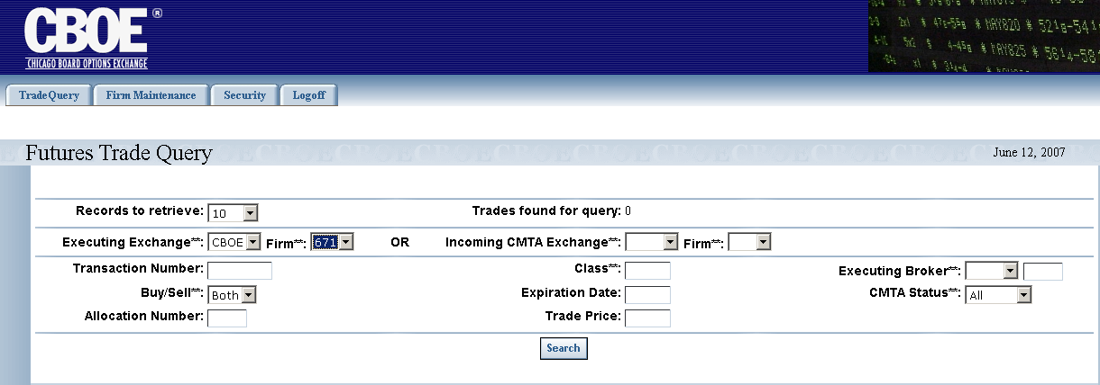

Query Futures Trade Data
OneChicago trade data is queried by using combinations of the fields in the Trade Query window. Below is a description of each field. Fields that have astericks (**) are used for exact match search criteria.
- Records to retrieve: you can select the number of data rows to display on the window from this drop down list. The default is 10 rows.
- (Executing) Firm**: refers to the executing Firm’s (EXEC Firm) number. The Firm number is selected from the drop down list.
- Executing Exchange**: refers to the Futures executing exchange acronym and is selected from the drop down list box.
- Transaction Number: trade identification number.
- Class**: this is a text field that allows you to enter the class symbol you wish to query (i.e. AMZN1C or GOOG1C).
- Buy/Sell**: refers to the Futures contract type. The default is Both.
- Expiration Date: this is a text field that allows you to enter the date the security will expire (maturity date). The allowable formats are: mm/yy (03/06), mm yy (03<space>06) and mmyy (0306).
- Allocation Number: entering a ‘1’ (or another number) will locate trades with that number or a higher allocation number.
- Trade Price: this is a text field that is used to enter the trade price of the security. The allowable format is: 72.65.
- Incoming CMTA Exchange**: Select the give-up Firm exchange. The give-up Firm may be different from the actual clearing account at the OCC.
- Executing Broker**: the acronym of the broker executing the trade.
- CMTA Status**: identifies the status of the CMTA Firm as valid, invalid, error, release. Make your selection from the drop down list.
- (Incoming CMTA) Firm**: this allows you to select the Firm number of the incoming CMTA Firm from the drop down list.
In the Futures example above, the data request is filtered based on Executing Exchange CBOE firm 671 for both Buy/Sell. The trade date for Futures queries is always the current business day. The CMTA Status is set to All. The query will display up to 10 records per window. Select either by Executing Exchange and Firm or by Incoming CMTA Exchange and Firm.
Click Search. Your query results will display. Errors in the trades will display above the search criteria section.
 | 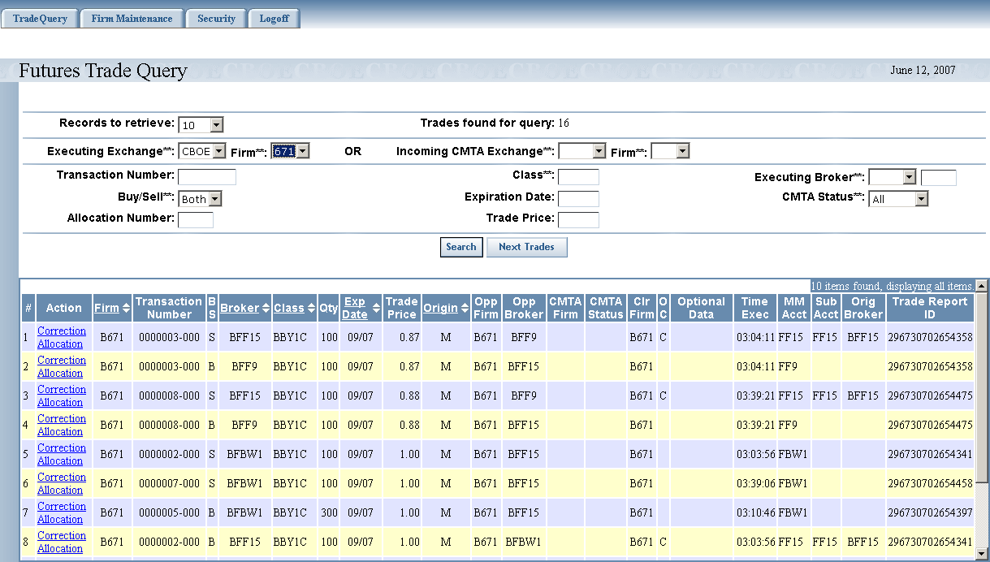
Trades found for query shows the count of all stored trades that satisfy the query. However, the window only displays up to the number selected by the Records to retrieve drop-down list.
Data columns that display the up/down arrows can be sorted. Click on the column name to perform an ascending or descending sort.
 | Clicking on the Export To links on the botton of the page will fill a form with data from the screen in the selected format. For instructions on exporting CTM data to CSV, Excel or XML format, refer to the section Customize and Export Windows, page 23.

Futures Trade Allocation
The allocation window allows you to split a contract quantity on a previously entered trade between two or more CMTA Firms. From the Trade Query window, click the Allocation link in the Action column. The following window will display.
 | 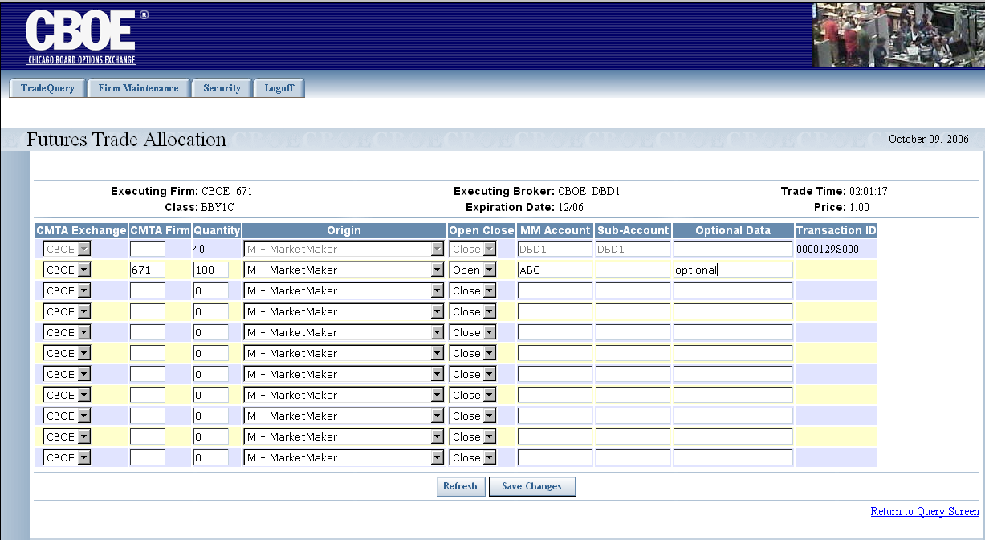
- Select the CMTA Exchange from the dropdown list.
- Enter the CMTA Firm number.
- Enter the quantity you want to allocate to the CMTA Firm. The entire quantity of the original trade cannot be given up, as the original trade is not deleted.
- Select Open or Close from the drop down list. The field may be left blank, which is a default to open position.
- If available, enter the MM Account and Sub-Account information.
- You can click Refresh at anytime to clear the data you have entered.
- Click Save Changes. The trade quantity will be allocated to the chosen CMTA Firms.
- If at anytime you wish to return to the Trade Query window, click Return to Query Screen.
 | - Note: Data errors will be shown in a box at the top of the screen. For details, refer to the Data Errors section, page 14.

Futures Trade Correction
The system allows you to make corrections to Futures trade data. From the Trade Query window, click the Correction link in the Action column. The following window will display.
 | 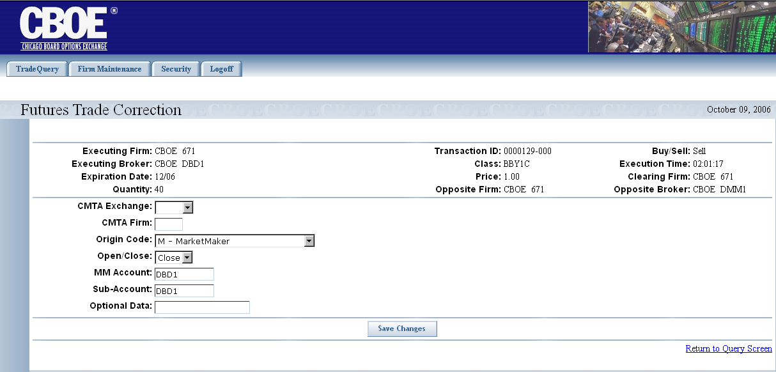
Corrections can be made to the following fields: CMTA Exchange, CMTA Firm, Origin Code, Open/Close, MM Account, Sub-Account and Optional Data.
Make corrections to the desired fields. Click Save Changes. The corrections will be saved in the system.
To return to the Futures Trade Query window, click Return to Query Screen.
 | - Note: Data errors will be shown in a box at the top of the screen. For details, refer to the Data Errors section, page 14.

Firm Release Request
Give-up Firms can request to be released from a trade. If a Firm wishes to be released from a trade, execute a query from the Futures Trade Query window.
Select the Give-up Firm’s number in the Incoming CMTA Firm and the Incoming CMTA Exchange from the dropdown list boxes. Click Search. The following window will display.
 | 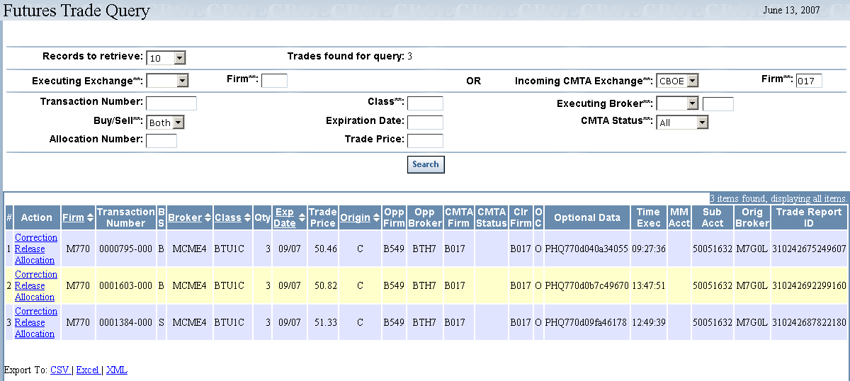
 | If the Give-up Firm is eligible to be released from a trade, the Release link will appear in the Action column.
 | - Click on the Release link to display the window below.
 | 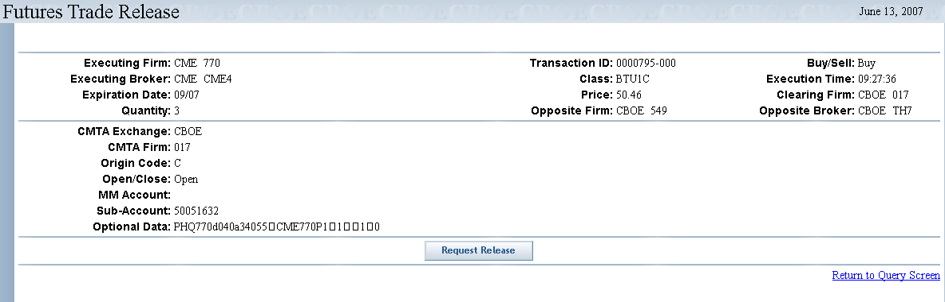
- Click Request Release to activate the trade release request.
- To return to the Futures Trade Query window, click Return to Query Screen.

Firm Release Accept
To accept a Firm’s release request:
- Select the Executing Firm number from the dropdown list.
- Select the Executing Exchange from the dropdown list. The following window will display.
 | 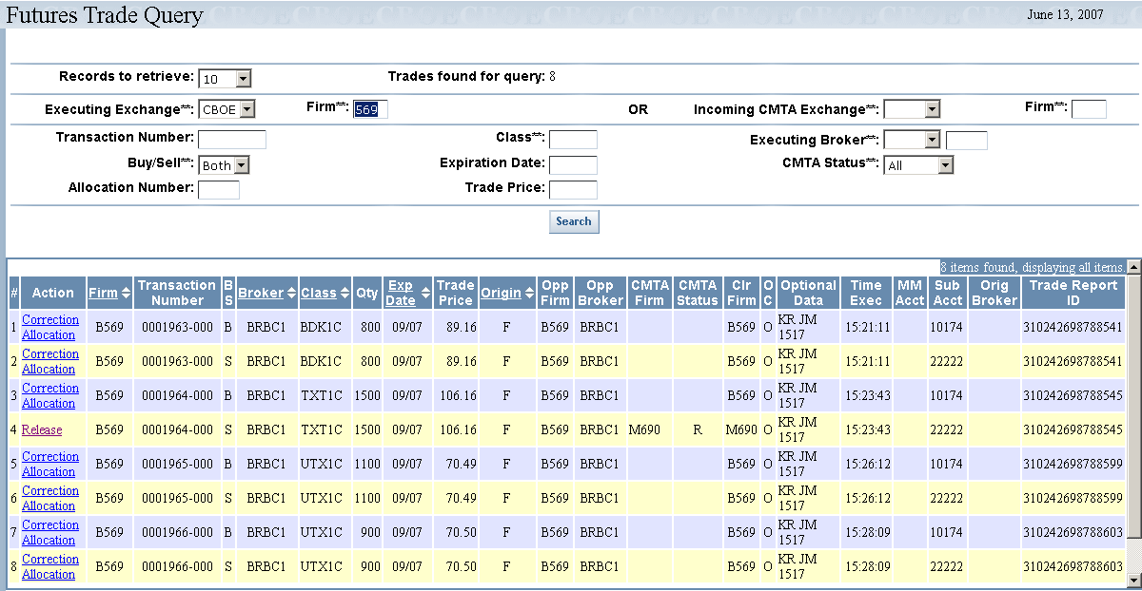
 | - If the Firm has requested to be released from a trade, an “R” will appear in the CMTA Status column for the trade. Click on the Release link in the Action column for the trade. The Futures Trade Release window will display.
 | 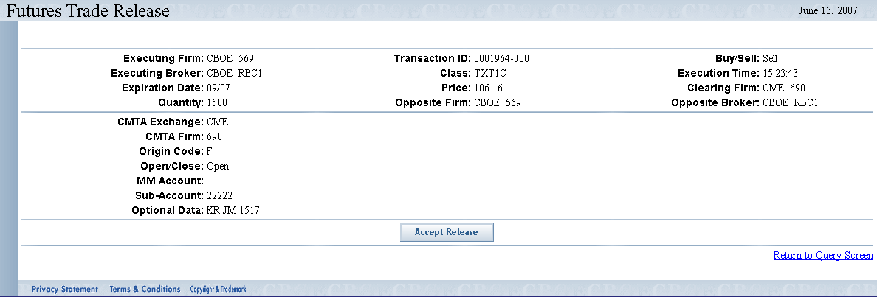
- To release the Give-up Firm from the trade, click Accept Release. The Firm will be released from the trade. The CMTA Firm should be blank, CMTA status should not be “R”, clearing Firm should be re-factored to the executing Firm’s clearing.
- To return to the Futures Trade Query window, click Return to Query Screen.
 | For instructions on exporting CTM data to CSV, Excel or XML format, refer to the section Customize and Export Windows, page 23.
Data Errors | Data errors for Futures Trade Query correction and allocation will be shown in a box at the top of the window. If the fields in error are correctable, then make the changes. If they are not, contact the OneChicago administrator about the trade.
 | 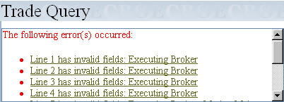
 | Click on the link for a particular error (i.e. Line 1 has invalid fields: Executing Broker). The system will bring you to the selected line in the query. In this example, the Executing Broker field needs to be corrected for the first four errors.

Firm Maintenance

 | The Firm Maintenance window enables you to perform maintenance functions for your individual Firm and related member Firms.
Functionality Restrictions | ENTRY level: N/A  CONTROL level: Firm Authorization  ALL level: Firm Authorization
Firm Authorization | The Futures Firm Authorization window allows you to view which Firms are authorized to perform entry, maintenance and reporting functions for their Firms. Firm operators can also add and delete authorizations for their Firms.  Click Firm Maintenance and then select Futures Firm Authorization. The Futures Firm Authorization window will display.
 | 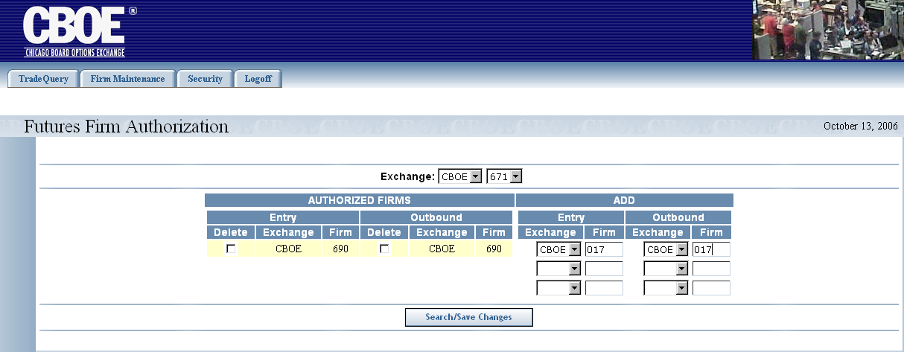
To display Firms that are currently authorized to perform CTM functions:
- Select your Exchange and Firm number from the Exchange dropdown list boxes.
- Click Search/Save Changes. The authorized Firms will display.
To authorize a new Firm to enter, correct or allocate trades:
- From the Entry column, select the Exchange from the drop down list.
- Enter the Firm’s entry clearing number in the Entry Firm text box.
- From the Outbound column, select the Exchange from the drop down list.
- Enter the Firm’s outbound clearing number in the Outbound Firm text box to receive outbound trade data and reports.
- Click Search/Save Changes. The new authorized Firm will display in the Authorized Firms column
 | 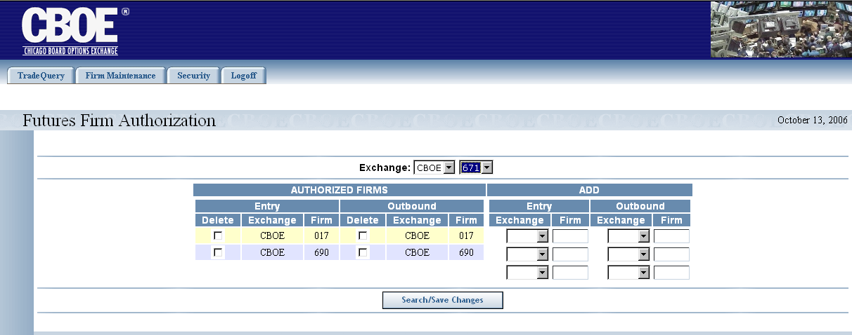
If you wish to remove a Firm’s authorization:
- Select the Delete check box for the desired Firm from the Authorized Firms column.
- Click Search/Save Changes.
 | 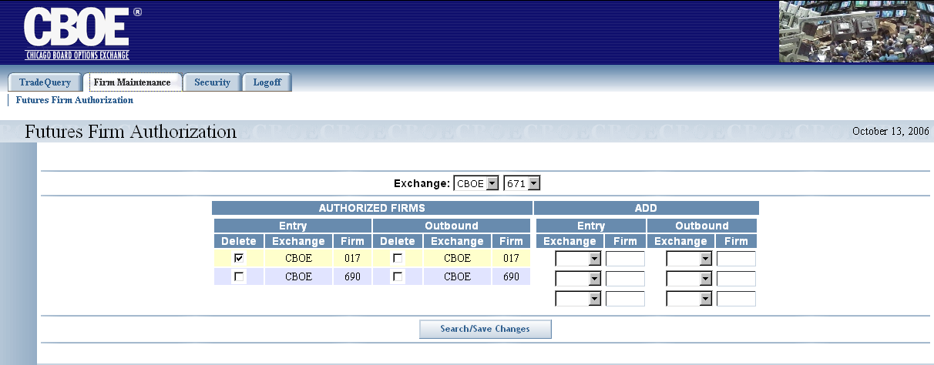
 | The system will prompt you to verify you wish to delete the Firm’s authorization.
 | 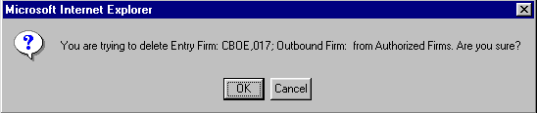
Click OK to proceed with the deletion.
If you decide not to remove the Firm’s authorization, click Cancel.

Security

 | The Security window allows you to perform data security functions for your Firm and associated Firms.
Functionality Restrictions | ENTRY level: N/A  CONTROL level: authorized to perform data security control functions only for your Firm and associated Firms. These functions include setting users and passwords.  ALL level: access to all functions authorized Firm access.
User Maintenance | From the User Maintenance window, you can perform searches for existing users, add new users and update existing users.  Click Security and then select User Maintenance.
 | 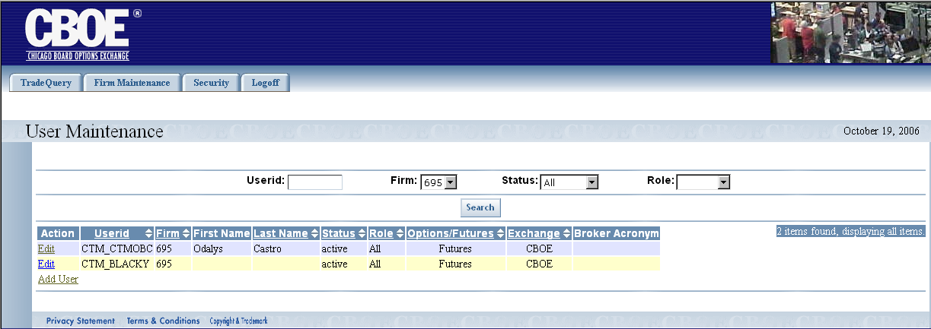
 | The User Maintenance window displays with your Firm’s users information. The window above shows users for Firm 695.

Search Features
To search by Userid:
- Enter the user’s ID in the Userid text box.
- The Firm number defaults to your Firm.
- Click Search. The user with the corresponding User ID will display.
 | 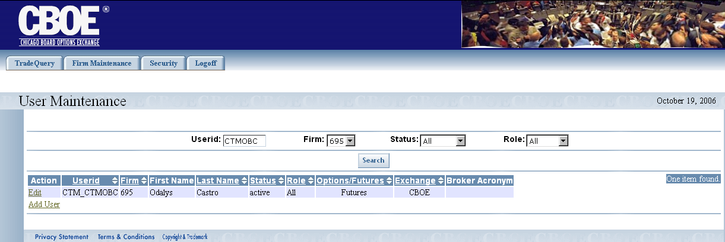
To search by status:
- Select the user’s Status from the dropdown list.
- The Firm number defaults to your Firm.
- Click Search.
 | 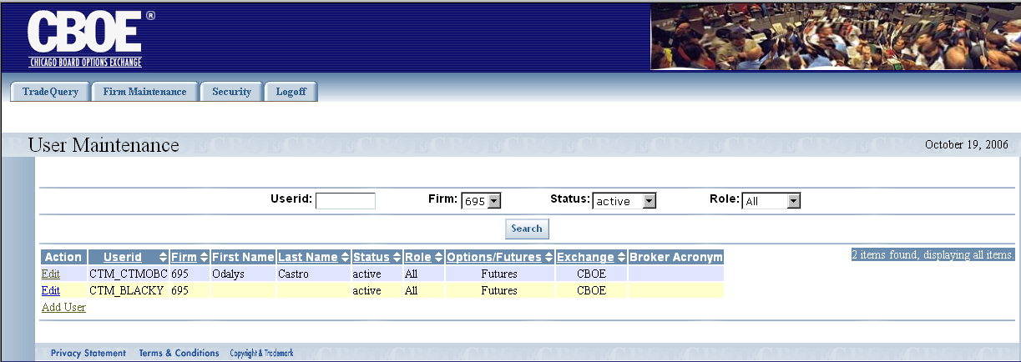
To search by role:
- Select the user’s Status from the dropdown list.
- The Firm number defaults to your Firm.
- Choose the user’s Role from the dropdown list.
- Click Search.
 | 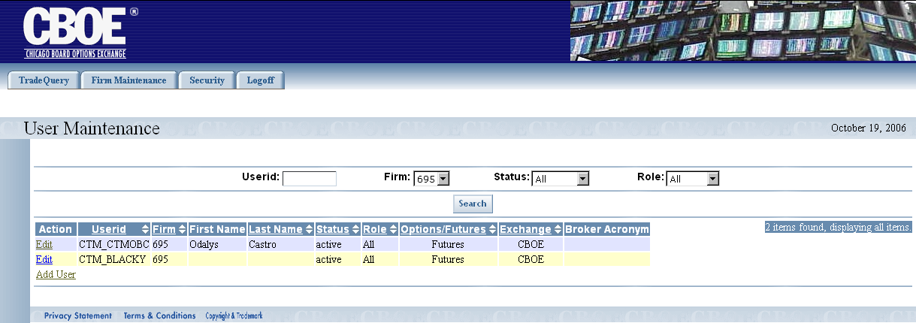

Add New User
To add a new Firm user, click Add User. The User Edit window will display.
 | 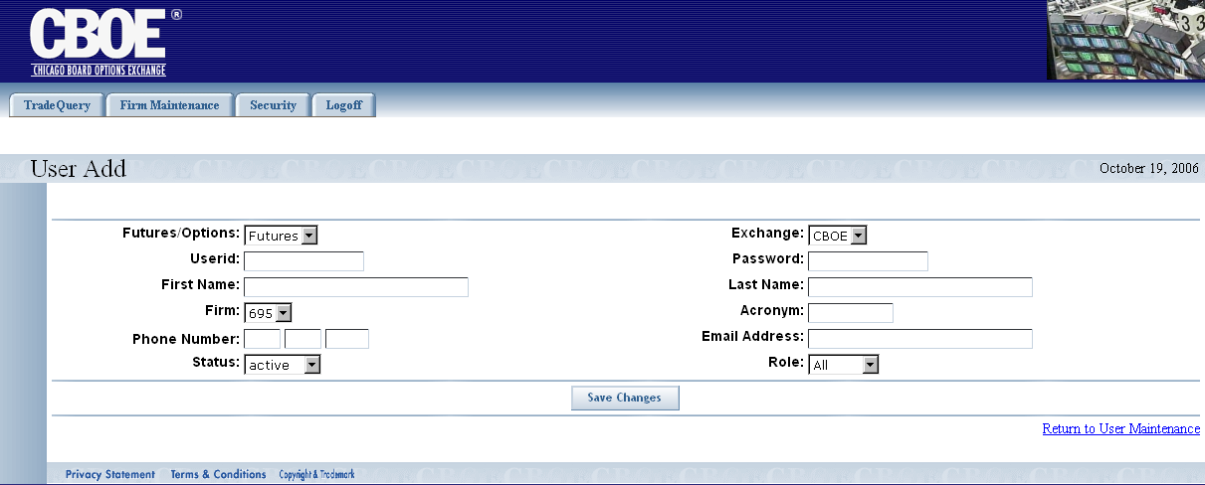
- The window defaults to Futures, your Firm number, a Status of active, Exchange equal to CBOE and Role set to All.
- Select the Exchange and Firm from the drop-down lists.
- Enter the Userid and Password in the corresponding text fields.
- Insert the user’s First Name and Last Name, Acronym, Phone Number (optional) and Email address (optional).
- Select if the user is active or disabled from the Status dropdown list.
- Enter the user’s security Role.
- Click Save Changes.
- To view the new user addition, click Return to User Maintenance. The system will return to the User Maintenance window displaying the new user’s information.

Update an Existing User
To update an existing user, click the Edit link in front of the user’s name. The User Edit window will display the user’s information.
 | 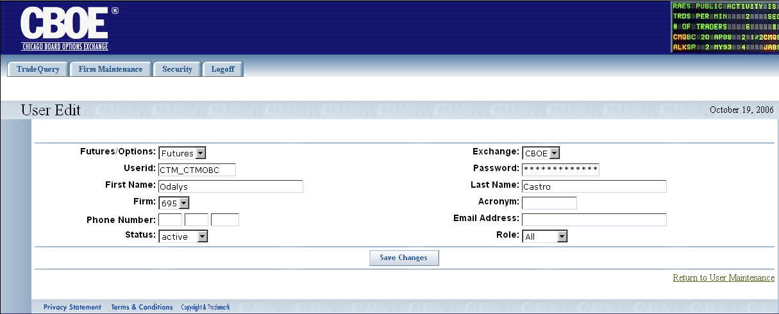
- Change any of the information as you desire.
- Click Save Changes.
- To view the updated user information, click Return to User Maintenance. The system will return to the User Maintenance window displaying the updated user’s information.
 | - Note: The Password is encrypted and cannot be displayed. If a password is forgotten someone with proper authority can change it. Unused or unneeded user IDs should be set to disabled status and a request should be made to have it deleted.

Exit the System

 | You can log out and exit the system at any time during the day.
Exit the System | To exit the system, click on the Logoff tab and select Logoff CTM. You will be logged out of the application and will be returned to the CTM Login window.
 | - Note: The CTMI system has a timer that inactivates a user who has not recently clicked the mouse or typed on a screen. This requires the user to log back into the system. This insures that displayed data is not too old, and frees up CTMI web resources.

◻ | Section 2:  Reference Guide

Customize and Export Windows

Exporting Data | Windows that exhibit data in column format can be exported to different file formats.

Export to CSV Format
- Click CSV (Comma Separated Values). The File Download window will display. The window defaults to Save this file to disk.
 | 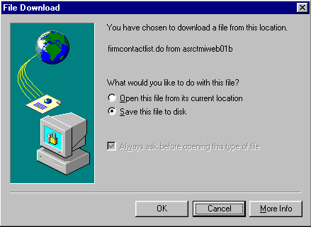
- Click OK. The Save As window displays.
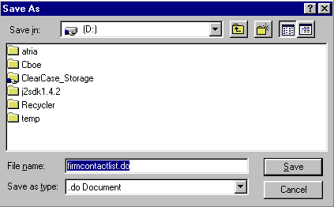
- Select the location where you want to save the file and enter the file name.
- Click Save. Your file will be saved in CVS format.
- To exit the window without saving, click Cancel.
To open the file from the current location:
- Click on the corresponding radio button. The Open With window displays.
 | 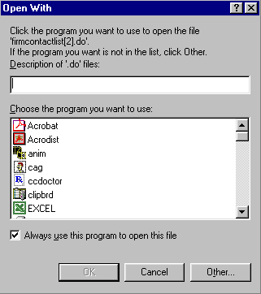
- Select the program in which to display the data.
- Click OK.
- Click Cancel to exit the window.

Export to Excel
If you wish to export the data to an Excel spreadsheet, click Excel. The system will open an Excel window and export the data.
 | 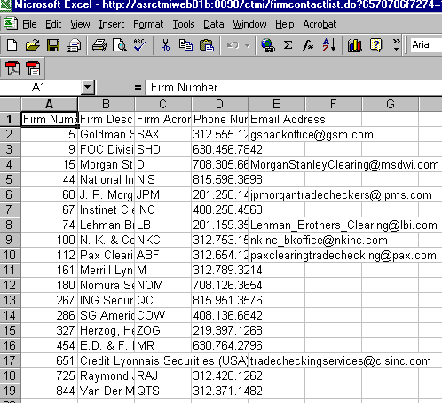

XML Conversion
To convert the data to XML, click XML. A new browser window will open and the data will display in XML format.
 | 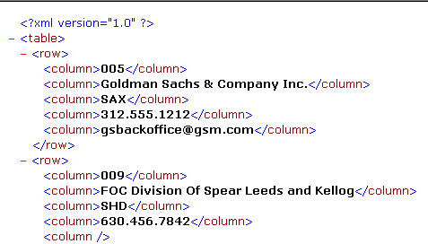
 | Click the right button (X) in the uppder right corner of the window to close the window and return to CTM system.
Sizing Windows | The windows are only as sizable as the browser allows.
 | 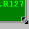 | Place the mouse on any edge of the window until it becomes a two-sided arrow. Hold the left mouse button down and move it to the desired size.
Resizing a window on the corner will expand or contract it in both directions (i.e. up and down and side-to-side). Resizing it on the side or top/bottom will expand or contract the window only in that one direction.
Windows can also be resized using the center glyph in the upper right corner of the window.
 |  | Click the left button () to minimize the window. Click the right button () to close the window. The center button is used for sizing.
If  is displayed, clicking it will increase the window size to a full-screen display.
If  is displayed, clicking it will return the window to its default size.

