

Continuous Trade Match (CTM-I) Systems Support User’s Guide
Version 1.2

Disclaimer

Copyright © 2006-2007 Chicago Board Options Exchange. All rights reserved.
The information contained in this document constitutes confidential and/or trade secret information belonging to CBOE. This document is provided "As Is" with all faults and without warranty of any kind, either expressed or implied.

Change Notices

The following change notices are provided to assist users of the CBOE Trade Match system in determining the impact of changes to their processing.
If you have any questions or review comments about this document, please contact Odalys Castro at (312) 786-8817.

Date | Version | Description of Change
8/16/07 | 1.2 | No changes
6/12/07 | 1.1 | No changes
7/07/06 | 1.0-draft | Third draft of V1.0:  - Captured several new screen shots.
3/21/06 | 1.0-draft | Second draft of V1.0:  - Added new Login window  - Separated the Query Trade Data section by (1) Options, (2) Futures  - Enhanced description of drop copy re-send functionality  - Changed resolution to capture entire CTM windows without scrolling  - Overall documentation changes for Firm text box entry
3/07/06 | 1.0-draft | First draft of Version 1.0.

Table of Contents
Table of Contents iii
Introduction v
Purpose v
Intended Audience v
Window Settings v
Note About Displayed Screens v
Conventions Used in this Guide v
Section 1: CBOE Trade Match 6
Getting Started 7
Functionality Restrictions 7
Login 7
Trade Query 8
Functionality Restrictions 8
Trade Query 8
Options 8
Query Options Trade Data 8
Futures 11
Query Futures Trade Data 11
Data Errors 12
Trade Message 13
Firm Maintenance 15
Functionality Restrictions 15
Firm Authorization 15
Firm Contact List 17
Send Email to a Firm 17
Firm TCP/IP Socket Password 18
Broker Contact List 20
Firm Statistics 20
Trading Group 21
Real-Time Communication 22
Functionality Restrictions 22
Drop-Copy 22
Add Drop Copy 23
Delete Drop Copy 24
Matching 25
Functionality Restrictions 25
Status Display 25
Tier Match 26
Control Update 27
Batch Match 28
APP Support 29
Functionality Restrictions 29
Log Control 29
Audit Query 30
Internal Switch Maintenance 31
Exit the System 32
Exit the System 32
Section 2: Reference Guide 33
Customize and Export CTM Windows 34
Exporting CTM Data 34
Export to CSV Format 34
Export to Excel 36
XML Conversion 37
Sizing CTM Windows 37

Introduction

Purpose | This user guide was written to assist CBOE System Operators in utilizing the Continuous Trade Match (CTM) features using a web browser.  The CTM system combines the basic functions of the Intra-day Trade Processing (ITP), End of Day Trade Processing (EOD), and Real Time Trade Communication (RTC) systems.
Intended Audience | This user guide is intended for System Operations users interested in the Trade Match administrator functions.
Window Settings | The recommended resolution to view CTM windows is 1280 x 1024 pixels. If your desktop display is set to a lower resolution, you will have to use the scroll bar to view CTM windows in their entirety.
Note About Displayed Screens | An attempt is made to show the current look and format of screens that are included in this document. However, the displays here may not reflect recent changes to these browser screens. Also, information displayed on the screens may not reflect true production data.
Conventions  Used in this Guide | The Continuous Trade Match system was designed so that you can perform all of your administrative functions from a web browser. All web browser functionality applies to the CTM system.  Section 1 of the document illustrates how to perform the necessary System Operation functions. Additional information about window configuration and sizing can be found in Section 2: Reference Guide.  There are conventions used throughout this guide to help trigger important information:
 | Bolding | Used to highlight menu selections (e.g., Login) and button names (e.g., Update)
 |  Note: | This notation is used to indicate important information you should note when performing the associated function.
 |   Data Values | This graphic will appear in the margin when there is information relating to data values.

 | Section 1:  CBOE Trade Match

This section of the user guide will direct you through all the System Operation functions of CBOE’s Continuous Trade Match system using a web browser.

Getting Started

 | When you launch the CTM application, the following login window will display.
 | 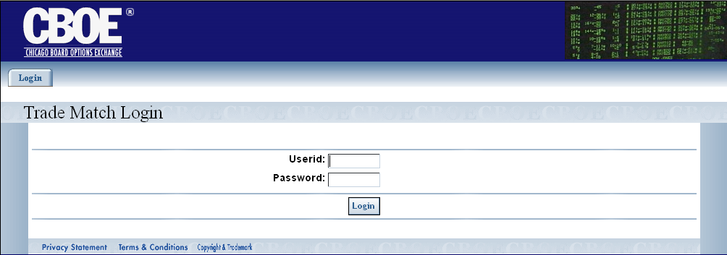
Functionality Restrictions | Functionality restrictions apply based on your User ID and Password. There are three Roles (restriction types) that pertain to the CTM system.  - Entry: allows data entry and browse functions only  - Control: authorized to perform data security control functions only. These functions include setting passwords, trade matching parameters, and firm and wire authorizations.  - All: access to all functions
Login | Enter your User ID and Password. Both User ID and Password are case sensitive.
 | 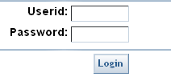
 | Click Login.
The CTM Welcome window will display.
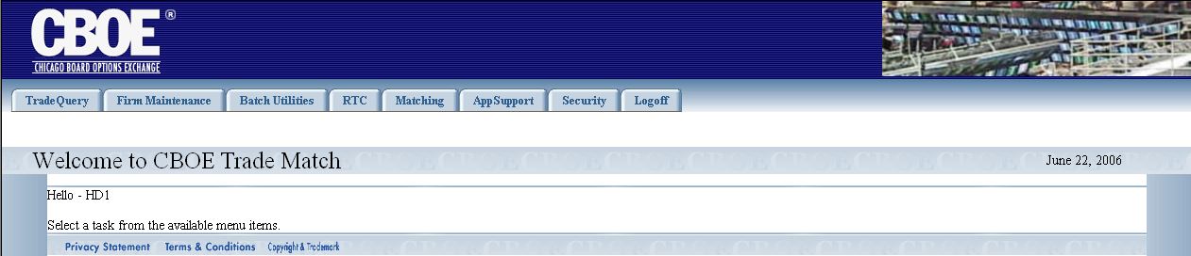
 | You are now ready to perform CTM functions.

 | Trade Query
From the Trade Query tab, you can query trades, browse trade messages and enter trades into the system. Click on the Trade Query tab to display the sub-menus for these functions.
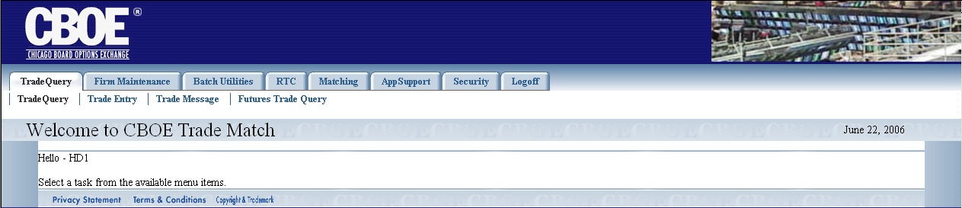

Functionality Restrictions | ENTRY level: query trades, browse trade messages, enter trades  CONTROL level: browse trade messages  ALL level: query trades, browse trade messages, enter trades
Trade Query | The CTM trade query functionality allows you to display trade information based on the filters you provide. To display the Trade Query window for Options, click on the TradeQuery option. The following window will display.

Options
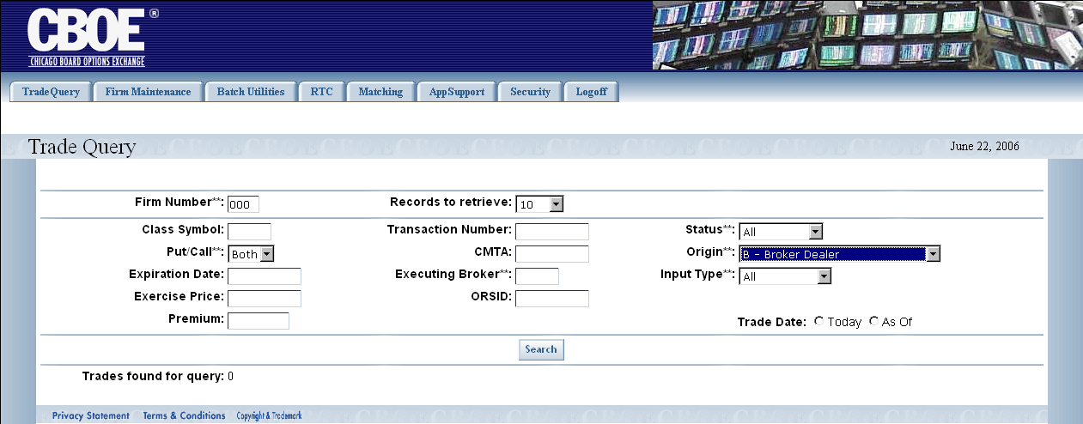

Query Options Trade Data
CTM trade data is queried by using combinations of the fields in the Trade Query window. Below is a description of each field. Fields that have astericks (**) are used for exact match search criteria.
- Firm Number**: refers to the executing Firm’s (EXEC Firm) number. The Firm number is entered in the text box.
- Class Symbol: this is a text field and allows you to enter the class symbol you wish to query (i.e. IBM).

- Put/Call**: refers to the type of option. You can elect to query by Call, Put or Both by making your selection from the dropdown list. The default is Both.
- Expiration Date: this is a text field that allows you to enter the date the security will expire. The allowable formats are: mm/yy (03/06), mm yy (03<space>06) and mmyy (0306).
- Exercise Price: allows you to enter the expiration price of the security. The allowable format is: 42 4 (42<space>4).
- Premium: this is a text field that can be used to enter the premium price of the security. The allowable format is: 72.65.
- Records to retrieve: you can select the number of data rows to display on the window from this dropdown list. The default is 10 rows.
- Transaction Number: trade identification number
- CMTA: Clearing Member Trade Agreement provides non-member firms (who have clearing numbers with the OCC) a way to trade at the Exchange through member firms who contractually agree to submit trades for them.
- Executing Broker: the acronym of the broker executing the trade.
- ORSID: identification number from the ORS system
- Status**: allows you to query by matched or unmatched trades, trades with errors or all trades. Make your selection from the dropdown list.
- Origin**: account type that identifies the type of trade origin. E.g. customer, firm, market maker, etc. Make your selection from the dropdown list.
- Input Type**: the system where the trade was entered.
- Trade Date: you must select a trade date for your query. To choose the current business day, click Today. To display all trades previous to the current business day, click As of. If neither radio button is selected, the trade date defaults to today.
In the Options example above, the data request is filtered based on Firm 000 for both Puts/Calls for all trades previous to the current business day. The Status and Input Type are set to All. The Origin is set to B-Broker Dealer. The query will display up to 10 records per window. The total number of trades found in the query displays in the window.
Click Search. Your query will display.
 | - Note: Some trades returned to the screen may have data errors. Errors by trade will be given in a box in the upper left part of the screen. For details, refer to the Data Errors section, page 13.
 | 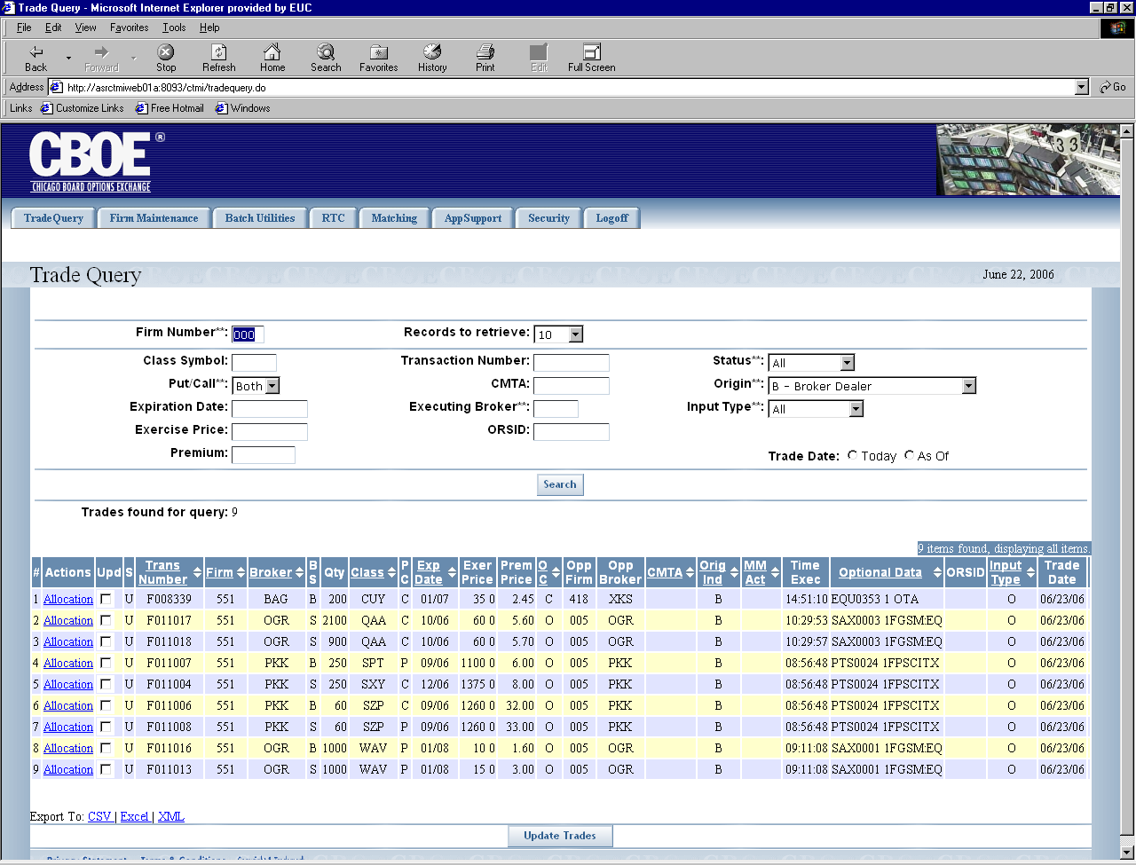
To view additional trades, click Next Trades.
Click Search at anytime to refresh the window for the current query.
To view trades that were earlier displayed, click Previous Trades.
 | Data columns that display the up/down arrows can be sorted. Click on the column name to perform an ascending or descending sort. This only sorts data last retrieved into the current screen.
 | Clicking on the Export To links on the botton of the page will fill a form with data from the screen in the selected format. For instructions on exporting CTM data to CSV, Excel or XML format, refer to the section Customize and Export CTM Windows, page 36.

Futures
To display the Trade Query window for Futures, select Futures Trade Query. The following window will display.
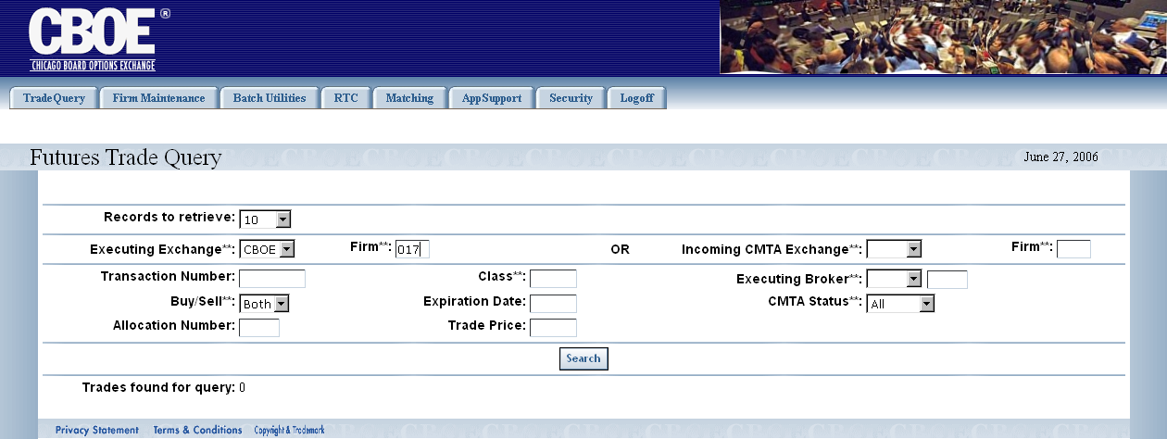

Query Futures Trade Data
CTM trade data is queried by using combinations of the fields in the Trade Query window. Below is a description of each field. Fields that have astericks (**) are used for exact match search criteria.
- Records to retrieve: you can select the number of data rows to display on the window from this dropdown list. The default is 10 rows.
- Firm**: refers to the executing Firm’s (EXEC Firm) number. The Firm number is entered in the text box.
- Executing Exchange**: refers to the Futures executing exchange acronym and is selected from the dropdown list box.
- Transaction Number: trade identification number.
- Class**: this is a text field that allows you to enter the class symbol you wish to query (i.e. AMZN1C or GOOG1C).
- Buy/Sell**: refers to the Futures contract type. The default is Both.
- Expiration Date: this is a text field that allows you to enter the date the security will expire. The allowable formats are: mm/yy (03/06), mm yy (03<space>06) and mmyy (0306).
- Allocation Number: entering a ‘1’ (or another number) will locate trades with that number or a higher allocation number.
- Trade Price: this is a text field that is used to enter the trade price of the security. The allowable format is: 72.65.
- Incoming CMTA Exchange**: Clearing Member Trade Agreement provides non-member firms (who have clearing numbers with the CME) a way to trade at the Exchange through member firms who contractually agree to submit trades for them. In Futures trading, this is usually called the give-up Firm (and Exchange). For Futures agreements held at the CME, the give-up Firm may be different other than the executing Firm.
- Executing Broker**: the acronym of the broker executing the trade.
- CMTA Status**: identifies the status of the CMTA Firm as valid, invalid, error, release. Make your selection from the dropdown list.
- Firm**: this is a text field that allows you to enter the Firm number of the incoming CMTA Firm.
In the Futures example above, the data request is filtered based on Firm 017 for both Buy/Sell. The trade date for Futures queries is always the current business day. The Executing Exchange/Firm is CBOE and the CMTA Status is set to All. The query will display up to 10 records per window.
Click Search. Your query will display.
 | 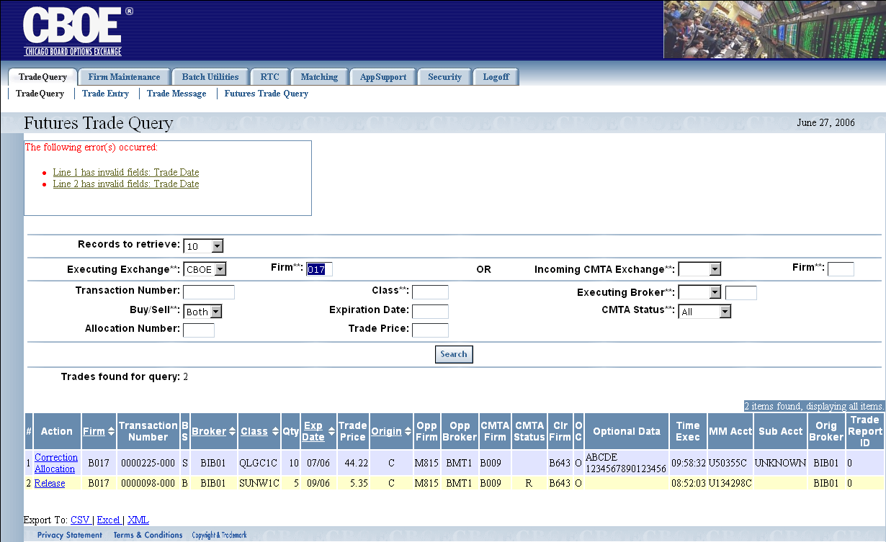
Trades found for query shows the count of all stored trades that satisfy the query. However, the window only displays up to the number selected by the Records to retrieve drop-down list.
Data columns that display the up/down arrows can be sorted. Click on the column name to perform an ascending or descending sort.
 | Clicking on the Export To links on the botton of the page will fill a form with data from the screen in the selected format. For instructions on exporting CTM data to CSV, Excel or XML format, refer to the section Customize and Export CTM Windows, page 36.

Data Errors
Data errors for Trade Query windows will be shown in a box at the top of the window. The error box lists all the corrections that need to be made in the query. No corrections or trade allocations will be accepted until all errors are corrected.
 | 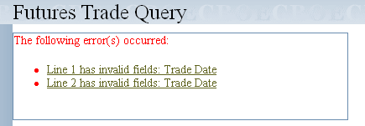
 | Click on the link for a particular error (i.e. Line 1 has invalid fields: Trade Date). The system will bring you to the selected line in the query. In this example, the Trade Date needs to be corrected for both errors.
Trade Message | The Trade Message window allows you to browse messages for all receiving or sending Firms.  To display the Trade Message window, click on the Trade Query tab and then select Trade Message. The following window will display.
 | 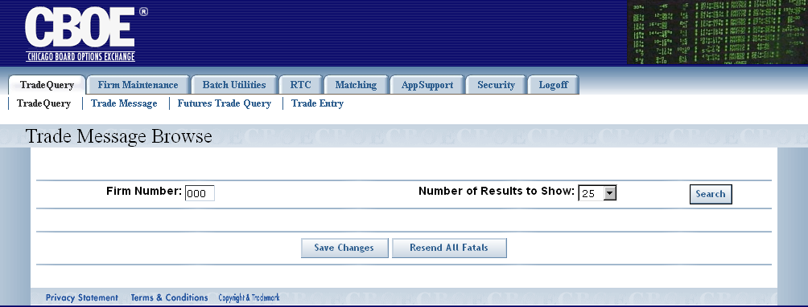
To browse messages for a particular Firm:
- Enter the Firm Number in the text box.
- Choose the Number of Results to Show.
- Click Search.
 | 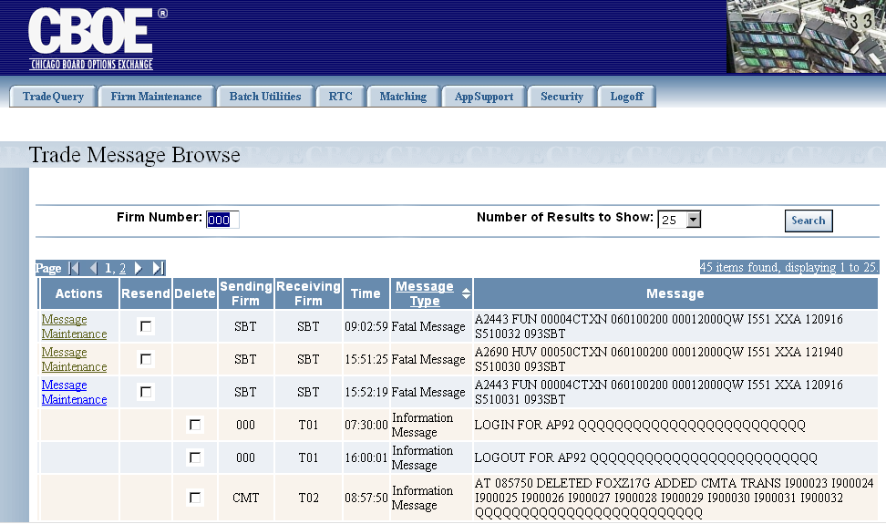
From the Trade Message Browse window you can view the time the message was sent along with a description of the message type and the actual message text.
Click the in the Message Type column to perform a column sort.

 | To view another page, click on a page number and scroll through the window.
 | 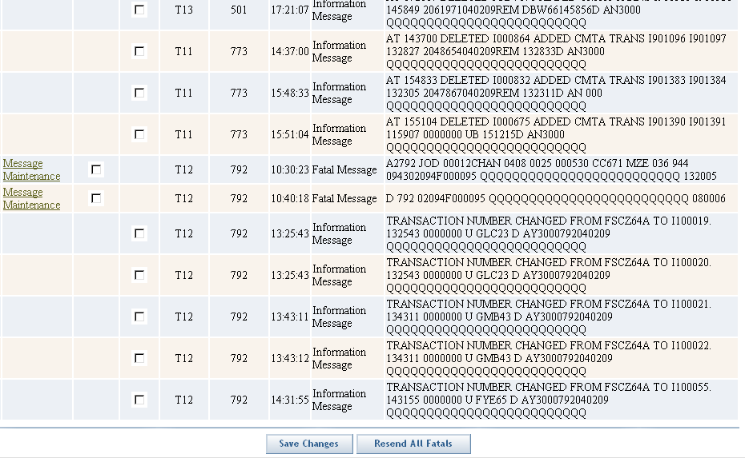
 | To resend fatal messages, click Resend All Fatals. This attempts to take trade fatal messages and add them as new trades.

Firm Maintenance

 | The Firm Maintenance window gives you the ability to perform maintenance functions for Firms.
Functionality Restrictions | ENTRY level: Firm Contact List, Broker Contact List, Firm Statistics  CONTROL level: Firm Authorization, Firm Contact List, Broker Contact List, Firm Statistics, ORS Correspondent Conversion, Trading Group  ALL level: Firm Authorization, Firm Contact List, Firm TCP/IP Socket Password, Broker Contact List, Firm Statistics, ORS Correspondent Conversion, Trading Group
Firm Authorization | The Firm Authorization window allows you to view which Firms are authorized to perform ITP functions on behalf of a Firm. Operators can also add and delete authorizations for Firms.  Click Firm Maintenance and then select Firm Authorization. The Firm Authorization window will display.
 | 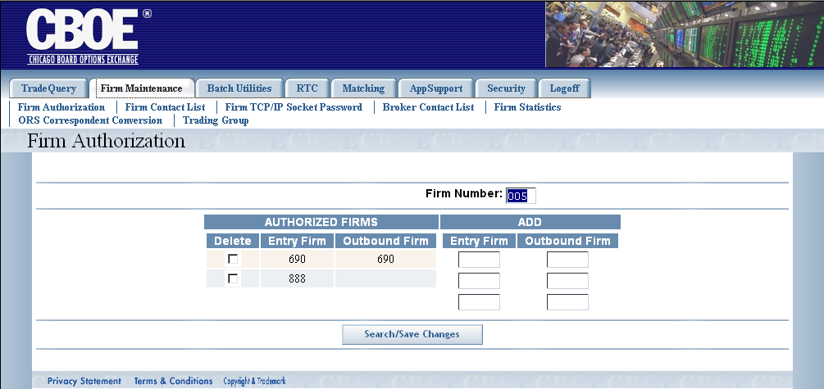
To display Firms that are currently authorized to perform CTM functions:
- Enter the Firm Number in the text box.
- Click Search/Save Changes. The authorized Firms will display.
To authorize a new Firm to enter, correct or allocate trades:
- Enter the Firm’s entry clearing number in the Entry Firm text box.
- Enter the Firm’s outbound clearing number in the Outbound Firm text box. This will allow the Firm to receive outbound trade data and reports.

- Click Search/Save Changes. The new authorized Firm will display in the Authorized Firms column.
 | 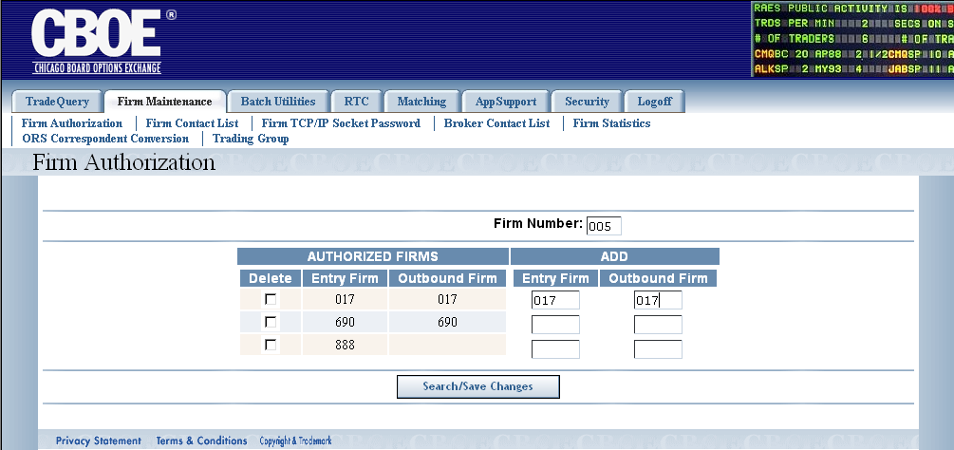
If you wish to remove a Firm’s authorization:
- Select the Delete check box for the desired Firm from the Authorized Firms column.
- Click Search/Save Changes.
 | 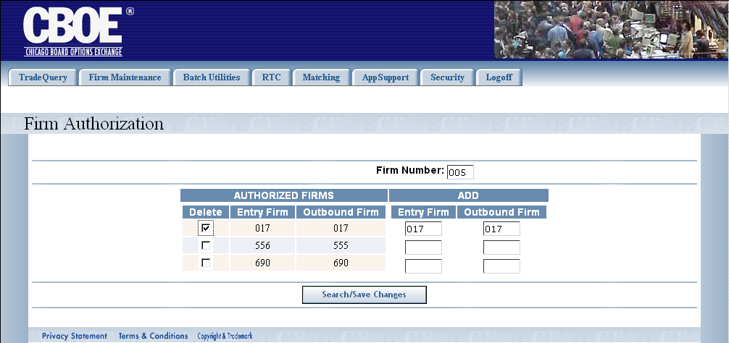
 | The system will prompt you to verify you wish to delete the Firm’s authorization.
 | 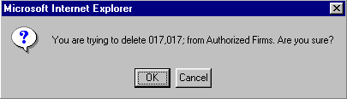
Click OK to proceed with the deletion.
If you decide not to remove the Firm’s authorization, click Cancel.
Firm Contact List | The Firm Contact List contains the Firm’s ID number, name, acronym, phone number and email address.
Not available in Version 1.0 | 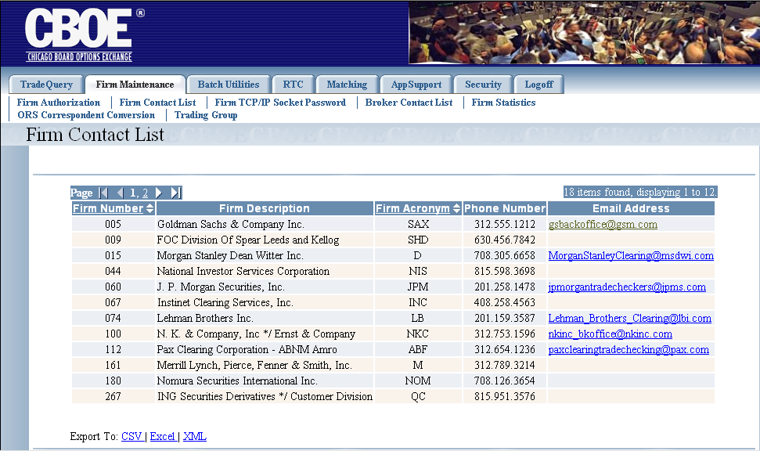
 | To scroll through the pages, click on the page numbers or the direction arrows until the desired page is reached.

Send Email to a Firm
To send an email to a Firm, click on the Firm’s email address from the Email Address column. The Untitled email window will display.
 | 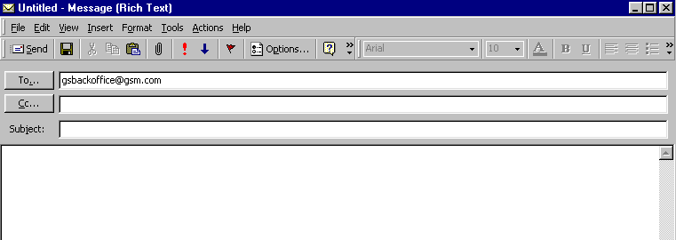
 | Enter your message and click Send.
 | For instructions on exporting CTM data to CSV, Excel or XML format, refer to the section Customize and Export CTM Windows, page 36.
Firm TCP/IP Socket Password | This CTM application allows you to set TCP/IP socket passwords.  Click Firm Maintenance and then select Firm TCP/IP Socket Password. The following window will display.
 | 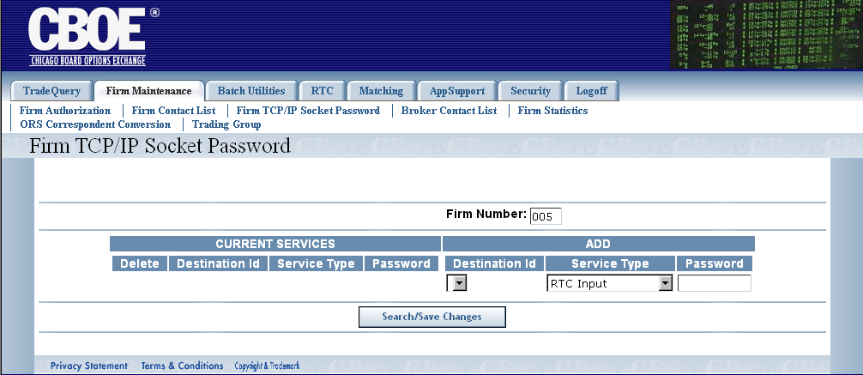
To display the current services:
- Enter the Firm Number in the text box.
- Click Search/Save Changes. The services for the selected Firm will display in the Current Services column.
 | 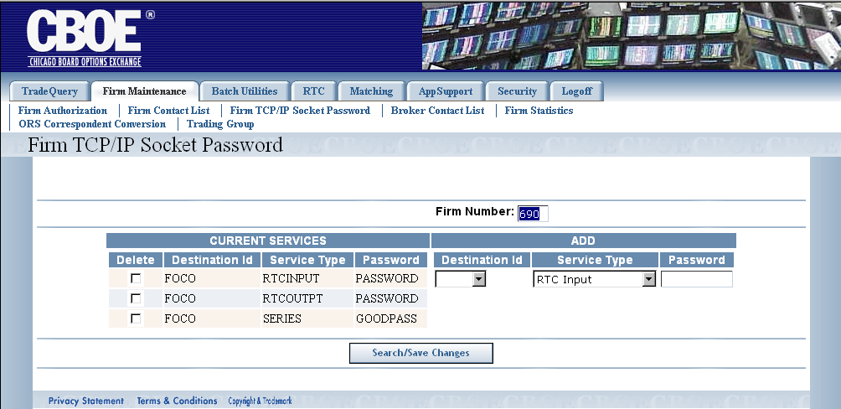
To add a new service:
- From the Add column, select the Destination ID and Service Type from the corresponding dropdown lists.

- Enter the password in the Password text box. To change the password you must delete it and then re-add the new password.
  - Note: The password must be eight characters.

- Click Search/Save Changes. The new service will display in the Current Services column.
 | 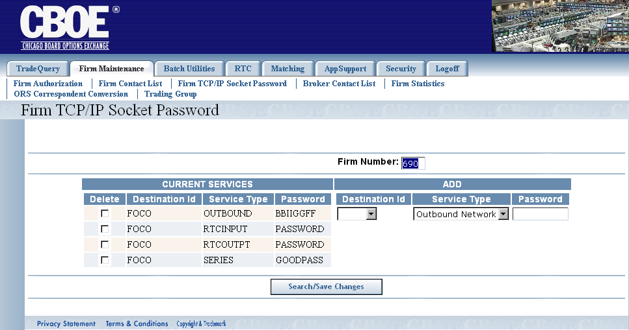
To delete a current service:
- From the Current Services column, select the Delete check box for the service you wish to remove.
- Click Search/Save Changes.
 | 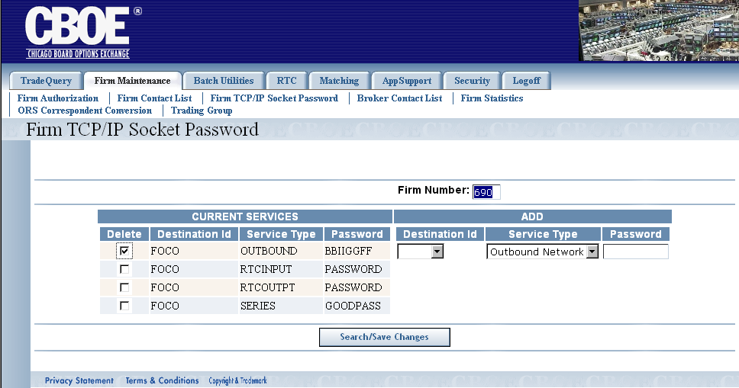
 | The system will prompt you to confirm your delete request.
 | 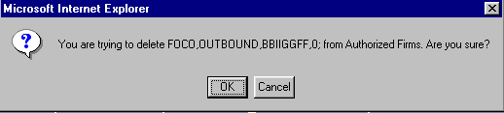
- Click OK to proceed with the delete.
- Click Cancel to remove your request.
Broker Contact List | Not available in Version 1.0.
Firm Statistics | This window allows you to view the number of records and contracts that have been entered into the CTM system.  To display the Firm Statistics window, click Firm Maintenance and then select Firm Statistics.
 | 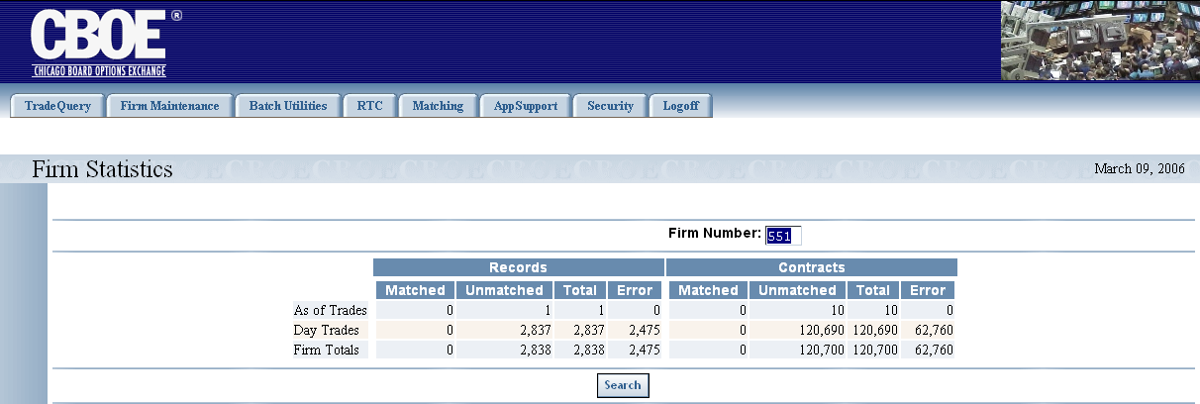
- Enter the Firm’s number in the Firm Number text box.
- Click Search. The number of records and contracts that were entered into the CTM system for the selected Firm will display.
Trading Group | The CTM system enables you to display trading groups by Firm.  To display the Trading Group window, click on the Firm Maintenance tab and select Trading Group.
Not available in Version 1.0 | 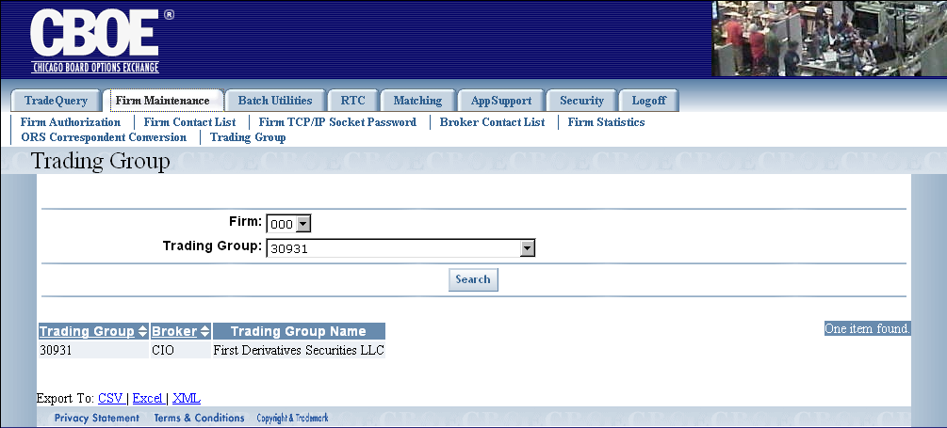
- Enter the Firm’s number from the Firm text box list.
- Select the trading group from the Trading Group dropdown list.
- Click Search. The trading group number, broker and trading group name display in column format.
 | For instructions on exporting CTM data to CSV, Excel or XML format, refer to the section Customize and Export CTM Windows, page 36.

Real-Time Communication

 | The CTM system allows you to route trades to the Real-Time Communication (RTC) system.
Functionality Restrictions | ENTRY level: N/A  CONTROL level: Drop-copy, TCP IP Re-send  ALL level: access to all functions
Drop-Copy | The drop copy destination table for a Firm is maintained by the Drop Copy window. The window displays whether trades will be routed to RTC.  To display the Drop Copy window, click RTC and then select Drop Copy. The following window will display.
 | 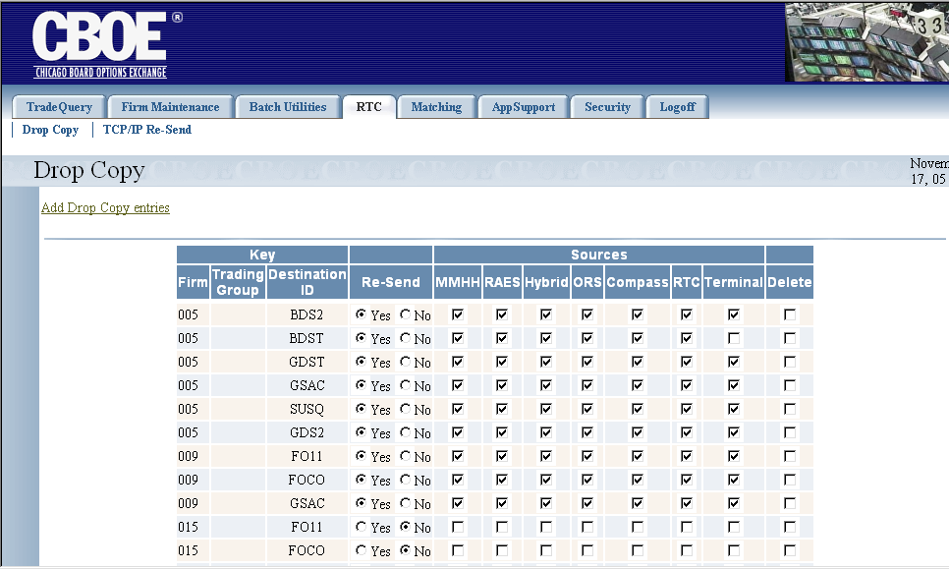
The rows consist of the following information:
- The Firm number
- Trading Group
- Destination ID
- Yes/No radio button for whether or not the Firm is to be resent messages.
- Checkbox for every input source (RTC, MMHH, Hybrid, etc.).
- Checkbox for the delete of a drop copy entry.

 | During ITP online processing, whenever a trade is added, changed, or deleted, the Drop Copy table is checked to see if a copy of the trade needs to be sent. For example, in the window above, a copy of the trade will be sent to MMHH, RAES, Hybrid, ORS, Compass, RTC and Terminal for Firm 005.

Add Drop Copy
To add entries for Drop Copy, click Add Drop Copies entries. The following window will display.
 | 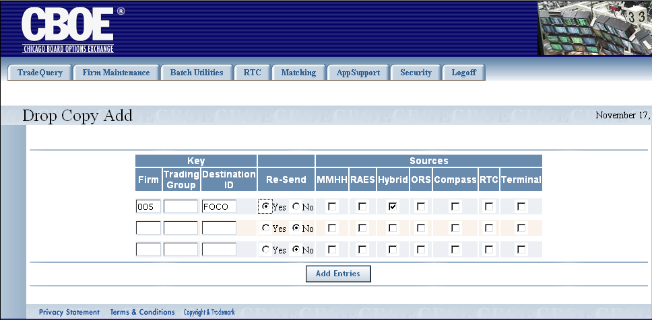
- Enter the Firm’s number and Destination ID.
- If the Firm requests the re-send messages option be turned on, select the Yes radio button in the Re-Send column. If the Firm does not wish to have messages resent, select the No radio button.
  - Note: The Re-Send choice allows trades to be resent to Firms at the Firms request. A re-send of the same trade will be sent to the Firm after 30 minutes from the last time the trade was sent.
- From the Sources column, select where the Firm wants to send the drop copy by checking the corresponding check box. In the example above, the drop copy will be sent to Hybrid.
- Click Add Entries. The drop copy entry will display in the Drop Copy window.
 | 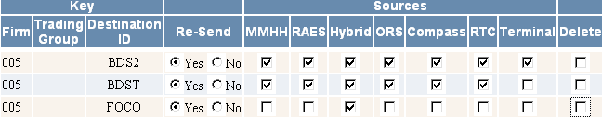

Delete Drop Copy
To delete a drop copy entry, select the Delete check box on the data row you wish to remove.
Click Save Changes.
 | 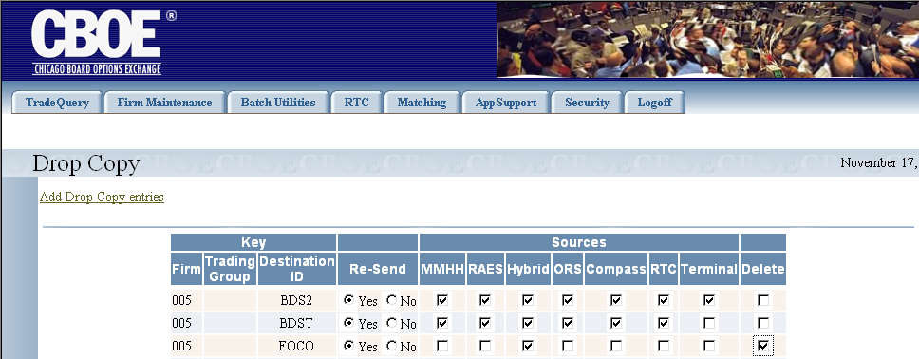
 | The system will prompt you to confirm your delete request.
 | 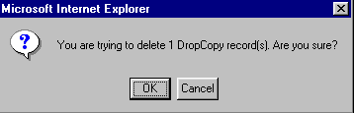
Click OK to remove the data row from the Drop Copy table.
Click Cancel to remove the delete request.

Matching

 | The Matching windows allow you to set and display trade matching criteria for ITP.
Functionality Restrictions | ENTRY level: N/A  CONTROL level: Status Display, Tier Match, Control Update, Batch Match  ALL level: access to all functions
Status Display | This Status Display window shows the current settings that are modified for tier match or control update.  To open the Status Display window, click on the Matching tab and then select, Status Display. The following window will open.
 | 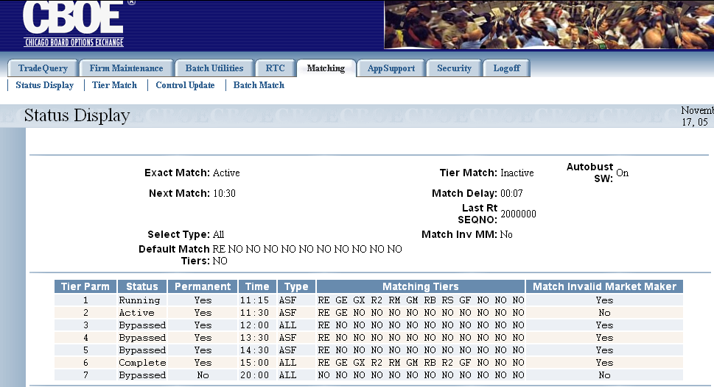
The Status Display shows the criteria as last set in the Tier Match and Control Update windows. These windows are discussed in the following sections.
The table below describes the matching criteria shown in the Matching Tiers column.
Data Values
  GE - Group Exact | GF - Group Firm | GI - Group Independent | GJ - Group Joint Account
  GM - Group Member | GX - Group OBOS | RB - Record Broker Buy | RE - Record Exact
  RI - Record Independent | RJ - Record Joint Account | RM - Record Member | RS - Record Broker Sell
  R2 - Record Broker X2
Tier Match | The system allows you to add and change tier matching criteria for CTM through the Tier Match window.  From the Matching tab, select Tier Match. The following window will display.
 | 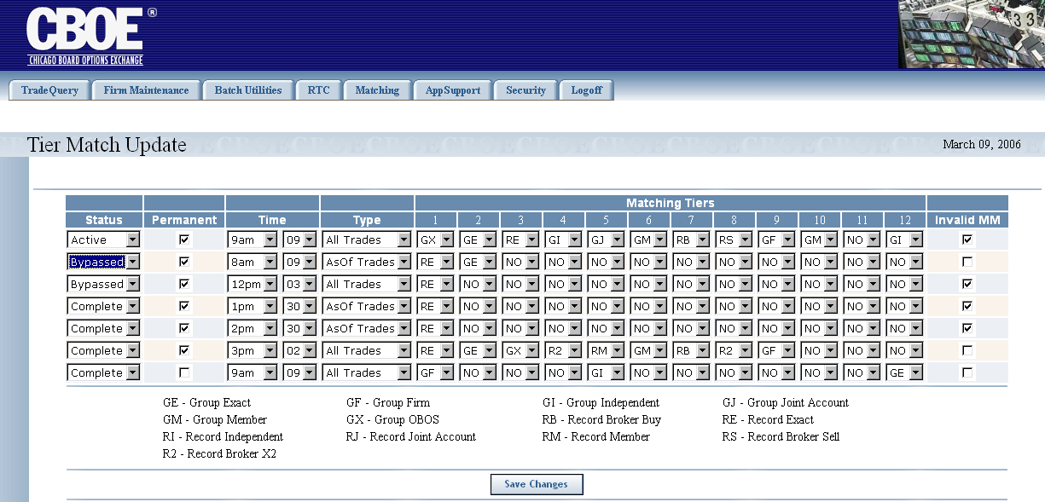
- From the Status column, set the state of the intraday processing to Active, Bypassed or Complete.
- Active: activate intraday processing
- Complete: intraday processing is completed
- Bypassed: skip the processing for the scheduled time
  - Note: You may choose to bypass the processing time due to an existing production issue.
  - Note: If intraday processing is executing, the status will display as “Running”.
- To permanently set your tier match update, select the Permanent checkbox. Deselect the checkbox if you want the tier match criteria to only run once.
- The Time column allows you to set the time that matching tier will run. Set the time from the drop down selection.
- Select the type of trades from the Type drop down list. You can choose either All Trades or As Of Trades.
- Select the Matching Tiers based on the criteria described in the table below.
Data Values
  GE - Group Exact | GF - Group Firm | GI - Group Independent | GJ - Group Joint Account
  GM - Group Member | GX - Group OBOS | RB - Record Broker Buy | RE - Record Exact
  RI - Record Independent | RJ - Record Joint Account | RM - Record Member | RS - Record Broker Sell
  R2 - Record Broker X2
- If you want the CTM system to match invalid Market Makers, select the Invalid MM checkbox.
- Click Save Changes. The system will capture your changes.
Control Update | This Control Update window allows you to change the trade matching process control parameters.  Click Matching and then select, Control Update. The Control Update window will display.
 | 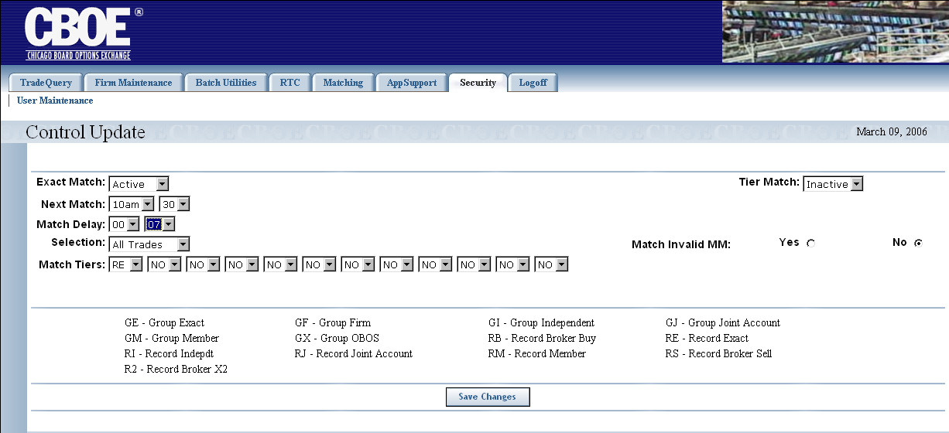
Several matching parameters are controlled through this window.
- From the Exact Match drop down list, choose if you want exact matching to be Active or Inactive.
- Select when you would like the next match to occur by selecting the time from the Next Match drop down selection.
- Set the Match Delay in minutes or seconds from the drop down selection.
- From the Selection drop down list, choose if you want to set these parameters for All Trades or As Of Trades.
- Select the match criteria from the Matching Tiers drop down lists based on the legend at the bottom of the window (i.e, GE - Group Exact, etc.).
- From the Tier Match drop down list, select if you want tier match to be Active or Inactive.
- If you want the CTM system to match invalid Market Makers, select the Yes or No radio buttons.
- Click Save Changes. The system will set your matching parameters.
In the example above, the matching parameters are set to match active trades at 10:30a.m. for all trades corresponding to RE-Record Exact. The tier match is inactive and invalid Market Makers will not be matched. Match delays are set to 7 seconds.
Batch Match | This window allows you to select the type of trade and tier match criteria you want to use in the batch matching process.  To display the Batch Match window, click on the Matching tab and then select Batch Match. The following window will display.
 | 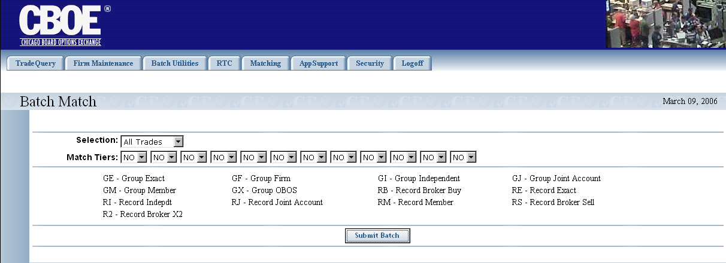
- From the Selection drop down list, choose if you want All Trades or As Of Trades to be included in the batch matching process.
- From the Match Tiers drop down list, select which matching criteria to include in the batch.
- Click Submit Batch. An unscheduled match batch will be submitted into the system.

APP Support

 | The APP Support window allows you to perform log controls, internal switch maintenance and audit logs.
Functionality Restrictions | ENTRY level: N/A  CONTROL level: Log Control, Audit Query, Internal Switch Maintenance  ALL level: Parm Browse, Log Control, Audit Query, Internal Switch Maintenance, Back-door Futures Delete, Back-door Futures Maintenance, Range Delete
Log Control | The Log Control window allows you to activate specific logs per server.  From the App Support tab, select Log Control. The following window will display
 | 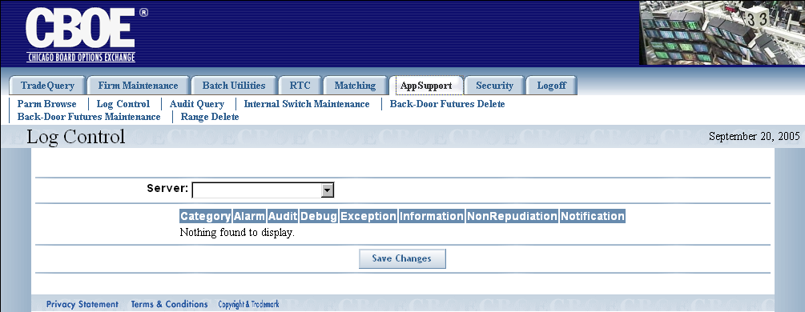
 | - Select the Server from the drop down list. The selected trade server will display with its active logs.
 | 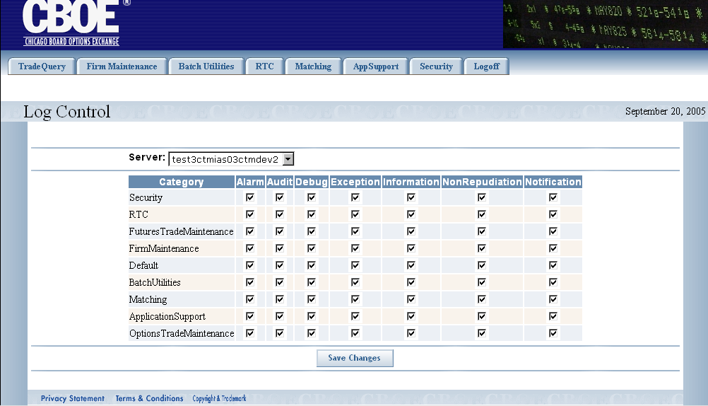
In the example above, server: test3ctmias03ctmdev2 has all logs activated for each category.
If you wish to remove logging for any category, deselect the corresponding checkbox. For example, to remove the audit log for the Security category, deselect the Audit checkbox. Click Save Changes.
Audit Query | The Audit Query feature allows you to retrieve trade data in report format for a specified time.  From the App Support tab, select Audit Query. The following window will display
Not available in Version 1.0 | 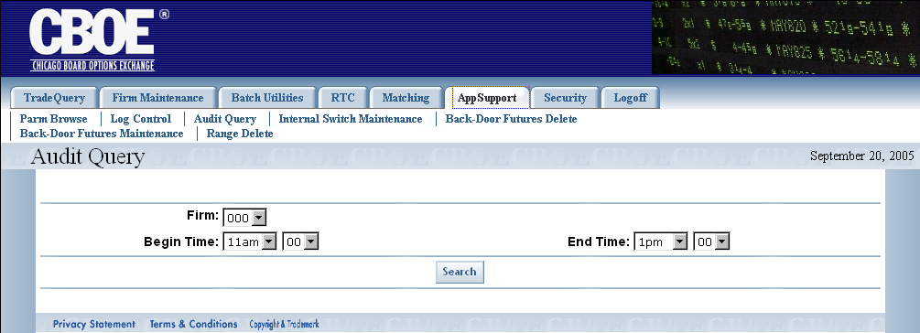
- Select the Firm number from the Firm drop down list.
- Enter the Begin Time and End Time from the corresponding drop down lists.
- Click Search. Trade data for the specified time will display.
 | 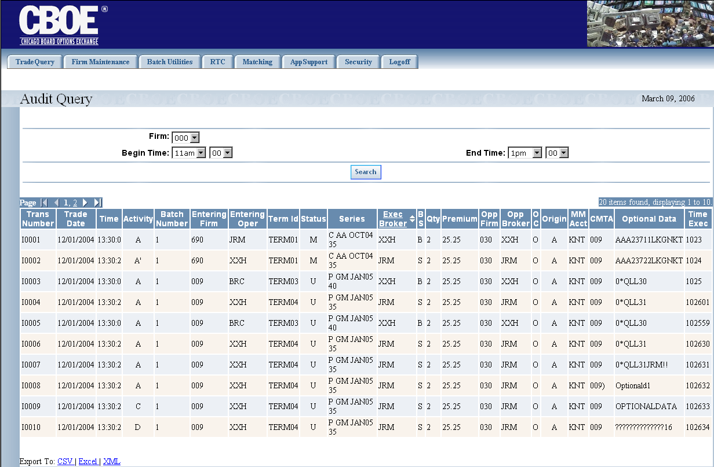
 | To scroll through the pages, click on the page numbers or the direction arrows until the desired page is reached.
 | For instructions on exporting CTM data to CSV, Excel or XML format, refer to the section Customize and Export CTM Windows, page 36.
Internal Switch Maintenance | To activate internal switches, click App Support and then select Internal Switch Maintenance. The following window will display.
 | 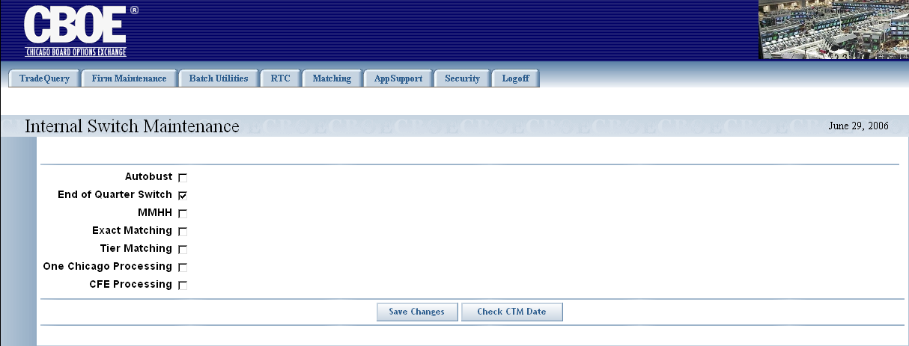
The Internal Switch Maintenance window allows you to set certain features to automatically activate for the CTM system.
For example, to set end of quarter switch to automatically activate, select the End of Quarter Switch checkbox. Click Save Changes. The system will save your request.

Exit the System

 | You can log out and exit the system at any time during the day.
Exit the System | To exit the CTM system, click on the Logoff tab and select Logoff CTM. You will be logged out of the application and will be returned to the CTM Login window.

◻ | Section 2:  Reference Guide

Customize and Export CTM Windows

Exporting CTM Data | CTM windows that exhibit data in column format can be exported to different file formats.

Export to CSV Format
- Click CSV (Comma Separated Value). The File Download window will display. The window defaults to Save this file to disk.
 | 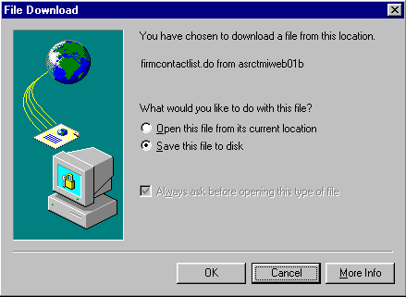
- Click OK. The Save As window displays.
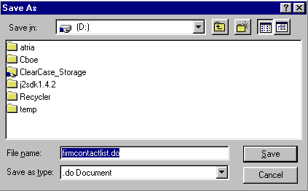
- Select the location where you want to save the file and enter the file name.
- Click Save. Your file will be saved in CVS format.
- To exit the window without saving, click Cancel.
To open the file from the current location:
- Click on the corresponding radio button. The Open With window displays.
 | 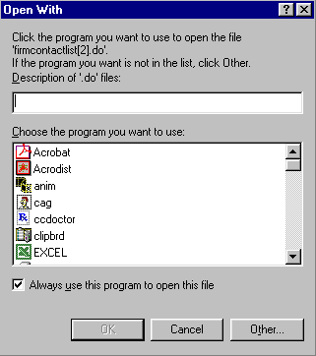
- Select the program in which to display the data.
- Click OK.
- Click Cancel to exit the window.

Export to Excel
If you wish to export the data to an Excel spreadsheet, click Excel. The system will open an Excel window and export the data.
 | 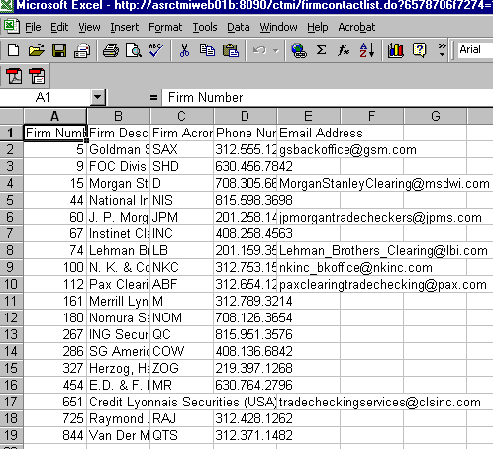

XML Conversion
To convert the data to XML, click XML. A new browser window will open and the data will display in XML format.
 | 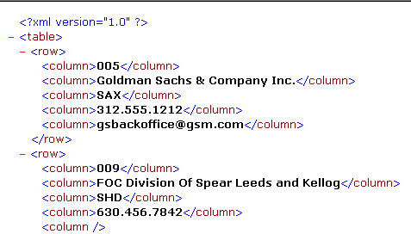
 | Click the right button (X) in the uppder right corner of the window to close the window and return to CTM system.
Sizing CTM Windows | The CTM windows are only as sizable as the browser allows.
 | 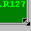 | Place the mouse on any edge of the window until it becomes a two-sided arrow. Hold the left mouse button down and move it to the desired size.
Resizing a window on the corner will expand or contract it in both directions (i.e. up and down and side-to-side). Resizing it on the side or top/bottom will expand or contract the window only in that one direction.
Windows can also be resized using the center glyph in the upper right corner of the window.
 |  | Click the left button () to minimize the window. Click the right button () to close the window. The center button is used for sizing.
If  is displayed, clicking it will increase the window size to a full-screen display.
If  is displayed, clicking it will return the window to its default size.

