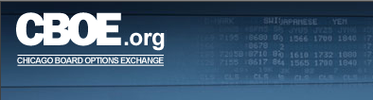

CBOE Central Log Monitor
User’s Guide
Version 1.0

Disclaimer

Copyright © 2007 Chicago Board Options Exchange. All rights reserved.
The information contained in this document constitutes confidential and/or trade secret information belonging to CBOE. This document is provided "As Is" with all faults and without warranty of any kind, either expressed or implied.

Change Notices

The following change notices are provided to assist users of the CBOE Back Office Monitor system in determining the impact of changes to their processing.
If you have any questions or review comments about this document, please contact Odalys Castro at (312) 786-8817.

Date | Version | Description of Change
5/02/07 | 1.0 | New document

Table of Contents
Table of Contents iii
Introduction iv
Purpose iv
Intended Audience iv
Note About Displayed Screens iv
Conventions Used in this Guide iv
Section 1: CBOE Central Log Monitor 5
Getting Started 6
Login 6
Central Log Details 7
Filtering Mechanism 9
Filter by a Specific Date 9
Filter by Origin ID 10
Filter by Priority 10
Filter by Component 11
Filter by Catetory 11
Filter by Tag 12
Filter by Message Description 12
Filter by Standard Message Type 12
Filter by Duplicate Count 13
Filter by Parm Name 13
Filter by Parm Value 13
Sorting Functionality 13
Exit the System 15
Logout 15
Section 2: Reference Guide 16
Customize and Export Windows 17
Exporting Data 17
Export to CSV Format 17
Export to Excel 19
Sizing Windows 19

Introduction

Purpose | This user guide was written to assist users in utilizing the Central Log Monitor features using a web browser. The system is used to monitor messages in the assurance environment for real-time replication, data warehouse, market regulations and back office.
Intended Audience | This user guide is intended for CBOE personnel interested in monitoring back office assurance testing data.
Note About Displayed Screens | An attempt is made to show the current look and format of screens that are included in this document. However, the displays here may not reflect recent changes to these browser screens. Also, information displayed on the screens may not reflect true production data.
Conventions  Used in this Guide | The Central Log Monitor system was designed so that you can perform all of your functions from a web browser.  Section 1 of the document illustrates how to perform the necessary back office functions. Additional information about window configuration and sizing can be found in Section 2: Reference Guide.  There are conventions used throughout this guide to help trigger important information:
 | Bolding | Used to highlight menu selections (e.g., Login) and button names (e.g., Update)
 |  Note: | This notation is used to indicate important information you should note when performing the associated function.

 | Section 1:  CBOE Central Log Monitor

This section of the user guide will direct you through all the functions of CBOE’s assurance testing environment Central Log Monitor system using a web browser.

Getting Started

Links are available for Production, Assurance and Test Backoffice monitor applications in the intranet at http://intranet/departments/EDMG/EDMGAppMon.html.

Click on the link Assurance Central Log Monitor. The following login window will display.
 | 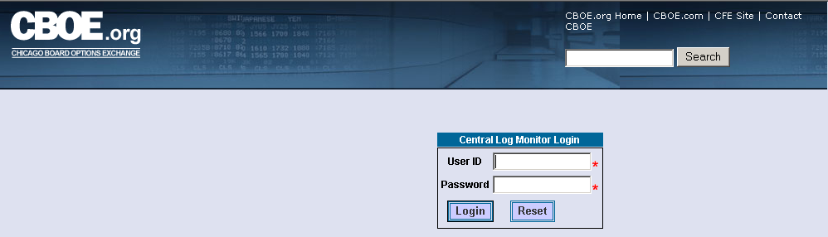
Login | Enter your User ID and Password.
 | 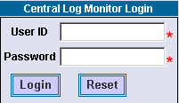
If you incorrectly typed in your User ID or Password, click Reset. The login window will clear. Re-enter your User ID and Password.
Click Login. The Central Log Monitor window displays.
 | 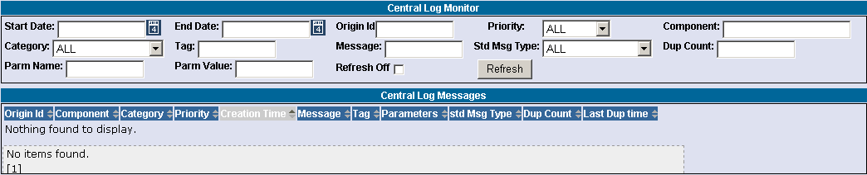
 | You are now ready to monitor back office assurance environment central log messages.

Central Log Details
The Central Log Monitor window allows you to monitor assurance testing log messages for all back office applications.
At the initial opening of the window, the Category, Priority and Std Msg Type fields default to ALL.
To generate log messages for these filters, click Refresh.
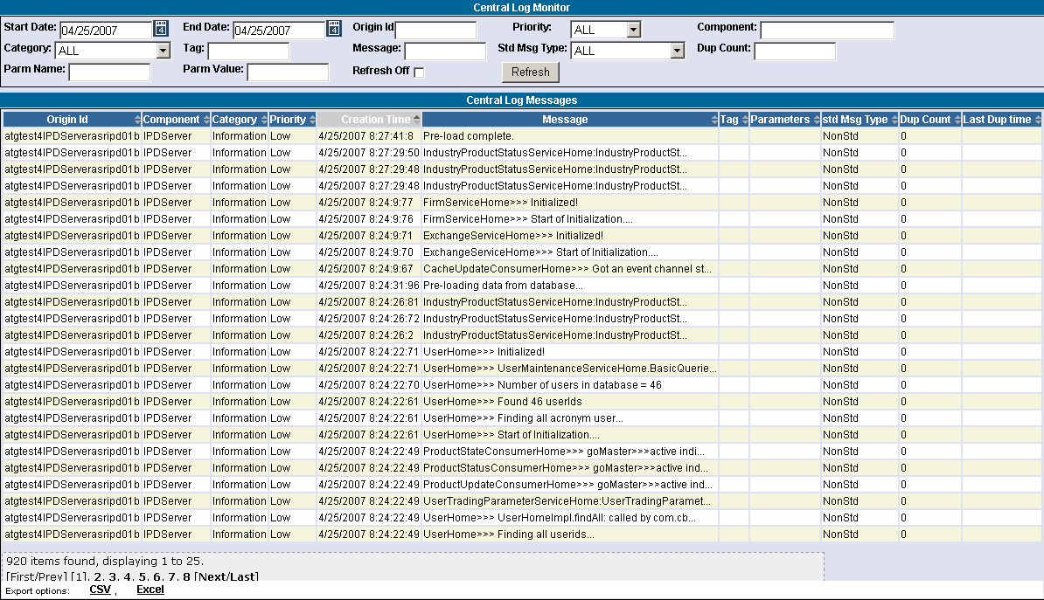
The Central Log Messages section of the window displays the results of the chosen criteria. Below is a description of each column.
- Origin ID: the location of the assurance server
- Component: the server name
- Category: the type of log message
- Priority: the severity level of the log message
- Creation Time: the date and time the log message occurred
- Message: the message description
- Tag: tag associated with the message
- Parm Name/Parm Value: name/value associated with the message
- std Msg Type: the message type
- Dup Count: the number of duplicates of this message that have been eliminated by the duplicate message filtering in the logging service
- Last Dup time: the time the duplicate message occurred
The total number of items found in this search is 920. The window displays up to 25 rows.
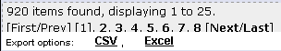
To view additional data rows or previously viewed data rows, click First/Prev, Next/Last or the corresponding page number (i.e. 1, 2, etc.).
Clicking on the Export option links on the botton of the page will fill a form with data from the screen in the selected format. For instructions on exporting data to CSV or Excel format, refer to the section Customize and Export Windows, page 17.

Filtering Mechanism

You can filter the Central Log messages by the criteria: Start Date/End Date, Origin ID, Priority, Component, Category, Tag, Message, Standard Message Type (Std Msg Type), Dup Count, Parm Name and Parm Value or a combination of each.
- Note: The drop down lists are searchable. Type in the first letter of the process name in the drop down box. The system will scroll down to the processes beginning with that letter. Continue to press the first letter of the process name on your keyboard until you reach your item in the list.
The Central Log monitor automatically updates data within a configurable amount time. To remove the automatic refresh option, select the Refresh Off checkbox.

Filter by a Specific Date
To filter the messages by Start Date/End Date:
- Click on the calendar button to select the Start and End dates. Or, you can manually enter the dates in the text box using the format 04/27/07 or 04/27/2007.
- Click to exit the calendar.
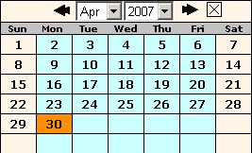
- Click Refresh. The following results will display.
  - Note: You can also filter for a specific date range (i.e. from 04/27/07 to 04/30/07).
 | 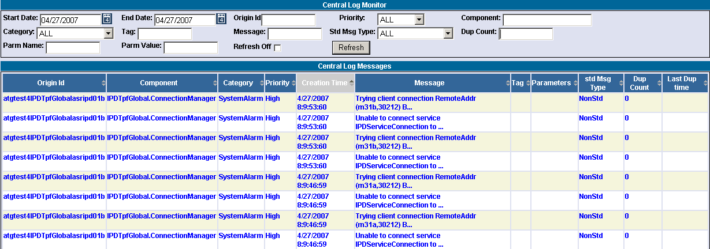
 | In the example above, data is displayed for April 27, 2007 in descending order. The results display central log messages for all standard message types with all priority types and category levels.

Filter by Origin ID
To filter the log messages by Origin ID:
- Type the Origin ID in the corresponding text box.
- Click Refresh. The following results will display.
 | 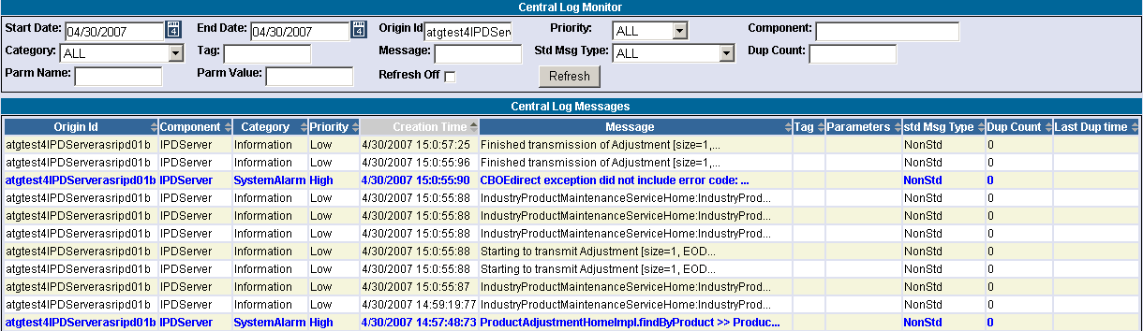
 | In the example above, data is displayed for April 30, 2007 in descending order. The results display central log messages for messages with Origin ID atgtest4IPDServerasripd01b for all categories, priorities and standard message types.

Filter by Priority
To filter by priority:
- Select the message Priority type from the drop down list.
- Click Refresh. The following results will display.
 | 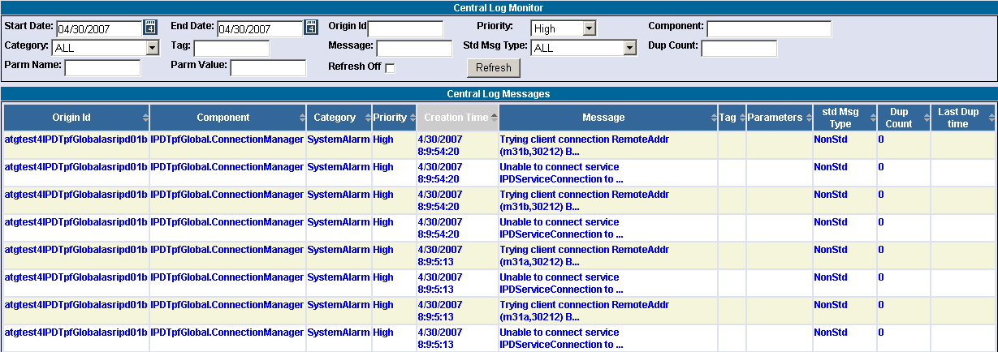
 | In the example above, data is displayed for April 30, 2007 in descending order. The results display central log messages with a high priority type for all categories and standard message types.

Filter by Component
To filter by component:
- Enter the Component name in the corresponding text field.
- Click Refresh. The following results will display.
 | 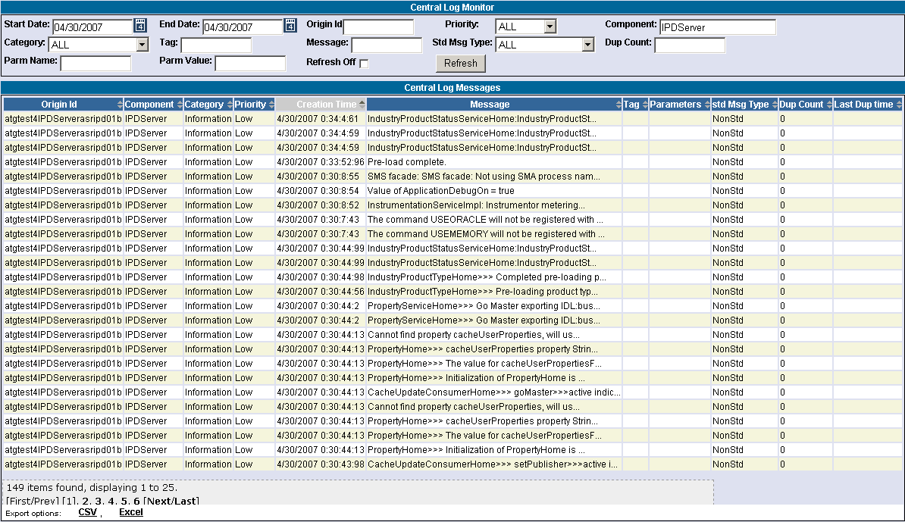
 | In the example above, data is displayed for April 30, 2007 in descending order. The results display central log messages for the IPDServer component for all priority types, categories and standard message types.

Filter by Catetory
To filter by category type:
- Select the Category type from the Category drop down list.
- Click Refresh. The following results will display.
 | 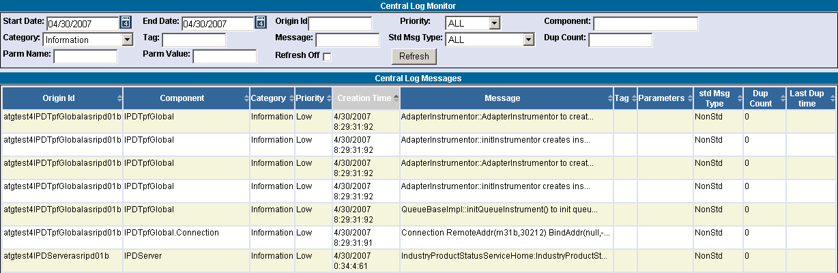
 | In the example above, data is displayed for April 30, 2007 in descending order. The results display central log messages with Information category type for all priorities and standard message types.
 | Filter by Tag

Filter by Message Description
To filter by message description:
- Enter the message description in the Message text field.
- Note: Filtering of messages is not case sensitive.
- Click Refresh. The following results will display.
 | 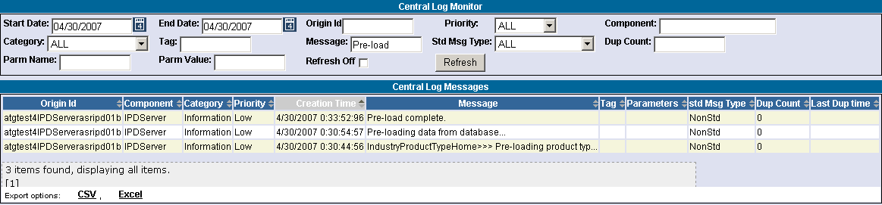
In the example above, data is displayed for April 30, 2007 in descending order. The results display central log messages for message description Pre-load for all category types, all priorities and all standard message types.
- Note: If you don’t know the exact message description to filter, use the Oracle LIKE character of "%" before and after partial verbage.

Filter by Standard Message Type
To filter by standard message type:
- Select the standard message type from the Std Msg Type drop down list box.
- Click Refresh. The following results will display.
 | 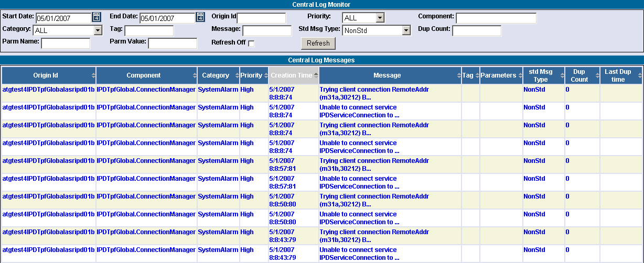
 | In the example above, data is displayed for May 1, 2007 in descending order. The results display central log messages for standard message type NonStd for all categories and priority type messages.

Filter by Duplicate Count
To filter by duplicate count:
- Enter the duplicate count number in the Dup Count text field.
- Click Refresh. The following results will display.

 | 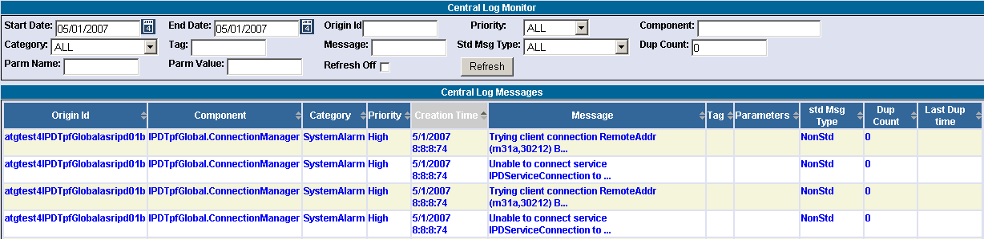
 | In the example above, data is displayed for May 1, 2007 in descending order. The results displays central log messages for duplicate counts of “0” for all categories, standard message types and priority type messages.
 | Filter by Parm Name
 | Filter by Parm Value
Sorting Functionality | Data columns that display the up/down arrows can be sorted. Click on the column name to perform an ascending or descending sort. This only sorts data last retrieved into the current screen.
 | 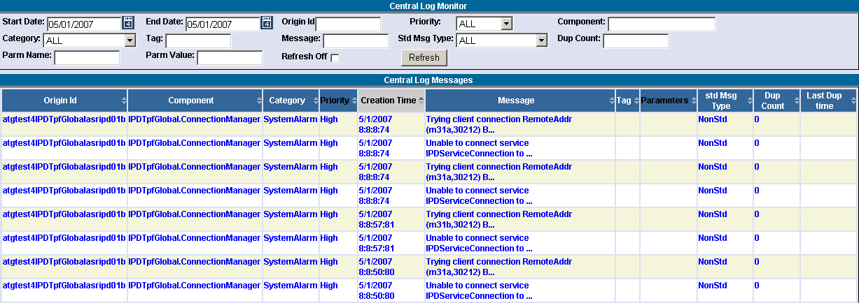
 | In the example below, the Creation Time column was originally in descending order. After the sort, it is in ascending order.
 | 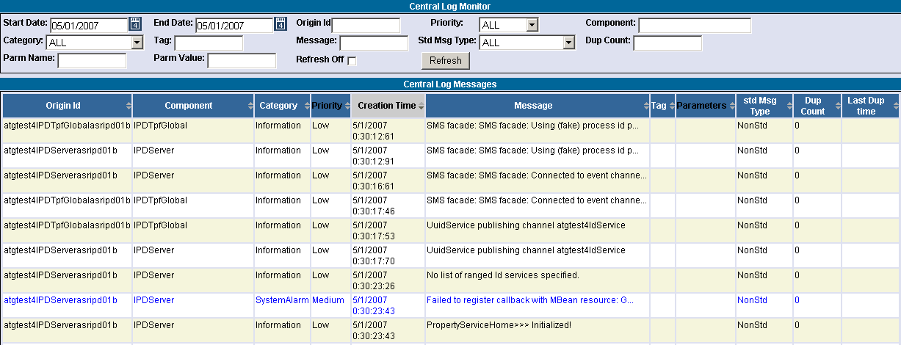

Exit the System

 | You can log out and exit the system at any time during the day.
Logout | To exit the system, Click the right button () to close the window. You will be logged out of the application and will be returned to the EDMG: Application Monitor Links window.

◻ | Section 2:  Reference Guide

Customize and Export Windows

Exporting Data | Windows that exhibit data in column format can be exported to different file formats.

Export to CSV Format
- Click CSV (Comma Separated Values). The File Download window will display.
 | 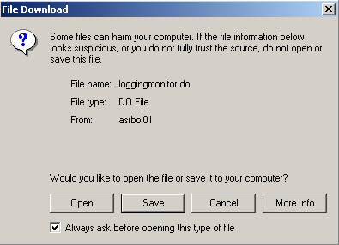
- Click Save. The Save As window displays.
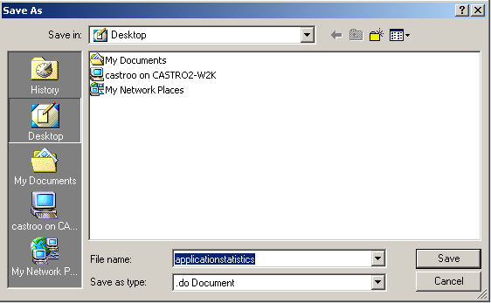
- Select the location where you want to save the file and enter the file name.
- Click Save. Your file will be saved in CVS format.
- To exit the window without saving, click Cancel.
To open the file from the current location:
- Click on the corresponding radio button. The Open With window displays.
 | 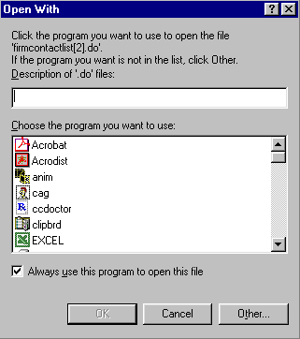
- Select the program in which to display the data.
- Click OK.
- Click Cancel to exit the window.

Export to Excel
If you wish to export the data to an Excel spreadsheet, click Excel. The system will open an Excel window and export the data.
 | 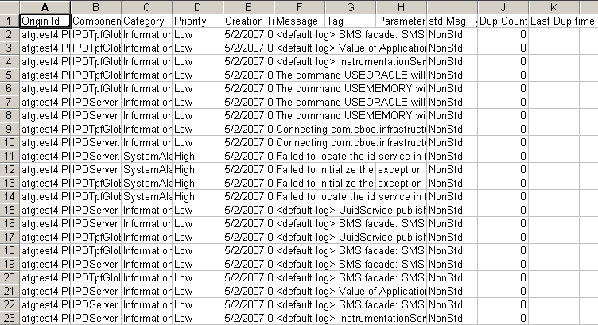
Sizing Windows | The windows are only as sizable as the browser allows.
Resizing a window on the corner will expand or contract it in both directions (i.e. up and down and side-to-side). Resizing it on the side or top/bottom will expand or contract the window only in that one direction.
Windows can also be resized using the center glyph in the upper right corner of the window.
 |  | Click the left button () to minimize the window. Click the right button () to close the window. The center button is used for sizing.
If  is displayed, clicking it will increase the window size to a full-screen display.
If  is displayed, clicking it will return the window to its default size.

