

Expected Opening Price and Expected Opening Size
User’s Guide
Version 1.0

Disclaimer

Copyright © 2006 Chicago Board Options Exchange. All rights reserved.
The information contained in this document constitutes confidential and/or trade secret information belonging to CBOE. This document is made available to CBOE members and member firms for use with CBOEdirect™. This document is provided "As Is" with all faults and without warranty of any kind, either expressed or implied.

Change Notices

The following change notices are provided to assist users of the CBOEdirect screen-based trading system in determining the impact of changes to their processing.
If you have any questions or review comments about this document, please contact Odalys Castro at (312) 786-8817.

Date | Version | Description of Change
8/18/06 | 1.0 | New document.

Table of Contents
Table of Contents 3
Introduction 4
Purpose 4
Intended Audience 4
Conventions Used in this Guide 4
Screen-Based Trading 5
Getting Started 6
Login 6
Monitor Opening Imbalances 8
Select the Post / Station to Monitor 8
EOP Message Types 11
Purge and Auto-Purge 11
Manual Purge 12
Auto-Purge 12
Print 13
Save Preferences 13
Configure the EOP/EOS Display 14
Filter EOP Message Types 14
Edit Table Preferences 17
Column Arrangement 18
Display Specifications 20
Display Color Options 20
Sizing Windows 24
Open Console Window 25
Exit the System 26
Exit the System 26

Introduction

Purpose | This document was written to assist users in utilizing the Expected Opening Price (EOP) and Expected Opening Size (EOS) features of the CBOEdirect screen-based trading system. The EOP/EOS system displays expected opening price and size data to allow you to monitor opening imbalances in the market.
Intended Audience | This user guide is intended for any person interested in CBOEdirect's EOP/EOS functions.
Conventions  Used in this Guide | The system was designed so that you can monitor the opening price and size activity from a standalone application. Some fields are sensitive to both right and left mouse clicks. Window control functions can also be activated by using keyboard commands.  There are several conventions used throughout this guide to help trigger important information:
 | Bolding | Used to highlight menu selections (e.g., Login) and button names (e.g., Update)
 |  Note: | This notation is used to indicate important information you should note when performing the associated function.
 | Brackets [ ] | Used to highlight keyboard commands (e.g., [Alt]-[T]). Note that when [Alt] or [Ctrl] are used in conjunction with another key, hold down the first key while pressing the second.  Some button functions can be executed through keyboard commands. Hold down the [Alt] key and press the keyboard character of the underlined letter in the command. For example:  [Alt]-[R] Restores an active window
 | 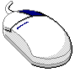 | This mouse graphic with the right mouse button highlighted will appear in the margin when accompanying instructions relate to functions activated by clicking the right mouse button.  All other mouse commands (such as double clicking to display a window) refer to a normal left mouse click.

 | Screen-Based Trading

This user’s guide will direct you through all the EOP/EOS functions for CBOEdirect.

Getting Started

 | When you launch the EOP/EOS application, the following login window will display.
 | 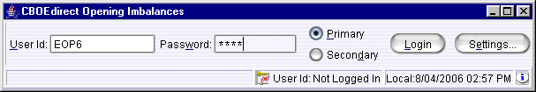
Login | Enter your User ID and Password. Both User ID and Password are case sensitive. Select your login as Primary by clicking the appropriate radio button.  Click Settings, to change your login mode. The Session Settings window will display.
 | 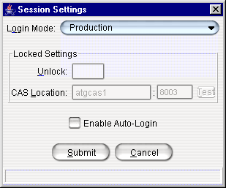
Select your Login Mode setting from the drop down list, click Submit, Confirm. If you decide you do not wish to change your login mode, click Cancel. The system will return to the menu window. Click Login.
To change your CAS location, enter your password in the Unlock field and enter the new CAS location. Click Test to check your setting. Click Submit. If you decide you do not wish to change your login mode, click Cancel. The system will return to the menu window.
Click Login. The CBOEdirect Opening Imbalances window will display.
 | 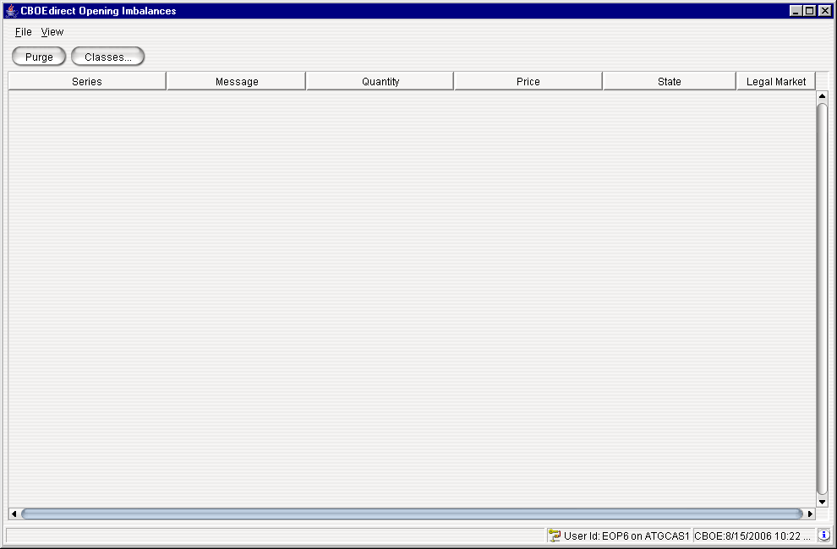
 | You are now ready to monitor opening price and size imbalances.

Monitor Opening Imbalances

 |  | The EOP/EOS system displays expected opening price and size data to allow you to monitor opening imbalances in the market.
Select the Post / Station to Monitor |  | To begin monitoring opening imbalances in the market, you must select which Post/Stations or classes to monitor. The selection is made through the CBOEdirect Opening Imbalances window.
 |  | Click on the Classes button, or choose Select Classes… from the View menu. The following window will display.
 |  | 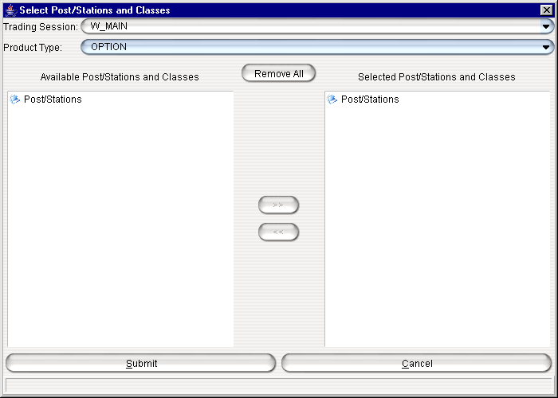
- Select the Trading Session and Product Type from the drop down lists.
- Double-click on the Post/Stations directory to display the list of available Post/Stations and related classes. The following window will display.
 |  | 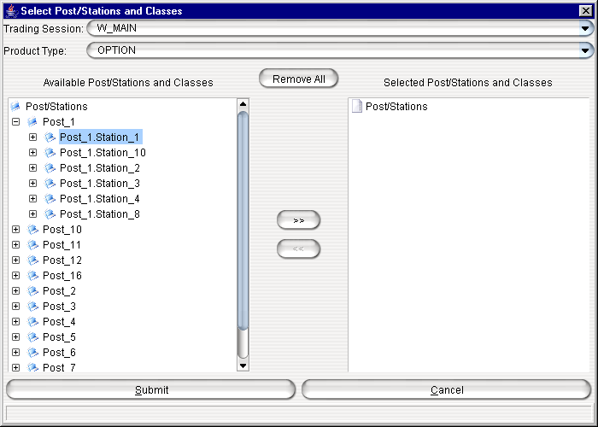
- Highlight the Post/Stations or individual classes you wish to monitor for opening imbalances. To highlight multiple Post/Stations or classes, hold down the Shift key on your keyboard and click on each selection. In the example above, all of Post_1Station_1 is highlighted.
- Click the double arrow to move the Post/Station to the Selected Post/Stations and Classes list box.
 |  | 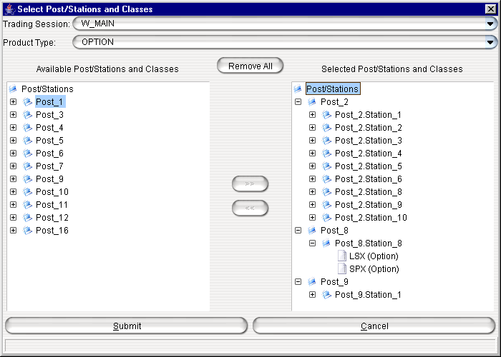
- To remove your Post/Station selection, highlight the Post/Station from the Selected Post/Stations and Classes list box.
- Click . Your selection will be moved back to the Available Post/Stations and Classes list box.
- If you wish to cancel your entire selection and return to the CBOEdirect Opening Imbalances window, click Cancel.
- To submit your selection, click Submit, Confirm. The system will return to the CBOEdirect Opening Imbalances window displaying opening imbalances for the series in the selected Post/Stations.
 |  | 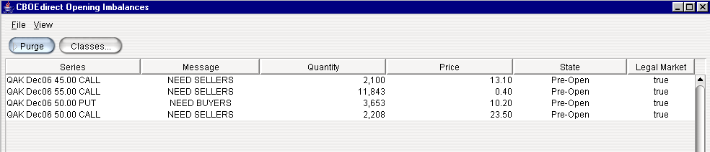
EOP Message Types |  | The CBOEdirect Opening Imbalances table provides descriptive opening messages to be used by Market Makers to send in valid/tradable quotes at the open.
Below are descriptions of the available message types that appear in the Message column:
NEED BUYERS: This EOP message type indicates that the current market is imbalanced and will need more buyers' contracts (n) at the opening price. The EOP message will provide users with the potential opening price (bid price) and the imbalanced quantity (n).
NEED SELLERS: This EOP message type indicates that the current market is imbalanced and will need more sellers' contracts (m) at the opening price. The EOP message will provide users with the potential opening price (ask price) and the imbalanced quantity (m).
DPM QUOTE INVALID: This EOP message type indicates that the DPM quote is invalid.
MULTIPLE OPENING PRICES:
- Note: This message type is not currently supported
NO OPENING TRADE: This EOP message type indicates there is no opening trade available.
PRICE NOT IN BOTR RANGE: This EOP message type indicates that the potential opening price is not in the valid Best of the Rest (BOTR) range based on the current BOTR price, current potential opening quantity and the system configuration. The EOP message will provide users with the potential opening price and opening quantity.
PRICE NOT IN QUOTE RANGE: This EOP message type indicates that the potential opening price is not in the valid quote range.
NEED DPM QUOTE TO OPEN: This EOP message type indicates that a DPM quote is needed to open the series.
NEED QUOTE TO OPEN: This EOP message type indicates that a valid quote is needed to open the series.
Purge and Auto-Purge |  | You can setup your display to auto-purge data or you can manually remove data during your monitoring session.
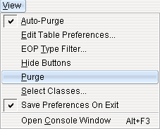

Manual Purge
A manual purge can be performed when the product is in “Open” state. As soon as the product’s state changes to “Open”, the row is grayed out, but it remains in the table until a purge is performed.
To immediately remove all “Open” rows from your display, click on the Purge button or select Purge from the View menu.

Auto-Purge
When enabled, auto-purge occurs every 30 seconds. It will remove all rows that have a product state of "Open", only if there are currently too many rows in the table to fit in the window. If there are one or more product state “Open” rows, but all the rows are visible without having to scroll down, the “Open” rows will remain in the table.

To set the Opening Imbalances window to auto-purge, click on the Auto-Purge option in the View menu. A checkmark will appear in front of the Auto-Purge option, enabling the feature.
You can customize your window by selecting or deselecting specific columns to display and by changing your display color. To customize your display, right mouse click on a data row. Select Edit Table Preferences. The Edit Column Preferences window will display.
For detailed information, refer to the Edit Table Preferences section, page 19.
 |  | 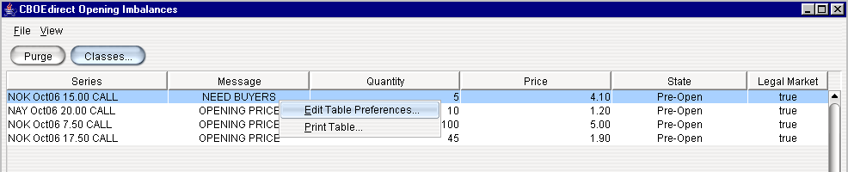
Print |  | You have the ability to print your table display at any time. Right mouse click on a data row and select Print Table. The Print window will display.
 |  | 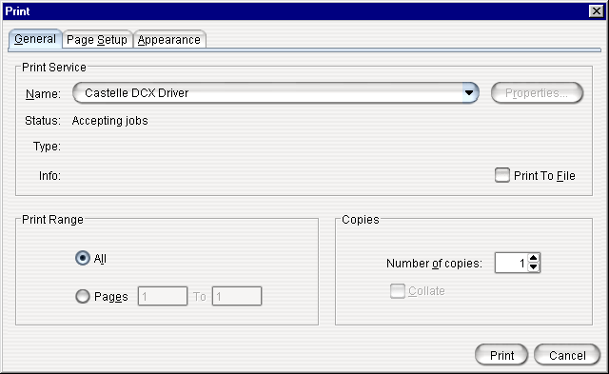
- To print your display, set your print options and click Print.
- If you decide not print the display, click Cancel.
Save Preferences  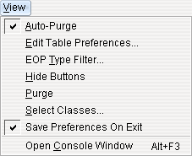 | If you want the system to save your changes and automatically open the window with your customized defaults, be sure to save your configuration.  From the View menu, click Save Preferences on Exit. A checkmark will appear in front of the option, enabling the feature. Setting the Save Preferences on Exit feature will prevent you from losing any configuration changes you make while you are monitoring opening imbalances. At exit, the system will save your configuration and make it available at your next login.  To save your preferences periodically, as you configure your display, click File, Save Preferences.
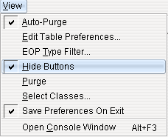 |  | You can expand the view of the CBOEdirect Opening Imbalances window by hiding the Purge and Classes buttons.  From the View menu, select the Hide Buttons option. A checkmark will appear in front of the selection and the CBOEdirect Opening Imbalances window will display without the buttons.
 |  | 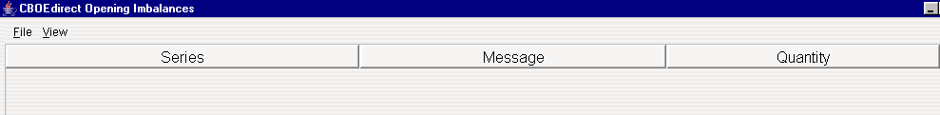

Configure the EOP/EOS Display

 |  | The CBOEdirect Opening Imbalances window is configurable. You can set it to your specifications to monitor opening imbalances in the market.
Filter EOP Message Types  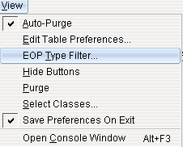 |  | The EOP/EOS system allows you to select which EOP message types you wish to monitor for opening imbalances.  From the View menu, select EOP Type Filter or hold down the [Alt]-[T] keys to display the EOP Type Filtering window.
 |  | 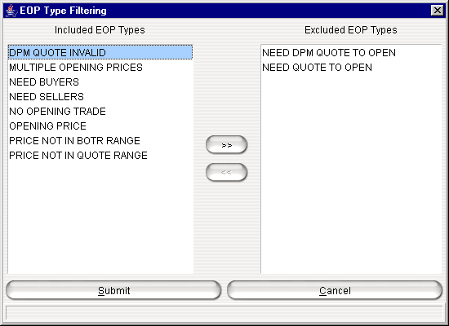
The EOP messages type available for monitoring are displayed in the Included EOP Types list box.
- Note: The message types: NEED DPM QUOTE TO OPEN and NEED QUOTE TO OPEN are excluded by default but can be included as EOP types to monitor.
To exclude additional EOP types from your display:
- Highlight the EOP type from the Included EOP Types list. In the example above, the DPM QUOTE INVALID message is highlighted.
- Click . The message type will be moved to the Excluded EOP Types list.
 |  | 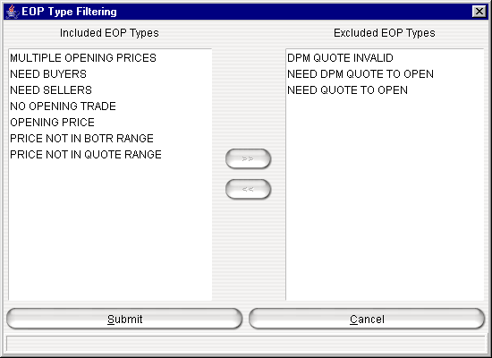
- To remove your EOP message type selection, highlight the message from the Excluded EOP Types list box.
- Click . Your selection will be moved back to the Included EOP Types list box.
- If you wish to cancel your entire selection and return to the CBOEdirect Opening Imbalances window, click Cancel.
- To submit and save your filtering selection in the system, click Submit, Confirm. The system will return to the CBOEdirect Opening Imbalances window.
Edit Table Preferences |  | When you initially open the CBOEdirect Opening Imbalances window the default columns display for monitoring opening imbalances. Data that is in column format can be customized to your specifications.
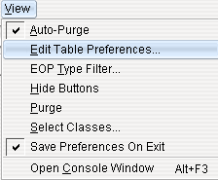 |  | To modify the column display, select Edit Table Preferences from the View menu. The Edit Column Preferences window will display.  From this window, you can rearrange column positions and select or deselect columns for viewing.  - Note: Tabs that are not available are grayed out.
 |  | 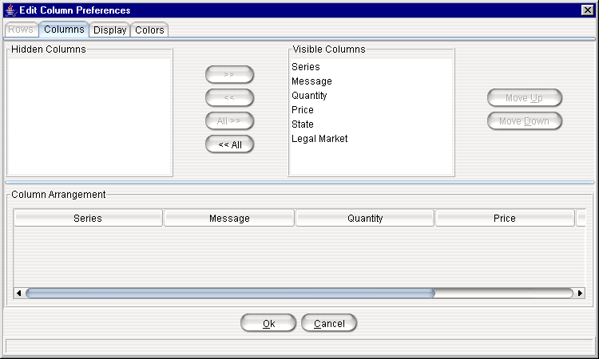

Column Arrangement
If there is a data column you do not wish to view:
- Select the column name in the Visible Columns list box. To select a continuous range of columns, hold down the shift key and highlight the column names. Hold down the ctrl key to select individual, non-continuous, column names.
- Click to move the column name to the Hidden Columns list box.
- Click Ok to update the column arrangement.
- If you decide to retain the default layout, click Cancel.
To hide all columns:
- Click to move all the column names in the Visible Columns to the Hidden Columns list box.
- Click Ok to update the column arrangement.
- If you decide to retain the default layout, click Cancel instead of Ok.
To display a hidden column:
- Select the column name(s) from the Hidden Columns list box.
- Click to move the selected column name(s) to the Visible Columns list box.
- Click Ok to update the column arrangement.
- If you decide to retain the default layout, click Cancel instead of Ok.
To display all hidden columns:
- Click to move the column names to the Visible Columns list box.
- Click Ok to update the column arrangement.
- If you decide to retain the default layout, click Cancel instead of Ok.
You may prefer to view data columns in a different order than the default display.
To move a column:
- Highlight the column name from the Visible Columns list box.
- Click or until you reach the new column location.
- Click Ok to update the column arrangement.
- If you decide to retain the default layout, click Cancel.
 | From the Column Arrangement section of the window, the columns can be resized to make viewing information easier for you.
 |  | 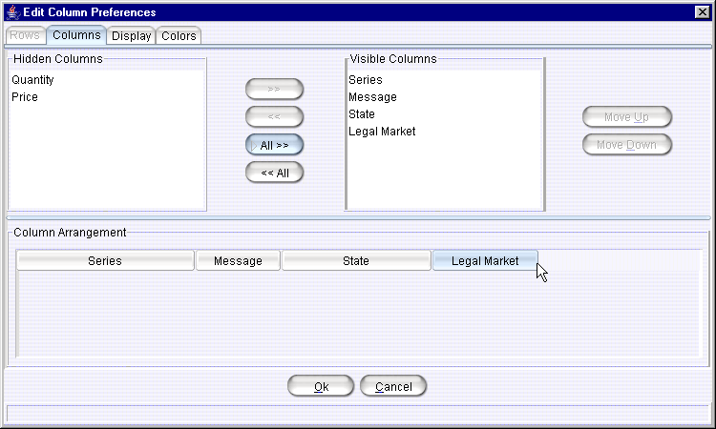
To resize a column:
- Place the mouse on the right edge of the column header (where the column titles are displayed).
- Hold the left mouse button down and move it to the desired size.
- Click Ok to save the new column size.
- If you decide to retain the default column size, click Cancel instead of Ok.

Display Specifications
In addition to customizing column settings, you can adjust the display of the text on your windows. From the Edit Column Preferences window, select the Display tab.
 |  | 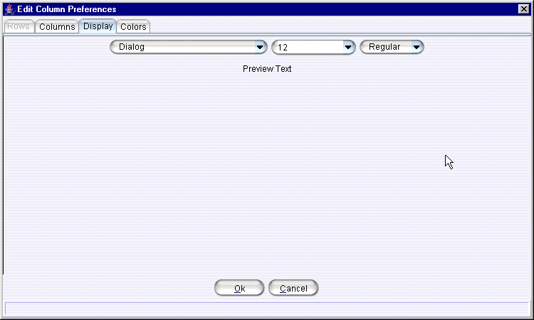
Select the font type, font size and font style from the drop down lists. Your selection will display in the Preview Text section of the window.
- Click Ok to set the new text style.
- If you wish to retain the default text settings, click Cancel.

Display Color Options
You can change the look of your EOP/EOS opening imbalance display by choosing alternating row colors. Click on the Colors tab in the Edit Column Preferences window.
 |  | 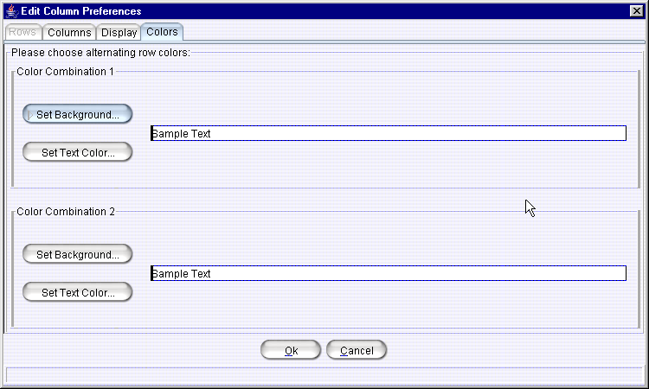
 |  | To change the background or text color, click Set Background or Set Text Color in the Color Combination 1 box. The Pick a Color window will display. The system allows you to setup a second color combinations in the Color Combination 2 box.
 |  | 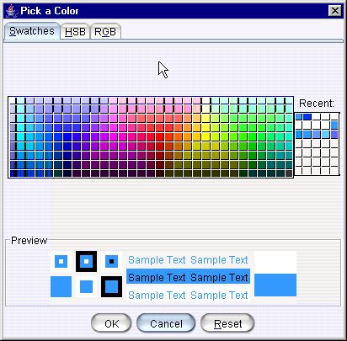
 |  | From the Swatches tab, click on your background color choice. An example of your color choice and text will appear in the Preview section of the window.
 |  | Click the HSB tab to set your hue, saturation and brightness. Place your mouse on the scroll bar button and adjust your color preference.
 |  | 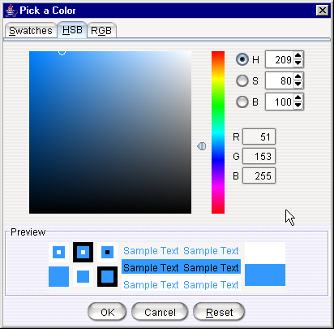
- Click Cancel to remove your changes and exit the window.
- Click Reset to retain the original settings.
- Click OK to save your changes. The background and text color will display in the Preview section of the window.
 |  | Click the RGB tab to set your red, green and blue color model. Place your mouse on the side scroll bar and adjust your color preference.
 |  | 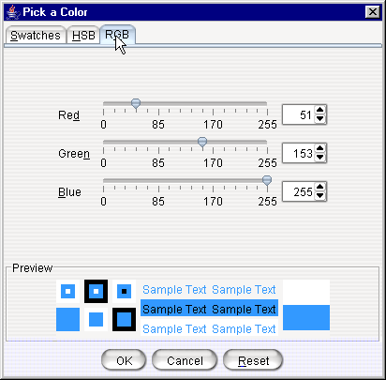
- Click Cancel to remove your changes and exit the window.
- Click Reset to retain the original settings.
- Click OK to save your changes. The background and text color will display in the Sample Text box.
 |  | 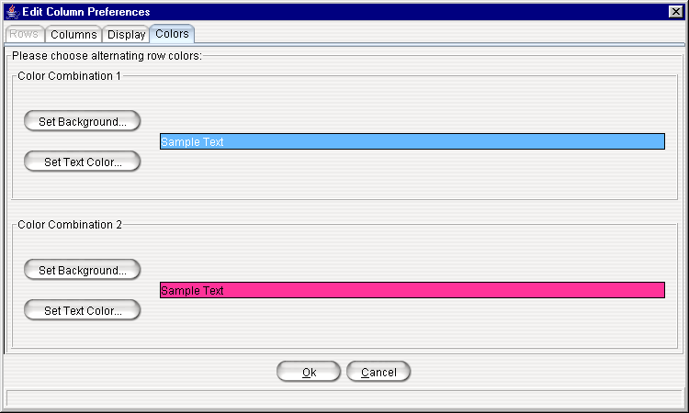
- Click Cancel to retain the original settings.
- Click Ok to save the color combinations. The CBOEdirect Imbalances window will display will alternating row colors.
 |  | 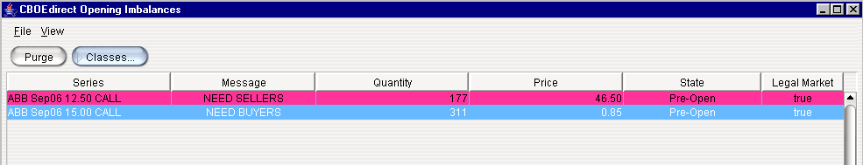
Sizing Windows | The CBOEdirect Opening Imbalances window is sizable. That is, it can be resized on the screen to make viewing information easier for you.
 | 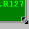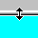 |  | Place the mouse on any edge of the window until it becomes a two-sided arrow. Hold the left mouse button down and move it to the desired size.
Resizing a window on the corner will expand or contract it in both directions (i.e. up and down and side-to-side). Resizing it on the side or top/bottom will expand or contract the window only in that one direction.
Windows can also be resized using the center glyph in the upper right corner of the window.
 |  |  | Click the left button () to minimize the window. Click the right button () to close the window. The center button is used for sizing.
If  is displayed, clicking it will increase the window size to a full-screen display.
If  is displayed, clicking it will return the window to its default size.
Open Console Window  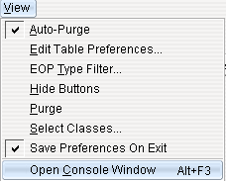 |  | The EOP/EOS system allows you to view system messages that are generated by the functions you perform. To view these messages, select Open Console Window from the View menu or press [Alt-F3] on your keyboard from anywhere on your screen. The Console Window will display.
 |  | 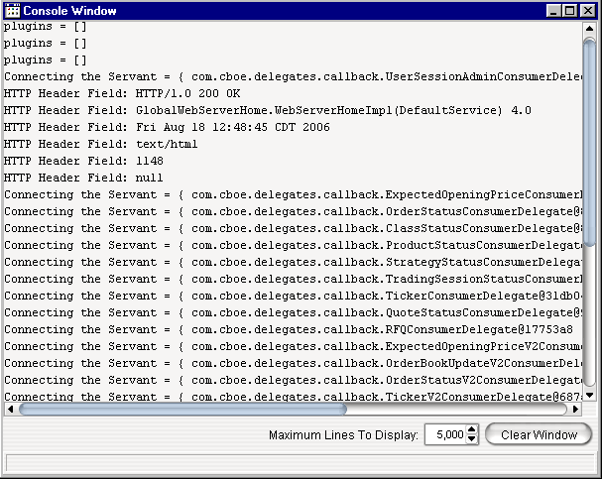
The information in this window can be copied to any text editor on your PC. To copy text from this window,
- Place your cursor on the line you want to copy and using your mouse highlight the text.
- Press Ctrl C on your keyboard to copy the text.
- Open your text editor (Word, Notepad, etc.) and place your cursor in the text entry area.
- Press Ctrl V on your keyboard. The text is copied to your editor.
The window defaults to display 5,000 lines. You can change the maximum amount of lines to display by entering a new quantity in place of the default value, or you can select a higher/lower quantity by clicking the up/down arrows until the desired quantity is reached.
If you wish to clear the window of all its contents, click the Clear Window button.

Exit the System

 | You can log out and exit the system at any time.
Exit the System | To exit the system, select Exit from the File Menu. You will be prompted to verify that you wish to close all windows and logout. Click Yes. The application will be closed and you will be returned to your system desktop.

