

Infrastructure Message Monitor
Version 5.4

Disclaimer

Copyright © 2007 Chicago Board Options Exchange. All rights reserved.
The information contained in this document constitutes confidential and/or trade secret information belonging to CBOE. This document is made available to CBOE members and member firms for use with CBOEdirect™. This document is provided "As Is" with all faults and without warranty of any kind, either expressed or implied.

Change Notices

The following change notices are provided to assist users of the Infrastructure Message Monitor (IMM) application in determining the impact of changes to their processing.
If you have any questions or review comments about this document, please contact Odalys Castro at (312) 786-8817.

Date | Version | Description of Change
12/1/06

Table of Contents
Table of Contents iii
Introduction v
Purpose v
Intended Audience v
Conventions Used in this Guide v
Section 1: Screen-Based Trading Infrastructure Message Monitor 6
Getting Started 7
Alarms 8
Historical Alarms Search 11
Edit Column Preferences 13
Sort and Rearrange Columns 13
Audible Alarm 14
Orb Name Alias Admin 16
System Health Error! Bookmark not defined.
System Health Functionality 22
Access Components and Processes 22
Verify Process State 23
Subscribe for Instrumentors 23
Subscribe for Multiple Orbs 23
View the Context Details of a CAS 26
Copy/Print Cell Information 29
Condense Instrumentor Branches 31
Editing the Orb Name 31
View Notifications 31
Notification Processing 32
Table Row Chart 33
Edit Preferences 34
Queue 34
Thread Pool 36
Method 37
Network 39
Heap 40
Count 42
Event 43
Filter and Search Options 44
Sort and Rearrange Columns 47
Edit Column Preferences 47
Save Window Preferences 47
Console Window 49
Open Console Window 49
Exit the System 51
Exit the System 51
Section 2: Reference Guide 52
Task Toolbar 53
About System Health Monitor 53
Open Tasks 53
Resize 53
Save Configurations 54
Apply Default Preferences 54
Window Control 55
Customizing System Health Monitor Windows 56
Edit Column Preferences 56
Display 58
Sizing Windows 58

Introduction

Purpose | This user guide was written to assist CBOE system operators, developers and support personnel in monitoring CBOEdirect’s infrastructure messages using the Infrastructure Message Monitor (IMM) application. The IMM application provides representations of current publish/subscribe message activity in a given environment. The data is near-real-time and can be viewed continuously.
Intended Audience | This user guide is intended for System operators or any person interested in the state of the CBOEdirect screen-based trading system.
Conventions  Used in this Guide | The IMM application was designed so that you can perform all of your activities from several display windows. Some fields are sensitive to both right and left mouse clicks. Window control functions can also be activated by using keyboard commands.  Section 1 of the document illustrates how to perform the necessary functions of the monitoring tool. Additional information about window configuration and sizing can be found in Section 2: Reference Guide.  There are several conventions used throughout this guide to help trigger important information:
 | Bolding | Used to highlight menu selections (e.g., Login) and button names (e.g., Update)
 |  Note: | This notation is used to indicate important information you should note when performing the associated function.
 | Brackets [ ] | Used to highlight keyboard commands (e.g., [Alt]-[O]). Note that when [Alt] or [Ctrl] are used in conjunction with another key, hold down the first key while pressing the second.  Some button functions can be executed through keyboard commands. Hold down the [Alt] key and press the keyboard character of the underlined letter in the command. For example:  [Alt]-[R] Restores an active window
 | 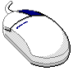 | This mouse graphic with the right mouse button highlighted will appear in the margin when accompanying instructions relate to functions activated by clicking the right mouse button.  All other mouse commands (such as double clicking to display a window) refer to a normal left mouse click.

 | Section 1:  Screen-Based Trading Infrastructure Message Monitor

This section of the user guide will direct you through all functions of the IMM tool for CBOEdirect.

Getting Started

When you launch the IMM application, the following menu window will display.
From this window, you can proceed to use all the functions of the IMM application to monitor CBOEdirect’s infrastructure messages.

Alarms

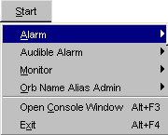 | Situations that are considered critical to CBOEdirect’s infrastrucuture are highlighted through alarms.  From the Start Menu, click Alarms, View Alarm Browser. The following window will display.
 | 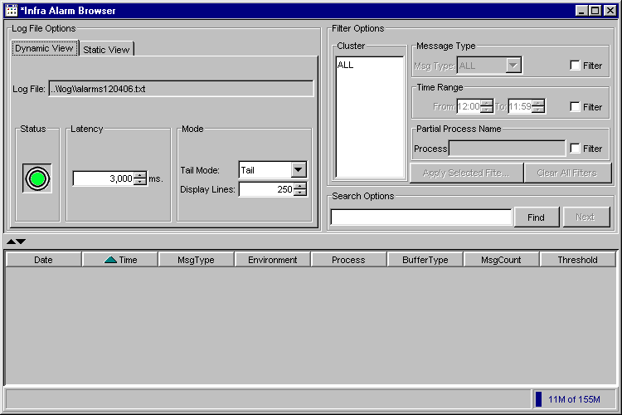
 | From this window, you have the capability to create, update or delete alarm conditions. For ease of readability, you can also select filters to sort the conditions.
 | You can view additional information for a specific alarm by right-mouse clicking on the alarm’s data row and selecting Show Detail.
 | 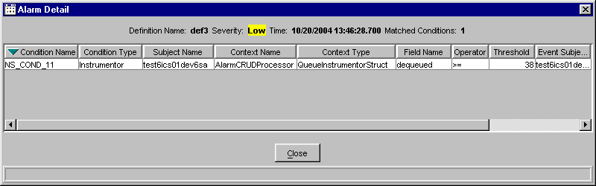
Scroll to the right to view additional data fields.
To return to the Alarm Notification window, click Close.
 | Select additional filters and click Apply Filters. The Alarm Notification window displays with the requested information.
 | 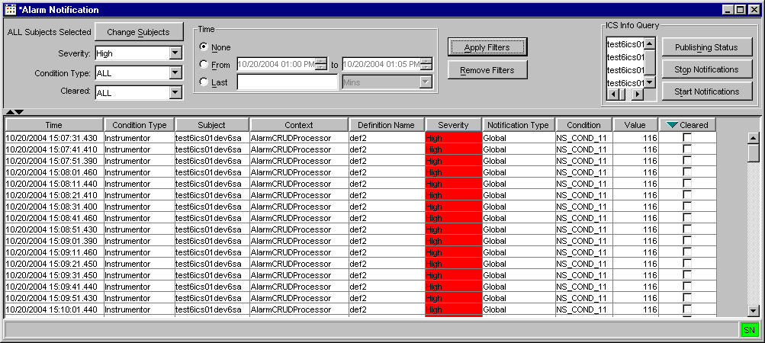
To sort by time, select the From radio button in the Time section of the window and choose the time range to filter. Click Apply Filters.
Or, select the Last radio button to sort by minutes or hours. For example, enter the number 2 and select minutes from the drop down list. Click Apply Filters. The system will sort alarm notifications for the last two minutes.

 | To clear alarm notifications for multiple conditions:
 | 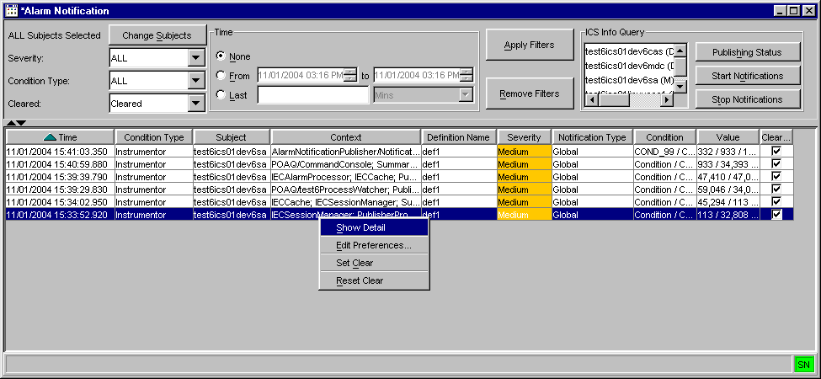
- Highlight multiple data rows and perform a right-mouse click. A sub-menu will display.
- Click Set Clear. The Clear column will display check boxes for the highlighted data rows.
- If you would like to query for only the cleared alarm notifications, select Cleared from the Cleared drop down list. Click Apply Filters. The system will display only the cleared alarms.
- If you would like to reset the alarms: highlight the data rows and choose the option, Reset Clear. The system will deselect the check boxes from the Clear column.
- To filter alarms notifications that are not cleared, select Not Cleared from the Cleared drop down list. Click Apply Filters. The system will display all the alarm notifications that have not been cleared.
- Click Remove Filters to edit out the applied filters and retain the original notification list.
 | To query ICS status, select the process from the ICS Info Query section of the window and click Publishing Status. The Alarm Notification Publishing State window displays with the state of the notification.
 | 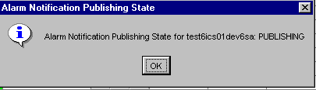
In the example above, alarm notification is publishing for test6ics01dev6sa.
Click OK to close the window.
 | If you would like to begin monitoring conditions for the process, select the option: Start Alarm Notifications.
 | 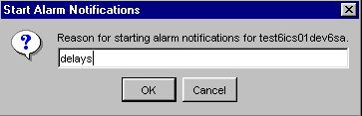
The Start Alarm Notifications window displays. Enter the reason for starting alarm notifications for the process and click OK. Alarm notifications will activate.
Click Cancel to close the window without starting notifications.
 | If you would like to stop alarm notifications for the process, select the option: Stop Alarm Notifications.
 | 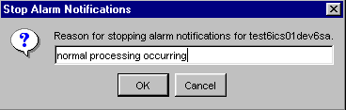
The Stop Alarm Notifications window displays. Enter the reason for starting alarm notifications for the process and click OK. Alarm notifications will deactive.
Click Cancel to close the window without starting notifications.
Historical Alarms Search | The Systems Health Monitor allows you to view alarms that occurred on previous days. From the Alarm sub-menu, select Historical, Create New Window. The Alarm Historical window will display.
 | 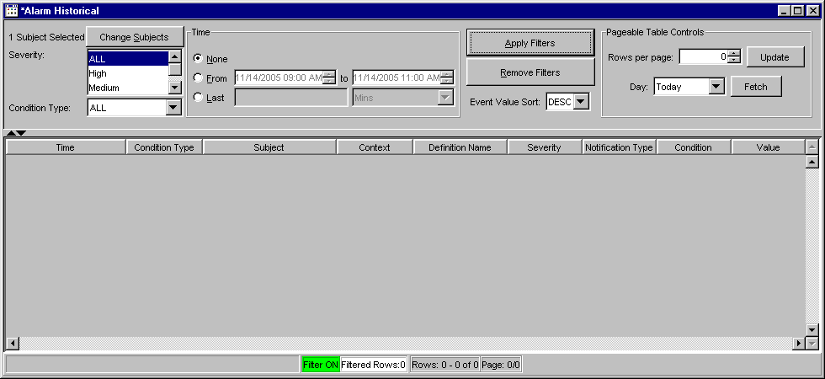
➢ | To view historical alarms by component:  - Click the Change Subjects button. The component selection window will display.
 | 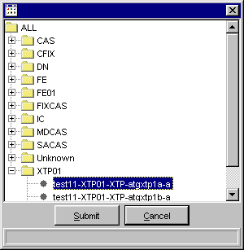
- If you would like to view historical alarms for all components, select the ALL folder.
- If you would like to view historical alarms for one component, select the component from the corresponding folder. In the example above, the selection is for test11-XTP01-XTP-atgxtp1a-a.
- Click Cancel to exit the window without making a selection.
- Click Submit to enter your selection. The Alarm Historical window will display with the selected component.
- Select Apply Filter to retain your changes.
- Choose Remove Filter to override your selection and query alarms for all components.
- Select the Severity and Condition Type you wish to view from the corresponding drop down lists.
- From the Pageable Table Controls section, select the day of the week for which you are interested in viewing alarms.
- Click Fetch. The Alarms for the selected component will appear in row format.
- Choose to sort by either ascending or descending order from the Event Value Sort drop down list.
➢ | To view historical alarms by time:  - Select the From radio button and enter the desired time.  - Click on the Last radio button to enter the desired time in minutes or hours.  - Click Fetch. The Alarms for the selected component will appear in row format.  - Choose to sort by either ascending or descending order from the Event Value Sort drop down list.
Edit Column Preferences | You can customize your Alarm windows by selecting or deselecting specific columns to display. To filter columns, right mouse click on a data row. Select Edit Preferences. The Edit Column Preferences window will display.  - Select or deselect columns for viewing and modify column arrangement as desired.  - To save your changes, click Ok.  - If you wish to retain the default settings, click Cancel.  For detailed information, refer to the Edit Column Preferences section, page 56.
Sort and Rearrange Columns | You can sort any column on the Alarm windows at any time by clicking on the column heading. The column changes to reflect the sorted data.  To rearrange the display of the columns, place your cursor on the column heading, then using your mouse, click on the column and drag it to the desired position.

Audible Alarm

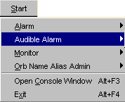 | The Infra Message Monitor application allows you to set an audible alarm for different levels of severity.  To set the audible alarm, click the Start button from the Menu window. Select Audible Alarm, Open. The Audible Alarm window will display.
 | 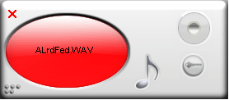
 | The audible alarm window displays based on the settings you choose. Click the settings button to display the alarm options window below.
 | 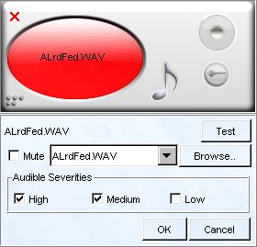
- Choose the audible sound from the drop down list. Or, click on the Browse button to expand your search.
- Click Test to listen to the alarm sound you selected.
- Set the Audible Severities. The above example configures the alarm to activate when severity levels are High or Medium.
- If you would like the alarm alert to appear without any sound, select the Mute check box.
- Click OK to enter your audible alarm settings.
- Click Cancel at any time to exit the window. You can also exit the window by clicking on the Dismiss Alarm Window button,  or by clicking .

Orb Name Alias Admin

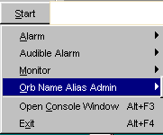 | The Orb Name Alias Admin allows you to view and modify all processes in CBOEdirect from one window.  From the Start menu, select Orb Name Alias Admin, Create New Window. The Orb Name Alias Admin window will display.  Click Cancel at any time to exit the window.
 | 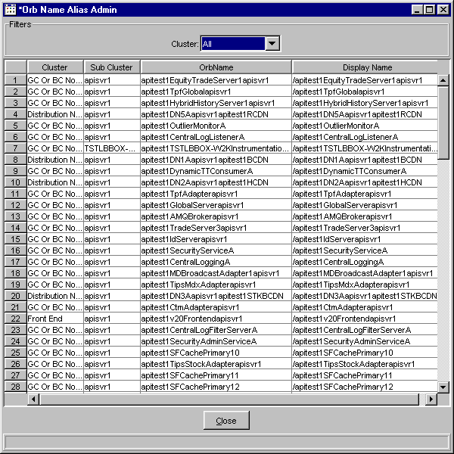
To edit the name of an Orb, right-mouse click on the OrbName row and select Orb Name Alias Edit.
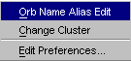
 | 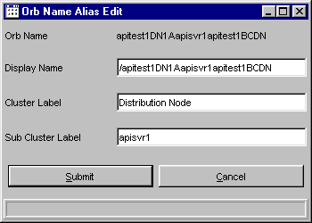
The Orb Name Alias Edit window displays. The Orb Name displays with its values along with editable text fields for Display Name, Cluster Label and Sub Cluster Label. Edits in this window can only be performed on one row at a time.
- In the Display Name text field, enter the name you want displayed in the Display Name column in place of the Orb Name.
- In the Cluster Label text field, enter the name of the server cluster (i.e. BC01)
- If you wish, you can enter the name of the sub cluster (i.e. BC01a) in the Sub Cluster Label text field.
- Click Submit. Click Confirm. The Display Name column labels the Orb Name as testCAS. The Cluster and Sub Cluster columns display BC01 and BC01a, respectively. The Orb Name column will still show the full Orb Name.
You can change the cluster or sub cluster of an Orb Name by right-mouse clicking on the Orb Name row and selecting the Change Cluster option. The Change Cluster window displays.
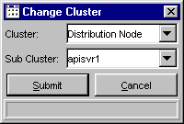
You can select multiple rows to edit as long as the Orb Name will use the same cluster and sub cluster.
Enter the new cluster in the Cluster field or you can select a cluster from the drop down list.

Enter the sub cluster in the Sub Cluster field. Click Submit. Click Confirm. The Orb Name Alias Admin window displays with the new cluster and sub cluster labels for all highlighted rows.
 | The Orb Name Alias Admin window can be filtered by cluster. Select the cluster from the Cluster drop down list in the Filters section of the window. The window displays only the Orb Name information based on your cluster selection.
You can customize your Orb Name Alias Admin window by selecting or deselecting specific columns to display. To filter columns, right mouse click on a data row. Select Edit Preferences. The Edit Column Preferences window will display.
- Select or deselect columns for viewing and modify column arrangement as desired.
- To save your changes, click Ok.
- If you wish to retain the default settings, click Cancel.
For detailed information, refer to the Edit Column Preferences section, page 56.

Monitor Environments

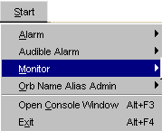 | The IMM application allows you to monitor and manager all components that the Talarian RT servers report in that environment. This information is updated periodically to reflect the actual conditions of the environment in near real-time.  To display the Infra Message Monitor window, click Start from the main window. Select Monitor, View Environment.
 | 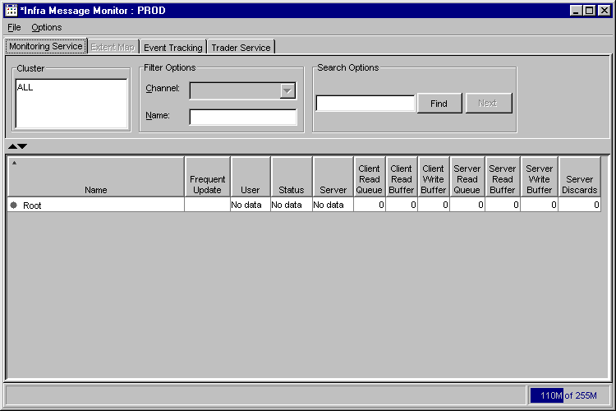
 | Initially, the IMM application is not connected to any environment. Selecting File, Connect will cause the application to connect to the default environment, if it has been specified. Otherwise, select File, Connect To… The following window will display to allow you to select a pre-defined environment.
 | 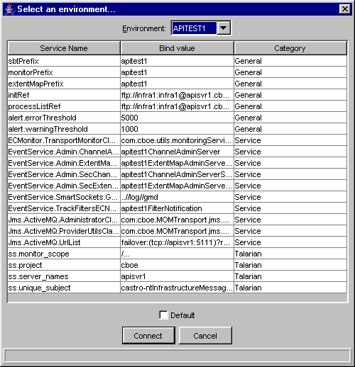
From the Environment drop down list, select the environment you are interested in monitoring. Click Connect. The IMM application will connect you to the chosen environment. The window displays all the processes that the Talarian RT server(s) report in that environment.
Selecting the Default checkbox will set the chosen environment as the default for your login.
Click Cancel if you wish to exit the window without selecting an environment.

 | 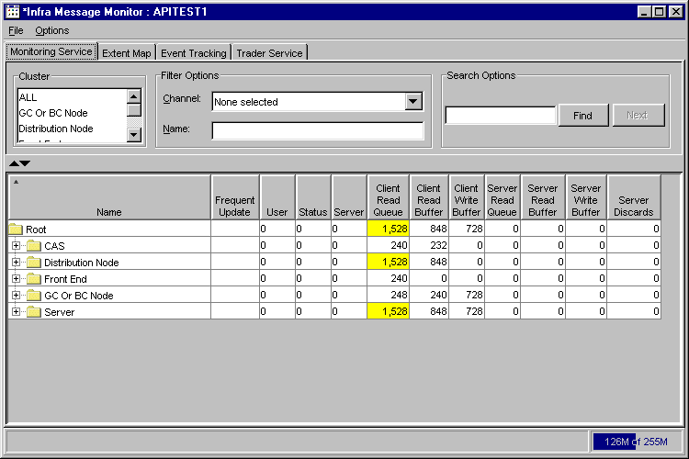
System Health Functionality | To begin using System Health functionality, click on the All tab to display all the data fields. From the All tab, you can view queue data, thread pool information, method call rates and peaks, network bytes sent through the system as well as disconnects and memory data.  If at anytime you wish to exit the System Health window, click Close.
 | 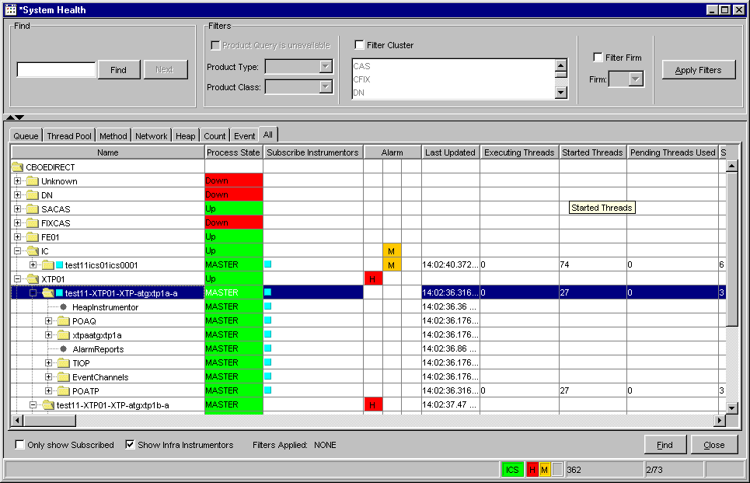
 | Use your scroll bar to view additional data fields to the right of the window.
 | 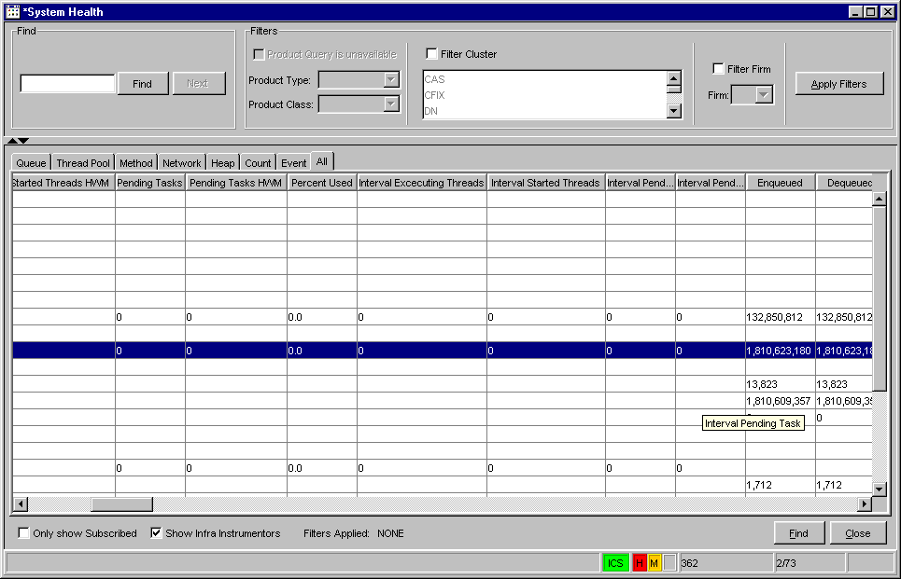
➢ | Access Components and Processes  Initially, the ALL tab appears with the Name column displaying the components at the base container level. You have the ability to determine what level of data you want to view by selecting which level of the component tree to display.  If you wish to view the components at the process level, click the component’s folder to expand the process list. In the example above, the IC tab has been expanded to display its processes.
➢ | Verify Process State  The Process State column displays the status of each process. The background color of the cell reflects the state of the process. For CAS processes (FIXCAS, SACAS, MDCAS and CFIX), if the process is Up, the background color displays in green. If the process is Down, the background color displays in red.  The Server processes will show a process state of Master, Slave, Unkown or Down. Server processes include: IC, BC, GC or any component that is not a CAS.  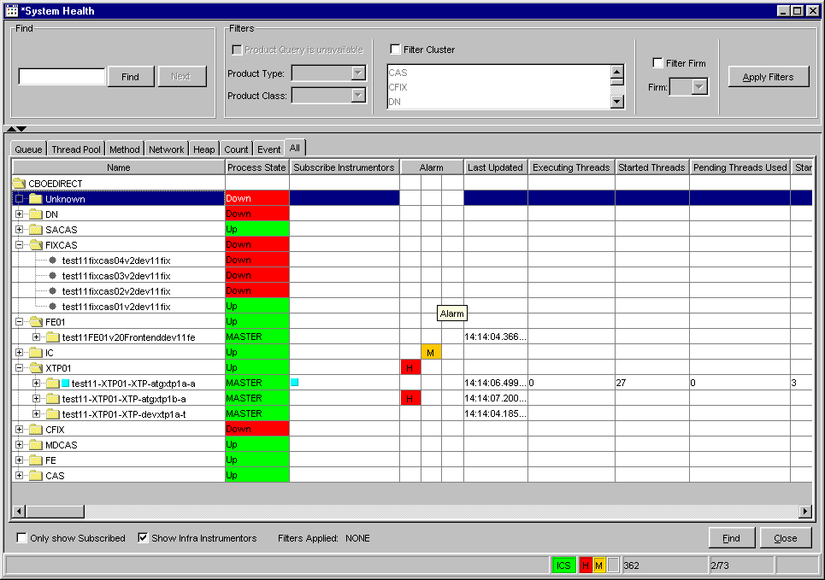  See below for a list of Server process status identifiers.
Process State Values
  Server Status | Background Color
  Up | Green
  Master | Green
  Slave | Blue
  Unknown | Red
  Down | Red
 |  Note: If any of the processes are unknown or down for a cluster, the status of the entire cluster will display as Down or Unknown.

Subscribe for Instrumentors
To subscribe for Instrumentors for a process, right-mouse click on the process name. A new menu displays.
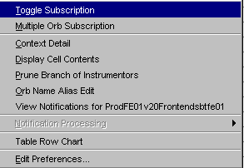

- Select the Toggle Subscription option. A blue box displays in front of the process name and in the Subscribe Instrumentors column, indicating the request for instrumentor information.
- You can subscribe for instrumentors for multiple processes by holding down the Shift or Ctrl key on your keyboard and highlighting the process names. Once the names are highlighted, right-mouse click on a row and select the Toggle Subscription option.
- To display Infra instrumentors, select the Show Infra Instrumentors checkbox on the System Health window. POATP, POAQ and TIOP processes will display beneath the processes.
 Note: The total number of Instrumentors is noted in the lower right-center of the window. In the example above, the total number of instrumentors is 2,811.
- To only display the processes with subscribed instrumentors, click the Only Show Subscribed checkbox on the System Health window. The processes that do not request instrumentor subscriptions will be removed from the display.

Subscribe for Multiple Orbs
To subscribe for Multiple Orbs, right-mouse click on the CAS name. A new menu displays.
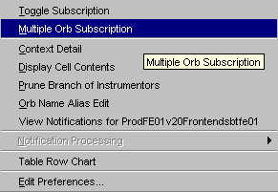

- Select the Multiple Orb Subscription option. The Orb Filter window displays.
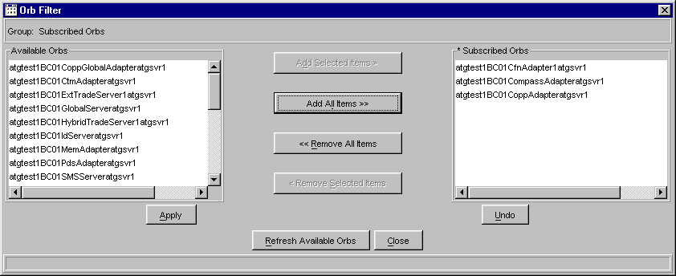

- From the Available Orbs list box, select the Orbs you want to subscribe to. To subscribe to multiple Orbs, hold down the Shift Key on your keyboard and highlight the desired Orbs. Click Add Selected Items. The Orbs will appear in the Subscribed Orbs list box.
- To subscribe to all Orbs, click Add all Items. All the Orbs in the Available Orbs list box will display in the Subscribed Orbs list box.
 Note: If the selected Orbs exceed the maximum number of Orbs set in the property file (currently set at 50), an error message will display. If you receive the error message, reduce the number of Orb subscriptions and continue.
- To unsubscribe from Orbs, select the Orbs from the Subscribed Orbs list. Click Remove Selected Items. The Orbs will display in the Available Orbs list box.
- To unsubscribe from all the Orbs, click Remove All Items or click Undo. The subscribed Orbs will appear in the Available Orbs list box.
- When you are satisfied with your selections, click Apply. Click Close. The subscribed Orbs will appear in the All tab as sub-processes of the CAS.
 Note: The subscribed and total number of Orbs appears in the lower right-center of the System Health window. In the example above, the number of Subscribed/Total Orbs is 48/48.
- To update the available Orbs selection, click Refresh Available Orbs. The available Orbs will update in the Available Orbs list box.

View the Context Details of a CAS
The System Health Monitor allows you to view background details of a CAS. Context detail is only available for CASs.
To view the context deails of a CAS, right-mouse click on the CAS name and select Context Detail.

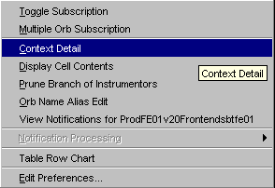

The Context Detail window displays.
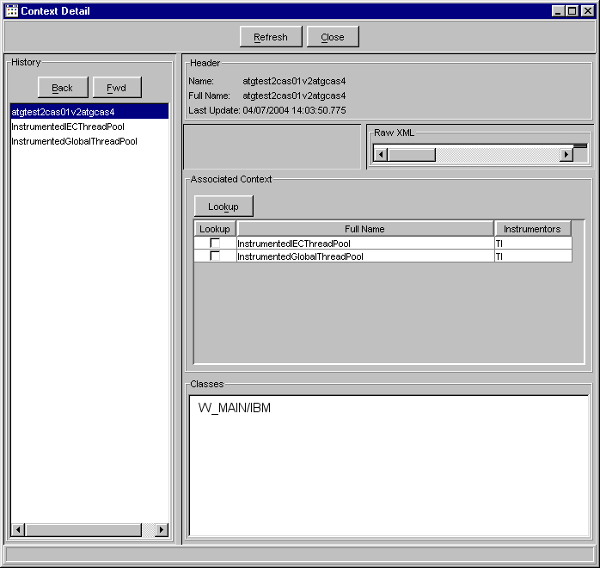
- Initially, the window displays with the Header information, which contains the full name of the CAS and the date and time it was last updated.
- The Raw XML section shows XML related to the CAS.
- The Associated Context section displays the full name of the instrumentors you are interested in.

- Product class information for the CAS appears in the Classes section of the window.
- The History section of the window displays the name of the selected CAS. The Back and Fwd buttons allow you to move backwards and forwards in the list, reflecting previous and refreshed data.
- Click the Refresh button to retrieve current instrumentor updates.
- Click the Close button to exit the window at anytime.

- To display related Thread Pool and XML data for an instrumentor, right-mouse click on the desired instrumentor in the Associated Context section. The following menu displays.
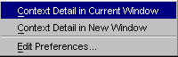

- You have the option to displays the detailed data in the current window, or in a new window. Select Context Detail in Current Window to show the data in the current window. If you wish to open a new window, select Context Detail in New Window. The XML, ThreadPool Instrumentor and History sections update to display the requested data.
 | 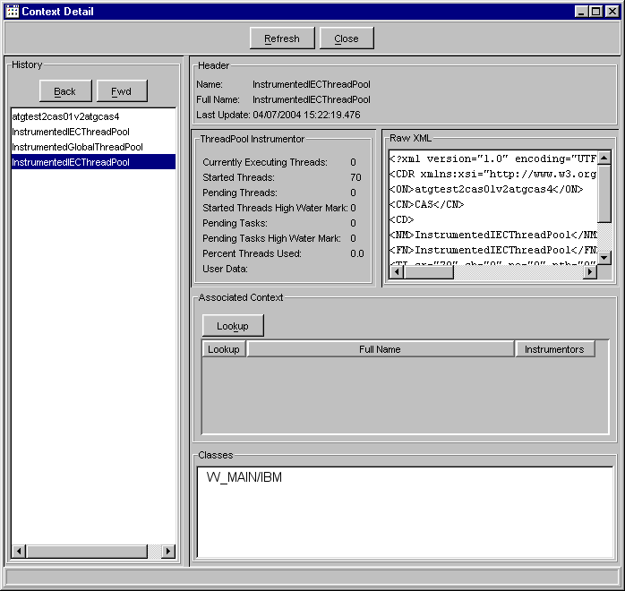
- To retrieve additional Thread Pool, Method or Queue instrumentor information, select the Lookup checkbox next to the instrumentors of your choice from the Associated Context section of the window. Click the Lookup button. The Multiple Context Detail window displays.
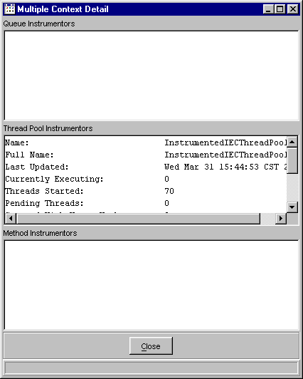
The Thread Pool Instrumentors section of the window displays with the following fields: Currently Executing Threads, Started Threads, Pending Threads, Start Threads High Water Mark, Pending Tasks, Pending Tasks High Water Mark, Percnet Threads Used and User data.
Information for Queue and Method Instrumentors display in their corresponding text boxes.
To copy the information in the window to Outlook or Microsoft Word, highlight the text. Press Ctrl-C to copy the contents to the clipboard. Open a Microsoft Word window and paste the clipboard into a document or paste the information into Outlook to send it as an email.
To exit the window at anytime, click Close.

Copy/Print Cell Information
Any cell data for any component can be copied or printed. For this example, right-mouse click in the Last Updated column cell for the CAS name, select Display Cell Contents.
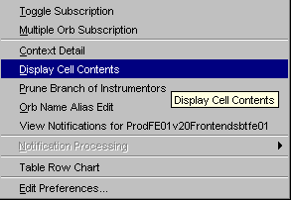

The Cell Contents window displays with the information that appears in the cell.
 | 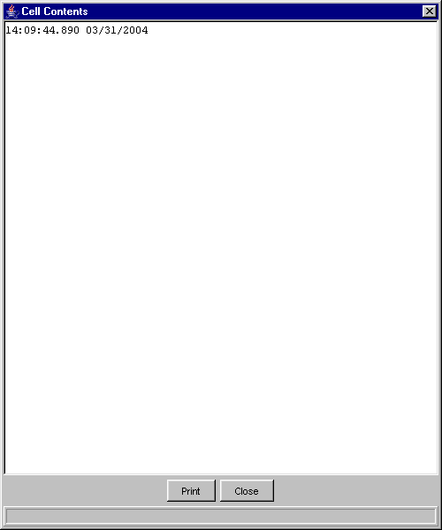
- To print the window, click Print. The window contents prints to a printer.
- To copy the information in the window, highlight the text. Press Ctrl-C to copy the contents to the clipboard. Open a Microsoft Word window and paste the clipboard into a document or you can paste the information into Outlook to send it as an email.
- To exit the window, click Close.

Condense Instrumentor Branches
For ease of visibility, you can quickly condense the Instrumentor branches on any component. Right-mouse click on a component process and select Prune Branch of Instrumentors.
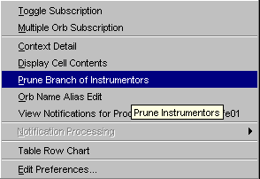

 | The instrumentors are immediately removed from the component tree. Within 30 seconds, the instrumentors reappear for monitoring.

Editing the Orb Name
Changing the name of a process to be more descriptive can be accomplished by displaying a new label. Select a process and right-mouse click to display the menu below.
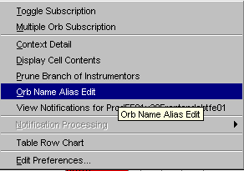

Select the Orb Name Alias Edit option. For details on editing Orb Names, refer to the Error: Reference source not found section, page Error: Reference source not found.

View Notifications
Detailed alarm notifications for a particular process can be viewed at anytime. Right-mouse click on the data row you are interested in viewing and select View Notifications.
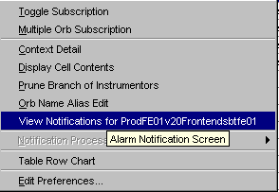
 | The Alarm Notification window displays. For detailed information, refer to the Edit Column Preferences section, page 56.

Notification Processing
You can start/stop alarm notifications for a process from the Notification Processing option. Right-mouse click on the process and select Notification Processing.

 | 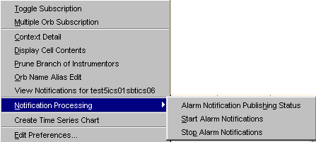
A sub-menu appears that allows you to: (1) view the publishing status of the alarms, (2) start alarm notifications and (3) stop alarm notifications.
If you select Alarm Notification Publishing Status, a window displays with the state of the notification.
In the example above, alarm notification is publishing for test6ics01dev6sa.
Click OK to close the window.
 | If you would like to begin monitoring conditions for the process, select the option: Start Alarm Notifications.
The Start Alarm Notifications window displays. Enter the reason for starting alarm notifications for the process and click OK. Alarm notifications will activate.
Click Cancel to close the window without starting notifications.
 | If you would like to stop alarm notifications for the process, select the option: Stop Alarm Notifications.
The Stop Alarm Notifications window displays. Enter the reason for starting alarm notifications for the process and click OK. Alarm notifications will deactive.
Click Cancel to close the window without starting notifications.

Table Row Chart
The Table Row Chart option allows you to graph the selected components time series. Right-mouse click on the component and select Table Row Chart.
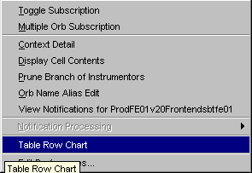
 | 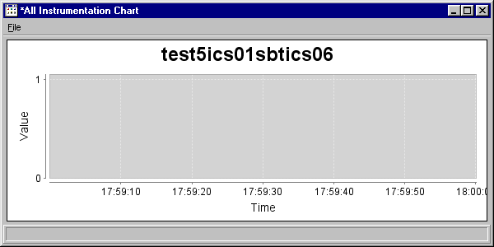
 | The example above, shows the time series for test5ics01sbtics06.

Edit Preferences
You can edit column preferences at any time. Right-mouse click on a data row. The Edit Column Preferences window displays.
For detailed information, refer to the Edit Column Preferences section, page 56.
Queue | The Queue tab allows you to monitor specific queue information for CBOEdirect components.
 | 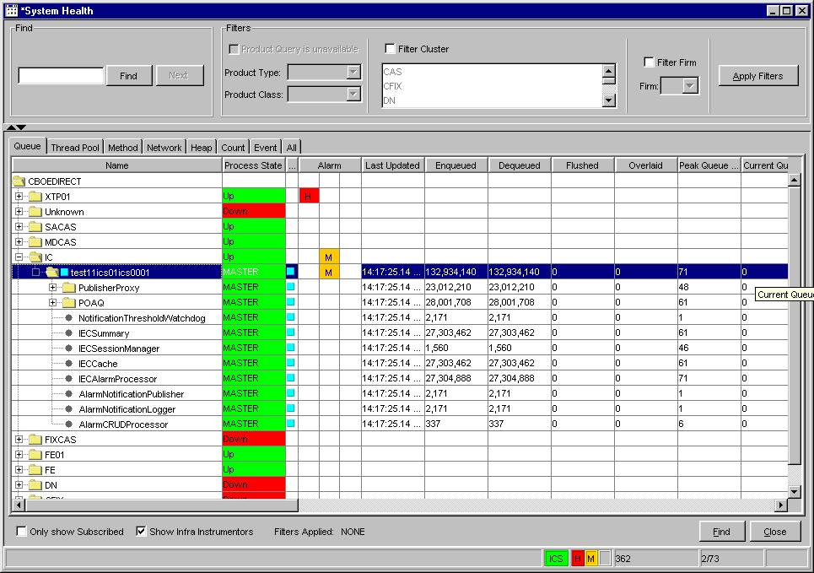
 | Use your scroll bar to view additional queue information.
 | 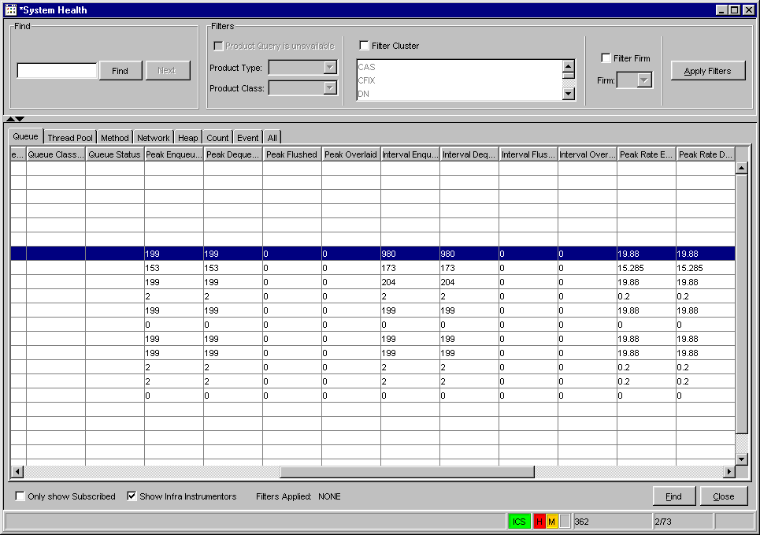
The Queue tab displays enqueued and dequeued data, peak queue information and average queue times.
Expand the IC folder to display its sub-processes. The Queue tab Process State column varies based on the state of the threads.
- If the thread is initializing, waiting or running, the background color of the cell displays in green.
- If the thread has not started, the background color of the cell displays in yellow.
- The background color of the cell displays in red if the thread has exited.
- A background color of white, states the queue status is not reported and should be ignored.
The Queue tab only displays queue instrumentors, not thread pool, method, heap or network instrumentors. For instructions on how to subscribe to instrumentors and Orbs, refer to the Subscribe for Instrumentors section of the document, page 24.
Thread Pool | Click on the Thread Pool tab to view threading information for CBOEdirect components.
 | 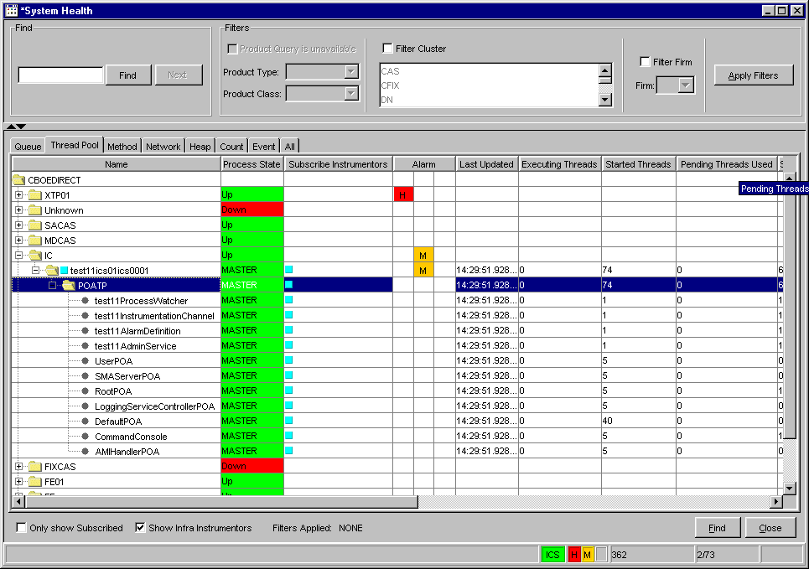
 | Use your scroll bar to view additional thread pool fields.
 | 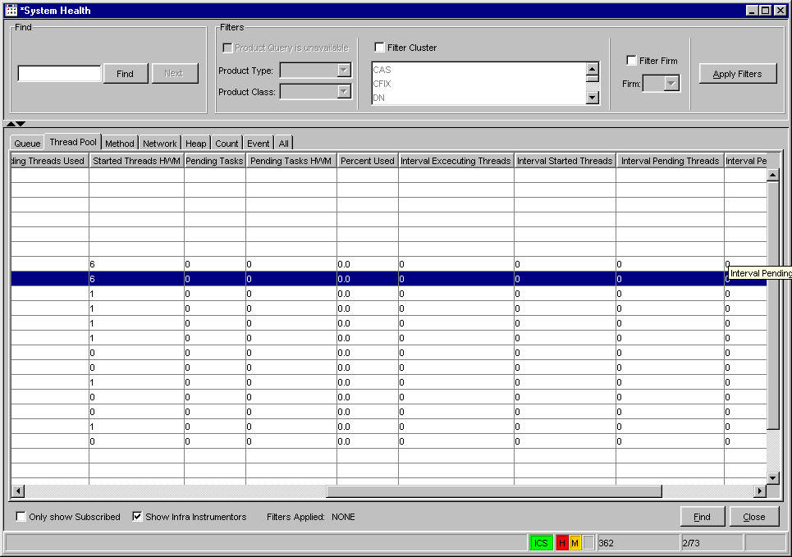
The Thread Pool tab provides current thread pool information as well as data that occur at peak intervals.

Expand the IC folder to display its sub-processes. To determine the state of any process in the Thread Pool tab, refer the Verify Process State section of the document, page 23.
The Thread Pool tab displays only thread pool instrumentors. For instructions on how to subscribe to instrumentors and Orbs, refer to the Subscribe for Instrumentors section of the document, page 24.
Method | Click on the Method tab to display the number of method calls accessed through CBOEdirect, as well as peak and average method rates.
 | 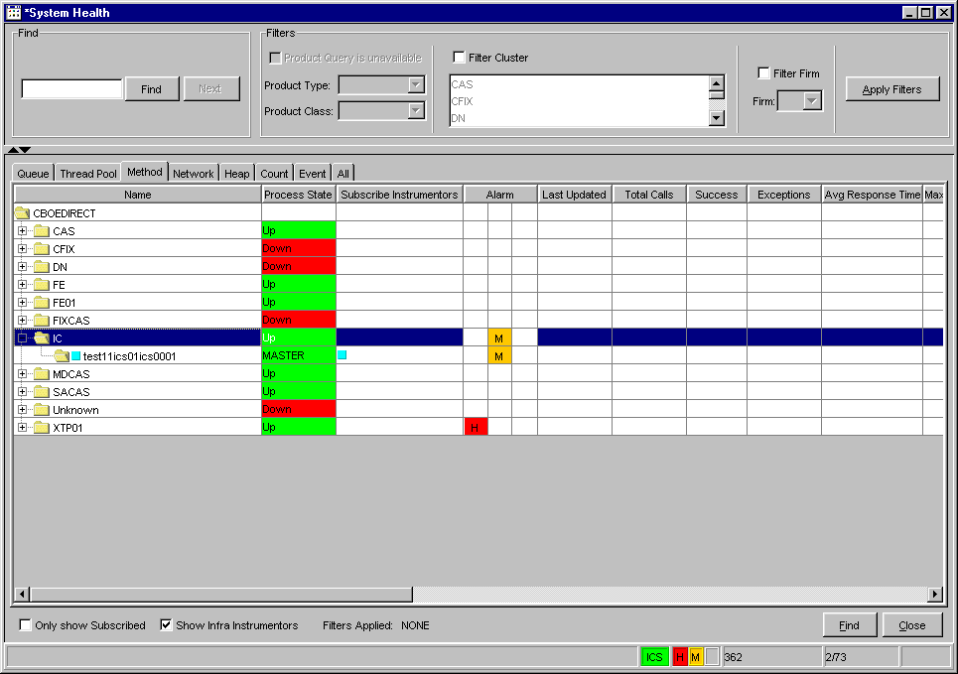
 | Scroll to the right to view additional method data.
 | 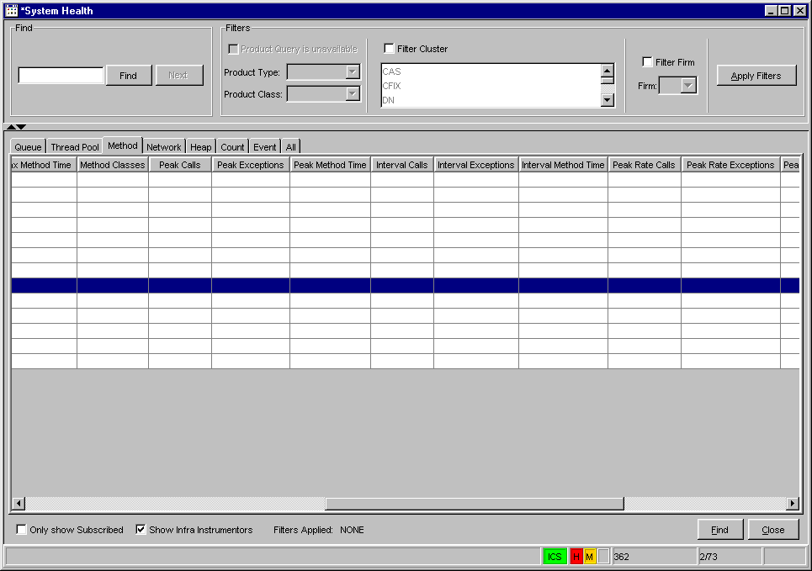
Expand the IC folder to display its processes. The Method tab does not display instrumentors.
 Note: All times are represented in milliseconds.
To determine the state of any process in the Method tab, refer the Verify Process State section of the document, page 23.
Network | Click on the Network tab to view the number of bytes sent through CBOEdirect, network disconnects and external adapter information.
 | 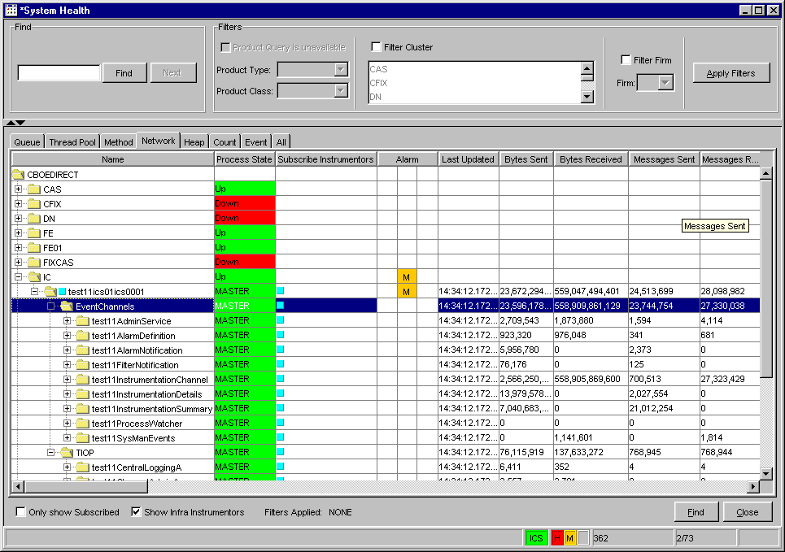
 | Use your scroll bar to view additional network information.
 | 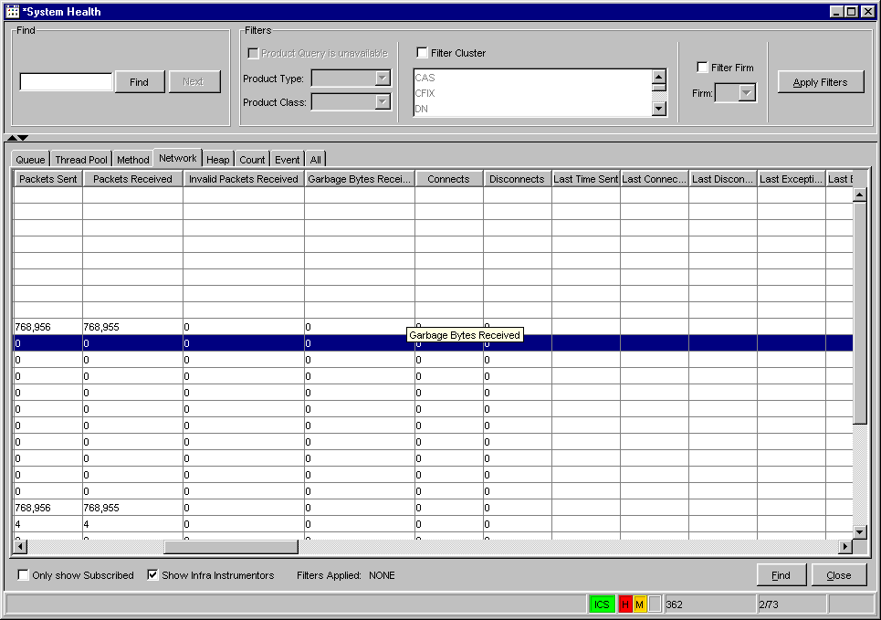
The Network tab Process State column varies based on the state of the adapters.
- If an adapter is Up or initializing the background color of the cell displays in green.
- The background color of the cell displays in red if the adapter is down.
The Network tab displays only network instrumentors. For instructions on how to subscribe to instrumentors and Orbs, refer to the Subscribe for Instrumentors section of the document, page 24.
Heap | To view system memory usage for any component and its processes, click on the Heap tab.
 | 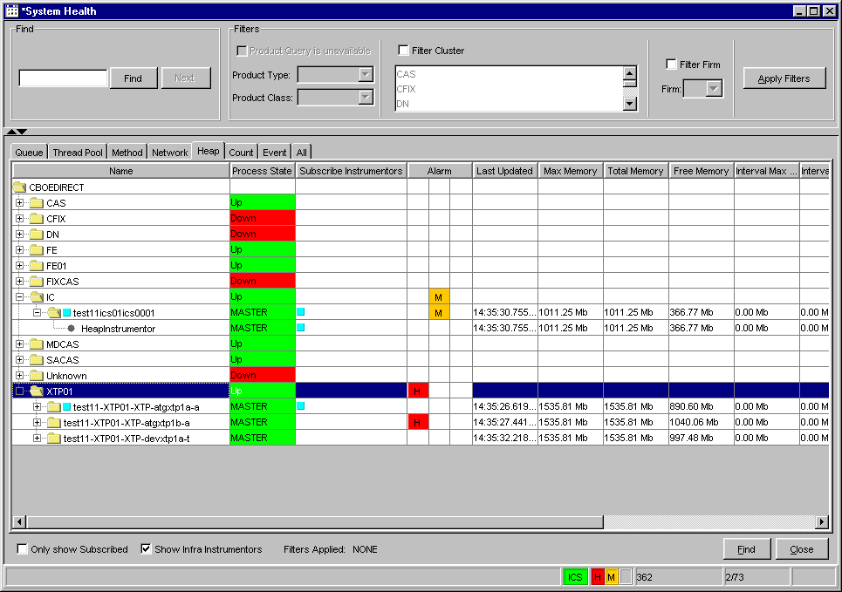
 | Scroll to the right to view additional heap data.
 | 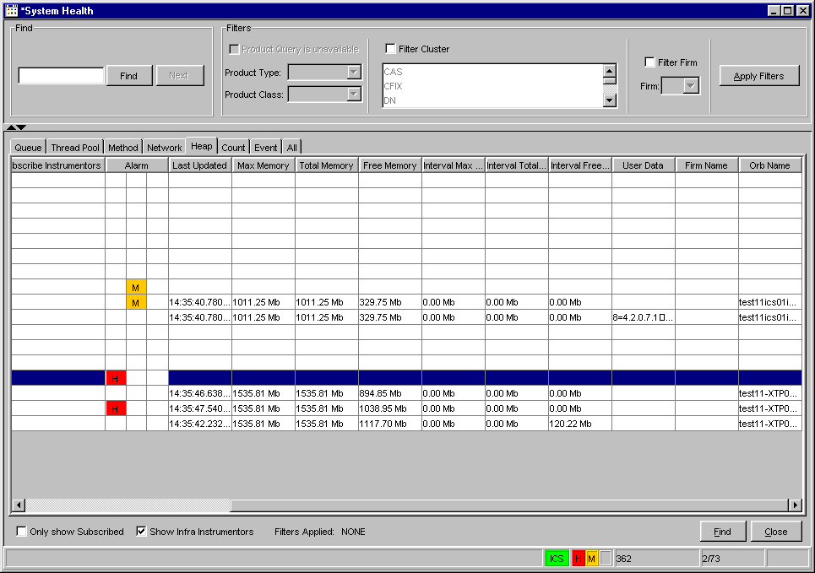
Expand the IC folder to display its sub-processes. To determine the state of any process in the Heap tab, refer the Verify Process State section of the document, page 23.
The Heap tab displays only heap instrumentors. For instructions on how to subscribe to instrumentors and Orbs, refer to the Subscribe for Instrumentors section of the document, page 24.
Count | To view the message count for any component and its processes, click on the Count tab
 | 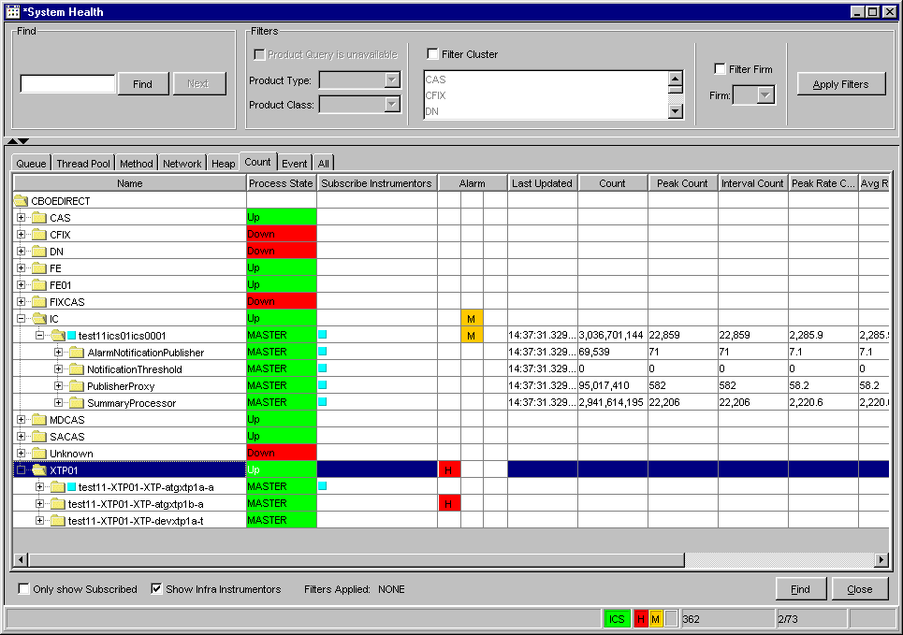
 | Scroll to the right to view peak and total data counts.
 | 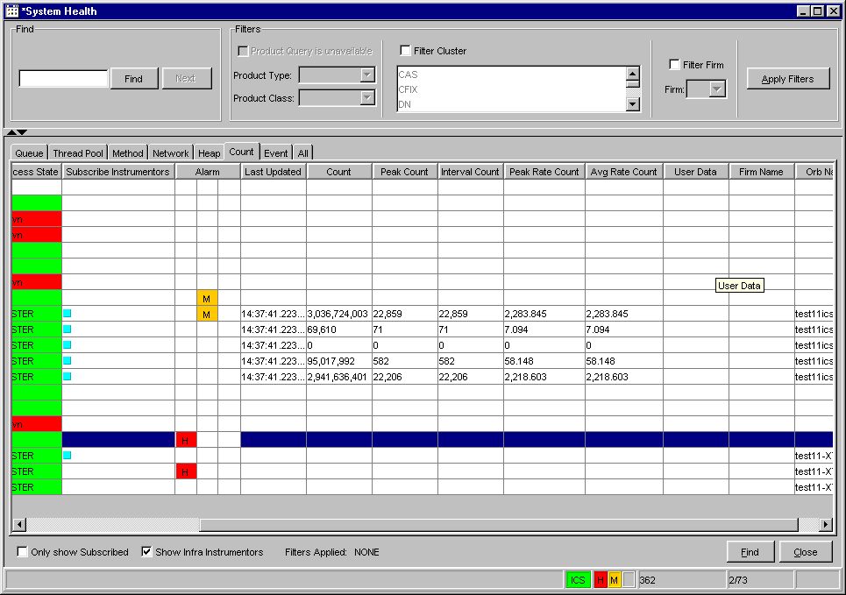
Expand the IC folder to display its sub-processes. To determine the state of any process in the Count tab, refer the Verify Process State section of the document, page 23.
For instructions on how to subscribe to instrumentors and Orbs, refer to the Subscribe for Instrumentors section of the document, page 24.
Event | Click on the Event tab to monitor the impact of event channels through CBOEdirect.
 | 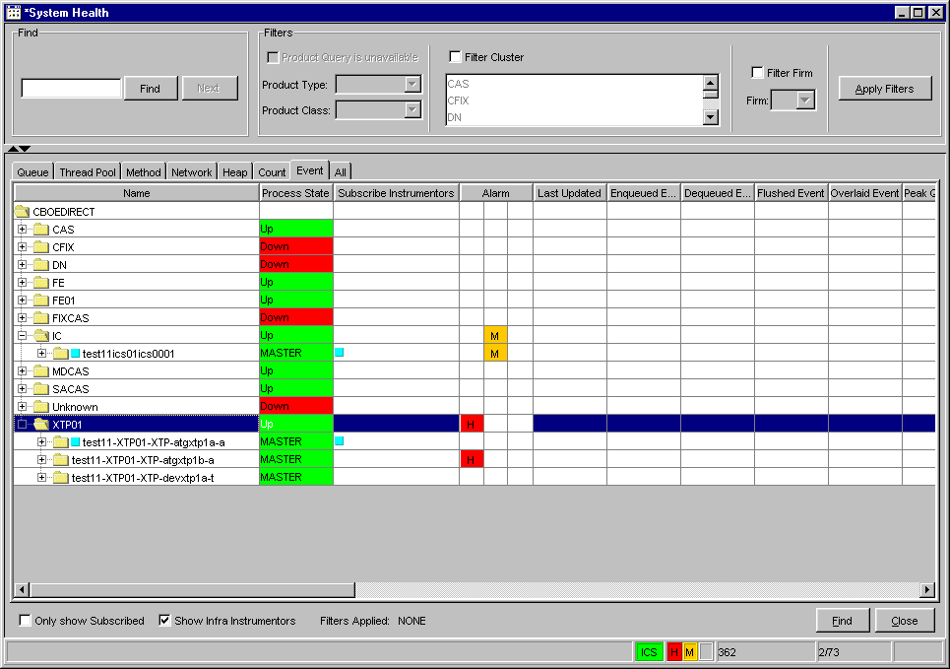
 | Scroll to the right to view additional data fields.
 | 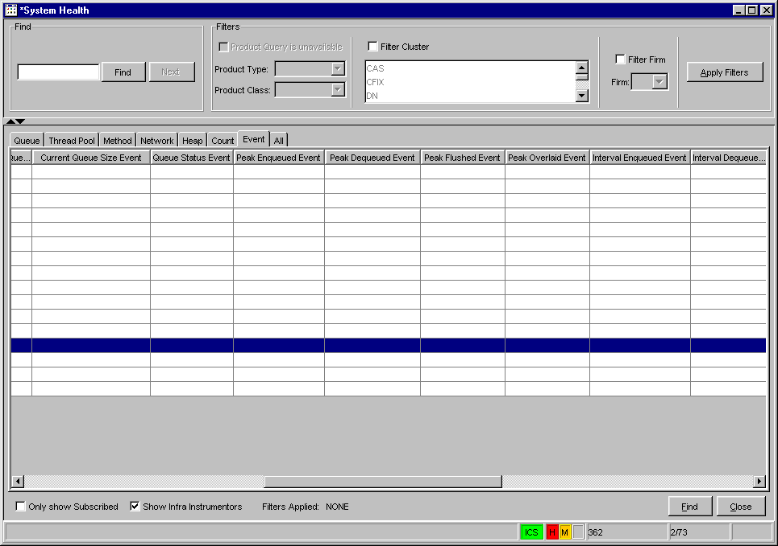
Expand the IC folder to display its processes and related event channels. To determine the state of any process in the Event tab, refer the Verify Process State section of the document, page 23.
For instructions on how to subscribe to instrumentors and Orbs, refer to the Subscribe for Instrumentors section of the document, page 24.
Filter and Search Options | The filter and search options in the System Health Monitor tool allows you to quickly locate specific information. The Find and Filter sections are located at the top section of the System Health window.
 | 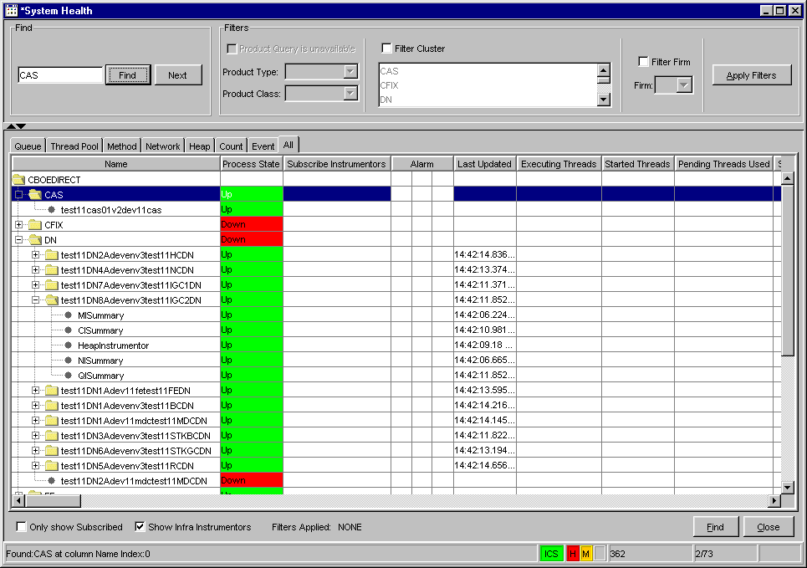
To find a specific component or process:
- Partially enter the component name or process name in the Find text field. In the example above, the search is for CAS.
- Click Find. The row in the component tree where the CAS is located is highlighted.
- Click Next to scroll to the following components or processes with CAS in its name.
To filter information by class:
- Select the Filter Class checkbox.
- Select the Product Type and Product Class from the drop down lists.
- Click Apply Filters. All instrumentors that do not contain class ABT disappear. At the bottom of the window, the filter label shows Filters Applied: Class ABT (Options).
To filter by Firm:
- Deselect the Filter Cluster checkbox.
- Select the Filter Firm checkbox and select a Firm from the drop down list.
- Click Apply Filters. All processes that are not in the Firm are removed. The filter label at the bottom of the window displays: Filters Applied: Class ABT (Option) Firm: Test Firm 1001.
 | 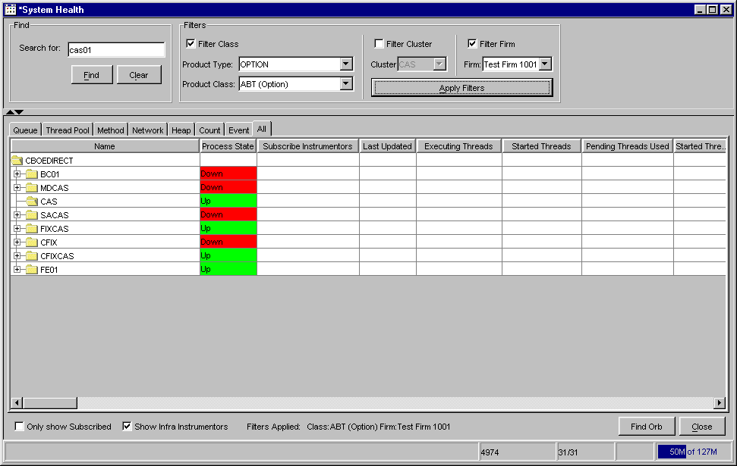
To further filter your request by cluster, select the Filter Cluster checkbox. Then select the cluster from the Cluster drop down list. In the example below the IC has been selected.
Click Apply Filters. All the clusters, except for the IC, are removed. Only the data rows that contain the ABT class display in the components tree. The filter label at the bottom of the window shows Filters Applied: Cluster: IC.
 | 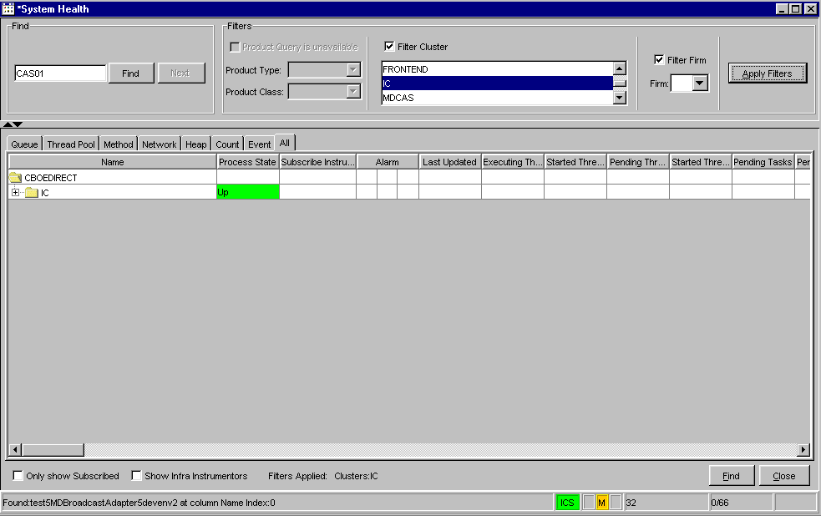
 | To turn off all filters, deselect the Filter checkboxes and click Apply Filters. All the clusters and processes display. The filter label at the bottom of the window reads: Filters Applied: NONE.
To quickly find a specific component, click the Find button. The Find window displays.
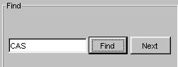

- Enter the specific component you are searching for in the text box. In the example above, CAS has been entered in the search field.
- Click Find. The system scrolls to the CAS process, expanding the tree to properly show the process.
- Click Next to scroll to the following process or component with CAS in its name.
Sort and Rearrange Columns | You can sort any column on the System Health window at any time by clicking on the column heading. The column changes to reflect the sorted data.   Note: The sort is not refreshed.  To rearrange the display of the columns, place your cursor on the column heading, then using your mouse, click on the column and drag it to the desired position.
Edit Column Preferences | You can customize your System Health window by selecting or deselecting specific columns to display. To filter columns, right mouse click on a data row. Select Edit Preferences. The Edit Column Preferences window will display.  - Select or deselect columns for viewing and modify column arrangement as desired.  - To save your changes, click Ok.  - If you wish to retain the default settings, click Cancel.  For detailed information, refer to the Edit Column Preferences section, page 56.
Save Window Preferences | If you want to save your changes and automatically open the window with your saved window preferences, be sure to save the configuration on the Open Tasks toolbar.  To save window preferences:  - Right mouse click on the corresponding window task button.  - Select Save Configuration. The Save Configuration window will display.  - Enter the Configuration Name for the window.  - Click Submit. Click Confirm. The saved window will appear when you open a new System Health window.  - If you decide you do not wish to save the new configuration, click Cancel.  For detailed information, refer to the Save Configurations section, page 54.

Console Window

Open Console Window | The Infra Message Monitor application allows you to view system messages that are generated by the functions you perform. To view the messages, select Open Console Window from the Start Menu or press Alt F3 on your keyboard from anywhere on your screen. The Console Window will display.
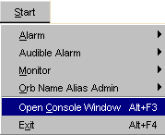 | 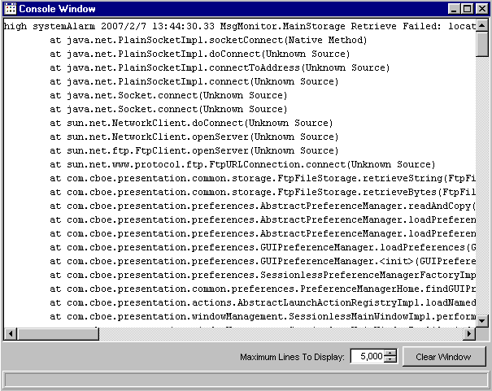
The information in this window can be copied to any text editor on your PC. To copy text from this window,
- place your cursor on the line you which to copy and using your mouse highlight the text.
- press Ctrl C on your keyboard to copy the text.
- open your text editor (Word, Notepad, etc.) and place your cursor in the text entry area.
- press Ctrl V on your keyboard. The text is copied to your editor.
The window defaults to display 9,999 lines. You can change the maximum lines to display by entering a new quantity in place of the default value, or you can select a

higher/lower quantity by clicking the up/down arrows until the desired quantity is reached.
If you wish to clear the window of all its contents, click the Clear Window button.

Exit the System

Exit the System | To exit the Infra Message Monitor, select Exit from the Start Menu. You will be prompted to verify that you wish to close all windows and exit. Click Yes. The application will be closed and you will be returned to your system desktop.

◻ | Section 2:  Reference Guide

Task Toolbar

When you launch the System Health Monitor, the Open Tasks toolbar will display. From this window you can open tasks, save window settings and perform window controls.
Note: The toolbar remains active during the trading session.
 | 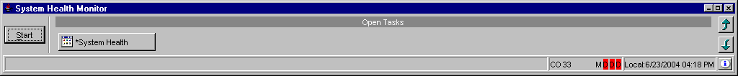
About System Health Monitor | To display system information about The System Health Monitor application, click . The About window will display.
 | 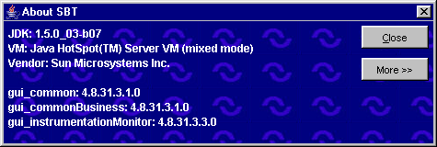
To view specific configuration information, click More. Detailed system information will display.
To exit the window, click Close.
Open Tasks | Initially, the Open Tasks toolbar will be empty. For each window you create, a task button will appear on the toolbar. From the task button, you can resize or change the configuration name of each window.  To resize the window or to change the default configuration name, click on the window task button. The active window will display. Right mouse click on the task button for the corresponding window. The resize and configuration menu will display.  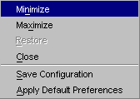
➢ | Resize  To resize a window:  - Highlight the resize choice or  - Hold down the [Alt] key and press the character of the underlined letter in the command.
➢ | Save Configurations  The system allows you to retain window configurations.  To save the configuration of a window:  - Right mouse click on the window’s task button and select Save Configuration. The Save Configuration window will display.  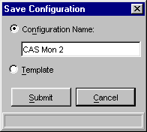  - Select the Configuration Name radio button. The text box displays in editable format.  - Enter the configuration name for the window. In the example above, the CAS Monitor window name will be changed to “CAS Mon 2”.  - To submit your configuration without setting a template, click Submit. Click Confirm. The system will save the configuration for the window and the task button will display with the new name.  - To set this configuration to be the default configuration for all windows, select the Template radio button. Click Submit. Click Confirm.  - If you decide not to change the default configuration, click Cancel instead of Submit.
➢ | Apply Default Preferences  The System Health Monitor application allows you to apply a default preference template to a window that has been already created.  For example, if you previously saved the configuration of a CAS Monitor window, right mouse click on the new CAS Monitor window task button and select Apply Default Preferences. The CAS Monitor window settings will be changed to the default preferences for all CAS Monitor windows.
Window Control | The system allows you to organize your windows. From the Open Tasks toolbar, click the button. The Window Control toolbar will display.
 | 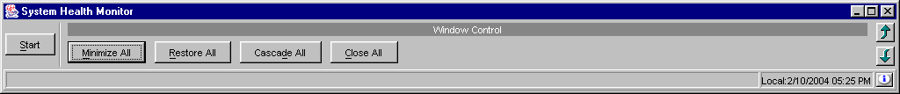
You have the ability to minimize, restore, cascade or close all of your active windows.
- To minimize all your windows, click Minimize All or hold down the [Alt] key and press "M" on your keyboard.
- To restore all your windows, click Restore All or hold down the [Alt] key and press "R" on your keyboard.
- To cascade all your windows, click Cascade All or hold down the [Alt] key and press "D" on your keyboard.
- To close all your windows, click Close All or hold down the [Alt] key and press "C" on your keyboard.

Customizing System Health Monitor Windows

Edit Column Preferences | Several System Health Monitor windows that exhibit data in column format can be customized to display specific information. For example, to modify the CAS Monitoring window, right mouse click on any data row. Select Edit Preferences.  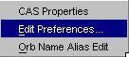  The Edit Column Preferences window will display. From this window, you can rearrange column positions and select or deselect columns for viewing.
 | 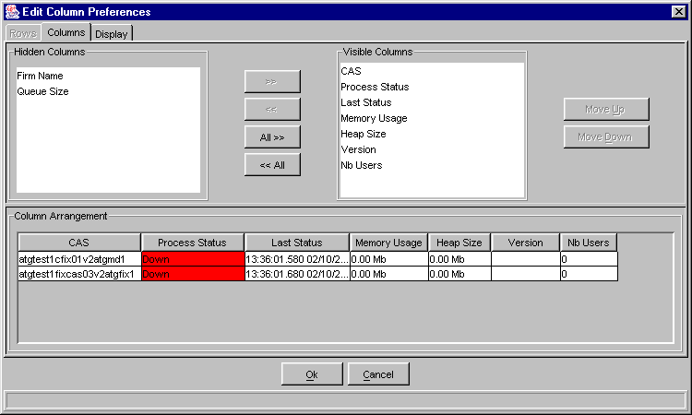
If there is a data column you do not wish to view:
- Select the column name in the Visible Columns list box. To select a continuous range of columns, hold down the shift key and highlight the column names. Hold down the ctrl key to select individual, non-continuous, column names.
- Click << to move the column name to the Hidden Columns list box.
- Click Ok to update the column arrangement.
- If you decide to retain the default layout, click Cancel.
To hide all columns:
- Click <<All to move all the column names in the Visible Columns to the Hidden Columns list box.
- Click Ok to update the column arrangement.
- If you decide to retain the default layout, click Cancel instead of Ok.

 |  Note: If you hide all columns, you will subsequently have to make some columns visible before the update will take effect.
To display a hidden column:
- Select the column name(s) from the Hidden Columns list box.
- Click >> to move the selected column name(s) to the Visible Columns list box.
- Click Ok to update the column arrangement.
- If you decide to retain the default layout, click Cancel instead of Ok.
To display all hidden columns:
- Click All>> to move the column names to the Visible Columns list box.
- Click Ok to update the column arrangement.
- If you decide to retain the default layout, click Cancel instead of Ok.
You may prefer to view data columns in a different order than the default display.
To move a column:
- Highlight the column name from the Visible Columns list box.
- Click Move Up or Move Down until you reach the new column location.
- Click Ok to update the column arrangement.
- If you decide to retain the default layout, click Cancel.
From the Column Arrangement section of the window, the columns can be resized to make viewing information easier for you.
To resize a column:
- Place the mouse on the right edge of the column header (where the column titles are displayed) until it becomes a two-sided arrow.
- Hold the left mouse button down and move it to the desired size.
- Click Ok to save the new column size.
- If you decide to retain the default column size, click Cancel instead of Ok.

Display
In addition to customizing column settings, the System Health Monitor allows you to adjust the text on your windows. From the Edit Column Preferences window, select the Display tab.
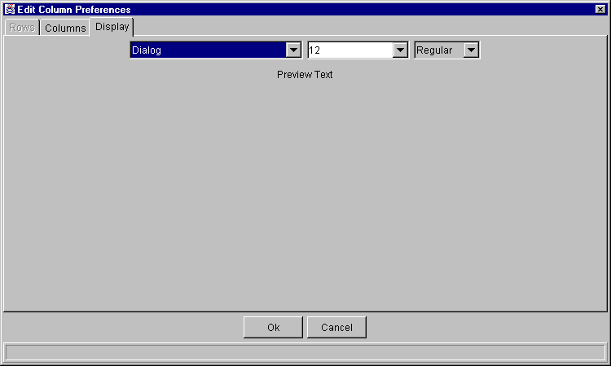
Select the font type, font size and font style from the drop down lists. Your selection will display in the Preview Text section of the window.
- Click Ok to set the new text style.
- If you wish to retain the default text settings, click Cancel.
Sizing Windows | The System Health Monitor windows are sizable. That is, they can be resized on the screen to make viewing information easier for you.
 | 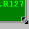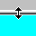 | Place the mouse on any edge of the window until it becomes a two-sided arrow. Hold the left mouse button down and move it to the desired size.
Resizing a window on the corner will expand or contract it in both directions (i.e. up and down and side-to-side). Resizing it on the side or top/bottom will expand or contract the window only in that one direction.
Windows can also be resized using the center glyph in the upper right corner of the window.
 |  | Click the left button () to minimize the window. Click the right button () to close the window. The center button is used for sizing.
If  is displayed, clicking it will increase the window size to a full-screen display.
If  is displayed, clicking it will return the window to its default size.

