

Linkage Monitor User’s Guide
Version 1.1

Disclaimer

Copyright © 2011 Chicago Board Options Exchange. All rights reserved.
The information contained in this document constitutes confidential and/or trade secret information belonging to CBOE. This document is made available to CBOE members and member firms for use with CBOEdirect™. This document is provided "As Is" with all faults and without warranty of any kind, either expressed or implied.

Change Notices

The following change notices are provided to assist users of the Linkage Monitor system in determining the impact of changes to their processing.
If you have any questions or review comments about this document, please contact Odalys Castro at (312) 786-8817.

Date | Version | Description of Change
6/24/11 | 1.1 | Updated version.
2/23/11 | 1.0 | New document.

Table of Contents
Table of Contents 3
Introduction 4
Purpose 4
Intended Audience 4
Conventions Used in this Guide 4
Linkage Monitoring 5
Getting Started 6
Lauching the Linkage Monitor 6
Monitor Linkage Activity 8
Order Monitoring 8
Original and Filled Orders 9
Canceled Orders 12
Order Partially Filled and then Canceled 13
Order Canceled Without an “Order Accepted” Execution 16
Orders With Delayed Execution 17
Filters 19
Print 20
Copy Selected Cell Contents 20
Print Selected Rows 20
Export Table 21
Configure the Linkage Monitor 23
Save Preferences 23
Configure Audible Alarm 23
Pending Orders Alarm Threshold 24
Edit Table Preferences 25
Column Arrangement 26
Display Specifications 28
Data Highlighting Options 29
Display Color Options 29
Order Status Color Options 35
Current Counts Setup 36
Sizing Windows 37
Open Console Window 38
Exit the System 39
Exit the System 39

Introduction

Purpose | This document was written to assist users in utilizing the Linkage Monitoring features. The Linkage Monitor application will provide users with the ability to observe the status of orders that are routed to other exchanges through Linkage.
Intended Audience | This user guide is intended for any person interested in CBOEdirect's Linkage monitoring functions.
Conventions  Used in this Guide | The system was designed so that you can monitor Linkage activity from a standalone application. Some fields are sensitive to both right and left mouse clicks. Window control functions can also be activated by using keyboard commands.  There are several conventions used throughout this guide to help trigger important information:
 | Bolding | Used to highlight menu selections (e.g., Login) and button names (e.g., Update)
 | 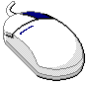 | This mouse graphic with the right mouse button highlighted will appear in the margin when accompanying instructions relate to functions activated by clicking the right mouse button.  All other mouse commands (such as double clicking to display a window) refer to a normal left mouse click.

 | Linkage Monitoring

This user’s guide will direct you through all the Linkage monitoring functions for CBOEdirect.

Getting Started

The Linkage Monitor application gives users the ability to observe the status of orders that are routed to other exchanges through Linkage. The system captures this activity by following the Linkage Cluster’s FIX log file and reading in all FIX messages for the orders.
When you launch the Linkage Monitor application, the following window will display.
Lauching the Linkage Monitor | 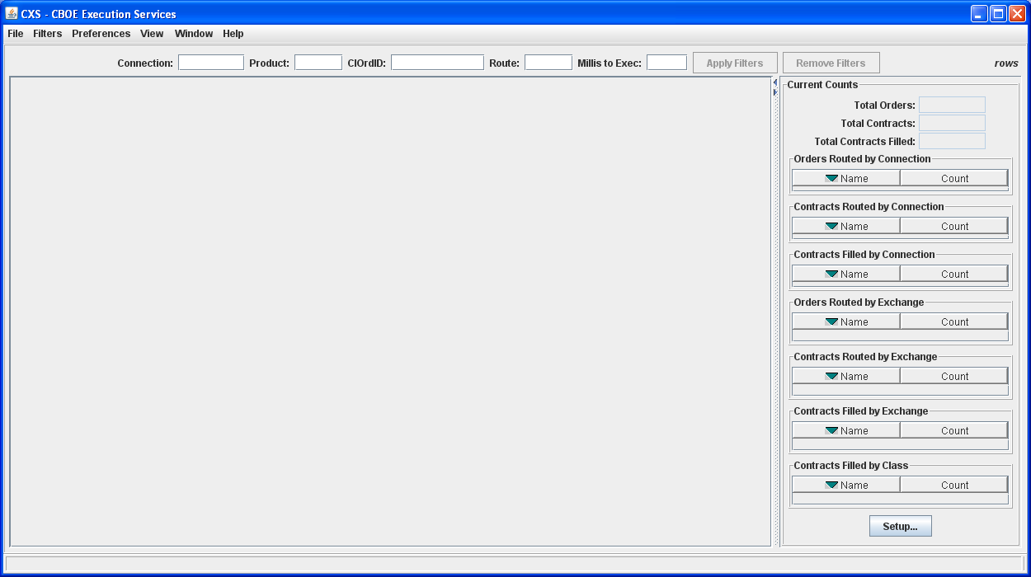
 | Depending on what Linkage data you want to monitor, you can choose to load the current FIX log file or a different log file. Make your selection from the File menu.
 | 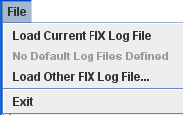
 | If you select to load the current FIX log file, the system will connect to the current real-time Linkage Cluster log file.
 | If you choose to load a different FIX log file, the following window will display
 | 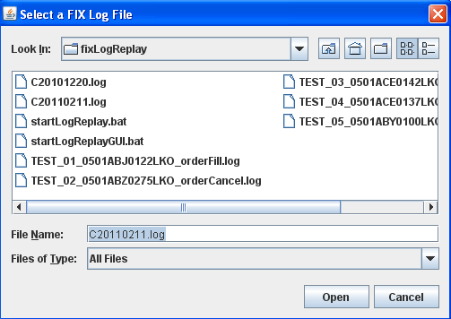
Select the FIX log file name and click Open. The Linkage Monitor application will connect to the FIX log file in real-time. You are now ready to monitor the status of orders that are routed to other exchanges.
To return to the main window without selecting a FIX log file, click Cancel.

Monitor Linkage Activity

 | Once you are connected to a Linkage Cluster FIX log file, you can monitor the status of orders that are routed to other exchanges.
Order Monitoring | When an order is routed through the Linkage Cluster to another exchange the Linkage monitor will read in the corresponding FIX messages and display the order’s activity.
 | 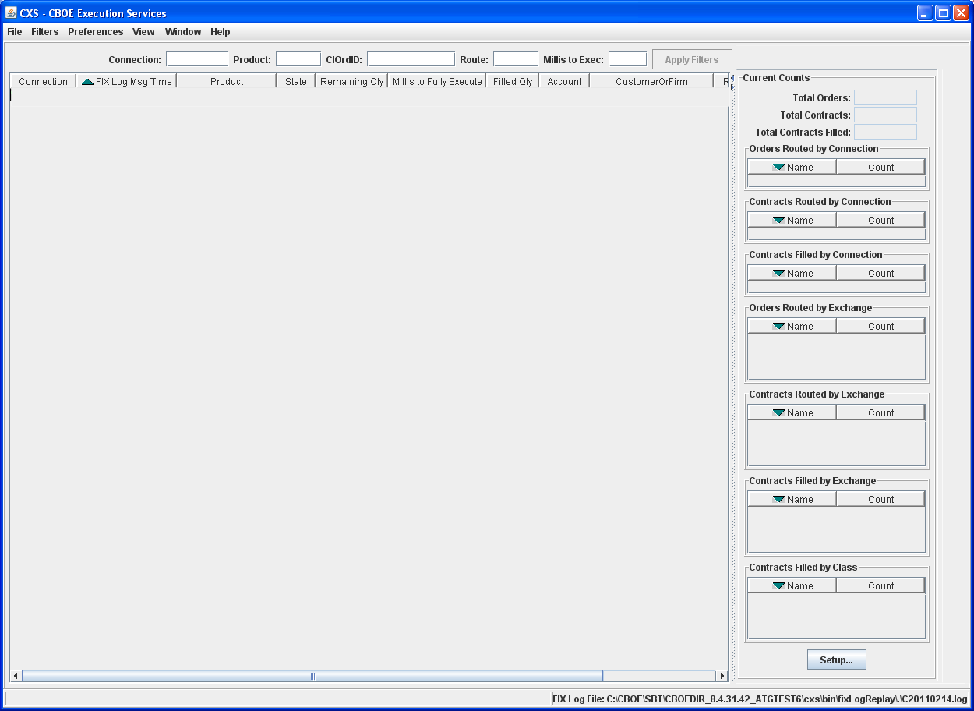
The Linkage Monitor captures the following information.
- FIX Log Msg Time: the time when the FIX message was received.
- Connection: the Firm the system is monitoring for Linkage.
- Product: the product that linked away.
- Route: the exchange where the order was routed.
- State: the status of the order.
- Remaining Qty: the remaining order quantity after a partial fill or cancel.
- Millis to Fully Execute: the number of milliseconds that elapsed between when CBOE routed the order to the away exchange, and when CBOE received the order’s final execution report back from the exchange. When the order is fully executed its remaining qty is zero, meaning it was fully filled and/or canceled.
- Filled Qty: the amount of the order that was filled.
- Account: the order’s account type
- Customer or Firm: the Customer or Firm that executed the order.
- Route: the Exchange where the order was routed.
- Order Qty: the original order quantity.
- Price: the price of the order.
- Side: the side (Buy or Sell) of the order.
You can customize your window by selecting or deselecting specific columns to display and by changing your display color. To customize your display, right mouse click on a data row. Select Edit Table Preferences. The Edit Column Preferences window will display.
For detailed information, refer to the Edit Table Preferences section, page 27.
The Current Counts section of the window captures the following data:
- Total Orders: the number of order that routed away.
- Total Contracts: the number of contracts for the routed order.
- Total Contracts Filled: the number of routed orders that were filled.
- Orders Routed By Connection: the number of orders routed by Firm connection.
- Contracts Routed By Connection: the number of contracts routed by Firm connection.
- Contracts Filled by Connection: the number of contracts filled by Firm connection.
- Orders Routed by Exchange: the number of orders routed by exchange.
- Contracts Routed by Exchange: the number of contracts routed by exchange.
- Contracts Filled By Exchange: the number of contracts filled by exchange.
- Contracts Filled By Class: the number of contracts filled by class.

 | You can customize your Current Counts setup by selecting or deselecting specific counts to display. To customize your display, refer to the Current Counts Setup section, page 38.

Original and Filled Orders
When an order is routed to another exchange, the order is displayed on the Linkage Monitor’s main table.
 | 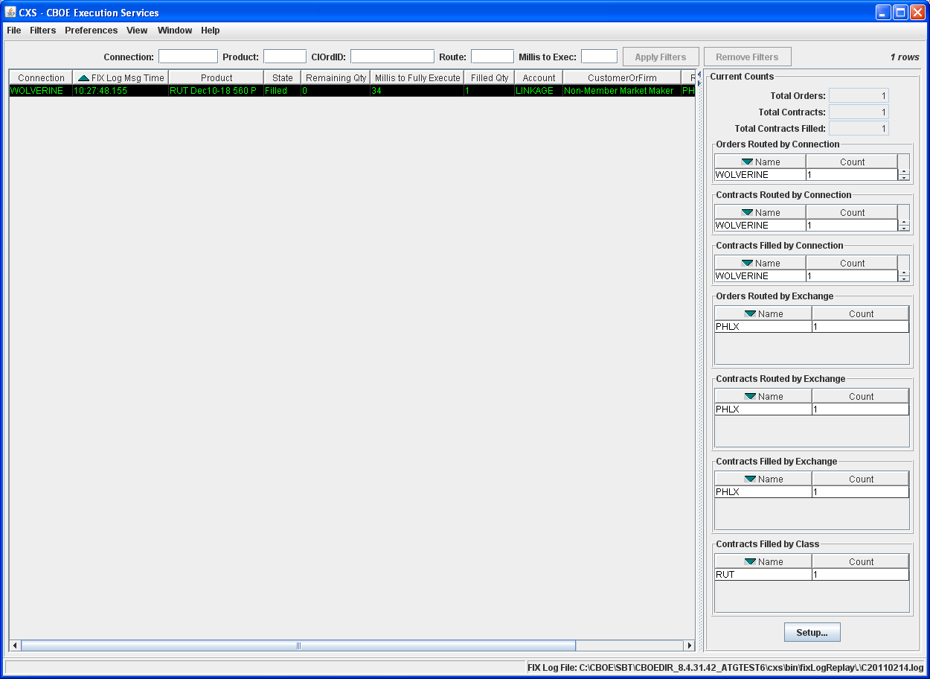
 | Scroll to the right to view additional data fields.
 | 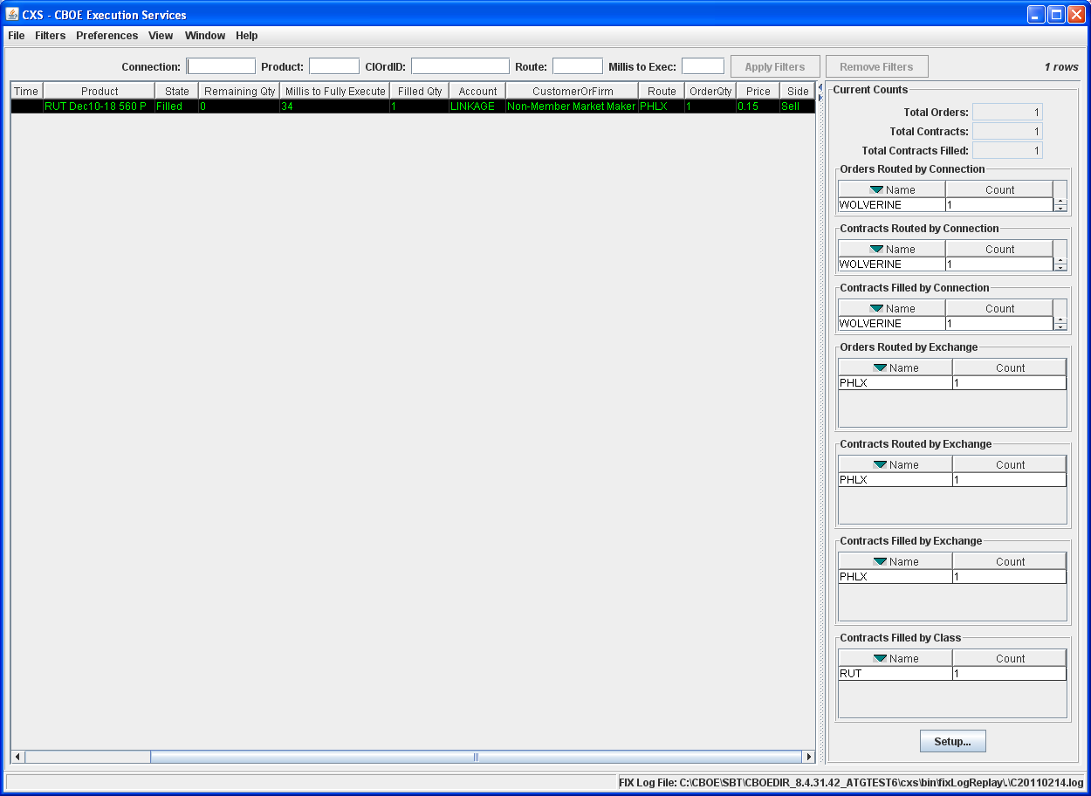
 | In the example above, an order was routed to the NASDAQ OMX PHLX and filled.
 | To view order details, right-mouse click on any data row and select View Selected Order Details or from the View menu, select View Selected Order Details.
 | 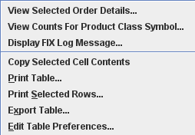
 | The Original Order Details window will display.
 | 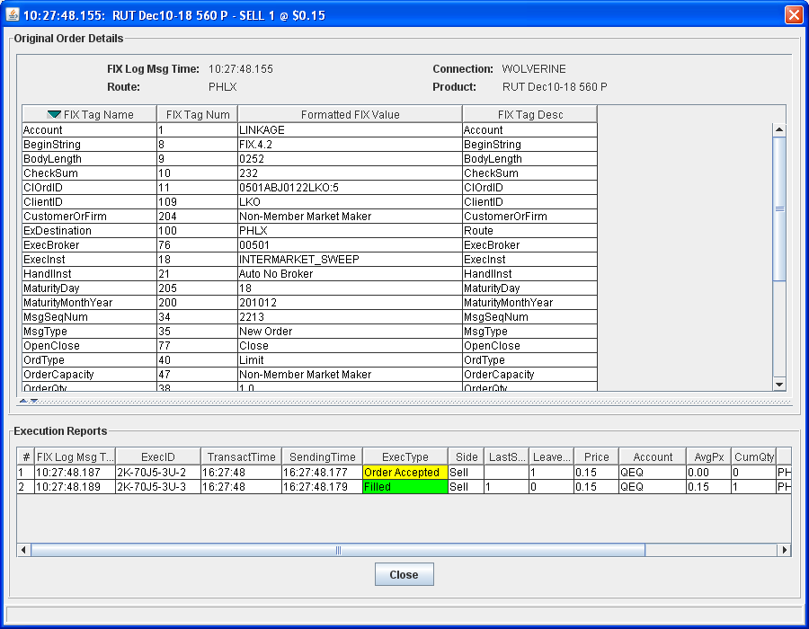
The original order details display in the top section of the window. From this section, you can view the FIX Tag (field) names and numbers along with their values.
The execution reports display in the lower section. The first execution shows the away exchange accepted the order at 10:27:48.187. The second execution shows the order was filled at 10:27:48.189. Scroll to the right to view additional data fields.
To return to the main window, click Close.
 | To view the FIX message for the order, select Display FIX Log Message. The following window will display.
 | 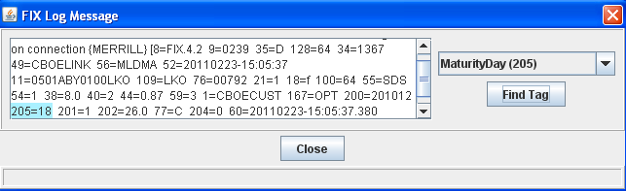
You can search for FIX tags from the drop down list. Select the tag you want to locate in the message and click Find Tag. The FIX tag is highlighted in the message text.
Click Close to exit the window.

Canceled Orders
Orders that are canceled at away exchanges appear in the Linkage Monitor. In the example below, an order was routed to ISE and cancelled.
 | 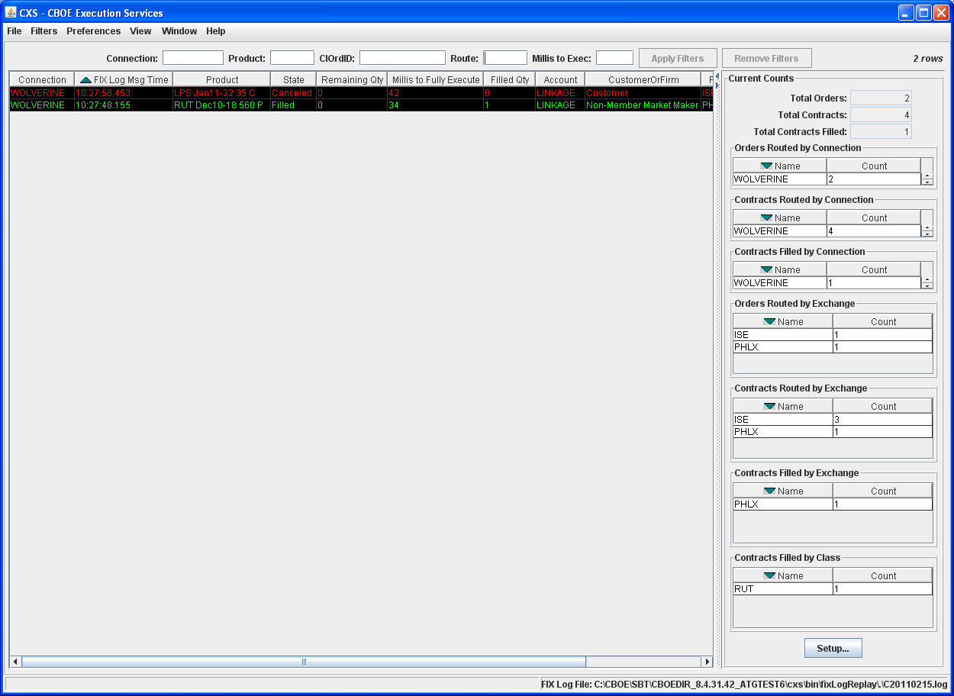
 | The current counts are updated for Total Orders, Total Contracts and Total Contracts Filled.
 | To view order details, right-mouse click on any data row and select View Selected Order Details or from the View menu, select View Selected Order Details.
 | The Original Order Details window will display.
 | 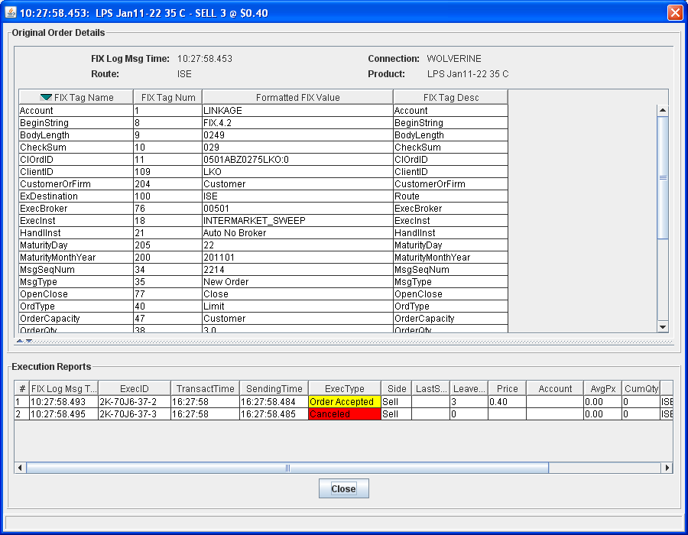
 | The first execution shows the away exchange accepted the order at 10:27:58.493. The second Execution shows the order was canceled at 10:27:58.495.

Order Partially Filled and then Canceled
Partially filled orders that are later canceled display in the Linkage Monitor.
 | 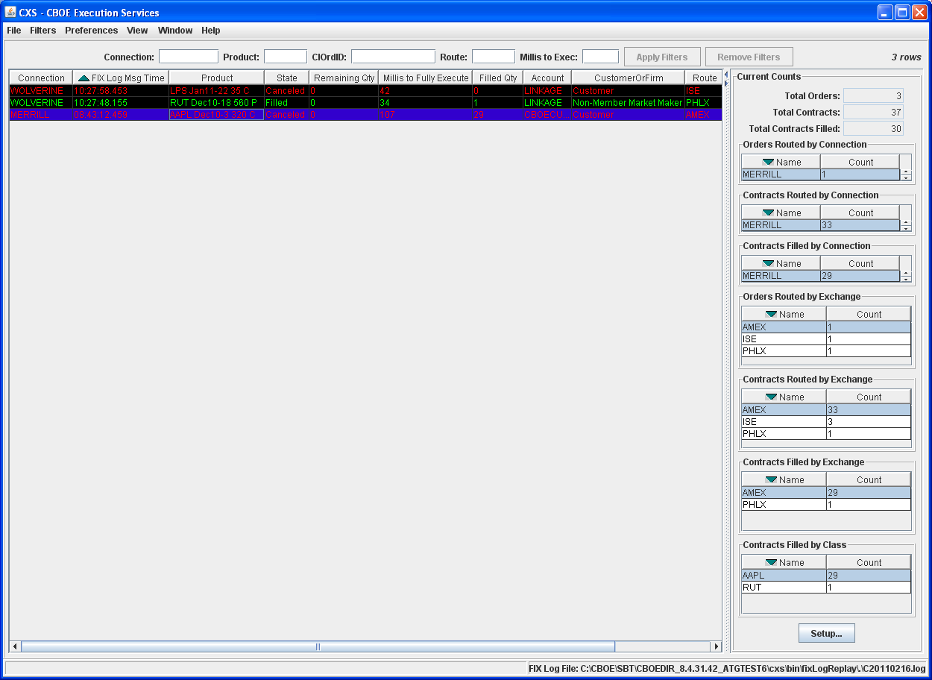
 | In the example above, an order was routed to the AMEX. The order was partially filled and then canceled.
 | To view order details, right-mouse click on any data row and select View Selected Order Details or from the View menu, select View Selected Order Details.
 | The Original Order Details window will display.
 | 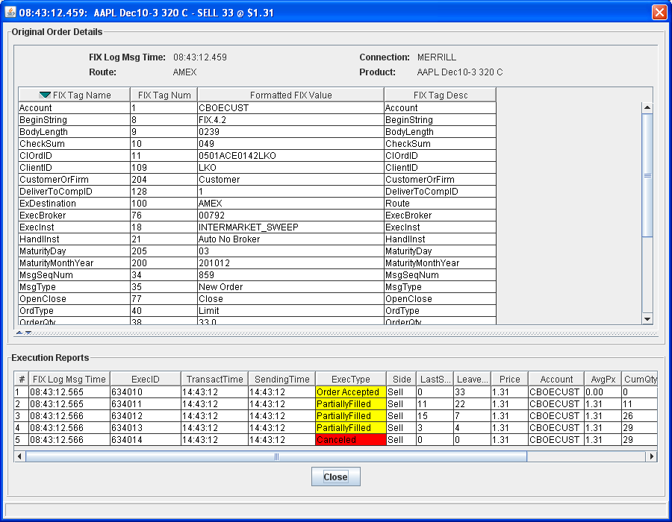
 | The first execution shows the away exchange accepted the order at 08:43:12.565. The second, third, and fourth executions show the order was partially filled, resulting in a “Leaves Qty” of 4. The last execution shows the remaining qty was canceled at 08:43:12.566.

Order Canceled Without an “Order Accepted” Execution
Orders that are immediately canceled display on the Linkage Monitor.
 | 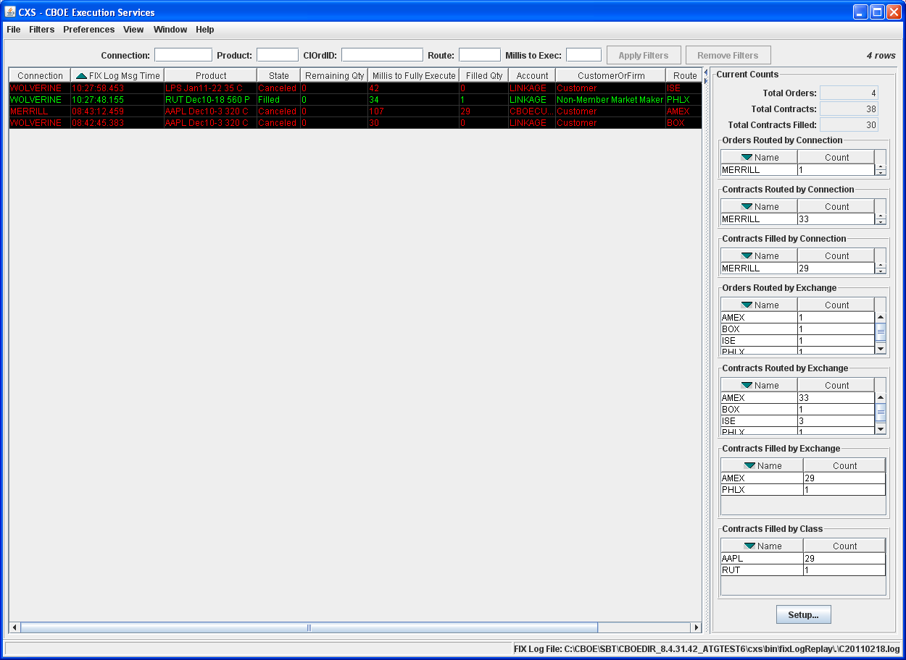
 | In the example above, an order routed to the BOX and was immediately canceled.
 | To view order details, right-mouse click on any data row and select View Selected Order Details or from the View menu, select View Selected Order Details.
 | The Original Order Details window will display.
 | 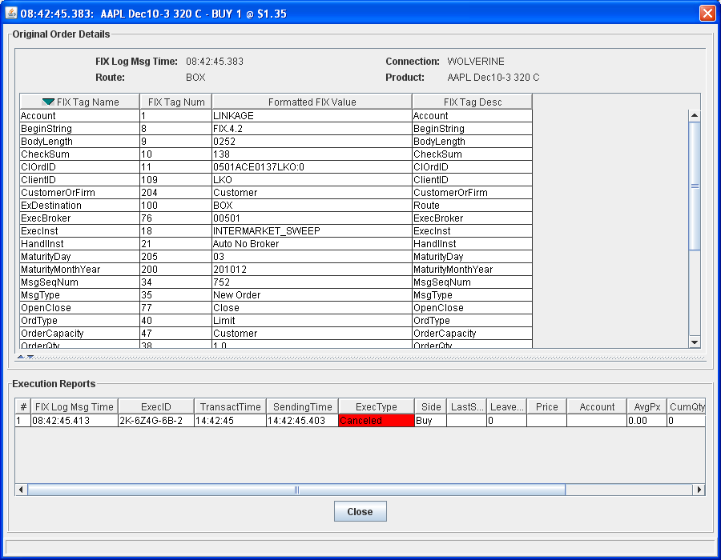
 | The execution report shows the order was canceled at 08:42:45:413

Orders With Delayed Execution
Orders that are slow to execute appear on the Linkage Monitor.
 | 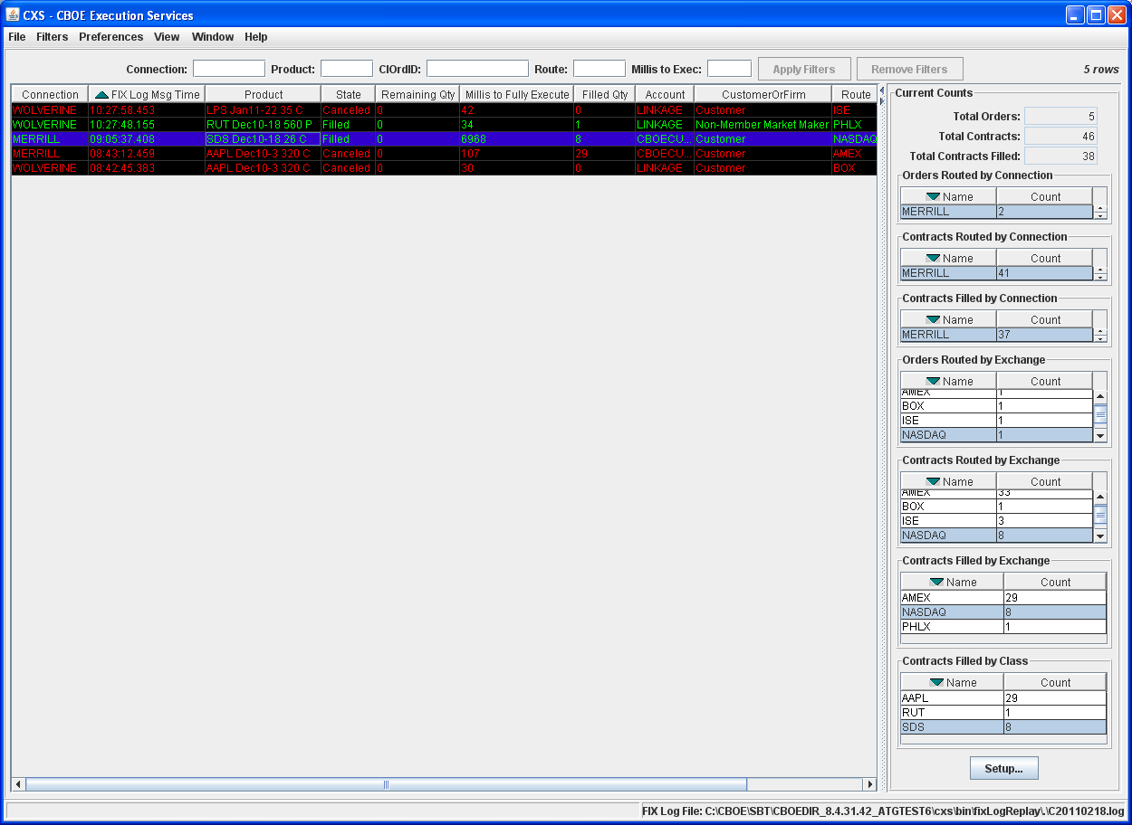
 | A new row is added to the Linkage Monitor’s main table. The order’s state is set to “New” for approximately 7 seconds. After about 7 seconds the order’s state is changed to “Filled”. The Millis to Fully Executed column shows that the order took 6,968 milliseconds to execute.
 | To view order details, right-mouse click on any data row and select View Selected Order Details or from the View menu, select View Selected Order Details.
 | The Original Order Details window will display.
 | 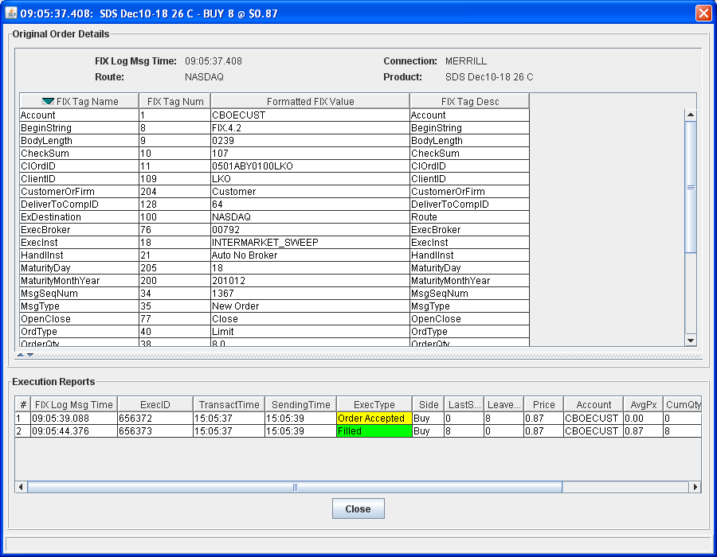
The original order’s FIX Log Msg Time is 09:05:37.408 and the second Execution shows the order was filled at 09:05:44.376, resulting in the 6968 millisecond delay.
If the audible alarm is configured, the alarm will sound to alert the user that the order took more than 500 milliseconds to be fully executed. Refer to the Configure Audible Alarm section, page 26, for details on how to setup your alarm notification.
Filters | Filtering options are available on the Linkage Monitor. From the data table, you can filter by Connection, Product, CIOrdID, Route and Millis to Exec.
In the example above, the data table has been filtered by product AAPL. To filter by product, enter the product symbol in the Product text box and click Apply Filters. The data table will display only Linkage activity for that product. Follow these steps to filter by Connection, CiORDID, Route and Millis to Exec.
To remove the filter setup, click Remove Filters. The window will reset to display all Linkage activity.
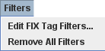 | From the Filters menu, you can edit FIX tag values. Click on Filters and then select Edit FIX Tag Filters. The following window will display.
 | 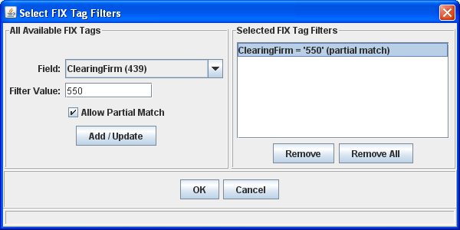
From this window, you can enter specific values for FIX tags. To change a FIX value:
- Select the FIX field (tag) from the drop down list.
- Enter the Filter Value and click Add/Update. The FIX tag filter will display in the corresponding text box.
- To allow partial match on the value, click the checkbox in from of the Allow Partial Match.
- Click OK to save the FIX tag filter.
- Click Cancel to remove the filter request and return to the main window.
To remove a defined FIX filter:
- Highlight the specific FIX tag in the Selected FIX Tag Filters text box and click Remove.
- To remove all FIX filters, click Remove All. In addition, you can remove all FIX tag filters by selecting Remove All Filters from the Filters menu.
- Click OK to save your changes.
- Click Cancel to withdrawal your changes and return to the main window.
Print | You have the ability to print your table display at any time. Right mouse click on a data row and select Print Table. The Print window will display.
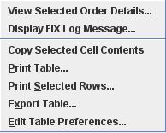 | 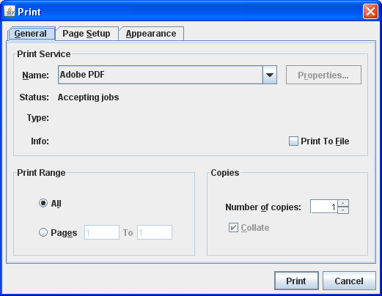
- To print your display, set your print options and click Print.
- If you decide to not print the display, click Cancel.

Copy Selected Cell Contents
You can copy the value of a cell in the Linkage Monitor table. Right-mouse click on the cell you wish to copy and select Copy Selected Cell Contents. You can paste the cell value into any document.

Print Selected Rows
The Linkage Monitor allows you to print a selection of rows.
- Highlight the rows you wish to print.
- Right-mouse click and select the option, Print Selected Rows. The following window will display.
 | 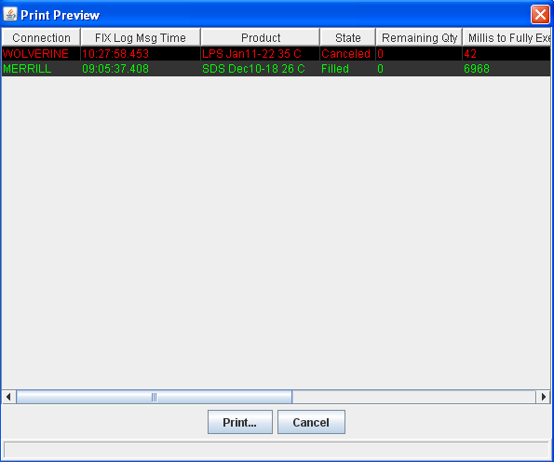
The selected rows appear in the Print Preview window. Click Print to proceed with printing the data rows.
Click Cancel to cancel the print request and return to the main table.

Export Table
You can export the Linkage Monitor’s table data to a .csv file.
Right-mouse click on the data table and select Export Table. The following window will display.
 | 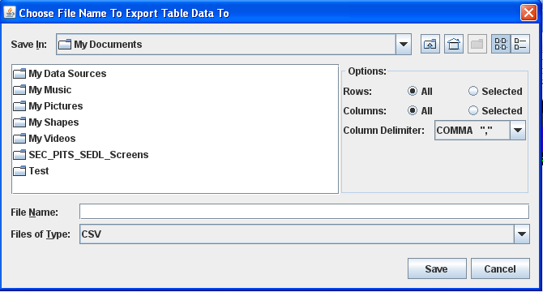
Enter the File name and click Save. The Linkage table data will be saved as a .csv file.
If you decide you do not wish to save the file, click Cancel.

Configure the Linkage Monitor

 |  | The Linkage Monitor window is configurable. You can set it to your specifications to monitor Linkage activity in the market.
Save Preferences  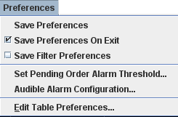 |  | If you want the system to save your changes and automatically open the window with your customized defaults, be sure to save your configuration.  From the Preferences menu, click Save Preferences on Exit. A checkmark will appear in front of the option, enabling the feature. Setting the Save Preferences on Exit feature will prevent you from losing any configuration changes you make while you are monitoring Linkage activity. At exit, the system will save your configuration and make it available at your next login.  To save your preferences periodically, as you configure your display, click Preferences, Save Preferences.  To save your filtered preferences, click Preferences, Save Filter Preferences. A checkmark will appear in front of the option, enabling the feature.
Configure Audible Alarm |  | The Linkage Monitor system allows you to set audible alarm notification for orders that are linked away to other exchanges.
From the Preferences menu select Audible Alarm Configuration. The Audible Alarm Configuration window will display.
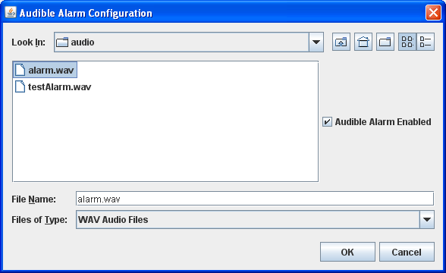
To set the alarm, click the Audible Alarm Enabled checkbox and select the alert.wav file. Click OK. The audible alarm is now activated.
To inactivate the alarm, deselect the Audible Alarm Enabled checkbox and click OK.
Click Cancel to withdrawal your changes and return to the main window.

Pending Orders Alarm Threshold
To set the pending orders threshold time, select Set Pending Order Alarm Threshold. The Alarm Threshold for Pending Orders window will display.
 |  | 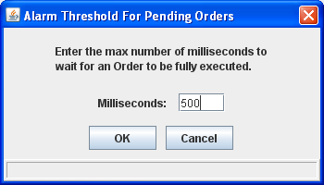
In the Milliseconds text box, enter the maximum number of milliseconds the system should wait for an order to be fully executed.
Click OK to save your changes. In the example above, the audible alarm will sound when a new order hasn’t been filled for at least 500 milliseconds.
Click Cancel to retain the default setup and return to the main window.
Edit Table Preferences |  | When you initially open the Linkage Monitor the default columns display for Linakge monitoring. Data that is in column format can be customized to your specifications.
To modify the column display, select Edit Table Preferences from the Preferences menu. The Edit Column Preferences window will display.
From this window, you can rearrange column positions and select or deselect columns for viewing.
- Note: Tabs that are not available are grayed out.
 |  | 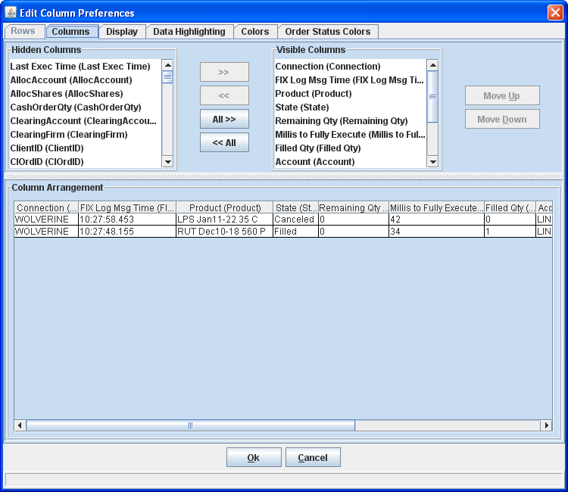

Column Arrangement
If there is a data column you do not wish to view:
- Select the column name in the Visible Columns list box. To select a continuous range of columns, hold down the shift key and highlight the column names. Hold down the ctrl key to select individual, non-continuous, column names.
- Click to move the column name to the Hidden Columns list box.
- Click Ok to update the column arrangement.
- If you decide to retain the default layout, click Cancel.
To hide all columns:
- Click to move all the column names in the Visible Columns to the Hidden Columns list box.
- Click Ok to update the column arrangement.
- If you decide to retain the default layout, click Cancel instead of Ok.
To display a hidden column:
- Select the column name(s) from the Hidden Columns list box.
- Click to move the selected column name(s) to the Visible Columns list box.
- Click Ok to update the column arrangement.
- If you decide to retain the default layout, click Cancel instead of Ok.
To display all hidden columns:
- Click to move the column names to the Visible Columns list box.
- Click Ok to update the column arrangement.
- If you decide to retain the default layout, click Cancel instead of Ok.
You may prefer to view data columns in a different order than the default display.
To move a column:
- Highlight the column name from the Visible Columns list box.
- Click or until you reach the new column location.
- Click Ok to update the column arrangement.
- If you decide to retain the default layout, click Cancel.
 | From the Column Arrangement section of the window, the columns can be resized to make viewing information easier for you.
 |  | 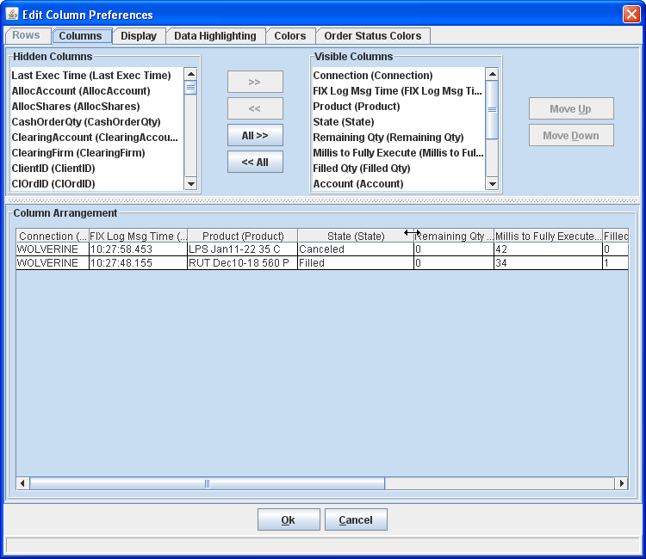
To resize a column:
- Place the mouse on the right edge of the column header (where the column titles are displayed).
- Hold the left mouse button down and move it to the desired size.
- Click Ok to save the new column size.
- If you decide to retain the default column size, click Cancel instead of Ok.

Display Specifications
In addition to customizing column settings, you can adjust the display of the text on your windows. From the Edit Column Preferences window, select the Display tab.
 |  | 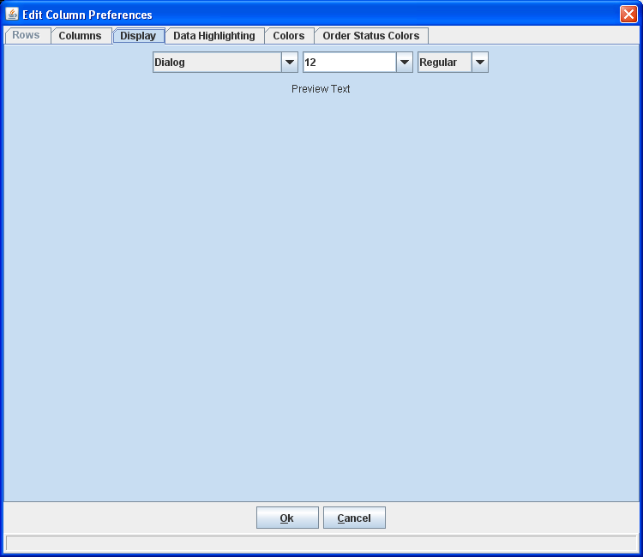
Select the font type, font size and font style from the drop down lists. Your selection will display in the Preview Text section of the window.
- Click Ok to set the new text style.
- If you wish to retain the default text settings, click Cancel.

Data Highlighting Options
Not currently supported.

Display Color Options
You can change the look of your Linkage Monitor display by choosing alternating row colors. Click on the Colors tab in the Edit Column Preferences window.
 |  | 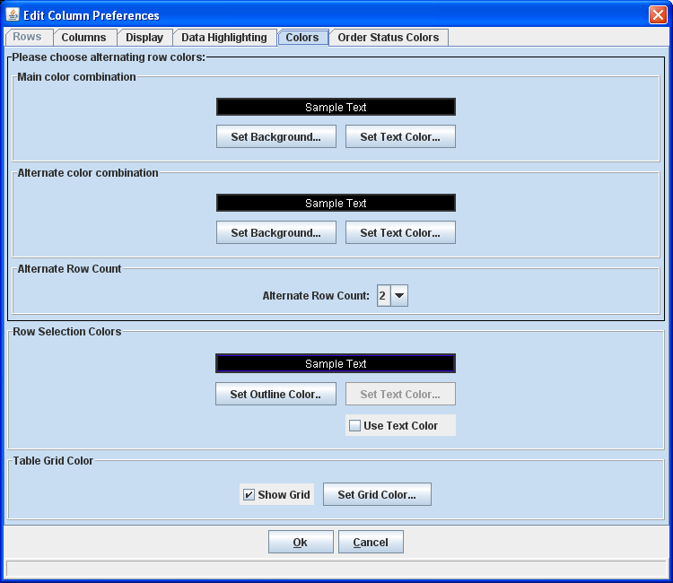
 |  | To change the background or text color, click Set Background or Set Text Color in the Main color combination box. The Pick a Color window will display. The system allows you to setup a second color combinations in the Alternate color combination box.
 |  | 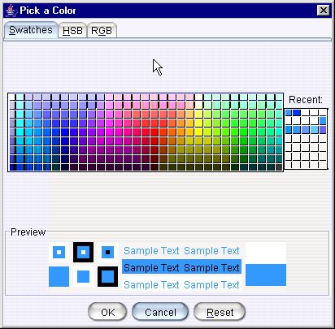
 |  | From the Swatches tab, click on your background color choice. An example of your color choice and text will appear in the Preview section of the window.
 |  | Click the HSB tab to set your hue, saturation and brightness. Place your mouse on the scroll bar button and adjust your color preference.
 |  | 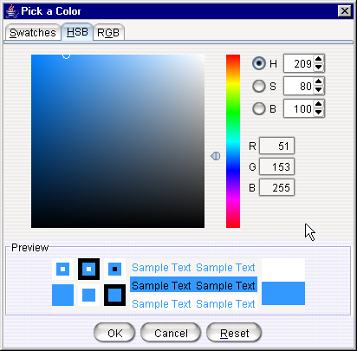
- Click Cancel to remove your changes and exit the window.
- Click Reset to retain the original settings.
- Click OK to save your changes. The background and text color will display in the Preview section of the window.
 |  | Click the RGB tab to set your red, green and blue color model. Place your mouse on the side scroll bar and adjust your color preference.
 |  | 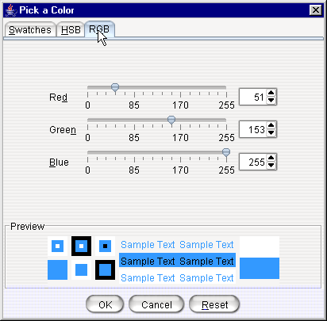
- Click Cancel to remove your changes and exit the window.
- Click Reset to retain the original settings.
- Click OK to save your changes. The background and text color will display in the Sample Text box.
 |  | 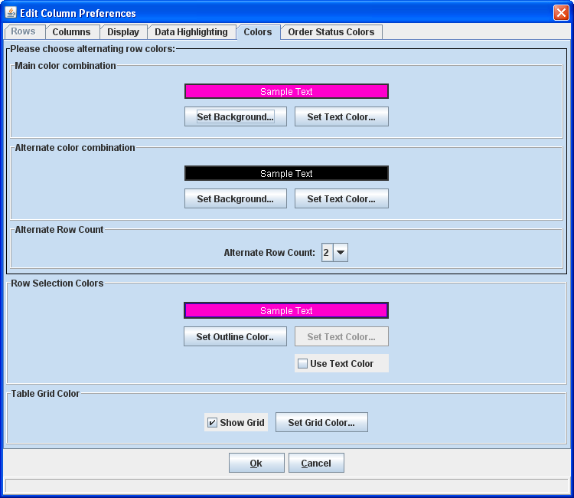
The Row Selection Colors correspond with the colors you choose for the main color combination.
- You can alternate the row colors by selecting from the Alternate Row Count drop down list.
- The Table Grid Color defaults to display in black. To change the color of the grid, click Set Grid Color. Select your table grid color from the Pick a Color window display.
- Click Cancel to retain the original settings.
- Click Ok to save the color combinations.

Order Status Color Options
You can change the look of your Linkage Monitor display by choosing alternative colors for order status. Click on the Order Status Colors tab in the Edit Column Preferences window.
 |  | 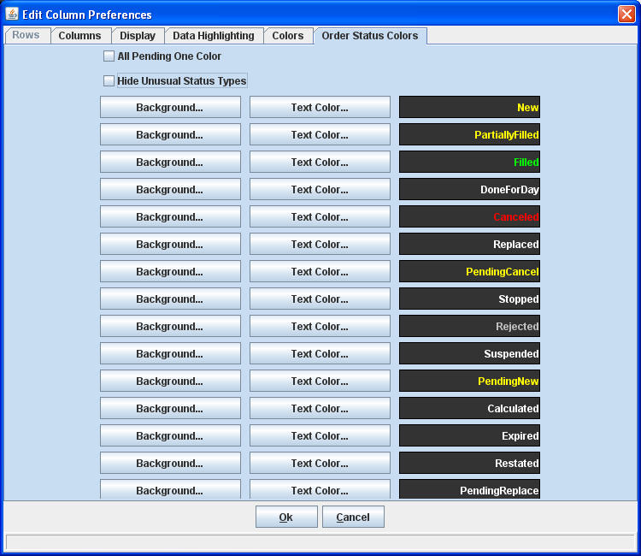
Select the Background Color and Text Color for each status type and Click OK. The Linkage Monitor will display each status type with its corresponding color.
To select one color for all pending order states, click the checkbox in front of the option, All Pending One Color.
To hide order status types that are not regularly used, select the checkbox in front of the option, Hide Unusual Status Types.
Current Counts Setup |  | From the Linkage Monitor’s main table, you can configure the Current Counts display to capture specific data.
 |  | Click Setup to customize your Current Counts display.
 |  | 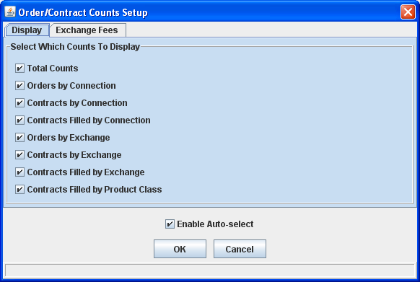
From the Display tab, select the checkbox in front of the counts you wish to display. Click OK. The counts will be visible in the main window.
To have your options automatically displayed at startup, activate the Auto-select option. Place a checkmark in the checkbox in front of the Enable Auto-select option and click OK.

 |  | The Exchange Fees tab allows you to set exchange fees per contract.
 |  | 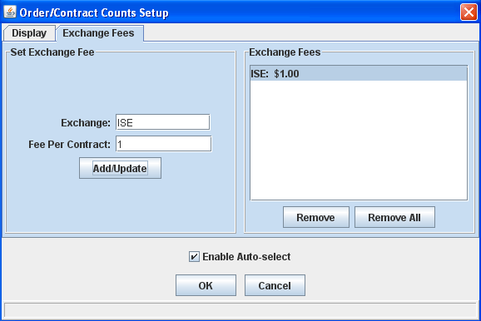
- Enter the Exchange name and the Fee Per Contract.
- Click Add/Update. The exchange fee appears in the Exchange Fees text box.
- If you wish to remove the exchange fee, highlight the exchange in the Exchange Fees text box and click Remove.
- To remove all the exchange fees, click Remove All.
Sizing Windows | The CBOEdirect Opening Imbalances window is sizable. That is, it can be resized on the screen to make viewing information easier for you.
 | 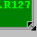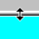 |  | Place the mouse on any edge of the window until it becomes a two-sided arrow. Hold the left mouse button down and move it to the desired size.
Resizing a window on the corner will expand or contract it in both directions (i.e. up and down and side-to-side). Resizing it on the side or top/bottom will expand or contract the window only in that one direction.
Windows can also be resized using the center glyph in the upper right corner of the window.
 |  |  | Click the left button () to minimize the window. Click the right button () to close the window. The center button is used for sizing.
If  is displayed, clicking it will increase the window size to a full-screen display.
If  is displayed, clicking it will return the window to its default size.

Open Console Window  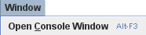 | The Linkage Monitor allows you to view system messages that are generated by the functions you perform. To view these messages, select Open Console Window from the Window menu or press [Alt-F3] on your keyboard from anywhere on your screen. The Console Window will display.
 | 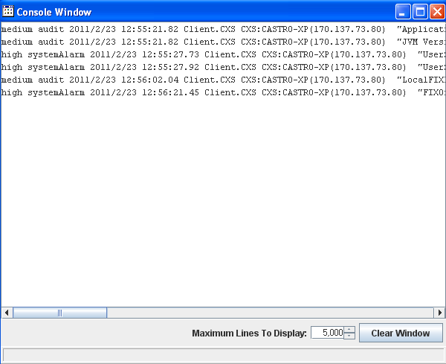
The information in this window can be copied to any text editor on your PC. To copy text from this window,
- Place your cursor on the line you want to copy and using your mouse highlight the text.
- Press Ctrl C on your keyboard to copy the text.
- Open your text editor (Word, Notepad, etc.) and place your cursor in the text entry area.
- Press Ctrl V on your keyboard. The text is copied to your editor.
The window defaults to display 5,000 lines. You can change the maximum amount of lines to display by entering a new quantity in place of the default value, or you can select a higher/lower quantity by clicking the up/down arrows until the desired quantity is reached.
If you wish to clear the window of all its contents, click the Clear Window button.

Exit the System

 | You can log out and exit the system at any time.
Exit the System | To exit the system, select Exit from the File Menu. You will be prompted to verify that you wish to close all windows and logout. Click Yes. The application will be closed and you will be returned to your system desktop.

