

Market Replay User’s Guide
Version 6.1

Disclaimer

Copyright © 2001-2011 Chicago Board Options Exchange. All rights reserved.
The information contained in this document constitutes confidential and/or trade secret information belonging to CBOE. This document is made available to CBOE members and member firms for use with CBOEdirect™. This document is provided "As Is" with all faults and without warranty of any kind, either expressed or implied.

Change Notices

The following change notices are provided to assist users of the CBOEdirect market replay system in determining the impact of changes to their processing.
If you have any questions or review comments about this document, please contact Odalys Castro at (312) 786-8817.

Date | Version | Description of Change
5/18/11 | 6.1 | Updated screen shots.  Enhanced the graph description section.  Updated the CBOE logo.
12/31/10 | 6.0 | Captured new web screens
11/02/05 | 5.10b | Modified to include displays for single acronym and automated auctions
6/17/05 | 5.08 | Updated all display to reflect current data.
2/6/04 | 5.01b | Removed the Customizing Windows section  Added RFQs and Composite displays
1/23/04 | 5.01b | First draft.

Table of Contents
Table of Contents iii
Introduction 4
Purpose 4
Intended Audience 4
Conventions Used in this Guide 4
Bolding 4
Section 1: Market Replay 5
Getting Started 6
Login 6
Display Trading Information 8
Selection Parameters 9
Orders 11
Quotes 16
Market Conditions 19
Trades 22
Assignments 27
Alert Messages 30
CTMR Trades 34
Ending a Market Replay Session 37
Exit the System 37
Section 2: Reference Guide 38
Customize and Export Data 39
Exporting Data 39
Export to CSV Format 39
Export to Excel 39
Export to a Graph 41

Introduction

Purpose | This user guide was written to assist users in utilizing all of the features of the Market Replay system.
Intended Audience | This user guide is intended for Help Desk Administrators, System Operators or any person interested in Market Replay functions for CBOEdirect.
Conventions  Used in this Guide | The Market Replay system for CBOEdirect was designed so that you can perform all of your Market Replay activities by trading session. More than one Market Replay window can be active at the same time. Some window control functions can also be activated by using keyboard commands.  Section 1 of the document illustrates the most efficient way to perform Market Replay functions. Additional information about each of the Menu Bar options and window configuration can be found in Section 2: Reference Guide.  There are several conventions used throughout this guide to help trigger important information:
 | Bolding | Used to highlight menu selections (e.g., Login) and button names (e.g., Update)
 | Brackets [ ] | Used to highlight keyboard commands (e.g., [Ctrl]-[P]). Note that when [Alt] or [Ctrl] are used in conjunction with another key, hold down the first key while pressing the second.
 |  Note: | This notation is used to indicate important information you should note when performing the associated function.
 | Valid Codes & Definitions | This graphic will appear in the margin when there is information relating to valid system codes and definitions.

 | Section 1:  Market Replay

This section of the user guide will direct you through all functions of the Market Replay system.

Getting Started

To launch the Market Replay application, enter the URL: http://marketreplay.cboe.com/ on your web browser.
The following Login window will display.
 | 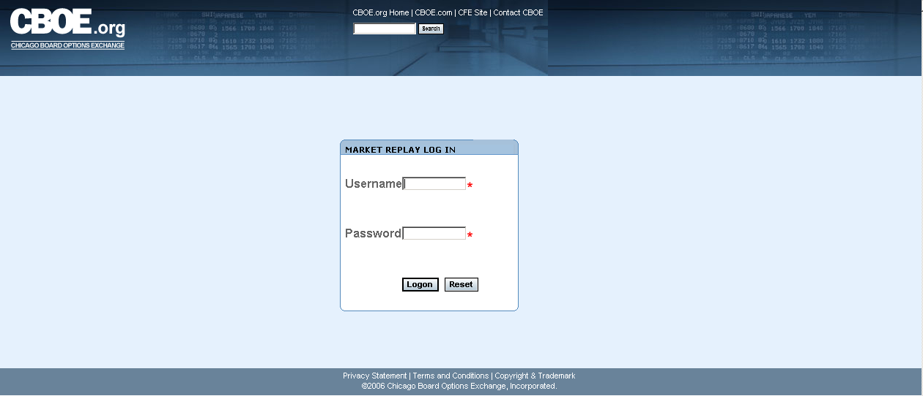
Login | In order to login to CBOE’s Market Replay application, you will need to acquire, from CBOE, a valid user name, password and a RSA SecurID token value.  Enter your Username.  In the Password field, type in your password followed by your RSA token value. Do not enter a space between the password and token value.
 | 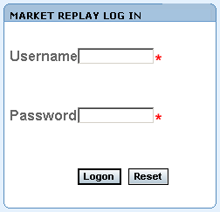
If you incorrectly typed in your Username or Password, click Reset. The login window will clear. Re-enter your User name. Re-enter your Password followed by your RSA token value. Click Logon.
If you get a message indicating Next Token Mode when you login, please do the following:

- Open a browser and go to http://rsa.cboe.com
- Enter username and passcode when prompted: Enter the code displayed in the RSA SecurID window.
- You should receive a message that they are in next code mode.
- Be sure to wait for the RSA software application to flip to a new 8 digit tokencode, then enter that new tokencode.
- You should now get a message that they’ve been successfully authenticated.
- Please wait 90 seconds before attempting a login to Market Replay.
- After a successful login, Market Replay’s main window will display.

 | 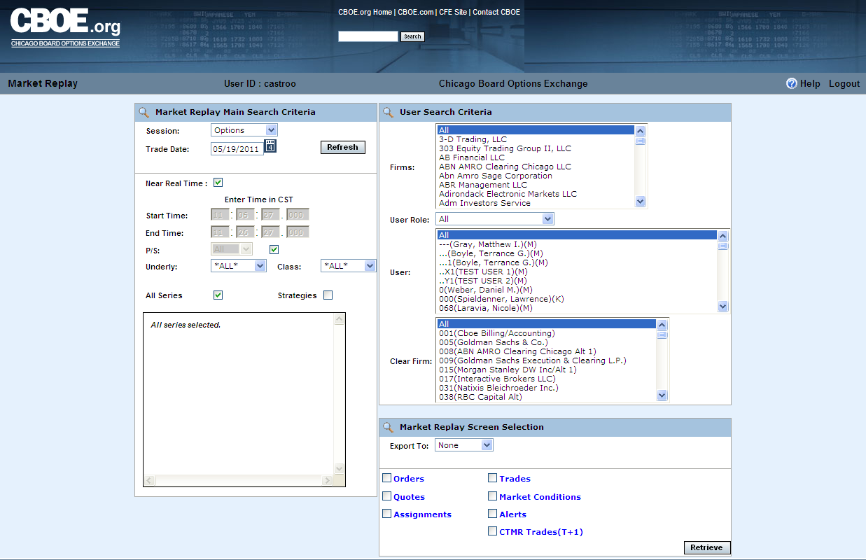
 | You are now ready to use Market Replay’s functionality.

Display Trading Information

The Market Replay window allows you to specify the type of trading data you wish to view by session. The window defaults to the Options session and the current business day.
To easily understand the data represented in Market Replay, the window displays are presented as single data types (i.e. Trades) rather than combination displays (i.e. Trades & Orders).
 | 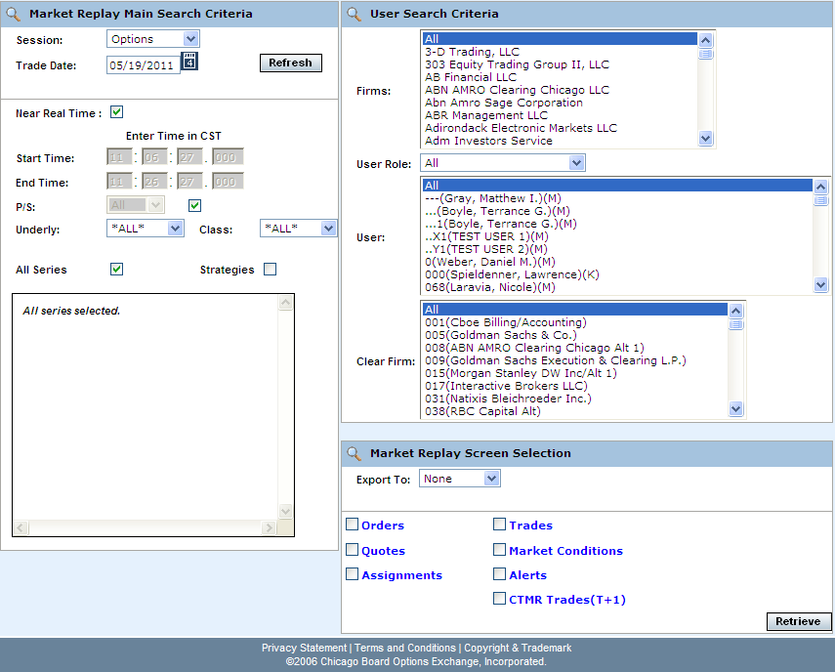
 | At this point, you can obtain current trading information for any CBOEdirect trading session.
Selection Parameters | The Market Replay window allows you to specify the type of trading data you wish to view by session. The window defaults to the Options session and the current business day.  To easily understand the data represented in Market Replay, the window displays are presented as single data types (i.e. Trades) rather than combination displays (i.e. Trades & Orders).
 | 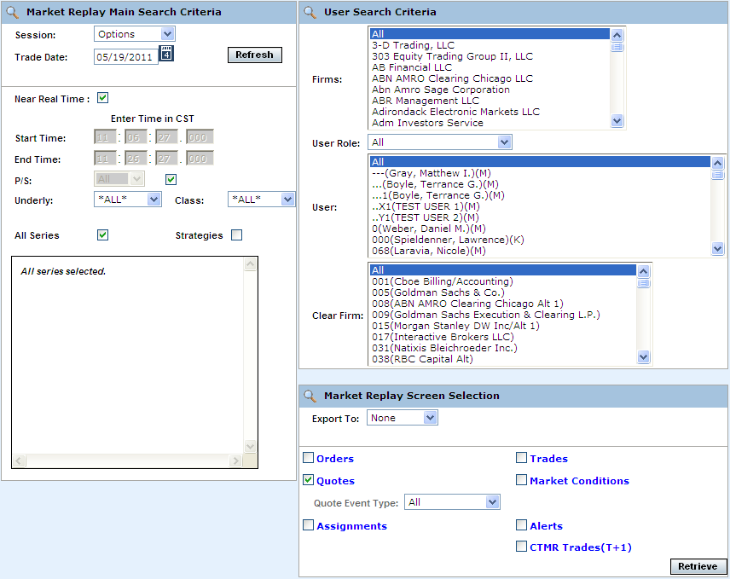
The Market Replay window is split into three panels: Market Replay Main Search Criteria, User Search Criteria and Market Replay Screen Selections. This window is used to set limitations for your data request.
The Market Replay Main Search Criteria section of the window allows you to select:
- The session and trade date
- Near real-time monitoring or a fixed time range
- Underlying and Class selections or select classes by Post and Station (P/S)

 | The User Search Criteria section allows you to filter your Market Replay requests by Firm, User Role, Market Maker, or Clearing Firm.
 | If you select only one user from the User list, only the Clearing Firm for that user will display in the Clear Firm list box.
 | 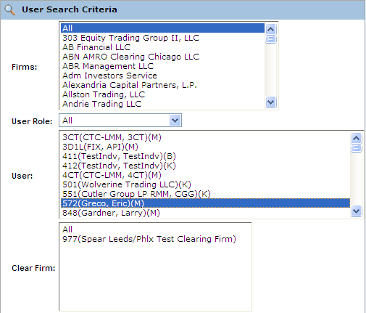
The Market Replay Screen Selection section allows you to filter your Market Replay requests by Orders, Quotes, Trades, Assignments, Market Conditions, Alerts and CTMR Trades.
You can also export the data to Excel or PDF formats.
 | 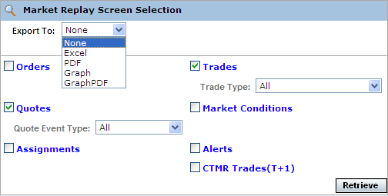
Orders | Market Replay allows you to retrieve order information. Make your selections from the Market Replay Main Search Criteria section of the window.  - Select the trading session from the Session drop down list.  - The date of the request defaults to the current business day and is displayed in the Trade Date text box.  - To choose a previous trading day, click on the calendar button. The following calendar window will display.  - Note: The data warehouse maintains trade information for three years.  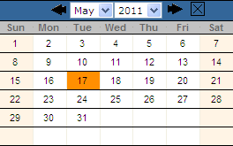  - Click on the trade day you wish to query. The date will display in the Trade Date text box.  - Choose the time of your request as near real time by selecting the Near Real Time checkbox. If you would like to select a fixed time range, deselect the Near Real Time Monitoring checkbox. Enter the Start Time and End Time by, hour:minutes:seconds:milliseconds (i.e. Start Time: 10:48:00:000, End Time: 13:55:00:000).  - Note: The maximum valid time range is 20 minutes.  - Class/Series selection by post and station (P/S)  - To query all the class and series at every post/station, select the P/S checkbox. The P/S drop down list will gray out, defaulting to query ALL post/stations.  - If you wish to generate data for all the class and series activity for a specific Post and Station, select the Post/Station from the P/S drop down list box.  - Class/Series selection  - Select the underlying security from the Underly drop down list box or select a class from the Class drop down list box. Select ALL for both to retrieve all class and series information.  - Specify the series you are interested in viewing by clicking on the corresponding checkbox.   Note: You must select a series, clearing firm or broker in order to retrieve the data.
 | 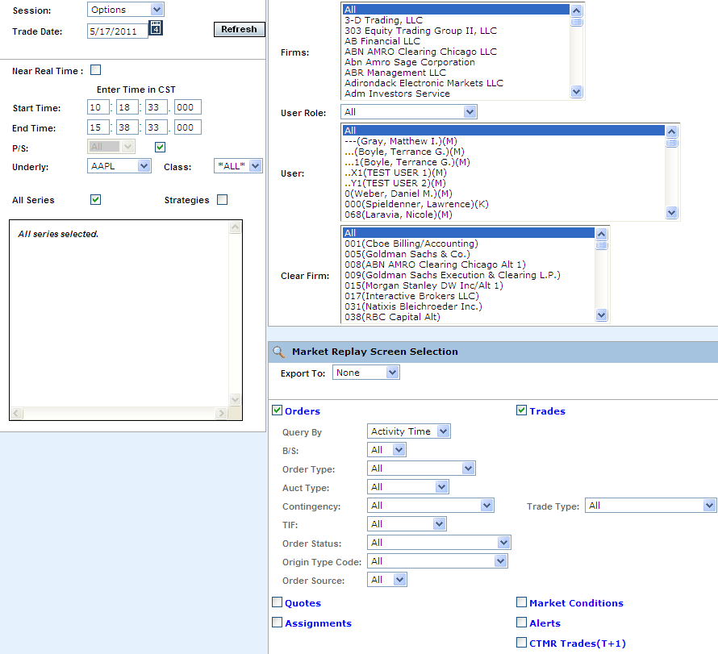
- To further filter your request, select to retrieve Orders.
- You can further filter your order requests by: Query (Activity Time or Receive Time), Buy/Sell (B/S), Order Type, Auction Type, Contingency, TIF, Order Status, Origin Type Code or Order Source. Make your selections from the corresponding dropdown lists. The default for the filters is All.
- To save the query results to an Excel, PDF, Graph or Graph PDF format, select either format from the Export To: drop down list. For export details, refer to the Customize and Export Data section, page 41.
- If you are satisfied with your selections and would like to view the data, click Retrieve. The Orders window will display with the requested data.

 | 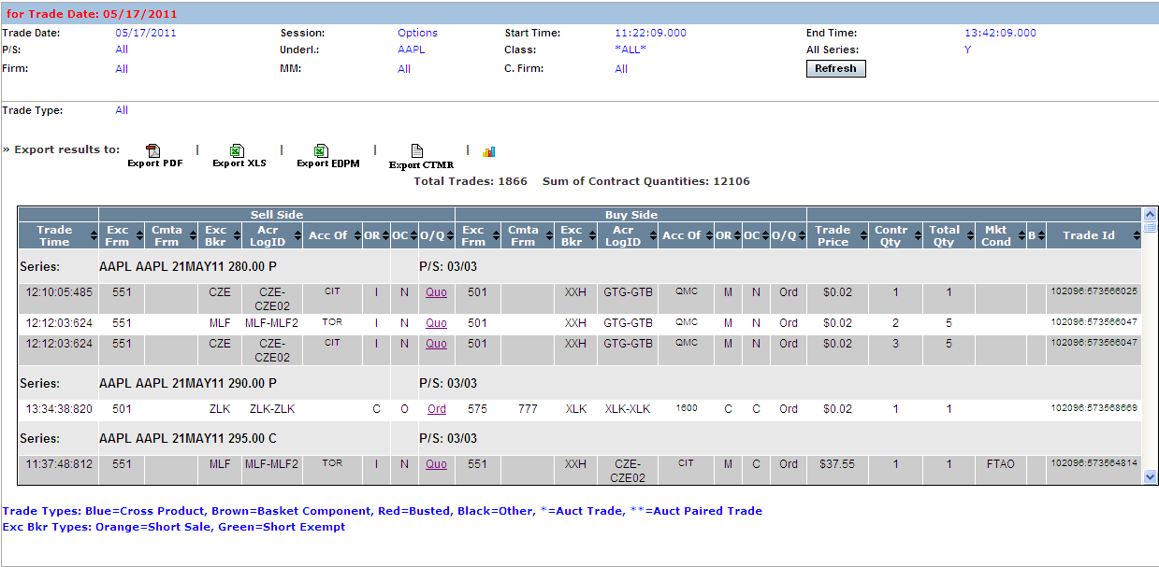
The example above displays all the order activity that occurred in the Options (W_MAIN) session on May 17, 2011 from 11:22:09 to 13:42:09 for all the Call and Put series in the AAPL class.
Market Replay gives you the ability to sort on the contents of any column in the display by clicking on the column heading.
Click Refresh at anytime to update the query.
 | Most of the fields in the Orders display are descriptive. The following table describes valid system codes found in the order display.
 | Column |  | Description
Valid Codes& Definitions | OR & CVG |  | CUSTOMER = C, CTI Equivalent - Non Member, Customer Segregated Account  FIRM = F CTI Equivalent - Firm Trader, House Account  BROKER_DEALER = B  CUSTOMER_BROKER_DEALER= X  MARKET_MAKER = M  MARKET_MAKER_AWAY = N  CTI1Origin1 = V - Member, Customer Segregated Account  CTI1Origin2 = E - Member, House Account  CTI1Origin5 = Q - Member, SIPC Protected Account  CTI3Origin1 = G - User Proxy for trader, Customer Segregated Account  CTI3Origin2 = H - User Proxy for trader, House Account  CTI3Origin5 = R - User Proxy for trader, SIPC Protected Account  CTI4Origin2 = O - Non Member, House Account  CTI4Origin5 = T - Non Member, SIPC Protected AccounT  PRINCIPAL = P  PRINCIPAL_ACTING_AS_AGENT = A  SATISFACTION = S
 | OC |  | O=Open, C=Close
 | TIF |  | D=Day, G=Good until cancelled, T=Good until expire time
 | To view order details, click on the corresponding value in the ORSID column for the selected data row. The order history window will display.
 | 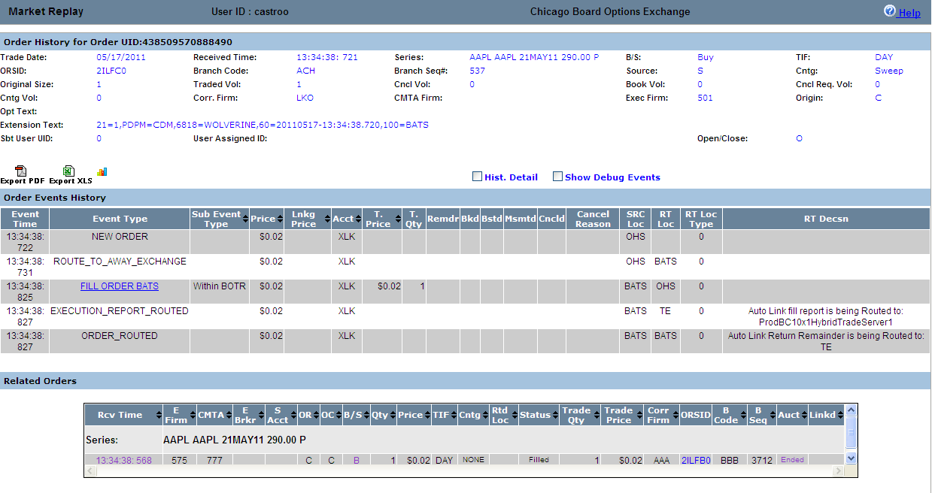
 | If the order is an Auction order, the Auction order details display in the lower portion of the window.
 | 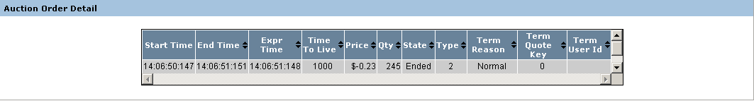
 |  | Column |  | Description
Valid Codes& Definitions |  | Start Time |  | When auction starts and RFQ is sent
 |  | End Time |  | When auction processing completes, including fill allocation (time when finished expiring the auction)
 |  | Expr Time |  | When auction processing completes, including fill allocation (time when CBOE starts processing the auction expiration.
 |  | Time to Live (sec) |  | Configured and calculated auction timeout period in milliseconds. It is the time period in milliseconds for which the auction will be live/active. Once the time to live expires, the auction order will get traded.
 |  | Price |  | Auction starting price
 |  | Qty |  | Auction quantity
 |  | State |  | State of the auction: Started or Ended
 |  | Type |  | Internalization, strategy, regular single, HAL, SAL, unspecified
 |  | Term Reason |  | Auction terminate reason:  UNSPECIFIED = 0  ORDER_MARKETABLE_AGAINST_BOOK = 1  ORDER_MARKETABLE_AGAINST_AUCTION = 2  QUOTE_BID_LOCK = 3  QUOTE_ASK_LOCK = 4  QUOTE_BID_TRIGGER = 5  QUOTE_ASK_TRIGGER = 6  QUOTE_MARKETABLE_AGAINST_AUCTION = 7  Q_ORDER_LOCK = 8  Q_ORDER_TRIGGER = 9  Q_ORDER_MARKETABLE_AGAINST_AUCTION = 10  AUCTION_RESPONSE = 11  NEW_AUCTION = 12  AUCTIONED_ORDER_CANCEL = 13  PRODUCT_STATE_CHANGE = 14
 |  | Term Quote Key |  | The quote key value for the terminated the auction.
 |  | Term User ID |  | The identification of the user who terminated the auction.
 | To view market conditions, click on the Derived Market link.
 | 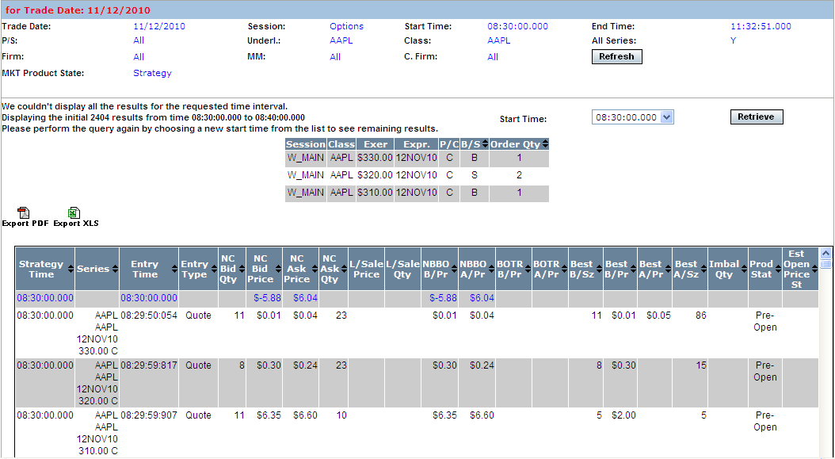
Quotes | Market Replay allows you to retrieve quote information. Make your selections from the Market Replay Main Search Criteria section of the window.  - Select the trading session from the Session drop down list.  - The date of the request defaults to the current business day and is displayed in the Trade Date text box.  - To choose a previous trading day, click on the calendar button. The following calendar window will display.  - Note: The data warehouse maintains trade information for three years.  - Click on the trade day you wish to query. The date will display in the Trade Date text box.  - Choose the time of your request as near real time by selecting the Near Real Time checkbox. If you would like to select a fixed time range, deselect the Near Real Time Monitoring checkbox. Enter the Start Time and End Time by, hour:minutes:seconds:milliseconds (i.e. Start Time: 10:48:00:000, End Time: 13:55:00:000).  - Note: The maximum valid time range is 20 minutes.  - Class/Series selection by post and station (P/S)  - To query all the class and series at every post/station, select the P/S checkbox. The P/S drop down list will gray out, defaulting to query ALL post/stations.  - If you wish to generate data for all the class and series activity for a specific Post and Station, select the Post/Station from the P/S drop down list box.  - Class/Series selection  - Select the underlying security from the Underly drop down list box or select a class from the Class drop down list box. Select ALL for both to retrieve all class and series information.  - Specify the series you are interested in viewing by clicking on the corresponding checkbox.   Note: You must select a series, clearing firm or broker in order to retrieve the data.
 | 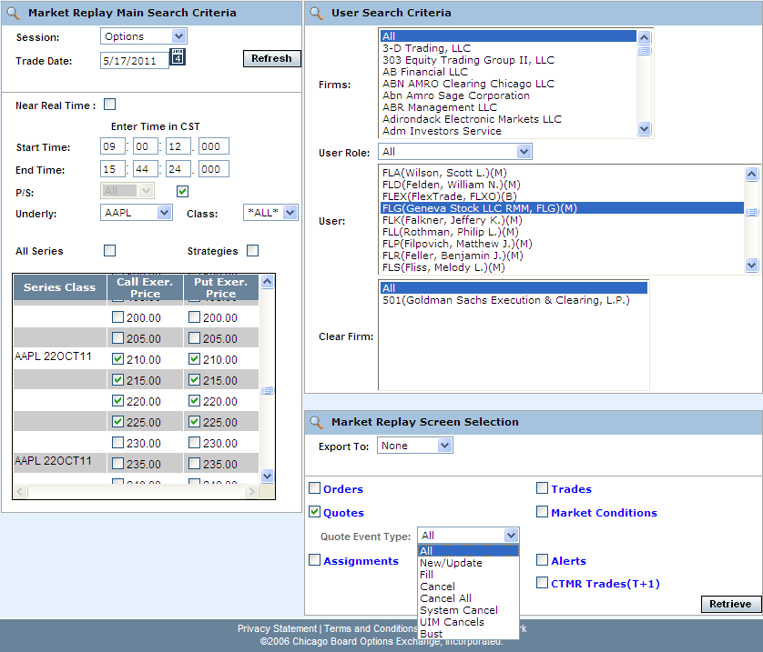
- To further filter your request, select to retrieve Quotes.
- You can further filter your quote requests by Quote Event Type. Make your selections from the corresponding dropdown lists. The default for the filters is All.
- To save the query results to an Excel, PDF, Graph or Graph PDF format, select either format from the Export To: drop down list. For export details, refer to the Customize and Export Data section, page 41.
- If you are satisfied with your selections and would like to view the data, click Retrieve. The Quotes window will display with the requested data.

 | 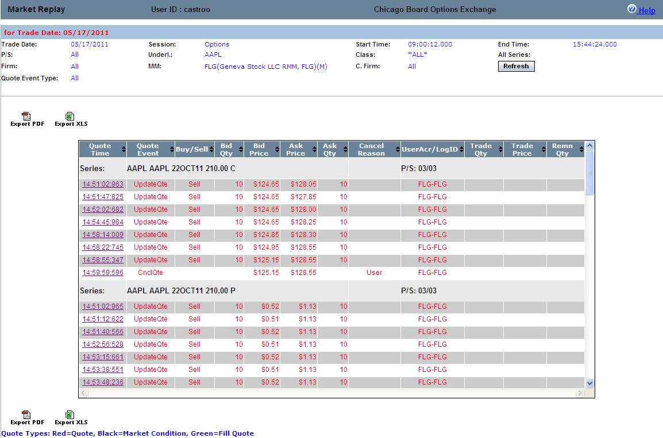
In the example above, quote information for all classes in underlying symbol AAPL, displays for user FLG.
Market Replay gives you the ability to sort on the contents of any column in the display by clicking on the column heading.
Click Refresh at anytime to update the window display.
Market Conditions | To obtain current market condition information. Make your selections from the Market Replay Main Search Criteria section of the window.  - Select the trading session from the Session drop down list.  - The date of the request defaults to the current business day and is displayed in the Trade Date text box.  - To choose a previous trading day, click on the calendar button. The following calendar window will display.  - Note: The data warehouse maintains trade information for three years.  - Click on the trade day you wish to query. The date will display in the Trade Date text box.  - Choose the time of your request as near real time by selecting the Near Real Time checkbox. If you would like to select a fixed time range, deselect the Near Real Time Monitoring checkbox. Enter the Start Time and End Time by, hour:minutes:seconds:milliseconds (i.e. Start Time: 10:48:00:000, End Time: 13:55:00:000).  - Note: The maximum valid time range is 20 minutes.  - Class/Series selection by post and station (P/S)  - To query all the class and series at every post/station, select the P/S checkbox. The P/S drop down list will gray out, defaulting to query ALL post/stations.  - If you wish to generate data for all the class and series activity for a specific Post and Station, select the Post/Station from the P/S drop down list box.  - Class/Series selection  - Select the underlying security from the Underly drop down list box or select a class from the Class drop down list box. Select ALL for both to retrieve all class and series information.  - Specify the series you are interested in viewing by clicking on the corresponding checkbox.   Note: You must select a series, clearing firm or broker in order to retrieve the data.
 | 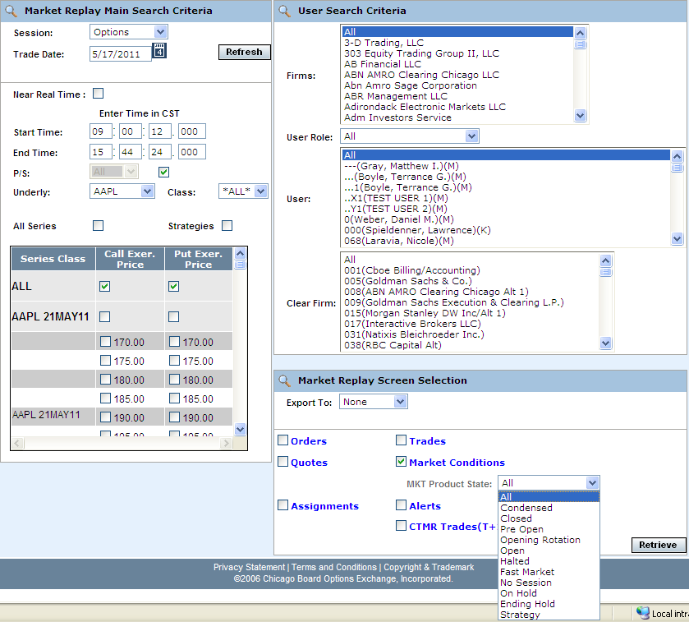
- To further filter your request, select to retrieve Market Conditions.
- You can further filter your market condition requests by Product State. Make your selections from the corresponding dropdown lists. The default for the filters is All.
- To save the query results to an Excel, PDF, Graph or Graph PDF format, select either format from the Export To: drop down list. For export details, refer to the Customize and Export Data section, page 41.
- If you are satisfied with your selections and would like to view the data, click Retrieve. The Market Conditions window will display with the requested data.

 | 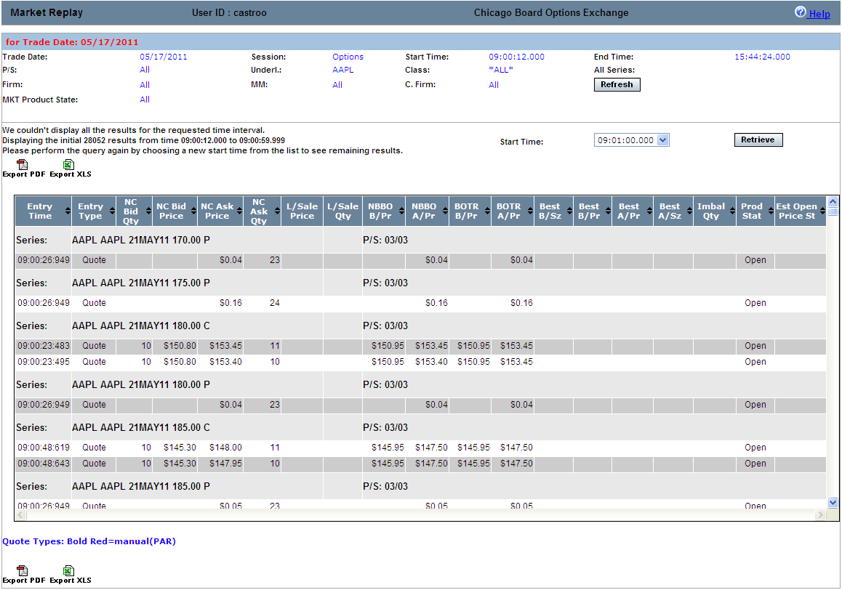
Details are provided for all the market events that occurred in the Options session for all the Put/Call series in the AAPL class.
Scroll down on your scroll bar to view all the events for each series.
Market Replay gives you the ability to sort on the contents of any column in the display by clicking on the column heading.
Trades | Market Replay allows you to retrieve trade information. Make your selections from the Market Replay Main Search Criteria section of the window.  - Select the trading session from the Session drop down list.  - The date of the request defaults to the current business day and is displayed in the Trade Date text box.  - To choose a previous trading day, click on the calendar button. The following calendar window will display.  - Note: The data warehouse maintains trade information for three years.  - Click on the trade day you wish to query. The date will display in the Trade Date text box.  - Choose the time of your request as near real time by selecting the Near Real Time checkbox. If you would like to select a fixed time range, deselect the Near Real Time Monitoring checkbox. Enter the Start Time and End Time by, hour:minutes:seconds:milliseconds (i.e. Start Time: 10:48:00:000, End Time: 13:55:00:000).  - Note: The maximum valid time range is 20 minutes.  - Class/Series selection by post and station (P/S)  - To query all the class and series at every post/station, select the P/S checkbox. The P/S drop down list will gray out, defaulting to query ALL post/stations.  - If you wish to generate data for all the class and series activity for a specific Post and Station, select the Post/Station from the P/S drop down list box.  - Class/Series selection  - Select the underlying security from the Underly drop down list box or select a class from the Class drop down list box. Select ALL for both to retrieve all class and series information.  - Specify the series you are interested in viewing by clicking on the corresponding checkbox.   Note: You must select a series, clearing firm or broker in order to retrieve the data.
 | 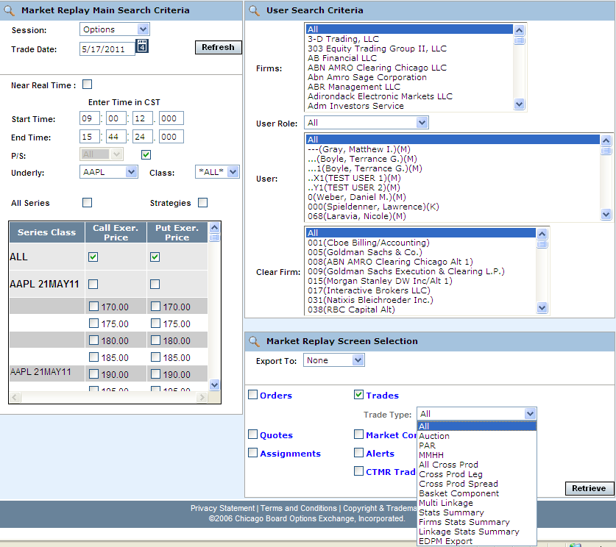
- To further filter your request, select to retrieve Trades.
- You can further filter your trades request by Trade Types. Make your selections from the corresponding dropdown lists. The default for the filters is All.
- To save the query results to an Excel, PDF, Graph or Graph PDF format, select either format from the Export To: drop down list. For export details, refer to the Customize and Export Data section, page 41.
- If you are satisfied with your selections and would like to view the data, click Retrieve. The Trades window will display with the requested data.

 | 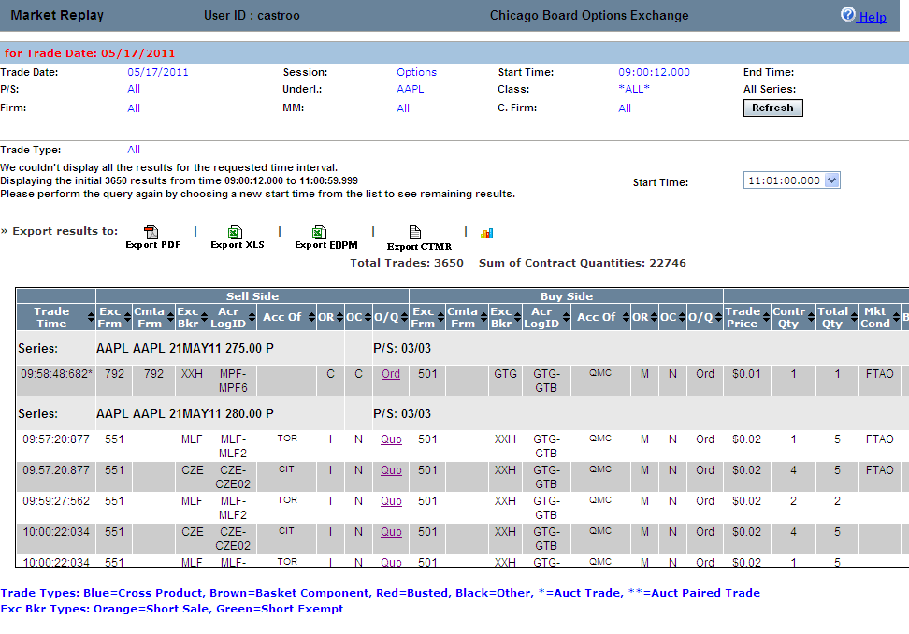
 | The example above displays all the trades that occurred in the W_MAIN session on May 17, 2011, for the AAPL class. The total number of trades represents all the trades in the display.
 | Click on the Ord or Quo link in the O/Q column to display order and quote details.
 | 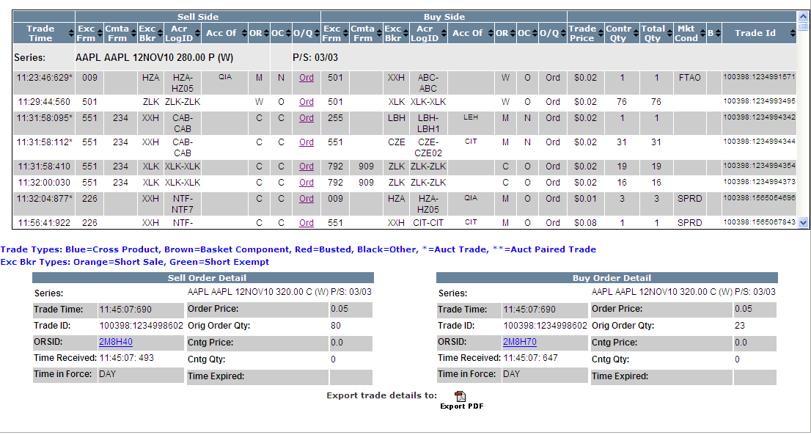
 | Click on the ORSID link to view details on related orders.
 | 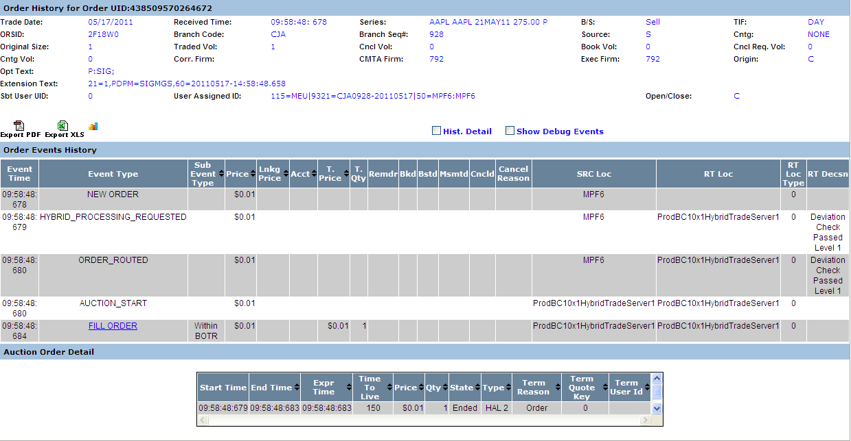
Trade details are provided as well as system specific information. Valid codes and column definitions that are represented in the Trades window are defined in the table below.
Market Replay gives you the ability to sort on the contents of any column in the display by clicking on the column heading.
 | Column |  |  |  | Description
Valid Codes& Definitions | OR |  |  |  | P/A Linkage = 'A'  B/D = 'B'  CUSTOMER = 'C'  Customer-FBW = 'D'  Member, House Account = 'E'  FIRM = F'  User Proxy for trader, Customer Segregated = 'G'  User Proxy for trader, House Account = 'H'  In-Crowd MM = 'I'  Firm - FBW = 'J'  B/D-FBW='K'  Firm-FBW='L'  MARKET_MAKER = 'M'  Away MM='N'  Non Member, House Account='O'  Principle Linkage = 'P'  Member, SIPC Protected Account = 'Q'  User Proxy for trader, SIPC Protected Account = 'R'  Satisfaction Linkage = 'S'  Non Member, SIPC Protected Account='T'  M-FBW='U'  Member, Customer Segregated Account='V'  Broker/Dealer-FBW='W'  Customer Broker/Dealer='X'  Underly Specialist='Y'  N,Y-FBW='Z'
 | OC |  |  |  | O=Open, C=Close
 | Sell Acc of |  |  |  | This column will be populated with a Q account if this side of the trade was originated by a DPM, otherwise, it will be populated with the Broker or Market Maker acronym. If the order originator is not a Market Maker or a broker, then the value in this field will not be validated by CBOEdirect.
 | Buy Acc of |  |  |  | This column represents the buyer’s account information. If this is a trade from a quote, the Q account or Market Maker acrynom is displayed. If this is a trade from an order, it is a free form field for the firm.
 | Mkt Cond |  |  |  | CANC=trade bust report  CNCO=trade bust report for opening trade  FTAO=used if the first trade for product occurs after the opening  OPNT=used if first trade for product occurs during opening  REOP=trade that occurs during an opening rotation that is not the first rotation of the day
 | S (Trade Source) |  |  |  | How the trade was entered. SYSTEM or MANUAL. The Help Desk has the ability to enter a manual trade (block trade)
 | B |  |  |  | The letter ‘B’ stands for Bust. An * displayed in this column represents a busted trade.
Assignments | Market Replay allows you to retrieve user assignment information. Make your selections from the Market Replay Main Search Criteria section of the window.  - Select the trading session from the Session drop down list.  - The date of the request defaults to the current business day and is displayed in the Trade Date text box.  - To choose a previous trading day, click on the calendar button. The following calendar window will display.  - Note: The data warehouse maintains trade information for three years.  - Click on the trade day you wish to query. The date will display in the Trade Date text box.  - Choose the time of your request as near real time by selecting the Near Real Time checkbox. If you would like to select a fixed time range, deselect the Near Real Time Monitoring checkbox. Enter the Start Time and End Time by, hour:minutes:seconds:milliseconds (i.e. Start Time: 10:48:00:000, End Time: 13:55:00:000).  - Note: The maximum valid time range is 20 minutes.  - Class/Series selection by post and station (P/S)  - To query all the class and series at every post/station, select the P/S checkbox. The P/S drop down list will gray out, defaulting to query ALL post/stations.  - If you wish to generate data for all the class and series activity for a specific Post and Station, select the Post/Station from the P/S drop down list box.  - Class/Series selection  - Select the underlying security from the Underly drop down list box or select a class from the Class drop down list box. Select ALL for both to retrieve all class and series information.  - Specify the series you are interested in viewing by clicking on the corresponding checkbox.   Note: You must select a series, clearing firm or broker in order to retrieve the data.
 | 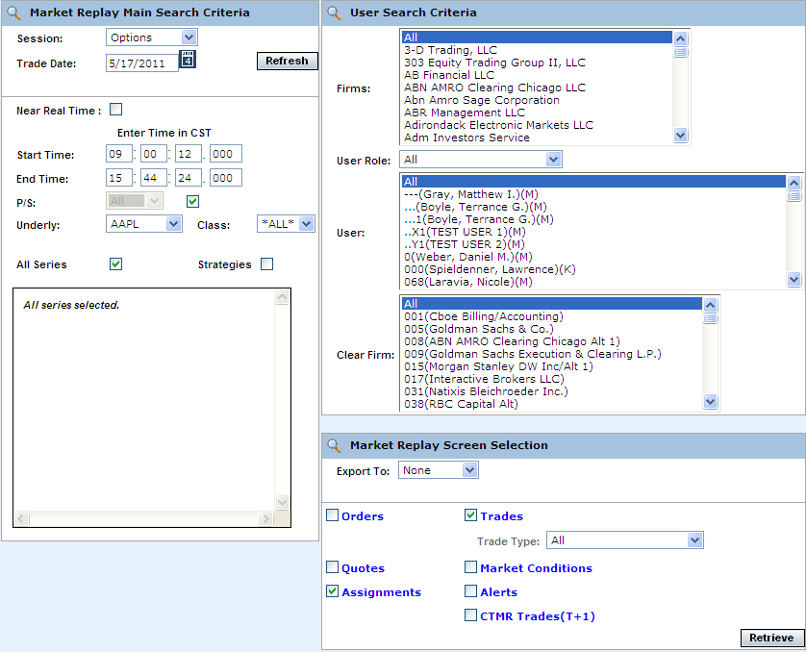
- To further filter your request, select to retrieve Assignments.
- To save the query results to an Excel, PDF, Graph or Graph PDF format, select either format from the Export To: drop down list. For export details, refer to the Customize and Export Data section, page 41.
- If you are satisfied with your selections and would like to view the data, click Retrieve. The Assignments window will display with the requested data.

 | 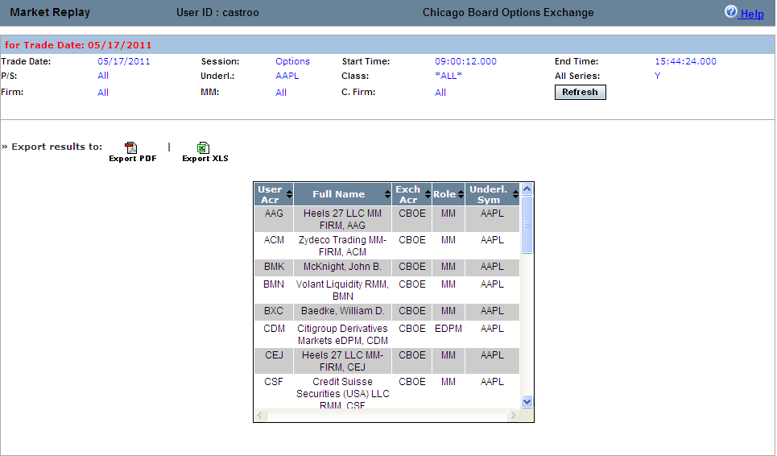
 | The example above displays the user assignments on May 17, 2011 for the class, AAPL.
Alert Messages | The Alerts message display allows you to view types of trade throughs that have occurred in CBOEdirect.  - Select the trading session from the Session drop down list.  - Note: Alert messages are not available for the OneChicago, CFE Options and Futures sessions.  - The date of the request defaults to the current business day and is displayed in the Trade Date text box.  - To choose a previous trading day, click on the calendar button. The following calendar window will display.  - Note: The data warehouse maintains trade information for three years.  - Click on the trade day you wish to query. The date will display in the Trade Date text box.  - Choose the time of your request as near real time by selecting the Near Real Time checkbox. If you would like to select a fixed time range, deselect the Near Real Time Monitoring checkbox. Enter the Start Time and End Time by, hour:minutes:seconds:milliseconds (i.e. Start Time: 10:48:00:000, End Time: 13:55:00:000).  - Note: The maximum valid time range is 20 minutes.  - Class/Series selection by post and station (P/S)  - To query all the class and series at every post/station, select the P/S checkbox. The P/S drop down list will gray out, defaulting to query ALL post/stations.  - If you wish to generate data for all the class and series activity for a specific Post and Station, select the Post/Station from the P/S drop down list box.  - Class/Series selection  - Select the underlying security from the Underly drop down list box or select a class from the Class drop down list box. Select ALL for both to retrieve all class and series information.  - Specify the series you are interested in viewing by clicking on the corresponding checkbox.   Note: You must select a series, clearing firm or broker in order to retrieve the data.
 | 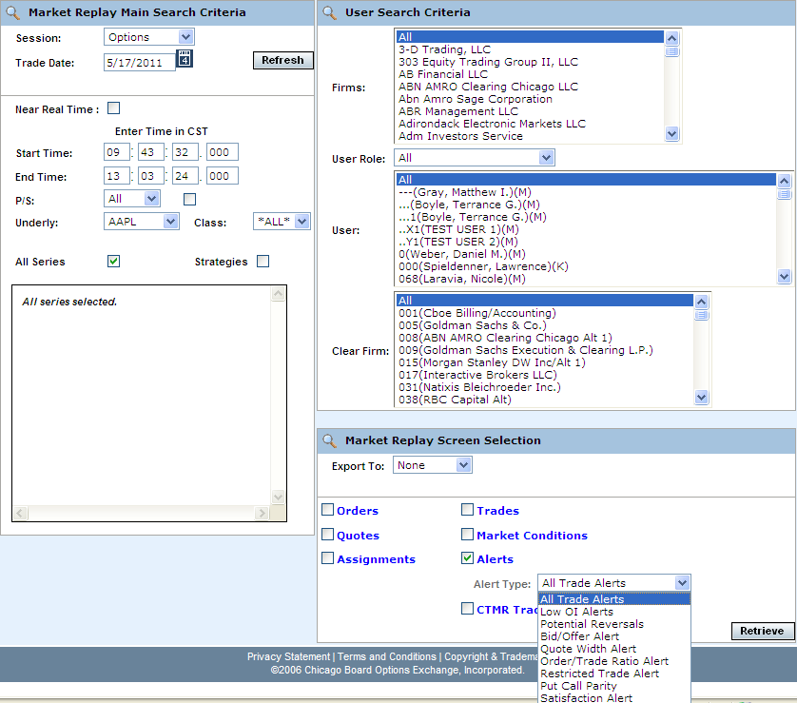
- To further filter your request, select to retrieve Alerts.
- To save the query results to an Excel, PDF, Graph or Graph PDF format, select either format from the Export To: drop down list. For export details, refer to the Customize and Export Data section, page 41.
- If you are satisfied with your selections and would like to view the data, click Retrieve. The Alerts window will display with the requested data.

 | 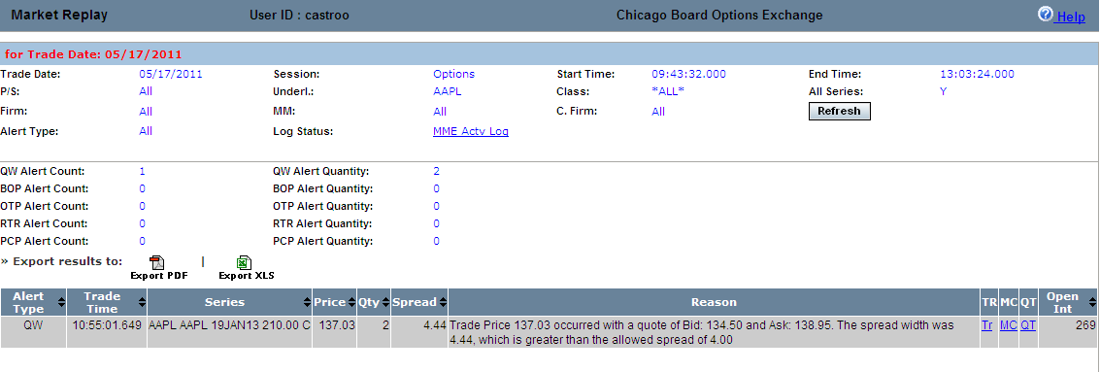
 | The Alert Messages window above displays all the alerts that occurred on May 17, 2011 from 09:43:32 to 13:03:24 for all the AAPL class. If there is any related trade / order activity in the alert, it is shown in the bottom half of the display.
 | Click the TR link to view trade summary data.
 | 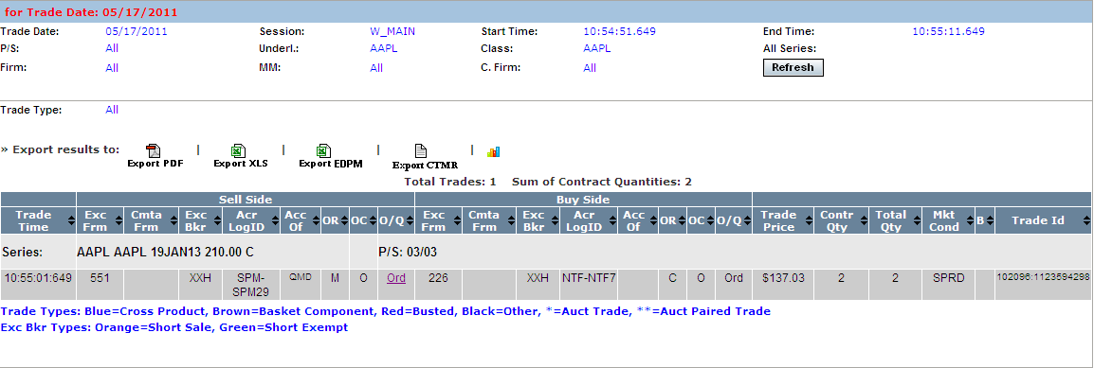
 | To view market condition information, click the MC link.
 | 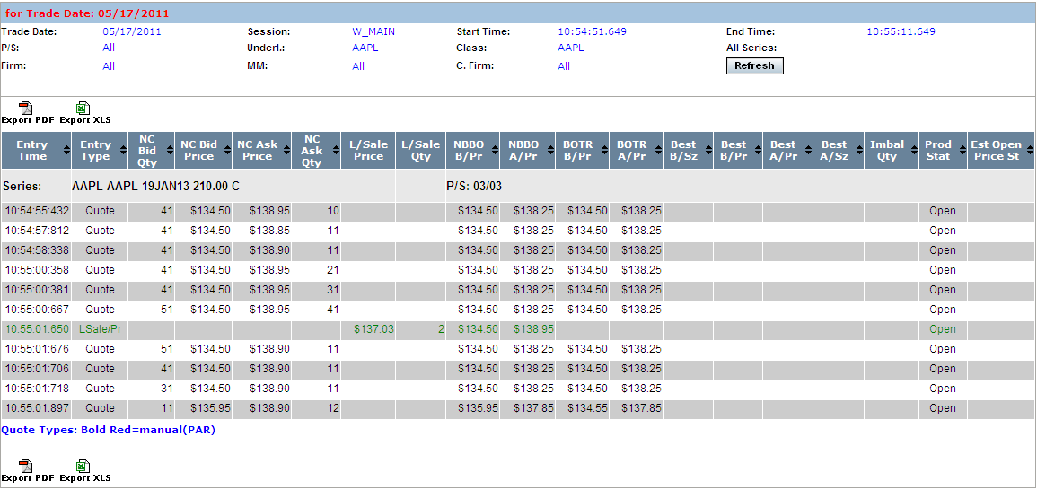
 | Quote summary information can be viewed by clicking on the QT link.
 | 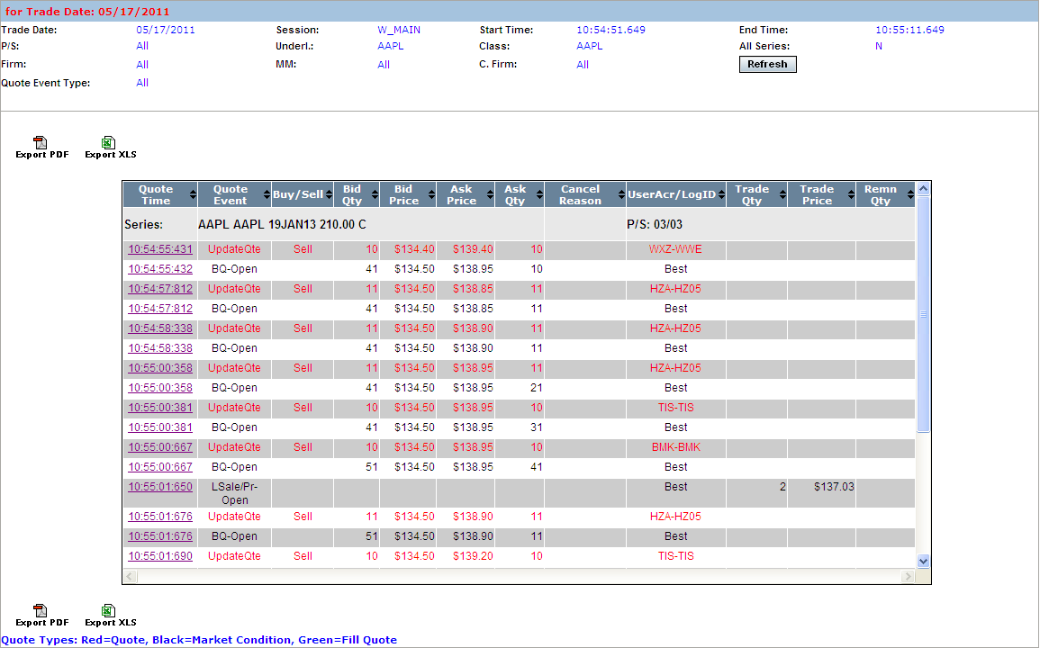
 | Click Refresh at anytime to update the search results.
CTMR Trades | The CTMR trades display allows you to view trade match information for CBOEdirect.  - Select the trading session from the Session drop down list.  - Note: CTMR trades are not available for the OneChicago, CFE Options and Futures sessions.  - The date of the request defaults to the current business day and is displayed in the Trade Date text box.  - To choose a previous trading day, click on the calendar button. The following calendar window will display.  - Note: The data warehouse maintains trade information for three years.  - Click on the trade day you wish to query. The date will display in the Trade Date text box.  - Choose the time of your request as near real time by selecting the Near Real Time checkbox. If you would like to select a fixed time range, deselect the Near Real Time Monitoring checkbox. Enter the Start Time and End Time by, hour:minutes:seconds:milliseconds (i.e. Start Time: 10:48:00:000, End Time: 13:55:00:000).  - Note: The maximum valid time range is 20 minutes.  - Class/Series selection by post and station (P/S)  - To query all the class and series at every post/station, select the P/S checkbox. The P/S drop down list will gray out, defaulting to query ALL post/stations.  - If you wish to generate data for all the class and series activity for a specific Post and Station, select the Post/Station from the P/S drop down list box.  - Class/Series selection  - Select the underlying security from the Underly drop down list box or select a class from the Class drop down list box. Select ALL for both to retrieve all class and series information.  - Specify the series you are interested in viewing by clicking on the corresponding checkbox.   Note: You must select a series, clearing firm or broker in order to retrieve the data.
 | 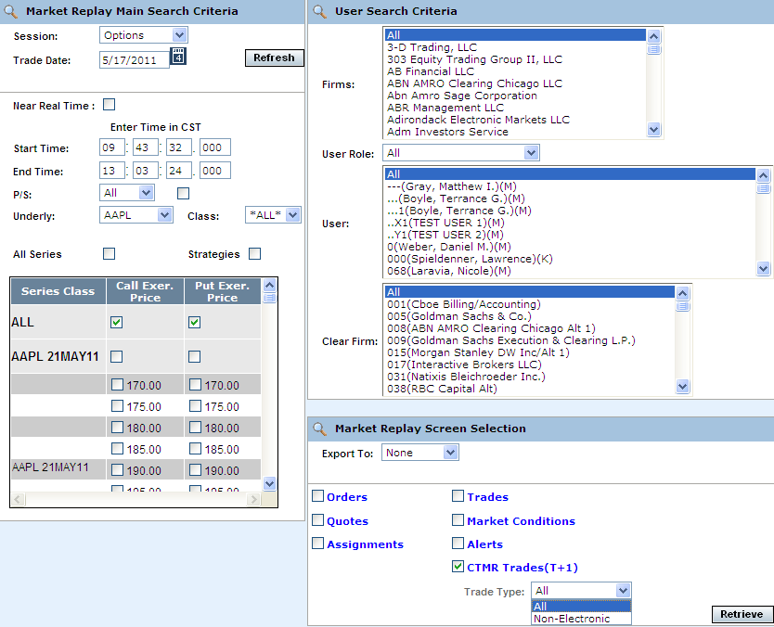
- To further filter your request, select to retrieve CTMR Trades (T+1).
- To save the query results to an Excel, PDF, Graph or Graph PDF format, select either format from the Export To: drop down list. For export details, refer to the Customize and Export Data section, page 41.
- If you are satisfied with your selections and would like to view the data, click Retrieve. The CTMR window will display with the requested data.

 | 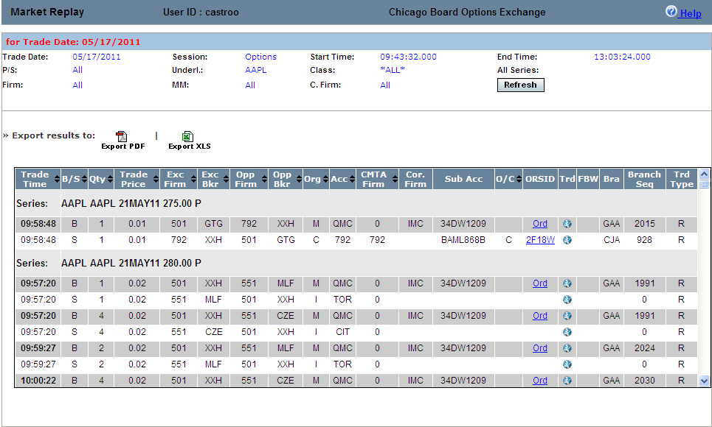
 | The example above shows trade match data for the AAPL class that occurred on May 17, 2011 from 09:43:32 to 13:03:24.
 | From the Trd (Trade) column, click on the Globe icon to view CBOEdirect trade history.
 | 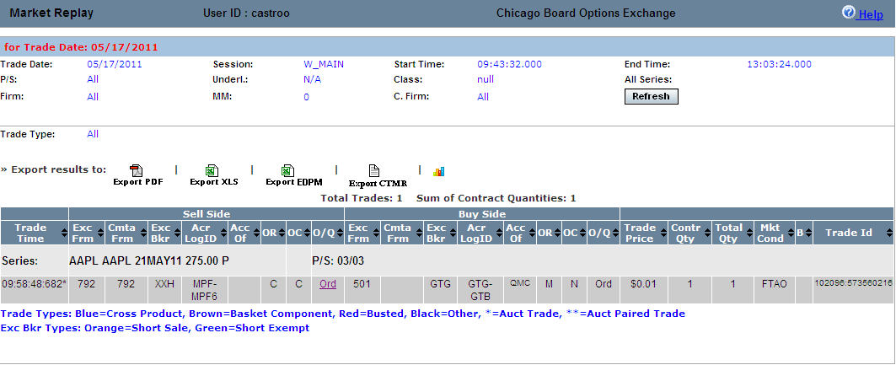
 | To save the query results to an Excel, PDF, Graph or Graph PDF format, select either format from the Export To: drop down list. For export details, refer to the Customize and Export Data section, page 41.

Ending a Market Replay Session

Exit the System | To exit the Market Replay system, click Logout. The application will be closed and you will be returned to your system desktop.

◻ | Section 2:  Reference Guide

Customize and Export Data

Exporting Data | CTM windows that exhibit data in column format can be exported to different file formats.

Export to CSV Format
- Click CSV (Comma Separated Values). The File Download window will display. The window defaults to Save this file to disk.
 | 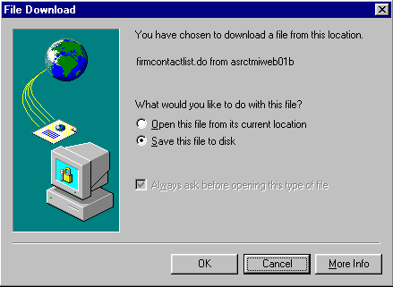
- Click OK. The Save As window displays.
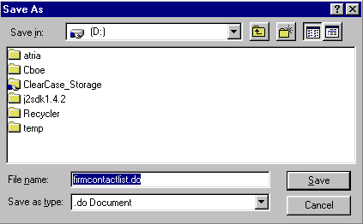
- Select the location where you want to save the file and enter the file name.
- Click Save. Your file will be saved in CVS format.
- To exit the window without saving, click Cancel.

Export to Excel
If you wish to export the data to an Excel spreadsheet, click Excel. The system will open an Excel window and export the data.
 | 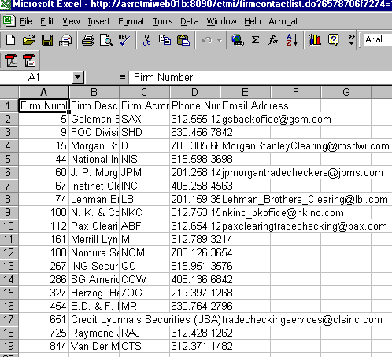

Export to a Graph
If you wish to export the data to a graph, select Graph from the Export To drop down list or click on the graph icon, when it appears in the search results. The Market Replay system will export the data to a graph.
 | 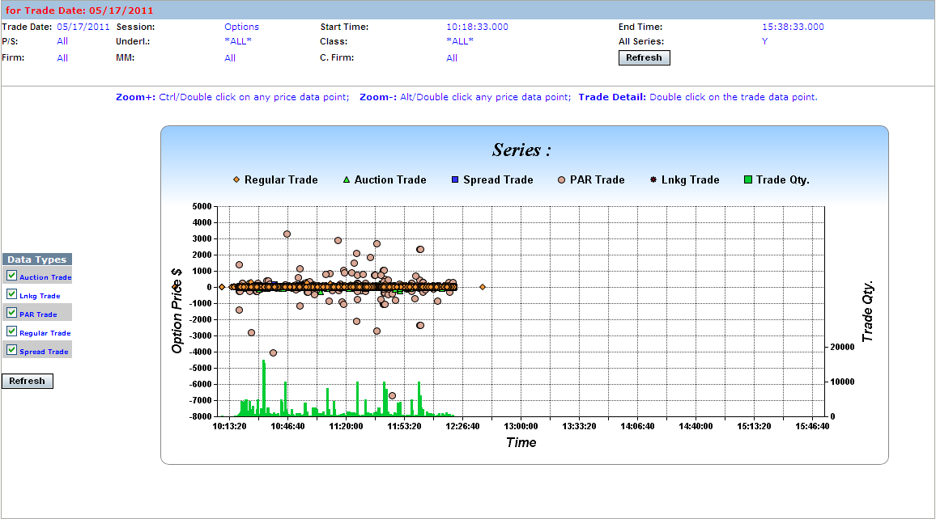
Graphs will appear according to the type of data being reported. In the example above, trade data was converted to graph format. The details below pertain to the above trade data graph but can apply to other data types such as orders or quotes.
- Hover on any of the price data points to display the trade data.
- Double-click on any of the price data points to open the Trade Summary window for that particular trade.
- The graph above displays data types for trades that occurred through regular trades, spreads, auctions, linkage and PAR. To remove a data type from the graph, deselect the type from the Data Types legend and click Refresh. The graph will rebuild without the deselected data type. In the example below, trades that occurred through auctions were removed from the graph display.
 | 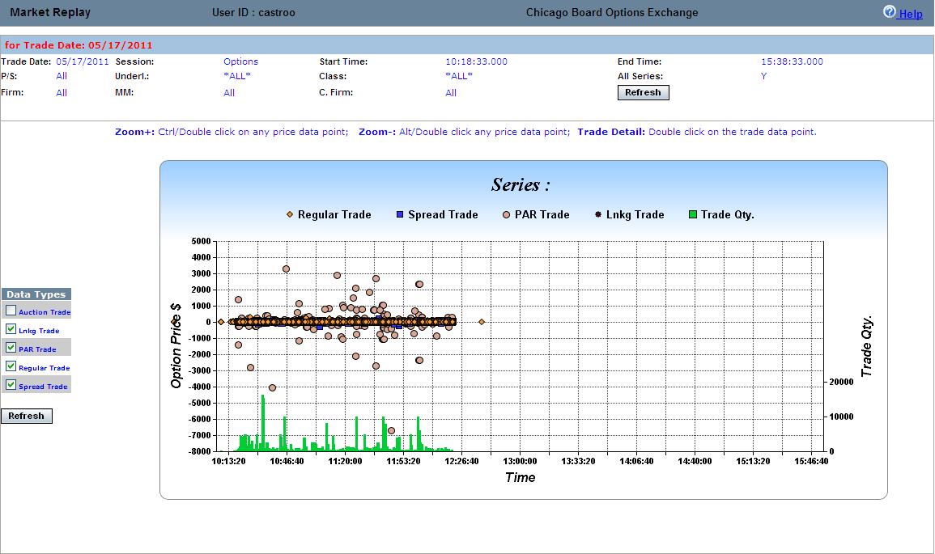
 | - Click Refresh at anytime to update the window.

