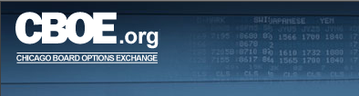

Market Replay Member Firm User’s Guide
Version 7.0

Disclaimer

Copyright © 2001-2009 Chicago Board Options Exchange. All rights reserved.
The information contained in this document constitutes confidential and/or trade secret information belonging to CBOE. This document is made available to CBOE members and member firms for use with CBOEdirect™. This document is provided "As Is" with all faults and without warranty of any kind, either expressed or implied.

Change Notices

The following change notices are provided to assist users of the CBOEdirect market replay system in determining the impact of changes to their processing.
If you have any questions or review comments about this document, please contact Odalys Castro at (312) 786-8817.

Date | Version | Description of Change
4/24/09 | 7.0 | - Removed the capability to change passwords.  - RSA token value is required for login.  - New order filtering capabilities.
2/05/08 | 6.0 | First version of the Member Firm user’s guide.

Table of Contents
Table of Contents iii
Introduction 4
Purpose 4
Intended Audience 4
Conventions Used in this Guide 4
Bolding 4
Section 1: Market Replay 5
Getting Started 6
Login 6
Display Trade Information 8
Selection Parameters 9
Orders 12
Quotes 18
Trades 21
Composite Display 26
Ending a Market Replay Session 29
Exit the System 29
Section 2: Reference Guide 30
Exporting Data 31
Export to PDF Format 31
Export to Excel 33

Introduction

Purpose | This user guide was written to assist Firm users in utilizing all of the features of the Market Replay system using a web browser.
Intended Audience | This user guide is intended for CBOE Member Firms that are interested in Market Replay functions for CBOEdirect.
Conventions  Used in this Guide | The Market Replay system for CBOEdirect was designed so that you can perform all of your Market Replay activities by trading session. More than one Market Replay window can be active at the same time.  There are several conventions used throughout this guide to help trigger important information:
 | Bolding | Used to highlight menu selections (e.g., Login) and button names (e.g., Update)
 |  Note: | This notation is used to indicate important information you should note when performing the associated function.
 | Valid Codes & Definitions | This graphic will appear in the margin when there is information relating to valid system codes and definitions.

 | Section 1:  Market Replay

This section of the user guide will direct you through all the functions of CBOE’s Market Replay system using a web browser.

Getting Started

To launch the Market Replay application, enter the URL: http://marketreplay.cboe.com/ on your web browser.
The following Login window will display.
 | 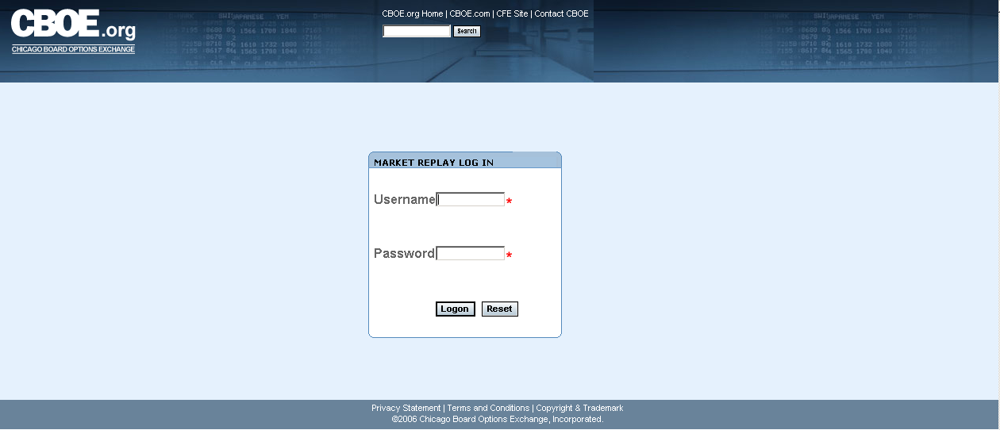
Login | In order to login to CBOE’s Market Replay application, you will need to acquire, from CBOE, a valid user name, password and a RSA SecurID token value.  Enter your Username.  In the Password field, type in your password followed by your RSA token value. Do not enter a space between the password and token value.
 | 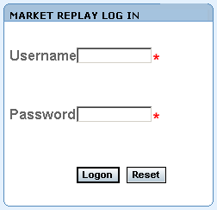
If you incorrectly typed in your Username or Password, click Reset. The login window will clear. Re-enter your User name. Re-enter your Password followed by your RSA token value. Click Logon.
If you get a message indicating Next Token Mode when you login, please do the following:

- Open a browser and go to http://rsa.cboe.com
- Enter username and passcode when prompted: Enter the code displayed in the RSA SecurID window.
- You should receive a message that they are in next code mode.
- Be sure to wait for the RSA software application to flip to a new 8 digit tokencode, then enter that new tokencode.
- You should now get a message that they’ve been successfully authenticated.
- Please wait 90 seconds before attempting a login to Market Replay.
- After a successful login, Market Replay’s main window will display.

 | 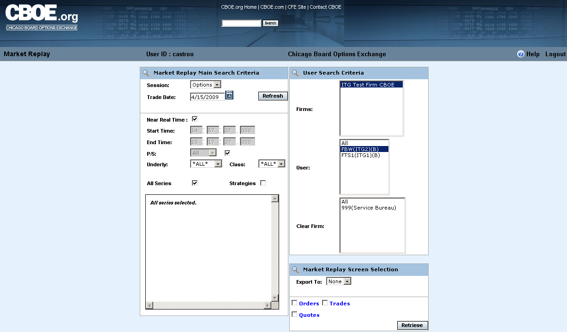
 | From this window you can query CBOEdirect’s real-time and historical trading information for your Firm.
 | You are now ready to use Market Replay’s functionality.

Display Trade Information

 | The Market Replay system allows you to retrieve your Firm’s real-time and historical trading information for CBOEdirect. Historical information is maintained for three years.
 | 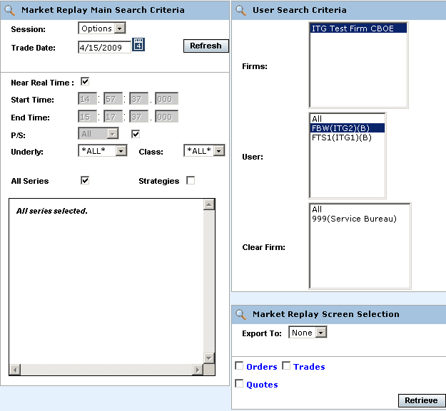
 | Trading information is available based on the security access setup for your Firm.
Selection Parameters | The Market Replay window allows you to specify the type of trading data you wish to view by session. The window defaults to the Options session and the current business day.  To easily understand the data represented in Market Replay, the window displays are presented as single data types (i.e. Trades) rather than combination displays (i.e. Trades & Orders).
 | 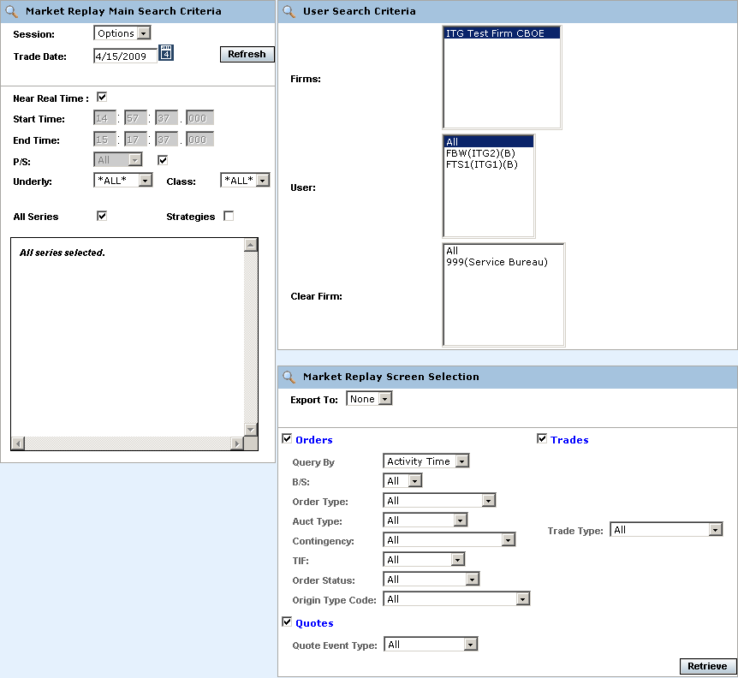
The Market Replay window is split into three panels: Market Replay Main Search Criteria, User Search Criteria and Market Replay Screen Selections. This window is used to set limitations for your data request.
The Market Replay Main Search Criteria section of the window allows you to select:
- The session and trade date
- Near real-time monitoring or a fixed time range
- Underlying and Class selections or select classes by Post and Station (P/S)

 | The User Search Criteria section allows you to filter your Market Replay requests by Firm, Market Maker, or Clearing Firm. The window defaults to display your Firm name, your Firm’s users and Clearing Firms.
 | 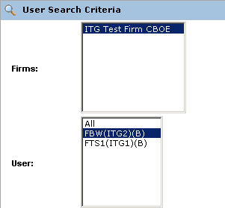
 | If you select only one user from the User list, only the Clearing Firm for that user will display in the Clear Firm list box.
 | 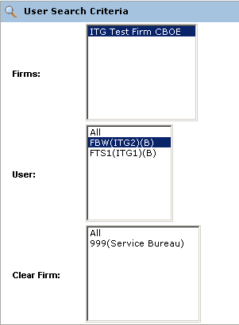
The Market Replay Screen Selection section allows you to filter your Market Replay requests by Orders, Trades and Quotes.
You can also export the data to Excel or PDF formats.
 | 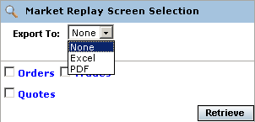
Orders | Market Replay allows you to retrieve your Firms order information. Make your selections from the Market Replay Main Search Criteria section of the window.  - Select the trading session from the Session drop down list.  - The date of the request defaults to the current business day and is displayed in the Trade Date text box.  - To choose a previous trading day, click on the calendar button. The following calendar window will display.  - Note: The data warehouse maintains trade information for three years.  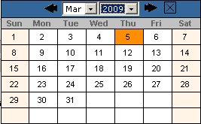  - Click on the trade day you wish to query. The date will display in the Trade Date text box.  - Choose the time of your request as near real time by selecting the Near Real Time checkbox. If you would like to select a fixed time range, deselect the Near Real Time Monitoring checkbox. Enter the Start Time and End Time by, hour:minutes:seconds:milliseconds (i.e. Start Time: 10:48:00:000, End Time: 13:55:00:000).  - Note: The maximum valid time range is 20 minutes.  - Class/Series selection by post and station (P/S)  - To query all the class and series at every post/station, select the P/S checkbox. The P/S drop down list will gray out, defaulting to query ALL post/stations.  - If you wish to generate data for all the class and series activity for a specific Post and Station, select the Post/Station from the P/S drop down list box.  - Class/Series selection  - Select the underlying security from the Underly drop down list box or select a class from the Class drop down list box. Select ALL for both to retrieve all class and series information.  - Specify the series you are interested in viewing by clicking on the corresponding checkbox.   Note: You must select a series, clearing firm or broker in order to retrieve the data.
 | 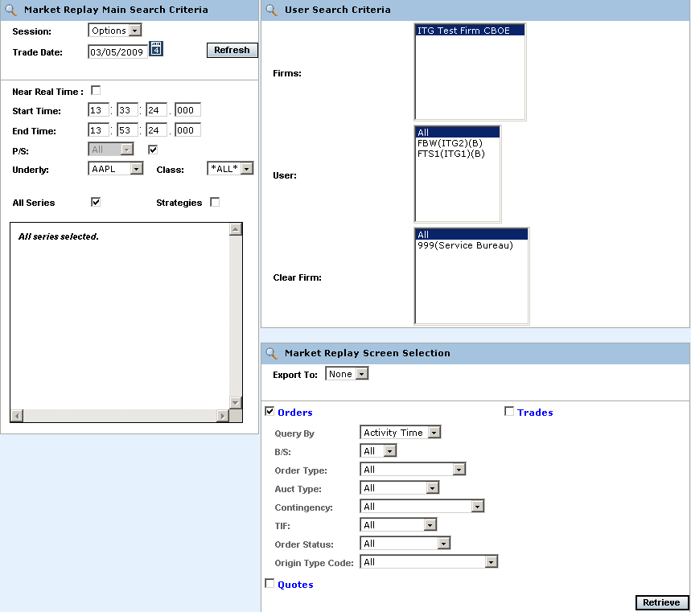
- To further filter your request, select to retrieve Orders, Quotes, or Trades. Select Orders.
- You can further filter your order requests by: Query (Activity Time or Receive Time), Buy/Sell (B/S), Order Type, Auction Type, Contingency, TIF, Order Status or Origin Type Code. Make your selections from the corresponding dropdown lists. The default for the filters is All.
- To save the query results to an Excel or PDF format, select either format from the Export To: drop down list. For export details, refer to the Exporting Data section, page 32.
- If you are satisfied with your selections and would like to view the data, click Retrieve. The Orders window will display with the requested data.

 | 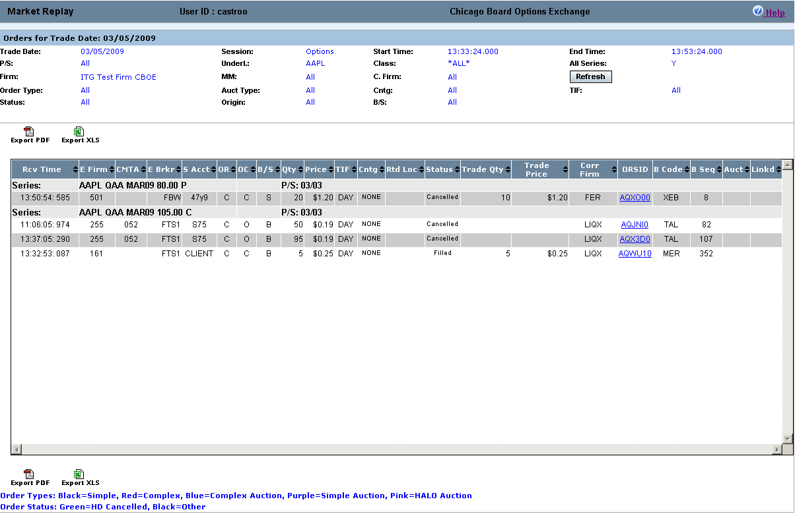
The example above displays all the order activity that occurred in the W_MAIN session for options on March 5, 2009 from 13:33:24.00 to 13:53:24.00 for all the Call and Put series in the AAPL underlying class. Market Replay gives you the ability to sort on the contents of any column in the display by clicking on the column heading.
Click Refresh at anytime to update the query.
 | Most of the fields in the Orders display are descriptive. The following table describes valid system codes found in the order display.
 | Column | Description
Valid Codes& Definitions | OR | Role of the Originating User:  CUSTOMER = C, CTI Equivalent - Non Member, Customer Segregated Account  FIRM = F CTI Equivalent - Firm Trader, House Account  BROKER_DEALER = B  CUSTOMER_BROKER_DEALER= X  MARKET_MAKER = M  MARKET_MAKER_AWAY = N  CTI1Origin1 = V - Member, Customer Segregated Account  CTI1Origin2 = E - Member, House Account  CTI1Origin5 = Q - Member, SIPC Protected Account  CTI3Origin1 = G - User Proxy for trader, Customer Segregated Account  CTI3Origin2 = H - User Proxy for trader, House Account  CTI3Origin5 = R - User Proxy for trader, SIPC Protected Account  CTI4Origin2 = O - Non Member, House Account  CTI4Origin5 = T - Non Member, SIPC Protected AccounT  PRINCIPAL = P  PRINCIPAL_ACTING_AS_AGENT = A  SATISFACTION = S
 | OC | O=Open, C=Close
 | TIF | D=Day, G=Good until cancelled, T=Good until expire time
 | To view order details, click on the corresponding value in the ORSID column for the selected data row. The order history window will display.
 | 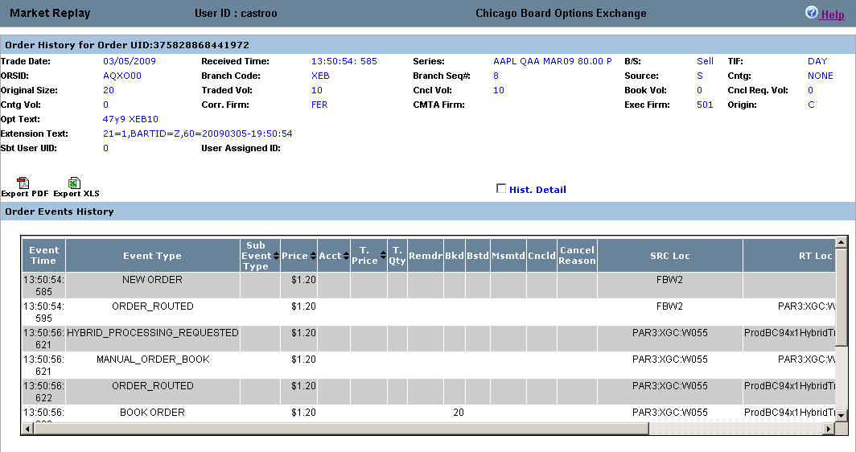
 | Click on the Hist. Detail checkbox to obtain BBO, NBBO and BOTR details. Move the scroll bar to the right to view the data.
 | If the order is an Auction order, the Auction order details display in the lower portion of the window.
 | 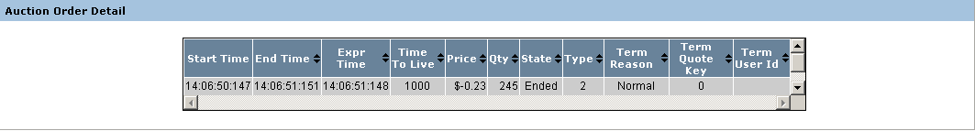
 | Column |  | Description
Valid Codes& Definitions | Start Time |  | When auction starts and RFQ is sent
 | End Time |  | When auction processing completes, including fill allocation (time when finished expiring the auction)
 | Expr Time |  | When auction processing completes, including fill allocation (time when CBOE starts processing the auction expiration.
 | Time to Live (sec) |  | Configured and calculated auction timeout period in milliseconds. It is the time period in milliseconds for which the auction will be live/active. Once the time to live expires, the auction order will get traded.
 | Price |  | Auction starting price
 | Qty |  | Auction quantity
 | State |  | State of the auction: Started or Ended
 | Type |  | Internalization, strategy, regular single, HAL, SAL, unspecified
 | Term Reason |  | Auction terminate reason:  UNSPECIFIED = 0  ORDER_MARKETABLE_AGAINST_BOOK = 1  ORDER_MARKETABLE_AGAINST_AUCTION = 2  QUOTE_BID_LOCK = 3  QUOTE_ASK_LOCK = 4  QUOTE_BID_TRIGGER = 5  QUOTE_ASK_TRIGGER = 6  QUOTE_MARKETABLE_AGAINST_AUCTION = 7  Q_ORDER_LOCK = 8  Q_ORDER_TRIGGER = 9  Q_ORDER_MARKETABLE_AGAINST_AUCTION = 10  AUCTION_RESPONSE = 11  NEW_AUCTION = 12  AUCTIONED_ORDER_CANCEL = 13  PRODUCT_STATE_CHANGE = 14
 | Term Quote Key |  | The quote key value for the terminated the auction.
 | Term User ID |  | The identification of the user who terminated the auction.
 | To view order filled details, click on the FILL ORDER link for the interested data row. The Trade Detail window will display. The Related Orders windows will display only if there are associated orders.
 | 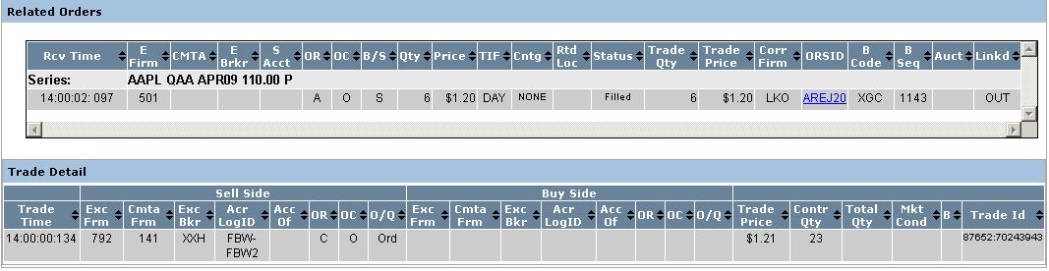
 | The Related Orders window provides details on orders associated to the original order. Click on the ORSID in the Related Orders window to view information for this particular order.
 | 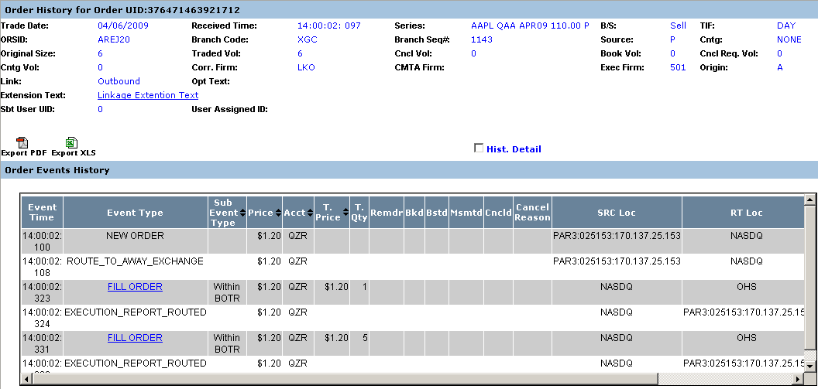
 | ORSID AREJ20 is a Linkage order. Click on the Linkage Extension Text link to view the Linkage details.
 | 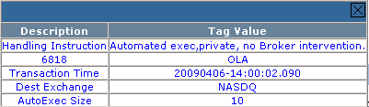
Quotes | Market Replay allows you to retrieve your Firms quote information. Make your selections from the Market Replay Main Search Criteria section of the window.  - Select the trading session from the Session drop down list.  - The date of the request defaults to the current business day and is displayed in the Trade Date text box.  - To choose a previous trading day, click on the calendar button. The following calendar window will display.  - Note: The data warehouse maintains trade information for three years.  - Click on the trade day you wish to query. The date will display in the Trade Date text box.  - Choose the time of your request as near real time by selecting the Near Real Time checkbox. If you would like to select a fixed time range, deselect the Near Real Time Monitoring checkbox. Enter the Start Time and End Time by, hour:minutes:seconds:milliseconds (i.e. Start Time: 10:48:00:000, End Time: 13:55:00:000).  - Note: The maximum valid time range is 20 minutes.  - Class/Series selection by post and station (P/S)  - To query all the class and series at every post/station, select the P/S checkbox. The P/S drop down list will gray out, defaulting to query ALL post/stations.  - If you wish to generate data for all the class and series activity for a specific Post and Station, select the Post/Station from the P/S drop down list box.  - Class/Series selection  - Select the underlying security from the Underly drop down list box or select a class from the Class drop down list box. Select ALL for both to retrieve all class and series information.  - Specify the series you are interested in viewing by clicking on the corresponding checkbox.   Note: You must select a series, clearing firm or broker in order to retrieve the data.
 | 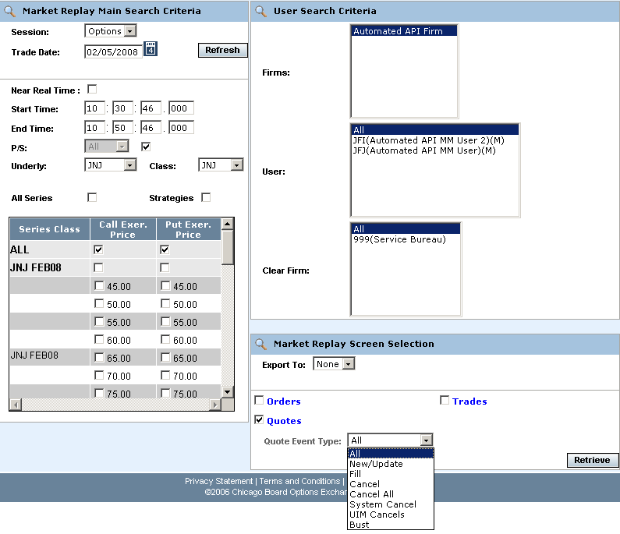
- To further filter your request, select to retrieve Orders, Quotes or Trades, Select Quotes.
- You can further filter your quote requests by Quote Event Type. Make your selections from the corresponding dropdown lists. The default for the filters is All.
- To save the query results to an Excel or PDF format, select either format from the Export To: drop down list. For export details, refer to the Exporting Data section, page 32.
- If you are satisfied with your selections and would like to view the data, click Retrieve. The Quotes window will display with the requested data.

 | 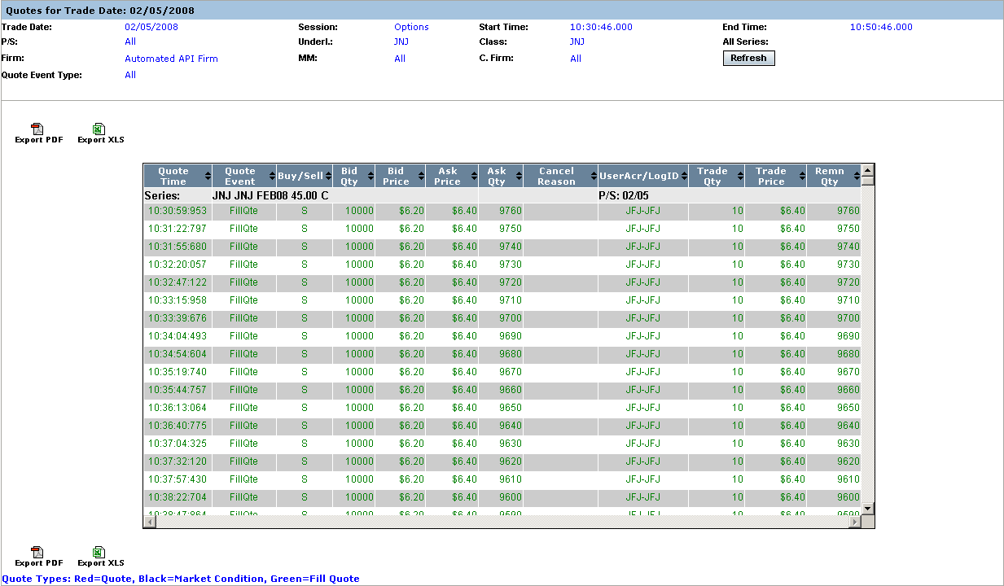
In the example above, quote information for class JNJ displays for the W_MAIN session.
Market Replay gives you the ability to sort on the contents of any column in the display by clicking on the column heading.
Click Refresh at anytime to update the window display.
Trades | Market Replay allows you to retrieve your Firms trade information. Make your selections from the Market Replay Main Search Criteria section of the window.  - Select the trading session from the Session drop down list.  - The date of the request defaults to the current business day and is displayed in the Trade Date text box.  - To choose a previous trading day, click on the calendar button. The following calendar window will display.  - Note: The data warehouse maintains trade information for three years.  - Click on the trade day you wish to query. The date will display in the Trade Date text box.  - Choose the time of your request as near real time by selecting the Near Real Time checkbox. If you would like to select a fixed time range, deselect the Near Real Time Monitoring checkbox. Enter the Start Time and End Time by, hour:minutes:seconds:milliseconds (i.e. Start Time: 10:48:00:000, End Time: 13:55:00:000).  - Note: The maximum valid time range is 20 minutes.
- Class/Series selection by post and station (P/S)
- To query all the class and series at every post/station, select the P/S checkbox. The P/S drop down list will gray out, defaulting to query ALL post/stations.
- If you wish to generate data for all the class and series activity for a specific Post and Station, select the Post/Station from the P/S drop down list box.
- Class/Series selection
- Select the underlying security from the Underly drop down list box or select a class from the Class drop down list box. Select ALL for both to retrieve all class and series information.
- Specify the series you are interested in viewing by clicking on the corresponding checkbox.
 Note: You must select a series, clearing firm or broker in order to retrieve the data.
 | 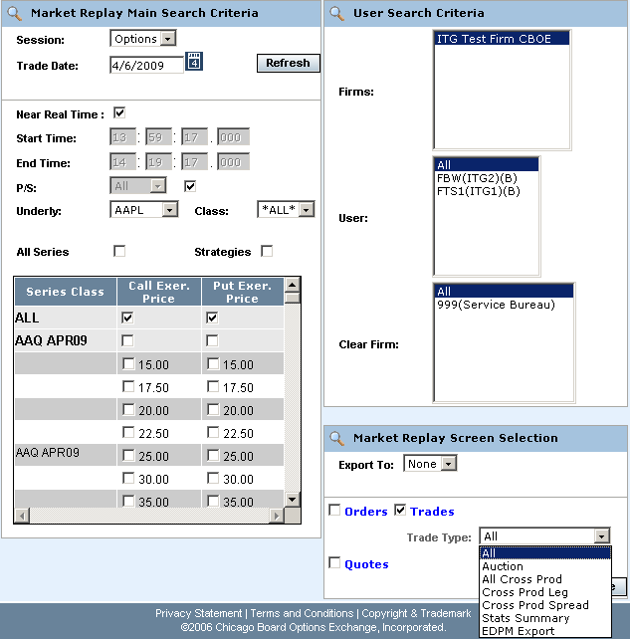
- To further filter your request, select to retrieve Orders, Quotes, or Trades, Select Trades.
- You can further filter your trade request by Trade Type. Make your selections from the corresponding dropdown lists. The default for the filters is All.
- To save the query results to an Excel or PDF format, select either format from the Export To: drop down list. For export details, refer to the Exporting Data section, page 32.
- If you are satisfied with your selections and would like to view the data, click Retrieve. The Trades window will display with the requested data.

 | 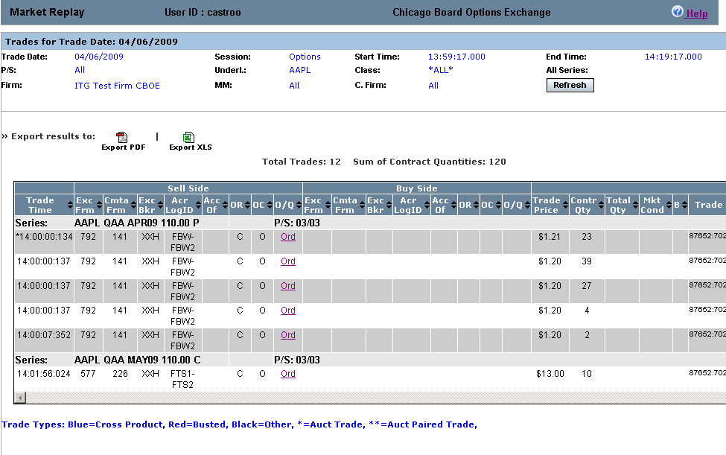
 | The example above displays all the trades that occurred in the W_MAIN session on April 6, 2009, for the AAPL class between 13:59:17-14:19:17. The total number of trades represents all the trades in the display.
 | Click on the Ord or Quo link in the O/Q column to display order and quote details.
 | 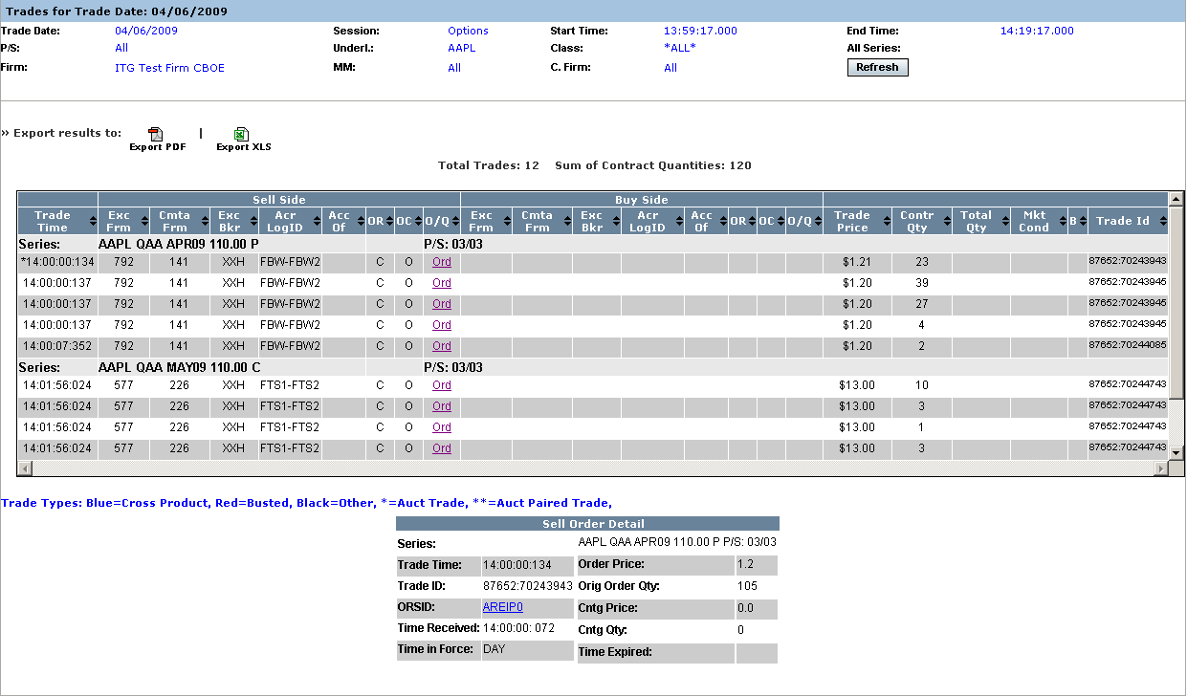
 | Click on the ORSID link to view details on related orders.
 | 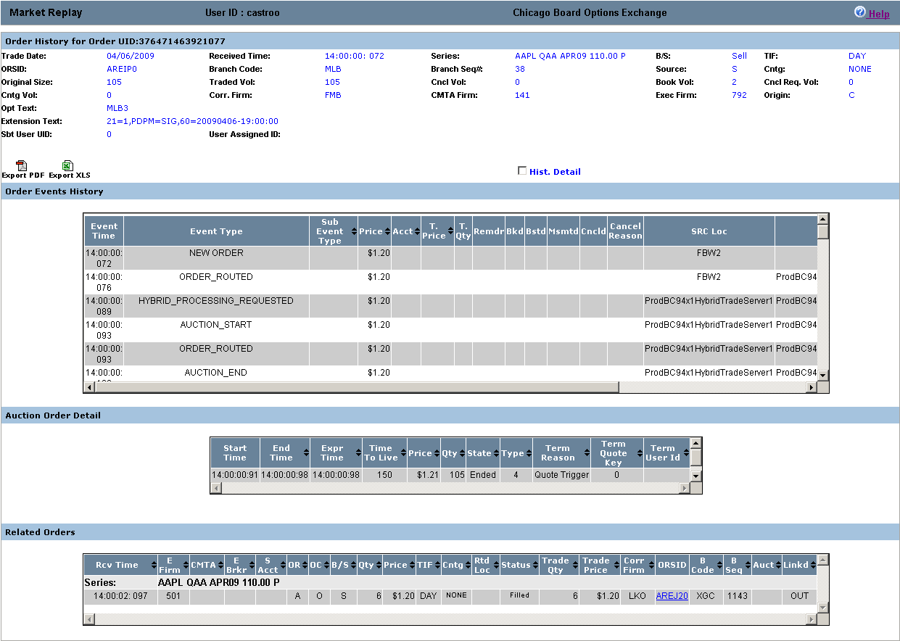
Market Replay gives you the ability to sort on the contents of any column in the display by clicking on the column heading.
Valid codes and column definitions that are represented in the Trades window are defined in the table below.
 | Column |  |  | Description
Valid Codes& Definitions | OR |  |  | P/A Linkage = 'A'  B/D = 'B'  CUSTOMER = 'C'  Customer-FBW = 'D'  Member, House Account = 'E'  FIRM = F'  User Proxy for trader, Customer Segregated = 'G'  User Proxy for trader, House Account = 'H'  In-Crowd MM = 'I'  Firm - FBW = 'J'  B/D-FBW='K'  Firm-FBW='L'
MARKET_MAKER = 'M'
Away MM='N'
Non Member, House Account='O'
Principle Linkage = 'P'
Member, SIPC Protected Account = 'Q'
User Proxy for trader, SIPC Protected Account = 'R'
Satisfaction Linkage = 'S'
Non Member, SIPC Protected Account='T'
M-FBW='U'
Member, Customer Segregated Account='V'
Broker/Dealer-FBW='W'
Customer Broker/Dealer='X'
Underly Specialist='Y'
N,Y-FBW='Z'
 | OC |  |  | O=Open, C=Close
 | Sell Side/Acc of |  |  | This column will be populated with a Q account if this side of the trade was originated by a DPM, otherwise, it will be populated with the Broker or Market Maker acronym. If the order originator is not a Market Maker or a broker, then the value in this field will not be validated by CBOEdirect.
 | Buy Side/ Acc of |  |  | This column represents the buyer’s account information. If this is a trade from a quote, the Q account or Market Maker acrynom is displayed. If this is a trade from an order, it is a free form field for the firm.
 | Mkt Cond |  |  | CANC=trade bust report  CNCO=trade bust report for opening trade  FTAO=used if the first trade for product occurs after the opening  OPNT=used if first trade for product occurs during opening  REOP=trade that occurs during an opening rotation that is not the first rotation of the day
 | S (Trade Source) |  |  | How the trade was entered. SYSTEM or MANUAL. The Help Desk has the ability to enter a manual trade (block trade)
 | B |  |  | The letter ‘B’ stands for Bust. An * displayed in this column represents a busted trade.
Composite Display | Market Replay allows you to query for more than one type of criteria (orders, trades and quotes). In the example below, the query has been set to display both orders and trades for the AAPL class.
 | 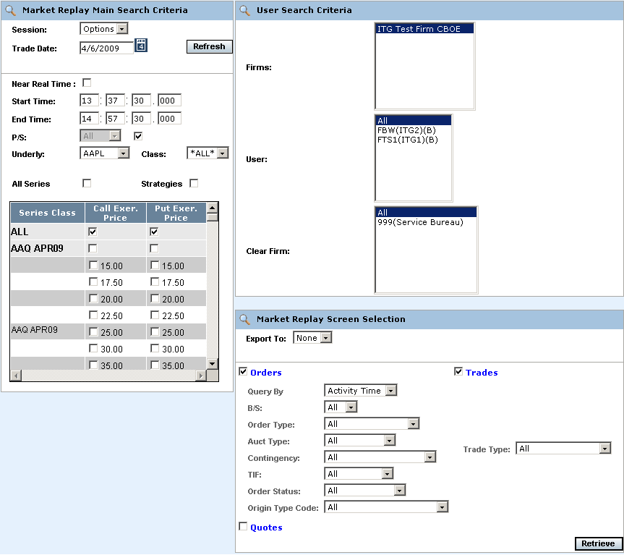
 | Two windows display for the query; Orders and Trades.
 | 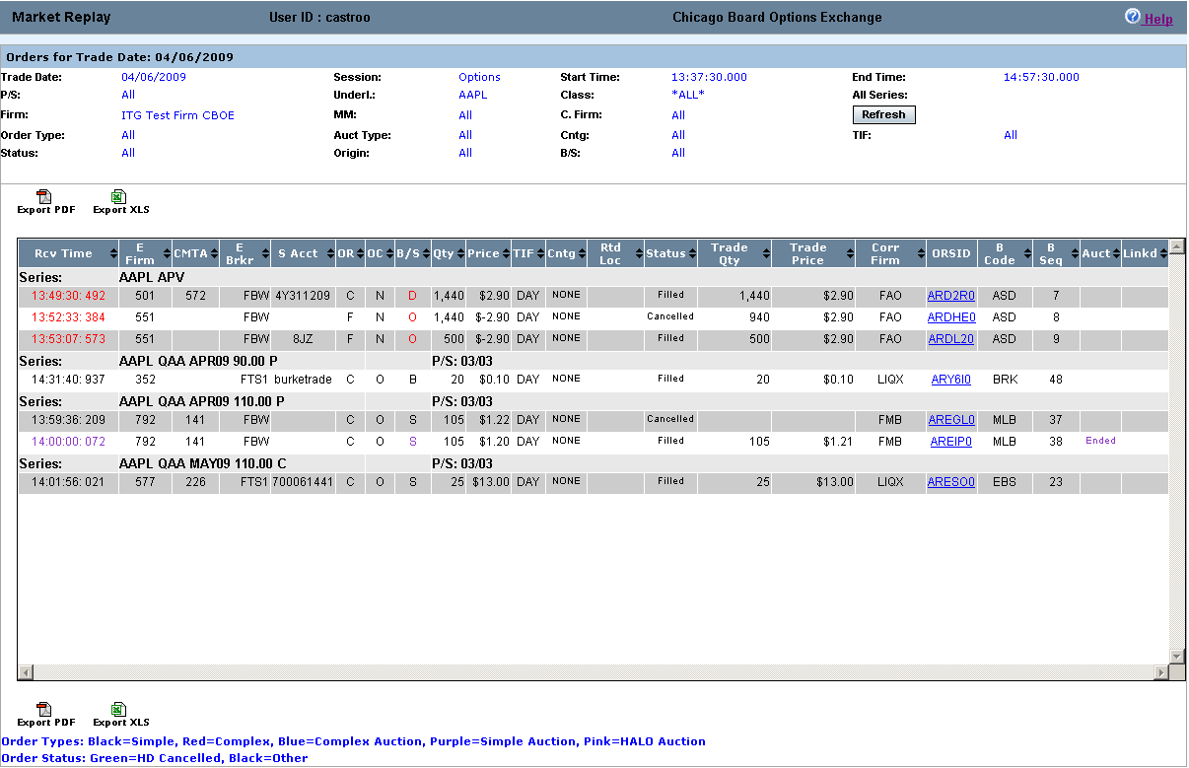
 | Click on the ORSID for a data row to view order details.
 | 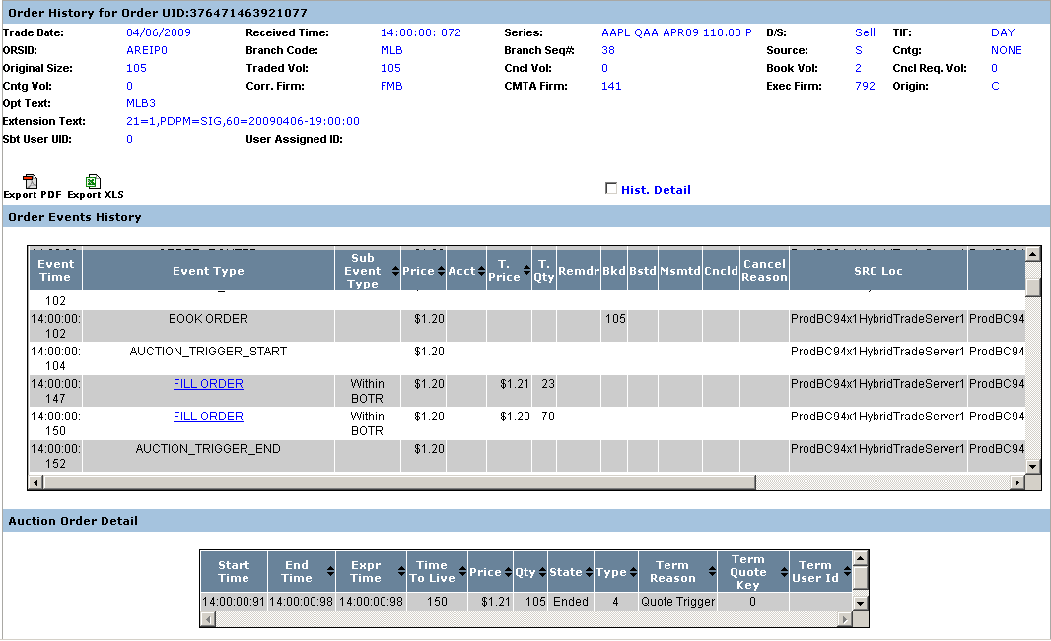
 | For fill report details, click on the FILL ORDER link in the Order History window.
 | 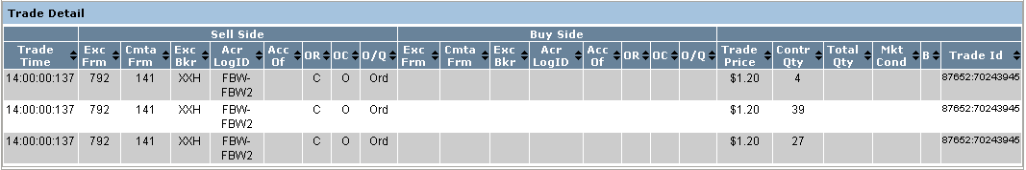
 | Click on the Trade Summary window to view trades data for class AAPL.
 | 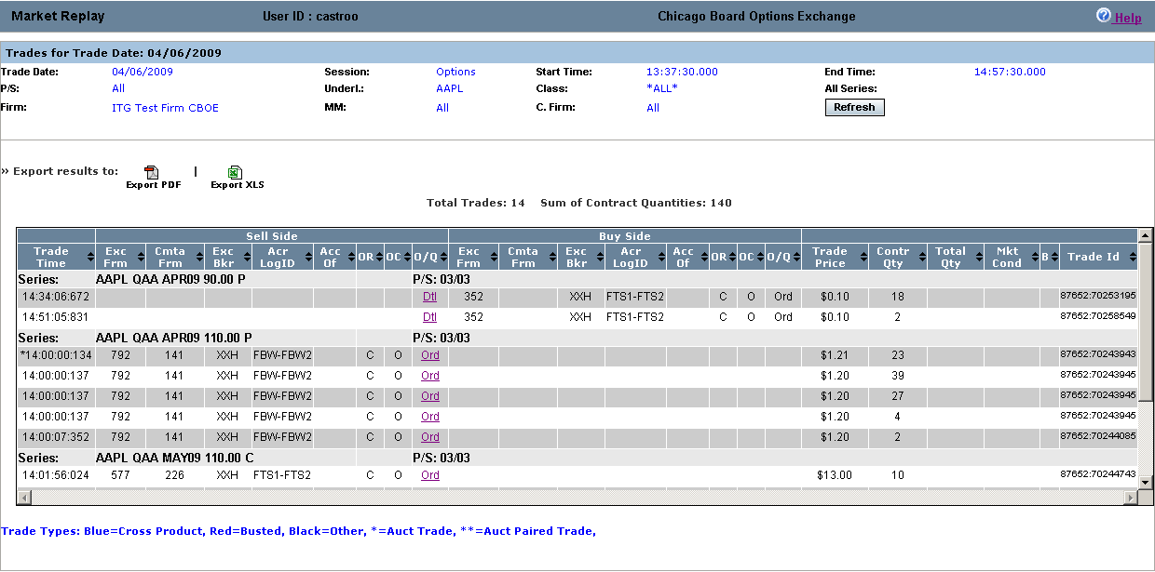
 | From the Trades window, click on the Quo link to view quote details for the trade.
 | 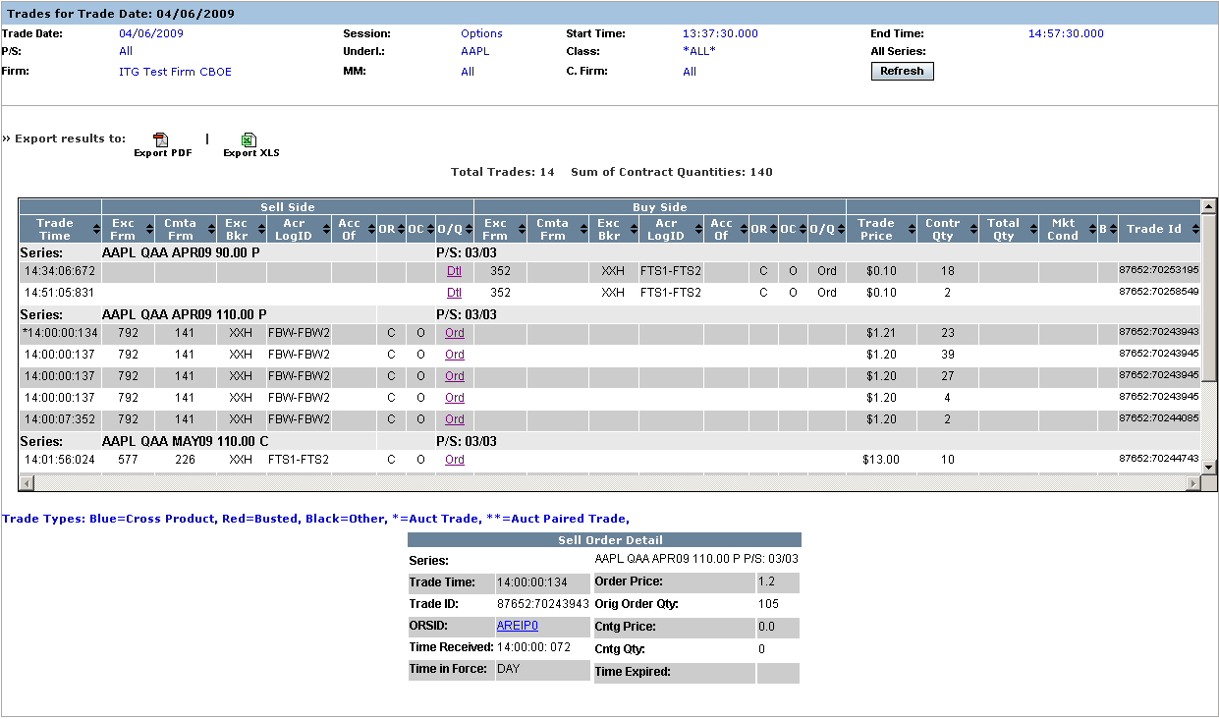

Ending a Market Replay Session

Exit the System | To exit the Market Replay system, click 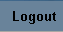 in the upper right corner of the window. The Market Replay system will prompt you to confirm your logout.
 | 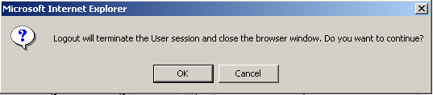
Click OK to confirm your logout request or click Cancel to remain in the system.
If you click OK the system will prompt you to reconfirm terminating the Market Replay session.
 | 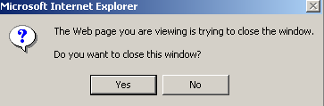
 | Click No to remain in the system.
 | Click Yes to close the application. You will be returned to your system desktop.

◻ | Section 2:  Reference Guide

Exporting Data

 | Market Replay data can be exported to two different file formats: PDF and Excel.
Export to PDF Format | Market Replay allows you to save your search results in PDF format.  To export your query results to PDF format, select your Main Search Critiera, User Search Criteria and Screen Selection.
 | 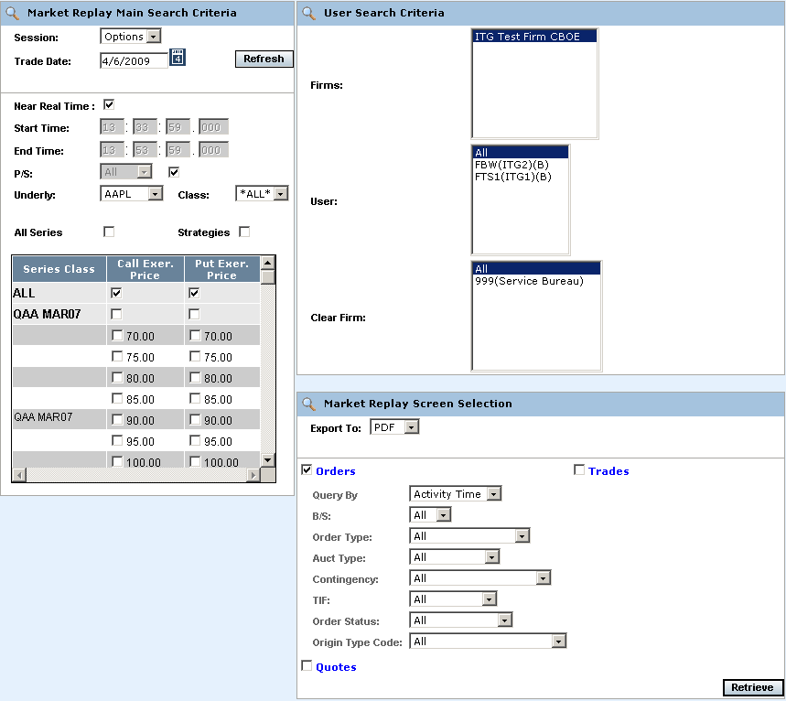
- From the Export To dropdown list, select PDF.
- Click Retrieve. The system will prompt you to either Open or Save the file to your computer. At this point, you may also cancel your format request my clicking on the Cancel button.
 | 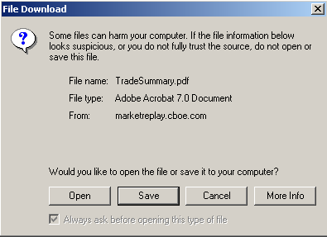
 | - To quickly view the data in PDF format, click Open. The data will be exported in PDF format.
 | 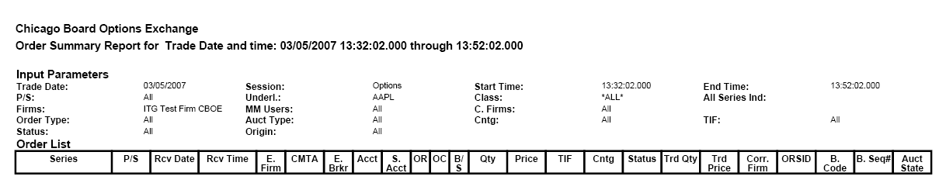
 | - To store the data before viewing, click Save.
 | 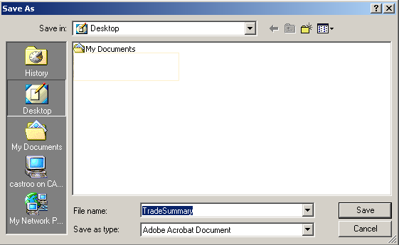
- Select the location where you want to save the file and enter the file name. If you wish to exit the window without saving the file, click Cancel.
- Click Save. Your file will be saved in PDF format. The system will display the Download complete window.
 | 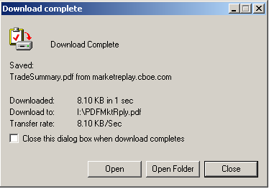
- Click Open to extract the data in PDF format, or select Open Folder to choose the file from the Windows directory.
- Click Close to exit the window without opening the PDF file.
Export to Excel | If you wish to export the data to an Excel spreadsheet, select Excel from the Export To drop down list. The system will prompt you to open an Excel window or save the data. If you wish to cancel your export request, click Cancel.
 | 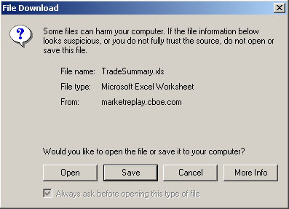
 | - To quickly view the data in Excel format, click Open. The data will be exported to Excel.
 | 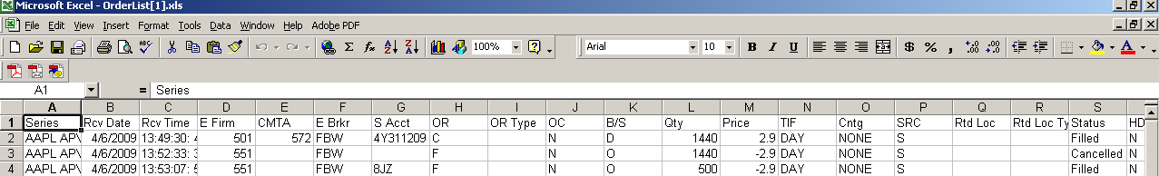
 | - To store the data before viewing, click Save.
 | 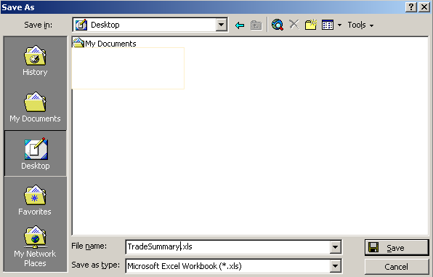
- Select the location where you want to save the file and enter the file name. If you wish to exit the window without saving, click Cancel.
- Click Save. Your file will be saved in Excel format. The system will display the Download complete window.
 | 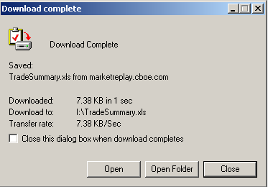
- Click Open to extract the data to Excel format or select Open Folder to choose the file from the Windows directory.
- Click Close to exit the window without opening the Excel file.

