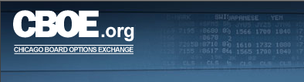

Market Replay User Guide
Version 6.0

Disclaimer

Copyright © 2001-2008 Chicago Board Options Exchange. All rights reserved.
The information contained in this document constitutes confidential and/or trade secret information belonging to CBOE. This document is made available to CBOE members and member firms for use with CBOEdirect™. This document is provided "As Is" with all faults and without warranty of any kind, either expressed or implied.

Change Notices

The following change notices are provided to assist users of the CBOEdirect market replay system in determining the impact of changes to their processing.
If you have any questions or review comments about this document, please contact Odalys Castro at (312) 786-8817.

Date | Version | Description of Change
1/11/08 | 6.0 | Web based version of Market Replay
11/02/05 | 5.10b | Modified to include displays for single acronym and automated auctions
6/17/05 | 5.08 | Updated all display to reflect current data.
2/6/04 | 5.01b | Removed the Customizing Windows section  Added RFQs and Composite displays
1/23/04 | 5.01b | First draft.

Table of Contents
Table of Contents iii
Introduction 5
Purpose 5
Intended Audience 5
Conventions Used in this Guide 5
Bolding 5
Section 1: Market Replay 6
Getting Started 7
Login 7
Change Password 8
Display Options Trade Information 9
Selection Parameters 10
Orders 13
Quotes 18
Market Conditions 21
Trades 24
Alert Messages 28
Assignments 31
Composite Display 33
Display Futures Trade Information 35
Orders 37
Quotes 42
Market Conditions 45
Trades 48
Alerts 52
Composite 54
Display Stock Trade Information 56
Orders 58
Quotes 61
Trades 64
Market Conditions 68
Alerts 70
ITS Admin Messages 72
Ending a Market Replay Session 74
Exit the System 74
Section 2: Reference Guide 75
Exporting Data 76
Export to PDF Format 76
Export to Excel 78

Introduction

Purpose | This user guide was written to assist users in utilizing all of the features of the Market Replay system using a web browser.
Intended Audience | This user guide is intended for Help Desk Administrators, System Operators or any person interested in Market Replay functions for CBOEdirect.
Conventions  Used in this Guide | The Market Replay system for CBOEdirect was designed so that you can perform all of your Market Replay activities by trading session. More than one Market Replay window can be active at the same time.  There are several conventions used throughout this guide to help trigger important information:
 | Bolding | Used to highlight menu selections (e.g., Login) and button names (e.g., Update)
 |  Note: | This notation is used to indicate important information you should note when performing the associated function.
 | Valid Codes & Definitions | This graphic will appear in the margin when there is information relating to valid system codes and definitions.

 | Section 1:  Market Replay

This section of the user guide will direct you through all the functions of CBOE’s Market Replay system using a web browser.

Getting Started

To launch the Market Replay application, enter the URL: http://marketreplay.cboe.com/ on your web browser.
The following Login window will display.
 | 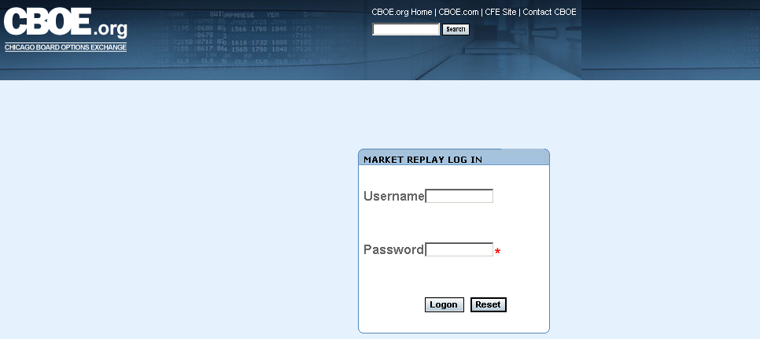
Login | Enter your Username and Password.
 | 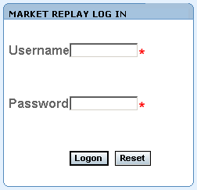
If you incorrectly typed in your Username or Password, click Reset. The login window will clear. Re-enter your User name and Password.
Click Logon. Market Replay’s main window will display.
 | 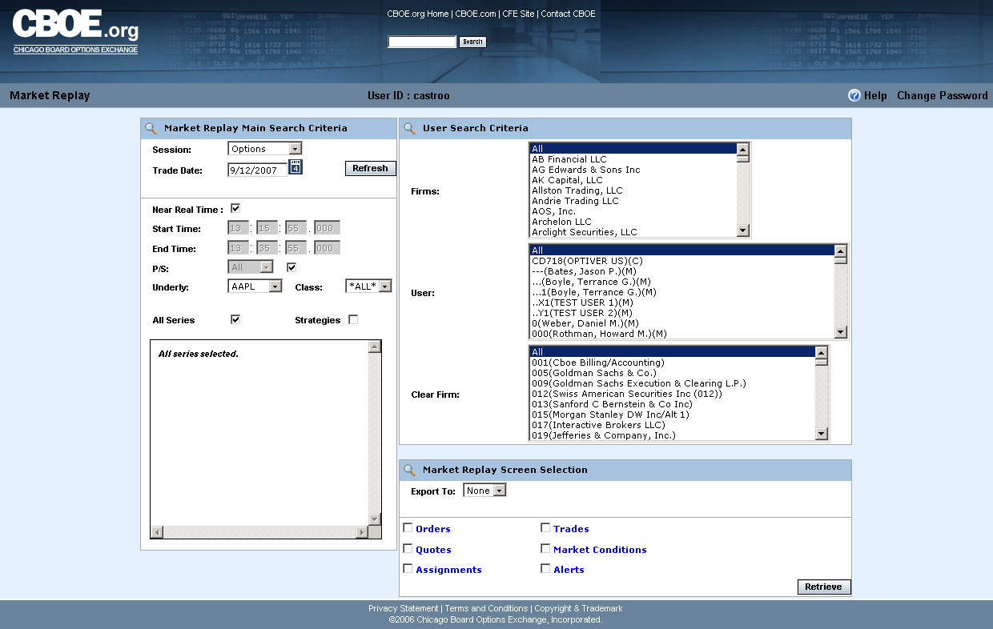
 | From this window you can query both real-time and historical trading information for CBOEdirect, change passwords and search Help functions.
Change Password | Once you have logged into the Market Replay application, the system allows you to change your password.  Click on the Change Password link at the top right-hand corner of the main page. The Change Password window will display.
 | 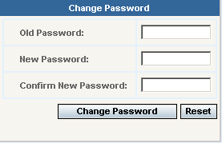
- Enter your Old Password in the text field provided.
- Enter your New Password in the corresponding text field.
- Re-enter your new password in the Confirm New Password text box. If you make a mistake, click Reset. The Change Password window will clear so you can re-enter your passwords.
- Click Change Password.
 | You are now ready to use Market Replay’s functionality.

Display Options Trade Information

 | The Market Replay system allows you to retrieve both real-time and historical trading information for CBOEdirect. Historical information is maintained for three years.
 | At this point, you can obtain current trading information for any CBOEdirect trading session.
Selection Parameters | The Market Replay window allows you to specify the type of trading data you wish to view by session. The window defaults to the Options session and the current business day.  To easily understand the data represented in Market Replay, the window displays are presented as single data types (i.e. Trades) rather than combination displays (i.e. Trades & Orders).
 | 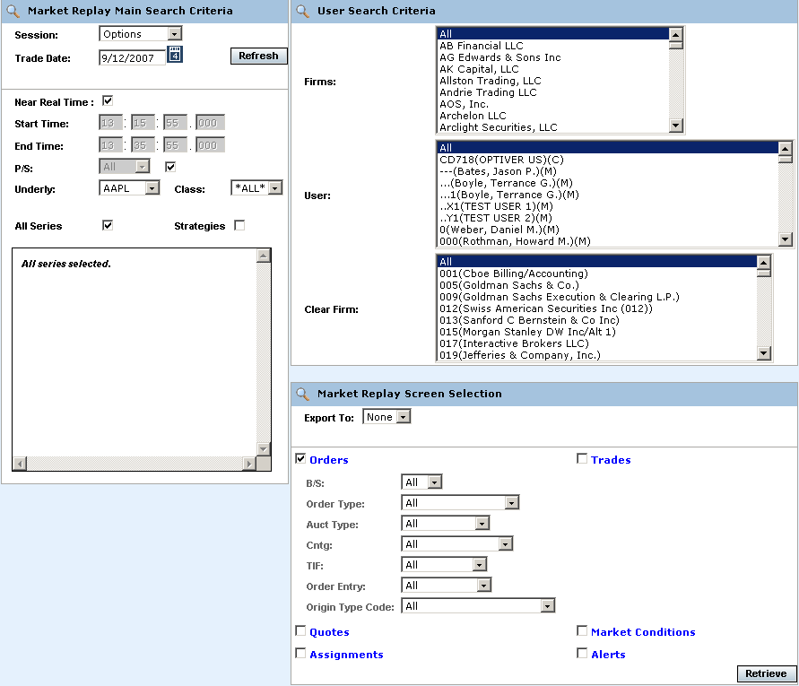
The Market Replay window is split into three panels: Market Replay Main Search Criteria, User Search Criteria and Market Replay Screen Selections. This window is used to set limitations for your data request.
The Market Replay Main Search Criteria section of the window allows you to select:
- The session and trade date
- Near real-time monitoring or a fixed time range
- Underlying and Class selections or select classes by Post and Station (P/S)

The User Search Criteria section allows you to filter your Market Replay requests by Firm, Market Maker, or Clearing Firm. The window defaults to display all Firms, Market Makers and Clearing Firms for the Options session.
If you select only one Firm from the Firm list, only the Market Makers for that Firm will display in the MM list box.
 | 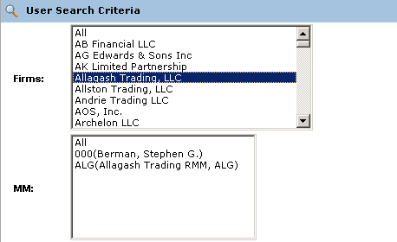
 | If you select only one Market Maker from the MM list, only the Clearing Firm for that Market Maker will display in the Clear Firm list box.
 | 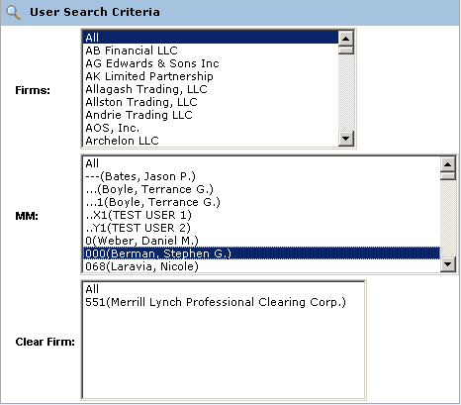
The Market Replay Screen Selection section allows you to filter your Market Replay requests by Orders, Trades, Quotes, Market Conditions, Assignments and Alerts.
- Note: The search for Assignments is only available for Data Warehourse archive Trade dates.
You can also export the data to Excel or PDF formats.
 | 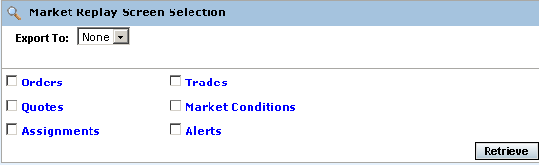
Orders | Market Replay allows you to retrieve current order information. Make your selections from the Market Replay Main Search Criteria section of the window.  - Select the Options trading session from the Session drop down list.  - The date of the request defaults to the current business day and is displayed in the Trade Date text box.  - To choose a previous trading day, click on the calendar button. The following calendar window will display.  - Note: The data warehouse maintains trade information for three years.  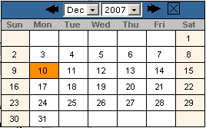  - Click on the trade day you wish to query. The date will display in the Trade Date text box.  - Choose the time of your request as near real time by selecting the Near Real Time radio button. If you would like to select a fixed time range, deselect the Near Real Time Monitoring radio button. Enter the Start Time and End Time by, hour:minutes:seconds:milliseconds (i.e. Start Time: 10:48:00:000, End Time: 13:55:00:000).  - Class/Series selection by post and station (P/S)  - To query all the class and series at every post/station, select the P/S checkbox. The P/S drop down list will gray out, defaulting to query ALL post/stations.  - If you wish to generate data for all the class and series activity for a specific Post and Station, select the Post/Station from the P/S drop down list box.  - Class/Series selection  - Select the underlying security from the Underly drop down list box or select a class from the Class drop down list box. Select ALL for both to retrieve all class and series information.  - Specify the series you are interested in viewing by clicking on the corresponding checkbox.   Note: You must select a series, clearing firm or broker in order to retrieve the data.
 | 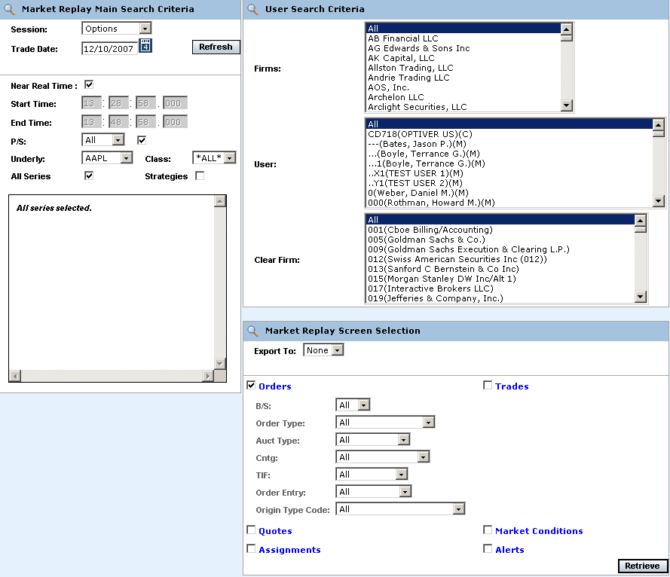
- To further filter your request, select to retrieve Orders, Quotes, Trades, Market Conditions, Assignments or Alerts. Select Orders.
- Note: The search for Assignments is only available for Data Warehouse archive trade dates.
- You can further filter your order requests by: Buy/Sell (B/S), Order Type, Order Entry or Origin Type Code. Make your selections from the corresponding dropdown lists. The default for the filters is All.
- To save the query results to an Excel or PDF format, select either format from the Export To: drop down list. For export details, refer to the Exporting Data section, page 77.
- If you are satisfied with your selections and would like to view the data, click Retrieve. The Orders window will display with the requested data.

 | 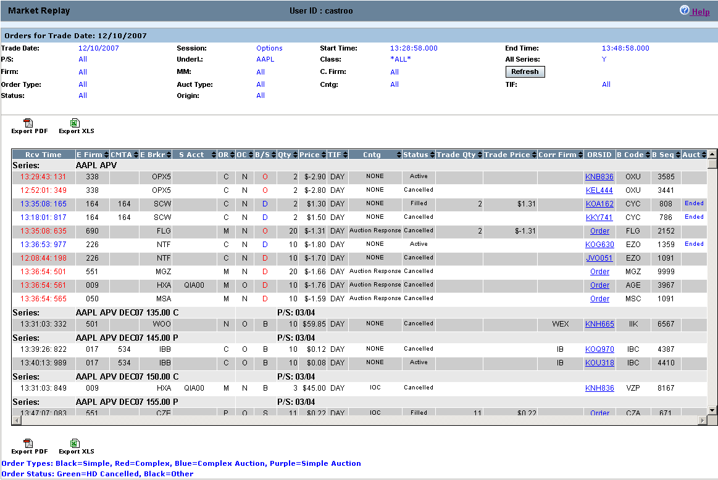
The example above displays all the order activity that occurred in the W_MAIN session on December 10, 2007 from 13:28:58 to 13:48:58 for all the Call and Put series in the AAPL class. Market Replay gives you the ability to sort on the contents of any column in the display by clicking on the column heading.
Click Refresh at anytime to update the query.
 | Most of the fields in the Orders display are descriptive. The following table describes valid system codes found in the orders display.
 | Column | Description
Valid Codes& Definitions | OR | Role of the Originating User:  CUSTOMER = C, CTI Equivalent - Non Member, Customer Segregated Account  FIRM = F CTI Equivalent - Firm Trader, House Account  BROKER_DEALER = B  CUSTOMER_BROKER_DEALER= X  MARKET_MAKER = M  MARKET_MAKER_AWAY = N  CTI1Origin1 = V - Member, Customer Segregated Account  CTI1Origin2 = E - Member, House Account  CTI1Origin5 = Q - Member, SIPC Protected Account  CTI3Origin1 = G - User Proxy for trader, Customer Segregated Account  CTI3Origin2 = H - User Proxy for trader, House Account  CTI3Origin5 = R - User Proxy for trader, SIPC Protected Account  CTI4Origin2 = O - Non Member, House Account  CTI4Origin5 = T - Non Member, SIPC Protected AccounT  PRINCIPAL = P  PRINCIPAL_ACTING_AS_AGENT = A  SATISFACTION = S
 | OC | O=Open, C=Close
 | TIF | D=Day, G=Good until cancelled, T=Good until expire time
 | To view order details, click on the corresponding value in the ORSID column for the selected data row. The order history window will display.
 | 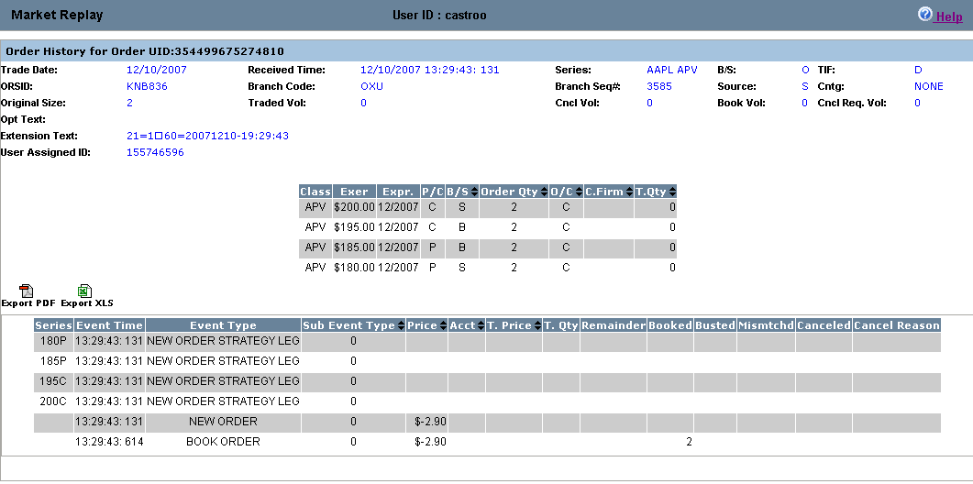
 | If the order is an Auction order, the Auction order details display in the lower portion of the window.
 | Column |  | Description
Valid Codes& Definitions | Start Time |  | When auction starts and RFQ is sent
 | End Time |  | When auction processing completes, including fill allocation (time when finished expiring the auction)
 | Expr Time |  | When auction processing completes, including fill allocation (time when CBOE starts processing the auction expiration.
 | Time to Live (sec) |  | Configured and calculated auction timeout period in milliseconds. It is the time period in milliseconds for which the auction will be live/active. Once the time to live expires, the auction order will get traded.
 | Auct Price |  | Auction starting price
 | Auct Qty |  | Auction quantity
 | State |  | State of the auction: Ended or Active
 | Auct Type |  | Internalization, strategy, regular single, HAL, SAL, unspecified
 | Terminate Reason |  | Auction terminate reason:  UNSPECIFIED = 0  ORDER_MARKETABLE_AGAINST_BOOK = 1  ORDER_MARKETABLE_AGAINST_AUCTION = 2  QUOTE_BID_LOCK = 3  QUOTE_ASK_LOCK = 4  QUOTE_BID_TRIGGER = 5  QUOTE_ASK_TRIGGER = 6  QUOTE_MARKETABLE_AGAINST_AUCTION = 7  Q_ORDER_LOCK = 8  Q_ORDER_TRIGGER = 9  Q_ORDER_MARKETABLE_AGAINST_AUCTION = 10  AUCTION_RESPONSE = 11  NEW_AUCTION = 12  AUCTIONED_ORDER_CANCEL = 13  PRODUCT_STATE_CHANGE = 14
Quotes | Market Replay allows you to retrieve quote information for the current business day. Select the Options trading session from the Session drop down list.  - The date of the request defaults to the current business day and is displayed in the Trade Date text box.  - To choose a previous trading day, click on the calendar button. The following calendar window will display.  - Note: The data warehouse maintains trade information for three years.  - Click on the trade day you wish to query. The date will display in the Trade Date text box.  - Choose the time of your request as near real time by selecting the Near Real Time radio button. If you would like to select a fixed time range, deselect the Near Real Time Monitoring radio button. Enter the Start Time and End Time by, hour:minutes:seconds:milliseconds (i.e. Start Time: 10:48:00:000, End Time: 13:55:00:000).  - Class/Series selection by post and station (P/S)  - To query all the class and series at every post/station, select the P/S checkbox. The P/S drop down list will gray out, defaulting to query ALL post/stations.  - If you wish to generate data for all the class and series activity for a specific Post and Station, select the Post/Station from the P/S drop down list box.  - Class/Series selection  - Select the underlying security from the Underly drop down list box or select a class from the Class drop down list box. Select ALL for both to retrieve all class and series information.  - Specify the series you are interested in viewing by clicking on the corresponding checkbox.   Note: You must select a series, clearing firm or broker in order to retrieve the data.
 | 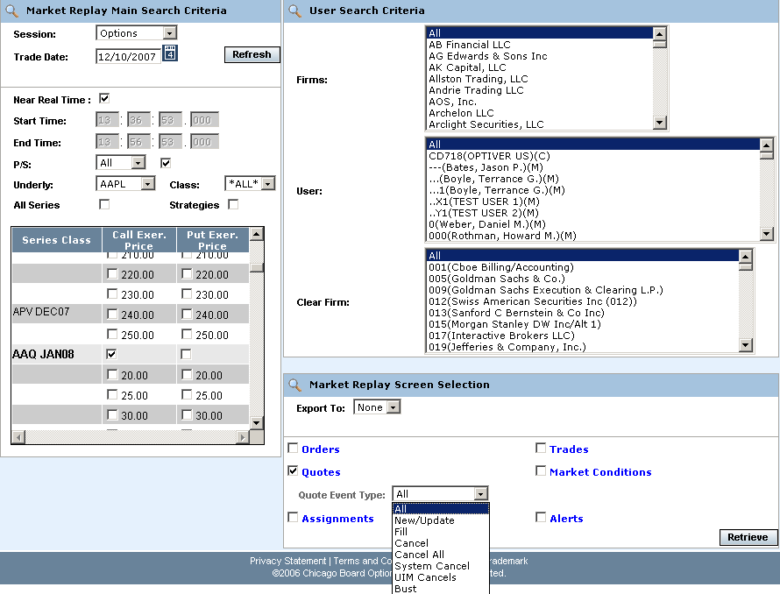
- To further filter your request, select to retrieve Orders, Quotes, Trades, Market Conditions, Assignments or Alerts. Select Quotes.
- Note: The search for Assignments is only available for Data Warehouse archive trade dates.
- You can further filter your quote requests by Quote Event Type. Make your selections from the corresponding dropdown lists. The default for the filters is All.
- To save the query results to an Excel or PDF format, select either format from the Export To: drop down list. For export details, refer to the Exporting Data section, page 77.
- If you are satisfied with your selections and would like to view the data, click Retrieve. The Quotes window will display with the requested data.

 | 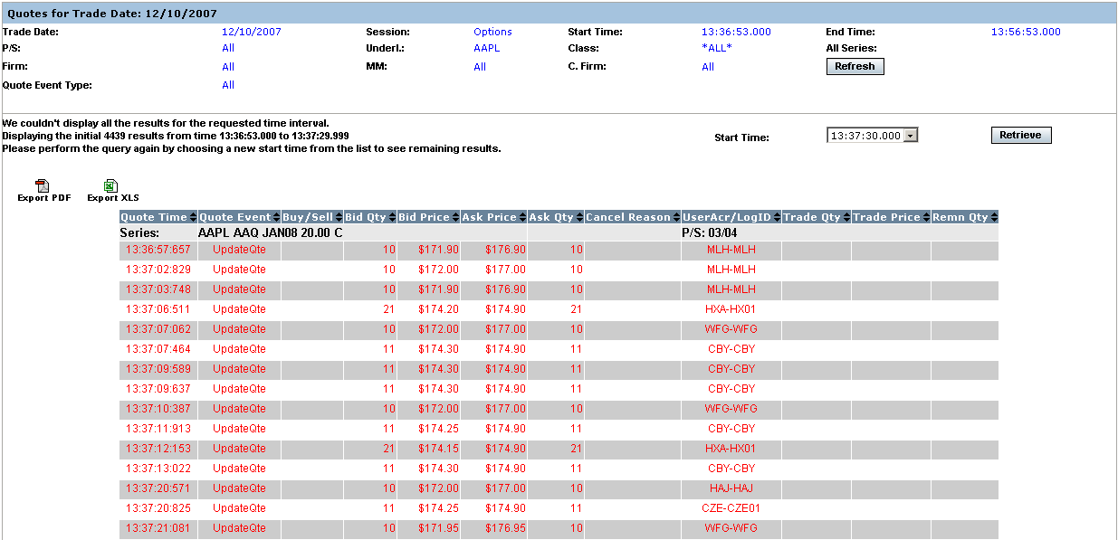
In the example above, quote information for class AAPL displays for the W_MAIN session.
Market Replay gives you the ability to sort on the contents of any column in the display by clicking on the column heading.
Click Refresh at anytime to update the window display.
Market Conditions | Market Replay allows you to retrieve market condition information for the current business day. Select the Options trading session from the Session drop down list.  - The date of the request defaults to the current business day and is displayed in the Trade Date text box.  - To choose a previous trading day, click on the calendar button. The following calendar window will display.  - Note: The data warehouse maintains trade information for three years.  - Click on the trade day you wish to query. The date will display in the Trade Date text box.  - Choose the time of your request as near real time by selecting the Near Real Time radio button. If you would like to select a fixed time range, deselect the Near Real Time Monitoring radio button. Enter the Start Time and End Time by, hour:minutes:seconds:milliseconds (i.e. Start Time: 10:48:00:000, End Time: 13:55:00:000).  - Class/Series selection by post and station (P/S)  - To query all the class and series at every post/station, select the P/S checkbox. The P/S drop down list will gray out, defaulting to query ALL post/stations.  - If you wish to generate data for all the class and series activity for a specific Post and Station, select the Post/Station from the P/S drop down list box.  - Class/Series selection  - Select the underlying security from the Underly drop down list box or select a class from the Class drop down list box. Select ALL for both to retrieve all class and series information.  - Specify the series you are interested in viewing by clicking on the corresponding checkbox.   Note: You must select a series, clearing firm or broker in order to retrieve the data.
 | 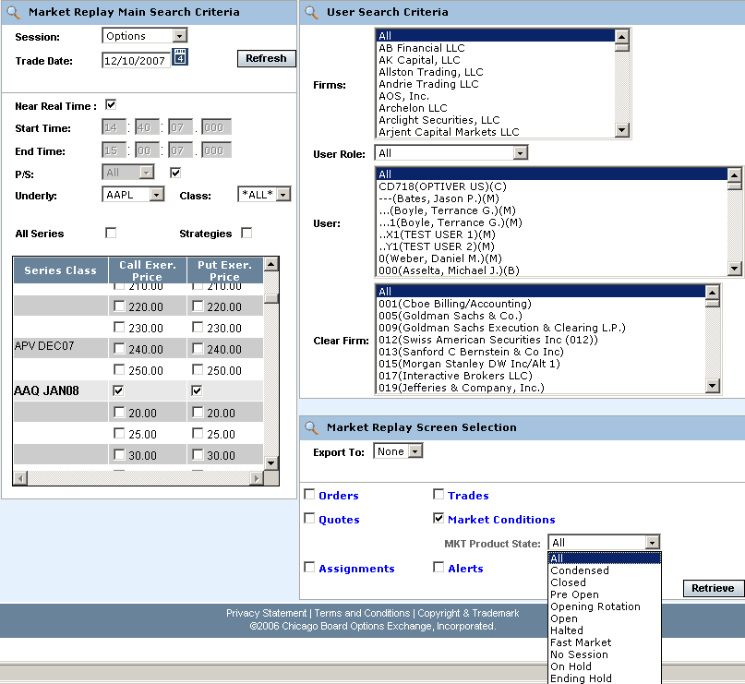
- To further filter your request, select to retrieve Orders, Quotes, Trades, Market Conditions, Assignments or Alerts. Select Market Conditions.
- Note: The search for Assignments is only available for Data Warehouse archive trade dates.
- You can further filter your market conditions request by Market (Mkt) Product State. Make your selections from the corresponding dropdown lists. The default for the filters is All.
- Note: Choosing Condensed will display a smaller subset of columns and automatically export the query results to Excel. Refer to the Exporting Data section, page 77.
- To save the query results to an Excel or PDF format, select either format from the Export To: drop down list. For export details, refer to the Exporting Data section, page 77.
- If you are satisfied with your selections and would like to view the data, click Retrieve. The Market Conditions window will display with the requested data.

 | 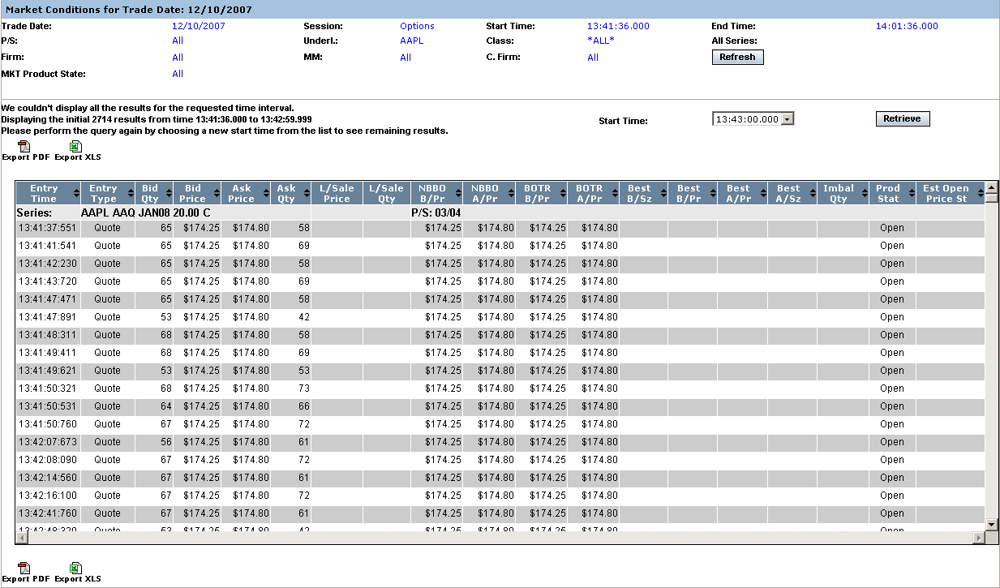
Details are provided for all the market events that occurred in the W_MAIN session from 13:41:36 to 14:01:36 for all the Put/Call series in the APPL class. Columns that are specific to Market Replay for market conditions are defined in the picture above.
Scroll down on your scroll bar to view all the events for each series.
Market Replay gives you the ability to sort on the contents of any column in the display by clicking on the column heading.
Trades | Market Replay allows you to retrieve trade information for the current business day. Select the Options trading session from the Session drop down list.  - The date of the request defaults to the current business day and is displayed in the Trade Date text box.  - To choose a previous trading day, click on the calendar button. The following calendar window will display.  - Note: The data warehouse maintains trade information for three years.  - Click on the trade day you wish to query. The date will display in the Trade Date text box.  - Choose the time of your request as near real time by selecting the Near Real Time radio button. If you would like to select a fixed time range, deselect the Near Real Time Monitoring radio button. Enter the Start Time and End Time by, hour:minutes:seconds:milliseconds (i.e. Start Time: 10:48:00:000, End Time: 13:55:00:000).
- Class/Series selection by post and station (P/S)
- To query all the class and series at every post/station, select the P/S checkbox. The P/S drop down list will gray out, defaulting to query ALL post/stations.
- If you wish to generate data for all the class and series activity for a specific Post and Station, select the Post/Station from the P/S drop down list box.
- Class/Series selection
- Select the underlying security from the Underly drop down list box or select a class from the Class drop down list box. Select ALL for both to retrieve all class and series information.
- Specify the series you are interested in viewing by clicking on the corresponding checkbox.
 Note: You must select a series, clearing firm or broker in order to retrieve the data.
 | 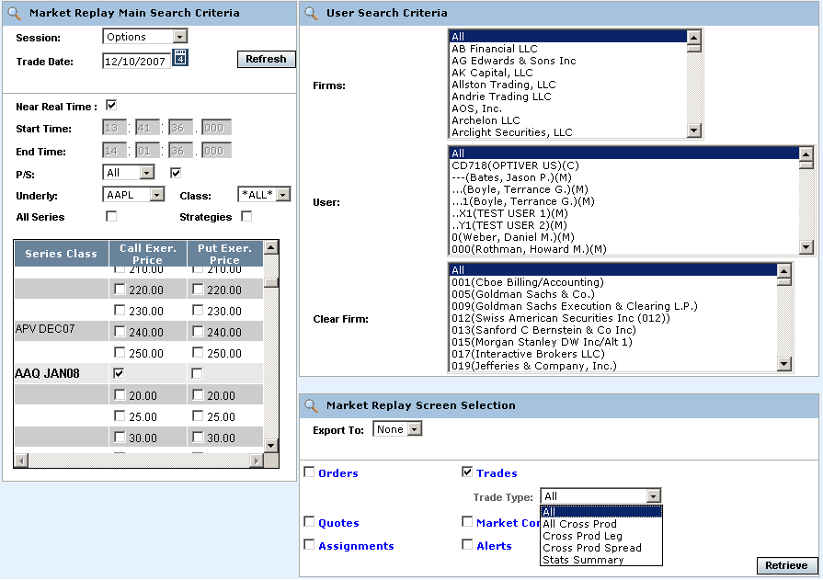
- To further filter your request, select to retrieve Orders, Quotes, Trades, Market Conditions, Assignments or Alerts. Select Trades.
- Note: The search for Assignments is only available for Data Warehouse archive trade dates.
- You can further filter your trade request by Trade Type. Make your selections from the corresponding dropdown lists. The default for the filters is All.
- To save the query results to an Excel or PDF format, select either format from the Export To: drop down list. For export details, refer to the Exporting Data section, page 77.
- If you are satisfied with your selections and would like to view the data, click Retrieve. The Trades window will display with the requested data.

 | 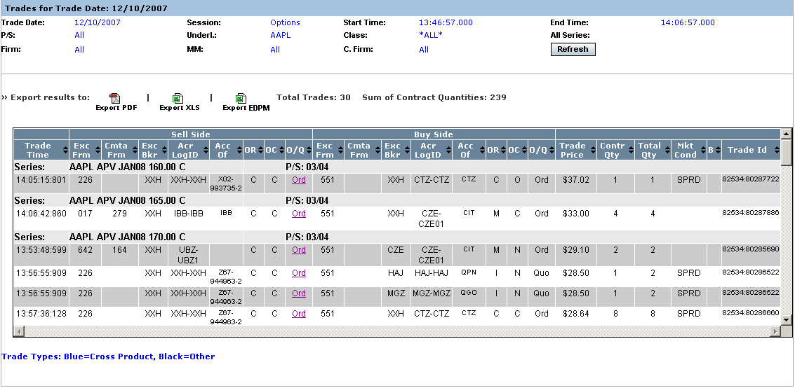
 | The example above displays all the trades that occurred in the W_MAIN session on December 10, 2007, for the AAPL class between 13:46:57-14:06:04. The total number of trades represents all the trades in the display.
 | Double click on the Ord or Quo link in the O/Q column to display order and quote details.
 | 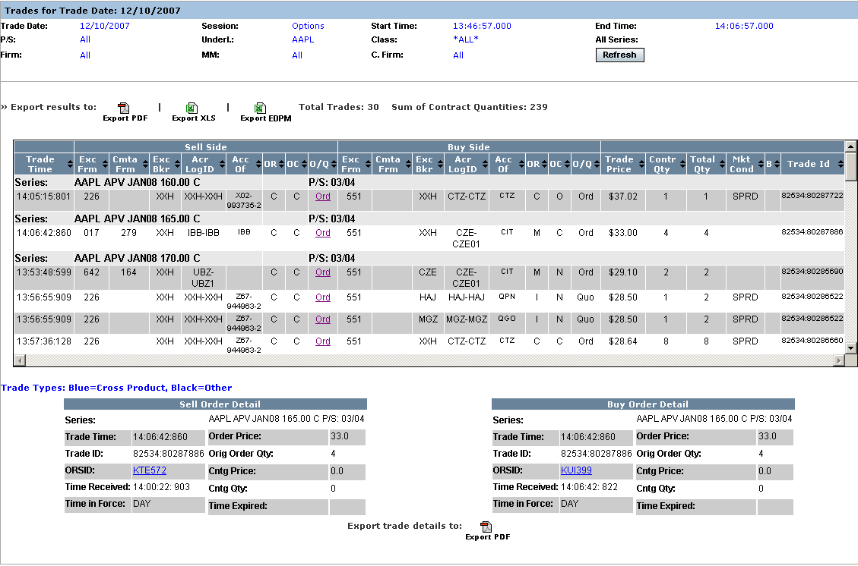
 | Click on the ORSID field to display order history details.
 | 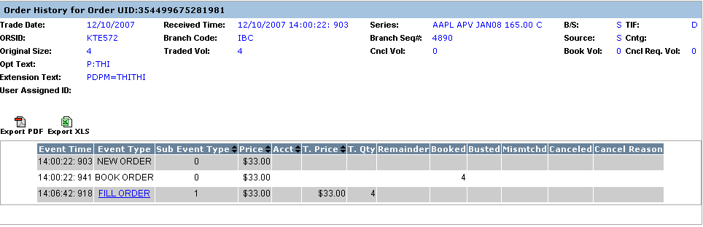
 | Click on the FILL ORDER link to display trade details.
 | 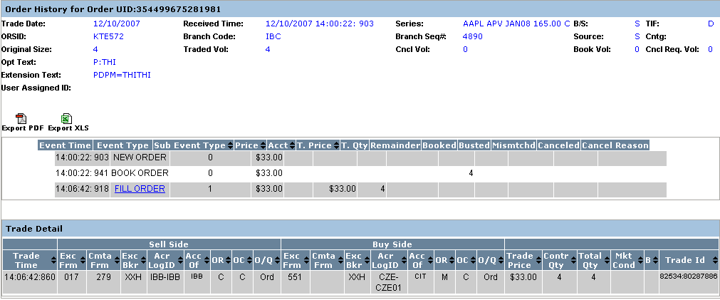
Market Replay gives you the ability to sort on the contents of any column in the display by clicking on the column heading.
Valid codes and column definitions that are represented in the Trades window are defined in the table below.
 | Column |  |  | Description
Valid Codes& Definitions | OR |  |  | P/A Linkage = 'A'  B/D = 'B'  CUSTOMER = 'C'  Customer-FBW = 'D'  Member, House Account = 'E'  FIRM = F'  User Proxy for trader, Customer Segregated = 'G'  User Proxy for trader, House Account = 'H'  In-Crowd MM = 'I'  Firm - FBW = 'J'  B/D-FBW='K'  Firm-FBW='L'
MARKET_MAKER = 'M'
Away MM='N'
Non Member, House Account='O'
Principle Linkage = 'P'
Member, SIPC Protected Account = 'Q'
User Proxy for trader, SIPC Protected Account = 'R'
Satisfaction Linkage = 'S'
Non Member, SIPC Protected Account='T'
M-FBW='U'
Member, Customer Segregated Account='V'
Broker/Dealer-FBW='W'
Customer Broker/Dealer='X'
Underly Specialist='Y'
N,Y-FBW='Z'
 | OC |  |  | O=Open, C=Close
 | Sell Side/Acc of |  |  | This column will be populated with a Q account if this side of the trade was originated by a DPM, otherwise, it will be populated with the Broker or Market Maker acronym. If the order originator is not a Market Maker or a broker, then the value in this field will not be validated by CBOEdirect.
 | Buy Side/ Acc of |  |  | This column represents the buyer’s account information. If this is a trade from a quote, the Q account or Market Maker acrynom is displayed. If this is a trade from an order, it is a free form field for the firm.
 | Mkt Cond |  |  | CANC=trade bust report  CNCO=trade bust report for opening trade  FTAO=used if the first trade for product occurs after the opening  OPNT=used if first trade for product occurs during opening  REOP=trade that occurs during an opening rotation that is not the first rotation of the day
 | S (Trade Source) |  |  | How the trade was entered. SYSTEM or MANUAL. The Help Desk has the ability to enter a manual trade (block trade)
 | B |  |  | The letter ‘B’ stands for Bust. An * displayed in this column represents a busted trade.
Alert Messages | The Alert Message display allows you to view types of trade throughs that have occurred in CBOEdirect.  To retrieve current data in the Alert Messages display, make your selections from the Selection Parameters window.
- Select the Options trading session from the Session drop down list.
- The date of the request defaults to the current business day and is displayed in the Trade Date text box.
- To choose a previous trading day, click on the calendar button. The following calendar window will display.
- Note: The data warehouse maintains trade information for three years.
- Click on the trade day you wish to query. The date will display in the Trade Date text box.
- Choose the time of your request as near real time by selecting the Near Real Time radio button. If you would like to select a fixed time range, deselect the Near Real Time Monitoring radio button. Enter the Start Time and End Time by, hour:minutes:seconds:milliseconds (i.e. Start Time: 10:48:00:000, End Time: 13:55:00:000).
- Class/Series selection by post and station (P/S)
- To query all the class and series at every post/station, select the P/S checkbox. The P/S drop down list will gray out, defaulting to query ALL post/stations.
- If you wish to generate data for all the class and series activity for a specific Post and Station, select the Post/Station from the P/S drop down list box.
- Class/Series selection
- Select the underlying security from the Underly drop down list box or select a class from the Class drop down list box. Select ALL for both to retrieve all class and series information.
- Specify the series you are interested in viewing by clicking on the corresponding checkbox.
 Note: You must select a series, clearing firm or broker in order to retrieve the data.
 | 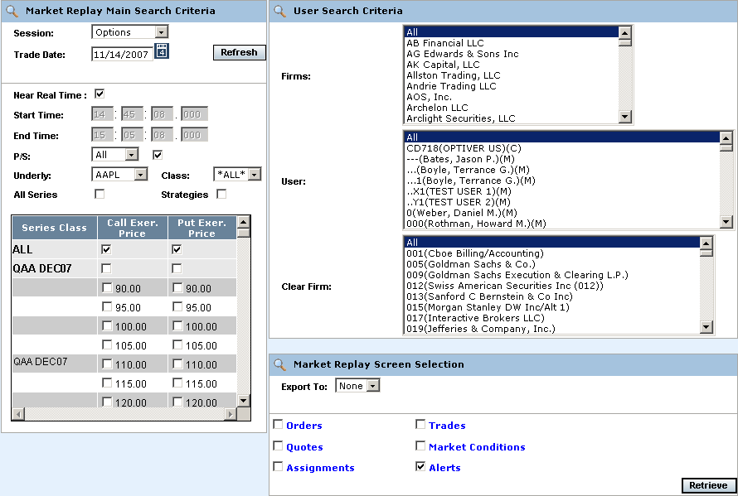
- To further filter your request, select to retrieve Orders, Quotes, Trades, Market Conditions, Assignments or Alerts. Select Alerts.
- Note: The search for Assignments is only available for Data Warehouse archive trade dates.
- To save the query results to an Excel or PDF format, select either format from the Export To: drop down list. For export details, refer to the Exporting Data section, page 77.
- If you are satisfied with your selections and would like to view the data, click Retrieve. The Alerts window will display with the requested data.
 | 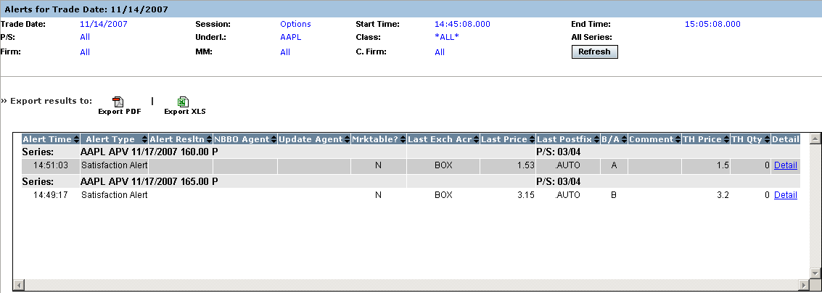
 | The Alert Messages window above displays all the alerts that occurred on November 14, 2007 from 14:45:08 to15:05:08 for all Hybrid classes. If there is any related trade / order activity in the alert, it is shown in the bottom half of the display.
 | Click on the Detail link in the Detail column to view additional information about the alerts.
 | 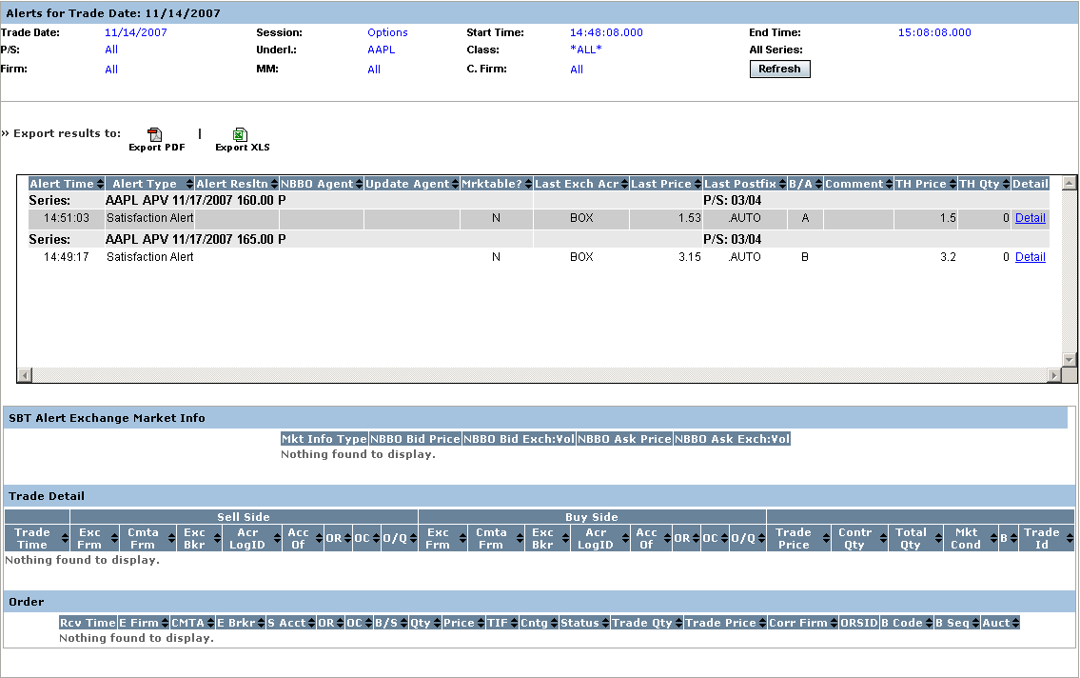
 | You can sort on the contents of any column in the display by clicking on the column heading.
Assignments | The Assignments display allows you to view user assignments for historical trade dates.  To retrieve user assignments data, make your selections from the Selection Parameters window.
- Select the Options trading session from the Session drop down list.
- The date of the request defaults to the current business day and is displayed in the Trade Date text box.
- To choose a previous trading day, click on the calendar button. The following calendar window will display.
- Note: The data warehouse maintains trade information for three years.
- Click on the archive trade day you wish to query. The date will display in the Trade Date text box.
- Choose the time of your request as near real time by selecting the Near Real Time radio button. If you would like to select a fixed time range, deselect the Near Real Time Monitoring radio button. Enter the Start Time and End Time by hour:minutes:seconds:milliseconds (i.e. Start Time: 10:48:00:000, End Time: 13:55:00:000).
 | 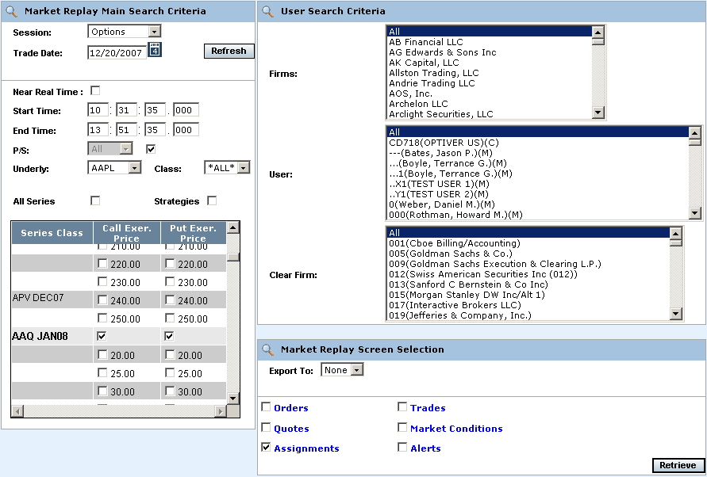
- To further filter your request, select to retrieve Orders, Quotes, Trades, Market Conditions, Assignments or Alerts. Select Assignments.
- To save the query results to an Excel or PDF format, select either format from the Export To: drop down list.
- If you are satisfied with your selections and would like to view the data, click Retrieve. The User Assignments window will display with the requested data.
 | 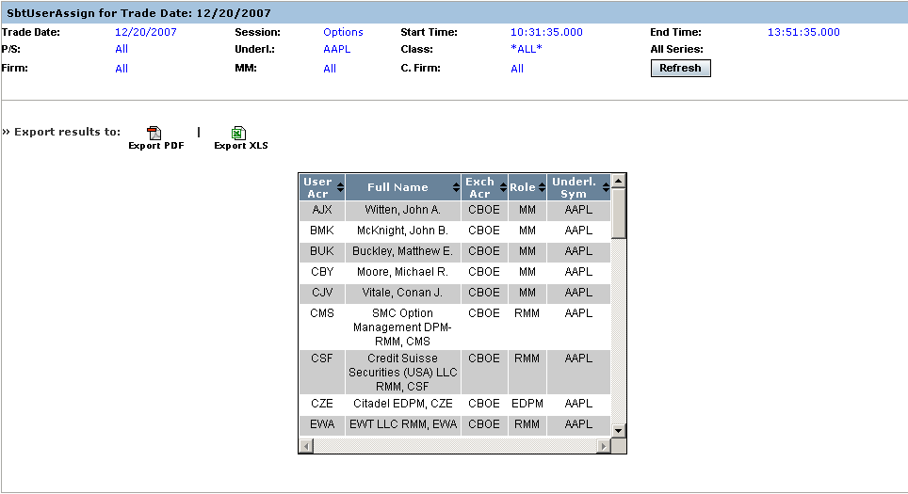
 | The Assignments window displays the user assignments for the AAPL class that occurred on the archive date of December 20, 2007 from 10:33:35 to 13:51:35.
 | You can sort on the contents of any column in the display by clicking on the column heading.
Composite Display | Market Replay allows you to query for more than one type of criteria (orders, trades, quotes, alerts, market conditions). In the example below, the query has been set to display both orders and trades for the AAPL class.
 | 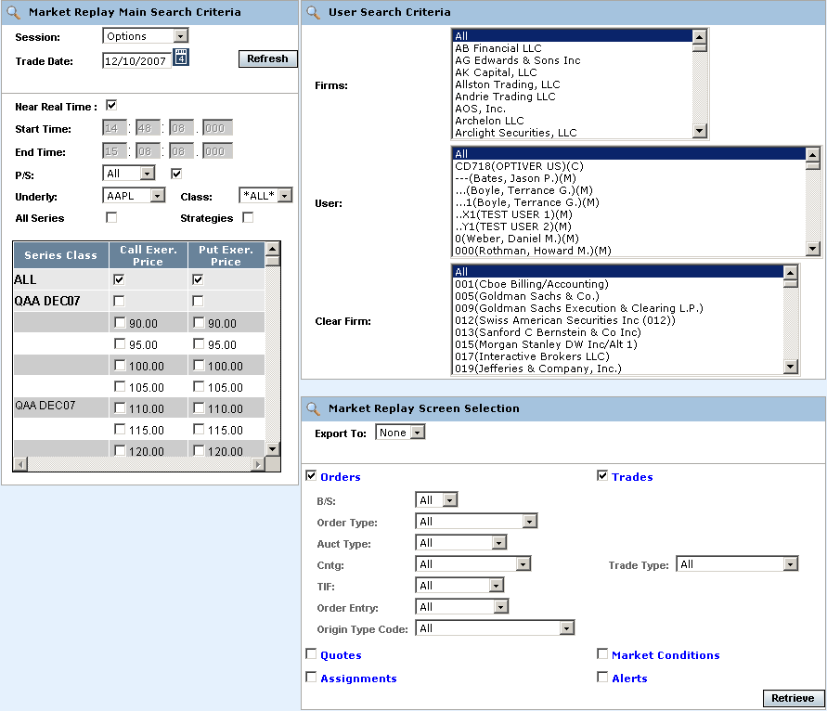
 | Two windows display for the query; Orders and Trades.
 | 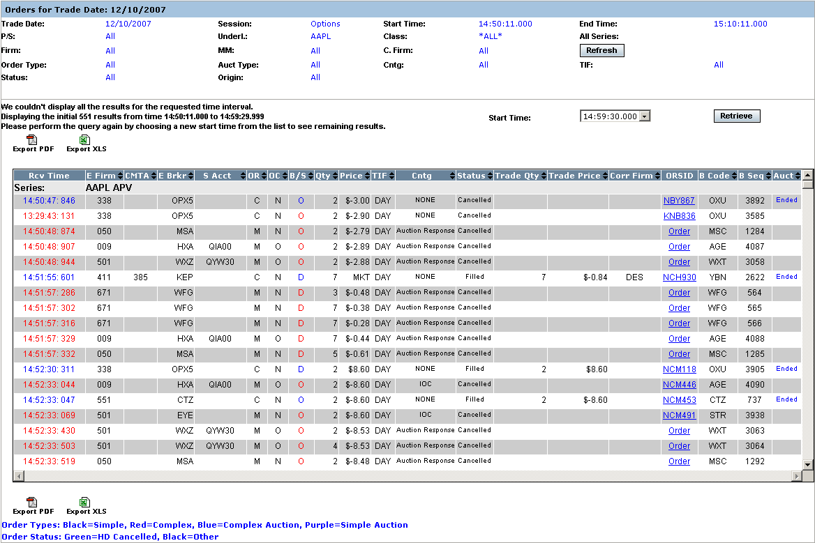
 | 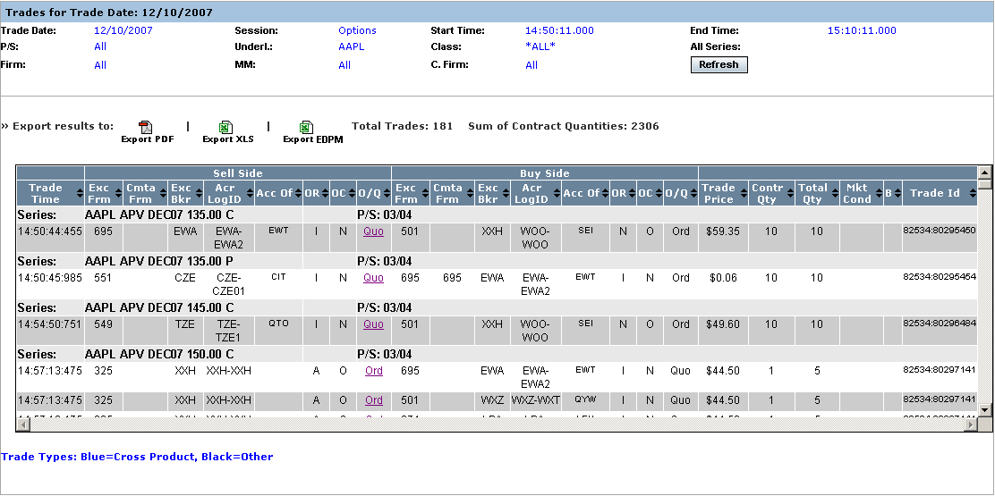

Display Futures Trade Information

Market Replay allows you to view current and historical Futures data for both the CFE and OneChicago sessions. The window defaults to the Options session and the current business day.
The window examples below present single data types (i.e. Trades) rather than combination displays (i.e. Trades & Orders).
 | 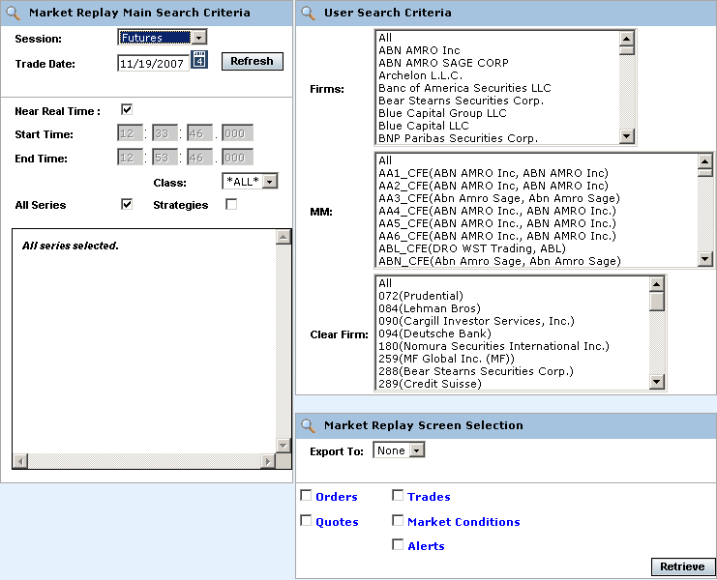
The Market Replay window is split into three panels: Market Replay Main Search Criteria, User Search Criteria and Market Replay Screen Selections. This window is used to set limitations for your data request.
The Market Replay Main Search Criteria section of the window allows you to select:
- The session and trade date
- Near real-time monitoring or a fixed time range
- Underlying and Class selections
The User Search Criteria section allows you to filter your Market Replay requests by Firm, Market Maker, or Clearing Firm. The window defaults to display all Firms, Market Makers and Clearing Firms for the Options session.
If you select only one Firm from the Firm list, only the Market Makers for that Firm will display in the MM list box.
 | 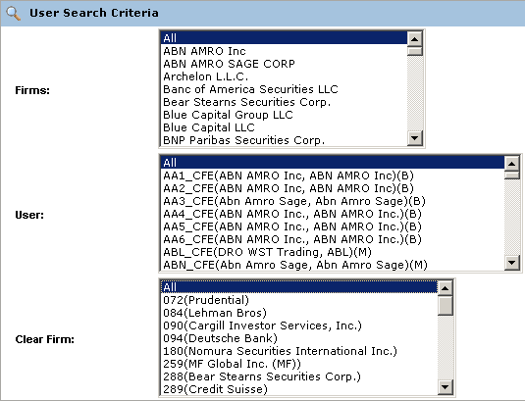
 | If you select only one Market Maker from the MM list, only the Clearing Firm for that Market Maker will display in the Clear Firm list box.
 | The Market Replay Screen Selection section allows you to filter your Market Replay requests by Orders, Trades, Quotes, Market Conditions and Alerts. You can also export the data to Excel or PDF formats.
 | 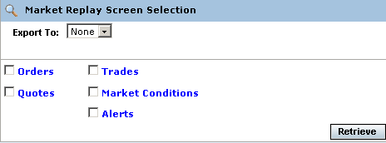
Orders | Market Replay allows you to retrieve current order information for CFE and OneChicago futures contracts. Make your selections from the Selection Parameters window:  - Select either the Futures or OneChicago trading session from the Session drop down list.  - The date of the request defaults to the current business day and is displayed in the Trade Date text box.  - To choose a previous trading day, click on the calendar button. The following calendar window will display.  - Note: The data warehouse maintains trade information for three years.  - Click on the trade day you wish to query. The date will display in the Trade Date text box.  - Choose the time of your request as near real time by selecting the Near Real Time radio button. If you would like to select a fixed time range, deselect the Near Real Time Monitoring radio button. Enter the Start Time and End Time by, hour:minutes:seconds:milliseconds (i.e. Start Time: 10:48:00:000, End Time: 13:55:00:000).  - If you wish to view only Strategy contracts, select the Strategy checkbox. If you wish to view all classes and series, deselect the checkbox.  - Specify the futures contract you are interested in viewing by clicking on the corresponding checkbox.   Note: You must select a futures contract, clearing firm or broker in order to retrieve the data.
 | 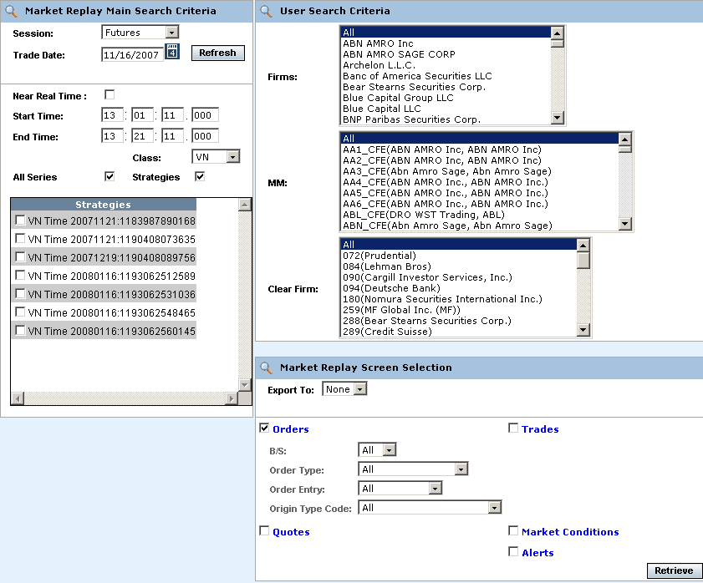
- To further filter your request, select to retrieve Orders, Quotes, Trades, Market Conditions, or Alerts. Select Orders.
- You can further filter your orders request by: Buy/Sell (B/S), Order Type, Order Entry or Origin Type Code. Make your selections from the corresponding dropdown lists. The default for the filters is All.
- To save the query results to an Excel or PDF format, select either format from the Export To: drop down list. For export details, refer to the Exporting Data section, page 77.
- If you are satisfied with your selections and would like to view the data, click Retrieve. The Orders window will display with the requested data.
 | 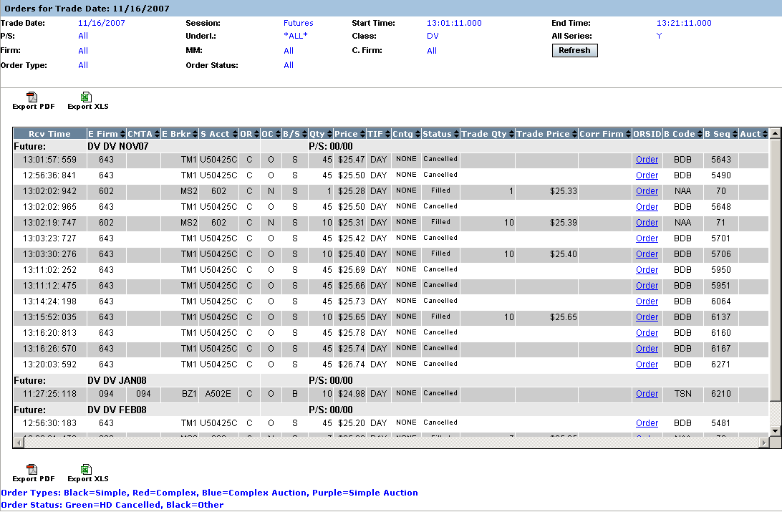
The example above displays all the order transactions that occurred in the CFE_MAIN session on November 16, 2007, for all the DV futures contracts.
Market Replay gives you the ability to sort on the contents of any column in the display by clicking on the column heading.
 | To view order details, click on the corresponding value in the ORSID column for the selected data row. The order history window will display.
 | 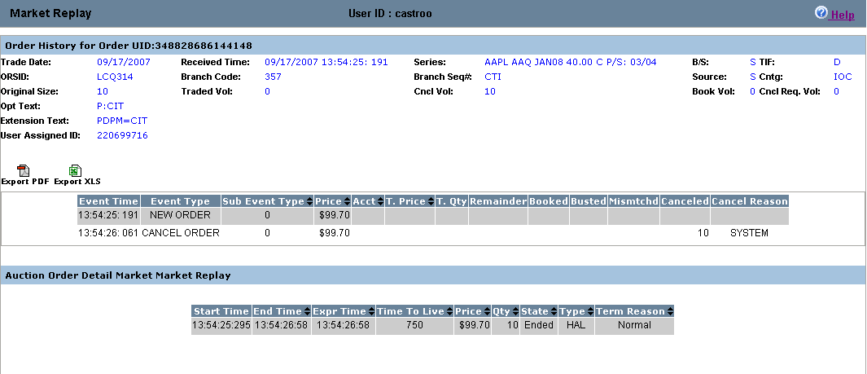
 | If the order is an Auction order, the Auction order details display in the lower portion of the window. Data fields are described below.
 | Column |  | Description
Valid Codes& Definitions | Start Time |  | When auction starts and RFQ is sent
 | End Time |  | When auction processing completes, including fill allocation (time when finished expiring the auction)
 | Expr Time |  | When auction processing completes, including fill allocation (time when CBOE starts processing the auction expiration.
 | Time to Live (sec) |  | Configured and calculated auction timeout period in milliseconds. It is the time period in milliseconds for which the auction will be live/active. Once the time to live expires, the auction order will get traded.
 | Auct Price |  | Auction starting price
 | Auct Qty |  | Auction quantity
 | Auct Type |  | Internalization, strategy, regular single, unspecified
 | Match ORS ID |  | Related (match) ORS ID to determine which order is the related (match) order to the auction order.
 | Terminate Reason |  | Auction terminate reason:  UNSPECIFIED = 0  ORDER_MARKETABLE_AGAINST_BOOK = 1  ORDER_MARKETABLE_AGAINST_AUCTION = 2  QUOTE_BID_LOCK = 3  QUOTE_ASK_LOCK = 4  QUOTE_BID_TRIGGER = 5  QUOTE_ASK_TRIGGER = 6  QUOTE_MARKETABLE_AGAINST_AUCTION = 7  Q_ORDER_LOCK = 8  Q_ORDER_TRIGGER = 9  Q_ORDER_MARKETABLE_AGAINST_AUCTION = 10  AUCTION_RESPONSE = 11  NEW_AUCTION = 12  AUCTIONED_ORDER_CANCEL = 13  PRODUCT_STATE_CHANGE = 14
 | State |  | State of the auction: Expired or Active
 | Window buttons and system codes that are specific to Market Replay are defined in the table below.
 | Column | Description
Valid Codes& Definitions | OR & CVG | CUSTOMER = C, CTI Equivalent - Non Member, Customer Segregated Account  FIRM = F CTI Equivalent - Firm Trader, House Account  BROKER_DEALER = B  CUSTOMER_BROKER_DEALER= X  MARKET_MAKER = M  MARKET_MAKER_AWAY = N  CTI1Origin1 = V - Member, Customer Segregated Account  CTI1Origin2 = E - Member, House Account  CTI1Origin5 = Q - Member, SIPC Protected Account  CTI3Origin1 = G - User Proxy for trader, Customer Segregated Account  CTI3Origin2 = H - User Proxy for trader, House Account  CTI3Origin5 = R - User Proxy for trader, SIPC Protected Account  CTI4Origin2 = O - Non Member, House Account  CTI4Origin5 = T - Non Member, SIPC Protected AccounT  PRINCIPAL = P  PRINCIPAL_ACTING_AS_AGENT = A  SATISFACTION = S
 | OC | O=Open, C=Close
 | TIF | D=Day, G=Good until cancelled, T=Good until expire time
Quotes | Market Replay gives you the ability to retrieve current quote information for CFE and OneChicago futures contracts. Make your selections from the Selection Parameters window:  - Select either the Futures or OneChicago trading session from the Session drop down list.  - The date of the request defaults to the current business day and is displayed in the Trade Date text box.  - To choose a previous trading day, click on the calendar button. The following calendar window will display.  - Note: The data warehouse maintains trade information for three years.  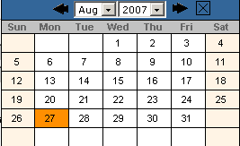  - Click on the trade day you wish to query. The date will display in the Trade Date text box.  - Choose the time of your request as near real time by selecting the Near Real Time radio button. If you would like to select a fixed time range, deselect the Near Real Time Monitoring radio button. Enter the Start Time and End Time by, hour:minutes:seconds:milliseconds (i.e. Start Time: 10:48:00:000, End Time: 13:55:00:000).  - If you wish to view only Strategy contracts, select the Strategy checkbox. If you wish to view all classes and series, deselect the checkbox.  - Specify the futures contract you are interested in viewing by clicking on the corresponding checkbox.   Note: You must select a futures contract, clearing firm or broker in order to retrieve the data.
 | 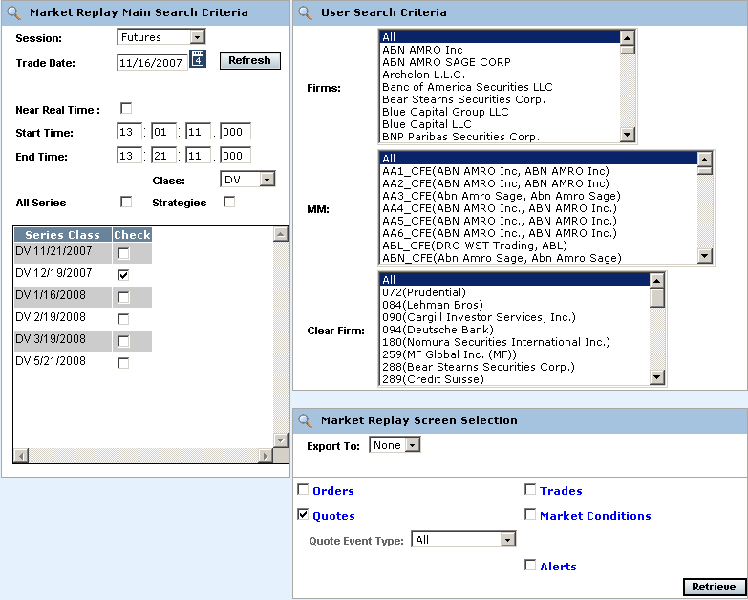
- To further filter your request, select to retrieve Orders, Quotes, Trades, Market Conditions, or Alerts. Select Quotes.
- You can further filter your quote requests by Quote Event Type. Make your selections from the corresponding dropdown lists. The default for the filters is All.
- To save the query results to an Excel or PDF format, select either format from the Export To: drop down list. For export details, refer to the Exporting Data section, page 77.
- If you are satisfied with your selections and would like to view the data, click Retrieve. The Quotes window will display with the requested data.
 | 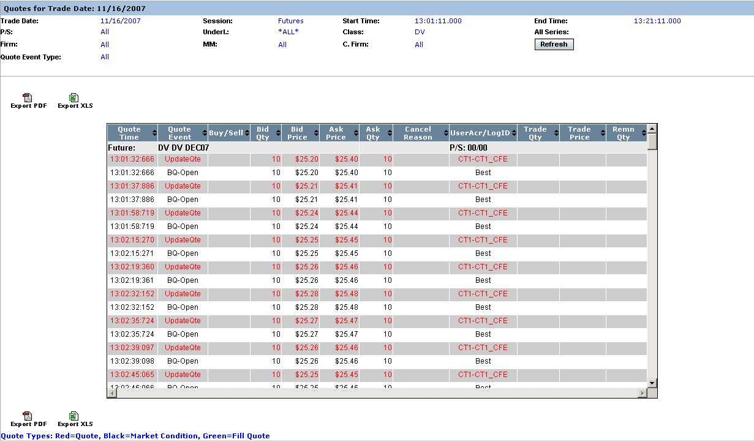
In the example above, quote information for DV futures contracts displays for the CFE_MAIN session.
Market Replay gives you the ability to sort on the contents of any column in the display by clicking on the column heading.
Market Conditions | Market Replay gives you the ability to retrieve current market condition information for CFE and OneChicago futures contracts. Make your selections from the Selection Parameters window:  - Select either the Futures or OneChicago trading session from the Session drop down list.  - The date of the request defaults to the current business day and is displayed in the Trade Date text box.  - To choose a previous trading day, click on the calendar button. The following calendar window will display.  - Note: The data warehouse maintains trade information for three years.  - Click on the trade day you wish to query. The date will display in the Trade Date text box.  - Choose the time of your request as near real time by selecting the Near Real Time radio button. If you would like to select a fixed time range, deselect the Near Real Time Monitoring radio button. Enter the Start Time and End Time by, hour:minutes:seconds:milliseconds (i.e. Start Time: 10:48:00:000, End Time: 13:55:00:000).  - If you wish to view only Strategy contracts, select the Strategy checkbox. If you wish to view all classes and series, deselect the checkbox.  - Specify the futures contract you are interested in viewing by clicking on the corresponding checkbox.   Note: You must select a futures contract, clearing firm or broker in order to retrieve the data.
 | 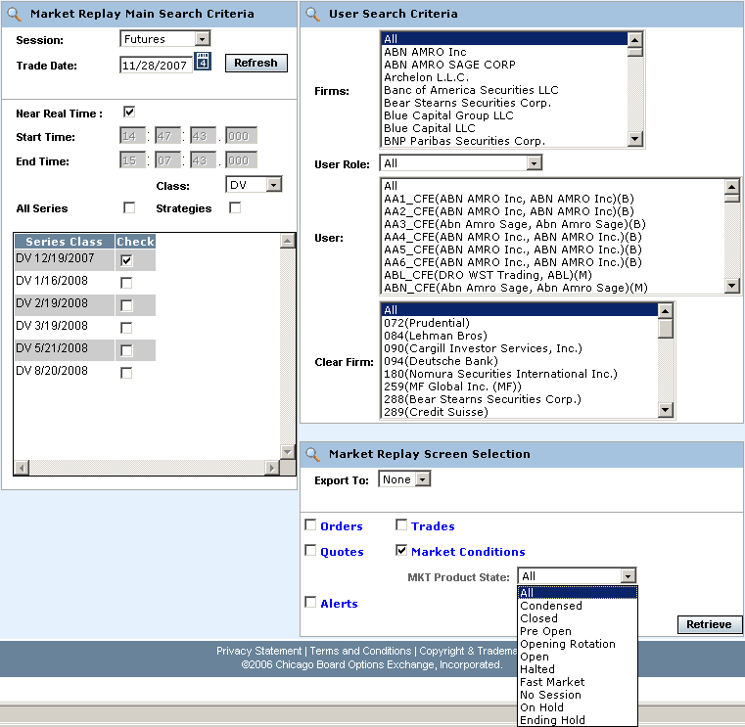
- To further filter your request, select to retrieve Orders, Quotes, Trades, Market Conditions, or Alerts. Select Market Conditions.
- You can further filter your request by Mkt Product State. Make your selections from the corresponding dropdown lists. The default for the filters is All.
- Note: Choosing Condensed will display a smaller subset of columns and automatically export the query results to Excel. Refer to the Exporting Data section, page 77.
- To save the query results to an Excel or PDF format, select either format from the Export To: drop down list. For export details, refer to the Exporting Data section, page 77.
- If you are satisfied with your selections and would like to view the data, click Retrieve. The Market Conditions window will display with the requested data.
 | 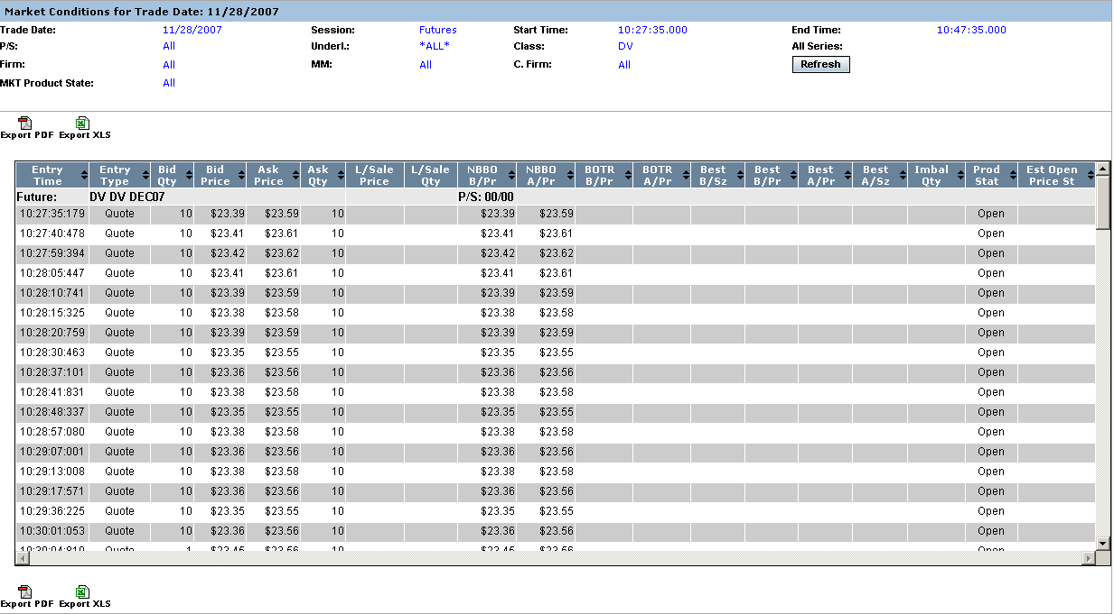
Details are provided for all the market events that occurred in the CFE session from 10:27:35 to 10:47:35 for all the DV DEC07 futures contracts. Columns that are specific to Market Replay for market conditions are defined in the picture above.
Scroll down on your scroll bar to view all the events for each series.
Market Replay gives you the ability to sort on the contents of any column in the display by clicking on the column heading.
Trades | Market Replay allows you to retrieve current trade information for futures contracts. Make your selections from the Selection Parameters window:  - Select either the Futures or OneChicago trading session from the Session drop down list.  - The date of the request defaults to the current business day and is displayed in the Trade Date text box.  - To choose a previous trading day, click on the calendar button. The following calendar window will display.  - Note: The data warehouse maintains trade information for three years.  - Click on the trade day you wish to query. The date will display in the Trade Date text box.  - Choose the time of your request as near real time by selecting the Near Real Time radio button. If you would like to select a fixed time range, deselect the Near Real Time Monitoring radio button. Enter the Start Time and End Time by, hour:minutes:seconds:milliseconds (i.e. Start Time: 10:48:00:000, End Time: 13:55:00:000).  - If you wish to view only Strategy contracts, select the Strategy checkbox. If you wish to view all classes and series, deselect the checkbox.  - Specify the futures contract you are interested in viewing by clicking on the corresponding checkbox.   Note: You must select a futures contract, clearing firm or broker in order to retrieve the data.
 | 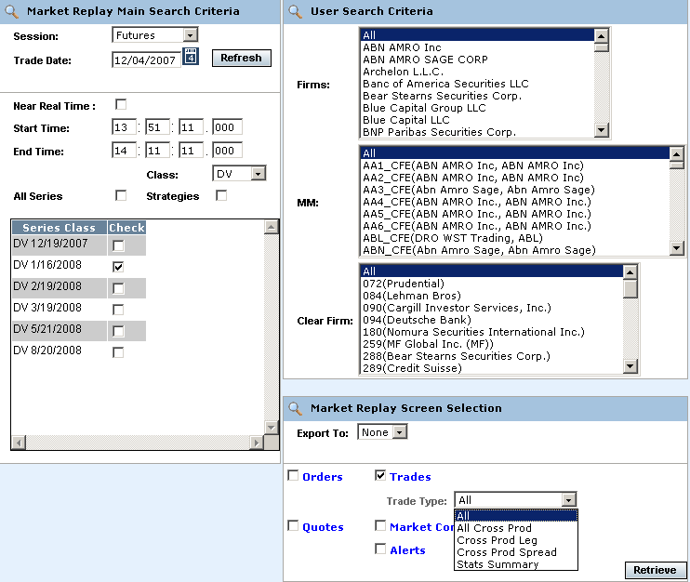
- To further filter your request, select to retrieve Orders, Quotes, Trades, Market Conditions, or Alerts. Select Trades.
- You can further filter your trades request by Trade Type. Make your selections from the corresponding dropdown lists. The default for the filters is All.
- To save the query results to an Excel or PDF format, select either format from the Export To: drop down list. For export details, refer to the Exporting Data section, page 77.
- If you are satisfied with your selections and would like to view the data, click Retrieve. The Trades window will display with the requested data.
 | 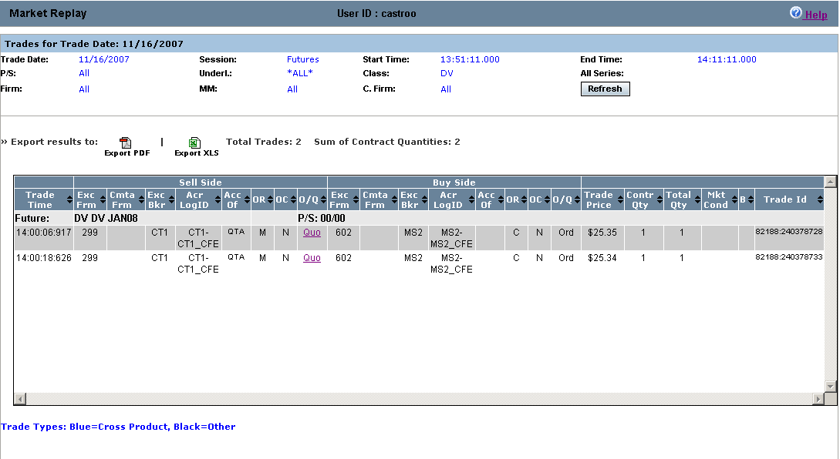
The example above displays all the trades that occurred in the CFE_MAIN session on November 16, 2007, for the DV futures contracts. The total number of trades represents all the trades in the display.
Trade details are provided as well as system specific information. Valid codes and column definitions that are represented in the Trades window are defined in the table below.
Market Replay gives you the ability to sort on the contents of any column in the display by clicking on the column heading.
 | Column |  |  | Description
Valid Codes& Definitions | OR |  |  | P/A Linkage = 'A'  B/D = 'B'  CUSTOMER = 'C'  Customer-FBW = 'D'  Member, House Account = 'E'  FIRM = F'  User Proxy for trader, Customer Segregated = 'G'  User Proxy for trader, House Account = 'H'  In-Crowd MM = 'I'  Firm - FBW = 'J'  B/D-FBW='K'  Firm-FBW='L'  MARKET_MAKER = 'M'  Away MM='N'  Non Member, House Account='O'  Principle Linkage = 'P'  Member, SIPC Protected Account = 'Q'  User Proxy for trader, SIPC Protected Account = 'R'  Satisfaction Linkage = 'S'  Non Member, SIPC Protected Account='T'  M-FBW='U'  Member, Customer Segregated Account='V'  Broker/Dealer-FBW='W'  Customer Broker/Dealer='X'  Underly Specialist='Y'  N,Y-FBW='Z'
 | OC |  |  | O=Open, C=Close
 | Sell Acc of |  |  | This column will be populated with a Q account if this side of the trade was originated by a DPM, otherwise, it will be populated with the Broker or Market Maker acronym. If the order originator is not a Market Maker or a broker, then the value in this field will not be validated by CBOEdirect.
 | Buy Acc of |  |  | This column represents the buyer’s account information. If this is a trade from a quote, the Q account or Market Maker acrynom is displayed. If this is a trade from an order, it is a free form field for the firm.
 | Mkt Cond |  |  | CANC=trade bust report  CNCO=trade bust report for opening trade  FTAO=used if the first trade for product occurs after the opening  OPNT=used if first trade for product occurs during opening  REOP=trade that occurs during an opening rotation that is not the first rotation of the day
 | Trade Source |  |  | SYSTEM or MANUAL. The Help Desk has the ability to enter a manual trade (block trade)
 | B |  |  | The letter ‘B’ stands for Bust. An * displayed in this column represents a busted trade.
Alerts | The Alert Message display allows you to view types of trade throughs that have occurred in CBOEdirect.  To retrieve current data in the Alert Messages display, make your selections from the Selection Parameters window.
- Select either the Futures or OneChicago trading session from the Session drop down list.
- The date of the request defaults to the current business day and is displayed in the Trade Date text box.
- To choose a previous trading day, click on the calendar button. The following calendar window will display.
- Note: The data warehouse maintains trade information for three years.
- Click on the trade day you wish to query. The date will display in the Trade Date text box.
- Choose the time of your request as near real time by selecting the Near Real Time radio button. If you would like to select a fixed time range, deselect the Near Real Time Monitoring radio button. Enter the Start Time and End Time by, hour:minutes:seconds:milliseconds (i.e. Start Time: 10:48:00:000, End Time: 13:55:00:000).
- If you wish to view only Strategy contracts, select the Strategy checkbox. If you wish to view all classes and series, deselect the checkbox.
- Specify the futures contract you are interested in viewing by clicking on the corresponding checkbox.
 Note: You must select a futures contract, clearing firm or broker in order to retrieve the data.
 | 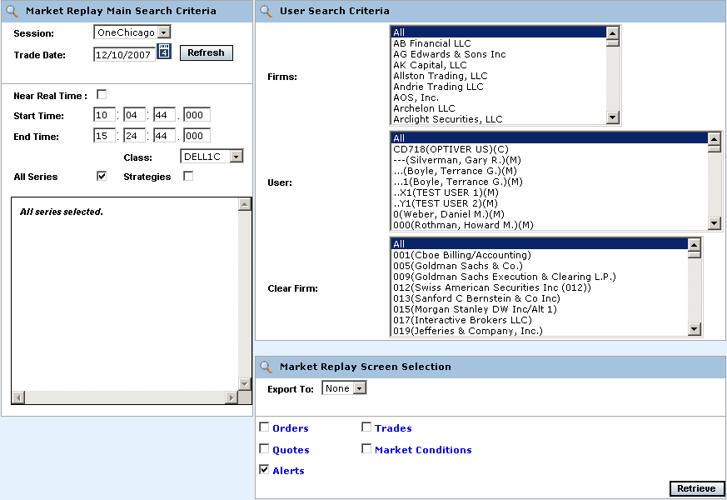
- To further filter your request, select to retrieve Orders, Quotes, Trades, Market Conditions, or Alerts. Select Alerts.
- To save the query results to an Excel or PDF format, select either format from the Export To: drop down list. For export details, refer to the Exporting Data section, page 77.
- If you are satisfied with your selections and would like to view the data, click Retrieve. The Alerts window will display with the requested data.
 | 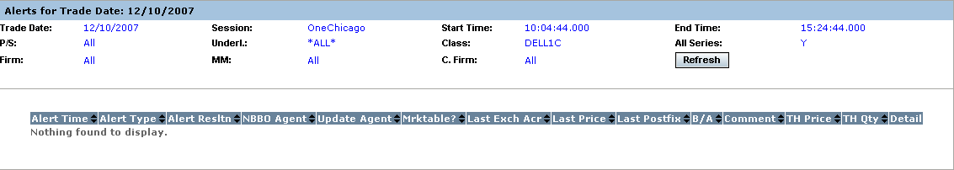
 | The Alerts window shows that no alerts occurred for the DELL1C futures contract on 12/10/07.
Composite | Market Replay allows you to query for more than one type of criteria (orders, trades, quotes, alerts, market conditions). In the example below, the query has been set to display both quotes and market conditions for DV futures contract.
 | 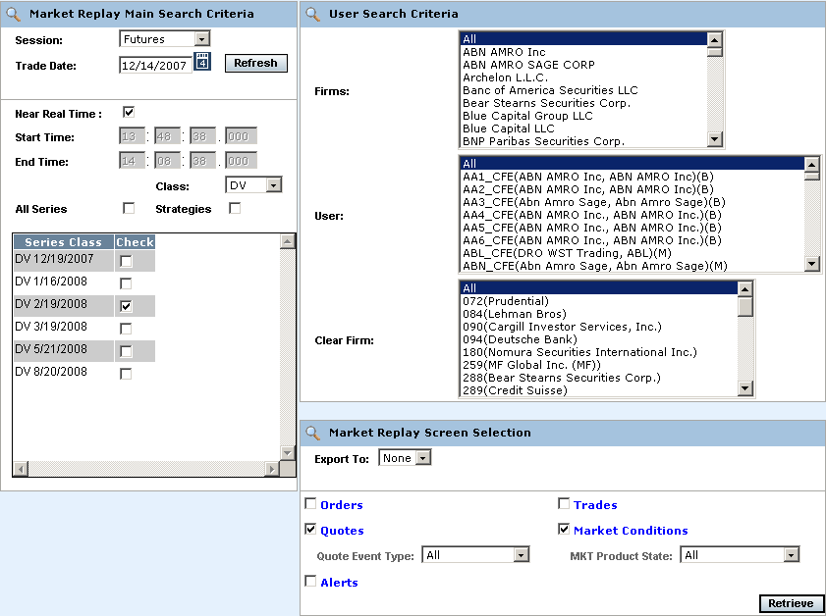
 | Two windows display for the query; Market Conditions and Quotes.
 | 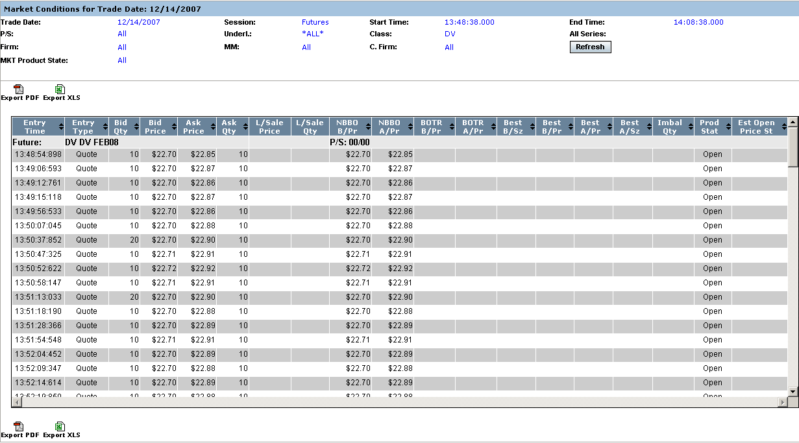
 | 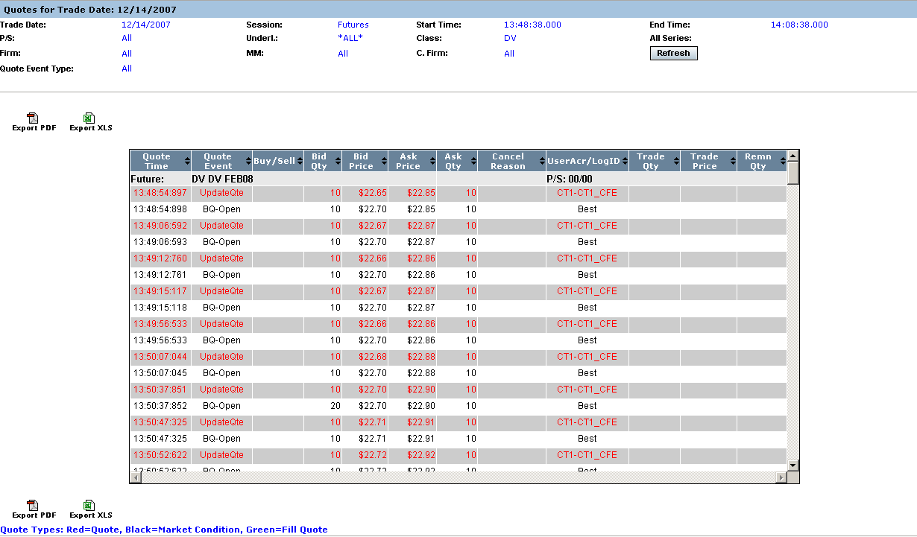

Display Stock Trade Information

Market Replay allows you to view current and historical Stock (underlying) trading information. The window defaults to the Options session and the current business day.
The window examples below present single data types (i.e. Trades) rather than combination displays (i.e. Trades & Orders).
 | 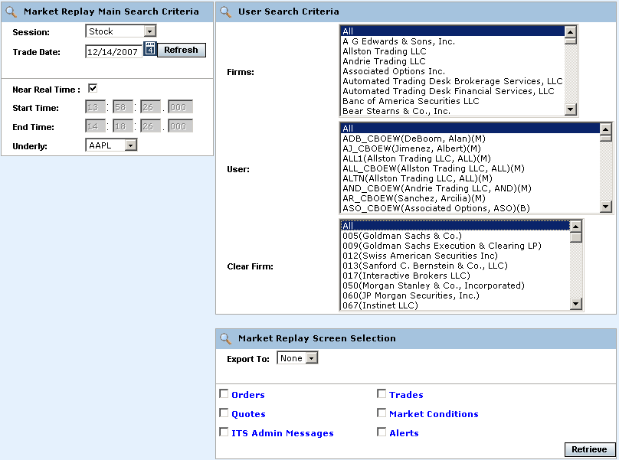
The Market Replay window is split into three panels: Market Replay Main Search Criteria, User Search Criteria and Market Replay Screen Selections. This window is used to set limitations for your data request.
The Market Replay Main Search Criteria section of the window allows you to select:
- The session and trade date
- Near real-time monitoring or a fixed time range
- Underlying selections
The User Search Criteria section allows you to filter your Market Replay requests by Firm, Market Maker, or Clearing Firm. The window defaults to display all Firms, Market Makers and Clearing Firms for the Options session.
If you select only one Firm from the Firm list, only the Market Makers for that Firm will display in the MM list box.
 | 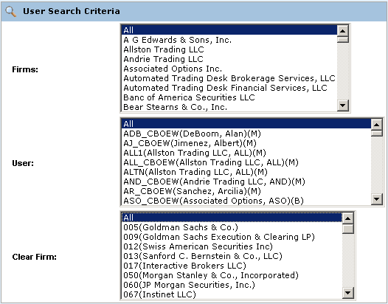
 | If you select only one Market Maker from the MM list, only the Clearing Firm for that Market Maker will display in the Clear Firm list box.
 | The Market Replay Screen Selection section allows you to filter your Market Replay requests by Orders, Trades, Quotes, Market Conditions, ITS Admin Messages and Alerts. You can also export the data to Excel or PDF formats.
 | 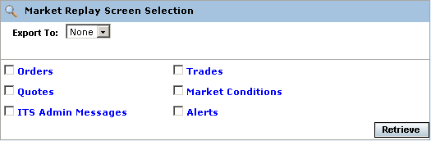
Orders | Market Replay allows you to retrieve current order information for the Stock (underlying) trading session. Make your selections from the Selection Parameters window:  - Select the Stock trading session from the Session drop down list.  - The date of the request defaults to the current business day and is displayed in the Trade Date text box.  - To choose a previous trading day, click on the calendar button. The following calendar window will display.  - Note: The data warehouse maintains trade information for three years.  - Click on the trade day you wish to query. The date will display in the Trade Date text box.  - Choose the time of your request as near real time by selecting the Near Real Time radio button. If you would like to select a fixed time range, deselect the Near Real Time Monitoring radio button. Enter the Start Time and End Time by, hour:minutes:seconds:milliseconds (i.e. Start Time: 10:48:00:000, End Time: 13:55:00:000).  - Select the Stock (underlying) product.   Note: You must select a Stock product, clearing firm or broker in order to retrieve the data.
 | 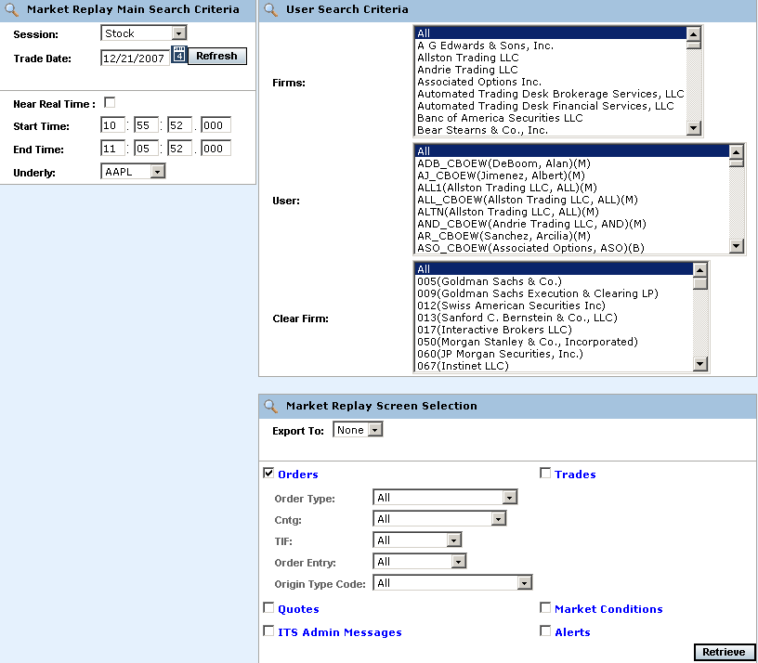
- To further filter your request, select to retrieve Orders, Quotes, Trades, Market Conditions, ITS Admin Messages or Alerts. Select Orders.
- You can further filter your orders request by: Order Type, Contingency (Cntg), Time in Force (TIF), Order Entry or Origin Type Code. Make your selections from the corresponding dropdown lists. The default for the filters is All.
- To save the query results to an Excel or PDF format, select either format from the Export To: drop down list. For export details, refer to the Exporting Data section, page 77.
- If you are satisfied with your selections and would like to view the data, click Retrieve. The Orders window will display with the requested data.
 | 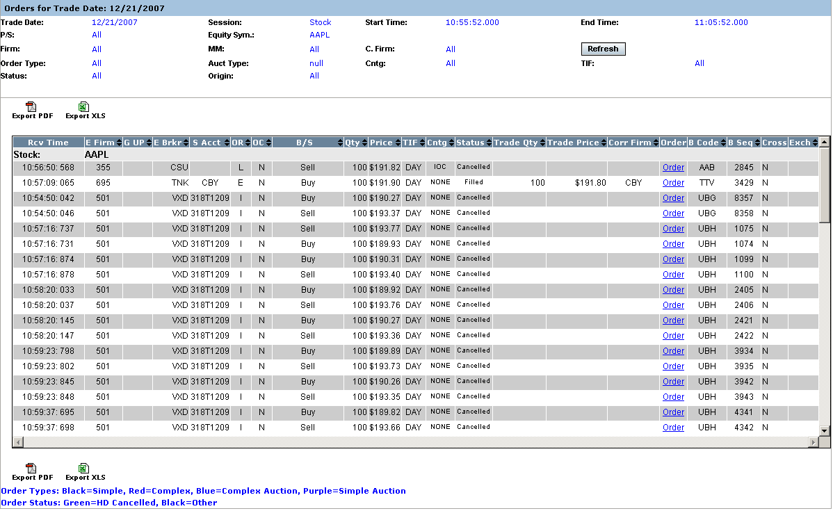
The example above displays all the order activity that occurred in the W_MAIN session on December 21, 2007 from 10:55:52 to 11:05:52 for the AAPL class. Market Replay gives you the ability to sort on the contents of any column in the display by clicking on the column heading.
Click Refresh at anytime to update the query.
 | To view order details, click on the corresponding value in the Order column for the selected data row. The order history window will display.
 | 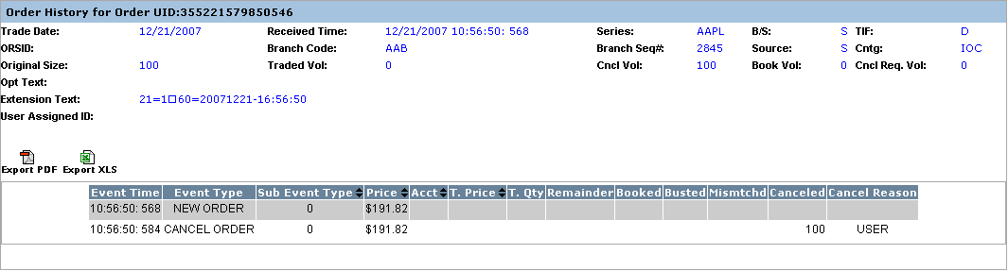
Quotes | Market Replay allows you to retrieve current quote information for the Stock (underlying) trading session. Make your selections from the Selection Parameters window:  - Select the Stock trading session from the Session drop down list.  - The date of the request defaults to the current business day and is displayed in the Trade Date text box.  - To choose a previous trading day, click on the calendar button. The following calendar window will display.  - Note: The data warehouse maintains trade information for three years.  - Click on the trade day you wish to query. The date will display in the Trade Date text box.  - Choose the time of your request as near real time by selecting the Near Real Time radio button. If you would like to select a fixed time range, deselect the Near Real Time Monitoring radio button. Enter the Start Time and End Time by, hour:minutes:seconds:milliseconds (i.e. Start Time: 10:48:00:000, End Time: 13:55:00:000).  - Select the Stock (underlying) product.   Note: You must select a Stock product, clearing firm or broker in order to retrieve the data.
 | 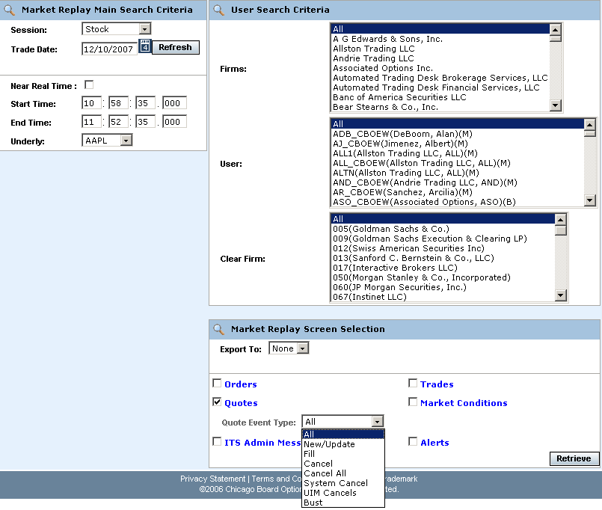
- To further filter your request, select to retrieve Orders, Quotes, Trades, Market Conditions, ITS Admin Messages or Alerts. Select Quotes.
- You can further filter your quote requests by Quote Event Type. Make your selections from the corresponding dropdown lists. The default for the filters is All.
- To save the query results to an Excel or PDF format, select either format from the Export To: drop down list. For export details, refer to the Exporting Data section, page 77.
- If you are satisfied with your selections and would like to view the data, click Retrieve. The Quotes window will display with the requested data.
 | 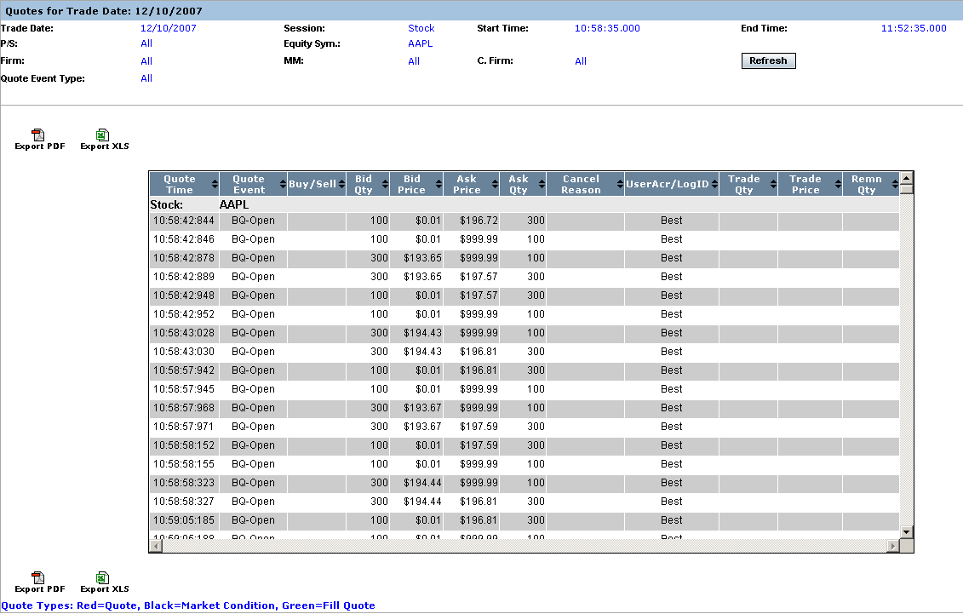
In the example above, quote information for APPL displays for the Stock session.
Market Replay gives you the ability to sort on the contents of any column in the display by clicking on the column heading.
Trades | Market Replay allows you to retrieve current trade information for the Stock (underlying) trading session. Make your selections from the Selection Parameters window:  - Select the Stock trading session from the Session drop down list.  - The date of the request defaults to the current business day and is displayed in the Trade Date text box.  - To choose a previous trading day, click on the calendar button. The following calendar window will display.  - Note: The data warehouse maintains trade information for three years.  - Click on the trade day you wish to query. The date will display in the Trade Date text box.  - Choose the time of your request as near real time by selecting the Near Real Time radio button. If you would like to select a fixed time range, deselect the Near Real Time Monitoring radio button. Enter the Start Time and End Time by, hour:minutes:seconds:milliseconds (i.e. Start Time: 10:48:00:000, End Time: 13:55:00:000).  - Select the Stock (underlying) product.   Note: You must select a Stock product, clearing firm or broker in order to retrieve the data.
 | 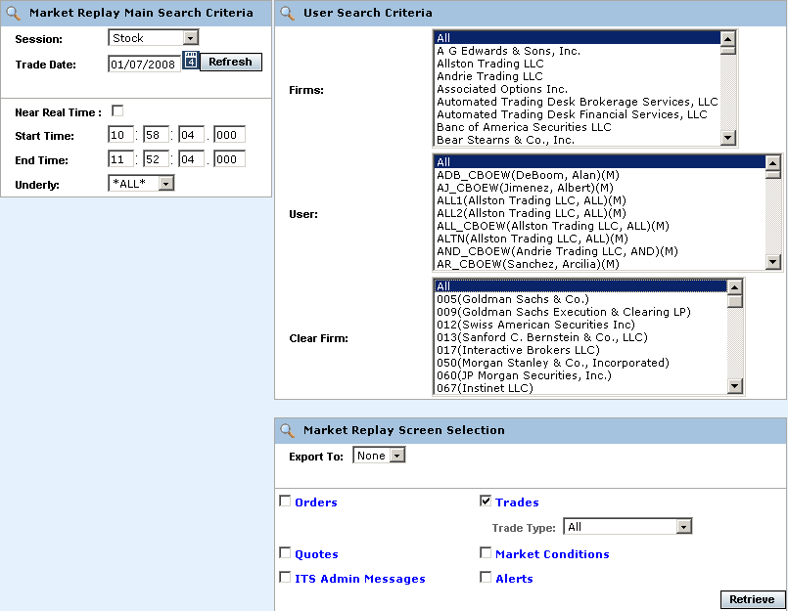
- To further filter your request, select to retrieve Orders, Quotes, Trades, Market Conditions, ITS Admin Messages or Alerts. Select Trades.
- You can further filter your quote requests by Trade Type. Make your selections from the corresponding dropdown lists. The default for the filters is All.
- To save the query results to an Excel or PDF format, select either format from the Export To: drop down list. For export details, refer to the Exporting Data section, page 77.
- If you are satisfied with your selections and would like to view the data, click Retrieve. The Trades window will display with the requested data.
 | 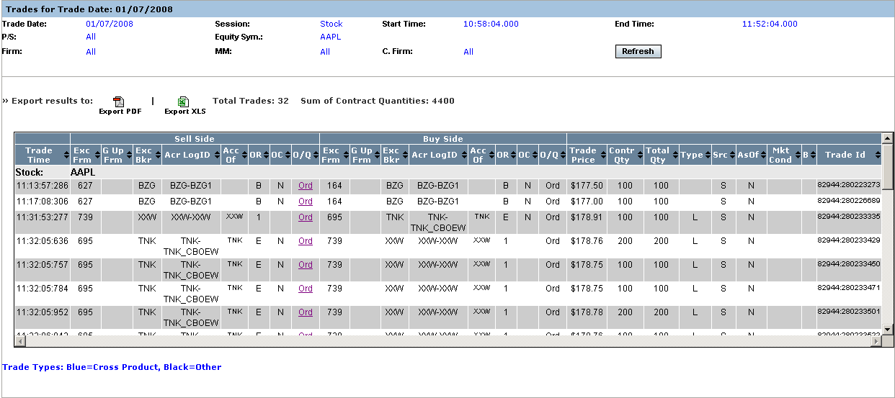
The example above displays all the trades that occurred in the Stock session on January 7, 2008, for the APPL class. The total number of trades represents all the trades in the display.
Trade details are provided as well as system specific information. Valid codes and column definitions that are represented in the Trades window are defined in the table below.
Market Replay gives you the ability to sort on the contents of any column in the display by clicking on the column heading.
 | Column | Description
Valid Codes& Definitions | OR | P/A Linkage = 'A'  B/D = 'B'  CUSTOMER = 'C'  Customer-FBW = 'D'  Member, House Account = 'E'  FIRM = F'  User Proxy for trader, Customer Segregated = 'G'  User Proxy for trader, House Account = 'H'  In-Crowd MM = 'I'  Firm - FBW = 'J'  B/D-FBW='K'  Firm-FBW='L'  MARKET_MAKER = 'M'  Away MM='N'  Non Member, House Account='O'  Principle Linkage = 'P'  Member, SIPC Protected Account = 'Q'  User Proxy for trader, SIPC Protected Account = 'R'  Satisfaction Linkage = 'S'  Non Member, SIPC Protected Account='T'  M-FBW='U'  Member, Customer Segregated Account='V'  Broker/Dealer-FBW='W'  Customer Broker/Dealer='X'  Underly Specialist='Y'  N,Y-FBW='Z'
 | OC | O=Open, C=Close
 | Sell Acc of | This column will be populated with a Q account if this side of the trade was originated by a DPM, otherwise, it will be populated with the Broker or Market Maker acronym. If the order originator is not a Market Maker or a broker, then the value in this field will not be validated by CBOEdirect.
 | Buy Acc of | This column represents the buyer’s account information. If this is a trade from a quote, the Q account or Market Maker acrynom is displayed. If this is a trade from an order, it is a free form field for the firm.
 | Mkt Cond | CANC=trade bust report  CNCO=trade bust report for opening trade  FTAO=used if the first trade for product occurs after the opening  OPNT=used if first trade for product occurs during opening  REOP=trade that occurs during an opening rotation that is not the first rotation of the day
 | Src (Trade Source) | SYSTEM or MANUAL. The Help Desk has the ability to enter a manual trade (block trade)
 | B | The letter ‘B’ stands for Bust. An * displayed in this column represents a busted trade.
Market Conditions | Market Replay allows you to retrieve current market condition information for the Stock (underlying) trading session. Make your selections from the Selection Parameters window:  - Select the Stock trading session from the Session drop down list.  - The date of the request defaults to the current business day and is displayed in the Trade Date text box.  - To choose a previous trading day, click on the calendar button. The following calendar window will display.  - Note: The data warehouse maintains trade information for three years.  - Click on the trade day you wish to query. The date will display in the Trade Date text box.  - Choose the time of your request as near real time by selecting the Near Real Time radio button. If you would like to select a fixed time range, deselect the Near Real Time Monitoring radio button. Enter the Start Time and End Time by, hour:minutes:seconds:milliseconds (i.e. Start Time: 10:48:00:000, End Time: 13:55:00:000).  - Select the Stock (underlying) product.   Note: You must select a Stock product, clearing firm or broker in order to retrieve the data.
 | 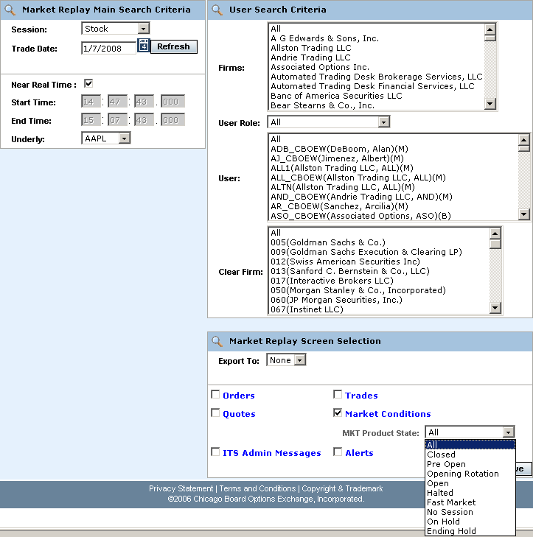
- To further filter your request, select to retrieve Orders, Quotes, Trades, Market Conditions, ITS Admin Messages or Alerts. Select Market Conditions.
- You can further filter your request by Mkt Product State. Make your selections from the corresponding dropdown lists. The default for the filters is All.
- To save the query results to an Excel or PDF format, select either format from the Export To: drop down list. For export details, refer to the Exporting Data section, page 77.
- If you are satisfied with your selections and would like to view the data, click Retrieve. The Market Conditions window will display with the requested data.
 | 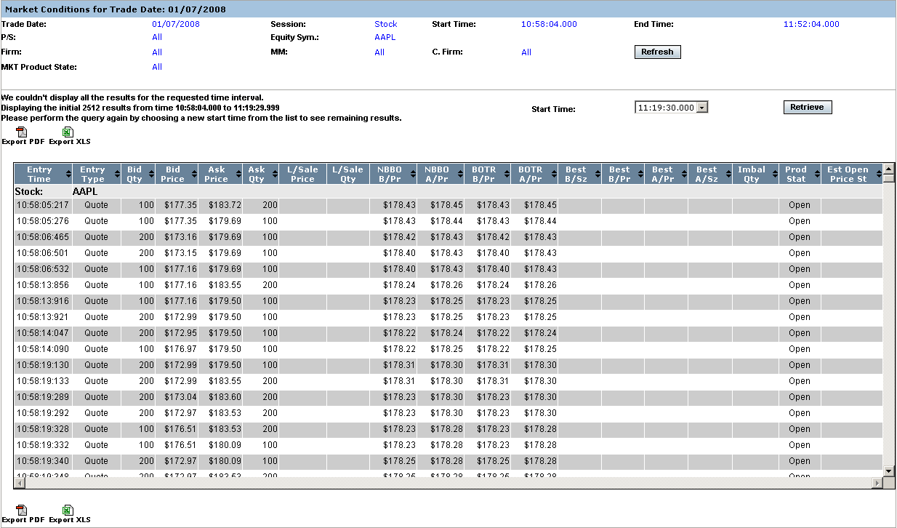
Details are provided for all the market events that occurred in the Stock session from 10:58:04 to 11:52:04 for the AAPL class. Columns that are specific to Market Replay for market conditions are defined in the picture above.
Scroll down on your scroll bar to view all the events for each series.
Market Replay gives you the ability to sort on the contents of any column in the display by clicking on the column heading.
Alerts | The Alert Message display allows you to view types of trade throughs that have occurred in CBOEdirect.  To retrieve current data in the Alert Messages display, make your selections from the Selection Parameters window.
- Select the Stock trading session from the Session drop down list.
- The date of the request defaults to the current business day and is displayed in the Trade Date text box.
- To choose a previous trading day, click on the calendar button. The following calendar window will display.
- Note: The data warehouse maintains trade information for three years.

- Click on the trade day you wish to query. The date will display in the Trade Date text box.
- Choose the time of your request as near real time by selecting the Near Real Time radio button. If you would like to select a fixed time range, deselect the Near Real Time Monitoring radio button. Enter the Start Time and End Time by, hour:minutes:seconds:milliseconds (i.e. Start Time: 10:48:00:000, End Time: 13:55:00:000).
- Select the Stock (underlying) product.
 Note: You must select a Stock product, clearing firm or broker in order to retrieve the data.
 | 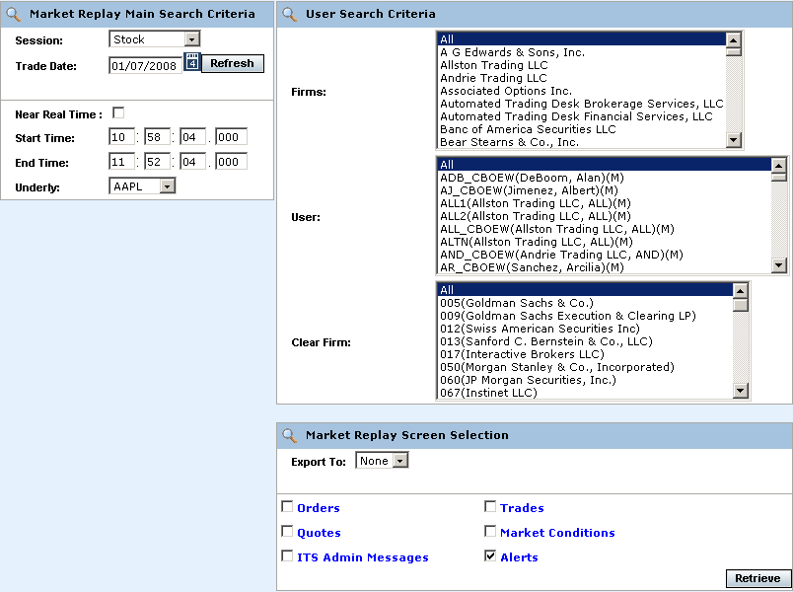
- To further filter your request, select to retrieve Orders, Quotes, Trades, Market Conditions, ITS Admin Messages or Alerts. Select Alerts.
- To save the query results to an Excel or PDF format, select either format from the Export To: drop down list. For export details, refer to the Exporting Data section, page 77.
- If you are satisfied with your selections and would like to view the data, click Retrieve. The Alerts window will display with the requested data.
 | 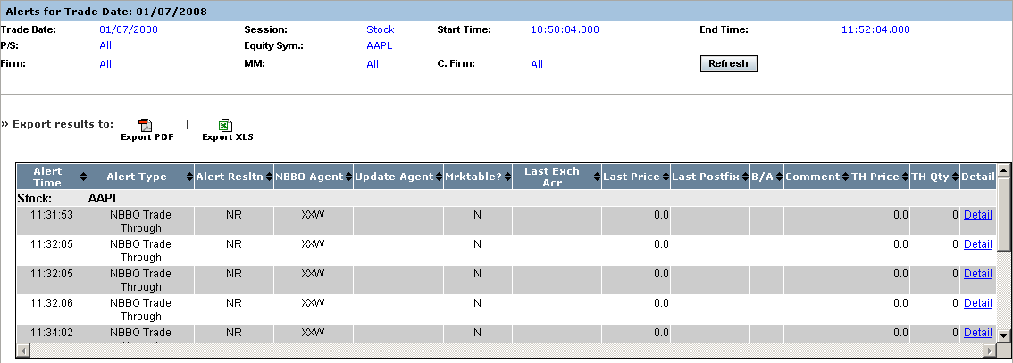
Alerts that occurred on 1/7/08 for AAPL display in the window above.
Click on the Detail link of any row to view additional information on the alert type.
 | 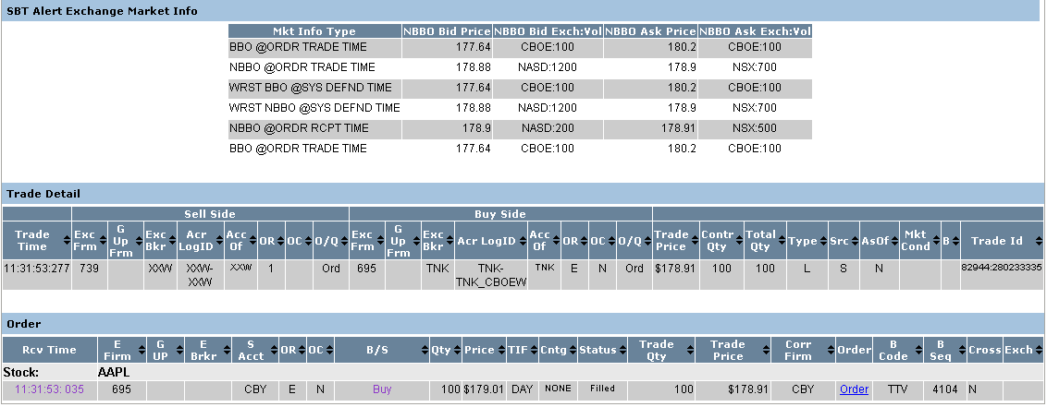
ITS Admin Messages | Market Replay allows you to view Intermarket Trading System (ITS) administrative messages that occurred on a specific trade date.
- Select the Stock trading session from the Session drop down list.
- The date of the request defaults to the current business day and is displayed in the Trade Date text box.
- To choose a previous trading day, click on the calendar button. The following calendar window will display.
- Note: The data warehouse maintains trade information for three years.
- Click on the trade day you wish to query. The date will display in the Trade Date text box.
- Choose the time of your request as near real time by selecting the Near Real Time radio button. If you would like to select a fixed time range, deselect the Near Real Time Monitoring radio button. Enter the Start Time and End Time by, hour:minutes:seconds:milliseconds (i.e. Start Time: 10:48:00:000, End Time: 13:55:00:000).
- Select the Stock (underlying) product.
 Note: You must select a Stock product, clearing firm or broker in order to retrieve the data.
 | 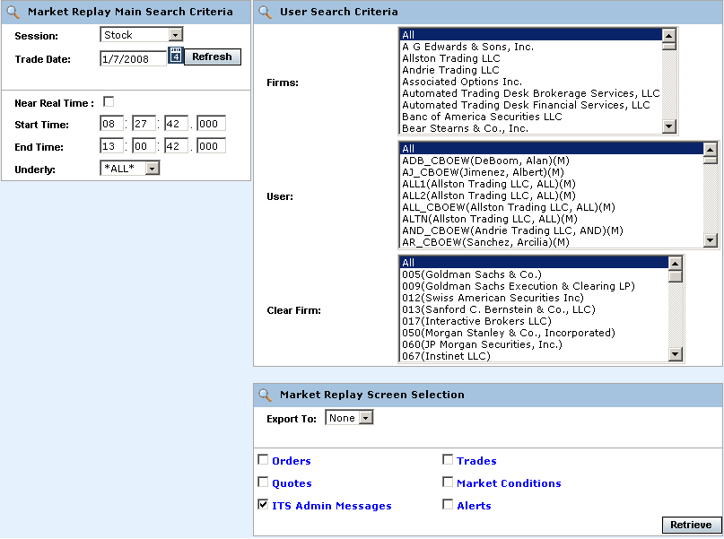
- To further filter your request, select to retrieve Orders, Quotes, Trades, Market Conditions, ITS Admin Messages or Alerts. Select ITS Admin Messages.
- To save the query results to an Excel or PDF format, select either format from the Export To: drop down list. For export details, refer to the Exporting Data section, page 77.
- If you are satisfied with your selections and would like to view the data, click Retrieve. The ITS Message window will display with the requested data.
 | 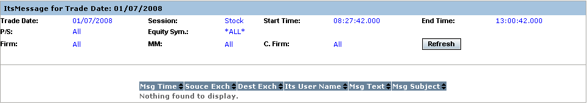
 | In the example above, there were no ITS administrative messages delivered on 1/07/08 from 08:27:42 through 13:00:42.

Ending a Market Replay Session

Exit the System | To exit the Market Replay system, click the right button (X) in the upper right corner of the window. The application will be closed and you will be returned to your system desktop.

◻ | Section 2:  Reference Guide

Exporting Data

 | Market Replay data can be exported to two different file formats: PDF and Excel.
Export to PDF Format | Market Replay allows you to save your search results in PDF format.  To export your query results to PDF format, select your Main Search Critiera, User Search Criteria and Screen Selection.
 | 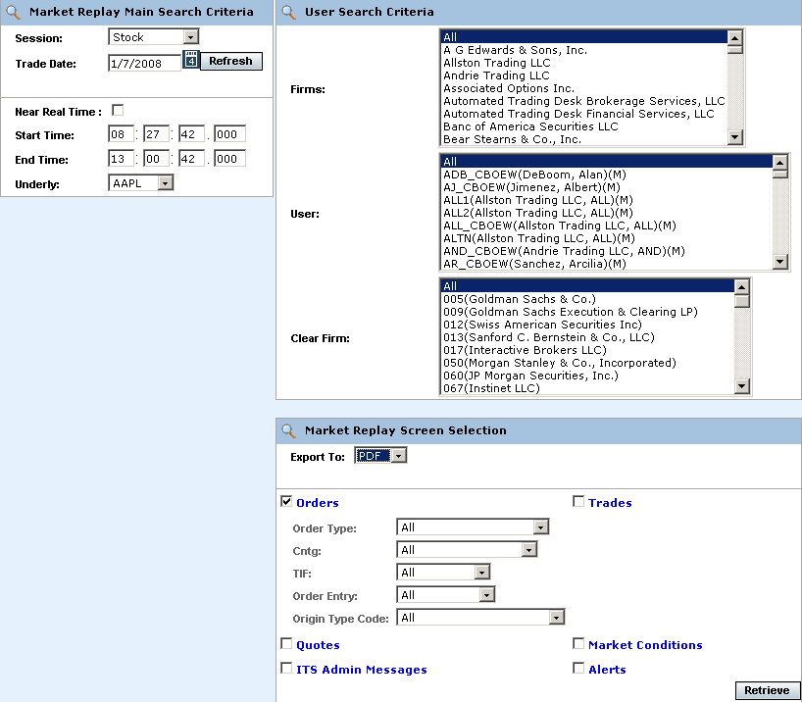
- From the Export To dropdown list, select PDF.
- Click Retrieve. The system will prompt you to either Open or Save the file to your computer. At this point, you may also cancel your format request my clicking on the Cancel button.
 | 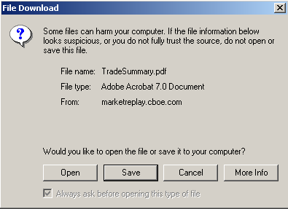
 | - To quickly view the data in PDF format, click Open. The data will be exported in PDF format.
 | 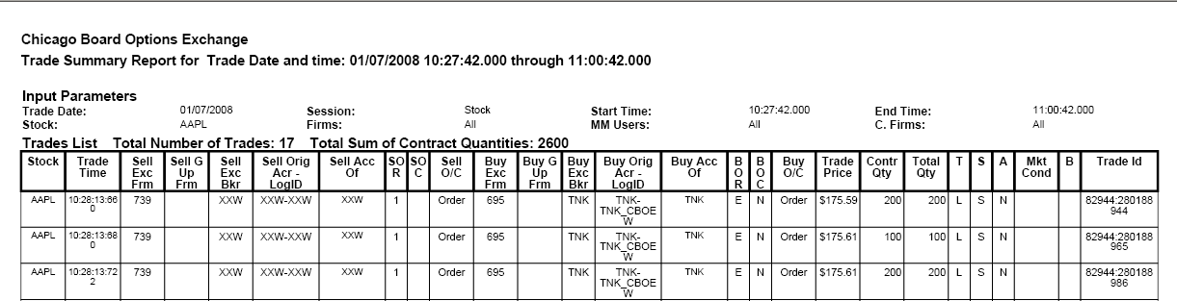
 | - To store the data before viewing, click Save.
 | 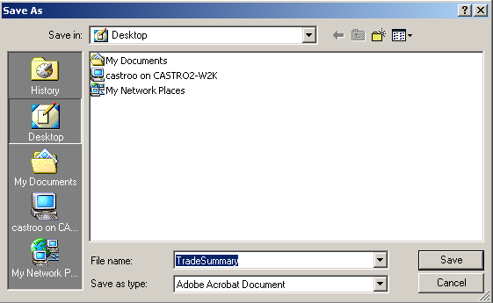
- Select the location where you want to save the file and enter the file name. If you wish to exit the window without saving the file, click Cancel.
- Click Save. Your file will be saved in PDF format. The system will display the Download complete window.
 | 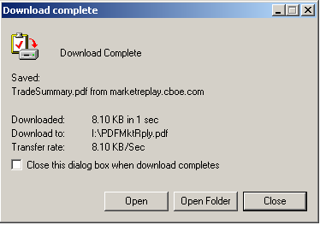
- Click Open to extract the data in PDF format, or select Open Folder to choose the file from the Windows directory.
- Click Close to exit the window without opening the PDF file.
Export to Excel | If you wish to export the data to an Excel spreadsheet, select Excel from the Export To drop down list. The system will prompt you to open an Excel window or save the data. If you wish to cancel your export request, click Cancel.
 | 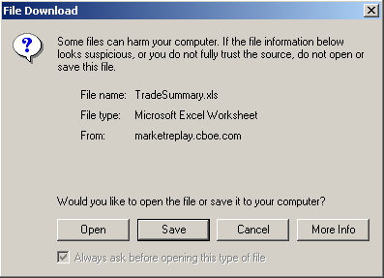
 | - To quickly view the data in Excel format, click Open. The data will be exported to Excel.
 | 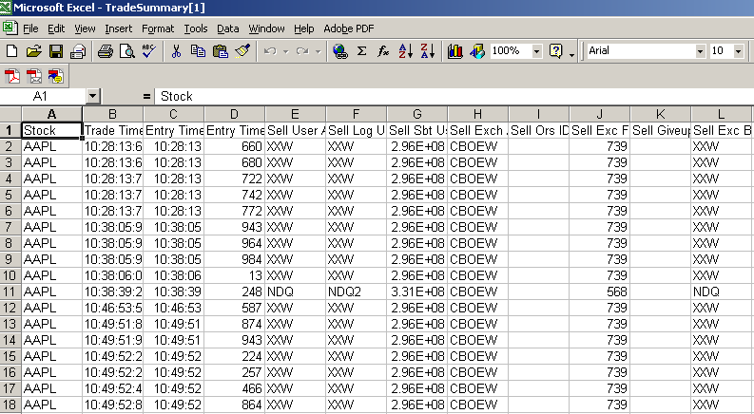
 | - To store the data before viewing, click Save.
 | 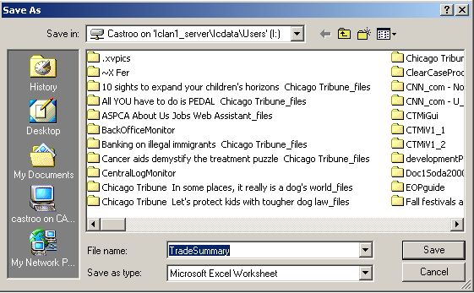
- Select the location where you want to save the file and enter the file name. If you wish to exit the window without saving, click Cancel.
- Click Save. Your file will be saved in Excel format. The system will display the Download complete window.
 | 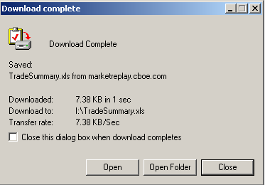
- Click Open to extract the data to Excel format or select Open Folder to choose the file from the Windows directory.
- Click Close to exit the window without opening the Excel file.

