

User Guide for Order Providers
Version 3.5

Disclaimer

Copyright © 2000 - 2003 Chicago Board Options Exchange. All rights reserved.
The information contained in this document constitutes confidential and/or trade secret information belonging to CBOE. This document is made available to CBOE members and member firms for use with CBOEdirect. This document is provided "As Is" with all faults and without warranty of any kind, either express or implied.

Change Notices

The following change notices are provided to assist users of the CBOEdirect screen-based trading system in determining the impact of changes to their processing.
If you have any questions or review comments about this document, please contact Odalys Castro at (312) 786 8817.

Date | Version | Description of Change
11/19/03 | 3.5 | Support for CBOE Futures (CFE_MAIN)  Start Menu updates  New user interface for a custom tab
6/18/03 | 3.0 | New user interface and functionality for Locked Market Status  Updated user interfaces for Add Class, Order Entry and Preferences  New login user interface for preferences
12/17/02 | 2.2 | Updated the ticker preferences user interface in the Ticker Menu section.
8/12/02 | 2.2 | User interface and functionality changes to support Large Order Utility.  Additional user interface changes for: login, strategies and cancel all quotes.  Changed the version number to 2.2 from 2.5.  Changed the document name to Trader's User Guide.
7/24/02 | 2.5 | User interface and functionality changes to support Large Order Utility
5/16/02 | 2.0 | Updated the number of characters allowed in the subaccount field to 10 alphanumeric characters instead of 15.
5/16/02 | 2.0 | User interface and functionality changes.
3/22/02 | 2.0-draft | First draft of Version 2.0. User interface and functionality changes for: futures trading session, book depth, strategies, multiple logins, multiple exchanges, RTH and preferences.
10/04/01 | 1.1 | No functionality changes. User interface changes for misc. preferences, order status and order history.
9/06/01 | 1.0 | Minor format editing.
6/20/01 | 1.0 | Publication release.
06/11/01 | 1.0 | Removed the Strategy section and made user interface changes.
02/12/01 | 0.9 | Additional Start Menu features and user interface changes.
12/13/00 | 0.8 | Continued revisions and user interface changes.
11/22/00 | 0.7 | User interface changes and ETH functionality.
09/22/00 | 0.6 | Fourth draft. Continued revisions, additional user interface changes.
06/30/00 | 0.5 | Third draft. Continued revisions, additional user interface changes. Indicators where trader-only or market maker-only functions apply
02/25/00 | 0.4 | Second draft. First draft revisions, user interface changes.
12/06/99 | 0.3 | First draft.

Table of Contents
Change Notices ii
Table of Contents iv
Introduction vii
Purpose vii
Intended Audience vii
Support and Questions vii
Conventions Used in this Guide viii
Section 1: Basic Screen-Based Trading 1
Getting Started 2
Login 2
Set User Preferences 3
Miscellaneous Preferences 3
Send a Message 4
Open a New Market Display Window 5
Opening a Trading Session 6
Market Display Window 6
Select Product Classes 6
At-the-Money 6
Add Custom Tab 7
Remove a Tab 8
Modify a Tab 8
Ticker/Recap 8
Side by Side Display 9
Single Row Display 9
Single Row Display with Multiple Product Classes 10
Sizing the Market Display Window 10
Displaying Products for Trading 11
Customize Market Display 11
Setting Row and Column Preferences 11
Row Preferences 12
Column Preferences 13
Display 15
Table View 15
Show all Rows / Show all Columns 15
Grow / Shrink 15
Side by Side / Single Row Formats 16
Save Customized Defaults 16
Request for Quote 17
Orders 18
Add New Order 18
Contingency Orders 19
Hit the NBBO Bid—Add Sell Order 19
Take the NBBO Offer—Add Buy Order 19
Hit the Bid—Add Sell Order 20
Take the Offer—Add Buy Order 20
Order Status 21
Update 21
Cancel 21
Cancel Replace 21
Order History 21
Edit Preferences 21
Strategies 22
Creating a New Strategy Product 22
Viewing Status 27
My Trades Log 27
Activity Log 27
Market History 28
Book Depth 28
Display Pending Price Adjustments 28
Closing a Trading Session 29
Get Out of the Market 29
Logout 29
Exit the System 29
Section 2: Detailed Reference Guide 31
Task Toolbar 32
About CBOEdirect 32
Open Tasks 32
Resize 33
Saving the Configuration for Windows Other Than the Market Display 33
Apply Default Preferences 33
Saving the Configuration for a Market Display Window 34
Session Information 36
Logout 36
Change Password 36
Main Window Settings 36
Window Control 37
Start Menu 38
Book Depth 38
Edit Column Preferences 39
History 39
Activity Log 39
Edit Column Preferences 40
Market History 41
Edit Column Preferences 42
Trades Log 42
Edit Column Preferences 43
Market Display 44
Message Center 44
Order Status 45
Edit Column Preferences 45
Pending Price Adjustment 47
Preferences 47
Miscellaneous Preferences 48
Configuration Maintenance 50
User Information 51
Status Window 52
Ticker Display 53
Ticker Configuration 54
Open Console Window 58
Order Menu 59
Add New Order 59
Order Status 61
Cancel Replace 62
Cancel 63
Update 64
Order History 65
Edit Preferences 65
Spread Creation Entry 66
Strategy Containing Leg 66
Strategy Match 69
Strategy Assist 72
Execute Menu 75
Hit the Bid 75
Take the Offer 76
Hit the NBBO Bid 78
Take the NBBO Offer 79
Request for Quote 81
Quote Request 81
Ticker Menu 82
Recap / Ticker 82
Recap 82
Ticker 82
Edit Preferences 83
Recap Enablements 83
Ticker Enablements 84
Display 85
View Menu 88
Add Class 88
Add Custom Tab 89
Remove a Tab 90
Modify a Tab 90
Multi Class Tabs 90
At the Money 90
View Type 91
Table 91
Window Menu 92
My Trades Log 92
Edit Column Preferences 92
Activity Log 93
Edit Column Preferences 94
Market History 95
Edit Column Preferences 96
Book Depth 96
Display Pending Price Adjustments 97

Introduction

Purpose | This user guide was written to assist users in utilizing all of the features of the CBOEdirect screen-based trading system. It provides comprehensive information on trading activity and suggests how to customize your trading environment for optimal use.
Intended Audience | This user guide is intended for any person interested in CBOEdirect's screen-based trading functions.
Support and Questions | Questions regarding this document can be directed to The Chicago Board Options Exchange at (312) 786 7300 or via email at api@cboe.com.

Conventions  Used in this Guide | The CBOEdirect system was designed so that you can perform all of your trading activities from the Market Display window. Therefore, you should be aware that the active trading fields for a product are sensitive to both right and left mouse clicks. Many functions can also be activated from the Menu Bar and using keyboard commands.  In order to streamline Section 1 of the documentation, we will illustrate the most efficient ways to perform a function. Additional information about each of the Menu Bar options can be found in Section 2: Reference Guide.  There are several conventions used throughout this guide to help trigger important information:
 | Bolding | Used to highlight menu selections (e.g., Login) and button names (e.g., RFQ)
 | Brackets [ ] | Used to highlight keyboard commands (e.g., [Alt]-[O]). Note that when [Alt] or [Ctrl] are used in conjunction with another key, hold down the first key while pressing the second.  Most menu and button functions can be executed through keyboard commands. Hold down the [Alt] key and press the keyboard character of the underlined letter in the command. For example:  [Alt]-[O] displays the Order Menu  [Alt]-[T] gets you out of the market—Out button
 | n(10) | This notation is used to designate values when the value in parentheses is indicative and will be specified in the future.
 |  Note: | This notation is used to indicate important information you should note when performing the associated function.
 | 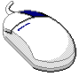 | This mouse graphic with the right mouse button highlighted will appear in the margin when accompanying instructions relate to functions activated by clicking the right mouse button.  All other mouse commands (such as double clicking to display a window) refer to a normal left mouse click.
 | Express Trading | This graphic will appear in the margin whenever accompanying instructions illustrate a trading shortcut that enables you to execute an activity without going through the menu options.
 | Special Situations | This graphic will appear in the margin when there is information relating to special trading situations.
 | Broker-Only Function | This graphics will display in the margin whenever the trading feature being described is a Broker-only function.

 | Section 1:  Basic Screen-Based Trading

This section of the user guide introduces all functions of the CBOEdirect Trader Workstation.

Getting Started

 | When you launch the CBOEdirect Screen-Based Trading application, the following login window will display.
 | 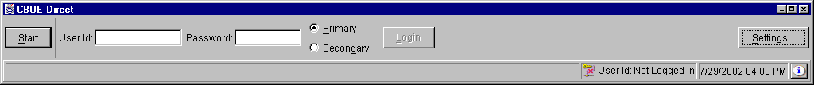
Login | CBOEdirect allows you to login as a Primary or Secondary user. You can use your Primary or Secondary login to login with another application while using the CBOEdirect Screen-Based Trading application.  Multiple primary and secondary logins are allowed using the same User ID. Primary logins are subject to a forced logout by the system. Secondary logins are not monitored for application termination. However, if the system forces the logout of a user, all primary and secondary login sessions for that User ID will be terminated. A Secondary login does not require a Primary login session to be active.  To login, enter your User ID and Password. Both User ID and Password are case sensitive. Select if your login is Primary or Secondary by clicking the appropriate radio button.  Click Settings, to change your login mode. The Session Settings window will display.
 | 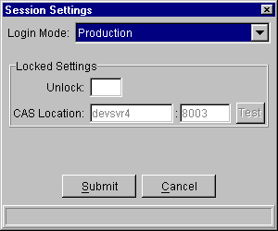
 | Select your login setting from the drop down list. To change your CAS location, enter your password in the Unlock field and enter the new CAS location. Click Test to check your setting. Click Submit. If you decide you do not wish to change your login mode, click Cancel. The system will return to the menu window. Click Login.
The first time you login to CBOEdirect, The system will prompt you to convert your Business and GUI Preferences to the current version.
To convert your preferences to the current version, click Yes.
If you do not wish to convert your preferences, click No.
 | 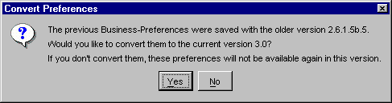
 | 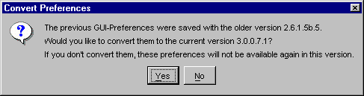
 | Once logged in, the Open Tasks toolbar will display in the CBOEdirect window. From this window you can open tasks, set your user preferences and open a trading session. Click the Up and Down arrows to view session information and perform window controls. For more details, see Section 2: Reference Guide (Task Toolbar, page 32).
 | 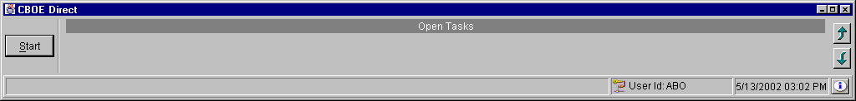
Set User Preferences | The system allows you to set user preferences to customize your trading session. Values set through this function will become the default values. All values can be changed manually during trading, however, these values will set your beginning parameters.  To display the Preferences menu, click the Start button on the CBOEdirect window and select Preferences, Miscellaneous Preferences. From this menu, you have options to set up defaults for, order entry, execution, alarms and sequence numbers.
➢ | Miscellaneous Preferences  For each class you trade, you can set order and execution defaults. The Default tab will set base values for all trading classes.
 | 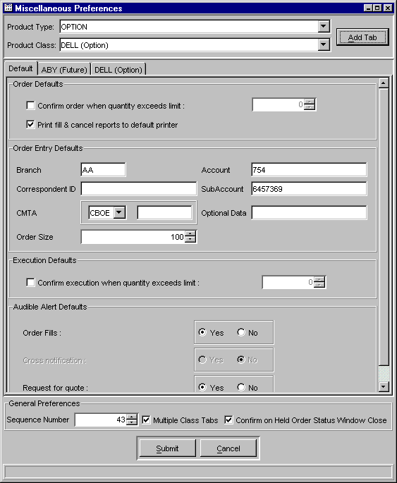
If you want some trading classes to have different defaults, you can select the class and set specific values and settings. For more details, see Section 2: Reference Guide (Miscellaneous Preferences, page 48).
Click Submit, and then click Confirm.
Send a Message | If you need to send a message to the CBOEdirect help desk, select the Message Center option from the Start Menu, then select Send Message. Enter your message, and then click Send Message.
Open a New Market Display Window | From the Start Menu, select Market Display, and then select Create New Market Display. A new Market Display window will open and a Market Display window task button will appear on the Open Tasks toolbar. You are ready to begin trading.  CBOEdirect allows you to open—and trade from—only one Market Display window. You can change the default window name of your Market Display from the Open Tasks Toolbar.  From the task button on the Market Display, perform a right mouse click, select Save Configuration. The Save Configuration window will display. Type the new Configuration Name. Click Submit. Click Confirm. The Market Display window task button will display with the new window name.  The preferences described in the previous section will apply to your Market Display window during your trading session.   Note: There are a variety of function and activity windows that open during the course of a trading session. Most trading function windows can remain open during trading. This documentation will provide notes regarding the windows that must be closed before trading can resume.

 | Opening a Trading Session
Market Display Window | When you select Market Display, Create New Market Display from the Start Menu, the Market Display window will open.  Initially, the window will be blank. Press F9 on your keyboard. The Add Class window will display.  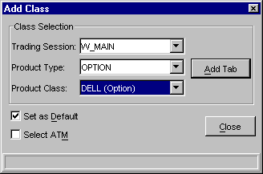

Select Product Classes
Select the trading session and product class from the drop down list boxes. For each product class, select the valid product type(s).
Select the Set as Default checkbox to retain the Trading Session and Product Type settings. The next class selection will automatically display with these values so you need only define the product class.
Click Add Tab. The system will display a tabbed window listing all of the series in the class with related market data.
Note: Only three product class tabs are allowed on the Market Display.
Option classes default to display in side-by-side format. Other types of product classes will display only in single row format.

At-the-Money
By selecting the Select ATM checkbox in the Add Class window, CBOEdirect will calculate the at-the-money series for your product class selection. When you click Add Tab, the at-the-money series displays in the center of the Market Display window for that class.
The at-the-money series is calculated based on the underlying value. If there is no underlying value available, the previous day's closing stock price will be used to determine the at-the-money series. You can highlight the at-the-money series from anywhere on the Market Display window by pressing F11 anytime during your trading session.

Add Custom Tab
CBOEdirect allows you to create custom tabs that contain multiple product classes. A tab can only contain classes of the same session and product type. From the Market Display window, press F12 on you keyboard. The Add Tab window will display.
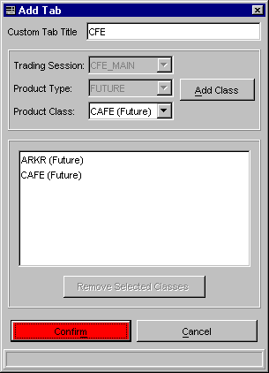
To add multiple product classes to a tab:
- Select a trading session from the Trading Session drop down box.
- Select a product type from the Product Type drop down box.
- Select a product class. Click Add Class. The product class will display in the text box section of the window. You can continue to add product classes to the tab as long as the classes are of the same session and product type.
  - Note: There are limits for the number of product classes of each product type that can be added to a single tab.
    - An Option or Strategy tab can only contain one product class
    - A Futures tab can contain up to 50 product classes
    - An Equity tab can contain up to 200 product classes - Equity product classes are not currently supported.
- When you select your first product class, the system defaults to set the name of the product class as the Custom Tab Title. You can override the default setting by entering a custom title for your tab in the Custom Tab Title text box.

- If you wish to remove a product class from your selection, select the product class from the text box and click Remove Selected Classes. The product class will be removed from the text box.
- To remove multiple product classes, hold down the Shift key on your keyboard and select the product classes. Click Remove Selected Classes. The product classes will be removed from the text box.
- To create your custom tab, select Submit. Click Confirm. The system will display a tabbed window on the Market Display listing all the series for the product classes with related market data.
- If you decide not to create a custom tab, click Cancel.

Remove a Tab
To remove a tab from the Market Display, right mouse click on the tab and select Remove.

Modify a Tab
To modify product classes for a tab on the Market Display, right mouse click on the tab and select Modify. The Add Tab window displays.
From this window, you can add or remove product classes and edit the title. Click Submit. Click Confirm. The modified tab will display on the Market Display window.
Note: If all the product classes are removed and you try to Submit the changes, the system will prompt you that if the changes are finalized, the tab would be empty, and therefore removed from the Market Display window.

Ticker/Recap
To view ticker or recap information, press [Alt]-[K] at any time from anywhere on the Market Display window and select your option. The ticker or recap information will display in the frame below the trading information section of the window.

 | Below are examples of the Market Display window in side by side and single row formats.
 | Side by Side Display
 | 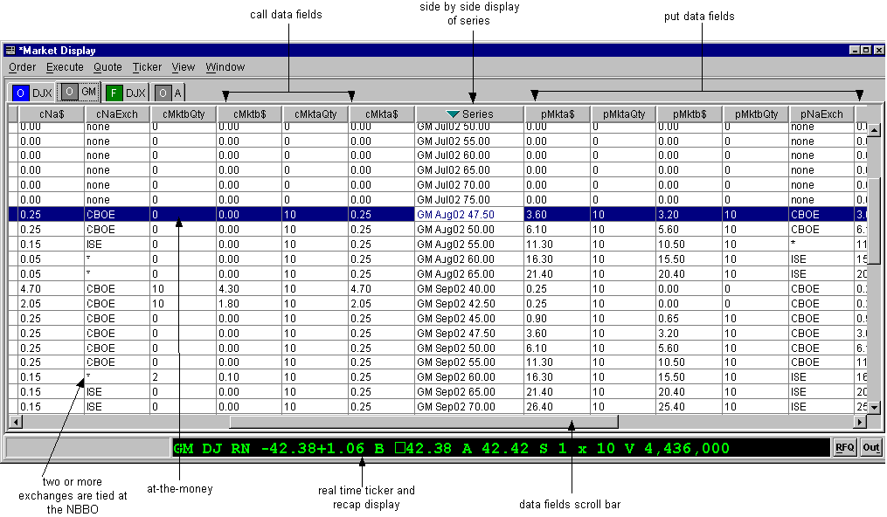
 | There are a number of data fields for each series. To view the fields off the right of the window, slide the scroll bar (below the data fields) to the right or left.
 | Single Row Display
 | 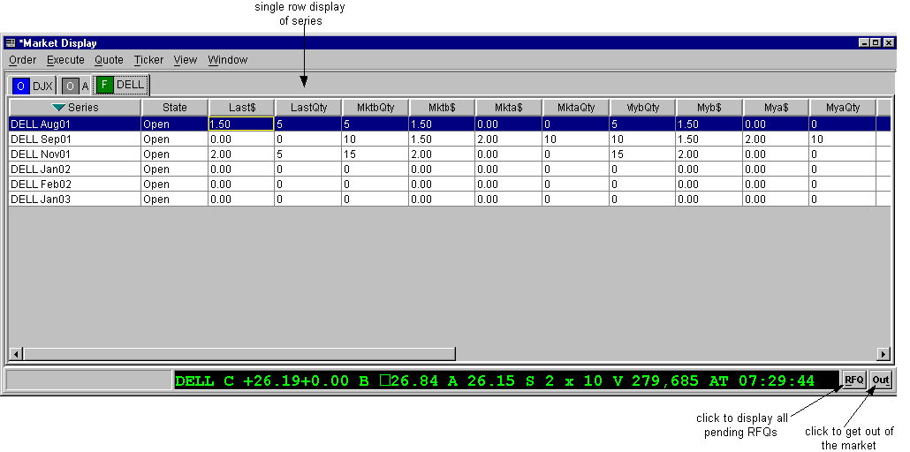
 | Single Row Display with Multiple Product Classes
 | 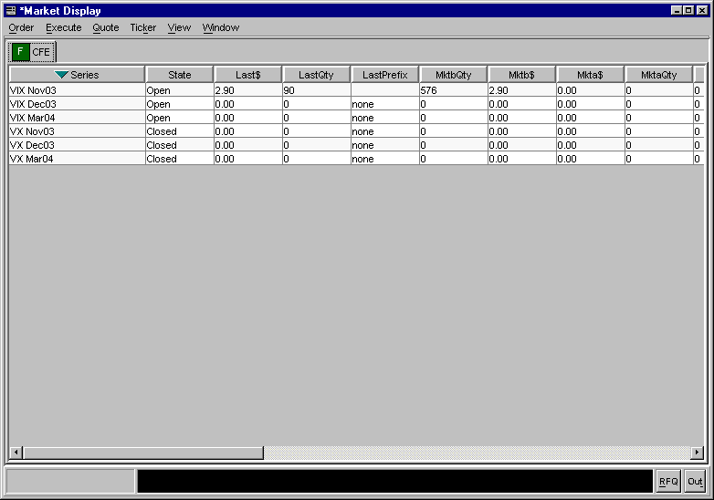
➢ | Sizing the Market Display Window  The Market Display windows are sizable. That is, they can be resized on the screen to make viewing information easier for you.
 | 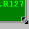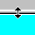 | Place the mouse on any edge of the window until it becomes a two-sided arrow. Hold the left mouse button down and move it to the desired size.
Resizing a window on the corner will expand or contract it in both directions (i.e. up and down, side to side). Resizing it on the side or top/bottom will expand or contract the window only in that one direction.
Windows can also be resized using the center glyph in the upper right corner of the window.
 |  | Click the left button () to minimize the window. Click the right button () to close the window. The center button is used for sizing.
If  is displayed, clicking it will increase the window size to a full-screen display.
If  is displayed, clicking it will return the window to its default size.

Displaying Products for Trading

Customize Market Display | From the Market Display window, press F9 or click the View Menu and select Add Class. The Add Class window will display.  Select the trading session, product type and product class you wish to display. Click Add Tab. A tabbed window will display for each class selection. If you wish to retain the trading session and product type values for additional class selections, click the Set as Default checkbox. Click Close to exit the window.  Refer to the Market Display window sample on the previous page to review what data is displayed for each class.  By clicking on the tab, you bring the Current Selected Product Class to the front of the window. These fields are now active for trading.  To remove a product class display, right mouse click on the selected class tab. Select Remove Tab. The product class is removed from the Market Display window.
Setting Row and Column Preferences | 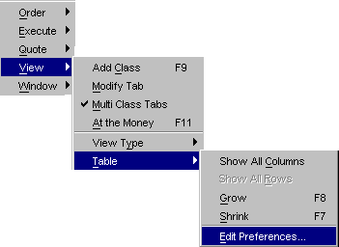
You can refine your Market Display window by selecting or deselecting specific series in each class. If there is a series that you are not interested in trading and don't want the data displayed on your Market Display window, you can deselect it.
To filter products on your Market Display window, right mouse click on any series. Select View, Table, Edit Preferences. The Edit Column Preferences window will display.

➢ | Row Preferences
(Not Currently Supported) | 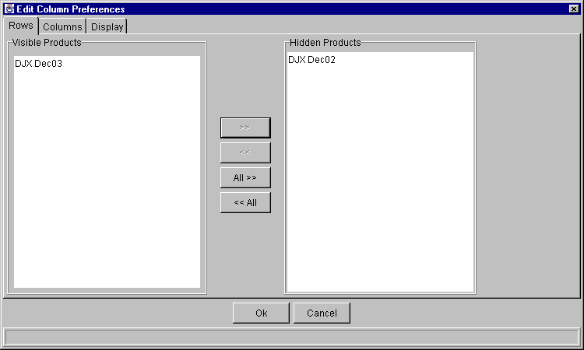
If there are series data you do not wish to view:
- Select the series from the Visible Products list box.
- Click >> to move the series data to the Hidden Products list box.
- Click Ok to update the product selection.
- If you decide to retain the default layout, click Cancel.
To hide all series data:
- Highlight all the series in the Visible Products list box.
- Click All>> to move all the series to the Hidden Products list box.
- Click Ok to update the product selection.
- If you decide to retain the default layout, click Cancel.
To display hidden series data:
- Select the series from the Hidden Products list box.
- Click << to move the series to the Visible Products list box.
- Click Ok to update the product selection.
- If you decide to retain the default layout, click Cancel.
To display all hidden series:
- Highlight all the series from the Hidden Products list box.
- Click <<All to move all the series the Visible Products list box.
- Click Ok to update the product selection.
- If you decide to retain the default layout, click Cancel.
➢ | Column Preferences
 | 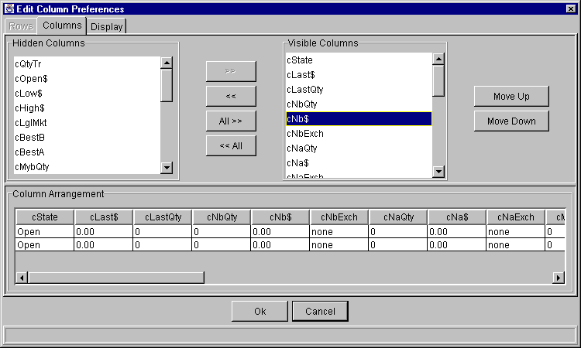
If there is a data column you do not wish to view:
- Select the column name in the Visible Columns list box. To select multiple columns, hold down the shift key and highlight the column names.
- Click << to move the column name to the Hidden Columns list box.
- Click Ok to update the column arrangement.
- If you decide to retain the default layout, click Cancel.
To hide all columns:
- Highlight all the column names in the Visible Columns list box.
- Click <<All to move all the column names to the Hidden Columns list box.
- Click Ok to update the column arrangement.
- If you decide to retain the default layout, click Cancel.
To display a hidden column:
- Select the column name from the Hidden Columns list box.
- Click >> to move the column name to the Visible Columns list box.
- Click Ok to update the column arrangement.
- If you decide to retain the default layout, click Cancel.
To display all hidden columns:
- Highlight all the column names from the Hidden Columns list box.
- Click All>> to move the column names to the Visible Columns list box.
- Click Ok to update the column arrangement.
- If you decide to retain the default layout, click Cancel.
To facilitate trading, you may prefer to view data columns in a different order than the default display.
To move a column:
- Highlight the column name from the Visible Columns list box.
- Click Move Up or Move Down until you reach the new column location.
- Click Ok to update the column arrangement.
- If you decide to retain the default layout, click Cancel.
From the Column Arrangement section of the window, the columns can be resized to make viewing information easier for you.
To resize a column:
- Place the mouse on the right edge of the column until it becomes a two-sided arrow.
- Hold the left mouse button down and move it to the desired size.
- Click Ok to save the new column size.
- If you decide to retain the default column size, click Cancel.
 | An alternate way of re-ordering columns can be done in the Market Display window itself by clicking on a column header and moving the column to a new position.
From the Column Arrangement section of the window, the columns can be resized to make viewing information easier for you.
To resize a column:
- Place the mouse on the right edge of the column header (where the column titles are displayed) until it becomes a two-sided arrow.
- Hold the left mouse button down and move it to the desired size.
- Click Ok to save the new column size.
- If you decide to retain the default column size, click Cancel instead of Ok.
➢ | Display
 | 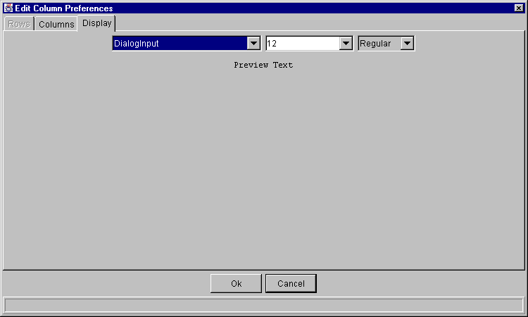
From the Display tab, you can modify the font type, size and style by selecting the new settings from the drop down lists. The new font will display in the Preview Text section of the window.
- Click Ok to update the font display.
- Click Cancel to retain the default settings.
Table View | 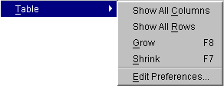
➢ | Show all Rows / Show all Columns  - To display all the data columns, highlight Show All Columns. All the data columns will appear on the Market Display.  - To display all the series, select Show All Rows. All the series will become visible on the Market Display.
➢ | Grow / Shrink  - To increase the size of the data rows and columns, highlight Grow or press F8 from anywhere on the window.  - To decrease the size of the data rows and columns, highlight Shrink or press F7 from anywhere on the window.
 | 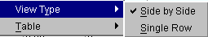
➢ | Side by Side / Single Row Formats  To facilitate trading, you have the option to view the Market Display trading data by single row or side-by-side formats. Highlight your preferred choice. CBOEdirect will rearrange the display of the trading data.  Note: Only option classes will display in both side-by-side and single row formats. Other product types will only display in single row format.
➢ | Save Customized Defaults  If you want the Market Display window changes to be saved and automatically open with your customized defaults, be sure to save the configuration on the Open Tasks toolbar. To save customization:  - Right mouse click on the corresponding Market Display window task button.  - Select Save Configuration. The Save Configuration window will display.  - Click Submit. Click Confirm.  - If you decide you do not wish to save the new configuration, click No. Click Cancel.  To further customize (i.e. font size, etc.) your Market Display window, refer to the Saving the Configuration for a Market Display Window, page 34.

Request for Quote

Quote functions are performed on an individual series. Any user may initiate a Request for Quote (RFQ). To select a series, click it once to highlight it. The Quote Menu can be displayed from the Menu Bar or by right mouse clicking on the series.
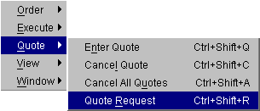
When you select Quote Request, the Quote Request window will display. The fields automatically display with the product and series currently highlighted or selected.
- Enter the quantity (optional).
- Click Submit.
The system will automatically send the RFQ to all Market Makers assigned to that class and to other Market Makers who are required to receive RFQs for that class or who are currently quoting that class.
 Note: The system will send out multiple RFQs (RFQs for a product for which an RFQ is outstanding).
If you decide you do not wish to proceed with the request for quote, click Exit to close the Quote Request window.

Orders

Order functions are entered manually on a selected series in a class. To select a series, click it once to highlight it. The Order Menu can be displayed from the Menu Bar or by right mouse clicking on the series you wish to trade to display the Order Shortcut Menu.
Note: The ability to pass orders from one session to another is not currently supported.
Add New Order | 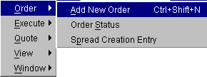
When you select Add New Order, the Add Order window will display. The fields will automatically display with the product and series selected. The fields default to a buy, day order.
- Click the corresponding buttons to change to a sell or good till cancel order.
- Enter the price and quantity of the order by clicking on the up and down arrow counters or highlighting the price and quantity values and keying over them with new values.
- If you wish to enter the order as a market order, click the Mkt field to fill the checkbox.
- If you are placing a contingency order, select an applicable contingency from the drop down list. For a Stop, Stop LMT, and MIN order, enter the stop price and minimum quantity of the contingency order.
- Update the Account and Details fields as needed.
- Note: The subaccount field is required for Futures and can include up to 10 alphanumeric characters. Firms that do not have subaccounts can enter their account information in this field after confirmation from their clearing firm.
- Click Submit.
- If you decide you do not wish to proceed with the order, click Cancel to close the Add Order window.

Special Situations | Contingency Orders  The market's best bid and best offer quantity fields normally contain only limit orders. In the case where contingency orders are present at the best bid or offer, the system will display:  - aggregate quantity of limit orders, including IOC (immediate or cancel) orders  - aggregate quantity of FOK (fill or kill), AON (all or none) and MIN (minimum) orders  - indicator of more than one FOK, AON, or MIN order  - aggregate quanity of STP (Stop) and Stop Limit (STP Limit)  - smallest quantity of the minimums of the MIN orders, if any  in the format L+C*(M), where  L = quantity of limit orders, including IOC  + = indicates the presence of contingency orders  C = quantity of FOK, AON, and MIN contingency orders  * = indicates there is more than one FOK, AON, or MIN order  M = the smallest minimum of the MIN orders  Because of the preset length of the display field, not all of the characters may be displayed at once. If this occurs, hover the mouse over the field without clicking it. The tool tip function will display the full field information.
Express Trading | Hit the NBBO Bid—Add Sell Order  To Hit the NBBO Bid when CBOE is part of the bid and quickly place a sell order, click on either the NBBO Bid Qty or NBBO Bid Price fields of the series you wish to trade. The Hit the NBBO Bid window will display with the price and quantity fields defaulting to the NBBO Bid Qty and NBBO Bid Price values. Adjust values, if necessary, indicate whether the order is a day order or an immediate or cancel order, and click Submit. CBOEdirect will submit the order to the CBOE based on the NBBO price.

Take the NBBO Offer—Add Buy Order
To Take the NBBO Offer when CBOE is part of the offer and quickly place a buy order, click on either the NBBO Ask Qty or NBBO Ask Price fields of the series you wish to trade. The Take the NBBO Offer window will display with the price and quantity fields defaulting to the NBBO Ask Qty and NBBO Ask Price values. Adjust values, if necessary, indicate whether the order is a day order or an immediate or cancel order, and click Submit. CBOEdirect will submit the order to the CBOE based on the NBBO price.
 | If you decide you do not wish to proceed with the order, click EXIT to close the window.

Express Trading | Hit the Bid—Add Sell Order  To Hit the Bid and quickly place a sell order, click on either the Mkt Bid Qty or Mkt Bid Price fields of the series you wish to trade. The Hit the Bid window will display with the price and quantity fields defaulting to the Mkt Bid Qty and Mkt Bid Price values. Adjust values, if necessary, indicate whether the order is a day order or an immediate or cancel order, and click SELL.  If you change the price or quantity of the order, the following results will occur if the bid is available for trading:
 | Price | Quantity | Results
 | Same | Same | Full execution of bid order at bid price
 | Same | Lower | Partial execution of bid order at bid price
 | Same | Higher | Full execution of bid order at bid price and book new order to sell at bid price with remaining quantity
 | Lower | Same | Full execution of bid order at bid price
 | Lower | Lower | Partial execution of bid order at bid price
 | Lower | Higher | Full execution of bid order at bid price and new order to sell with remaining quantity that could either execute against lower bid orders, if any, or be booked
 | Higher | Any | No execution, book new order to sell
 | If the bid is no longer available for trading, the system will book the full order as a day or IOC order.

Take the Offer—Add Buy Order
To take the Offer and quickly place a buy order, click on either the Mkt Ask Qty or Mkt Ask Price fields of the series you wish to trade. The Take the Offer window will display with the price and quantity fields defaulting to the Mkt Ask Qty and Mkt Ask Price values. Adjust values, if necessary, indicate whether the order is a day order or an immediate or cancel order, and click BUY.
If you change the price or quantity of the order, the following results will occur if the offer is available for trading:
 | Price | Quantity | Results
 | Same | Same | Full execution of offer order at offer price
 | Same | Lower | Partial execution of offer order at offer price
 | Same | Higher | Full execution of offer order at offer price and book new order to buy at offer price with remaining quantity
 | Higher | Same | Full execution of offer order at offer price
 | Higher | Lower | Partial execution of offer order at offer price
 | Higher | Higher | Full execution of offer order at offer price and new order to buy with remaining quantity that could either execute against higher offer orders, if any, or be booked
 | Lower | Any | No execution, book new order to buy
If the offer is no longer available for trading, the system will book the full order as a day or IOC order.
If you decide you do not wish to proceed with the order, click EXIT to close the window.

Order  Status | 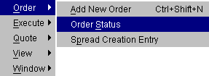
You can display the status of your orders by selecting Order Status from the Order Menu. A separate Order Status window will open.
The Order Status window will maintain ongoing status of all of your working orders as well as orders completely filled or cancelled. This window can remain open during further trading or click the  button in the upper right corner to close.
➢ | Update  To update order information for an unfilled order, highlight the order and select Update. The Update Order window will display.
➢ | Cancel  To cancel an unfilled portion of an order, highlight the order and select Cancel. The Cancel Order window will display. Adjust the quantity that you wish to cancel and click Submit.
➢ | Cancel Replace  To cancel an unfilled order and replace it with a new order, highlight the order to be canceled and click Cancel/Replace. The Cancel Replace Order window will display. Enter the new order information for the series and click Submit.
➢ | Order History  To display the history for an order, highlight the order and select Order History. The Order History window will display.
➢ | Edit Preferences  To edit preferences for an order or quote, highlight the order or quote and select Edit Preferences. The Edit Preferences window will display.

Strategies

Creating a New Strategy Product | 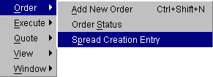
When you select Spread Creation Entry, the Spread Order Entry window will display. This window enables you to add a new strategy product to the class.
Note: CBOEdirect currently does not support strategy product creation for Hybrid classes.
CBOEdirect provides three methods for entering a new strategy product: Strategy Containing Leg, Strategy Match and Strategy Assist.
Strategy Containing Leg
Under this method, you can specify one leg of the product and the system will return a list of the spread products that contain the specified leg.
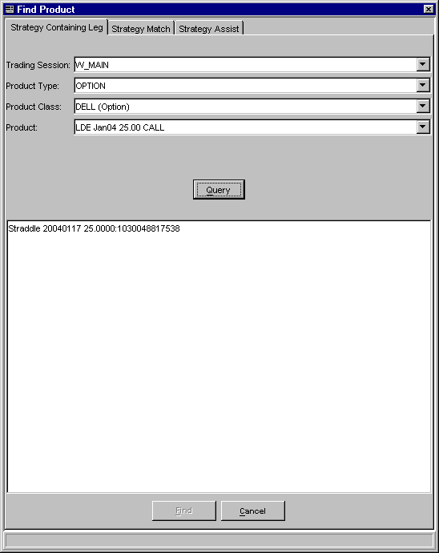
- Select a trading session, product type and class from the dropdown lists. Click Query. The system will generate the spread products that contain the specified leg.
- Select the product. Click Find. The spread product displays on the Market Display window.
- From the Order Menu, select Add New Order. The Add Strategy Order window displays with the spread product information.
- Indicate whether you would like to submit the Same or Opposite side of the spread order by choosing the corresponding button.
- Enter the price and quantity.
- Enter the information for the Details and Account fields.
- Note: The subaccount field is required for a Future strategy orders. The subaccount field is alphanumeric and can contain up to 10 characters.
- To enter the order, click Submit, depending on the order type selected.
- If you decide not to proceed, click Cancel to close the Add Order Entry window.

Strategy Match
Under the Strategy Match method, you must specify fully the legs of the spread product.
 | 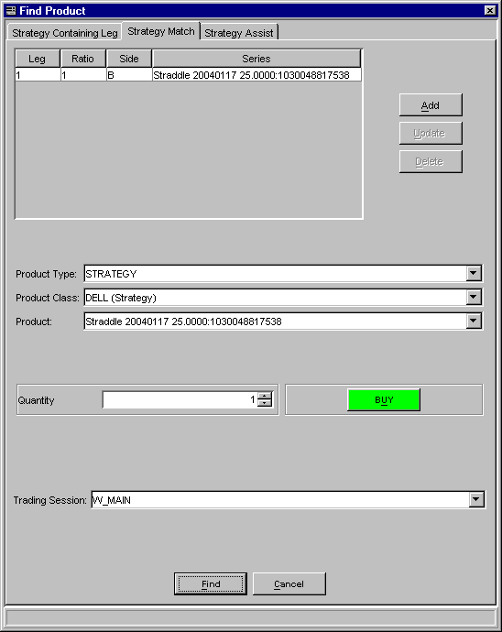
- For each leg,
- select the trading session, product type, class and series from the dropdown lists.
- Click on the combined buy/sell button to select the order type.
- Enter the quantity. Click Add. Click Find. The spread product exists and displays on the Market Display window.
- From the Order Menu, select Add New Order. The Add Strategy Order window displays with the spread product information.
- Indicate whether you would like to submit the Same or Opposite side of the spread order by choosing the corresponding button.
- Enter the price and quantity.
- Enter the information for the Details and Account fields.
- Note: The subaccount field is required for a Futures strategy order. The subaccount field is alphanumeric and can contain up to 10 characters.
- To enter the order, click Submit.
- If you decide not to proceed, click Cancel to close the Add Order Entry window.

Strategy Assist
Under the Strategy Assist method, CBOEdirect will fill in the second leg based on the selection of the first leg as shown in the table below.

 | First Leg |  |  | Second Leg
Spread Type | B/S | C/P | Strike Price | B/S | C/P | Strike Price
Straddle | B/S | C/P | Strike Price 1 | Same | Opposite | Strike Price 1
Combo | B/S | C/P | Strike Price 1 | Opposite | Opposite | Strike Price 1
Vertical | B | C | Strike Price 1 | S | C | Higher Strike Price
Vertical | S | P | Strike Price 1 | B | P | Lower Strike Price
Vertical | S | C | Strike Price 1 | B | C | Higher Strike Price
Vertical | B | P | Strike Price 1 | S | P | Lower Strike Price
Time | B/S | C/P | Strike Price 1 | Opposite | Same | Same Strike Price, Next Month

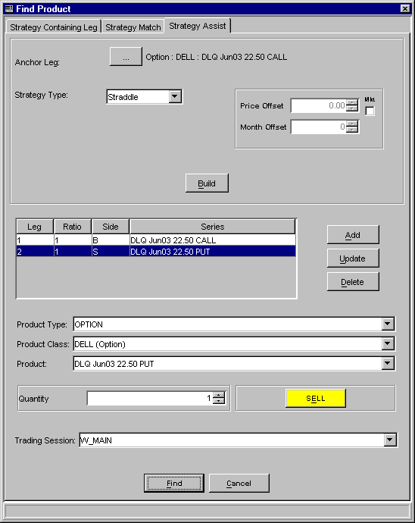
- Click Anchor Leg. The Class/Product Selection window displays. Select a product type, product class and series from the dropdown lists. Click Ok. The spread product displays.
- Click Build. The spread product displays.
- Click on the combined buy/sell button to select the order type.
- Set the quantity and select the trading session. Click Find. The spread product displays on the Market Display window.
- From the Order Menu, select Add New Order. The Add Strategy Order window displays with the spread product information.
- Indicate whether you would like to submit the Same or Opposite side of the spread order by choosing the corresponding button.
- Enter the price and quantity.
- Enter the information for the Details and Account fields.
- Note: The subaccount field is required for a Futures strategy order. The subaccount field is alphanumeric and can contain up to 10 characters.
- To submit the order, click Submit.
- If you decide not to proceed, click Cancel to close the Add Order Entry window.

Viewing Status

 | Trading activity status can be viewed at any time during an open trading session. Each of the functions opens a separate activity window. Multiple activity windows can be opened during a trading session. To access an activity status function, display the Window Menu from the Menu Bar or right mouse click on any series in your Current Selected Product Class.
 | 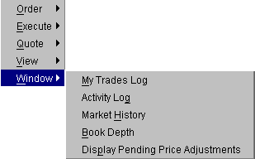
My Trades Log | To view your trades, highlight a series on the Market display window and select My Trades Log from the View Menu. The Trades Log window will open for the selected series. The window will automatically update as orders are executed.  - You can change the display to view any or all classes and/or series by clicking the Class/Product Selection button and selecting the items from the list boxes.  - Trades are listed by date/time stamp from the most recent to the earliest trade in the current trading session.
Activity Log | To view the activity log, highlight a series on the Market display window and select Activity Log from the View Menu. The Activity Log window will display for the Current Selected Product Class.  - Set the date and time selection fields to the point when you wish to begin viewing activity. Click Submit.  - You can change the display to view a different product type or class by clicking the Class/Product Selection button and selecting the items from the list boxes.  - Select the product and activity you wish to view from the list boxes. The display will refresh for the currently selected product and activity.
Market History | To view the chronological list of quotes and trades disseminated to the internal network during the trading day for a selected product, select Market History from the View Menu. The Market History window will open for the Current Selected Product Class and series.  - You can change the display to view another class and/or series by clicking the Class/Product Selection button and selecting the items from the list boxes.  - The date and time fields default to the current date and time. Update as desired.  - The display defaults to both quotes and trades. Select the appropriate radio button if you want a different listing.  - Quotes and trades are listed by date/time stamp from the most recent to the earliest trade in the current trading session.  - Click Submit to update selection criteria and refresh the display.
Book Depth | To view the book depth, highlight a series on the Market Display window and select Book Depth from the View Menu. The Book Depth window will open for the Current Selected Product Class and series. Real-time updates are provided for the first five levels of market depth.  - You can change the display to view another class and/or series by selecting the items from the list boxes.  - To obtain the most current data, click Refresh.
Display Pending Price Adjustments | For orders that do not get filled the same day they're placed, you may wish to review pending price adjustments as a result of stock splits, dividends, etc.  Select Display Pending Price Adjustments from the View menu. The Pending Price Adjustments window will open. At this window, you can view:  - order submit date and price adjustment effective date  - outstanding order quantity and new price effect each outstanding order for each of your Current Selected Product Classes.

Closing a Trading Session

 | You can close down all or part of your trading activity at any time during the day. You can get out of the market, yet remain on-line, or you can end your trading session by logging out and exiting the system.
Get Out of the Market | If you wish to get out of the market immediately, click the Out button on the Market Display window or press [Alt]-[T] from anywhere on the window. You will be prompted to verify that you wish to cancel all quotes. Click Yes. The system will immediately cancel all quotes.  You can then log out of the trading session and exit the system.
Logout | To log out of the trading system, select Logout from the Session Information toolbar. You will be prompted to verify that you wish to close all windows, cancel all quotes, and logout. Click Yes.
Exit the System | To exit the CBOEdirect screen-based trading system, select Exit from the Start Menu You will be prompted to verify that you wish to close all windows, cancel all quotes, and logout. Click Yes. The application will be closed and you will be returned to your system desktop.

◻ | Section 2:  Detailed Reference Guide

Task Toolbar

When you log into the CBOEdirect Screen-Based Trading application, The Open Tasks toolbar will display on the CBOEdirect window. From this window you can open tasks, view session information and perform window controls.
The Start Menu, which is executed from the toolbar, will be addressed in the Start Menu section (Start Menu, page 38) of the Reference Guide.
Note: The toolbar remains active during the trading session.
 | 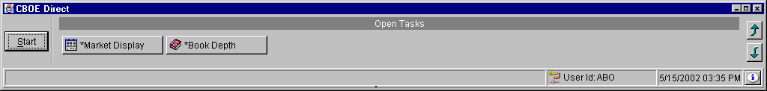
About CBOEdirect | To display system information about CBOEdirect, click . The About window will display.
 | 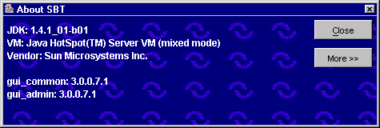
 | To view specific configuration information, click More. Detailed system information will display. To exit the window, click Close.
Open Tasks | Initially, the Open Tasks toolbar will be empty. For each window you create, a task button will appear on the toolbar. From the task button, you can resize or change the configuration name of each window.  To resize the window or to change the default configuration name, click on the Market Display window task button. The Market Display window will display. Right mouse click on the task button for the corresponding window. The resize and configuration menu will display.  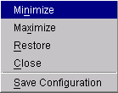
➢ | Resize  To resize a window:  - Highlight the resize choice or  - Hold down the [Alt] key and press the character of the underlined letter in the command.
➢ | Saving the Configuration for Windows Other Than the Market Display  CBOEdirect allows you to retain window configurations. Most of the CBOEdirect window configurations can be saved using the Book Depth example below. Saving the configuration for the Market Display window is explained in the next section.  To save the configuration for a Book Depth window:  - Right mouse click on the window’s task button and select Save Configuration. The Save Configuration window will display.  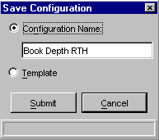  - Select the Configuration Name radio button. The text box displays in editable format.  - Enter the configuration name for the Book Depth window. In the example above, the Book Depth window name will be changed to “Book Depth RTH”.  - To submit your configuration without setting a template, click Submit. Click Confirm. The system will save the configuration for the window and the task button will display with the new Book Depth configuration name.  - To set this configuration to be the default configuration for all Book Depth windows, select the Template radio button. Click Submit. Click Confirm.  - If you decide not to change the default configuration, click Cancel instead of Submit.
➢ | Apply Default Preferences  CBOEdirect allows you to apply a default preference template to a window that has been already created.  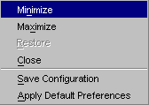  For example, if you previously saved the configuration for a Book Depth window, right mouse click on the new Book Depth window task button and select Apply Default Preferences. The Book Depth window settings will be changed to the default preferences for all Book Depth windows.
➢ | Saving the Configuration for a Market Display Window  To save the configuration for a Market Display window:  - Right mouse click on the Market Display window task button and select Save Configuration. The Save Configuration window will display.  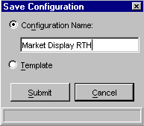  - Select the Configuration Name radio button. The text box displays in editable format.  - Enter the configuration name for the Market Display window. In the example above, the Market Display window name will be changed to “Market Display RTH”.  - To submit your configuration without changing the template settings, click Submit. Click Confirm. The system will save your configuration and the task button will display with the new Market Display configuration name.  - If you decide not to change the default configuration, click Cancel instead of Submit.
To save window and table preferences for the Market Display:
- Select the Template radio button. Choices for default table preferences will display.
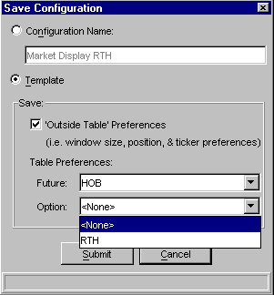
- To save the window size, position and ticker preferences, select the ‘Outside Table’ Preferences check box.
- You can save table (column, row, etc.) preferences for a type of product that has been defined in the Market Display window. In the example above, Future and Options products have been defined.
- From the Future drop down list, the settings for HOB have been selected as the table preferences for Futures.
- Option product table preferences will not be saved, therefore, the Table Preferences selection is set to <None> from the Option drop down list.
- If you are satisfied with your choices, click Submit. Click Confirm. Your preferences will be saved and the task button will display with the new Market Display window name. New Future products that are created on the Market Display will display with the saved table preferences.
- If you decide not to change the default configuration name, click Cancel instead of Submit.
Session Information | From the Open Tasks toolbar, click the button to display the Session Information toolbar.
 | 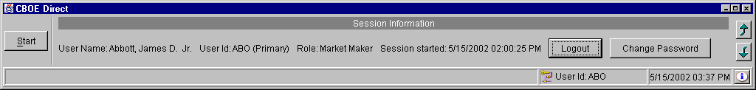
 | From this toolbar, you can view your user name and Id, role and session information. You also have the ability to logout of the system or to change your password.
➢ | Logout  To logout of the trading system, click Logout. You will be prompted to verify that you wish to close all windows, cancel all quotes, and logout. Click Yes. If you do not wish to logout of the system, click No.
➢ | Change Password  To change your password, click Change Password. The Change Password window will display.  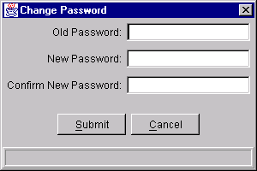
Enter your Old Password. Enter and confirm your New Password. Click Submit. Click Confirm.
If you decide not to change your password, click Cancel.
Main Window Settings | The system allows you to save your window preferences. From the Session Information toolbar, click the button. The Main Window Settings toolbar will display.
 | 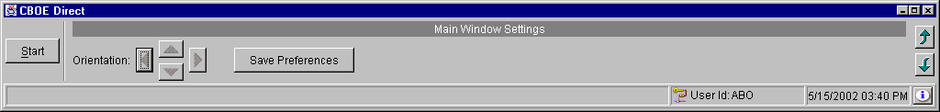
 | From this window you can save your window preferences. Click Save Preferences. The system will store your window configuration.
Window Control | The system allows you to organize your Market Display windows. From the Main Window Settings toolbar, click the button. The Window Control toolbar will display.
 | 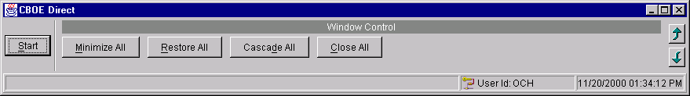
You have the ability to minimize, restore, cascade or close your Market Display windows.
- To minimize all your Market Display windows, click Minimize All or hold down the [Alt] key and press "M" on your keyboard.
- To restore all your Market Display windows, click Restore All or hold down the [Alt] key and press "R" on your keyboard.
- To cascade all your Market Display windows, click Cascade All or hold down the [Alt] key and press "D" on your keyboard.
- To close all your Market Display windows, click Close All or hold down the [Alt] key and press "C" on your keyboard.

Start Menu

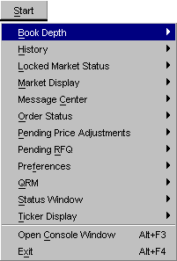 | The Start Menu allows you to quickly create new windows for various CBOEdirect functions.  To display the Start Menu:  - Click the Start button on the CBOEdirect Screen-Based Trading window or  - Press [Alt]-[S] from anywhere on the window.  The Start options will display. If a menu option is unavailable, it will display grayed out and no action will take place when the option is selected.
Book Depth | Select Book Depth from the Start Menu, and then highlight Create New Window to open a new Book Depth window.
 | 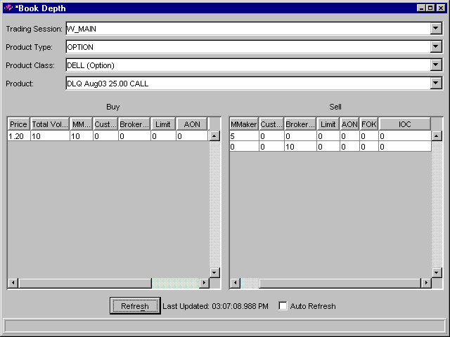
At first, the window will be blank. Select the trading session, product type, class and series you wish to display. Click Submit. CBOEdirect will display the aggregate orders in the book at various price levels at the time of the Book Depth request. The Total Volume column displays the total volume of contracts at a price level. The Limit, AON, FOK and IOC columns display the portion of the volume that comes from contingency orders.
- Real-time updates are provided for the first five levels of market depth. To obtain updated book depth data, click Refresh.
- To have the window refresh automatically, click the Auto Refresh check box.

Edit Column Preferences
You can customize your Book Depth window by selecting or deselecting specific columns to display. To filter columns, right mouse click on a data row. Select Edit Preferences. The Edit Column Preferences window will display.
- Select or deselect columns for viewing and modify column arrangement as desired.
- To save your changes, click Ok.
- If you wish to retain the default settings, click Cancel.
For instructions on screen customization, refer to the Customize Market Display, page 11.
 | - Note: Multiple Book Depth windows can be created during a trading session. Each Book Depth window configuration can be saved using the Task Toolbar. For detailed information, see the Task Toolbar section (Task Toolbar, page 32) of the Reference Guide.
History  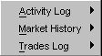 | The History option on the Start Menu gives you three ways to view trading information; Activity Log, Market History and Trades Log.

Activity Log
To view the Activity Log, select History from the Start Menu. From the sub-menu select Activity Log, Create New Window. The Activity Log window will display.
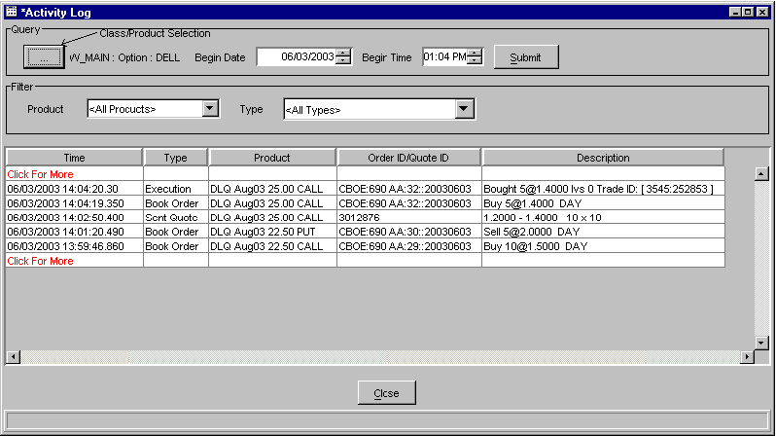

Initially, the window will be blank. To select the trading session, product type and product class you wish to display, click the Class/Product Selection button in the Query section of the window. The Class/Product Selection window will display.
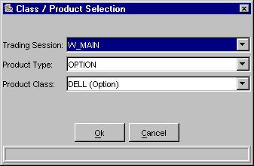

- Select the Trading Session, Product Type and Product Class from the drop down lists. Click Ok.
- The date field defaults to the current date. Click the up/down arrows to select the desired date.
- The time field defaults to the current time. Update as desired. Click Submit.
- The system defaults to query for all products and all types for the selected product class. If you wish to filter the product class activity by a specific product or activity type, select the product or type from the box lists in the Filter section of the window.
- All activity for the selected product class will display from the most recent to the earliest trade set by the date/time selection.
- Click Close to exit the display.

Edit Column Preferences
You can customize your Activity Log window by selecting or deselecting specific columns to display. To filter columns, right mouse click on a data row. Select Edit Preferences. The Edit Column Preferences window will display.
- Select or deselect columns for viewing and modify column arrangement as desired.
- To save your changes, click Ok.
- If you wish to retain the default settings, click Cancel.
For instructions on screen customization, refer to the Customize Market Display, page 11
 | - Note: Multiple Activity Log windows can be created during a trading session. You can save the configuration of each window from the Task Toolbar. For detailed information, see the Task Toolbar section (Task Toolbar, page 32) of the Reference Guide.

Market History
To create a new Market History window, select History from the Start Menu, and then select Market History, Create New Window. A blank Market History window will display.
 | 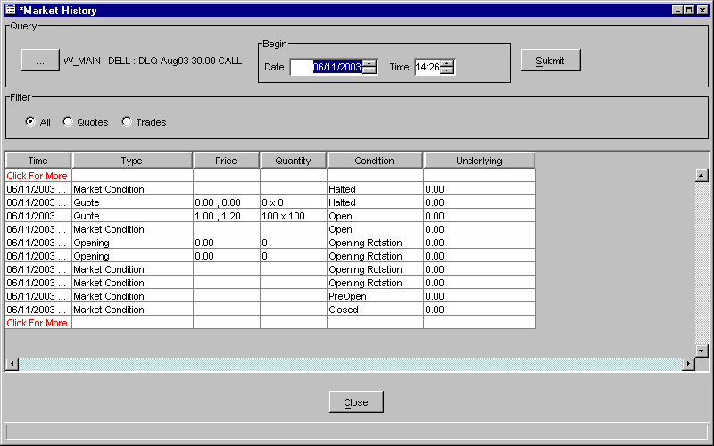
 | - From the Query section of the window, click the Class/Product Selection button. The Class/Product Selection window will display.
- From the box lists, select the trading session, product type, class, and series to display.
- Click Ok.
- The date field defaults to the current date. Click the up and down arrows to select the desired date.
- The time field defaults to the current time. Update as desired.
- The display defaults to both quotes and trades. Select the appropriate radio button if you want a different listing.

- Quotes and trades are listed by date/time stamp from the most recent to the earliest trade in the current trading session.
- Click Submit to update selection criteria and refresh display.
- Click Close to exit the display.

Edit Column Preferences
You can customize your Market History window by selecting or deselecting specific columns to display. To filter columns, right mouse click on a data row. Select Edit Preferences. The Edit Column Preferences window will display.
- Select or deselect columns for viewing and modify column arrangement as desired.
- To save your changes, click Ok.
- If you wish to retain the default settings, click Cancel.
For instructions on screen customization, refer to the Customize Market Display, page 11
 | - Note: Multiple Market History windows can be created during a trading session. Each window configuration can be saved using the Task Toolbar. For detailed information, see the Task Toolbar section (Task Toolbar, page 32) of the Reference Guide.

Trades Log
To create a new Trades Log window, select History from the Start Menu, and then select Trades Log, Create New Window. The Trades Log window will display.
 | 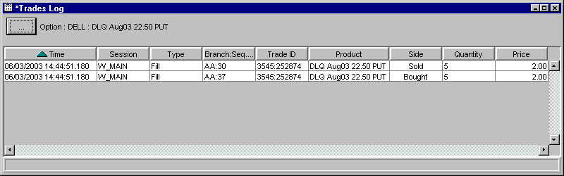
 | Initially, the window will be blank. Click the Class/Product Selection button to select the product type, class and series you wish to display. Click Ok.
 | 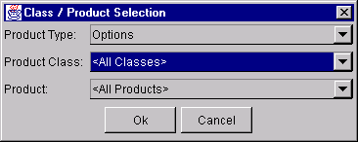
 | Trades are listed by date/time stamp from the most recent to the earliest trade in the current trading session.

Edit Column Preferences
You can customize your Trades Log window by selecting or deselecting specific columns to display. To filter columns, right mouse click on a data row. Select Edit Preferences. The Edit Column Preferences window will display.
- Select or deselect columns for viewing and modify column arrangement as desired.
- To save your changes, click Ok.
- If you wish to retain the default settings, click Cancel.
For instructions on screen customization, refer to the Customize Market Display, page 11.
 | - Note: You can create multiple Trades Log windows during a trading session. Each window configuration can be saved using the Task Toolbar. For detailed information, see the Task Toolbar section (Task Toolbar, page 32) of the Reference Guide.
Market Display | Select Market Display from the Start Menu, then highlight Create New Market Display to open a new trading window.
CBOEdirect allows you to open—and trade from—only one Market Display window. Any preferences you set up will apply to the Market Display window during your trading session.
Refer to Section 1 (Market Display Window, page 6) in this guide for a description of the fields on the Market Display window and instructions for customizing it for your use.
Message Center | If you need to send a message to the CBOEdirect Help Desk, click Message Center and highlight, Send Message. A New Message window will display.
 | 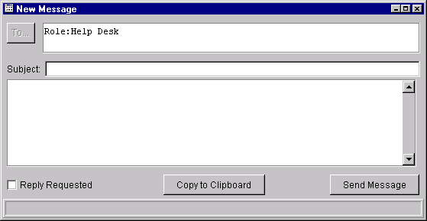
 | Enter the Subject and the text of your message. Click Send Message. The email will automatically be routed to the Help Desk representative. To copy your message to the clipboard, click Copy to Clipboard.
 | - Note: Multiple Message Center windows can be created during a trading session.
Order Status | You can create a new Order Status window from the Start Menu. Select Order Status, then click Create New Window. A blank Order Status Window will display.
 | 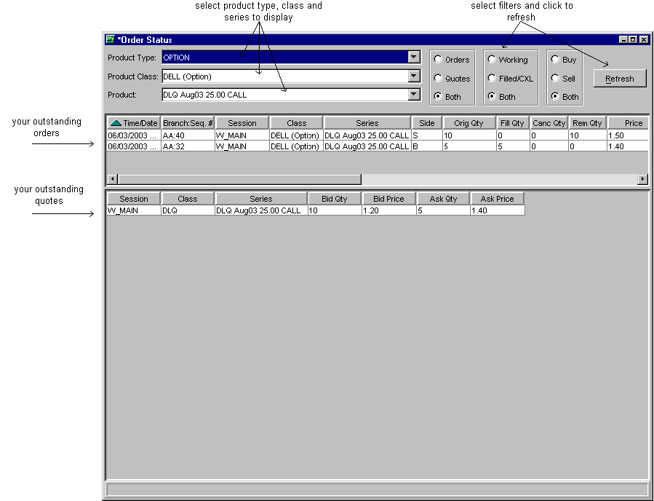
At this window you can view orders and/or quotes, buy and/or sell orders, and working and/or completely filled/cancelled orders. Select the product type, class and series you wish to view from the list boxes. Select the appropriate radio buttons, then click Refresh.
To update order information, refer to the Order Status window in the Order Menu section, page 61.

Edit Column Preferences
You can customize your Order Status window by selecting or deselecting specific columns to display. To filter columns, right mouse click on a data row. Select Edit Preferences. The Edit Column Preferences window will display.
- Select or deselect columns for viewing and modify column arrangement as desired.
- To save your changes, click Ok.
- If you wish to retain the default settings, click Cancel.

For instructions on screen customization, refer to the Customize Market Display section, page 11.
 | - Note: Multiple Order Status windows can be created during a trading session. Each window configuration can be saved using the Task Toolbar. For detailed information, see the Task Toolbar section (Task Toolbar, page 32) of the Reference Guide.
Pending Price Adjustment | Price adjustments on orders are caused by changes in the underlying security, such as stock splits, stock dividends, etc.  To view the effects of pending price adjustments on your outstanding orders:  Highlight Pending Price Adjustments, then select Create New Window. The Pending Price Adjustment window will open.
 | 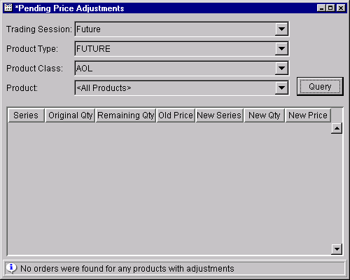
Select the trading session, product type, product class and product from the drop down lists. Click Query. For the selected product, you can view:
- original and new series
- original and new quantity
- remaining and new quantity
- old and new price
Preferences | The system gives you the ability to tailor your trading sessions to your trading style by setting session defaults for quotes and orders.  Multiple preference windows can be created during a trading session.
 | 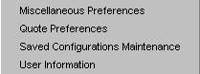 | From the Start Menu, select Preferences, then highlight the option you want to display. Values set using these functions will become the default values for new trades and trading sessions.

➢ | Miscellaneous Preferences  This window enables you to set order and execution defaults for all classes or specific classes.
To set defaults for all orders:
- To set an order size confirmation default, fill the checkbox and enter the order size limit for confirmations.
- If you want fill reports to print, fill the checkbox.
- To set order entry default information enter:
- Branch
- Account - this field is the OCC-recognized account ID and is limited to three characters.
- Correspondent ID
- Subaccount - this field is required for Futures and is limited to ten characters.
- CMTA
- Order size
- Optional data
- To set an execution (hit the bid or take the offer) confirmation default, fill the checkbox and enter the order size limit for confirmations.
- To set audible alerts:
- If you would like the system to audibly prompt you for order fills, cross notification, or RFQs, select the appropriate radio buttons.
- To set the sequence number for order entry:
- Enter the desired number in the Sequence Management section of the window.
- The number you set is saved as the next increment to use for order entry. This is a global setting for all classes.
- Sequence number increments by one automatically for each order submitted.
- The sequence number you set cannot be a previously used number.
- CBOEdirect currently allows users to display only one Market Display window and a maximum of three class tabs within the window. If you wish to display only one class tab during your trading session, deselect the Multiple Class Tabs checkbox.
- Note: If your trading session is configured to display multiple class tabs and you decide to switch to single tab format during the trading session, the current class tabs will remain in the window until you attempt to add a new class. At that time, the system will remove the class tabs from the window.
- To set order defaults for a specific class:
- Select the product type from the drop down list.
- Select the class from the drop down list, click Add Tab.
- Follow the steps above for setting default values.
- The checkbox to Confirm on Held Order Status Window is not currently supported.

When you have set or updated your order defaults, click Submit. You will be prompted to confirm. Click Confirm. Your preferences will be saved immediately.
If you wish to close the window without saving your settings or changes, click Cancel.

➢ | Configuration Maintenance  Window configurations from previous versions of CBOEdirect are saved in the Saved Configurations Maintenance window.  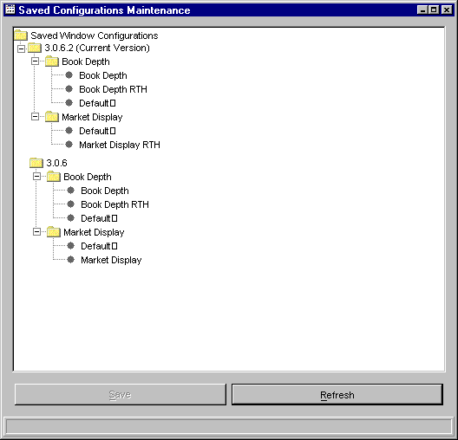
 | From this window, you can apply your previously defined named configurations and default template preferences to the current version of CBOEdirect. For example, to apply the default configurations for the Market Display from version 3.0.6 to version 3.0.6.2, double-click on the folder labeled 3.0.6. Click on the Market Display folder. After the folder is highlighted, drag and drop it with your mouse onto the folder labeled Market Display under version 3.0.6.2. The system will prompt you to confirm the conversion.
Click Yes to perform the conversion. CBOEdirect will apply the configuration.
Click Save to apply the configuration.
If you decide not to apply the configuration, click No.
Click Refresh to condense the Saved Window Configurations directory tree.

➢ | User Information  The User Information Preferences window allows you to view the data that is setup for you in CBOEdirect.
 | 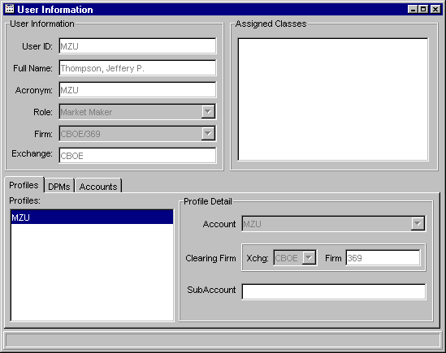
The User Information section of the window displays your User ID, Name, Acronym, Role, Firm and Exchange information.
The Profiles tab shows your Profiles Account, Clearing Firm and SubAccount details.

The DPMs tab displays assigned DPMs and DPM classes.
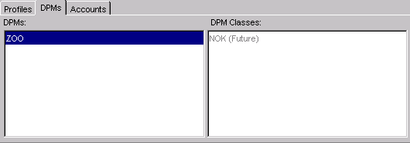
The Accounts tab display all your accounts with the Exchange and Firm information.
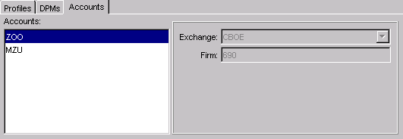
Status Window | Select Status Window from the Start Menu to open a new system status window. The configuration of the Status window can be saved using the Task Toolbar. For detailed information, see the Task Toolbar section (Task Toolbar, page 32) of the Reference Guide.  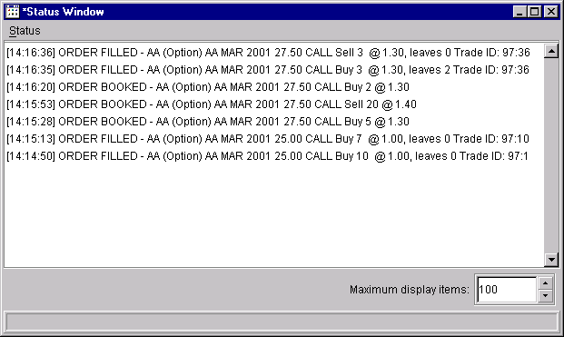
 | The Status Window will open displaying a maximum number of 100 items. CBOEdirect allows a maximum of 100 items to be displayed on the Status Window. To increase or decrease the number of items to display, click the Up or Down arrows until the desired number is reached.
- For detailed information, right mouse click to highlight the order and select Details. You can also select Details from the Status menu or press [Alt]-[D] from anywhere on the window.
- To print status information, select Print from the right mouse click menu or from the Status menu. You can also press [Alt]-[P] from anywhere on the window. The print window will display.
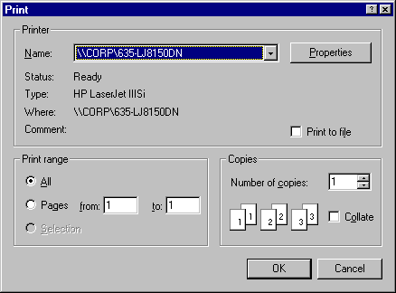
- To clear the status information, select Clear from the right mouse click menu or from the Status menu. You can also press [Alt]-[C] from anywhere on the window.
Ticker Display | CBOEdirect allows you to view underlying security market data by displaying ticker and recap information. From the Start Menu, select the Ticker Display option, then select Create New Window. The Ticker Display window will open.  You can create multiple Ticker Display windows during a trading session. Each window configuration can be saved using the Task Toolbar. For detailed information, see the Task Toolbar section (Task Toolbar, page 32) of the Reference Guide
 | 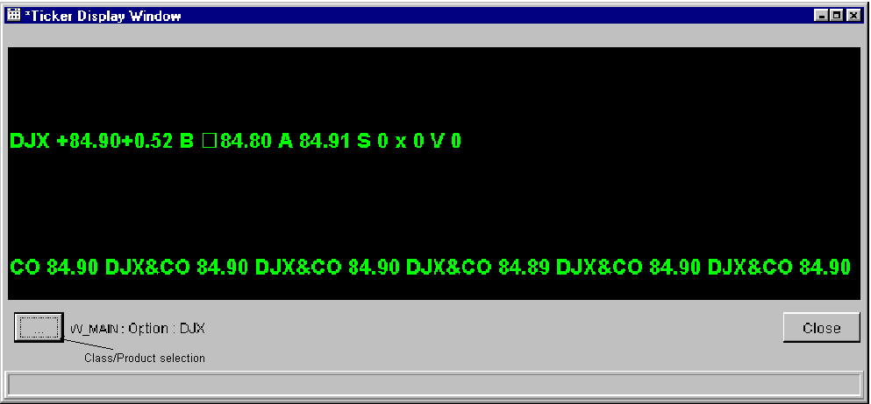
 | Initially, the window will be blank. Click the Class/Product Selection button to display the Class/Product Selection window.
 | 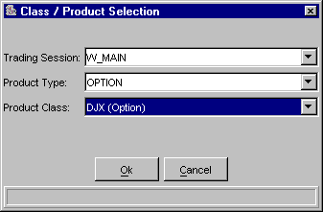
From the drop down lists, select the trading session, product type and product class you wish to view. Click Ok. Ticker and recap information will display for the selected product class.
If you decide you do not wish to view ticker information for a product class, click Cancel.

Ticker Configuration
You can define the ticker and recap information you wish to display by placing your mouse on the ticker portion of the window and performing a right mouse click. The Ticker Configuration window displays.
 | 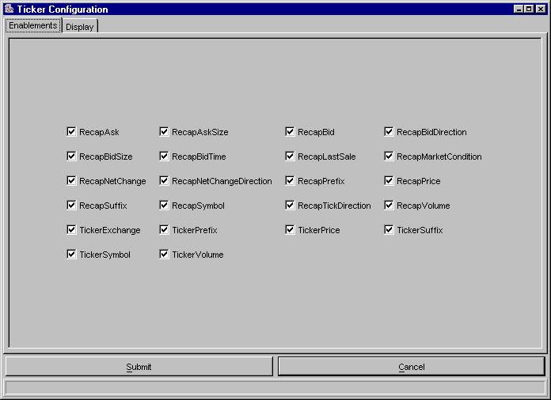
This window displays two tabs: Enablements and Display. The Enablements tab defaults to display all ticker and recap information. You can choose the ticker and recap information you would like to display by selecting/deselecting the appropriate check boxes.
- To save your configuration, click Submit. Click Confirm.
- If you decide to retain the default settings, click Cancel.
To further define your ticker display, select the Display tab. From this window, you can set a new font type and color for your display.
- To select a new font, select the type, size and style from the drop down lists. The new font will display in the Preview Colors section of the screen.
- To change the foreground or background color of the ticker, select the appropriate radio button.
- From the Swatches tab, click on the color you wish to display. The new color is viewable in the Preview Colors section of the screen.
 | 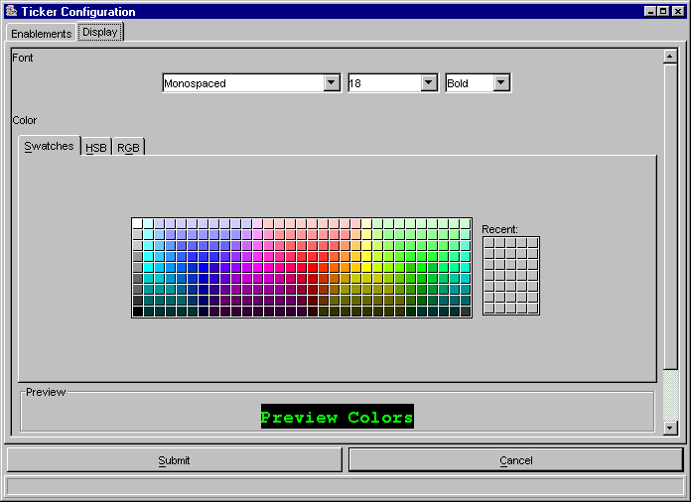
- To save the configuration, click Submit. Click Confirm.
- To retain the default settings, click Cancel.
 | - Click the HSB tab to set your hue, saturation and brightness. Place your mouse on the scroll bar button and adjust your color preference. You can view the changes in the Preview Colors section of the window.
 | 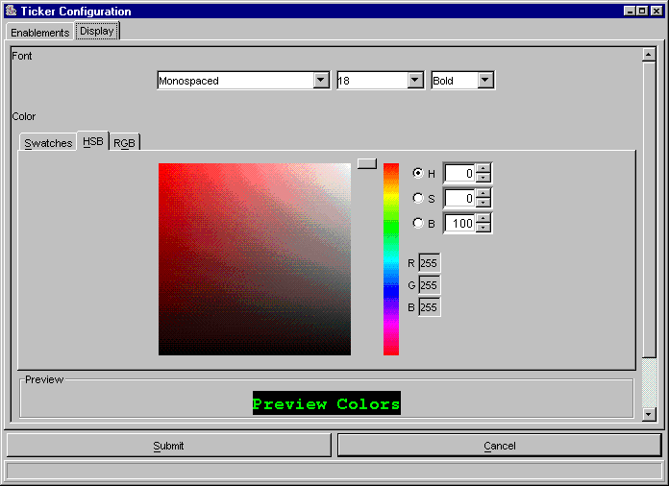
- To save the configuration, click Submit. Click Confirm.
- To retain the default settings, click Cancel.
 | - Click the RGB tab to set your red, green and blue color model. Place your mouse on the side scroll bar and adjust your color preference. You can view the changes in the Preview Colors section of the window.
 | 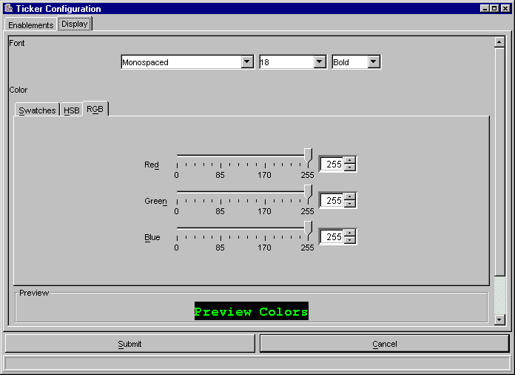
- To save the configuration, click Submit. Click Confirm.
- To retain the default settings, click Cancel.
Open Console Window | CBOEdirect allows you to view system messages that are generated by the functions you perform. To view the messages, select Open Console Window from the Start Menu. The Console Window will display.
 | 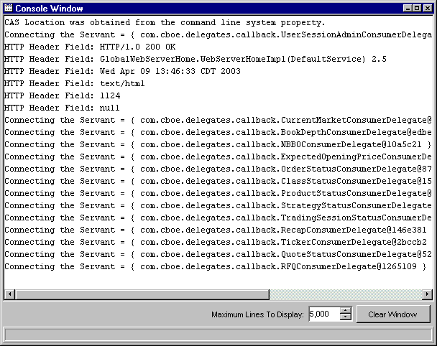
The information in this window can be copied to the CBOEdirect Message Center. To copy text from this window,
- place the cursor on the line you which to copy and using your mouse highlight the text.
- press Ctrl C on your keyboard to copy the text.
- open CBOEdirect Message Center window and place your cursor in the text entry area.
- press Ctrl V on your keyboard. The text is copied in the window.

Order Menu

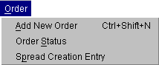 | To display the Order Menu:  - Click Order on the Menu Bar on the Market Display window, or  - Right mouse click on the series you wish to trade and select Order, or  - Press [Alt]-[O] from anywhere on the window.  The order options will display. If a menu option is unavailable, it will display grayed out and no action will take place if the option is selected.
Add New Order | Highlight a product, then select Add New Order from the Order Menu or press [Ctrl]+[Shift]+[N] from anywhere on the window. The Add Order window will display. There are two versions of this window: Buy and Sell. Buy is the default order option. Time in force defaults to Day.
 | 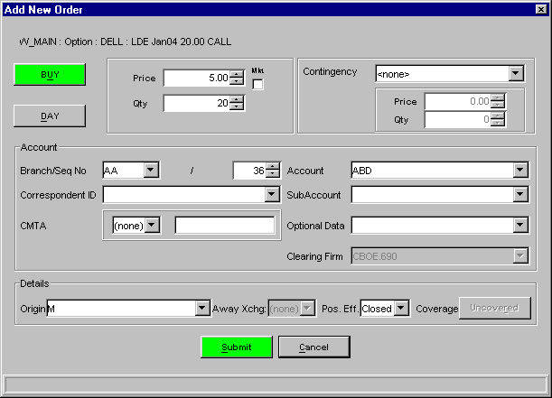
- Select Buy or Sell by clicking the appropriate button.
- Select whether the order is for the day or good till canceled by clicking the appropriate button.
- Enter the price and quantity of the order. If you wish to place a market order, click the Mkt checkbox (the checkbox will fill and the Price field will then be grayed out).
- If this is a contingency order, select one of the available contingencies from the drop down list box.
- If the order is a Stop or Stop Limit order, enter the price and minimum quantity.
- The Account section of the window displays order account fields. Update the fields as required.
- The branch ID defaults to the branch ID set in your preferences; sequence number increments to the next order entry number or the number you set in your preferences; account defaults to the user acronym (limited to three characters); give up firm defaults to the set user give up firm.
Note: Two or more CBOEdirect users for the same firm cannot utilize the same branch ID and sequence number. The CBOEdirect Help Desk can assist users in setting up unique branch IDs and sequence numbers.
Improper logout from CBOEdirect prevents the order sequence number from being saved. When you login again, the sequence number will begin at the same number as your previous login session.
The subaccount field is required for Futures and can include up to 10 alphanumeric characters. Firms that do not have subaccounts can enter their account information in this field after confirmation from their clearing firm.
- The Details section of the window displays order detail fields. Update fields as needed.
- Select the user origin from the Origins drop down list.
- Buy orders have an unspecified coverage type. Sell orders can be either Covered or Uncovered, the default is Uncovered.
- To process the order, click Submit.
- To exit without processing the order, click Cancel.
Order  Status | To view the status of your orders, select Order Status from the Order Menu. The Order Status window will open as a separate display. This window can be kept open while working on the Market Display window.
At this window, you can filter the orders to be viewed. Select the appropriate radio buttons, then click Refresh. Orders display at the top of the window. You can adjust the display to fit your trading activity.
This window can remain open during further trading or click the  button in the upper right corner to close.
➢ | Cancel Replace  To cancel an unfilled order and replace it with a new order, highlight the order to be canceled, right mouse click to display the Order Status Menu, and click Cancel/Replace. The Cancel Replace Order window will display.  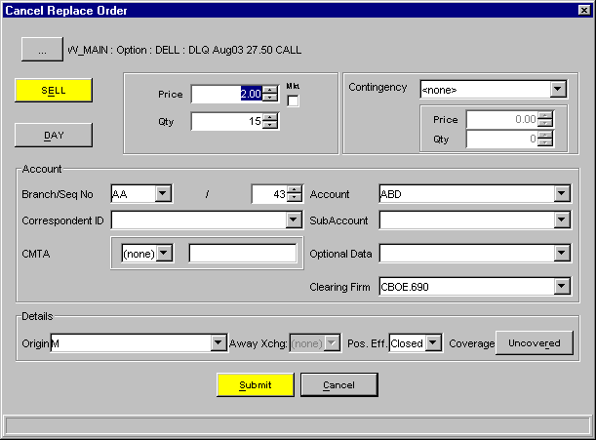  - Enter the new order information for the series and click Submit.  - To exit without processing the order, click Cancel.
➢ | Cancel  To cancel an unfilled portion of an order, highlight the order, right mouse click to display the Order Status Menu, and select Cancel. The Cancel Order window will display.  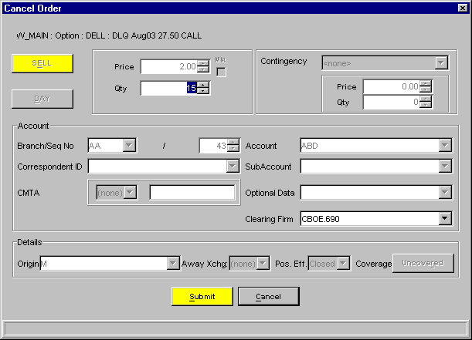  - Adjust the quantity that you wish to cancel and click Submit.  - To exit without canceling the order, click Cancel.
➢ | Update  To update order information for an unfilled order, highlight the order, right mouse click to display the Order Status Menu, and select Update. The Update Order window will display.  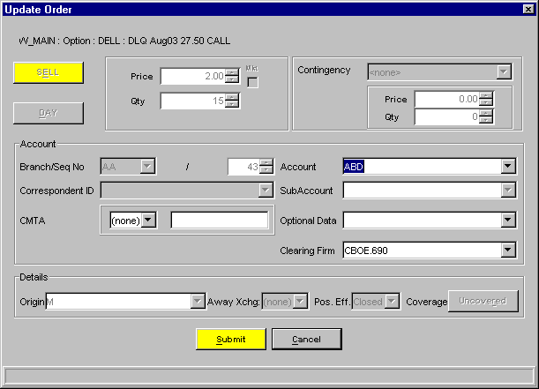  - Make changes to the unfilled order quantity and click UPDATE.  - To exit without updating the order, click Exit.
➢ | Order History  To display the history for an order, highlight the order, right mouse click to display the Order Status Menu, and select Order History. The Order History window will display.  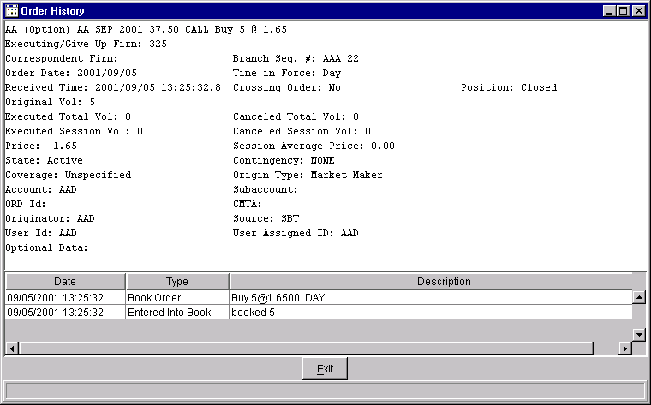
➢ | Edit Preferences  To edit preferences for an order or quote, highlight the order or quote, right-mouse click on the order or quote and select Edit Preferences. The Edit Preferences window will display. For instructions on screen customization, see Section 1: Customize Market Display, page 11.  - Update row or column preferences and click Ok.  - To exit without changing preferences, click Exit.

Spread Creation  Entry | To create a new strategy product, select Spread Creation Entry from the Order Menu. The Spread Order Entry window will display.  Note: CBOEdirect currently does not support strategy product creation for Hybrid classes.  CBOEdirect provides three methods for entering a strategy product: Strategy Containing Leg, Strategy Match and Strategy Assist.

Strategy Containing Leg
Under this method, you can specify one leg of the product and the system will return a list of the spread products that contain the specified leg.
- Select a trading session, product type and class from the dropdown lists. Click Query. The system will generate the spread products that contain the specified leg.
- Select the product. Click Find. The spread product displays on the Market Display window.
- From the Order Menu, select Add New Order. The Add Strategy Order window displays with the spread product information.
 | 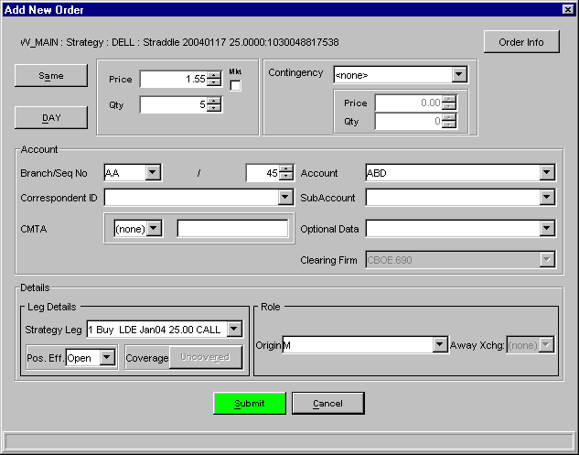
- Indicate whether the order is the Same or Opposite, Day or GTC by clicking the appropriate buttons.
- Enter the price and quantity.
- Select the contingency type from the Contingency drop down list. If the contingency type selected requires a price and quantity, use the up/down arrows until the desired amounts are reached.
- The Account section of the window displays the order's account fields.
- The branch ID defaults to the branch ID set in your preferences; sequence number increments to the next order entry number or the number you set in your preferences; account defaults to the user acronym (limited to three characters); give up firm defaults to the set user give up firm.
Note: Two or more CBOEdirect users for the same firm cannot utilize the same branch ID and sequence number. The CBOEdirect Help Desk can assist users in setting up unique branch IDs and sequence numbers.

Improper logout from CBOEdirect prevents the order sequence number from being saved. When you login again, the sequence number will begin at the same number as your previous login session.
The subaccount field is required for Futures and can include up to 10 alphanumeric characters. Firms that do not have subaccounts can enter their account information in this field after confirmation from their clearing firm.

 | - In the Details section of the window, the leg details defaults to Open and Uncovered. Update fields as needed.
 | - To view strategy order information, click Order Info. The strategy legs will display on the left panel of the window and the strategy order's calculated price and quantity will display on the right panel. Update the calculated fields as desired. Click OK to exit the window.
 | 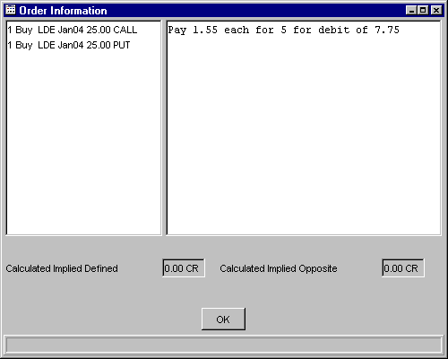
- To enter the new strategy order, click Submit.
- If you decide not to proceed, click Cancel to close the window.

Strategy Match
Under the Strategy Match method, you must specify fully the legs of the spread product. Click the Strategy Match tab to display the window.
- Add a new strategy product
- For each leg,
- Select the trading session, product type, class and series from the dropdown lists.
- Click on the combined buy/sell button to select the order type.
- Enter the quantity. Click Add. Click Find. The spread product exists and displays on the Market Display window.
- Update a strategy leg
- Select the leg you wish to modify.
- Update the information as needed. Click Update. The updated strategy leg will display. Click Add. Click Find. The spread product exists and displays on the Market Display window.
- Delete a strategy leg
- Select the leg you wish to delete.
- Click Delete. The leg will be removed from the system. Click Add. Click Find. The spread product exists and displays on the Market Display window.
- From the Order Menu, select Add New Order. The Add Strategy Order window displays with the spread product information.
- Indicate whether the order is the Same or Opposite, Day or GTC by clicking the appropriate buttons.
- Enter the price and quantity.
- Select the contingency type from the Contingency drop down list. If the contingency type selected requires a price and quantity, use the up/down arrows until the desired amounts are reached.
- The Account section of the window displays the order's account fields.
- The branch ID defaults to the branch ID set in your preferences; sequence number increments to the next order entry number or the number you set in your preferences; account defaults to the user acronym (limited to three characters); give up firm defaults to the set user give up firm.
Note: Two or more CBOEdirect users for the same firm cannot utilize the same branch ID and sequence number. The CBOEdirect Help Desk can assist users in setting up unique branch IDs and sequence numbers.
Improper logout from CBOEdirect prevents the order sequence number from being saved. When you login again, the sequence number will begin at the same number as your previous login session.
The subaccount field is required for Futures and can include up to 10 alphanumeric characters. Firms that do not have subaccounts can enter their account information in this field after confirmation from their clearing firm.
 | - In the Details section of the window, the leg details defaults to Open and Uncovered. Update fields as needed.
 | - To view strategy order information, click Order Info. The strategy legs will display on the left panel of the window and the strategy order's calculated price and quantity will display on the right panel. Update the calculated fields as desired. Click OK to exit the window.
- To enter the new strategy order, click Submit.
- If you decide not to proceed, click Cancel to close the window.

Strategy Assist
Under the Strategy Assist method, CBOEdirect will pre-fill a second leg based on the selections of the first leg. Click the Strategy Assist tab to display the window.
- To add a strategy product
- Click Anchor Leg. The Class/Product Selection window displays. Select a product type, product class and series from the dropdown lists. Click Ok. The spread product displays.
- Click Build. The spread product displays.
- If required, set the Price offset and Month offset for the strategy type by using the up/down arrows until the desired amount is reached.
- Click on the combined buy/sell button to select the order type.
- Set the quantity and select the trading session. Click Find. The spread product displays on the Market Display window.
- Update a strategy leg
- Select the leg you wish to modify.
- Update the information as needed. Click Update. The updated strategy leg will display. Click Find. The spread product displays on the Market Display window.
- Delete a strategy leg
- Select the leg you wish to delete.
- Click Delete. The leg will be removed from the system. Click Find. The spread product displays on the Market Display window.
- From the Order Menu, select Add New Order. The Add Strategy Order window displays with the spread product information.
- Indicate whether the order is the Same or Opposite, Day or GTC by clicking the appropriate buttons.
- Enter the price and quantity.
- Select the contingency type from the Contingency drop down list. If the contingency type selected requires a price and quantity, use the up/down arrows until the desired amounts are reached.
- The Account section of the window displays the order's account fields.
- The branch ID defaults to the branch ID set in your preferences; sequence number increments to the next order entry number or the number you set in your preferences; account defaults to the user acronym (limited to three characters); give up firm defaults to the set user give up firm.
Note: Two or more CBOEdirect users for the same firm cannot utilize the same branch ID and sequence number. The CBOEdirect Help Desk can assist users in setting up unique branch IDs and sequence numbers.
Improper logout from CBOEdirect prevents the order sequence number from being saved. When you login again, the sequence number will begin at the same number as your previous login session.
The subaccount field is required for Futures and can include up to 10 alphanumeric characters. Firms that do not have subaccounts can enter their account information in this field after confirmation from their clearing firm.
 | - In the Details section of the window, the leg details defaults to Open and Uncovered. Update fields as needed.
 | - To view strategy order information, click Order Info. The strategy legs will display on the left panel of the window and the strategy order's calculated price and quantity will display on the right panel. Update the calculated fields as desired. Click OK to exit the window.
- To enter the new strategy order, click Submit.
- If you decide not to proceed, click Cancel to close the window.

Execute Menu

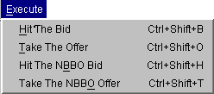 | To display the Execute Menu:  - Click Execute on the Menu Bar on the Market Display window or  - Press [Alt]-[E] from anywhere on the window.  The execution options will display. If a menu option is unavailable, it will display grayed out and no action will take place if the option is selected.
Hit the Bid | Highlight a product, then select Hit the Bid from the Execute Menu or click on the Mkt Bid Qty or Mkt Bid Price field of the series you wish to trade. The Hit the Bid window will display. You can also display the window by pressing Ctrl+Shift+B.
 | 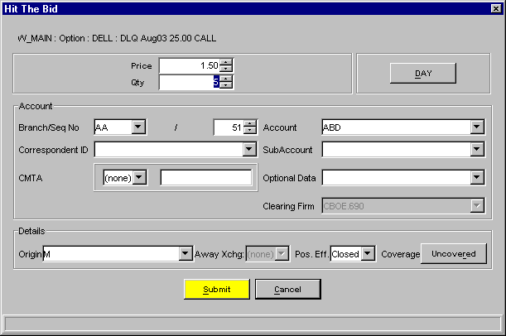
- The price and quantity will default to the Mkt Bid values displayed on the Market Display window for the series. The order defaults to a Day order. If you wish to adjust the numbers, click on the up and down arrow counters or highlight the price and quantity values and key over them with new values.
- Indicate whether the order is for the day or immediate or cancel by clicking on the appropriate button.
- The Account section of the window displays order account fields. Update the fields as required.
- The branch ID defaults to the branch ID set in your preferences; sequence number increments to the next order entry number or the number you set in your preferences; account defaults to the user acronym (limited to three characters); give up firm defaults to the set user give up firm.

Note: Two or more CBOEdirect users for the same firm cannot utilize the same branch ID and sequence number. The CBOEdirect Help Desk can assist users in setting up unique branch IDs and sequence numbers.
Improper logout from CBOEdirect prevents the order sequence number from being saved. When you login again, the sequence number will begin at the same number as your previous login session.
The subaccount field is required for Future orders. This field is limited to 10 alphanumeric characters.
- The Details section of the window displays order detail fields. Update fields as needed.
- Select the user role from the Origins drop down list.
- Select the order's coverage type by clicking on the corresponding button.
- To process the order, click Submit.
- To exit without processing the order, click Cancel.
Take the Offer | Highlight a product, then select Take the Offer from the Execute Menu or click on the Mkt Ask Qty or Mkt Ask Price field of the series you wish to trade. The Take the Offer window will display. You can also display the window by pressing Ctrl+Shift+O.
 | 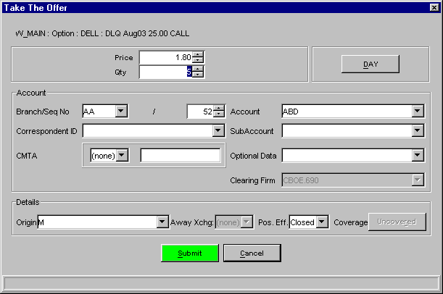
- The price and quantity will default to the Mkt Ask values displayed on the Market Display window for the series. The order defaults to a Day order. If you wish to adjust the numbers, click on the up and down arrow counters or highlight the price and quantity values and key over them with new values.
- Indicate whether the order is for the day or immediate or cancel by clicking on the appropriate button.

- The Account section of the window displays order account fields. Update the fields as required.
- The branch ID defaults to the branch ID set in your preferences; sequence number increments to the next order entry number or the number you set in your preferences; account defaults to the user acronym (limited to three characters); give up firm defaults to the set user give up firm.
Note: Two or more CBOEdirect users for the same firm cannot utilize the same branch ID and sequence number. The CBOEdirect Help Desk can assist users in setting up unique branch IDs and sequence numbers.
Improper logout from CBOEdirect prevents the order sequence number from being saved. When you login again, the sequence number will begin at the same number as your previous login session.
The subaccount field is required for Future orders. This field is limited to 10 alphanumeric characters.
- The Details section of the window displays order detail fields. Update fields as needed.
- Select the user role from the Origins drop down list.
- The order's coverage type defaults to Uncovered.
- To process the order, click Submit
- To exit without processing the order, click Cancel.
Hit the NBBO Bid | To hit the NBBO bid when CBOE is part of the bid, highlight a product, then select Hit the NBBO from the Execute Menu or click on the NBBO Bid Qty or NBBO Bid Price field of the series you wish to trade. The Hit the NBBO Bid window will display. Pressing Ctrl+Shift+H will also open the window.  Note: The NBBO will only display for the W_MAIN session.
 | 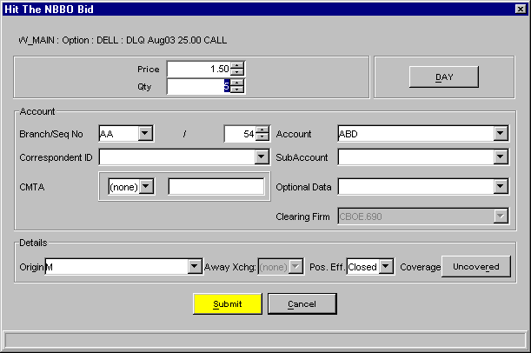
- The price and quantity will default to the NBBO Bid values displayed on the Market Display window for the series. The order defaults to a Day order. If you wish to adjust the numbers, click on the up and down arrow counters or highlight the price and quantity values and key over them with new values.
- Indicate whether the order is for the day or immediate or cancel by clicking on the appropriate button.
- The Account section of the window displays order account fields. Update the fields as required.
- The branch ID defaults to the branch ID set in your preferences; sequence number increments to the next order entry number or the number you set in your preferences; account defaults to the user acronym (limited to three characters); give up firm defaults to the set user give up firm.
Note: Two or more CBOEdirect users for the same firm cannot utilize the same branch ID and sequence number. The CBOEdirect Help Desk can assist users in setting up unique branch IDs and sequence numbers.
Improper logout from CBOEdirect prevents the order sequence number from being saved. When you login again, the sequence number will begin at the same number as your previous login session.
The subaccount field is required for Future orders. This field is limited to 10 alphanumeric characters.
- The Details section of the window displays order detail fields. Update fields as needed.
- Select the user role from the Origins drop down list.
- Select the order's coverage type.
- To process the order, click Submit. CBOEdirect will submit the order to the CBOE based on the NBBO price.
- To exit without processing the order, click Cancel.
Take the NBBO Offer | To take the NBBO offer when CBOE is part of the offer, highlight a product, then select Take the NBBO Offer from the Execute Menu or click on the NBBO Ask Qty or NBBO Ask Price field of the series you wish to trade. The Take the NBBO Offer window will display. The window will also display by pressing Ctrl+Shift+T.  Note: The NBBO will only display for the W_MAIN session.
 | 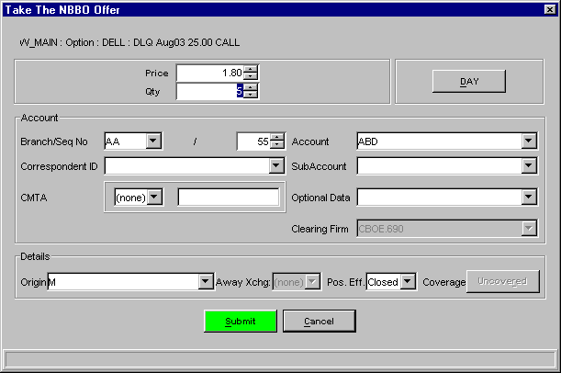
- The price and quantity will default to the NBBO Ask values displayed on the Market Display window for the series. The order defaults to a Day order. If you wish to adjust the numbers, click on the up and down arrow counters or highlight the price and quantity values and key over them with new values.
- Indicate whether the order is for the day or immediate or cancel by clicking on the appropriate button.
- The Account section of the window displays order account fields. Update the fields as required.
- The branch ID defaults to the branch ID set in your preferences; sequence number increments to the next order entry number or the number you set in your preferences; account defaults to the user acronym (limited to three characters); give up firm defaults to the set user give up firm.
Note: Two or more CBOEdirect users for the same firm cannot utilize the same branch ID and sequence number. The CBOEdirect Help Desk can assist users in setting up unique branch IDs and sequence numbers.
Improper logout from CBOEdirect prevents the order sequence number from being saved. When you login again, the sequence number will begin at the same number as your previous login session.
The subaccount field is required for Future orders. This field is limited to 10 alphanumeric characters.
- The Details section of the window displays order detail fields. Update fields as needed.
- Select the user role from the Origins drop down list.
- The order's coverage type defaults to Uncovered.
- To process the order, click Submit. CBOEdirect will submit the order to the CBOE based on the NBBO price.
- To exit without processing the order, click Cancel.

Request for Quote

Quote Request | To request a quote, highlight any series for a class and select Quote Request or press Ctrl+Shift+R. The Quote Request window will display.
 | 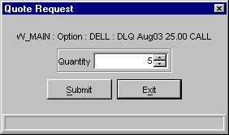
- Enter the quantity (optional).
- Click Submit. The series requested for quote will display in red on the Market Display window.
- If you decide you do not wish to proceed with the quote request, click Cancel to close the Quote Request window.

Ticker Menu

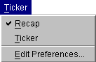 | To display the Ticker Menu:  - Click Ticker on the Menu Bar on the Market Display window, or  - Press [Alt]-[K] from anywhere on the window.  The ticker options will display. If a menu option is unavailable, it will display grayed out and no action will take place if the option is selected.
Recap / Ticker | CBOEdirect allows you to view underlying security market data in the Ticker frame of the Market Display window. Click on a class tab and select the Recap or Ticker option from the Ticker Menu. Recap and ticker data will display in the frame below the trading information section of the Market Display window.

Recap
From the recap line you can view a snapshot of the day's transactions of the underlying security of the class as well as any indicators of news alerts.

Ticker
The sliding ticker line displays sales and transactions of the underlying security.
 | You can only view recap and ticker data for the selected product tab.

Edit Preferences | You can choose the ticker and recap information you wish to view by selecting Edit Preferences from the Ticker Menu. The Ticker Configuration window displays corresponding with the selected Recap or Ticker option.

Recap Enablements
The enablements tab defaults to display all recap information. You can choose the recap information you wish to display by selecting/deselecting the appropriate check boxes.
- To save your configuration, click Submit. Click Confirm.
- If you decide to retain the default settings, click Cancel.

Ticker Enablements
The enablements tab defaults to display all ticker information. You can choose the ticker information you wish to display by selecting/deselecting the appropriate check boxes.
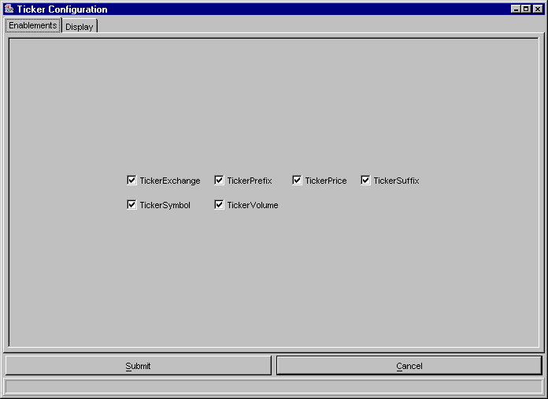
- To save your configuration, click Submit. Click Confirm.
- If you decide to retain the default settings, click Cancel.

Display
To further define your ticker display, select the Display tab. From this window, you can set a new font type and color for your display.
- To select a new font, select the type, size and style from the drop down lists. The new font will display in the Preview Colors section of the screen.
- To change the foreground or background color of the ticker, select the appropriate radio button.
- From the Swatches tab, click on the color you wish to display. The new color is viewable in the Preview Colors section of the screen.
- To save the configuration, click Submit. Click Confirm.
- To retain the default settings, click Cancel.
- Click the HSB tab to set your hue, saturation and brightness. Place your mouse on the scroll bar button and adjust your color preference. You can view the changes in the Preview Colors section of the window.
- To save the configuration, click Submit. Click Confirm.
- To retain the default settings, click Cancel.
- Click the RGB tab to set your red, green and blue color model. Place your mouse on the side scroll bar and adjust your color preference. You can view the changes in the Preview Colors section of the window.
- To save the configuration, click Submit. Click Confirm.
- To retain the default settings, click Cancel.

View Menu

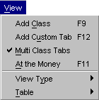 | To display the View Menu:  - Click View on the Menu Bar on the Market Display window, or  - Right mouse click on the series you wish to trade and select View, or  - Press [Alt]-[V] from anywhere on the window.  The view options will display. If a menu option is unavailable, it will display grayed out and no action will take place if the option is selected.
Add Class | The Add Class option is used to display a product class for trading on CBOEdirect. From the View Menu, select Add Class or press F9 from anywhere on the window. The Add Class window will display.
Select the trading session, product type and product class from the drop down lists. Click Add Tab. The selected class will appear on the Market Display window.
Note: CBOEdirect currently allows users to display only one Market Display window and a maximum of three class tabs within the window.
If you would like CBOEdirect to retain the trading session and product type settings, select the Set as Default checkbox. The next class selection will automatically display with these values so you need only define the product class.
If you would like CBOEdirect to select the at-the-money series for the product class, select the Select ATM checkbox. CBOEdirect will highlight the ATM series on the Market Display.
To exit the Add Class window, click Close.
Add Custom Tab | The Add Custom Tab option is used to create custom tabs that contain multiple product classes for trading on CBOEdirect. From the View Menu, select Add Custom Tab or press F12 from anywhere on the window. The Add Tab window will display.
To add multiple product classes to a tab:
- Select a trading session from the Trading Session drop down box.
- Select a product type from the Product Type drop down box.
- Select a product class. Click Add Class. The product class will display in the text box section of the window. You can continue to add product classes to the tab as long as the classes are of the same session and product type.
  - Note: There are limits for the number of product classes of each product type that can be added to a single tab.
    - An Option or Strategy tab can only contain one product class
    - A Futures tab can contain up to 50 product classes
    - An Equity tab can contain up to 200 product classes - Equity product classes are not currently supported.
- When you select your first product class, the system defaults to set the name of the product class as the Custom Tab Title. You can override the default setting by entering a custom title for your tab in the Custom Tab Title text box.
- If you wish to remove a product class from your selection, select the product class from the text box and click Remove Selected Classes. The product class will be removed from the text box.
- To remove multiple product classes, hold down the Shift key on your keyboard and select the product classes. Click Remove Selected Classes. The product classes will be removed from the text box.
- To create your custom tab, select Submit. Click Confirm. The system will display a tabbed window listing all the series for the product classes with related market data.
- If you decide not to create a custom tab, click Cancel.
To view a custom tab example, refer to the Market Display Window section, page 6.

Remove a Tab
To remove a tab, right mouse click on the tab and select Remove.

Modify a Tab
To modify product classes for a tab, right mouse click on the tab and select Modify. The Add Tab window displays.
From this window, you can add or remove product classes and edit the title. Click Submit. Click Confirm. The modified tab will display on the Market Display window.
Note: If all the product classes are removed and you try to Submit the changes, the system will prompt you that if the changes are finalized, the tab would be empty, and therefore removed from the Market Display window.
Multi Class Tabs | CBOEdirect allows users to view a maximum of 3 class tabs on the Market Display window. If you wish to view only one class tab on the Market Display, deselect the Multi Class Tabs option from the View Menu.  Note: If your trading session is configured to display multiple class tabs and you decide to switch to single tab format during the trading session, the current class tabs will remain in the window until you attempt to add a new class. At that time, the system will remove the class tabs from the window.  For examples of multi class and single class tabs, refer to the Market Display Window, page 6.
At the Money | To facilitate trading, CBOEdirect will center and highlight the at-the-money series when the underlying stock symbol or the reporting class symbol is entered for trading on the Market Display window. You can request to view the at-the-money series anytime during trading.  From the View Menu, select At the Money or press F11 from anywhere on the window. The at-the-money series for option products will be highlighted and accessible for trading.  For examples, refer to the Market Display Window, page 6.
View Type | For ease of trading, you have the option to view the Market Display trading data by single row or side by side formats. From the View Menu, select View Type, then select your display choice.
 | 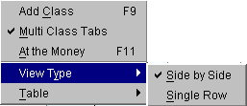
CBOEdirect will rearrange the Market Display data to your viewing preference.
Note: Only option classes will display in both side-by-side and single row formats. Other product types will only display in single row format.
For examples, refer to the Market Display Window, page 6.
Table | There are several ways to customize your Market Display. From the View Menu, select Table. From this window, you can display all data columns and rows, grow or shrink the window and edit column and row preferences.
 | 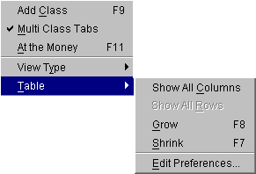
- To display all the data columns, highlight Show All Columns. All the data columns will appear on the Market Display.
- To display all the series, select Show All Rows. All the series will become visible on the Market Display.
- To increase the size of the data rows and columns, highlight Grow or press F8 from anywhere on the window.
- To decrease the size of the data rows and columns, highlight Shrink or press F7 from anywhere on the window.
- To Edit Preferences, refer to the Customize Market Display section, page 11.

Window Menu

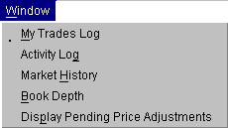 | To display the Window Menu:  - Click Window on the Menu Bar on the Market Display window, or  - Right mouse click on the series you wish to trade and select Window, or  - Press [Alt]-[W] from anywhere on the window.  The window options will display. If a menu option is unavailable, it will display grayed out and no action will take place if the option is selected.
My Trades Log | To view the Trades Log, highlight a series on the Market Display window and select My Trades Log from the Window Menu. The Trades Log window will open for the selected series. The window will automatically update as your orders are executed.
- To change the display to view a different class and/or series or all classes and series, click on the Class/Product Selection button. The Class/Product Selection window will open.
- Select the product type, product class and product series from the box lists.
- Click Ok.
- If you decide you do not want to change the Class/Product selection, click CANCEL to close the Class/Product selection window.
Trades are listed by date/time stamp from the most recent to the earliest trade in the current trading session.

Edit Column Preferences
You can customize your Trades Log window by selecting or deselecting specific columns to display. To filter columns, right mouse click on a data row. Select Edit Preferences. The Edit Column Preferences window will display.

- Select or deselect columns for viewing and modify column arrangement as desired.
- To save your changes, click Ok.
- If you wish to retain the default settings, click Cancel.
For instructions on screen customization, refer to the Customize Market Display section, page 11.
 | - Note: Multiple Trades Log windows can be created during a trading session. You can save the configuration of each window from the Task Toolbar. For detailed information, see the Task Toolbar section (Task Toolbar, page 32) of the Reference Guide.
Activity Log | Highlight a series and select Activity Log from the View Menu. The Activity Log window will display for the Current Selected Product Class.
- To view the activity log for another class:
- Click the Class/Product Selection button. The Class/Product Selection window will open.
- From the box lists, select the trading session, product type and product class to display. Click Ok.
- If you decide you do not wish to change the selection, click Cancel.
- The date field defaults to the current date. Click the Calendar button or the up and down arrows to select the desired date.
- The time field defaults to the current time. Update as desired.
- Select the product and activity type you wish to display from the list boxes in the Filter section of the window.
- Click Submit.
- All activity for the selected product class will display from the most recent to the earliest set by the date/time selection.
- Click Submit to update the selection criteria and/or refresh the display.
- Click Close to exit the display.

Edit Column Preferences
You can customize your Activity Log window by selecting or deselecting specific columns to display. To filter columns, right mouse click on a data row. Select Edit Preferences. The Edit Column Preferences window will display.
- Select or deselect columns for viewing and modify column arrangement as desired.
- To save your changes, click Ok.
- If you wish to retain the default settings, click Cancel.
For instructions on screen customization, refer to the Customize Market Display section, page 11.
 | - Note: Multiple Activity Log windows can be created during a trading session. You can save the configuration of each window from the Task Toolbar. For detailed information, see the Task Toolbar section (Task Toolbar, page 32) of the Reference Guide.
Market History | Highlight a series and select Market History from the View Menu. The Market History window will display for the Current Selected Product Class and series.
- To display market history for a different class:
- Click the Class/Product Selection button on the Query section of the Market History window. The Class/Product Selection window will open.
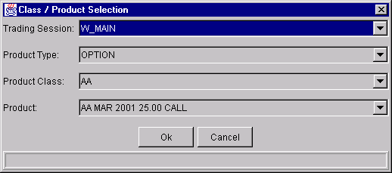
- From the box lists, select the trading session, product type, product class and series to display.
- Click Ok.
- If you do decide you do not wish to change the selection, Click Cancel.
- The date field defaults to the current date. Click the button or the up and down arrows to select the desired date.
- The time field defaults to the current time. Update as desired.
- The display defaults to both quotes and trades. Select the appropriate radio button if you want a different listing.
- Quotes and trades are listed by date/time stamp from the most recent to the earliest in the current trading session.
- Click Submit to update selection criteria and refresh display.
- Click Close to exit the display.

Edit Column Preferences
You can customize your Market History window by selecting or deselecting specific columns to display. To filter columns, right mouse click on a data row. Select Edit Preferences. The Edit Column Preferences window will display.
- Select or deselect columns for viewing and modify column arrangement as desired.
- To save your changes, click Ok.
- If you wish to retain the default settings, click Cancel.
For instructions on screen customization, refer to the Customize Market Display section, page 11.
 | Note: Multiple Market History windows can be created during a trading session. You can save the configuration of each window from the Task Toolbar. For detailed information, see the Task Toolbar section (Task Toolbar, page 32) of the Reference Guide.
Book Depth | Highlight a series and select Book Depth from the View Menu. The Book Depth window will display the Selected Product Class and series for the current session. Book depth information is updated in real-time.
- Real-time updates are provided for the first five levels of market depth. To obtain updated book depth data, click Refresh.
- To have the window refresh automatically, select the Auto Refresh check box.
 | Note: Multiple Book Depth windows can be created during a trading session. Each Book Depth window configuration can be saved using the Task Toolbar. For detailed information, see the Task Toolbar section (Task Toolbar, page 32) of the Reference Guide.
Display Pending Price Adjustments | Price adjustments on orders are caused by changes in the underlying security, such as stock splits, stock dividends, etc.  To view the effects of pending price adjustments on your outstanding orders:  - Highlight Display Pending Price Adjustments from the View Menu or  - Right mouse click on a series and select Display Pending Price Adjustments from the View Menu.  The Pending Price Adjustment window will open.
Select the trading session, product type, product class and product from the drop down lists. Click Query. For the selected product, you can view:
- original and new series
- original and new quantity
- remaining and new quantity
- old and new price

