

Production Issues Tracking System

User Training Guide

Table of Contents

Table of Contents 2
Getting Started 3
Steps: Launching the Remedy User Tool 3
Opening the Production Issues Tracking System (PITS) form 6
Status Phase Transitions 7
Create a Ticket for an Issue that Occurred in Production 8
Flow of Events for Entering a Production Issue 8
Create a Ticket for an Issue that Occurred during Testing 13
Flow of Events for Entering a Testing Issue 13
Description and Use of Tabs 17
Problem Information 17
General Information 17
User Information 18
Problem Forwarding 19
Contact Responsibility 19
Solution 20
Defect 20
Audit Trail 21
Search Features 22
Setting Search Options 22
Using Predefined Searches 29
Advanced Search Features 30
Introduction 30
To Access the Advance Search Bar 30
The Field Label 32
Handling a Date Range 40
Steps: Using the Advance Search Bar 55
Search Criteria 56
Saving Search Criteria 56
Steps: Saving Search Criteria 56
Working with a Saved Search 57
Steps: Re-executing the Saved Search 57
Working with Recent Search Requests 58

Getting Started
The Help Desk, Operations, Trading Operations and API groups will enter issues that occur in the production environment and the testing environments into the Production Issues Tracking System (PITS) form in Remedy.

Steps: Launching the Remedy User Tool
Double-click the appropriate desktop icon that launches the AR System.


The AR System logo displays and the main window opens in the background. A Login dialog box appears on the monitor screen.
AR System Main Window
AR System Login Dialog Window

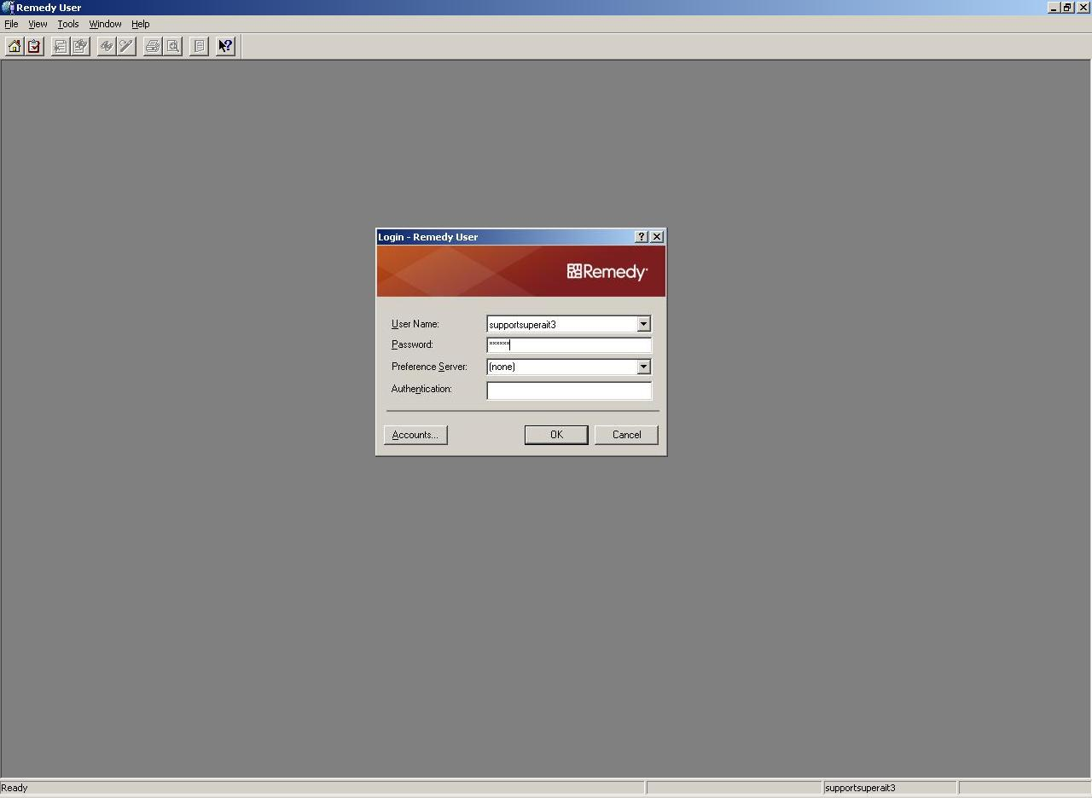
Remedy User Tool open with Login Dialog

Alternatively, open the Start menu, and select Programs. See Figure below.
  - From the list of programs, select Action Request System.
  - Finally, select Remedy User. The AR System logo displays and the main window opens in the background. A Login dialog box appears on the monitor screen, as seen in Figure above.

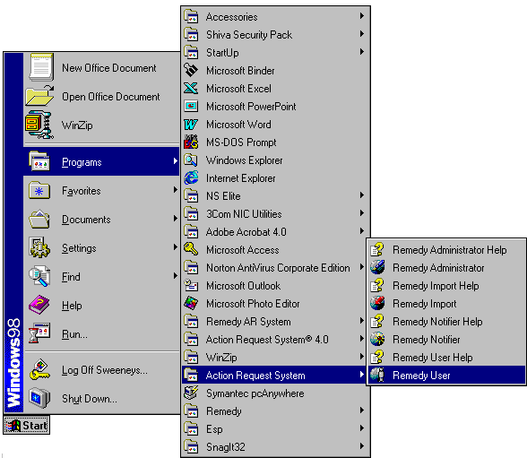

Launching Remedy User from the MS Windows Programs menu

Logging In - Launching the AR System causes a Login dialog box to appear. For security reasons, everyone who works with the AR System has a Remedy login name and a password — both are case sensitive. Therefore, remember to type them into the Login dialog box exactly as they are spelled.

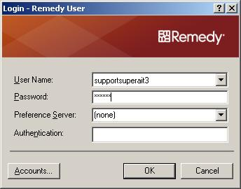
The Login Dialog Box

Most of the ID’s consist of a person’s last name and first initial. Notice that the password appears as a row of asterisks.

Opening the Production Issues Tracking System (PITS) form

To open the PITS form press the icon , or select “File”> “Open”> “Object List” from the menu bar. The following dialog form will open:

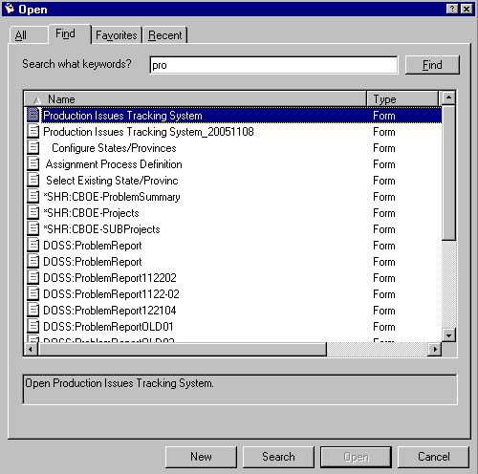

On the find tab, type in “pro” and press the find button. Select the Production Issues Tracking System as seen above and press the “New” button at the bottom of the dialog window. This will open the PITS form. When creating a new PITS ticket the form must be opened in a green window as seen in the diagram on the next page. If you happen to open the form in the Search mode, the screen will be “Blue”. You can easily toggle to the “Submit” mode (green screen) by pressing the icon, on the icon menu bar.

When a ticket is initially opened the ‘Priority’ defaults to “Medium” and ‘Status’ defaults to “New.” The user must fill in all the required fields (bold fields).

Other required fields are:

Ticket Initiator – Name of the person who is submitting the issue
User Acronym – The acronym of the Firm user reporting the issue. If there is no Firm acronym associated with the issue, type None in the Acronym field and hit the Enter key.
Summary – One line description of the problem
Specific Complaint – Detailed description of the issue that was reported
Project – The system where the problem occurred
Source - The location of where the problem occurred
Origin – Where the problem originated
Original Load – What application load the issue is associated with. The default is NONE.
Organization - Group name of the person who entered the issue
D/T Problem Occurred – The data and time the problem occurred
Sysops Call Receiver – The Systems Operator who received the call

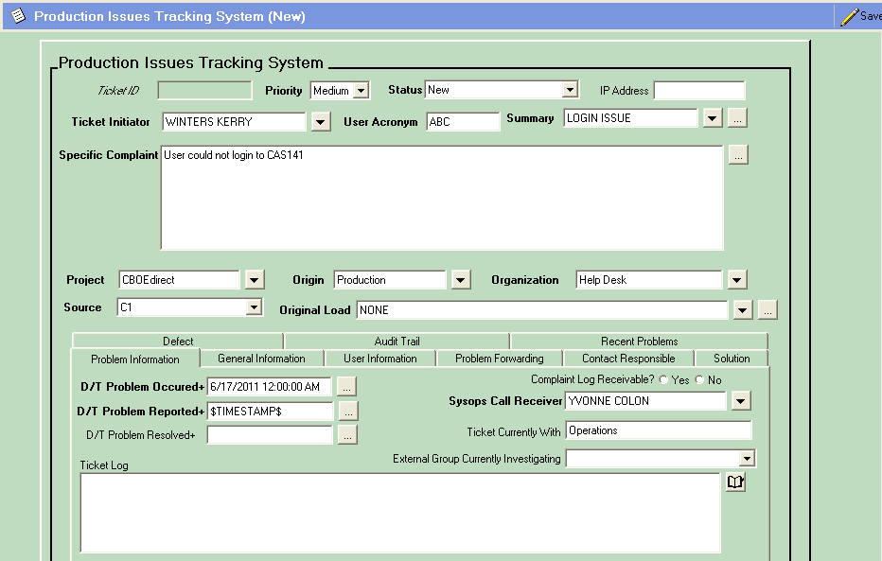

Status Phase Transitions
The Production Issues Tracking System (PITS) has 11 statuses. Below is a list of the statuses, with definitions:
- New – A new issue was submitted but has not been investigated
- Work in Progress – The issue is being investigated
- Forwarded Once – The issue was forwarded to a new party for investigation
- Forwarded 2 Times – The issue was forwarded a second time for investigation
- Forwarded 3 Times - The issue was forwarded a third time for investigation
- Forwarded 4 Times - The issue was forwarded a fourth time for investigation
- Forwarded 5 Times - The issue was forwarded a fifth time for investigation
- Pending – The issue has not been resolved and is awaiting further investigation
- Defect – The issue is a defect in the system
- Enhancement – The issue is an enhancement to the system
- Resolved – The issue has been resolved
- Closed – The issue is automatically set to Closed from Resolved by Remedy after 10 days

Note: A ticket can be forwarded up to 15 times.

Create a Ticket for an Issue that Occurred in Production
Issues that originate in production will be reported using the PITS form. These issues are routed first to Operations for review.

Flow of Events for Entering a Production Issue

- The user selects his/her name from the ‘Ticket Initiator’ field.

Note: The ‘Ticket Initiator’ will receive email notification as the ticket transitions through the investigation process.

- The acronym of the Firm’s user, who is reporting the problem, is entered in the ‘Acronym’ field. If the user’s acronym is unknown, type None and hit Enter on your keyboard. The required fields will populate with N/A. Or, enter your own user’s acronym in the ‘Acronym’ field.

- A one-line summary of the problem is entered in the ‘Summary’ field. Pre-defined summaries are available for selection from the drop down list.

- Details of the problem are entered in the ‘Specific Complaint’ field.

- The user selects the ‘Project’ the issue affects.

- Select where the problem originated from the ‘Origin’ drop down list.

Note: Production issues will automatically route first to Operations for research.

- The user selects his/her group name from the ‘Organization’ drop down list.

- Select the date/time the problem occurred from the ‘D/T Problem Occurred+’ field.

- Information that is acquired after the ticket is opened can be added to the “Ticket Log” field. The “Ticket Log” field is a diary field. Click on the to view if additional information has been added.

- From the ‘User Information’ tab, enter the external users ‘User Contact Name Primary’ and ‘User Contact Phone Primary.’

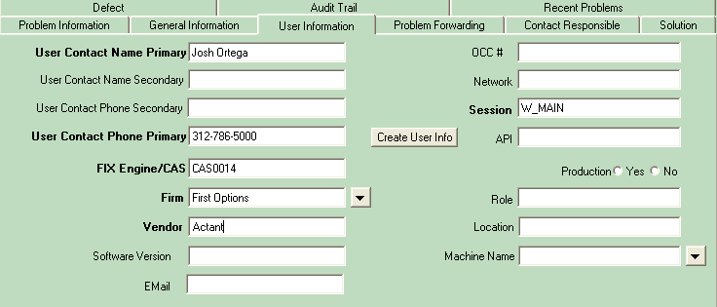

- Click Create User Info. The ‘FIX Engine/CAS’, ‘Firm’, ‘Vendor’ and ‘Session’ fields will automatically populate with the user’s information stored in the database.

- Click Save. Remedy assigns a number to the issue and sends e-mail notification to Operations for review.

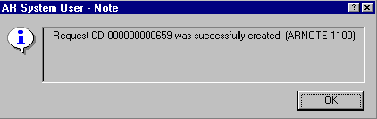

- If Operations cannot resolve the issue, the issue is forwarded to the appropriate group from the Problem Forwarding tab. CBOEdirect issues are forwarded to SBT Support.

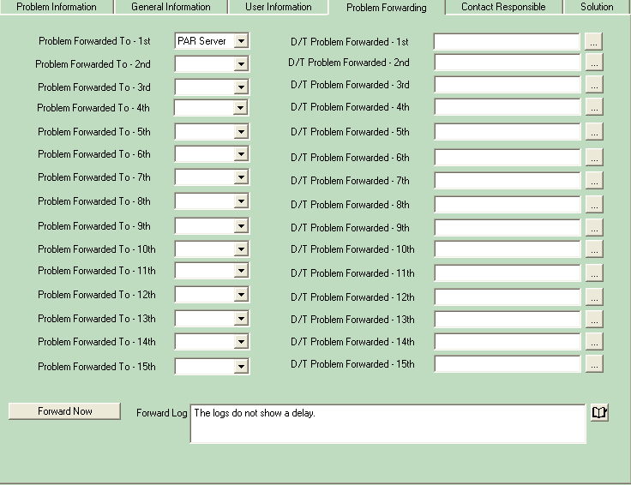

- Select the group you want to forward the issue to from the drop down list.

- Text must be entered in the ‘Forward Log’ field before forwarding to a group. You can populate the field with text as in the example above, or you can enter a blank space and Remedy will recognize it as a character. If you do not populate the ‘Forward Log’ field, the system will generate an error message.

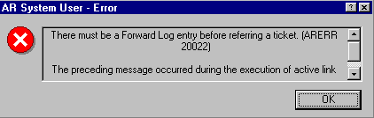

- Click Forward Now.

- If SBT Support or Systems Management determines the issue is a defect, the ‘Defect’ radio button and the affected Systems ‘Sub-project’ group are selected from the ‘Defect’ tab.

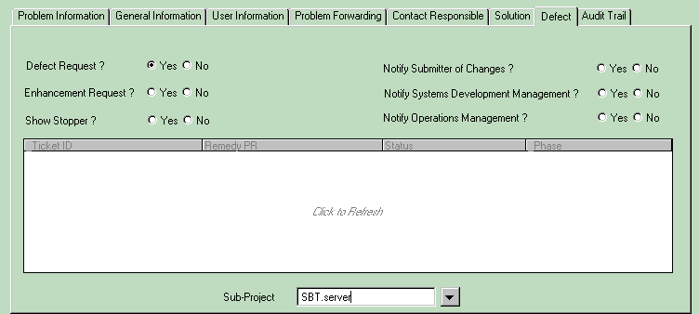

- Click Save. Remedy will create a ticket to track the defect in the Systems Enhancement and Defect Log (SEDL) and link it to the PITS issue. The following message will appear:

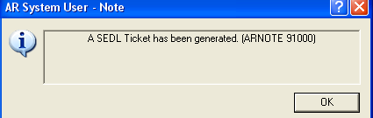

- Once the SEDL ticket has been generated an entry fill displays in table field below.

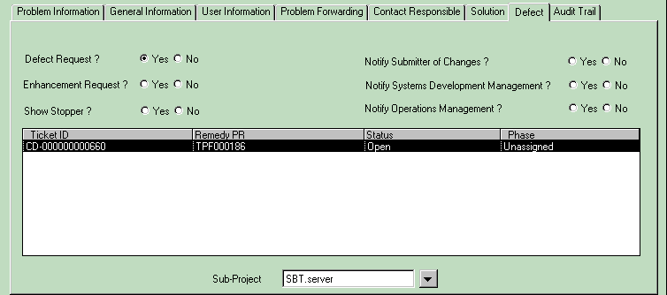

- Remedy will forward the issue to the SEDL form and will send e-mail notification to the selected Systems Sub-project group for investigation.

- If SBT Support or Systems Management determines the issue is an enhancement, the ‘Enhancement’ radio button and the affected Systems ‘Sub-project’ group are selected.

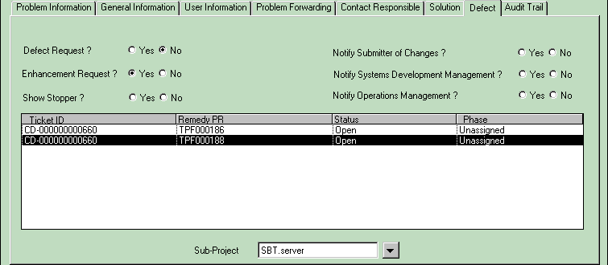

- On ‘Save’, Remedy will forward the issue to the (SEDL) form and will send e-mail notification to the selected Systems Sub-project group for investigation.

The submitter must indicate if the Request is a Defect or Enhancement by selecting “Yes”. If a Request is not marked “Yes” for either ‘Enhancement Request?’ or ‘Defect Request?’ the following error message will appear:

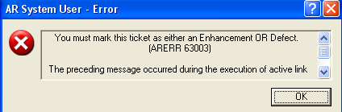

Note: A request cannot be marked as both a Defect and Enhancement at the same time. The following error message will appear:

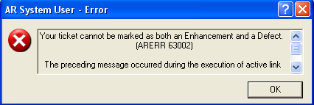

Create a Ticket for an Issue that Occurred during Testing

Issues that originate during the testing phases (i.e., assurance testing, functional testing, API testing, etc.) will be reported using the PITS form. These issues will not be reported to Operations but will be automatically forwarded to the Load Manager for review.

Flow of Events for Entering a Testing Issue

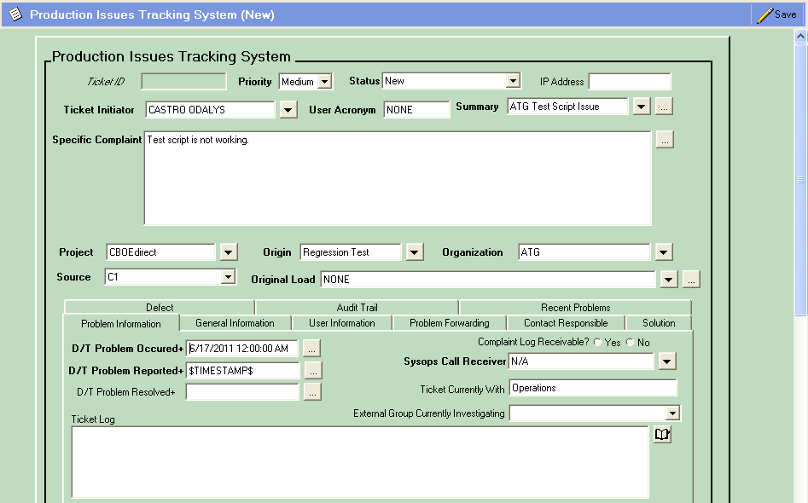

- The user selects his/her name from the ‘Ticket Initiator’ field.

Note: The ‘Ticket Initiator’ will receive email notification as the ticket transitions through the investigation process.

- For testing issues, the Firm’s user acronym is unknown. Therefore, you must type None in the ‘Acronym’ field and hit Enter on your keyboard to populate the acronym required fields in the ‘User Information’ tab with N/A.

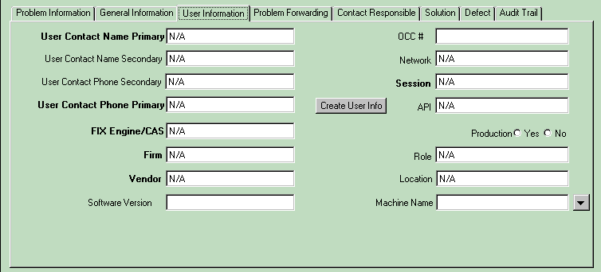

- A one-line summary of the problem is entered in the ‘Summary’ field. Pre-defined summaries are available for selection from the drop down list.

- Details of the problem are entered in the ‘Specific Complaint’ field.

- The user selects the ‘Project’ the issue affects.

- Select where the problem originated from the ‘Origin’ drop down list.

- The user selects his/her group name from the ‘Organization’ drop down list.

- Select the date/time the problem occurred from the ‘D/T Problem Occurred+’ field.

- Click Save. Remedy will automatically forward the issue to the Load Manager for investigation.

Note: Currently, the Load Manager group includes: B. Shively, R. Vazirani, A. Brazhnichenko, D. Zagorski, Bill Gillund, Keith Kiley, Dave Hultquist, Dave Schmitz, Dave Wegener, Linda Gerdes, Stella Ulyanov

- If the Load Manager determines the issue is a defect, the ‘Defect’ radio button and the affected Systems ‘Sub-project’ group are selected from the Defect tab.

- Click Save. Remedy will create a ticket to track the defect in the Systems Enhancement and Defect Log (SEDL) and link it to the PITS issue. The following message will appear:

- Once the SEDL ticket has been generated an entry fill displays in table field below.

- Remedy will forward the issue to the SEDL form and will send e-mail notification to the selected Systems Sub-project group for investigation.

- If the Load Manager determines the issue is an enhancement, the ‘Enhancement’ radio button and the affected Systems ‘Sub-project’ group are selected.

- On Save, Remedy will forward the issue to the (SEDL) form and will send e-mail notification to the selected Systems Sub-project group for investigation.

Description and Use of Tabs

Problem Information
The ‘Problem Information’ tab provides details of when the issue occurred and who is currently investigating.

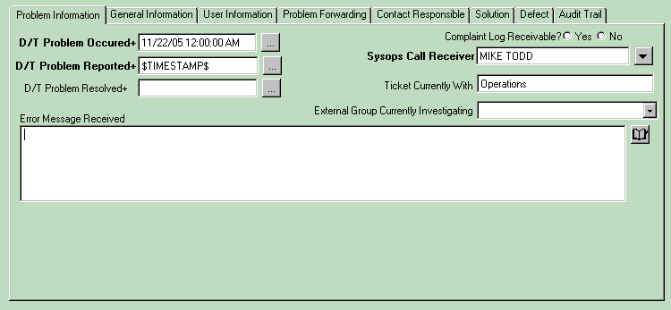

General Information
The ‘General Information’ tab is where attachments can be saved. To add an attachment, move your cursor over the File Name column, right click on the mouse, and then select ‘Add’ and search for the file you wish to attach.

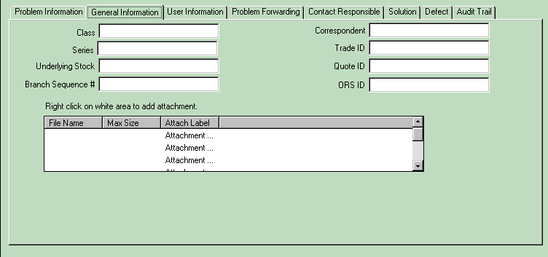

Information related to trade IDs, class, series and underlying stock can be entered in this tab.

User Information
The ‘User Information’ tab is linked to a database that stores information based on user acronym. If the ‘Acronym’ field is populated, clicking on Create User Info will populate the ‘FIX Engine/CAS’, ‘Firm’, ‘Vendor’ and ‘Session’ information for that user.

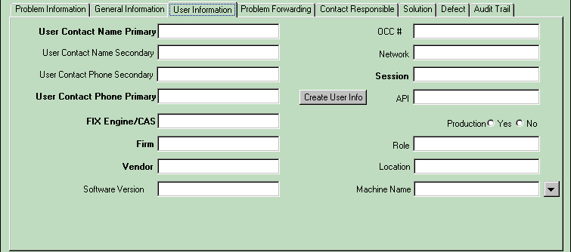

If a user’s acronym is unavailable, type None in the ‘Acronym’ field and then press Enter on your keyboard. The system will populate the required acronym fields with N/A.

Problem Forwarding
The ‘Problem Forwarding’ tab is used to send issues to different groups for investigation.

Contact Responsibility
The ‘Contact Responsibility’ tab shows you primary and secondary contacts for the listed groups.

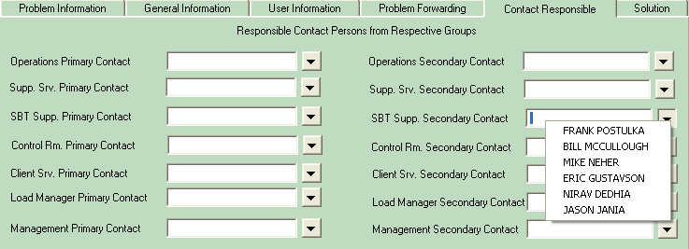

Solution
The ‘Solution’ tab contains the ‘Resolution’ text field that allows a user to enter details of the solution.

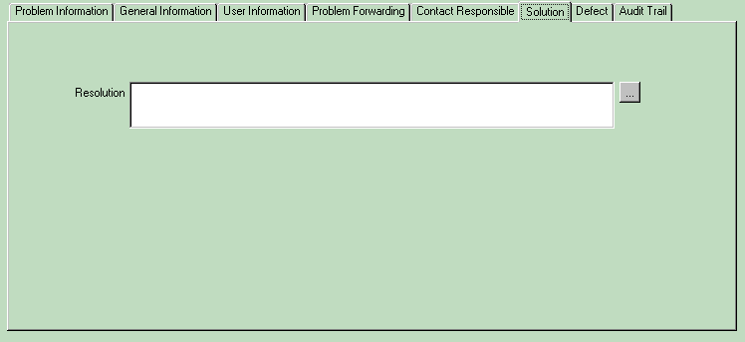

Defect
The ‘Defect’ tab allows Support and Systems Management to declare an issue is a system defect or enhancement.

Audit Trail
The audit trail tab is automatically populated by the system when there are changes made to a ticket. When the ticket is initially created the ‘Submitter’, ‘Create Date’, ‘Last Modified by’, and ‘Modified Date’ fields are populated.

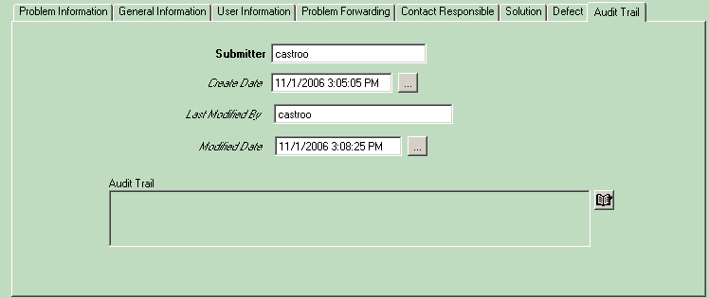

Click on the icon to view the transition of the ticket in the Audit Trail.

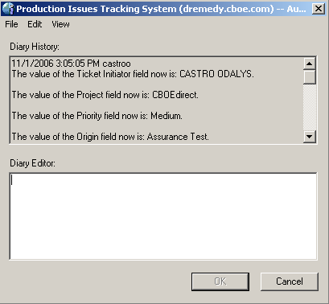

Search Features

Setting Search Options

The Action Request System® (AR System™) provides a number of option settings through the Options dialog box, which is accessed from the Tools menu. Many of the settings should not be changed. However, there are some that should be adjusted.

The figure below illustrates some common options associated with searching:
- Does the support analyst want all field values to clear?
- Would the support analyst rather have the previous search criteria display in the window? Or, should all default values display?
- What record limit does the analyst want on search returns? (This cannot exceed the server setting limit.)
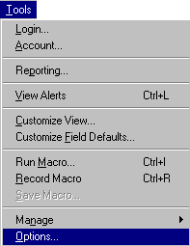
Maximum matches for a search
What happens when a Search window opens?
Tools menu
“Options” command
Behaviors tab

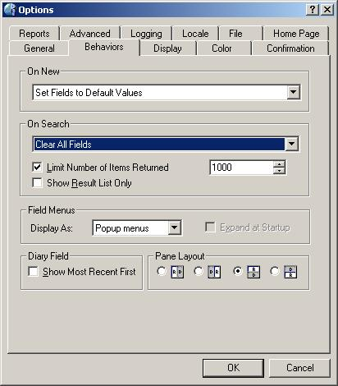

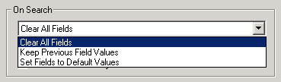
Default value is “Clear All Fields” for “On search” on the Behaviors tab
Setting Search Options
Search by Example

Search by Example simply means filling one or more fields in the Search window with appropriate values that match those cases one is interested in locating.

Some fields require that the value be typed, while others involve selecting a radio button or choosing from a drop-down menu. If multiple fields are used in the search criteria, the logical relationship between them is “AND” which means that all conditions must be true before a match is found. To produce more precise searches, include more fields in the search criteria.

Steps: Using the Search by Example Technique
- Open the Remedy User tool.
- Open the desired form. A Search window for the selected form displays.
- From the Edit menu, select “Clear All”, or press the CTRL+E keys to clear all data from all fields.
- Type, or select, an appropriate value for one or more fields in the Search window.
- Click the Search button. If records matching the search criteria exist, they display in a search results pane. If there are no matching records, a message displays stating that fact.

Common Searches
Tickets

To search for a ticket, type in the ticket number in the Remedy PR field. Press enter or the search button to open the ticket.

Note that the Remedy PR number is TPF000065 but that on a search, you only need to put in the number of the ticket not the full ticket number.

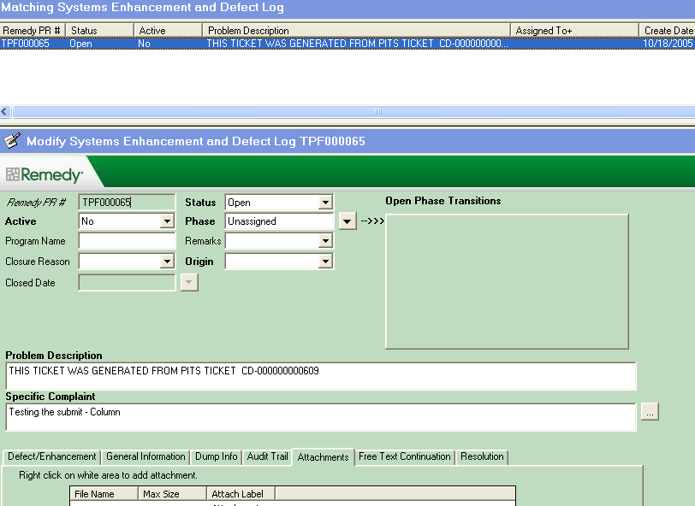
The particular ticket (TPF0000065 in this example) is displayed

Summary Keyword Searches
The contents of the Summary field are searchable by typing a case-sensitive keyword into the Summary field. The wildcard is understood in this search field. For Example: Type Password and the system interprets it as %Password%. This search returns all tickets that contain the word “Password” in the Summary field.

Note: Overall, you should assume that searches are case sensitive. However, a limited number of floating licenses exists which allow case-insensitive searches in both the Summary and Description fields. Whether your search is case sensitive depends on the available of a license when you initiate your search.
Sorting Search Results

Sort Options
The default sort order for all search requests is by the unique ID number assigned by the system to the form (i.e., the Remedy PR). However, using the Sort Options dialog box, you can specify a different sort order prior to executing the search. Up to five fields can be used in either ascending or descending order for each form. It is also possible to specify whether the sort should be permanent or apply only to the next operation. Permanent sorts can be disabled if necessary. They remain in effect until changed. If a sort order is set after a search is executed, the sort applies when the search is refreshed manually or automatically.

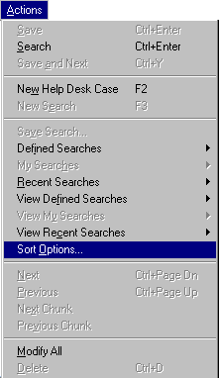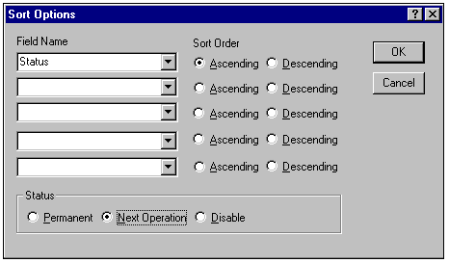

The Sort Options Dialog Box
Steps: Setting Sort Options
- From the Actions menu, select “Sort Options”.
- In the Sort Options dialog box, select each field to use in the sort, to a maximum of five, from the drop-down lists in the Field Name area.
- Opposite each field name, select either “Ascending” or “Descending” as the sort order.
- In the Status area, make an appropriate selection.
- Click the OK button.

Steps: Removing a Permanent Sort
- From the Actions menu, select “Sort Options”.
- In the Status area, select “Disable”. The system returns the sort to the default sort order by Case ID number.
- Click the OK button.

Sorting by Column Headers
Another method of sorting a list of records is to simply click the column header label in the list of matching records, after the search has been executed. This technique sorts records in ascending and descending order. Refer to the picture below where clicking the column “Status” sorts the records in ascending order. Clicking it a second time sorts the list in descending order.

Arrow indicates ascending or descending sort

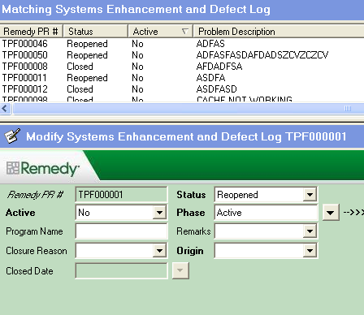
Click the column header to resort a list of records

Sorting By Column Headers

Using Predefined Searches

Predefined searches appear as an item on a menu, a button, an icon on the Toolbar, a table listing records within a form, etc. In order to execute a search request that is predefined, simply locate the name of the search and click it with the mouse; or in the case of a table, refresh it manually to redisplay the search results. The picture below illustrates how to find all open cases for your group (based on your user account’s group membership).

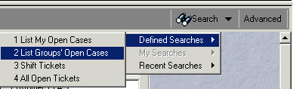

Executing a Predefined Search – List my Group’s open cases

Advanced Search Features

Introduction
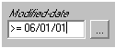Although Search by Example is easy, it does not allow more complex types of searches. Only one value can appear in a field. It is not possible to search for more than one Status, for example, using the Search by Example technique. Although one can include an operator such as a greater-than-or-equal sign (see figure to the left), it is not possible to request records that fall within a specific date range. Thus, there are limitations using the Search by Example technique.

The second search technique—using the Advanced Search bar—provides more flexibility when building search criteria. The Advanced Search is activated by clicking the Advanced button found toward the top right-hand corner of a Search window, or by opening the View menu and selecting “Advanced Search Bar”, while a Search window is open. The Advanced Search bar displays at the bottom of a Search window.

One may utilize both the Advanced Search bar and the Search by Example techniques to build effective searches. A logical “AND” joins the search criteria when both Search by Example and the Advanced Search bar techniques are used together.
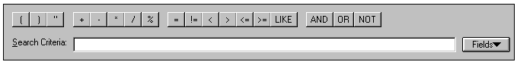
The Advanced Search Bar
Build the search criteria statement here
List of fields available here
Relational operators
Logical operators
Wild card
Performs a pattern search

To Access the Advance Search Bar
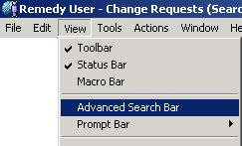
Within the form search window, the Advance Search Bar can be accessed through the menu bar. Go to the menu bar and select View → Advance Search Bar.
Statement Syntax
Search criteria are defined in the Advanced Search bar by writing logical statements. Figure 6.2 shows the syntax for statements, along with a few examples. To build statements in the Advanced Search bar, use the following guidelines:
- Type field names inside single quotation marks (‘Status’).
- Type text character values in double quotation marks (“Open”).
- Type numeric values and operators without any quotation marks (3).
- Character values in double quotation marks are case-sensitive and space-sensitive.
- Repeat the field name when searching for multiple values in a field.

Syntax: | ‘Field Label’ |  | Relational Operator |  | “Field Value”
Example:  Character values in double quotes  Field name in single quotes  Field name is repeated when using a logical OR to find multiple values for a field  A logical AND joins different fields | ‘Status’ |  | = |  | “Open”

Syntax: | Statement |  | Logical Operator |  | Statement
Example: | ‘Status’ = “Open” |  | OR |  | ‘Status’ = “Reopened”

Syntax: | Statement |  | Logical Operator |  | Statement
Example: | ‘Phase’ = “Active” |  | AND |  | ‘Status’ = “Open”

Statement Syntax and Examples for the Advanced Search Bar

The Field Label
The field label appears within single quotation marks. There are three ways of getting the field name into the Advanced Search bar.
- Click on a field label in the Search window to insert the field name into the Advanced Search bar. The AR System automatically adds the single quotation marks.
- Alternatively, select the field name from the drop-down menu attached to the Fields button.
- Type the field name with single quotes around it.

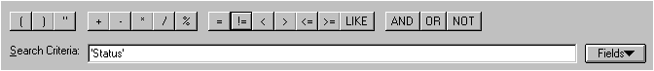
Click the field label once
Copying the Field Label into the Advanced Search Bar from the Form

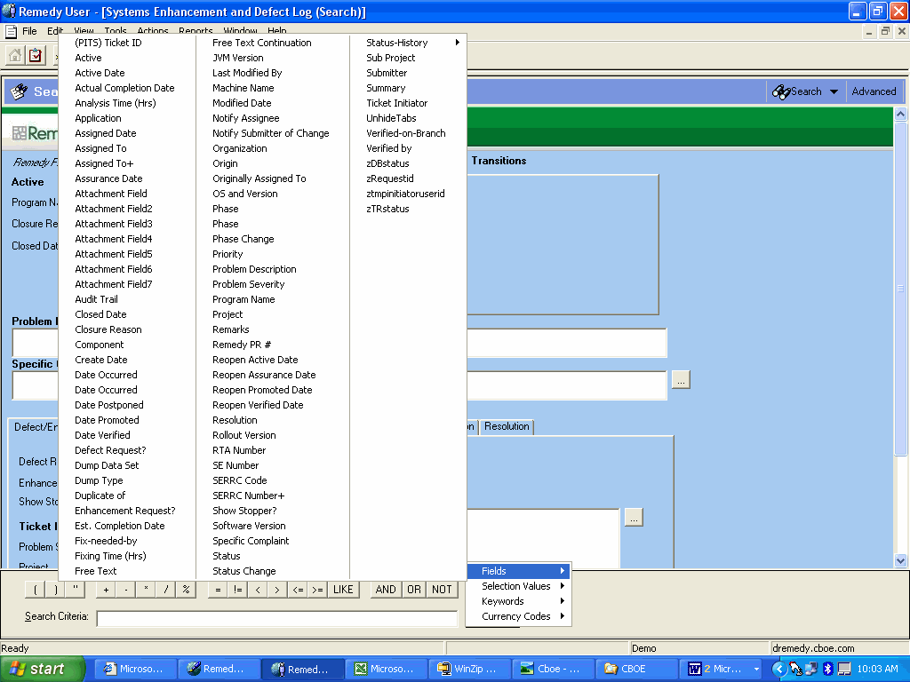
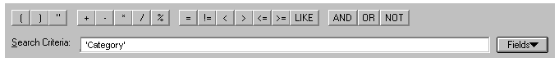
4
The field name is copied into the search bar with single quotes around it
Open the Fields menu
Click the Fields button
1
3
Select the field name
2
Copying the Field Label into the Advanced Search Bar from the List of Field Names

Field Values
A field value (depending on the field definition) can be text, a number or a keyword. To add the field value to a statement in the Advanced Search bar, use one of the following techniques.

- Type the value. Character values must be enclosed within double quotation marks (for example: “Open”).

- If the field is defined as a selection field, you may select the value from the list of “Selection Values” on the Fields menu.
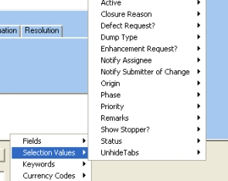
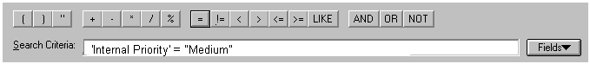
Select field
3
1
Click the Fields button
2
Select value
4
5
Selection value is copied into the Advanced Search bar
Open the Selection Values menu
Copying a Selection Field Value into the Advanced Search Bar

Typically, the field value must be typed into the statement. However, in the case of selection fields, the value can be selected from the menu, as demonstrated in the diagram above.

One advantage of selecting from a menu, whether it is a field name or a selection field value, is that it lessens the chance of typing errors. If field names or selection values are lengthy, it is also easier to select them from a menu, than to remember them.

Selection Field Values
The values in a selection field are assigned a numeric value in the database. This means that relational operators can be used with these fields in a search. Therefore, one has a choice of working with a selection field’s character value, or its numeric equivalent.

The numeric assignments for values in a selection field begin with a zero (0). Therefore, to use the Status field in the SEDL as an example: “Open” is zero; “Reopened” is 1; “Closed” as seen below:

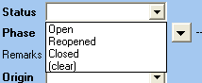
0
1
2

In the first two examples below, the result is the same, although the statements are written differently. The first statement searches for all records where the Status is less than or equal to (<=) “Reopened”—that is, all records that are not closed. The second statement searches for all records where the Status is not equal (!=) to “Closed”, which means the same thing. The third statement searches for all records where the Status is either “Open” or “Reopened”.

Example: ‘Status’ <= 1
Example: ‘Status’ != 2
Example: ‘Status’ = “Open” OR ‘Status’ = “Reopened”

Operators
Operators perform a variety of functions. A relational operator defines the relationship between the field and its value. A logical operator defines a logical operation that is performed between two or more statements. An arithmetic operator performs a mathematical operation, and the LIKE operator performs a pattern search. These operators are explained later in this chapter. In the Advanced Search Bar, operators can be typed, or they can be selected from the various buttons located on the Advanced Search bar. Relational operators can also be typed into fields when using the Search by Example search technique.

Relational Operators
Relational operators are especially useful in non-text fields (such as date and time fields). To search for all requests created after a certain date, use the greater than (>) relational operator and specify a date and time format. For example, > “May 6, 2001” in the Arrival Time field finds all requests submitted after May 5, 2001. Leaving out the time defaults the search criteria to 0:00:00, the start of the day.

A relational operator can be typed, with a space on either side of it, or its button in the Advanced Search bar can be clicked to add it to a statement. The relational operators can be used in both Search by Example and Advanced Search bar searches.


Relational Operators | Descriptions | Examples
< | Match contents that are less than the value. | In a date field: < Dec 15, 2000
> | Match contents that are greater than the value. | In a date field: > Jan 31, 00
!= | Match contents that are not equal to the value. | In the Created By field:  != bcrocker
<= | Match contents that are less than or equal to the value. | In a date field: <= May 15, 2001
>= | Match contents that are greater than or equal to the value. | In a date field: >= May 31, 01
= | Match contents that are equal to the value. | In the Created By field:  = bcrocker
Relational Operators


A relational operator typed into a field in a Search by Example search
Using the relational operator in the Advanced Search bar
NOTE: The date can be entered with or without double quotes
Working with Relational Operators

The LIKE Operator
The LIKE operator performs a pattern search, and is used only in the Advanced Search bar. It is useful when searching for text in character and diary fields, and is often used in conjunction with a wildcard such as the percent sign (%).

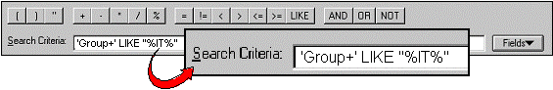
Like Operator in the Advance Tool Bar
In the above example, one is searching for any records where the Group+ field has some text that resembles “IT”. The percent signs at either end of “IT” indicate that the system should search for all characters that appear before or after the text “IT”. Therefore, the system will find records where Group+ contains “IT” or “IT-New Hire”.

In the example below, the system searches for values in the Ticket Initiator field where the name contains the characters “Swe”. Remember that the search is case sensitive.

Example: ‘Ticket Initiator’ LIKE “%Swe%”

If one wants to execute a similar search using the Search by Example technique, the operator cannot be used as part of the search because it does not work when typed in a field on a form. Instead, one simply types the expression with a percent sign at each end, as seen is this example.

Logical Operators
Logical operators are used only in the Advanced Search bar. Where expressions are joined by AND, both conditions on either side of the operator must be true before the system can resolve the statement and find the records that match the specified criteria. In the case of expressions joined by OR, either expression can be true in order for the system to resolve the statement and find the records that match the search criteria.

Logical Operators | Descriptions
AND  && | When a logical AND joins two conditions, the result is true only if both conditions are true.  Example: ‘Status’ = “Work In Progress” AND ‘Category’ = “Hardware”
OR  || | When a logical OR joins two conditions, the result is true if either of the conditions is true.  Example: ‘Priority’ = “Low” OR ‘Priority’ = “Medium”
NOT  Logical Operators  ! | Negates the condition that follows. If the condition is true, the result is false.  Example: NOT ‘Status’ = “Closed”

The logical OR operator cannot be used in the Search by Example technique; it can be used only in the Advanced Search bar. In the following example, the system searches for all requests where the Status is “Open” or “Reopened”.

Example: ‘Status’ = “Open” OR ‘Status’ = “Reopened”

Handling a Date Range
To indicate a date range, use the statement in the following example. Notice that the start and end dates are joined by a logical AND operator. Observe closely the two operators that are placed before the dates.

Example: ‘Arrival Time’ >= “Jan 15, 01” AND ‘Arrival Time’ <= “Jan 30, 01”
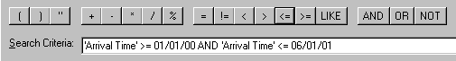
Handling Date Ranges
Logical operator is “AND”
Relational operators are: >= and <=

In the above example, the system searches for all records with an Arrival Time that falls between January 1, 2000 and June 1, 2001. One must remember that when a time is not specified, the system assumes midnight, the beginning of the day. Therefore, in this example, records for June 1st would not be included in the search results list, if they existed in the database.
Arithmetic Operators
The arithmetic operators are the same for all calculations: a plus (+) sign for addition; a minus (-) sign for subtraction; a diagonal (/) for division and an asterisk (*) for multiplication.

Operators | Descriptions
+ | - Adds two integers or real values.  - Adds an integer interval to a time value.  - Concatenates two character strings.  - Example: ‘Arrival Time’ > $DATE$ + (8 * 60 * 60) finds all records that were submitted after 8:00 AM today. “8 * 60 * 60” is the number of seconds in eight hours.
- | - Subtracts two integer or real values.  - Subtracts two time values (resulting in an integer).  - Subtracts an integer interval from a time value.  - Example: ‘Arrival Time’ > $DATE$ - (7 * 24 * 60 * 60) finds all records that were submitted within the last week. “7 * 24 * 60 * 60” is the number of seconds in one week.
* | - Multiplies two integer or real values.
/ | - Divides two integer or real values.
Arithmetic Operators

Operator Precedence
When multiple operators are used in a search statement, they are executed in a specified order of precedence. If there is any doubt as to how the system will interpret a complex statement, be safe, and use parentheses to indicate which operations belong together. Statements inside parentheses are executed first.

In the example below, the parentheses group the date range so that there is no confusion as to what belongs together. The logical operator, AND, between the date range and the remaining part of the statement indicates that a record must meet both conditions before it is a valid match—that is, the Status must be “Reopened” and the Arrival Time must fall within the specified range.

Example:
(‘Arrival Time’ >= “Feb 10, 01” AND ‘Arrival Time’ <= “Feb 20, 01”) AND ‘Status’ = “Reopened”
AND

Working with Parentheses

Order of Precedence | Description
1 | ( ) parentheses
2 | ! NOT negative
3 | * / multiplication and division
4 | + - addition and subtraction
5 | < <= > >= = !=  less than; less than or equal to; greater than; greater than or equal to; equals; not equal to
6 | AND
7 | OR
Order of Precedence for Operators

Notice that an AND executes before an OR. Be careful using these operators. Ensure that the results expected are indeed the results one gets from a search. The expression can be interpreted two ways, depending on whether or not parentheses are used.

Examples:
Parentheses added
1
2
‘Phase’ = “Active” OR ‘Phase’ = “Assurance” AND Priority = “Medium”

(‘Phase’ = “Active” OR ‘Phase’ = “Assurance”) AND Priority = “Medium”

Interpreting an Expression Correctly

In the first example, the system searches first for records where the Phase is “Active” and the Priority is “Medium”. Then, it looks for “Assurance” records—all records for “Assurance”.

In the second example, however, the system searches for all “Active” and “Assurance” records that have a Priority of “Medium”. This second example is a very different search from the first example.

Working with Wild Cards
The most frequently used wild card is probably the percent sign (%). It generates a pattern search to match any string of zero (0) or more characters. For example, T%son matches Thompson, Tompson, Thornson or Terry Johnson. The next Table explains other wild card characters that can help to further refine search criteria. When working with wild cards in the Advanced Search bar, the LIKE operator must be used, otherwise the system interprets the wild card(s) as literal characters (refer to the section entitled “The LIKE Operator”, which appears earlier in this chapter, for examples).

Wild Cards | Descriptions | Examples
% | Use the percent sign to match any string of 0 or more characters. | T%son matches Thompson, Tompson, Thornson
_ | Use the underscore to match any single character. | P_ _l matches Paul, Phil, Pool
- | Use the hyphen to indicate a range. It is used only within brackets. | [g-l] matches all letters from “g” through to “l”
[ ] | Use square brackets to match any single character within a specified range or set. There must be an open and close bracket. Not all databases support the use of these square brackets. | [g-l] matches all letters from “g” through to “l”, whereas [g,h,j,k] specifically matches a set of characters - “g”, “h”, “j’ or “k”
[^] | Use this wild card to match any single character not within a specified range or set. There must be an open and close bracket. | [^g-l] matches all characters except those from “g” through to “l”, whereas [^g,h,j,k] matches all characters except “g”, “h”, “j” and “k”
Working with Wild Cards

Using Keywords in a Search
Keywords can be used in a Search by Example or in the Advanced Search bar. They can also be typed wherever it is possible to type character values. Table 6.6 provides a list of typical keywords used in searching and their corresponding values. All keywords must be spelled in capital letters with a dollar sign ($) at the beginning and end of the word. They do not appear inside quotation marks.

Keywords | Descriptions
$DATE$ | Current date. In a date/time field, the time defaults to midnight, at the beginning of the day
$NULL$ | A null value.
$TIME$ | Current time. In a date/time field, the date defaults to the current date.
$TIMESTAMP$ | Current date and time.
$USER$ | Name of the user currently logged into the AR System
$WEEKDAY$ | The current day of the week.
Keyword Examples

Using a Keyword for the Search by Example and the
Advanced Search Bar Techniques
Search by Example
Advanced Search bar statement
Example:‘Phase’ != $NULL$

In the first example above, the operator “!=” means “not equal to”; therefore, the expression “!=$NULL$” means “not equal to null”—in other words, the system will locate all records where the System Type/Model field has a value in it.
Example: ‘Submitted By’ = $USER$
The second example comes from the Advanced Search bar. The result of this search displays all requests submitted by the person currently logged into the AR System.
Example: ‘Arrival Time’ >= $TIMESTAMP$ - (60*15)

The last example illustrates searching for all requests that have been submitted to the database within the last 15 minutes.

Selecting Keywords
The easiest way to get a keyword into an Advanced Search bar is to select it from the Fields menu.
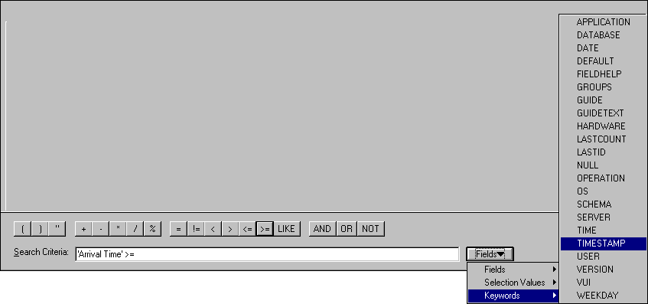
Selecting a Keyword from the Fields Menu
Select the keyword
Select the Keywords menu
Click the Fields button
1
2
3
4
Keyword will be added to Advanced Search bar

Handling Date and Time Values
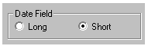The table below illustrates how the date and time are entered into date/time fields in the AR System. Although the date must always be formatted as month-day-year, there are a variety of options available for that format. When only a date is provided, the system assumes the time is midnight (at the beginning of the day—00:00:00). Once a form is saved, reopening it causes the date to display according to the format specified on the Behaviors tab of the Options window.

Description | Examples
Enter the date first when entering date and time. | April 9, 2001 10:25:36 AM
Enter the month as text or numbers. | April Apr 04 4
Enter the month in long or abbreviated form. | April 9, 2001 Apr 09 2001
The day and year can be separated with/without a comma. | April 9, 2001 Apr 09 2001
Enter the year as two or four digits (optional). | 04/22/2001 04/22/01
To specify a time, provide hours. Minutes and seconds are optional. If minutes/seconds are left blank, they are assumed to be 0. If no time is specified, the system assumes the time is midnight (at the beginning of the day) — 00:00:00. | 15:25:36 10:45 AM
Enter the time in either 24- or 12-hour format.  Use AM/PM with the 12-hour format. | 15:25:36 3:25:36 PM
Formatting the Date and Time

Working with Absolute Time
Time is expressed in the AR System either in absolute or relative terms. Absolute date/time is expressed as an explicit value.

Examples: ‘Create Date’ >= “May 1, 2001”
‘Create Date’ >= “May 1, 2001 10:00:00 AM”

Understanding “Epoch” Time
Time in the AR System is based on the number of seconds since January 1st, 1970 at 00:00:00 Greenwich Mean Time (GMT). This date/time is referred to as Epoch time. Any moment in time can be captured as the number of seconds since the beginning of Epoch time. In the figure below shows a timeline, starting at the beginning of Epoch time. Each additional year represents approximately 31.5 million seconds.

It is not possible to calculate differences between absolute date/time values. The AR System, therefore, translates any absolute date/time value into a specific numeric equivalent—in seconds, since Epoch time. Thus, comparisons can be made between date/time values, and calculations can be carried out on these date/time values.

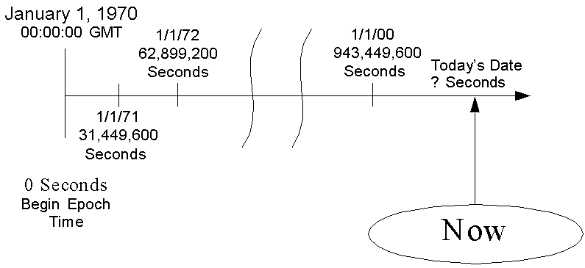
Epoch time

Understanding “Epoch” Time

Working with Relative Time
When it is not appropriate to enter hard-coded dates and times (that is, specific dates and times), one can work with relative time. Like Epoch time, relative time is calculated as a number of seconds. In the figure below shows the format required for calculating relative time.
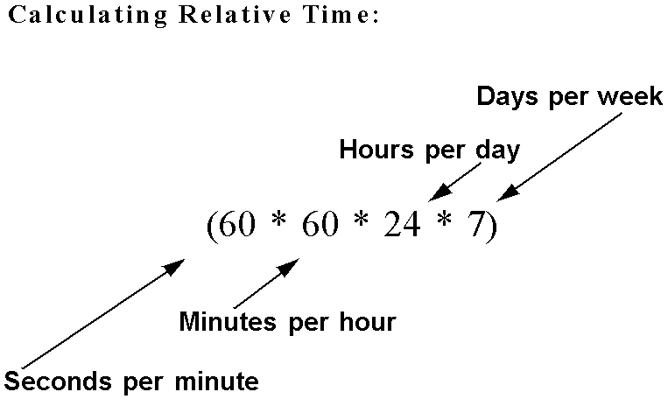

Calculating Relative Time

The above example calculates one week in relative time. The total number of seconds in one week, if this calculation is executed, equals 604,800. One can carry out mathematical calculations using a number like this one. One cannot carry out a calculation using absolute date/time values. Hence, there is the need to understand how to handle relative time in the AR System.

Using absolute time, one can create a successful search statement that looks for all records between two dates. However, if one wants all records created within the last 48 hours, for example, one must use relative time to build the search statement. Refer to Figure 6.16 later in this section for an example of the difference between using absolute and relative time in a search statement.
Combining Relative Time with Keywords
The maximum flexibility for defining effective time-based search statements that are never obsolete comes from combining relative time with keywords. The figure below illustrates using keywords to extract the current date/time, and then adding or subtracting time in seconds to determine particular points in time, such as: the last 15 minutes; the last 48 hours; the previous 2 weeks, etc.

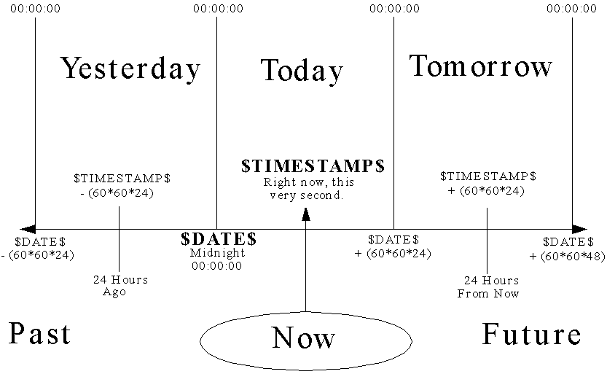

Combining Keywords with Relative Time to Calculate Periods of Time

Using Keywords and Relative Time in Search Statements
In the example in the figure below, the search statement looks for all records that arrived within the last 15 minutes. The request is expressed by saying that the Arrival Time must be greater than the current date/time ($TIMESTAMP$) minus the number of seconds in 15 minutes (60*15).

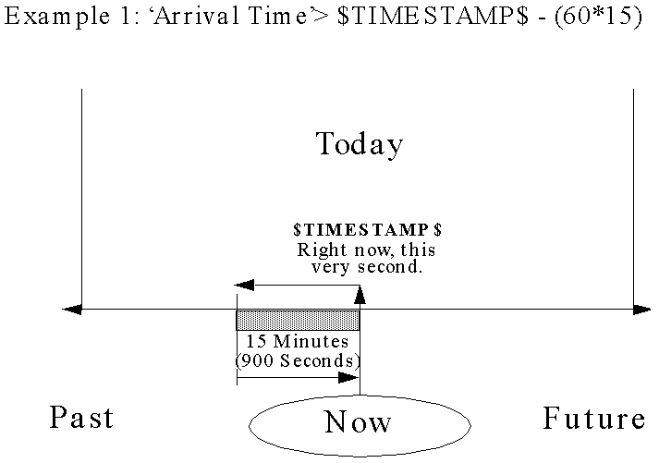

Example 1: Using Keywords and Relative Time in a Search

In the figure below, the search statement looks for all records that arrived within the last week. The request is expressed by saying that the Arrival Time must be greater than today’s date ($DATE$) minus the number of seconds in one week (60*60*24*7). The number of seconds in one week is expressed as the number of seconds in a minute, multiplied by the number of minutes in an hour, times the number of hours in a day, times the number of days in a week, or seven days.

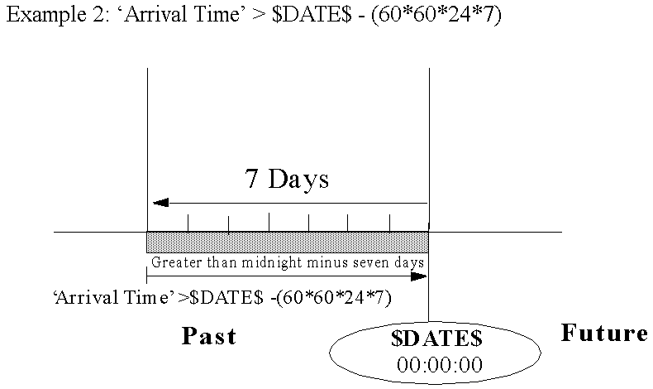

Example 2: Using Keywords and Relative Time in a Search

In the figure below, the search statement looks for all records that arrived yesterday, between 8:00 AM and 5:00 PM. The request is expressed by saying that the Arrival Time is between 24 less than today’s date ($DATE$ at midnight (00:00:00)) plus 8 hours (8:00 AM), and 24 hours less than $DATE$ plus 17 hours (5:00 PM).

Relational operators
Logical operator joining the two relative time expressions

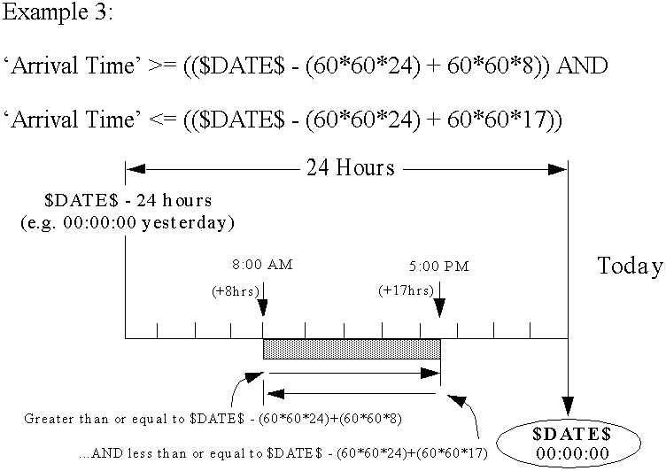

Example 3: Using Keywords and Relative Time in a Search

Finally, the figure below illustrates the difference between search statements that look for records that fall within a specified date range, when the dates are absolute values versus using keywords and relative time.

In the first example, the search statement looks for records that fall within a two-week period, specifically between May 1st and May 15th. If this search were executed on May 15th, all tickets created within the last two weeks would be found.

The drawback with this technique is that one is locked into the same two-week period because the dates are hard-coded, and will always remain the same, whenever the search might be re-executed. Therefore, it lacks flexibility to search for the last two weeks, regardless of when the search is executed. There is a way around this dilemma by developing a variable parameter macro whereby one may redefine the absolute dates each time the macro is executed. This macro technique is explained later in this chapter.
Absolute date values
Today’s date (midnight) minus 14 days
Today’s date (midnight)
1
2

Example 4: Using Keywords and Relative Time versus
Absolute Date/Time Values in a Search Statement

The second example illustrates a more flexible approach to searching for records within a specified period of time—a time period that changes with each execution of the search. It subtracts 14 days from today’s date to obtain the first date in the date range. The last date in the date range is today’s date. Therefore, when executed, this statement always obtains records from the previous two weeks, regardless of when it is run. Both date expressions, by default, assume a time of midnight at the beginning of the day (00:00:00).

Steps: Using the Advance Search Bar
- Open the User Tool.
- Open the Help Desk Case form in a Search window. A Search window for the Help Desk Case form displays.
- From the Edit menu, select “Clear All”, or press the CTRL+E keys. All data clear from all fields.
- Click the Advanced button. The Advanced Search bar displays at the bottom of the window.
- Using the techniques described in this chapter, build the desired search statement(s), including appropriate operators and keywords, as necessary.
- Click the Search button. The system executes the search. If matching records are found in the database, they are listed in the Search Results pane of a Modify window.

Search Criteria

Saving Search Criteria
Having executed a search request, one may decide to save the search for re-execution in the future. The next Figure illustrates how to save search criteria. The form upon which the search is executed must be open when the search is saved.

Steps: Saving Search Criteria
- While the search results are displayed on the monitor screen, open the Actions menu found on the Menu bar.
- Select “Save Search”.
- Type a name for the search in the Save search dialog box.
- Click the OK button, or press the Enter key. The system saves the search criteria, using the assigned name.
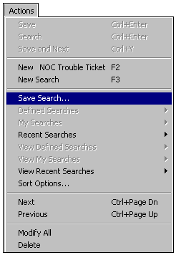
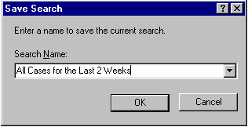

Saving Search Criteria

Working with a Saved Search
In order to re-execute the same search at any time in the future, one must first open the form for which the search was originally built. The next Figure demonstrates how to re-execute the saved search.

Steps: Re-executing the Saved Search
- Open the form for which the search was created.
- From the Actions menu, select “My Searches” or “View My Searches”.
- Select the name of the desired search. The system executes the search, using the predetermined criteria, if the name is selected from “My Searches”. If it was selected from “View My Searches”, the search criteria display; then one may make modifications, if desired, before re-executing the search.

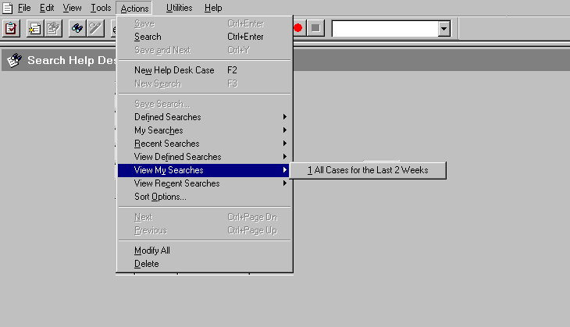
An open Help Desk Case form in a Search window
Selecting the saved search
Actions menu handles saved and recent searches

Previewing a Saved Search

Working with Recent Search Requests
The AR System remembers all recent searches. How many searches are listed on the recent menus, which form some of the selections on the Actions menu, is determined by an option set in the Options dialog box. See the figures below.
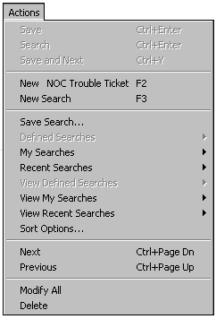
Select “Recent Searches” to re-execute a recent search
Select “View Recent Searches” to modify a recent search
Select “View My Searches” to modify a saved search
Recent Search Items Listed on the Actions Menu

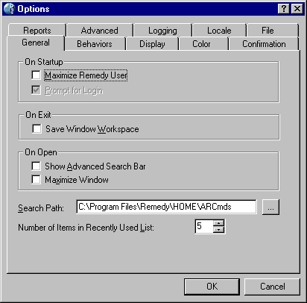

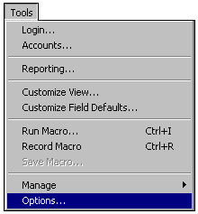
Setting an option to Control Recent Lists

Re-executing a Recent Search Request
Selecting a search request from the “Recent Searches” item on the Actions menu automatically executes the selected search request (refer to the figures below).

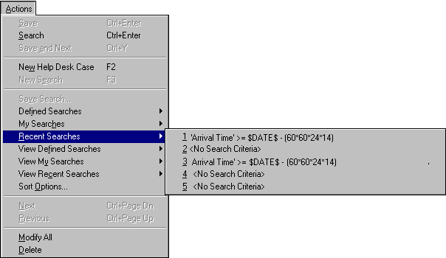
List of recent searches
Select “Recent Searches” from the menu
“5” represents the maximum number of searches to be listed, based on the Options setting

Re-executing a Recent Search

Reviewing Search Criteria
Having the ability to recall a search and make changes to it is very useful. Reviewing a search request’s search criteria is helpful in a situation where one wants to rerun a search with slight modifications to the criteria. The above Figure shows how to recall search criteria.
Steps: Reviewing Search Criteria
- Open the form for which the search was created.
- From the Actions menu, select “View My Searches” or “View Recent Searches”. The system opens a search window with the search criteria displayed in it.
- Make changes to the search criteria.
- Click the Search button. The search executes, using the modified search criteria.

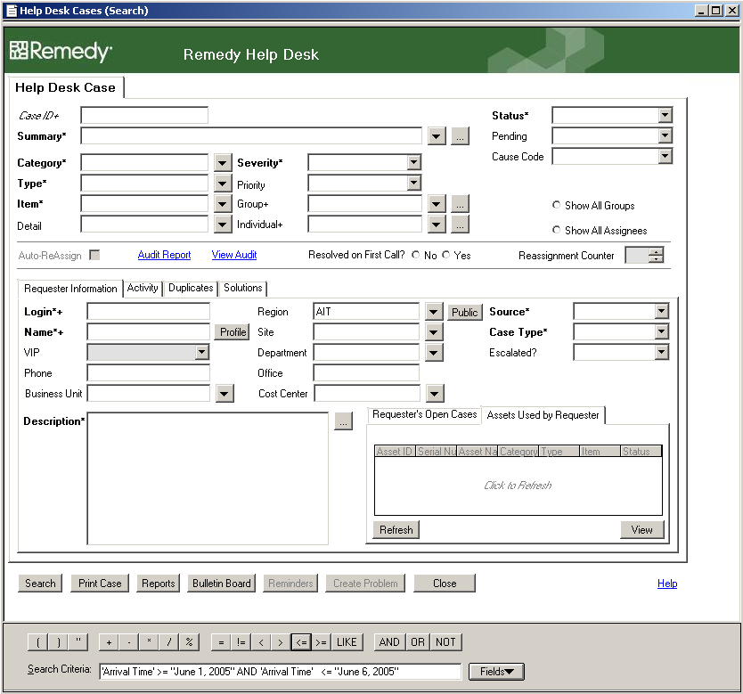
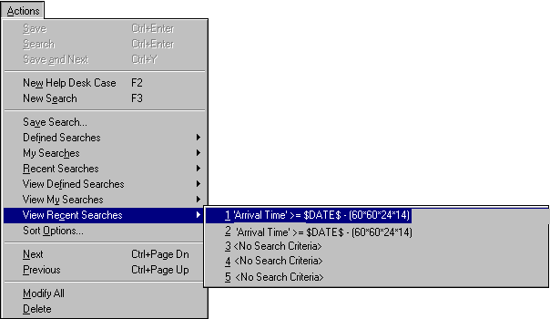
Reviewing Search Criteria
Selected search criteria to view
Select “View Recent Searches”
Click Search button to execute revised search
6
3
2
1
New criteria to be added to search
5
Search window opens
Recalled search criteria
4

