

Product Definition and Trading Session Maintenance User Guide
Version 8.7

Disclaimer

Copyright © 2001-2011 Chicago Board Options Exchange. All rights reserved.
The information contained in this document constitutes confidential and/or trade secret information belonging to CBOE. This document is made available to CBOE members and member firms for use with CBOEdirect™. This document is provided "As Is" with all faults and without warranty of any kind, either expressed or implied.

Change Notices

The following change notices are provided to assist users of the CBOEdirect screen-based trading system in determining the impact of changes to their processing.
If you have any questions or review comments about this document, please contact Odalys Castro at (312) 786-8817.

Date | Version | Description of Change
5/06/11 | 8.7 | No functional changes.  Updated CBOE logo.
1/28/11 | 8.6 | No changes
11/01/10 | 8.5 | No changes
9/15/10 | 8.4 | No changes
4/27/10 | 8.3 | Updated for CBOEDIR_8.3
6/23/09 | 8.0 | Updated the Futures product interfaces
11/10/08 | 7.1 | No changes
8/29/08 | 7.0 | Update for Order Maintenance Terminal (OMT) Functionality
7/26/07 | 6.4 | Updated for HDE2
 | 6.3 | No changes
4/13/07 | 6.2 | No changes
3/16/07 | 6.1 | No changes
1/05/07 | 6.0 | Updated the Start menu interface to include the ITS option
11/14/06 | 5.5 | Updated Trading Session windows
8/30/06 | 5.4 | Updated Trading Session windows
1/12/06 | 5.0 | Updated Trading Session windows to display COF_MAIN
10/05/05 | 4.8 | Updated the Product Definition interfaces
8/08/05 | 4.7 | No changes
5/18/05 | 4.5.1 | Updated the Trading Session user interfaces to include a password protected confirmation dialog
5/4/05 | 4.5 | No changes
3/03/05 | 4.4 | Updated Start menu interface
2/14/05 | 4.3.1 | Updated Trading Session Maintenance to include support mode access for session setup
1/12/05 | 4.3 | Product Definition user interface updates to include the CUSIP number field
8/25/04 | 4.0 | User interface updates to include the Stock trading session
5/24/04 | 3.10 | New user interfaces for Trading Session Maintenance  New functionality for trade server process start up in a trading session
3/8/04 | 3.7 | New user interface for Save Configuration  New Start Menu user interface
10/17/03 | 3.5 | Support for the CBOE Futures session (CFE_MAIN)  Product Definition user interface updates for the new session code selector
9/19/03 | 3.3 | New user interfaces for the CBOE Futures (CFE_MAIN) session – not currently supported.  Product Definition user interface updates for the new session code selector – not currently supported.  New user interfaces for Product Lookup
7/22/03 | 3.1 | Product Control tab user interface update  New user interface for Product Description  User interface update for Product Definition  Updated user interface for the Start Menu
6/06/03 | 3.0 | New Open Console Window user interface  New section for Intraday Procedures  Updated user interfaces for Product Definition  New Product Class Group user interface
4/05/03 | 2.3 | Added the steps to create option product classes using the TPF download process.  Added a section for maintaining option products with the TPF download.  Changed the Product Defintion section layout.
12/17/02 | 2.2 | Updated the Price Adjustment user interface.  Updated the Edit Column Preferences user interface in the Customizing CBOEdirect Windows section.
10/10/02 | 2.2 | User interface changes for Product Definition.
6/19/02 | 2.0 | Noted the affect of Product Description changes on product types.
6/18/02 | 2.0 | Added an Edit Column Preferences section to the Reference Guide. User interface changes for Product Definition and Login.
5/13/02 | 2.0 | User interface and functionality changes for Product Maintenance and Session Management.
03/21/02 | 2.0-draft | First draft of Version 2.0. User interface and functionality changes for Futures, Product Maintenance and Session Maintenance.

Table of Contents
Table of Contents v
Introduction vii
Purpose vii
Intended Audience vii
Support and Questions vii
Conventions Used in this Guide viii
Section 1: Screen-Based Trading 9
Getting Started 10
Login 10
Product Maintenance 12
Price Adjustment 12
Edit Column Preferences 14
Product Class Groups 15
Create a New Product Group Type 16
Add Product Classes to the New Group Type 17
Remove Product Classes from the Group Type 18
Create a New Group 20
Link Sub-Groups to a Group 20
Defining a Product 21
Create a New Future Product Class 21
Create a New Option Product Using the TPF Download Process 25
Overview for Maintaining Option Products Using the TPF Download 28
Create a New Option Product without the TPF Download Process 29
Create a New Equity Product Class 33
Create a New Index Product Class 36
Edit Product Information 40
Edit an Existing Reporting Class 40
Product Description 41
Edit Product Descriptions 41
Create New Product Description 42
Product Lookup 42
Lookup by Selector 42
Lookup by Key 44
Trading Session Maintenance 45
Trading Session Management 45
Support Mode Access 45
Setup a Trading Session 46
Open Session 48
Open Trade Servers 48
Start End of Session 50
Start End of Session By Trade Server 52
End of Day 53
Product Classes 53
Product Series 56
Intraday Procedures 60
Open Console Window 60
Exit the System 62
Logout 62
Exit the System 62
Section 2: Reference Guide 63
Task Toolbar 64
About CBOEdirect 64
Open Tasks 64
Resize 64
Save Configurations 64
Apply Default Preferences 64
Session Information 66
Logout 66
Change Password 66
Main Window Settings 66
Window Control 67
Customizing CBOEdirect Windows 68
Edit Column Preferences 68
Display 70
Save Customized Defaults 70
Sizing CBOEdirect Windows 70

Introduction

Purpose | This user guide was written to assist the System Administrator in utilizing the Product Maintenance and Trading Session Management features of the CBOEdirect screen-based trading system.
Intended Audience | This user guide is intended for System Administrators or any person interested in CBOEdirect's administrator functions.
Support and Questions | Questions regarding this document can be directed to The Chicago Board Options Exchange at (312) 786 7300 or via email at api@cboe.com.
Conventions  Used in this Guide | The CBOEdirect system was designed so that you can perform all of your Product Maintenance and Session Management activities from several display windows. Some fields are sensitive to both right and left mouse clicks. Window control functions can also be activated by using keyboard commands.  Section 1 of the document illustrates how to perform the necessary functions of the System Administrator. Additional information about window configuration and sizing can be found in Section 2: Reference Guide.  There are several conventions used throughout this guide to help trigger important information:
 | Bolding | Used to highlight menu selections (e.g., Login) and button names (e.g., Update)
 |  Note: | This notation is used to indicate important information you should note when performing the associated function.
 | Brackets [ ] | Used to highlight keyboard commands (e.g., [Alt]-[O]). Note that when [Alt] or [Ctrl] are used in conjunction with another key, hold down the first key while pressing the second.  Some button functions can be executed through keyboard commands. Hold down the [Alt] key and press the keyboard character of the underlined letter in the command. For example:  [Alt]-[R] Restores an active window
 | 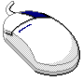 | This mouse graphic with the right mouse button highlighted will appear in the margin when accompanying instructions relate to functions activated by clicking the right mouse button.  All other mouse commands (such as double clicking to display a window) refer to a normal left mouse click.
 | Help Desk-Only Function | This graphic will display in the margin whenever the feature being described is a Help Desk-only function.
 |   Support Staff-Only Function | This graphic will display in the margin whenever the feature being described is a Support Staff-only function.

 | Section 1:  Screen-Based Trading

This section of the user guide will direct you through all functions for Product Definition and Trading Session Maintenance using CBOEdirect.

Getting Started

 | When you launch the CBOEdirect Screen-Based System Administrator application, the following menu window will display.
 | 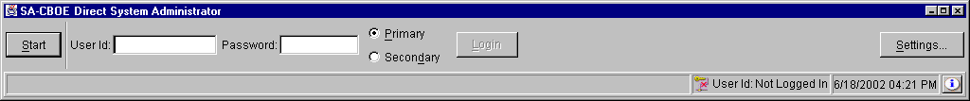
Login | Enter your User ID and Password. Both User ID and Password are case sensitive. Select your login as Primary by clicking the appropriate radio button.  Click Settings, to change your login mode. The Session Settings window will display.
 | 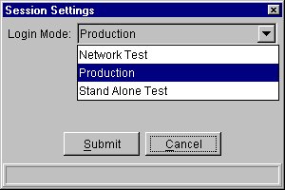
Select your login setting from the drop down list, click Submit. If you decide you do not wish to change your login mode, click Cancel. The system will return to the menu window. Click Login.
The first time you login, the system will prompt you to convert your GUI-Preferences to the current version. Click Yes. If you decide not to convert your preferences, click No.
 | 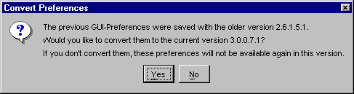
Once you are logged into the system, the Open Tasks toolbar will display on the CBOEdirect window.
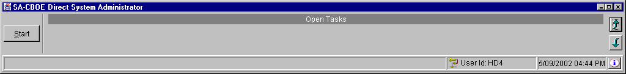
From this window you can open tasks, view session information, save window settings, and perform window controls. For more details, see Section 2: Task Toolbar, page 64.
You are now ready to perform System Administrator functions.

Product Maintenance

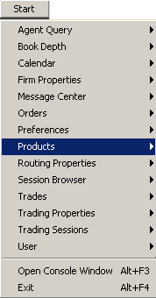  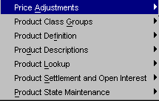 | CBOEdirect allows you to perform various tasks for the maintenance of products. The features described in this section include: price adjustments and product definition and editing.  The system allows you to create multiple Product Maintenance windows. To save the configuration of each window, see the Task Toolbar section, page 64.  This window can remain open while performing other activities or click the  button in the upper right corner to close.
Price Adjustment | Price adjustments on orders are caused by changes in the underlying security, such as stock splits, stock dividends, symbol changes, etc.  From the Start menu, select Products, Price Adjustments then select Create New Window. The Price Adjustments window will display.
 | 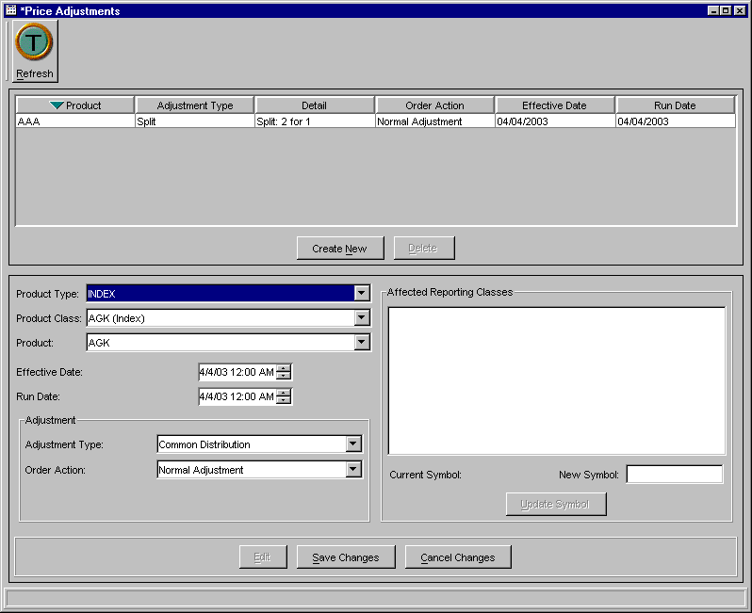
From this window, you can create, edit and delete product price adjustment information.
To create a new price adjustment for a product:
- Click the Create New button.
- Select the product type, product class and product from the drop down lists.
- Select the effective date of the price adjustment by clicking the up/down arrows until the desired date is reached.
- Select the run date by clicking on the up/down until the desired date is reached.
- From the Adjustment section of the window, select the adjustment type from the drop down list.
- For a stock split adjustment, enter the stock split information below the adjustment type box.
- For a symbol change adjustment type, enter the new symbol in the box below the adjustment type list box and in the Affected Reporting Classes section of the screen. Click Update Symbol. The new symbol will be applied to the affected reporting classes.
- For a dividend percent adjustment, enter the percent in the box below the adjustment type list box.
- For a dividend cash adjustment, enter the cash amount.
- For a divident stock adjustment, enter the number of shares.
- For a merger adjustment, enter the new symbol in the box below the adjustment type list box.
- Select the type of Order Adjustment from the drop down list.
- You can clear your price adjustment entries at anytime by clicking the Refresh button.
- Verify that the information is correct. Click Save Changes. The new price adjustment will display in the information section at the top of the window.
- To cancel the entry, click Cancel Changes.
To edit price adjustment information:
- Select the existing product from the information section at the top of the window. Click Edit. The product and its information will highlight and display.
- Change the effective date and run date by clicking on the calendar button or by clicking on the up/down arrows until the desired date is reached.
 Note: At this time, only the effective date and run date can be modified.
- Click Save Changes.
- To cancel the update, click Cancel Changes.
To delete price adjustment information:
- Select the product you wish to delete from the price adjustment information section at the top of the window. Click Delete. The Confirm Delete window will display.
- To complete the delete request, click OK.
- If you decide not to delete the price adjustment information, click Cancel.

Edit Column Preferences
You can customize your Price Adjustement window by selecting or deselecting specific columns to display. To filter columns, right mouse click on a data row. Select Edit Preferences. The Edit Column Preferences window will display.
- Select or deselect columns for viewing and modify column arrangement as desired.
- To save your changes, click Ok.
- If you wish to retain the default settings, click Cancel.
For detailed information, refer to the Edit Column Preferences section, page 68.
Product Class Groups  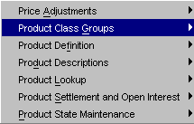 | CBOEdirect allows you to view the product classes that are available for specific group types. To view the product class groups, select Products, Product Class Groups from the Start Menu, then select Create New Window. The Product Class Groups window will display.   Note: Only the System Support Staff will perform Product Class Group modifications.  This window can be closed at anytime by clicking the  button in the upper right corner or by selecting Close from the Window Menu.
 | 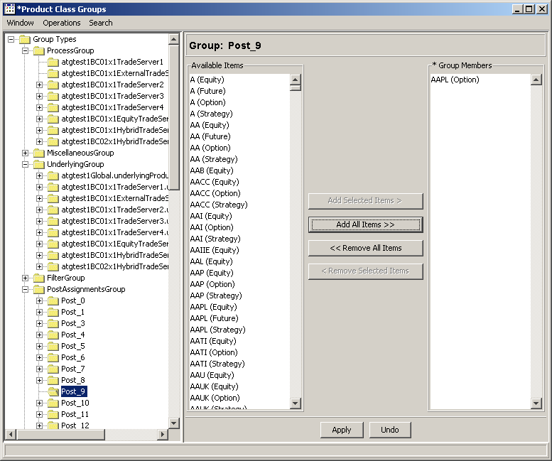
 | To view the product classes that are available for a specific group, click on the group name from the Group Types directory tree. The product classes that are available for this group will display in the Available Items list box. The product classes that have been selected for this group will appear in the Group Members list box.
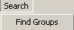  Support Staff-Only Function | To search for a specific group, click on the Search menu option and select Find Groups. The following window will display.
 | 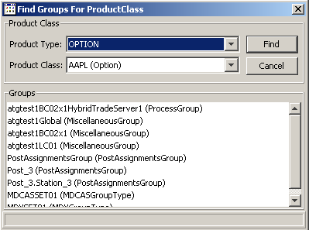
- Select the Product Type and Product Class from the drop down lists.
- Click Find. In the example above, the groups containing option class AAPL display in the Groups section of the window.
- Click Cancel to close the Find Group for ProductClass window.
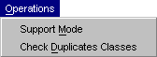 | An additional access login is required to create a new group or modify an existing group. From the Operations Menu, select Support Mode. The Enable Support Mode window will display.  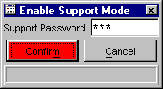
Support Staff-Only Function
At this window, enter the Support Password in the text field and click Submit. Click Confirm. If the login is successful, the Product Class Groups window will display in editable format. If the login is unsuccessful, the system will prompt you with an "invalid password" message.
You can verify there are no duplicate product classes at anytime. From the Operations Menu, click Check Duplicate Classes. If there are no duplicate classes, the system will generate a message box stating there are no duplicate classes. If duplicate classes exist, the system will list the duplicate classes in the message box.
➢  Support Staff-Only Function | Create a New Product Group Type  - From the directory tree, right mouse click on the Group Type folder and select Create Group Type. The Create Group Type window will display.  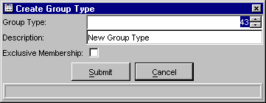
- From this window, enter the group type number in the Group Type text box.
- Enter the new group type description in the Description text box.
- Select if the group type will have restricted membership by selecting the Exclusive Membership check box.
- Click Submit. Click Confirm. The new group type will display in the Group Type directory tree.
- If you decide not to create a new group type, click Cancel.

➢  Support Staff-Only Function | Add Product Classes to the New Group Type  - Select the new Product Group name from the directory tree. The available product classes will display in the Available Items list box.  - From the Available Items list box, highlight the product classes you would like to add to the new product class group.  - Click the Add Selected Items button. The product classes you selected will display in the Group Members list box.  - If you decide to cancel your changes, click Undo.  - To save the changes, click Apply. CBOEdirect will generate a confirmation message to verify that you are sure you want to make the change.  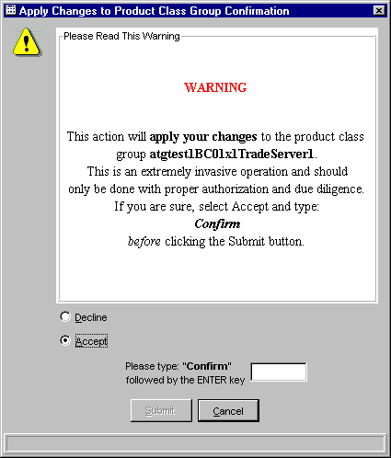  - The window defaults to Decline. Click Cancel to exit the Confirmation dialog without executing the changes.  - If you are sure you want to make the change, read the dialog carefully, click the Accept radio button and type “Confirm” in the text box followed by the Enter key.  - Click Submit. The product classes you selected will be added to the Group Members list box and will display in the Available Items list box.  - If you wish to add all of the product classes displayed in the Available Items list box to the new product group, click Add All Items. Click Apply. The Confirmation dialog will appear for your verification.  - If you accept the changes, all the product classes will be added to the Group Members list box and will display in the Available Items list box.
➢  Support Staff-Only Function | Remove Product Classes from the Group Type  - Select the Product Group name from the directory tree. The product classes included in the group will display in the Group Members list box.  - From the Group Members list box, highlight the product classes you would like to remove from the product class group.  - Click the Remove Selected Items button. If you decide to cancel your changes, click Undo. The remove function will be reversed.  - To save the changes, click Apply. CBOEdirect will generate a confirmation message to verify that you are sure you want to make the change.  - The window defaults to Decline. Click Cancel to exit the Confirmation dialog without executing the changes. If you are sure you want to make the change, read the dialog carefully, click the Accept radio button and type “Confirm” in the text box followed by the Enter key.  - Click Submit. The product classes you selected will be removed from the Group Members list box and will display in the Available Items list box.  - If you wish to remove all of the product classes from the product group, click Remove All Items. Click Apply. The Confirmation dialog will appear for your verification.  - If you accept the changes, all the product classes will be removed from the Group Members list box and will display in the Available Items list box.
➢ | Create a New Group  To add new Group to a Group Type, right mouse click on the desired Group Type folder in the directory tree. Select Create Group. The Create Group window will display.  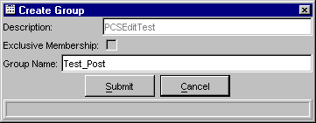

Support Staff-Only Function
- From this window, enter the group name in the Group Name text box.
- Enter the new group description in the Description text box.
- If you decide not to create a new group, click Cancel.
- Click Submit. Click Confirm. The new group will display in the directory tree.
 Note: Once created, groups cannot be removed. All groups must be descendants of a group type.
- To add product classes to the new group, refer to Add Product Classes to the New Group Type in the section above.
➢  Support Staff-Only Function | Link Sub-Groups to a Group  Groups become Sub-Groups when they are linked within other Group folders. In the example above, the group folder ProdBC01ExternalTradeServer1 is a sub-group of group ProdBC01.  To create a Sub-Group link:  - Right mouse click on the group folder you want to add as a sub-group in another group folder, select the option Create SubGroup Link.  - Right mouse click on the receiving folder, select Paste SubGroup Link. The group folder becomes a sub-group folder in the receiving folder.  To remove a Sub-Group:  - Right mouse click on the Sub-Group you wish to remove, select Remove Group.
Defining a Product  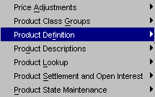 | From the Start menu, select Products, Product Definition then select Create New Window. The Product Definition window will display.  Initally, the window will be blank. From this window you will be able to create new products and edit existing product information.   Note: New product classes cannot be created intraday. Reporting classes can be entered intraday.   Note: Products not currently supported by CBOEdirect include: Commodity, Debt, Linked_Note, Unit_Investment_Trust, Volatility_Index and Warrant.
➢ | Create a New Future Product Class  From the CBOE Product Types directory tree, click on the Future folder. Click Create New Future Class. The Product Class Definition tab will display.
 | 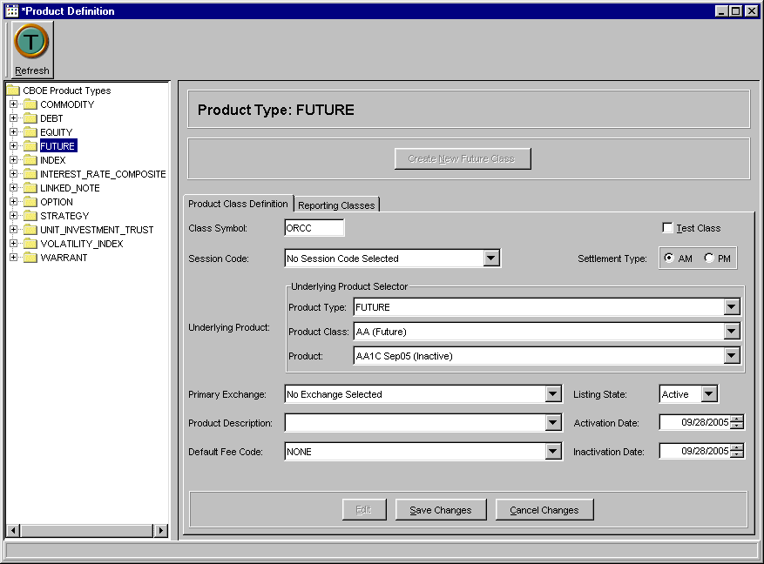
- Enter the class symbol for the new product class in the Class Symbol box. The class symbol must be entered in uppercase letters.
- Select the session where the product class will trade by selecting the session code from the Session Code drop down list.
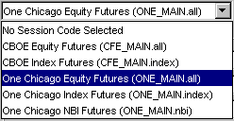
 Note: In the example above, product class ORCC has been assigned to the One Chicago Equity Futures session represented by ONE_MAIN.all in CBOEdirect.
- If the new product class is a test class, click the Test Class checkbox.
- Click on the AM or PM radio button to choose the product class Settlement Type.
- From the Underlying Product Selector drop down list boxes, choose the product type, product class and product to be used as the underlying security.
 Note: If the underlying product does not exist, a new Equity product must be created. To create a new Equity product, refer to the Create a New Equity Product section, page 33.
- Select the product class’s primary exchange and listing state from the Primary Exchange and Listing State drop down lists.
- To enter the activation and inactivation dates select the up/down arrows until the desired dates are reached.
- Select the product description from the Product Description drop down list box.
 Note: For product description features and limitations, refer to the Product Description section, page 41.
- Select the fee code from the Default Fee Code drop down list box.
- To enter the new product class into the system, click Save Changes. The new product will display in the CBOE Product Types directory.
Create a Future Reporting Class
To create a new reporting class, click the Reporting Class tab.
 Note: Future classes can have only four reporting classes.
 | 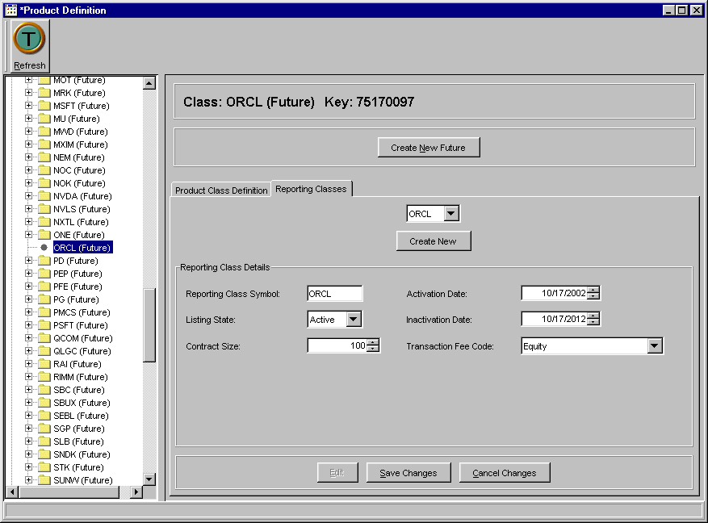
- Click Create New. Enter the reporting class symbol for the new product in the Class Symbol box. The class symbol must be entered in uppercase letters.
- Select the listing state from the listing state drop down lists.
- To enter the activation and inactivation dates select the up/down arrows until the desired dates are reached.
- Select the contract size.
- Select the fee code from the Default Fee Code drop down list box.
- To save the new reporting class, click Save Changes. The reporting class displays in the CBOE Product Types directory.
- If you decide not to create a new reporting class, click Cancel Changes.
Create a New Future Product
From the CBOE Product Types directory, double click on the Future Directory and highlight the Future class you wish to modify. The Product Class Definition tab will display.
 | 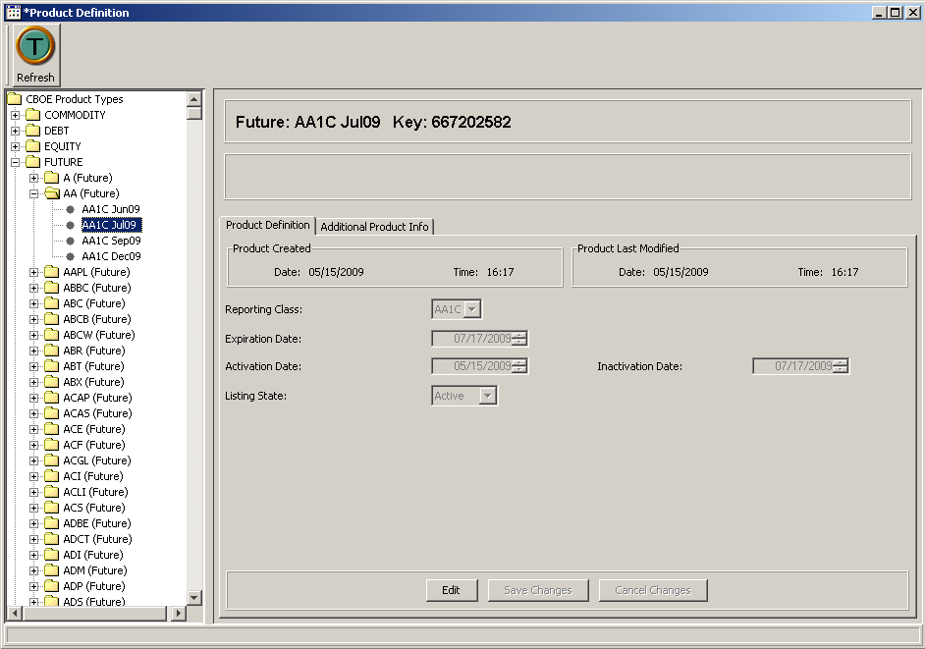
- Click Create New Future.
- From the drop down list boxes, update the Reporting Class, Expiration date, Activation Date, Inactivation Date and Listing State, if required.
- If you wish to change the product’s CUSIP number, click on the Additional Product Info tab.
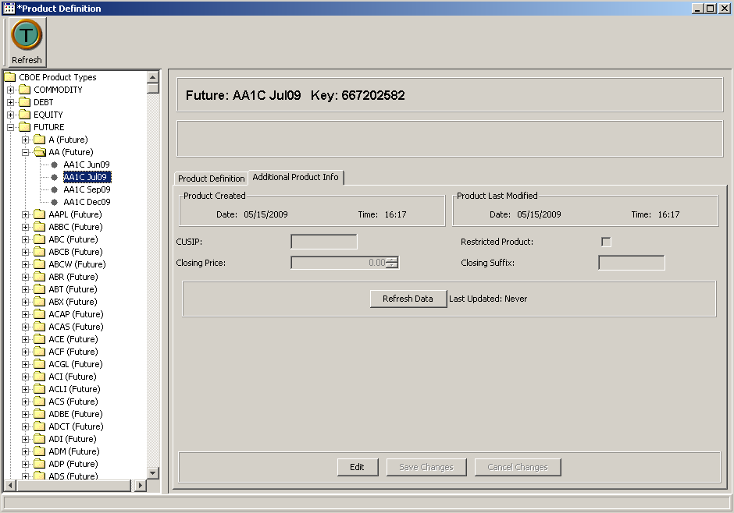
- Enter the CUSIP number in the text box. You can also change the Closing Price and select if the product should be restricted.
- To save the product, click Save Changes. The product displays in the CBOE Product Types directory.
- If you decide not to create a new product, click Cancel Changes.
- To update the data in this window, click Refresh Data.
Help Desk-Only Function | Create a New Option Product Using the TPF Download Process  - From the CBOE Product Types directory, click on the Option folder. Click Create New Option Class. The Product Class Definition tab will display.  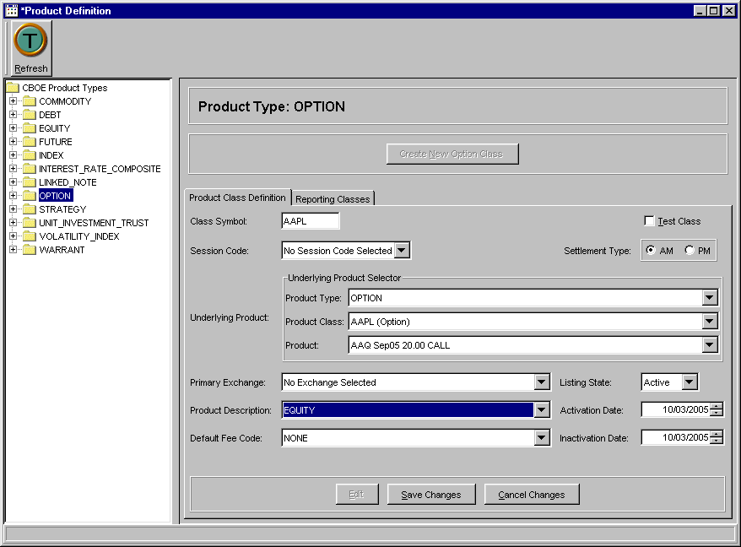
- Enter the class symbol for the new product in the Class Symbol box. The class symbol must be entered in uppercase letters.
- When creating Option product classes using the TPF download, select No Session Code Selected from the Session Code drop down list. The TPF download automatically assigns the product class to the appropriate session.
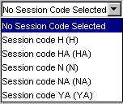
- From the Underlying Product Selector drop down list boxes, choose the product type and product class to be used as the underlying security.
 Note: If the underlying product does not exist, a new Equity product must be created. To create a new Equity product, refer to the Create a New Equity Product section, page 33.
- Choose the corresponding radio button for the Settlement Type: AM or PM.
- Select the product class's Primary Exchange and Listing State from the drop down lists.
- To enter the activation and inactivation dates select the up/down arrows until the desired dates are reached.
- Select the Product Description from the drop down list box.

 Note: For product description features and limitations, refer to the Product Description section, page 41.
- Select the fee code from the Default Fee Code drop down list box.
- To enter the new product class into the system, click Save Changes. The new product class will display in the CBOE Product Types directory.

Create an Option Reporting Class
To create a new reporting class, click the Reporting Class tab.
 | 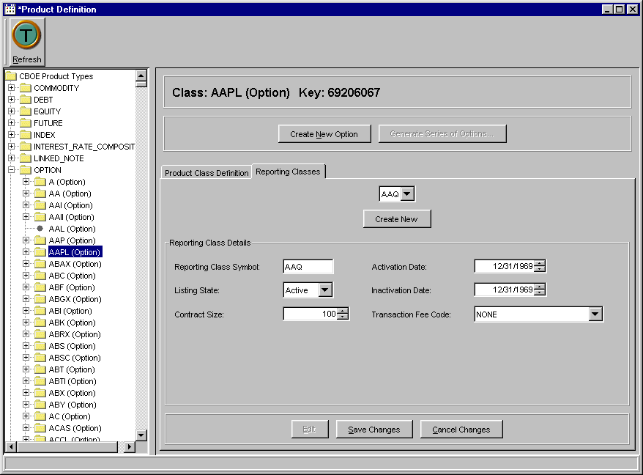
- Click Create New. Enter the reporting class symbol for the new product in the Class Symbol box. The class symbol must be entered in capital letters.
- Select the listing state from the listing state drop down lists.
- To enter the activation and inactivation dates select the up/down arrows until the desired date is reached.
- Select the contract size.
- Select the fee code from the Default Fee Code drop down list box.
- To save the new reporting class, click Save Changes. The reporting class displays in the CBOE Product Type directory.
- If you decide not to create a new reporting class, click Cancel Changes.
Create a New Option Product
- Option products are not created. They are downloaded from the system.
➢ | Overview for Maintaining Option Products Using the Download  Several steps must be considered for maintaining Option products from the download, formally, the TPF download.  - Define the Underlying Product Class.  - Define the Option Product Class and assign it to the appropriate underlying.  - Define all the related Reporting Classes for the Option Product Class.  - No need to manually add products.  - Assign Underlying to the Underlying session.  - The class will be available in the session on the next business day.
To Add a Reporting Class Intraday
- Add the Reporting Class to the existing Product Class.
- Contact Operations to perform a refresh of the new Reporting Class.
➢ | Create a New Option Product without the Download Process  - From the CBOE Product Types directory, click on the Option folder. Click Create New Option Class. The Product Class Definition tab will display.   Note: Option product classes should not be created intraday.
- Enter the class symbol for the new product in the Class Symbol box. The class symbol must be entered in uppercase letters.
- If the class will be used as a test class, select the Test Class checkbox.
- Choose the corresponding radio button for the Settlement Type: AM or PM.
- If you must create an option product class intraday, select No Session Code Selected from the Session Code drop down list. The TPF download automatically assigns the product class to the appropriate session the next business day.
- From the Underlying Product Selector drop down list boxes, choose the product type and product class to be used as the underlying security.
 Note: If the underlying product does not exist, a new Equity product must be created. To create a new Equity product, refer to the Create a New Equity Product section, page 33.
- Select the product's Primary Exchange and Listing State from the drop down lists.
- To enter the activation and inactivation dates select the up/down arrows until the desired dates are reached.
- Select the Product Description from the drop down list box.
 Note: For product description features and limitations, refer to the Product Description section, page 41.
- Select the fee code from the Default Fee Code drop down list box.
- To enter the new product class into the system, click Save Changes. The new product class will display in the CBOE Product Types directory.
- If you decide not to create a new product class, click Cancel Changes.
Create an Option Reporting Class
To create a new reporting class, click the Reporting Class tab.
 | 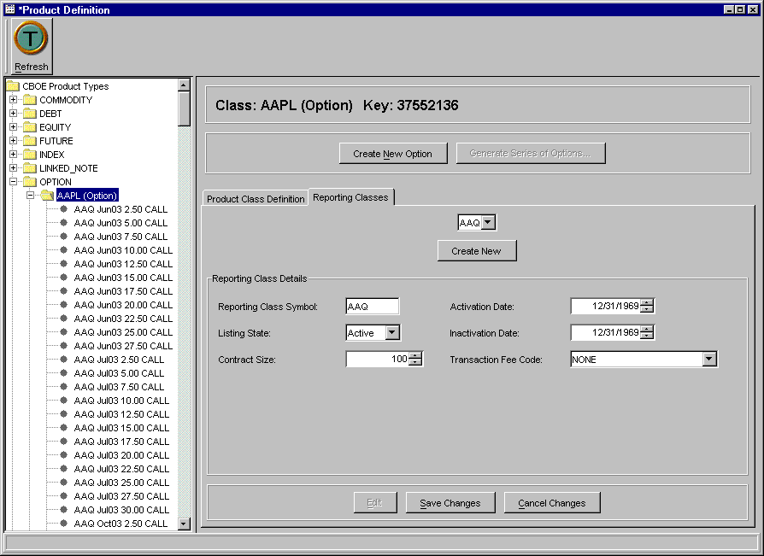
- Click Create New. Enter the reporting class symbol for the new product in the Class Symbol box. The class symbol must be entered in capital letters.
- Select the listing state from the listing state drop down lists.
- To enter the activation and inactivation dates select the up/down arrows until the desired dates are reached.
- Select the contract size.
- Select the fee code from the Default Fee Code drop down list box.
- To save the new reporting class, click Save Changes. The reporting class displays in the CBOE Product Type directory.
- If you decide not to create a new reporting class, click Cancel Changes.
Create a New Option Product
From the CBOE Product Types directory, double click on the Option Directory and highlight the Option class you wish to modify. The Product Class Definition tab will display.
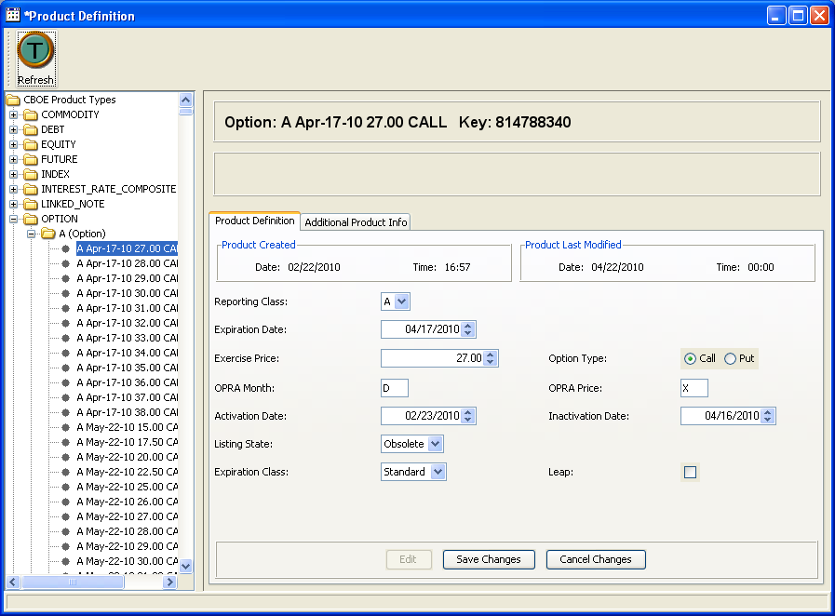
- Click Create New Option.
- From the drop down list boxes, update the Reporting Class.
- Select the Expiration date, Activation Date, Inactivation Date by typing over the current dates or click on the up/down arrows until the desired dates are reached.
- If you wish to change the CUSIP number for the product, click on the Additional Product Info tab.
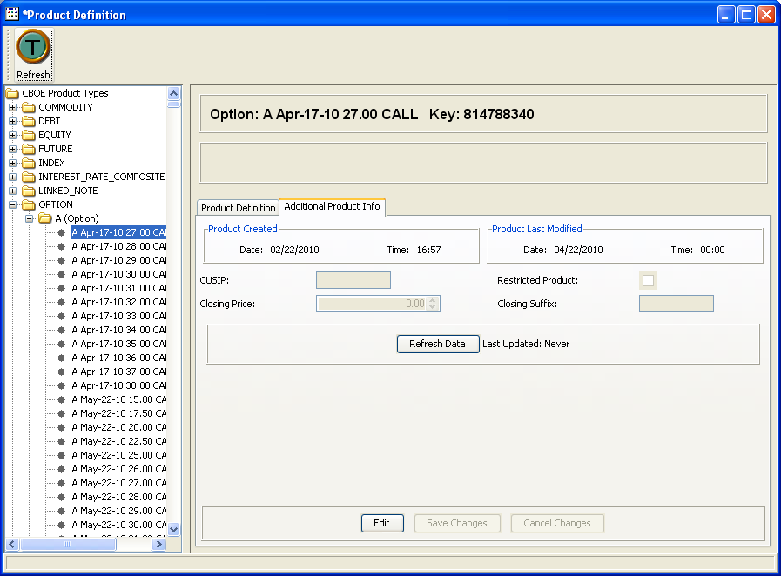
- Click Edit. The fields will become editable. Enter the CUSIP number in the text box. You can also change the Closing Price and select if the product should be restricted.
- To save the product, click Save Changes. The product displays in the CBOE Product Types directory.
- If you decide not to create a new product, click Cancel Changes.
- To update the data in this window, click Refresh Data.
➢ | Create a New Equity Product Class  - From the CBOE Product Types directory tree, click on the Equity folder. Click Create New Equity Class. The Product Class Definition tab will display.  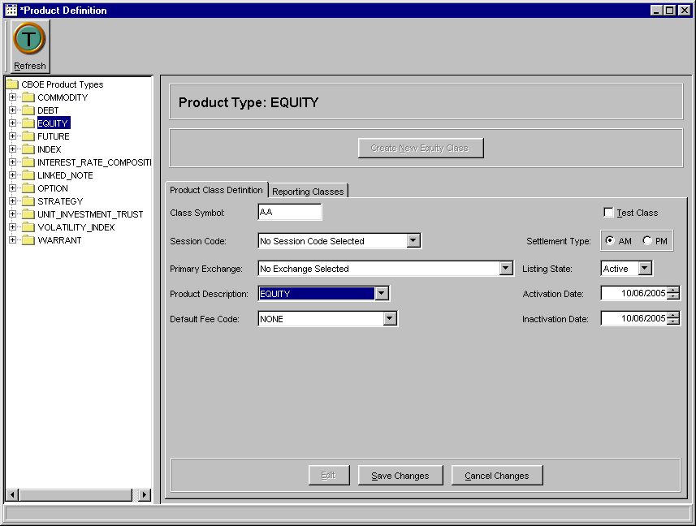
- Enter the class symbol for the new product class in the Class Symbol box. The class symbol must be entered in capital letters.
- The Session Code selector defaults to No Session Code Selected.
- If the new product class is a test class, click the Test Class checkbox.
- Choose the corresponding radio button for the Settlement Type: AM or PM.
- Select the product class’s primary exchange and listing state from the Primary Exchange and Listing State drop down lists.
- To enter the activation and inactivation dates select the up/down arrows until the desired dates are reached.
- Select the Product Description from the drop down list box.
 Note: For product description features and limitations, refer to the Product Description section, page 41.
- Select the fee code from the Default Fee Code drop down list box.
- To enter the new product into the system, click Save Changes. The new product will display in the CBOE Product directory.
- If you decide not to create a new product class, click Cancel Changes.

Create a New Equity Reporting Class
To create a reporting class, select the reporting class tab.
 Note: Equity classes can have only one reporting class.
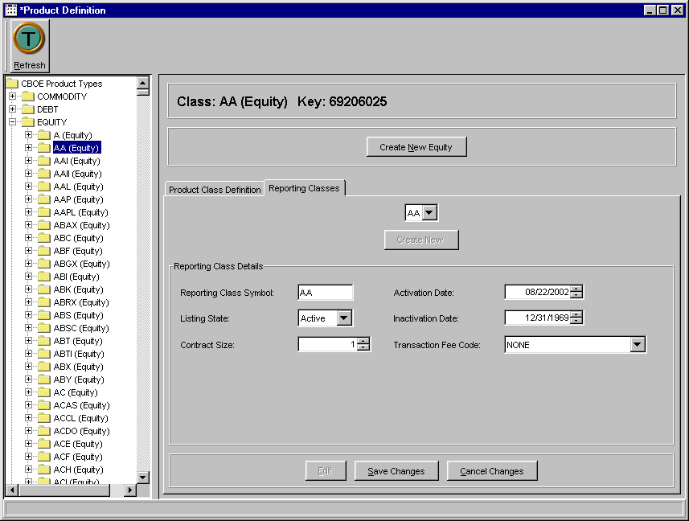
- Click Create New. Enter the reporting class symbol for the new product in the Class Symbol box. The class symbol must be entered in capital letters.
- Select the listing state from the listing state drop down lists.
- To enter the activation and inactivation dates select the up/down arrows until the desired dates are reached.
- Select the contract size.
- Select the fee code from the Default Fee Code drop down list box.
- To save the new reporting class, click Save Changes. The reporting class displays in the CBOE Product Type directory.
- If you decide not to create a new reporting class, click Cancel Changes.
Create a New Equity Product
From the CBOE Product Types directory, double click on the Equity Directory and highlight the Equity class you wish to modify. The Product Class Definition tab will display.
 | 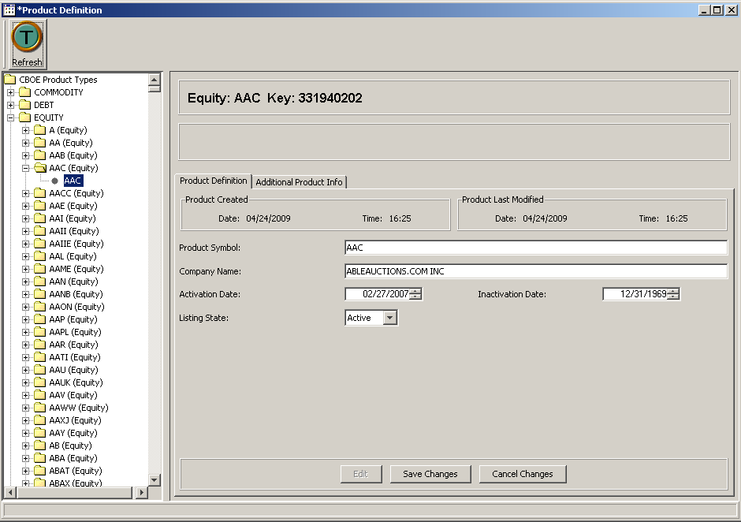
- Click Create New Equity.
- Enter the Product Symbol in all capital letters.
- Enter the Company Name.
- Select the Expiration date and Activation Date by typing over the current dates or click on the up/down arrows until the desired dates are reached.
- Select the Listing State from the drop down list box.
- If you wish to change the CUSIP number for the product, click on the Additional Product Info tab.
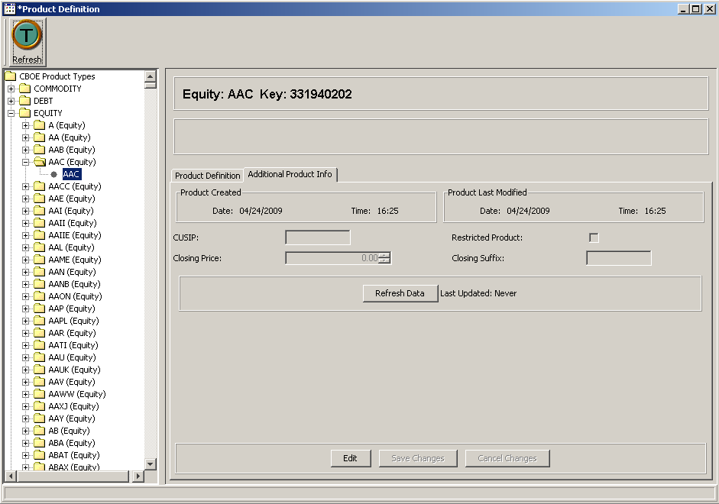
- Enter the CUSIP number in the text box. You can also change the closing price and select if the product should be restricted.
- To save the product, click Save Changes. The product displays in the CBOE Product Types directory.
- If you decide not to create a new product, click Cancel Changes.
- To update the data, click Refresh Data.
➢ | Create a New Index Product Class  - From the CBOE Product Types directory tree, click on the Index folder. Click Create New Index Class. The Product Class Definition tab will display.  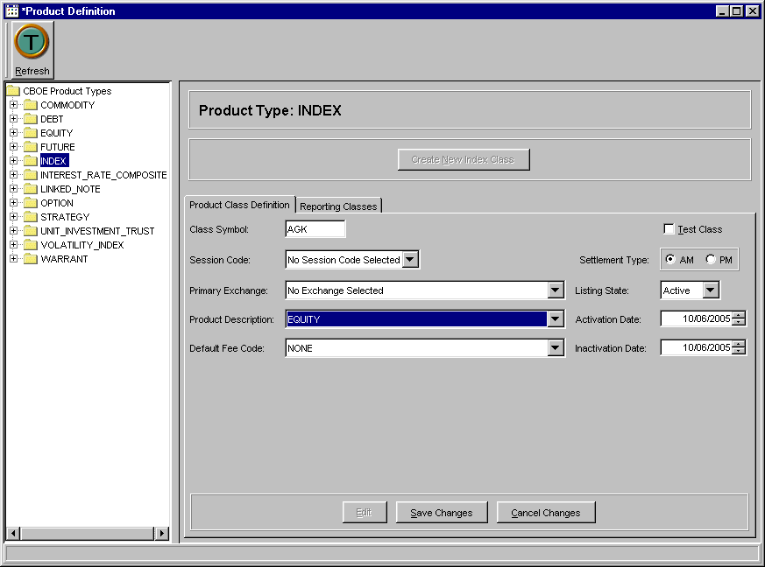
- Enter the class symbol for the new product class in the Class Symbol box. The class symbol must be entered in capital letters.
- The Session Code selector defaults to No Session Code Selected.
- If the new product class is a test class, click the Test Class checkbox.
- Choose the corresponding radio button for the Settlement Type: AM or PM.
- Select the product class's primary exchange and listing state from the Primary Exchange and Listing State drop down lists.
- To enter the activation and inactivation dates select the up/down arrows until the desired dates are reached.
- Select the product description from the drop down list box.
 Note: For product description features and limitations, refer to the Product Description section, page 41.
- Select the fee code from the Default Fee Code drop down list box.
- To enter the new product class into the system, click Save Changes. The new product will display in the CBOE Product Types directory.
- If you decide not to create a new product class, click Cancel Changes.
Create an Index Reporting Class
Click on the Reporting Class tab to enter a new Index reporting class.
 Note: Index classes can have only one reporting class.
 | 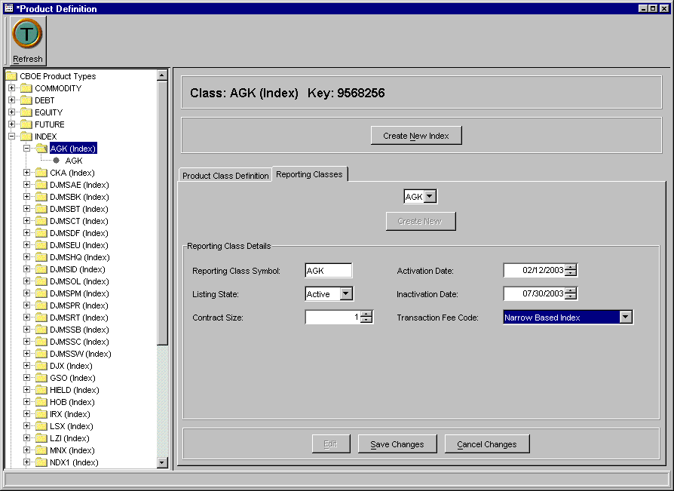
- Click Create New. Enter the reporting class symbol for the new product in the Reporting Class Symbol box. The class symbol must be entered in capital letters.
- Select the listing state from the listing state drop down lists.
- To enter the activation and inactivation dates select the up/down arrows until the desired dates are reached.
- Select the contract size.
- Select the fee code from the Default Fee Code drop down list box.
- To save the new reporting class, click Save Changes. The reporting class displays in the CBOE Product Types directory.
- If you decide not to create a new reporting class, click Cancel Changes.
Create an Index Product
From the CBOE Product Types directory, double click on the Index Directory and highlight the Index class you wish to modify. The Product Class Definition tab will display.
 | 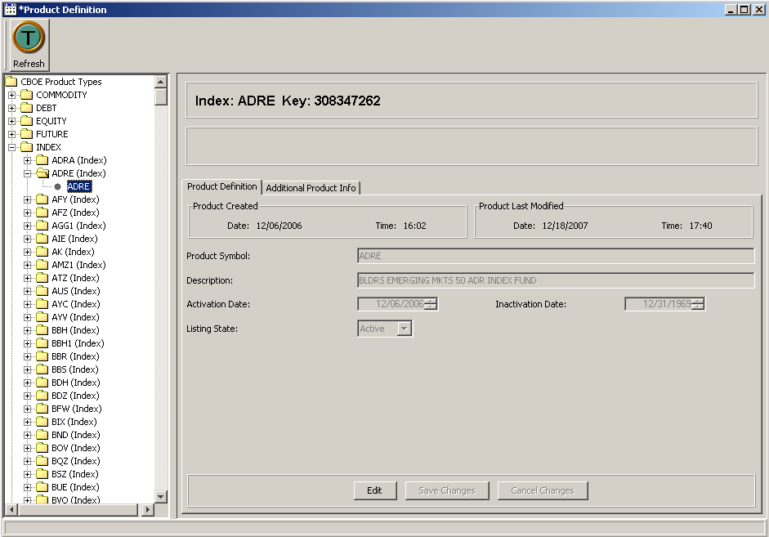
- Click Create New Index.
- Enter the Product Symbol in all capital letters.
- Enter the Company Name.
- Select the Expiration and Activation Dates by typing over the current dates or click on the up/down arrows until the desired dates are reached.
- Select the Listing State from the drop down list box.
- If you wish to change the CUSIP number for the product, click on the Additional Product Info tab.
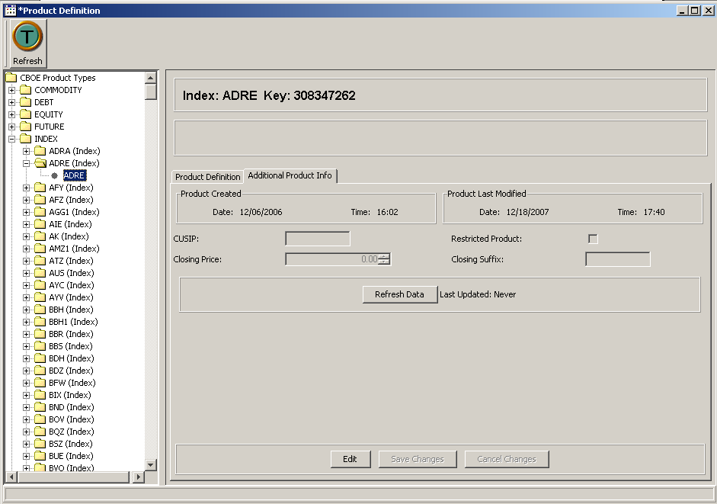
- Enter the CUSIP number in the text box. You can also change the closing price and select if the product should be restricted.
- To save the product, click Save Changes. The product displays in the CBOE Product Types directory.
- If you decide not to create a new product, click Cancel Changes.
- To update the data, click Refresh Data.
➢ | Edit Product Information  - From the CBOE Product Type directory, select the product you wish to modify. Click Edit. The selected product's information will display in editable format.  - Modify the existing product information.  - To save the new product information, click Save Changes. The product information will be saved and displayed in the CBOE Product Types directory.  - If you decide not to modify the product information, click Cancel Changes. The window will revert to the original product information.
➢ | Edit an Existing Reporting Class  - Select the product class from the CBOE Product Type directory.  - Select the reporting class from the Reporting Classes drop down list. Click Edit. The reporting class information displays in editable format.  - Modify the existing information as required.  - To save the updates, click Save Changes. The reporting class displays in the CBOE Product Types directory with updated information.  - If you decide not to modify the existing reporting class, click Cancel Changes.
Product Description  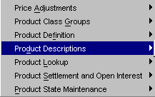 | Product descriptions are unique by 'Description Name’. Every product that uses this name is sharing the product description. If a change is made to a product description, it affects all products using that name. Make sure that different product types have their own product descriptions.  To edit product descriptions, select Products, Product Description, Create New Window. The Product Description window will display.
 | 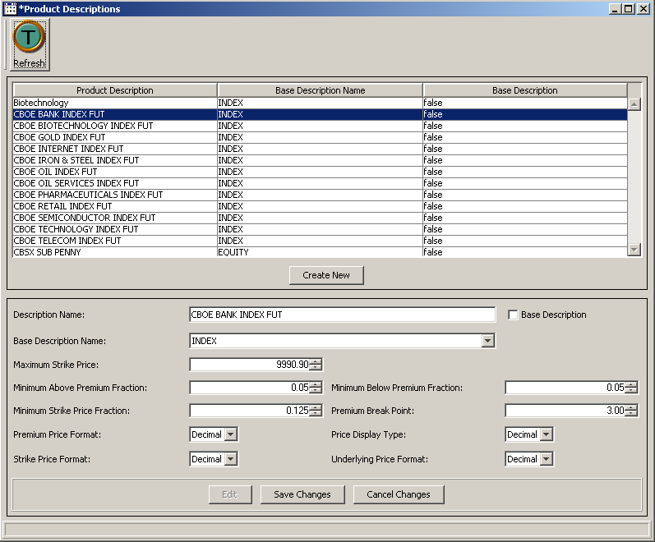
 | From this window, you can modify product descriptions and/or create new descriptions.

Edit Product Descriptions
- To modify the description of a product, select the product type description from the product description panel of the window. Click Edit. Product description details display in editable format.
- Modify the Description Name and the Base Description Name by placing the curser in the text box and typing in the new information.
 Note: Any changes to a Product Description will change the description for all products that share the description.
- Select the Maximum Strike Price, Minimum Strike Price, Minimum Below Premium Fraction and the Premium Break Point by clicking the up/down arrows until the desired value is reached.

- From the drop down lists, select the Premium Price Format, Price Display Type, Strike Price Format and the Underlying Price Format.
- To save the updates, click Save Changes. The product displays in the CBOE Product Type directory with updated information.
- If you decide not to modify the existing product, click Cancel Changes.

Create New Product Description
- To add a new product description, click Create New. The text fields display in editable format.
- Enter the Description Name and the Base Description Name by placing the curser in the text box and typing in the new information.
 Note: The Product Description you enter will apply to all products that share the description.
- Select the Maximum Strike Price, Minimum Strike Price, Minimum Below Premium Fraction and the Premium Break Point by clicking the up/down arrows until the desired value is reached.
- The price formats default to decimal for Premium Price, Price Display Type, Strike Price and the Underlying Price. To change the price format to a fraction, select the fraction option from the corresponding drop down list for each price type.
- To save the updates, click Save Changes. The product displays in the CBOE Product Type directory with updated information.
- If you decide not to modify the existing product, click Cancel Changes.

Product Lookup  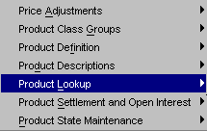 | CBOEdirect has the functionality to search for specific product information. From the Start Menu, select Products. From the sub-menu, select Product Lookup, Create New Window. The Product Lookup window will display.  From this window, you can retrieve product information by product type and class, or by key reference number.
➢ | Lookup by Selector  From the Lookup by Selector section of the window, CBOEdirect allows you to retrieve detailed product information for a particular product or for all products related to a product class.  To request product information for a particular product class:  - Select the Product Type and Product Class from the corresponding drop down lists.  - Select the product from the Product drop down list and click on the Lookup button. The product information will display in the Details section of the window. Use the up/down arrows to scroll through the text box for additional system details about the product.
 | 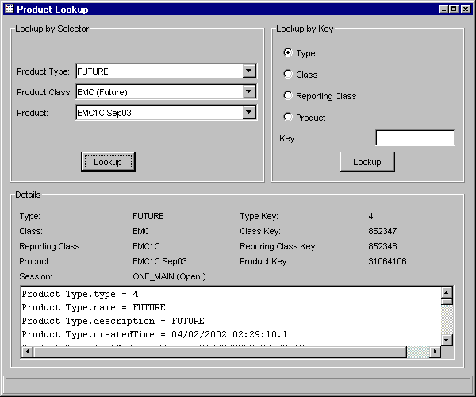
To request product information for all products pertaining to a product class:
- Select the Product Type and Product Class from the corresponding drop down lists.
- Select the All Products option from the Product drop down list box. The products common information will display in the Details section of the window. Use the up/down arrows to scroll through the text box for additional system details about all the products in the product class.
 | 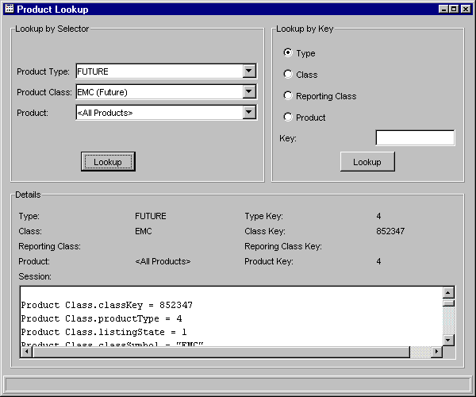

Lookup by Key
You can quickly lookup product information by type, class, reporting class or product if you have the Key reference number.
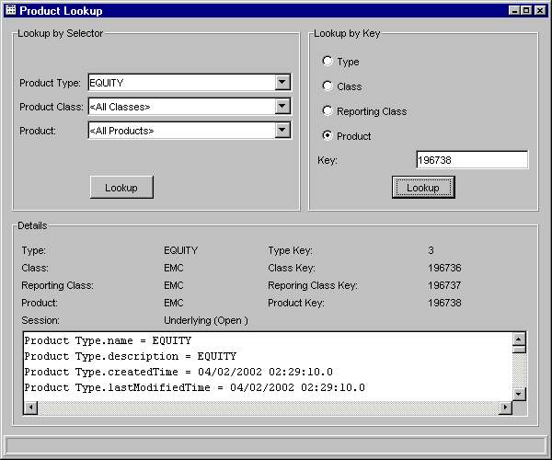
For example, to lookup product information by the key reference number, select the Product radio button in the Lookup by Key section of the window. Enter the key reference number in the Key text box and click Lookup. In the example window above, the product with key number 196738 displays in the Details section of the window. Use the up/down arrows to scroll through the text box for system details about the product.
Follow the steps detailed above to lookup class, type or reporting class information by the key reference number.

Trading Session Maintenance

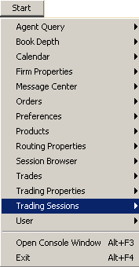 | CBOEdirect performs all Trading Session and End of Day (EOD) steps automatically. Manual operations should only be used in exceptional cases.  To manually modify trading session activity, select Trading Sessions from the Start Menu, then select Create New Window. The Trading Session Management window will display.  Initially, the window will be blank. Double-click on the CBOE folder to display the trading sessions.  Session information can be reloaded at anytime by selecting the Refresh Sessions option in the Session menu.
Trading Session Management | 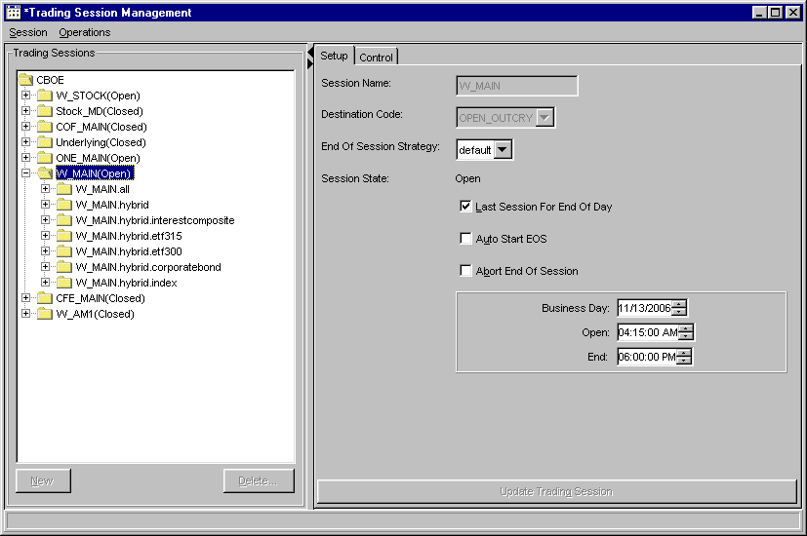
 | From this window, CBOEdirect Support staff can setup and control trading session activity. However, support mode access must be obtained.
Support Staff-Only Function | Support Mode Access  From the Operations menu, select the Support Mode option or hold down the Ctrl+Shift+S keys on your keyboard. The Enable Support Mode window displays and a checkmark is placed in front of the Support Mode option.
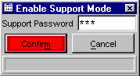
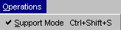
 | The Support staff enters the Support Password, clicks Submit and then Confirm. The Setup section of the window displays in editable format.
 | If you wish to exit the Enable Support Mode window without obtaining support access, click Cancel.
 | To deactivate the support mode access, select the Operations menu and click on the Support Mode option. The check mark is removed, thereby, removing access to setup functionality.
➢  Support Staff-Only Function | Setup a Trading Session  Once you have obtained support mode access, you can modify trading session activity from the Setup tab.  - Select the trading session from the Trading Sessions directory tree. The Session Name will display in the Session Name text box.  - Select the destination code.  - Select the End of Session Strategy from the list box  - Select the appropriate check box if:  - you would like the selected trading session to be the last session for end of day.  - you would like to auto start end of session.  - you would like to abort the end of session process.  - To change the automatic setting of the trading session's business day, opening time and ending time, click the up and down arrows until the desired date and times are reached.  - To save your changes, click Update Trading Session or select Update Session from the Session Menu. You can also press [Ctrl]-[U] from anywhere on the window to save your changes. A Confirmation dialog will appear prompting you to verify your setup changes.
 | 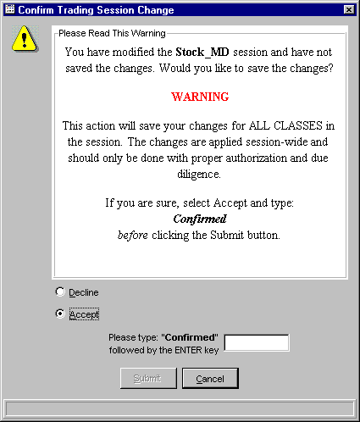
- The window defaults to Decline. Click Cancel to exit the Confirmation dialog without executing the changes.
- If you are sure you want to make the change, read the dialog carefully, click the Accept radio button and type “Confirmed” in the text box followed by the Enter key.
- Click Submit. The system will change the session setup.
 | To close the window, select Close from the Session Menu or click the  button in the upper right corner.
From the Control tab, you can open a trading session, start the End of Session (EOS) process and monitor session and End of Session events. To display the control tab, click Control.
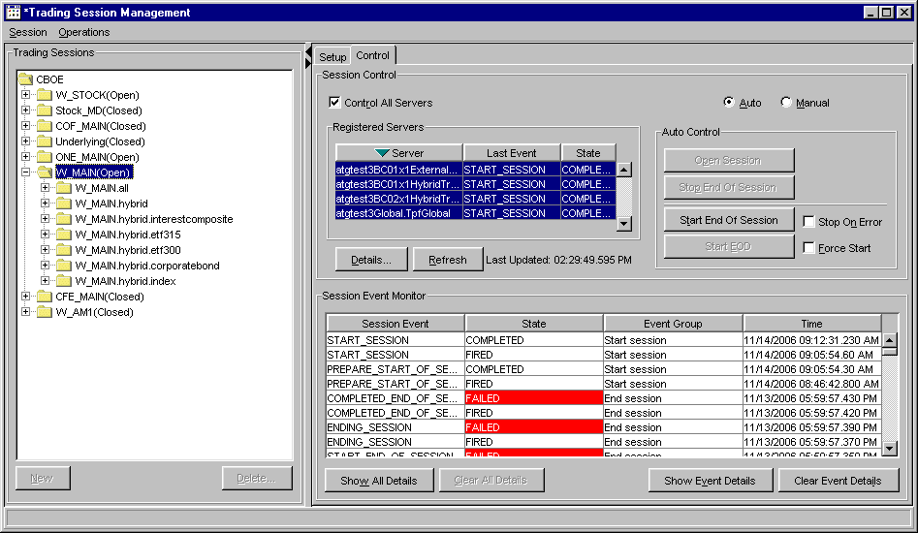
➢  Support Staff-Only Function | Open Session  Trading sessions will be set to automatically open at a pre-defined time. If the session must be manually opened:  - Select the session from the Trading Session directory tree.  - Click Open Session. The session will be set to Open state. The registered servers for the session, displayed in the Registered Servers section of the window, will perform the start session procedure and display their events and states. The Session Event Monitor displays the trading session’s state and start time.
➢  Support Staff-Only Function | Open Trade Servers  In the event that a failover is performed on one of the registered trade servers in the trading session, CBOEdirect allows Support staff to restart the trade server without having to restart the entire trading session.  To restart a trade server after a failover you must first obtain Support Mode Access.
 | 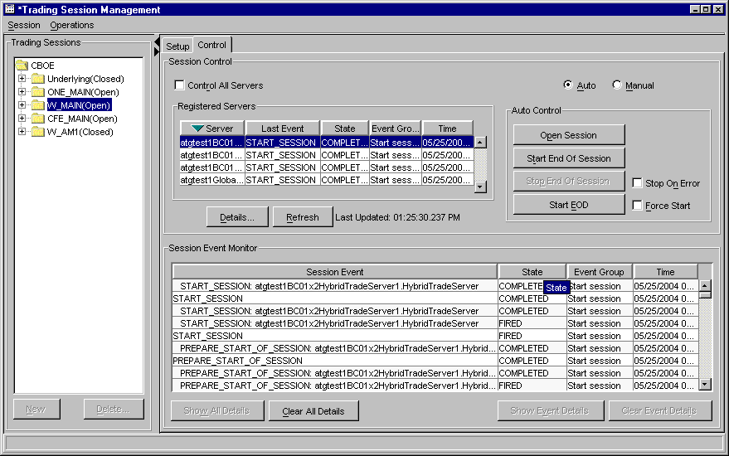
- To restart the trade server without starting the entire session:
- Deselect the Control All Servers check box and select the trade server you wish to restart. Click Open Session. The Last Event, State, Event Group and Time information display in the corresponding columns.

- To view trade server information, click Details. The Details for Registered Server window displays.
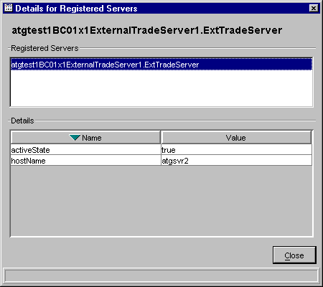
From this window, you can view the server process names and their values. Click Close to return to the Control tab.
- Click the Refresh button to update the window with current information.
➢ | Start End of Session  To automatically start the EOS process:  - Select the session from the Trading Session directory tree.  - Select the Auto radio button.  - Click Start End of Session. A Confirmation dialog will display prompting you to verify you wish to start the end of session.
 | 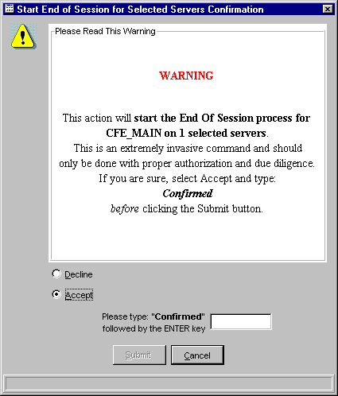
- The window defaults to Decline. Click Cancel to exit the Confirmation dialog without executing the changes.
- If you are sure you want to make the change, read the dialog carefully, click the Accept radio button and type “Confirmed” in the text box followed by the Enter key.
- Click Submit. The EOS process will begin. The Session Event Monitor will display the state and time of the process.
- To manually stop the end of session process, click Stop End of Session.
To manually start the End of Session (EOS) process:
 Note: Manual EOS is not currently supported.
- Select the session from the Trading Session directory tree.
- Select the Manual radio button. The Manual EOS Control section will display.
 | 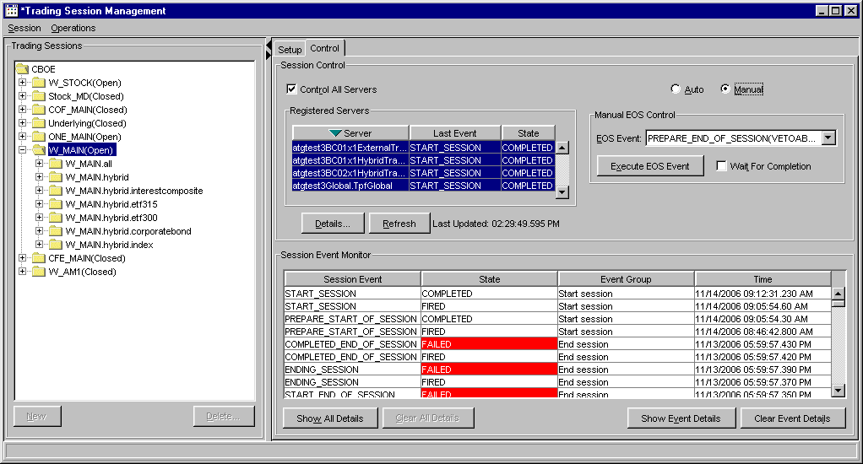
- From the Manual EOS Control section, select the EOS event you want to execute from the drop down list.
- Click Execute EOS Event. The Session Event Monitor section of the window displays the state of the event, event group information and the time the event was executed.
- Select the Wait For Completion check box if you do not want the EOS process interrupted by other operations.

➢  Support Staff-Only Function | Start End of Session By Trade Server  To start the End of Session process for a trade server:  - Select the Manual radio button.  - Select the trade server from the Registered Servers section of the window.  - Click Execute EOS Event. The Registered Servers section of the window updates with the process state and the last event that was executed.  - Select the Wait For Completion check box if you do not want the EOS process interrupted by other operations.  - Click the Show all Details button to display all session and registered server events on the Session Event Monitor section of the window.  - To hide all registered server events, click Clear All Details.  - To show all registed server events for the selected session, click Show Event Details.  - Click Clear Event Details to hide all registered server events for the selected session.
➢ | End of Day  CBOEdirect will not support the End of Day process. For details, refer to the End of Day section in the Operator Procedures document.  For illustration purposes only, below are the steps to perform the End of Day process.  - Select the session from the Trading Session directory tree.  - Select the Auto radio button.  - Click Start EOD. The end of day process will begin. The Session Event Monitor will display the state and time of the process.  - To force start the end of day process, select the Force Start check box.  - Click the Stop on Error check box to adjust the system to stop the end of day process if an error occurs.
 |  Note: The system automatically deletes day orders and expiring GTC orders at the end of the trading session. CBOEdirect will not support the passing of orders between trading sessions. Extended trading hour orders are restricted to the session to which they have been submitted.
 | To close the window, select Close from the Session Menu or click the  button in the upper right corner to close.
➢  Support Staff-Only Function | Product Classes  To update product class information for a Trading Session, select the product class from the Trading Session directory tree. Click Setup. The Setup tab for the product class will display.  Support Mode Access is required before making any changes to the setup functions.  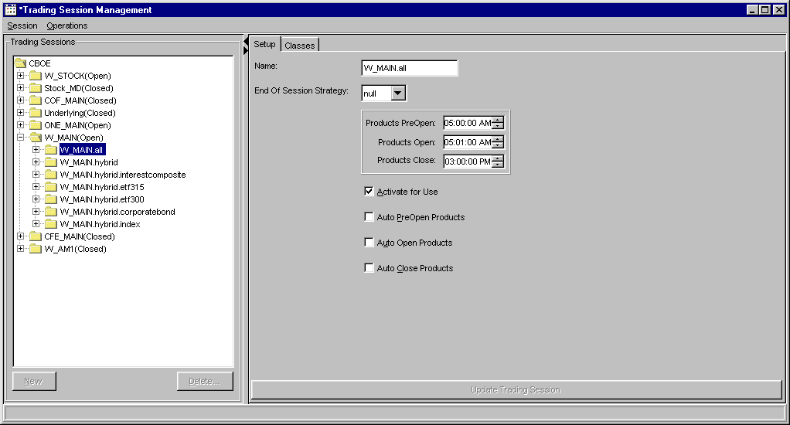
- Select the End of Session Strategy from the list box.
- If you wish to change the products pre-opening, opening and closing times, click the up and down arrows until you reach the desired time.
- To activate the products for the session, select the Activate for Use checkbox.
- The system automatically pre-opens, opens and closes products. If you wish to manually pre-open, open and close products, deselect the appropriate check boxes.
- To save your changes, click Update Trading Session or select Update Session from the Session Menu. You can also press [Ctrl]-[U] from anywhere on the window to save your changes. A Confirmation dialog will display prompting you to verify your changes.
 | 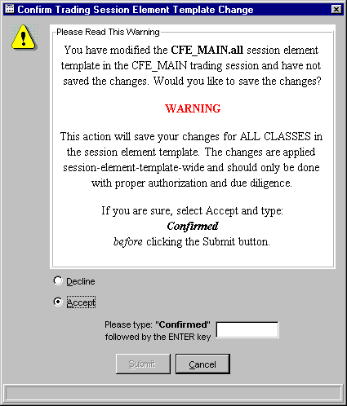
- The window defaults to Decline. Click Cancel to exit the Confirmation dialog without executing the changes.
- If you are sure you want to make the change, read the dialog carefully, click the Accept radio button and type “Confirmed” in the text box followed by the Enter key.
- Click Submit. The system will change the session element setup.
 | To close the window, select Close from the Session Menu or click the  button in the upper right corner to close.
To assign or remove product classes from a trading session, click Classes. The Classes tab will display.
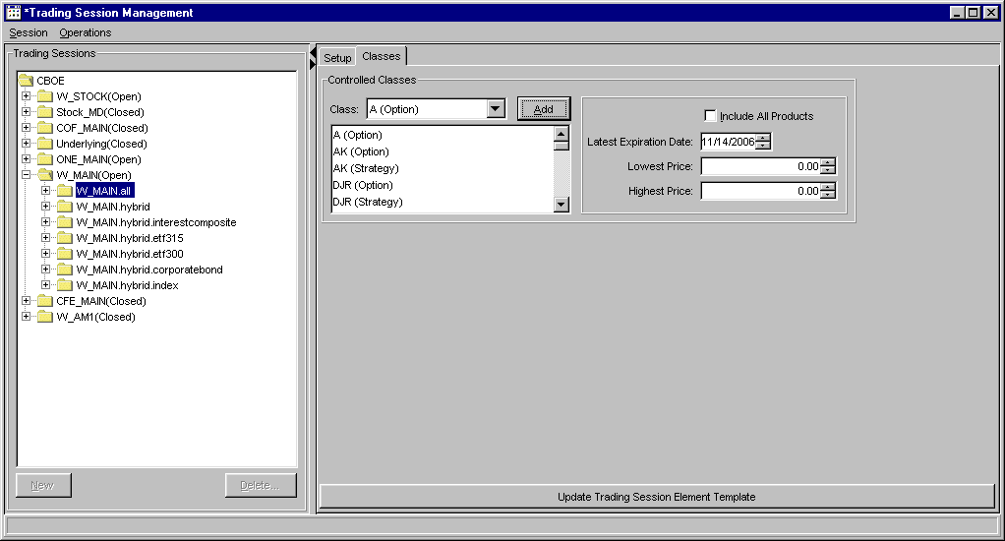
To add a product class to a trading session:
- Select the class from the Class list box. Click Add.
- To include all product series for the class, highlight the class and select the Include All Products checkbox.
- To save your changes, click Update Trading Session Element Template or select Update Template from the Session Menu. You can also press [Ctrl]-[U] from anywhere on the window to save your changes.
To remove a product from the trading session:
- Right mouse click on the class, select Remove.
- To save your changes, click Update Trading Session Element Template or select Update Template from the Session Menu. You can also press [Ctrl]-[U] from anywhere on the window to save your changes.
- You can filter the product series you wish to add to the trading session by latest expiration date, lowest price and highest price.
- Highlight the class.
- Select the expiration date by clicking the up and down arrows until you reach the desired date.
- Select the lowest price and the highest price.
- To save your changes, click Update Trading Session Element Template or select Update Template from the Session Menu. Product series for the class will be added to the trading session based on your filters.
 | If you decide you do not wish to add a product to the session, select Close from the Session Menu or click the  button in the upper right corner to close.
 |  Note: A template can only be used once to add a product class to the trading session. Changes will only apply to the current trading session.
➢  Support Staff-Only Function | Product Series  To update product series information, select the product series from the Trading Session directory tree. Click Setup. The Setup tab for the product series will display.  Support Mode Access is required in order to perform setup functions.  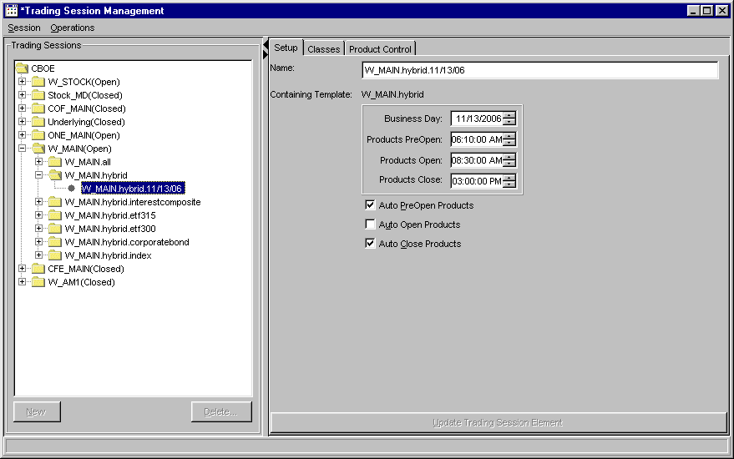
- If you wish to change the products opening and closing times, click the up and down arrows until you reach the desired time to pre-open, open and close products.
- The system automatically pre-opens, opens and closes products. If you wish to manually pre-open, open and close products, deselect the appropriate check boxes.
- To save your changes, click Update Trading Session Element or select Update Template from the Session Menu. You can also press [Ctrl]-[U] to save your changes.
To close the window, select Close from the Session Menu or click the  button in the upper right corner to close.
 | To view product class and series for a trading session, click Classes. The Classes tab will display.
 | 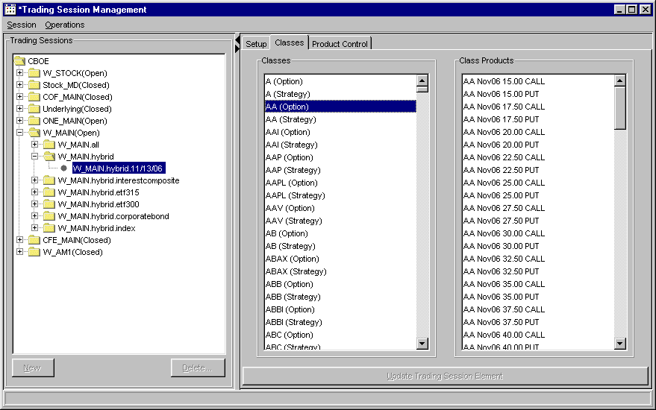
- To view the series in a product class, highlight the class from the Classes list box. All the series for the class will display in the Class Products list box.
- To save the changes, click Update Trading Session Element.
 | To close the window, select Close from the Session Menu or click the  button in the upper right corner to close.
To change product states, click Product Control. The Product Control tab will display.
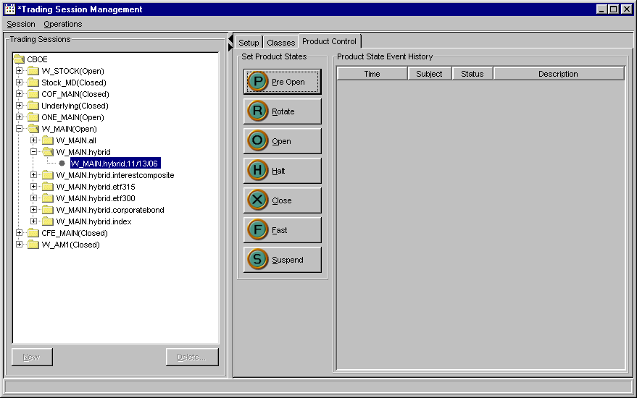
To change the state of a product class:
- Select the class from the Classes tab. Click the desired product state from the Product Control tab.
- To save your changes, select Update Element from the Session Menu or press [Ctrl]-[U]. A Confirmation dialog will appear prompting you to verify your changes

 | 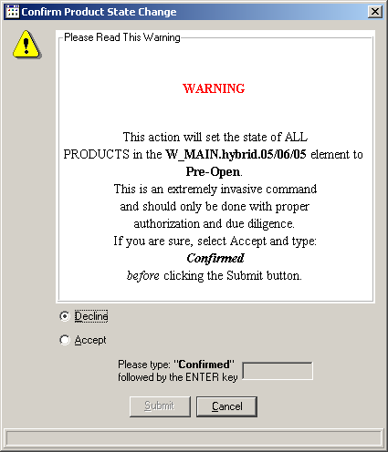
- The window defaults to Decline. Click Cancel to exit the Confirmation dialog without executing the changes.
- If you are sure you want to make the change, read the dialog carefully, click the Accept radio button and type “Confirmed” in the text box followed by the Enter key.
- Click Submit. The system will save your changes.
 | To close the window, select Close from the Session Menu or click the  button in the upper right corner to close.

Intraday Procedures

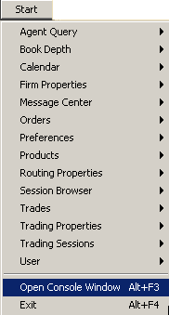 | CBOEdirect allows you to view system messages that are generated by the functions you perform. To view these messages, select Open Console Window from the Start Menu or press Alt F3 on your keyboard from anywhere on your screen. The Console Window will display.
Open Console Window | 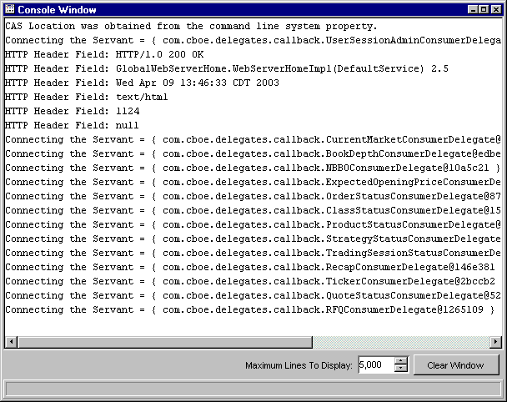
The information in this window can be copied to any text editor on your PC. To copy text from this window,
- Place your cursor on the line you want to copy and using your mouse highlight the text.
- Press Ctrl C on your keyboard to copy the text.
- Open your text editor (CBOEdirect Message Center, Word, Notepad, etc.) and place your cursor in the text entry area.
- Press Ctrl V on your keyboard. The text is copied to your editor.
The window defaults to display 5,000 lines. You can change the maximum amount of lines to display by entering a new quantity in place of the default value, or you can select a higher/lower quantity by clicking the up/down arrows until the desired quantity is reached.
If you wish to clear the window of all its contents, click the Clear Window button.

Exit the System

 | You can log out and exit the system at any time during the day.
Logout | To log out of the system, click Logout from the Session Information toolbar. You will be prompted to verify that you wish to close all windows and logout. Click Yes.
Exit the System | To exit the CBOEdirect system, select Exit from the Start Menu You will be prompted to verify that you wish to close all windows and logout. Click Yes. The application will be closed and you will be returned to your system desktop.

◻ | Section 2:  Reference Guide

Task Toolbar

When you log into the CBOEdirect Screen-Based Trading application, The Open Tasks toolbar will display on the CBOEdirect window. From this window you can open tasks, view session information, save window settings and perform window controls.
Note: The toolbar remains active during the trading session.
 | 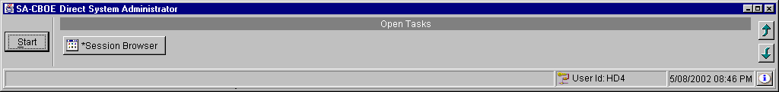
About CBOEdirect | To display CBOEdirect system information, click . The About window will display.
 | 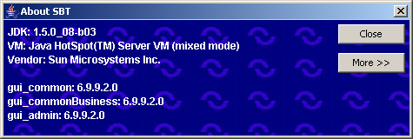
To view specific configuration information, click More. Detailed system information will display.
To exit the window, click Close.
Open Tasks | Initially, the Open Tasks toolbar will be empty. For each window you create, a task button will appear on the toolbar. From the task button, you can resize or change the configuration name of each window.  To resize a window or to change the default configuration name, click the window task button. The selected window will display. Right mouse click on the task button for the corresponding window. The resize and configuration menu will display.  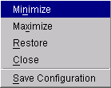
➢ | Resize  To resize a window:  - Highlight the resize choice or  - Hold down the [Alt] key and press the character of the underlined letter in the command.
➢ | Save Configurations  The system allows you to retain window configurations.  To save the configuration of a window:  - Right mouse click on the window’s task button and select Save Configuration. The Save Configuration window will display.  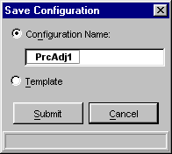  - Select the Configuration Name radio button. The text box displays in editable format.  - Enter the configuration name for the window. In the example above, the window name will be changed to “PrcAdj1”.  - To submit your configuration without setting a template, click Submit. Click Confirm. The system will save the configuration for the window and the task button will display with the new name.  - To set this configuration to be the default configuration for all windows, select the Template radio button. Click Submit. Click Confirm.  - If you decide not to change the default configuration, click Cancel instead of Submit.
➢ | Apply Default Preferences  CBOEdirect allows you to apply a default preference template to a window that has been already created.  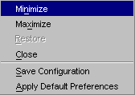  For example, if you previously saved the configuration of a Price Adjustment window, right mouse click on the new Price Adjustment window task button and select Apply Default Preferences. The Price Adjustment window settings will be changed to the default preferences for all Price Adjustment windows.
Session Information | From the Open Tasks toolbar, click the button to display the Session Information toolbar.
 | 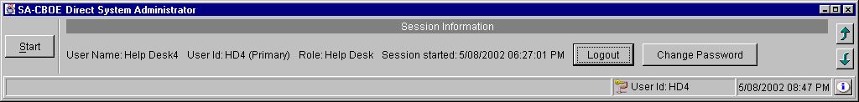
 | From this section of the toolbar, you can view user, role and session information. You also have the ability to logout of the system or to change your password.
➢ | Logout  To logout of the Help Desk system, click Logout. You will be prompted to verify that you wish to close all windows and logout. Click Yes. If you do not wish to logout of the system, click No.
➢ | Change Password  To change your password, click Change Password. The Change Password window will display.  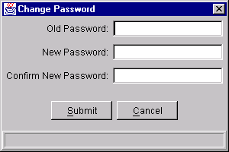
Enter your Old Password. Enter and confirm your New Password. Click Submit. Click Confirm.
If you decide not to change your password, click Cancel.
Main Window Settings | The system allows you to save your window preferences. From the Session Information secion of the toolbar, click the button. The Main Window Settings toolbar will display.
 | 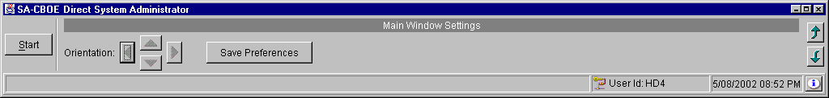
 | From this window you can save your window preferences. Click Save Preferences. The system will store your window configuration.
Window Control | The system allows you to organize your windows. From the Main Window Settings toolbar, click the button. The Window Control toolbar will display.
 | 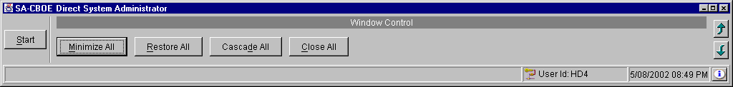
You have the ability to minimize, restore, cascade or close all of your active windows.
- To minimize all your windows, click Minimize All or hold down the [Alt] key and press "M" on your keyboard.
- To restore all your windows, click Restore All or hold down the [Alt] key and press "R" on your keyboard.
- To cascade all your windows, click Cascade All or hold down the [Alt] key and press "D" on your keyboard.
- To close all your windows, click Close All or hold down the [Alt] key and press "C" on your keyboard.

Customizing CBOEdirect Windows

Edit Column Preferences | Several CBOEdirect windows that exhibit data in column format can be customized to display specific information. For example, to modify your Price Adjustment window, right mouse click on any data row. Select Edit Preferences. The Edit Column Preferences window will display.  From this window, you can rearrange column positions and select or deselect columns for viewing.
 | 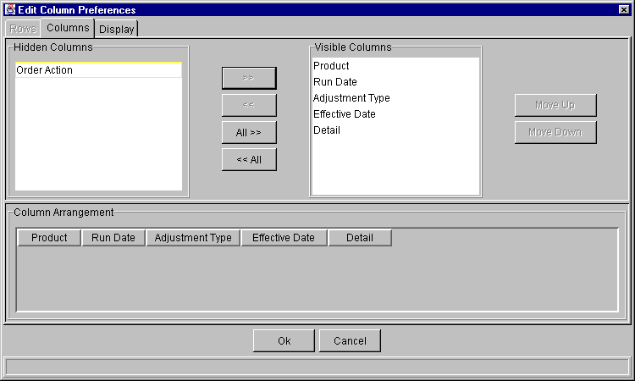
If there is a data column you do not wish to view:
- Select the column name in the Visible Columns list box. To select a continuous range of columns, hold down the shift key and highlight the column names. Hold down the ctrl key to select individual, non-continuous, column names.
- Click << to move the column name to the Hidden Columns list box.
- Click Ok to update the column arrangement.
- If you decide to retain the default layout, click Cancel.
To hide all columns:
- Click <<All to move all the column names in the Visible Columns to the Hidden Columns list box.
- Click Ok to update the column arrangement.
- If you decide to retain the default layout, click Cancel instead of Ok.

 Note: If you hide all columns, you will subsequently have to make some columns visible before the update will take effect.
To display a hidden column:
- Select the column name(s) from the Hidden Columns list box.
- Click >> to move the selected column name(s) to the Visible Columns list box.
- Click Ok to update the column arrangement.
- If you decide to retain the default layout, click Cancel instead of Ok.
To display all hidden columns:
- Click All>> to move the column names to the Visible Columns list box.
- Click Ok to update the column arrangement.
- If you decide to retain the default layout, click Cancel instead of Ok.
You may prefer to view data columns in a different order than the default display.
To move a column:
- Highlight the column name from the Visible Columns list box.
- Click Move Up or Move Down until you reach the new column location.
- Click Ok to update the column arrangement.
- If you decide to retain the default layout, click Cancel.
From the Column Arrangement section of the window, the columns can be resized to make viewing information easier for you.
To resize a column:
- Place the mouse on the right edge of the column header (where the column titles are displayed) until it becomes a two-sided arrow.
- Hold the left mouse button down and move it to the desired size.
- Click Ok to save the new column size.
- If you decide to retain the default column size, click Cancel instead of Ok.

Display
In addition to customizing column settings, CBOEdirect allows you to adjust the text on your windows. From the Edit Column Preferences window, select the Display tab.
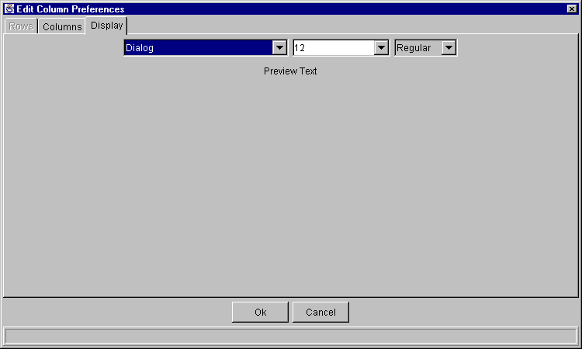
Select the font type, font size and font style from the drop down lists. Your selection will display in the Preview Text section of the window.
- Click Ok to set the new text style.
- If you wish to retain the default text settings, click Cancel.

Save Customized Defaults
If you want to save your changes and automatically open the window with your customized defaults, be sure to save the configuration on the Open Tasks toolbar.
To save customization:
- Right mouse click on the corresponding window task button.
- Select Save Configuration. The Save Configuration window will display.
- Enter the Configuration Name for the window.
- Click Submit. Click Confirm.
- If you decide you do not wish to save the new configuration, click Cancel.
Sizing CBOEdirect Windows | The CBOEdirect windows are sizable. That is, they can be resized on the screen to make viewing information easier for you.
 | 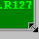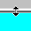 | Place the mouse on any edge of the window until it becomes a two-sided arrow. Hold the left mouse button down and move it to the desired size.
Resizing a window on the corner will expand or contract it in both directions (i.e. up and down and side-to-side). Resizing it on the side or top/bottom will expand or contract the window only in that one direction.
Windows can also be resized using the center glyph in the upper right corner of the window.
 |  | Click the left button () to minimize the window. Click the right button () to close the window. The center button is used for sizing.
If  is displayed, clicking it will increase the window size to a full-screen display.
If  is displayed, clicking it will return the window to its default size.

