
SToC

Stock Trader's User Guide
Version 2.0

Disclaimer

Copyright © 2006-2007 Chicago Board Options Exchange. All rights reserved.
The information contained in this document constitutes confidential and/or trade secret information belonging to CBOE. This document is made available to CBOE members and member firms for use with CBOEdirect. This document is provided "As Is" with all faults and without warranty of any kind, either express or implied.

Change Notices

The following change notices are provided to assist users of the CBOEdirect stock screen-based trading system in determining the impact of changes to their processing.
If you have any questions or review comments about this document, please contact Odalys Castro at (312) 786 8817.

Date | Version | Description of Change
1/26/07 | 2.0 | Update for Stock Hybrid. New functionality for Cross orders.  Removal of ITS Admin pre-opening price messages interface  Removal of Manual Handling interface
10/29/06 | 1.0 | New document

Table of Contents
Table of Contents iii
Introduction vi
Purpose vi
Intended Audience vi
Note about Displayed Screens vi
Conventions Used in this Guide vii
Section 1: Screen-Based Trading 1
Getting Started 2
Login 2
Set User Preferences 4
Miscellaneous Preferences 4
Quote Preferences 5
Set Trading Parameters 6
QRM Maintenance 6
Send a Message 7
Messages to CBOEdirect Help Desk 7
Opening a Stock Trading Session 9
Market Display Window 9
Select Product Classes 9
Examples of Market Display 10
Customize Market Display 12
Row Preferences 12
Column Preferences 13
Display 15
Scrolling Ticker 16
Market Display Theme 17
Increase/Decrease Market Data Font 17
Sizing the Market Display Window 18
Quotes 19
Enter Quote 19
Update an Existing Quote 20
Updating One Side of a Quote 20
Delete Quote 21
Delete All Quotes 22
Request for Quote 23
View Pending RFQs 24
Respond to RFQs 25
Primary Exchange Quotes 26
Orders 28
Add New Buy Order 28
Add New Sell Order 30
Paired Order 31
Cross Orders 33
Hit the Bid 35
Take the Offer 36
Hit the NBBO Bid 37
Take the NBBO Offer 37
Contingency Orders 38
Order and Quote Status 39
Cancel Replace 39
Cancel 40
Update 40
Order History 41
Edit Preferences 41
Viewing Status 42
Trades Log 42
Activity Log 43
Market History 44
Book Depth 45
Display Pending Price Adjustments 45
Closing a Trading Session 46
Logout 46
Exit the System 46
Section 2: Detailed Reference Guide 47
Task Toolbar 48
About CBOEdirect 48
Open Tasks 49
Resize 49
Saving the Configuration for Windows 49
Apply Default Preferences 50
Session Information 50
Logout 50
Change Password 50
Main Window Settings 51
Window Control 51
Start Menu 52
Book Depth 52
Edit Column Preferences 53
Held Order Status 53
Fill Held Order 54
Reroute Without Protection 54
Reroute With Protection 55
Reroute By Class Without Protection 55
Reroute By Class With Protection 55
Send P/A Order 56
Fill Satisfaction Order 56
Fill Satisfaction Order In-Crowd 57
Reject Satisfaction Order 58
History 58
Activity Log 58
Edit Column Preferences 59
Market History 59
Priority Market History 60
Edit Column Preferences 61
Trades Log 61
Edit Column Preferences 62
Locked Market Status 62
Market Display 63
Message Center 63
Order Status 64
Edit Column Preferences 64
Pending Price Adjustment 65
Pending RFQs 65
Preferences 67
Miscellaneous Preferences 67
Quote Preferences 69
Configuration Maintenance 71
User Information 72
Product Lookup 73
Lookup by Selector 73
Lookup by Key 75
QRM 76
QRM Maintenance 76
Status Window 77
Ticker Display 78
Ticker Configuration 79
Open Console Window 84

Introduction

Purpose | This user guide was written to assist users in utilizing all of the features of the stock screen-based trading system using CBOEdirect. It provides comprehensive information on trading activity and suggests how to customize your trading environment for optimal use.
Intended Audience | This user guide is intended for anyone interested in CBOEdirect's stock screen-based trading functions.
Note about Displayed Screens | An attempt is made to show the current look and format of screens that are included in this document. However, the displays here may not reflect recent changes to these screens. Also, information displayed on the screens may not reflect true production data.

Conventions  Used in this Guide | The CBOEdirect stock system was designed so that you can perform all of your trading activities from the Market Display window. Therefore, you should be aware that the active trading fields for a product are sensitive to both right and left mouse clicks.  In order to streamline Section 1 of the documentation, we will illustrate the most efficient ways to perform a function. Additional information about each of the functions can be found in Section 2: Reference Guide.  There are several conventions used throughout this guide to help trigger important information:
 | Bolding | Used to highlight menu selections (e.g., Login) and button names (e.g., RFQ)
 | Brackets [ ] | Used to highlight keyboard commands (e.g., [Alt]-[O]). Note that when [Alt] or [Ctrl] are used in conjunction with another key, hold down the first key while pressing the second.  Most menu and button functions can be executed through keyboard commands. Hold down the [Alt] key and press the keyboard character of the underlined letter in the command. For example:  [Ctrl]+[Shift]+[N] sends a message to ITS
 | n(10) | This notation is used to designate values when the value in parentheses is indicative and will be specified in the future.
 |  Note: | This notation is used to indicate important information you should note when performing the associated function.
 | 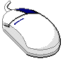 | This mouse graphic with the right mouse button highlighted will appear in the margin when accompanying instructions relate to functions activated by clicking the right mouse button.  All other mouse commands (such as double clicking to display a window) refer to a normal left mouse click.
 | Express Trading | This graphic will appear in the margin whenever accompanying instructions illustrate a trading shortcut that enables you to execute an activity without going through the menu options.
 | Special Situations | This graphic will appear in the margin when there is information relating to special trading situations.
 |   Designated Primary Market Maker - Only Function | This graphics will display in the margin whenever the trading feature being described is a Designated Primary Market Maker-only function.
 | Market Maker-Only Function | This graphics will display in the margin whenever the trading feature being described is a Market Maker-only function.

 | Section 1:  Screen-Based Trading

This section of the user guide introduces all functions of the CBOEdirect Stock Trader Workstation.

Getting Started

 | When you launch the CBOEdirect Stock Screen-Based Trading application, the following login window will display.
 | 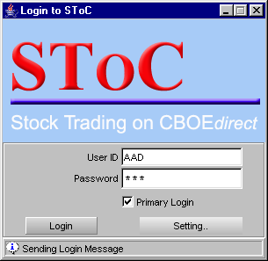
Login | CBOEdirect allows you to login as a Primary or Secondary user. You can use your Primary or Secondary login to login with another application while using the CBOEdirect Screen-Based Trading application.  Multiple primary and secondary logins are allowed using the same User ID. Primary logins are subject to a forced logout by the system. Secondary logins are not monitored for application termination. However, if the system forces the logout of a user, all primary and secondary login sessions for that User ID will be terminated. A Secondary login does not require a Primary login session to be active.  To login, enter your User ID and Password. Both User ID and Password are case sensitive. If your login is Primary, select the Primary Login checkbox. If you are logging in as a Secondary user, deselect the checkbox. The login window defaults to a primary login.  Click Settings, to change your login mode. The Session Settings window will display.
 | 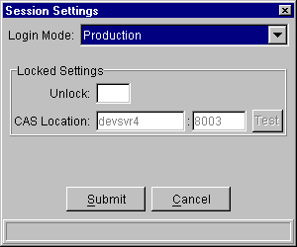
 | Select your login setting from the drop down list. To change your CAS location, enter your password in the Unlock field and enter the new CAS location. Click Test to check your setting. Click Submit. If you decide you do not wish to change your login mode, click Cancel. The system will return to the menu window. Click Login.
The first time you login to CBOEdirect, The system will prompt you to convert your Business and GUI Preferences to the current version.
To convert your preferences to the current version, click Yes.
If you do not wish to convert your preferences, click No.
 | 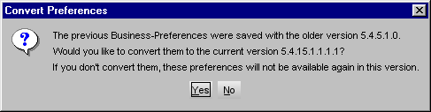
 | Once you are logged into the system, the Stock Market Display window appears. You can set your user and quote preferences from this window before you begin trading.
 | 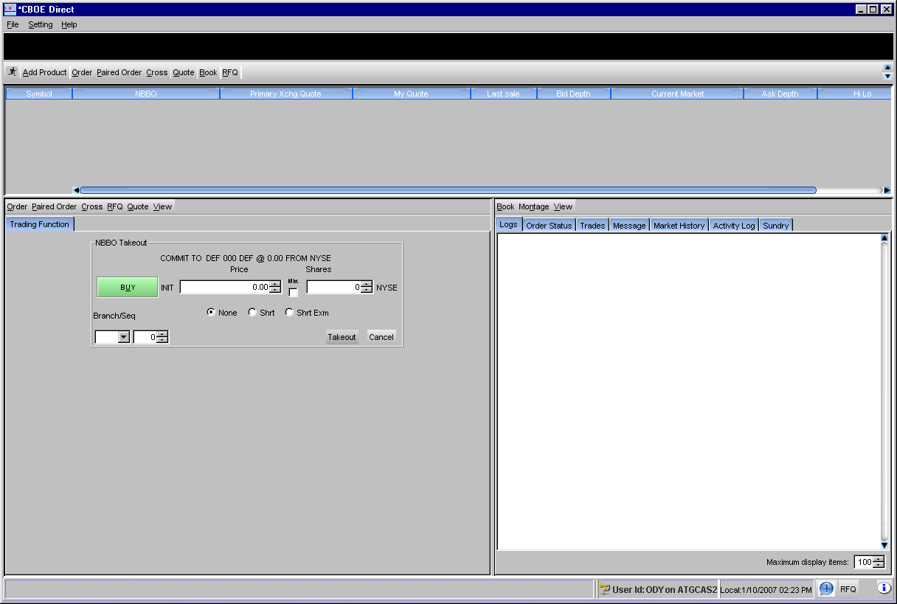
Set User Preferences | The system allows you to set user preferences to customize your trading session. Values set through this function will become the default values. All values can be changed manually during trading, however, these values will set your beginning parameters.  To display the Preferences menu, click the Start menu on the CBOEdirect stock market display window and select Preferences, Miscellaneous Preferences. From this window, you have options to set up defaults for order entry, execution, alarms and sequence numbers.
➢ | Miscellaneous Preferences  For each class you trade, you can set order and execution defaults. The Default tab will set base values for all trading classes.
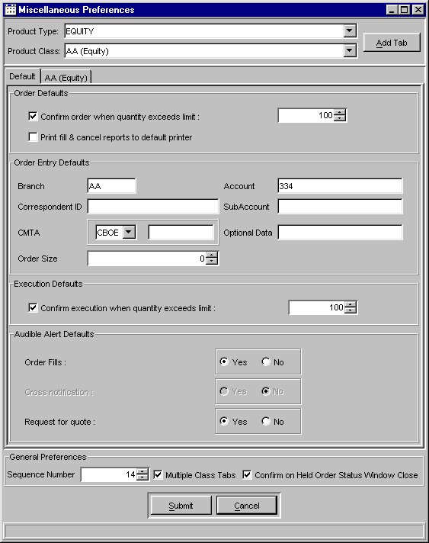
If you want some trading classes to have different defaults, you can select the class and set specific values and settings. For more details, see Section 2: Reference Guide (Miscellaneous Preferences, page 70).
Click Submit, and then click Confirm.

➢ | Quote Preferences  For each class you trade, you can set quote size and spread defaults. The Defaults tab will set base values for all trading classes. These are the values that will automatically be used to calculate new quotes.  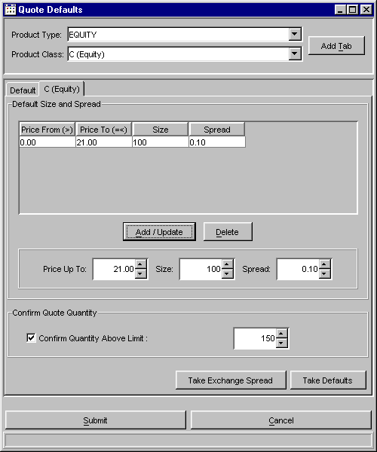
If you want some trading classes to have different price and quantity levels, you can select the class and set specific values. For more details, see Section 2: Reference Guide (Quote Preferences, page 72).
Click Submit, and then click Confirm.
Set Trading Parameters | The system allows you to set trading parameters to customize your trading session. Values set through this function will become the default values. All values can be changed manually during trading.
➢ | QRM Maintenance  To limit your risk while encouraging deep and liquid markets, CBOEdirect has a Quote Risk Monitor function.  The system will cancel your remaining quotes from a class when your resting quotes have been filled to a specific total (e.g., 200 contracts) in a specific period of time (e.g., 60 seconds or less) in order to give you a chance to react.  The system will notify you when this occurs. You can then assess the risk and provide replenishment quotes.  The Quote Risk Monitor will take effect even if the incoming orders are uncoordinated, coming from more than one source.  You can set the time period and contract volume limits on the QRM window from the Start menu .  From this option, you can set a default quote risk manager profile and individual profiles for each class you quote. For more details, see Section 2: Reference Guide (QRM, page 79).  Click Save.
Send a Message | Messages to CBOEdirect Help Desk  If you need to send a message to the CBOEdirect help desk, click . Enter your message, and then click Send Message.  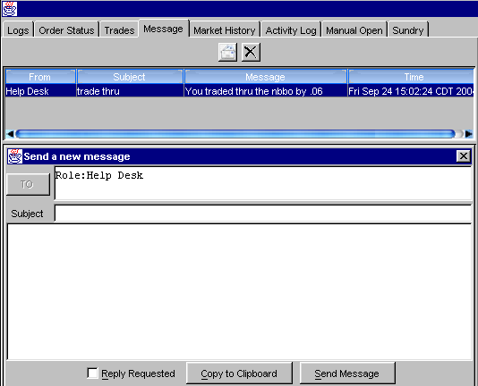  If you receive a message from the Help Desk, an e-mail envelope will appear in the lower right-side of the market display window. Double-click on the envelope to display the message in the Message tab.
 | There are a variety of function and activity windows that open during the course of a trading session. Most trading function windows can remain open during trading. This documentation will provide notes regarding the windows that must be closed before trading can resume.
 | You are now ready to begin trading.

 | Opening a Stock Trading Session
Market Display Window | CBOEdirect allows you to open—and trade from—only one Market Display window. The preferences described in the previous section will apply to your Market Display window during your trading session.
When you initially log into the CBOEdirect stock system, the market display window will be blank. Click the Add Product button. The Product Selector window will display. From this window, you will select the product classes to add to your trading session.
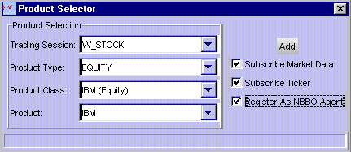

Select Product Classes
Select the trading session and product class from the drop down list boxes. For each product class, select the valid product type.
To register as a NBBO agent for a class, select the Register As NBBO Agent checkbox. If you are the DPM for the product class, CBOEdirect will automatically register you as the NBBO agent.
  - Note: ITS administration messages will be delivered to the DPM who is registered as the NBBO agent.
Mark the checkbox Subscribe Market Data. CBOEdirect will display the product symbol row with related market data.
To receive ticker data for the selected product, click the checkbox Subscribe Ticker.
To remove a product symbol row from the market display, right-mouse click on the data row and select, Remove Product.
CBOEdirect illustrates the state of the product class by cell color on the Symbol column of the market display window. Below are the various product states.

Product Cell Color | Product State
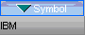 | Close
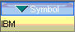 | Pre-Open
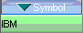 | Opening Rotation
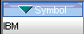 | Open
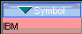 | Halt
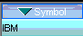 | Fast

Examples of Market Display
Below are examples of the CBOEdirect stock market display window.
 | 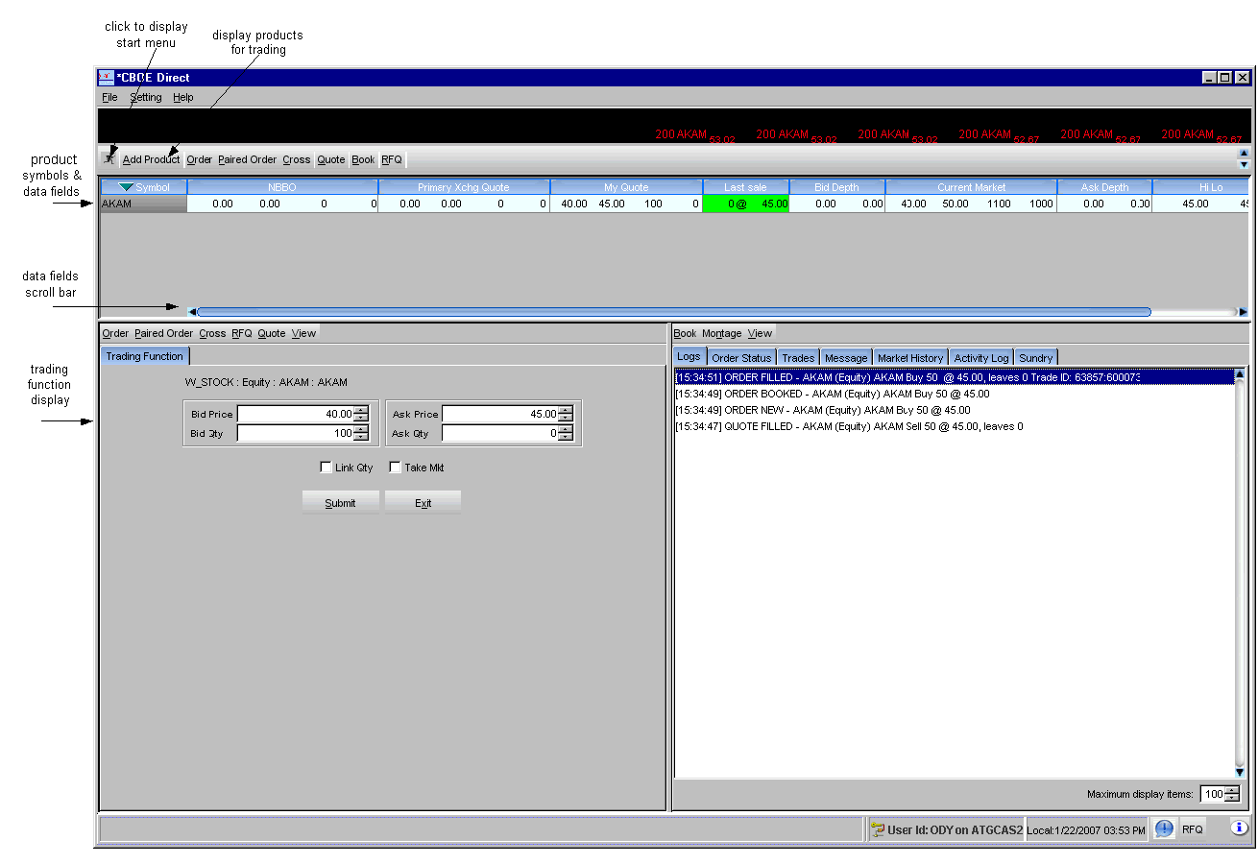
There are a number of data fields for each product. To view the fields off the right of the window, slide the scroll bar (below the data fields) to the right or left.
Using your mouse, hover over the columns and data rows to display tooltips.
 | 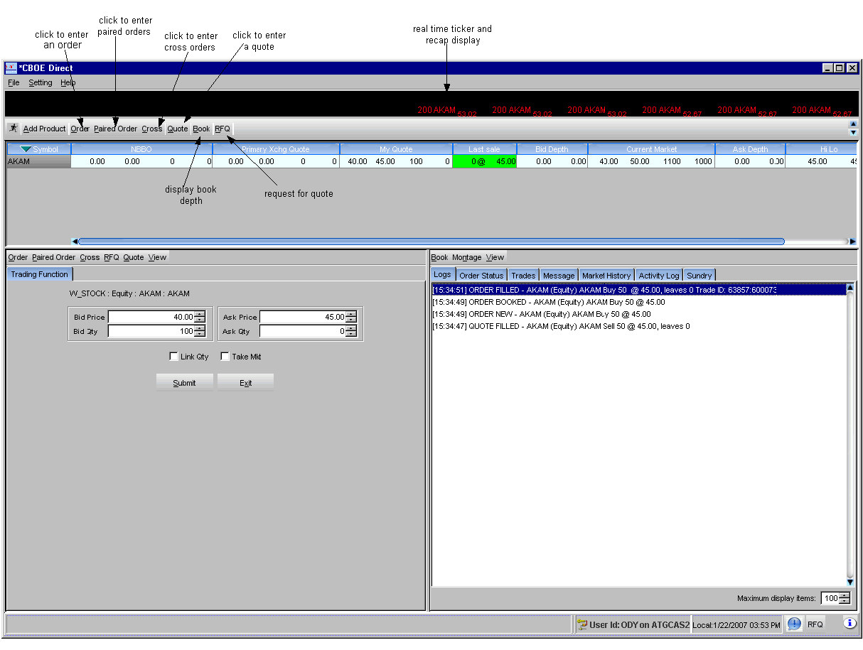
 | 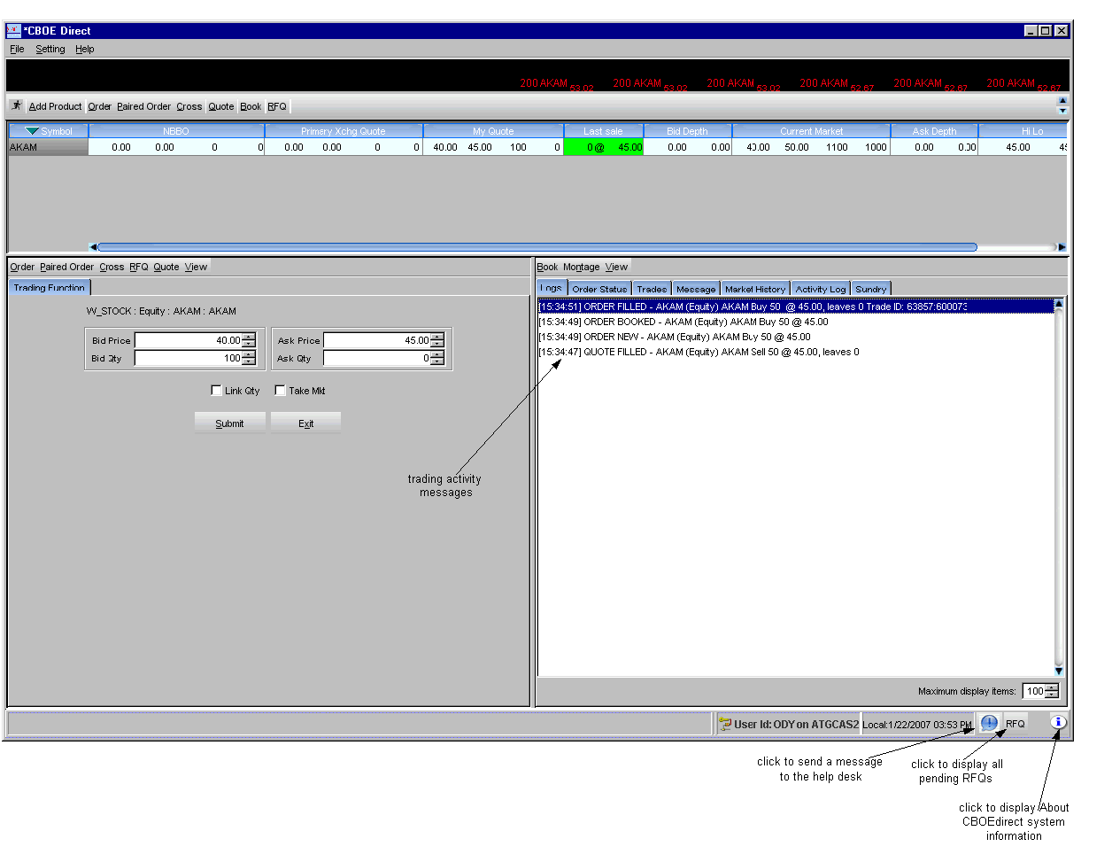
Customize Market Display | You can refine your Market Display window by selecting or deselecting specific rows and columns to display.  To filter rows and columns for the products on your Market Display window, right mouse click on any series. Select Edit Preferences. The Edit Column Preferences window will display.
(Not Currently Supported | 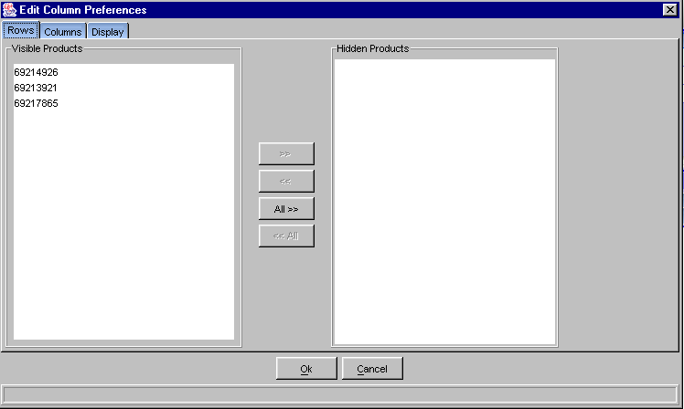
➢ | Row Preferences  If there are products data you do not wish to view:  - Select the product from the Visible Products list box.  - Click >> to move the series data to the Hidden Products list box.  - Click Ok to update the product selection.  If you decide to retain the default layout, click Cancel.
To hide all product data:
- Highlight all the products in the Visible Products list box.
- Click All>> to move all the series to the Hidden Products list box.
- Click Ok to update the product selection.
If you decide to retain the default layout, click Cancel.
To display hidden product data:
- Select the series from the Hidden Products list box.
- Click << to move the series to the Visible Products list box.
- Click Ok to update the product selection.
If you decide to retain the default layout, click Cancel.
To display all hidden products:
- Highlight all the series from the Hidden Products list box.
- Click <<All to move all the series the Visible Products list box.
- Click Ok to update the product selection.
If you decide to retain the default layout, click Cancel.
➢ | Column Preferences
 | 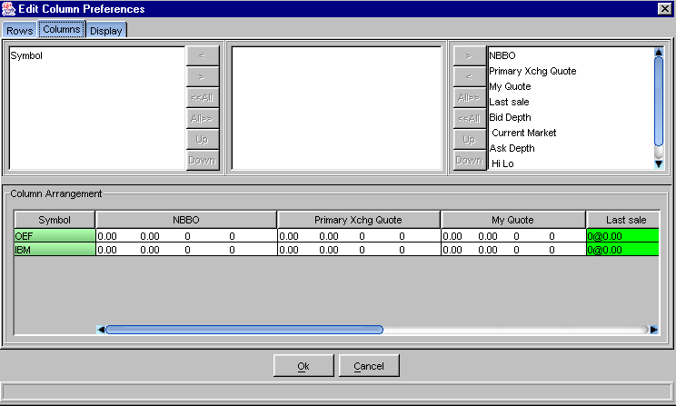
If there is a data column you do not wish to view:
- Select the column name in the Visible Columns list box. To select a continuous range of multiple columns, hold down the Shift key and highlight the column names. Hold down the Ctrl key to select individual, non-continuous column names.
- Click << to move the column name to the Hidden Columns list box.
- Click Ok to update the column arrangement.
If you decide to retain the default layout, click Cancel.
To hide all columns:
- Click <<All to move all the column names in the Visible Columns to the Hidden Columns list box.
- Click Ok to update the column arrangement.
If you decide to retain the default layout, click Cancel instead of Ok.
  - Note: If you hide all columns, you will subsequently have to make some columns visible before the update will take effect.

To display a hidden column:
- Select the column name(s) from the Hidden Columns list box.
- Click >> to move the selected column name(s) to the Visible Columns list box.
- Click Ok to update the column arrangement.
If you decide to retain the default layout, click Cancel instead of Ok.
To display all hidden columns:
- Click All>> to move the column names to the Visible Columns list box.
- Click Ok to update the column arrangement.
If you decide to retain the default layout, click Cancel instead of Ok.
To facilitate trading, you may prefer to view data columns in a different order than the default display.
To move a column:
- Highlight the column name from the Visible Columns list box.
- Click Move Up or Move Down until you reach the new column location.
- Click Ok to update the column arrangement.
If you decide to retain the default layout, click Cancel.
 | An alternate way of re-ordering columns can be done in the Market Display window itself by clicking on a column header and moving the column to a new position.
From the Column Arrangement section of the window, the columns can be resized to make viewing information easier for you.
To resize a column:
- Place the mouse on the right edge of the column header (where the column titles are displayed) until it becomes a two-sided arrow.
- Hold the left mouse button down and move it to the desired size.
- Click Ok to save the new column size.
- If you decide to retain the default column size, click Cancel instead of Ok.
➢ | Display
 | 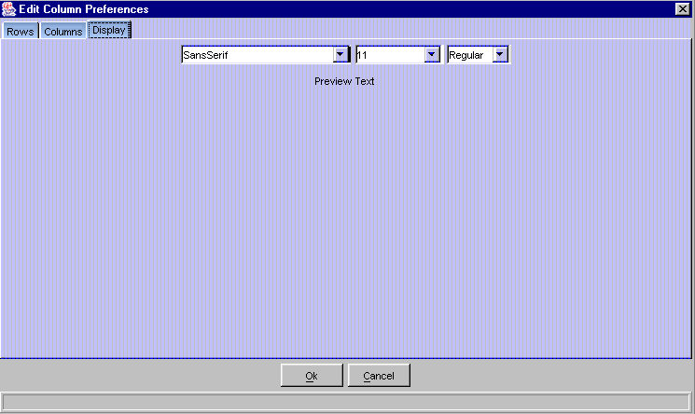
From the Display tab, you can modify the font type, size and style by selecting the new settings from the drop down lists. The new font will display in the Preview Text section of the window.
- Click Ok to update the font display.
- Click Cancel to retain the default settings.
➢ | Scrolling Ticker  From the Setting Menu, you can set the ticker to display for a particular class.
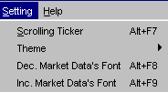 | - Select Setting, Scrolling Ticker. The following window will display.  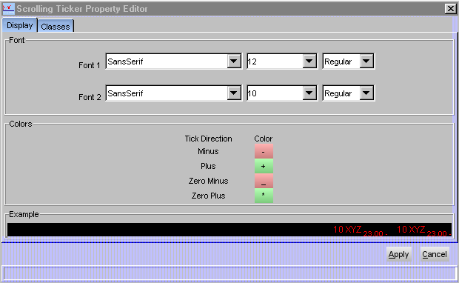
- Select the font settings for your ticker display and click Apply. An example of the scrolling ticker will display in the Example section of the window.
- To close the window without making any font changes, click Cancel.
- Click the Classes tab to subscribe for ticker information.
 | 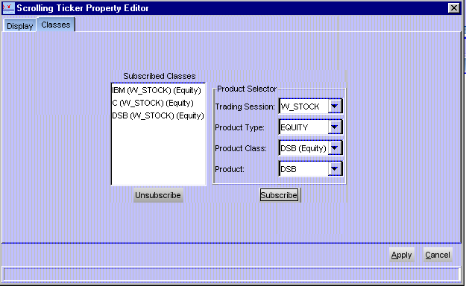
- From the Product Selector drop down boxes, select the Trading Session, Product Type, Product Class and Product. Click Subscribe. The selected class will appear in the Subscribed Classes list box. Click Apply. Scrolling ticker data will be available for subscribed classes.
- To unsubscribe a class from the scrolling ticker display, highlight the class in the Subscribed Classes list box. Click Unsubscribe. Click Apply. The class will be removed from the ticker display.
- Click Cancel to close the window without making subscription changes.
➢ | Market Display Theme  You can select a color theme for your market display window.  - Click Setting, Theme. The following color choices will display.  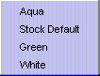
 | - Select your color choice. The colors on the Market Display window will change based on your selection.
➢ | Increase/Decrease Market Data Font  To decrease the market data font on your Market Display window, click Settings,  Dec. Market Data’s Font or press [Alt] + [F8] on your keyboard. The displayed market data font will decrease.
 | 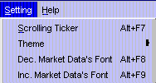
To increase the market data font on your Market Display window, click Settings,
Inc. Market Data’s Font or press [Alt] + [F9] on your keyboard. The displayed market data font will increase.
➢ | Sizing the Market Display Window  The Market Display windows are sizable. That is, they can be resized on the screen to make viewing information easier for you.
 | 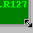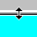 | Place the mouse on any edge of the window until it becomes a two-sided arrow. Hold the left mouse button down and move it to the desired size.
Resizing a window on the corner will expand or contract it in both directions (i.e. up and down, side to side). Resizing it on the side or top/bottom will expand or contract the window only in that one direction.
Windows can also be resized using the center glyph in the upper right corner of the window.
 |  | Click the left button () to minimize the window. Click the right button () to close the window. The center button is used for sizing.
If  is displayed, clicking it will increase the window size to a full-screen display.
If  is displayed, clicking it will return the window to its default size.

Quotes

Market Maker-Only Function | Market Makers and Designated Primary Market Makers can enter quotes in two ways: manually, by keying in quotes at a keyboard, or automatically, by generating quotes through an autoquote system and submitting them through a CBOEdirect API.  Only one quote is allowed from a Market Maker for a product, but submitting a quote does not preclude you from entering orders for the same class.  Quotes will be automatically canceled when the Market Maker logs off, either normally, or due to a system failure. The log off will not cancel the Market Maker's orders.
Enter Quote | Quote functions are performed on an individual product. To enter a quote, click on the My Quote field for the desired product on the market display window, or click on the Quote button, 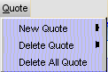, New Quote and select the product from the product list. The Trading Function tab displays with the quote entry fields for the product you selected for trading.  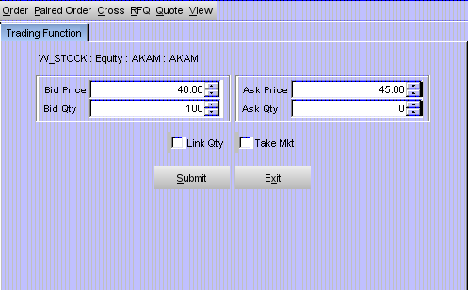
- Enter the bid and ask prices and quantity. If you already have an existing quote, the fields will be automatically filled with your existing quote prices and quantities.
- If you wish to take the market prices for your quote, click Take Mkt. The system will automatically fill the fields with the Mkt Bid and Mkt Ask prices.
- As a default, the system will set the Ask Qty to match the value in the Bid Qty field. If you do not wish to link the quantities, deselect the Link Qty checkbox.
- Click Submit.
- If you decide you do not wish to proceed with the quote, click Exit to remove the fields from the Trading Function tab.
 | Once you have confirmed your quote, the system submits it for trading. The system displays your quote in the My Quote fields, if they are your best bid and offer, and, in the Current Market fields, if they are the best in the market.
Express Trading | Update an Existing Quote  When you click on the My Quote field on a product row, the Quote Entry window will display in the Trading Function tab. The fields automatically display with the selected product and the price and quantity values of your outstanding quote, if you have submitted one.  - Change the bid and ask prices and quantities, as needed.  - The new quote will be processed as a cancel/replace of the old quote.  If you decide you do not wish to proceed with the quote, click Exit to close the Quote Entry window.
Depending on how you modify the quote, its position relative to other orders in the book may change as follows:
- If the price is changed (either increased or decreased), the changed side loses position and the order goes behind all orders at the new price.
- If the quantity is decreased, the order retains position.
- If the quantity is increased, the order loses position and goes behind all orders at the same price.
- If only one side's quantity is changed, the unchanged side retains position.
Special Situations | Updating One Side of a Quote  In the case where you have half a quote in the market (the bid or ask has been hit) and you want to keep the remaining side, the system will allow you to replace the missing side of the quote.  In the case where you are updating only one side of a quote, the system will allow you to enter a quote with one side updated and the other side unchanged, and the system will update only the changed side, thus preserving your position for the unchanged side.

Delete Quote | To delete a quote, click the Quote button, select Delete Quote and highlight the product. The Trading Function tab will display with the data for your quote.  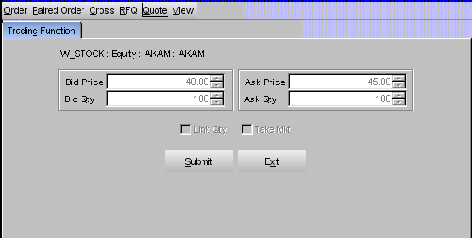  Verify that this is the quote you wish to delete and click Submit.  The system will delete the buy and sell order pair for the quote as follows.  - If one side of the quote has already been executed, the system will delete the remaining side and notify you that it was too late to delete the executed side.  - If one or both sides of the quote have been partially executed, the system will delete the remainder and notify you that it was too late to delete the filled quantity.  Click Exit to close the window without deleting the quote.
Delete All Quotes | To delete all the quotes you have submitted, click the Quote button and select Delete All Quotes  The Trading Function tab displays all the products with quotes.  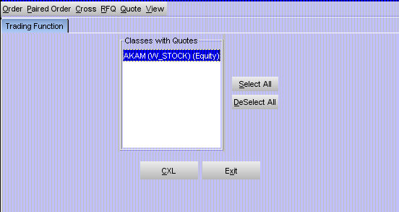  - To delete all quotes for a product, highlight the class and click CXL.  - To delete all quotes for several products, hold down the [Ctrl] key and highlight each of the products where you have quotes to be canceled. Click CXL.  - To delete all quotes for all products, click Select All. All products will automatically be highlighted. Click CXL.  - If you do not wish to delete all quotes, click Exit.
Request for Quote | A user may initiate a Request for Quote (RFQ).  To submit a RFQ, click the RFQ button, , and select the product. The Quote Request window will display in the Trading Function tab.  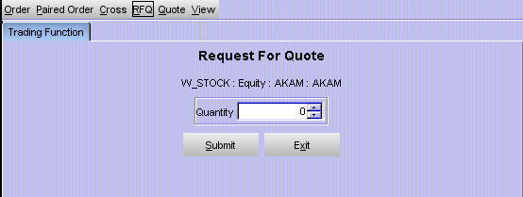  The fields automatically display with the highlighted product.  - Enter the quantity (optional).  - Click Submit.  The system will automatically send the RFQ to all Market Makers assigned to that class and to other Market Makers who are required to receive RFQs for that class or who are currently quoting that class.   Note: The system will send out multiple RFQs (RFQs for a class for which an RFQ is outstanding).  If you decide you do not wish to proceed with the request for quote, click Exit to close the Quote Request window.
View Pending RFQs | The system will prompt you by flashing the RFQ button when there is a pending RFQ.  To view pending RFQs, click the RFQ button on the lower right corner of the Market Display window. The Pending RFQ window will open in the Sundry tab and pending RFQs for all products for which you are responsible will display in the order they were received, from the earliest to the latest.  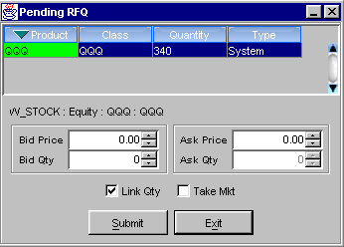  RFQs display on this window for n (30) seconds. The RFQ will display in green for the first n (10) seconds; in yellow for the second n (10) seconds; then in red for the last n (10) seconds. After n (30) seconds (or when you have responded to it), the RFQ will disappear from the window.
- If an RFQ is pending, you can respond to the RFQ by clicking on it. The Quote Entry window will display at the bottom of the Pending RFQ window.
- Enter quote information and click Submit to send the quote. (Enter Quote, page 19).

Respond to RFQs | Market Makers are required to respond to n (50%) of RFQs; DPMs to n (60%). To get credit for a response:  - You must respond within n (30) seconds.  - The quote width must be equal or narrower than the exchange-prescribed width.  - You must provide a continuous market for a subsequent period of n (30) seconds unless your quote gets filled. You may change your quote during this period, but you must not cancel it.  - An existing standard quote (quote that meets exchange-prescribed width and size) is considered a response.  You may or may not respond to an RFQ if you already have a quote in the market. If you don't wish to respond, you can simply let the RFQ expire.  Respond to an RFQ by double clicking on it. The Enter Quote window will display at the bottom of the Pending RFQ window. Enter quote information and click Submit to send the quote. RFQ responses are submitted to the book as they arrive.   Note: You do not have to respond to each duplicate RFQ. One response will cover all duplicate RFQs for a product.  If you decide you do not wish to proceed with the quote, click Exit to close the Quote Entry window.
Primary Exchange Quotes | CBOEdirect links to the Intermarket Trading System (ITS) which allows you to connect to several major U.S Stock Exchanges for the purpose of choosing the best market.  From the market display, click on the Primary Xchg Quote column for a class. The window will display in the Trading Function tab.
 | 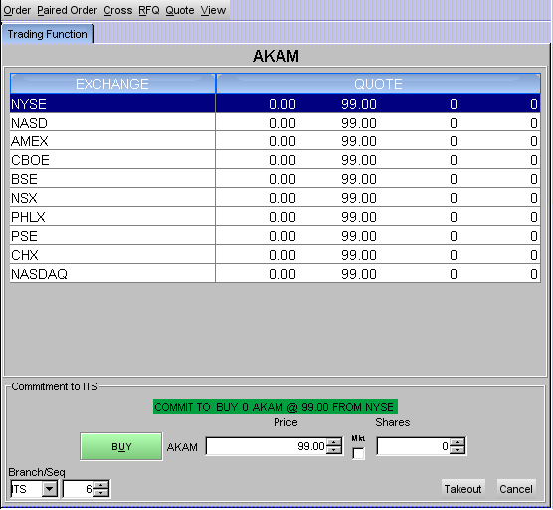
 | Or, click on the button to display the window in the Sundry tab.
 | 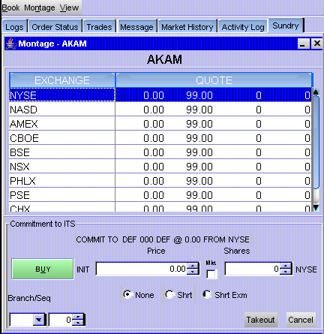
 | Click on the bid or ask column of the desired Exchange. The price and quantity fields defaulting to the NBBO Bid Qty and NBBO Bid Price values.
 | To enter the order, click Takeout. CBOEdirect will send the commitment to ITS. If you decide you do not wish to proceed with the order, click Cancel to close the window.

Orders

The CBOEdirect stock system receives orders from Member Firms, Compass, Market Makers, Broker/Dealers, Designated Primary Market Makers (DPM) and the Intermarket Trading System (ITS).
Note: The ability to pass orders from one session to another is not currently supported.
Add New Buy Order | Order functions are entered manually on a selected product. To submit a new buy order, click the Bid Depth row for the desired product or click on . The Trading Function tab opens to display the order entry window for the selected product.
 | 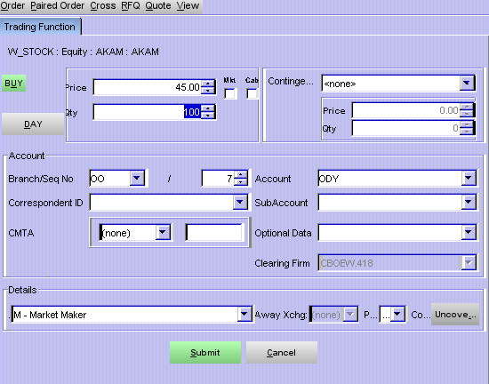
- The window defaults to a BUY order. Select if the order will be a BUY or SELL order by clicking the appropriate button.
- The system defaults to a day order. To enter a good till canceled order, click on the DAY button. The button displays as GTC.
- Enter the price and quantity of the order. If you wish to place a market or cabinet order, click the Mkt or Cab checkbox (the checkbox will fill and the Price field will then be grayed out).

- If this is a contingency order, select one of the available contingencies from the drop down list box.
- If the order is a Stop or Stop Limit order, enter the price and minimum quantity.
- The Account section of the window displays order account fields. Update the fields as required.
- The branch ID defaults to the branch ID set in your preferences; sequence number increments to the next order entry number or the number you set in your preferences; account defaults to the user acronym (limited to three characters); give up firm defaults to the set user give up firm.
- Two or more CBOEdirect users for the same firm cannot utilize the same branch ID and sequence number. The CBOEdirect Help Desk can assist users in setting up unique branch IDs and sequence numbers.
- Improper logout from CBOEdirect prevents the order sequence number from being saved. When you login again, the sequence number will begin at the same number as your previous login session.
- The subaccount field can include up to 10 alphanumeric characters. Firms that do not have subaccounts can enter their account information in this field after confirmation from their clearing firm.
- The Details section of the window displays order detail fields. Update fields as needed.
- Select the user origin from the Origins drop down list.
- Buy orders have an unspecified coverage type. Sell orders can be either Covered or Uncovered, the default is Uncovered.
- To process the order, click Submit, Confirm.
- To exit without processing the order, click Cancel.
Add New Sell Order | To submit a new sell order, click the Ask Depth row for the desired product. The Trading Function tab opens to display the order entry window for the selected product.
 | 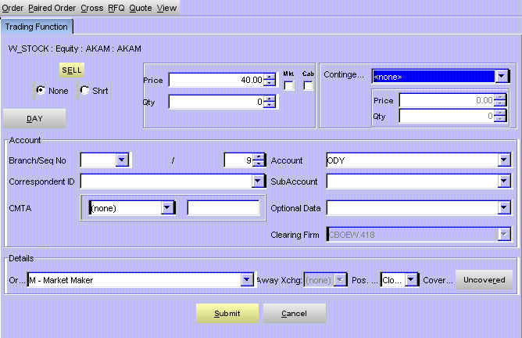
- The window defaults to a regular SELL order. Select if the order will be a SELL or BUY order by clicking the appropriate button.
- If the order is Sell Short check the appropriate check box.
- The system defaults to a day order. To enter a good till canceled order, click on the DAY button. The button sets to display as GTC.
- Enter the price and quantity of the order. If you wish to place a market order or cabinet order, click the Mkt or Cab checkbox (the checkbox will fill and the Price field will then be grayed out).
- If this is a contingency order, select one of the available contingencies from the drop down list box.
- If the order is a Stop or Stop Limit order, enter the price and minimum quantity.
- The Account section of the window displays order account fields. Update the fields as required.
- The branch ID defaults to the branch ID set in your preferences; sequence number increments to the next order entry number or the number you set in your preferences; account defaults to the user acronym (limited to three characters); give up firm defaults to the set user give up firm.
- Two or more CBOEdirect users for the same firm cannot utilize the same branch ID and sequence number. The CBOEdirect Help Desk can assist users in setting up unique branch IDs and sequence numbers.
- Improper logout from CBOEdirect prevents the order sequence number from being saved. When you login again, the sequence number will begin at the same number as your previous login session.
- The subaccount field can include up to 10 alphanumeric characters. Firms that do not have subaccounts can enter their account information in this field after confirmation from their clearing firm.
- The Details section of the window displays order detail fields. Update fields as needed.
- Select the user origin from the Origins drop down list.
- Buy orders have an unspecified coverage type. Sell orders can be either Covered or Uncovered, the default is Uncovered.
- To process the order, click Submit, Confirm.
- To exit without processing the order, click Cancel.
Paired Order | Orders that are submitted into the system as part of a pair (i.e., Cross, Midpoint Cross, Autolink Cross and Autolink Cross Match) can be entered one at a time using the Paired Order entry window.  Click . The following window will display in the Trading Function tab.
 | 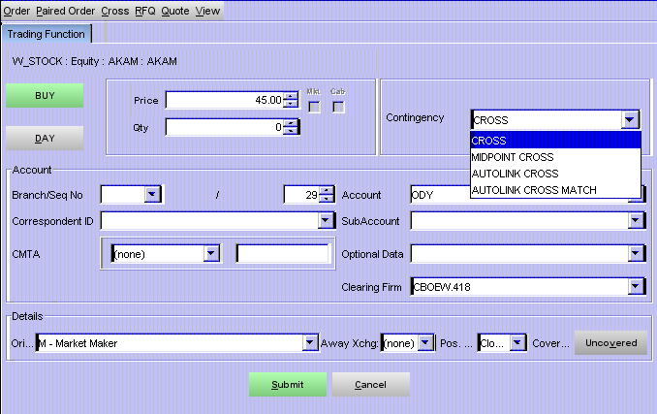
- The window defaults to a BUY order. Select if the order will be a BUY or SELL order by clicking the appropriate button. If the order is a SELL order, select if the order is a SELL Short or SELL Short Exempt by clicking on the appropriate radio button.
- The system defaults to a day order. To enter a good till canceled order, click on the DAY button. The button displays as GTC.
- Enter the price and quantity of the order.
- Note: Market (Mkt) and Cabinet (Cab) orders are not available for selection when entering paired orders.
- Select the type of Cross order you want to enter from the Contingency drop down list box.
- The Account section of the window displays order account fields. Update the fields as required.
- The branch ID defaults to the branch ID set in your preferences; sequence number increments to the next order entry number or the number you set in your preferences; account defaults to the user acronym (limited to three characters); give up firm defaults to the set user give up firm.
- Two or more CBOEdirect users for the same firm cannot utilize the same branch ID and sequence number. The CBOEdirect Help Desk can assist users in setting up unique branch IDs and sequence numbers.
- Improper logout from CBOEdirect prevents the order sequence number from being saved. When you login again, the sequence number will begin at the same number as your previous login session.
The subaccount field can include up to 10 alphanumeric characters. Firms that do not have subaccounts can enter their account information in this field after confirmation from their clearing firm.
- The Details section of the window displays order detail fields. Update fields as needed.
- Select the user origin from the Origins drop down list.
- Buy orders have an unspecified coverage type. Sell orders can be either Covered or Uncovered, the default is Uncovered.
- To process the order, click Submit, Confirm.
- To exit without processing the order, click Cancel.
Cross Orders | Two Cross orders can be submitted at the same time through the Cross Order entry window.  Click . The following window will display in the Trading Function tab.
 | 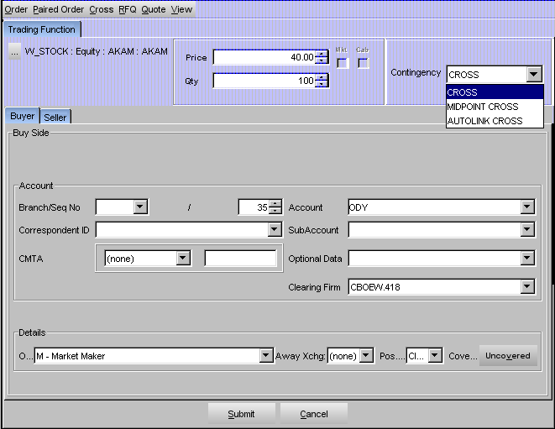
- Enter the price and quantity of the order.
- Select the type of Cross order you want to enter from the Contingency drop down list box.
- In the Buyer tab, the Account section of the window displays order account fields. Update the fields as required.
- The branch ID defaults to the branch ID set in your preferences; sequence number increments to the next order entry number or the number you set in your preferences; account defaults to the user acronym (limited to three characters); give up firm defaults to the set user give up firm.
- Two or more CBOEdirect users for the same firm cannot utilize the same branch ID and sequence number. The CBOEdirect Help Desk can assist users in setting up unique branch IDs and sequence numbers.
- Improper logout from CBOEdirect prevents the order sequence number from being saved. When you login again, the sequence number will begin at the same number as your previous login session.
- The subaccount field can include up to 10 alphanumeric characters. Firms that do not have subaccounts can enter their account information in this field after confirmation from their clearing firm.
- The Details section of the window displays order detail fields. Update fields as needed.
- Select the user origin from the Origins drop down list.
- Buy orders have an unspecified coverage type. Sell orders can be either Covered or Uncovered, the default is Uncovered.
 | Click on the Seller tab to enter the sell side information.
 | 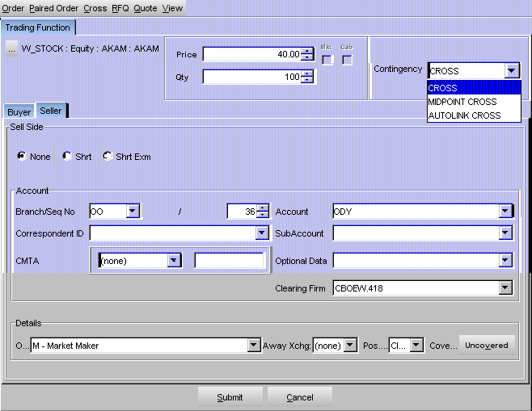
- If the order is Sell Short or Sell Short Exempt, check the appropriate radio button.
- Enter the Account and Details information as described above.
- To process the order, click Submit, Confirm.
- To exit without processing the order, click Cancel.
Hit the Bid | To hit the current market Bid and place a sell order, click on the bid side in the Current Market column of the product you wish to trade. The Hit Market Bid window will display with the price and quantity fields defaulting to the Current Market values.
 | 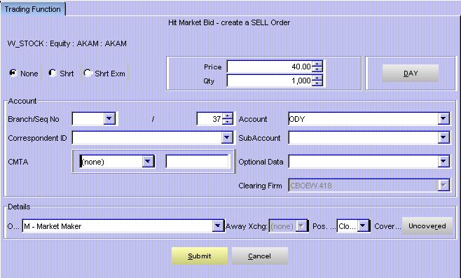
Adjust values, if necessary. Indicate whether the order is a day order or an immediate or cancel order. Specify if the order is a Sell Short and click Submit.
If you change the price or quantity of the order, the following results will occur if the bid is available for trading:
 | Price | Quantity | Results
 | Same | Same | Full execution of bid order at bid price
 | Same | Lower | Partial execution of bid order at bid price
 | Same | Higher | Full execution of bid order at bid price and book new order to sell at bid price with remaining quantity
 | Lower | Same | Full execution of bid order at bid price
 | Lower | Lower | Partial execution of bid order at bid price
 | Lower | Higher | Full execution of bid order at bid price and new order to sell with remaining quantity that could either execute against lower bid orders, if any, or be booked
 | Higher | Any | No execution, book new order to sell
 | If the bid is no longer available for trading, the system will book the full order as a day or IOC order.
Take the Offer | To take the current market Offer and quickly place a buy order, click on the offer side in the Current Market column of the product you wish to trade. The Hit Market Offer window will display with the price and quantity fields defaulting to the Current Market values.
 | 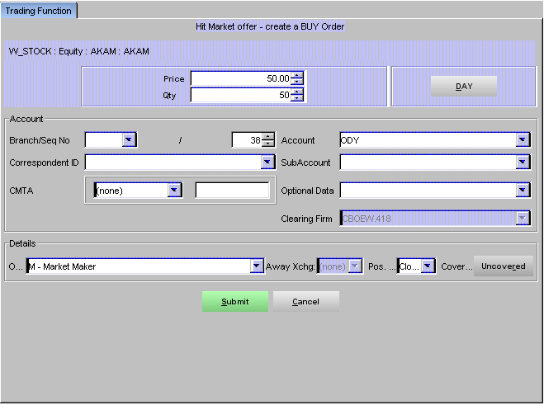
Adjust values, if necessary, indicate whether the order is a day order or an immediate or cancel order, and click Submit.
If you change the price or quantity of the order, the following results will occur if the offer is available for trading:
 | Price | Quantity | Results
 | Same | Same | Full execution of offer order at offer price
 | Same | Lower | Partial execution of offer order at offer price
 | Same | Higher | Full execution of offer order at offer price and book new order to buy at offer price with remaining quantity
 | Higher | Same | Full execution of offer order at offer price
 | Higher | Lower | Partial execution of offer order at offer price
 | Higher | Higher | Full execution of offer order at offer price and new order to buy with remaining quantity that could either execute against higher offer orders, if any, or be booked
 | Lower | Any | No execution, book new order to buy
If the offer is no longer available for trading, the system will book the full order as a day or IOC order.
If you decide you do not wish to proceed with the order, click Cancel to close the window.

Hit the NBBO Bid | To Hit the NBBO Bid and quickly place a sell order, click on the NBBO Bid Price field in the NBBO column for the product you wish to trade. The NBBO Takeout window will appear in the Trading Function tab with the price and quantity fields defaulting to the NBBO Bid Qty and NBBO Bid Price values.
 | 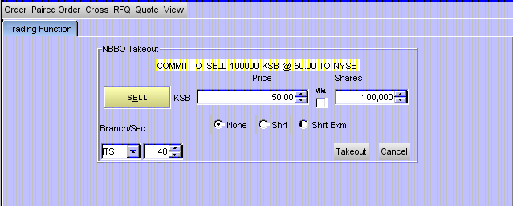
 | To enter the order, click Takeout. CBOEdirect will send the commitment to ITS. If you decide you do not wish to proceed with the order, click Cancel to close the window.
Take the NBBO Offer | To Take the NBBO Offer and quickly place a buy order, click on the NBBO Ask Price field in the NBBO column for the product you wish to trade. The NBBO Takeout window will display in the Trading Function tab with the price and quantity fields defaulting to the NBBO Ask Qty and NBBO Ask Price values.
 | 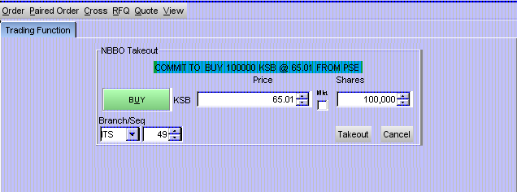
 | To enter the order, click Takeout. CBOEdirect will send the commitment to ITS. If you decide you do not wish to proceed with the order, click Cancel to close the window.

Special Situations | Contingency Orders  The market's best bid and best offer quantity fields normally contain only limit orders. In the case where contingency orders are present at the best bid or offer, the system will display:  - aggregate quantity of limit orders, including IOC (immediate or cancel) orders  - aggregate quantity of FOK (fill or kill), AON (all or none) and MIN (minimum) orders  - indicator of more than one FOK, AON, or MIN order  - aggregate quantity of STP (Stop) and Stop Limit (STP Limit)  - smallest quantity of the minimums of the MIN orders, if any  in the format L+C*(M), where  L = quantity of limit orders, including IOC  + = indicates the presence of contingency orders  C = quantity of FOK, AON, and MIN contingency orders  * = indicates there is more than one FOK, AON, or MIN order  M = the smallest minimum of the MIN orders  Because of the preset length of the display field, not all of the characters may be displayed at once. If this occurs, hover the mouse over the field without clicking it. The tool tip function will display the full field information.
Order  and Quote Status | To display the status of your orders, click on the Order Status tab. A separate Order Status window will open.  The Order Status window will maintain ongoing status of all of your working orders as well as orders completely filled or cancelled. This window can remain open during further trading.
 | 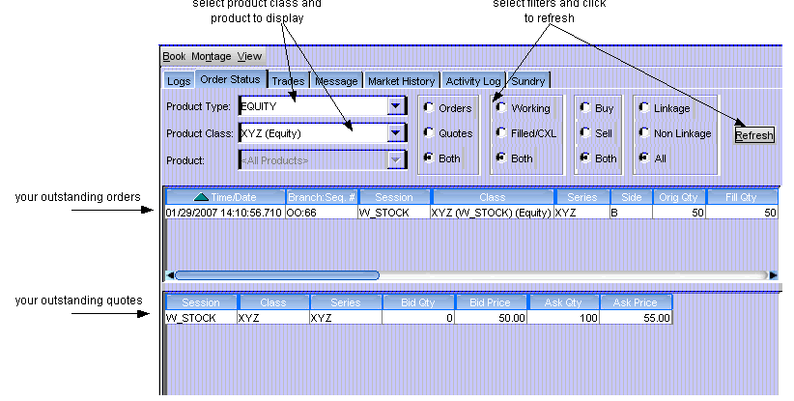
➢ | Cancel Replace  To cancel an unfilled order and replace it with a new order, highlight the order to be canceled, right mouse click to display the Order Status Menu, and click Cancel/Replace. The Cancel Replace Order window will display.  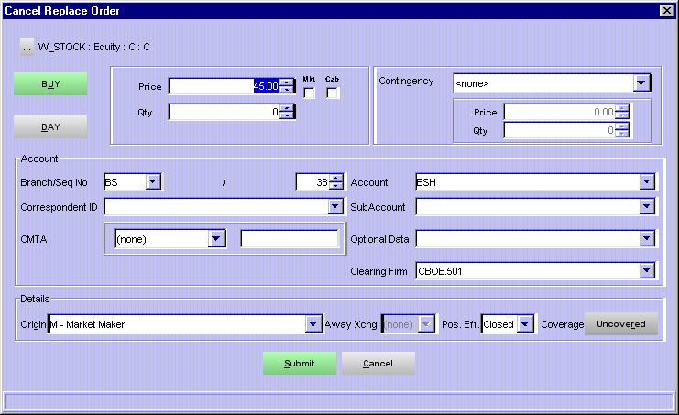  - Enter the new order information for the series and click Submit.  - To exit without processing the order, click Cancel.
➢ | Cancel  To cancel an unfilled portion of an order, highlight the order, right mouse click to display the Order Status Menu, and select Cancel. The Cancel Order window will display.  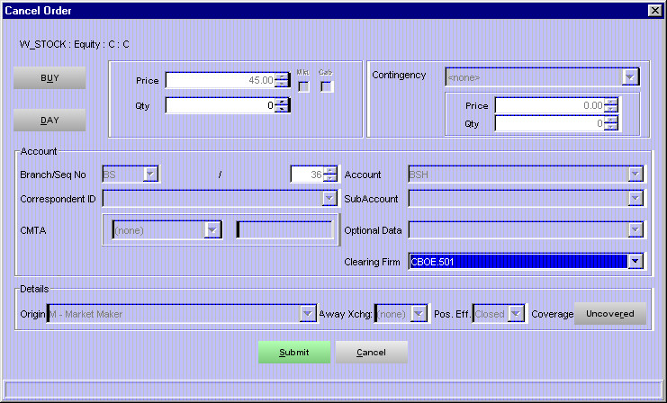  - Adjust the quantity that you wish to cancel and click Submit.  - To exit without canceling the order, click Cancel.
➢ | Update  To update order information for an unfilled order, highlight the order, right mouse click to display the Order Status Menu, and select Update. The Update Order window will display.  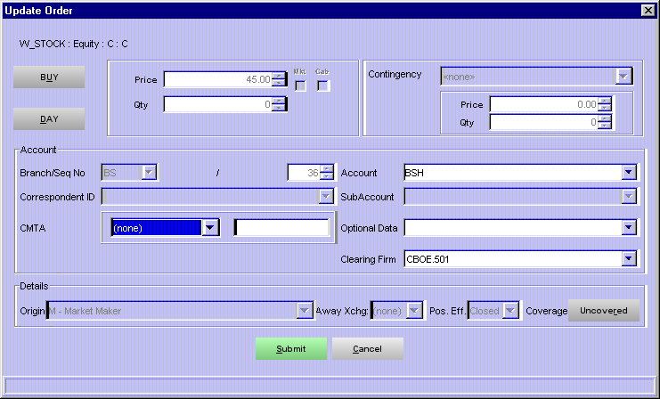  - Make changes to the Account information and click Submit. Text fields that are grayed cannot be changed.  - To exit without updating the order, click Cancel.
➢ | Order History  To display the history for an order, highlight the order, right mouse click to display the Order Status Menu, and select Order History. The Order History window will display.  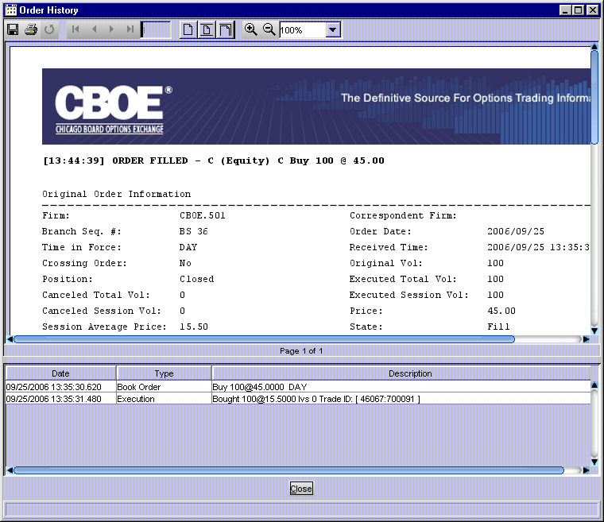
➢ | Edit Preferences  To edit preferences for an order or quote, highlight the order or quote, right-mouse click on the order or quote and select Edit Preferences. The Edit Preferences window will display.  For instructions on screen customization, refer to the Customize Market Display section, page 12.  - Update row or column preferences and click Ok.  - To exit without changing preferences, click Exit.

Viewing Status

 | Trading activity status can be viewed at any time during an open trading session. Each of the functions opens a separate activity window.
Trades Log | To view your trades, click on the Trades tab. The Trades window will open. Select the Product Class from the drop down list and click Refresh. The window will automatically update as orders are executed.  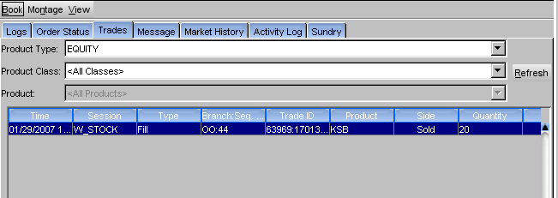  - Trades are listed by date/time stamp from the most recent to the earliest trade in the current trading session.
Activity Log | To view the activity log, click on the Activity Log tab. The Activity Log window will display.  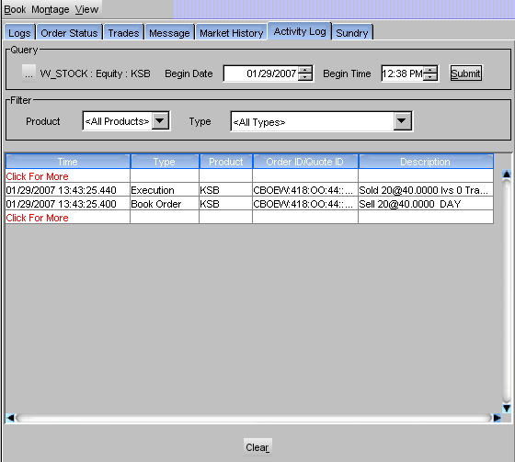  - Click on the Class/Product Selector button to select the Trading Session, Product Type and Class you wish to view. Click OK. Click Cancel to close the window without making a seletion.  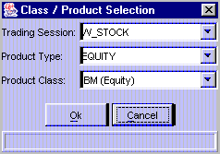
- Set the date and time selection fields to the point when you wish to begin viewing activity. Click Submit.
- Select the product and activity you wish to view from the Type list box. The display will refresh for the currently selected product and activity.
- Click Clear to remove the contents from the window.

Market History | To view the chronological list of quotes and trades disseminated to the internal network during the trading day for a selected product, select the Market History tab. The Market History window will open.  - Based on your enablements setup, you have the ability to view market history details.  - You can change the display to view another class and/or series by selecting the Trading Session, Product Type, Product Class and Product from the Query section of the window.  - The date and time fields default to the current date and time. Update as desired.  - The display defaults to both quotes and trades. Quotes and trades are listed by date/time stamp from the most recent to the earliest trade in the current trading session.  - Click Submit to update selection criteria and refresh the display.
 | 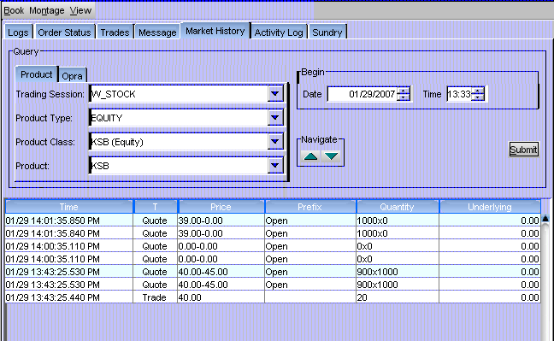
Book Depth | To view the book depth for a product, double-click on the product from the Symbol column in the market display. The Book Depth window can also be opened by clicking on the button and selecting the product you wish to display. The Book Depth window will open in the Sundry tab.  You can open multiple book depth windows and arrange them in the Sundry tab for viewing.  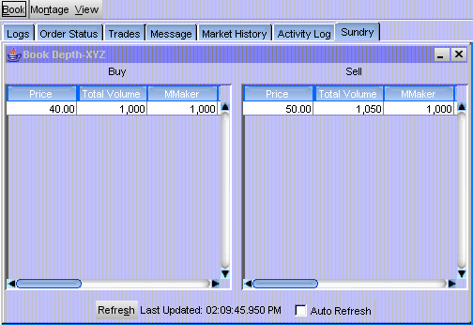
CBOEdirect will display the aggregate orders in the book at various price levels at the time of the Book Depth request. The Total Volume column displays the total volume of contracts at a price level. The Limit, AON, FOK and IOC columns display the portion of the volume that comes from contingency orders.
- Real-time updates are provided for the first five levels of market depth. To obtain updated book depth data, click Refresh.
- To have the window refresh automatically, click the Auto Refresh check box.
Display Pending Price Adjustments | For orders that do not get filled the same day they're placed, you may wish to review pending price adjustments as a result of stock splits, dividends, etc.  Select Pending Price Adjustments from the Start menu. The Pending Price Adjustments window will open. At this window, you can view:  - order submit date and price adjustment effective date  - outstanding order quantity and new price effect each outstanding order for each of your Current Selected Product Classes.

Closing a Trading Session

Logout | To log out of the stock trading system, click on the Market Display until you reach the Logout and Change Password toolbar. Click Logout . You will be prompted to verify that you wish to close all windows, cancel all quotes, and logout. Click Yes.
Exit the System | To exit the CBOEdirect stock trading system, select Exit from the File Menu or Start Menu. You will be prompted to verify that you wish to close all windows, cancel all quotes, and logout. Click Yes. The application will be closed and you will be returned to your system desktop.

◻ | Section 2:  Detailed Reference Guide

Task Toolbar

When you log into the CBOEdirect Stock Screen-Based Trading application, The Tasks toolbar will display on the Market Display window. From this window you can view session information and perform window controls.
The Start Menu, which is executed from the toolbar, will be addressed in the Start Menu section (Start Menu, page 54) of the Reference Guide.
Note: The toolbar remains active during the trading session.
About CBOEdirect | To display system information about CBOEdirect, click . The About window will display.
 | 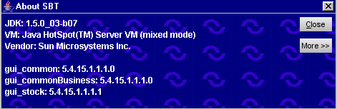
To view specific configuration information, click More. Detailed system information will display.
To exit the window, click Close.
Open Tasks | Initially, the toolbar will be empty. For each window you create from the Start Menu , a task button will appear on the toolbar.  From the task button, you can resize or change the configuration name of each window.  To resize the window or to change the default configuration name, click on the window task button. The active window will display. Right mouse click on the task button for the corresponding window. The resize and configuration menu will display.  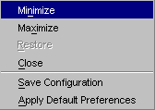
➢ | Resize  To resize a window:  - Highlight the resize choice or  - Hold down the [Alt] key and press the character of the underlined letter in the command.
➢ | Saving the Configuration for Windows  CBOEdirect allows you to retain window configurations. Most of the CBOEdirect Start Menu window configurations can be saved using the Book Depth example below. .  To save the configuration for a Book Depth window:  - Right mouse click on the window’s task button and select Save Configuration. The Save Configuration window will display.  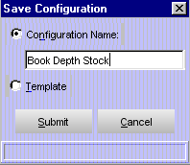  - Select the Configuration Name radio button. The text box displays in editable format.  - Enter the configuration name for the Book Depth window. In the example above, the Book Depth window name will be changed to “Book Depth Stock”.  - To submit your configuration without setting a template, click Submit. Click Confirm. The system will save the configuration for the window and the task button will display with the new Book Depth configuration name.  - To set this configuration to be the default configuration for all Book Depth windows, select the Template radio button. Click Submit. Click Confirm.  - If you decide not to change the default configuration, click Cancel instead of Submit.
➢ | Apply Default Preferences  CBOEdirect allows you to apply a default preference template to a window that has been already created.  For example, if you previously saved the configuration for a Book Depth window, right mouse click on the new Book Depth window task button and select Apply Default Preferences. The Book Depth window settings will be changed to the default preferences for all Book Depth windows.
Session Information | From the Open Tasks toolbar, click the button to display the Session Information toolbar.
 | From this toolbar, you can view your user name and Id, role and session information. You also have the ability to logout of the system or to change your password.
➢ | Logout  To logout of the trading system, click Logout. You will be prompted to verify that you wish to close all windows, cancel all quotes, and logout. Click Yes. If you do not wish to logout of the system, click No.
➢ | Change Password  To change your password, click Change Password. The Change Password window will display.  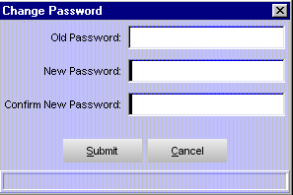
Enter your Old Password. Enter and confirm your New Password. Click Submit. Click Confirm.
If you decide not to change your password, click Cancel.
Main Window Settings | The system allows you to save your window preferences. From the Session Information toolbar, click the button. The Main Window Settings toolbar will display.
 | From this window you can save your window preferences. Click Save Preferences. The system will store your window configuration.
Window Control | The system allows you to organize your Market Display windows. From the Main Window Settings toolbar, click the button. The Window Control toolbar will display.
You have the ability to minimize, restore, cascade or close your Market Display windows.
- To minimize all your Market Display windows, click Minimize All or hold down the [Alt] key and press "M" on your keyboard.
- To restore all your Market Display windows, click Restore All or hold down the [Alt] key and press "R" on your keyboard.
- To cascade all your Market Display windows, click Cascade All or hold down the [Alt] key and press "D" on your keyboard.
- To close all your Market Display windows, click Close All or hold down the [Alt] key and press "C" on your keyboard.

Start Menu

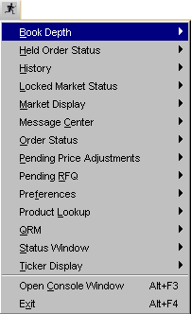 | The Start Menu allows you to quickly create new windows for various CBOEdirect stock functions.  To display the Start Menu:  - Click the Start button on the CBOEdirect Stock Screen-Based Trading window or  - Press [Alt]-[S] from anywhere on the window.  The Start options will display. If a menu option is unavailable, it will display grayed out and no action will take place when the option is selected.
Book Depth | Select Book Depth from the Start Menu, and then highlight Create New Window to open a new Book Depth window.
 | 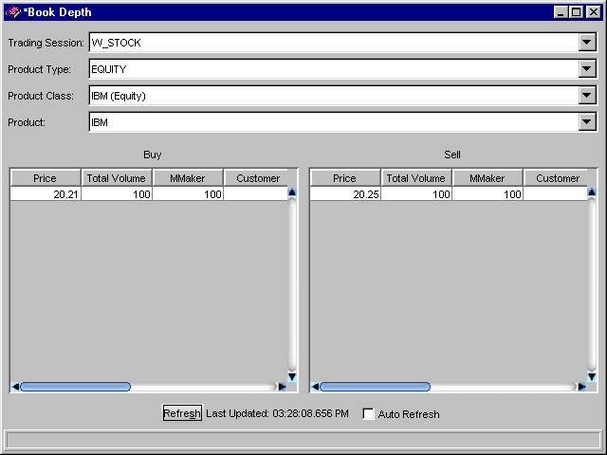
At first, the window will be blank. Select the trading session, product type, class and product you wish to display. Click Refresh. CBOEdirect will display the aggregate orders in the book at various price levels at the time of the Book Depth request. The Total Volume column displays the total volume of contracts at a price level. The Limit, AON, FOK and IOC columns display the portion of the volume that comes from contingency orders.
- Real-time updates are provided for the first five levels of market depth. To obtain updated book depth data, click Refresh.
- To have the window refresh automatically, click the Auto Refresh check box.

Edit Column Preferences
You can customize your Book Depth window by selecting or deselecting specific columns to display. To filter columns, right mouse click on a data row. Select Edit Preferences. The Edit Column Preferences window will display.
- Select or deselect columns for viewing and modify column arrangement as desired.
- To save your changes, click Ok.
- If you wish to retain the default settings, click Cancel.
For instructions on screen customization, refer to the Customize Market Display page 12.
 | - Note: Multiple Book Depth windows can be created during a trading session. Each Book Depth window configuration can be saved using the Task Toolbar. For detailed information, see the Task Toolbar section (Task Toolbar, page 50) of the Reference Guide.
Held Order Status | Through the use of the Held Order Status window, CBOEdirect gives you, as an NBBO agent, the capability to manage inbound held Customer and Satisfaction orders and Satisfaction alerts for outbound Satisfaction orders. In addition, you have the capability to query Linkage related orders.  From the Start menu, select Held Order Status, Create New Window. The Held Order Status window displays.
Designated Primary Market Maker - Only Function | 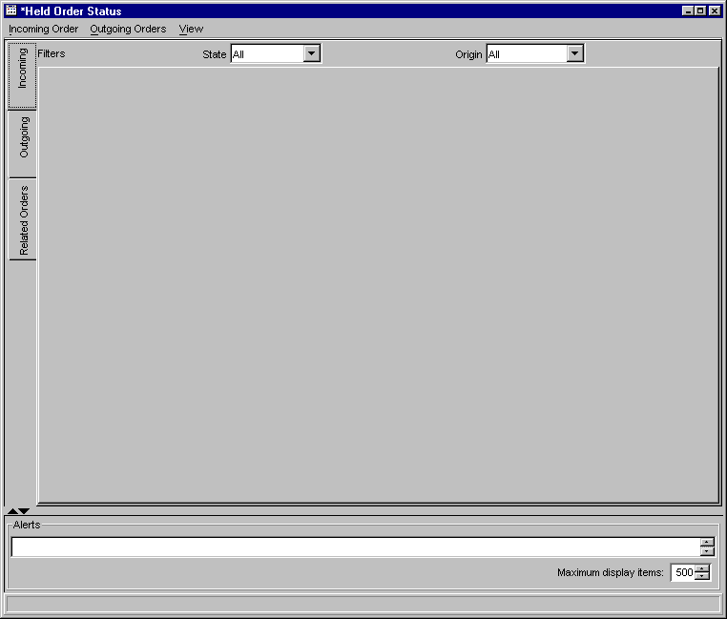
➢ | Fill Held Order  To manually fill a held order, right-mouse click on the order and select Order, Fill Held Order. The following window will display.
 | 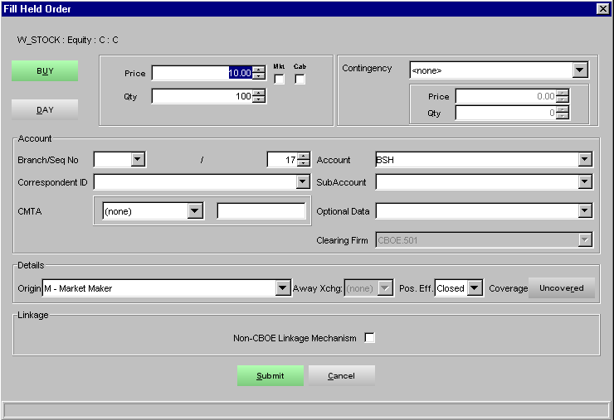
- The price and quantity will be automatically filled in.
- If you wish to cancel the fill, click Cancel.
- Fill in the remaining order information. Click Submit, Confirm.
➢ | Reroute Without Protection  To reroute the order without NBBO protection, right-mouse click on the order and select Order, Reroute Without Protection. The following window will display.
 | 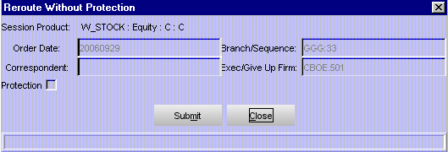
- The order information will display grayed out and the Protection checkbox will be deselected.
- Click Close to exit the window without rerouting.
- Click Submit, Confirm to reroute the order without NBBO protection.
➢ | Reroute With Protection  To reroute the order with NBBO protection, right-mouse click on the order and select Order, Reroute With Protection. The following window will display.
 | 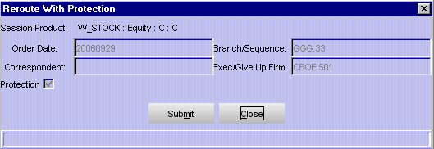
- The order information will display grayed out and the Protection checkbox will be selected.
- Click Close to exit the window without rerouting.
- Click Submit, Confirm to reroute the order with NBBO protection.
➢ | Reroute By Class Without Protection  To reroute the order by class without NBBO protection, right-mouse click on the order and select Order, Reroute By Class Without Protection. The following window will display.
 | 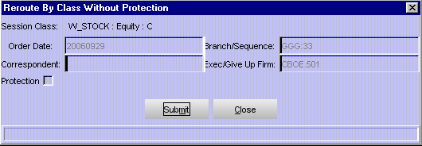
- The order information will display grayed out and the Protection checkbox will be deselected.
- Click Close to exit the window without rerouting.
- Click Submit, Confirm to reroute the order without NBBO protection.
➢ | Reroute By Class With Protection  To reroute the order by class with NBBO protection, right-mouse click on the order and select Order, Reroute By Class With Protection. The following window will display.
 | 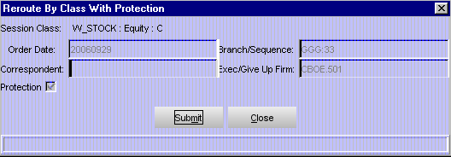
- The order information will display grayed out and the Protection checkbox will be selected.
- Click Close to exit the window without rerouting.
- Click Submit, Confirm to reroute the order with NBBO protection.
➢ | Send P/A Order  To send an order as a Principal Acting as Agent, right-mouse click on the order and select Order, Send P/A Order. The following window will display.
 | 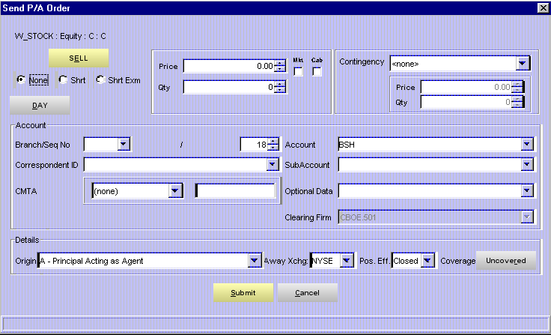
- Enter the order information.
- The Origin field will default to A-Principal Acting as Agent.
- If you wish to cancel the fill, click Cancel.
- Fill in the remaining order information. Click Submit, Confirm.
➢ | Fill Satisfaction Order  To fill a Satisfaction order, right-mouse click on the order and select Order, Fill Satisfaction Order. The following window will display.
 | 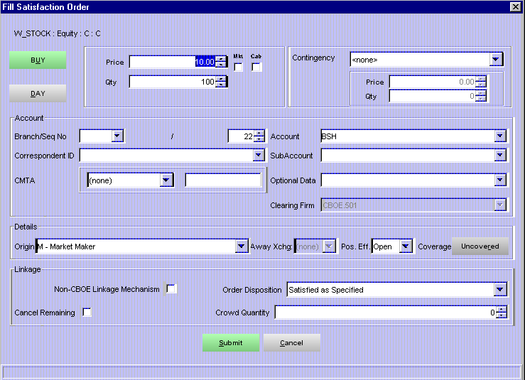
- The price and quantity will be automatically filled.
- If you wish to cancel the fill, click Cancel.
- Fill in the remaining order information. Click Submit, Confirm.
➢ | Fill Satisfaction Order In-Crowd  To fill an In-crowd Satisfaction order, right-mouse click on the order and select Order, Fill Satisfaction Order In Crowd. The following window will display.
 | 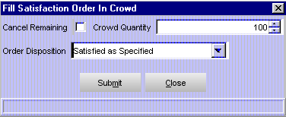
- The Crowd quantity will be automatically filled.
- To cancel the remaining quantity, select the Cancel Remaining checkbox.
- Select the Order Disposition from the drop down list.
- If you wish to cancel the fill request entirely, click Cancel.
- To submit the order, click Submit, Confirm.
➢ | Reject Satisfaction Order  To reject a Satisfaction order, right-mouse click on the order and select Order, Reject Satisfaction Order. The following window will display.
 | 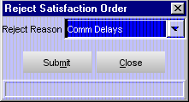
- Select the Reject Reason from the drop down list.
- If you wish to cancel the reject request, click Cancel.
- To submit the reject request, click Submit, Confirm.
History  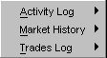 | The History option on the Start Menu gives you three ways to view trading information; Activity Log, Market History and Trades Log.

Activity Log
To view the Activity Log, select History from the Start Menu. From the sub-menu select Activity Log, Create New Window. The Activity Log window will display.
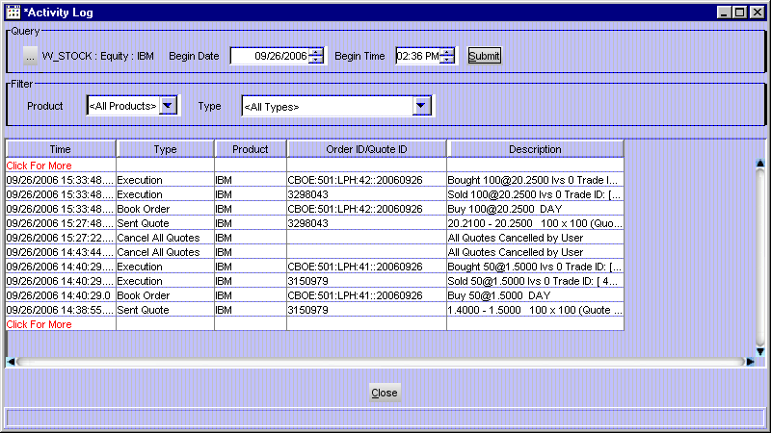

Initially, the window will be blank. To select the trading session, product type and product class you wish to display, click the Class/Product Selection button in the Query section of the window. The Class/Product Selection window will display.
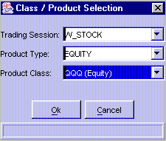

- Select the Trading Session, Product Type and Product Class from the drop down lists. Click Ok.
- The date field defaults to the current date. Click the up/down arrows to select the desired date.
- The time field defaults to the current time. Update as desired. Click Submit.
- The system defaults to query for all products and all types for the selected product class. If you wish to filter the product class activity by a specific product or activity type, s
- elect the product or type from the box lists in the Filter section of the window.

- All activity for the selected product class will display from the most recent to the earliest trade set by the date/time selection.

- Click Close to exit the display.

Edit Column Preferences
You can customize your Activity Log window by selecting or deselecting specific columns to display. To filter columns, right mouse click on a data row. Select Edit Preferences. The Edit Column Preferences window will display.
- Select or deselect columns for viewing and modify column arrangement as desired.
- To save your changes, click Ok.
- If you wish to retain the default settings, click Cancel.
For instructions on screen customization, refer to the Customize Market Display page 12.
 | - Note: Multiple Activity Log windows can be created during a trading session. You can save the configuration of each window from the Task Toolbar. For detailed information, see the Task Toolbar section (Task Toolbar, page 50) of the Reference Guide.

Market History
To create a new Market History window, select Market History from the Window menu. A blank Market History window will display.
If your user enablements are set to the system default, your Market History window will only display the Time, Type, Price, Prefix, Quantity and Underlying columns (see below for a description of each column and its values).
 | 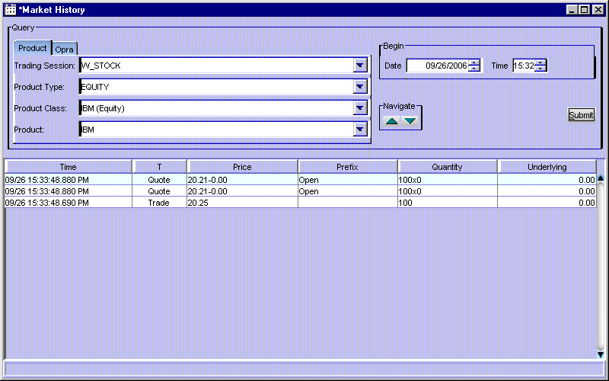
To query by product:
- From the Product tab, select the trading session, product type, product class, and product to display.
- The date/time fields default to the current date and time. Click the up and down arrows to select the desired date and time for the query.
- Click Submit.
- The default Market History window displays quotes, trades and various market conditions. Quotes and trades are listed by date/time stamp from the most recent to the earliest trade in the current trading session.
- To scroll through the display, click the up/down arrows .
- Click Submit to update selection criteria and refresh display.

Priority Market History
If your user enablements are setup to view priority market history data, your Market History window will display with the default data, NBBO information and Broker/Contra Broker fields.
If your enablements are setup to view detailed market history data, your display will generate default data and NBBO information.

 | To query by Opra code, click on the Opra tab:
 | 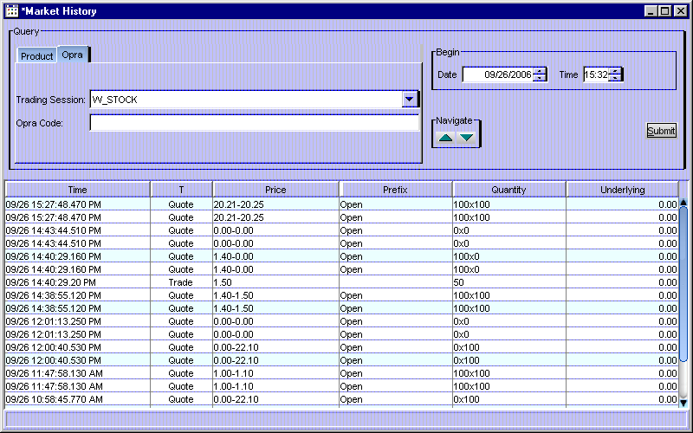
- Select the Trading Session from the drop down list.
- Enter the Opra code which consists of the class symbol, the Opra month code and the Opra price code.
- The date/time fields default to the current date and time. Click the up and down arrows to select the desired date and time for the query.
- Click Submit.
- To scroll through the display, click the up/down arrows .

Edit Column Preferences
You can customize your Market History window by selecting or deselecting specific columns to display. To filter columns, right mouse click on a data row. Select Edit Preferences. The Edit Column Preferences window will display.
- Select or deselect columns for viewing and modify column arrangement as desired.
- To save your changes, click Ok.
- If you wish to retain the default settings, click Cancel.
For instructions on screen customization, refer to the Customize Market Display page 12.
 | - Note: Multiple Market History windows can be created during a trading session. Each window configuration can be saved using the Task Toolbar. For detailed information, see the Task Toolbar section (Task Toolbar, page 50) of the Reference Guide.

Trades Log
To create a new Trades Log window, select History from the Start Menu, and then select Trades Log, Create New Window. The Trades Log window will display.
 | 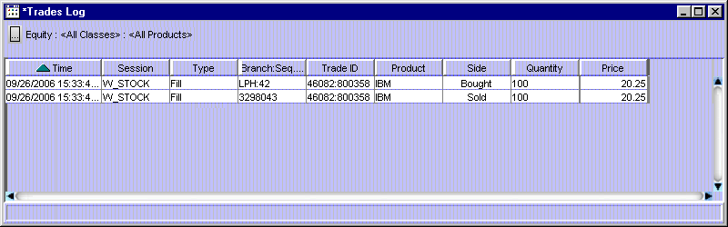
 | Initially, the window will be blank. Click the Class/Product Selection button to select the product type, class and series you wish to display. Click Ok.
 | 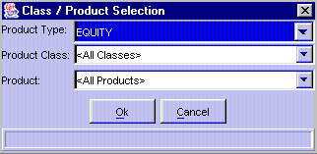
 | Trades are listed by date/time stamp from the most recent to the earliest trade in the current trading session.

Edit Column Preferences
You can customize your Trades Log window by selecting or deselecting specific columns to display. To filter columns, right mouse click on a data row. Select Edit Preferences. The Edit Column Preferences window will display.
- Select or deselect columns for viewing and modify column arrangement as desired.
- To save your changes, click Ok.
- If you wish to retain the default settings, click Cancel.
For instructions on screen customization, refer to the Customize Market Display page 12.
 | - Note: You can create multiple Trades Log windows during a trading session. Each window configuration can be saved using the Task Toolbar. For detailed information, see the Task Toolbar section (Task Toolbar, page 50) of the Reference Guide.
Locked Market Status | CBOEdirect supports locked market status for options. For instructions on how to use this window, refer to the CBOEdirect Trader’s User Guide.
Market Display | If you are enabled to trade Options or Futures products on CBOEdirect, select Market Display from the Start Menu, then highlight Create New Market Display to open a new trading window. For instructions on how to use this window, refer to the CBOEdirect Trader’s User Guide.
 | 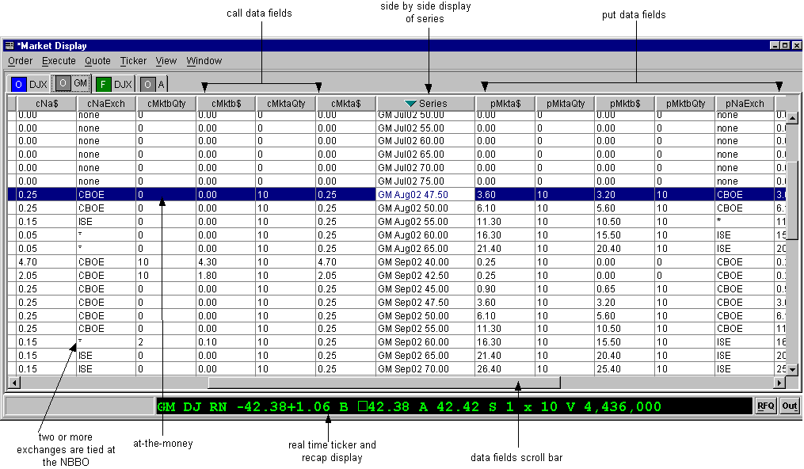
Message Center | If you need to send a message to the CBOEdirect Help Desk, click Message Center and highlight, Send Message. A New Message window will display.
 | 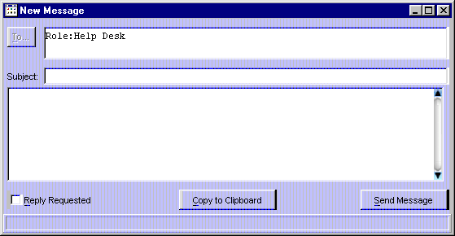
 | Enter the Subject and the text of your message. Click Send Message. The email will be automatically routed to the Help Desk representative. To copy your message to the clipboard, click Copy to Clipboard. If you would like the Help Desk to reply to your message, select the Reply Requested checkbox.
 | - Note: Multiple Message Center windows can be created during a trading session.
Order Status | You can create a new Order Status window from the Start Menu. Select Order Status, Create New Window. A blank Order Status Window will display.
 | 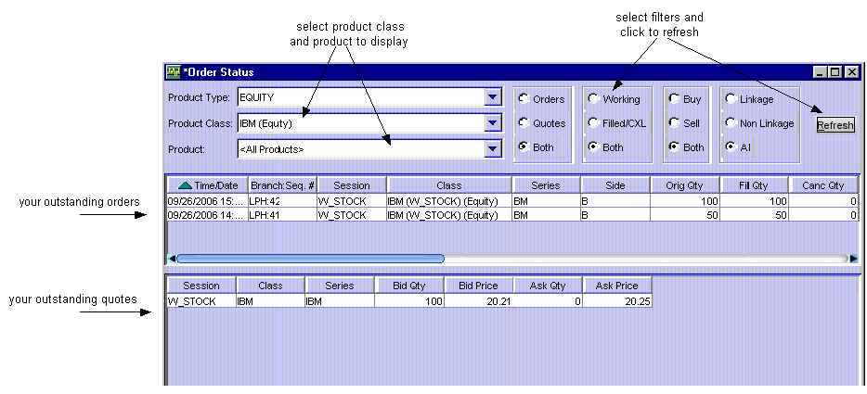
At this window you can view orders and/or quotes, buy and/or sell orders, and working and/or completely filled/cancelled orders. Select the product type, class and series you wish to view from the list boxes. Select the appropriate radio buttons, then click Refresh.
To update order information, refer to the Order Status window in the Order and Quote Status section, page 39.

Edit Column Preferences
You can customize your Order Status window by selecting or deselecting specific columns to display. To filter columns, right mouse click on a data row. Select Edit Preferences. The Edit Column Preferences window will display.
- Select or deselect columns for viewing and modify column arrangement as desired.
- To save your changes, click Ok.
- If you wish to retain the default settings, click Cancel.
For instructions on screen customization, refer to the Customize Market Display page 12.
 | - Note: Multiple Order Status windows can be created during a trading session. Each window configuration can be saved using the Task Toolbar. For detailed information, see the Task Toolbar section (Task Toolbar, page 50) of the Reference Guide.
Pending Price Adjustment | Price adjustments on orders are caused by changes in the underlying security, such as stock splits, stock dividends, etc.  To view the effects of pending price adjustments on your outstanding orders:  Highlight Pending Price Adjustments, Create New Window. The Pending Price Adjustment window will open.
 | 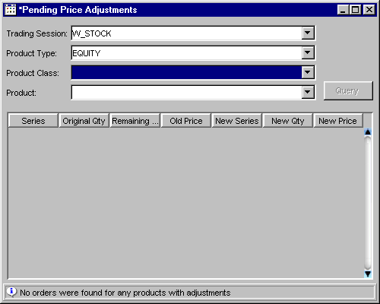
Select the trading session, product type, product class and product from the drop down lists. Click Query. For the selected product, you can view:
- original and new series
- original and new quantity
- remaining and new quantity
- old and new price
Pending RFQs | You can view pending RFQs for all products for which you are assigned by selecting Pending RFQ from the Start Menu, then selecting Create New Window.
 | 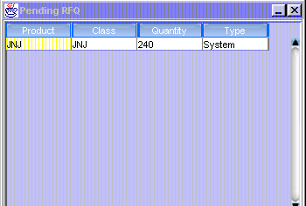
 | RFQs display on this window for n (30) seconds. The RFQ will display in green for the first n (10) seconds; in yellow for the second n (10) seconds; then in red for the last n (10) seconds. After n (30) seconds, the RFQ will disappear from the window.
 | 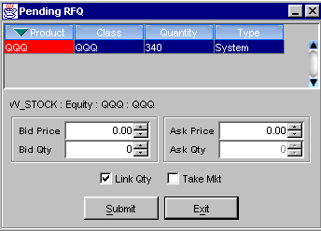
- If an RFQ is pending, you can respond to the RFQ by clicking on it. The Quote Entry window will display at the bottom of the Pending RFQ window.
- Enter quote information and click Submit to send the quote. (See Enter Quote, page 19).
- If you decide you do not wish to proceed with the quote, click Exit to close the Quote Entry window.
 | - Note: Multiple Pending RFQ windows can be created during a trading session. Each window configuration can be saved using the Task Toolbar. For detailed information, see the Task Toolbar section (Task Toolbar, page 50) of the Reference Guide.
Preferences | The system gives you the ability to tailor your trading sessions to your trading style by setting session defaults for quotes and orders.  Multiple preference windows can be created during a trading session.
 | 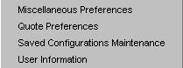 | From the Start Menu, select Preferences, and then highlight the option you want to display. Values set using these functions will become the default values for new trades and trading sessions.
➢ | Miscellaneous Preferences  This window enables you to set order and execution defaults for all classes or specific classes.
- To set defaults for all orders:
- To set an order size confirmation default, fill the checkbox and enter the order size limit for confirmations.
- If you want fill reports to print, fill the checkbox.
- To set order entry default information enter:
- Branch
- Account - this field is the OCC-recognized account ID and is limited to three characters.
- Correspondent ID
- Subaccount - this field is required for Futures and is limited to ten characters.
- CMTA
- Order size
- Optional data
- To set an execution (hit the bid or take the offer) confirmation default, fill the checkbox and enter the order size limit for confirmations.
- To set audible alerts:
- If you would like the system to audibly prompt you for order fills, cross notification, or RFQs, select the appropriate radio buttons.
- To set the sequence number for order entry:
- Enter the desired number in the Sequence Management section of the window.
- The number you set is saved as the next increment to use for order entry. This is a global setting for all classes.
- The sequence number automatically increments by one for each order submitted.
- The sequence number you set cannot be a previously used number.
- CBOEdirect currently allows users to display only one Market Display window and a maximum of three class tabs within the window. If you wish to display only one class tab during your trading session, deselect the Multiple Class Tabs checkbox.
- Note: If your trading session is configured to display multiple class tabs and you decide to switch to single tab format during the trading session, the current class tabs will remain in the window until you attempt to add a new class. At that time, the system will remove the class tabs from the window.
- To set order defaults for a specific class:
- Select the product type from the drop down list.
- Select the class from the drop down list, click Add Tab.
- Follow the steps above for setting default values.
- Click the checkbox to Confirm on Held Order Status Window.

When you have set or updated your order defaults, click Submit. You will be prompted to confirm. Click Confirm. Your preferences will be saved immediately.
If you wish to close the window without saving your settings or changes, click Cancel.

➢ | Quote Preferences  This window enables you to set defaults for all quotes or quotes for specific classes.
- Set defaults for all quotes:
- To add a setting, enter the price, size, and spread values. Click Add/Update.
- To change a setting, highlight the setting, update the price, size, and/or spread values. Click Add/Update.
- To delete a setting, highlight the setting, click Delete.
- To set the system to prompt you for a quote size confirmation, fill the checkbox and enter the quote limit for confirmations.
- To set quote defaults for a specific class:
- Select the product type from the drop down list.
- Select the class from the drop down list, click Add Tab.
- Follow the steps above for setting default values. If you wish to use your global defaults as the basis for these settings, click Take Defaults. The fields will fill with your default values.
- To take the exchange spread as your default, click Take Exchange Spread. The fields will fill with the default size and spread values.
- To change a setting, highlight the setting, update the price, size, and/or spread values. Click Add/Update.
When you have set or updated your quote defaults, click Submit. You will be prompted to confirm. Click Confirm. Your preferences will be saved immediately.
If you wish to close the window without saving your settings or changes, click Cancel.

➢ | Configuration Maintenance  Window configurations from previous versions of CBOEdirect are saved in the Saved Configurations Maintenance window.  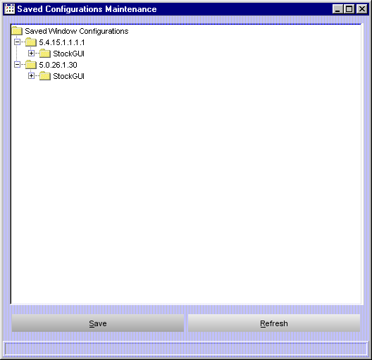
 | From this window, you can apply your previously defined named configurations and default template preferences to the current version of CBOEdirect. For example, to apply the default configurations for the Market Display from version 5.0.26.1.30 to version 5.4.15.1.1.1.1, double-click on the folder labeled 5.0.26.1.30. Click on the Market Display folder. After the folder is highlighted, drag and drop it with your mouse onto the folder labeled Market Display under version 5.4.15.1.1.1. The system will prompt you to confirm the conversion.
Click Yes to perform the conversion. CBOEdirect will apply the configuration to your Market Display window.
Click Save to apply the configuration.
If you decide not to apply the configuration, click No.
Click Refresh to condense the Saved Window Configurations directory tree.

➢ | User Information  The User Information Preferences window allows you to view the data that is setup for you in CBOEdirect.  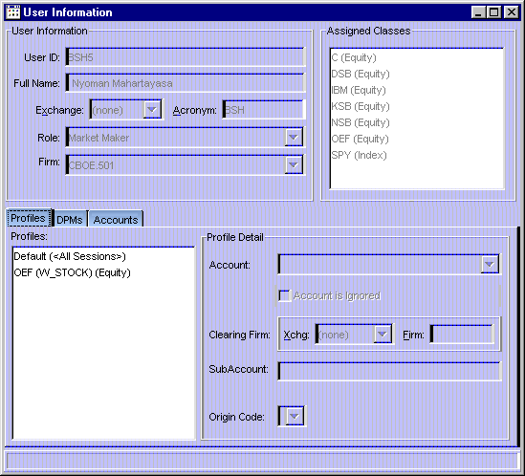
The User Information section of the window displays your User ID, Name, Acronym, Role, Firm and Exchange information.
The Profiles tab shows your Profiles Account, Clearing Firm and SubAccount details.

The DPMs tab displays assigned DPMs and DPM classes.
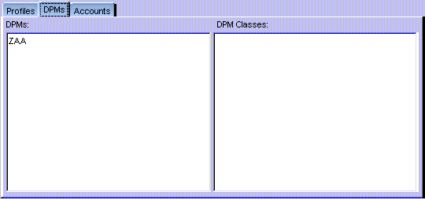

The Accounts tab display all your accounts with the Exchange and Firm information.
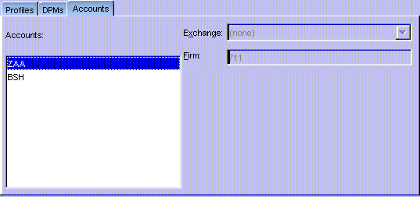
Product Lookup | CBOEdirect has the functionality to search for specific product information. From the Start Menu, select Product Lookup, Create New Window. The Product Lookup window will display.  From this window, you can retrieve product information by product type and class, or by key reference number.
➢ | Lookup by Selector  From the Lookup by Selector section of the window, CBOEdirect allows you to retrieve detailed product information for a particular product or for all products related to a product class.  To request product information for a particular product class:  - Select the Product Type and Product Class from the corresponding drop down lists.  - Select the product from the Product drop down list and click on the Lookup button. The product information will display in the Details section of the window. Use the up/down arrows to scroll through the text box for additional system details about the product.
 | 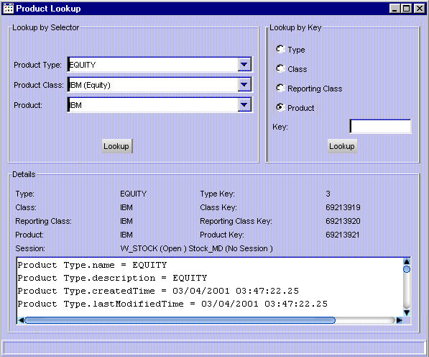

Lookup by Key
You can quickly lookup product information by type, class, reporting class or product if you have the Key reference number.
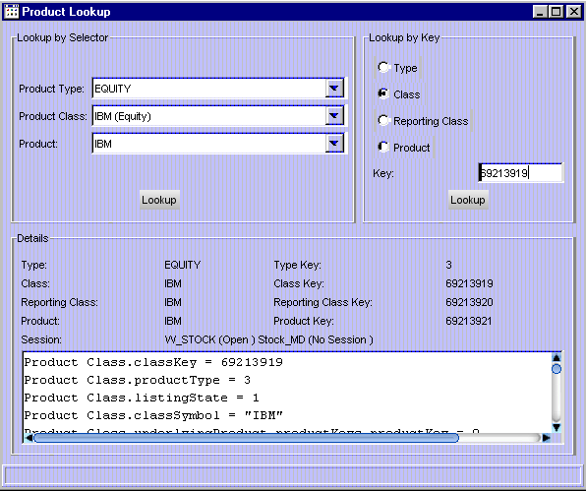
For example, to lookup product information by the key reference number, select the Class radio button in the Lookup by Key section of the window. Enter the key reference number in the Key text box and click Lookup. In the example window above, the product with key number 69213919 displays in the Details section of the window. Use the up/down arrows to scroll through the text box for system details about the product.
Follow the steps detailed above to lookup class, type or reporting class information by the key reference number.
QRM | The system gives you the ability to tailor your trading sessions to your trading style by setting session defaults from the Quote Risk Manager.  From the Start Menu, select QRM, and then highlight QRM Maintenance. Values set using this function will become the default values for new trades and trading sessions.
➢ | QRM Maintenance
This window enables you to set QRM defaults for each class quoted.
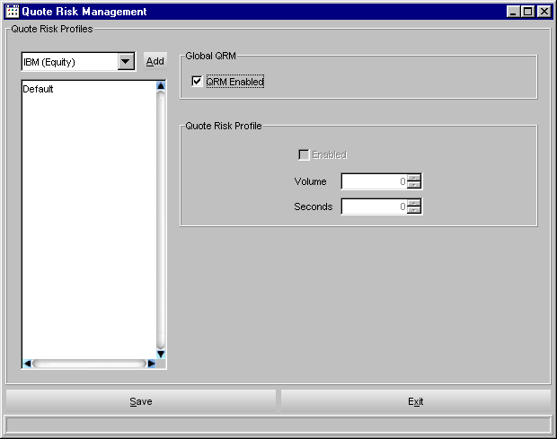
To add a new class to the Quote Risk Monitor:
- Select a class from the drop down list box and click Add.
To set defaults:
- Highlight the class, fill the appropriate checkboxes, and set the volume and seconds levels.
When you have set or updated your QRM defaults, click Save.
When you wish to close the window, click Exit.
 | - Note: Multiple QRM windows can be created during a trading session.
Status Window | Select Status Window from the Start Menu to open a new system status window. The configuration of the Status window can be saved using the Task Toolbar. For detailed information, see the Task Toolbar section (Task Toolbar, page 50) of the Reference Guide.  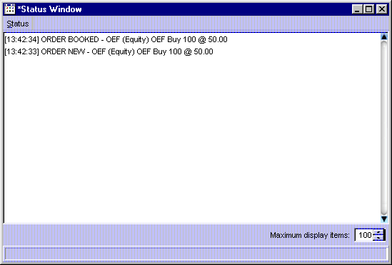
 | The Status Window will open displaying a maximum number of 100 items. CBOEdirect allows a maximum of 100 items to be displayed on the Status Window. To increase or decrease the number of items to display, click the Up or Down arrows until the desired number is reached.
- For detailed information, right mouse click to highlight the order and select Details. You can also select Details from the Status menu or press [Alt]-[D] from anywhere on the window.
- To print status information, select Print from the right mouse click menu or from the Status menu. You can also press [Alt]-[P] from anywhere on the window. The print window will display.
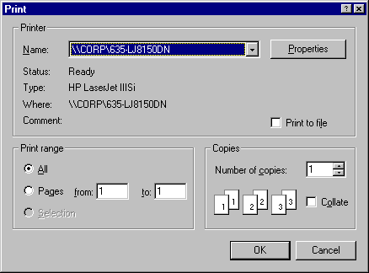
- To clear the status information, select Clear from the right mouse click menu or from the Status menu. You can also press [Alt]-[C] from anywhere on the window.
Ticker Display | CBOEdirect allows you to view underlying security market data by displaying ticker and recap information. From the Start Menu, select the Ticker Display option, then select Create New Window. The Ticker Display window will open.  You can create multiple Ticker Display windows during a trading session. Each window configuration can be saved using the Task Toolbar. For detailed information, see the Task Toolbar section (Task Toolbar, page 50) of the Reference Guide
 | 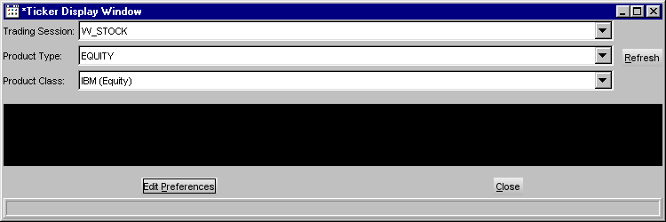
From the drop down lists, select the trading session, product type and product class you wish to view. Click Refresh. Ticker and recap information will display for the selected product class.
If you decide you do not wish to view ticker information for a product class, click Close.

Ticker Configuration
You can define the ticker and recap information you wish to display by placing your mouse on the ticker portion of the window and performing a right mouse click. Select Edit Preferences. The Ticker Configuration window displays.
 | 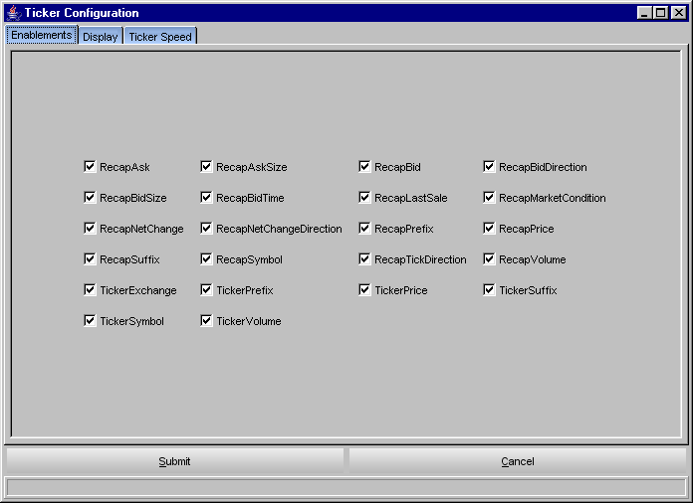
This window displays three tabs: Enablements, Display and Ticker Speed. The Enablements tab defaults to display all ticker and recap information. You can choose the ticker and recap information you would like to display by selecting/deselecting the appropriate check boxes.
- To save your configuration, click Submit. Click Confirm.
- If you decide to retain the default settings, click Cancel.
To further define your ticker display, select the Display tab. From this window, you can set a new font type and color for your display.
- To select a new font, select the type, size and style from the drop down lists. The new font will display in the Preview Colors section of the screen.
- From the Swatches tab, click on the color you wish to display. The new color is viewable in the Preview Colors section of the screen.
 | 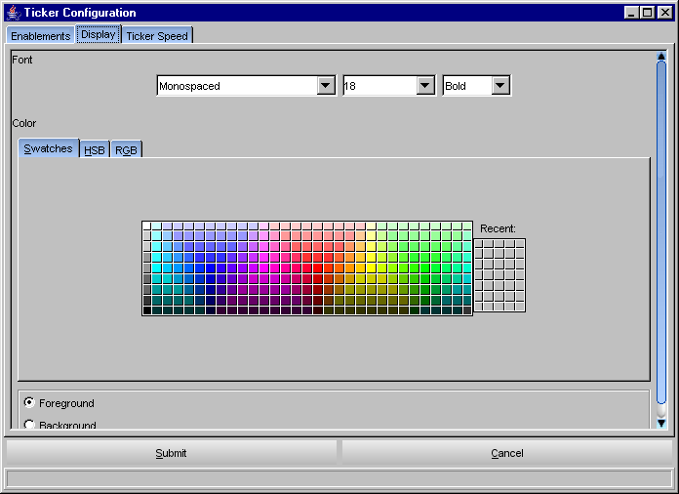
- To save the configuration, click Submit. Click Confirm.
- To retain the default settings, click Cancel.
 | - Click the HSB tab to set your hue, saturation and brightness. Place your mouse on the scroll bar button and adjust your color preference. You can view the changes in the Preview Colors section of the window.
 | 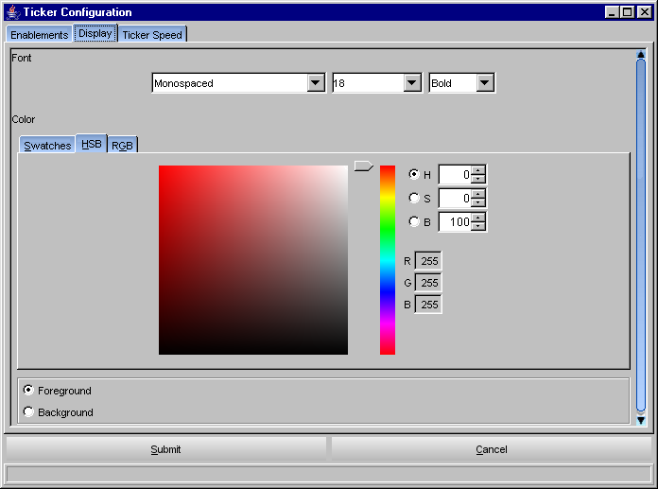
- To save the configuration, click Submit. Click Confirm.
- To retain the default settings, click Cancel.
 | - Click the RGB tab to set your red, green and blue color model. Place your mouse on the side scroll bar and adjust your color preference. You can view the changes in the Preview Colors section of the window.
 | 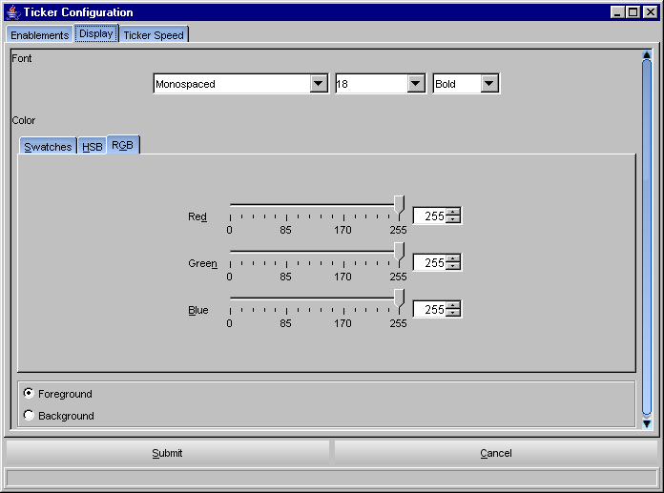
- To save the configuration, click Submit. Click Confirm.
- To retain the default settings, click Cancel.
 | - Click the Ticker Speed tab to set your ticker and block size speed. Place your mouse on the side scroll bar and adjust your speed preference.
 | 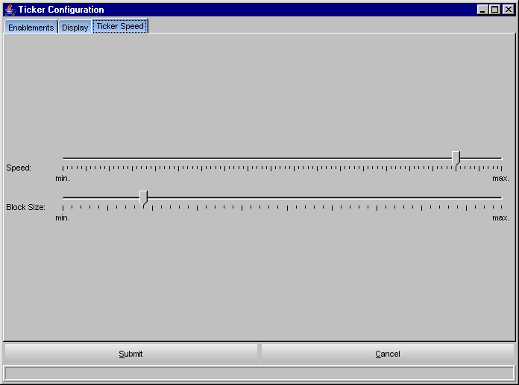
- To save the configuration, click Submit. Click Confirm.
- To retain the default settings, click Cancel.
Open Console Window | CBOEdirect allows you to view system messages that are generated by the functions you perform. To view the messages, select Open Console Window from the Start Menu. The Console Window will display.
 | 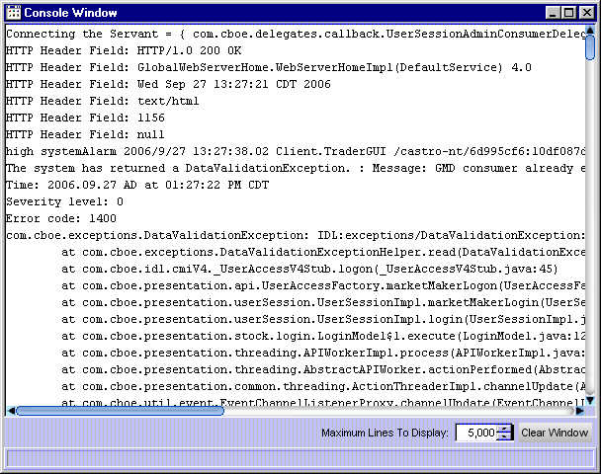
The information in this window can be copied to the CBOEdirect Message Center. To copy text from this window,
- place the cursor on the line you which to copy and using your mouse highlight the text.
- press Ctrl C on your keyboard to copy the text.
- open CBOEdirect Message Center window and place your cursor in the text entry area.
- press Ctrl V on your keyboard. The text is copied in the window.

