

Transaction Timing Performance Tool
User Guide
Version 1.1

Disclaimer

Copyright © 2011 Chicago Board Options Exchange. All rights reserved.
The information contained in this document constitutes confidential and/or trade secret information belonging to CBOE. This document is made available to CBOE members and member firms for use with CBOEdirect™. This document is provided "As Is" with all faults and without warranty of any kind, either expressed or implied.

Change Notices

The following change notices are provided to assist users of the Transaction Timing (TT) Performance tool in determining the impact of changes to their processing.
If you have any questions or review comments about this document, please contact Odalys Castro at (312) 786-8817.

Date | Version | Description of Change
06/01/11 | 1.1 | New screen capture
05/10/10 | 1.0 | New document

Table of Contents
Table of Contents iii
Introduction iv
Purpose iv
Intended Audience iv
Conventions Used in this Guide iv
Transaction Timing Performance Tool 5
Getting Started 6
Transaction Timing (TT) Reporting 7
General Search 8
TT Search 8
Perform TT Search by Class 12
Order/ Quote 17
TIDs Reporter 18
TID Detail 22
General TTE Reporter 24
Exit the System 27
Exit the System 27
Customizing TT Windows 28
Sizing Windows 28

Introduction

Purpose | This user guide was written to assist users in measuring the performance and dependability conditions of the CBOEdirect screen-based trading system.
Intended Audience | This user guide is intended for systems management, developers or any person interested in the performance state of the CBOEdirect screen-based trading system.
Conventions  Used in this Guide | The Transaction Timing (TT) Performance tool was designed so that you can perform all of your activities from a web page.  There are several conventions used throughout this guide to help trigger important information:
 | Bolding | Used to highlight menu selections (e.g., Login) and button names (e.g., Update)
 |  Note: | This notation is used to indicate important information you should note when performing the associated function.

 | Transaction Timing Performance Tool

This section of the user guide will direct you through all functions of the Transaction Timing Performance tool for CBOEdirect.

Getting Started

The Transaction Timing (TT) Performance tool is a CBOE internal web-based application. It is accessed through the CBOEdirect Development website.
To launch the application, open an Internet browser window and enter URL: http://ccserv1. The CBOEdirect Development website will display.
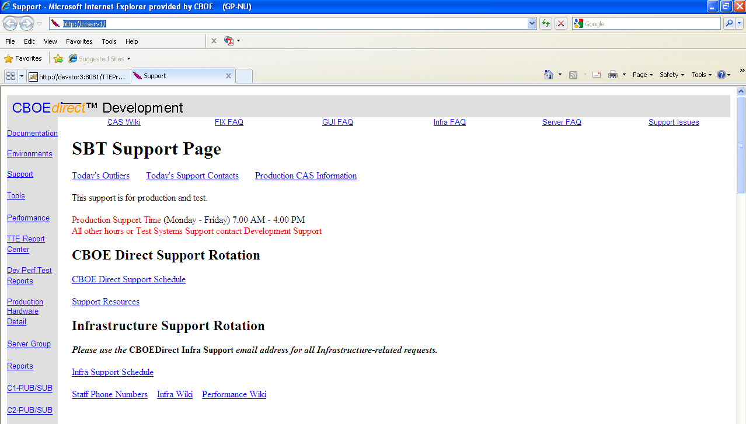
From the menu banner located to the left of the window, click TTE Report Center. The TT Performance application will display.
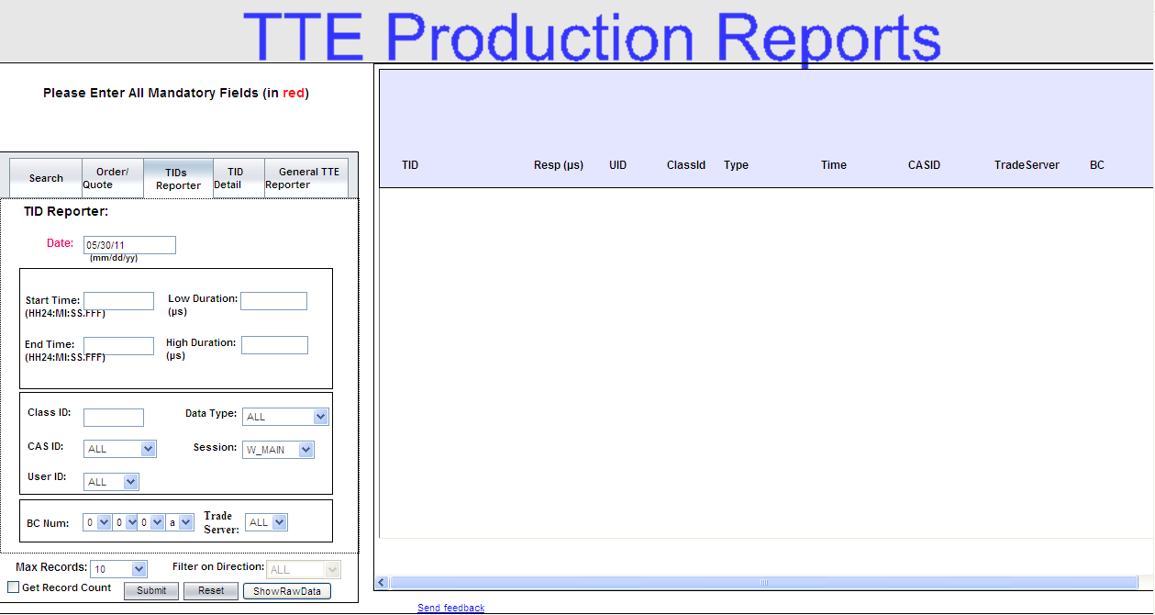
You are now ready to perform TT reporting functions.

Transaction Timing (TT) Reporting

 | Transaction Timing (TT) is a measurement-based tool and technique for system performance and dependability. The technique involves intercepting system method calls and logging the enter and exit times of the method. It is used to provide insight into processing times of various logical pieces in a call originating from the customer into CBOEdirect. The TT reporting application allows you to query for events and method timing information based on the filters you provide. It also provides detailed investigation into specific Transaction ID (TID) metrics.
 | The TT reporting application is setup to query by general search, order/quote, TIDs reporter, TID detail and general TTE reporter.
General Search | The search feature in the TT Performance tool allows you to execute general TT queries or queries based on a specific class. Click on the Search tab to define your filters.
 | 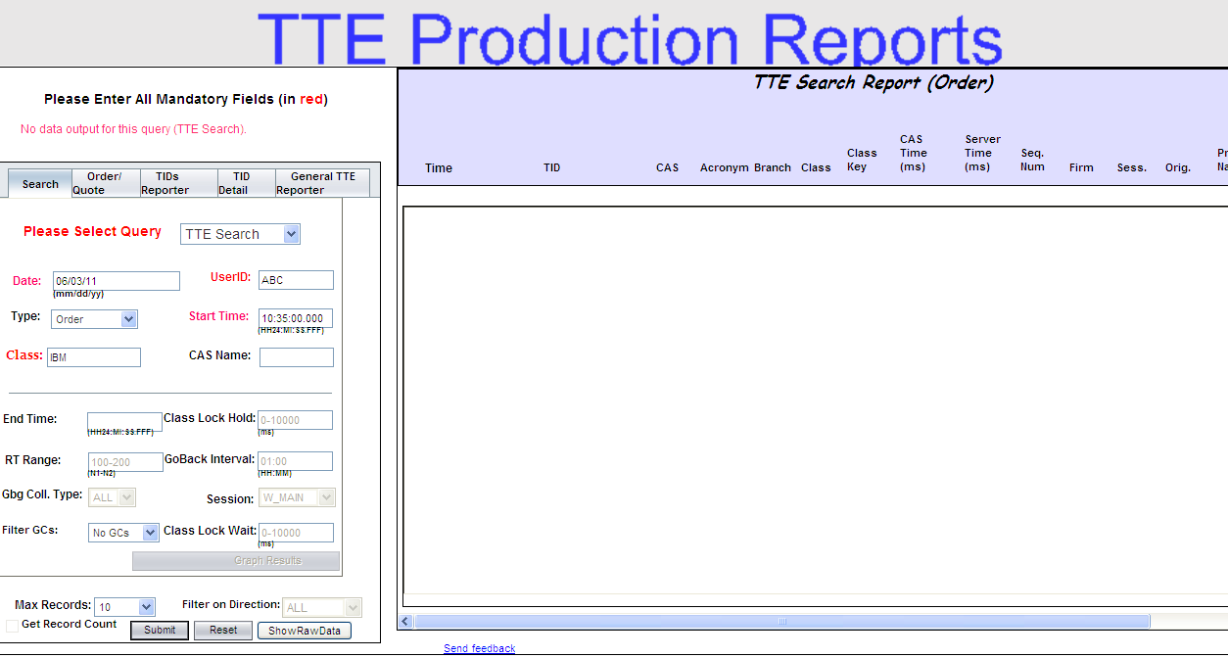
 | TT Search
In the Search tab, all fields in red font are required. To perform a general TT query:
- Select TTE Search from the Please Select Query drop down list.
- In the Date field, enter the date you want to capture in your query. The date format is mm:dd:yy.
- Type in the start time of your data request in the Start Time field. The time format is HH24:MM:SS.FFF. For example, 10:35:00.000 represents 10:35a.m.
- From the Type drop down list, choose the category of your search (i.e. quote, order, etc.). Quote is the default value.
- Provide the user’s acronym in the User’s ID field.
- Enter the class name in the Class field.
- The Max Records field allows you to select the number of records you want to display in your query. The default is 10.
- For a TT search, the following fields are predefined and cannot be changed.
  - Class Lock Hold field defaults to 0-1000, GoBack Interval defaults to 01-00, RT Range defaults to 100-200, Session defaults to W_MAIN, GLB Coll. Type defaults to “ALL”, Class Lock Wait defaults to 0-10000.
- If you do not want to display garbage collection, select No GCs from the Filters GC drop down checkbox.
- To clear your entries and begin a new query, click Reset.
- To enter your search request, click Submit. The result of your query will display in the TTE Search Report section of the window.
 | 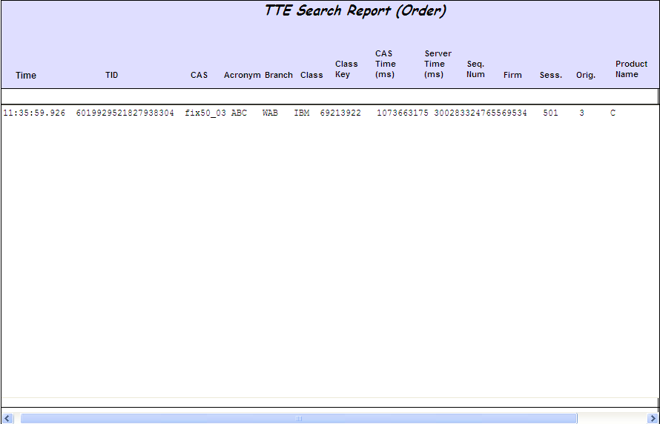
 | The example above displays the TT order data for user ABC and class IBM on June 03, 2011, starting at 10:35a.m. The report generates the following information:
- Time: the time the transaction occurred.
- TID: the transaction ID for the order.
- CAS: name of the CAS engine.
- Acronym: refers to the user’s acronym.
- Branch: the Firm’s branch ID.
- Class: the name of the class.
- Class Key: class identifier.
- CAS Time (ms): the transaction time for the CAS in milliseconds.
- Server Time (ms): the transction time for the server in milliseconds.
- Seq. Num: the order sequence number
- Firm: the Firm’s number
- Sess.: the trading session where the order was entered.
- Orig.: the order originator
- Product Name:
 | Use your scroll bar to view additional data fields to the right of the window.
 | To display your search results in raw data, click Show Raw Data. The results will display as follows.
To display detailed information for a TID, click on the TID data row. A new window will open detailing the method entry and exit timings for that TID.
The report has three tabs with each tab providing a different perspective of the selected TID. The three tabs are: QueryTID Report, QueryTID Time Report and Query CLL Report.
 | QueryTID Report
 | 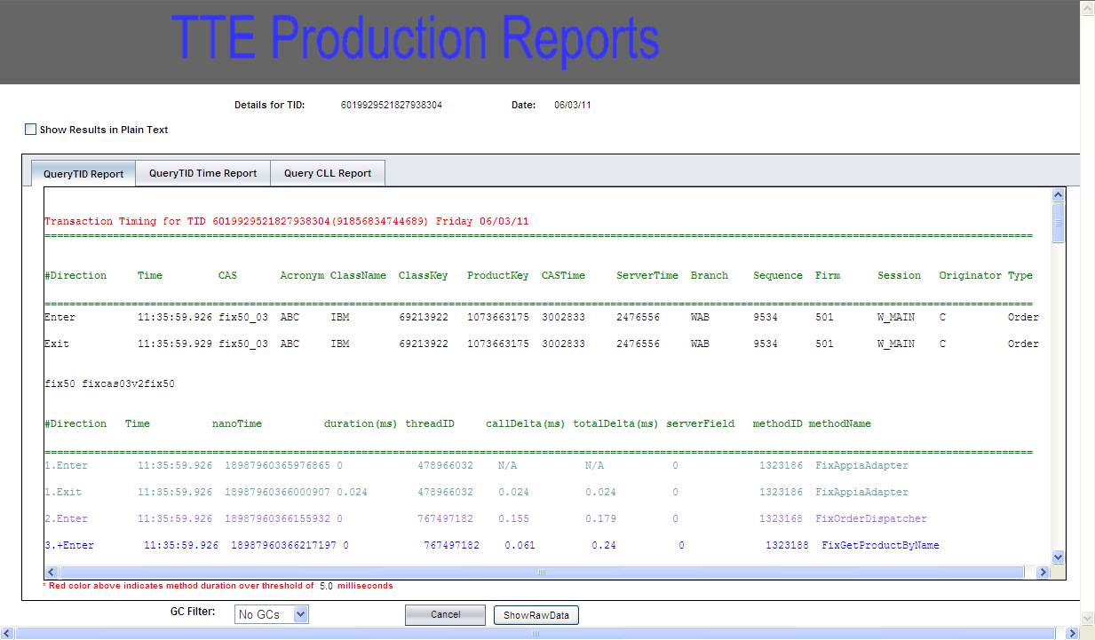
The QueryTID Report tab provides a detailed view of the time the TID has spent within a method and between methods. It also presents the applicable method ids and method names.
This output shows entry and exit into a method and the durations inside these methods. To allow a user to line-up the related entries and exits, by default the entry to the methods are numbered, indented and colorized to match their peer exit.
To turn off these decorations and see a linear list of all exits and entries, select the checkbox. Show Results in Plain Text.
Click Cancel to return to the main reporting page.
 | QueryTID Time Report
 | 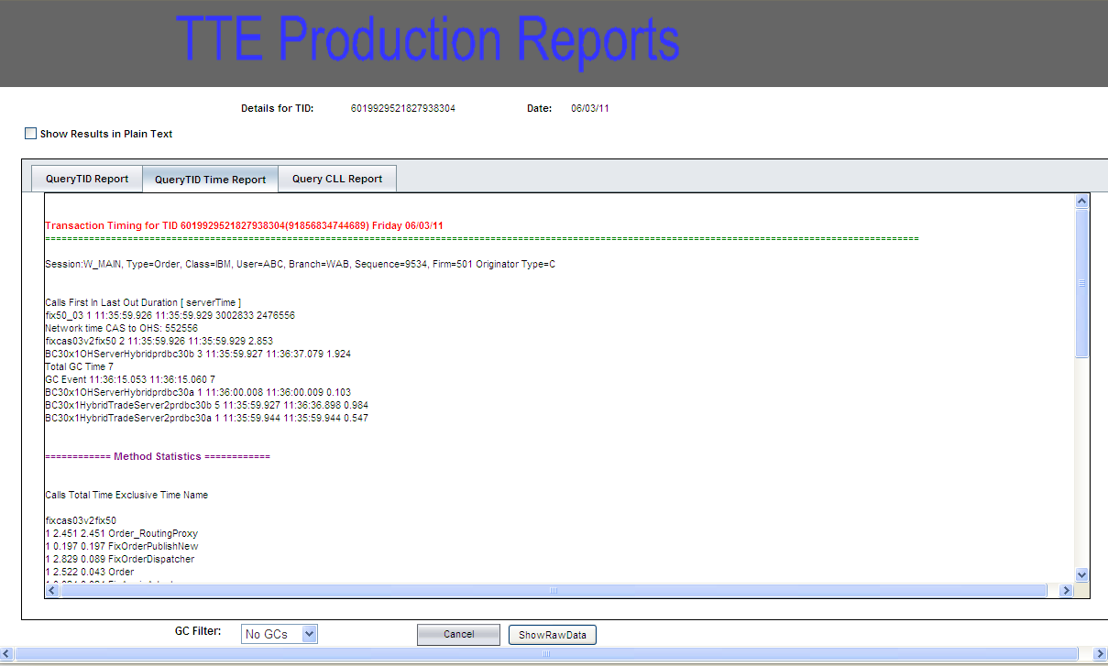
The QueryTID Time Report is a summary of the methods visited by this TID for each Trade Server involved.
Click Cancel to return to the main reporting page.
 | Query CLL Report
 | 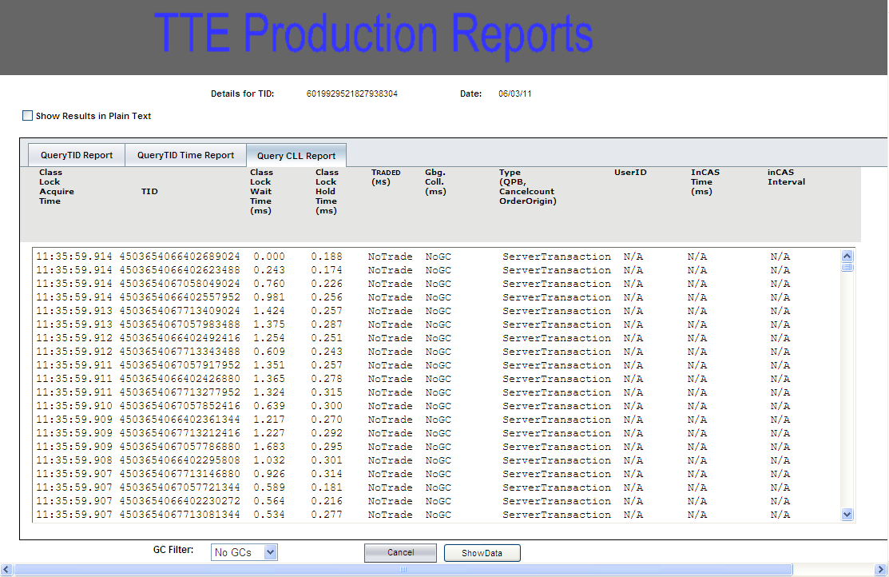
The Query CLL (Class Level Lock) Report is a list of the TIDs associated with the main TID of the report. Clicking on these associated TIDs allows investigation into the different layers of connected TIDs for this TID.
Click Cancel to return to the main reporting page.

Perform TT Search by Class
The TT tool allows you to perform a search based on a specific class.
 | 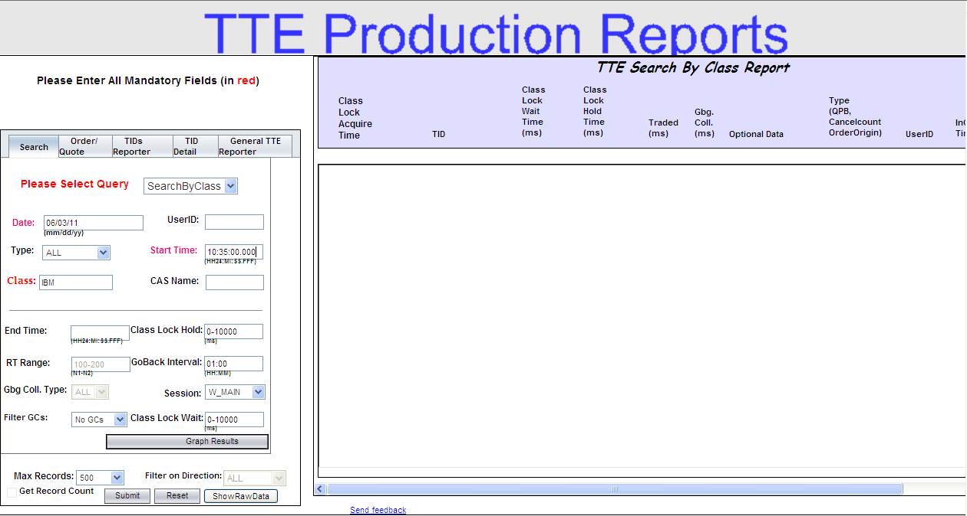
In the Search tab, all fields in red font are required. To perform a TT query based on a specific class:
- Select SearchByClass from the Please Select Query drop down list.
- In the Date field, enter the date you want to capture in your query. The date format is mm:dd:yy.
- Type in the start time of your data request in the Start Time field. The time format is HH24:MM:SS.FFF. For example, 10:35:00.000 represents 10:35a.m.
- From the Type drop down list, choose the category of your search (i.e. quote, order, etc.). Quote is the default value.
- Provide the user’s acronym in the User’s ID field.
- Enter the class name in the Class field.
- The Max Records field allows you to select the number of records you want to display in your query. The default is 500.
- For a search by class, the following fields are predefined and cannot be changed.
  - RT Range defaults to 100-200
  - GLB Coll. Type defaults to “ALL”
- The following fields can be changed at your discretion but are predefinned as follows:
  - Class Lock Hold field defaults to 0-10000
  - GoBack Interval defaults to 01:00
  - Session defaults to W_MAIN
  - Class Lock Wait defaults to 0-10000
- If you do not want to display garbage collection, select the No GCs from the Filter GCs drop down list.
- To clear your entries and begin a new query, click Reset.
- To enter your search request, click Submit. The result of your query will display in the TTE Search by Class Report section of the window.
 | 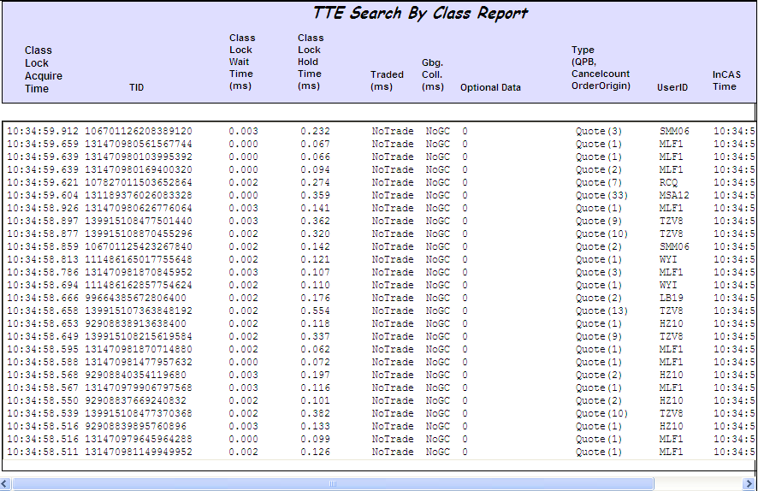
 | The example above displays the TT order data for class IBM on June 03, 2011, starting at 10:35a.m. The report generates the following information:
- Class Lock Acquire Time: the time the class lock occurred.
- TID: the transaction ID for the order.
- Class Lock Wait Time: the class lock waiting period in milliseconds.
- Class Lock Hold Time: the class lock holding period in milliseconds.
- Traded: the time the trade occurred in milliseconds.
- Gbg Col: refers to the garbage collection times in milliseconds.
- Type: the count of actions that took place (i.e., number of quotes per block).
- User ID: the user’s acronym.
- InCAS Time (ms): the time the transaction reached the CAS in milliseconds.
- InCAS Interval (ns): the CAS interval times for the transaction in nanoseconds.

 | Use your scroll bar to view additional data fields to the right of the window.
 | To display your search results in raw data, click Show Raw Data. The results will display as follows.
 | To display your search results in graph format, click Graph Results.
 | 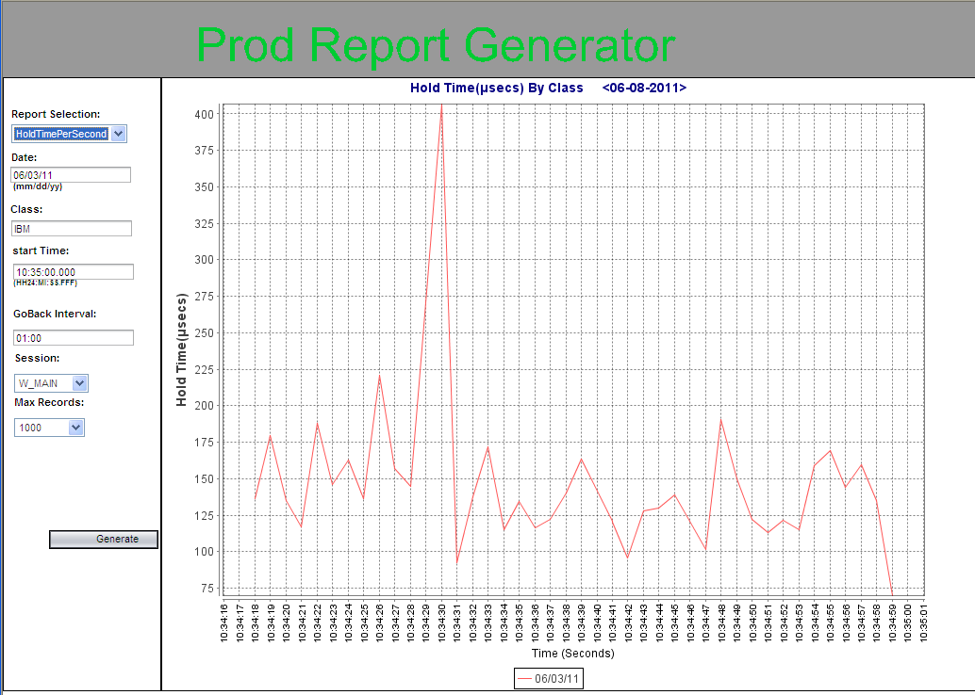
To display detailed information for a transaction ID, click on the TID data row. A new window will open detailing the method entry and exit timings for that TID.
The report has three tabs with each tab providing a different perspective of the selected TID. The three tabs are: QueryTID Report, QueryTID Time Report and Query CLL Report.
 | QueryTID Report
 | 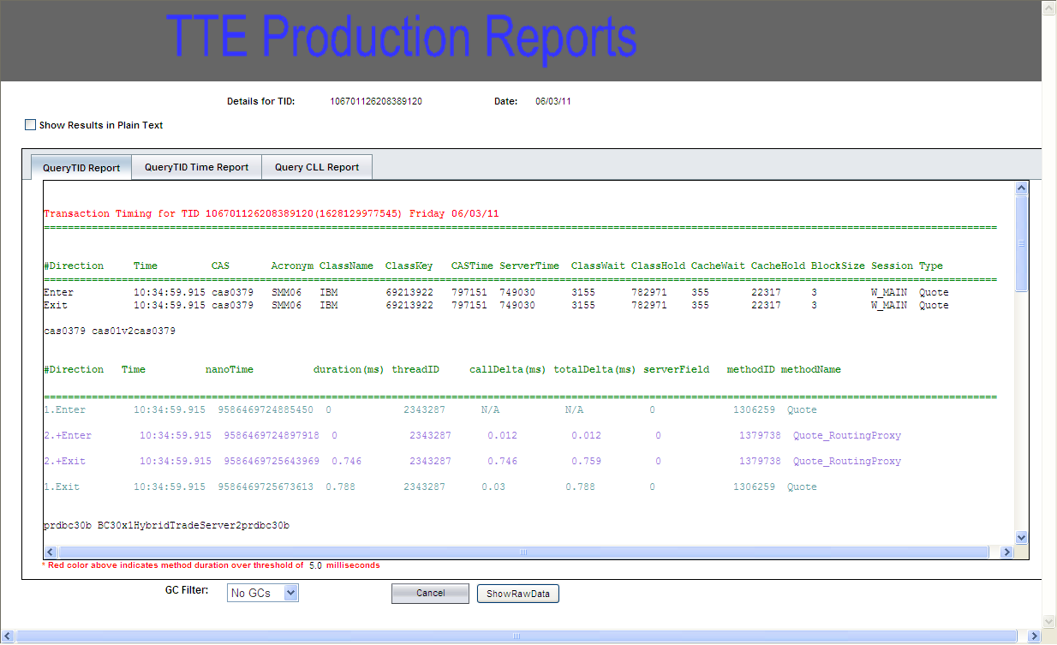
The QueryTID Report tab provides a detailed view of the time the TID has spent within a method and between methods. It also presents the applicable method ids and method names.
This output shows entry and exit into a method and the durations inside these methods. To allow a user to line-up the related entries and exits, by default the entry to the methods are numbered, indented and colorized to match their peer exit.
To turn off these decorations and see a linear list of all exits and entries, select the checkbox. Show Results in Plain Text.
Click Cancel to return to the main reporting page.
 | QueryTID Time Report
 | 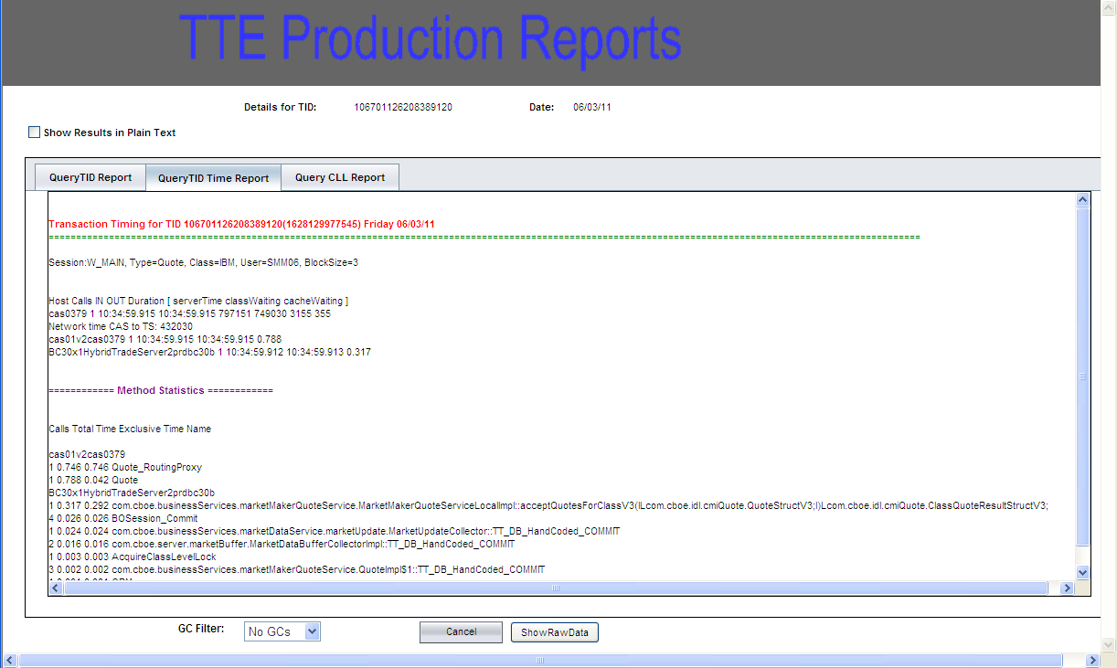
The QueryTID Time Report is a summary of the methods visited by this TID for each Trade Server involved.
Click Cancel to return to the main reporting page.
 | Query CLL Report
 | 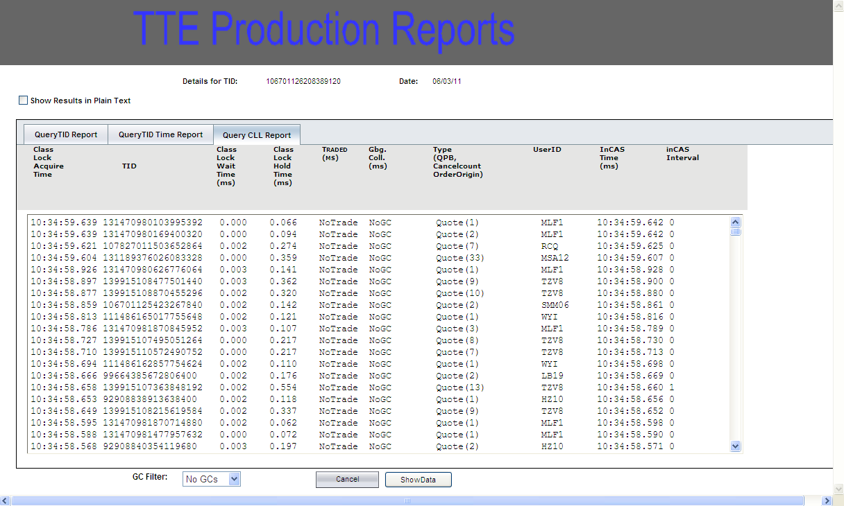
 | The Query CLL (Class Level Lock) Report is a list of the TIDs associated with the main TID of the report. Clicking on these associated TIDs allows investigation into the different layers of connected TIDs for this TID. Click Cancel to return to the main reporting page.
Order/  Quote | Click on the Order/Quote tab to query TT data by order/quote count per class.
 | 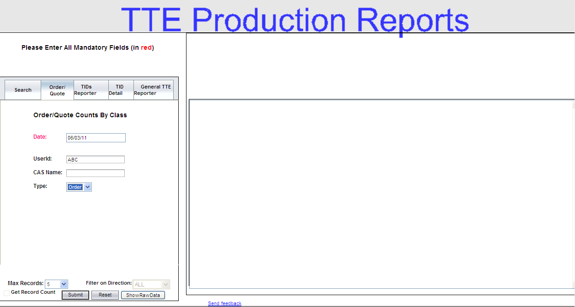
In the Order/Quote tab, all fields in red font are required.
- Enter the date of your query in the Date field. The date format is mm/dd/yy.
- Although the fields are not in red font, you are required to enter a User ID or CAS Name or both.
- From the Type field, choose the category of data you want to display. Quote is the default value.
- The Max Records field allows you to select the number of records you want to display in your query. The default is 10.
- Filter on Direction is predefined to “All” and cannot be changed.
- To clear your data and start a new query, click Reset. The values you entered in the fields will be removed.
- If you are satisfied with your query request, click Submit. The results will display to the right of your window.
 | 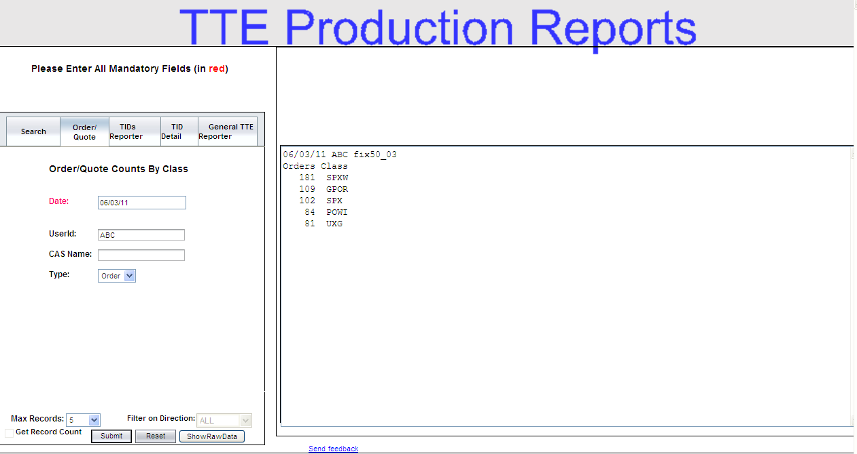
 | The example above shows that on June 03, 2011, user ABC on FIX50 engine 03 had 181 orders for class SPXW, 109 orders for class GPOR, etc.
TIDs Reporter | The TIDs Reporter tab provides a general mechanism for investigating transaction IDs.
 | 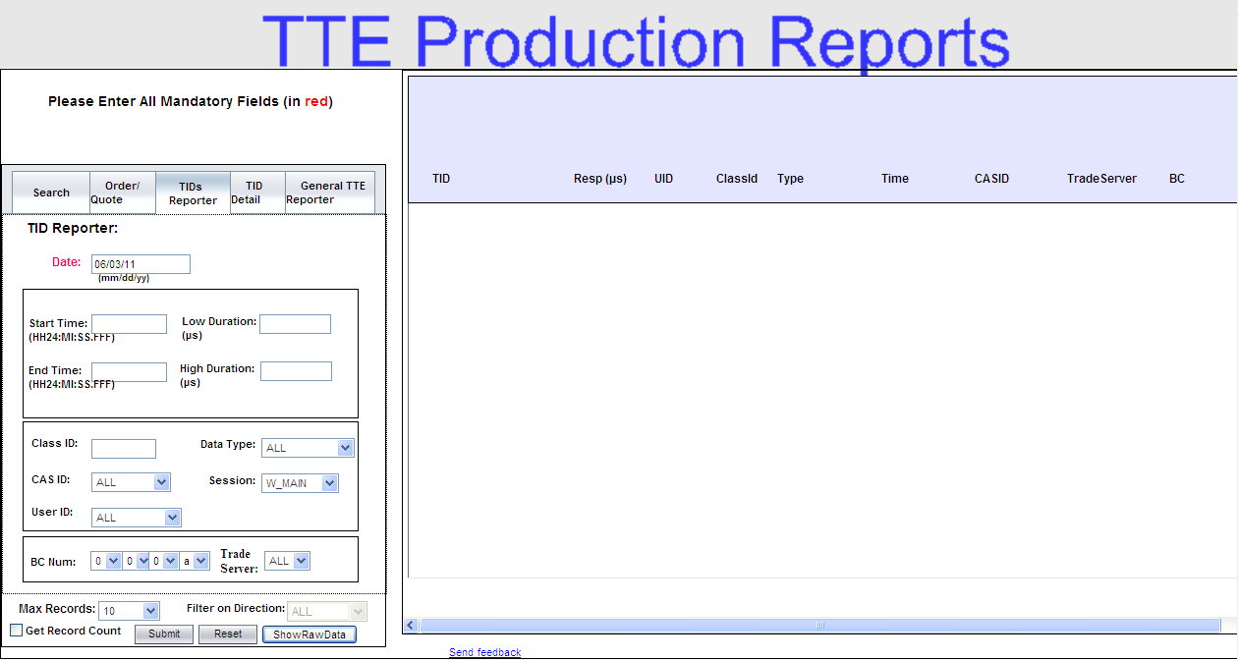
In the TIDs Reporter tab, all fields in red font are required. To perform a TT query:
- In the Date field, enter the date you want to capture in your query. The date format is mm:dd:yy.
- Optional fields include: Start Time, End Time, Low Duration, High Duration, Class ID, Data type, CAS ID, Session and User ID.
 Note: Although the fields above are optional, you must enter a Class ID, CAS ID or User ID to run the query.
- The Max Records field allows you to select the number of records you want to display in your query. The default is 10.
- To clear your entries and begin a new query, click Reset.
- To enter your search request, click Submit. The result of your query will display in the TTE Search Report section of the window.
 | 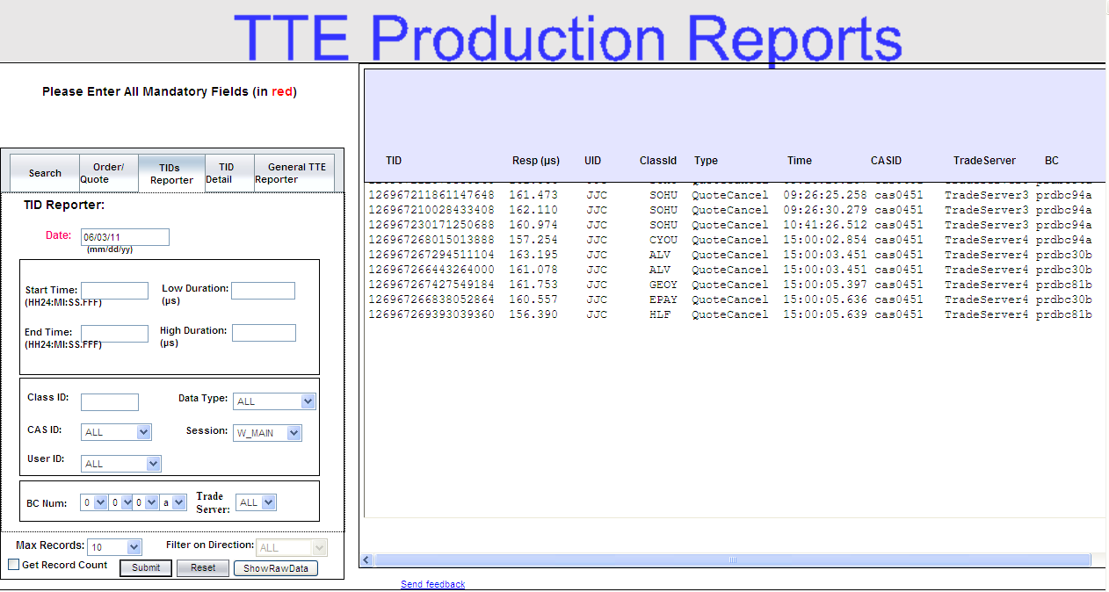
 | The example above shows the list of TIDs on June 03, 2011, for All users. The report generates the following information.
- TID: the transaction ID for the data type (i.e., order, quote, etc.)
- Resp: response time for the TID.
- UID: the user’s acronym.
- ClassID: the class acronym.
- Type: the data type (i.e., order, quote, etc.)
- Time: the time the transaction occurred.
- CASID: the CAS engine identifier.
- FE: the Front-end identifier.
- BC: the Business Cluster identifier.
- Session: the trading session where the order was entered.
 | Use your scroll bar to view additional data fields to the right of the window.
 | To display your search results in raw data, click Show Raw Data.
To display detailed information for a transaction ID, click on the TID data row. A new window will open detailing the method entry and exit timings for that TID.
The report has three tabs with each tab providing a different perspective of the selected TID. The three tabs are: QueryTID Report, QueryTID Time Report and Query CLL Report.
 | QueryTID Report
 | 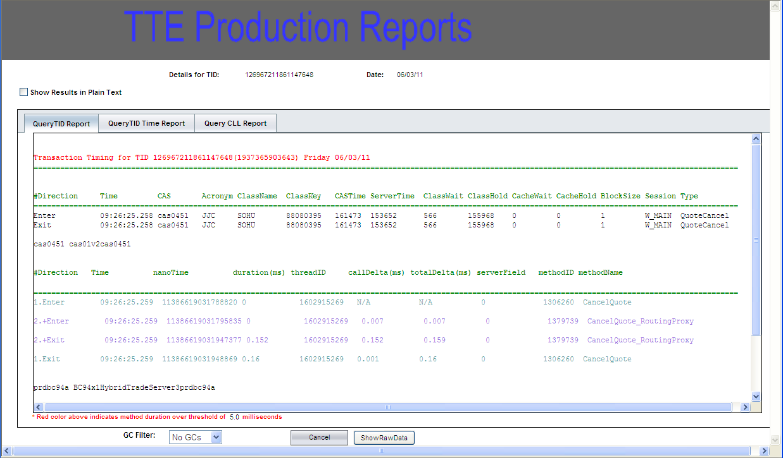
The QueryTID Report tab provides a detailed view of the time the TID has spent within a method and between methods. It also presents the applicable method ids and method names.
This output shows entry and exit into a method and the durations inside these methods. To allow a user to line-up the related entries and exits, by default the entry to the methods are numbered, indented and colorized to match their peer exit.
To turn off these decorations and see a linear list of all exits and entries, select the checkbox. Show Results in Plain Text.
Click Cancel to return to the main reporting page.
 | QueryTID Time Report
 | 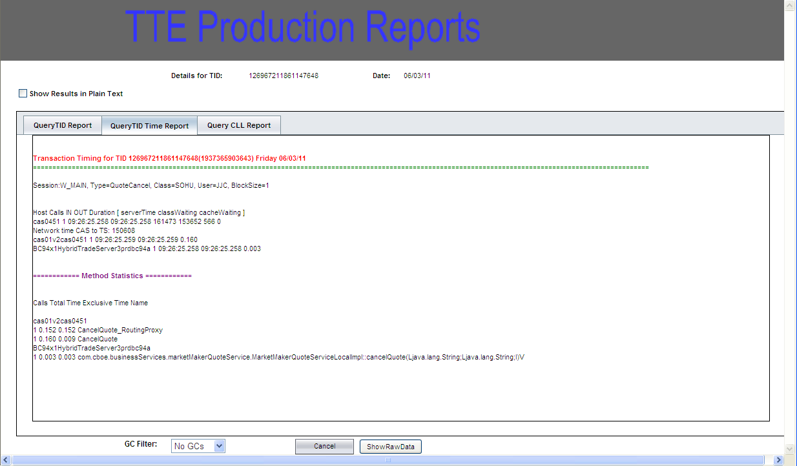
The QueryTID Time Report is a summary of the methods visited by this TID for each Trade Server involved.
Click Cancel to return to the main reporting page.
 | Query CLL Report
 | 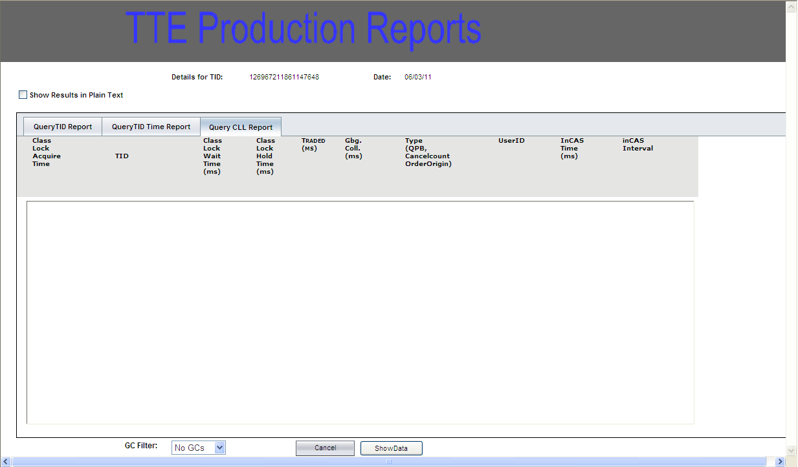
The Query CLL (Class Level Lock) Report is a list of the TIDs associated with the main TID of the report. Clicking on these associated TIDs allows investigation into the different layers of connected TIDs for this TID.
Click Cancel to return to the main reporting page.
TID Detail | The TID Detail tab offers the option of providing a detailed report for any chosen transaction ID.
 | 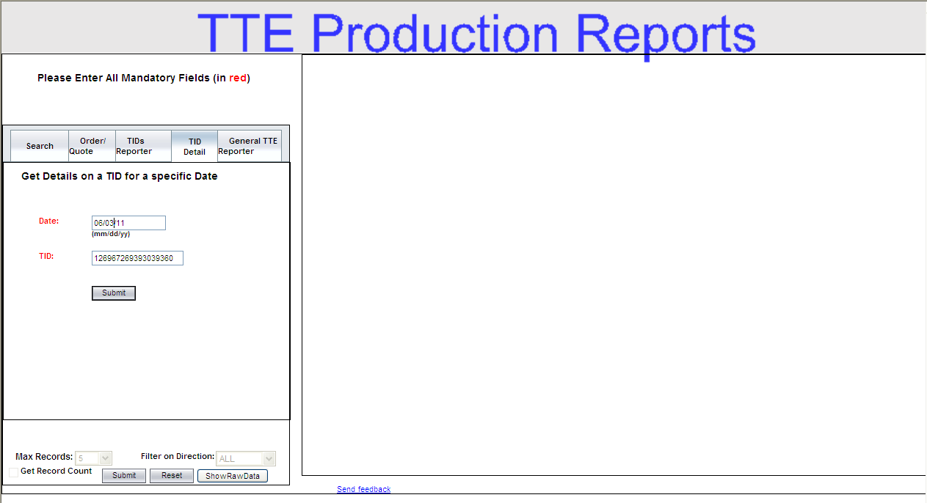
In the TID Detail tab, all fields in red font are required. To perform a TT query:
- Enter the date of the transaction ID in the Date field. The date format is mm:dd:yy.
- Enter the transaction ID in the TID field.
- The Max Records field allows you to select the number of records you want to display in your query. The default is 5.
- To clear your entries and begin a new query, click Reset.
- To enter your search request, click Submit. The results displays three tabs with each tab providing a different perspective of the selected TID. The three tabs are: QueryTID Report, QueryTID Time Report and Query CLL Report.

 | QueryTID Report
 | 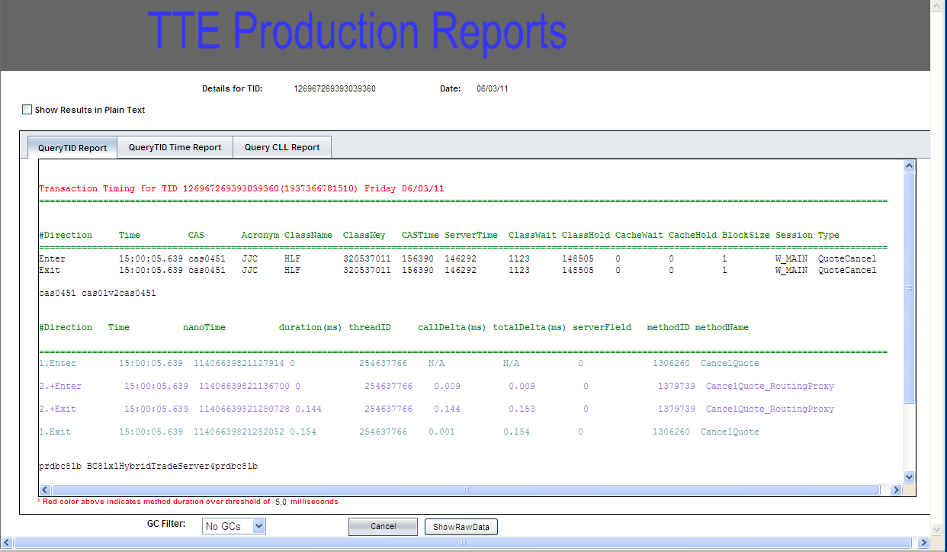
The QueryTID Report tab provides a detailed view of the time the TID has spent within a method and between methods. It also presents the applicable method ids and method names.
This output shows entry and exit into a method and the durations inside these methods. To allow a user to line-up the related entries and exits, by default the entry to the methods are numbered, indented and colorized to match their peer exit.
To turn off these decorations and see a linear list of all exits and entries, select the checkbox. Show Results in Plain Text.
Click Cancel to return to the main reporting page.
 | QueryTID Time Report
 | 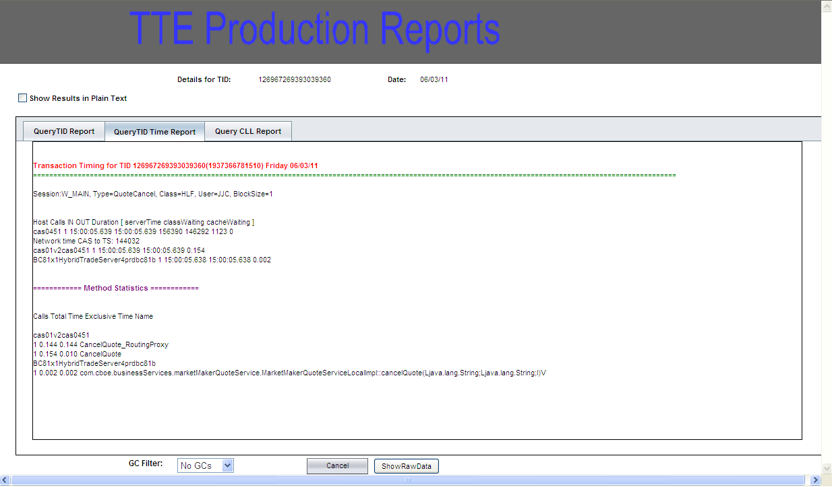
The QueryTID Time Report is a summary of the methods visited by this TID for each Trade Server involved.
Click Cancel to return to the main reporting page.
 | Query CLL Report
 | 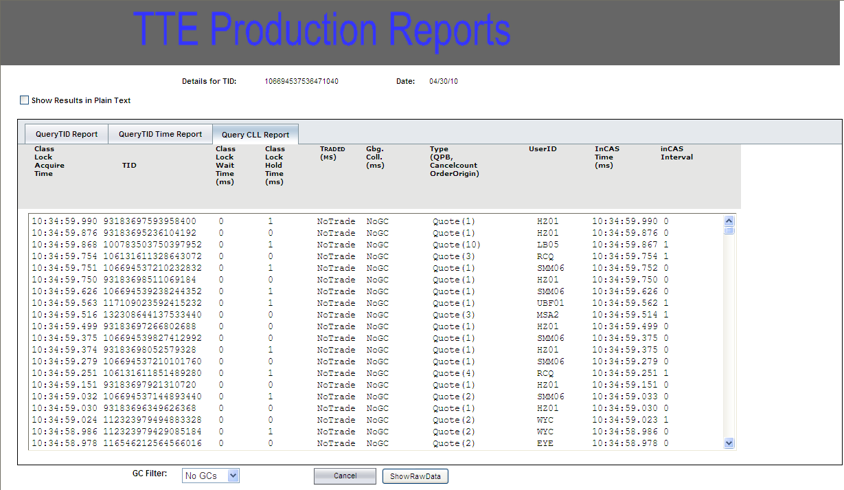
The Query CLL (Class Level Lock) Report is a list of the TIDs associated with the main TID of the report. Clicking on these associated TIDs allows investigation into the different layers of connected TIDs for this TID.
Click Cancel to return to the main reporting page.
General TTE Reporter | The General TTE Reporter section offers a view into the underlying database tables that isn’t available through other means. Most of these allow one to see what is going on in a specific process.
 | 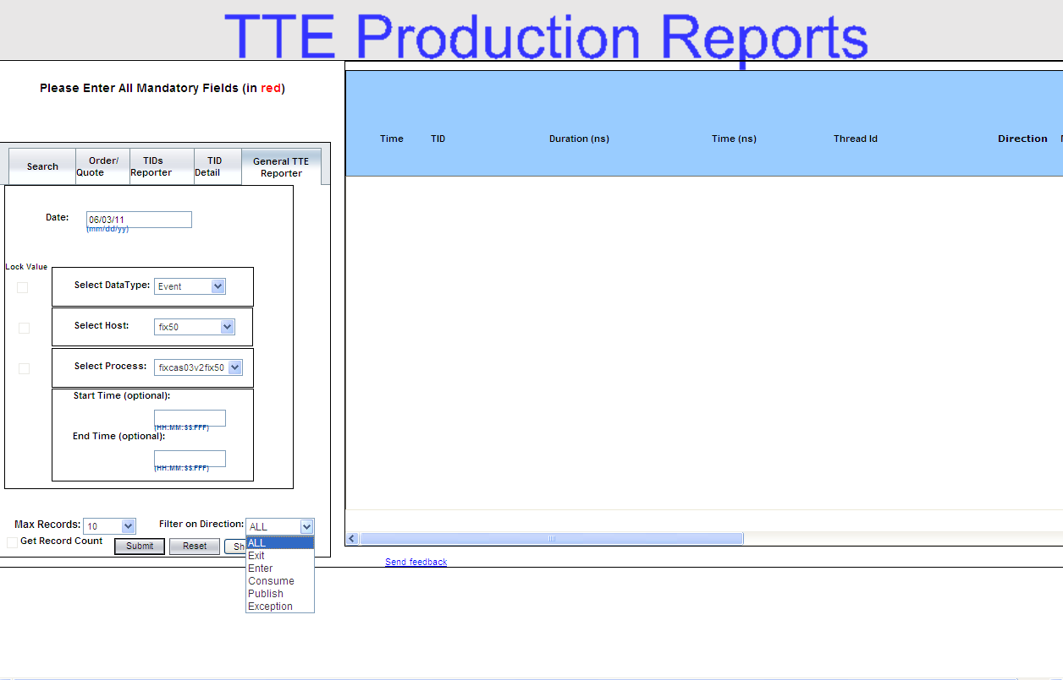
In the General TTE Reporter tab, all fields in red font are required. To perform a TT query:
- In the Date field, enter the date you want to capture in your query. The date format is mm:dd:yy.
- Select the DataType you wish to query. Depending upon the selected DataType, a differing set of outputs is available. The Datatypes and their usage are as follows:
 | 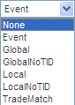
- ‘Global’ and ‘Local’ let one see all synchronous events that have a TID for a process and time period.
- ‘Event’ lets one see all asynchronous events (publish/subscribe events) associated with a process for a time period.
- ‘GlobalNoTID’ and ‘LocalNoTID’ let one see events that do not have a TID for a process and time period. There are no other queries in which these show up.
- The ‘TradeMatch’ query, which shows class, quantity, and session information for trades; as with ‘GlobalNoTID’ and ‘LocalNoTID’, there are no other queries that show the ‘TradeMatch’ data.
- Start Time and End Time are optional fields.
- From the Filter on Direction drop down list, select the path of your query.

- The Max Records field allows you to select the number of records you want to display in your query. The default is 10.
- To clear your entries and begin a new query, click Reset.
- To enter your search request, click Submit. The result of your query will display.
 | 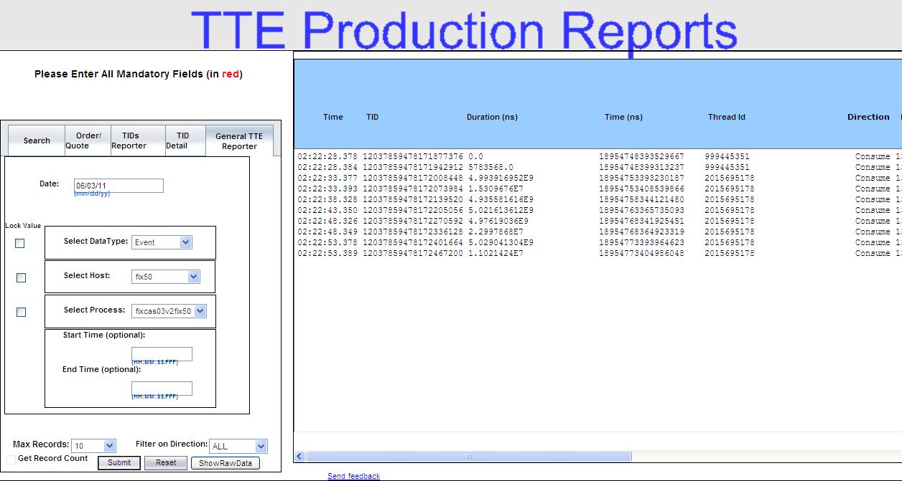
 | Use your scroll bar to view additional data fields to the right of the window.
 | 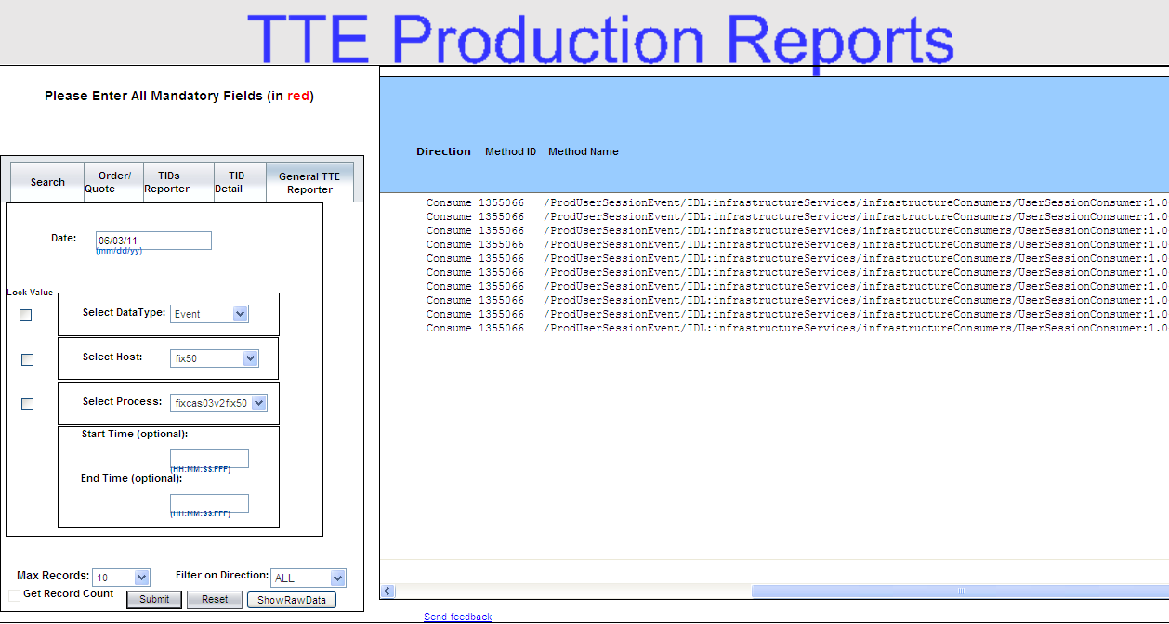
 | The example above shows the event data types that occurred on FIX50 for process fixcas03v2fix50 on June 03, 2011. The report generates the following information.
- Time: the time of the event.
- TID: the transaction ID for the data type (i.e., order, quote, etc.)
- Duration: the length of time for the event in nanoseconds.
- Thread Id: the thread identification.
- Direction: the method path type.
- Method ID: the method identification.
- Method Name: the method name.
 | To display your search results in raw data, click Show Raw Data.
 | To display detailed information for a transaction ID, click on the TID data row. A new window will open detailing the method entry and exit timings for that TID.

Exit the System

Exit the System | To exit the TT Performance tool, click the right button () to close the window. The application will be closed and you will be returned to your system desktop.

Customizing TT Windows

Sizing Windows | Several TT windows are sizable. That is, they can be resized on the screen to make viewing information easier for you.
 | 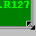 | Place the mouse on any edge of the window until it becomes a two-sided arrow. Hold the left mouse button down and move it to the desired size.
Resizing a window on the corner will expand or contract it in both directions (i.e. up and down and side-to-side). Resizing it on the side or top/bottom will expand or contract the window only in that one direction.
Windows can also be resized using the center glyph in the upper right corner of the window.
 |  | Click the left button () to minimize the window. Click the right button () to close the window. The center button is used for sizing.
If  is displayed, clicking it will increase the window size to a full-screen display.
If  is displayed, clicking it will return the window to its default size.

