


Project: HDE 2
Feature # 3
Navigation Trees

Submitted by:
Kanbay Inc.

Table of Contents
1. assumption 3
2. USER INTERFACE 3
2.1 Changed/Enhanced GUI: 3
3. analsysis & working flow 3
3.1 Analysis: 3
3.2 Flow as Steps: 4
4. idl/service 4
5. classes 4
5.1 New Classes: 4
5.2 Modify/Delete Classes: 5
5.3 Utilized Classes: 5
6. database 5
7. xml 5
8. questions and queries 5
9. Appendix A 6

assumption
- Two new tree navigation panels (Primary Exchange and Post-Station based) will be added to the existing ones.
- Primary Exchange based navigation tree will have three levels. Root → Exchange →Product
- Post-Station (Location) based navigation tree will have four levels. Root → Post →Post.Station → ProductClass
- Primary Exchange based navigation tree will have the first two levels pre-loaded at the time of invocation of maintenance window. The third level will be lazily loaded from the cache.
- Post-Station based navigation tree will have the first three levels pre-loaded at the time of invocation of maintenance window. The fourth level will be lazily loaded.
- At the time of expansion, if there are no children available, the parent node will be changed into a leaf node.
- All the nodes under root will be in sorted order.
- The tree structures wont have anything related to session.

USER INTERFACE
Product State Maintenance window will have the new navigation panels:
- SAGUI: Products > ProductStateMaintenance.
  - Changed/Enhanced GUI:

Control | Description
Single-select tree navigation for Primary Exchange and Post-Station. | Will be using a single-select tree for the navigation of Primary Exchange and Post-Station based product classes.

Action | Description
View > Refresh | Will perform the same. Will reload the navigational tree.

analsysis & working flow
  - Analysis:
Will be using the existing API methods for creating the trees. So no change is required in server side code.
  - Flow as diagram

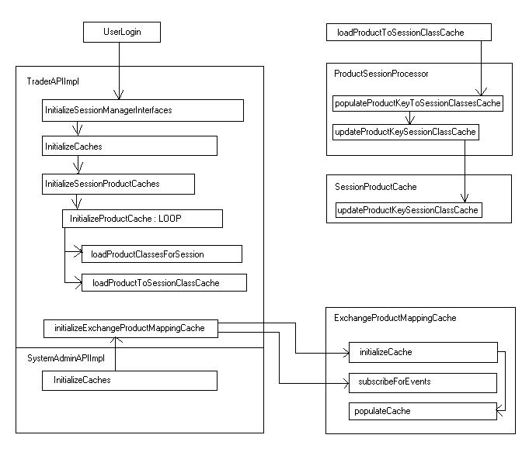
  - Flow as Steps:

When user login to the application,

- The Exchange: Product-Set cache and Product-Key: Session-Class-Set cache gets initialized during login operation following the below mentioned process.
- All exchanges including the undefined exchange will be used for creating the key for the Exchange: Product cache. The key is the exchange name string.
- Then all product types available will be obtained.
- Then all product classes pertaining to the product types will be obtained.
- If the product type is of equity or index, for which the product classes don’t have a valid underlying product, first the product struct array will be obtained using the class key.
- Then the product obtained for the key from each struct will be stored in the set corresponding to the exchange.
- For product classes of other types, the underlying product is first obtained.
- Then the product class corresponding to the underlying product is obtained.
- Then if the underlying product class is having a product of type equity/index inside, the underlying product from which the underlying product class has been obtained, will be added to the set corresponding to the exchange.
- If the underlying product class again is having some product, which is other than of type equity/index, those classes will be collected and resend for further processing.
- Then the product-key: session-class cache will be updated.
- For this, session_class_structs of corresponding to product type and session will be obtained.
- Then the product struct array corresponding to each session class struct will be obtained.
- These session_class_struct and corresponding product_structs will be collected in a map will be send for updating the productKey:sessionClass cache.
- Steps 12 – 14 will be repeated for all sessions and each product types.
- This will ensure that all product classes, which are spanning in multiple sessions, will get collected in the cache.

When "Product State Maintenance" window gets invoked,
- The navigation panels will get created first with tree structures using customized models.
- For primary exchange based tree creation, first get all the exchanges from the cache and create a tree out of it. The customized tree model will take care of this. This way at the time of invocation, two levels of the tree will get created.
- On expanding the second level, the Products for the selected exchange will be obtained from the cache and will be used to create the third level.
- For post-station based tree creation, all posts and stations will be obtained from the server and the tree is created from that. The customized tree model will take care of this. So three levels of the tree will get created at the time of invocation.
- On expanding the third level, the product classes will be obtained from the server corresponding to the station selected. These product classes are used for creating the fourth level.

idl/service
Not Applicable.

classes
  - New Classes:
VOB, Package, Class | Description
GUI > admin  com.cboe.internalPresentation.product .navigation  ProductPrimaryExchangeNavigationPanel extends AbstractProductNavigationPanel | Panel incorporating primary exchange navigation tree. Also includes the concrete implementation of abstract methods in the parent class.
GUI > admin  com.cboe.internalPresentation.product .navigation  ProductPostStationNavigationPanel  extends AbstractProductNavigationPanel | Panel incorporating post-station navigation tree. Also includes the concrete implementation of abstract methods in the parent class.
GUI > admin  com.cboe.internalPresentation.product .models  PrimaryExchangeTreeModel extends AbstractProductNavigationTreeModel | Model for creating the primary exchange based tree representation. Used by the tree in the ProductPrimaryExchangeNavigationPanel. Also includes the concrete implementations of abstract methods in the parent class.
GUI > admin  com.cboe.internalPresentation.product .models  PostStationTreeModel extends AbstractProductNavigationTreeModel | Model for creating the post-station based tree representation. Used by the tree in the ProductPostStationNavigationPanel. Also includes the concrete implementations of abstract methods in the parent class.
GUI > commonBusiness  com.cboe.presentation.renderers  ExchangeTreeCellRenderer | Renderer for rendering the node corresponding to undefined exchange.
Client > translator  com.cboe.presentation.api  ExchangeProductMappingCache | Cache for caching exchange:product_set.

  - Modify/Delete Classes:
VOB, Package, Class | Change Description (why and what in the class is being changed?)
GUI > admin  com.cboe.internalPresentation.product.navigation  ClassProductBrowserPanel | Modified to include the two new navigation panels.
SysAdminClient > sysAdminClient  com.cboe.interfaces.internalPresentation  ProductQueryServiceAPI | Modified to include one more method declaration.
Client > internalTranslator  com.cboe.internalPresentation.api  SystemAdminAPIImpl | Modified to include lookup for newly created caches.
Client > translator  com.cboe.presentation.api  TraderAPIImpl | Modified to initialize and populate the newly created caches.
Client > commontranslator  com.cboe.presentation.api  ProductSessionProcessor | Modified to update the productKey:sessionClass cache.
Client > commontranslator  com.cboe.presentation.api  SessionProductCache | Modified to include the productKey:sessionClass cache.

  - Utilized Classes:
VOB, Package, Class | Description (how class is utilized?)
GUI > admin  com.cboe.internalPresentation.product .navigation  AbstractProductNavigationPanel | Our class extends and makes a concrete implementation of this class.
GUI > admin  com.cboe.internalPresentation.product .models  AbstractProductNavigationTreeModel | Our class extends and makes a concrete implementation of this class.

database
Not Applicable.

xml
Not Applicable.

questions and queries

Appendix A

