


Project: HDE 2
Feature # 6
Non Default Rate Limits report

Submitted by:
Kanbay Inc.

Table of Contents
1. assumption 3
2. user interface 3
2.1 New GUI: 3
2.2 Changed/Enhanced GUI: 3
3. analsysis & working flow 4
3.1 Implementation Approach as Steps: 4
4. idl/service 5
4.1 Utilized IDL: 5
5. classes 5
5.1 New Classes: 5
5.2 Changed Classes: 5
5.3 Utilized Classes: 5
6. database 6
7. xml 6
7.1 New XML: 6
8. questions and queries 6

assumption

- Only non-default Rate limits are displayed on the report per user.
- The report will be generated using JasperReports. Using JasperReport following feature won’t be available.
- Sorting on different columns, which is possible in case of Swing table.

user interface
New menu will be added in the “User Management” screen as “Report → Non-default rate limit report”.
  - New GUI:
Following is the report table. CBOE logo should be added on top.
User | Trading session | Limit Type | Count | Interval
AJX | W_main | Quote rate | 3000 | 3000
AJX | W_main | Quote rate size | 40 | 0
X101 | One_main | Order _call | 102 | 10
X101 | One_main | Quote _call | 102 | 10
X101 | Cfe_main | Quote_call | 103 | 10
… | … | … | … | …

Note: users having default rate limits won’t be displayed.

  - Changed/Enhanced GUI:

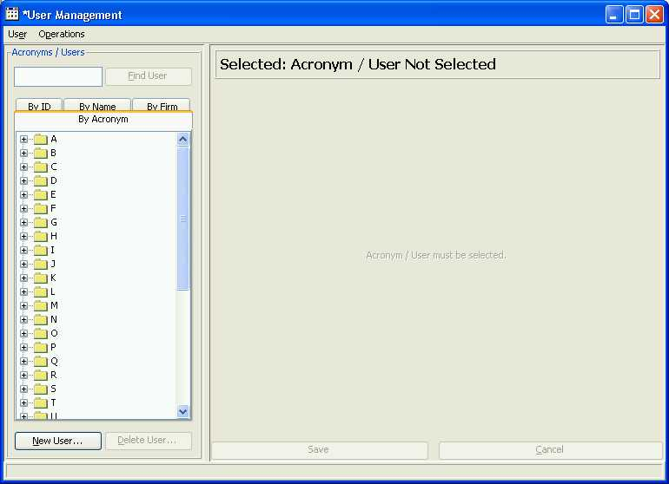
New Menu will be added as,
“Reports > Non-default Rate Limits Report”

Action | Description
On menu selection | New frame will be loaded as shown in the New GUI section.

analsysis & working flow
  - Implementation Approach as Steps:
- PropertyServiceFacadeHome.find().getPropertyGroupsForPartialKey () this method is part of PropertyServiceFacadeImpl. Will be used to retrieve non-default rate limit from server (this internally calls getPropertiesForPartialKey on Property Service). Following parameter will be used:
  - category = "RateLimits"
  - partial Key = "CBOE"
  - partialKeySearchType = 1
- To convert above PropertyServicePropertyGroup to RateLimits we use RateLimitsFactory.createRateLimitsList
- To parse user id from key use BasicPropertyParser
- Collection of Map will be created as List<Map<String, String>> to be used in Jasper Report.
- PrintReport and PrintReportHelper class is used to generate and display report.

idl/service
  - Utilized IDL:
Class/Service
Method Signature
Description (how this method utilized?)
Property Service
public PropertyGroupStruct[] getPropertiesForPartialKey( String category, String propertyKey, short partialPropertyKeyType )
Above service PropertyServiceFacadeImpl calls method internally to fetch all the non-default rate limits.

classes
  - New Classes:
VOB, Package, Class | Description
GUI > Admin  com.cboe.internalPresentation.  userMaintenance.rateLimits.reports  NonDefaultRateLimitsReportAction | Action class to for report menu item. Retrieves and prepares data to be used in report and display reports using PrintReport and PrintReportHelper class.

  - Changed Classes:
VOB, Package, Class | Description (why and for what class is changed?)
GUI > admin  com.cboe.internalPresentation.userMaintenance  UserManagementFrame | New menu item ‘Reports > Non-default Rate Limits’ added in the menu.
GUI > commonBusiness  com.cboe.presentation.alert  PrintReport | New report template name constants for 2 reports are added in the class.

  - Utilized Classes:
VOB, Package, Class | Description (how class is utilized?)
Client > internalTranslator  com.cboe.internalPresentation.propertyService  PropertyServiceFacadeImpl | PropertyServiceFacadeImpl.getPropertyGroupsForPartialKey will be used to retrieve non default rate limit from server (this internally calls  getPropertiesForPartialKey on Property Service)
Domain > Impls  com.cboe.domain.rateMonitor  RateLimitsFactory | To convert above PropertyServicePropertyGroup to RateLimits RateLimitsFactory.createRateLimitsList method is used.
Domain > Interfaces  com.cboe.interfaces.domain.rateMonitor  RateLimits | To hold the rate limit data for user use this class.
Domain > Impls  com.cboe.domain.property  BasicPropertyParser | To parse the user id from the key use this class’s method
GUI > commonBusiness  com.cboe.presentation.alert  PrintReport | Class to load and fill the jasper report and create JasperPrint object.
GUI > commonBusiness  com.cboe.presentation.printing  PrintReportHelper | Class to display report as new window with print functionality.

database
Not Applicable.

xml
  - New XML:
Location  XML File | Description
GUI > commonBusiness  com.cboe.presentation.resource.reports  NonDefaultRateLimitsReportTemplate.xml | JasperReport main template file for report.
GUI > commonBusiness  com.cboe.presentation.resource.reports  NonDefaultRateLimitsSubReportTemplate.xml | JasperReport subreport template file for report.

questions and queries
Q1) Don’t’ know how to use the ‘User Management’ > ‘Group Edit Enablement’ to generate Jasper Report. Please send steps to generate reports.

A1) No, need to edit.
Select the User Acroynm you will see the enablement tab on the right side of a panel.
Select Enablement tab there,
See the pic bellow Copy From and Copy To can show you the reports.
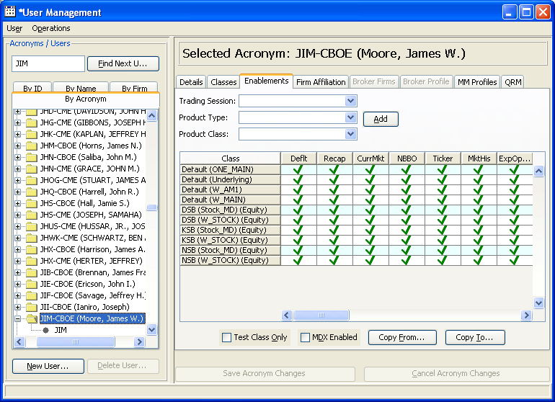

Q2) To edit ‘Rate Limits’ inside ‘User Management’ we required password for ‘Support Mode’. Please check with CBOE and send us the password. Also send steps to generate reports.

A2) The password for Support mode is SUPPORT

Q3) Found JasperReport related classes ‘com.cboe.presentation.alert.PrintReport’ and ‘com.cboe.presentation.printing.PrintReportHelper’ inside ‘GUI > commonBusiness’ used to generate the report. Looked at the code ‘CopyToRateLimitsDialog’ in analysis. Now want to know,
  - Where the Jasper Report definition XML files are stored? Want to see some samples?
  - Where the complied JasperReport objects ‘.jasper’ files are stored in clear case?
  - What are the steps to compile definition XML files and create ‘.jasper’ file? Is there any scripts already written to do the JasperReport compile.
  - Which version of JasperReport is used? Required to create definition file.

A2) Check Mail from Alex, compile is done at the time of build. All Third party tools are in different VOB. \tpt_tools

