


Project: HDE 2
Feature # 7
Order status filter

Submitted by:
Kanbay Inc.

Table of Contents
1. assumption 3
2. user interface Error! Bookmark not defined.
Changed/Enhanced GUI: 4
3. analsysis & working flow 5
Analysis: 5
Flow as Steps: 5
4. idl/service 5
5. classes 5
New Classes: 5
Modify/Delete Classes: 6
Utilized Classes: 6
6. database 6
7. xml 7
8. questions and queries 7
Document control Error! Bookmark not defined.

assumption
- Since this new filters are related to Orders and not Quotes. These filters will be disabled when Quote is selected in filter.
- Contingencies are (as in cmiConstants -> ContingencyTypes) ( check Appendix A):
    - NONE
    - AON
    - FOK
    - IOC
    - OPG
    - MIN
    - NOTHELD
    - WD
    - MIT
    - STP
    - STP_LOSS
    - CLOSE
    - STP_LIMIT
    - AUCTION_RESPONSE
    - INTERMARKET_SWEEP
    - RESERVE
    - MIDPOINT_CROSS
    - CROSS
    - TIED_CROSS
    - AUTOLINK_CROSS
    - AUTOLINK_CROSS_MATCH
- Order Types are (as in cmiConstants -> Sides):
    - UNSPECIFIED
    - BUY
    - SELL
    - BID
    - ASK
    - AS_DEFINED
    - OPPOSITE
    - SELL_SHOR
    - SELL_SHORT_EXEMPT
    - BUY_MINUS
    - SELL_PLUS

USER INTERFACE
There are two places require adding new order filters:
- Trader GUI: Order Status feature
- SAGUI: User Management > Order tab. Changes are similar to Order Status.

The frame needed to be made a little wider to incorporate two new filter criteria (Contingency & Order type).
  - Changed/Enhanced GUI:
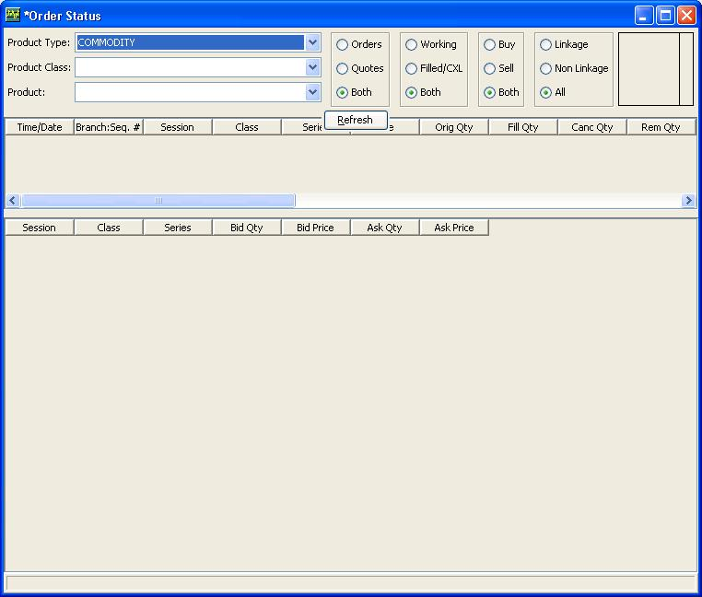
Refresh button moved to center
Two new filters are added here.
This filter will be removed
Control | Description
Multi-select List for Contingency | Since there are 21 options for contingency hence planning to use multi-select list option. Also ‘ALL’ option will be added.  Trader GUI: When ‘Quote’ filter is selected ‘Contingency’ filter criteria will be disabled.
Multi-select List for  Order Type | Will be using a multi-select list box containing all the order-types. Also ‘ALL’ will also be there.

Action | Description
Refresh | Will perform same. Will take care filter based on new criteria also.
… | …
… | …

analsysis & working flow
  - Analysis:
Filtering of orders takes place in GUI layer, hence no changes required in server code.
  - Flow as Steps:
When "Refresh" button gets invoked,
- The filter criteria selected will be stored for filtering the orders retrieved from the server.
- Then orders will be retrieved from the server based on the selected Product Type, Product Class and Products. No filter will be applied while retrieving the orders from the server.
- Once orders are received, based on the filter values selected, the results (orders) will be filtered out by table model class.
- The filtered results will be displayed in the table.

idl/service
Not Applicable.

classes
  - New Classes:
VOB, Package, Class | Description
GUI > commonBusiness  com.cboe.presentation.orderStatus  ContingencyListFilterPanel | The panel, which is having the list of contingencies that will be used as filter. The list is populated as following;  list.add(new Contingency (ContingencyTypes.toString(ContingencyTypes.AON), ContingencyTypes.toString(ContingencyTypes.AON), ContingencyTypes.AON));  Am using a temporay wrapper (ContingencyWrapper) for the time being which will be replaced by the Contingency class once it is moved to a common location.
GUI > commonBusiness  com.cboe.presentation.filters  ContingencyFilterCriteria extends CBOETableFilterCriteria | Filtering criteria for filtering the orders fetched from the server. This will be applied to the corresponding row filter. And the table model for filtering the display values of the table will use this row filter. This class is exactly like OrderTypeFilterCriteria and can be replaced by a common criteria class. But if at later if somebody wants to modify the behavior for one then have to implement carefully.
GUI > commonBusiness  com.cboe.presentation.orderStatus  OrderTypeListFilterPanel | The panel that is having the list of order types (sides) to be used as filter. The data for filter will be obtained similar to this.  public static final Character BUY = new Character(Sides.BUY);
GUI > commonBusiness  com.cboe.presentation.filters  OrderTypeFilterCriteria extends CBOETableFilterCriteria | Filtering criteria for filtering the orders fetched from the server. This will be applied to the corresponding row filter. And the table model for filtering the display values of the table will use this row filter. This class is exactly like ContingencyTypeFilterCriteria and can be replaced by a common criteria class. But if at later if somebody wants to modify the behavior for one then have to implement carefully.

  - Modify/Delete Classes:
VOB, Package, Class | Change Description (why and what in the class is being changed?)
GUI > commonBusiness  com.cboe.presentation.orderStatus  OrderStatusSelectionFilterPanel | Modified to include the two new filter panels.
GUI > commonBusiness  com.cboe.presentation.orderStatus  OrderStatusSelection | Modified to set our newly created filter criteria to a table row filter.
GUI > trader  com.cboe.presentation.commonBusiness  Contingency | Needed moving this class from trader specific package to common package, since both Trader GUI and SAGUI will share this class.
GUI > trader  com.cboe.presentation.orderQuote  MMOrderEntryPanel | Imports will get changed when Contingency is moved.
GUI > trader  com.cboe.presentation.commonBusiness  ContingencyPanel | Imports will get changed when Contingency is moved.
GUI > commonBusiness  com.cboe.presentation.orderStatus  OrderStatusSelectionPanel | Modified to rearrange the refresh button.

  - Utilized Classes:
VOB, Package, Class | Description (how class is utilized?)
GUI > trader  com.cboe.presentation.orderStatus MMOrderStatusOrderTableModel | Utilized class’s filtering functionality, which this class obtains from the CBOETableModel, in background. It is in this class, the server calls are being made and the orders are retrieved from the server. Then that resultset will be filtered based on the criteria entered and will be displayed in the table.

database
Not Applicable.

xml
Not Applicable.

questions and queries
Q1) What are the different Order-Types we needed to add in the filter? [Anish: 26 Mar 07]

A1) Use all the Sides mentioned in cmiConstants [Amit: 26 Mar 07]

Q2) Should we increase the size of the frame for placing extra filters or should we try and rearrange to include the filters without a change in the outer dimension? [Anish: 26 Mar 07]

A2) Adjust the width of the dropdowns based on width of the widest value inside. Remove the existing buy-sell filter. Center the refresh button as shown in the screen shot. [Amit: 26 Mar 07]

Q3) While analysis we’ve found some more type of contingencies (SWEEP, RESERVE, CROSS, MIDPOINT_CROSS, AUTOLINK_CROSS, AUTOLINK_CROSS_MATCH, TIED_CROSS). Should we need to support these contingencies? Presently we took those that are being used at the time of order creation. [Anish: 26 Mar 07]

A3) Use all contingencies mentioned in cmiConstants. [Amit: 26 Mar 07]

Q4) If we are going to use all the contingencies mentioned in the cmiConstants, how we can create orders with those contingencies which are not available in the drop down at the time of order creation? This is needed for testing. Not on high priority. [Anish: 27 Mar 07]

A4) [Design mtg 27th March] Need to check with latest code some of them may not be represent in the combo Box

Q5) Can we move the “Contingency” class from its current location to commonBusiness. Presently this is inside ‘trader’ package. But from now on this will be common for TRADER GUI as well as SAGUI. If this is fine we can reuse this class. [Anish: 27 Mar 07]

A5) [Design mtg 27th March] Yes, Joel to respond on this

Q6) While analyzing Order-Types (sides) it is found that the value for BID and BUY are same in cmiConstants. Is this intentional? If yes how to distinguish between the two? [Anish: 27 Mar 07]

A6) [Design mtg 27th March] Yes, they are same

Q7) How can we create orders having various Order-Types? [Anish: 27 Mar 07]

A7) [Design mtg 27th March] Ask david

Q8) Is it okay to disable the filters when quotes is selected? Now though the existing filters are not functional in the case of quotes, it is enabled.
A8) [Design mtg 27th March] Bottom table is only Quotes. No Need

Q9) Is Linkage-NonLinkage filter related with Contingency or Contingency Types? [Design Meeting: 27 Mar 07]

A9) Cannot find any relation with Contingency. It seems this has some thing to do with Origin, which is mentioned in cmiConstants as OrderOrigins. It is based on “series” column in result table the filter is getting applied.[Anish: 28 Mar 07]
[Amit] Check mail from Alex
[Alex – Email – 28 Mar 2007] Yes. The Linkage filter in the Order Status should stay as is. It is not based on contingencies. It is based on the origin type.

Q10) Can we reuse existing “ComboBox Model” for Contingency for building the contingency filter? [Design Meeting- Alex: 27 Mar 07]

A10) We are not reusing it for mainly two reasons. (1)The ComboBox model don’t have the complete data that needed to be used in contingency filter. (2) We need a multi-select list and this model is meant to be used in a drop-down. [Anish: 28 Mar 07]
[Amit] This is Fine

Q11) Even after rearranging the refresh button to middle, SAGUI don’t have enough space to show the new filters. A small portion of data is not seen in the dropdown unless it is not expanded a bit. [Anish: 29 Mar 07]

A11) Move the refresh button under the drop-downs. Then try with different resolutions. [Amit: 30 Mar 07]

Q12) Whenever I select sessions W_STOCK or STOCK_MD, am getting Authorization exception. What should I do? [Anish: 30 Mar 07]

Q13) Where can I find Broker.xml mentioned in the document sent for creating various types of Orders with contingencies like TIED_CROSS etc? [Anish: 30 Mar 07]

Q14) When I tried to create the TIED_CROSS order (for BT future) as mentioned in the document, it is giving me the error in status bar as “invalid contingency type (19) for single stock future order”. Similar error for other cross based contingencies. Is this because of probable invalid configurations in Broker.xml or is it only valid for some particular type of products like “Strategy”? [Anish: 09 Apr 07]

Q15) How can I check with different resolutions? I cannot change the screen resolution of remote machine in which the software runs. [Anish: 09 Apr 07]

Q16) Do we need to have borders extended to have a consistent look or do we need borders for the size of the filter? Presently we are having extended borders. [Anish: 10 Apr 07]

Appendix A
Contingencies:
- NONE
- AON → (ALL session) All or None
- FOK → (ALL session) Fill or Kill
- IOC → (ALL session) Immediate or cancel
- OPG → (STOCK) Pre open state and trade at opening price
- MIN
- NOTHELD
- WD
- MIT → Market If Touched
- STP → (Hybrid) Stop order at specific price, activate after market reaches at that price – Take me out
- STP_LOSS
- CLOSE → Market on Close
- STP_LIMIT → (Hybrid) Stop Limit not MKT price – make me IN
- AUCTION_RESPONSE → (Hybrid)
- INTERMARKET_SWEEP (STOCK) → Same as SWEEP → SWEEPS the book
- RESERVE → (STOCK) Specify qty → e.g. Sell 100 at time
- MIDPOINT_CROSS → Order in pairs
- CROSS → (STOCK)
- TIED_CROSS → (STOCK)
- AUTOLINK_CROSS → (STOCK)
- AUTOLINK_CROSS_MATCH → (STOCK)
Order Types:
- UNSPECIFIED
- BUY
- SELL
- BID
- ASK
- AS_DEFINED
- OPPOSITE
- SELL_SHOR → (STOCK)
- SELL_SHORT_EXEMPT → (STOCK)
- BUY_MINUS
- SELL_PLUS

Misc
2 ways to enter the orders
    - Separately: buy & sell come at different times (paired cross). Use Order Entry Window
    - Together buy & sell come together (Tied cross). Use Execute → Cross Window.
Contingencies in Stock
All Orders Qty > 100

