

Report For NonDefault RateLimits
User’s Guide
Version 1.0

Disclaimer

Copyright © 2006 Chicago Board Options Exchange. All rights reserved.
The information contained in this document constitutes confidential and/or trade secret information belonging to CBOE. This document is made available to CBOE members and member firms for use with CBOEdirect™. This document is provided "As Is" with all faults and without warranty of any kind, either expressed or implied.

Change Notices

The following change notices are provided to assist users of the SA-CBOEdirect System Administrator help-desk system in determining the impact of changes to their process.
If you have any questions or review comments about this document, please contact Odalys Castro at (312) 786-8817.

Date | Version | Description of Change
05/23/07 | 1.0 | New document.

Table of Contents
Table of Contents 3
Introduction 4
Purpose 4
Intended Audience 4
Conventions Used in this Guide 4
Help Desk Enhancements 5
Getting Started 6
Login 6

User Management……………………………………………………………………………..7
Report for Non Default Rate Limits………………………………………………………………………………7
Exit the System 13
Exit the System 13

Introduction

Purpose | This document was written to assist users in utilizing the feature of generating the report for non-default rate limits of the SA-CBOEdirect System Administrator screen-based trading system.
Intended Audience | This user guide is intended for any person interested in SA-CBOEdirect System Administrator’s User Management’s Report Feature.
Conventions  Used in this Guide | The system was designed so that you can use the feature as a standalone application.  There are several conventions used throughout this guide to help trigger important information:
 | Bolding | Used to highlight menu selections (e.g., Login) and button names (e.g., Update)
 | Brackets [ ] | Used to highlight keyboard commands (e.g., [Alt]-[T]). Note that when [Alt] or [Ctrl] are used in conjunction with another key, hold down the first key while pressing the second.  Some button functions can be executed through keyboard commands. Hold down the [Alt] key and press the keyboard character of the underlined letter in the command. For example:  [Alt]-[R] Restores an active window

 | Help Desk Enhancements

This user’s guide will direct us how to generate Report for all the user who have NonDefault rate limits in SA-CBOEdirect System Administrator.

Getting Started

 | Login to SA-CBOEDirect System Administrator.
 | 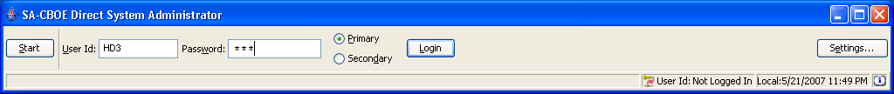
Login | Enter your User ID and Password. Both User ID and Password are case sensitive. Select your login as Primary by clicking the appropriate radio button.  Click Settings, to change your login mode. The Session Settings window will display.
 | 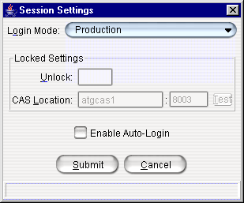
Select your Login Mode setting from the drop down list, click Submit, Confirm. If you decide you do not wish to change your login mode, click Cancel. The system will return to the menu window. Click Login.
To change your CAS location, enter your password in the Unlock field and enter the new CAS location. Click Test to check your setting. Click Submit. If you decide you do not wish to change your login mode, click Cancel. The system will return to the menu window.
Click Login. The SA-CBOEDirect System Administrator window will display.
 | 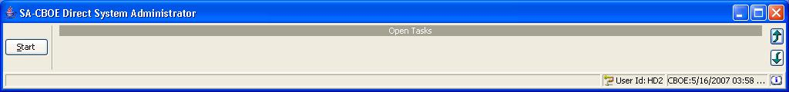
 | You are now ready to go to the User Management Window
 | Select Start → User→ User Management → Create New Window
 | 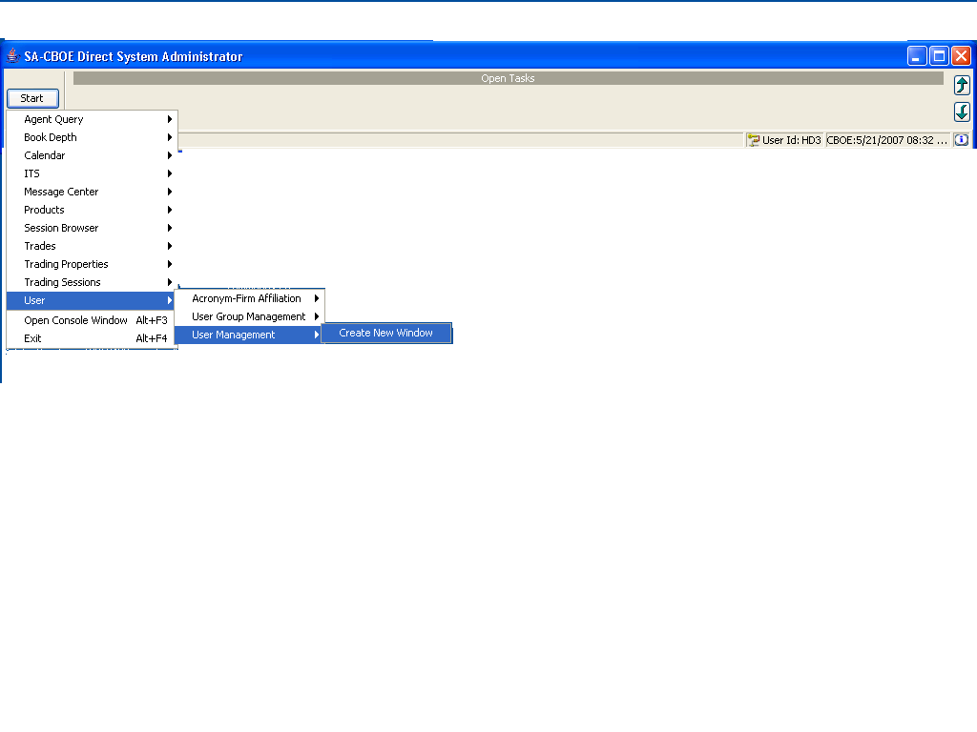

User Management Window

 | The user management window allows us to generate a report for all users who have non-default rate limits. There is one menu i.e Report which is used to generate a report.
Report  Menu | To generate the report select the Report Menu, then select the menuitem Non Default Rate Limit Report.Alternatively you can use [Ctrl]+[N].
 | 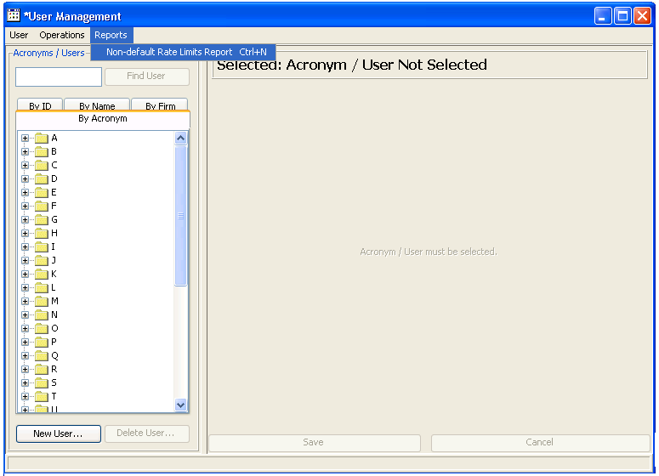
 | - It will genetrate the report for all the user who have Non Default Rate Limits.
 | 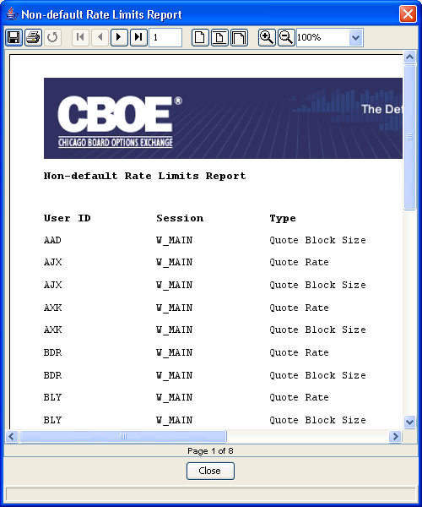

Exit the System

 | You can log out and exit the system at any time.
Exit the System | To exit the system, select Exit from the Start Menu. You will be prompted to verify that you wish to close all windows and logout. Click Yes. The application will be closed and you will be returned to your system desktop.

