

Order Status
User’s Guide
Version 1.0

Disclaimer

Copyright © 2006 Chicago Board Options Exchange. All rights reserved.
The information contained in this document constitutes confidential and/or trade secret information belonging to CBOE. This document is made available to CBOE members and member firms for use with CBOEdirect™. This document is provided "As Is" with all faults and without warranty of any kind, either expressed or implied.

Change Notices

The following change notices are provided to assist users of the SA-CBOEdirect System Administrator help-desk system in determining the impact of changes to their process.
If you have any questions or review comments about this document, please contact Odalys Castro at (312) 786-8817.

Date | Version | Description of Change
05/23/07 | 1.0 | New document.

Table of Contents
Table of Contents 3
Introduction 4
Purpose 4
Intended Audience 4
Conventions Used in this Guide 4
Help Desk Enhancements 5
Getting Started 6
Login 6

Order Status………………….…………………………………………………………………………………….7 Order Status Filter…………………………………………………………………………………………………...7
Exit the System 13
Exit the System 13

Introduction

Purpose | This document was written to assist users in utilizing the Order Status features of the CBOE direct system. This document will help the user in the filtering of the order.
Intended Audience | This user guide is intended for any person interested in CBOEdirect System’s order status function.
Conventions  Used in this Guide | The system was designed so that you can use the feature as a standalone application.  There are several conventions used throughout this guide to help trigger important information:
 | Bolding | Used to highlight menu selections (e.g., Login) and button names (e.g., Update)
 | Brackets [ ] | Used to highlight keyboard commands (e.g., [Alt]-[T]). Note that when [Alt] or [Ctrl] are used in conjunction with another key, hold down the first key while pressing the second.  Some button functions can be executed through keyboard commands. Hold down the [Alt] key and press the keyboard character of the underlined letter in the command. For example:  [Alt]-[R] Restores an active window

 | Help Desk Enhancements

This user’s guide will help in filtering the order. The order status feature gives us the functionality of filtering the order based upon different criteria.

Getting Started

 | Login to CBOEDirect.
 | 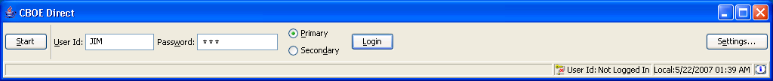
Login | Enter your User ID and Password. Both User ID and Password are case sensitive. Select your login as Primary by clicking the appropriate radio button.  Click Settings, to change your login mode. The Session Settings window will display.
 | 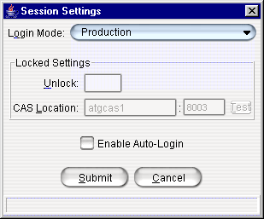
Select your Login Mode setting from the drop down list, click Submit, Confirm. If you decide you do not wish to change your login mode, click Cancel. The system will return to the menu window. Click Login.
To change your CAS location, enter your password in the Unlock field and enter the new CAS location. Click Test to check your setting. Click Submit. If you decide you do not wish to change your login mode, click Cancel. The system will return to the menu window.
Click Login. CBOE Direct window will display.
 | You are now ready to go to the Order Status Window.
 | Select Start → Order Status → Create New Window
 | 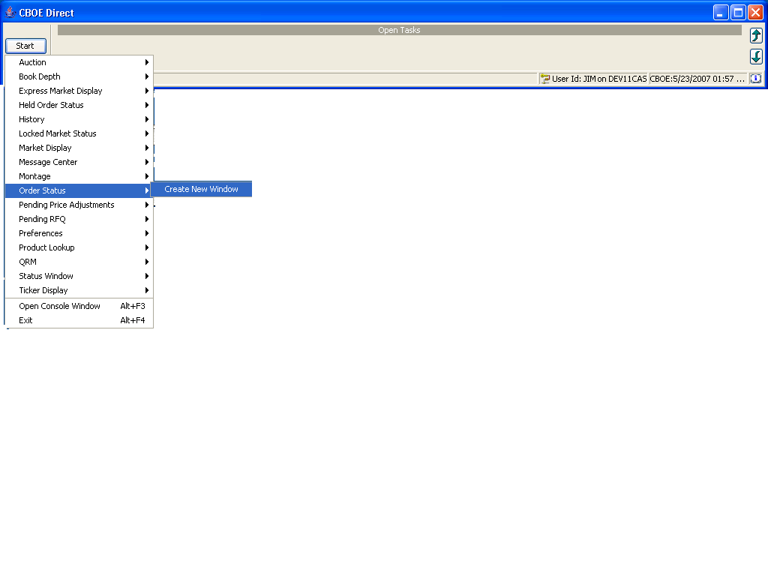

Order Status

The order status feature is used for filtering the order. Filtering is based upon the
Product type, product class, product and contingencies. These all are the different criteria
Which we can use to filter our order.

 |  | 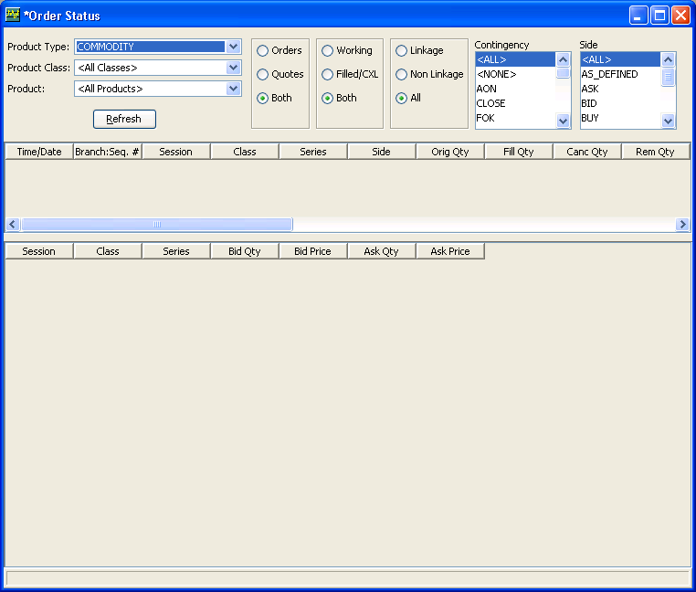
Select Product Type |  | Select product type from product type combo box. Will find that corresponding product  Class get appear in product class combo box.
 |  | 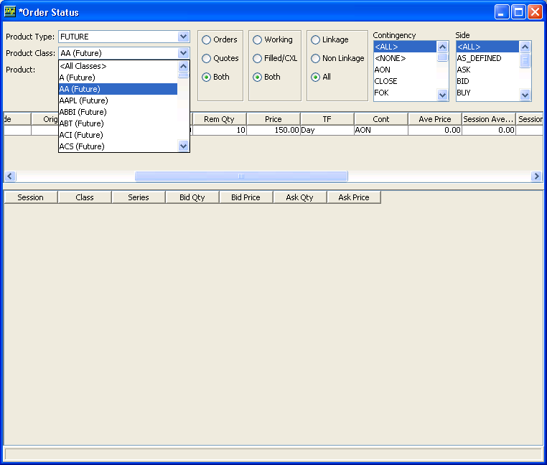
Select product class |  | Select any product class, will find that corresponding products get appear in product  Combo box.
 |  | 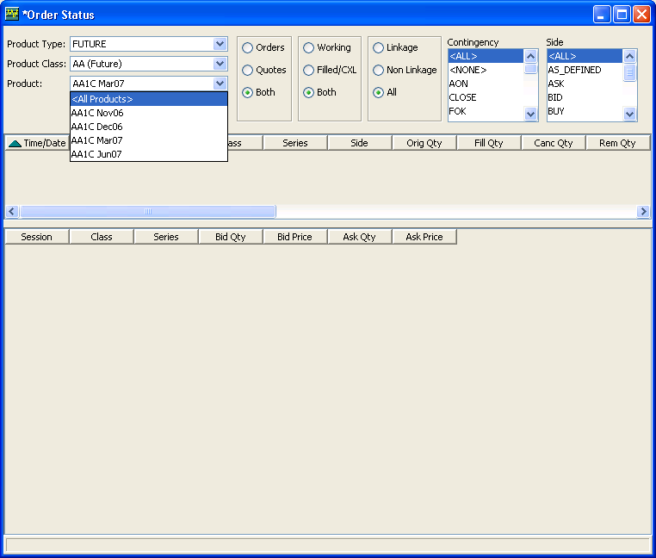
Select Product |  | Select any product from product combo box. Four filters are there, default value for  First and second filter is Both and for third and fourth filter that is Contingency and Side  Multi select list box is ALL.First Hit on Refresh Button with default values of filter. And  see the result.All the orders corresponding to that series get appear.
 |  | 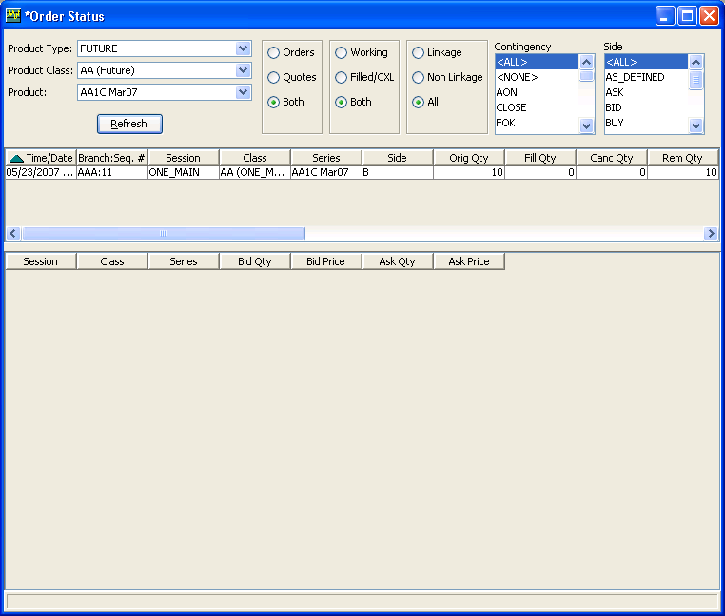
Select order, Quote or Both. (Check for each combination).
Select working filled/CXL or Both (check for each combination).
Select Linkage, Non linkage or Both (check for each combination).
Select any Contingency type.
Select one option from side.
Click on refresh button
 |  | 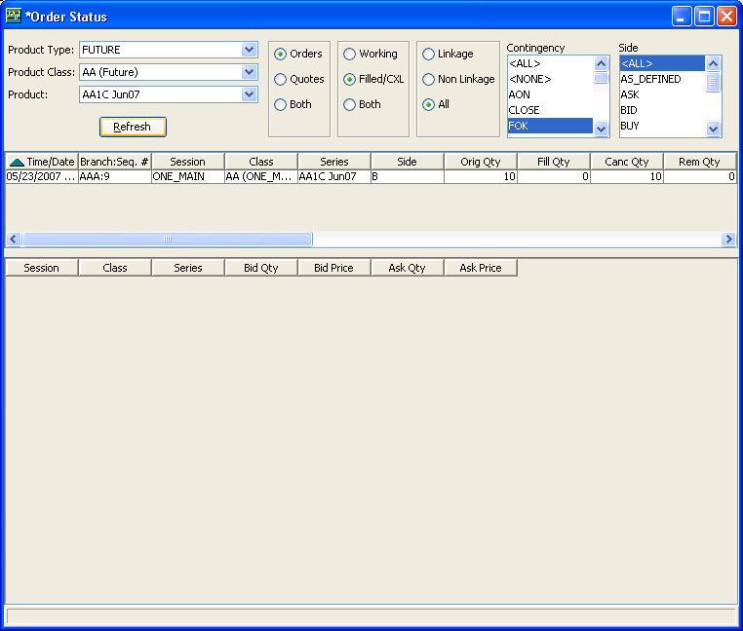
 |  | 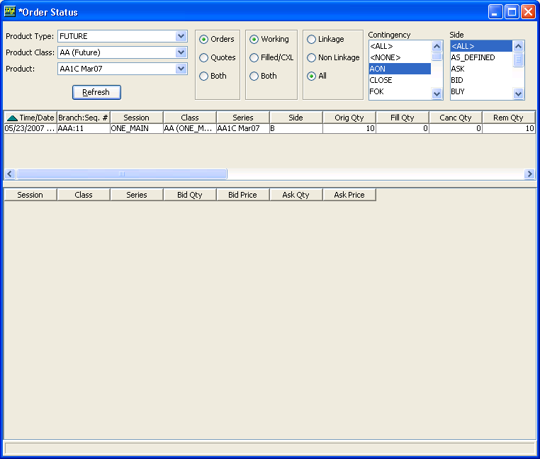
 | Exit the System

 | You can log out and exit the system at any time.
Exit the System | To exit the system, select Exit from the start Menu. You will be prompted to verify that you wish to close all windows and logout. Click Yes. The application will be closed and you will be returned to your system desktop.

