

Product State Maintenance
User’s Guide
Version 1.0

Disclaimer

Copyright © 2006 Chicago Board Options Exchange. All rights reserved.
The information contained in this document constitutes confidential and/or trade secret information belonging to CBOE. This document is made available to CBOE members and member firms for use with CBOEdirect™. This document is provided "As Is" with all faults and without warranty of any kind, either expressed or implied.

Change Notices

The following change notices are provided to assist users of the SA-CBOEdirect System Administrator help-desk system in determining the impact of changes to their process.
If you have any questions or review comments about this document, please contact Odalys Castro at (312) 786-8817.

Date | Version | Description of Change
8/18/06 | 1.0 | New document.

Table of Contents
Table of Contents 3
Introduction 4
Purpose 4
Intended Audience 4
Conventions Used in this Guide 4
Help Desk Enhancements 5
Getting Started 6
Login 6
Product State Maintenance 7
State Change Operations 7
Exit the System 13
Exit the System 13

Introduction

Purpose | This document was written to assist users in utilizing the Product State Maintenance features of the SA-CBOEdirect System Administrator screen-based trading system. The Product State Maintenance feature has got four options for changing the state. This document explains two of those features.
Intended Audience | This user guide is intended for any person interested in SA-CBOEdirect System Administrator's ProductState Maintenance functions.
Conventions  Used in this Guide | The system was designed so that you can use the feature as a standalone application.  There are several conventions used throughout this guide to help trigger important information:
 | Bolding | Used to highlight menu selections (e.g., Login) and button names (e.g., Update)
 | Brackets [ ] | Used to highlight keyboard commands (e.g., [Alt]-[T]). Note that when [Alt] or [Ctrl] are used in conjunction with another key, hold down the first key while pressing the second.  Some button functions can be executed through keyboard commands. Hold down the [Alt] key and press the keyboard character of the underlined letter in the command. For example:  [Alt]-[R] Restores an active window

 | Help Desk Enhancements

This user’s guide will direct you through two of the Product State Maintenance functions for SA-CBOEdirect System Administrator.

Getting Started

 | Login to SA-CBOEDirect System Administrator.
 | 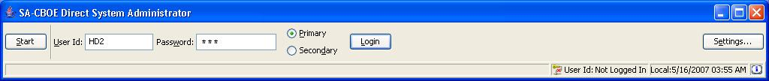
Login | Enter your User ID and Password. Both User ID and Password are case sensitive. Select your login as Primary by clicking the appropriate radio button.  Click Settings, to change your login mode. The Session Settings window will display.
 | 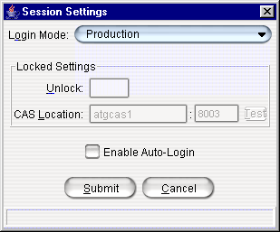
Select your Login Mode setting from the drop down list, click Submit, Confirm. If you decide you do not wish to change your login mode, click Cancel. The system will return to the menu window. Click Login.
To change your CAS location, enter your password in the Unlock field and enter the new CAS location. Click Test to check your setting. Click Submit. If you decide you do not wish to change your login mode, click Cancel. The system will return to the menu window.
Click Login. The SA-CBOEDirect System Administrator window will display.
 | 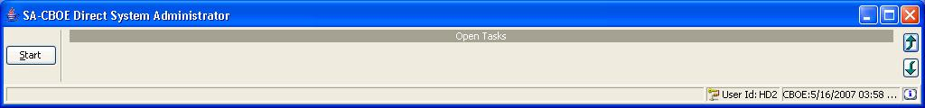
 | You are now ready to go to the ProductState Maintenance window.
 | Select Start → Products → Product State Maintenance → Create New Window

Product State Maintenance

 | The Product State Maintenance allows you to modify the state of various products. Presently you can change the state of a product based on four criteria. They are “By Session”,”By Group”, “By Primary Exchange” and “By Post Station”. This document explains operations based on “By Primary Exchange” and “By Post Station”.
State Change Operations | To begin changing the state of Product Classes you must first select the tab you wish to use. Select By Primary Exchange or By Post Station tab.
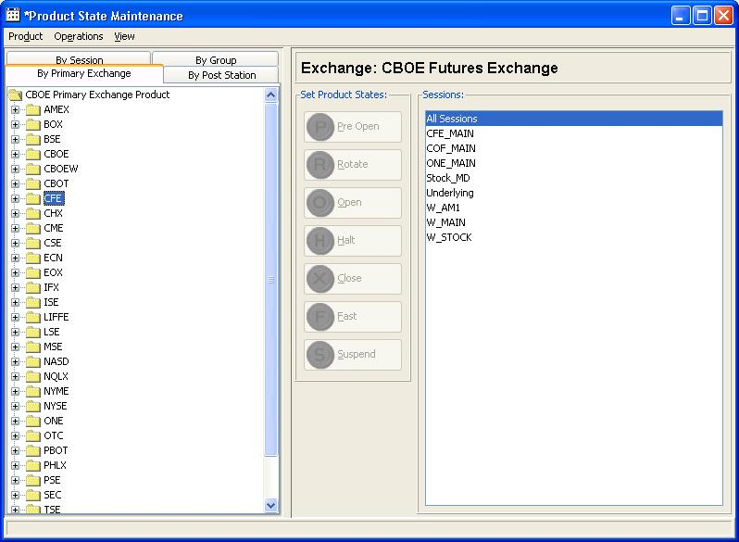
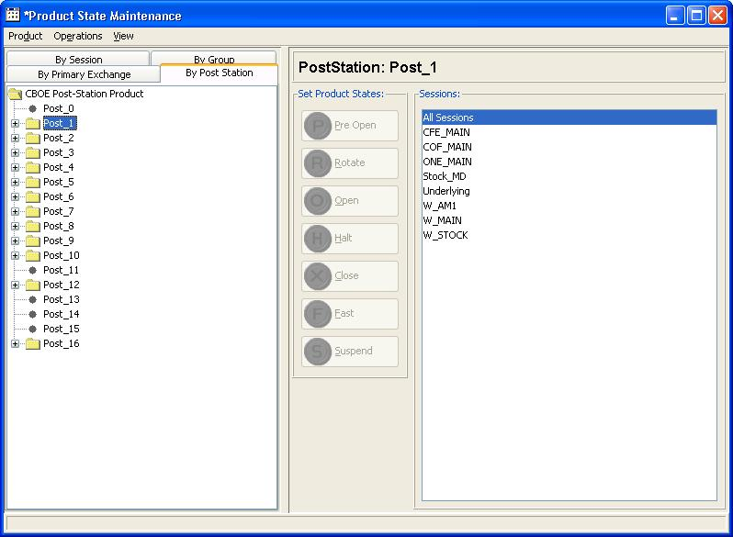
 | - Enable the “support mode” for enabling the change operation controls.
 | For this click on Operations → Support Mode in the Product State Maintenance window. Alternately you can use [Ctrl]+[Shift]+[S] shortcut key.
 | 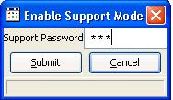
- Enter the password, click on Submit.
- This changes the button to Confirm. Click on Confirm for confirming the operation. This enables the support mode if you enter a valid password.
- If you don’t wish to enable support mode, hit cancel.
- If you wish to disable the support mode after enabling the support mode, simply hit the shortcut or select the menu.
- Select any node in the tree navigation present on the left side of the product state maintenance window.
In the case of PrimaryExchange, the tree will have all exchanges listed. Expanding the exchange node will display all underlying products registered under that exchange. If no product is registered under the exchange, the node will change to a leaf, which cannot be expanded then onwards.
 | In the case of Post Station, the tree will have all Posts available in the system. The second level in the hierarchy will have all Stations and the last level in the hierarchy will have the Product Classes under that station. When the window comes up, all Posts that don’t have a Station will be shown as leaves that cannot be expanded.
- Select the node for which the state to be changed. These can be any nodes under navigational tree except the root node.
- Then the state change buttons will get enabled. This requires “Support Mode” to be enabled.
 | 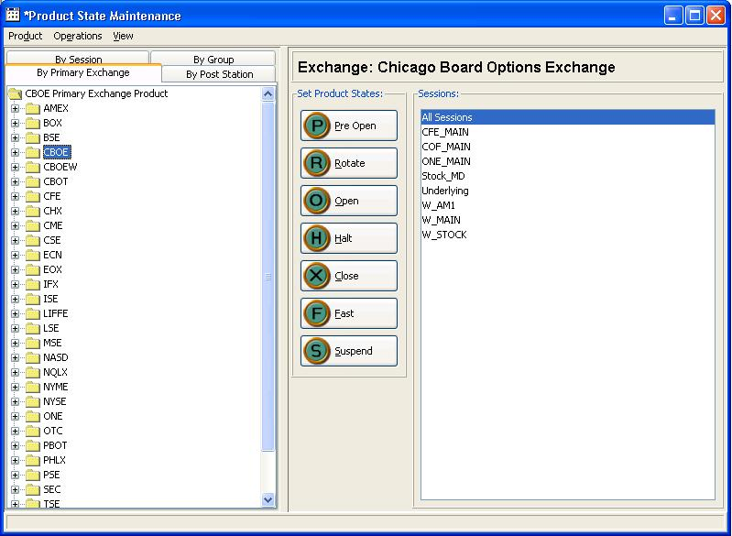
 | - Once the required node is selected, you may need to select the “Trading Session” for which the state to be changed. “All Sessions” option is selected by default.
 | The trading sessions are shown as a list on the right side of the window. You can select multiple items from the list at a time by holding shift button pressed for continuous selection or Ctrl button pressed for random selection while selecting trading sessions from the list.
- Once you have done with your selections, click on the state change, which you want to perform.
- Or you can use menu items in Product State Maintenance window. Product → Change State → XXXX.
- Then a warning dialog will be displayed which you need to confirm for going further with the operations. It is shown below.
 | 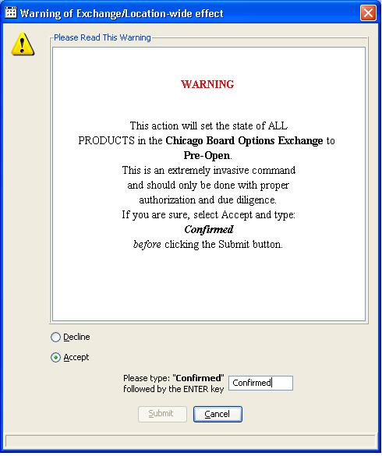
- You need to select the “Accept” radio button for continuing the operation.
- This will enable the text field where you need to key-in “Confirmed”.
- This will enable the Submit button.
- Click on Submit button to go on with state change operation. Or hit "Cancel” button to cancel the operation.
- Then a message will be shown whether the operation has completed successfully or not. The message dialogs are shown below.
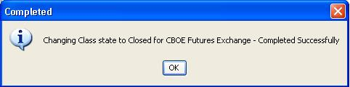
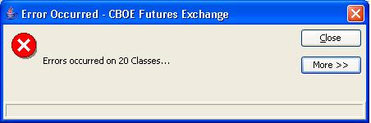
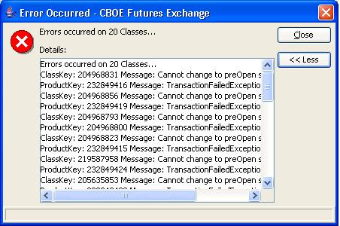
- If errors occurred, user can always see the details by clicking on the More>> button. The above error message gets displayed when more than one error occurs during the operation.
- If error happened only in one case, the error message shown will be like the one shown below. Here also you can see details by clicking on More>> button.

 | 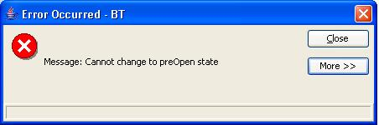

Exit the System

 | You can log out and exit the system at any time.
Exit the System | To exit the system, select Exit from the File Menu. You will be prompted to verify that you wish to close all windows and logout. Click Yes. The application will be closed and you will be returned to your system desktop.

