Table of Contents
CBOqa07070 – TradingPropertyServiceCacheManager unsafe initialization: Test Plan 3
Pretest Condition: 3
Test Plan 3
Test Case 1: 3
Test Case 2: 3
Test Case 3: 3
CBOqa06995 Opening Delays: Test Plan 4
Pretest Condition: 4
Unit Test: 4
Full Test: 4
CBOqa07126 – Find the missing orders when TpfAdapter is down: Test Plan 5
Pretest Condition: 5
Test 1: Enter orders when TpfAdapter is down 5
CBOqa07115 – TipsAdapter product cache does not have intraday product updates: Test Plan 6
CBOqa06880 – QRM's Quotes not cancelled due to Update Exception: Test Plan 7
Pretest Condition: 7
Test 1: Cancel Quotes for Class due to QRM Condition 7
CBOqa06909- Get Lost size is called when products not in session: Test Plan 8
Unit Test: 8
CBOqa07095 – Creating new Spread during PRE_OPEN prevents state change: Test Plan 9
Pretest Condition: 9
Test 1: Create a strategy using the Trader Gui prior to the opening 9
CBOqa06881-NullPointer in getOpeningRequirementCode before session star: Test Plan 10
Unit Test: 10
CBOqa07007 – Spread market order is not routing back to TPF: Test Plan 11
Pretest Condition: 11
Test 1: Market Spread order routed back to TPF with “rejected” reason when the Strategy product is ON_HOLD 11
Test 2: Market Spread order routed back to TPF (PAR) with “No Market” reason when leg market volume depleted 11
CBOqa06940- "Trader Activity" Events are dropped when times are identical: Test Plan 13
Unit Test: 13
CBOqa06568-Strategy order leg quantity validation: Test Plan 14
Pretest Condition: 14
Test 1: Reject a strategy order with invalid leg quantity 14

CBOqa07070 – TradingPropertyServiceCacheManager unsafe initialization: Test Plan

Pretest Condition:
- Server Installation and configuration completed and ready to start.
- Tail Global and Hybrid logs on separate xterms.

Test Plan

Test Case 1:
- Start the GC/BC server processes as per documentation
- Start W_MAIN session with - startSession W_MAIN
- Check global and hybrid logs for any ‘lock’ being held or being waited for.
- Stop W_MAIN session with – endSession W_MAIN
- Repeat the above 3 steps several times.

Test Case 2:
- Start the GC/BC server processes as per documentation
- Start ONE_MAIN session with - startSession ONE_MAIN
- Check global and TradeServer logs for any ‘lock’ being held or being waited for.
- Stop ONE_MAIN session with – endSession ONE_MAIN
- Repeat the above 3 steps several times.

Test Case 3:
- Start the GC/BC server processes as per documentation
- Start CFE_MAIN session with - startSession CFE_MAIN
- Check global and TradeServer logs for any ‘lock’ being held or being waited for.
- Stop CFE_MAIN session with – endSession CFE_MAIN
- Repeat the above 3 steps several times.

CBOqa06995 Opening Delays: Test Plan

Pretest Condition:

Note: these steps must be taken immediately after the new install before any other tests are run
- Copy setContext.template from /sbt/…/tradeeng/run_dir/bin to /sbt/tradeeng and rename it from setContext.template to setContext
- Hand-edit the setContext in the tradeeng base directory in the same way setContext is currently edited in the run_dir/bin directory. For help, see /sbt/…/tradeeng/run_dir/bin/setContext.readme

Unit Test:
Do the following tests on each BC/GC/FE upgraded:
- Login with the tradeeng id (tradengp, etc.), and verify that no error messages are printed to the screen on login.
- Start all services for this machine. Verify that all processes came up and started correctly
- Type echo $RUN_SET_CONTEXT;echo $SBT_PREFIX;echo $INSTANCE_ID;echo $BASE_PORT;echo $INFRA_BASE_PORT;echo $CLUSTER_ID;echo $SUB_CLUSTER_ID;echo $CLUSTER_TYPE;echo $ALT_HOST;echo $RUN_DIR;echo $INFRA_HOME_DIR;echo $ORACLE_VERSION and verify that the values echoed are the same as those set in the setContext file in the tradeeng base directory
- Type echo $ALL_SESSION_NAMES and verify that the response is ONE_MAIN W_MAIN CFE_MAIN W_STOCK
- Type echo $ALL_DATABASE_SCHEMA_NAMES and verify that the response is NOT a blank line
- Type echo $JAVA_HOME and verify that the response is NOT a blank line

Full Test:

In order to fully test these changes after the unit test is run, do another “new” install. This install can use either the same code base or a different one. After this install do not modify any of the setContext files, but perform the Unit Test (above) once again, and verify that all of the conditions are met.

CBOqa07126 – Find the missing orders when TpfAdapter is down: Test Plan

Please use the corresponding Pretest Condition below that is specific for ATG or development environment testing.

Pretest Condition:
    - Tests are for Hybrid.
    - W_MAIN Session is started
    - Products are in OPEN state

Test 1: Enter orders when TpfAdapter is down
- Enter several orders while TpfAdapter is up.
- Run findMissingOrders script. It should not print out any orders entered in step 1.
- Shut down TpfAdapter. Enter several orders.
- Run findMissingOrders script. It should print out the orders entered in step 3.

CBOqa07115 – TipsAdapter product cache does not have intraday product updates: Test Plan
1) The test requires Tips running with BOTR traffic or BOTR driver
running

2) run ar command to find a product in the BadProductList:
ar TipsAdapter showBOTRContext
From ar command output, find a product in the BadProductList. The
product has key like "C:G:W". We use "C:G:W" as example.

3) Open SAGui start/Products/ProductDefinition,choose option reporting
class C, and create a new product with Month code G and Strike Price
code W.

4) run command again
ar TipsAdapter showBOTRContext
and make sure that C:G:W is not in the BadProductList anymore.

CBOqa06880 – QRM's Quotes not cancelled due to Update Exception: Test Plan
Please use the corresponding Pretest Condition below that is specific for ATG or development environment testing.

Pretest Condition:
- Set up QRM for Class via SAGUI
- Go to User management QRM tab
- Add option class to the QRM controlled list.
- Select the class in the list box and click on Global QRM Enabled, and Class QRM Profile Enabled check boxes
- In the CLASS QRM Profile change the Volume = 5, and Seconds = 1
- Save settings.

Test 1: Cancel Quotes for Class due to QRM Condition
- Login to Trader GUI and open Market Display, add the target Class tab from W_MAIN/options.
- Enter quotes for several products
- Produce a trade for one of the products. The trade volume must be > 5.
- Make sure all quotes in the class are canceled.

Note: This bug fix must go through the PERF testing before it can be released into PROD

CBOqa06909- Get Lost size is called when products not in session: Test Plan

Unit Test:
- If session W_MAIN has already been started from the command line on the GC enter ‘endSession W_MAIN’

- If the Hybrid TradeServer is currently running kill it and bring it back up

- Using a trader GUI log on and open a market display window.

- Pick a class and add it to the market display window. Verify that the products are currently in ‘NO SESSION’ state

- Using the GUI attempt to enter a quote for one of the products in no session state. The following error should appear: (verify that the “No Session assigned to product…” message appears at the bottom of the box.)

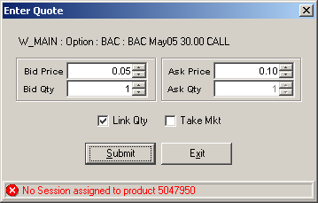

CBOqa07095 – Creating new Spread during PRE_OPEN prevents state change: Test Plan

Please use the corresponding Pretest Condition below that is specific for ATG or development environment testing.

Pretest Condition:
- Tests are for Hybrid.
- W_MAIN Session is started
- Products are in PRE_OPEN state

Test 1: Create a strategy using the Trader Gui prior to the opening
      - Any strategy created should move into ON_HOLD state
      - After the opening timers are triggered, underlying ticker data feeds from Tips should move the products to OPENING_ROTATION
      - Check to make sure all existing strategies and outright products move to OPENING_ROTATION – except BUY_WRITES, which should remain CLOSED
      - Open all products.
      - The newly created strategy should remain ON_HOLD.
      - Enter valid quotes on legs of strategies.
      - The newly created strategies should move to OPEN state.

CBOqa06881-NullPointer in getOpeningRequirementCode before session star: Test Plan

Unit Test:
1. If session W_MAIN has already been started from the command line on the GC machine enter ‘endSession W_MAIN’
2. If the Hybrid TradeServer is currently running kill it and bring it back up
3. Using a SAGUI log on and open a Product State Maintenance window.
4. Click a class under W_MAIN Hybrid. Verify that the NotFoundException error should appear with message “Trading Session W_MAIN is not Available.”
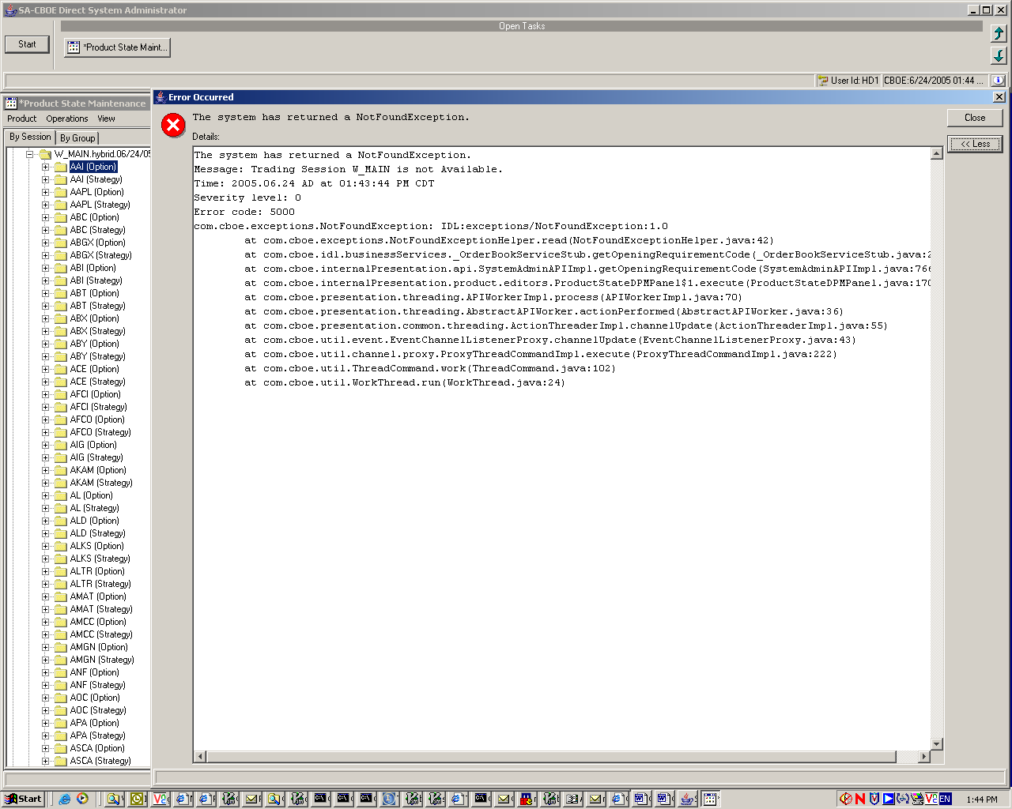

CBOqa07007 – Spread market order is not routing back to TPF: Test Plan
Please use the corresponding Pretest Condition below that is specific for ATG or development environment testing.

Pretest Condition:
- Tests are for Hybrid.
- W_MAIN Session is started
- Create a 2 leg B/S strategy
- Strategy product ON HOLD
- TPF flags to be set to allow routing back
- CBOE Direct flag to be set to allow Spread Market Orders

Test 1: Market Spread order routed back to TPF with “rejected” reason when the Strategy product is ON_HOLD

Buy 1/ Sell 1 Strategy Product

0.00-0.0 0x0 Leg # 1
0.00-0.0 0x0 Leg # 2
Product Status ON_HOLD

1. Submit “C” market spread order 10 @ MKT SAME SIDE from PAR

Order routed back to PAR. Make sure PAR got the order back with reason “Rejected”.

Test 2: Market Spread order routed back to TPF (PAR) with “No Market” reason when leg market volume depleted

Buy 1/ Sell 1 Strategy Product

0.00-0.00 0x0 Leg # 1
0.00-0.00 0x0 Leg # 2
Product Status ON_HOLD

- Submit quote for Leg 1: 1.00 – 1.25 10x10
- Submit quote for Leg 2: 1.00 – 1.25 10x10
- Strategy product state changed to OPEN
- Submit “C” Market Spread Order 20 @ MKT SAME SIDE from PAR

Result:

Spread order trades quantity of 10 against legs and leave 10.
Leg market changes to:
1.00 – 0.0 10x0
- – 1.25 0x10
The Spread Market order with remaining quantity of 10 is routed back to par with reason “NO MARKET”.

Make sure PAR got the order back with reason “NO MARKET”.

CBOqa06940- "Trader Activity" Events are dropped when times are identical: Test Plan

Unit Test:
1. Enter quote for a hybrid option from TraderGui
2. Enter order trade against the quote from step 1.
3. On the TraderGui, select Start->History->Activity Log->Create New Window to display the activities for the option. Should see Execution with the same time stamp.

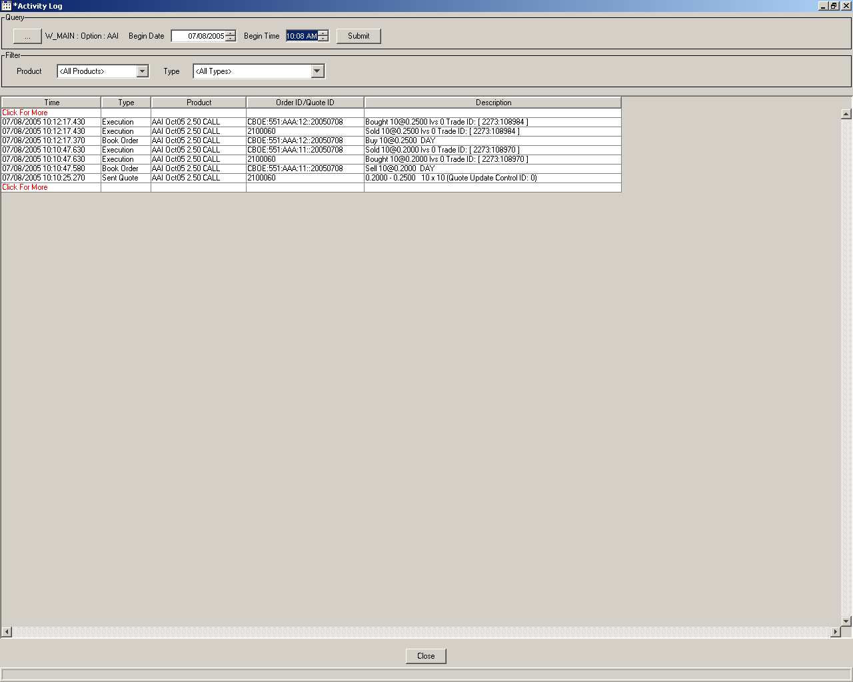

CBOqa06568-Strategy order leg quantity validation: Test Plan
Please use the corresponding Pretest Condition below that is specific for ATG or development environment testing.

Pretest Condition:
- Tests are for Hybrid.
- W_MAIN Session is started
- Create strategy with 100 leg ration
- Strategy leg products must be OPEN
- Strategy product ON HOLD, OR OPEN

Test 1: Reject a strategy order with invalid leg quantity
Enter order for the strategy with 100-leg ratio.
Enter the order quantity @ 100000. On order submission invalid quantity message is shown on Trader GUI.

