Distributed Trade Engine
CBOE Integration Architecture

 | 26 June 1998  CBOE/TRC

Change History:
Version | Date | Author | Reason for Change
0.1 | October 30, 1997 | Error: Reference source not found | Create Outline
1.0 | December 17, 1997 | Paul K. Fisher | Final Draft
1.5 | June 1, 1997 | Luis I. Benavides | Final draft after incorporating Screen-based Trading requirements

Copyright © 2026
All rights reserved. No part of this document may be reproduced or copied in any form or by any means, electronic or mechanical, including photocopying, recording, or information storage and retrieval system without permission in writing. This document contains information that is considered company sensitive. While The Technical Resource Connection, Inc. may freely copy and distribute this material, all copies must remain in the possession The Technical Resource Connection, Inc.
Product names are trademarked by their respective companies.
Document Tracking Information
File Name: | 0000.doc
Document  Reference: | CBOE Integration Architecture/CBOE Integration Architecture/0000.doc/Chicago Board Options Exchange/Draft
Version: | Version 1.5
Status: | Final Draft
Sign-offs
Authorized by , Mark Novak, Joe Kambich
Signature
Signature
Signature

Contents

Foreword vii
1. Introduction 1
1.1 Architectural and Operational Requirements 2
1.2 Constructive Software Environment 3
1.3 Integrating External Systems 3
2. Architectural and Operational Requirements 5
2.1 Overall 5
2.2 Information/Data 7
2.3 Connectivity and System Interface 7
2.4 Presentation 8
2.5 Security and Audit Trails 9
2.6 Configuration and Support 10
2.7 Scalability and Performance 10
3. Fundamental System Services 13
3.1 Directory Services 13
3.1.1 Standard Specifications 13
3.1.2 Features, Qualities, and Constraints 15
3.1.3 Service Profiles 16
3.1.4 Usage Strategies 17
3.2 Messaging Services 22
3.2.1 Service Model 22
3.2.2 Standard Specifications 25
3.2.3 Service Profiles 27
3.2.4 Usage Strategies 33
3.3 Transaction Services 38
3.3.1 Service Specifications 38
3.4 Security Services 40
3.4.1 Security 41
3.4.2 Features, Qualities, and Constraints 43
3.4.3 Firewalls 55
3.4.4 Object Security Service Usage Strategies 61
3.4.5 Threats to CBOE’s Trading Floor Systems 64
3.5 Logging Services 65
3.5.1 Core Conceptual Components 66
3.5.2 Features, Qualities and Constraints 69
3.5.3 Service Profiles 72
3.5.4 Usage Strategies 77
3.6 Systems Management Services 78
3.6.1 Features, Qualities, and Constraints 79
3.6.2 Usage Strategies 79
4. Processing Paradigms 83
4.1 Workflow 83
4.1.1 Components 83
4.1.2 Features, Qualities, and Constraints 85
4.1.3 Context for Use 85
4.2 Object Server 87
4.2.1 Identity Management 87
4.2.2 Eviction Manager 88
4.2.3 Session Manager 91
4.2.4 Thread Management 93
5. External System Integration 97
5.1 System Integration Strategies 98
5.1.1 Static Integration 100
5.1.2 Dynamic Integration 102
5.2 CBOE Legacy Systems 104
5.2.1 Continuous Trade Match Integration 105
5.2.2 COPP Integration 106
5.2.3 TIPS Integration 107
5.3 SBT Application Programming Interface (API) 107
5.3.1 API Requirements 107
5.3.2 API Implementation 107
5.3.3 API Architecture 108
5.3.4 API Design 108
6. Appendix A – Abstract Integration Model 120
6.1 Common Object Semantics 120
6.2 Distributed Transparencies 122
6.3 CORBA Implementation Abstractions 123
6.3.1 Interface Definition, Management, and Language Independence 124
6.3.2 Static and Dynamic Invocation Mechanisms 127
6.3.3 Interoperability 128
6.3.4 Object Adapters 128
6.3.5 ORB Core 129
6.3.6 ORB Services 129
7. Appendix B – Service Engine Abstraction Framework 131
7.1 Service Implementation Architecture 131
7.2 Service Administration Architecture 133
8. Glossary 135

Figures
Figure 1. Object Naming Service Model 14
Figure 2. Object Naming Service Object Model 15
Figure 3. Failure Resilient NamingContexts 18
Figure 4. Trader Service Reference Partitioning 19
Figure 5. Federated Trader Service Deployment Strategy 21
Figure 6. Event Service Components 26
Figure 7. Normal EventChannel Configuration 29
Figure 8. Event Channel Group 29
Figure 9. EventChannelGroup IDL Definition 31
Figure 10. Configuration Propagation Architecture 35
Figure 11. Snapshot Query System 36
Figure 12. Dissemination Backbone Architecture 37
Figure 13. Object Transaction Service Elements 39
Figure 14. Access Decisions 49
Figure 15. No Delegation 51
Figure 16. Simple Delegation 51
Figure 17. Composite Delegation 51
Figure 18. Combined Delegation 52
Figure 19. Traced Delegation 52
Figure 20. Components Involved in the Functioning of CORBA Firewalls 58
Figure 21. SBT's Physical Network Components 60
Figure 22. Major Architectural Components of the SBT System 62
Figure 23. Document Title Functional Areas 65
Figure 24. Conceptual Diagram of Core Components 67
Figure 25. Trace Message Record Contents 74
Figure 26. System Monitoring Bands 80
Figure 27. Hierarchical Band Filtering 81
Figure 28. Basic Deadlock Situation 94
Figure 29. Thread Pool Abstraction 95
Figure 31 Design of the SBT API 109
Figure 32. CORBA Implementation Components 123
Figure 33. CORBA System: Language Independence Components 124
Figure 35. Interoperability Components 128
Figure 36. Object Adapter Components 129
Figure 37. ORB Services Components and Invocation Interaction 130
Figure 38. Abstract Pluggable Engine Architecture. 132

Tables
Table 1. Message Categories 76

Foreword
This document specifies the integration components required to build CBOE’s systems on a rich infrastructure that addresses end-to-end consistency and enforces architectural qualities and constraints. The integration architecture focuses on establishing the overall vision for integrating application systems by providing a constructive software environment and strategies for external system integration. The architecture also leverages legacy assets and bridges the information and technology architectures, as well as legacy integration and the constructive software environment components.
This document augments the CBOE Technology Architecture document and the migration documents (Distributed Trading Engine and PSP Applications) that describe the path between CBOE's current state and target state.
This document is intended to be evergreen and maintained continually as new requirements are identified. In particular, it incorporates the requirements introduced by Screen-based Trading.
The CBOE Integration Architecture is meant to be utilized to support a process of technological oversight, so that new projects and development activities are not contrary to the recommendations and conclusions found within this document.
Scope
This document covers the following technologies:
- employment of middleware
- client and server issues
- employment of distributed environment services
- employment of processing paradigms underpinned by technology.
The CBOE Integration Architecture addresses the requirements of the Distributed Trading Engine, PSP Applications and the Screen-based Trading (SBT) System.
Audience
This document is written for CBOE IT professionals who need to understand the architecture required to successfully implement object technology. It is also intended for CBOE staff performing the technological oversight process.
Some knowledge of object technology, and an understanding of distributed object computing concepts is useful for reading this document.
It is also assumed that the reader has access to external sources of information regarding the technologies described in this document.
Organization
- Introduction
- Architecture and Operational Requirements
- Fundamental System Services
- Processing Paradigms
- External System Integration
- Appendices.
Related Documents
Requirements used are derived from the Trading Engine SRS, PSP Applications SRS, and Screen-based Trading SRS.
The Technology Architecture describes the computing platforms, fundamental infrastructural components, and development environment for CBOE's future architecture that enables distributed object systems.
The path of migrating from the current environment and set of applications to the target one based on distributed object technology is captured in the Trading Engine Migration and the PSP Applications Migration documents.

1. Introduction
This document specifies the integration components needed to build CBOE’s systems on a rich infrastructure, which address end-to-end consistency while enforcing architectural qualities and constraints. The integration architecture focuses on establishing the overall vision for integrating application systems by providing a constructive software environment and strategies for external system integration. The architecture also leverages legacy assets and bridges the information and technology architectures, as well as legacy integration and the constructive software environment components
Each component of the architecture identifies a key area of flexibility. These areas of flexibility provide hot points, or integration points, in the architecture, and prescriptions for types of adaptability available to system applications. This chapter describes how the concepts of the integration architecture work together to form a unified system for CBOE’s Distributed Trading Engine Redevelopment and Screen-based Trading (SBT) projects. The integration architecture creates the framework to allow easy expression of object-oriented abstractions by building the constructive development environment and integrating legacy systems.
To meet CBOE’s needs, the integration architecture identifies the high level architectural and operational requirements, goals, and constraints. Each component of the integration architecture individually identifies the operational requirements it satisfies, with a particular focus on the architecture’s ability to adapt to changing requirements without reengineering.
To build a distributed object system, we need to recreate the simplicity and capabilities of the monolithic, or single-process environment. In other words, it should be as easy to construct solutions with a distributed architecture as it is to construct solutions in a monolithic environment using a conventional object-oriented language, and the standard (non-distributed) operating system environment. All object instances created within the environment can equally share system resources and provide services to one another.
A few factors contribute to the simplicity of monolithic environments:
- The language system supports a uniform type, reference, and invocation system.
- All object instances are equally accessible because of a virtual memory environment.
- The operating system treats objects within the process uniformly in terms of access, availability, and transparency of service⎯and may even provide management of multiple threads of execution through the system.
Therefore, a distributed object system environment must in turn support each of these features to provide the same ease of use found in a monolithic environment. CBOE’s integration architecture will be based on the Common Object Request Broker Architecture and Specification (CORBA). An introduction to CORBA and how it provides the previously outlined features is presented in 6. Appendix A–Abstract Integration Model
This environment supports solutions to both the internal and external integration needs of the architecture. Internally, the integration architecture provides for a uniformly transparent object-oriented constructive software environment. Externally, the integration architecture supports integrating other systems into the overall architecture: external system integration. Both the constructive software environment and external system integration build on the fundamentals of the CORBA-based system to deliver real solutions to the CBOE Trading Engine Redevelopment and Screen-based Trading projects.
The constructive software environment is presented in the integration architecture as a set of fundamental services and processing paradigms. Fundamental services encapsulate classes of technology function needed to move from monolithic to transparent distribution systems. The processing paradigms are high level sets of abstractions providing the essential roles, associations, and behaviors for application system tasks while transparently enforcing end-to-end system properties.
The following sections introduce these concepts, and they are detailed in the remainder of the document.

1.1 Architectural and Operational Requirements
Defining architecture requirements is similar to the traditional requirements gathering phase of any software development project. The actual requirements gathered are slightly different in nature from traditional functional requirements. Requirements that are gathered as part of the architecture are operational requirements. Operational requirements support functionality essential to operating the system as a whole by identifying the features, qualities, and constraints of this functionality. Specifically, an operational requirement is defined as:
A capability, carried out by one or more portions of the architecture, that supports the delivery of a functionality essential to the operating of the system as a whole.
Following the lines of these definitions, the architecture supports the satisfaction and development of the functional requirements for a given application. It is important to note that the satisfaction of the operational requirements by the architecture is not the same as an application’s satisfaction of an application’s functional requirements. In regard to an application’s functional requirements, the goal is to achieve measurable adherence to a specific purpose. An operational requirement aims at providing flexibility in the architecture to fulfill any arbitrary functions within the domain described by the project scope. The operational requirements are defined by identifying the features, qualities, and constraints the architecture must enable.

1.2 Constructive Software Environment
The integration architecture specifies a software environment that provides an overall implementation framework for the construction of multiple application systems. In addition, the constructive software environment provides a platform for the abstraction of common business services identified in the enterprise information architecture and specific application architecture efforts.
While the technology architecture provides the selection of off-the-shelf products, and the information architecture provides a consistent model of the business; the integration architecture provides the processing facilities that make the enterprise applications systems reliable, scalable, manageable, and perform. To this end, the integration architecture specifies two different types of components:
- Service Roles—Actual abstractions of the service definitions from which objects in the information architecture inherit behavior. Service roles exist to maintain cohesion between the integration architecture and information architecture.
- Processing Paradigms—The goal of processing paradigms is to provide coordinated interaction between computing resources. These coordinated interactions are frameworks for developing solutions in a particular problem set. Service roles and components from multiple object services are opaquely aggregated into framework objects that cooperate into forming high-level interaction scenarios. A framework provides direct support for building object models from the Abstract Information Model components (defined as part of the information architecture). In essence, they are frameworks that can be fundamentally enabled at the architectural level and, in turn, optimized.
Processing paradigms are the basis for providing "in the small" environments. These frameworks are the beginning of the construction of tools that empower developers and end-users to assemble information architecture objects into specific business solutions. Objects carrying out roles in the processing paradigm enable coordination of other objects, building associations between those objects, and creating high-level views. Specific paradigms include publish and subscribe, workflow, and transactional objects.
These components represent the heart of the integration architecture. The services required in CBOE’s Trading Engine Redevelopment Project, associated PSP applications and Screen-based Trading application are specified in section , 3. Fundamental System Services. The processing paradigms are presented in section , 4. Processing Paradigms.

1.3 Integrating External Systems
A legacy, or more generally, an external system, is an environment that does not conform to and is not built with the components of the integration architecture. The integration architecture allows for integrating legacy systems into the architecture environment by using the common semantics and components of the CORBA system. Together, these components provide a unifying framework enabling interaction at all levels.
The integration architecture addresses external system integration using two practical approaches:
- Object Wrapping—A static method for creating objects in the information architecture that map directly to legacy system information. Multiple wrapping of objects communicates specific information between the external systems and the distributed objects. Advantages of this include the ability to quickly develop an object to communicate specific information. Disadvantages are that the wrapping objects must be re-deployed to accommodate any changes in the legacy system and almost every legacy application requires one or more object wrappers.
- Object Bridging—A dynamic method of communicating information between the legacy system and the distributed objects. One object bridge coordinates the communication of all information between a single external system type and the distributed objects. Advantages include minimal effort required by changes in the external system or distributed objects and fewer objects to maintain. The main disadvantage is that the object bridge is large and complex.
Each of the external systems in the CBOE environment will be individually addressed in section 5. External System Integration.

2. Architectural and Operational Requirements
This chapter contains the architectural requirements organized by infrastructure category. Each of the requirements are described and followed by more detailed definitions (sub-requirements) of what must be done to accomplish the broader requirements definition. The architecture requirements also describe a mapping to the CBOE Trading Engine Redevelopment and Screen-based Trading projects’ business drivers and business objectives.
The most critical business driver identified as part of the CBOE Trading Engine Redevelopment and Screen-based Trading projects is reducing the time to market. This architecture should provide the common services and business functionality development components and techniques.
It should be noted, however, that establishing metrics, initiating a measurement program, and defining improvement goals are the first steps in fulfilling this requirement. A baseline metric for the cost and time to market of developing software in the existing infrastructure must be established. The improvement goals must be defined and communicated (for example, 50% reduction in cycle time, 30% reduction in development costs, 70% reduction in support costs). Finally, a measurement program must be put into place and be integrated with the Software Development Process to track progress toward the goal. This step is almost entirely dependent on a focused attempt at improving the system design and development practices at CBOE. Without a measurement program, the potential benefits provided by this architecture will not be achieved.
The following requirements are derived from the CBOE system team and existing system documentation.

2.1 Overall
Broad architecture requirements (features, qualities, and constraints) are the foundation for the enterprise computing systems. These requirements are not restricted to a single facet of the infrastructure or application systems. These requirements span the entire scope of the architecture to establish the vision that guides systems development.
- The CBOE software must be responsive to changes in the business environment.
CBOE’s current core trading systems do not provide the flexibility needed to respond quickly to changes in the business environment. The CBOE Trading Engine Redevelopment Project is aimed at developing an architecture that will promote the construction of systems that can accommodate future modifications. The architecture must also facilitate modifications to the Screen-based Trading application. During an initial learning period in electronic trading, CBOE will most likely be forced to fine-tune the Screen-based Trading application. After that period, rapid innovation in electronic trading will also drive frequent modifications.
- Adopt industry standards.
Technology selections and standards will be based on (computer) industry standards when cost allows and technologies are available. In the absence of industry standards, de facto standards that dominate market share will be used.
It is the intention of this requirement to minimize the amount of custom infrastructure software that is built and maintained by CBOE (for example, the elimination of the NAPI library is a goal of this architecture).
- The architecture should provide for easy replacement of technology products.
The architecture should allow the easy integration of new technologies (hardware and software). It is a goal for the architecture to allow applications to transparently capitalize on new functionality provided by technological advances, but not a strict requirement. Components should be explicitly developed to provide this abstraction only when there is a clear driver for this type of flexibility.
- The architecture must be portable to a wide range of hardware and software platforms.
This is not a general requirement for CBOE’s systems, but there are several specific system components in the CBOE environment that need to allow external organizations to develop software using CBOE’s frameworks, such as Firm order creation, the Market Maker terminal interface NCC, and the Screen-based Trading client component. CBOE will not have control over what hardware and software platforms will be used to develop this new software. To minimize long-term porting costs, these components must be purchased, integrated, and developed with portability as a key architectural principle. This requirement includes minimizing dependence on vendor products.
- The architecture must ensure that the constructed system components are available to heterogeneous computing platforms.
CBOE applications must be allowed to operate in a heterogeneous computing environment. Specifically, it is required for the system functionality to be directly usable from C, C++, and Java programming environments, running on the majority of UNIX platforms (for example, Solaris). The requirement applies to distributed application interfaces and middle-ware services, such as database management systems, messaging, and synchronous remote method calls.
The Screen-based Trading application client component will run on existing member-owned hardware, over which CBOE has no control. Thus, system components must be available in the most popular desktop platforms, including Windows NT. Middleware services must perform the appropriate data representation conversions to support a heterogeneous hardware environment.
- Eliminate single points of failure in the computing system environment.
The CBOE Trading Engine Redevelopment Project, and more generally the CBOE IT five-year plans, are focused at eliminating all single points of failure in CBOE’s systems. Additionally, the system should be structured so as to eliminate the possibility of a failing component causing any interruption in processing floor-wide.
It is crucial that the SBT system provides continuous service, since traders cannot use alternative manual trading to cover their positions in case of failure. After outages, the SBT system must be recovered in the shortest time possible.
CBOE exists to allow the member firms to trade options, therefore, continuous operation is a critical requirement and outages should be rare and should be restricted to the smallest practical subset of the trading floor.

2.2 Information/Data
The following comprise the architecture requirements (features, qualities, and constraints) for supply, storage, and accessing data, both inside and outside the CBOE system.
- Orders submitted from member firms must never be lost.
CBOE is completely responsible for the handling of an Order once it is accepted from a member firm. Therefore, data store services must provide for the utmost data integrity for this information.
- Data should be accessible from heterogeneous software platforms.
Information and data storage mechanisms must be accessible from multiple language environments including C, C++, and Java, in order to provide existing applications and new application systems.
- Information should be accessible from remote platforms.
Information and data storage mechanisms must allow application components to access data remotely from their computing platform.

2.3 Connectivity and System Interface
Connectivity defines the levels of communication required within and external to the CBOE Trading Engine Redevelopment and Screen-based Trading projects infrastructure and applications. The system interface requirements defined in this section are limited to the externalization services provided by the CBOE Trading Engine Redevelopment Project infrastructure, PSP applications, and the SBT system. This section describes the architecture requirements (features, qualities, and constraints) that must be supported by the connectivity and system interface components of the CBOE Trading Engine Redevelopment and Screen-based Trading projects’ architecture.
- 1. The architecture should use internal network protocol based on an industry standard protocol that will support a heterogeneous computing environment.
The dominant network protocol in the heterogeneous, distributed computing market is TCP/IP. Therefore, TCP/IP connectivity is required.
The main motivation for using industry standards is to reduce costs by purchasing software and hardware that will be interoperable and portable because of the industry standards.
The SBT system clients will be located in remote physical locations and will communicate with the SBT server components over leased and possibly public lines. If practically possible, the common network protocol utilized for SBT client/server communication over these lines will be TCP/IP.
- 2. Adopt communications standards above the network transport layer (TCP/IP) that conform to industry standards where possible.
Electronic exchange of data between applications within CBOE should be accomplished using a standard set of application protocols. The set of standards above the transport layer will include standards for conversational messaging, queuing, remote procedure, transaction management, directory services, and network management. Provide networking services in a cost-effective manner by reducing proprietary interfaces. Where the standards are not available, a single set of standards will be established.
Whenever possible, the set of standards above the transport layer used in SBT client/server interaction will be the same for all SBT clients, irrespectively of the type of lower-level protocols. Additionally, the set of standards will be the same as those adopted for interactions within CBOE.
- 3. Heterogeneous network protocols for external access.
While internal communication between the CBOE system services will be based on TCP/IP, external communications with the CBOE system may be required to support multiple network protocols. The need to support multiple external network protocols will be based on specific business needs.
Specifically external protocols will need to be supported when interfacing to external agencies (for example, market data feeds through TIPS, and CBOE market reporting through COPP).

2.4 Presentation
Presentation determines how information is displayed to the end user. These architecture requirements are meant to help the end user by keeping the interface as familiar and easy to use as possible. This section describes the architecture requirements (features, qualities, and constraints) of the user interface components in the CBOE Trading Engine Redevelopment and the Screen-based Trading project architecture.
- The architecture must support multiple clients.
CBOE has not established a standard client interface platform for the trading floor as a whole and as a result the architecture and application components must support a variety of client platforms. Specifically, several of the PSP applications are running on DOS-based systems that CBOE does not wish to, or cannot change as a result of choices made within this architecture. The SBT system client component will run on existing member-owned platforms. However, CBOE may specify standard platforms for running the SBT system’s client component, which will include the most popular desktop platforms.
The architecture must support DOS, Windows 3.x, Windows NT, and Java-capable presentation clients.
- Presentation technology must provide predictable input response times so as to allow “no look” input.
The majority of CBOE’s application interfaces are used for repetitive tasks during active open outcry trading, and therefore must allow expert users to develop input patterns that do not result in the incorrect action because of timing considerations in the presentation technologies.
- The architecture must provide a level playing field for all SBT traders.
No trader using the SBT system will have an unfair advantage over the others. Specifically, a trader should not be able to have their trades posted to the SBT system faster than others or have access to trading information faster than others because of performance differences of the trader’s physical connection to CBOE. The architecture must ensure that, on average, these data transfer times are equal for all traders, independently of the performance characteristics of individual physical connections at any moment in time.
- The architecture should promote the decoupling of business logic and application services from application user interfaces or views.
To achieve CBOE’s business objectives of improved time to market and increased flexibility, the system must be delivered as fine-grained services. These fine-grained services must provide a single function and be deployed as self-contained, reusable components. The first level of separation of any good architecture is to divide presentation, business, and data access logic. This enables each of the components to evolve independently with minimal impact on the other system components.

2.5 Security and Audit Trails
Security requirements begin with the most important concerns of securing data and services from external access. Security requirements must also consider internal data and service access. Audit trails are a mechanism for tracking internal security. This section describes the architecture requirements (features, qualities, and constraints) for the CBOE Trading Engine Redevelopment and Screen-based Trading projects’ architecture security services and audit trails.
- Systems off the trading floor must not be able to access trading application services running on the trading floor unless explicitly authorized by CBOE.
The architecture must provide a means of securing trading application from access by systems that are not physically on the trading floor. The exceptions to this requirement are CBOE systems and the operations groups working to maintain these application systems and SBT clients, which may be located in remote member offices.
At present, these application services are protected by “physical security,” as the application interfaces are provided only on the trading floor.
- Login and identification must be provided.
The architecture must provide a consistent method of user login and identification for use by CBOE systems. Specifically, the MMHH and the PAR systems require the current system to understand the identity of the user interacting with the application client so as to properly route information.
Currently these systems do not require authentication to be performed by the system.
User login and identification in SBT will be effected using the trader’s badge to prevent simultaneous physical pit and screen-based trading.
- Security must be provided in a non-obtrusive and transparent manner and should attempt to not degrade overall system performance.
The objective will be to maintain security without inhibiting legitimate use or adversely affecting defined performance expectations. However, CBOE infrastructure and applications will comply with established security standards, auditing requirements, and legal requirements.
The implementation of security services will be required to strike a balance between the levels of security implemented and the performance impact on the delivered applications. The objective of the architecture will be to minimize the performance impact of the security service.
- Audit trails to track user activity.
Actions that are deemed critical and subject to audit must be tracked and logged. This can in-extremis involve the tracking of all user actions, but in practice will only involve those that have an impact on rule observance and liability (whether CBOE's or that of traders).

2.6 Configuration and Support
Configuration and support includes configuration management, change management, system support, and system administration. This section describes the architecture requirements (features, qualities, and constraints) for deployment and management of the CBOE Trading Engine Redevelopment and Screen-based Trading projects’ infrastructure and applications.
- The services must be distributed but managed from a single console.
Early experiences with the deployment of distributed computing solutions were extremely costly and poorly supported. Many of the problems were due to the lack of proper support processes and the ability to manage the network from a single location. Therefore, CBOE systems must enable the ability to manage the infrastructure and applications from a single location. However, this single location may change during a 24-hour period as different regions become more active.
- Capturing measurements and differentiating service levels.
Measurements will be used to assess system quality, operational status, process improvement, and service levels provided to the businesses. Applications, data, and technology architectures will be implemented in such a way that appropriate measurement data is available for capture and analysis. Service level agreements will define the measures of performance.
- Change management must be built in to the production and test environment.
CBOE will ensure the integrity of the production environment and avoid business outage through the management of change. The infrastructure and application services must allow multiple versions to operate at the same time.
Application configuration changes will be managed by a single infrastructure component in the new architecture.
- A common application logging facility will be used by all systems.

2.7 Scalability and Performance
Scalability and performance include the system's ability to be statically and dynamically configured to support new demands. Performance characteristics depend on service level expectations for each specific usage of the system. This section describes the architecture requirements (features, qualities, and constraints) related to the scalability and performance characteristics of the CBOE Trading Engine Redevelopment and Screen-based Trading projects’ infrastructure and applications.
- The system component and applications must be able to operate at a defined service level.
The existing CBOE applications have established an expected response time expectation of sub second response. The current response times cannot be compromised as new application systems are delivered.
- The system must support the ability to add small, incremental increases in computing capacity at a minimal cost.
New infrastructure or application components developed under the architecture must support multi-threaded operating systems, symmetric multi-processing (SMP), and massively parallel processing (MPP) hardware.
The business services must be defined as small fine-grain services that can be deployed on a single machine or spread across several processors as determined when the system is deployed.
A number of exchanges in the US and Europe have experienced explosive volume growth in screen-based trading. CBOE may experience the same level of growth once screen-based trading is introduced. the integration architecture must support SBT scalability by allowing incremental addition of “SBT Posts” to process increased volume of existing products or new products. The SBT system will utilize the same post-centric model of CBOE’s trading floor systems to provide scalability and availability. However, SBT posts will not necessarily correspond to trading floor posts, since the trading volume patterns of individual products may vary greatly in the two environments.
The customer’s required capacity will determine the deployment configuration.

3. Fundamental System Services
The basic tenet of the integration architecture is to provide the capabilities, simplicity, and manageability of the monolithic, or single process environment to distributed object systems. To this end, capabilities similar to that of a monolithic environment are encapsulated into fundamental services that can provide these capabilities horizontally to all applications in the distributed system.
The OMG is continually evolving a set of common service definitions within the CORBAServices: Common Object Services Specification, or COSS. This set of services is used as a basis for the specification of the services detailed in this section—but is not exhaustive. When a specification from an alternate forum addresses the needs of the integration architecture it will be presented and considered within the appropriate section.
The services in the COSS specification provide only interface specifications and do not detail implementation strategies or qualities of service. This level of specification is insufficient for the integration architecture, therefore this chapter will present the service specifications as they relate to CBOE’s systems environment, and will investigate the particular needs that exist within this environment.
The following sections present a type of basic horizontal service needed in the CBOE architecture. Each service will provide: a description of the service model; a discussion of the features, qualities, and constraints that are specifically required in the CBOE environment; one or more service profiles required for deployment; and one or more usage strategies to employ.

3.1 Directory Services

3.1.1 Standard Specifications
There are two standards specifications that are applicable in providing directory services for the CBOE Trading Engine Redevelopment and Screen-based Trading projects—the Naming Service and the Trading Service. While the Trading Service provides a direct superset of functionality, if not interface, of the Naming Service, both should be employed as part of infrastructure because the Trader Service provides a much more complex interface that in many cases is unnecessary.
This section will introduce both service specification and functionality.

3.1.1.1 Object Naming Service
The Object Naming Service (ONS) represents a directory service that enables object references to be bound indirectly to names that represent a logical service or system component. The ONS is the foundation for communicating references of existing objects. The basic concepts contained in the ONS are similar to the DCE Cell Directory Service, in that an implementation resolves its logical name identifiers relative to the current context it contains. This allows the developed system to directly function in the deployment environment by simply configuring the current naming context that it utilizes. Note that ONS does not contain the notion of a global identifier space, so all names are relative references from a particular NamingContext.
There are two basic components of the ONS: NamingContext and NameBinding. The NamingContext controls a logical grouping of named, or bound, object references within that NamingContext. This strongly mirrors the structure of traditional file systems with the ability to federate the management of the global naming space. In fact the Object Naming Service does not enforce a hierarchically structured namespace with such a global root. The principal of federation within the ONS provides simply for relative references. This capability will become important as we examine the usage scenarios in section , 3.1.4 Usage Strategies.
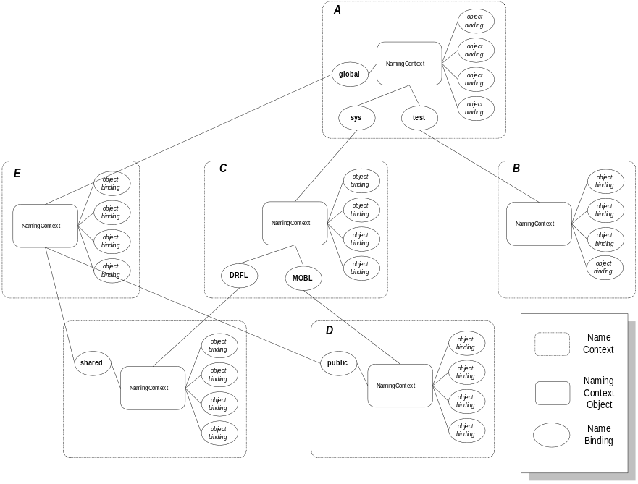
Figure 1. Object Naming Service Model
These concepts are represented in Figure 1. The Name Contexts in the figure represent a locality of reference, with the NamingContext object controlling that locality. The NamingContext object manages two separate types of bindings that roughly relate to directories and files within a traditional file system, the former is name bindings to other NamingContext objects, and the latter is the name bindings to application and service object references. The Names that bind object references within a NamingContext are any valid CORBA string.
Figure 2 provides a set of NamingContexts that have been administratively arranged into a single rooted hierarchy, but application objects interact with this from a relative position within the hierarchy.
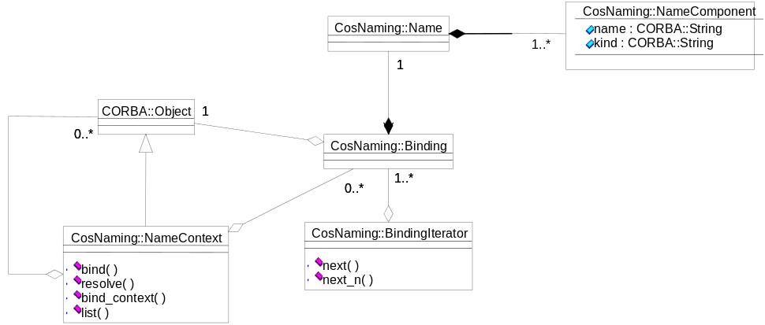
Figure 2. Object Naming Service Object Model
Figure 2 represents the basic object model of the ONS components. It also depicts the component’s basic operations and attributes. One additional item to note—while the Names used by the NamingContext for binding can be converted to and from string form, there is no restriction on the actual form of that string. More specifically, the Name structure does not use a special character to designate a path identifier, but is a sequence of NameComponents that maintain a separate ID, the string portion, and the Kind, the type of component. The string representation of a particular NameComponent is the domain of that NamingContext implementation.

3.1.1.2 Trader Service
If the Naming Service can be likened to a "white pages" service, then the Trading Service is the "yellow pages" for the DOI. A Trading Service stores exported service offers from services in the DOI and when clients wish to make use of a service with particular characteristics, the trader assists them in providing a match (if one exists). If multiple matches exist, then the client has the option of refining its query with the trader, or performing its own navigation of the list of matches returned it. The client is then free to make use of the service previously unknown to it by virtue of having an object reference returned as a result of its query of the trading service. A comparison of the two and their utilization in the target CBOE environment is detailed in the following section.

3.1.2 Features, Qualities, and Constraints
This section distills the needs of the Distributed Trading Engine, the PSP applications, and the SBT system into a coherent and measurable set of criteria that directory services must satisfy horizontally across CBOE systems. These criteria follow as individual requirement statements:
- All directory services must maintain a persistent representation of the directory information.
- All directory services must be constructed, or be used, to prevent a single system failure to form, thus rendering them unavailable.
- All directory service information must be able to be backed up and restored from archival media.
- Directory services must allow for directory space federation across the multi-post environment at CBOE.
- All directory services must be available in SBT clients. The directory service must allow registering and resolving references to objects residing in SBT clients.
- Graphical configuration services must be provided to maintain the directory information.

3.1.3 Service Profiles
No specialized service configurations are needed in the CBOE environment. Standard implementations of Naming and Trader services can be employed to provide directory services in CBOE’s post-centric and screen-based trading environments with the application of the techniques presented here and in the following section on Usage Strategies.
The only foreseeable problem that CBOE will encounter with standard implementations of the Naming and Trading services concerns the overall availability requirement for trading floor and screen-based systems. To address the need for running duplicate copies of the service implementations CBOE will need to develop a simple scheme for managing named references.

3.1.3.1 Directory Service Availability
To meet the availability requirement in CBOE’s environment, a straightforward abstraction encapsulating the lookup into the directory service interface needs to be developed. To support this abstraction, the application is configured with a secondary well known reference to a service instance in addition to the single primary that is discussed above. As a result, the abstraction would catch internally any communication failure, or related exception failure, and reroute the lookup to the secondary service instance transparently to the application.
Of course, this entails the replication of directory service information between two service instances. To achieve this end the same abstraction that provides fault tolerant lookup should also provide for update of the primary and secondary instances of the services. A binding in the Naming service would register an object reference by symbolic name first in one and then in the other instance of the Naming service.
This scheme of replication is viable in the case of directory services because the registration of this information is by its very nature static. The configuration of system components simply will not change that rapidly to cause any difficulties.

3.1.4 Usage Strategies
This section presents several architectural blueprints for the use of directory service capabilities that are appropriate to CBOE application systems. They are focused at using the services to solve a particular category of problems that are seen as occurring in the CBOE systems environment.

3.1.4.1 Naming Service versus Trader Service Criteria
There are a few very basic criteria that an implementation should use in selecting between the Naming service and the Trader service. To understand these criteria look first at the Naming service.
The Naming service provides one simple property of differentiating one object reference from another—a symbolic name. To express that two different object references are similar, but not exactly the same, the Naming service necessitates the specification of two different names. The supplier and the user of these references need to agree on a naming convention that would only be implied to a third party that looked at the entries.
The Trading service, in contrast, provides for the use of a symbolic name for the references, which can be the same because the Trading service provides for the explicit registration of specific properties. These properties are also used at reference registration to differentiate the two instances, but still allowing their likeness to be explicit.
Therefore, the primary trade-off in choosing between the use of Naming or Trader services boils down to simplicity versus robustness of expression. The Naming service provides a very straightforward and easy to use interface for registering straightforward references. The Trader service provides for complex and explicit specification of the intention of a registered reference with which a client will potentially need to make a decision on its own in order to choose a reference for use.

3.1.4.2 Simple NS Failover Strategy
This section presents a strategy for employing off-the-shelf basic naming services in order to provide failure resilient naming services in a single post or SBT post environment. It is presented because, while the Naming service has a basic interface and is a very simple object service to implement, commercial vendors have not provided robust implementations.
The failover strategy that is presented here is made up of two important abstractions:
- Symbolic Naming Convention
- Named References
The following sections describe each of these abstractions.

3.1.4.2.1 Symbolic Naming Convention
As is presented previously, the Naming service uses a structured name to represent the symbolic names used to register object references. In addition to the name readable component, this name contains an additional "kind" field. This need not ever be employed in the use of the Name service, and was provided to replace the file type concept in modern-day file systems (for example, test.txt, where .txt is the extension of the file, here it would be placed in the kind field).
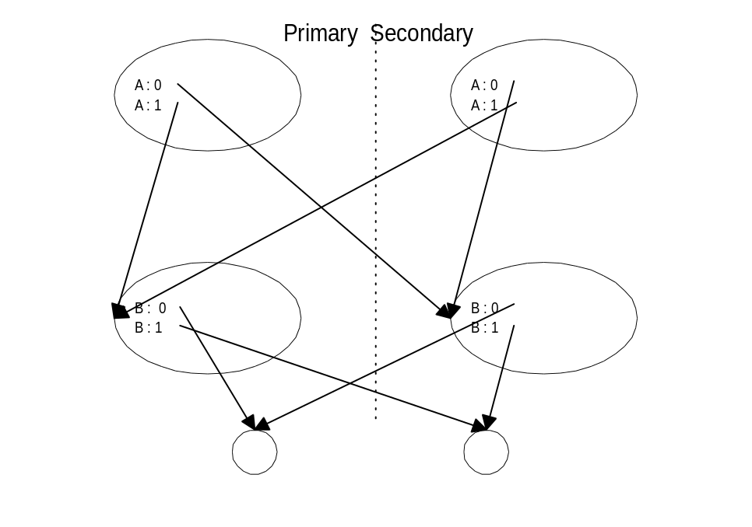
Figure 3. Failure Resilient NamingContexts
To create failure resilient NamingContexts, the kind field can be used in a simple convention of primary and secondary links. In Figure 3, Failure Resilient NamingContexts, a set of primary and secondary NamingContext instances are shown. In this scenario the configured reference “A/B” is used to symbolically refer to an object reference. As you can see, there are multiple paths to this reference: “A : 0/B : 0”, or “A : 1/B : 0.” The second path will be used if the lower primary NamingContext fails.
Both this convention and the handling of the exceptions can be encapsulated into the lookup abstraction that is presented previously.

3.1.4.2.2 Named Reference Abstraction
A named reference is simply an object reference that is acquired by an application by symbolic name lookup using directory services. This reference lookup is made on an instance, or reference, to the directory services themselves, which is provided to the application as well known configuration information.
The resulting object reference encapsulation holds the symbolic name that was used to acquire the reference in addition to the actual reference that was returned by the service lookup. This is a convenience for the application, because if at any time the original reference fails, the named reference encapsulations can be asked to re-resolve the reference to a secondary, that is registered, as shown in Figure 3 as “B : 1.”

3.1.4.3 Global Knowledge Trader Strategy
This section introduces a strategy for using the trader service to abstract the situation in which several distributed application service instances are handling a partition of a global set of information and function.
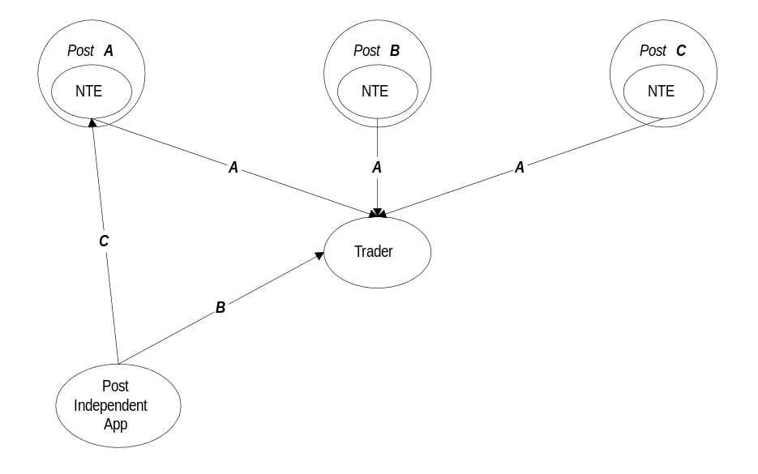
Figure 4. Trader Service Reference Partitioning
Figure 4 presents a scenario that demonstrates the overall configuration strategy to be used in the trading floor or SBT post-centric environment. In this scenario, the service or object reference that is traded represents any post-centric functionality that is duplicated at each post for the purpose of handling that function for the specific set of products that are configured for the post.
What follows is a description of the scenario that is intended to be illustrative of the configuration and use of this type of reference:
- In message A, the DTE exports a service reference by properties that indicate the product symbols serviced.
- In message B, the post-independent application queries the Trader for all service references and their properties.
- In message C, the post-independent application makes an operation invocation on the service reference of Post A, because the properties returned indicated that processing for that product was available at that post.
For this to work optimistically (for example, the post-independent application reads references at startup and not at each invocation), the service interfaces will need to declare and possibly throw an InvalidPost exception. When this exception is received it will indicate that the post-independent application should refresh the references and properties from the Trader. This is a very practical strategy considering that it will only occur in the infrequent case of moving a class/series product from one post to another.

3.1.4.4 Trader Federation
When employing the Trader service in the CBOE system environment, the physical deployment architecture will need to be considered in light of the usage scenarios that are expected in the post-centric environment. This section presents an initial analysis and recommends a deployment architecture for the Trader service.
At its foundation, the post-centric environment is based on a very natural partitioning and isolation of knowledge, the post. The post is responsible for the processing of a set of class/series independent of all other posts. Within a single post environment, the processing and configuration needs will most likely be very dynamic; but external to the post, the partitioning of product sets will remain very stable. Therefore, the post structuring can, and should be, extended directly to the use of the trader in the CBOE environment.
In the same manner, the SBT post-centric environment is based on the premise that in most cases the processing of different product categories (classes) is independent in screen-based trading. The only exception occurs in processing Spread orders involving products in different categories. However, these types of orders very rarely involve products belonging to more than one category. As in the trading floor post-centric environment, processing and configuration needs in SBT will be very dynamic within a single SBT post, but the partitioning of products among SBT posts will remain stable.
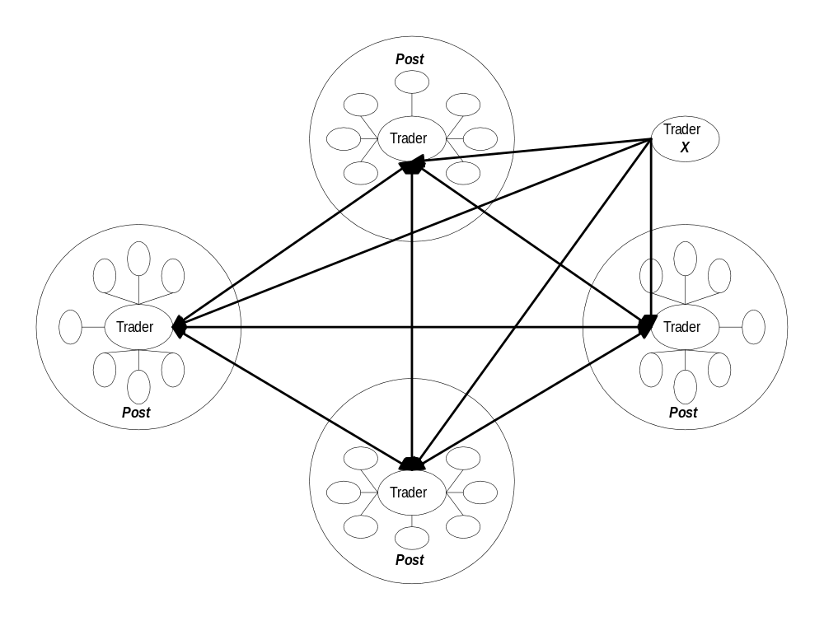
Figure 5. Federated Trader Service Deployment Strategy
Figure 5 depicts the recommended Trader service deployment architecture. The heavy black lines connecting the individual post environments are connected N-to-N through trader federation. This means that an import invocation made on the local trader at a given post will first attempt to resolve the query within itself, and will, if the query is not constrained locally, also include the federated Traders at the other posts. As a result, the information from other posts is transparently accessible through the Trader federation design without the need to explicitly register any post-centric references outside of their local Trader instance.
Note:
It should be noted that the queries that extend outside of the local post environment must be limited to “one hop” in the trader federation to prevent circular and duplicate queries from occurring. This will, in practice, not be a problem as the imports will naturally be constrained to the local post or will want to address all posts that are accessible through one hop.
This arrangement goes beyond interconnecting posts and can naturally include one or more Trader service instances that are installed on the CBOE backbone to provide floor-wide lookup for centralized services such as COMPASS, the new Order Gateway, and the new Booth System.

3.2 Messaging Services
Messaging services provide a mechanism for delivering information without the message supplier having any knowledge of the message consumer. In fact, the message supplier and consumer can be separated by time so that the consumer does not even need to be in existence when the supplier creates the message.
Messaging services provide a type of structuring that is important because it uniquely promotes the decoupling of application processing components and enables incremental evolution of an application with respect to changes in existing and new functionality needs.
In fact, message-driven architectures with fine-grain services enable the flexibility to add services dynamically that are not concerned with other interpretations of the event. For example, a new service could be added that monitors product price changes and informs a customer that the product has reached their price point. Adding this new service would not impact the existing systems response to a price change event.
There are several aspects to messaging services that should be considered in the development of a consistent architectural specification of these services for the CBOE systems environment. This section will:
- specify an abstract service model that will be used in the discussion of each recommended messaging service for the CBOE architecture
- present relevant standards specifications
- present and evaluate the features, qualities, and constraints that are specifically required in the CBOE environment
- specify the recommended service profiles to be used as part of the CBOE architecture
- present abstract usage scenarios for messaging services.

3.2.1 Service Model
This section specifies an abstract service model that will be used in the following sections to examine the need for messaging services at CBOE. This model is composed of the following components:
- Interaction Styles
Provides an overall messaging interaction mechanism for the application that is either a supplier or consumer of messaging information.
- Processing Elements
Details the elements of the messaging service itself, and the way in which these components handle messaging information.
- Subscription Semantics
Provides a description of several tiers of control over subscription to messaging information.
Each of these models is presented in the following sections.

3.2.1.1 Interaction Styles
Fundamentally, there are two types of structural messaging interactions that messaging services can provide to an application. Each of these provides a separate effect on message suppliers and consumers. Therefore, the full list of messaging interaction styles is:
- Supplier Push
The supplier of the message calls into the messaging service when it is ready to provide the message.
- Supplier Pull
The messaging service calls the supplier of the message when it is ready to receive the message.
- Consumer Push
The messaging service calls into the consumer when a message is available to be delivered.
- Consumer Pull
The consumer calls into the messaging service when it is ready to process the next available message.
Each of these styles can exist independently from one another. In other words, the supplier and consumer to the same message flow can select the interaction style that is appropriate to their application processing without affecting the other participants.

3.2.1.2 Processing Elements
The Processing Elements describe the logical components that must be present for the handling of messages within any messaging service. Some of these components are directly related to the supplier of the message, some to the administrator of the messaging infrastructure, and some to the consumer of the message. In this way, the point of influence by each of these roles is clearly defined and can therefore be directly controlled by the service implementation.
The processing elements of messaging services are:
- Distribution
Addresses the supplier’s or administrator’s intentions for the extent to which the message should be made available to the rest of the system.
- Delivery
Addresses the administrator’s or consumer’s intentions for which messages should be delivered to the consumer.
- Message Representation
Addresses the agreed upon transparencies between suppliers and consumers. The transparencies involved are machine representation and native language data type representation.
- Dispatch
Addresses the identity and programming model of the consumer’s native programming language environment (for example, direct method invocation on the registered object in a C++ or Java language environment).
Each of these components is important for providing messaging services to application systems and should be considered part of the messaging infrastructure services. Without providing one or more of these components within the messaging infrastructure services, applications will be required to duplicate this functionality within their system. This is an important point to consider when examining the expense of not building this type of infrastructure.
For example, without the dispatch component, applications are required to provide a structuring model for connecting application specific processing with individual message types. In other words, if a tick on an underlying security is provided to an application as a message, it will be necessary for the application to differentiate the content of the tick message from other possible types of messages and then invoke the appropriate application code to process the message. It is inefficient and error prone to create this structure in each new application because it is most likely common across application systems.

3.2.1.3 Subscription Semantics
It is seldom the case that all consumers should receive all messages in the system. Application components are designed to handle one specific set of message information as an encapsulation mechanism used to reduce the complexity of each individual component. Therefore, messaging services must provide an interface for these application components to express these desires, and a mechanism for enforcing these wishes.
In addition, the messaging service components themselves can benefit from knowledge of the processing requirements of the application by restricting the message flow across the network, thereby achieving decreased congestion and increased efficiency.
The messaging service model specifies three separate levels of subscription semantics that can be used by application and are provided by many commercial products. These are:
- Channel
The channel provides for the structuring of flows of message information across the system. The message information flowing across two channels can be the same in every other property, but they will be delivered to two separate sets of consumers unless they are connected. This is important when two completely identical instances of an application system are running on the same network hardware, as may be the case for development, test, and production systems.
- Type
Within a channel or information flow, many distinct types of messaging information are handled. Each type of information has potentially disparate consumers. Within the context of this architecture, messaging information type indicates an IDL interface where the operations and parameters make up the individual messages.
Because of the interface inheritance possible in an IDL type-based subscription, it is an important tool in system extensibility without the need for system components to either maintain numerous subscriptions or change those subscriptions when a new derivative type of information is added to an unrelated part of the system.
- Filter
Provides the ability to select messages to process based on the content of the message. For example, a type of message may be quotes on options products, but an application (for example, an RCN display manager), wants only to receive quote messages for a specific symbol. Filtering would address this level of subscription.

3.2.2 Standard Specifications
There are three standards specifications that are applicable in providing messaging services for the CBOE Trading Engine Redevelopment and Screen-based Trading projects: the Event Service, the Notification Service, and the Asynchronous Messaging Specification. The third is not strictly a service definition, but is an extension of the CORBA invocation model to include asynchronous messaging semantics for clients and servers of an IDL interface.
It is interesting to note that the Event and Notification services strictly address the point-to-multipoint model for consumers, and the Asynchronous Messaging Specification addresses the point-to-point model for consumers. In addition, the Notification mostly adds to the Event Service specification the notion of filtering. In this way these three specifications follow closely the abstract service model that is introduced above.
This section will introduce each service's specification and functionality.

3.2.2.1 Event Service
The CORBAServices Object Event Service specification provides for two basic abstractions for asynchronous communication: suppliers and consumers. There are two processing models for suppliers and consumers: push and pull. Each model can be used arbitrarily for instances of suppliers and consumers participating in a given interaction. Finally, the connection of suppliers to consumers is potentially an N-to-N relationship.
The pull driven model provides for a polling type of message dispatch driven by the receiver of the message. The push driven model enables an active delivery system that attempts to provide the control flow in the interaction. Fundamentally, the pull model specifies a tendency toward deferring priority in terms of resource optimization. Therefore, the integration architecture must take two different approaches in interface implementation.
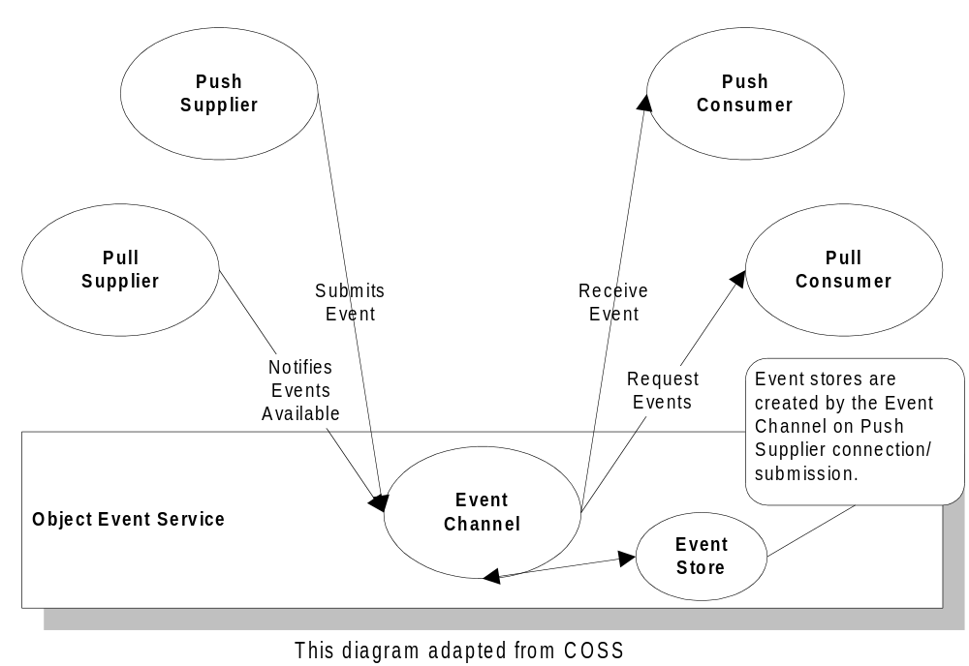
Figure 6. Event Service Components
Intrinsic to both the push and pull driven approaches is a requirement of reliable basic ORB communication. The nature of “reliable” is a moving target based mainly upon the application requirements, but the Integration Architecture is addressed here in its reliable state because that contains a superset of the overall requirements. Figure 6 shows the basic components of the Object Event Service.
There are three basic levels of quality of service for event-based systems:
- Basic Event Activation with Best Effort Semantics
This entails a minimum conformance to the Event Service Interface. The implementation typically makes no guarantees as to the acceptance and processing of the event message by all targets.
- Guaranteed Delivery Semantics
This typically places a greater level of certainty on the reception and atomicity of delivery to all targets. This is typically the minimal level of conformance necessary for distributed applications. The main consideration is whether some piece of information will be irreplaceably lost if the message is not delivered. This level also has assurances that allow adding a logging facility to cooperate in providing strong reliability and recovery characteristics.
- Ordered Causal Message Delivery
This level places responsibility for coordinating information sequencing on the event message delivery system. This in turn reduces the complexity of the process implementation by guaranteeing that all other recipients of the message see it in the same sequence, thereby increasing the assurance of assumptions of the state of other cooperating processes. This means that a process can’t distinguish ordered execution from asynchronous execution, but this relaxation greatly increases the potential for concurrency.
The full definition of the Object Event Service is presented in the CORBAServices: Common Object Services Specification (COSS).
In addition to the simplistic model presented previously that does not define message content semantic, the Event Service specification provides for the concept of typed events. The typed event interfaces provide for the definition of both data content and operation semantic to a single typed event. This means that typed events are defined by IDL interfaces with only one way operations. This is very robust because it provides for the dispatch semantics at the Consumer (in addition to the message content semantics) in a way that allows the ORB core to actively participate in the system. In addition, the system has a very natural mapping to the language environment because of the existing IDL interface binding system.
This provides the background for examining further service definition and implementation considerations. It is important to note that the Object Event Service (OES) provides the basis for both the implementation of other Object Services and monitoring framework for Service Role objects. Therefore, providing implementations of at least the second level of quality of service is necessary for implementing the integration architecture.
As a whole, the CORBA environment is a message-based system, but the overall interaction paradigm is procedural. The Object Event Service adds purely asynchronous semantics to the system architecture. This allows for the Information Object Models to be built with asynchronous semantics and for the continuous improvement of the distributed systems concepts that implement these components. In addition, because the integration architecture separates out the basic failure-free event semantics (the OES) and the failure recovery abstraction (the Recovery/Replication service), the system can be constructed using the failure-free event abstraction, and add or change support for the recovery abstraction later.

3.2.3 Service Profiles
The CBOE Distributed Trade Engine, post-centric processing applications, and SBT system will require two separate messaging service implementations that differ in the delivery semantics: event messaging and message queuing.
They differ in that event messaging distributes messages to all currently attached consumers (this is the model and interface supported by the CORBA Event Service and CORBA Notification specification). Message queuing, on the other hand, delivers messages to one currently attached consumer. This is the model supported by many commercial messaging products.
The required properties of each of these messaging services are examined in the following sections.

3.2.3.1 Event Messaging
The CBOE system possesses several instances of information dissemination where the application system consuming this information is separately developed and maintained. The most common example of this is underlying market data that is being supplied today by the TIPS system. Many applications simply display this information for the user without any further processing. These systems fit the one-to-many model of event messaging, but because of the volume of information that is available, they have strong requirements for the control of message flows across the network hardware. Specifically, these applications must use all of the Subscription Semantics that are presented previously, and the event messaging service must honor these subscriptions in order to avoid flooding the network infrastructure.
In the SBT system it is also critical to control information flows to SBT clients, since the leased lines may have low bandwidth and/or high latency, thus requiring efficient utilization in order to minimize transfer times for high priority messages. In addition to one-to-many event flows, the SBT system also includes many-to-many event flows. One instance is SBT market quotes and last sales, which are supplied by multiple SBT posts and consumed by multiple SBT clients.
To address the need for coordination and control, the abstraction of EventChannelGroups must be created to augment commercial messaging or Event Service offerings.

3.2.3.1.1 Event Channel Groups
The EventChannel abstraction to the Object Event Service provides a minimal amount of configurability of the control of event flows throughout the system, but has no way to differentiate between local and remote traffic. Therefore, an additional abstraction must be introduced to handle this need.
The primary abstraction we introduce is the EventChannelGroup interface. In addition to solving the local and remote bridging problem, it more generally provides an interface to automatically address the composability of EventChannels. The federation problem is solved by possibly incorporating in the configuration of the EventChannelGroup basic network configuration information that allows the automation of these configuration tasks, and for the EventChannelGroup to directly or indirectly control the request-level bridging necessary.
The Event Service specification in COSS provides for basic external configuration of event service through the introduction of the EventChannel object interface. While a supplier generically understands that it must supply its events to an EventChannel object, it does not need to understand the composition of EventChannel objects into chains, because this is largely a reflection of the system’s deployment environment.
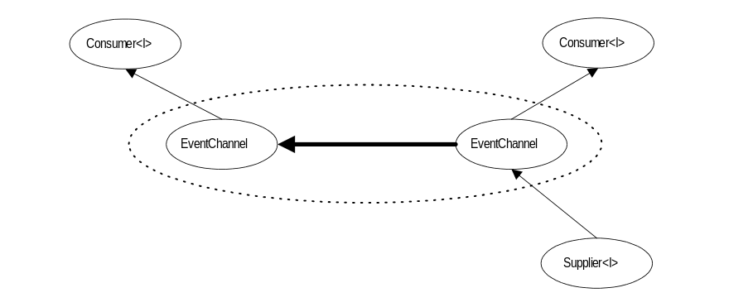
Figure 7. Normal EventChannel Configuration
Figure 7 shows the basic configuration capability present in the Event Service specification. The connection between the two EventChannels provides the events generated from the supplier to both consumers, creating a logical grouping (indicated by the dotted ellipse) of the two EventChannels. Unfortunately, this composition is largely manual and is dependent upon the third party (which is, of course, necessitated by the scalability needs of the system) knowing the nature of the supplier and consumer interactions with each individual EventChannel.
So while the configuration interfaces provided in the EventChannel interface are necessary for administrative composability, it is not sufficient in any but the smallest deployment environments. To this end, the integration architecture provides an important abstraction to service the management needs of both this automated logical composability and the federation issues mentioned earlier—the EventChannelGroup.
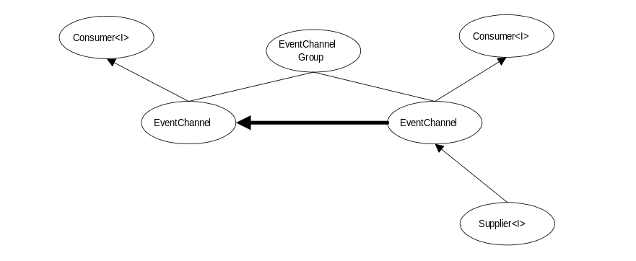
Figure 8. Event Channel Group
The EventChannel interface is composable, and the configuration between two EventChannel objects can be changed. While this enables third party (or external) control of the overall configuration of the event flows in an application system, it is an entirely manual process. In examining the configuration of event flows we can see a limited number of fundamental issues involved in this activity: establishment of bands of event flows and efficient traffic configurations of those bands.
In other words, the bands of event flows can be thought of as groups of event channels participating in the bands, and the traffic consideration is more simply a routing problem. The EventChannelGroup interface defines the semantics of an object that both maintains the membership of these bands and is responsible for establishing the previously manual EventChannel compositions.
The essential behavior of the EventChannelGroup interface is to automatically provide composability of EventChannels simply by their assignment to the group. With the addition of a small amount of deployment network configuration the EventChannelGroup allows us to solve the two basic problems of distribution and scalability: routing and WAN bridging. First, the routing problem is the essence of the automatic composition of EventChannels in large-scale applications. With very little information about the physical network, the EventChannelGroup can make connections between EventChannels in optimal configurations. Second, because the relationships between physical network locations are known, the EventChannelGroup can also provide efficient encapsulation of WAN bridging.
Note:
The basic functionality provides the means and point of control in the CBOE environment to provide for subscription propagation. Subscription propagation simply means that an EventChannel will propagate the subscriptions of its consumers back to its supplying EventChannels. While this functionality increases the overhead of managing the event messaging service, it is required in the CBOE environment to avoid flooding the network infrastructure with essentially useless information.
There are two administrative IDL modules that provide for the externalization of the administrative and configuration management of a system.
- The EventChannelGroupAdmin module that introduces the concepts important to the implementation of the EventChannelGroup interface.
- The EventServiceAdmin that introduces several interfaces for the management of the basic components of the Event Service model.
Together these modules provide the configuration facilities necessary to provide an almost complete separation of the object models of the information architecture from the system scalability and distribution concerns.
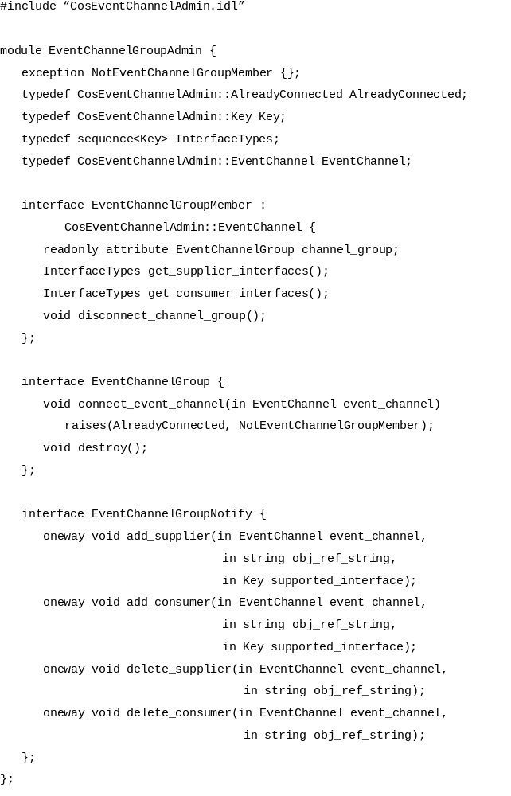
Figure 9. EventChannelGroup IDL Definition
Figure 9 presents the IDL specification of the interfaces necessary to support the EventChannelGroup abstraction. This abstraction is composed of three interfaces, the EventChannelGroup, the EventChannelGroupMember, and the EventChannelGroupNotify. Each carries out a role in the overall EventChannelGroup management protocol. This protocol actively manages the configurations of the individual EventChannels to optimize the routing of messages to only the transmissions necessary to reach all Consumers from all Suppliers that support a given interface (for example, events of a particular type are not sent to an EventChannel if it does not have Consumers registered for that event type).
The EventChannelGroup object coordinates the active routing protocol by establishing connections between EventChannels in the group based on the registered needs of their Suppliers and Consumers. The EventChannelGroup interface contains operations for arbitrary third parties to register EventChannels into its control. Upon registration the EventChannelGroup attempts to provide connections to the other EventChannels in the group.
The EventChannelGroupMember represents a specialized EventChannel that can participate in the active routing management protocol carried out by the EventChannel by providing operations for the EventChannel to use to determine the optimal connections to make. For example, if a specific EventChannelGroupMember is not a registered Consumer for the interface type X, and suppliers to some other EventChannelGroupMember does supply for interface type X, a connection does not need to be created to transmit those events.
The EventChannelGroupNotify interface represents notifications of changes to the Suppliers or Consumers at a particular EventChannel to the EventChannelGroup. This enables the EventChannelGroup to synchronously receive the information needed to dynamically manage the routing of events to maintain an optimal configuration. The EventChannelGroupMembers use the basic TypedEventChannel interface to register as Suppliers for this interface to the EventChannelGroup object.

3.2.3.2 Message Queuing
The second messaging service profile that is needed at CBOE is a message queuing system. There are several specific instances where the one-to-one delivery semantics of a message queuing service will be needed. Examples of these uses are:
- quote submission to the trading engine from vendor, manual, and Autoquote quote supplying systems.
- Trade information from multiple posts will need to be delivered reliably to CTM.
- As an adapter at the post for the Autoquote system for processing underlying ticks from the event messaging system.
In addition to the uses mentioned previously, The SBT system also presents a number of other one-to-one reliable messaging uses:
- Order and Market-maker quote submission from an SBT client to the corresponding SBT Post.
- Trade notifications from an SBT Post to the originating SBT client.
It is essential that the messaging service delivers these messages in strict chronological order.

3.2.3.2.1 Queue Semantics
In addition to the standard first in, first out (FIFO) queuing semantics that every messaging product provides, CBOE system components will need to have some very specialized features. In the case of both the quotes to the trading engine and underlying data to the AutoQuote system, the message queuing service will need to provide essentially last in, first out (LIFO) queuing. This LIFO queuing will be controlled by filtering for equality on the symbol for the underlying tick or the quoted option and overlaying any undelivered messages.
This is a common capability that is needed in the CBOE system environment beyond these two examples.

3.2.4 Usage Strategies
Fundamentally, any system of cooperating components must have their interactions structured in a procedural paradigm or a discrete event based paradigm. Because of the basic weakness of the event paradigm for failure recovery, the use of events must account for these potential failure states. The choice of events over a procedural paradigm must be based on the following factors:
- Potential Cooperative Parallelism
Can the problem be reduced to smaller isolated segments? If so there is a potential to arrange cooperating components so they each independently receive a triggering event they then process on their own time, freeing the originator to carry out another task.
- Dynamically Changing Configuration
If the problem contains many discrete activities that are each acting on the same information, and the presence or absence of an activity is dependent upon dynamic configuration information, you can benefit from an event based paradigm. Coordinating the required discrete activities is difficult to manage at the time of generation of the information. This is the case in a procedural implementation of this system. In the event case the information is supplied to the system as an event and independently delivered to all registered consumers. Each discrete activity can then be responsible for understanding if it is currently configured into the system, which results in much less complex implementation code. This is due to the complete lack of regard for the ultimate consumer of any given event in the system
- Tolerance to Failures
The ability of a procedural system to recover in the face of a process failure is assured by the application of the OTS coordination. In the case of event-based systems, the ability to ensure efficient recovery from a failure is dependent upon the nature of the problem itself. If the problem is deterministic, or will yield the same results if execution is played back by the same sequence of actions, then simple logging provides an assured recovery mechanism.
The following examples clarify this by demonstrating the potential trade-offs between these factors.
- Bank Deposit
Register beginning of federal reserve processing, update individual's account balance. Must maintain ACID properties at all times because other system components are dependent on these and must view them as isolated updates. In this case the use of messaging to coordinate this type of processing is not optimal. The necessity of isolating both the updates until they are complete is not possible with a message driven system.
- Distributed Directory Changes
Notifications for optimization, otherwise normal procedural processing. This scenario works well as the messages will possibly eliminate extraneous processing if the message is received before a query is made, otherwise it would function as if the notifications never took place.
- System Monitoring
Messaging is used to capture application component status and errors throughout a set of application systems. This scenario works because the processing overhead of procedurally notifying the system management components is in most cases unacceptable.
The remainder of this section discusses several specific strategies for using messaging services in the CBOE system environment.

3.2.4.1 Configuration Propagation
Because the processing of CBOE systems is expected to continue to be distributed, there is some amount of shared information upon which the components make decisions. This information, such as active product class and series or member attributes, is controlled centrally from trading operations. It is not possible, for reasons of efficiency, to have all applications processing components from within each post access this information from one data storage centralized source. Therefore, each system component must possess current copies of this information in order to carry out ongoing processing.
In this circumstance, the following figure presents a generalized architecture for handling this information.
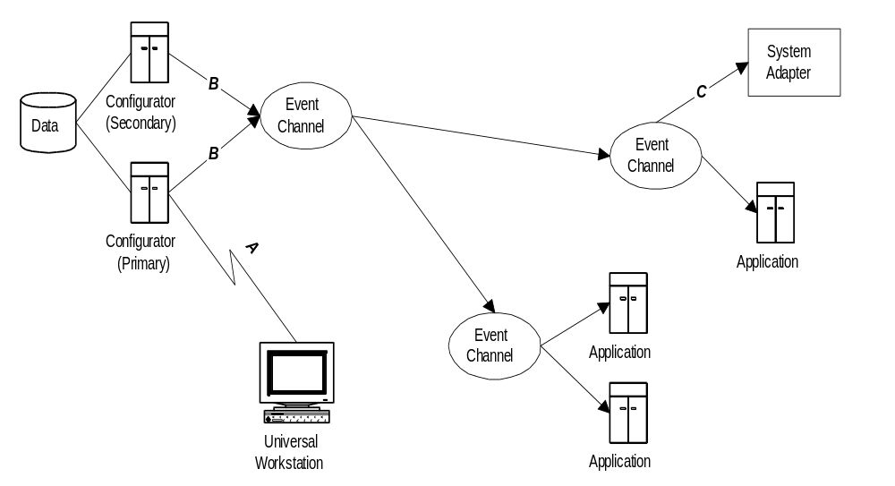
Figure 10. Configuration Propagation Architecture
Figure 10 presents the architecture for building configuration information management and a dissemination system for that information. The individual components are as follows:
- In message flow A, a universal workstation interacts with the configuration application system point-to-point to create, read, update, or delete individual elements. This workstation could be located anywhere in the CBOE system environment.
- In message flow B, the configuration application system sends a message to the event messaging system that makes the change available across the system. Individual system components act on the change of configuration, most likely storing it for future processing.
- In message flow C, the event messaging system delivers the change message to an adapter that subscribes just as any other consumer in the system. This adapter can directly call some external system interface to hand off the information or store it locally and create a tape of the consolidated information sometime later.

3.2.4.2 Information Dissemination
A second recurring category of message processing in the CBOE systems environment is dissemination of constantly changing data regarding equities and other underlying interests upon which options are based. In addition, information about the constant change in state of trading within the exchange is provided to a variety of systems for everything from display to decision making support.
The systems that use this data have a very well defined structure that is a natural extension to the event messaging infrastructure components. This is the ability to bootstrap themselves with the most current information, when they are starting up or recovering from a fault. This capability is essential because while there is a constant flow of this type of information, it is not periodic with respect to the symbol of an options product.
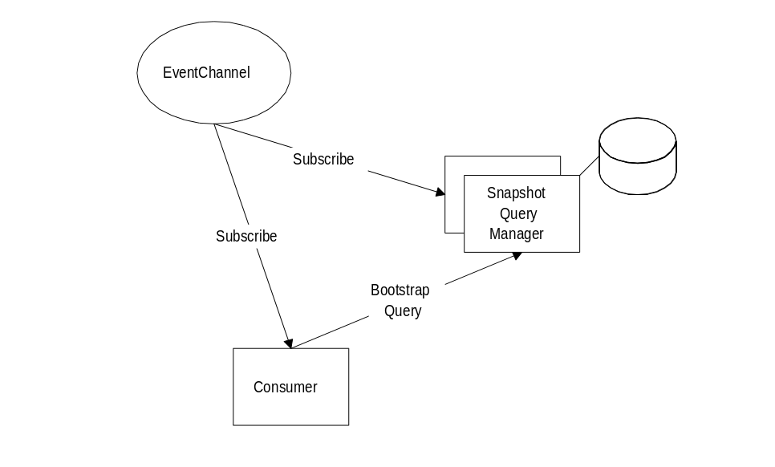
Figure 11. Snapshot Query System
An arrangement for providing this generic functionality is depicted in Figure 11 Snapshot Query System. A special consumer, the snapshot query manager, is attached in the locality of some set of consumers. It receives events just as the intended client of the bootstrapping function does. As a result, when a standard application is starting up, or recovering, it will subscribe to the event messaging system and contact the snapshot query manager and issue a point-to-point request for the current information. From this point on it will operate solely from the event messaging system.
Note:
It is important to note that the snapshot query manager must be constructed as a primary/secondary application so that it will not lose state in the case of a failure. This is particularly important in this case because the standard application system components are counting on it for their recovery.
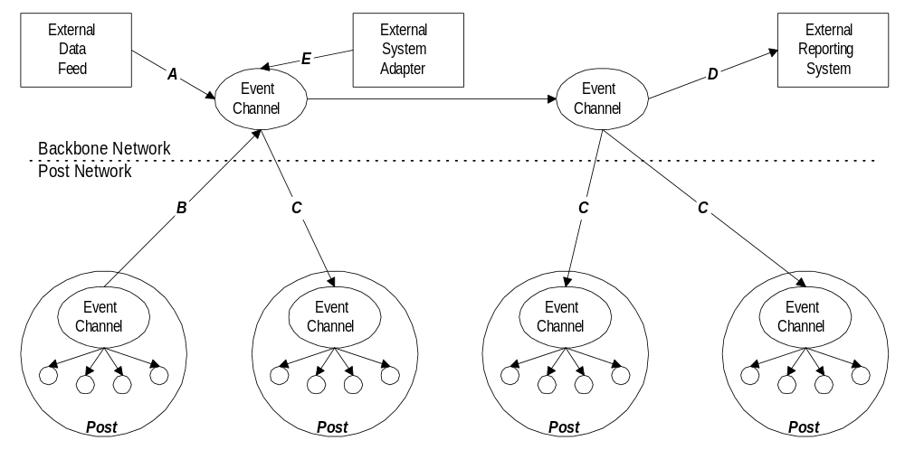
Figure 12. Dissemination Backbone Architecture
In addition to providing a recovery environment for the information dissemination strategy, an architecture must be put in place for controlling this dissemination across the whole multi-post environment. Figure 12 Dissemination Backbone Architecture, presents the various elements of this approach. It should be noted that what is presented is a hierarchical arrangement of EventChannels that reside on the post networks and the backbone network.
The following present these elements in terms of the message flows that will be present in the system:
- Message flow A presents the input of a data feed provided externally to the CBOE system environment. This external system is not post-centric and therefore enters the event messaging infrastructure through the backbone network.
- Message flow B depicts post-centric information, such as last sale in the DTE environment. This information is configured for global distribution and therefore is propagated by the post EventChannel to the backbone network. This information will be distributed throughout the backbone network, but will only be propagated down to other Post environments if some application element has subscribed to it.
- Message flow C shows the propagation of information that is flowing on the backbone network, only if the post environment has subscribed with interest. As presented in the section entitled “3.2.3.1.1 Event Channel Groups,” this subscription propagation is automatically controlled by the EventChannel Group component of the event messaging system.
- Message flow D presents a non-post-centric system that is external to the CBOE system environment, such as COPP or CTM. These systems collect certain types of information from all post environments which is naturally propagated up to the backbone event messaging components.
- Message flow E shows a migration option for TPF broadcast, such as last sale, etc., to be adapted into the new message dissemination architecture and to be available to the Posts while they are being migrated.

3.3 Transaction Services
Transaction services are focused at providing two-phase commit style processing in a distributed system environment. This should be considered distinct from, but complementary to, the two-phase commit mechanisms implemented in most database management systems.
Under this definition, neither the Trading Engine Redevelopment nor the Screen-based Trading projects present a compelling case for utilizing transaction services. As a result, this section will present the conceptual elements of transaction services, but does not go into detail because this functionality is not required.

3.3.1 Service Specifications
There are three relevant standards specifications that address distributed transaction management: Distributed Transaction Processing (DTP), Object Transaction Service (OTS), and OSI Transactions. The first two specifications are directly aligned, as OTS is almost entirely an objectization of DTP integrated into CORBA. The latter specification is not generally used outside of specialized environment such as OSI network management.
As a result we will present a description of the OTS specification.

3.3.1.1 Object Transaction Service
The Object Transaction Service (OTS) specified in COSS provides the core component for developing reliable large-scale distributed object systems. The concept of transactions is an important paradigm for simplifying the construction of these systems by providing external guarantees of atomic update across multiple objects, and removing the burden of supporting atomicity from the object implementations.
The OTS specification closely follows the X/Open Distributed Transaction Processing (DTP) Reference Model, which details a family of specifications, and basically provides a two-phased commitment protocol with presumed abort semantics. However, while following the DTP, the OTS goes further toward simplifying the construction of distributed systems by integrating transactional processing within the object paradigm. In particular, this means that a transaction can be used to coordinate non-durable activities that do not require permanent changes for storage.
Two-phase transactional coordination and behavior is a well-established paradigm for simplifying the development of reliable application solutions. A transaction is a coordinated activity that possesses ACID characteristics: atomicity, consistency, isolation, and durability. All but the last is directly supported by the OTS specification. Durability is defined as the effects of the transaction are persistent and are never lost (except in catastrophic failure). While an implementation of the OTS must support this characteristic, the durability of an application transaction depends upon the use of persistent data services to coordinate this characteristic.
Fundamentally, the Object Transaction Service provides operations to:
- “control the scope and duration of a transaction
- allow multiple objects to be involved in a single, atomic transaction
- allow objects to associate changes in their internal state with a transaction
- coordinate the completion of transactions.” [COSS, pg. 244].

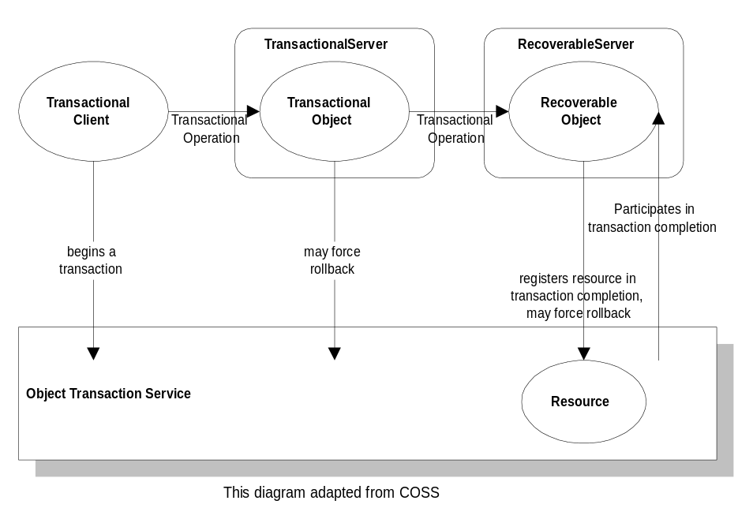
Figure 13. Object Transaction Service Elements
Figure 13 details the basic components of the OTS, which together provide transparent integration of transaction facilities with a unified interface for carrying out transaction operations. Basically, there are three components of this model: the client; the transactional object; and the Resource object. The client sets the top-level transactions boundaries and can request the transaction to be terminated or committed. The transactional client is both the transactional object and the recoverable object in the diagram above and may force rollback. The main difference is that the transactional object is simply aware of the transaction, and the recoverable object participates in the two-phase commit protocol by registering Resource objects. Finally, the resource object implements the two-phase commit protocol driven by the transaction service.
The transaction service provides for two transaction models: flat transactions and nested transactions. The difference in the semantics of the two models is straightforward; the nested model is a superset of the flat model. The nested model provides for fine-grained control over the isolation of failures with the introduction of sub-transactions, or child transactions, that can be individually recovered and retried while preserving the ACID properties of the parent transaction. An implementation of the OTS is required only to support the flat transaction model.

3.4 Security Services
Security Services are aimed at controlling and monitoring access to the resources of a set of distributed systems. This capability is becoming more necessary as networks use “open” technologies, and provide more direct customer access into corporate information systems. Specifically, security services address the following aspects of systems security:
- Authentication
Provide for the secure and reliable identification of users and empowered system components.
- Authorization
Provide for the specification and enforcement of access rights to system resources based on individual identity or group identity.
- Information Integrity
Provide for the assurance of the accuracy of transmitted information (for example, preventing tampering, etc.)
- Information Confidentiality
Provide for the secrecy of the transmitted information from non-authorized use.
- Non-repudiation
Provide for the reliable and provable recording of actions taken within the system.
Each of these areas should be reexamined periodically in any system to continuously assess the risks to which a corporation is exposing itself. In the case of CBOE, security risks have been largely handled through physical security. Nevertheless, in a screen-based trading world, physical security is no longer possible, since SBT client workstations can be located virtually anywhere in the world, out of the direct physical control of CBOE. Without proper security mechanisms in place, SBT workstations may act as entry points to CBOE’s network, opening up the gate for external attacks.
CBOE has decided to use leased communication lines in an effort to (among other reasons) limit the security threats arising from allowing external connection of SBT workstations. However, it is important to note that even in this case, there is still the potential for intrusion into CBOE systems from anyone with direct physical (or indirect via a corporate network) access to a SBT workstation. Some examples of the security threats that CBOE would potentially face with the introduction of screen-based trading, even utilizing leased lines, are:
- a user of the system gaining malicious or accidental access to information that should be hidden
- someone invoking operations on the system without authorization
- someone impersonating an authorized user of the system in order to perform actions, and have these actions attributed erroneously to the authorized user.
Furthermore, if a member’s SBT workstation is not physically connected to the leased line but instead is connected indirectly via a corporate network, there are additional security risks:
- someone eavesdropping on the corporate network to gain access to confidential information
- someone tampering with the messages while in transit through the corporate network, in order to alter their contents.
Notwithstanding the decision of employing leased lines for SBT workstation connectivity, CBOE should monitor the evolution of the Internet to assess if and when to employ it. Currently, although the Internet is the cheapest and most pervasive connectivity technology, it suffers from considerable security, latency, and reliability problems. These problems make its use unacceptable for conducting screen-based trading. Nevertheless, as Internet technology continues evolving at a rapid pace, we can expect tremendous improvements in the near future that will probably change this situation.
In summary, the introduction of screen-based trading in CBOE requires a complete rethinking of the current physical security scheme and the deployment of stronger security mechanisms to protect CBOE and its members.
An important point worth noting is that an Object Security Service by itself is not sufficient to protect CBOE and its members from all the security threats resulting from external accessibility through leased lines. It is also necessary to restrict access to only a particular subset of SBT server components, concealing all other resources in CBOE’s network. Firewall technology is used for this purpose. For this reason, a subsection discussing firewalls has been added to this section.

3.4.1 Security
This section presents object security service specifications; available and required features, qualities, and constraints; firewalls; and usage strategies for the CBOE environment. The last section discusses possible areas of risk in the current trading floor-only environment that CBOE will need to further consider.
Security in a distributed object system must fundamentally provide for the controlling and administering of identity and the organization of objects deployed throughout the system into domains. In addition, the management of these two issues requires an Object Security Service (OSS) which must provide for the interaction and cooperation with the underlying security system of the user's environment. This enables the OSS to provide a policy-based protection that will not be individual to object instances or even implementations in the system.
The OSS specification allows almost complete flexibility for the underlying security scheme, whether it is Access Control List (ACL), capability or label-based. The specification provides sufficient guidance in the formation of operating environment and technology engine strategies that directly integrate into the OSS functionality in the distributed object systems environment. Note that the interfaces specified are security mechanism neutral and can be implemented using a wide variety of security mechanisms and protocols. As a result, implementation of this service specification will need to determine the most appropriate underlying technology base for this capability.
A technology engine chosen to provide a security function in the distributed object system must meet or provide integrations to other products that meet the integration points for carrying out all the functions of the OSS. These functions must be able to be used in an encapsulated fashion where each is an isolated activity and be driven as such by the OSS implementation. The integration points, or functions, needed for the OSS are briefly detailed in the following list:
- Principal Authentication
The engine must have the generic concept of a principal, or a user (human or object) which needs to operate under his or her own rights. The verification of principals is outside of the OSS specification, but the technology engine must provide for this verification and provide the OSS the abstraction of that principal for future engine interactions.
- Security Association among Client and Server
The ORB must be able to have the OSS validate the security implications of establishing an association between a client and a server for request invocation. This must be carried out using the abstract concepts of principal identity and privilege attributes, and control attributes of the target of a request.
- Message Protection
This allows the target to be the only recipient of the request message and includes the concepts of integrity protection and optionally confidentiality protection.
In addition to the requirements for the technology engine, the OSS specification gives guidance on the requirements for building secure ORB implementations. This is achieved by first minimizing the actual security-related decisions that the ORB must carry out, and instead requiring that the ORB interrogate the OSS implementation for the security decision. Second, the OSS specifies these interactions as boolean results on secure information managed by the service.
The overall reference model of the OSS is based on access decision functions. The OSS access decision functions base authorizations of request invocations on access control rules. These access control rules are based on privilege attributes of the principal or client acting on his behalf, control attributes of the target, and contextual information about the invocation, such as the operation, data, and possibly the time of invocation. The OSS specification provides direct abstractions for these entities.
The OSS specification provides for the two types of accountability: auditing and non-repudiation. The OSS specification includes interfaces to manage security policies and defines three Common Secure IIOP (CSI) profiles for “out-of-the-box” secure ORB interoperability.
The OSS specification defines the provision of security in a distributed system with and without application involvement. The OSS always enforces security policies, but optionally allows security-aware application components to modify their own security environment to achieve finer control, for example, when making access control decisions based on the contents of a request.
Conformance to the OSS comprises the following aspects:
- Main Security Functionality. There are two possible levels of conformance:
- Level 1: Provides basic security for applications unaware of security or for those with limited requirements to enforce their own additional security concerning access control and auditing.
- Level 2: Provides additional security features to allow applications to control security at object invocation. It also includes administration of security policies.
- Security Functionality Options. These are optional common security functions that do not merit inclusion in one of the levels defined above. Currently, the only function in this category is non-repudiation.
- Security Replaceability. This specifies if and how the ORB fits with different security mechanisms. The ORB must conform to the following two options to allow replacement of either the standard security policies or the implementation of security mechanisms:
- ORB services replaceability. The ORB calls interceptor interfaces, including security ones, in the order specified.
- Security service replaceability. The ORB may or may not use interceptors, but all calls on security services are made via replaceability interfaces defined in the OSS specification. These interfaces are designed such that the security mechanisms need not know about the functioning of the ORB, thus permitting their replacement.
- Secure Interoperability. There are two levels of conformance:
- Secure Interoperability – Standard. An ORB conforming to this level can interoperate securely with other conforming ORBs using the GIOP/IOP protocol with the security enhancements (SECIOP)
- Standard plus DCE-CIOP Option. An ORB conforming to this level can interoperate securely with other standard conforming ORBs and also with DCE Security-compliant ORBs using the DCE-CIOP protocol.

3.4.2 Features, Qualities, and Constraints
Security requirements vary widely for different environments. Therefore, the OSS specification provides a framework for accommodating many different security schemes (each one characterized by a set of security policy types), employing a variety of technologies and protocols, as opposed to a single security scheme supported by a fixed set of technologies. CBOE’s particular security needs demand a specific set of security policies supported by appropriate security technologies.
This section has two goals. First, to survey the range of features, qualities, and constraints that an OSS implementation can offer. Second, to indicate, whenever possible, which of these features, qualities and constraints CBOE’s particular OSS implementation must posses in order to support CBOE’s required set of security policies. The next section, Usage Strategies, adds more specific features, qualities, and constraints necessary to support CBOE’s usage strategies.
The features, qualities, and constraints identified for CBOE in these two sections will guide the selection of the particular security technologies and protocols used in implementing the OSS.

3.4.2.1 Security Domains
A security policy domain, or security domain for short, is a set of objects to which a security policy applies for a set of security related activities and is administered by a security authority. The policy represents the rules and criteria that constrain activities of the objects to make the domain secure. Security policies concern access control, authentication, secure object invocation, credentials delegation, auditing, and message integrity and confidentiality.
Security domains may be defined at different levels of granularity, from individual instances of an object (a rare example) to large sets of related objects.
Security domains address the problem of scale in security policy administration, by allowing policy enforcement at domain granularity rather that object granularity.
Security domains may form hierarchies to allow delegation of security administration. These hierarchies normally reflect organization hierarchies. As well as being structured into superior/subordinate relationships, security domains may also be federated. In a federation, each domain retains much of its authority, while agreeing to grant other domains limited rights.
Not all policies have the same scope. For example, certain access control policy may apply to a set of objects while certain message protection policy applies to a different, although possibly overlapping, set of objects. In these cases two, possibly overlapping, domains are defined, one for scoping each policy.
As is further detailed below, there are two kinds of security policies: system-enforced and application-enforced. System security policies are enforced cooperatively by the ORB, security service, existing security mechanisms and operating systems. These policies are applied to objects whether or not are security-aware. Application security policies are enforced by the application themselves and allow finer control than that provided by system security policies.

3.4.2.2 Authentication
An active entity must first establish its identity to issue a request in a secure distributed system. An active entity is either a principal or a client acting on behalf of a principal. A principal can be either a human or an object that is authenticated once by the system and given a set of credentials. Credentials include identity and privilege attributes. Identity attributes include the principal’s authenticated ID as well as other pieces of identification information.
The authenticated ID is used for the following purposes:
- make human users accountable for their actions
- let a target object determine which specific services it can provide to a client
- uniquely identify the originator of a request
- determine who to charge for a specific service
- serves as an additional privilege passed by a target object to its delegated objects.
Typically, only principals are authenticated to ensure that they are who they claim to be before allowing access to a target object. However, in certain situations, a principal may also want to make sure that the target object it is dealing with is the real one, not an impostor. This scenario commonly occurs on the Internet, where a principal, for example, wants to make sure that he is making a credit card payment to the right merchant.
There are three main methods for principal authentication:
- What you know – ID and password
- What you have – physical key or security pass, for example an ATM card
- What you are – voice recognition, fingerprints, retina analysis.
In the monolithic mainframe world, using IDs and passwords is an adequate authentication method. In the distributed systems world, however, where computers communicate over insecure networks, it is not advisable to transmit passwords that can be easily captured for subsequent user impersonation. Stronger authentication methods based on cryptography are required.
Kerberos is the most commonly used authentication method based on private key cryptography. The Kerberos Authentication System uses a series of encrypted messages to prove that a client is running on behalf of a particular principal. Though conceptually Kerberos authentication proves that a client is running on behalf of a particular principal, a more precise statement is that the client has knowledge of an encryption key that is known by only the user and the authentication server. In Kerberos, the principal’s encryption key is derived from and should be thought of as a password.
Kerberos is a powerful security technology, however, it requires libraries on the client. For this reason, Secured Sockets Layer (SSL), a lightweight alternative, is becoming increasingly popular, particularly for Internet applications. In addition to authentication, SSL provides session privacy and integrity. SSL is described in more detail in the upcoming Security of Communication subsection.

3.4.2.2.1 Public and Private Key Cryptography
Authentication methods based on cryptography are classified basically into those using private keys (symmetric key cryptography) and those using private keys (asymmetric key cryptography). Private key cryptography uses the same key for encrypting and decrypting the data. Public key cryptography, also known as PKC, uses two keys, one for encryption and one for decryption.
A traditional method for achieving data privacy (while it is in transit or placed on a storage media) is by encrypting it. This objective is usually achieved by employing a symmetric encryption key. The problem with this approach deals with the transportation of the encryption key that has to be provided at the destination. The key must be transported through another secure medium that makes the approach less workable.
Public key cryptography solves the key transportation problem by providing two keys—a private key and a public key. The keys are a matched pair. Any data encrypted by the public key can only be decrypted by the corresponding private key. The parties involved in the data transfer freely publish their public keys to anyone who wishes to send them data. This data can be decrypted at the destination using the private key, which is never be transmitted across the Internet.
A rudimentary solution for non-repudiation can also be provided. Using a one-way function, which is signed by the sender’s private key, creates a hash of the document (also called a message digest). Therefore, the sender constitutes a digital signature. The signature can be verified at the other end by using the sender’s public key, and comparing the hash value thus obtained with the actual computed hash of the data. A match of the two values implies data integrity and authentication of the source.
Although public key cryptography solves the problem of transporting the key securely, it also introduces a problem of its own. The performance of PKC is quite slow and encrypting large amounts of data is time consuming. There are some hybrid approaches utilizing both public and private keys that overcome the performance problem such as Pretty Good Privacy™ (PGP)
Although PGP and PKC solve the privacy problem, the authentication problem still exists. To some extent, the question of how to ensure the data came from the person who claims to have sent it can be answered by digital signatures, but the possibility that a person published a fake public key is still viable. A certain level of guarantee is desired that the public key conveniently available on the Internet does belong to the proper individual. The certification authorities (CA), that issue digital certificates to the end users, provide such guarantees. The digital certificate contains a person’s public information such as name, address and the public key duly signed by the CA’s private key. It is the responsibility of the CA to ensure the person’s authenticity before issuing the certificate. One such certification authority is Verisign (http://www.verisign.com). However, large companies have the option of setting themselves up as a CA and issuing the certificates to their clients. Such companies merely need to obtain one certificate for signing the end user certificates from a higher-ranking CA.

3.4.2.2.2 CBOE Authentication Requirements
In CBOE, a trader is not allowed to trade in the open outcry and screen-based environments simultaneously. There are two aspects that make using a password as the authentication mechanism not adequate to prevent simultaneous trading. First, the trader may give his password to another person and continue trading in a trading pit. Second, CBOE systems cannot verify the physical presence of a trader in a pit so that they could detect simultaneous use of the same user ID.
An alternative mechanism to work around this problem is to use the trader’s badge as a key that must be inserted in a reader attached to an SBT workstation in order to use the SBT system. This badge may be as simple as a magnetic card or as sophisticated as a smart card. The decision depends on the level of security required. A smart card is substantially more secure than a magnetic card.
A particular requirement of the SBT system is to ensure that a trader can trade only as long as his or her badge continues inserted into the reader. To support this requirement, the authentication mechanism needs to invalidate the trader’s privileges as soon as the badge is retired from the reader. Alternatively, it may check the card presence every time the trader initiates a security-sensitive activity.
SBT requires only client authentication—the SBT system needs to make sure that it is dealing with a legitimate SBT user, on the other hand, a user can be sure it is dealing with the legitimate SBT server component.
Since it is not a problem to distribute private keys securely to SBT users, it is possible to use private key encryption to digitally sign security-sensitive message so that recipients have certainty a message came from a properly identified principal.
A smart card (also serving as a badge) can be used to store a private key encrypted with a password. In this way, a SBT user could move to another SBT workstation without leaving his encrypted private key in local storage, thus preventing key stealing. In addition to simplifying authentication, using private key encryption reduces the overhead of providing data integrity and message privacy.
Kerberos is an appropriate technology for user authentication for SBT because it supports client authentication and private key cryptography.

3.4.2.3 Authorization
While authentication establishes who the principal is, authorization establishes what the principal is allowed to do given he is who claims to be.
The unit of activity in a distributed object system is an object invocation. In an object invocation, a principal (or a client acting on its behalf) sends a request to a target object to cause an operation to be executed.
Security policies dictate the security functions performed during object invocation. Typically, these security functions are:
- establishing a security association between client and target object so that each one has the trust that the other is who they claim to be
- deciding if the client can invoke the operation on the target object according to the access control policy
- auditing the invocation according to the auditing policy
- protecting the request and response from unauthorized modifications and eavesdropping while in transit, according to the specified quality of protection (QoP).

3.4.2.3.1 Privilege Attributes
A principal can have a number of privilege attributes. Privilege attributes are used to decide which resources (normally encapsulated in target objects) the principal (or a client acting on its behalf) can access. Typical privilege attributes include:
- The principal’s access identification.
- The different roles the principal can play in using the system. Examples in the CBOE context are trader, market-maker, administrator, and so forth.
- The groups the principal belongs to. These groups normally correspond to organizational units. Some groups identified in the SBT system include member firms, CBOE staff, market-makers, and clearing firms.
- Capabilities. These define the target object or group of target objects, and their operations that the principal is allowed to use.
- Other privilege attributes that the organization considers useful in controlling access to resources. Some CBOE specific privileges associated with a trader role are, for example, maximum trading volume, set of assigned series, et cetera.
- Constraints on the validity of the privileges, for example, the time period during which the privileges are valid or the maximum number of object invocations the privileges are good for.
Security policies define how security attributes can be acquired:
- Some attributes may be available to any principal without authentication
- Some attributes are acquired through authentication; these include the identity and privilege attributes mentioned at the beginning of this section.
- Some attributes may be acquired from other principals through delegation.

3.4.2.3.2 Access Control
The OSS defines a two-layer framework for controlling access during object invocation. One layer is an object invocation access policy, which is enforced automatically on object invocation by the ORB. The other layer is the application access policy, which the application itself enforces.
The object invocation access policy determines whether a principal (or client acting on its behalf) can invoke the requested operation on the target object. The ORB (in cooperation with the Security service) enforces object invocation access policies on all objects automatically, whether they are security-aware or not. This means that object invocation access policies can be added to a system without any modification to application code.
The application access policy is enforced by the client and/or the target object. This policy is aimed at fine-tuning access control to the target object’s functionality or data.
Enforcement of access control policies is based on access decisions in several points during object invocation as shown in Figure 14. Access Decisions.
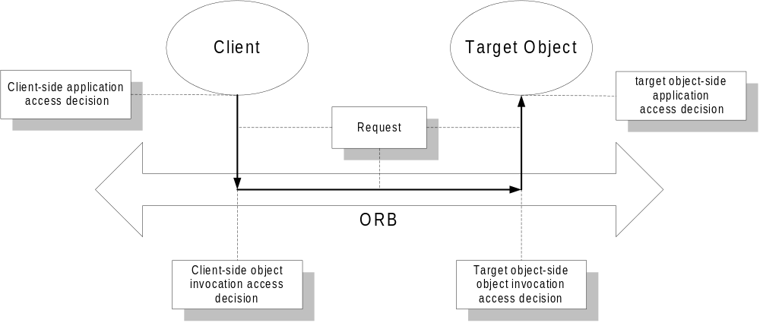
Figure 14. Access Decisions
Client-side access decisions define the conditions under which the client can invoke the operation on the target object. Target object-side access decisions define the conditions under which the target object accepts the request from the client. None, one or both sides of the access decisions may exist for any given client-target object pair. All access decisions return a boolean result.

Object Invocation Access Decisions
In addition to the identity attributes of the client and the target object, access decisions on object invocation is based on:
- The current privilege attributes of the client. Note that some of these may have been acquired from a principal through delegation.
- Any constraints on these privileges, for example the time for which they are valid.
- Security clearance or authorization level.
- The operation to be performed.
- The access control attributes of the target object.

Application Access Decisions
Applications may also enforce access policies. An application access policy provides finer control than the object invocation access policies enforced automatically by the ORB. Finer control may include further restricting the use of an operation on the target object or the data that is made available to a client.
Application access decisions may be based not only on the client and target object’s security attributes, but also on the values of the parameters passed on the request as well as on any other information such as the time of the request.
As is the case of object invocation access decisions, application access decisions may occur on the client-side, target object-side or both.

Access Control Attributes
Access control attributes are associated with the target object and depend on the specific access control scheme utilized. The most common and flexible access control scheme is Access Control Lists (ACLs).
An ACL contains a list of associations between privilege attributes and access rights. A right is a group of related operations. For example, in the case of CBOE, an association might be defined between the market-maker role and the “quote” and “book depth” rights. The “quote” right, in turn, would contain the operations for entering, canceling, and replacing quotes. This scheme is very flexible and appropriate for the SBT system.
There are other less flexible and popular access control schemes such as Capability Lists and label-based schemes.

Granularity of Access Control
A typical distributed system has a large number of users and thousands, if not millions of objects, each with many operations. Defining and maintaining access control policies for each one of them would be an administrative nightmare and a serious barrier for scalability. Therefore, grouping constructs are an absolute necessity. The grouping constructs used in the OSS to enable security management in large-scale systems are:
- Subjects (principals or clients acting on their behalf) are grouped using privileges such as roles and groups. This eases the administration burden when a new user is added to the system, for example.
- Objects (target objects) are grouped using security policy domains.
- Operations on target objects are grouped using rights.
There is a classic trade-off between granularity of control and cost in the form of administrative burden, performance penalty and limited scalability. The coarser the level of access control, the less administration, the lower the performance penalty and, consequently, the higher the scalability. On the other hand, finer control may be necessary to contain security risks, well worth its costs.

3.4.2.3.3 Delegation
In a distributed system, a task is typically accomplished through a chain of object invocations. How does an ORB enforce access control in this environment of chained calls? Which access credentials does the target object use to make access decisions? The OSS requires that an access decision be made at each stage in the chain. The credentials used at each stage are acquired according to one of five credentials delegation schemes:
- No delegation means that an intermediary object cannot use its client’s credentials to invoke operations on other objects, but only its own.

Figure 15. No Delegation
- Simple delegation means that an intermediary object assumes its client’s credentials, thus impersonating the client when invoking operations in other objects. Furthermore, the intermediary object can also delegate its client’s credentials to others so that they can use them.

Figure 16. Simple Delegation
- Composite delegation means that the intermediary object utilizes the credentials of its client as well as its own in dealing with other objects. Target objects can individually verify the credentials of the intermediary object as well as its client.

Figure 17. Composite Delegation
- Combined delegation means that the intermediary object combines the credentials of its client with its own in dealing with other objects. Target objects cannot distinguish which credentials come from which object.

Figure 18. Combined Delegation
- Traced delegation means that the intermediary object contains each and every credential in the invocation chain starting from the request originator plus its own. The target object can trace back the credentials all the way back to the original holder.
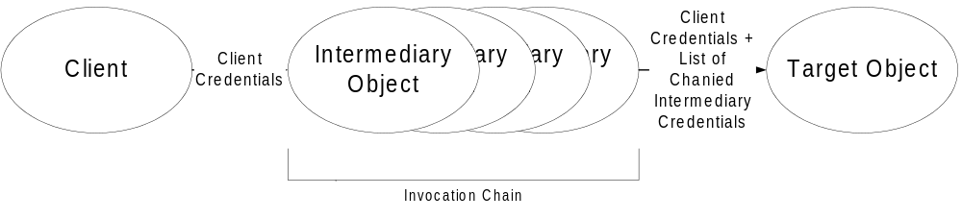
Figure 19. Traced Delegation
Normally, administrators define a default delegation policy and let the ORB automatically enforce it. Security-aware application objects, however, may be allowed to alter it during object invocation to achieve fine-grain control over how privileges are delegated.
The most secure delegation scheme is no delegation, because it prevents the malicious use of client credentials, however, it is the most restrictive. On the other extreme is composite delegation, where impersonation may represent a security hazard, even though is the least restrictive.
One way to conciliate these two extremes is to place restrictions on which objects can be called on behalf of an originating principal. These restrictions may be defined as part of delegation policies by an administrator or, within policy limits, by application objects themselves. In either case, the ORB has to enforce these restrictions since the originator has no involvement on the chain of invocations after the initial request. Nevertheless, this type of restriction may be prohibitively costly because it requires policy changes every time there is a change in the way delegated objects carry out the an activity. As a result, target object-side access control is typically used.
There are potentially a large number of delegation variations. They can all be captured using the next structured sentence.
“An intermediate invoking a target may perform:
- one operation on one object or
- several operations on one object or
- any operation on
- one object
- some object(s) – target restrictions
- any object – no target restrictions
- using
- no privileges
- a subset of the originator’s privileges – simple delegation
- both the originator’s and its own privileges – composite delegation
- received privileges and its own privileges – combined or traced delegation, depending on whether privileges are combined or concatenated.
- during some validity period – part of time constraints
- for a specified number of invocations -- part of time constraints”
In OSS Level 1, all delegation is done automatically in the ORB according to the delegation policy, so the objects in the chain cannot change the mode of delegation used, or restrict privileges passed and where or when they are used. In OSS Level 2, applications may use OSS specified interfaces to change the delegation mode and privileges passed as permitted by the delegation policy.
In the particular case of the SBT system, it is necessary to trace back most object invocations to the principal originator of the request. For example, it is necessary to ensure that the “cancel” operation on an “order” object is being invoked (probably through a chain of invocations) by the trader owning that order. Nobody else, except perhaps a system administrator or a clearing firm broker taking over the trader’s account, should invoke this operation. Enforcement of this type of access control rule requires traced delegation. In addition, it necessitates a target object-side access control decision to ensure the principal originator (end user) of the “cancel” request is authorized to invoke this operation.

3.4.2.4 Auditing
Security auditing assists in detecting actual and attempted security violations. This is achieved by recording details about security-relevant events. Recording a security event may involve sending a message to a system operator, writing a record on a log, or taking other actions.
Audit services allow system administrators to define audit policies to monitor important security events. There are two types of events: system events and application events.
System events are audited without any application intervention. Some examples of key system events that must be auditable are authentication of principals, changing privileges, invocations on security-sensitive objects, failed invocations, and administration of security policies. System-level auditing requires no application intervention; it is performed automatically by the ORB in conjunction with the auditing services.
Application events are specific to the security needs of an application. For example, it is important for an application that accepts payment with credit cards to keep an audit log of all payments. The OSS defines a set of interfaces that allow security-aware objects to record application events.
A typical system generates a very large number of events. Audit policies let the administrator restrict the events to be audited to contain the size of audit logs. Level 2 OSS compliance dictates a particular invocation audit policy scheme where system- and application-level auditing can be defined by:
- Security domain
- Principal invoking the operation
- Target object or object type
- Operation invocated
- Success or failure of the operation
- Time
To support the SBT system’s auditing needs, the implementation of audit services must provide system and application-level auditing as well as Level 2 compliance.
All CBOE systems make extensive use of logging services. Audit services is a specialized form of logging whereby security-related events are logged. To avoid redundant functionality, audit services shall employ the logging service for logging audited events whenever appropriate.

3.4.2.5 Security of Communication
As mentioned before, requests and responses can be protected during transit for:
- Integrity: detecting when a message has been altered
- Confidentiality: making sure that nobody has read the information in a message.
Security policy specifies the minimum strength of integrity and confidentiality protection. Achieving the required integrity protection may involve adding checksums and sequence numbers to the message. Achieving the required confidentiality protection may involve encrypting the message. In general, the trade-off in choosing a particular protection technology is between level of protection and processing overhead.
Message protection may be implemented directly at the ORB level or at lower levels, such at the Sockets Layer (using Secure Sockets Layer, or SSL), or all the way down to the physical level.
The SSL specification, developed by Netscape, specifies a protocol for providing data security between remote applications that typically communicate via TCP/IP. It is rapidly becoming the de facto standard for secure Internet communication. It provides one-way authentication (optionally two-way) between the communicating parties. It also provides data integrity and privacy using encryption during the transmission. However, it does not provide non-repudiation, as it has no knowledge of the persons using it. That is left up to the application level protocols. SSL does cause a performance penalty, as the transmission is much slower than the regular TCP/IP transmission.
The use of SSL in CORBA has been standardized by the OMG. The OMG currently specifies 2 levels of CORBA security which deal with increasingly sophisticated secure environments. An implicit level 0 below OSS’s Level 1 corresponds to the provision of authentication and session encryption, which maps onto the functionality provided by the SSL library.
SSL operates by layering a security protocol on top of standard TCP sockets in a way that is almost completely transparent to the ORB and the application.
The recommendation continues to be Kerberos, since it supports the private key-based privacy and integrity protection required by SBT. SSL, on the other hand, only provides server-side authentication and suffers from the performance penalty of using public key encryption.

3.4.2.6 Non-Repudiation
Non-repudiation is one of the most difficult security problems to solve and deals with assuring that any action initiated by a principal cannot be denied in the future. A principal receiving data cannot deny the receipt and a target object sending data cannot deny that the data was sent. In order to avoid problems with non-repudiation, a sufficient amount of information associated with a principal’s identity should be sent with any transaction (for example, a digital signature).
It is necessary to explore in detail the need for non-repudiation in SBT. It may be desirable or even legally necessary to have a proof that a trader entered an order, however, there is a cost to pay in increased application complexity and performance overhead.

3.4.3 Firewalls
Many organizations use network firewalls to protect their internal computing resources from the Internet. A firewall is a network gateway between an organization’s networked environment and the networks of the outside world, for example; the Internet. Many organizations also use firewalls between internal networks in order to segregate critical resources and restrict intra-organizational access to them.
In general, there are two types of firewalls: packet-filtering routers and proxy-based application gateways.
Packet-filtering is a mechanism that provides a basic level of network security at the IP level. Packet filters drop, reject, or permit access to packets based on destination IP address, source IP address, and port number. These type of firewalls do not maintain context or understands the application they are dealing with. They make their decisions purely by looking at the IP header of the current packet and then applying a set of pre-defined rules. Networks that rely solely on packet-filtering firewalls are substantially less secure than those that use proxy-based firewalls.
Proxy firewalls are the most secure form of firewall. They run a small number of programs —called proxies—that can be secured and trusted by internal applications. All incoming traffic is funneled to the appropriate proxy depending on its type. The proxies then transfer the requests to the appropriate internal network resource. Because each proxy is an application in itself, it can make its decisions based on context, authorization, and authentication rules instead of only on IP addresses. This means that the firewall operates at the highest level of the protocol stack and makes possible to enforce security policies based on a richer set of defensive measures.
Some firewalls combine packet-filtering and proxy techniques to provide even more security than either alone. They are configured to force computers on both sides of the firewall to communicate exclusively via proxies, blocking all direct communications.
The key function of a firewall is to control incoming and outgoing network traffic. Typical network traffic includes HTTP, SNMP, FTP, et cetera. In this section we are concerned specifically with CORBA General Inter-ORB Protocol (GIOP) traffic.
Currently there is no standard approach to control CORBA GIOP traffic in a firewall. Each product implements its own approach. Nevertheless, The OMG is in the process of standardizing the technology.

3.4.3.1 CORBA Firewall Requirements
This section summarizes the requirements that a CORBA firewall must satisfy as stated in the OMG’s CORBA/Firewall Security RFP.
The following are mandatory requirements:
- Permit external clients invoke operations on some internal CORBA-based applications and services; and also prevent external clients from seeing or invoking operations on CORBA-based applications and services that should not be accessible.
- Enable internal clients to invoke operations on external target objects.
- Perform these functions transparently to clients and target objects.
- Impose minimal performance overhead during target object connection and operation invocation.
In addition, the firewall shall work in conjunction with the ORB to ensure that internal object references (IORs) passed to external invokers can be used to make requests that the firewall may allow.
There are a number of optional requirements:
- Control access at the granularity of object, operation, or any other level as specified by internal access control policies.
- Support multiple protocols: IIOP (GIOP on TCP), SSL-IIOP, and/or Secured IOP (SECIOP).
- For SSL-IOP or SECIOP traffic, the firewall shall employ the appropriate authentication mechanism to authorize access to internal target objects.
- For SSL-IOP or SECIOP traffic, the firewall shall allow private interaction between client and target object.
- Perform all required security-related functions as dictated by the protocol and/or internal security policies.

3.4.3.2 CORBA Firewall Proposed Specification
OMG’s CORBA Firewall Security RFP generated two submissions. One of them, jointly submitted by BEA Systems, Expersoft, Fujitsu, IBM, Iona, Netscape, Oracle, Sun, and Visigenic, is the most highly evolved of the two. It is likely that the adopted standard will closely follow this proposal. Therefore, a high-level description of this proposed specification is presented here in lieu of a standard specification.
The proposed CORBA firewall design employs proxies as a mechanism to forward IIOP messages through the firewall. Using proxies is a powerful and effective way of hiding network internals while providing external access to selected internal resources.
Before continuing, let us define the elements involved in the functioning of CORBA firewalls:
- IOR – the structure used by CORBA v2.0 GIOP to identify a server object.
- GIOP Proxy – is a dedicated bridge that relays GIOP messages from a client to a target object securely across the firewall.
- Enclave – a network that is separated from other enclaves and/or the Internet by a firewall, and can only be linked using proxies.
- Outbound proxy – a proxy that allows the messages of an internal client to be relayed to a target object outside the enclave.
- Inbound proxy – a proxy that allows the messages of an external client to be relayed to a target object inside the enclave.
- Proxified IOR – encapsulates a sequence of IORs, one for each inbound proxy along the path to the target object’s innermost enclave, as well as the target object’s object key – hence providing a transparent way for a client to connect to a target object in another enclave via a chain of proxies.
Figure 20 shows diagrammatically the key elements:
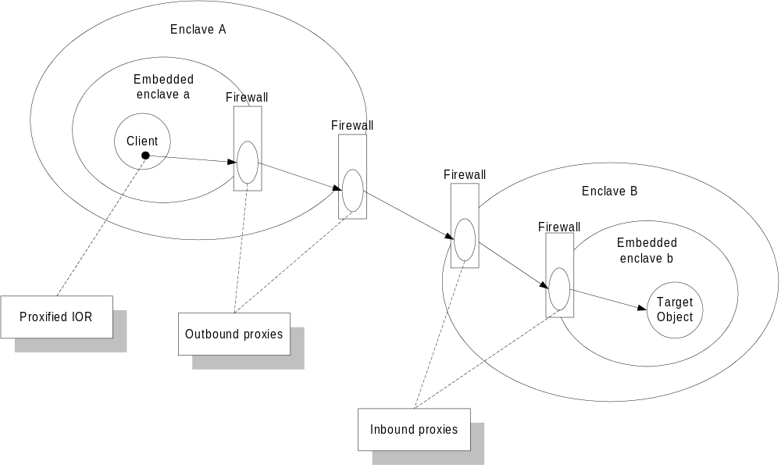
Figure 20. Components Involved in the Functioning of CORBA Firewalls
To invoke operations on a target object in a remote enclave, a client first needs to establish a connection to the target object. This is accomplished by passing the target object’s proxified IOR to the (firewall-aware) ORB. Whether the target object is in the same enclave or a remote enclave is completely transparent to the client.
Using configuration information and information encapsulated in the proxified IOR, the firewall-aware ORB determines whether a direct connection can be established (if the target object is in the same enclave) or it is necessary to use an outbound proxy. In the second case, the ORB invokes connect_to_object()on the outbound proxy passing the target object’s proxified IOR, which in turn determines whether a direct connection can be established on its enclave or it is necessary to use the next upstream outbound proxy. This process continues until either a direct connection is established or the organization’s outermost enclave is reached (Enclave A in the previous diagram).
The target object’s proxified IOR encapsulates a sequence of IORs, one for each inbound proxy in the path to the target object’s innermost enclave. Using this information, each inbound proxy, starting with the one at Enclave B’s boundary, invokes connect_to_object()on the next embedded enclave until reaching the innermost enclave, where a direct connection to the target object can be established.
Once a connection has been established successfully through the process described, the client is allowed to invoke operations on the target object. Object invocations are completely transparent to the client, they are relayed by the chain of outbound and inbound proxies behind the scenes.

3.4.3.2.1 Integrating CORBA Firewalls with the Object Security Service
Firewalls need to cooperate with the Security service to enforce security policies. Each proxy along the chain (or at least each inbound proxy) may need to enforce security rules. When a proxy receives a secured request via a secured CORBA protocol (SSL-IOP or SECIOP), it may need to authenticate the principal (or client acting on his behalf), and in the case of an inbound proxy, impose access control policies before relaying the request. Furthermore, each proxy may need to maintain the integrity and privacy of the request.
Proxies that support a secured CORBA protocol fall into two categories, trusted and untrusted.
Untrusted proxies forward the initial request from a client to a server and then “get out of the way” by letting them communicate directly over a pass-through connection – the proxy has no control over or visibility of the encrypted byte stream after the initial contact. This ensures the integrity of the client and server communication but leaves little opportunity for authentication and access control. This type of connection restricts the proxy’s ability to enforce access control rules, but it is necessary when either the server or client do not trust the proxy. Thus, most authentication and access control is done when the request has already reached the target object, somewhat defeating the purpose of having a firewall.
Trusted proxies can forward requests using pass-through connections, but also can establish separate connections to the server and provide full authentication and access control for them. Servers grant trusted proxies access to the client’s privilege attributes, the server’s control attributes and the contents of requests themselves (in unencrypted form), so that the proxies can fully enforce access control rules at the operation level or even finer-grained. At this point, if the internal environment does not present risk, the proxies can send and receive unencrypted messages to and from target objects, thus reducing computational load.

3.4.3.3 CORBA Firewall Usage Strategies
Figure 21 depicts the physical network components of the SBT system.
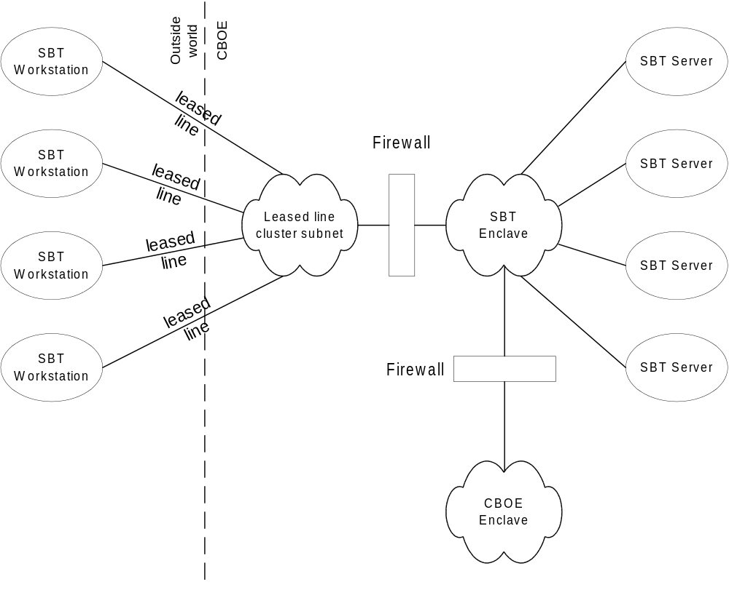
Figure 21. SBT's Physical Network Components
Leased lines coming from SBT workstations are clustered into a sub-network physically separated from CBOE’s internal network by a firewall. The firewall is a machine with two physical network cards, one attached to the leased line cluster sub-net and the other to the internal network.
We consider two alternatives to structure the internal enclaves. The first alternative, depicted in Figure 21, completely segregates all SBT application servers in an independent enclave (SBT Enclave). The rest of CBOE’s network is contained in another enclave (CBOE Enclave). These two enclaves are linked via an additional firewall to allow SBT application components and CBOE systems to communicate. This alternative minimizes the risk of an attack coming from the leased lines on CBOE systems, because there are two firewalls to cross. Additionally, it minimizes the risk of, albeit improbable, intrusion on SBT from CBOE’s network. Interposition of this firewall, however, may impose an unacceptable performance penalty.
The second alternative is to have a single enclave encompassing all CBOE systems, including SBT, protected by a firewall (CBOE may have or has additional firewalls to protect itself from the Internet, for example). This alternative is simpler and imposes no performance penalty, but may provide less protection.
The CORBA firewall employed by CBOE shall support at least the following features, qualities, and constraints:
- support mandatory requirements
- support non-embedded enclaves
- handle inbound and outbound IIOP on the internal side of the firewall
- support interceptors to encrypt/decrypt IIOP messages before reaching or leaving the firewall
- support trusted proxies with operation-level access control
- support passing of internal proxified IORs to external invokers for later use.

3.4.4 Object Security Service Usage Strategies
A high-level overview of the SBT system architecture serves as a background to discuss the usage strategies of the OSS at CBOE.
Figure 22 depicts the major architectural components of the SBT system.
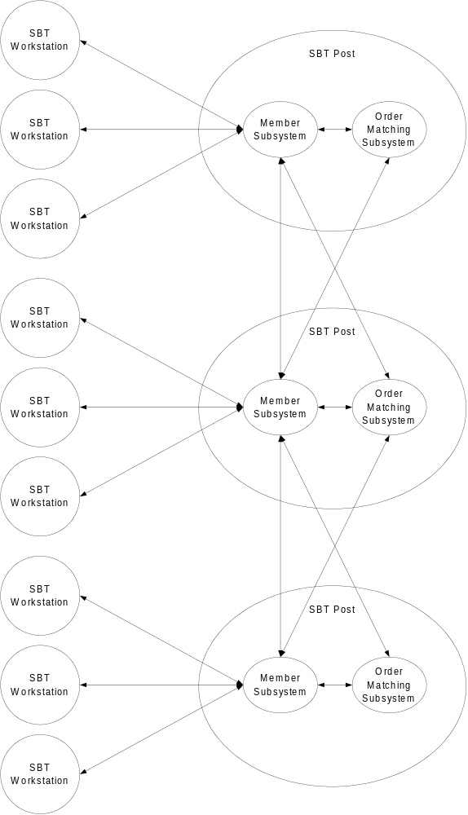
Figure 22. Major Architectural Components of the SBT System
The SBT system has a thin client/thick server architecture. SBT workstations essentially implement the presentation layer, although some information may be cached for efficiency purposes. Most processing is done centrally in “SBT Posts” analogous to their trading floor counterparts. The post-centric model is used to achieve the same goals as in the trading floor systems: high scalability and availability. Each SBT Post is self-contained and completely independent of the others to prevent entire system crashes.
Each SBT post runs instances of two major subsystems (along with other secondary subsystems omitted from the diagram): the Member subsystem and the Order Matching subsystem. The Member subsystem is responsible for processing the orders and quotes of a group of members. The Order Matching subsystem is responsible for matching the orders of a set of products.
Each trader is assigned to the specific SBT post containing the products he trades the most. The purpose of this arrangement is to minimize inter-post traffic. When a trader places an order for a product traded in a SBT post distinct from his own, the Member subsystem contacts the Order Matching subsystem in the other SBT post. This is to maintain a single point of contact for the member’s SBT workstation.
There are two basic mechanisms by which application components interact in the SBT system: object invocations and events. Object invocations enable one-to-one interactions, while events enable one-to-many or many-to-many interactions. Each type of component interaction has a number of variants in SBT, each one with its own security requirements.
The security requirements of the typical component interactions in SBT are:
- Operation invocations that require tight security such as order entry, market-maker quote entry, and responses to RFQ. These operation invocations have the most stringent security requirements. Firstly, since they originate externally, it is necessary to authenticate the principal originator. Once the principal originator has been authenticated, it is necessary to verify a number of conditions before accepting the invocation. For example, a market-maker must be previously assigned to the product in order to respond to an RFQ. Note that there may be a chain of invocations from entry of an order on the workstation to invocation on a “member” object on the Member subsystem to invocation of the actual “create” operation on an “order” object on the Order Matching subsystem. Proper authentication and authorization under these conditions requires simple privilege delegation.
Secondly, it is critical to ensure that the invocation’s data has not been altered nor revealed while in transit.
Thirdly, it is necessary to keep an audit log of all operations of this type.
Lastly, non-repudiation may probably be needed to prove legally that, for example, a trader entered certain order.
- Private event notifications such as trade notifications or requests for quote. To receive these events, a principal first needs to subscribe to an event channel. It is at this moment that security plays an important role.
Firstly, it is necessary to authenticate the trader to ensure that it can subscribe to receive trade notifications only for his orders, and nobody else’s. Likewise, a market-maker can subscribe to receive requests for quotes only for the products he has been assigned to. In these two cases, the granularity of access control is not an object’s operation, but a filtered, typed event supplied by an EventChannelGroup. To support this requirement, the Event service will need to be integrated with the Security service in order to enforce an access control rule restricting subscriptions to allowable filtered, typed events. The access control rule must restrict subscriptions based on the identity of the trader or market-maker, and the orders he entered, or the products he has been assigned to, respectively.
Private event notifications of this type also require protection to maintain integrity and privacy, as well as audit logging.
Lastly, non-repudiation may be needed to generate a legally-binding proof that a trader was notified of a trade or a quote was requested from a market-maker.
- Public event notifications such as best quotes and last sales. These events, by virtue of its public nature, do not require any authentication, access control, or privacy protection. Integrity protection may be needed in some cases, if the data is used for critical processing, as is the case of auto-quote calculation. Since these events may be generated at high rates, performance is critical. Therefore, it is necessary to keep to a minimum high overhead, security-related processing.
These requirements can be satisfied by an Object Security Service Level 1 implementation with the option of non-repudiation, if needed, and an extension to control subscriptions to filtered typed event channels.

3.4.5 Threats to CBOE’s Trading Floor Systems
It may not be immediately apparent, but there are potential risks present in CBOE’s trading floor systems environment. This section presents and explores those risks of the standardized communications technology that will be employed under this architecture.

3.4.5.1 Standardized Infrastructure
Existing CBOE trading floor systems are protected by “physical security.” In other words, the application interfaces are only provided physically on the trading floor and, therefore, no one can affect trading activity. This could be considered secure only to the extent that NAPI message formatting and addressing is proprietary to CBOE and would need to be discovered in some way before an attempt could be made.
Unfortunately, with the adoption of industry standard messaging technologies, such as CORBA, CBOE will become more exposed to security threats than it is currently because the messaging formats and tools for generating those formats are readily available external to CBOE. In addition, CORBA defines an Interface Repository that provides the structural definitions of the interfaces that are accessible through standardized CORBA IDL interfaces. As a result, as long as there is physical network connectivity and routing to the trading floor, a person could probe machines to locate the ORB Interface Repository and then attempt to locate and access the application services for the interfaces that are discovered.

Note:
It should be understood that these hazards apply equally to other standardized or de facto messaging standards such as DCOM or Java RMI.
As a result, the security implications of the new infrastructure environment should be examined closely as an independent effort focused exclusively on determining acceptable risk in the CBOE systems environment and specifying required security measures that should be implemented throughout the systems.

3.5 Logging Services
Even a cursory analysis of CBOE’s software systems reveal several scenarios in which system components need to create messages capturing information about their execution. For example:
- Provide run-time code execution path information used in debugging.
- Provide product level errors messages that must support internationalization.
- Provide statistics regarding computation running time, completeness, etc.
- Provide system monitoring notifications.
All of these scenarios are fundamentally the same activity–the generation of run-time information programmatically–which can be referred to as tracing.
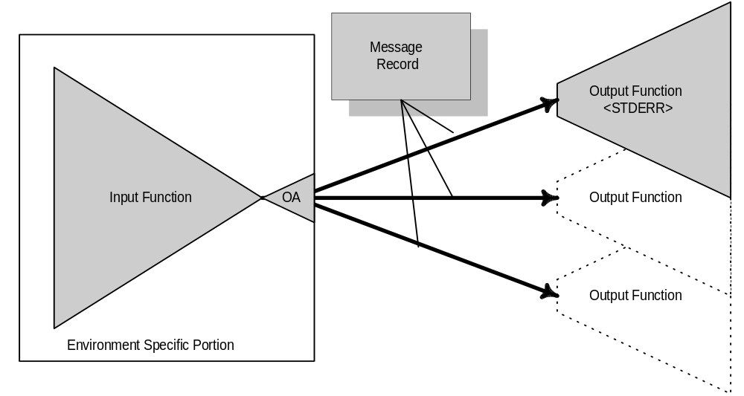
Figure 23. Document Title Functional Areas
Conceptually there are two orthogonal functional areas that make up the Document Title: the input function and the output function. Between these functional areas there is a standard message record format that is platform-independent and is generated by the Input function and transported by the output function.
Figure 23, Functional Areas, presents a logical representation of the functional areas. While the input function gathers information from the developer and program execution, the output function is clearly separated. This separation allows Message Records to be routed to one or more output targets, such as standard out, standard error, a log file, and even a logging service located on a remote node. The result is clear separation of the creation of information and the disposition of it.
In addition, the input function is decoupled from one or more independently developed output functions through the pluggable-engine adapter OA, or output adapter. Because concrete implementations of a pluggable-engine adapter are dynamically loaded, output functions can be independently developed. This allows the special purpose outputs functions to be introduced at any time in the software lifecycle, from development through deployment. Output functions become a tool for the continuing management of the components of a system.
The shaded areas constitute the core functionality and will constitute the API and basic tracing support that must be developed for each language environment. This core functionality should meet the following overall goals:
- Simple, rich, and easy to use programmatic interface, or API.
- Formally separating the process of information capture from that of information output, formatting, and interpretation.
- Supply a rich set of extensible message categories.
- Provide the capability to filter the generation of Message Records based on the contents or the context of the generation.
- Allow filtering to be controlled both programmatically and externally to the executing process.
- Provide direct support for internationalization for Message Records.

3.5.1 Core Conceptual Components
The core is focused at providing tracing in an object-oriented development language environment, such as C++ or Java. Within these environments it is important for the developer to declare that something has happened. But from the outside of a process that contains a potentially large number of code fragments constructed by multiple developers it is important to be able to know what the process was doing, where it was, and where it had been prior to this notification occurring.
To this end, there are several fundamental components that are necessary to support the transparency and configurability goals presented previously.
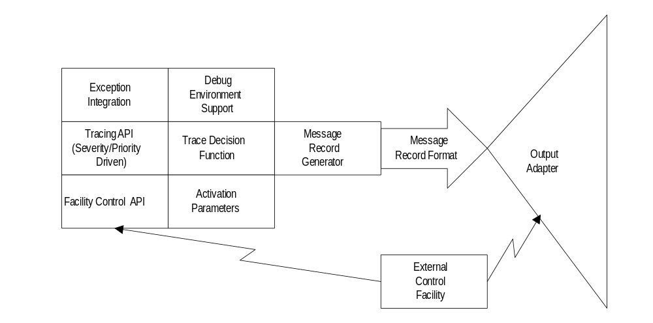
Figure 24. Conceptual Diagram of Core Components
Figure 24. Conceptual Diagram of Core Components, depicts the conceptual components that make up the Document Title Input function. The interface to the input function is made up of the Tracing API, Exception Integration, and Facility Control API components. The remaining components provide the implementation of the Input function. All components are described below.

3.5.1.1 Exception Integration
This component of the Document Title provides for the integration with the C++ exception mechanism by establishing an exception base class from which developers can inherit when creating traceable exceptions. This allows such exceptions to be traced automatically when instances are created. In addition, system exceptions, standard C++ exceptions, CORBA exceptions, or third party exceptions are specifically wrapped to establish automatic logging.

3.5.1.2 Tracing API
The tracing API is largely declarative. It provides the ability to declare the "what" of the overall system and provides the facility with its point of possible action through the specification of tracepoints. A tracepoint is a simple statement of “here is something that may be useful to know,” that is made programmatically by the developer. Each tracepoint specifies a separate instance of a MessageRecord.
In addition, the tracing API provides for the separation of messages according to their thread, source module, group or a logical specification of the enclosing code, tracing category, criticality, and importance.
The tracing API also provides a mechanism for assigning a semantically meaningful designation to one or more threads and allowing tracing to be activated based on that thread designation. Similar to this thread based tracing is the subject-based tracing which allows the developer to identify regions in an execution stream and assign a label based on the “subject” of the execution.

3.5.1.3 Facility Control API
The Facility Control API is used by the External Control Facility to communicate with the internals of the tracing facility and to modify or define its configuration. This API provides for such things as module selection, thread selection, subject selection, group definition, authorization control, enabling/disabling of logging, definition and activation of tracepoints, and so forth. The developer may also use the Facility Control API in order to capture some of the same functionality of the External Control Facility in another program.
The tracing API can specify tracepoints to begin or to end at a given module location using its module id: the program, library, file, class, method, and line. For example, a tracepoint can set to begin at the trace message located at
server.exe:utility.dll:miscutil.cpp:utilclass:useyourhammer:line30
and set to stop tracing at the message located at server.exe:utility.dll:miscutil.cpp:utilclass:dropyourhammer:line55.
This component also provides for module level tracing by allowing only partial module ids to be specified. Partials module ids are formed by leaving out the more fine grained items such as line, file , class, and method. For instance, specifying server.exe:utility.dll while leaving off the fine grained part miscutil.cpp:utilclass:useyourhammer:line30 allows tracing to be turned on for all messages appearing in server.exe:utility.dll rather than just the miscutil.cpp:utilclass:useyourhammer:line30 message. Further, these modules can be arranged ad-hoc into groups, where each group consists of one or more possibly related or unrelated modules, allowing tracing to be turned on or off for all the modules in the group at once.

3.5.1.4 Trace Decision Function
The trace decision function is responsible for deciding whether a trace message should be generated based on the current activation parameters. Activation parameters include static information such as the module and group, current thread id, and source file. Dynamic information contained in activation parameters include the current thread id and current control settings supplied from the external control facility or programmatically.

3.5.1.5 Static Process Data
The global data that is necessary for tracing.

3.5.1.6 Message Record Generator
This Message Record Generator aggregates all of the data necessary for one trace message record. The message record format is well defined and standard across hetrogeneous platforms.

3.5.1.7 Debug Environment Support
This component provides miscellaneous support for one or more debug environments. It provides mechanisms for supplying debug traps, called stack traces, symbol table cross references, etc.

3.5.1.8 External Control Facility
This external control facility is a utility program that utilizes the facility control API to communicate with the internals of the logging facility itself in order to control it and modify activation and configuration parameters.

3.5.2 Features, Qualities and Constraints
This section details the specific functionality that the tracing and logging service should possess for the CBOE system environment. It is separated into individual cohesive categories of functionality.

3.5.2.1 Multithreaded
The tracing and logging services must possess the following properties with respect to multithreaded development environments:
- All trace messages occurring within a single thread of execution can be turned on/off.
- A thread can be given an identifying label to allow the user to select the thread to be turned on/off.
- All trace messages occurring within a single thread of execution and within all of the threads created by it can be turned on. The threads created by another thread will be termed "descendant" threads. The threads that these descendant threads derive from directly or indirectly will be termed "ancestor" threads. This requirement allows trace messages to be turned on/off for an entire line of descent beginning at any one place and working down.
- If a descendant thread is not explicitly given an identifying label, then it is implicitly given one.
- The logging facility must support simultaneous logging from multiple threads within a process and be thread safe.
- To the extent that this contributes to simultaneous logging from different sources, the logging facility itself must be multithreaded and thread-safe.
- The logging facility API must be re-entrant. The logging facility can be called from within itself.

3.5.2.2 Tracepoints
The tracing and logging services must possess the following properties with respect to the specification of tracepoints:.
- Should allow the tracepoints to be enabled/disabled. When tracepoints are enabled, all log messages between the tracepoint start and the tracepoint end must be turned on. When disabled, the log messages must be turned off.
- Tracepoints must be specified by a fully qualified or partially qualified point-of-origin stamp.
- There should be built in tracepoints and log messages for entrypoints and exitpoints. These tracepoints should be both start and end tracepoints so that tracing only traces the fact that an entrypoint or exitpoint was encountered and does not trace all of the log messages in between.
- Should allow the developer to enable/disable the entrypoint/exitpoint tracing tracepoints. These tracepoints should be disabled by default and should be able to be manually enabled.
- The enabling of any type of tracepoint should be able to be done through the External Control Facility. That is, the External Control Facility must be able to define and turn on a tracepoint.

3.5.2.3 Exception Encapsulation
The tracing and logging services must possess the following properties with respect to native language environment exceptions:
- Every exception should be automatically logged through the log facility (for example, by encapsulating the use of the log facility within the exception base class).
- The log facility should be integrated with the CORBA exception facility.
- Exception log messages should be automatically turned on and should be able to be turned off individually by exception type.

3.5.2.4 Debug Trap/Just-in-Time Intervention
Each message or message type should be able to be marked to fire a debug trap. This marking takes place externally. This trap can be a break point resulting in the activation of a JIT debugger, a signal, a procedure, a call stack dump, etc. The action of the trap can be configured among these options and others.

3.5.2.5 Multiple Severity/Priority Level Logging
The tracing and logging services must possess the following properties with respect to the categorization of and priority designation of tracepoints:
- The logging facility should provide support for severity and priority levels of logging.
- The severity level logging should distinguish between levels of criticality.
- The priority level logging should provide the ability to categorize the importance of the message and should be able to be used in sorting the message output stream. The priority level may also be used when delivering the message (for example, as out-of-band).

3.5.2.6 Module/group level logging
The tracing and logging services must possess the following properties with respect to module and code grouping designation and control:
- The API must provide a means to establish a module designation, which is a name assigned to a module. A module is some namable unit and can be either a runtime unit or a compilation unit of the following types: Process, thread, procedure(s), class(es), file(s), executable, static library, shared library.
- The logging service should be able to turn on/off logging based on a module designation.
- The API should provide a means to establish a group designation which is a name assigned to a grouping of modules or to both modules and other groups.
- The logging service should be able to turn on/off logging based on a group designation.

3.5.2.7 External Control Facility
The logging facility should be able to interact with an external control facility which allows runtime control of the logging facility. The control facility acts as a pseudo terminal allowing simultaneous logging and reconfiguration of the logging facility for each process. The control facility and the application process should have the same capabilities to control the parsing of the commands utilized to control the logging facility.
- Must provide for the recording of control session activity (for example, control session log).
- Must be accessible from in both GUI, API, and command line forms.
- Must be able to enable/disable logging activity based on each category of logging levels specified in this document (for example, severity, priority, module, group, tracepoint, exceptions).
- Must be able to control all configurable items mentioned in this document (for example, debug trap, definition of groups, configuring tracepoints).
- Must be able to view a list of all named items (for example, modules, groups).

3.5.2.8 API Richness
All functionality present in the External Control Facility must be present in the API. The API functionality will not necessarily be exposed in the External Control Facility.

3.5.3 Service Profiles

3.5.3.1 Trace Message Record Format
The key component for integration of multiple language environments into a consistent tracing and logging facility is a heterogeneous trace message representation. This section specifies that representation in terms of IDL.

module TraceFacility
{
typedef TimeBase::UtcT timestamp;
typedef unsigned long threadid;
typedef unsigned long processid;
typedef unsigned long ipaddress;

//Definitions for Module Identity
struct ModuleVersion
{
unsigned long major;
unsigned long minor;
};
struct ModuleName
{
string name;
ModuleVersion version;
};
typedef sequence< ModuleName > ModuleAddressStack;

// Message Identity
struct MessageOrigin
{
ipaddress address;
processid process;
threadid thread;
ModuleAddressStack moduleaddress;
};
struct MessageId
{
MessageOrigin origin;
timestamp when;
};

// Message Attachements
typedef sequence< octet > AttachmentBody;
struct Attachment
{
string type;
AttachementBody body;
};
typedef sequence< Attachement > MessageAttachments;

// Message Text Identity
typedef sequence< octet, 16 > UUID;
typedef unsigned long MessageId;
typedef wstring InfoText;
struct MessageId
{
UUID catalog;
Entry id;
};
enum TextType
{
catalog_message,
adhoc_message
};
union MessageText switch( TextType )
{
case catalog_message:
MessageId id;
case adhoc_message:
InfoText text;
};

// MessageRecord Definition
struct MessageRecord
{
MessageId id;
string catagory;
short priority;
MessageText text;
MessageAttachments attachements;
};
};
Figure 25. Trace Message Record Contents

3.5.3.2 Message Record
The Message Record is the complete set of data comprising one trace message in the log facility. The record is divided into five standard parts, three of which are compound in nature, meaning that they themselves are made up of other pieces. The five standard parts of the message record are the Unique ID, the Category, the Priority, the Message Specifier, and the Attachment List. The Unique ID, the Message Specifier, and the Attachment List are compound in nature.

3.5.3.3 Message ID
Every instance of a message ever generated has a unique ID. This ID indicates the origination place of the message and the time and date on the host where the message originated.

3.5.3.4 Message Origin
This ID indicates the origination place of a message. An origination place is defined by specifying the fully qualified runtime unit which generated the message (host_address:process_id:thread_id) and the fully qualified compile time unit (the module address) containing the message instruction.
This is the IP address of the machine that executed the program that generated the message. It is the first component needed to identify the runtime unit.
This is the host-relative process id number of the program which generated the message. It is the second component needed to identify the runtime unit.
This is the process-relative thread id number of the specific thread within the program that generated the message. It is the third and final component needed to fully identify the runtime unit.

3.5.3.4.1 Module Address
This is the compile time unit containing the instruction producing the message that was generated. It is the combination of the module name “stack” and the version “stack” of all these modules.
The module name stack is identified by descending the hierarchy of compile time objects making up an executing instance of a program. This “stack” of compile time objects is defined by specifying each of the following as they appear in descending hierarchical order: program name, library name, file name, class name, method name, line number. The message instruction, or line of code, is considered to belong to all the modules that can be named by descending the compile time object stack for the message. So, for example, if a message instruction was located at the module address of program.exe:miscutil.dll:util.cpp:utilclass:usehammer:line30 then that message is said to belong to each of the following modules: program.exe, program.exe:miscutil.dll, program.exe:miscutil.dll:util.cpp, program.exe:miscutil.dll:util.cpp:utilclass, program.exe:miscutil.dll:util.cpp:utilclass:usehammer.

3.5.3.4.2 Time-Date Stamp
This is the date and time on the host machine of origin when the message was generated.

3.5.3.5 Category
The category defines the classification type to which the message belongs. The categories are well-defined and consist of an object description of what kind of message was generated and not a subjective judgment about the seriousness of the message. Because the subjective judgment is eliminated, there are no categories such as WARNING or ERROR. The available categories currently consist of the following:
Category | Definition
INFORMATION | This message simply consists of information that the developer wishes to supply. The developer supplies text and attachments freely.
ABORTION | This indicates that some runtime entity, a program, thread, or procedure call has aborted. The programmer must identify the runtime entity that aborted and can supply any commentary text and attachments as desired.
PRODUCT | This message is a standard part of the product operation. The developer supplies an id code and the message text is derived from a global and internationalized lookup table. The developer can neither supply any commentary nor attachments. The id as well as the message text is fixed by management and is not altered by the developer.
SYSTEM ERROR | This message indicates that an unexpected error was received from the operating system or COTS package. The developer must log the message using an id code but may supply additional commentary text or attachments. The message text is derived from a global and internationalized lookup table which is fixed by management.
RESOURCE ERROR | This message indicates that some operation on some resource has failed or completed incorrectly. The developer must identify the resource and the operation that failed. The developer may supply any commentary or attachments as desired.
Table 1. Message Categories

3.5.3.6 Priority
This is a number from 1 to 10 which specifies the attention that is to be given to the message both on output and on delivery. A value of 1 signifies the least amount of to be given and a value of 10 signifies the most. The greater the attention demanded by the message, the higher it will appear during the sorting of messages when being output. The greater attention will also demand more during the delivery of the message where some messages might be sent out-of-band so that they are delivered sooner.

3.5.3.7 Message Text
The message specifier specifies the semantic content of the message. It is comprised of two parts, an ID and info text.

3.5.3.7.1 Message ID
The message ID, if it is not empty, holds the index into the global lookup table for the message text. The idenity of the text message is specified through the use of a universally unique identifier, or UUID, and an index into the catalog of the message that is being transmitted. If the message ID is empty, then the message text is supplied by the developer rather than from within a message catalog.

3.5.3.7.2 Info Text
When a Message ID is not specified the message may contain ad hoc informational text describing the message. This value is transmitted in Unicode. Some categories of messages do not permit developer defined commentary and, therefore, will not allow this branch of the union to be defined.

3.5.3.8 Attachment List
This is a list of attachments for messages whose categories permit attachments. Each attachment is comprised of an attachment type, an attachment link, and an attachment body.

3.5.3.8.1 Attachment Type
This specifies the type of the current attachment. The following types are currently permitted: NT Call Stack, SUN Call Stack, HP Call Stack, Subject Name, Thread Name, Application State.

3.5.3.8.2 Attachment Body
The following attachment body types are currently permitted: NT Call Stack Data, SUN Call Stack Data, HP Call Stack Data, Subject Name Stack, Thread Name Stack, and Application State Data.

3.5.4 Usage Strategies
The CBOE system environment has several natural uses for the logging and tracing features that are presented above. CBOE should develop language environment specific interfaces that are overall labeled "Input Function" in section . In the language environments to be used in CBOE’s system (i.e., C, C++, and Java,), the core functionality can be developed in C++ and interfaces developed to that functionality. Specifically, this would be a set of native interfaces on the Java language interface.
Beyond the language environment support for the logging and tracing facility, CBOE needs to develop several Output Functions for capturing and using the different types of trace messages that are emitted from infrastructure components and application systems. This section outlines several Output Functions that are needed.
It is expected that all of the following Output Functions will be required in the CBOE environment, but that the proposed control mechanisms would be used to segregate the trace output from applications to the functions that are desired.

3.5.4.1 Log File Output Function
The first, and most basic, tracing method is simply a filesystem log. This is very much like the way in which CBOE manages application tracing and statistics information today. CBOE should develop an Output Function that formats the MessageRecord IDL type into a formatted, human readable, and places the resulting text messages into standard filesystem file.

3.5.4.2 Post Based Logging Service
It will be important to log application messages to a single point from all applications within a Post environment. To achieve this an Output Function will need to be developed using the underlying ORB communication infrastructure.
This will appear as a CORBA IDL service interface that accepts MessageRecords as in a parameter.

3.5.4.3 System Management Output Function
Finally, the tracing facility can be used to integrate into the System Management system. This would take the form of an Output Function that translated, or encapsulated, MessageRecords into the native system management trap service.
For example, with a system management platform, such as NetView or OpenView, MessageRecords can be encapsulated into SNMP traps. This would provide a single point of integration without requiring application specific adaptation into such a system management environment. Other system management tools would use a very similar approach, possibly making API calls on libraries provided with the tool.

3.6 Systems Management Services
As in most environments, CBOE uses a commercially available network and system management product (for example, NetView). With this, and most other commercial products, custom applications management is not well addressed. In fact, integration is largely left to ad hoc methods that integrate with base SMNP, and even file system services.
In this context, system management services address several aspects of application administration, monitoring, and configuration within a distributed systems environment. More specifically, the system management services that are specified in this section will address the following distinct areas of functionality:
- Application Instrumentation
The ability to provide statistical information about the performance or activities of the application to a management platform. This must address the application programming interface used to create and update this information, as well as the mechanism that make it available to the management system.
- Application Information/Faults
Provide the ability to specify, capture, and act on application notifications of abnormal processing conditions. This includes notifications as a result of exceeding some administratively set thresholds on Application Instrumentation counters.
- Application Configuration
Provide a consistent mechanism for specifying and controlling application system specific configuration information, such as file system usage, logging levels, etc. This mechanism should integrate into a single console interface and not introduce a new management application for each new application system.
Application Information/Fault monitoring functionality is discussed in detail in section . The approach recommended in that section provides a generalized integration approach for all application information/fault monitoring functionality needed in the CBOE system environment.
The remainder of this section will address integration approaches for application Instrumentation and Configuration. It is important to stress that, regardless of the approach taken in each of these functional areas, a single common approach should be used across applications. Without this level of investment of effort the possibility of improved integration, into whatever commercial management platform used, will be very limited. This was the common conclusion from discussions with CBOE systems personnel regarding the current system management systems.

3.6.1 Features, Qualities, and Constraints
In the CBOE environment system management functions have been largely carried out through manual or application specific mechanisms that do not share a common mechanism, much less a centralized and unified console. The result of discussion with the system development group at CBOE resulted in the following requirements:
- It is a requirement to have application specific monitoring and control.
- It is a requirement to set the filters and thresholds on application information and provide notification at the console.
- The system should be able to manage application systems logically and not via node based viewpoints. There is a hardware management group that needs to monitor the physical nodes, and there is an application group that needs to monitor the health of the applications.
- It is a requirement to have a consistent interface to using application specific applications.
- Want the look, feel, and responsiveness of a MVS console directly attached to the box.
Note:
Beyond these general requirements (specific feature) qualities and constraints need to be further developed for application configuration, instrumentation, and control. This functionality is generally agreed upon as absolutely necessary for the CBOE systems environment, thus further specification should be investigated through prototyping by the systems group.

3.6.2 Usage Strategies

3.6.2.1 System Monitoring
System monitoring is a generalized specification for using EventChannel and EventChannelGroup objects to construct monitoring systems based on the Logging Services presented in section 3.5 Logging Services.
The system monitoring component first specifies event interfaces and objects to define high level content semantics for different types of information that can be monitored within the system. In general there are four types of system information that can be managed within the monitoring environment. They are:
- Performance: Execution performance that can be used to diagnose potential problems and to enable active management of system configuration and resources.
- Fault: This type identifies abnormal behavior of objects within the system. These conditions are not restricted to hard process failures, but for example, could be signals of a rollback of a transaction.
- Security: This information is derived from the OSS specification and is detailed in the auditing component of that service. The content semantics of security events are driven by the policies defined for security domains. In addition, the EventChannels used by this system are specified in the OSS specification to posses additional security semantics provided by the security service implementation.
- Accounting: Usage information semantics defined by the services that manage resources and by application services that provide chargeback functionality.
The system monitoring component then defines logical bands of monitoring and management for each of these areas. In this way these bands are, first, well-known components existing within each local environment, and secondly, provide the means of the separate management of each type of information. Therefore all such events are provided to the system and the monitoring solutions for each type can establish different hierarchical structuring of management and filtering.
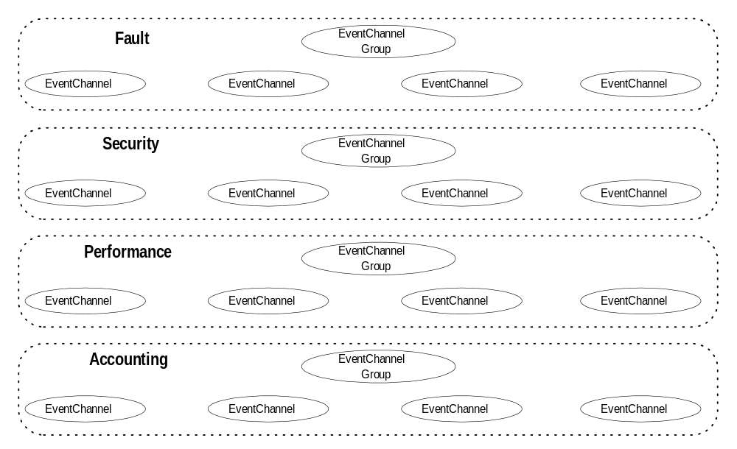
Figure 26. System Monitoring Bands
Figure 26 presents the logical concept of the system monitoring event bands. Although these bands of event flows are presented as equivalent, the scope (or extent of distribution) of each information type is potentially different. For example, there is generally a LAN segment level and, although the fault event information may be directly transported up one level, performance information typically is not.
This separation into bands also allows for physical transport and priority semantics to be individually managed based upon information type. This is particularly useful in physical network environments that provide virtual channel abilities, such as ATM, that allow limitations on the actual bandwidth consumed by an individual channel to be constrained. This allows, for example, the fault information to be allowed to consume much higher bandwidth than the restricted accounting information flow.
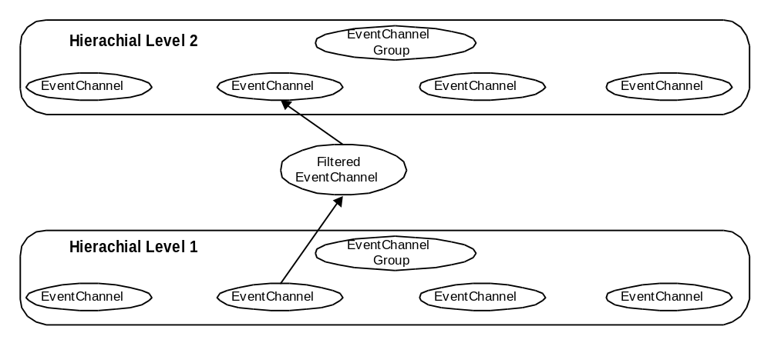
Figure 27. Hierarchical Band Filtering
In addition to the basic components of the Event Service, the system monitoring components define two abstractions that can be used to manage the composition of monitoring solutions within the overall distributed system. The first is a specialization of the EventChannel interface to provide for the establishment of event filters. Figure 27 depicts this basic concept allowing the construction of the hierarchical structuring. Normally, the filtered EventChannel interface is implemented by an object that otherwise processes the events in that band for the first level in the hierarchy.
The second provides event gateway into standard network management environments. For example, implementations of this interface can be constructed to bridge into external management systems supporting SNMP or an OSI management protocol.
In the CBOE system environment, this hierarchical approach to banding system management information should be applied in two levels. The first level is within the Post environment itself. Most of the information should be logged locally and setup filtered to restrict the amount of information that is propagated up to the second level on the backbone network.

4. Processing Paradigms
The Integration Architecture provides the base services of technology products through end-to-end integration known as processing paradigms. A processing paradigm is high level integration of many integration services into a processing framework that structures application functionality. A good example of a processing paradigm is IBM’s IMS, which prescribes a very specific structure for application functionality, as well as integrated security, load balancing transactional recovery, and data storage. Therefore, the development of processing paradigms represents a key component in systems architecture, because they provide the structuring for the development of application functionality in a way that overall architectural considerations are met without the individual application developer being aware of these considerations.
In addition, these will be critical to the success of the parallel application development and migration activities being attempted as part of the CBOE Trade Engine Redevelopment Program.
There are two processing paradigms that should be considered in the development of application systems at CBOE. These are:
- workflow
- object server.
Each processing paradigm will be specified by presenting: the overall structure and components that make up the processing paradigm, the features, qualities and constraints that are required in implementing it at CBOE, and the application context, or category, for which it should be used.

4.1 Workflow
Workflow may be an important element of the CBOE Trading Engine Redevelopment Project by enabling the definition of end-to-end business transactions to be declared, possibly involving some manual processing tasks, or out of architecture applications. Thus rule-based configuration will allow incremental integration of these manual tasks as automated components of the system. This will significantly increase the flexibility of the deployment and migration planning process.
Within the context of developing workflow application solutions, achieving this "in the small" environment means providing the ability to express the application purely in terms of workflow concepts. Specifically, being able to express an application system as a set of business processes, their ordering and their dependencies is the goal. This is both simplistic and very meaningful if the essential coordination of those business processes is carried out by the architecture itself.

4.1.1 Components
The most important element is the decoupling of the rule evaluation system, the work routing system, the task execution system, and the workflow monitoring system. Separating these four areas allows the Workflow Processing Paradigm to employ specific engines that are optimized for each of these three elements to allow an integrated solution that would otherwise be expensive.

4.1.1.1 Rules Specification
There are two sets of rules that are configurable in a workflow: (activity processing logic, and routing logic) application rules and business rules. Both are contextual and driven from the information architecture business model.
The first is the user adjustable rules that represent ad hoc aspects of workflow task enactment, for example, routing based on the availability of personnel expertise that address the task of the workflow business model. Changes to these rule sets would be carried out by a manager of the organization that is executing the workflow (or individual task) in a business workflow. In a way this is viewed as the dynamic model of the workflow system.
The second is base business rules that are enforced on any use of the workflow. These address issues that are minimal requirements for the execution of the workflow or task. For example, one such rule could be that a task, within an overall workflow, must be carried out by an actor assuming a specific role. This can be viewed as the rules that address the static aspects of the workflow system.
Specification of rules for workflow systems are strictly in terms of tasks and relationships. There are several potential relationships that can exist between tasks: serialized (Sequential Routing), parallel (Parallel Routing), synchronous join (AND-Join), asynchronous join (OR-Join), split (AND-Split), conditional routing (OR-Split), and iteration (specialization of OR-Split).
During rules processing there is a need for handling and processing exceptional cases discovered in an otherwise predefined process. The system must be able to route the task and associated work packet to a meaningful and authoritative destination that is not known at process definition. Exceptional situations will inevitably occur and the system must allow them to be handled in an ad hoc fashion.
Common forms of dependencies that are typically expressed as sequencing rules between tasks are: control flow and data flow dependencies, contingency dependencies, task termination dependencies, and critical task dependencies. Each represents a slightly different aspect of the specification of task and their relationships.
In this classification there exists two different types of task termination states: semantic and system. The semantic termination states refer to normal task termination, such as success or failure. The system termination state refers to an abort that resulted from resource or program error conditions.
Control flow and data flow dependencies are evaluated based on task or resultant state. The management and reasoning by the rules about this state is carried out by providing a Naming service—such as symbolic naming of workflow-related information, and externally reasonable state is placed within the Workpacket. Because of the uniform access of the CORBA model this is transparently possible.

4.1.1.2 Routing
There are several aspects to routing of control and information to the individual tasks used to compose the workflow. The following details some of these aspects:
- information transfer - the work items need to be provided to the task, and potentially relocated based on the technology at hand in the locale of the task to be currently carried out. The Workflow system needs to be able to affect these transfers transparently so that the application is not required to understand the impact of reconfiguration of the workflow itself.
- Actor identity specification by role and group based specification.
- prioritization - the ability to not follow a strict FIFO paradigm by allowing administrative or dynamic priority adjustment of a workflow process.

4.1.2 Features, Qualities, and Constraints
Within the span of problems addressed by workflow systems there are two general categories uses fall within:
- Human-centric
“…, human-oriented workflow involves humans collaborating in performing tasks and coordinating tasks.”
- System-centric
“…, system-oriented workflow involves computer systems that perform computation-intensive operations and specialized software tasks.”
The important differentiating point that is made in [GHS95] is the level of information semantics that each type of system must posses to carry out its task. Human-oriented workflow systems do not have the knowledge of what is being processed, relying on the participants to protect the consistency of the context that they are working within. In contrast, system-oriented workflow systems focus on highly automated work that has to have consistency of the underlying context enforced on it.
Within the CBOE system environment the prevailing opportunities for use of workflow systems is system-centric in nature.

4.1.3 Context for Use
Consider the tradition development model. The system is analyzed and designed and the system modules are cast into code. The logic flow of the system is captured as state transition engines, or even conditional logic. These are, with all diligence, traceable to the requirements specification, which details the overall business goals and scenario for use.
If object oriented techniques are used the system may have a high degree of configurability due to many well-developed abstractions. Even in the latter case these systems are considered as embedded workflow. From this standpoint, what can be considered the potential of workflow usage everywhere. The real question is when should we apply these techniques.
Overall, the criteria for applying workflow techniques to the system operation of business use cases is derived from a fundamental realization that most systems contain workflow constructs. The only real difference between what has traditionally been done in systems development and the application of workflow techniques is simply identification and granularity.
We will establish several criteria for evaluation, and give heuristics for that evaluation. These criteria should be used after the Business Model is developed to determine whether there is a reasonable expectation of benefit from the additional structuring that the workflow processing paradigm brings.
A basic set of usage criteria and their heuristic are presented as follows:
- To span application system layers to form end-to-end activities.
Recall that a business object model is meant to provide a layering of abstractions to enforce structuring and consistency. The overall intent is to provide reusability through the granularity that falls out of this structure.
Workflow can be viewed as a mechanism to span those object model components by making several small discrete business functions. Through the application of the workflow framework these smaller components can be coordinated in a meaningful way to the business.
Therefore, when the coupling or clarity between layer abstractions becomes vague, workflow can give a more solid structure.
- Business use case is highly volatile.
Some aspects of the business are inherently changeable, and in fact are identified in the high-level business use cases. There are several types of flexibility that may be required, or would be beneficial in terms of productivity: when work assignment is conditional; when the sequencing of a set of actions is controlled by dynamic aspects of the business; and when the high-level business action can have many exceptional situations.
This is normally the largest cause of system changes, and while traditional modeling can help, the casting of the problem into a workflow typically simplifies the solution. It should be attempted to develop a complete business model, because this will focus the effort on the points of flexibility that is important to the business and not just an anticipated need for flexibility. In other words, the business model should be used to provide traceability to the real requirements.
- To achieve business function componentization.
Workflow techniques can be used to create very componentized business object models that serve as the most fundamental form of reuse in the information architecture. The real difficulty is in identifying when there are real possibilities for business componentization and reuse across multiple business lines or operating companies. This would not normally be apparent when approaching a particular application system because cross company lines are not visible. What is needed is the active maintenance of the business models and their derivations from the overall business themes.
The tracability from business use cases up to business themes provides visibility that spans vertical business boundaries. A particular business theme may indicate componentization from the start, but the ability to discover and re-factor these solutions provides tremendous benefit.
- Cooperative or distributed work.
Where there is cooperative or distributed work identified within the overall business use case. This could be indicated by several different types of information in the business use case, such as: multiple actors cooperating in the conclusion of the use case; identification of work that must be done at several distinct locations in the organization; and interaction with a focused set of business entities.

4.2 Object Server
Using distributed technologies, such as CORBA, to create application systems can result in the components of the system being structured as a large set of autonomously operating implementation objects. For reasons of manageability and efficiency, these implementation objects are not widely distributed or even separately deployed. In fact, many such systems place numerous objects within one server process.
This can result in unpredictable and very real negative performance impacts to the overall system. In addition, limitations of underlying technologies and competition for system resources aggravate this situation. In fact, the very nature of separate development and encapsulation makes these object implementations blind to the effects of on each other.
Finally, problems such as resource leveling, concurrency control, and work scheduling are hard problems. The typical application developer should not solve these problems over and over again.
As a result, there is a need for an execution environment for distributed objects that addresses these problems. This section will specify the Object Server Processing Paradigm. Specifically, this will address:
- Identity Management
Provide management of object state and actual in memory instantiation.
- Resource Management
Provide monitoring of server-wide resources and fairly balancing the needs of all objects running within it. Two separate types of resource management are presented in the Eviction management an Session management sections.
- Thread Management
Provide for the parallelism of operation by efficiently utilizing the underlying machine processing resources.
Each of these areas will be addressed by one or more techniques that are specified in the first section on Components of the object server processing paradigm.

4.2.1 Identity Management
Objects encapsulate state, but in a practical sense every instance can not be constantly available in memory. Therefore, it will be important for this processing paradigm to be able to take actions to control resource utilization while maintaining the façade to the outside world of a constant in memory state. Thus, a system of associating the ORB notion of identity with the persistent storage technology and implementation code.
To achieve this end, the ORB must provide a mechanism for notifying the identity management code of the that an invocation arrived for an object that did not exist in the server memory and allow identity management to bring the object into memory. The many current commercial ORB products provide this capability through proprietary extension that are easy to integrate with.
In addition, the ORB Portability specification provides for the specification, when an object is created, of servant manager that is responsible for that object. The Portable Object Adapter (POA) will make invocations on the servant manager to materialize the object or bring it into memory.
Note:
The object state to which this section refers and which is managed by identity management is not necessarily the same thing as persistence of application data. In fact, it is expected that the object materialization that is discussed here will deal solely with associating a running language instance of the object implementation with the identity that the instance will manage. Any further persistent state management should be handled by either a generalized persistence mechanism or the application implementation code directly.
On top of this basic capability, a framework, such as identity management, can be built. One consequence of this arrangement is that server recovery is vastly simplified as a recovering object server will simply materialize objects as they are needed, thereby eliminating a lengthy recovery process before any application request can be handled.

4.2.2 Eviction Manager
As an Object Server runs, CORBA and associated implementation objects are created in response to client requests. When these objects are created to be shared by potentially many different clients, there is no clear point at which the object is no longer needed. In other words, it is said to exist until it is explicitly deleted.
In this situation, if an Object Server remains running for an extended period of time the build-up of object instances can consume available memory and system resources needed to server new requests. This will ultimately adversely impact the performance of the entire system.
Eviction strategy, in general, seeks to determine the optimal conditions under which freeing an in memory object will increase overall performance, thus offsetting the overhead associated with the eviction processing. At its most basic eviction identifies shared objects that have not been used for the longest period of time and releases their resources, returning them to memory only if they are needed by some later client request. The goal is an overall management of the processing lifecycle of implementation objects that mirrors, in many respects, virtual memory processing within modern operating systems.
This section will begin by presenting eviction strategy in detail, the criteria that should be used to understand when to apply it, and an overview of the implementation techniques that must be used to realize it within a CORBA system.

4.2.2.1 What is Eviction?
Eviction, within the context of CORBA systems, is the process of releasing implementation objects from memory. An eviction strategy is aimed both at the identification of candidate objects and the removal of these objects before the system is under resource constraints. The result of applying an eviction strategy is the optimal use of system resources.
In order to understand the place of an eviction strategy, we must first understand the context that creates the need for it. By design, CORBA objects can be used by multiple processes on multiple nodes in a distributed system. Connection information, or a CORBA object reference, can be used by any number of processes to request service from an implementation object. Therefore, while CORBA object references maintain a reference count, it is independently maintained within each process. In other words, a client of a CORBA server will connect to the server through an IDL generated proxy class. When connected to a specific server object, the client will have an instance of the proxy class. The proxy instance will have a reference count that is independent of the reference count on the server object. This asymmetry exists between client proxies and server objects in order to protect server objects from client process crashes that would leave dangling reference counts or from improperly coded clients that overly decrement reference counts. Each of these situations could potentially compromise the server objects with respect to all of its respective clients.
Therefore, all CORBA objects must be removed and recreated in memory from within the object server process, independent of the lifecycle of its clients.

4.2.2.2 Eviction Benefits
The benefits of eviction include:
- frees memory
- reduces the number of internal ORB table entries
- increases overall system performance
Server memory will be made available once the objects are stored persistently and their reference counts set to zero to mark them for deletion. Having more memory available will reduce or eliminate the amount of paging in the system, which will in turn improve performance.
Within the implementations of most commercial object request brokers (ORBs) each active implementation object that is capable of servicing requests maintains an entry in what is commonly referred to as an object table. This is typically a hash table that contains an entry for each instance, which is an association between the implementation object and the ORB maintained identifier, or object ID. During request processing, there are three distinct points at which the object table is accessed and manipulated: object creation, object deletion, and request de-multiplexing, or dispatching.
As a result, the size of the object table may create a large overhead on these operations. In fact, the existing commercial implementations are known to exhibit an order of magnitude larger overhead when going from a single instance to 6000 instances, or a few milliseconds to a few seconds. Actively managing the object table size allows the system to maintain consistent performance of object creation, deletion, and overall request processing.
The net result of eviction is greater system performance for processes that remain active over long periods of time.

4.2.2.3 Criteria for Applying Eviction
Eviction is not applicable in all situations or processing arrangements. For example, a system that provides well known service objects that are relatively stable and do not increase the amount of system resources that they use, or one that processes completely random requests with respect of the target implementation objects, do not require the application of eviction strategy. In fact, these systems would experience degraded performance it was applied.
Therefore, it is important to develop a set of criteria that can be used to weigh the use of eviction techniques against the processing components of a system. To this end the following criteria are used within this document:
- Objects must be shared by multiple independent clients.
- Objects must be able to be recreated when a request for service arrives.
- The number of potential objects should be much larger than could fit within the memory resources available to the application.

4.2.2.4 Abstract Design
Eviction could be initiated when certain conditions occur:
- memory reaches a certain percentage full
- the internal object table is a certain number of entries.
These percentages should be configurable to respond to actual runtime conditions.
There can be several levels in determining when to start eviction. Selected data points are monitored to get information to compare with the criteria. One model is to compare configurable criteria, like percent of memory in use and percent of object table used, to monitored data points and start eviction when a threshold is crossed. Here the eviction process is static; Only the criteria are configurable.
Another model is to add a configurable algorithm that uses as input the monitored data points to indicate when a threshold has been crossed. However, instead of just starting the eviction process, the algorithm can determine several courses of action.
For example, the algorithm could determine that while a criterion has passed the threshold the state of the system does not require eviction at this time. It could determine that it is time to evict large objects in the best way for large objects and not evict smaller objects. It could also determine that all available objects should be evicted; It may evict all objects the same way or have different eviction models for different categories of objects, like large and small. In this model, both the criteria and the algorithm are configurable.
The algorithm can be configurable in several ways. There could be several ways to monitor the data points to choose from: poll at a set interval, run as a low priority background thread or callback, whereby the sensors monitoring the data points sends a message. Also, the algorithm could be set to use the different scenarios discussed above. For example, if large objects account for more than 30% of the oldest, 15% of objects in the object table behave differently than if only 10% of the objects are large. The definitions of “large” and “small” could also be configurable.
Once the eviction strategy determines that it is time to run eviction it is necessary to determine which objects and how many of them should be evicted. If the stored objects are relatively the same size then identifying the objects that have been unused for the longest time would identify the best objects.
If there is a significant variance in size then an ordering by size from the largest to the smallest within a range of time unused would identify the objects that would free up memory the quickest.

4.2.3 Session Manager
Within distributed systems there are client and server roles. Fundamentally, two types of interactions occur between these roles: stateless interactions, and stateful interactions. In a stateless interaction the server doesn’t keep any information, or state, regarding the interactions from a given client. Conversely, in a stateful interaction, the server keeps track of a set of interactions from a client in order to optimize their communication and make their communication reliable.
Unfortunately, in the face of failure, there is a cost for stateful systems in terms of complexity and resource recovery. The server maintains information about the interactions of each particular client session and must recover the resources used to maintain the state if the client connection unexpectedly terminates.
A CORBA system is no different from this basic model: an IDL interface can capture either stateful or stateless interactions. Additionally, CORBA does not provide, as part of the core ORB, a facility to manage the complexity or the recovery of resources. Therefore, CORBA systems that provide stateful interactions must handle these issues. Essentially, at the server they must provide for session management.

4.2.3.1 What is Session Management?
A session is a connection between two processes, such as a client and a server. In most cases TCP/IP is the underlying protocol for the session. A client opens a TCP/IP connection to start a session, and closes the TCP/IP connection when the session finishes or breaks. This session is then used for all subsequent communication between the client and the server. Once a client’s session finishes, all resources used only by that session can be recovered for further use.
Session management monitors interactions between clients and servers and records the state of the interaction and all objects created on the server for each session. Therefore, session management is the perfect tool to manage system memory. In fact, information kept by session management will be used to automatically release all objects created by a client session when the session terminates. If a server constantly talks to clients, and most objects created by the server are only used for one particular client, those objects can be removed from memory as soon the connection is close. The connection can close either through normal application interaction ending for that client or a failure relating to the client’s communication to the server. In these cases it is likely that objects created for that session are left on the server.

4.2.3.2 Session Management Benefits
There are several benefits to using session management in the object service processing paradigm:
- Prevent memory exhaustion—a system will not perform without enough resources. If the software cannot efficiently manage those resources, eventually the resources are exhausted. For example, a Virtual Memory Low message indicates too many processes running without enough memory or resources to support them.
- Averts object table overload—this is the same as in eviction management.
- Increases system efficiency and performance.

4.2.3.3 Criteria for Applying Session Management
There are mainly two kinds of objects on servers:
- Server objects that are shared among different sessions and live for a long time. These may be persistent objects.
- Objects that are created for only one particular session and are not shared among different sessions. The lifecycle of those objects are within the session.
There could be a large number of objects that are short-lived and not shared. If they are not promptly released, the system memory is easily exhausted and the system could crash. Session management is deployed on servers that are primarily used for short-lived servers and objects.
It should be noted that the type of memory management that session management does is very different than eviction management. Eviction management is applicable to when object instances in the object server do not have a clear lifecycle. In contrast, the object instances controlled by session management do have a lifecycle that is strictly limited to a given client’s interaction with the object server.

4.2.3.4 Abstract Design
To provide session management in an object server we first identify which clients are connected to the server and what objects have been created on the server. Good session management requires monitoring:
- All clients connected to the server, including start time and termination time with the session id.
- All objects created by any of those clients, as well as the objects each client created. If possible, the server should know which objects must be removed from memory.
Connection Monitoring
To implement session management, we need to know when the session starts and when the session terminates. As stated before starting a session means starting a TCP/IP connection and terminating a session means stopping a TCP/IP connection or the communication layer reports a break in service. The ORB must provide a means of monitoring connection establishment and termination, in addition to a means of identification of the individual connections.
Session Manager
Beyond the tracking of connection establishment and termination, session management must provide a means of registering implementation objects as belonging to a particular client session. To this end a Session Manager object needs to be provided to the object implementation with which to perform this registration. In fact, the implementation needs to ask the Session Manager for the Session object that is applicable to the context of the current invocation. In other words, session management must track on a request level which connection the request was made from and provide the appropriate Session object when ask within the context of that request.
There are a variety of implementation strategies that are available to construct this mechanism.

4.2.4 Thread Management
There are several issues relating to work dispatching and concurrency that result from independently developed object implementations running within the same address space. These issues range from request invocation deadlock, to violating database update isolation rules. To address these issues in a way that allows developers of application functionality to avoid addressing them within their implementations, the object server processing paradigm must provide a thread management facility.
This section examines some of the issues that are commonly found in a shared object implementation environment, and presents abstractions that can be used by application object implementers to allow the thread management facility to avoid the potential problems.

4.2.4.1 Deadlock and Concurrency
Most commercial ORB environments do not automatically utilize multi-threading for potential parallelism, or prevent a very common form of deadlock that can occur in a distributed system environment.
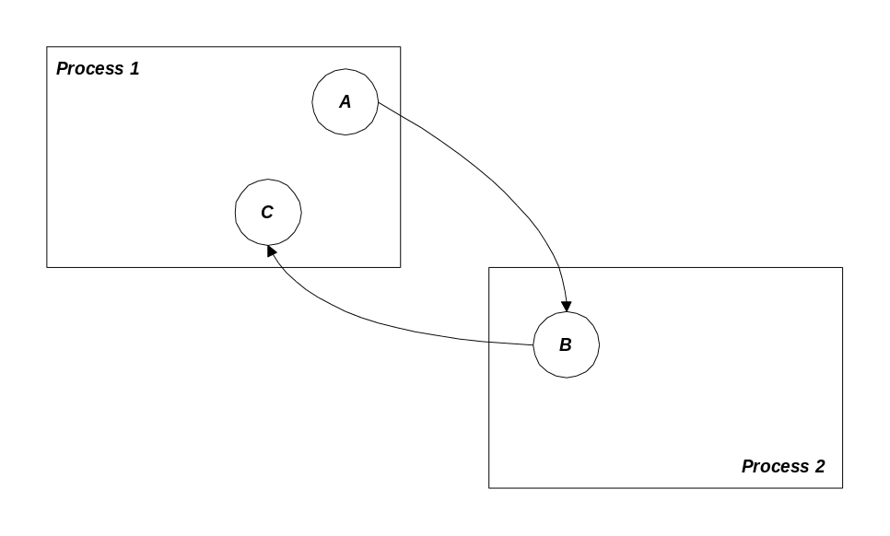
Figure 28. Basic Deadlock Situation
Figure 28, Basic Deadlock Situation, depicts a very simple situation that can happen very easily. Process 1 has two objects, A and C, while Process 2 has one object B. A calls B, then B calls C, finally C returns to A. In a single threaded implementation, these processes would become deadlocked when the call from C to B was issued. If this seems impractical, note that the same diagram applies to a common form of callback operation.
As a result, distributed object implementations are typically threaded servicing requests in parallel. In addition, threading will allow the objects in the process address space to take advantage of any inherent machine parallelism and therefore service multiple client requests concurrently. The Thread Management facility should include a mechanism for pooling native operating system threads, and dispatching incoming requests on the individual threads managed in that pool.
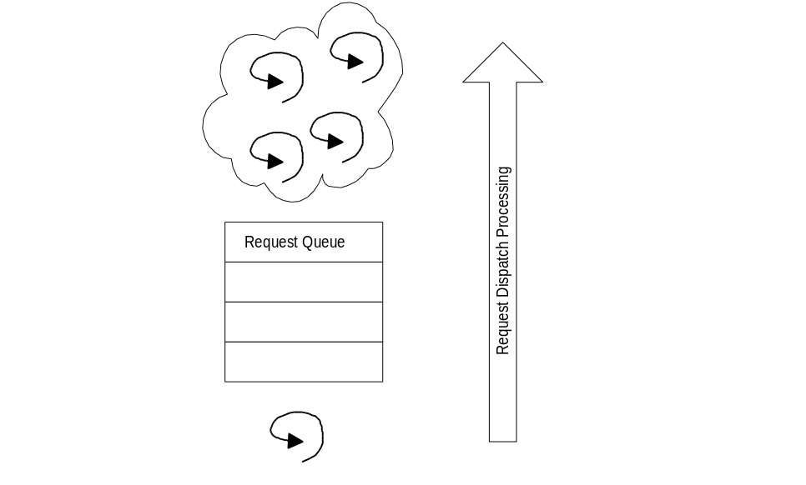
Figure 29. Thread Pool Abstraction
The thread pool abstraction is presented in Figure 29. A thread receives the request from the network placing it on a queue. The pool of threads are waiting on a condition variable synchronization primitive used to wake on or more of them up to check the queue for requests that are to be processed.

4.2.4.2 Concurrency and Safety
Threading naturally raises several implementation issues, not the least of which is that two threads can be executing in the same object instance at the same time. In this situation all object implementations will need to be made thread safe. This may not be an acceptable for all object implementers, so the Thread Management facility should provide a way to designate implementations as not thread safe and handle dispatching them to honor this restriction. This model is the same that Microsoft COM uses to do apartment threading.

5. External System Integration
The operational requirements documented in the Architecture section of this document describe general aspects of interoperability with CBOE’s external systems. While the architecture attempts to provide a uniform and flexible development environment for constructing information technology solutions, there are specific systems that will not, or can not, be constructed. The functionality of these systems are necessary to CBOE’s information systems and, therefore, need to be integrated into the new constructive development environment. Once these legacy systems have been integrated into the architecture, they can be incrementally replaced in a controlled fashion through a migration plan.
The requirements for interaction with external systems address different problems areas, such as desktop integration and mainframe data assurance. The integration of these systems can be achieved with the same approaches, because the concepts involved remain the same. Fundamentally, the concepts of bridging external systems derive from the essential elements presented in the Abstract Object Model: the common object semantics and the distributed transparencies. When the overall solution to the integration is considered in this manner, the reflection of the design of those solutions map clearly onto the implementation abstractions present in the CORBA architecture.
Without considering the technical issues of integrating specific external environments there are basic factors to consider that evaluate the possibility of achieving such integration. This is a vital step in deciding the overall approach to the use of legacy system, because there are certain situations in which systems are not presentable externally. Encapsulating (or deciding whether to even try) a legacy then becomes a matter of evaluating:
- Information Architecture Compatibility
Does the legacy have hooks, or can it be given them, to supply the right levels of abstraction of its internal data to the various tiers, or at least a meaningful subset of them, called for in the information architecture? In an ideal case, the legacy will have a discernible internal information architecture that maps (somewhat) to the enterprise information architecture. This evaluation is done by the Information Architect to validate information model compatibility.
The limiting characteristics that a legacy external system can have center around some very basic concepts: separation of presentation from system function and persistent storage structure and data integrity constraints. If each of these areas are separated, one can establish the appropriate level of abstraction for the integration.
- Processing Capabilities
Will it support the appropriate mechanisms (event, transaction, etc.) for interprocess communication specified, for components of its functional category, in the integration architecture? This issue is whether the legacy system itself has the ability to communicate externally, and how that communication must be carried out. This interaction is based upon system service related information. If the basis of this information is internal to the system the level of direct encapsulation is severely limited.
- Technology Facilities
Does the legacy system, or can some other third-party or custom software, provide interoperable interfaces with the technology infrastructure? This consideration is along the lines of basic interaction. For example, if the system is only capable of transmitting files, then the possible integration is limited to data replication and there is no possibility of a more direct interaction.
Essentially, the interaction of disparate systems can follow one of these lines: data exchange; data access and update; or functional interaction. Data exchange would include the file transfer example from above. Data access and update would include database gateway technology. Functional interaction includes various levels of interaction, but basically involves some type of direct operation invocation. The first two lines can be addressed as a specialized service. The third is addressed in this section.
We first examine external system integration by looking at general strategies providing integration. These strategies are evaluated in terms of the trade-offs in the overall requirements and goals. Then we consider specific external system integrations that will be required for the CBOE Trade Engine Redevelopment Project.

5.1 System Integration Strategies
The fundamental issues involved in system integration derive from the essential elements presented in the Abstract Object Model: the common object semantics and the distributed transparencies. Integrating each system must first resolve mapping the common object semantics of the architecture with the semantics of the external system. Second, the interaction with the external system must, at some level, manage the distributed transparencies into the CORBA system.
The important consideration is that integrating with external systems does not respect the clear implementations in the architecture. In fact, these systems are rarely object-oriented in nature. Implementation environment problems are most likely intimately linked to the use of the external system. For example, service delivery may be product and even operating system specific, and the external system environment may follow a separate interaction paradigm. Therefore, any integration must consider the following factors in their implementation:
- Interface Definition
In general, all distributed objects export potential operations in some well-known fashion, which defines the syntax of the potential conversation. The CORBA system defines objects with interfaces in IDL syntax. External systems need to be mapped into IDL and IDL to the external system to enable complete interoperation.
- Development Environment
Handles the implementation details of both system APIs.
- Data Representation
Provides basic mapping of the representation of IDL descriptions in terms of the interface definitions of the external system. This includes the message or call level format of scalar types such as the size of integers or the character set encoding of strings.
- Reference Representation
Provides a mapping between the CORBA object references to the handles of the external environment. Often the association of type or interface information must also be maintained to map between the two environments.
- Interaction Paradigm
Possibly need to deal with a fundamentally different interaction paradigm, including event or message versus a procedural or transactional invocation orientation.
- Managed Interactions
Possibly mapping domains of implicit identity, that systems on either side of the connection may maintain. These include managing transaction context, security privileges and credentials, and so on. These probably need to be mapped into representations of these managed interactions in the other system.
The most important factor in choosing external system integration is Interface Definition. More generally, this is an issue of mapping of the common object semantics presented in the Abstract Object Model into and out of the external systems definition language. In the CORBA system these common object semantics are realized in the IDL, but because IDL is directly derived from the common object semantics, a mapping to these must come first.
Therefore, the external system must possess system definition or behavior semantics that can be equated to the common object semantics elements. At minimum, the semantic elements of object, object reference, interface and operation must be mappable.
Without this level of equivalence the integration of the two systems is a very manual process that must be addressed on a case-by-case basis. Within each case the semantic elements need to be defined in IDL interface definitions with the operations carrying out the function of newly created objects through whatever operations the external system provides.
To reiterate, if the basic concepts of object and operations on these objects does not exist in the external system then they will need to be created to integrate into the architecture environment. This may indeed entail a manual modeling and development effort.
There are basically two strategies for integrating and encapsulating legacy, or more generally, external systems. They are static and dynamic strategies. Both offer benefits over the other in certain situations, but the trade-offs can be difficult to manage. In general, the dynamic integration has a critical mass point in terms of time, money, and resources before it can be used effectively and lower the overall development effort. Alternately, the static solution can generate much higher maintenance costs in the long term, while achieving expedient results.
There are many issues to consider on a case-by-case basis, and each are described in the following sections. Because of the inherent symmetry of most integration concepts, the following sections address the integration issue from a single direction. When there is a difference in the strategies and techniques used, we discuss both directions.
For integration with an external system that is as changeable as the distributed object systems, dynamic solutions provide technical superiority. The advantages, unfortunately, do not come without a drawback. A dynamic integration can be extremely difficult to implement, because of the generalized form of its solution. On the other hand, the static solutions favor expediency and reasonable effort.

5.1.1 Static Integration
The static strategy, or object wrapping, encapsulates the function of an external system by creating objects directly in the information object model. These information object model objects in turn directly call the external systems exported operations through the systems APIs. This implementation acts just as any direct client within the external system environment.
As mentioned above, the static strategy represented favors expediency. With a very stable external system configuration and small number of interactions, object wrapping represents very straightforward development that can quickly deliver results. At minimum, the object wrappers need to deal these factors from the list above:
- Interface Definition
- Development Environment
- Data Representation.
Differences in the direction of the desired interaction and the level of equivalence of the common object semantic elements require different tactics. For use of the external system the Interface Definition portion may need to include the creation of information object model abstractions to reflect the function of the external system into the architecture. This includes manual creation of the object implementations to call the functionality of the external system.
If the common object semantics can be directly mapped into IDL, then the process of generating the IDL definitions from the legacy systems definition language can be automated. This same approach can, in this situation, be used to generate the object implementations. These IDL and object implementation source files can in turn be compiled into the architecture environment.
Take, for example, integrating a mainframe CPI-C application that provides functionality for Loan Origination. Choosing the object wrapping approach, CORBA objects are defined with IDL interfaces, and object implementations activated and controlled by the Basic Object Adapter (BOA). The BOA provides for object creation and implementation in the CORBA environment. Each object implementation needs to provide for establishing and managing LU6.2 sessions. In addition, in each operation the objects implement needs to establish conversations on those sessions and make the corresponding calls to the appropriate CPI-C APIs to transact with the mainframe application.
To recap, Object Wrapping has the following advantages:
- Quick prototyping and deployment of a single or small set of services from another system.
- Straight forward static APIs can be used from each system.
- Invocation routing and interpretation is simple with statically generated skeleton code.
Finally, there are several overall drawbacks of an object wrapping strategy to consider. The previous discussion resolved three of the factors that integration implementations may need to deal with. While these designate the minimum support needed to encapsulate a legacy, the presence of the other factors complicates the use of the object wrapping strategy. These factors are the interaction paradigm and managed interactions.
The complication introduced by these factors derives from the significant amount of coordination abstractions and the amount of system level interaction necessary. First, for example, on the interaction paradigm level, providing object wrappers to bridge asynchronous events between systems usually requires interaction with complex filtering or scoping mechanisms, such as the OSI EventForwardingDiscriminator. Second, for example, on the managed interaction level, managing transaction identifiers is the domain of the Object Transaction Service, and the use of this service information in mapping to an LU 6.2 environment becomes very complicated.
While these issues can be solved through concerted development and reuse of system level abstractions in implementing the object wrappers, maintenance can become a problem. If the system level semantics of either system change, all object wrappers need to be at least re-linked to the new implementation of the system level abstractions. With a large number of object wrapper implementations, this can become a significant problem. In addition to the direct integration factor, the static mapping strategy comes with three additional complications:
- Physical Image Size
Static automatically generated or manually written code creates much larger system images when dealing with complex type systems. Introducing many external system integration objects into the system can tax the hardware.
- System Resource Usage
System resources optimization is decentralized to each object implementation. The example shows how using a single straightforward LU session can become expensive with many object implementations, and even instances if not managed. The solution is not simple in the static approach because the mainframe endpoint information of the session connection is contained in the individual object implementation, so providing for pooled LU use is a challenge.
- Dynamic Instance Management
System mapping can not effectively deal with systems that introduce new instances of objects, or more generally in terms of new application instances. Because an object wrapper does not have a concept of a parent or creator, it is difficult to manage creating and associating new object wrapper instances with the external instances. Furthermore, introducing new types in the external system is not accommodated in the static solution. This necessitates introducing a new object wrapper type itself, which is not accommodated.

5.1.2 Dynamic Integration
The integration architecture provides for a much more fundamental type of integration with external system that is distinct from the straightforward static integration. While the integration architecture provides support for the static form of integration in the overall constructive development environment, its implementation abstractions can form a more basic integration. The integration architecture uses the implementation abstractions of CORBA to provide a dynamic integration strategy.
The dynamic strategy, or model adaptation, seeks to address the underlying mapping of external system model to the common object semantics of the Abstract Object Model presented above. This interaction seeks to fundamentally understand the representation of one system's models of object definition and behavior, and system level constructs in terms of the other. The goal of model adaptation is transparent mapping between systems.
The basic CORBA implementation abstractions that support the construction of dynamic, or model adaptation, solutions are:
- Dynamic Interaction Mechanisms
There are three components used by dynamic integrations. They are: Interface Repository (IR), Dynamic Invocation Interface (DII); and Dynamic Skeleton Interface (DSI.) The reason for using these components is to allow generic code to operate into and out of the CORBA environment without using skeleton code generated from IDL by the Language bindings. In this way the generic code can be developed to handle the overall interaction and management of the integration with an external system, without knowing the specifics of the interfaces and operations it is bridging.
- Object Adapters
This abstraction provides the framework for constructing transparent bridges within the CORBA system. The Object Adapter represents external systems objects in a CORBA system, activating implementation on request invocation.
- ORB Services
The use of the ORB Services is through the normally object visible pseudo-object Current, and the underlying Object Service implementation if service to service interaction must be enabled. The specifics of the Current object and the service interfaces are presented in section 6.3.6 ORB Services.
In addition to the basic model adaptation architecture discussed later in this section, there is an even greater level of integration for legacy systems. This integration provides transparent wire-level interaction. In general, this must be done directly by the ORB Core, but the definition of the external wire protocol could be specified as an extension of the GIOP. These extensions take the form of a parallel to the IIOP. While this is a possible integration point it, it does not fit the model presented here, and is not discussed in this architecture specification.

Applying the CORBA abstractions to build model adaptation solutions follows a generalized form. Recall the example presented for the static integration solution. To the mainframe side of the conversation the only difference is a reduction and pooling of the LU sessions, but fundamentally the conversation remains the same. Alternately, the ORB side is drastically different in implementation, but fundamentally the representation to the rest of the architecture is the same.
Essentially, the conceptual information that the static and dynamic approaches is the same. Both need Interface Definitions of the objects, external reference mapped to object instance information, and operation semantics or behavior information. The difference is in the implementation and use of this information. The static approach captures this information in a particular object implementation, while the dynamic approach captures it as configuration information that drives a generic invocation framework.
The major component differences in the dynamic integration strategy are denoted by a heavier weight line. These components are:
- External Reference, Object Instance, and Operation Mappings.
- Dynamic Skeleton component of the ORB implementation.
- Object Adapter specific to the object model of the external system.
The External Reference is captured in configuration and registration profiles specific to the Object Adapter. The Object Instance helps construct the Operation Mappings, which registers logical objects (having known representation in the external model) with the ORB.
Model Adaptation must resolve the same factors of object wrapping, but seeks to solve them in a generic fashion. Regardless of whether the approach taken to achieve object wrapping uses common code to address these drawbacks, that code is spread across all wrappers of a given system type. Changes to any of the factors causes re-deployment or even code changes in all implementations. Model Adaptation seeks to concentrate the impact of change on a single generic bridge that can be easily administered and maintained.
Model Adaptation offers several advantages over the object wrapper approach:
- Change Flexibility
Most application specific logic of the objects or instances within external systems can be placed in configuration repositories. Changing this information involves only changing the repositories and note implementation code.
- Resource and Communications Optimization
The Object Adapter seeks to fundamentally manage the scenarios of communication to the external system by providing generic bridging of ORB requests. Because a single Object Adapter can potentially manage numerous bridged object references, the underlying resources and communications connections can be optimized. For example, an adapter to a LU6.2 environment can multiplex many individual logical object reference requests as Conversations over a pool of Sessions.
- Dynamic Instance Support
The object adapter supports creating additional logical object references into the ORB environment as a result of some form of notification from the external system. In addition, if the external system provides an external definition repository, and the common object semantics mapping is automated, the Object Adapter can dynamically introduce types into the ORB system as a result of an instance of that type being created.
The disadvantages:
- Longer Development and Deployment Cycle
The model adaptation strategy, because of its more generalized solution, can have a much longer development and deployment cycle. Using this approach depends upon a large overall project effort that necessitates its functionality, or a longer term strategic commitment to achieving the maintenance benefits.
- Significantly More Complex to Develop
Creating one large Object Adapter that understands all the functionality of a legacy system and can interact with distributed objects usually involves many times the development effort of object wrapping.
There are a number of factors that contribute to the choice to deploy a model adaptation strategy over an object wrapping strategy. The decision to take the model adaptation approach entails a significant development effort, and is based upon reaching a critical mass of these factors.

5.2 CBOE Legacy Systems
Within CBOE there are a few very specific external systems with which the newly architectured application systems will need to integrate. In addition, the interaction with these systems is very focused and possess very limited interfaces. As a result, all recommendations in this section utilize the static integration approach outlined above.
We examine each of these external systems, exploring possible integration approaches under the general framework. In general, following sections detail the overall interaction of the two systems with the architecture environment. Further, each of the six general integration factors outlined above are addressed. The six general factors are:
- Interface Definition
- Development Environment
- Data Representation
- Reference Representation
- Interaction Paradigm
- Managed Interactions.
Armed with these factors, we explore three external systems interfaces that are expected to remain beyond the migration of the trading engine functionality to the post environment.

5.2.1 Continuous Trade Match Integration
The Continuous Trade Match (CTM) system resides on MVS and runs under the CICS environment. Very simply CTM accepts reports of individual side of trades and performs matching between these sides for reporting to the firms and the Options Clearing Corporation.
The integration strategy that is recommended is static in nature. A single interface should be developed for accepting trade side reports from the distributed trading engine environment and making the existing calls into CICS to post the reports.

5.2.1.1 Interface Definition
The trade reports are simply well structured messages and therefore should be structured as typed message interface that is used by the post based trading engines.

5.2.1.2 Development Environment
The adapter will need to be constructed to receive trade report messages from the Message Queuing service. Therefore the development environment for this adapter will need to support the new messaging infrastructure.
In addition, the adapter will need to make the CICS transaction invocations. The Trading Engine Migration document recommends that the network protocol for the CTM interface be changed to IP. Therefore, the development environment will need have libraries to handle the transaction invocations over IP.

5.2.1.3 Data Representation
The adapter will need to perform ASCII to EBCDIC translation on the message contents before transmitting the trade reports to MVS.

5.2.1.4 Reference Representation
This is not an issue as the messaging infrastructure will be used.

5.2.1.5 Interaction Paradigm
None

5.2.1.6 Managed Interactions
None

5.2.1.7 Caveats
None

5.2.2 COPP Integration
The COPP system provides reporting to external agents regarding the trading activity at CBOE. This system takes a variety of messages created by the trading engine which the distributed trading engine should be placed on the messaging infrastructure. From there COPP will simply consume the information and report it externally.
The Trading Engine Migration document recommends that the COPP system be changed to accept incoming report via IP. In addition, it emphasizes that a new piece of functionality will need to be created to provide consolidated reports through the external reporting interface. This new adapter should be constructed to consume messages from the messaging infrastructure, make any consolidation calculations, and report the results through the IP version of the COPP interface.

5.2.2.1 Interface Definition
The Distributed Trading Engine will define event interface types for the messaging information that COPP reports on today, such as last sale and best quote reports. The adapter should subscribe to these interfaces.

5.2.2.2 Development Environment
The COPP adapter will need to support the new messaging infrastructure and transmit IP messages to the existing Stratus based COPP application system.

5.2.2.3 Data Representation
The adapter will need to perform ASCII to EBCDIC translation on the message contents before transmitting the trade reports to the external reporting agency.

5.2.2.4 Reference Representation
None

5.2.2.5 Interaction Paradigm
None

5.2.2.6 Managed Interactions
None

5.2.2.7 Caveats
None

5.2.3 TIPS Integration
This is detailed in the PSP migration document.

5.3 SBT Application Programming Interface (API)
A major requirement of the Screen-Based Trading system as specified in the SBT Software Requirements Specification, is to provide an Application Programming Interface (API) to enable members’ computer systems interact with the SBT system. The targeted users of this API are member firms, non-market-maker professional broker/dealers (BD), and market-makers (MM). Although these types of users have different capabilities, they are sufficiently similar to suggest the use of a single API with usage restrictions according the type of user, as opposed to using multiple APIs.

5.3.1 API Requirements
The following SBT system functions must be accessible through the API:
- Session logon and logoff
- Market state inquiry and change notification
- Connection status inquiry and change notification
- Order entry, cancellation, and replacement
- Quote entry, cancellation, and replacement
- “Request for Quote” notification
- Order status inquiry and fill notification
- Subscription to product markets
- Best market quotes notification
- Book “depth” inquire and change notification
The API is not intended for automating administrative or configuration functions; members will have to use a SBT Workstation to manually perform these functions with proper authorization.

5.3.2 API Implementation
The API leverages the distributed infrastructure utilized by CBOE to ensure a reliable, efficient and secure transmission of messages to and from the SBT system. In addition, this will substantially simplify the development of the API.
CBOE will provide a single portable API or a set of functionally-equivalent APIs for deployment in members’ platforms. In addition to the API, CBOE will provide the required libraries for the distributed infrastructure components such as ORB, messaging service, event service, security service et cetera. With the API, members will develop applications to automate trading or gateways to allow other computers automate trading. These applications or gateways will run in member’s computers connected to CBOE via leased lines.
To facilitate the development of the member’s application, CBOE will make available a special simulation SBT application server. The simulation SBT application server will support all the functionality of an actual server and provide a realistic environment for stress testing the member’s application.
The API’s functionality will be exposed as a set of CORBA IDL interfaces to facilitate its use from any language with a CORBA mapping. To simplify application development and maximize performance, the API will be multi-threaded and thread-safe.

5.3.3 API Architecture
The API exposes a replicated image of a master object graph residing in a SBT application server. These objects represent business object model entities such as orders, quotes, or series, whose state is maintained synchronized with the master copy in the SBT application server without application intervention. For example, whenever the application accesses an order object’s “filled volume” attribute, for example, it will return the current value of the attribute, without the application having to invoke a “refresh” operation explicitly.
Replicated objects are persisted by the API—if the client application fails or the connection to the SBT server is dropped, upon re-starting or reconnecting, the API restores the objects to its prevalent state. The API only presents a snapshot of the member’s current trading state at any given time; the application is responsible for storing relevant transactions to reconstruct history. Whenever possible, data validations will be performed locally using cached data to avoid unnecessary network traffic.
The API conforms to the event-based programming model—the API calls back a registered event handler upon occurrence of an event, passing the details of the event to the event handler. For example, to receive notifications every time an order is (partially) filled, the application first needs to register an application object, which implements an API-defined interface, with the API. Once a fill occurs, the API will invoke a method, defined in the interface, on the application object.
Events are fired asynchronously as soon as they occur, however, an event may be delayed if the application is not ready to process it. This will depend on the threading support of the application development environment used.
Invocation of critical methods is synchronous in order to let the application know of the success or failure of the call. Armed with this information, the application can decide whether to continue normal processing or take corrective actions immediately, instead of having to wait for an asynchronous reply.
To simplify the development of the application and the API, transaction boundaries will not span more than a single method invocation.

5.3.4 API Design
Figure 31 contains a class diagram depicting the design of the API. The subsections that follow describe each class in more detail.
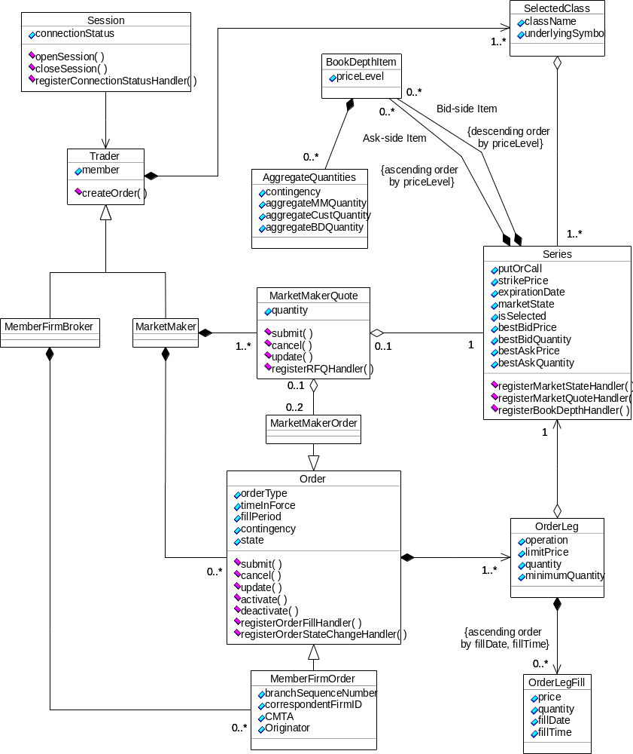
Figure 31 Design of the SBT API

5.3.4.1 Session
Purpose:
This class represents a session with the SBT system.
Responsibilities:
This class is responsible for opening and closing a session with the SBT system as well as providing the current status of the session.
Lifetime:
A single Trader object is created upon session opening and destroyed upon session closing. The openSession method of the Session object returns a pointer to the Trader object instance.

5.3.4.1.1 Public Properties

connectionStatus
Possible values:
- CONNECTED
- OPENED
- CLOSED
- DISCONNECTED

5.3.4.1.2 Public Methods

openSession () : Trader

closeSession ()

registerConnectionStatusHandler (connectionStatusHandler : ConnectionStatusHandler)

5.3.4.2 Trader
Purpose:
This is an abstract class representing the trader that has opened the session.
Responsibilities:
This class provides the ability to create an Order object in preparation for submission to the SBT system.
Lifetime:
A single Trader object is created upon session opening and destroyed upon session closing.

5.3.4.2.1 Public Properties

member

5.3.4.2.2 Public Methods

createOrder ()

5.3.4.3 MemberFirmBroker
Purpose:
This concrete class represents the member firm broker that has opened the session. Notice the member firm broker may be a computer that still requires an ID and proper authentication information (private key).
Responsibilities:
This class is the entry point to the object graph representing the trading activity of the member firm broker.
Lifetime:
A single memberFirmBroker object is created upon session opening and destroyed upon session closing. The openSession method of the Session object returns a pointer to the memberFirmBroker object instance.
Derivation:
Derived from Trader.

5.3.4.4 MarketMaker
Purpose:
This concrete class represents the market-maker that has opened the session. Notice the market-maker may be a computer that still requires an ID and proper authentication information (private key).
Responsibilities:
This class is the entry point to the object graph representing the trading activity of the market-maker.
Lifetime:
A single MarketMaker object is created upon session opening and destroyed upon session closing. The openSession method of the Session object returns a pointer to the MarketMaker object instance.
Derivation:
Derived from Trader.

5.3.4.5 Order
Purpose:
This abstract class represents an order.
Responsibilities:
This class contains the attributes of the order (it does not include the operation, price, quantity, etc because these attributes belong to an order's leg) and operations for handling the order.
Lifetime:
Instances of this class are created by the createOrder method on the Trader class and are persisted for a configurable period of time after complete filling or cancellation.

5.3.4.5.1 Public Properties

orderType
Possible values:
- SIMPLE
- STRADDLE_SPREAD
- COMBO_SPREAD
- VERTICAL_SPREAD

timeInForce
Possible values:
- DAY
- GTC (Good-till-Cancelled)

fillPeriod
Possible values:
- OPENING
- FREE_TRADING
- CLOSING

contingency
Possible values:
- LIMIT
- OPG
- AON
- FOK
- IOC
- MIN
- STP
- STP_LIMIT
- MOC

state
Possible values:
- NOT_SUBMITTED
- OUTSTANDING
- PARTIALLY_FILLED
- FILLED
- CANCELLED_BY_USER
- CANCELLED_BY_SYSTEM
- EXPIRED
- ACTIVE
- INACTIVE

5.3.4.5.2 Public Methods

submit ()

cancel ()

update ()

activate ()

deactivate ()

registerOrderFillHandler (orderFillHandler : OrderFillHandler)

registerOrderStateChangeHandler (contingentOrderStateChangeHandler : ContingentOrderStateChangeHandler)

5.3.4.6 MemberFirmOrder
Purpose:
This concrete class represents a member firm broker's order.
Responsibilities:
This class contains additional order information specific to a member firm.
Lifetime:
Instances of this class are created by the (inherited) createOrder method on the MemberFirmBroker class and are persisted for a configurable period of time after complete filling or cancellation.
Derivation:
Derived from Order.

5.3.4.6.1 Public Properties

branchSequenceNumber

correspondentFirmID

CMTA

Originator
Possible values:
- MARKET_MAKER
- CUSTOMER
- BROKER_DEALER

5.3.4.7 MarketMakerOrder
Purpose:
This concrete class represents a market-maker's order.
Responsibilities:
An instance of this concrete class contains a reference to a MarketMaketQuote object if it is part of the quote. Otherwise, it contains a null reference.
Lifetime:
Instances of this class are created by the (inherited) createOrder method on the MarketMaker class and are persisted for a configurable period of time after complete filling or cancellation.
Derivation:
Derived from Order.

5.3.4.8 MarketMakerQuote
Purpose:
This class represents a market-maker's quote.
Responsibilities:
This class contains the quantity requested in an outstanding RFQ, otherwise, it contains zero. In addition, this class allows the application to submit, cancel or update a Quote, as well as register an object to receive RFQs for the series. A Quote may be submitted by itself or in response to an outstanding RFQ.
Lifetime:
One instance of this class is created, upon session opening, for each series the market-maker has been assigned to.

5.3.4.8.1 Public Properties

quantity

5.3.4.8.2 Public Methods

submit ()

cancel ()

update ()

registerRFQHandler ()

5.3.4.9 OrderLeg
Purpose:
This class represents an order's leg.
Responsibilities:
This class contains the attributes of an order's leg, i.e. operation, price, quantity, and minimum quantity. Regular orders have one leg, spread orders have two or more different, but related legs.
Lifetime:
Instances of this class are created when an Order is being defined. They are destroyed when its Order object is destroyed.

5.3.4.9.1 Public Properties

operation
Possible values:
- BUY
- SELL

limitPrice

quantity

minimumQuantity

5.3.4.10 OrderLegFill
Purpose:
This class represents a fill of an order's leg.
Responsibilities:
This class contains the attributes of a fill of an order's leg, i.e. actual price, quantity, and fill date and time.
Lifetime:
Instances of this class are created immediately after an order is (partially) filled. They are destroyed when its OrderLeg object is destroyed

5.3.4.10.1 Public Properties

price

quantity

fillDate

fillTime

5.3.4.11 SelectedClass
Purpose:
This class represents a Class the trader has selected to trade.
Responsibilities:
This class contains the descriptive name of the Class as well as a sequence of references to the Series of the Class.
Lifetime:
One instance of this class is created, upon session opening, for each selected Class.

5.3.4.11.1 Public Properties

className

underlyingSymbol

5.3.4.12 Series
Purpose:
This class represents a Series of a Class the trader has expressed interest in trading.
Responsibilities:
The Series class contains the attributes of the Series and allows registration of the objects that will receive notifications of the events related to the Series.
Lifetime:
Series objects are created automatically upon opening of the session. One Series object is created for each series belonging to a Class that has been selected by the trader.

5.3.4.12.1 Public Properties

putOrCall

strikePrice

expirationDate

marketState
Possible values:
- PRE_OPENING
- OPENING
- FREE_TRADING
- HALTED
- CLOSING
- POST_TRADING

isSelected

bestBidPrice

bestBidQuantity

bestAskPrice

bestAskQuantity

5.3.4.12.2 Public Methods

registerMarketStateHandler (MarketStateEventHandler)
This method enables the application to register an object to receive notification upon a change in the state of the series.

registerMarketQuoteHandler ()

registerBookDepthHandler ()

5.3.4.13 BookDepthItem
Purpose:
This class represents a "row" in the "book" at a price level on one side of the market (Bid or Ask).
Responsibilities:
This class provides the aggregated quantities of a Series currently being asked or offered at a price level. The actual aggregated quantities segregated by contingency (LIMIT, AON, FOK, IOC, and MIN) and type of order originator (market-maker, customer and non-customer professional trader) are stored in the AggregateQuantites class.
Lifetime:
Instances of this class are created and destroyed dynamically during trading to reflect the prevailing "rows" in the "book".

5.3.4.13.1 Public Properties

priceLevel

5.3.4.14 AggregateQuantities
Purpose:
This class represents a group of columns associated with a specific contingency in a "row" of the "book".
Responsibilities:
This class provides the aggregated quantities of a Series currently being asked or offered at a price level for each type of order originator (market-maker, customer and non-customer professional trader), which are associated with a specific contingency (LIMIT, AON, FOK, IOC, and MIN).
Lifetime:
Instances of this class are created and destroyed dynamically during trading to reflect the prevailing "rows" in the "book".

5.3.4.14.1 Public Properties

contingency
Possible values:
- LIMIT
- AON
- FOK
- IOC
- MIN

aggregateMMQuantity

aggregateCustQuantity

aggregateBDQuantity

6. Appendix A–Abstract Integration Model
The integration architecture provides this fundamental environment while being able to adapt to changing technology. To deliver these features, the integration architecture begins by specifying the fundamentals that must exist to support the environment: uniform type, reference, and invocation system. To this end, the integration architecture provides an Abstract Integration Model, a definition of common semantics and a set of distributed transparencies. In addition the concrete implementation abstractions that support these components are presented.
The Integration Architecture document details the support for this system through the Common Object Request Broker: Architecture and Specification (CORBA). CORBA defines the fundamental implementation abstractions, which more than one Object Request Broker (ORB) environments use to both transparently interoperate and directly support optimizations for their environments. Through this, a CORBA-based system implementation provides the basis of a distributed object system, but does not dictate a particular form to that system. In essence the strategy of the system is provided by CORBA, which allows⎯and even promotes⎯the tactical solution optimizations.
The Abstract Integration Model establishes the basic and essential characteristics of the architecture environment, and is the unifying framework enabling object interaction at all levels. This framework is specifically targeted to provide the fewest elements needed to fully express the object-oriented abstractions. The framework also includes specifications for constructing the core abstractions to implement these elements.
Identifying the discrete elements and the abstractions that support them is the first step in the developing the Abstract Integration Model. The second task propagates these terms throughout the environment, enabling consistent communication. Every concept in the software system must be expressible using the same terms, at all points in the architecture.
A technology service provided in a particular environment, by a particular hardware or software product, must be accessible everywhere. This includes items such as development languages, hardware devices, multiprocessor systems, and so on. In this way deployment decisions can be driven by environment specific optimizations, not by the platform supplying the least common denominator.
Finally, the Abstract Integration Model includes a definition of the set of implementation abstractions that support the common object semantic and distributed transparencies. These implementation abstractions create the underlying basis for optimized system integrations, and in so doing form the heart of the integration architecture.

6.1 Common Object Semantics
The Abstract Integration Model enables portability and interoperability of software components in a distributed environment.
Design portability is necessary for two reasons. The most important is to allow an implementation created in one environment to be accessed by an implementation in another environment. The second, and slightly lesser reason is for the object model to define implementation semantics that allow source code to be used in different implementation environments. Semantic or source code portability is not the responsibility of the object model, and is therefore not discussed further in this section. This problem must be solved by the implementation language developers use to express the conceptual elements in the object model.
The basic elements of common object semantics:
- Type
A type is an identifiable entity with an associated predicate defined over values. A more practical definition might be: a type is a set of values that satisfy a set of characteristics.
Within the Abstract Integration Model there are two basic types: object types and scalar types. An object type characterizes the behavior of objects by how they satisfy a specific classification. This behavior is identified as a set of operations that are the object type’s interface. An object type is distinct from its interface and its set of instances. Both of these can change over time, but the identity of the type is constant. A scalar type is a basic value that identifies a discrete item of information.
Organizing relationships between object types based upon generalizations or specializations of their behavior is called supertyping and subtyping. Supertype and subtype are related such that the interface defining the supertype must also hold true for the subtype, so the subtype must be transparently substitutable for the supertype.
- Interface
An interface is the set of all operations that make up the behavior of a type. An object supports an interface if a reference to that object can be the target of a request for all operations in the interface. An interface of a specific type can change over time.
- Object
An object is an identifiable, opaque entity that provides one or more services to any requester. The basic characteristics of an object: it is an instance of a primary type; it supports one primary interface; and it has an identity that is constant and valid for the life of the object.
- Object Reference
The object reference is a unique permanent identity of a single object. This identity is distinct from and independent of the characteristics of the object itself, because these characteristics can vary over time. An object can have more than one valid object reference.
- Request
A request activates an operation, including associated parameters and context, on an object reference. Just as an operation specifies a specific behavior that can be carried out by an object of a given type, a request simply invokes that operation on a particular instance of that type.
- Operation
An operation is an identifiable entity that represents a specific requestable behavior. An operation is identified by an operation identifier and has a signature. The signature contains: a set of parameters necessary to carry out the service; a context with information that can affect the request; and potentially a result, that can be a value returned from the execution of the service or an exception indicating a problem that occurred during the execution of the service.
- Parameter
A parameter is a value with an identifiable type, either scalar or object. Parameters are declared in a operation specification indicating their mode. A mode designates that the value of this parameter is passed from requester to the object (in), from object back to requester (out), or both (inout).
- Context
A context is a value that is a scalar or object type, and can affect the processing of an operation request, and is derived from the environment of the client making the request.
- Exception
An exception is a value that has an identifiable type, either scalar or object, and indicates an abnormal condition that occurred during the processing of a request.
These elements of common object semantics help establish design portability because they define the fundamental conceptual semantic contents of object (and possibly other) systems. It is easy to imagine that by expressing the language of two or more systems using the common terms of these conceptual elements, that they can potentially interoperate. Note that a system can interoperate if its semantic elements are expressed in terms of these common object semantic elements.

6.2 Distributed Transparencies
Distributed object systems need distributed transparencies so that objects in different domains can interact as if within a monolithic environment. A distributed transparency is the representation of a type of interaction, or information, that is the same regardless of where that representation is used. Consider an example of a file system handle within a single operating system process. All objects in that process can use that handle to interact with the identical file resource.
Monolithic, or single process, systems did not require distributed transparencies because they were self-contained. Being self-contained reduced complexity, because fundamentally providing these transparencies was simple. Mapping conceptual elements using common terms creates transparent interaction between domains needed by the distributed object system environment.
CORBA 2.0 provides for specific transparencies:
- Network Addressing: Scope of the network address.
- Network Connectivity: The potential scope of a network message, resolving network or protocol transparency.
- Representation: Covers message transfer syntax and protocol. Completes format marshaling and unmarshalling of messages between objects.
- Type: A particular type identifier object type or interfaces must be uniformly and transparently expressed between implementations.
- Reference: Resolves the ultimate destination or routing of a particular request to a location.
- Security: The extent of a policy. Resolves access rights associated with any particular message.
- Transactional: The scope of a specific transaction service.

6.3 CORBA Implementation Abstractions
Properly implementing an Abstract Integration Model, and providing for the distributed transparencies, includes providing multiple points of flexibility. Common object semantics ensure all representations of objects are the same across the architecture, because all components use the same terms to communicate, but implementations must provide more than simple common object semantics.
Objects are dynamic by nature, and an implementation providing the common object semantics and supporting the distributed transparencies, must flexibly adapt that nature. CORBA implements the Abstract Integration Model by capturing its flexibility in a set of implementation abstractions. The CORBA architecture is documented through the implementation abstractions that define distinct points of flexibility.

Figure 32. CORBA Implementation Components
Figure 32 presents the implementation components of the CORBA system. These components can be grouped into the following functional implementation abstractions supported by the CORBA model.
The following sections describe each implementation abstraction.
- 6.3.1 Interface Definition, Management, and Language Independence
- 6.3.2 Static and Dynamic Invocation Mechanisms
- 6.3.3 Interoperability
- 6.3.4 Object Adapters
- 6.3.5 ORB Core
- 6.3.6 ORB Services.

6.3.1 Interface Definition, Management, and Language Independence
To effectively use the common object semantics of the Abstract Integration Model, a systematic way of maintaining language and implementation independence is needed. There are three components that maintain overall language independence in the architecture:
- Interface Definition Language: A generic interface definition language that defines the form of the common object semantics
- Interface Definition Repository: A repository of all type definitions existing in the system resulting from the those definitions
- Implementation Language Mapping: Individual mappings to language environments that satisfies the requirements of the activation and invocation needs in the system.
This set of components is pervasive, encompassing system interfaces and developer-generated objects.

Figure 33. CORBA System: Language Independence Components
The highlighted parts of Figure 33 represent the abstract implementation components of the CORBA specification that support language independence. Each component cooperates to support overall implementation environment independence, allowing discontinuous improvement and development of new components from the present systems.
These components are:
- Interface Definition Language (IDL): The implementation independent language that enables the specification of the common object semantics of objects in the system.
- Interface Repository (IR): Maintains the directed acyclic graph of all types in the distributed object system and make available at runtime their definitions as specified in the IDL.
- Individual Language Bindings: Specifies the mappings of IDL definitions into implementation language constructs that are predictable native representations.
- Client Interface Stubs and Implementation Skeletons: Generating implementation language constructs that conform the language binding. They introduce the static types of particular interfaces into the implementation language’s type system. The implementation skeletons directly support the development of objects supporting a particular interface. The code generated uses ORB-dependent interfaces to enable activation of this skeleton implementation as a result of requests received on an object reference.

6.3.1.1 Interface Definition Language
CORBA provides for generically defining the static elements within the common object semantics. The CORBA Interface Definition Language (IDL) satisfies this by providing only the minimal definition elements needed to create type definitions through the specification of interfaces, and operations on those interfaces. The full definition of the IDL is found in the Common Object Request Broker Architecture and Specification. This definition includes the ability to define modules, interfaces, complex non-object data types and aggregates, operations, parameters, and exceptions.
An interface definition written in IDL completely defines the interface and fully specifies each operation’s parameters, and result. An IDL interface provides the information needed to develop clients that can issue requests on the interface’s operations. In this sense IDL is purely a descriptive language, and therefore does not specify management of implementation state.

6.3.1.2 Interface Repository
Just as a given language environment provides a type system within a monolithic environment, the CORBA system provides a type system throughout the distributed object system. Knowledge of the static type information of the system is encapsulated within the core ORB Interface Repository service. The Interface Repository provides the storage, distribution, and management of definitions for a collection of related objects. This arrangement allows evolution of a type system that directly mirrors the incremental strategy of object-oriented development.
Because the interface definition of objects is separate from their implementation in the Interface Repository, it represents the common ground to establish higher level functionality of the object system. For example, the unified storage of interface definitions in the Interface Repository supports the construction of the following high level capabilities:
- Client Invocation and Server Implementation Independence
The client and server objects within a single interaction are isolated. Given a reference to two server implementations of a particular interface, the client performs the invocation on both in exactly the same way. This isolation provides for the measured evolution of system components along several lines, such as implementation language, implementation design, and levels of service.
- CASE Environment Integration with Development Environment
Traditionally, the analysis and design environment is separate and distinct from the development environment. This difference is essentially one of semantic domains. Analysis and design conform to a particular descriptive language and development conforms to an implementation language.
- While there are different levels of information captured in the two environments, the common object semantics remain constant. In other words, there is an intersection, but traditionally this intersection was not maintained because the resulting combinatorial number of mappings is difficult for either environment to maintain. By using IDL to describe common object semantics, and the Interface Repository to maintain an unified object model, these two environments can be integrated by mapping their models into the common object semantics of the Abstract Integration Model, or the interface repository.
- Language Bindings Independence
The natural outgrowth of the previous capability is the establishment of generic mappings into language environments for both client and server implementations.
- Type Discovery and Navigation
Given a reference to a particular target object, a client implementation can discover the principle type, or most derived interface, of that target object, because the type of all objects within a give system are known by the Interface Repository. In addition, if the principle type of the target was not even known when the client was created, the client still has the ability with the Interface Repository to discover that type.
- Therefore, while the expression of the object model that is created in the IDL is strongly typed and has a completely static binding model it is possible to—through interaction with the Interface Repository—provide knowledge of types consequently introduced.

6.3.1.3 Language Binding
The CORBA system is independent of the programming language used to construct clients and implementations. The Language bindings completely separate the implementation of objects, or more generally, programs acting as clients, from the implementation of server objects, by providing predictable native programming language reflections of the definition of interfaces in the CORBA object model (such as IDL interfaces). A language mapping contains essentially the same structure:
- All IDL basic data types
- All IDL constructed data types
- References to constants defined in IDL
- References to objects defined in IDL
- Invocations of operations, including passing parameters and receiving results
- Exceptions, including what happens when an operation raises an exception and how that exception parameters are accessed
- Access to attributes
- Signatures for the operations defined by the ORB, such as the dynamic invocation interface, the object adapters, etc.”
Presently, there are approved or recommended language bindings for C, C++, Java, Smalltalk, Ada, and Cobol 85.

6.3.2 Static and Dynamic Invocation Mechanisms
CORBA provides both static and dynamic invocation and activation mechanisms to make request on object operations defined in the IDL. The basic difference between the two invocation mechanism is that in the static case all request invocations are bound as compile time, and in the dynamic case compiled implementations discover and invoke operations on objects of unknown type at compile time. CORBA also provides a classic object model, ensuring that the system knows the static type of all objects in the system, and that all objects are of exactly one principle type.
An important aspect of invocation is that to the target object the request appears the same regardless of the mechanism used to invoke it. More specifically, a request created by the language binding generated stubs is the same as one created by the Dynamic Invocation Interface (DII) when transmitted to the target object. This is the same in the reverse directions, when the target object is servicing a request. The client does not know if the target skeleton code is being activated by via a language implementation stub or is receiving the request through the Dynamic Skeleton Interface (DSI).

presents the components of the static and dynamic invocation mechanisms. The components that make up the static invocation are:
- Language Binding
Specifies the mapping of IDL interface and type information to the native implementation language. The language binding is requested to create Language Binding Stubs.
- Language Binding Stubs
Represent CORBA objects as potentially native language objects so that a client object directly calls a CORBA object just as it would invoke native objects.
- Interface Repository
A client may request the interface definition of a generic opaque object reference for which it would not otherwise possess type information. The Interface Repository then allows the client to discover names of all operations and layout of all data parameters. Because the basic repository identifiers for all IDL definition components are textual in nature, discover or browsing driven solutions are possible.
- Dynamic Invocation Interface (DII)
The DII provides a client with the ability to construct requests on an opaque object reference based upon the information discovered in the Interface Repository. The actual interface to the DII is bound through the implementations Language Binding.
- Dynamic Skeleton Interface (DSI)
The DSI is the object implementation, or target object, equivalent of the client side DII. The DSI enables a generic implementation to create and register object references in the ORB environment. As a result, object requests can be received and processed by this generic implementation. The actual interface to the DSI is bound through the implementations Language Binding.

6.3.3 Interoperability
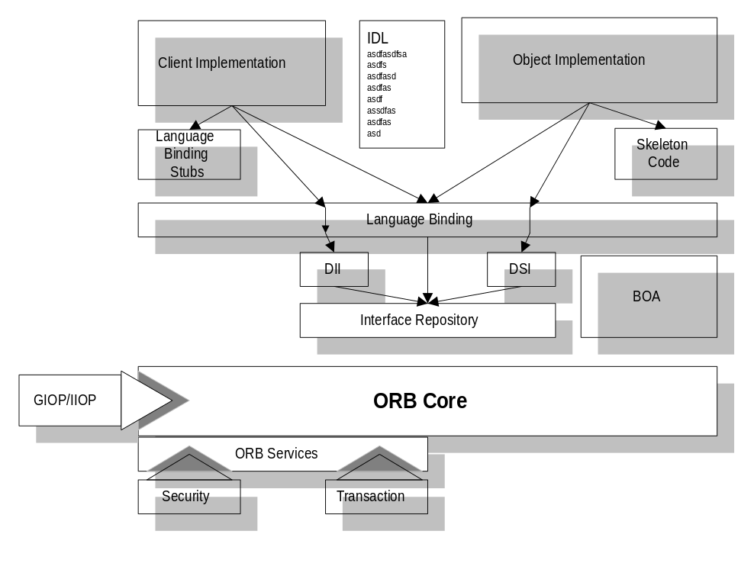
Figure 35. Interoperability Components
CORBA specifies a General Inter-ORB Protocol (GIOP) to guarantee transparent interoperability between heterogeneous CORBA 2.0 conforming ORB implementations. First, this allows ORBs to be selected based upon their support for the target language, platform, and COSS components. This directly affects language mapping, the GIOP will allow use of one environment for the front end and a second for the intermediate and back end services. And while not specifically required by CORBA, there is a possibility that the selection of COSS components for use with a given ORB implementation will not be constrained to the ORB vendor.

6.3.4 Object Adapters
CORBA defines an implementation abstraction that provides for bridging of the common object semantics from the ORB Core to the unique capabilities of an implementation environment. This is distinctly not the issues resolved in language bindings, but provides the interfaces and active coordination needed, by an object implementation, from the ORB. To restate the fundamental functions of Object Adapters, as specified in CORBA, “Object Adapters are responsible for the following functions:
- generation and interpretation of object references
- method invocation
- security of interactions
- object and implementation activation and deactivation
- mapping object references to the corresponding object implementations
- registration of implementations.”

Figure 36. Object Adapter Components
The Object Adapter implementation abstraction provided by CORBA is depict in Figure 36, with its relationships to the other CORBA components. In particular the interface of the Object Adapter is represented through the Language Binding of the implementation environment. This is called directly by the object implementations or by the generated IDL based skeleton code.
Specifically, CORBA defines a Basic Object Adapter (BOA), that can be used for general purpose object implementations, and must be available in every ORB implementation. The BOA activates and communication with implementation components using operating system facilities that are not part of the ORB. The BOA also provides support to connect the methods that implement interface operations for an object instance. This support is language-specific, and therefore specified in a general form that is adapted for each language environment.
Although all Object Adapters need to provide similar abilities, they do not need to provide them in the same way as the BOA. This is particularly true when we consider other, non-CORBA, environments. Essentially, any Object Adapter must provide all services necessary to allow an object implementation to participate in the CORBA environment.

6.3.5 ORB Core
The ORB Core provides the most basic functions associated with accepting and dispatching requests, and interpreting object references. With basic functionality the ORB Core provides for establishing logical bindings of the other CORBA components to carry out distributed invocations. In essence the ORB Core is the active agent in carrying out these invocations with the Distributed Transparency properties.
For example, object references contain specific profile information that the ORB Core uses to establish client and target bindings such as network transport addressing and protocol use, object adapter activation, and ORB Service associations.

6.3.6 ORB Services
There is a concept being developed as a result of the COSS work to let the ORB actively participate in the delivery of Object Services. This participation is generally needed to perform service specific actions, such as, transmitting contextual information for managed interactions from client to target, and security validation operations, during each request invocation. The ORB Services abstraction is provided to allow the ORB to solicit the individual object service implementation to perform the activity at the appropriate place during request invocation.
The ORB Services abstraction is used for, and can be more generally applied to providing the semantics for implementing the Distributed Transparencies presented in section , “6.2 Distributed Transparencies.” It is not important that all Distributed Transparencies are not Object Service specific. The generalized abstraction allows for a completely flexible framework that the CORBA Core specification⎯and in turn ORB Core implementations⎯can maintain to allow independent evolution of the distributed object systems environment.

Figure 37. ORB Services Components and Invocation Interaction
Structurally, Figure 37 presents the ORB Service abstraction. The ORB Core is logically constructed to pass the each object invocation request to an ORB Services component that is implemented and maintained as part of the ORB environment. Each individual Object Service that needs direct interaction in request invocation specifies both a set of interfaces for callback objects the ORB can activate per request, and an interface the ORB must support for the initialization and registration of objects supporting these interfaces. This ORB Services component is responsible for exporting the registration interfaces to the Object Services implementation, and the ORB Service represents a specific set of callback objects implemented by the Object Service.
Generally, the ORB Services component maintains generic information to determine the individual ORB Service objects to invoke for a given request invocation. The information that can be used to trigger invocations can be:
- Static properties of the client about membership in particular transparency domains.
- Static properties of the target of membership maintained with the profiles of the object reference
- Dynamic attributes associated with a particular thread invoking or receiving a request, such as an active transaction or additional confidentiality associations that have been established.

7. Appendix B–Service Engine Abstraction Framework
This section specifies an architecture to use in constructing technology-independent services implementations. This should be used in those cases that require implementations to transparently interact or migrate to a completely different COTS technology.

7.1 Service Implementation Architecture
The integration architecture attempts to address the implementation issues by considering each service as part of the whole of the integration architecture. By understanding the dependencies the integration architecture, we can resolve these issues. The service implementation architecture defines an abstract engine-based architecture, which achieves the plug-and-play infrastructure.
We need to understand the importance of the plug-and-play infrastructure. The general implementation architecture presented provides flexibility to technological change, because it isolates the service from the technology engine that carries out the service. The goal is to provide each service so that the engine component can be easily replaced or optimized. A natural outgrowth of this is the ability of the implementation architecture to adopt new technology products as they prove more effective than the last.
The generic implementation architecture is presented in two pieces:
- Engine Based Design Implementation: Presents the basic abstractions used to build a service implementation based upon a particular technology product.
- Distribution through Federation Considerations: Discusses generalized service federation considerations and approaches.
The integration architecture plug-and-play infrastructure focuses on providing an engine based services architecture that allows maximum client flexibility, in terms of selection of products or engines, and a tightly coupled infrastructure for building large-scale distributed object systems. The use of this abstract implementation architecture is dependent on an external enabling technology product. If the service can be implemented in terms of pure ORB function, this architecture does not need to be implemented.
Achieving the “plug and play” engine functionality, with a maximum of configurability, relies upon a very simple abstract “bridging” architecture. The bridging architecture is derived from the Bridge design pattern presented in the Gamma, et. al. book. Design Patterns. In addition, the Abstract engine can be in some implementation scenarios a Facade from the same reference.
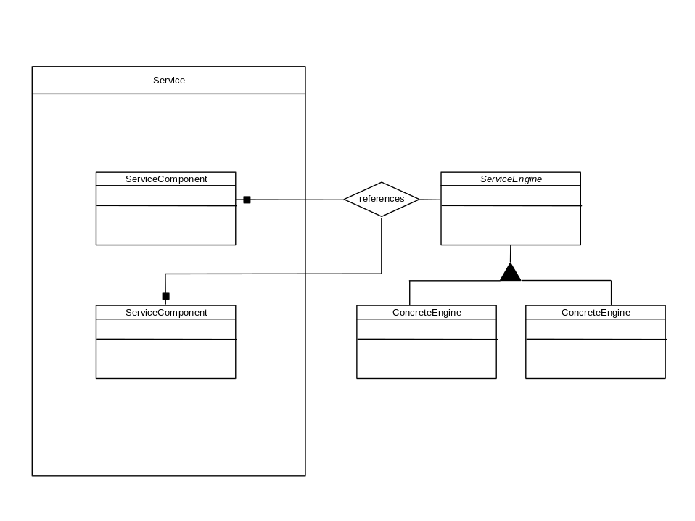
Figure 38. Abstract Pluggable Engine Architecture.
Figure 38 illustrates the basic nature of the pluggable engine arrangement. The Service has several ServiceComponents implemented in terms of and initialized with an instance of an abstract ServiceEngine. In providing a unified interface the ServiceEngine “bridges” the specific nature of the engines to the abstract interface. Then service components can be implemented in terms of the abstract engine interface. In addition, this architecture provides for the possibility to perform dynamic configuration when properly enabled, because the engine is attached as a reference that can be dynamically rebound with a reference to potentially a new engine implementation.
The underlying goal is twofold:
- Create an abstraction of all functionality of a given class of engine
This is to create a very thin layer of a common API mapping of the divergent engine APIs. This achieves two things. First, the maintenance of changing versions of underlying engine APIs to the common one is straightforward. Second, the abstract API only needs to implement and bridge to functionality that is needed in the service components, and not to create a union of all functionality of the candidate engines.
- As mentioned before, the engine can be a Facade for a set of objects that cooperate to provide the function of the engine. This is normally the case of complex services with two different technology directions for engines. For example, an ODBMS and a RDBMS have the same engine abstraction that was a Facade for two completely different sets of implementation objects.
- Access the engine through this interface by reference
This allows the service components to then independently evolve from the engine mappings, and most importantly abstract reference generation techniques allow the deployment of different version of the service, by engine, to be a relink or less.
The engine component represents the point of flexibility in the face of change or technological innovation. Engines are meant to be small, representing a minimal amount of investment in development, are quickly prototyped, and developed. The engine abstractions represent the point of optimization in the architecture. The engine is an abstract specification of the activities the Service carries out, and therefore not the full functionality of the individual engines. The abstraction is used to adapt the function of the engine to a very specialized form.
The generic implementation architecture provides the basic concepts of distribution through the use of federation. The concepts of Federations are essential to building large-scale distributed systems without the need or concept of centralized ownership. By removing the concept of centralized ownership, or a universal controlling agent, we remove an otherwise rigid limit on the scalability of the service.
One important reason, that is possible to arbitrarily scale a federated system, is that usage patterns, regardless of the physical scope of the service, will overall have a locality of reference. This means that the federated implementation does not need to perform at the required performance levels constantly across its entire scope, but only the locality of reference of the large percentage of its use.
A federated implementation is typically formed by a graph of interconnected duplicates of its basic set of components, or a federation locale. The sets understand this relationship and can be notified or simply cache well known paths instead of rediscovering them each time an operation is performed. There are two additional benefits to a federated system approach. First, single federation locale in a federated system is autonomous, i.e. it is possible for it to provide a particularly optimized implementation for its domain, but still maintain transparent interaction with the other sets. Second, is the possibility of the distribution and parallelization of computation across many federation locales.

7.2 Service Administration Architecture
All systems must be managed in an operational environment. The integration architecture takes this concept a step further and makes it first class within the architecture by enabling service components with administration and configuration interfaces. In addition, the service implementations provide a tremendous amount of administrative support automatically into the information architecture constructed objects through the concerted management of service role objects.
All components of a given service are discussed in terms of the administrative support that is initially indicated by the services and the abstractions that can be introduced into the service, or its implementation to bring about administrative control. Some services are fundamentally more administrative and configuration oriented. For example the Naming service is the primary object location primitive in the system; and the Lifecycle service is the primary facility for object instance creation based on the implementation and its properties.
There are three basic parts to the service administration architecture: service creation and configuration; the administrative framework abstractions that enable the control of the services and service role objects; and event based monitoring.
The service creation and configuration part is the activity of creating and configuring factories, and relating their implementations to computing platforms and system facilitates. In addition, the configuration of service built objects and their dynamic reconfiguration is an important supported concept. For example, you have a service that has two or three potential abstract engine implementations. The construction of the service level components should include the ability to configure a separate engine abstraction for different sites. This should be enabled by establishing a Factory interface for the Service, to initialize with a given engine.
Individual service components define interfaces for direct control of their operation by an administrative client. Each of these interfaces is separate from the service interfaces themselves so the storage of the administration interface object references can be separately managed, away from the user environment.
The overall implementation architecture of the system should enable and export monitoring event information. Each event is specific to the service the architecture implementing, but the overall structure should be the same. Therefore the abstract implementation architecture defines the overall structure of the event information that is export by the services components. This structure is derived from basic open systems management concepts.

8. Glossary
Term | Definition
American Option | An option that can be exercised on any business day before it expires.
Ask | Also called "offer." Indicates a willingness to sell a futures or options contract at a given price. (See Bid).
At-the-money | An option whose strike price equals the current price of the underlying commodity, security, currency, index or futures contract.
Auto Quote | A CBOE system that automatically generates auto-quotes and sends them to the trading engine.
BART | Booth Automated Routing Terminal is a CBOE client/server system used by booth staff. It receives and re-routes orders that are originally routed to it.
Bear | One who expects a decline in prices. The opposite of a "bull”.
Bear market | A market in which prices are declining.
Beta (or Beta coefficient) | A statistical measure of the relationship between the price volatility of an individual stock or stock portfolio and the price volatility of the overall market. Beta is often used in computing hedge ratios for stock index futures positions.
Bid | An offer to buy at a stated price.
Book | Contains pre-open orders, limit orders, and intra-day limit orders at least one tick away from the same-side market quote.
Book Staff Clerk | Someone who maintains book orders using the trading engine.
Broker | A person who is paid a fee or commission for executing orders. In futures and options trading, the term may refer to: (1) a floor broker, i.e., an exchange member who executes orders on the trading floor of an exchange; (2) an account executive or associated person who deals with customers for a futures or options commission merchant or introducing broker; and (3) a futures or options commission merchant.
Bull | One who expects a rise in prices. The opposite of a "bear.
Bull market | A market in which prices are rising.
Call option | An option that gives the buyer (holder) the right, but not the obligation, to purchase a specific asset or obtain a long futures position at a fixed price within a specified period of time.
CBOE | Chicago Board Options Exchange
Charting | The use of graphs and charts in the technical analysis of markets to plot trends of price movements, average movements of prices and volume and open interest.
Clearing | The procedure through which the clearinghouse becomes the buyer to each seller of a futures or options contract and the seller to each buyer and assumes responsibility for the financial integrity of each open contract.
Clearing Member | A member of a clearinghouse through whom all trades must be settled.
Clearinghouse | An adjunct to a futures or options exchange through which transactions executed on the floor of the exchange are matched, settled and guaranteed. Charged with assuring the adequate financial protection of trading through collection and payment of margin and the proper conduct of the exchange's delivery procedures.
COMPASS | A CBOE system that connects offsite member firm branches with the trading engine. It sends orders to the trading engine and receives fill reports from the trading engine.
COPP | CBOE OPRA Participant Processor is a CBOE system that forwards price reports, quote reports, and administrative messages from the trading engine to the OPRA for dissemination to the general public.
Covered call writing | To grant, or write, a call option while holding or having a long position in the underlying security, commodity, currency, index or futures contract.
Cross-hedge | Hedging a cash market risk in a futures or options contract for a different but price-related commodity, security, currency, or index.
CST | Class Series Tape is a tape created by the trading engine that contains class and series information as it existed immediately at the end of trading.
DART | Direct Access Routing Terminal is a CBOE system (currently known as BERS) used by the following:  Booth staff to enter orders into the trading engine  Fill reporters to enter fill reports into the trading engine  Floor workers to enter inquiries into the trading engine  The display subsystem to display information to floor workers
Day-trading | Establishing a futures or options position and offsetting it the same day.
DBC | Database Compare Tape is a tape created by the trading engine that contains class and series information, including those classes and series added at the end of the day.
Default | Failure to perform on a futures or short options contract as required by exchange rules.
Delivery | The tender and receipt of an actual commodity or financial instrument, or cash in settlement of a futures or options contract.
Delta | The amount of change of an option's price or theoretical value for a unit change in the price of the underlying security, commodity, currency, index or futures contract
EB Backup | Electronic Book Backup is a CBOE system that provides a view of the book if the trading engine fails.
Ebook | Electronic Book. See EB Backup.
EEOD | Electronic End Of Day is a CBOE system that faxes options summary information to subscribers.
Exercise or strike price | The price at which the holder (buyer) may purchase or sell the underlying asset upon the exercise of an option.
Expiration date | The last day that an options contract may be exercised.
Hedging | Taking a position in a futures and/or options market to minimize the risk of an adverse price change in a position held in the cash market.
Help Desk Staff | A CBOE employee who trouble shoots trading floor problems and determines start and end of trading.
Holder | One who purchases an option.
ICS | Integrated Class Series is a CBOE system used for entry and storage of information concerning valid products. Will become the IPS.
Initial margin | Customers' funds put up as security to guarantee contract fulfillment at the time a futures or options position is established.
In-the-money | A call option with a strike price lower, or a put option with a strike price higher, than the current market price of the underlying asset or futures contract.
Intrinsic value | For a call option, the excess of the current market price of the asset or futures contract underlying the option over the strike price of the option; for a put option, the excess of the strike price over the current market price of the asset or futures contract underlying the option.
IPS | Integrated Product System will replace ICS.
Limit move | A price that has advanced or declined the permissible amount during one trading session, as fixed by the rules of an exchange.
Limit order | An order given to a broker by a customer that specifies a price; the order can be executed only if the market reaches or betters that price.
Liquidation | (1) Offsetting or closing out a futures or options position; (2) a market in which open interest is declining.
Long | (1) One who has bought a futures or options contract to establish a market position; (2) a market position that obligates the holder to take delivery; (3) one who owns an inventory of commodities or securities.
Margin Call | (1) A request from a brokerage firm to a customer to bring margin deposits back to initial levels, normally because of losses resulting from an adverse price move; (2) a request by a clearinghouse to a clearing member to make payments to or increase deposits at the clearinghouse.
Market maker | Market Maker is a trader that is trading exclusively for himself. A market maker uses an MMT to enter price reports into the trading engine.
Mark-To-Market | The daily adjustment of margin accounts to reflect profits and losses.
Membership | The CBOE system that maintains member, trader, and firm information.
Minimum price fluctuation | Smallest price change possible in a futures or options contract. Also called the tick value.
MMHH | Market Maker Hand-Held is the PSP application responsible for accepting trade data that a market maker enters into his/her Market Maker Terminal and routing it CTM and forwarding price reports to the trading engine. In addition, it receives and displays trade acknowledgments from RAES.
MMT | Market Maker Terminal is a hand-held terminal used by market makers to enter trade reports. It also provides tools to help the market maker trade more efficiently, such as position tracking, risk management, equivalent stock position, delta analysis, pricing models, and graphic position monitor. The MMT is also the hardware component of the MMHH application that interacts with a market maker.
NBBO | National Best Bid Offer.
Nearby | The nearest active trading month of a futures or options contract. Also referred to as "lead month."
News Wire
OBO | Order Book Official is a CBOE employee who trades booked orders.
OCC | Open Clearing Corporation is an organization that maintains a database about open interest in all U.S. traded options based trading information received from options exchanges and clearing firms.
Offer | An indication of willingness to sell at a given price; opposite of bid.
Offset | (1) Liquidating a purchase of futures or options through the sale of an equal number of contracts of the same delivery month, or liquidating a sale of futures or options through the purchase of an equal number of contracts of the same delivery month; (2) matching total long with total short contracts for the purpose of determining a net long or net short position.
OMM | Opening Market Maker is a market maker designated to open a collection of products.
Open Interest | All futures or options contracts that have been entered into and not yet liquidated by an offsetting transaction or by delivery.
Open order | An order to a broker that is good until it is canceled or executed.
Opening Price (Or Range) | The range of prices at which the first bids and offers were made or first transactions were completed.
Opening, The | The period at the beginning of the trading session during which all transactions are considered made or first transactions were completed.
OPRA | Options Price Reporting Authority.
Option | A contract that gives the buyer the right but not the obligation to buy or sell a specified quantity of a commodity, security, currency or index at a specific price within a specified period of time, regardless of the current market price of the underlying item.
ORS | The Order Routing System is a TPF application responsible for routing electronic orders to RAES, EBOOK, PAR, or booth terminals.
ORT | Order Routing Tape is a tape created by the trading engine at the end of the day that contains all order information found in the trading engine.
Out-of-the-money | A call option with a strike price higher or a put option with a strike price lower than the current market price of the underlying commodity, security, currency, index or futures contract.
Out-Trades | A situation that results when there is some confusion or error on a trade. A difference in pricing, with both traders thinking they were buying, for example, is a reason why an out-trade may occur.
P&S (Purchase-and-sale) statement | A statement sent by a brokerage firm to a customer when a futures or options position is offset or extinguished by delivery. A P&S statement typically shows the number of contracts involved, the prices at which and dates on which the contracts were bought and sold, the gross profit or loss, the commission charges, the net profit or loss on the transactions and the account balance.
PAR | Public Automated Routing is a CBOE system used by Floor Brokers to process public orders.
PDS | Post Data Server is the part of the display subsystem that is the central repository of class and series information for a specific post. The trading engine sends display information (e.g., CBOE best quotes and NBBO quotes) to the PDS. The Display Subsystem is a CBOE system used to display information on AutoQuote, Datawall, MMT, PAR, RCN, SideBySide, DART, and WPT.
Position trader | A futures or options trader who buys or sells contracts and holds them for an extended period of time--as distinguished from a day trader, who normally initiates and offsets positions within a single trading session and ends the day "flat."
Post | A specially constructed arena on the trading floor where futures and options trading is conducted. Also called Pit.
Premium | The amount agreed upon between the purchaser and seller for the purchase or sale of an option – purchasers pay the premium and sellers (writers) receive the premium.
Put | An option to sell a specified amount of a commodity, security, currency, index or futures contract at an agreed-upon price within a specified period of time.
RAES | Retail Automated Execution System is used for executing small market orders automatically.
RAT | RAES Trade Tape is a tape created by the trading engine at the end of the day that contains information about all the trades for the day.
ROS | Rapid Open System is a CBOE system used by OMM’s to determine the opening price for options.
Round Turn | A completed transaction involving both a purchase and a sale.
SBT Operator | Screen Based Trading Operator.
Scalp | To trade for small gains. Scalping normally involves establishing and liquidating a position quickly, usually within the same day, hour or even just a few minutes.
Scalper | A speculator on the trading floor of an exchange who buys and sells frequently, holding positions for only a short period of time during a trading session. In liquid markets, scalpers stand ready to buy at the minimum price change (tick) below the last transaction price and to sell at a tick above.
Settlement Price | The price at which the clearinghouse each day settles all accounts between clearing members for each open position in each contract month of each futures or options contract. Settlement prices are used to determine both margin calls and invoice prices for deliveries.
Short | (1) The selling side of an open futures contract; (2) a trader whose net position in the futures market shows an excess of open sales over open purchases; (3) selling (granting) an options contract.
Short-covering | Buying to offset an existing short position.
Spot | Market for immediate delivery and payment of the product.
Spread | The purchase of one futures or options contract against the sale of another futures or options contract of the same or related commodity, security, currency or index.
Squeeze | Situation in which those who are short cannot repurchase their contracts, except at an artificially inflated price,
Stop order (or stop) | An order to buy or sell at the market when and if a specified price is reached.
System Operator | A CBOE employee who maintains the operation (e.g., startup, shutdown, control functions) of CBOE systems.
TAT | Trade Acknowledgment Ticket is a notification to a market maker that he / she is the counter-party for an automatic RAES trade.
Tick | Refers to a change in price, either up or down. Minimum price fluctuation of a futures or options contract.
Time value | The excess, if any, of an option's premium over its intrinsic value.
TIPS | Ticker Processing System is the CBOE system that forwards market information (e.g., NBBO quotes) from external exchanges to the trading engine.
Trade Match System | The CBOE system that matches trades based on trade report information sent from the trading engine.
Trend | The general direction of the market.
Variation margin | Settlement via the clearinghouse of daily or intraday gains and losses between clearing member firms.
Vendor Machine | The machines maintained by vendors and used to send vendor quotes to the trading engine.
VIC | Volatility Index Calculation.
Volatility | A measure of variability, usually of prices, and a major factor influencing the price of an option. The standard deviation of a price series is commonly used to measure price volatility.
Volume | The number of contracts (either the long or the short side of the market) traded during a specified period of time.
VTATS | Visual Trade Acknowledgment Ticket System is a visual display of RAES trade acknowledgments.
WPT | Windows Price Terminal is a CBOE system (currently known as DCN) used by the following:  Price reporters to enter price reports into the trading engine  Quote reporters to enter quote reports into the trading engine
Write | The act of selling or granting an options contract.
Writer | The seller or grantor of an option.

For the sake of clarity, Figure 22 does not show all the subsystems of the SBT system, nor does it show all interactions between subsystems.
[GHS95], pg. 128.
[GHS95], pg. 128.
DP95, pg. 151
DP95, pg. 185

