Autolink Service

Overview

Current processing
- This functionality is new for Options Linkage. AutoLinkService (referred as ALS)

New requirement
- This service will provide the functionality for linking the orders to away exchanges. These Autolink orders are the result of the sweep evaluation.
- After the sweep is completed Sweep service will publish the event for the Linked orders over Internal Order Status Channel to OHS which will call the AutoLinkService to link away all the order(s) in the event to the respective exchanges with the respective volume and price.
- Creates and persist the Linkage Orders and also creates the relationship between the Linkage Orders and the underlying Order.
- Starts and maintains the timer and route the orders to Linkage Server for routing to away exchanges.
- Accepts the responses (Fills, Cancels and Order Rejects) and process the responses.
- Handles any exceptions from Linkage cluster.
- OHS will retry all the cancel/rejects quantity from Linkage Server until we linked away to all the possible exchanges within the price range once after that OHS will hold order until all the linked away responses arrived.
- OHS will forward any fill coming from Away Exchange to Trade Server immediately for processing.
- Once all the responses are received then ALS will check to see if any Quantity left on any Linked away order then OHS will send this quantity to Trade Server for further processing either to book or to sweep again.

Implementation

1. Autolink Service
The OHSOMS will receive the SweepLinkAwayStruct on IOSC through acceptAutoLinkEvent and will call OHS Linkage Order Handling service acceptAutoLinkOrders. Linkage Order handling service will create the Linkage Orders based on the Exchange volume strcut provided by HTS and at the same time OHS will create a Linkage Order Relationship between all the Linked Away Orders and the underlying Order. OHS will add a new service called AutoLinkService (ALS). ALS will be called by the OHS Linkage Order Handling Service to create the bi-directional relationship through Linkage Order cache between Linkage Orders and underlying orders. This cache will be used for holding on to all the Linked Away Orders until the responses from all the exchanges are received. Once we received all the responses this service will check if any Quantity left after linking to all the possible away exchanges then it return left quantity to HTS (Using the Workflow) for further processing.

After creating the Relationship and adding the order to ALS cache, OHS will start timers for all the linked away orders before sending the orders to Linkage Server. Once timer expired ALS will check if all the responses from away exchanges are received then OHS will return the Quantity back to HTS, left if any, otherwise ALS will keep this Linked away order in its cache until all the responses are received and then it will return the Order back to HTS.

The new services and classes need to be implemented to complete this functionality. We will try to use some existing services if possible.
- AutoLinkService
  - AutoLinkHome
  - AutoLinkHomeImpl
  - AutoLinkImpl
- OrderRelationShipService (existing), if the persisting in done in OHS then we probably need to write a new implementation like OrderRelationShip cache.

- Modify the Internal Order status Channel interface to add the new method acceptAutoLinkEvent.
This method takes the following arguments
OrderRoutingParameterStruct,
OrderIdStruct,
SweepElementsStruct[ ]

Order History Events
The away exchange market data will contain the opposite side of the market only. Customer order will have these additional events in the history related to the Linkage Order.

- History Events Generated During Auto Link Process on Underlying Order:
  - 311 - LINKAGE_ORDER_RELATIONSHIP (Per Linked Away Order)
  - 312 - EXECUTION_REPORT_ON_LINKED_ORDER (Per Linked Away Order)
  - 315 - Log Away Exchange Market (one event Per Exchange) – New Event Type
  - 316 - Log Away Exchange Disqualified (one event Per disqualified Exchange) – New Event Type

- History Events Generated During Auto Link Process on Linked Away Order:
  - 1 - New_ORDER
  - 310 - ROUTE_TO_AWAY_EXCHANGE
  - 2 - FILL_ORDER
  - 3 - CANCEL_ORDER
  - 14 – Fill Reported Routed to Trade Server.

Handling Of Responses From Away Exchange

Handling Of Fill Reports From Away Exchanges
All the fill reports received from the away exchanges will be applied to the auto Linked Orders in OHS first and then the fill reports will be routed to Trade Server for applying the fill on the underlying order generating the Fill Report and Trade Report for the underlying Order.

In order to handle these Fill Reports Order Routing Destination (ORD) is modified and a new interface method is added. Please see the following IDL changes:

//Accept Fill Report for the Auto Link Order.
void acceptAutoLinkFillReport(
in order::OrderRoutingParameterStruct orderRoutingStruct,
in cmiProduct::ProductKeySequence productKeys,
in cmiOrder::OrderIdStruct underlyingOrderId,
in cmiOrder::FilledReportStructSequence filledReportStructs)
raises(
exceptions::SystemException,
exceptions::CommunicationException,
exceptions::DataValidationException,
exceptions::AuthorizationException,
exceptions::NotAcceptedException,
exceptions::TransactionFailedException
)

On receiving the fill report Trade engine has the following possible scenarios: In all the possible three scenarios TE will suppress the dissemination of Last Sale.

- Order not in the Book (No need to acquire Class Level Lock)
  - Trade server will validate the Fill Report
  - Adjust the ship Quantity and the Traded quantity
  - Generates the fill Report for the Underlying Order
  - Generates the Trade Report for the Underlying Order.

- Order is in the Book (TE Needs to acquire class Level Lock)
  - Trade server will validate the Fill Report
  - Trade Server will acquire the class Level Lock
  - Adjust the ship Quantity and the Traded quantity
  - Generates the fill Report for the Underlying Order
  - Generates the Trade Report for the Underlying Order

- Sweep and Return Order From PAR (No need to acquire Class Level Lock)
  - Trade server will validate the Fill Report
  - Adjust the ship Quantity and the Traded quantity
  - Generates the fill Report for the Underlying Order
  - Generates the Trade Report for the Underlying Order.
  - Return the Order back to OHS for routing to PAR if there is any remaining quantity left on the order.

Handling of Returned Unfilled Shipped Quantity From OHS
Once OHS receives all the responses for all the linked away orders from Away Exchanges, OHS will determine if any unfilled shipped quantity left then OHS will return this quantity to Trade engine for further processing:

In order to handle Return remaining unfilled quantity, Order Routing Destination (ORD) is modified and a new interface method is added. Please see the following IDL changes:

//Accept returned any Canceled and Rejected auto Link quantity
void acceptAutoLinkReturnedRemainder(
in order::OrderRoutingParameterStruct orderRoutingStruct,
in cmiProduct::ProductKeySequence productKeys,
in cmiSession::TradingSessionName sessionName,
in cmiOrder::OrderIdStruct underlyingOrderId,
in long unfilledShippedQuantity,
in long filledShippedQuantity,
in boolean resweepEligible)
raises(
exceptions::SystemException,
exceptions::CommunicationException,
exceptions::DataValidationException,
exceptions::AuthorizationException,
exceptions::NotAcceptedException,
exceptions::TransactionFailedException
);

Upon receiving the returned remained of unfilled shipped quantity Trade engine has the following scenarios:

- Underlying Order in the Book (Acquire the class Level Lock)
  - Acquire the class level lock
  - Increment the Book quantity.
- Underlying Order not in the Book
  - Acquire the class level lock
  - Re-sweep the Order (No HAL second time around).
- Sweep and Return From PAR (No Need to acquire Lock here)
  - Increment the remaining quantity
  - Return Order to OHS for routing to PAR.

Scripts
- None

Database
- None

SetContext
- None

XML/DTD
- .

Homes/Services
- AutoLinkService
  - AutoLinkServiceHome
  - AutoLinkServiceHomeImpl
  - AutoLinkServiceImpl
  - AutoLinkServiceDelegateImpl
- OrderRelationShipService (existing)
- OHSOrderMaintenanceService (existing)
- OHSLinkageOrderHandlingService (existing)
- OHSLinkageOrderMaintainenceService

ImplPlan
- .

PerformanceTestingProcedure
- Standard Performance. Testing in Performance environment.

TestingProcedure
- Regular ITG test plan.

OperatorProcedure
- .

Fallback/Failover
- .

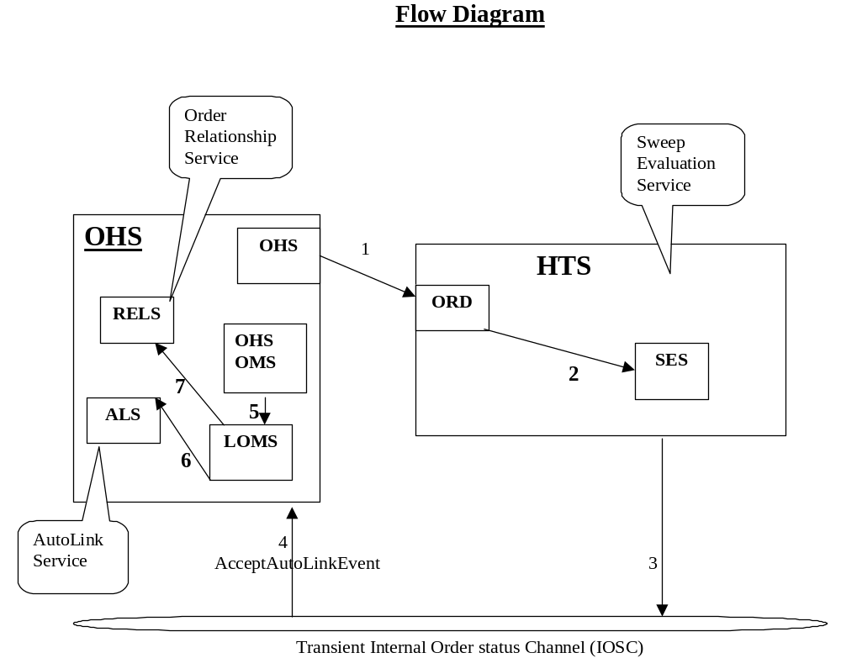

Incoming order: 100@1.20

Exchange | Price | Volume
CBOE-AR | 1.15 | 10
AMEX | 1.15 | 20
CBOE-AR | 1.16 | 10
BOX | 1.16 | 20
CBOE-Book | 1.18 | 10
CBOE-Book | 1.19 | 10
ISE | 1.20 | 10

