Performance Driver Eclipse Setup

To run the performance driver from Eclipse use the setting given below.

Pre-Test Requirement
Check out the data files under config\data folder (under OHS-drivers project), if you specify data-given flag to true in your test setup configuration.

Main Class
com.cboe.ohs.perfDrivers.DriverLauncher (under OHS-drivers project)

Example:
com.cboe.ohs.perfDrivers.DriverLauncher arg1 arg2

Program Arguments
Takes two arguments:
- Test setup configuration
- Test setup configuration mapping (always same)

Example:
config/xml/PerfSetup.xml config/xml/PerfSetupMapping.xml

VM Parameters (Example for Test 14)

-Xms256m -Xmx512m -DCHECK_REP_IDL=false -DORB.LocationService.Timeout=330000 -DSecurity.Admin.ServiceType=test14SecurityAdminService -DSecurity.Logout.ServiceType=test14SecurityServerLogout -DSecurity.Authorizor.ServiceType=test14SecurityServerAuthorize -DEventService.TrackFiltersECName=test14FilterNotification -DEventService.Admin.ExtentMapServerName=test14ExtentMapAdminServer -DEventService.Admin.ChannelAdminServerName=test14ChannelAdminServer -DSecurity.Authenticator.ServiceType=test14SecurityServerAuthenticator -DSMA.NoEventTransportStart -DDelayInitRegistrar -DEventService.RetryCount=10000 -DEventService.ListenTimeout=100 -DORB.ListenHostName=devenv2 -DORB.IRLocal=true -Dir.eventpackage=org/omg;com/cboe/idl;com/cboe;com/cboe/EventService -DtransactionTimer=true -DRegistration.ServiceType=test14RegistrationService -DOrderMetricsEnabled -DQuoteMetricsEnabled -DTradeMatchMetricsEnabled -DTpfOrderMetricsEnabled -DORB.TIOPTransport.AckWaitTime=60 -DmaxCommitTime=3000 -DmaxInterProcessTime=3000 -DcheckListenerTime=false -DdisableFridayExpiration=false -DallowUseClearingAcrConfigured=false -DEventService.Admin.ExtentMapServerNameV6=test14ExtentMapAdminServerV6 -DEventService.StoreAndForwardCache.CacheGroup=test14StoreAndForwardCache -DEventService.Admin.AdminPrefix=test14 -DORB.IRIds=IDL:events/OrderStatusEventConsumer:1.0;IDL:events/QuoteStatusEventConsumer:1.0;IDL:ohsEvents/InternalOrderStatusEventConsumer:1.0
-DIOR_FILE=file:///C:/Work_Area/Misc/Test14/initrefs.ior
-DSBT_SSCONFIG=C:/Work_Area/Misc/Test14/cboe.ssconfig.cm
-DSBT_PREFIX=test14
-DORBName=test14OHSLocal22
-DORBPortNum=19703
-DExtentMap.NodeName=devenv4V2TradeServer
-DSERVER_NAME=TradeServer2
Download IOR files
Download IOR and SSConfig files from the server against which you are intending to run the test and place it where you are running the driver. For example if you are trying to run against OHServer ONE_MAIN on Test 14, then do the pargs on the pid on server instance and you will see something like:
-DORB.InitRefURL=file:///sbt/test14/infra/run_dir/ior/initrefs.ior
-DEventService.SmartSockets.OptionsFile=/sbt/test14/infra/run_dir/properties/cboe.ssconfig.cm

Download these two above file to the place where your Driver can read and pass it as environment variables (-D args) as shown under VM parameters (
-DIOR_FILE=file:///C:/Work_Area/Misc/Test14/initrefs.ior,
-DSBT_SSCONFIG=C:/Work_Area/Misc/Test14/cboe.ssconfig.cm)

DLL path in Windows Environment For Talarian:

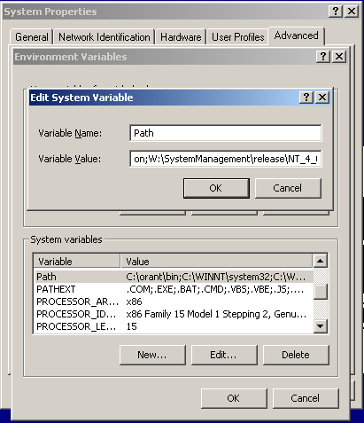

W:\SystemManagement\release\NT_4_00_sp3_x86_vc60\dynlib; W:\tools\release\NT

Where W: is you’re mapped drive letter for Clearcase VOB.

Classpath For Talarian

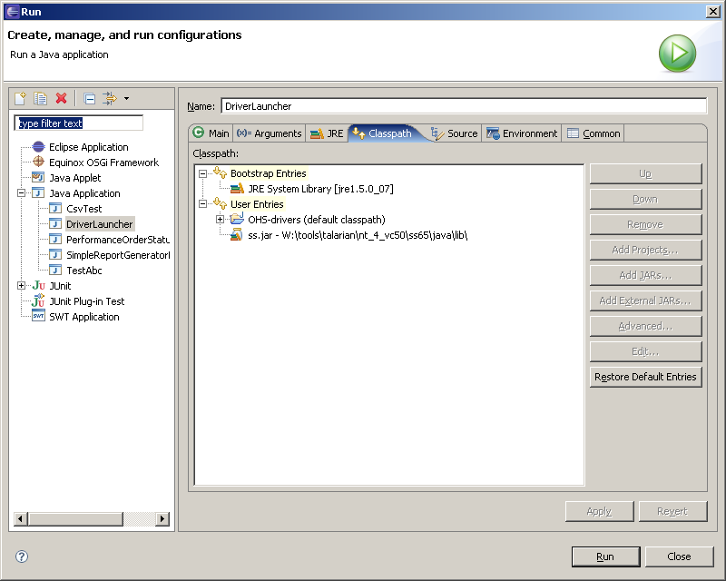

Notes: If you are running test from Unix box then you can skip DLL and Classpath setting for Talarian as this might be already setup.

