Order Cancel and Cancel-Replace By OMT

Overview

Current processing
An order cancel and cancel-replace request arriving at OHS from CMI is recorded in the sbtordermaintenance table if the order is at OMT. The request is routed to the owner OMT, but no action is taken on the request by the OMT.

New requirement
This feature requires the ability to:
- Allow an owner OMT to cancel or cancel-replace an order upon a cancel request the owner OMT receives from OHS.
- Allow an owner OMT to cancel or cancel-replace an order without a specific request from OHS.
- Allow authorized non-owner OMT to cancel or cancel-replace an order located on another OMT, a PAR, or a TE without a specific request from OHS.
See the feature requirement user cases document for the details.

Implementation
Two new workflows are added. The normal error-free paths of these workflows are shown in Figure 1 and 2. The ManualCancelFromOMTWorkflow uses a CancelContext, and processes a solicited or an unsolicited cancel from owner or non-owner OMT. The ManualCancelReplaceFromOMTWorkflow uses CancelReplaceContext, and processes a solicited or unsolicited cancel-replace from owner OMT.

Both workflows are nearly identical in the control flow structure. The main difference between the two workflow is the existing routing steps used for delivering an unsolicited request to the current location of the order. Several new workflow steps are described below.

- WFStepVerifyOwnership: This workflow step uses BaseOHSContext as input. The source OMT of the request is determined from the OrderRoutingParameterStruct of BaseOHSContext, and it is compared with the current location stored in the Order to determine whether the source OMT of the request is the order owner. The return value is a BooleanEnum where “True” value signifies that the request originator OMT is also the order owner.
- WFStepVerifyOMTUserAuthority: This workflow step uses BaseOHSContext as input. The source OMT of the request is determined from the OrderRoutingParameterStruct of BaseOHSContext, and the authority of the source OMT is verified with respect to the login role. The return value is a BooleanEnum where “True” value signifies that the request originator OMT is authorized to perform order cancel or cancel-replace operation. It is assumed that a non-owner OMT that has authority to cancel and order also has authority to cancel-replace and order. If this assumption is incorrect, then this workflow step must identify the current workflow.
- WFStepManualCancelFromOMT: This workflow takes a CancelContext or CancelReplaceContext as a BaseOHSContext, and performs appropriate downcast based on the action id stored in the context. It retrieves the order cancel information from the context, and performs the cancel operation.
- WFStepSendOrderUpdateToOMT: This workflow takes a CancelContext or CancelReplaceContext as a BaseOHSContext, and performs appropriate downcast based on the action id stored in the context. If the input context is a CancelContext, the cancelled order is published to its owner to update the owner. If the input context is a CancelReplaceContext, the replacement order is published to the destination in addition to the publish of the cancelled order.

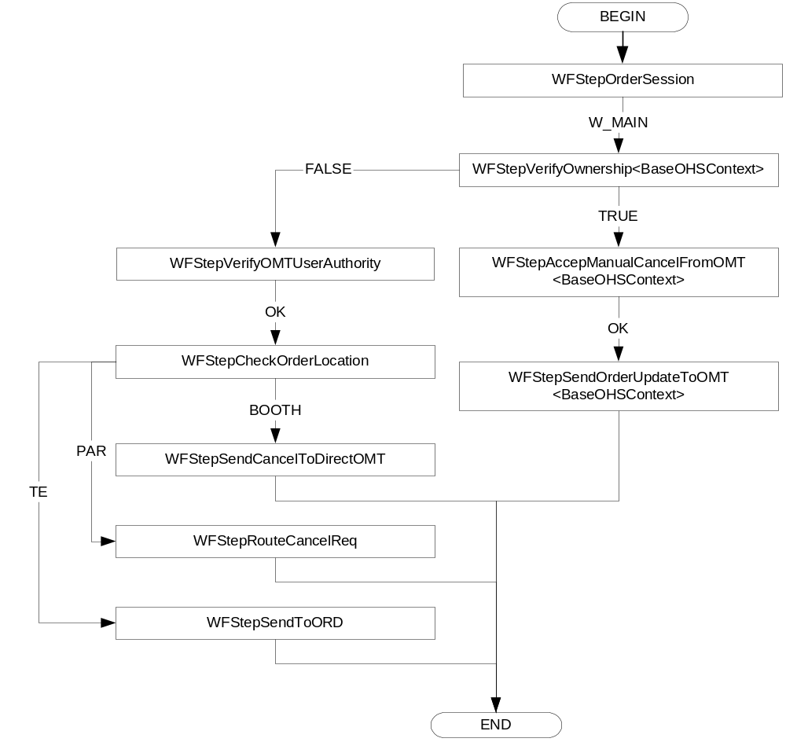
Figure 1: Manual Cancel FromOMT Worflow
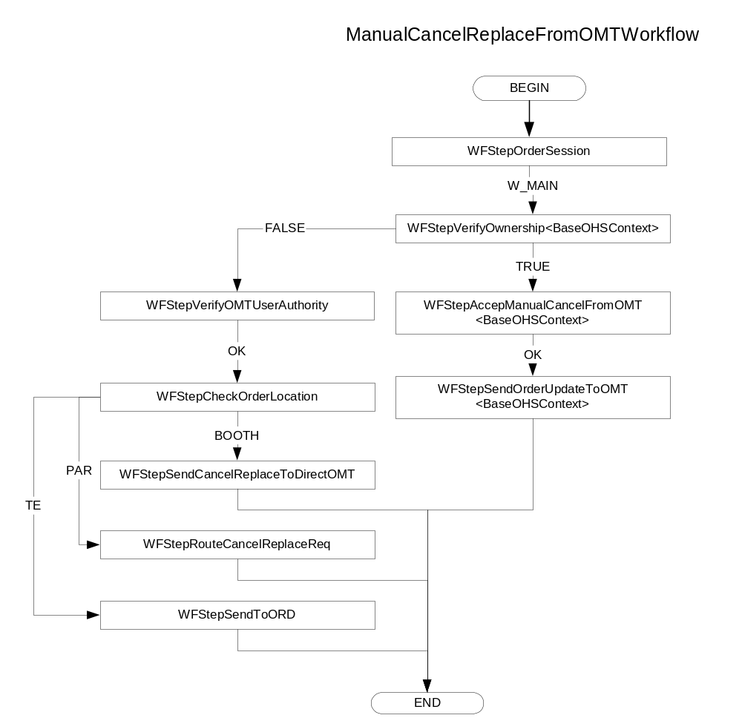
Figure 2: Manual Cancel-Replace From OMT Workflow

• IDL
The OMT will send cancel report to OHS to OrderHandlingService via CAS as shown in Figure 2. The OrderHandlingService, in turn, delegates the call to ManualOrderMaintenanceService. A new methods acceptManualCancel and acceptManualCancelReplace in OrderHandlingService and ManualOrderMaintenanceService shall be added.

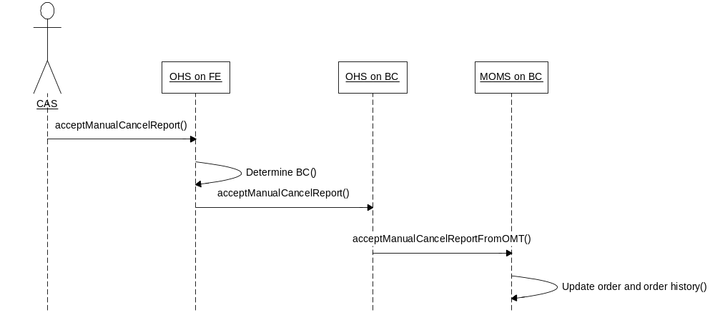
Figure 3: Invocation of acceptManualCancelReport from OMT via CAS
The new method details are shown below.

OrderHandlingService in /vobs/dte/server/idl/OrderHandlingService.idl

module businessServices
{
interface OrderHandlingServie : businessServices::OrderRoutingService
{
void acceptManualCancel (
in cmiOrder::CancelRequestStruct cancelRequest,
in cmiProduct::ProductKeysStruct productKey,
in cmiUtil::Identifier reqId,
in string userId) raises (
exceptions::SystemException,
exceptions::CommunicationException,
exceptions::DataValidationException,
exceptions::NotFoundException,
exceptions::AuthorizationException,
exceptions::TransationFailedException,
exceptions::NotAcceptedException);

void acceptManualCancelReplace(
in cmiOrder::CancelRequestStruct cancelRequest,
in cmiProduct::ProductKeysStruct productKey,
in cmiOrder::OrderStruct anOrder,
in cmiUtil::Identifier reqId,
in string userId) raises (
exceptions::SystemException,
exceptions::CommunicationException,
exceptions::DataValidationException,
exceptions::NotFoundException,
exceptions::AuthorizationException,
exceptions::TransationFailedException,
exceptions::NotAcceptedException);
}
}

ManualOrderMaintenanceService in /vobs/dte/server/idl/ohs.idl

module orderHandlingService
{
interface ManualOrderMaintenanceService
{
void acceptManualCancelFromOMT (
in cmiOrder::CancelRequestStruct cancelRequest,
in cmiUtil::Identifier reqId,
in string userId) raises (
exceptions::SystemException,
exceptions::CommunicationException,
exceptions::DataValidationException,
exceptions::NotFoundException,
exceptions::AuthorizationException,
exceptions::TransationFailedException,
exceptions::NotAcceptedException);

void acceptManualCancelReplaceFromOMT(
in cmiOrder::CancelRequestStruct cancelRequest,
in cmiUtil::Identifier reqId,
in cmiOrder::OrderStruct anOrder,
in string userId) raises (
exceptions::SystemException,
exceptions::CommunicationException,
exceptions::DataValidationException,
exceptions::NotFoundException,
exceptions::AuthorizationException,
exceptions::TransationFailedException,
exceptions::NotAcceptedException);
}

• Scripts
- None

Database
- No database schema changes are required.
- A cancel request or cancel-replace request is deleted from the sbtordermaintenance table after the request is processed.

SetContext
- None.

XML/DTD
- ManualCancelFromOMTWorkflow.xml: New workflow for cancel operations from OMT
- ManualCancelReplaceFromOMTWorkflow.xml: New workflow for cancel-replace operation from OMT.

Homes/Services

ImplPlan
- .

PerformanceTestingProcedure
- .

TestingProcedure
Test Case 1: Full Cancel By Owner OMT. Simple Order
- Enter a simple order (ORD:1) via CMI, and direct route it to an OMT
- Cancel the all quantity of the order via CMI. This step should generate a cancel request routed to the OMT.
- Perform manual cancel of all quantity of ORD:1 from OMT.
- Verify: The OHS cancels the order and updates the sbtorder and sbtorderhistory table accordingly.
- Verify: The OHS sends an event on OrderRouting channel to instruct the owner OMT to remove the order.
- Verify: The cancel routing request is removed from the sbtordermaintenance table.

Test Case 2: Send Full Cancel By Owner OMT with Invalid Cancel Request Id
- Cancel all quantity of ORD:1 from OMT. Note that ORD:1 has already been processed in test case 1, so this is a duplicate manual cancel report for ORD:1
- Verify: The OHS fails the cancel report with a NotAcceptedException.
- Verify: No events are published for this order.

Test Case 3: Partial Cancel By Owner OMT. Simple Order
- Enter a simple order (ORD:2) via CMI, and direct route it to an OMT
- Cancel partial quantity of the order ORD:2 via CMI. This step should generate a cancel request routed to the OMT.
- Perform manual cancel of the partial quantity of ORD:2 from OMT.
- Verify: The OHS cancels the partial quantity and updates the sbtorder and sbtorderhistory table accordingly.
- Verify: The OHS sends an event on OrderRouting channel to instruct the owner OMT to update the order.
- Verify: The cancel routing request is removed from the sbtordermaintenance table.

Test Case 4: Full Cancel with TLC By Owner OMT. Simple Order
- Enter a simple order (ORD:3) via CMI, and direct route it to an OMT
- Cancel the all quantity of the order via CMI. This step should generate a cancel request routed to the OMT.
- Perform manual cancel of the order with partial cancel quantity and partial TLC quantity that add up to full quantity of ORD:3 from OMT.
- Verify: The OHS cancels the partial quantity and updates the sbtorder and sbtorderhistory table accordingly.
- Verify: The OHS sends an event on OrderRouting channel to instruct the owner OMT to remove the order.
- Verify: The cancel routing request is removed from the sbtordermaintenance table.
- Verify: The order history for ORD:3 shows a TLTC.

OperatorProcedure
- .

Fallback/Failover
- .

