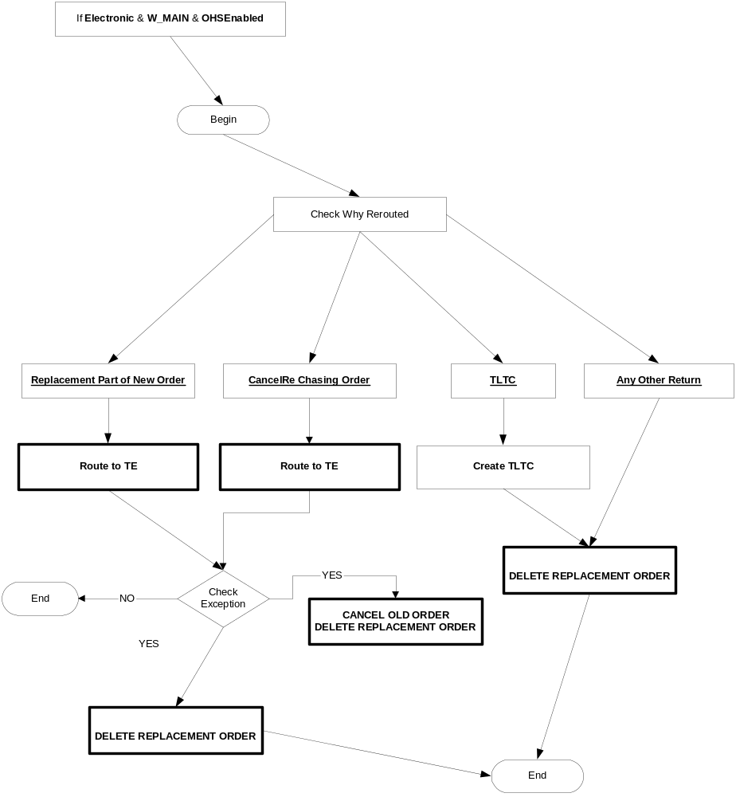
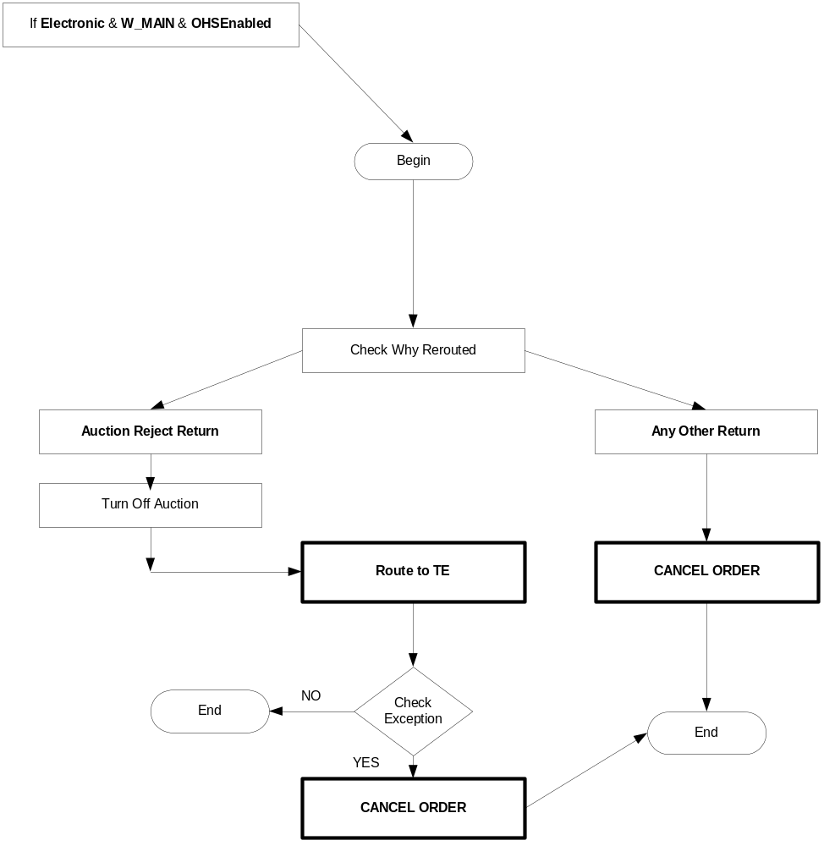

All-Electronic Trading Session Workflow: Quote-like orders

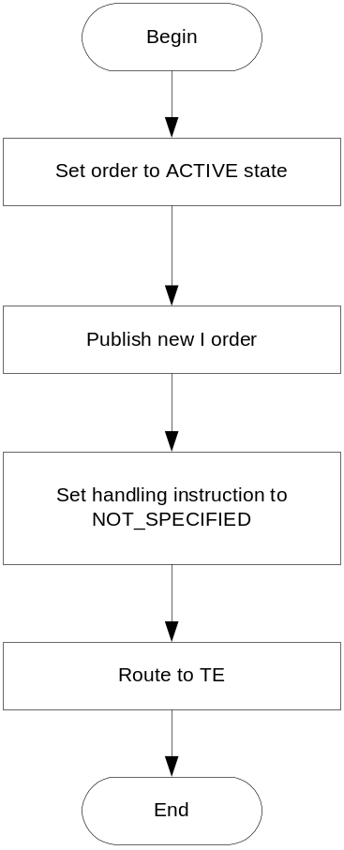

All-Electronic Trading Session Workflow: Auction Response orders

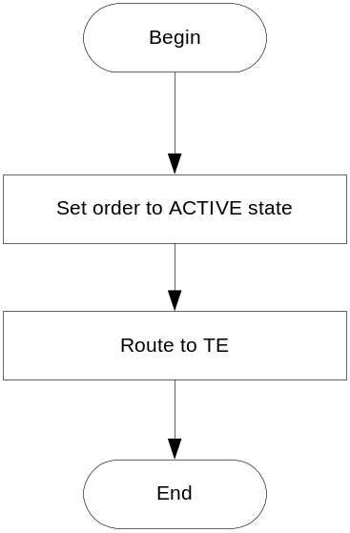

All-Electronic Trading Session Workflow: Inbound Linkage Orders
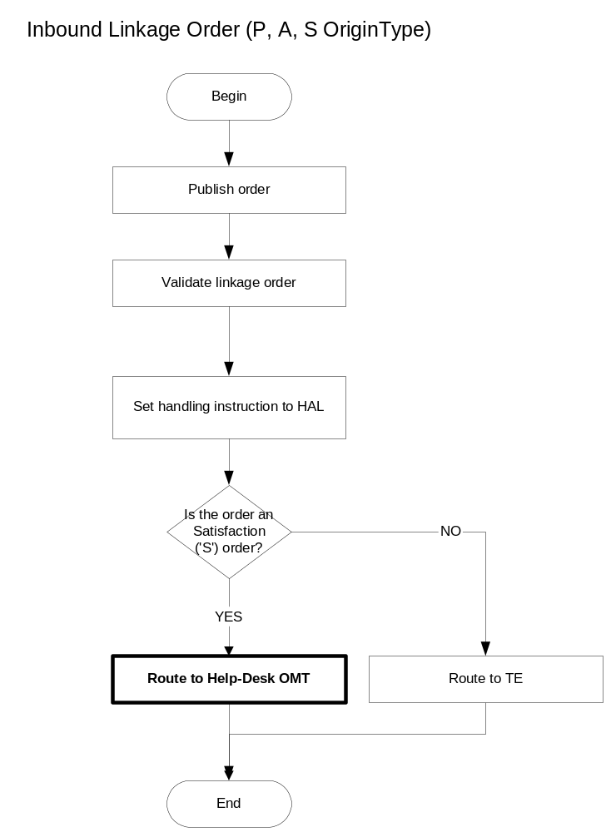

All-Electronic Trading Session Workflow: CAB Orders and Complex AIM orders.

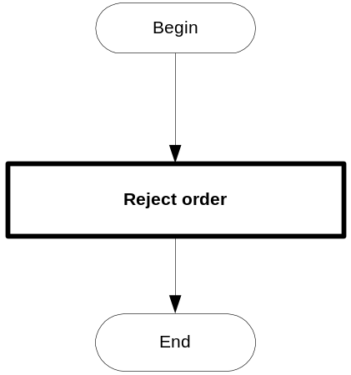

All-Electronic Trading Session Workflow: Simple AIM orders.

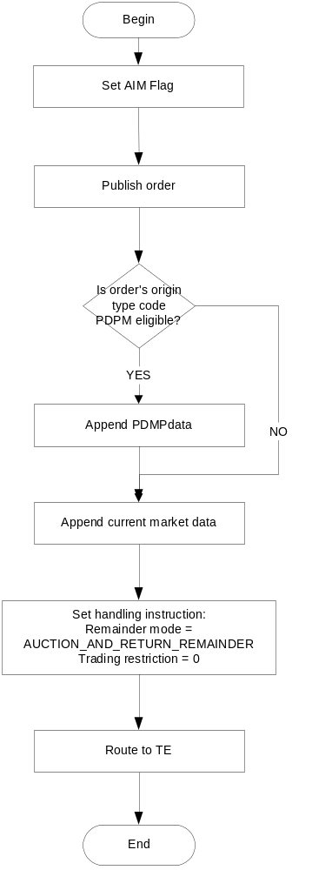

All-Electronic Trading Session Workflow: All other orders

This includes all other order types not covered in the above scenarios.

