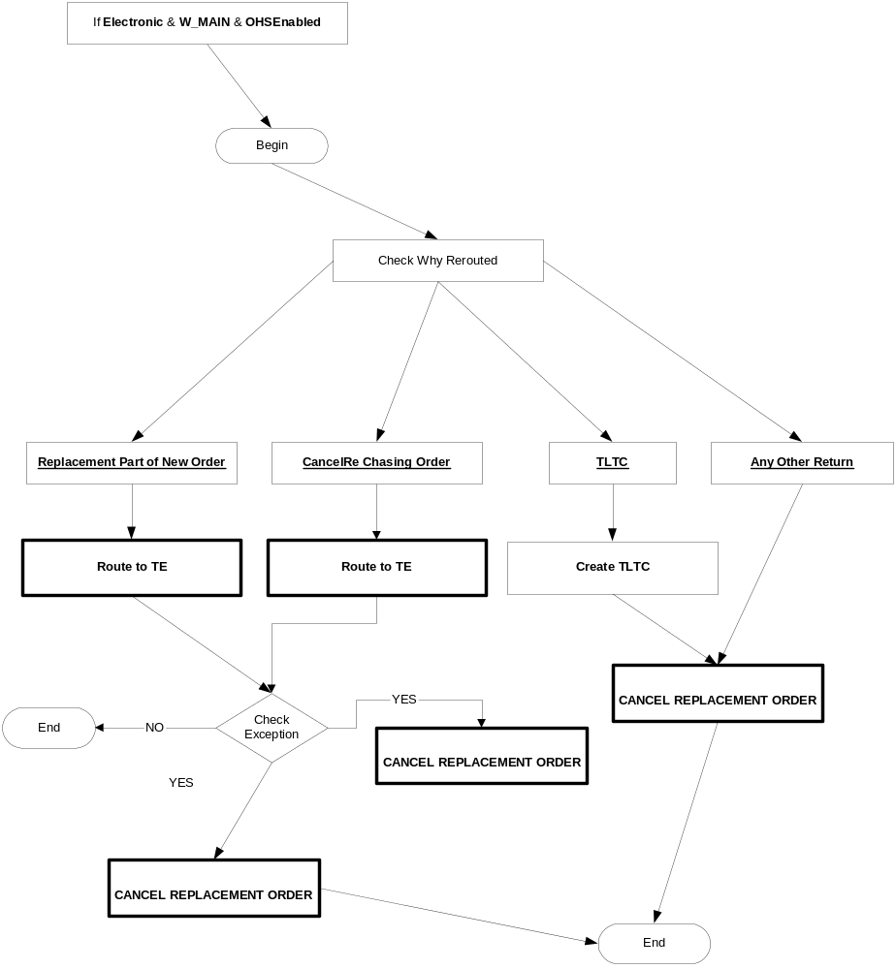
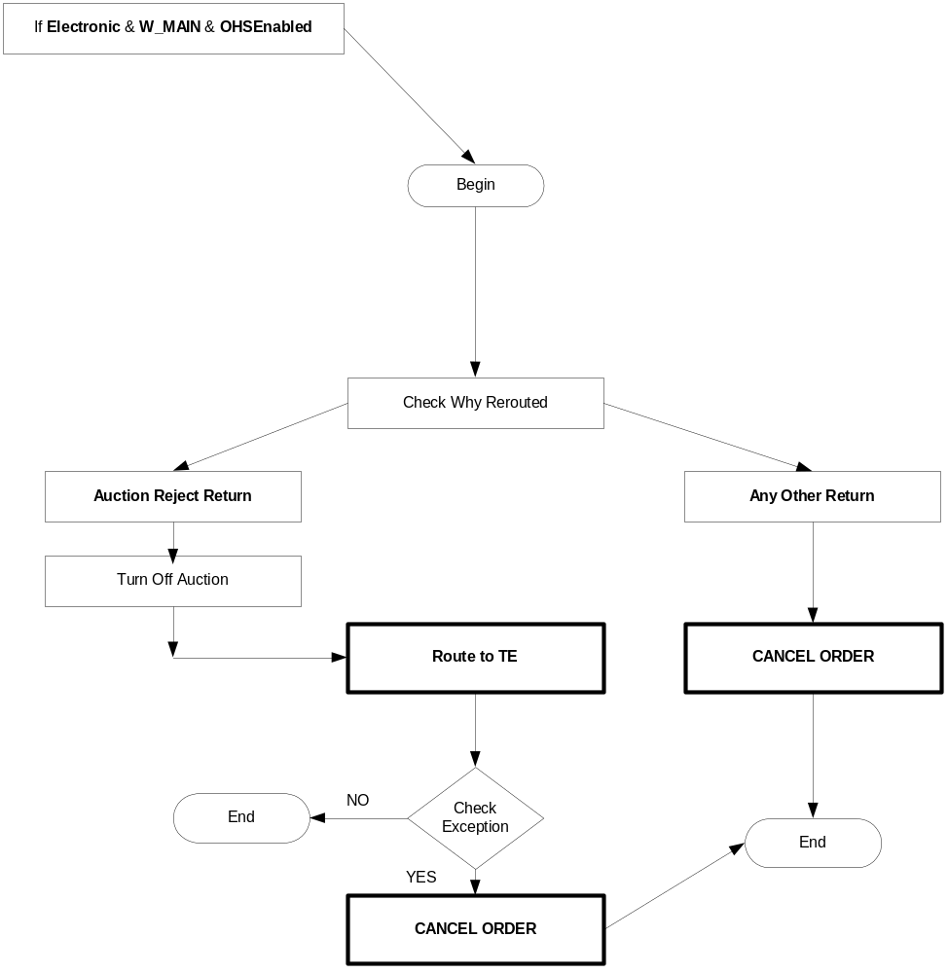

New Order Workflow #1: Quote-like orders

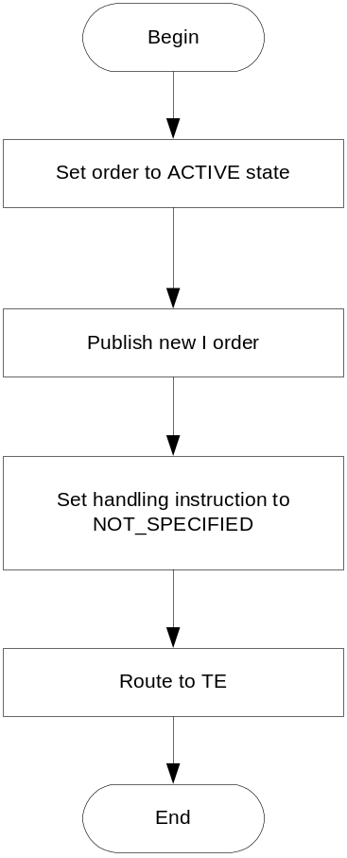

New Order Workflow #2: Auction Response orders

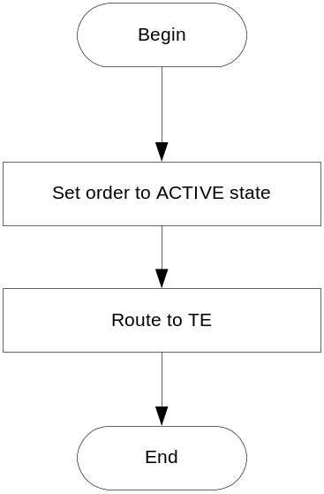

New Order Workflow #3: Inbound Linkage Orders
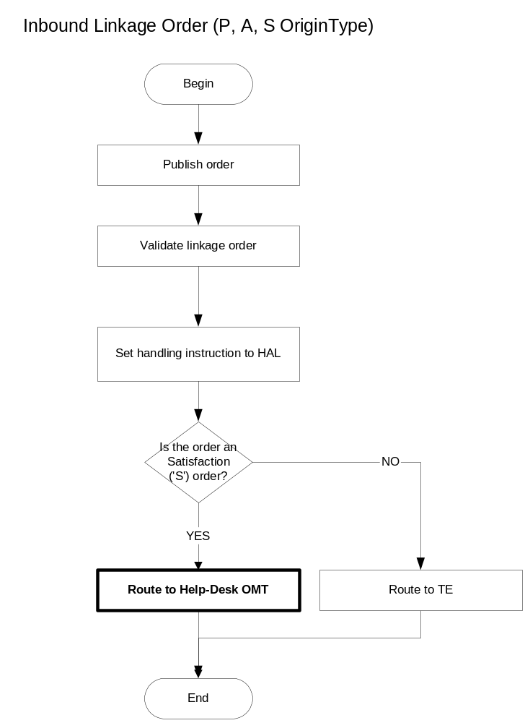

New Order Workflow #4: CAB Orders and Complex AIM orders.

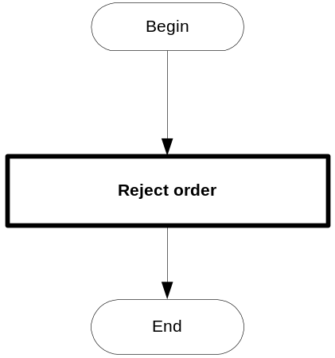

New Order Workflow #5: Simple AIM orders.

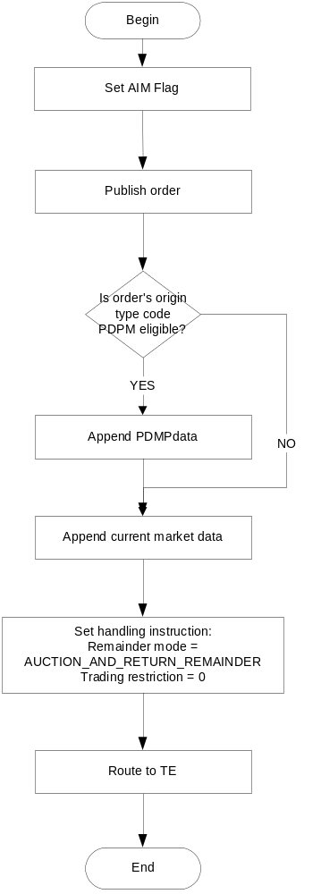

New Order Workflow #6: All other orders for simple orders

This includes all other simple order types not covered in the above scenarios.

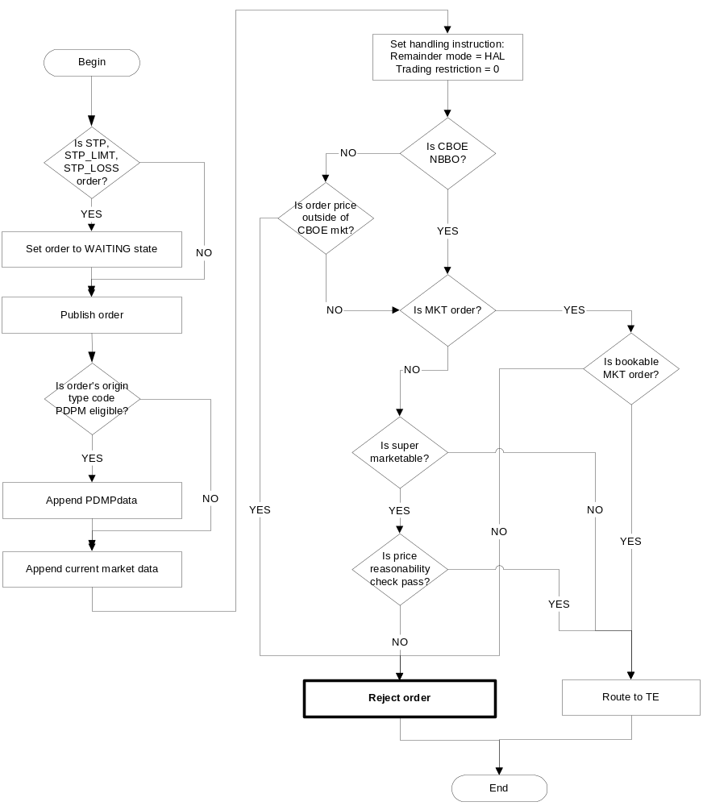

New Order Workflow #7: All other orders for strategy orders

This includes all other complex order types not covered in the above scenarios.

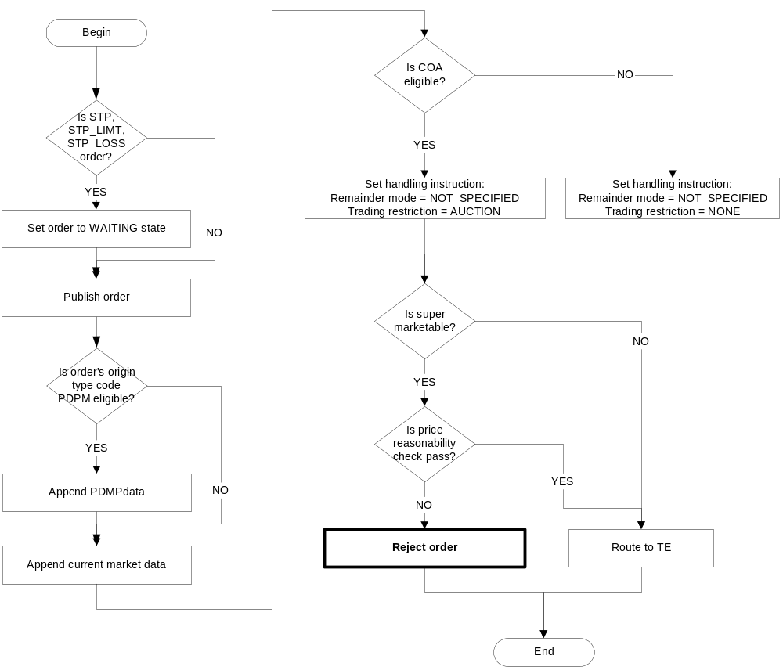

Cancel-Replace Workflow #1: Cancel-Replace of quote-like orders.

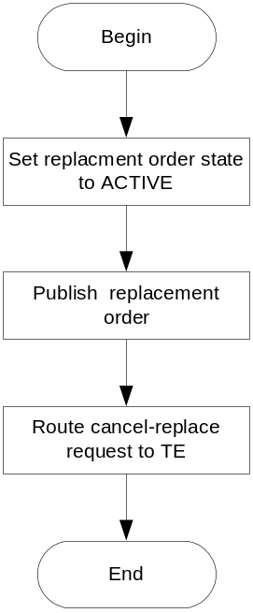

Cancel-Replace Workflow #2: Cancel-Replace of auction response orders.
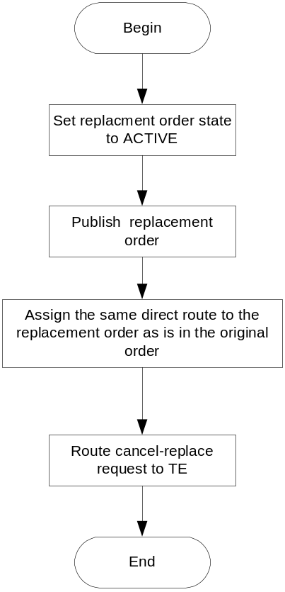
Cancel-Replace Workflow #3: Cancel-Replace of all other order types.
