Direct Route A-Z

Overview

Current processing
This feature is related to the piece of workflow that makes decision about where to send the Order/Request by the character provided in Extension field (BARTID). And that is been used in New Order, Cancel-Replace (for Replacement Order), and Reroute workflows. The present processing looks up only one specific Routing Property and returns back the valid Destination, if does not finds it will throw the Not Accepted Exception to the caller. (Ref old Requirement document version 1.0 for detail).

New requirement
Now, for the Order that has BARTID in the Extension field (a.k.a. Direct Route) can resolve the Destination by doing sequential Routing Property look up as described below. (Ref Requirement document version 1.1 for detail).

- New Order/Replacement Order Direct Route

  - Letter A-V assigned – Get the Destination from PAR Direct Route Routing Property, if not defined, rejects/throws back to the sender.
  - Letter X or Z assigned - Get the Destination from PAR Default (Firm-Class level) Routing Property, if not defined, rejects/throws back to the sender.
  - Number 0-9 assigned - Get the Destination from Booth Direct OMT Routing Property, if not defined, rejects/throws back to the sender.
  - Letter Y assigned - Get the Destination from FCB OMT Routing Property, if not defined, try to get it from Booth Default (Firm-Class level) OMT Routing Property, if not defined, rejects/throws back to the sender.
  - Any other one or more character - This will be assumed as exact name of the Destination (like W001, B001), the Location type will be resolved with the help of user/role service by providing this exact name, if found this exact name will become valid Destination, if not found, rejects/throws back to the sender.
- Reroute Order Route – This flow will use Routing Property in sequential look up pattern until it resolve the available OMT as described below, however the entry point might depending upon return code:
Starting from Class level PAR, if not defined => PAR Direct Route, if not defined => PAR Default Route, if not defined => Booth Direct OMT, if not defined => FCB OMT, if not defined => Booth Default OMT, if not defined => Help Desk OMT, if not defined => Log alarm and set to Primary destination (If an OMT, set to OMT address. If it was a PAR, set it to "OHS".

The workflow will be same for 1 and 2 however actual implementation of Reroute will be done under Reroute feature therefore that is out of scope.

Implementation
- Break these steps WFStepSendToPAR, WFStepSendToBooth, WFStepSendToDefaultPAR, WFStepSendToDefaultBooth to only resolve the Destination from Routing Property and use respective WFStepSendToNORD, WFStepSendToOMT to actually send. If Routing Property not found then put not found message in the context and send to step WFStepPropertyNotFound that will check new Order then wrap the not found message into Not Accepted Exception and throw back, otherwise, if Replacement Order then enter the Secondary sub-workflow and execute the flow in sequence starting after the option already been executed.
Below is the summary of the things discussed above:
  - Use WFStepFindFirmCorrespondantBranchOMT for FCB.
  - All the specific senders steps (WFStepSendToPAR, WFStepSendToBooth, WFStepSendToDefaultPAR, WFStepSendToDefaultBooth) will only resolve the Routing Property.
    - Set the NamedLocationEnum in the context to its own.
    - Get Routing Property.
    - If Routing Property Found.
    - Set the Original Destination
    - Return Success to call WFStepSendToNORD or WFStepSendToOMT to send.
    - If Routing Property Not Found set the not found error message on the Context.
    - And return Failure.
  - Implement WFStepPropertyNotFound like below:

//New Order will have source as CMI.
If(context.getRoutingParams.source == CMI)
{
get the Not Found error message from Context;
wrap the message into NotAcceptedException;
throw back to Originator;
}
cleanup the Not Found error message from Context;
return OK enum;

      - The OK enum will be use to call the Secondary sub-workflow and the entry point will be depending upon the NamedLocationEnum set in the context.

For the logical flow diagram please refer to Requirement document version 1.1.

- Create a sub-workflow that can be used by Reroute Order to resolve the Routing Property and eventually send it to the right Destination.

public enum NamedLocationEnum
{
PAR,
BOOTH,
DEFAULT_PAR,
DEFAULT_BOOTH,
DIRECT_ROUTE,
CLASS_PAR,
FCB_OMT,
HELP_DESK_OMT,
INIT_DESTINATION;
}

Put this NamedLocationEnum in the context and set it according to the flow being executed e.g. for flow WFStepSendToPAR set the PAR as NamedLocationEnum, at the entry of sub-workflow there will be WFStepSecondaryDestinationRouter that will decide where to divert the request, e.g. if it is PAR then it will start from PAR Default using the step WFStepSendToDefaultPAR and then flow the sequence as shown in the diagram below until it reaches end, then it will Log alarm and mark the Primary Destination as OHS.
Below is the logical flow diagram for Secondary Destination sub-workflow that will be implemented and used by Replacement Order and Reroute features:

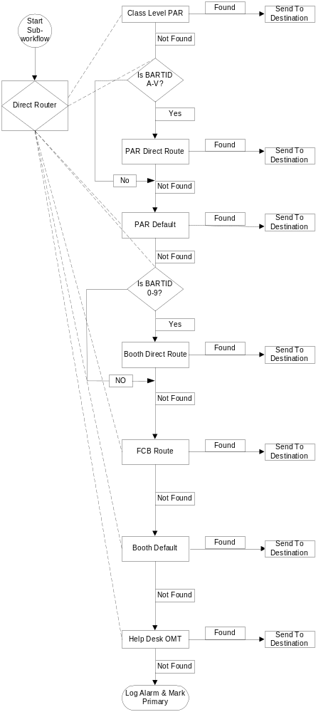

Scripts
- None

Database
- None

SetContext

XML/DTD
- Excerpt of XML for Direct Route is given below:
<step id="routeToDirect" desc="check the destination PAR/BOOTH/DEFAULT" type="WFStepCheckNamedLocation">
<param name="par">[A-V]</param>
<param name="bart">[0-9]</param>
<param name="defaultPar">[XZ]</param>
<param name="checkCorrespondant">[Y]</param>
<nextStep enum="PAR" desc="Direct Route to PAR" id="parRoute"/>
<nextStep enum="BOOTH" desc="Direct Route to BOOTH" id="boothRoute"/>
<nextStep enum="DEFAULT_PAR" desc="Direct Route to default crowd(Firm/Class) PAR" id="defaultParRoute"/>
<nextStep enum="DEFAULT_BOOTH" desc="Direct Route to firm booth default BOOTH" id="defaultBoothRoute"/>
<nextStep enum="DIRECT_ROUTE" desc="Direct Route to a workstation" id="directRoute"/>
<nextStep enum="(EXCEPTION)" desc="End the WorkFlow" id="FINAL"/>
</step>

<step id="parRoute" desc="Send Order to PAR Workstation" type="WFStepSendToPAR">
<nextStep enum="FOUND" desc="Found Routing Property" id="routeToNORD"/>
<nextStep enum="NOT_FOUND" desc="Unable to Find Property" id="noRoutingProperty"/>
<nextStep enum="(EXCEPTION)" desc="End the WorkFlow" id="FINAL"/>
</step>

<step id="boothRoute" desc="Send Order to BOOTH Workstation" type="WFStepSendToBooth">
<nextStep enum="FOUND" desc="Found Routing Property" id="routeToOMT"/>
<nextStep enum="NOT_FOUND" desc="Unable to Find Property" id="noRoutingProperty"/>
<nextStep enum="(EXCEPTION)" desc="End the WorkFlow" id="FINAL"/>
</step>

<step id="defaultParRoute" desc="Send Order to Default PAR Location" type="WFStepSendToDefaultPAR">
<nextStep enum="FOUND" desc="Found Routing Property" id="routeToNORD"/>
<nextStep enum="NOT_FOUND" desc="Unable to Find Property" id="noRoutingProperty"/>
<nextStep enum="(EXCEPTION)" desc="End the WorkFlow" id="FINAL"/>
</step>

<step id="checkCorrespondant" desc="Check if Correspondant exists" type="WFStepCheckIfCorrespondantExists">
<nextStep enum="True" desc="Find OMT based on FCB" id="findFirmCorrespondantBranchOMT"/>
<nextStep enum="False" desc="Find OMT based on Firm/Class" id="defaultBoothRoute"/>
<nextStep enum="(EXCEPTION)" desc="Got an exception" id="FINAL"/>
</step>

<step id="findFirmCorrespondantBranchOMT" desc="Find OMT based on Firm CorrespondantOMT" type="WFStepFindFirmCorrespondantBranchOMT">
<nextStep enum="FOUND" desc="Route To FCB_OMT" id="routeToOMT"/>
<nextStep enum="NOT_FOUND" desc="Route To NORD" id="defaultBoothRoute"/>
<nextStep enum="(EXCEPTION)" desc="Got an exception" id="FINAL"/>
</step>

<step id="defaultBoothRoute" desc="Send Order to Default BOOTH Location" type="WFStepSendToDefaultBooth">
<nextStep enum="FOUND" desc="Found Routing Property" id="routeToOMT"/>
<nextStep enum="NOT_FOUND" desc="Unable to Find Property" id="noRoutingProperty"/>
<nextStep enum="(EXCEPTION)" desc="End the WorkFlow" id="FINAL"/>
</step>

<step id="directRoute" desc="Send Order to a Workstation" type="WFStepSendDirect">
<param name="parRegex">W[0-9]+</param>
<param name="bartRegex">B[0-9]+</param>
<nextStep enum="NORD" desc="Route To NORD" id="routeToNORD"/>
<nextStep enum="OMT" desc="Route To OMT" id="routeToOMT"/>
<nextStep enum="(DEFAULT)" desc="Unable to Find Workstation" id="noRoutingProperty"/>
<nextStep enum="(EXCEPTION)" desc="End the WorkFlow" id="FINAL"/>
</step>

<step id="routeToNORD" desc="Routing order to NORD" type="WFStepSendToNORD">
<nextStep enum="Success" desc="Routed OK" id="persistOrderHistory"/>
<nextStep enum="Failure" desc="Failed to Route" id="alternateRoute"/>
<nextStep enum="(EXCEPTION)" desc="End the WorkFlow" id="FINAL"/>
</step>

<step id="routeToOMT" desc="Routing order to OMT" type="WFStepSendToOMT">
<nextStep enum="Success" desc="Routed OK" id="persistOrderHistory"/>
<nextStep enum="Failure" desc="Failed to Route" id="alternateRoute"/>
<nextStep enum="(EXCEPTION)" desc="End the WorkFlow" id="FINAL"/>
</step>

<step id="noRoutingProperty" desc="No Routing Property is defined" type="WFStepPropertyNotFound">
<nextStep enum="OK" desc="This is not a New Order" id=" secondaryDestinationRoute"/>
<nextStep enum="(EXCEPTION)" desc="Throw Back and end the WorkFlow" id="FINAL"/>
</step>

<!-- Secondary Destinations Starts -->
<step id="secondaryDestinationRoute" desc="Execute Secondary Destinations Route subworkflow" subworkflow="secondaryDestinations">
<nextStep enum="(DEFAULT)" desc="End the SubworkFlow" id="FINAL"/>
<nextStep enum="(EXCEPTION)" desc="End the WorkFlow" id="FINAL"/>
</step>
<!-- Secondary Destinations End -->

Homes/Services

ImplPlan

PerformanceTestingProcedure
- .

TestingProcedure
- .

OperatorProcedure
- .

Fallback/Failover
- .

