Handling_Rerouted_OrdersFrom_TE Design

Overview

Requirement
When an order is returned from TE OHS should handle it based on the Exception type, Exception code and/or return code.

Implementation
Overall Design:
A service will be created which will execute performs two functions:
1) Acts as a factory to map the error code /return code /exception type to the workflow that needs to be executed
2) Once the right workflow is found, this service executes that particular workflow.
This service will be looked up from a common workflow for all reroutes which will then execute subworkflows based on a certain key.
The different sub component are laid out as follows:

RerouteProperties: The “Key” object to find a specific WorkFlowFactory
- This object will serve as the key to find or lookup a particular subworkflow. The variables that make up this key would be.
private String[] returnCodes;
private String session;
private String function;
private String[] errorCodes;
private String[] exceptionType;
private String[] workFlows;
- Some mapping algorithm or structure would enforce one on one relationship between the combination of a Exception Type+ErrorCode to a subworflow.
- Some mapping algorithm or structure would enforce one on one relationship between the return code and the subworkflow.

ReroutedOrderExecutorService as a WorkFlowFactory

A work flow factory service will be created which will return a subworkflow based on the FunctionType (CancelReplaceReturn, OrderReturn,CancelReturn), Session(W_MAIN or NON_WAIN) ,Return code and exception details (Type and code). This will form the key, and be part of the attributes for an RerouteProperties object.
- This will be a service which will load the property on startup. There will be a check to ensure that the workflow is indeed valid and there exists one workflow for one code. If not a FatalFoundationFramework will be thrown to minimize run time errors.
- Also on startup the respective workflows will be created and cached. Though the startup time might be a little bit more, creation of workflows during run-time will be avoided.
- Will contain reroutePropertiesBySession
protected HashMap<String, RerouteProperties> reroutePropertiesBySession = new HashMap<String, RerouteProperties>();
and
protected HashMap<String, IWorkflowEngine<OrderContext>> rerouteWorkFlowsByRerouteProperties= new HashMap<String, IWorkflowEngine<OrderContext>>();
- The first hashmap contains the “key” object and the second one contains the workflow engine.
- If a particular error code or return code is not configured at all, then this will manifest itself as a runtime error. This needs clarification. We can either create a default subworkflow for this purpose if agreed.

ReroutedOrderExecutorService as a SubWorkFlow Executor
- When a request is returned from TE through IOSC, a RerouteOrderWorkFlow will be executed which will create the key (RerouteProperties) from the order.
- This will be passed to a ReroutedOrderExecutorService which will perform a search in the already loaded properties to return a subworkflow.
- This subworkflow will then be executed using a stateless executor and there will not be threading or contention issues.
- Any exception will then be rethrown and need to be handled by the initiated workflow. This needs clarification. Today, there are no specific handling required for returned orders except in the mismatch case which has an unique return code and thus could be handled within the subworkflow meant for that.

ReroutedOrderExecutorHome.xml
This XML will serve as the factory-configuration. An initial look at this XML will be like:
<?xml version="1.0" encoding="UTF-8"?>
<!DOCTYPE GlobalRerouteOMS SYSTEM "../dtd/ReroutedOrderExecutorHome.dtd">

<GlobalRerouteOMS>
<ReroutedOrderExecutorHomeImpl name="ReroutedOrderExecutorHomeImpl">
<ReroutedOrderExecutorHomeImplProperties>
<ReRoutedOrderConfigurationForSessions>Hybrid,Non_Hybrid</ReRoutedOrderConfigurationForSessions>
</ReroutedOrderExecutorHomeImplProperties>

<ReRoutedOrderConfiguration name="Non_Hybrid">
<ReRoutedOrderConfigurationProperties>
<sessionName>NON_W_MAIN</sessionName>
<function>CANCEL_REPLACE_RETURN</function>
<returnCodes>5302,5303,5309,5100</returnCodes>
<workFlows>cancelReplaceReturnChaseOrder,routePrintCancelReToOMT_FCBPath,routePrintCancelReToOMT_FCBPath,routePreviouslyCreatedNewOrder</workFlows>
</ReRoutedOrderConfigurationProperties>
</ReRoutedOrderConfiguration>

<ReRoutedOrderConfiguration name="Hybrid">
<ReRoutedOrderConfigurationProperties>
<sessionName>W_MAIN</sessionName>
<function>CANCEL_REPLACE_RETURN</function>
<returnCodes>5302,5303,5309,5100</returnCodes>
<workFlows>cancelReplaceReturnChaseOrder,routePrintCancelReToOMT_FCBPath,routePrintCancelReToOMT_FCBPath,routePreviouslyCreatedNewOrder</workFlows>
</ReRoutedOrderConfigurationProperties>
</ReRoutedOrderConfiguration>

</ReroutedOrderExecutorHomeImpl>

</GlobalRerouteOMS>

ReroutedOrderExecutorHomeImpl
Home to look up the Factory or the executor service. This will also load the properties that configure the factory. An example of how the query will be performed to load the properties is hown here.
@FFProperties(baseQuery = "ReRoutedOrderConfiguration", foreach = "ReRoutedOrderConfigurationForSessions", props = { "sessionName", "returnCodes" })

WFStepCallWorkFlowFactory
This step will call the service by passing the context.

Scripts()

Database()

SetContext()
- None

XML/DTD()
- ReroutedOrderExecutorHome.xml
- ReroutedOrderExecutorHome.dtd

Homes/Services
- ReroutedOrderExecutorHome
- ReroutedOrderExecutorService

ImplPlan
- This homes will be added to the OHSServer.xml

PerformanceTestingProcedure(1)
- None So far.

TestingProcedure(1)
- Every single code mentioned on the Requirements document should be tested.
- Every single code mentioned in the document will be mapped to a history entry.
- 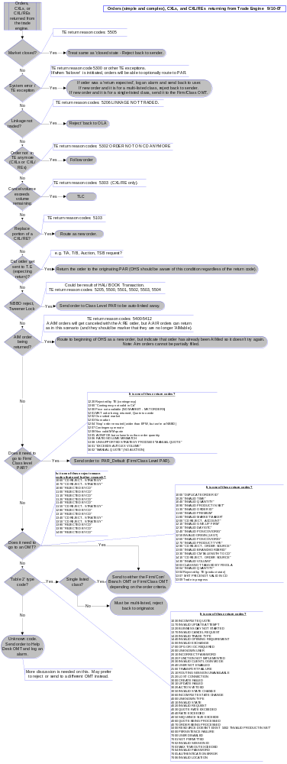

OperatorProcedure(.5)
- None

Fallback/Failover

CAS Design

GUI Design

.

