Fail Over and GoMaster Changes

Overview:
- Current processing:
TE Loading Orders from OHS:
- Presently the orders are loaded in one thread.
- The OHS order cache is maintained by class id and TE looks up and loads the cache by class ids. (and session)
- The resulting orders are retrieved from OHS in one call and added to TE cache.
- The loaded orders in TE are rechecked for “Bookable” order criteria.

OrderBook Creation:
- The Order book creation does not sort by the receive time. In the current processing however, the sorting is done when the orders are retrieved from the database when OHS builds its cache.

GoMaster Event:
- TE cannot be started until all the events in the IOSC channel is drained. This makes TE tied to the OHS process and the start up time involved is high.

OrderLoading in OHS from DB
- Currently the orders are loaded from the database into the cache in a single thread.

Race Conditions Involving OHS and TE startups:
- Presently when TE starts up order keeps coming into OHS since OHS has gone master.
- If TE is not up, then the new orders are removed from OHS cache.
- But since the orders are removed from the OHS cache and since TE starts up after OHS has gone master, the cache is clean and only contains orders that are “process able”

- New approach:
1. TE Loading Orders from OHS:
- The orders will be loaded in parallel by a configurable amount of threads.
- The orders in OHS will be queried upon by product ids (and session). The total number of products allocated to a single thread to query will be based on the modulo of the product id and the thread number.
- The total number of calls to OHS will be “throttled” based on grouping product ids. This will reduce the result set fetched in a single call and the GC time on the OHS side. The throttling or the total number of products to be called per call to OHS will be configurable.
- The rechecking of Bookable order criteria will be removed from the OHS side and TE will perform a plain insert into the cache upon restart.

2. OrderBook Creation:
- OrderBook Creation will use the cache retrieved from OHS but will sort it based on receive time in the ascending order before creation. The ohsReceiveTime field on the Order object will be used for sorting to preserve the integrity of Order Entry Time.

3.GoMaster Event:
- TE will not go master until all the events in IOSC channel is drained by OHS.
- This will be implemented with the OHS: TE ≡ 1:n relationship in mind. The RouteNameHelper will be used to check and provide the routing name.
- A utility class will be created which registers to the IOSC Channel and keeps track of the drain or dequeue count. The dequeue count is configurable. This counter or flag will be updated based on all the events, but there will be a flag (on or off) depending on the routing name. So each TE would know when the events pertaining to itself has drained and will thus load its cache.
- These changes will be implemented in OHSOrderMaintenanceService and if the events are not drained a system exception will be thrown which TE will catch and retry.

- OHSOrderLoading:
OHS will load the cache from the database in multiple threads to speed up.

- Race Conditions Involving OHS and TE startups:
- With the fail over changes TE might pick up orders that are in-flight which will be cancelled later on, on the OHS side.
- To avoid this the fail over has to be designed to load only orders, which are successfully returned from TE. (Actually TE should not load orders which were sent to OHS when TE was coming up)

FailOverSequence:
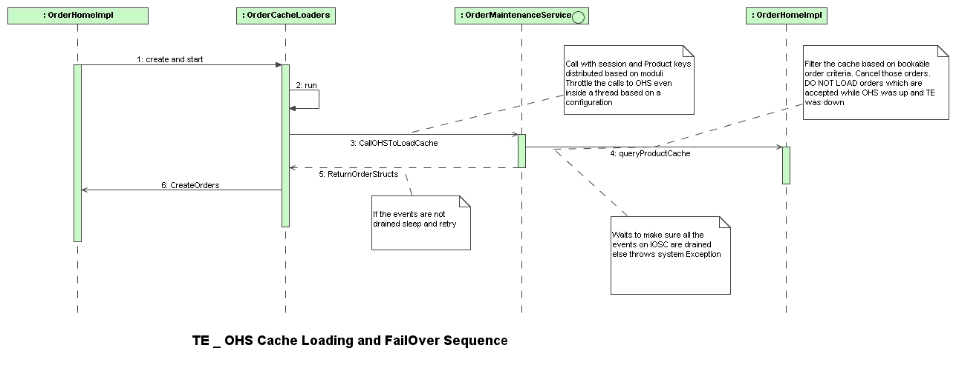

Detailed Changes:

1. Load TE Loading Orders from OHS:

- IDL changes: (in Bold)
OLD:
order::OrderHandlingStructSequence acceptOrderDestinationMaster(
in order::OrderRoutingParameterStruct orderRoutingStruct,
in cmiSession::TradingSessionName sessionName,
in cmiProduct::ClassKeySequence classKeys
)

NEW:
order::OrderHandlingStructSequence getOrderCacheByProductKey(
in order::OrderRoutingParameterStruct orderRoutingStruct,
in cmiSession::TradingSessionName sessionName,
in cmiProduct::ProductKeySequence productKeys
)

Changes:
Renamed from acceptOrderDestinationMaster to getOrderCacheByProductKey for more meaningful description and purpose:
NOTE: However this method should belong to OHSOrderQueryService, but left it at OHSOrderMaintenanceService.

- The cache search should be at a more granular level than the class level search implemented earlier.
- The search by product key should provide the paging necessary and also ensure that the distribution of the orders by product key is more uniform.

OrderHomeImpl (TE):
    - Creates the OrderCacheLoader threads and starts them
    - Obtains the set of Product keys from TradingProductHome
    - Uses a strategy to distribute the products
    - Creates the orders on successful call return from OHS.

OrderHomeImpl (OHS):
A new cache based on product keys is created for faster lookup
The orders are loaded from the DB in multiple threads.
Sorting on the OHS side is removed.

SimpleDistributor (NEW):
Distributes the products either based on the total number of threads or by a fixed batch size.
Used in the Order Cache loader threads to batch the calls to OHS.

OrderCacheLoader (NEW)
Calls OHS with a set of product keys and session.

OrderImpl
Method:
GetOrderHandlingStruct()
Changes:
Set Bypass reflection to true on the start of the method and set it back to false at the end to buy some performance.

2. OrderBook Creation:

OrderHomeImpl (TE)

Method:
public Order[] findOrdersForProduct(int productKey, boolean sorted)

Changes:

Added Arrays.sort using the comparator on ohsReceiveTime variable on the Order object. Sorted in the ascending order.
3. GoMaster Event:

OHSOrderMaintenanceServiceImpl
  - Contains the refactored method getOrderCacheByProductKey.
  - Checks IOSCEventsListenerUtil to see if the events are drained using ioscUtil.isReadyToProcess method.
  - If the events are drained then calls OrderHomeImpl.
  - If not, throws a SystemException with an error code ORDER_BEING_PROCESSED

IOSCEventsListenerUtil: (NEW)
- Listens to all the events on the IOSChannel
- Updates a local volatile variable to inform itself of events.
- When there are no events for a configurable amount of time, implements an utility method to inform on the same.

OrderCacheLoader (NEW)
Handles the system exception on IOSCEvent Draining. Keeps retrying until the events are drained.
Sleeps for the same configurable time between the retry.

OHSOrderLoading:
- OHS will load the data in multiple threads. Will remove sorting.

Race Conditions Involving OHS and TE startups:

Order:
A new flag loadable will be introduced. This is to ensure that the when TE starts up will only load orders that will not later be cancelled on OHSside.

OrderImpl:
This will implement isLoadable and getLoadable.

WFStepOrderToORD:
When the message is sent to TE this will flag will be set to false.
Upon successful return from TE, this flag will be set to true.

OrderHomeImpl:
When the cache is loaded from Database this flag will be set to true.
Upon the query by TE a new filter to check for only orders, which are loadable, will be sent to TE.

ISSUES:
Assumptions | Comments | Changes required
1::n relationship between OHS::TE is not needed in production | The coding done today assumes that there is 1:1 relationship and hence no need to implement one flag per TE on startup. | Will have to sort out issues regarding when to deregister the listener since all TEs need not fail over at the same time.  A hashmap containing the flag per TE and the variable pertaining to events per route name (TE) should be implemented.  The lookup should be performed on the OHSOMS side on every call from TE to identify the server also.
When a new event is added the listener should implement this method with the update to the local variable. | How do we enforce this?  Do we enforce rules on ant-build? | The compilation will fail, but does not stop anyone leaving an empty implementation.
OHS and TE fail over together. | IOSCUtility should not be running after a successful startup.  The listener is started on the post startup of OHSOMS. It is removed after the events are drained. If the OHS fails over by itself this listener will be running. | Should move the creation and starting of the listener tied to TE startup only. NOT VALID ANYMORE. Addressed already. Should be able to fail over independantly

