Use Cases: Order Cancel & Cancel-Replace By OMT

This requirement document discusses the use cases of a feature where and OMT originates an order cancel or an order cancel-replace operations for an order that it owns or for an order located on another OMT, a PAR, or a TE. Below is a brief one-line summary of each use case followed by the detailed sequence of actions taken by OHS for each use case.
- Accept unsolicited manual cancel: In this case, an OMT is originating a partial or full cancel operations on an order without a specific request from OHS to cancel the order.
- Accept unsolicited manual cancel-replace: In this case, an OMT is originating a cancel-replace of an order without a specific request from OHS to perform the cancel-replace of the order.
- Accept solicited manual cancel: In this case, an owner OMT is sending a response to OHS for a cancel operation previously requested by OHS.
- Accept solicited manual cancel-replace: In this case, and owner OMT is sending a response to OHS for a cancel-replace operation previously requested by OHS.

Use Case: Accept unsolicited manual cancel
- This use case starts when an OMT sends a manual cancel demand to OHS for an order without any specific cancel request from OHS.
- The OMT sends the following data:
- Cancel quantity.
- Order maintenance id = 0. The zero value for cancel request id signifies that the order cancel is not a response to a specific cancel request from OHS.
- OMT user id.
- If the current location of the order is PAR or TE, route the cancel request to the current location of the order.
- If the request is from an owner OMT,
- Verify that the order at OHS has remaining quantity greater than or equal to cancel quantity in the cancel request from OMT. If not, end this scenario returning a NotAcceptedException to the originator OMT.
- Perform the cancel operation on the order.
- Publish the cancelled order to update the owner OMT.
- If the request is from a non-owner OMT and the current location is another OMT,
  - Verify the authority of the non-owner OMT to cancel the order. If the OMT is unauthorized, then end this use case with a NotAcceptedException.
  - Create order maintenance message for order cancel request.
  - Route the order maintenance message to the owner OMT.
  - Persists order maintenance message in database.
- This use case ends when OHS has routed the cancel request to its current location or when the OHS has cancelled the order.

Use Case: Accept unsolicited manual cancel-replace
- This use case starts when the OHS receives an order cancel-replace demand from an OMT without any specific cancel-replace request from OHS.
- The OMT sends the following data:
  - Cancel quantity.
  - Order maintenance id = 0. The zero value for cancel request id signifies that the order cancel is not a response to a specific cancel request from OHS.
  - OMT user id.
  - Replacement order information
- If the current location of the order is PAR or TE, route the cancel-replace request to the current location of the order.
- If the request is from an owner OMT,
  - Verify that the order at OHS has remaining quantity greater than or equal to cancel quantity in the cancel request from OMT. If not, end this scenario returning a NotAcceptedException to the originator OMT.
  - Perform the cancel operation on the order.
  - Publish the cancelled order to update the owner OMT.
  - Create new order with replacement order information.
  - Activate the replacement order.
  - Publish the replacement order to the OMT that sent the cancel-replace request.
- If the request is from a non-owner OMT and the current location is another OMT,
  - Verify the authority of the non-owner OMT to cancel the order as part of the cancel-replace operation. If the OMT is unauthorized, then end this use case with a NotAcceptedException.
  - Create order maintenance message for order cancel-replace request.
  - Route the order maintenance message to the owner OMT.
  - Persists order maintenance message in database.
- This use case ends when OHS has routed the cancel request to its current location or when the OHS has cancelled the order.

Use Case: Accept solicited manual cancel
- This use case starts when an owner OMT sends a manual cancel response to OHS for the order cancel request it received from the OHS.
- The owner OMT sends the following data:
  - Cancelled quantity. This quantity must match the quantity in the request sent to OMT by the OHS.
  - Order maintenance id. This is the id of the order maintenance message to which this response is generated.
  - OMT user id.
- The OHS processes the cancel response involving:
  - Verify the existence of the order maintenance message for cancel request based on the order maintenance id supplied by the OMT. If this verification fails, the scenario ends with a NotAcceptedException.
  - Perform the cancel operation on the order.
  - Delete the order maintenance message for cancel request from database.
  - Publish the cancelled order to update the owner OMT.
- This use case ends when the order is cancelled.

Use Case: Accept solicited manual cancel-replace report
- This use case starts when an owner OMT sends a manual cancel-replace response to OHS in response to an order maintenance message for order cancel-replace request.
- The OMT sends the following data:
  - Cancel quantity.
  - Order maintenance id.
  - OMT user id.
  - Replacement order information
- If the request is from an owner OMT,
  - Verify the existence of the order maintenance message for cancel-replace request based on the order maintenance id supplied by the OMT. If this verification fails, the scenario ends with a NotAcceptedException.
  - Perform the cancel operation on the order.
  - Publish the cancelled order to update the owner OMT.
  - Create new order with replacement order information.
  - Activate the replacement order.
  - Publish the replacement order to the OMT that sent the cancel-replace request.
- This use case ends when the cancel-replace response from owner OMT has been completely processed by the OHS.

ISSUES
- Should the OHS keep a timer on an order maintenance message for order cancel routed to an OMT? If the OMT fails to respond, what should be the behavior of OHS?
  - No timer action should be taken by OHS. (9/10/07)
- How do we handle a case where an order is re-routed from an owner OMT to another OMT after an order maintenance message for order cancel request is routed to the owner OMT?
  - This case “SHOULD NOT HAPPEN”. The re-route implementation will be updated to ensure that an OMT (owner or non-owner) may not re-route and order from an OMT to any other location if there is a pending cancel request for that order. (9/10/07)

IDL Changes
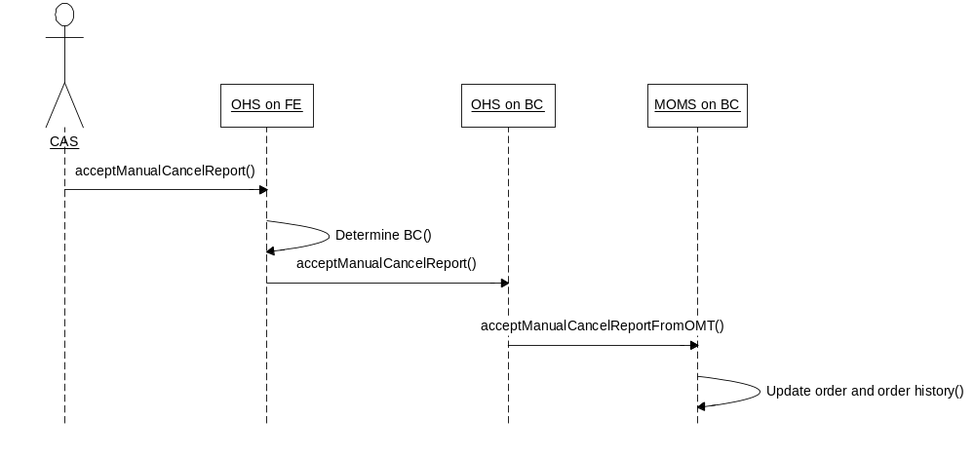
In all three above scenarios, the OMT will send cancel or cancel-replace demand or response to OHS to OrderHandlingService via CAS as shown in figure above. The OrderHandlingService, in turn, delegates the call to ManualOrderMaintenanceService. Two new methods for accepting manual cancel and cancel-replace information are added in OrderHandlingService and ManualOrderMaintenanceService.

OrderHandlingService in /vobs/dte/server/idl/OrderHandlingService.idl

Module businessServices
{
interface OrderHandlingServie : businessServices::OrderRoutingService
{
void acceptManualCancel (
in cmiOrder::CancelRequestStruct cancelRequest,
in cmiProduct::ProductKeysStruct productKey,
in cmiUtil::Identifier reqId,
in string userId) raises (
exceptions::SystemException,
exceptions::CommunicationException,
exceptions::DataValidationException,
exceptions::NotFoundException,
exceptions::AuthorizationException,
exceptions::TransationFailedException,
exceptions::NotAcceptedException);

void acceptManualCancelReplace(
in cmiOrder::CancelRequestStruct cancelRequest,
in cmiProduct::ProductKeysStruct productKey,
in cmiOrder::OrderStruct anOrder,
in cmiUtil::Identifier reqId,
in string userId) raises (
exceptions::SystemException,
exceptions::CommunicationException,
exceptions::DataValidationException,
exceptions::NotFoundException,
exceptions::AuthorizationException,
exceptions::TransationFailedException,
exceptions::NotAcceptedException);
}
}

ManualOrderMaintenanceService in /vobs/dte/server/idl/ohs.idl

Module orderHandlingService
{
interface ManualOrderMaintenanceService
{
void acceptManualCancelFromOMT (
in cmiOrder::CancelRequestStruct cancelRequest,
in cmiUtil::Identifier reqId,
in string userId) raises (
exceptions::SystemException,
exceptions::CommunicationException,
exceptions::DataValidationException,
exceptions::NotFoundException,
exceptions::AuthorizationException,
exceptions::TransationFailedException,
exceptions::NotAcceptedException);

void acceptManualCancelReplaceFromOMT(
in cmiOrder::CancelRequestStruct cancelRequest,
in cmiUtil::Identifier reqId,
in cmiOrder::OrderStruct anOrder,
in string userId) raises (
exceptions::SystemException,
exceptions::CommunicationException,
exceptions::DataValidationException,
exceptions::NotFoundException,
exceptions::AuthorizationException,
exceptions::TransationFailedException,
exceptions::NotAcceptedException);
}

