Menu 4, Firm Class Parameter Setting:

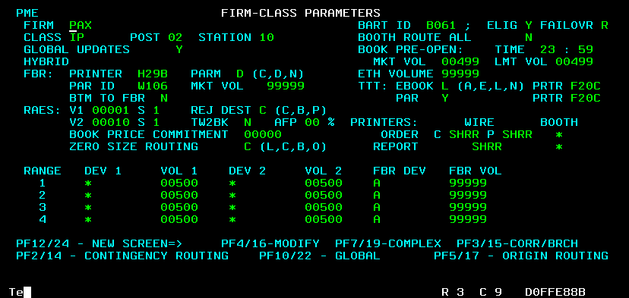

Menu 4, F2, Contingency Setting:

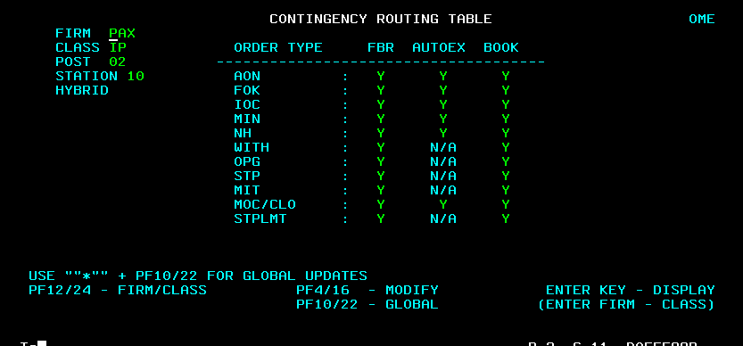

Menu 4, F5 Simple Order Routing

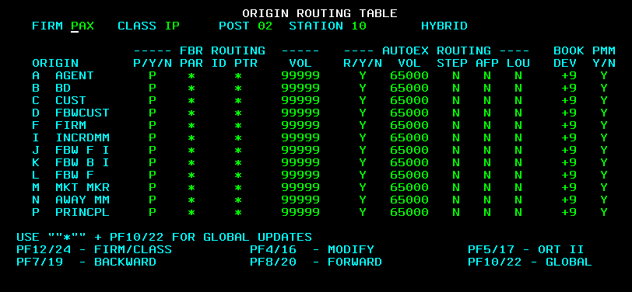
Menu 4, F5 then F8 Simple Order Routing (CONT.)

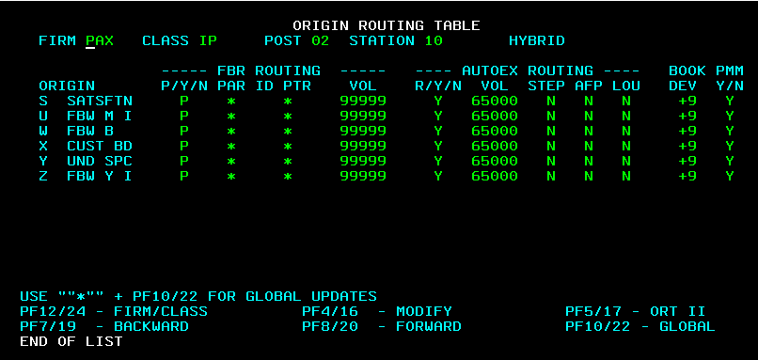

Menu 4, F5 then F5 HAL Order Routing

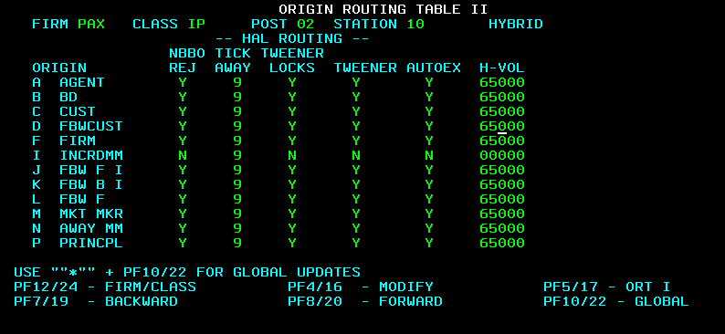

Menu 4, F5 then F5, then F8 HAL Order Routing (CONT.)

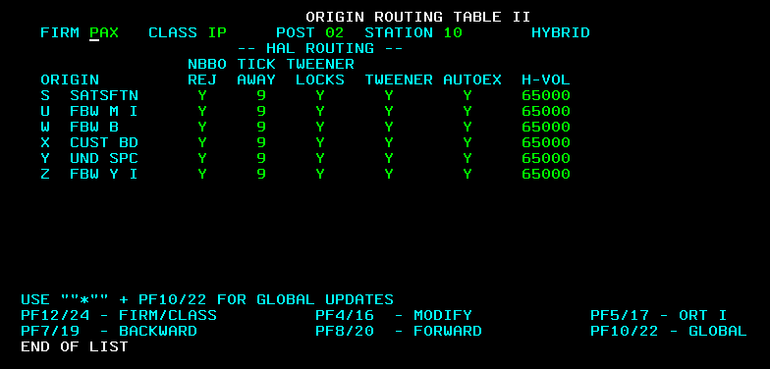

Menu 6, F5 Class Routing

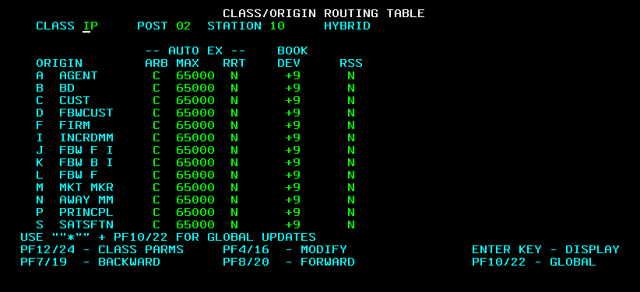

Menu 6, F5 then F8 Class Routing (CONT.)

