

Approved by:

CBSX ODD LOT HANDLING

FUNCTIONAL REQUIREMENTS

Prepared by: MOHAMMED KHAN
Version: 1.0
Work Request #:
Status: Open
Date: 10/09/2007

Distribution List

Name | Department | Email | Contact Number

Table of Contents

CBSX ODD LOT HANDLING 1
FUNCTIONAL REQUIREMENTS 1
1 Document Revision History 6
2 Introduction 7
2.1 History 7
2.2 Purpose of this Document 7
2.3 CBOEdirect Integration 7
3 Omissions 8
3.1 Omission 1 8
3.2 Omission 2 8
4 Assumptions 9
4.1 General Assumptions 9
4.1.1 Standard Trading Hours 9
4.1.2 Back Office Functions 9
4.1.3 Training 9
4.2 Product Assumptions 9
4.3 Access Assumptions 9
4.3.1 Customer Order Entry 9
4.3.2 Member Quote Entry 9
4.4 CBOEdirect Trading Session Name 9
5 Business and Functional Requirements 10
5.1 Inbound Order 10
5.2 Response to Flash 10
5.3 Trade at CBSX BBO 10
5.4 Book 10
5.5 New Contingency Type 11
5.6 Odd-Lot/Mixed Lot 11
5.7 Odd-Lot/Mixed Lot with IOC Contingency 11
5.8 Mixed Lot with AON Contingency 11
5.9 Odd Lot/Mixed Lot ISO 11
5.10 Routing Odd Lots to Other/Away Exchanges 11
5.11 Billing 11
5.12 Post Expiration 12
5.13 Trading Round Lots with Odd Lots 12
5.14 Price – Time Priority 12
5.15 Cross Orders 12
5.16 Sweep Orders 12
5.17 Stop and Stop Limit Orders 13
6 Process Flow Diagram 14
7 Odd Lot Scenarios 16
7.1 Buy 56 @ 6.00 16
7.2 Buy 34 @ 10.10 16
7.3 Buy 56 @ Market 16
7.4 Buy 56 @ Market 16
7.5 Buy 56 @ Market 16
7.6 Inbound Odd-Lot Orders 17
7.6.1 Scenario 1 – Odd Lot order enters system when market maker is at the NBBO. 17
7.6.2 Scenario 2 – Odd Lot order enters system when market maker is NOT at the NBBO. 17
7.7 Inbound Mixed-Lot Orders 18
7.7.1 Scenario 1 – Mixed Lot order enters system when market maker is at the NBBO and order quantity exceeds quantity at NBBO 18
7.7.2 Scenario 2 – Odd lot portion of mixed lot inbound 19
7.7.3 Scenario 3 – Mixed lot enters the system when market is not at NBBO 19
7.7.4 Scenario 4 –Mixed lot fills partially – with odd-lot portion attached. 20
7.7.5 Scenario 4 –Mixed lot fills partially – with odd-lot portion attached. 21
7.8 Inbound Odd-Lot Orders with resting orders in the book on the opposite side 22
7.8.1 Scenario 1 – Odd-Lot order enters system with resting orders in the book on the opposite side 22
7.9 Inbound Mixed Lot Orders with resting orders in the book on the opposite side 22
7.9.1 Scenario 1 – Resting odd lots and odd lot portions of mixed lots 22
7.10 All or None Contingency 23
7.10.1 Scenario 1 –Inbound All or None order without automatic NBBO step-up 23
7.11 Resting Odd Lot orders and Market Maker quoting 23
7.11.1 Scenario 1 – Resting odd-lot order is crossed with a market maker quote 23
7.12 Cross Orders 24
7.12.1 Scenario 1 – Round lot Cross Order 24
7.12.2 Scenario 2 – Odd lot Cross Order 24
7.13 Response to flash is inferior/superior 24
7.13.1 Scenario 1 – 24
7.13.2 Scenario 2 – 25
7.13.3 Scenario 3 – 25
7.13.4 Scenario 4 – 26
7.14 Sweep Orders 26
7.14.1 Scenario 1 – Sweep Order enters system 26
7.14.2 Scenario 2 – Sweep Order enters system 27
7.14.3 Scenario 3 – Sweep Order enters system 28
7.15 Locked Market 28
7.15.1 Scenario 1 – 28
7.16 Updating available quantity 28
7.16.1 Scenario 1 – Mixed Lot order enters system when market maker is at the NBBO and order quantity exceeds quantity at NBBO 28
7.16.2 Scenario 1 – Mixed Lot order enters system when market maker is at the NBBO and order quantity exceeds quantity at NBBO 30
7.17 Other 31
7.17.1 Scenario 1 – 31
8 Open Questions: 32
8.1 Scenarios 7.13.x will be discussed with David Reed in the next meeting. Error! Bookmark not defined.
9 Appendix 1 33

Document Revision History

Version | Date | Author | Reason
1.0 | October 9, 2007 | Mohammed Khan | Initial Revision
1.1 | October 16, 2007 | Mohammed Khan | Moved issues 8.1 and 8.3 as requirements 5.11 and 5.12
1.2 | October 17, 2007 | Mohammed Khan | Added about 10 mores scenarios under section 7 (7.6 onwards), – these need to be discussed and approved
1.3 | October 22, 2007 | Mohammed Khan | Added requirement for Sweep Orders and related scenarios
1.4 | October 23, 2007 | Mohammed Khan | Removed questions that were answered from the open issues section
1.5 | October 25, 2007 | Mohammed Khan | Added scenarios to reflect locked markets
1.6 | October 29, 2007 | Mohammed Khan | Added scenarios to update available quantity
1.7 | November 7, 2007 | Mohammed Khan | Updated Scenario 7.13
1.8 | November 8, 2007 | Mohammed Khan | Added diagrams
1.9 | November 9, 2007 | Mohammed Khan | Updates as per meeting

Introduction

History
Currently, CBSX trades Odd Lots, and the odd lot portions of mixed lots, against the CBSX BBO, as long as the BBO is comprised of some market maker interest. This handling corresponds to Reg NMS rules that do not require an NBBO fill for odd lots.
At this time, Odd Lot business is minimal since CBSX does not guarantee the NBBO. CBSX has received interest from potential odd lot traders indicating their willingness to trade odd lots at the NBBO, if the facility exists.
The objective of this project is to develop a new mechanism for trading odd lots that increases the likelihood of receiving an NBBO execution.

Purpose of this Document

This document will provide the requirements and specifications for CBSX Odd Lot Handling project.

CBOEdirect Integration

Omissions
This section covers noteworthy omissions, i.e. functionality that will not be included. This section is not all encompassing, if functionality is not described in the requirements specification specifically related to Odd Lot trading, then the assumption is that it is not included in the system.

Omission 1

Omission 2

Assumptions
This section articulates the assumptions used to define the requirements for the CBSX Odd Lot Handling.

General Assumptions

Standard Trading Hours
The hours of listed trading will be from 8:30 a.m. until 3:00 p.m. CST.
The hours of ETF trading will be from 8:30 a.m. until 3:15 p.m. CST

Back Office Functions
Regulatory/surveillance functions dependent upon receipt of data from CBOEdirect will be supported by CBOE, but these functions are out of scope of this document.

New values to the Bill_Type_Code will be added to support the billing functions. Please refer to 5.12 for more details.

Training
Any participant training requirements, such as user or technical training, are outside the scope of this document.

Product Assumptions

Access Assumptions

Customer Order Entry
Customer order flow will arrive from member firms attached to CBOEdirect using FIX 4.2 or CMi.

Member Quote Entry
DPMs and market makers will enter quotes via CBOE-provided interfaces CMi.

CBOEdirect Trading Session Name
The trading session name will be W_STOCK for the CBOEdirect equity trading system.

Business and Functional Requirements
This section captures business and functional requirements for CBSX Odd Lot Handling.

Inbound Order
When CBSX receives an Odd-Lot order, CBOEdirect will accept the odd lot order and:

- The system will first look for a matching order at NBBO in the book.
- If a matching order exists, the system will trade. If not,
- CBOEdirect will immediately send an odd lot Flash message indicating the side and size of the odd lot as well as the NBBO price on that side of the market to all interested parties.
- An ‘X’ millisecond timer will be started.
- As is the standard, the timer should be configurable
.

Response to Flash
Once CBOEdirect Flashes the Order to subscribers, it will wait for ‘X’ milliseconds for a response.

- Responders must respond for the full size of the odd lot.
- The first participant to respond at the flash price or better will trade against the resting odd lot at the price of the response, i.e. odd lots can be filled at prices better than the flash price.
- Any responses at prices worse than the flash price will be rejected.

Post Expiration
Once the flash timer has expired, if the system receives a response, the response will be rejected.

Trade at CBSX BBO
If there are no responders at the NBBO or better when the timer expires, the odd lot will trade against any CBSX Market Makers with interest at the CBSX BBO.

Book
If there are no Market Makers at the CBSX BBO, the odd lot order will book.
- Once the order has booked, CBSX market makers and interested parties can send an odd lot order to trade against the booked order.
- Additionally, if a Market Maker displays a regular quote at the CBSX BBO, it will trade against the booked odd lot order.

New Contingency Type
A new contingency type will be added that will allow the odd lot sender to indicate that the order should be cancelled if it cannot trade at the NBBO.
- New Contingency Type for Odd Lot will be STOC_ODD_LOT_AT_NBBO

Odd-Lot/Mixed Lot
- The odd lot portion of a mixed lot will be treated as an odd lot.

Odd-Lot/Mixed Lot with IOC Contingency
- An Odd-Lot or Mixed-Lot order with an IOC Contingency will trade against resting market makers at the NBBO.
- If it cannot trade at the NBBO, it will be cancelled.

Mixed Lot with AON Contingency
- A mixed lot order with AON contingency is rejected.

Odd Lot/Mixed Lot ISO
- Odd lot and mixed lot ISOs will be treated as they are today.
- The odd lot portion will trade at the CBSX market if it includes market maker interest, otherwise the odd lot portion will be cancelled.

Routing Odd Lots to Other/Away Exchanges
- Odd lots will not be routed to away exchanges.

Billing
For Billing, add the following new values under Bill_Type_Code:
- Odd_Lot_Flash to represent an order that is being flashed.
- Odd_Lot_Response to represent all responses to an order that is being flashed (including Sweep/ISO orders)
- The existing Bill_Type_Code Odd_Lot will be used for everything else.

Trading Round Lots with Odd Lots
A round lot customer order is not traded in a way that it becomes an odd lot itself. In other words, round lot customer orders are not broken down for an odd lot order.
- An inbound odd lot order is not traded against a customer round lot order.
- An inbound odd lot order can be traded against a round lot MM quote.
- Market Maker round odd lot orders can trade against odd lots.

Price – Time Priority
Inbound orders will trade based on price – time priority. For instance, if the System already has a Quote, or an I Order, or an M Order, or a Customer Order when an Odd-Lot Order is received and at the same price as the Order – the system will select based on price – time priority.

Cross Orders
All cross orders will be able to trade thru odd lots.

Sweep Orders
Odd lot sweep orders will not be flashed. They will be traded against odd lots if there is market interest or cancelled.
Round lot sweep orders will not trade against odd lots.
Odd lot sweep orders will trade against resting odd lots in the book at each price point. For e.g. if a sweep order Order4 B Sweep 50 @ .12 enters the system when NBBO is .05 - .12 and book has the following orders:
Origin Quantity Price
Cust1 (S) 15 .10
Cust2 (S) 15 .11
Cust3 (S) 20 .12

The sweep order will trade against each order at their price.
Flow of Events
- Order4 order trades with Cust1 15 @ .10
- Order4 order trades with Cust2 15 @ .11
- Order4 order trades with Cust3 20 @ .12

Stop and Stop Limit Orders
Currently the facility is off. If and when the facility to trade Stop and Stop Limit is turned on, the business rules governing the Stop and Stop Limit orders will be reviewed to be applied to handle odd lots.

Process Flow Diagram
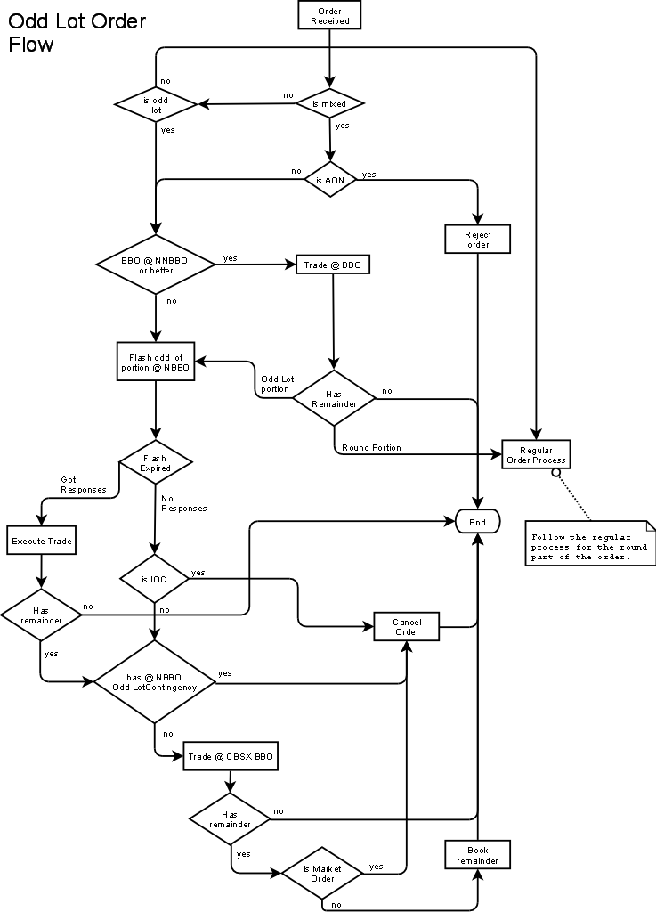
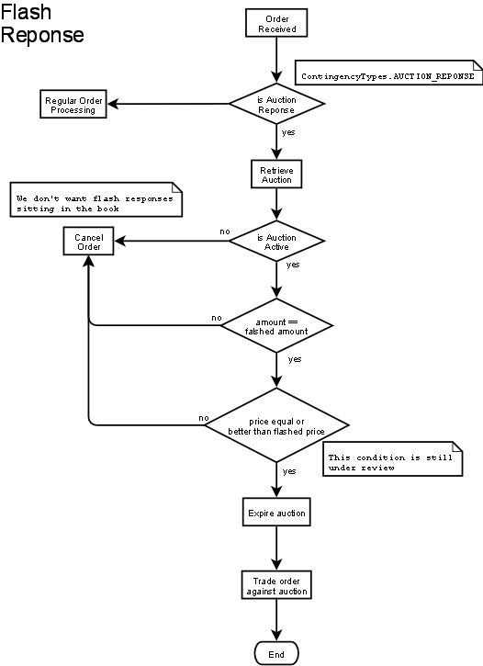

Odd Lot Scenarios
All scenarios assume the Price/Time priority method.

Buy 56 @ 6.00
NBBO: 9.00 - 10.00
CBSX: 8.00 - 11.00
Current: The System will Book the order
Required Action: The order is booked at 6.00

Buy 34 @ 10.10
NBBO: 9.00 - 10.00
CBSX: 8.00 - 11.00
Required Action: The System will Flash the Order at 10.00 i.e. the System will Flash the Order at NBBO. If there is no interest, the order is booked at 10.10.

Buy 56 @ Market
CBSX: no market
NBBO: 9.0 - 10.0 100x100
Current: The System will Cancel the Order
Required Action: The system will flash the Order at NBBO i.e. 10.00. If there is interest, the order will trade. If not, the order is cancelled.

Buy 56 @ Market
CBSX: no market – 11.0 (this is a sell customer order 11.0 x100)
NBBO: 9.0 - 10.0 100x100
Enter buy customer order 56 @ Market price
Current: The System will Cancel the Order
Required Action: The system will flash the Order at NBBO i.e. 10.00. If there is interest, the order will trade. If not the order is cancelled. This is because odd lot orders cannot trade against round lot customer orders.

Buy 56 @ Market
CBSX: 8.0 – 10.80 100x100
MM Quote: 8.0 - 11.0 100x100
Sell customer order 10.80x100
NBBO: 9.0 - 10.0 100x100
Current: The System will trade the Order at MM Quote
Required Action: The system will flash the order at NBBO i.e. 10.00
If there is no response, the order is traded with MM @ 11.00

Inbound Odd-Lot Orders

Scenario 1 – Odd Lot order enters system when market maker is at the NBBO.
NBBO: .05 - .12

Order Book – Sell Side
Origin Quantity Price
DPM 400 .12
MM1 200 .12

Inbound Order
Cust1: Buy 50 shares @ MKT.

Flow of Events
- Cust1 trade with DPM 50 @ .12 (DPM is first at this price).

Scenario 2 – Odd Lot order enters system when market maker is NOT at the NBBO.
NBBO: .05 - .12

Order Book – Sell Side
Origin Quantity Price
DPM 400 .13
MM1 200 .13

Inbound Order
Cust1: Buy 50 shares @ MKT.

Flow of Events
- Cust1 order is flashed
- System waits for a response
- If there is interest the order is traded. If not, Cust1 will trade against DPM @ .13.
Using the same scenario above, if the order had STOC_ODD_LOT_AT_NBBO contingency, the order would have been cancelled had it not received any response to flash at NBBO.

Inbound Mixed-Lot Orders

Scenario 1 – Mixed Lot order enters system when market maker is at the NBBO and order quantity exceeds quantity at NBBO

NBBO: .05 - .12

Order Book – Sell Side
Origin Quantity Price
DPM 400 .12
MM1 200 .12

Inbound Order
Cust1 Buy 840 shares @ MKT.

Flow of Events
- Cust1 trades with DPM 400 @ .12.
- Cust1 trades with MM1 200 @ .12
- Cust1 240 shares order quantity is broken down into 2 parts – Cust1 200 shares and Cust1 40 shares
- Cust1 200 shares is flashed | - Cust1 40 shares order is flashed
- System waits for a response | - System waits for a response
- Cust1 200 shares order is, if there is market response, filled completely or filled partially OR is not filled at all  - If the Cust1 order does not fill, the full 200 shares or balance is Autolinked  - If Cust1 is not filled at away exchange and is routed back to CBSX, its autolinked again  - If Cust1 does not trade, and is routed back, its Cancelled  - Available quantity of the original order (Cust1 840) is updated. | - Based on the response, either the order is traded OR if its not traded, the order is Cancelled  - Available quantity of the original order (Cust1 840) is updated.

Please note: The State of the original order is only set to ‘Cancel’ when the available of quantities of both the derived orders (Cust1 200 and Cust1 40) is set to 0. This in turn updates the available quantity of the original order to 0 which sets the state to ‘Cancel’.

Scenario 2 – Odd lot portion of mixed lot inbound
NBBO: .05 - .12

Order Book – Sell Side
Origin Quantity Price
DPM 400 .12
MM1 400 .12

Inbound Order
Cust1 Buy 840 shares @ MKT.

Flow of Events
- Cust1 - DPM 400 @ .12
- Cust1 – MM1 400 @ .12
- Cust1 remaining quantity of 40 shares are flashed @ NBBO
- System waits for a response
- If there is market interest, order is traded or, if not, the order is Cancelled

Scenario 3 – Mixed lot enters the system when market is not at NBBO
NBBO: .05 - .12

Order Book – Sell Side
Origin Quantity Price
DPM 400 .13
MM1 200 .13

Inbound Order
Cust4 Buy 820 shares @ MKT with STOC_ODD_LOT_AT_NBBO contingency

Flow of Events
- Cust1 820 order quantity is broken down into 2 parts – Cust1 800 shares and Cust1 20 shares
- Cust1 800 shares order is flashed  - The system waits for a response.  - If there is interest in the market, order is traded, or if not, order is routed to away exchange (autolinked)  - The complete order or balance is autolinked  - If the order does not fill and is routed back, its autolinked again  - If the order does not fill and is routed back, its Cancelled  - Available quantity of the original order (Cust1 820) is updated. | - Cust1 20 shares order is flashed  - System waits for a response  - If there is market interest then the order is traded, or if not, order is Cancelled  - Available quantity of the original order (Cust1 820) is updated.
Please note: The State of the original order is only set to ‘Cancel’ when the available of quantities of both the derived orders (Cust1 800 and Cust1 20) is set to 0. This in turn updates the available quantity of the original order to 0 which sets the state to ‘Cancel’.

Scenario 4 –Mixed lot fills partially – with odd-lot portion attached.
NBBO: .05 - .12

Order Book – Sell Side
Origin Quantity Price
Cust1 100 .12
DPM 400 .13
MM1 200 .13

Inbound Order
Cust2 Buy 820 shares @ MKT with STOC_ODD_LOT_AT_NBBO contingency

Flow of Events
- Cust2 – Cust1 100 shares @ .12
- Cust2 720 shares order quantity is broken down into 2 parts – Cust2 700 shares order and Cust2 20 shares order
- Cust2 700 shares order is flashed at NBBO  - System waits for a response  - If there is market interest, order is traded. If not, order is Autolinked  - The complete order or balance is autolinked  - If the order does not fill and is routed back, its autolinked again  - If the order does not fill and is routed back, its Cancelled  - Available quantity of the original order (Cust2 820) is updated. | - Cust2 20 shares order is flashed  - System waits for a response  - If there is market interest, order is traded. If not, order is Cancelled.  - Available quantity of the original order (Cust2 820) is updated.
Please note: The State of the original order is only set to ‘Cancel’ when the available of quantities of both the derived orders (Cust2 700 and Cust2 20) is set to 0. This in turn updates the available quantity of the original order to 0 which sets the state to ‘Cancel’.

Scenario 4 –Mixed lot fills partially – with odd-lot portion attached.
NBBO: .05 - .12

Order Book – Sell Side
Origin Quantity Price
Cust1 100 .12
DPM 400 .13
MM1 200 .13

Inbound Order
Cust2 Buy 820 shares @ MKT

Flow of Events
- Cust2 – Cust1 100 shares @ .12
- Cust2 720 shares order quantity is broken down into 2 parts – Cust2 700 shares order and Cust2 20 shares order
- Cust2 700 shares order is flashed at .12 (@ NBBO)  - System waits for a response  - If there is market interest, order is traded. If not, the system evaluates the available quantity at the away exchange. Based on the available quantity, the order is autolinked. The balance, if any, is traded with DPM at .13  - The complete order or balance is autolinked  - If the order does not fill and is routed back, its autolinked again  - If the order does not fill and is routed back, it is traded at CBSX BBO with DPM based on price/time priority. | c. Cust2 20 shares order is flashed at .12 (at NBBO)  d. System waits for a response  e. If there is market interest, order is traded. If not, order is traded at CBSX BBO with either DPM or MM1 based on price/time priority.

Inbound Odd-Lot Orders with resting orders in the book on the opposite side

Scenario 1 – Odd-Lot order enters system with resting orders in the book on the opposite side
NBBO: .05 - .12

Order Book – Sell Side
Origin Quantity Price
Cust1 50 .10
Cust2 75 .12
DPM 400 .12
MM1 200 .12

Inbound Order
Cust3 Buy 99 shares @ MKT.

Flow of Events
- Cust3 – Cust1 50 @ .10
- Cust3 – Cust2 49 @ .12

Inbound Mixed Lot Orders with resting orders in the book on the opposite side

Scenario 1 – Resting odd lots and odd lot portions of mixed lots
NBBO: .05 - .12

Order Book – Sell Side
Origin Quantity Price
Cust1 50 .10
Cust2 175 .12
Cust3 140 .12
DPM 100 .12

Inbound Order
Cust4 Buy 199 shares @ MKT.

Flow of Events
- Cust4 – Cust1 50 @ .10
- Cust4 – Cust2 149 @.12
- Cust2 is stays in the book since it has quantity available.
(Since its Price/Time priority if DPM 100 @ .12 had been on top of the book, ahead of Cust2, Cust4 would have traded with DPM after it traded with Cust1.)

All or None Contingency

Scenario 1 –Inbound All or None order without automatic NBBO step-up
NBBO: .05 - .12

Order Book – Sell Side
Origin Quantity Price
Cust1 50 .10
Cust2 275 .12
DPM 400 .13
MM1 200 .13

Inbound Order
Cust3 Buy 250 shares AON @ MKT.

As per requirement 5.8, mixed lot order with AON contingency @ market is rejected.
Odd or mixed lot AON Limit Orders are also rejected.

Resting Odd Lot orders and Market Maker quoting

Scenario 1 – Resting odd-lot order is crossed with a market maker quote
NBBO: .05 - .12

Order Book – Sell Side
Origin Quantity Price
Cust1 50 .10
Cust2 275 .12
DPM 400 .13
MM1 200 .13

Inbound Market Maker Quote
DPM submits a new quote. .11 x 5 - .14 x 5

Flow of Events
- The bid of .11 will trade Cust1 at .10 for 50 shares
- DPM available quote is .11 x 4 - .14 x 5
- DPM available bid quantity is 450

Cross Orders

Scenario 1 – Round lot Cross Order
NBBO: .05 - .12

Cust1 Order S 100 @ .10
Cross Order @ .11

Flow of events:
  - Cross Order is rejected because the cross order is trading thru CBSX book.

Scenario 2 – Odd lot Cross Order
NBBO: .05 - .12

Cust1 Order S 23 @ .10
Cross Order @ .11

Flow of events:
- Cross Order is accepted.
All cross orders can trade thru odd lots.

Response to flash is inferior/superior

Scenario 1 –

NBBO: .05 - .12
CBSX: .05 - .15

Order Book - Buy Side
Origin Quantity Price
MM 100 .05
Cust1 500 .05

Inbound Order
Cust2: Buy 50 Shares @ MKT

Flow of Events
- Cust2 order is flashed at nbbo
- System waits for a response
- Flash response: Cust3 Sell 50 @ .03
- Cust2 trades with Cust3 @ .06
The System finds a different price (one cent above) to match the odd lot and flash response without trading ahead of the resident interest in the book

Scenario 2 –

NBBO: .05 - .12
CBSX: .05 - .15

Order Book - Buy Side
Origin Quantity Price
Cust1 500 .05

Inbound Order
Cust2: Buy 50 Shares @ MKT

Flow of Events
- Cust2 order is flashed at nbbo
- System waits for a response
- Flash response: Cust3 Sell 50 @ .03
- Cust2 trades with Cust3 @ .05
The System matches the odd lot and flash response at the same price as the resident interest in the book.

Scenario 3 –

NBBO: .05 -.06
CBSX: .06 - .15

Order Book - Buy Side
Origin Quantity Price
MM 100 .06
Cust1 50 .05

Inbound Order
Cust2: Buy 50 Shares @ MKT

Flow of Events
- Cust2 order is flashed at nbbo
- System waits for a response
- Flash response: Cust3 Sell 50 @ .03
- The Cust2 order is traded Cust3 at .07

Scenario 4 –
NBBO: .06 - .03 (Crossed NBBO)
CBSX: .06 - .15

Order Book - Buy Side
Origin Quantity Price
MM 100 .06
Cust1 50 .05

Inbound order
Cust2 B 50 @ MKT

Flow of events
- Cust2 order is flashed @ .03
- System waits for a response
- Flash response: Cust3 order Sell 50 @ .03
- Cust2 trades with Cust3 @ .07
In this case, we go by effective market i.e. go by CBSX and ignore NBBO.

Sweep Orders

Scenario 1 – Sweep Order enters system

Round lot sweep order enters system
NBBO: .05 - .12

Order Book - Sell Side
Origin Quantity Price
DPM 100 .10
Cust1 100 .11
Cust2 100 .12

Order4 B Sweep 300 @ .12
Flow of Events
  - Order4 order trades with DPM 100 @ .10
  - Order4 order trades with Cust1 100 @ .11
  - Order4 order trades with Cust2 100 @ .12

Using the same book and NBBO above, if an inbound order Order4 B Sweep 56 @ .12 comes in:
Order4 B Sweep 56 @ .12
Flow of events
  - Sweep orders are not flashed
  - Trade if interest (i.e. trades with DPM @ .10) or
  - Cancel

Scenario 2 – Sweep Order enters system

Odd lot sweep order enters system
NBBO: .05 - .12

Order Book - Sell Side
Origin Quantity Price
Cust1 15 .10
Cust2 15 .11
Cust3 20 .12

Order4 B Sweep 50 @ .12
Flow of Events
- Order4 order trades with Cust1 15 @ .10
- Order4 order trades with Cust2 15 @ .11
- Order4 order trades with Cust3 20 @ .12

Using the same book and NBBO above, if an inbound order Order4 B Sweep 300 @ .12 comes in:

Order4 B Sweep 300 @ .12
Flow of events:
- We do not trade since this is a round lot order.

Scenario 3 – Sweep Order enters system

Odd lot sweep order enters system
NBBO: .05 - .12

Order Book - Sell Side
Origin Quantity Price
Cust1 60 .12
Cust2 40 .12

Order3 B Sweep 100 @ .12
Flow of Events
- The order is canceled. This is because even though we have the available quantity, customer round lot order is not traded against odd lots.

Locked Market

Scenario 1 –
NBBO .12 – .12

The following orders enter the system
- Customer1 Order S 50 @ .13
- Customer2 Order B 25 @ .13
Flow of events:
  - Customer1 Order S 50 @ .13 order is booked
  - Customer2 Order B 25 is flashed @ NBBO
  - If no one steps up, the Customer2 order is booked
  - Customer1 order trades against Customer2 order at .13

Updating available quantity

Scenario 1 – Mixed Lot order enters system when market maker is at the NBBO and order quantity exceeds quantity at NBBO

NBBO: .05 - .12

Order Book – Sell Side
Origin Quantity Price
DPM 400 .12
MM1 200 .12

Inbound Order
Cust1 Buy 840 shares @ .12

Flow of Events
- Cust1 trades with DPM 400 @ .12.
- Cust1 trades with MM1 200 @ .12
- Cust1 240 shares order quantity is broken down into 2 parts – Cust1 200 shares and Cust1 40 shares
- Cust1 200 shares is flashed | d. Cust1 40 shares order is flashed
- System waits for a response | e. System waits for a response
- Cust1 200 shares order is, if there is market response, filled completely or filled partially OR is not filled at all  - The Cust1 200 order does not fill and the order is Autolinked  - Cust1 200 is not filled at away exchange and is routed back to CBSX, and its autolinked again  - Cust1 200 does not trade, and is routed back to back to CBSX  - Customer order Cust1 200 @ .12 is now booked. | f. There is no response to the flash.  g. Customer order Cust1 40 @ .12 is now booked.
h. The Order Book is now updated with the remaining balance for Cust1

Order Book – Buy Side
Origin Quantity Price
Cust1 240 .12

Scenario 1 – Mixed Lot order enters system when market maker is at the NBBO and order quantity exceeds quantity at NBBO

NBBO: .05 - .12

Order Book – Sell Side
Origin Quantity Price
DPM 400 .12
MM1 200 .12

Inbound Order
Cust1 Buy 840 shares @ .12

Flow of Events
- Cust1 trades with DPM 400 @ .12.
- Cust1 trades with MM1 200 @ .12
- Cust1 240 shares order quantity is broken down into 2 parts – Cust1 200 shares and Cust1 40 shares
- Cust1 200 shares is flashed | d. Cust1 40 shares order is flashed
- System waits for a response | e. System waits for a response
- Cust1 200 shares order is, if there is market response, filled completely or filled partially OR is not filled at all  - If the Cust1 order does not fill, the full 200 shares or balance is Autolinked  - If Cust1 is partially filled – 140 are traded and the balance of 60 is routed back to CBSX.  - The balance of Cust1 60 @ .12 is Booked | f. There is no response to the flash.  g. Customer order Cust1 40 @ .12 is now booked.
h. The Order Book is now updated with the remaining balance for Cust1

Order Book – Buy Side
Origin Quantity Price
Cust1 100 .12

Other

Scenario 1 –
NBBO: .05 - .12

Consider the following flow of events
- Cust1 B 50 @ .12
- Order is immediately flashed
- Cust2 S 100 @ .12
- Cust1 is not traded against Cust2
- Cust2 is booked
- Cust3 S 75 @ .12
- Cust1 trades with Cust3 50 @ .12
- Cust3 balance 25 is booked.

Open Questions:

Appendix 1

