

CBSX BasicGUI Guide

Prepared by: LILIANA ROSAS
Version: 1.0
Work Request #:
Status: Open
Date: 10/09/2007

Distribution List

Name | Department | Email | Contact Number

Table of Contents

CBSX BasicgUI Guide 1
Start the GUI app 4
Login to the SQL DB 9
Start SA GUI 10

Start the GUI app

Open your view from IE explorer:
X:\gui\release\trader\bin\mystartGui

User: CCC password: CCC
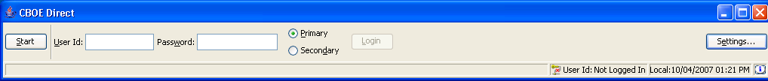

Press the Settings button:
Unlock: CCC
Press submit
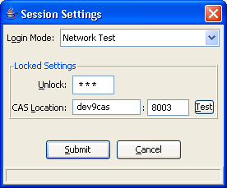

Press Login button.

Open Start / Market Display

Select View / Add Class
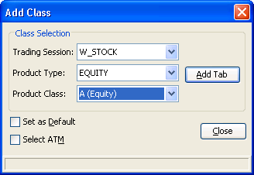

Press Add Tab button. A Row will appear in the Market display.
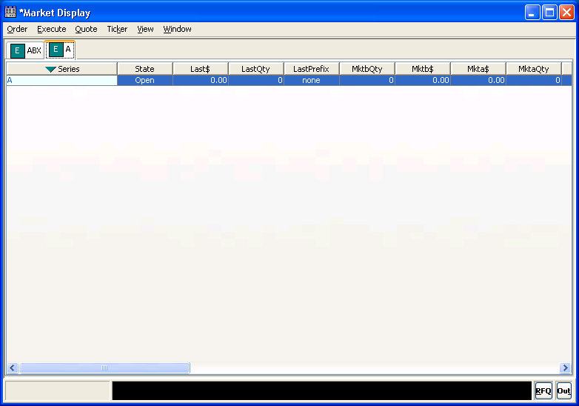

On the row, right click button, select Order/Add New Order.
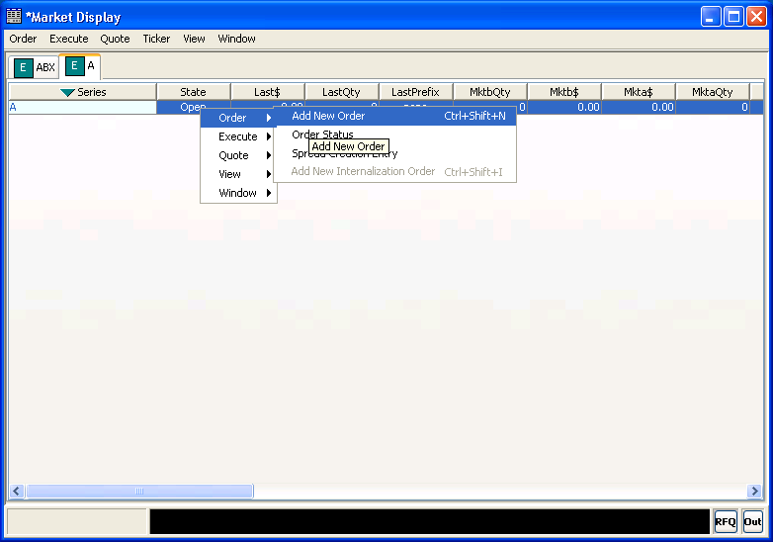
Enter the price, qty and Branch (Branch should be 3 letters).
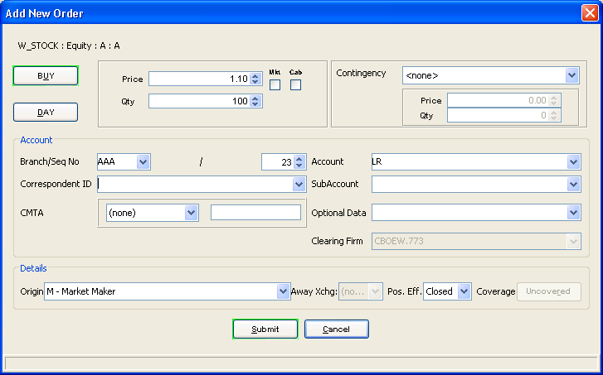

You can add either a Buy order or a Sell order.

To see the Order Status select Order / Order Status.
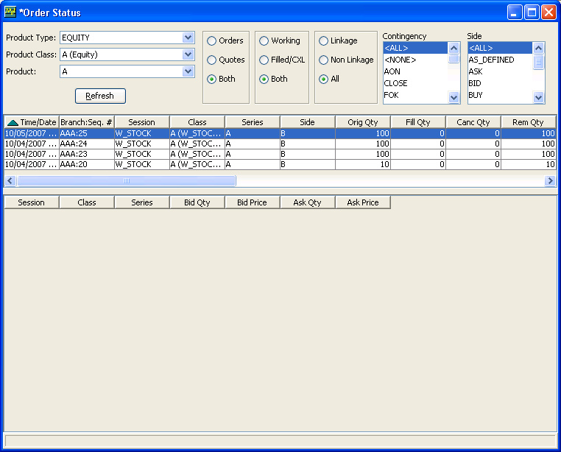

Select the Order, right click button, select Order History.
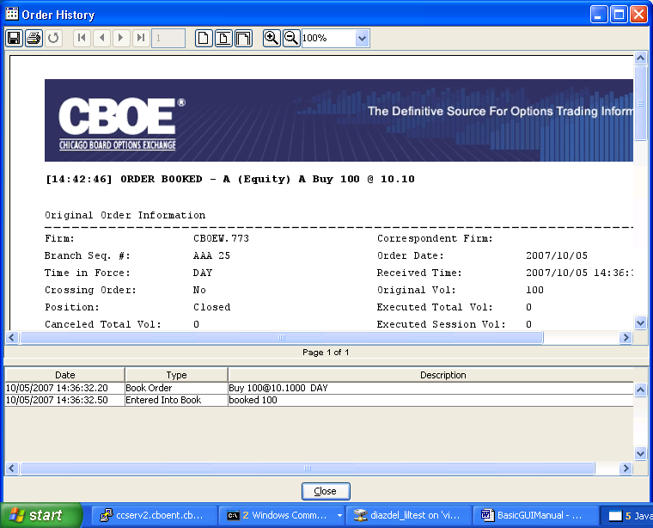

Quote / Enter Quote
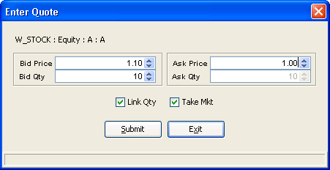

Login to the SQL DB
telnet devenv1
user: trade3
password: trade3

http://ccserv1/documents/SBT/SCRUMEnvironments.html#DetailsEnv9
telnet devenv3
user: trade9
password: trade9

devenv3 (infra9,trade9)
dev9cas (infra,tradeeng)

Para entrar a sql:
loginDb W_STOCK

select count(*) from sbtorder where orderdate=’20071001’;

Start SA GUI

Open a command prompt
Go to this directory (your mapped view)
X:\gui\release\admin\bin
Type: setenvironment
Type: startGui_test9

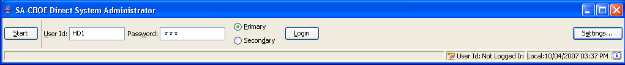

Press Settings button. Select ‘Network Test’, press ok and confirm. It will show an error message, disregard it. It is trying to save the new settings into a file called SbtAdminGui.properties but the file is locked, anyway the settings are already set.

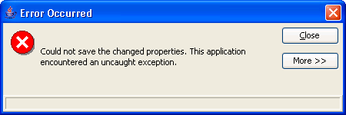

User Administrator id: HD1 password the same.
Also you can try HD2, HD3…

Press Login button.

- Products / Products State Maintenance / Create new Window
By Session
By Group IBM

To be able to change the state of the products, switch to support mode
Operations>Support Mode> CCC

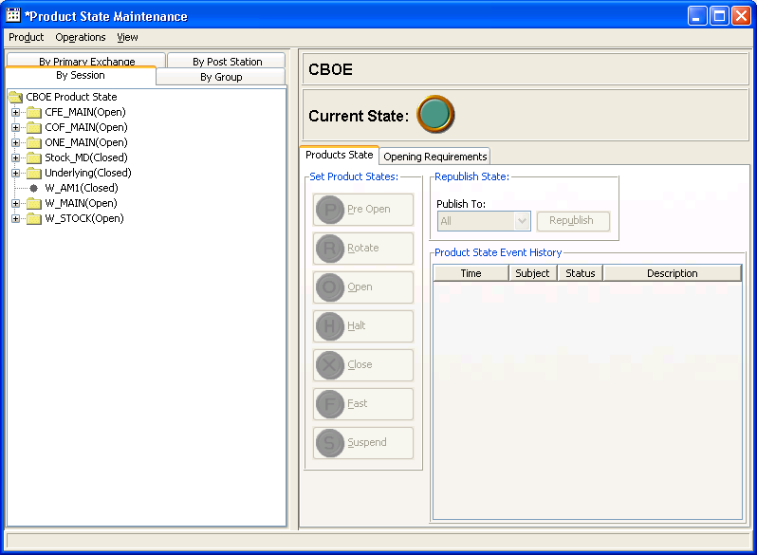

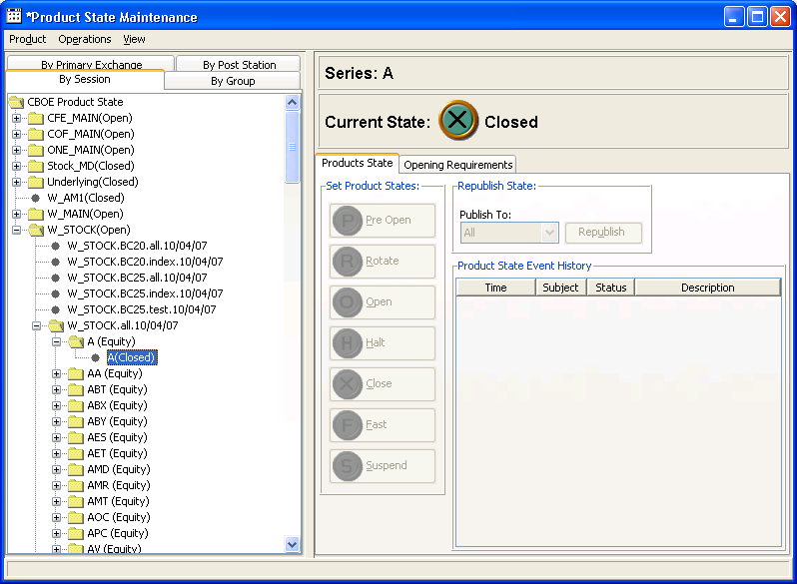

- Trading Session / Create New window
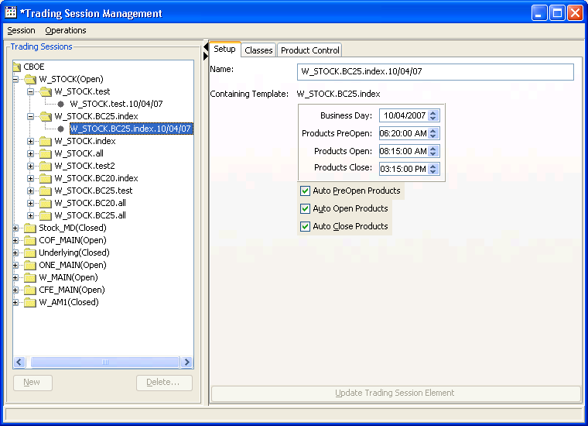

- Trading Properties
You can change the lot size.
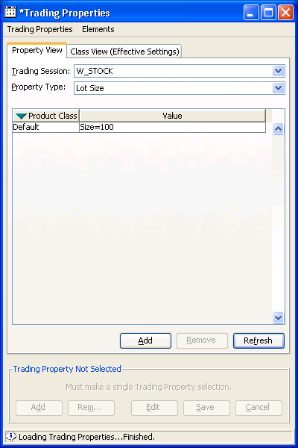

You can see a list of properties in the system by doing the following:
Open putty
telnet devenv3
user and password: trade9
You will be in /sbt/test9/tradeeng/run_dir
Type: getTradingProperty

devenv3 /sbt/test9/tradeeng/run_dir $ getTradingProperty

|= = = = = = = = = = = = = = = = = = = = = = = = = = = = = = = = = = = = = = =|
|Usage 1: getTradingProperty sessionName classSym prodType tradingProperty
|Usage 2: getTradingProperty sessionName default tradingProperty
|Usage 3: getTradingProperty sessionName default tradingProperty all
|
| sessionName - W_AM1, W_MAIN, ONE_MAIN, CFE_MAIN, COF_MAIN, Underlying, W_STOCK
|
| classSym - the acronym for the class, or "default".
|
| **** **** optional parameter **** ****
| prodType - option, strategy, index, equity, commodity or future.
|
| tradingProperty - one of:
| PrescribedWidthRatio FastMarketSpreadMultiplier
| AllocationStrategies
| DPMParticipationPercentage ExchangePrescribedWidth
| OpeningPeriodTimeRange OpeningPriceDelay
| OpeningPriceRate PreClosingTimePeriod
| RFQTimeout MinQuoteCreditDefaultSize
| RFQResponseRatio ContinuousQuotePeriodForCredit
| MinSizeForBlockTrade BookDepthSize
| IPPMinSize IPPTradeThroughFlag
| QuoteLockTimer QuoteLockNotificationTimer
| QuoteTriggerTimer DPMRightsSplitRate
| LinkageEnabledFlag SatisfactionAlertFlag
| FPQS FCQS
| SOrderTimeToLive POrderTimeToLive
| PAOrderTimeToLive SOrderTimeToRejectFill
| SOrderTimeToCreate SOrderTimeToCreateBeforeClose
| ProductOpenProcedureType DPMRightsScales
| UMASplitRate UMAEqualDistributionWeightForDPM
| LotSize ETFFlag
| IPPToleranceAmount NeedsDpmQuoteToOpen
| TradeType PreferredDPMRightsRate
| QuoteLockMinimumTradeQuantity AuctionTimeToLive
| AuctionMinPriceIncrement AuctionMinQuoters
| AuctionReceiverTypes InternalizationGuaranteedPercentage
| AuctionOrderTicksAwayFromNBBO AutoExEligibleStrategyTypes
| AuctionEnabled AuctionMinOrderSizeForTicksAboveNBBO
| AuctionMinMaxOrderSize OpeningPriceValidation
| AllowMarketOrder OpeningExchangePrescribedWidth
| PriceProtectPercentage SizeIncreasePercentageForNewRfp
| PDPMRightsScales BOTREnabled
| BOTRRangeScales EOPStartTime
| LeapsOepw EOPInterval
| MarketTurnerPercentage AllowedHALTypes
| HALTriggerTimer ReportingPriceAdjustment
| ITSCommitmentAutoCancelThreshold
| CrossMinOrderSize CrossMinDollarAmount
| NBBOCrossMinOrderSize NBBOCrossMinDollarAmount
| UIMTimeoutMS UIMActive
| MOCIntervalSeconds
| AutoLinkEnabled
| AutoExSizeAgainstNonCustomer ManualQuoteCancelTimerForNonPar
| IndexHybridIndicator ManualQuoteCancelTimerForPar
| ExtremelyWideQuoteWidth HoldBackTimer
|
| **** **** optional parameter **** ****
| all - retrieves for classes including default for property type
|= = = = = = = = = = = = = = = = = = = = = = = = = = = = = = = = = = = = = = =|

- User / User Management / Create New Window

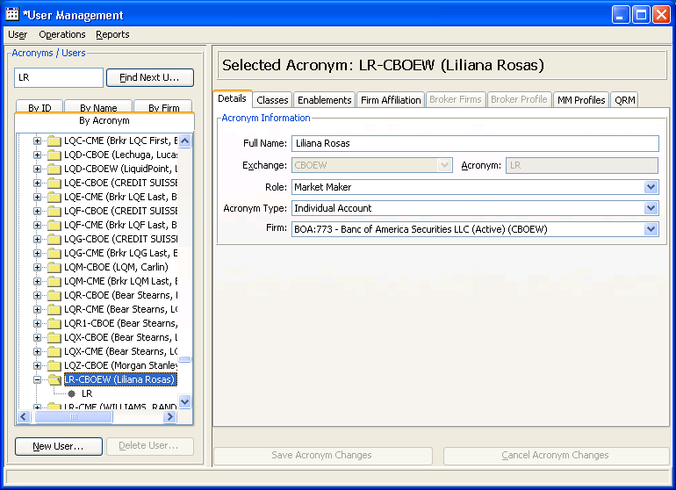

Select the ‘By Acronym’ tab. If you want to create a new user, first ensure the acronym does not exit. Type the acronym and press the ‘Find User’ button.

To create a new use press the ‘New User’ button. In the Xchg field select: CBOEW.
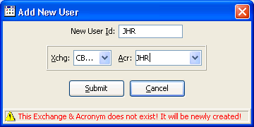
Enter the Full Name, select the Role: ‘Market Maker’, select a Firm related to CBOEW. Save.
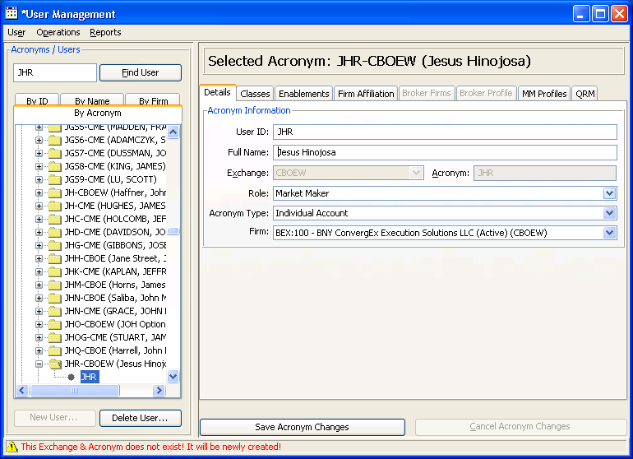

Press the ‘Enable’ button.
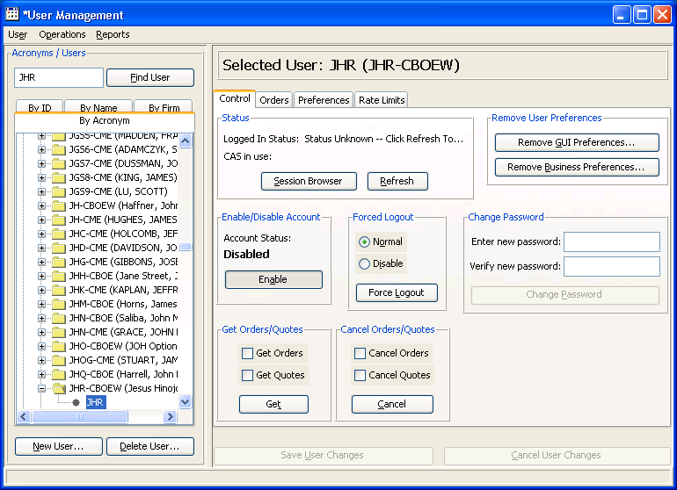

In the left side select the folder related to your user, the right side will show the previous screen. Select ‘Enablements’ tab.

Add the Trading Sessions: Stock_MD, W_MAIN, W_STOCK.
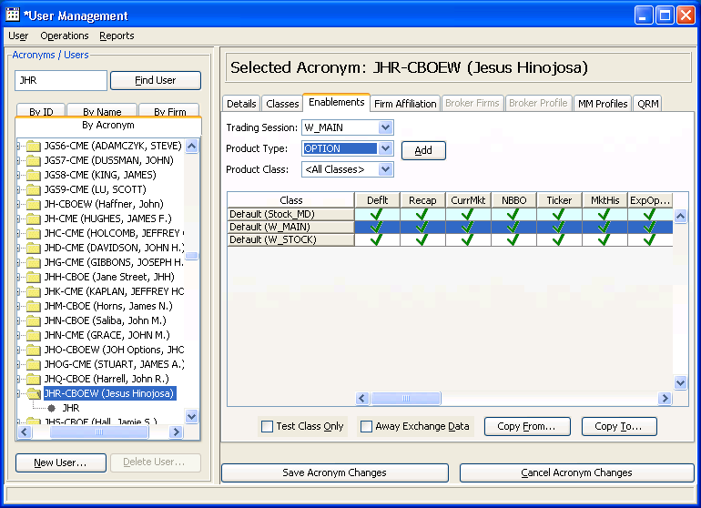

Start / Agent Query
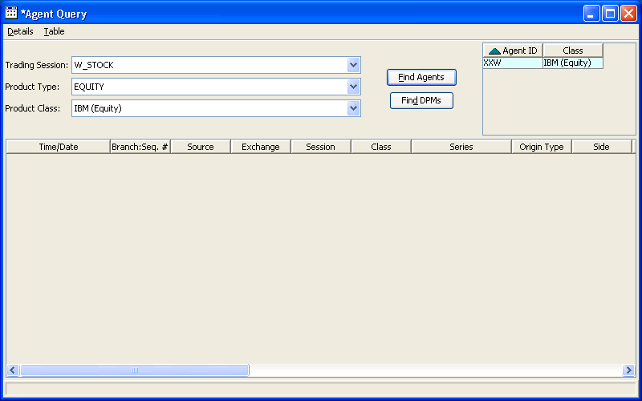

Start / Book Depth

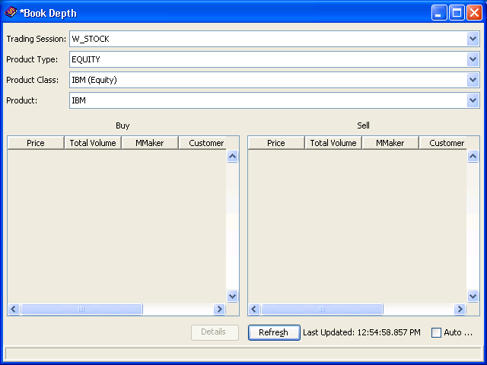

Start / Calendar
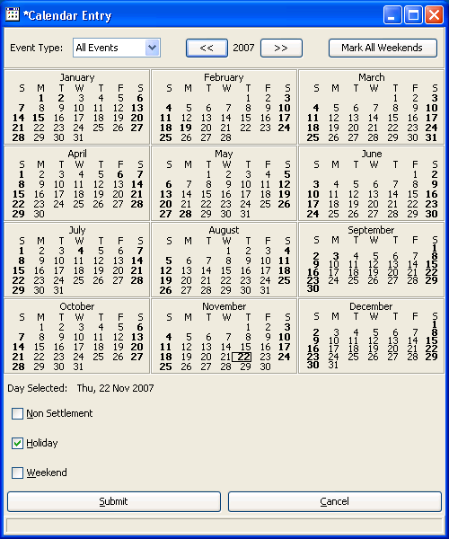

Start / ITS
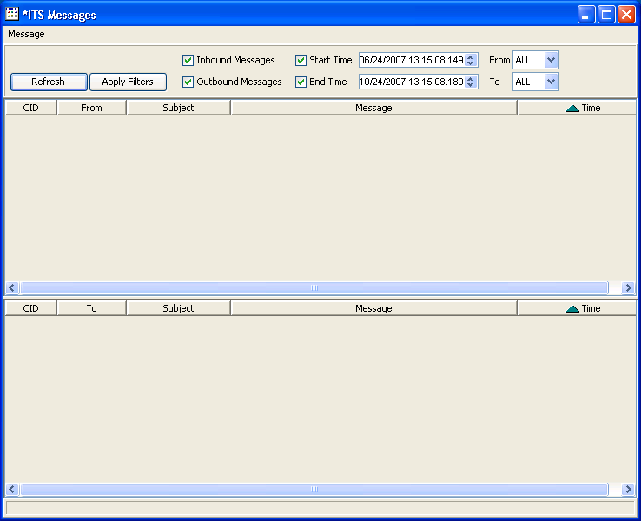

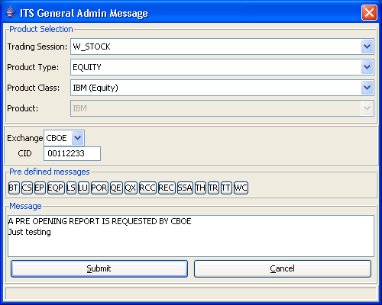

Start / Message Center

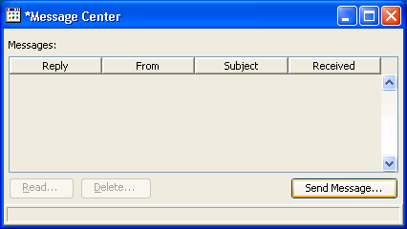

Send Message

Product / Price Adjustment

Pressed Create New button. Tried to add a new price adjustment and got an error:
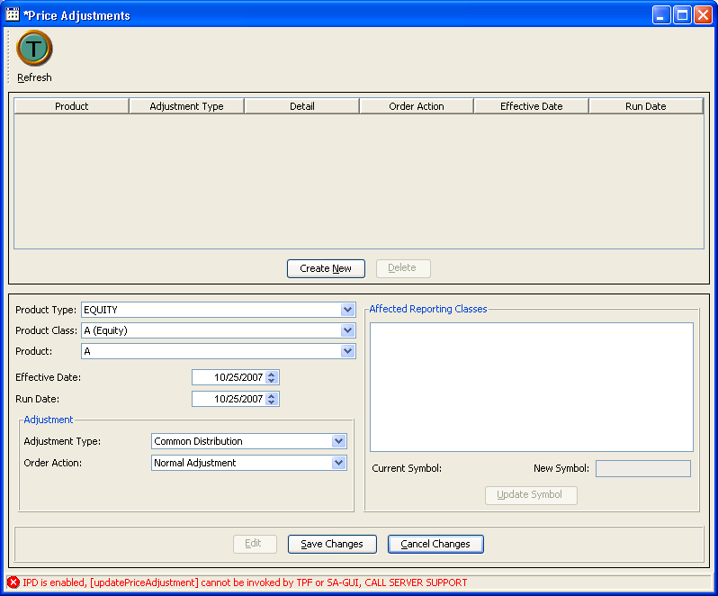

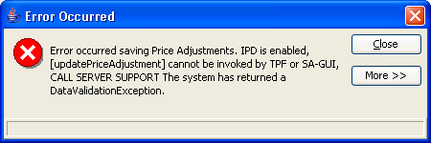

Start/ Products/ Product Definition
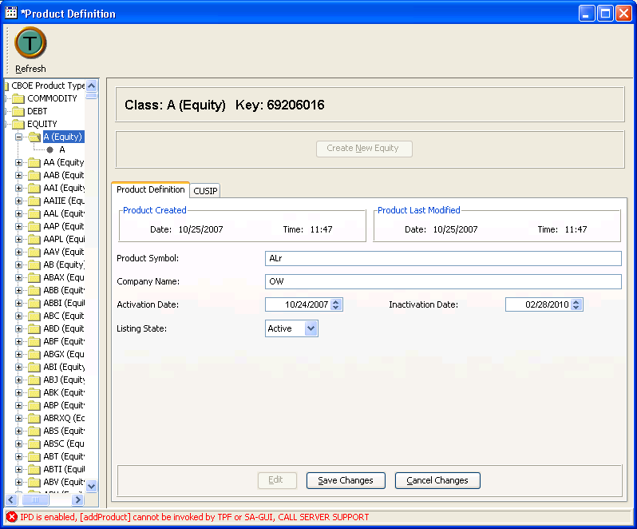

Start / Trades/ Block Trade
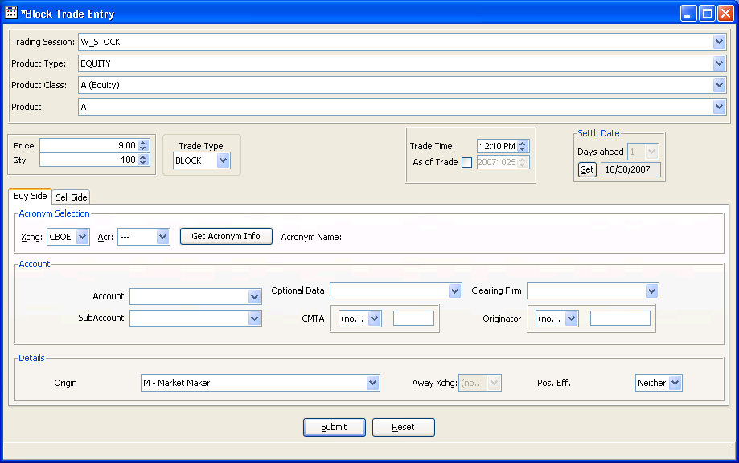

Start / Trades / Trade Bust 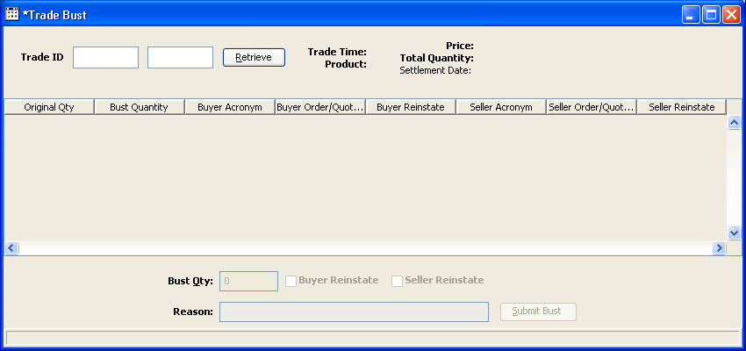

Strat/ Trades / Trade Query
