UNDERSTANDING THE DEVELOPMENT PROCESS @ CBOE

- ClearCase Basics.
ClearCase is a software tool for revision control (configuration management, SCM etc) of source code and other software development assets.

Objects under version control in ClearCase are stored with their histories in repositories called VOBs (Versioned Object Base). ClearCase's manages a versioned file system (called MVFS: MultiVersion File System), which can be used to mount VOBs as a virtual file system through a dynamic view, selecting a consistent set of versions and allowing for the production of derived objects which are files (intermediate or not) that are not directly maintained, but get created. The most typical context is that of compilation, linking, and packaging of source files.
The dynamic view allows this to map to a Software Configuration.

Alternatively, ClearCase supports snapshot views which are just copies of a directory tree spanning one or several VOBs. Snapshot views do not use a virtual file system to provide access to VOB data. Instead, a snapshot view stores a copy of the VOB data locally on the user's computer. Snapshot views can be used while disconnected from the network and later resynchronized to the VOB when a connection is reestablished. This mode of operation is similar to how the widely-used CVS (Concurrent Versions System) software works.

From the perspective of software on the client computer, a view appears as just another file system. If a file is created in a view by normal OS means (copying or saving from an editor for instance), then ClearCase will create this file as a "view-private" file. It will not be visible in any other view. This allows build systems to operate in the same directory structure as the source code, and ensures that each developer can build completely independently of each other (though if the view is a dynamic one then the normal overhead associated with accessing files over an NFS link applies). A view-private file (or directory for that matter) can be converted into a versioned element at any time, making it visible to other developers.

Each developer typically has one or several views at his/her disposal. It is sometimes practical to share views between developers, but sharing branches is usually used instead. Having a branch hierarchy is often useful, so an entire development project shares a common development branch.
- File Structure
The views that we created and currently use @ CBOE are NFS drives mounted on the directory /vobs/dte on server ccserv1. Each of the directories listed there is an individual ClearCase VOB. Some of the ones that we have been using are documents and gui; as well as server is one that we will be using very often on the following months while we develop the OddLot Handling project.

It is possible that if you login to clearcase structure in ccserv1 ( /vobs/dte ) and if you try to navigate through the directories there you might find some empty directories after executing an ls command. You solve this by setting your view using ct setview. After this you should be able to browse the contents of the clearcase vobs freely.

Each of the java related vobs will have a Java which will contain one ore more “Eclipse Java Projects”. If you go to /vobs/dte/server/Java you will see there some of the projects that we see in our eclipse environment. This is where some of the code that we will be modifying for OddLots resides.

- Making Code Changes
Before we do a change on any class that is checked-in clearcase we have to check it out. For new classes we just create the class in Eclipse and once we are satisfied with it we add it to source control to put it in clearcase.

When a particular resource that is already in ClearCase is checked-out by someone else it will be displayed in Eclipse with a MSN Messenger liked character on the side if not it will display with just a small orange cylinder.
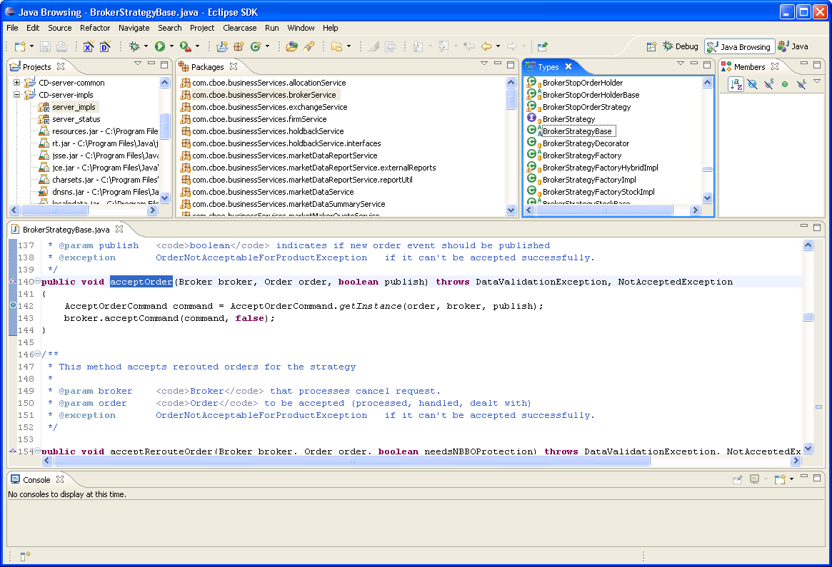
Let’s say we want to make some code changes to the class com.cboe.businessServices.brokerService.BrokerStrategyBase. We select the resource and bring the popup menu with the mouse’s right button and select Team>>Checkout or we just try to type something directly on the class source code in an Eclipse editor view and we will be prompted in we want to checkout the resource.

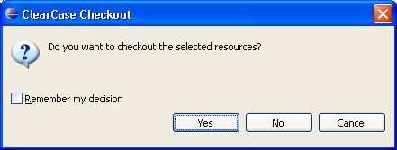

We just click on Yes and we are ready to start making changes to the class.

Once we are finished with the class changes and after we tested them properly in a test environment assigned to us we should put it back under clearcase control (or in the repository) by doing a checkin on it. We do this by selecting the class in Eclipse andbring the popup menu with the mouse’s right button and select Team>>Checking.

- Testing Our Changes
We need to test our code by using the testing environment assigned to us, in our case is test9 (devenv3). These are the steps we need to follow:

- We need to locate the file in clearcase and ftp it to the test server. Continuing with our example supposing we want to test the changes we did to BrokerStrategyBase, we locate ourselves where this class is we can do this from our local windows environment in which case it will be in X:\server\Java\impls\com\cboe\businessServices\brokerService

If we dot it from clearcase server directly we login into ccserv1 and locate ourselves in /vobs/dte/server/Java/impls/com/cboe/businessServices/brokerService

- We then FTP into the test environment devenv3 using a valid userId/password. For devenv3 will be trade9/trade9.

http://ccserv1/documents/SBT/SCRUMEnvironments.html

- We put the source code in /sbt/test9/tradeeng/run_dir/classes and quit from FTP.

- Now we telnet into deven3 and go to /sbt/test9/tradeeng/run_dir/classes, once there we compile our class :

javac –g –d . *.java
or
javac –g –d . BrokerStrategyBase.java

- We then bounce (restart) the corresponding server (or servers) where our just compiled classes normally run. We need to do this for its server to pickup the new version of the class(es). More about this in the next section.

- We test the code that is running on test9 now. Most of the times we will do this by sending an order from the GUI.

- Restarting Servers
We have to kill the server we want to restart. To do this once we are login to the test environment (deven3) we issue the chk script. This will give us the list of the different java servers that are running with our loginId; trade9 in our case. It will show something like this at the end of its output:

ALL java processes on host devenv3 for ID trade9
27911 26686 29450 26231 6 24950 26955 27620 28257 22662 23069 28701 1697 2254 1178 25336 19912 2859

detail for java processes on host devenv3 for ID trade9, environment <test9>
user trade9 pid 19912 test9EquityTradeServer1devenv3
user trade9 pid 1697 test9ExtTradeServer1devenv3
user trade9 pid 22662 test9GlobalServerdevenv3
user trade9 pid 6 test9HybridTradeServer1devenv3
user trade9 pid 25336 test9MDBroadcastAdapter1devenv3
user trade9 pid 26231 test9MarketDataReportServer1devenv3
user trade9 pid 27911 test9OHServerCFEdevenv3
user trade9 pid 28257 test9OHServerEquitydevenv3
user trade9 pid 26955 test9OHServerExtdevenv3
user trade9 pid 26686 test9OHServerHybriddevenv3
user trade9 pid 27620 test9OHServerONEdevenv3
user trade9 pid 1178 test9StatusServerdevenv3
user trade9 pid 2859 test9TipsStockAdapterdevenv3
user trade9 pid 2254 test9TpfAdapterdevenv3
user trade9 pid 23069 test9TpfGlobaldevenv3
user trade9 pid 28701 test9TradeServer2devenv3
user trade9 pid 29450 test9TradeServer3devenv3
user trade9 pid 24950 test9v20Frontenddevenv3

In our example, since we want to test BrokerStrategyBase and we know it runs in the EquityTradeServer we kill it now that we know its corresponding process ID (pid).

Kill –9 19912

The minimum set of servers that we need to have running in our test environment and the way to start them is shown below:

startServer -m Global
startServer -m v20Front
startServer -m Status
startServer -m OHSEquity
startServer -m -n 1 EquityTradeServer

So in order to start the server we just killed we run the startServer script for it:

startServer -m -n 1 EquityTradeServer
Note: You have to wait until you see a message saying that the server started succesfully.

There is also a cron job to stop all the processes and restart them (Warning: it takes about 2 hours to finish):
restartDevSystem

According to Mysbah these are the processes that we should stop and re-start (to avoid executing the above cron).
startServer -m -n 1 EquityTradeServer
startServer -m test9GlobalServerdevenv3
startServer -m test9OHServerEquitydevenv3
startServer -m test9StatusServerdevenv3
startServer -m test9TipsStockAdapterdevenv3
startServer -m test9v20Frontenddevenv3

To remove the compiled classes from the server after testing do this:

To remove the java clases:
rm –f *.java

To remove all the com directory that includes the compiled classes:
rm –fr com

- Remote Debugging
- To be able to do remote debugging within Eclipse of code running on a server in our testing environment create and run a Remote Java Application configuration.

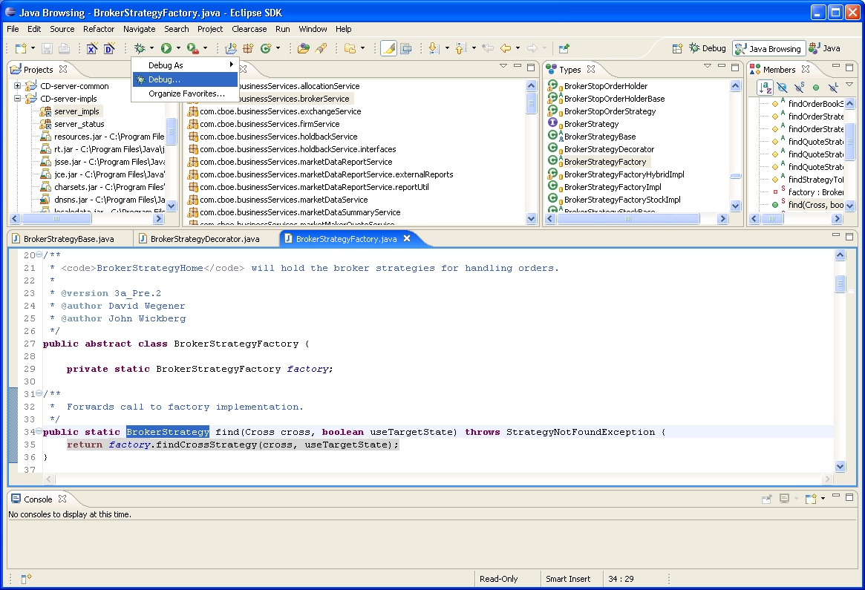
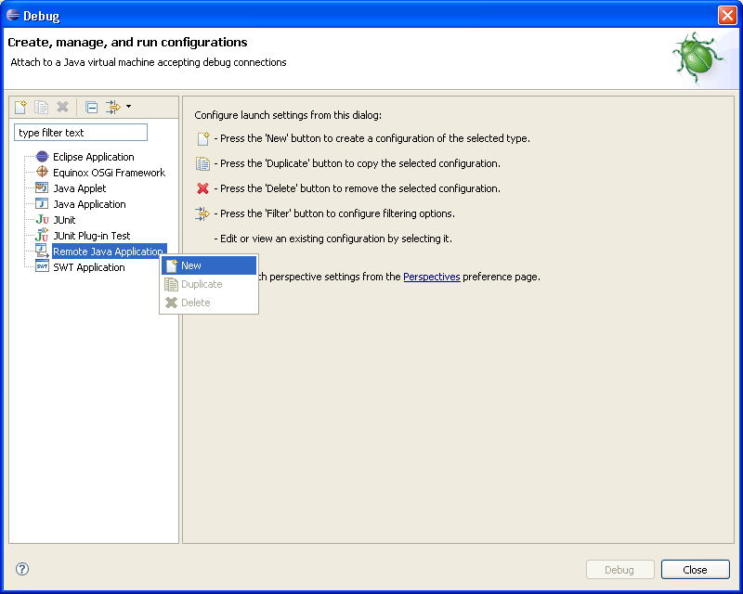
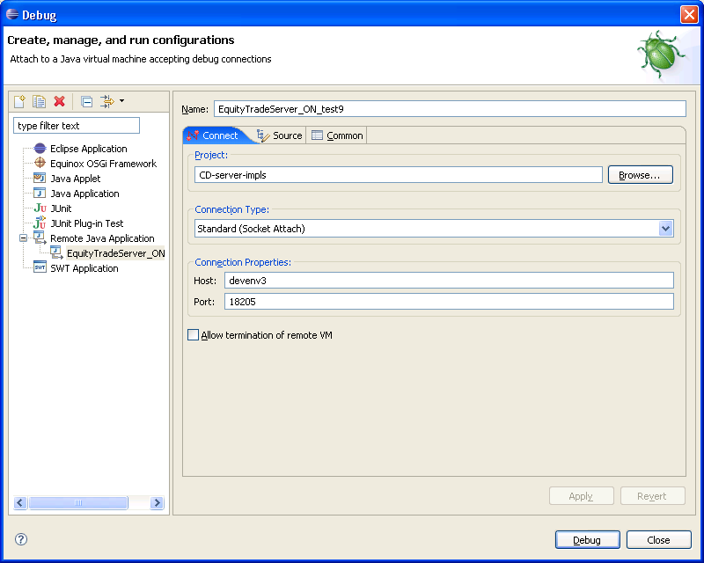
Hit the debug button and the Debug Perspective should open showing the current threads running on the server you configured to connect to.

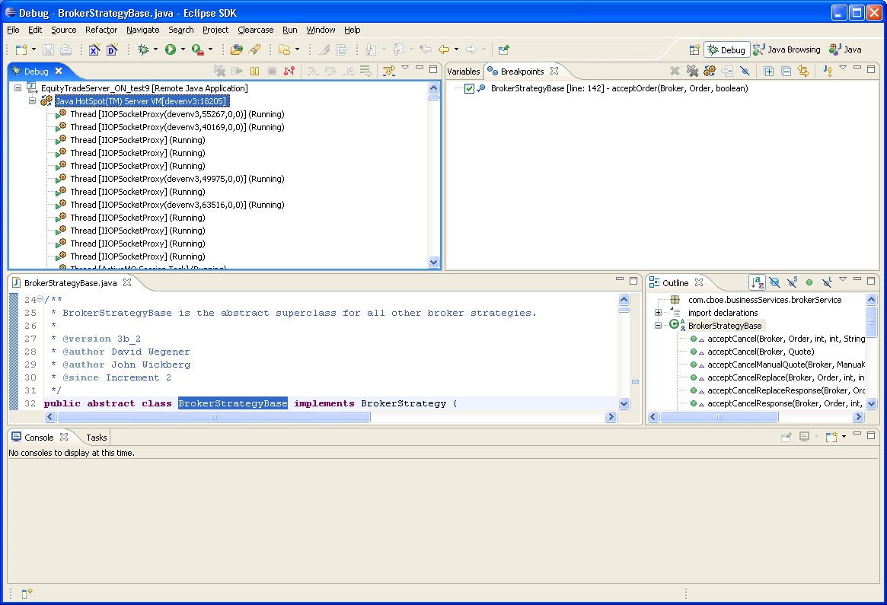

If it fails to connect then either the server process is not running on the test environment or it’s running not remote debugging enabled.

For a server to run remote debugging enabled the following line

# To turn debug on, uncomment following line
PROCESS_ARGS="${PROCESS_ARGS} -DApplicationDebugOn"

in the file /sbt/test9/tradeeng/run_dir/bin/setContext.main has to be uncommented.

If it’s not, then uncomment the line using vi, save the change and restart the corresponding server the way it was explained before.

Connect from eclipse again using the Remote Java Application configuration you previously created.

Now all you need to do is set the breakpoint you need in Eclipse and with the GUI on test9 send a new Order so your changes in the code are triggered and your breakpoint gets hit.

Here’s the list of the Remote Debug Ports for the minimum servers we might need when testing:

Global 18219
v20Front 18223
Status 18217
OHSEquity 18905
EquityTradeServer 18205

Restarting SACas

Check the processes:
chk

Look at the test9sacas01v2dev9sa process id. Kill that process:
kill -9 5683

Start SACas again:
v2startacas

