Table Of Contents
Table Of Contents 1
Disclaimer 3
Requirements 4
Dependencies with External Systems 6
GC changes 7
Id Server 7
Configuration in XML 7
Scripts 7
GlobalServer 7
Product Configuration and Product Routing changes 7
Compass Adapter 8
Membership Adapter 8
CoppGlobalAdapter/CoppGlobalBridge 8
IDL changes (highlighted are new additions in OpraService.idl) 8
Script changes 11
Code changes 12
Process Flow Diagram of CoppBridge 12
Class Diagram For CoppGlobalBridge 12
Sequence Diagram of EOD startSummary Flow 13
Tips Adapter 13
CFN Adapter 14
BC Changes 15
TradeServer4 15
Code Requirements 15
Script changes 15
Startup/Shutdown/MasterSlave 15
Miscellaneous 15
XML/DTD changes 15
CoppAdapter and CoppBridge 18
Code changes 18
XML/DTD changes 18
SetContext changes 18
CtmAdapter 18
Code Requirements 19
Script changes 19
XML/DTD changes 19
Other BC Processes 19
Product and Routing Configuration 20
Product Configuration 20
Sessions and templates 21
Routing groups 21
All other considerations 23
XML’s & DTD’s 23
Common 23
Tradeengine 23
Script changes 24
Miscellaneous scripts 24
Settlement Prices scripts 24
Summary scripts 25
Documentation changes 26
Documentation 26
Patrol changes (Production only) 26
Other Tasks 27
Project misc. Info 28
Estimates 29
Create Options on Futures Session and Product Configuration 29
Do Trading for Options on Futures 29
Trade Match and Clearing 29
Receiving Underlying Futures trades/prices 29
Disseminate LastSale and CurrentMarket to COPP ( COPP then to CFN ) 30
EOS/EOD processing (OpenInterest, Summary and Settlement reports and dissemination) 30
End to End Configuration and Testing 30
Other Miscellaneous 30
Total for all tasks above 31
ITG Testing 31
ATG. API, Perf Rollout 31
Rollout Considerations 32
See separate document in Rollout Plan 32

Disclaimer
This document is for server team only. Does not include other tier’s changes or estimates. Estimates is based on the best effort by external service team so design for message format and testing can be done in a timely fashion.

Requirements
See Project Charter (WR#5027) for details. Here are the highlights related to CBOEDirect..
- There will be a new session COF_MAIN created in CBOEDirect for Options on Futures products.
- Unless stated below, COF_MAIN products will be treated as options and will have all the functionalities like CFE_MAIN has, everything, including EOD.
- There will be no changes to the existing CFE_MAIN, ONE_MAIN, W_MAIN, W_STOCK sessions.
- Options will be created based on a future product.
- Product opening will be based on a timer.
- Options on Futures will be singly listed. So no BOTR calculation is needed.
- Existing settlement calculations of the average between bid/ask will be used.
- Only M, V, E, F, G, H, C, O order origin types are supported for COF_MAIN. Users will enter the CBOEdirect Origin that corresponds to the appropriate CTI/Origin combination.
- Open Interest will be loaded by Data Warehouse.
- EOD processing on EOD summary, settlements and opening interests will need to include option fields that Futures don’t have: ( Underlying Product symbol, Series ID(Month, Year, Strike Price, Call/Put code.) )
- A new database schema will be created for this new session.
- CBOEdirect data will be loaded into new DWS tables containing Options on futures data only.
- FIX/CMi input only, no COMPASS input for this project.
- Tips and TipsAdapter will need modification to get underlying futures trades and prices.
- CFE logins and clearing firms will be used for this new session, without changes. User enablements for the new session will be done manually by HelpDesk using SAGUI.
- Allocation strategies are the same as supported on CFE and ONE. CBOEdirect will be able to apply any of the foregoing allocation methods to the execution of Orders (other than Spread Orders):
  - Price-Time Priority
  - Combined Price-Time and Size Priority
  - Public Customer Priority
  - Market Turner Priority
  - Trade Participation Right Priority
- Trades and Order entry validations will be using the same strategy as CFE_MAIN.
- There will be no Hybrid trading specialties, such as: quote lock, quote trigger, ‘I’ orders, Auction and Buy/Write. COF_MAIN products are not Hybrid eligible.
- Symbols will not overlap with existing products.
- Current Trade History is adequate for billing.
- No MPP system changes are necessary for DPM or MM appointments. MPP will use CFE handling (Manual entry from SAGUI by help desk).
- Penny premiums are acceptable and sub-cent will be considered for a second phase project.
- CBOEdirect will disseminate Quote and last sale information to CBOE Financial Network (CFN) for distribution to market data vendors (CBOEDirect CoppAdapter sends to Copp then Copp sends to CFN).
- Clearing parameters to CTM will include everything Futures currently handles plus all of the options parameters: Strike month, price, year and call/put indicator, etc.

Dependencies with External Systems
- IPD – Product session code, Price Adjustments, etc…
- Copp – Messsage on Quotes, LastSale, Summary and settlement
- Tips – Underlying future ticker and recap
- CTMr – Trade Match and clearing
- Database – new schema
- Data Warehouse – data for new session

GC changes

Id Server

Configuration in XML
- Need to configure a new ranged id service in the IdServer (There are 3 already existing), need to add a 4th one called CtmCBOEOptionsOnFuturesIdService.
- The range for CtnCBOEOptionsOnFuturesIdService is from 10,000,000 – 12,999,999 (Checked with Chris Degreef but he will confirm with Bob Perterson. Bob said Chris will make the decision but he is busy with CTMr rollout and for now we can just use the new range. If later not good, it can be easily changed since it is a config change)

Scripts
- Modify cleanupServer to reset all these ids back to their standard values.
- Modify setContext.main to add the new environment variable for CBOEOptionsOnFuturesIdServerName (See CTM_ID_SERVICE_NAME as example).

GlobalServer

Product Configuration and Product Routing changes
- RoutingGroupAssignment.properties and RoutingGroupAssignment_Prod.properties – Modify to reflect the use of the new session when assigning classes to TradeServer4.
- Update scripts to create COF_MAIN session and templates, group and class configuration, and product opening configuration. Follow CFE_MAIN as example.
- configureTemplatesAndSessions – Add the new template and session for COF_MAIN.
- configureClusterGroups – Add new groups for TradeServer4. [Note: configureGroups is not used anymore]
- getTradingProperty, getTradingProperties, setTradingProperty, setTradingProperties – Fix the script to incorporate all trading properties and set defaults for the new session.
- sendNothingDones – Fix the script to incorporate support for the new COF_MAIN session.
- showProductStatesBySession – Review.
- Add 2 new scripts for configuring templates and sessions and cluster groups, which will be used to configure new session for COF and associated templates and groups during rollout to any env.
  - ConfigureTemplatesAndSessions_COF
  - ConfigureClusterGroups_COF
- TradingSessionElementTemplate.xml to include new templates for COF_MAIN and session codes and product types for each template. Make sure Commodity is included.
- UserMaintenanceService.xml to include new origin code lists for COF_MAIN.
- ProductMaintenanceService.xml to include defined COF_MAIN session codes for option product type and description for the defined templates.
- TradingSessionService.xml to specify strategyTickSizes and strategyAssignmentStrategies for COF_MAIN
If IPD is in production before we deploy, need to communicate with IPD team on new sessionCode changes for COF_MAIN

Assuming Product Description for the new session products will be created by HelpDesk using SAGUI if needed. See Section: Product and Routing Configuration for proposed setup.

Compass Adapter
No changes is needed since we will not be getting orders from Compass for COF_MAIN.

Membership Adapter
No changes is needed. User class assignments will be entered manually via SAGUI as stated by Requirements document.

CoppGlobalAdapter/CoppGlobalBridge
We are considering to write a new CoppGlobalBridge like CoppBridge to send these EOD messages to COPP via CORBA. The Bridge can be configure to run in CoppGlobal.

If changes is using CORBA message format:
- IDL changes See below
- New CoppGlobalBridge Classes and Opera Proxy classes.
- Configure the bridge in CoppGlobal.

IDL changes (highlighted are new additions in OpraService.idl)
struct OpraSummaryReportStruct
{
long productKey;
string symbol;
char opraMonthCode;
short expDay;
short expMon;
short expYear; // this is the 2 digit year
char optTypeCode;
char opraPriceCode;
string strikePrice;
string lastPrice;
long openInterest;
long totalVolume;
char netChangeIndicator;
string netChange;
string openPrice;
string highPrice;
string lowPrice;
string bidPrice;
string askPrice;
string underlyingPrice;
string extention;
OpraSessionIndicator sessionIndicator;
};
typedef sequence< OpraSummaryReportStruct > OpraSummaryReportStructSequence;

struct OpraSettlementReportStruct
{
long productKey;
string symbol;
char opraMonthCode;
short expDay;
short expMon;
short expYear; // this is the 2 digit year
char optTypeCode;
char opraPriceCode;
string strikePrice;
string settlementPrice;
string extension;
OpraSessionIndicator sessionIndicator;
};
typedef sequence< OpraSettlementReportStruct > OpraSettlementReportStructSequence;

interface OpraService
{
void sendData( in CoppBridgeId id, in OpraReportStructSequence block )
raises(
exceptions::SystemException,
exceptions::CommunicationException,
exceptions::AuthorizationException
);
void acceptBeginSummary(in CoppBridgeId id, in string sessionName,
in OpraSessionIndicator sessionIndicator)
raises(
exceptions::SystemException,
exceptions::CommunicationException,
exceptions::AuthorizationException
);

void acceptSummaryData( in CoppBridgeId id, in string sessionName, in OpraSummaryReportStructSequence block )
raises(
exceptions::SystemException,
exceptions::CommunicationException,
exceptions::AuthorizationException
);

void acceptEndSummary(in CoppBridgeId id, in string sessionName,
in OpraSessionIndicator sessionIndicator)
raises(
exceptions::SystemException,
exceptions::CommunicationException,
exceptions::AuthorizationException
);

// Good night message
void acceptEndOfReporting(in CoppBridgeId id,
in string message,
in OpraSessionIndicator sessionIndicator)
raises(
exceptions::SystemException,
exceptions::CommunicationException,
exceptions::AuthorizationException
);

void acceptTextMessage(in CoppBridgeId id,
in string message,
in OpraSessionIndicator sessionIndicator)
raises(
exceptions::SystemException,
exceptions::CommunicationException,
exceptions::AuthorizationException
);

void acceptSettlementData( in CoppBridgeId id, in string sessionName, in OpraSettlementReportStructSequence block )
raises(
exceptions::SystemException,
exceptions::CommunicationException,
exceptions::AuthorizationException
);

};

Script changes
- CoppAdmin – Added code to route the “ar” command for EOD summary to the new CoppGlobalBridgeHomeImpl for the session COF_MAIN.
- StartServer – Added OpraService and CoppGlobalBridge homes for the startup of CoppGlobalAdapter
- CoppGlobalAdapter.xml.template - Added OpraService and CoppGlobalBridge homes.
- CoppGlobalAdapter.xml - Added OpraService and CoppGlobalBridge homes.
- CoppGlobalBridgeHome.xml – New XML file listing the new home GlobalCoppGlobalBridgeHome.CoppGlobalBridgeHomeImpl
- CoppGlobalBridgeHome.dtd – New DTD file for the XML file CoppGlobalBridgeHome.xml.

Code changes
- New interface CoppGlobalBridgeHome.java for handling EOD summary.
- New implementation CoppGlobalBridgeHomeImpl for sending EOD summary to COPP using CORBA. The admin request from the coppAdmin script will use this implementation CoppGlobalBridgeHomeImpl for COF_MAIN.
- New IDL methods and structs added to the existing IDL interface OpraService.
- Changes to send option fields current code for future does not support.

Process Flow Diagram of CoppBridge
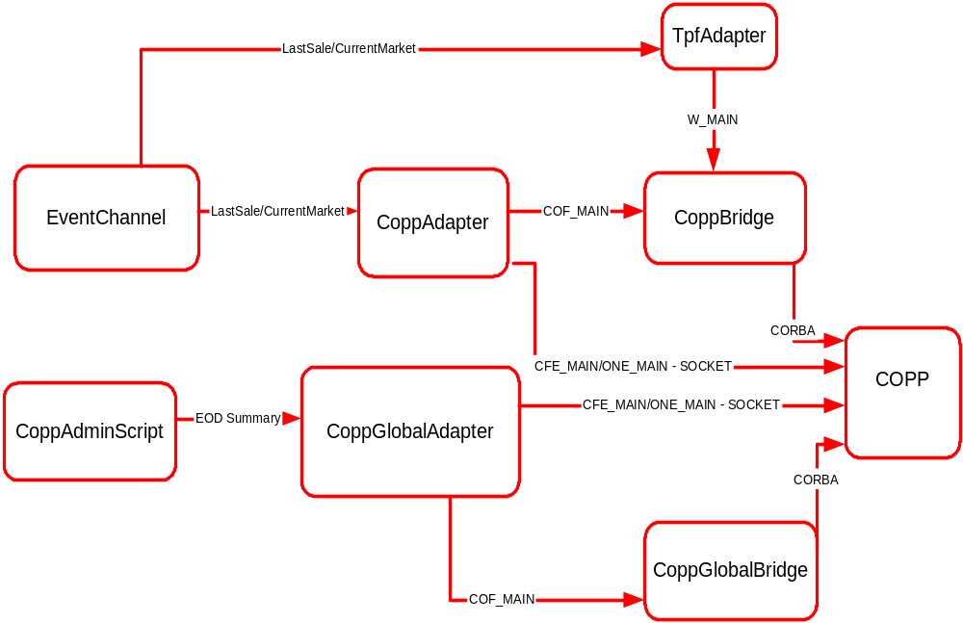

Class Diagram For CoppGlobalBridge

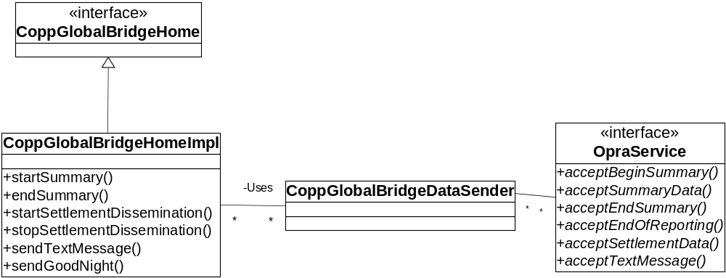

Sequence Diagram of EOD startSummary Flow

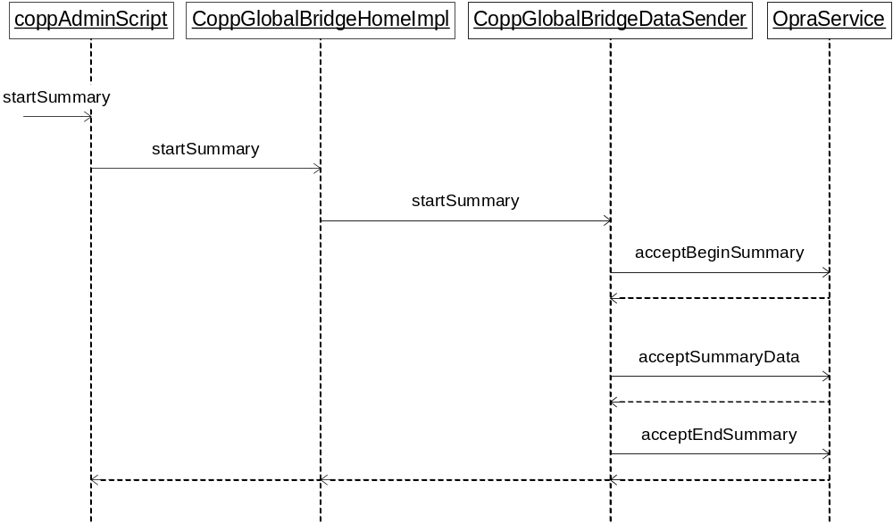

Tips Adapter
Design details see document: TipsAdapterCOFChanges.doc

- Code modification probably is needed to get message from TIPS with new message types
- We will tag using TIPS symbol format: such as for OIL Jan 2006 future, we will tag OILF6.

CFN Adapter
No changes since no requirement on BookDepth for COF_MAIN will be multicasted by CFNAdapter.

BC Changes

TradeServer4
- A new process TradeServer4 will be configured that will be the main tradeengine for COF_MAIN.
- The new process TradeServer4 should point to the new IdService CtmCBOEOptionsOnFuturesIdService as explained above in GC Changes.

Code Requirements
- new Order Validation to use for COF_MAIN. Order Validation xml should use the new strategy for COF_MAIN.
- new Trade Validation to use for COF_MAIN. Trade Validation xml should use the new strategy for COF_MAIN.
- Change TradeServiceImpl.java to allow Block Trade for COF_MAIN when Product is CLOSED.
- Change to com.cboe.businessServices.tradeService. TradeValidationDefaultStrategy.java
  - this is to make product type validation protected to allow overridden.

Script changes

Startup/Shutdown/MasterSlave
The following scripts need to be modified to include the new process
- startServer
- startTradeengSystem
- switchTradeengSystem
- stopTradeengSystem.

Miscellaneous
- Need to update the script setTradingProperties so it accurately updates all the trading properties for the specified session. Also all the defaults for each session need to be added accurately following examples for CFE_MAIN.
- setContext files needs to be updated (i.e. setTradeServerArgs in setContext.main so the trade server 4 can be started).
- setContext.database for new database schema
- Process template and process list for dev, perf and production need to be modified to include new trade server instance.
- installation scripts on new template and xml/dtd for COFTradeServer
- setCommonVars.ksh for new TradeServer.

XML/DTD changes
- Uses the same XML’s as the existing CFE TradeServer process.
- Make other changes as explained above.
- All other XMLs containing CFE_MAIN and CFEMAIN will need to be modified to work for COF_MAIN such as (but not limited to):
- TradeValidationStrategy.xml
- Order.xml
- Quote.xml
- OrderBook.xml
- OrderValidationStrategy.xml
- AuctionValidationStrategy.xml
- BookDepthDataHome.xml
- TradingSessionService.xml
- TPSPropertyServiceFacade.xml
- TPSTradingPropertyFactory.xml
- COFTradeServer.xml/dtd (new files so the installation script is changed to add this file)
- COFTradeServer.xml.template (new file so the installation script is changed to add this file)
Making sure no extend map changes with Infra team. KevinY said if still user name TradeServer, no need to change at their end on the script that used to generate the map. Although WatchedProcessList file needs to be regenerated by Infra after our configuration.

CoppAdapter and CoppBridge
- Existing CoppAdapter and CoppBridge will be used to send data to copp for COF_MAIN session. We can run CoppAdapter and configure CoppBridge in it.
- Need to make sure configuration to use a different instance of Copp is coded. See SetContext changes section below.
- A separate instance of this process will need to be configured for production if is using a new box. So process list file needs to add this new process for production XML generation.

Code changes
- Changes to allow only certain Session configured to go through so in test environment we will not get sending Options on future and Futures. Discard count needs to be incremented if not the session.
- Make sure the strike prices sending to COPP are such that they can hold 6 digit strike prices for the whole portion (currently it is checking if is > 4 digits, we send 9999)

XML/DTD changes
- If using CoppAdapter with Bridge configured in that process, need to add new CoppBridgeHome, OpraServiceHome, CurrentMarketConsumerHome, CurrentMarketStateChangeConsumerHome, HybridClassConfigurationHome and TickerConsumerHome to CoppAdpater XML.
- A new managedResourceName will be added with session Name as COF_MAIN for CoppAdapter to use. Change CoppBridgeHome.xml to add new managed resource <CoppBridgeCOFHomeImpl> and copy all the attributes from the existing managed resource < CoppBridgeHomeImpl>. Add the attribute <sessionNames> to the new managed resource with value of COF_MAIN. Current TpfAdapter will continue to use the current ManagedResourceName (sessionName will be W_MAIN in TpfAdapter case). Modify the script startServer and the template CoppAdapter.xml.template for the new CoppAdapter homes.

SetContext changes
- Need to make sure $OPRA_SERVICE and -DprefixOpraService is defined For COPPAdapter. See setContext.process.tpfAdapter for example. Note, this will be a different instance for COF so the name will not be ProdOpraService for production for example. Check with COPP group for the name to use.

CtmAdapter
Since we expect to have CTMR in production prior to our rollout, we do not expect to have these changes. However, we need to make sure the events on trades are published when testing. Also need to make sure it is still working fine with existing sessions.
- A new instance of CtmAdapter will be used to send data to CTM for COF_MAIN session. So make sure process list file is updated for production.

Code Requirements
- CTMAdapter code base will need to be updated to make sure it supports the new fields on Options on Future product trades (Sada has be working on details of changes).

Script changes
- setContext.process.CtmAdapter needs to be updated with new connections. See notes below
In development we will configure only one CtmAdapter which will list all the connections in process. In prod We will need to have a new CtmAdapter running where TradeServer4 for COF_MAIN is running. So configuration will have to be updated with new connection information. (The setContext on each box will pick the correct set of connections for that box based on what session is being traded on that box).

.

XML/DTD changes
- Add new connections and appl services for CBOEOptionsOnFuturesReports and Acknowledgements service, similar to CoppAdpater changes above.
- Product Type supported for the new connection is COF_MAIN/7.

Other Processes
- Even though there will be no changes for other processes in theory, we will need to make sure processList_Prod.out file for production is updated to include new processes depends on where (Cluster) the trade server 4 is going to be running.
- FE - Change CollectPerformanceMetrics.java to add COF_MAIN for intrumentation.

Product and Routing Configuration

Product Configuration
- Each product class has a Product Description, which defines certain properties for the class. This is the proposed Product Descriptions we could use if prefers separate description for Commodity, Commodity Futures and Option On Commodity Futures. 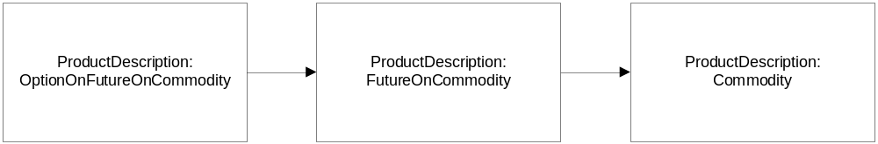
- The underlying for a COF_MAIN product will be a product of another kind of derivative class - Futures. Here is a Product Class, Reporting Class, Product setup example: (1 – COMMODITY, 4 – FUTURE, 7 – OPTION). 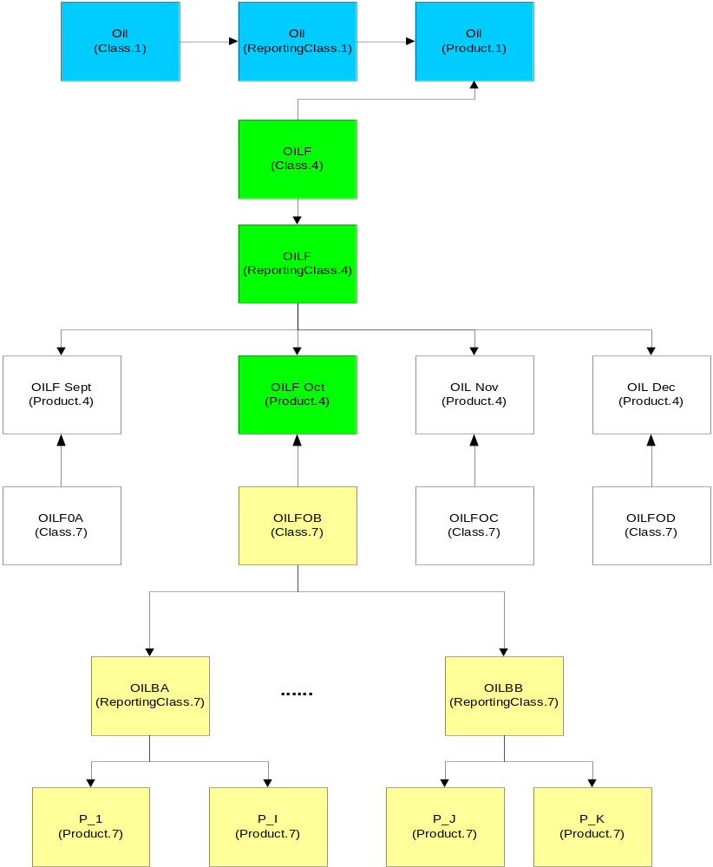

Sessions and templates
- Create the new template COF_MAIN.all
- Create new session COF_MAIN and assign the above template to it.

Routing groups
The following routing group hierarchies need to be created for COF_MAIN for production. Similar group setup is needed for development. (?? – The BC cluster name)
ProdGlobal (Existing)
|
ProdBC?? (Create this group with GROUP_TYPE=10. If using existing box, this group could be existing)
|
ProdBC??TradeServer4 (Create this group with GROUP_TYPE=2)

ProdGlobal.underlyingProducts (Existing)
|
ProdBC??TradeServer4.underlyingProducts
(Create this group with GROUP_TYPE=20)

All other considerations

XML’s & DTD’s

Common
- Fix OrbService.xml to add POA Pairs for TradeServer4 (already have pair4 on TradeServer defined. Just double check).
- Fix SbtLoggingService.xml to add TradeServer4 log file / debug file names.

Tradeengine
Review All XMLs and Scripts to add COF_MAIN session specific stuff.

Script changes
The following scripts need to be updated.

Miscellaneous scripts
- cleanupServer – Review this script to make sure there are no other changes other than stated above.
- setContext - to update FilterGroups and publishing groups correctly everywhere so the TradeServer4 gets the underlying data.
- setContext.database – to add new connections for database schema for COF_MAIN. (make sure ALL_SCHEMA_NAMES is also updated)
- configureTemplatesAndSessions – Add the new template and session for COF_MAIN.
- configureGroups – Add new groups for TradeServer4.
- coppAdmin – Fix Script it can handle COF_MAIN.
- getTradingProperty, getTradingProperties, setTradingProperty, setTradingProperties – Fix the script to incorporate all trading properties and set defaults for the new session.
- sendNothingDones – Fix the script to incorporate support for the new COF_MAIN session.
- showProductStatesBySession – Review.

Settlement Prices scripts
Listed are the changes for EOD/EOS script changes.
  - FindMissingSettlementPrices
    - Change email address from John wickberg to use the defined set of email list in setContext.
  - updateSettlementPrices
    - Change script to take in session name for COF_MAIN
  - createSettlementPriceReport
    - Add format comments as requested by Ravi V in the script
    - Modify FormatSettlementPrice.sql used in this script to,
      - Include session name COF_MAIN
      - Use same exchange code as CFE_MAIN ‘20’ for COF_MAIN as well.
      - Include expiration day for COF_MAIN and filler space of 2 for other sessions.
  - SendSettlementPrices
    - Change script to take in session name for COF_MAIN
    - To decide on how to send prices to OCC – TODO.
    - Need to change setContext.main for defining remote HOST/PORT/User/Pwd/filename information in setSettlementPriceAgs() method for COF_MAIN
  - sendSettlementPricesForVerification
    - Change script to take in session name for COF_MAIN
  - LoadOpenInterest – Please refer to design document /vobs/dte/documents/SBT/DesignDocs/LoadOptionOpenInterestDataDesgin.doc

Summary scripts
The following scripts also need to be reviewed and modified so sessionName passed in as a parameter in all the scripts will accept COF_MAIN. Make sure the option data field stated in requirements are included in the report.
  - UpdateSummary
    - Change script to take in session name for COF_MAIN
  - FutureSummaryReport
    - Rename script in vob to summaryReport.
    - Add new method for COF_MAIN, so that the report is generated with
      - options type ‘Call’ or ‘Put’ [to confirm from Brad Shively]
      - or Month codes.

Documentation changes

Documentation
- Copy all the documents from /vobs/dte/documents/SBT/<latest production release> to a new directory /vobs/dte/documents/SBT/OptionOnFutures and update the following
Rename the files appropriately when moving these files.
  - Operator procedures
  - Configuration Doc
  - Server Installation doc
  - Implementation/Rollout plan.
  - IRB documentation

Patrol changes (Production only)
- Notify patrol group of the new processes on new BC.
- Fix the spread sheet that lists the processes that run on each box.

Other Tasks
- Add new database schema (already mailed request to DBA 8/16/05).
- Configuration of unit test environment.
- Testing with Data Warehouse/Database team on Open Interest and others such as Trade History and data replication.
- Testing with new external connections such as Tips, CTM, Copp, etc.
- ITG testing.
- ATG/API Testing.
- Perf Testing.
- Training - Staff training for support and HelpDesk training prior to deployment.

Project misc. Info
- Baseline for development? HAL
- Test environment? TEST4
- What BC cluster for Production? BC01a/b
- What BC cluster for PERF? Sbtbc02a/b for now.
- Is test environment big enough to support another trade server? Asked Paul. He is aware of it and is going to work on it for test envs to have more memory. For now on test 4 if cannot get up, do not start all the trade servers.
- What project code to use for Timesheet billing? (5027)

Estimates

This does not include the time we already spent on requirement and project planning so far.

Create Options on Futures Session and Product Configuration
This task includes GlobalServer changes and product configuration.

Design + Coding + unit Testing – 14 days
Testing when trade server is up – 2 days

Do Trading for Options on Futures
This task includes TradeServer, StatusServer changes.
- New Trade Server configuration
- User Logging in
- Product Opening/Closing
- Orders /Quotes Validation
- Orders/Quotes Trading fuctionality
- All basic events, such order/quote status, current market verification
- Strategy trading
- Allocation Verification

Design + Coding + unit testing – 21 days

Trade Match and Clearing
Since we expect to have CTMr in production before this, we do not expect to have code changes for this except the Squence number changes for IdServer.
- New Trade Matched Seq# range for Options on Futures.
- Test to make sure for COF_MAIN trade and fill events contains Clearing parameters to CTM will include everything futures have plus all of the options parameters as stated in the Requirement document
- Test to make sure current CTMAdapter release in production still works for existing

Design + Coding + unit testing – 7 days
Testing with CTMR/CTM - 5 days

Receiving Underlying Futures trades/prices
This task includes TipsAdapter and related changes to get underlying future ticker/recap (depending on how Tips sending us the message)

Design + Coding + unit testing – 20 days
Testing with Tips – 5 days

Disseminate LastSale and CurrentMarket to COPP ( COPP then to CFN )
This include changes in CoppAdapter or CoppBridge and setting up the process in order to publish Options on Futures LastSale and CurrentMarket to COPP.
- Session and Product type need to be checked in existing CoppAdapter code
- CoppBridge code need to support check on SessionName.
- IDL changes for OperaService if any

Design + Coding + unit testing – 20 days
Testing with COPP – 7 days

EOS/EOD processing (OpenInterest, Summary and Settlement reports and dissemination)
This includes all the functionality for end of session and end of day processing.
- Open interest
- EOD summary
- Settlement reports
- Dissemination of Summary and Settlement to Copp (CoppGlobal)
- EOS processing
- sendEosToCTM(What is this. Currently only send for CFE, do we need this for COF?)

Design + Coding + unit testing – 20 days
Testing with COPP, OCC and Datawarehouse – 7 days

End to End Configuration and Testing
This includes development team testing and bug fixes when all the processes needed for COF_MAIN up running.
25 days

Other Miscellaneous
This includes:
- All configuraton, installation, operator procedure doc updates.
- Documentation for IRB
- Clearcase merges
- Review of all changes

20 days

Total for all tasks above
Around 9.5 Man Month.

ITG Testing
This is a separate estimates for ITG, unknown for now…

ATG. API, Perf Rollout
At least 2 calendar months.

Rollout Considerations

See separate document in Rollout Plan

