Load Option Interest Data For Options

Overview

Current processing
- Currently Open Interest Data is loaded for FUTURE products only.

New requirement
- For “Options of Future” products, need to provide a way to load open interest data for OPTION products.

Interface Changes
- Added 2 new domain interface objects for the new table representing “open interest data” for OPTIONS.
  - OptionOpenInterestData
  - OptionOpenInterestDataHome

Implementation
NOTE : If new ar command is required any time down the line to load open interest data for Options,
- Need to register the new ar command in ProductMaintenanceServiceHomeImpl
- Need to add the new ar command to ProductMaintenanceService.dtd
- Make the method public that does the update open interest data for Options in OpenInterestUpdateController class.
- Need to add a new script loadOptionOpenInterest.

Summary of changes.
- Implement the new interfaces OptionOpenInterestData and OptionOpenInterestDataHome
  - OptionOpenInterestDataImpl
  - OptionOpenInterestDataHomeImpl
- Add new methods to OpenInterestUpdateController class to support updating of open interest for Options.
  - private void updateOptionOpenInterestData()
  - protected ProductOpenInterestStruct[] create( final OptionOpenInterestData[] data )
  - protected ProductNameStruct createProductNameStruct( final OptionOpenInterestData data ) throws DataValidationException
  - protected ProductOpenInterestStruct createProductOpenInterest( final OptionOpenInterestData data, final ProductStruct productStruct )
  - protected OptionOpenInterestData[] getLatestOptionOpenInterest() throws SystemException, NotFoundException
  - protected OptionOpenInterestDataHome getOptionOpenInterestDataHome() throws NotFoundException

Sequence Of Events.
- Overivew of flow in words.
  - Execute operator command loadOpenInterest
  - Internally call loadOpenInterest methods each for Futures and Options separately,
    - Existing updateOpenInterestData() to update open interest data for FUTURES.
    - New method updateOptionOpenInterestData() to update open interest data for OPTIONS.
  - For details on sequence flow, Please refer to visio sequence diagram located at /vobs/dte/documents/SBT/OptionsOnFutures/DesignDocs/LoadOpenInterest
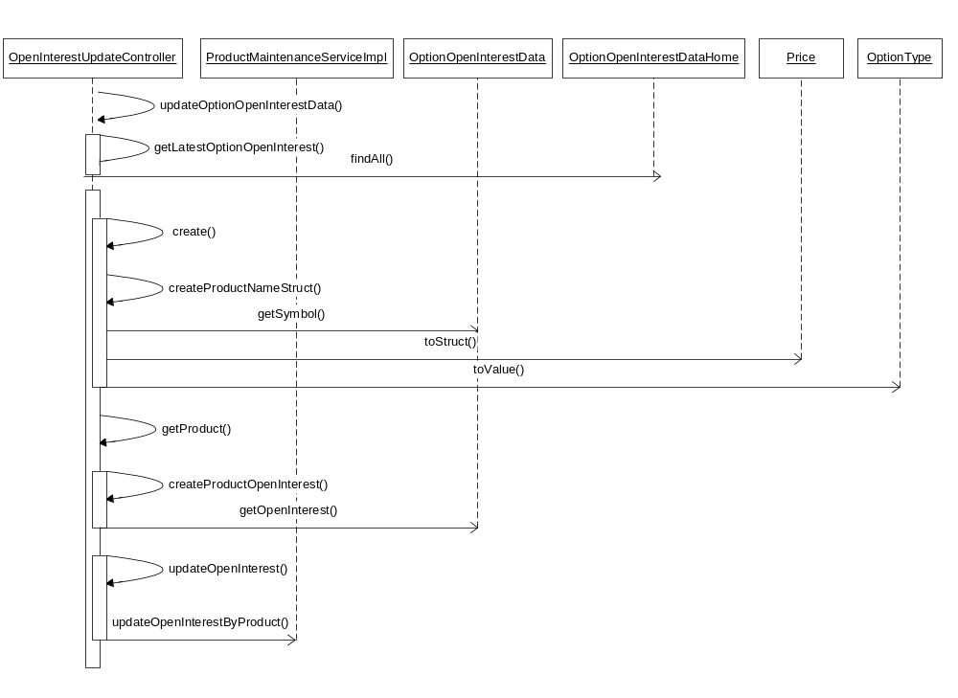
  - Make changes to information messages that indicates loading of Future or Options “Open Interest Data”, so in production support can tell which open interest failed.

Scripts
- None

Database
- New database table [SBT_OPT_FUT_OCC_OPEN_INT ] added by DWH group which will be loaded to SBT by DBA.
  - Columns defined in new table are
    - class_sym
    - exer_price
    - expr_date
    - opt_type_code
    - open_int_qty

SetContext
- None

XML/DTD
- GlobalServer.xml changes
  - Add a new BOHome for OptionOpenInterestDataHome
  - Include OptionOpenInterestDataHome in the listOfHomes

Homes/Services
- None

ImplPlan
- Refer to “Options On Futures” impl plan for details located at “/vobs/dte/documents/sbt/OptionsOnFutures/???”.

PerformanceTestingProcedure
- None

TestingProcedure
- /vobs/dte/server/IPD/TestPlans/EODChanges_TestPlan.doc

OperatorProcedure
- Need to update Load Open Interest section
  - Need to change the heading to specify both (Futures) and (Options)
  - Under verification section, need to update the log information to look for below messages
    - “ProductMaintenanceServiceHome>>> Completed updating open interest for FUTURES ...” 0
    - “ProductMaintenanceServiceHome>>> Completed updating open interest for OPTIONS ...” 0

Fallback/Failover
- Fallback to previous release.

Rollout Concerns
- DWH and DBA has to implement the new database table in production.

