Tips Adapter Changes to support Options on Futures underlying recap and tickers

Specifications

- Tips Message Types for Future Underlying

UPD_F_UDATA for Underlying data contains current market state and prices
UPD_F_TDATA for Underlying ticker data. Contains only price data relevant to a particular trade.

- Message Format
The message format will be exactly the same as the current format for message type UPD_UDATA and UPD_TDATA.

- Fields that will need to be specially handled

The underlying symbol field in the underlying message will be a string that contains the Underlying future’s report class name, Future MonthCode and a single digit year starting from the current decade.

Example: If the Options on Future class symbol OILF7 that has underlying future product as OIL January 2007, the underlying symbol from TIPS message will be OILF7. We need to handle this mingled name since OILF7 is not what we name the underlying product.

- Connection to TIPS

There will be no new connections to TIPS for this. Message will be from the same port as the existing underlying message.

- Tagging to Tips

We will need to tag to the TIPS system using the TIPS product symbol of the underlying future for Options on Futures.

Tips Adapter Changes
(for details of how classes interact with each other, see Sequence Diagrams in the next section)

Note: intraday add of product will not be handled as it has not been for current version of TIPSAdapter.

1. SetContext.main
- Add TradeServer4.underlyingProducts group to setContext.main setTipsAdapterArgs -DprefixListOfFilteringGroupsUnderlying and -DprefixListOfPublishingGroupsUnderlying

- Interface ExternalMarketDataService.java
Change the following interface method to getRecapHolders by ProductKey instead of symbol.
- RecapHolder[] getRecapHolders(String prodSym) throws DataValidationException, SystemException, CommunicationException, AuthorizationException;

- RecapHolder[] getRecapHolders(String prodSym, String [] sessions) throws DataValidationException, SystemException, CommunicationException, AuthorizationException;

- ExternalMarketDataServiceImpl.java
Caching of RecapHolder will be using ProductKey instead of symbol
- Implement method to getRecapHolders by ProductKey instead of symbol.
RecapHolder[] getRecapHolders(int prodKey) throws DataValidationException, SystemException, CommunicationException, AuthorizationException;
- Implement method RecapHolder[] getRecapHolders(int prodKey, String [] sessions) throws DataValidationException, SystemException, CommunicationException, AuthorizationException;
- Change all calls using getRecapHolders by symbol to get by productKey.
- Remove getUnderlyingProductSymbol method since it is bogus.
- Fix for getRecapForClass to return productRecaps instead using underlying since this the class passed in is already underlying.

- TIPSLWMessage

Add new message type:
public static final int MSG_UPD_F_TDATA = 0x2026; // for for TIPSTicketData for futures
public static final int MSG_UPD_F_UDATA = 0x2027; // for TIPSUnderlyingDataUpdate for futures

- TipsFutureProductKey.java – new class extends CacheKey

New class using the future’s product reporting class name, expirationMonth, expirationYear in ProductStruct as the key to be used for DerivedCache to retrieve product based on this key.

Only allow product type FUTURE in isProductTypeSupported

- TipsFutureFormatter.java – new class

New class to handle formatting related functions such as:
Public static TipsFutureProductKey getTipsFutureProductKey(String prodSymbolInTipsMessage); // Given symbol in TipsMessage (such as OILF6) pass it to get rptSymbol = OIL, expYear = 2006, expMonth = January.

Public static String getSymbolInTipsFormat(ProductNameStruct productName);

Public static byte getMonthNumber(char futureMonthCode) throws ParseException;

Public static char getMonthCode(byte monthNumber) throws ParseException;

Public static short get4DigitYear(short singleDigitYear); // given last digit return the full digit year. If is smaller than current year’s last digit, it is in the next decade. Otherwise, it is in the current decade.

Public static short getSingleDigitYear(short year); // last digit from the current year.

- TIPSUnderlyingUpdateTcpImp.java

- Rename and change getUnderlyingProductSymbol method to return arrays: getUnderlyingProductSymbols(ProductClassStruct) to handle the return of product symbols fro each of the product in TIPS message format using TipsFutureFormatter.getSymbolInTipsFormat as required for TIPS tagging if the product class’s is future

- Logging of message will continue to use TIPS symbol. If product is known at the time of logging, product key will be logged as well

- Change method sendRequests to use the new getUnderlyingProductSymbols to tag for each of the returned symbols

- TIPSUnderlyingUpdateImp.java

- Change createProductCache to create DerivedCache using TipFutureProductKey.
- Change handleMessage method to handle the 2 new message types above.
- Method maybePublishProductState and handlingUnderlyingStateChange will need to take a new parameter tipsSymbolName. This is only used for logging messages.
- New method publishRecap(TIPSLWMessage lwMessage, ProductStruct productStruct) – this replaces the publishRecap(TIPSLWMessage, ProductNameStruct) which ignores the productNameStruct and use the tips symble in the message to refill it.
  - Then getProductGroupKeys(classKey) → ExternalMarketDataService.getRecapHolders(productKey, session)
  - Then follow existing logic
- Change existing publishRecap(TIPSLWMessage) :
  - If message type is MSG_UPD_UDATA, use the symbol from the message → derivedCache.lookupProduct(productNameStruct) then pass it to publishRecap(ProductStruct)
  - If MSG_UPD_F_UDATA, TipsFutureFormater.getTipsFutureProductKey(prodSymbolInTipsMessage) → derivedCache.lookupProduct(tipFutureProductKey) look up product then pass it to publishRecap(TIPSLWMessage, ProductStruct )
- Remove existing publishRecap(TIPSLWMessage, ProductNameStruct)
- Logging of message will continue to use TIPS symbol. If product is known at the time of logging, product key will be logged as well

- MessageDispatcher.java

Change dispatchMessage to handle new message types.

We can reuse most of existing logic for MSG_UPD_TDATA and MSG_UPD_UDATA (need to re-factor some code to make it reusable though).

  - MSG_UPD_F_TDATA: TIPSLWMessage.getTickerStruct() → TipsFutureFormater.getTipsFutureProductKey(prodSymbolInTipsMessage) → derivedCache.lookupProduct(tipFutureProductKey) →getProductGroupKeys(productClassKey) →setTickerStructProductKeys(productKeysStruct) → TIPSUnderlyingUpdateImp.publishTicker( groupKeys, prodSymbolInTipsMessage, tickerStruct)

  - Change MSG_UPD_UDATA to call publishRecap(TIPSLWMessage) instead of old method
  - MSG_UPD_F_UDATA: Same as above for MSG_UPD_UDATA.

ClassNotFound and symbolsForTicks maps will have to use the symbol from TIPS message instead of the symbol from ProductStruct since for derivatives, symbol field will always be empty.

Logging of message will continue to use TIPS symbol. If product is known at the time of logging, product key will be logged as well

Sequence Diagrams

Tagging to TIPS
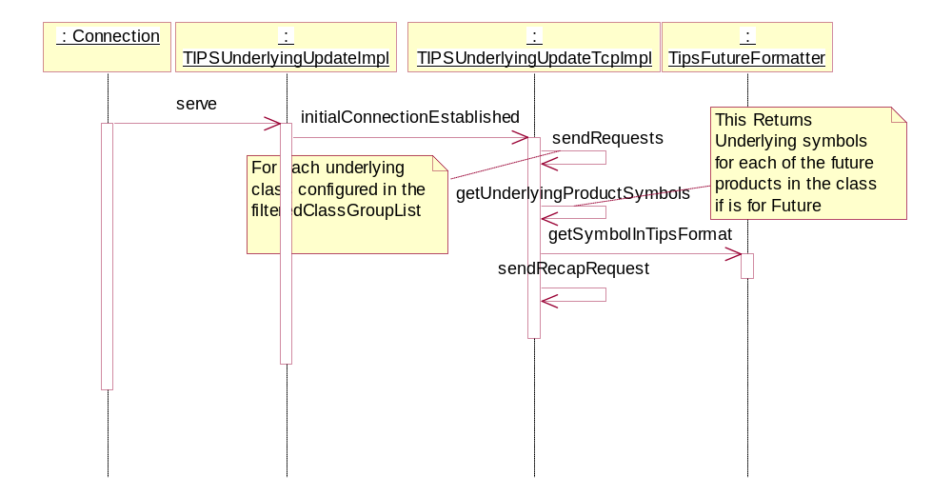

Ticker Message Processing

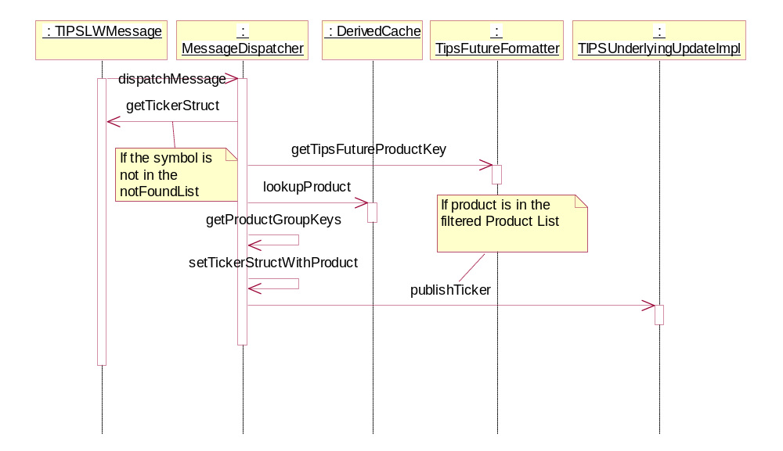

Recap Message Processing

