

SYSTEMS DIVISION

PROJECT CHARTER

CFE: Options on Futures
Document #5027
WR #5027

Prepared by: Diane Taff
Date: 07/14/05

Approved by:

Patrick Fay
CBOE Futures Exchange

Mark Novak
Systems Division

APPROVED

CONFIDENTIAL

CFE: Options on Futures – Project Charter Distribution List
Staff
Odalys Castro
Karen Christiansen
Steve Chodash

Sandy Elliott
Patrick Fay
Todd Furney
Linda Gerdes
Joe Hernandez
Chris Hield
Ed Horvath
Charlie Hullihan
Darlene Kijewski
Tom Knorring
Eva Kolasinski
Peter Lee
Tom Lynch
Doug Luzzi
Michael Mollet
Anthony Montesano
Jim Neceda
Mark Novak
Dennis Paradiso
Larry Pfaffenbach
Brad Peek
Bob Peterson
Bobbie Piwnicki
Brad Samuels
Curt Schumacher
Patrick Sexton
Brad Shively
Acacio Silveira
Eileen Smith
Maureen Smith
Pete Smith
Bill Speth
Diane Taff
Joe Ulowetz
Stella Ulyanov
Ravi Vazirani
Tim Watkins
Margaret Williams
Tom Wojick
Mark Woyna
Carole Zylius
CFE: Options on Futures

Table of Contents

1. Goal 1
2. Objective 1
3. Business Case 1
4. Strategy 1
5. Tactics Statement 1
6. Project Scope and Approach 1
7. Assumptions and Issues 4
8. Risk/Exposure 5
9. Cost Analysis 5
10. Benefits 6
11. Environmental Analysis 6
12. Schedule and Dependency Constraints 6
13. Resource Skill Needs 6
14. Product Research 6
15. Diagram 7

CFE: Options on Futures
PROJECT CHARTER

Goal
The goal of the CFE: Options on Futures project is to add the ability to trade options on futures to the CBOE Futures Exchange (CFE) trading engine.

Objective
The objective of this project is to modify the CFE trading platforms and messaging to accept and process the terms of options orders and trades.

Business Case
Product growth is the primary business reason for this project. Diversification into new, underserved products such as: energy, agricultural, interest rate, etc. is a primary goal. These futures markets often require the pairing of futures and futures-options to be successful.

Please note: Options on Index Futures are unlikely due to licensing agreements and lack of need due to coverage by existing securities options products.

Strategy
The strategy for this project is to define the terms and processing that must be added to the CFE platforms so options on futures can be traded.

Tactics Statement
This project will be developed following the standard Systems Development Methodology.

Project Scope and Approach
CBOEdirect:
Create a new session based on CFE_main and include the following:
- Sub-penny premiums: Penny premiums are acceptable, however sub-cent would be advantageous, or as fine an increment as can be developed down to 1/64th of a point {0.015625}, rounded. Existing rounding to 3rd decimal place in CBOEdirect is acceptable. Changes for sub-cent processing are necessary for other platforms and estimates for these changes will be provided in a second phase project.
- Strike Prices: Currently indexes have strike prices in decimals. Decimal strikes should be allowed for this product.
- Expirations: Expirations at any point during the month. There will only be one expiration a month for each symbol. Each symbol can expire on a different day. Expirations will be either rule based or designated date. Designated date is acceptable for initial implementation.
- Trading Hours: Trading hours ideally of 7:20 am – 4:00 pm. Minimally 7:20am – 3:15pm. Maximum possible trading hours should be provided.
- Contract Months: Full range of contract months, including leaps type months such that Nov. 2005 and Nov. 2006 can exist (18 months of contract months).
- Opening: Openings based on timer or underlying tick is a parameter by session and must be configured prior to development. The choice is TBD.
- Spread processing: The DPM (or other main market participant) will define and keep the spread for these products active.
- Settlements: the existing settlement calculation of the average between bid/ask will be used.
- Membership: CFE membership will be used. There will not be separate permits for CFE and options on futures.
- Trading Schemes (allocations): All allocation types currently available in the AM session should be made available for use by options on futures trading.
- Clearing parameters sent to CTM, including everything Futures currently handles and adding all of the options parameters: strike month, price, year and call/put, etc.
- Single list, unlikely for multiple list in the near future.
- Screen based trading only. Hybrid not currently necessary or included in this project.
- Allow give-up functionality, CTI codes and other futures-related information, similar to the current CFE process.
- Open interest and daily high/low/close will be disseminated at EOD.
- Book Depth data is not currently published for futures and will not be published in this initial phase for options on futures. Query of book depth will continue to be supported.

BUSINESS SERVERS:
- Underlying and Position data: The underlying futures are not fungible. If the underlying comes from an exchange not currently connected to CBOE, a new connection will be required and the format of the data will be an ISG format. Large trader firms (LOPR) data will continue to come from SIAC.
- TIPS and XTP will be modified to receive feeds from the appropriate exchanges for the underlying futures trades/prices. TIPS adapter modifications will also be required.
- Ensure CBOE Financial Network can send options data to vendors (such as ILX, Reuters, etc.). Modifications necessary include: CFN protocol modifications, specifications documents updates to CFN vendor protocol and book depth. Other documents and protocols will be evaluated during requirements.
- CFE does not contain half-hourly reports and reports for these options are not being added.
- Open interest and daily high/low/close will be disseminated at EOD

CTMI/CTMR:
CTM (CBOE Trade Match) will be modified to accept and process the above fields added for options on futures (CTM-R and current interfaces and CTM-I). Dissemination to BOTCC/TCC will continue with the new fields added for options. These fields were in the original agreement made with BOTCC/TCC. Additionally, there will be no online editing added for these products.

DWS/CDB:
Data Warehouse/CDB will be modified to capture all new fields.

BILLING:
There will be different charges for different items, similar to existing charges for CFE and ONEChicago. Transaction fees will be driven by class. Final fee structure TBD.

CBOEdirect CLIENT (API):
Ensure clients (FIX/CMi) can send orders to CFE for CFE: Options on Futures. Modifications necessary include:
- Day as well as month and year in the messages for these products (TBD during requirements)
- Ability to log in to the new session
- Trading Technologies FIX gateway modifications for multiple sessions

WEB DEVELOPMENT:
Update CFE Web pages for Options data, including a new page for options on futures statistics received from OCC.

REGULATORY:
- Add options fields to futures surveillance (IAD and Regulatory Systems)
- Create capping and pegging surveillance for options on futures expirations
- Add Front Running surveillance
- Market Replay
- Add these products to Position Limits
- Modify “102” forms to support these products (add call/put, strike, expiration month)
- Underlying position data to support regulatory applications, currently received from ISG, but not all futures exchanges are members of ISG. Data feeds will be required for these exchanges.
- Include LOPR for these products

Coordination with OCC (and TCC) will be required for development and testing of the clearing of these products.

EOD PROCESSES
Current EOD processes will continue, some of which are:
- Calculate Settlements
- Send Settlements
- Email Settlements
- Load Open Interest (from OCC)
- Calculate Summary and send to CFN

Assumptions and Issues
The OCC has made significant preparation for this processing and will need approximately 3 months of test time prior to the launch of these new products. It is assumed that this time will be considered in the scheduling of this project.

Regulatory Assumptions:
- There is an assumption that additional resources will be required to support regulatory development so existing regulatory priorities will not be impacted.
- Existing regulatory processing will be duplicated and modified to work for these new products.
- If the underlying products appear to be more subject to manipulation, modifications to Insider Trading may be required at a future date.
- It is assumed that the OCC will provide delta information.

Additional Development Assumptions:
- There will be a new session created in CBOEdirect for options on futures products.
- There will be no changes to the existing CFE_MAIN, ONE_MAIN, W_MAIN, W_STOCK sessions.
- CBOEdirect data will be loaded into new DWS tables containing Options on futures data only
- Data vendors such as OCC, SIAC, CTMR, etc will provide additonal files with Options on futures data. The data will be loaded onto new DWS tables
- FIX/CMi input only, no COMPASS input for this project.
- All applications except TIPS, ISG and ICS loads will be cloned from existing applications for Options.
- Table structures and table definitions will be cloned from existing Options tables (except tables for TIPS, ISG and ICS loads)
- The new session will be an options engine and it will be similar to the AM session of W_main.
- CFE logins and clearing firms will be used for this new session, without changes.
- Allocation strategies are the same as supported on CFE and ONE.
- There will be no Hybrid trading specialties, such as: quote lock, quote trigger, ‘I’ orders.
- Symbols will not overlap with existing options products.
- Current Trade History (with perhaps a new type) is adequate for billing.
- Membership system changes are limited to “102” forms.
- No MPP system changes are necessary for DPM or MM appointments. MPP will use CFE handling.
- CTM assumptions:
  - No changes to any OneChicago Screens
  - No changes to any "Special" support screens
  - No changes to the futures structures
  - No new GUI screens for CFE options on Futures
  - Any/all business logic changes, data storage & dissemination changes and editing rules changes (if any) will be done in CTMR

Requirements development will include re-evaluating the need and desirability of creating a new session for this project. Creating a new session was used for estimating this project as a “worst case” scenario.

Risk/Exposure
There appears to be little risk to existing trading floor systems since this is a new session and changes to platforms connecting with existing sessions will be kept to a minimum. The inherent risks associated with code modification will be mitigated through thorough testing.

Cost Analysis

Development Costs
 | Con MM | Con Cost/MM | Con Cost | Staff MM | Staff Cost@ $8,900/month | Total Cost
CBOEdirect server | 8.5 | $15,000 | $127,500 | 9 | $80,100 | $207,600
CBOEdirect client |  |  |  | 5 | $44,500 | $44,500
Business Server: TIPS, XTP, FOPP, CTMR |  |  |  | 12 | $106,800 | $106,800
Business Server per new data feed |  |  |  | 3 per new feed | $26,700 per feed | $26,700
Regulatory | 15.5 | $13,500 | $209,250 |  |  | $209,250
Back Office | 6 | $13,500 | $81,000 |  |  | $81,000
Real Time Replication (CDB/RTR) | 8 | $13,500 | $108,000 |  |  | $108,000
Data Architecture | 17.5 | $15,000 | $262,500 |  |  | $262,500
Data Warehouse | 12.75 | $13,500 | $172,125 |  |  | $172,125
Web Development | 2 | $13,500 | $27,000 |  |  | $27,200
Total | 70.25 |  | $987,375 | 29 | $258,100 | $1,245,475

Hardware/Software Costs

New Exchange Feed Line costs: TBD

Totals: Man Months = 99.25 Cost = $ 1,245,475 + line costs

Benefits
The benefits of this project are product growth on CFE and for CBOE.

Environmental Analysis
It is anticipated the current environment will support the capacity and other requirements of the CFE: Options on Futures project.

The current estimate for capacity is: 20 underlyings, 6-10 quoters each, 6 strikes per month, minimum of 6 months per product.

Schedule and Dependency Constraints
There is a dependency on a 3 month testing period with the OCC for modifications already in progress.

There are dependencies on the following projects:
- Industry Product Database (IPD – WR2111) for expirations at any point of the month
- Single Acronym (WR2952) for multiple session logins for users
- and portions of CTMR/CTMI (WR2213/2743) for give-up functionality and matching. If this project requires modifications to both CTM and CTMR/CTMI, the time and cost for development should be doubled.

Resource Skill Needs
In-house resources have the skills necessary to complete the CFE: Options on Futures Project. Consultants will be used to augment in-house staff.

Product Research
No further investigation of products or vendors will be necessary to complete the CFE: Options on Futures Project.

Diagram
Connections to CBOEdirect for Futures and Options on Futures

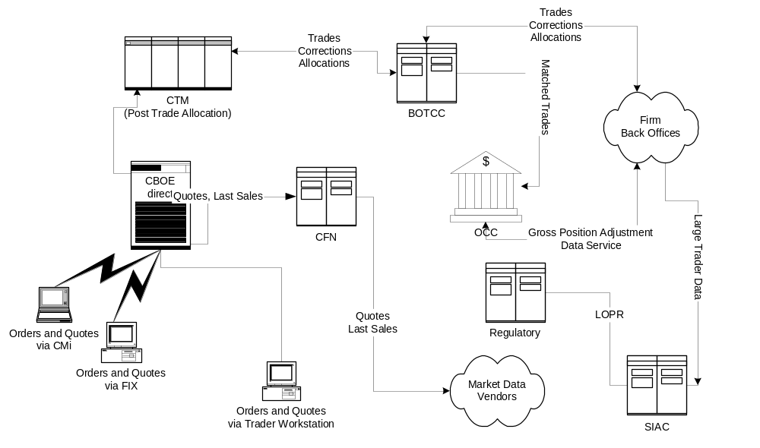

This project is not currently in the FY05 budget.

