

PAR to CBOEdirect
System Design Document
Version 0.1

Prepared by: PAR to CBOEdirect Team

Last updated Date: January 31, 2011

CBOE Confidential & Proprietary

Table of Contents
Table of Contents 1
1 Introduction 4
2 PAR to CBOEdirect Diagram 5
3 PAR API and Messaging 6
3.1 Interface changes, new IDL 6
3.2 CAS 6
3.2.1 New PAR Interface 6
3.2.2 Async data flow 6
3.2.3 Server-OHS 6
3.3 CBOEdirect Server - OHS 7
Simple and Complex Orders/requests will use the same mechanism. 9
3.4 PAR Client 9
3.4 SACAS 9
3.5 SAGUI 9
3.5 DWH 9
3.5 Regulatory 9
4 PAR Login and SMS 10
4.1 New API 10
4.2 CAS 10
4.2.1 New PAR Interface 10
4.2.2 Async data flow 10
4.2.3 Server-OHS 11
4.3 CBOEdirect Server - OHS 11
4.4 PAR Client 12
4.4 SACAS 12
4.5 SAGUI 12
4.6 DWH 12
4.7 Regulatory 12
5 Regulatory Data 13
5.1 Overview 13
5.2 CAS 13
5.2.1 New PAR Interface 13
5.2.2 Async data flow 13
5.2.3 Server-OHS 13
5.3 CBOEdirect Server - OHS 13
5.4 PAR Client 14
5.5 SACAS 14
5.6 SAGUI 14
5.7 DWH 14
5.8 Regulatory 14
6 PAR Workstation Recovery 15
6.1 Overview 15
6.2 CAS 15
6.2.1 New PAR Interface 15
6.2.2 Async data flow 15
6.2.3 Server-OHS 15
6.3 CBOEdirect Server - OHS 15
6.4 PAR Client 16
6.5 SACAS 16
6.6 SAGUI 16
6.7 DWH 16
6.8 Regulatory 16
7 Profile Maintenance, and PAR Control (Preferences, Properties, and Help Desk Functionality) 17
7.1 Overview 17
7.2 CAS 18
7.2.1 New PAR Interface 18
7.2.2 Async data flow 18
7.2.3 Server-OHS 18
7.3 CBOEdirect Server - OHS 18
7.4 PAR Client 18
7.5 SACAS 19
7.6 SAGUI 19
7.7 DWH 19
7.8 Regulatory 19
8 PAR EOD, SED, PAR Force Log Off 20
8.1 New API 20
8.2 CAS 20
8.2.1 New PAR Interface 20
8.2.2 Async data flow 20
8.2.3 Server-OHS 21
8.3 CBOEdirect Server - OHS 21
8.4 PAR Client 21
8.5 SACAS 21
8.6 SAGUI 21
8.7 DWH 21
8.8 Regulatory 22
9 Rollout/Fallback 23
9.1 Overview 23
9.2 CAS 23
9.2.1 New PAR Interface 23
9.2.2 Async data flow 23
9.2.3 Server-OHS 24
9.3 CBOEdirect Server - OHS 24
9.4 PAR Client 24
9.5 SACAS 24
9.6 SAGUI 24
9.7 DWH 24
9.8 Regulatory 25
10 PAR History / Activity 26
10.1 Current Processing 26
10.1.2 PAR Activities Records returned by Query 26
10.1.3 Filters used when Quierying for Activities 26
10.1.4 Query by Activity 27
10.1.5 Query by Symbol 27
10.1.6 Query by Series 27
10.1.7 Query by Order ID 28
10.1.8 Query by ORSID 28
10.1.9 Query by Date 28
10.1.10 Query by CBRKR 28
10.1.11 Query by Time 29
10.1.12 Query by Contra Firm 29
10.2 CBOEDirect Changes PAR History / Activites 30
10.2.1 Changes to Trade Report Processing 30
10.2.2 Changes to SBT OrderHistory 30
10.2.3 SBT OrderHistory Events For PAR Messages 30

1 Introduction
This document contains high level system design for PAR to CBOEdirect project. The design described here is based on current CBOEdirect code base as it is required that any changes to the system need to incorporate into the current code base and maintain the one code base across all trading sessions.

2 PAR to CBOEdirect Diagram
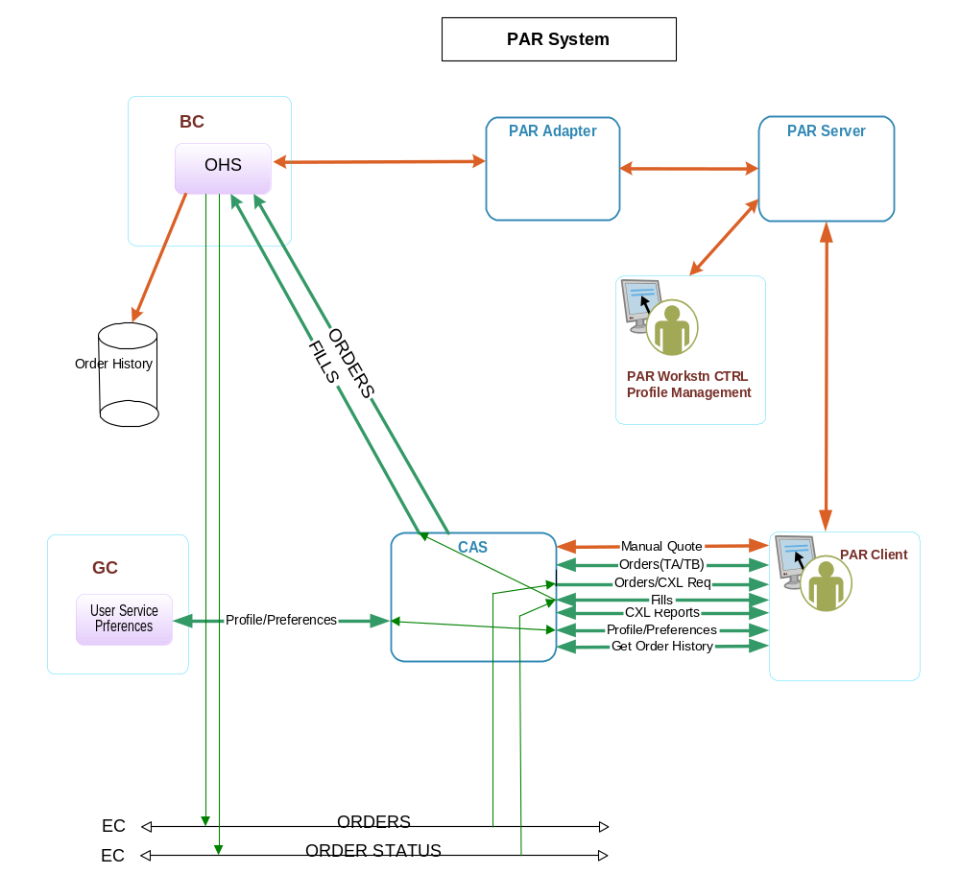

3 PAR API and Messaging
Add Description here…

3.1 Interface changes, new IDL
interface ProductTypes
{
...
const cmiProduct::ProductType FLEX_OPTION = 13;
}

3.2 CAS

3.2.1 New PAR Interface
Add Description here…
- Add Description here…
- …

3.2.2 Async data flow
Add Description here…
- Add Description here…
- …

3.2.3 Server-OHS
Add Description here…
- Add Description here…
- …

3.3 CBOEdirect Server - OHS
. This section will describe the new method OHS will use to send transactions to par

- Currently OHS sends orders, cancels, and cancel replace request to PAR through the Par Adapter. All these transactions are CORBA calls from OHS to Par Adapter. The current API for this is called NamedOrderRoutingDestination.
- This interface will change to use an event channel. Currently, all requests that go to OMT use the OrderRouting channel. It has been decided to use this event channel to route orders, cancel’s, and cancel replace requests to PAR.

- In OHS we will create a new interface that extends the OrderRoutingConsumerOperations. This new interface will have same method signatures as the NamedOrderRoutingDestion interface. OHS will then use this interface to publish orders, cancel’s and cancel replace transactions to PAR over the OrderRouting event channel.
- The method signature acceptSatisifactionAlert will be not be carried over to the new interface. We no longer send Satisfaction Alerts to PAR.

- OHS will have some trigger to send these transactions using either the NamedOrderRoutingDestination (CORBA call) or the new Publish using the OrderRoutingConsumerOperations. This trigger will either be a SMS call or some other property. The current view is to use SMS to determine if the transactions should be sent the old or new way. This should be covered more in the rollout section of this document.

Persistence for Guarantied Message Delivery
The outbound messages from OHS (CBOEdirect Server) to PAR will be through asynchronous communication, OHS will publish the message to event channel/queue and PAR will pick it up. This brings an apparent possibility of PAR not been available to pickup the message from the channel at the time of publish therefore this message will get lost.
To avoid the chance of message getting lost or not delivered to PAR there will be mechanism to persist the messages (in database table) on OHS side before publish and mark this message as not processed and PAR will acknowledge this message to mark the processed flag once it receives it. In the event of PAR gets disconnected while messages were getting published and therefore didn’t received messages, it will query the OHS after it reconnects for all of its un-processed/un-ack’ed messages (processed flag marked as ‘N’) and reconcile with its local database. There is currently similar mechanism used between OHS and OMT.

The existing Routed Message table (SBTROUTEDMESSAGE) will used to achieve this goal, the sample of this table is given below:
Routed Message Table
Column Name | Data Type | Example Data
DATABASEIDENTIFIER | Num(20) | 3.35E+14
MESSAGETYPE | Num(2) | 10
CREAT_REC_TIME | Timestamp | 2011-1-12.11.32. 27. 770571000
LOCATION | Varchar2 | 9HD5
LOCATIONTYPE | Num(3) | 7
ROUTEREASON | Num(3) | 30
ROUTEDESCRIPTION | Varchar2 | Fill Report Drop Copy
ROUTECOUNT | Num(5) | 1
PROCESSEDFLAG | Char | N
ADDITIONALDATA | BLOB | (BINARY - 0 bytes)
LASTROUTETIME | Num(24) | 1.29E+12
ORDERDBID | Num(20) | 3.35E+14

Once the messages get processed on PAR the processed flag will be marked ‘Y’, this way this message will not get redelivered upon PAR next reconnect. Message will be considered to be processed either PAR acknowledges it after successful receipt or if it gets rerouted (Order, Cancel, and Cancel-Replace reroute) to Trade Engine, OMT, or other place or was completely got cancelled or filled. OHS will detect this by checking each incoming or outgoing messages/request and appropriately marking the processed flag in Routed Message table for different types:
- Outbound Order from OHS to PAR – Each time the Order gets routed from OHS to PAR, create this routed message, mark the processed flag to ‘N’ and persist this message details. PAR will acknowledge on successful receipt and in-turn OHS will mark the processed flag to ‘Y’.
- Outbound Cancel from OHS to PAR - Each time the Cancel request (cancel follows the Order) gets routed from OHS to PAR, create this routed message, mark the processed flag to ‘N’ and persist this message details. PAR will acknowledge on successful receipt and in-turn OHS will mark the processed flag to ‘Y’.
- Outbound Cancel-Replace from OHS to PAR - Each time the Cancel-Replace request (cancel-replace follows the Order) gets routed from OHS to PAR, create this routed message, mark the processed flag to ‘N’ and persist the messages detail. PAR will acknowledge on successful receipt and in-turn OHS will mark the processed flag to ‘Y’.
- Inbound Print Order from PAR to OHS – Whenever PAR routes back the Order using print Order functionality, OHS will find the Order in Routed Message table mark that message processed flag as ‘Y’.
- Inbound Print Cancel from PAR to OHS - Whenever PAR routes back the Cancel request using print Cancel functionality, OHS will find the Cancel and corresponding Order in Routed Message table mark both messages processed flag as ‘Y’.
- Inbound Print Cancel-Replace from PAR to OHS - Whenever PAR routes back the Cancel-Replace request using print Cancel-Replace functionality, OHS will find the Cancel-Replace, corresponding Order, in Routed Message table mark all messages processed flag as ‘Y’.
- Inbound Manual Requests from PAR to OHS – All different types of manual request e.g. TA, TB, Book, Auction, Sweep & Return and Fish & Return will find the Order in routed massage table and will mark the processed flag to ‘Y’. Once these requests gets processed by Trade Engine and returns back then a new entry will be created in routed message table with processed flag as ‘N’.
- Inbound Manual Cancel Report from PAR to OHS – When OHS receives a cancel report for a given Order it will check to see if this can cancel the full quantity on Order then corresponding Order message in routed message table will be marked as processed.
- Inbound Manual Fill Report from PAR to OHS - When OHS receives a fill report for a given Order it will check to see if this can fill the full quantity on Order then corresponding Order message in routed message table will be marked as processed.

Simple and Complex Orders/requests will use the same mechanism.

3.4 PAR Client
Add Description here…
- Add Description here…
- …

3.4 SACAS
- No Changes

3.5 SAGUI
- No Changes

3.5 DWH
Add Description here…
- Add Description here…
- …

3.5 Regulatory
Add Description here…
- Add Description here…
- …

4 PAR Login and SMS
In order to maintain current OHS routing logic and PAR Recovery functionality this project will have to maintain PAR user login to PAR Workstation to CAS relationship in SMS.
This is similar to existing SMS PAR component relationship structure. This structure is created and maintained today by PAR Adapter.
Existing relationship looks like this: PS23:ABC:W060
The new relationship should look like this: CAS2004:ABC:W060, where CAS replaces the spot that currently represents PAR Server.

PAR Client will be login in to a CAS under a workstation ID – Wxxx. This will establish an SMS session for the PAR.
Once user logs into the PAR workstation, the PAR will call a new API method to register this user. The method implementation in the CAS layer will register the user Id with the Workstation Id in SMS.
When user logs out from PAR, the PAR Client will call a new method to de-register user.

Following additional scenarios have to be taken into consideration:
- PAR Workstation is down
In this case CAS will mark this workstation down in SMS, OHS will not route any new messages to this PAR workstation.

- CAS is down
SMS will mark this CAS as process down. OHS will receive the SMS event and will not route any messages to PAR workstations logged in to this CAS.

- PAR Recovery
PAR workstation allows users to manually trade orders while not being connected to the CAS/or PARAdapter.
The recovery process takes place when PAR workstation reconnects to the CAS. In this case the reports for the orders that were residing on PAR need to be sent back to OHS.
When PAR reconnect to the CAS it will first login as a workstation and send the reports to the OHS regardless of user being logged in to the workstation.

4.1 New API
Add Description here…
- Add Description here…
- …

4.2 CAS

4.2.1 New PAR Interface
Add Description here…
- Add Description here…
- …

4.2.2 Async data flow
Add Description here…
- Add Description here…
- …

4.2.3 Server-OHS
Add Description here…
- Add Description here…
- …

4.3 CBOEdirect Server - OHS
As PAR client will login through CAS similar to Trader GUI or OMT user, CAS will register this PAR user (XXX:Wxxx e.g. ABC:W060) under SMS and create the session for it. The SMS will send accept login event for this user (ABC:W060) and OHS will consume this event and put in separate PAR user cache, when this user logs out SMS will send accept logout event and OHS will consume this event remove this user from PAR user cache.

OHS will first check the new PAR user cache to determine if the user is logged in, if it does not find it there then it will look into old PAR Adapter based cache using the workstation information to determine if user logged in (old style). If user or workstation not found in either (new or old) caches then it will be considered as not logged in.
- If the user is logged in new style then OHS will publish the request to “Order Routing” channel.
- If the user is logged in old style then OHS will send the request using synchronous CORBA call.
Below is the high level diagram for this:
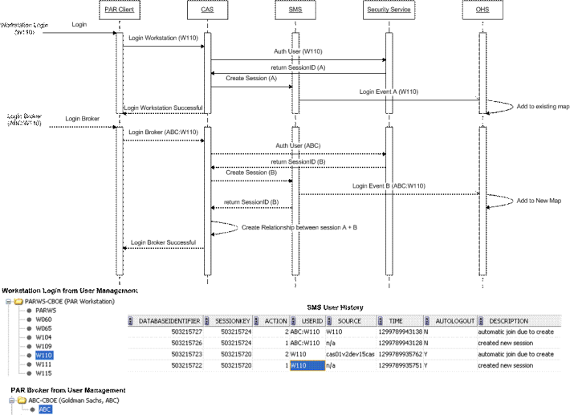

4.4 PAR Client
Add Description here…
- Add Description here…
- …

4.4 SACAS
- No Changes

4.5 SAGUI
- No Changes

4.6 DWH
Add Description here…
- Add Description here…
- …

4.7 Regulatory
Add Description here…
- Add Description here…
- …

5 Regulatory Data

5.1 Overview
Currently Regulatory applications are using data from the PAR Order Master/PAR Order Detail from the PAR Server.
They are looking for specific PAR order details and actions that take place on the PAR.
PAR Profile data is also used. REG applications are looking for Broker logins and switches, profile updates, and possibly workstation connection.

The goal for this project is to convert REG Applications to use the data from the SBTOrder and SBTOrderHistory for all order related information.
The new mechanism for storing and maintaining PAR Profile information will be discussed in the Thursday’s meeting.

Additional research needs to be done to identify what needs to be added or modified in the new implementation:
- Mapping of PAR Order to SBTOrder fields
- Mapping of PAR actions to SBTOrderHistory Activities, identify what is missing, or no longer needed
- Identify what data is being used from the PAR Profile, and/or what PAR profile changes being tracked.

5.2 CAS

5.2.1 New PAR Interface
Add Description here…
- Add Description here…
- …

5.2.2 Async data flow
Add Description here…
- Add Description here…
- …

5.2.3 Server-OHS
Add Description here…
- Add Description here…
- …

5.3 CBOEdirect Server - OHS
Add Description here…
- Add Description here…
- …

5.4 PAR Client
Add Description here…
- Add Description here…
- …

5.5 SACAS
- No Changes

5.6 SAGUI
- No Changes

5.7 DWH
Add Description here…
- Add Description here…
- …

5.8 Regulatory
Add Description here…
- Add Description here…
- …

6 PAR Workstation Recovery

6.1 Overview
PAR Recovery is taking place when workstation is being restarted due to the application problem or PC problem( crash, reboot, disconnect from the network).
During recovery PAR should get all the messages that were suppose to be sent to it while it was down. It should reconcile all the orders from the PAR Client.

In the new system PAR recovery also should be performed in those cases when PAR Client disconnects and subsequently reconnects from/to the CAS. This happens frequently with mobile PARs.
PAR Client needs to request all unaked messages from the OHS and reconcile them against its own database. In general it should use order data from the local database.

6.2 CAS

6.2.1 New PAR Interface
Add Description here…
- Add Description here…
- …

6.2.2 Async data flow
Add Description here…
- Add Description here…
- …

6.2.3 Server-OHS
Add Description here…
- Add Description here…
- …

6.3 CBOEdirect Server - OHS
When PAR re-connects it will query OHS to give back all its Orders and Requests using OrderHandlingService query by location functionality, in turns OHS will find all the messages that has processed flag marked as ‘N’ in routed message table and will publish it to the requesting PAR/location.

6.4 PAR Client
Add Description here…
- Add Description here…
- …

6.5 SACAS
- No Changes

6.6 SAGUI
- No Changes

6.7 DWH
Add Description here…
- Add Description here…
- …

6.8 Regulatory
Add Description here…
- Add Description here…
- …

7 Profile Maintenance, and PAR Control (Preferences, Properties, and Help Desk Functionality)

7.1 Overview
- PAR Profile contains Par user specific preferences, settings, and defaults. It is currently stored on the PAR Server.
The proposal is to migrate this functionality to the User Service (runs on GC) and save all the user profile entries as User Preferences. PAR Client will have to make changes to use User Preferences. There is existing API that allows CMI client to add and manage their preferences. Also HelpDesk can copy preferences from one user to another user.

- Currently HelpDesk and Ops have the ability to view and modify PAR profile information and other PAR workstation settings.
We probably need to enhance SA GUI to allow HD users view and modify User preferences.
We are going to meet with HelpDesk and Operations to discuss what functions should be exposed to them. The meeting is scheduled for Tuesday, January 25.
- Certain information in PAR Profile(contra broker info) needs to be Post/Station specific. This means that PAR Client and SA GUI need to support this functionality. User should be able to specify different set of contra brokers per Post/Station. HelpDesk should be able to copy Post/Station information from one Profile to another one.
- There is also a requirement to allow the same PAR broker to be logged in into multiple PAR workstations and use different profiles. Currently they are using different Auto Book and Auto Auction settings in these situations. They can do it in the current system by using PAR Workstations pointing to different PAR Servers(PAR Profiles are stored on the PAR Server). In order to support this we will require PAR Brokers to use different logins when login in into multiple workstations. These logins will have to be created in the user service and will point to the same acronym.
- During rollout we need to convert existing PAR Profiles into the new profiles in UserService. We need to develop an approach for this feature.
- Regulatory applications are using the data from the PAR Profile Log to keep track of user logins, logouts, and switches. The new approach for this is to use SMS History table. It should contain PAR Workstation and PAR Broker login and logout information. Regulatory group will review this data to make sure it satisfies all the requirements Additional investigation is required to verify that information in SMS History satisfies all the requirements. If the information is not sufficient we will have to either modify SMS to incorporate missing data or implement an alternative solution(possibly another PAR User History table maintained by OHS)
Regulatory applications are not using any information contained inside the PAR Profile.
- We need to maintain PAR User ability to be logged in to multiple PAR Workstations at the same time. This can be done by using different User IDs associated with the same acronym. This means that the same PAR broker will have to use different logins, and each login will have its own Profile.[Brazhnichenko, Alex] We need to revisit this item regarding having PAR brokers to use different user id if they need to be logged in in more than one PAR Workstation at the same time. This may not be necessary. We will come back to this subject after our meeting with Help Desk on Tuesday, Jan 25. It was decided that we will need additional user IDs defined to support multiple logins.
- Currently PAR user password is stored in the PAR profile. The new approach is to keep it with the User ID. User ID will be defined in the User Service and can be assigned a password.
When PAR user logs into the PAR workstation, PAR Client will pass user information to the CAS(as part of the new registerUser() method). In addition to performing SMS user registration, CAS will also verify user password against User Service and Security service.

- All the functions of the PAR Control GUI used by HelpDesk and Operations will be now implemented in SA GUI. This includes profile maintenance and monitoring of workstation/user status, as well as order count information. Workstation IP address also should be displayed.

7.2 CAS

7.2.1 New PAR Interface
Add Description here…
- Add Description here…
- …

7.2.2 Async data flow
Add Description here…
- Add Description here…
- …

7.2.3 Server-OHS
Add Description here…
- Add Description here…
- …

7.3 CBOEdirect Server - OHS
Add Description here…
- Add Description here…
- …

7.4 PAR Client
Add Description here…
- Add Description here…
- …

7.5 SACAS
- No Changes

7.6 SAGUI
- No Changes

7.7 DWH
Add Description here…
- Add Description here…
- …

7.8 Regulatory
Add Description here…
- Add Description here…
- …

8 PAR EOD, SED, PAR Force Log Off

8.1 New API
PAR EOD
In existing system PAR EOD is being executed as an AR Command from PAR Adapter. PAR Adapter sends message to PAR Server, and PAR Server notifies PAR Client.
Up on receiving Business EOD event PAR Client prints all orders and performs cleanup.
In addition to PAR Adapter OHS also performs PAR Log Off as part of EOD processing. This is initiated by the AR command. OHS reassigns all the orders that are marked to be on PAR back to OHS(or OMT?).

In the new implementation this functionality should be initiated from the SA GUI PAR Monitor screen. This should be a two step process.
1. SA GUI should Force Log Off PAR workstations via SMS Force logoff mechanism. The CAS will have to perform additional SMS operations to mark PAR Workstations components “down”.
When receiving Force Log Off event PAR Workstation should clear its database and log out currently logged in users.
2. SA GUI should call OHS to Force Log Off PAR workstations. This should be same method described above and exposed today via AR command. This method needs to be implemented on the SA CAS so it is available to the SA GUI.

PAR SOD.
In existing system PAR SOD is executed via an AR command on PAR Adapter. The message is sent from PAR Adapter to PAR Server. Once message is received users are allowed to log in to PAR Workstations.
This functionality is no longer needed.

In the case when PAR EOD was not performed(PC was turned off by the user, or mobile PAR disconnected) PAR will perform a database date verification on start up and clean the database if it is old, not the current day. This should also be done in the reconnect scenario.

PAR Force Log Off
This functionality should be implemented on SA GUI as described in the item #1 of the PAR EOD. The SA GUI PAR Monitor screen should display all PAR Workstations, their status, and order count. HelpDesk and Ops users should be able to initiate PAR Force Log Off or PAR EOD for any or all PARs from that screen.
AR commands should be maintained as a back up tool.

8.2 CAS

8.2.1 New PAR Interface
Add Description here…
- Add Description here…
- …

8.2.2 Async data flow
Add Description here…
- Add Description here…
- …

8.2.3 Server-OHS
Add Description here…
- Add Description here…
- …

8.3 CBOEdirect Server - OHS
OHS server is to implement the force off function to cooperate with SA GUI. The function will do :
- Consume force logoff event from SMS
- Find a list of active orders owned by workstation W101
- For each active order, reroute to OMT for printing
- Find a list of all unacked messages in the routed msg table for W101 and chase the order and in addition ack those messages internally. It is to have workstation come back fresh and clean
- Update this function to existed AR command as back door

8.4 PAR Client
Add Description here…
- Add Description here…
- …

8.5 SACAS
- No Changes

8.6 SAGUI
- No Changes

8.7 DWH
Add Description here…
- Add Description here…
- …

8.8 Regulatory
Add Description here…
- Add Description here…
- …

9 Rollout/Fallback

9.1 Overview
Rollout
The rollout for PAR to CBOEdirect project should be performed in the following sequence:
- SD Server/OHS rollout should be done on all BCs. All PAR Adapters, PAR Servers, PAR Workstations, CASes should be running old software.
This will ensure that the old code path is functioning correctly.
- New CASes are rolled. We need to roll couple of CAS pairs used by PAR workstations.
- PAR Clients rollout. We need to pick several PAR Clients pointing to the newly rolled out CASes. The alternate destination PARs should stay on the old version.
- Rollout should continue with new CASes and corresponding PAR workstations.
- Only when entire floor rollout is complete and there is now issues we can start decommissioning PAR Servers and PAR Adapters.

Fallback
PAR Client.
In the case of the PAR Client fallback the client workstation software should be shut down. The PAR Force Log Off has to be performed. The old Par workstation software can be launched and connected to the system via PAR Server and PAR Adapter. The Force Log Off step has to be performed to ensure that the orders from the failed PAR client are moved to the alternate destination.

CAS
If CAS has to be rolled back, the PAR workstations pointing to this CAS have to be rolled back.

OHS
In the case OHS needs to be rolled back all other components – CASes, PAR workstations have to be rolled back.

In order to support PAR to CBOEdirect rollout and possible fallback OHS needs to know the version of each PAR Workstation connecting to the system. It also needs to handle the possibility of the same workstation to be logged in under old and new version during the same business day.

The new PAR Monitor GUI should be in place before the start of the rollout. We need to provide the ability to monitor both old and new version PAR workstations during the rollout(2 separate screens?)

DWS and REG need to be able to get the PAR Log and PAR History from different sources during rollout. For old version workstations it should use the data from the PAR Server and for the new ones from the SBT Order History and SMS History. In the case of fallback the data for the same PAR workstation will be located in both sources.

9.2 CAS

9.2.1 New PAR Interface
Add Description here…
- Add Description here…
- …

9.2.2 Async data flow
Add Description here…
- Add Description here…
- …

9.2.3 Server-OHS
Add Description here…
- Add Description here…
- …

9.3 CBOEdirect Server - OHS
Add Description here…
- Add Description here…
- …

9.4 PAR Client
Add Description here…
- Add Description here…
- …

9.5 SACAS
- No Changes

9.6 SAGUI
- No Changes

9.7 DWH
Add Description here…
- Add Description here…
- …

9.8 Regulatory
Add Description here…
- Add Description here…
- …

10 PAR History / Activity

10.1 Current Processing

PAR History/Activity Queries
Currently, a PAR workstation user can request all activity history records for the current or previous business day. These queries are initiated by the PAR client, which makes a request to the PAR server. These queries are going to be moved from the current PAR Client to PAR Server architecture, to the new architecture PAR Client to CBOEDirect.

10.1.2 PAR Activities Records returned by Query

Current PAR activity types that can be returned by a query are as follows:

- BOOK – Book requests that include TA/TB functionality.
- ADD – ADD order. When an order is routed to workstation.
- CANCEL – any full, partial, or cancel replace request of an order on a workstation. Will also include cancel report.
- Maintenance – Volume maintenance don on PAR.
- PRINT – print order on workstation ( current route to OMT)
- TRADE – fill report processing
- COMPLEX Trade – fill’s for complex Orders.
- Complex Print
- ALL – All the above.

10.1.3 Filters used when Quierying for Activities
When a PAR user is requesting the activity records defined in previous section. There are additional fields that can be used as a filter in the query. Marked in Red are not needed. All of these filters can be used in combination with each other when running a query

When the records are returned from these queries, the user can select on each activity record and it will bring you to a detail page. The detail page has Order detail or Trade Detail. All of this information is in Order History on the Trade Server.

- Activity Type ( one or all of the above (All Types)
- Buy/Sell (Not Needed)
- Volume (Not Needed)
- Symbol (a particular Class )
- Series ( Jan thru Dec or All Months) with free form entry for strike
- Price (Not Needed)
- Order ID (firm.branch.seq.corresponent.OrderDate (YYYMMDD)
- ORSID
- Today /Previous Business day (Default is Today)
- Contra Broker
- Time (HH:MM)
- Firm Number (contra Firm – firm belonging to contra broker)

10.1.4 Query by Activity

Request:

- User selects Activity
- Radio Buttons → Add, Book, Cancel, Maintenance, Print, Trade, Complex Trade, Complex Print, and All types

Response:

History records that match the activity type selected above.

Data returned → Activity Type, Call/Put, volume, class, Strike, price, firm, Branch, Sequence number, Post station, ORSID.

10.1.5 Query by Symbol
Request:

- User selects Class
- Text Box displays to enter Class

Response:

History records that match the type selected class above.

Data returned → Activity Type, Call/Put, volume, class, Strike, price, firm, Branch, Sequence number, Post station, ORSID

10.1.6 Query by Series
Request:

- User selects Series
- Text Box appears to enter strike. User Selects Month using radio button.

Response:

History records that match the type selected series above.
Data returned → Activity Type, Call/Put, volume, class, Strike, price, firm, Branch, Sequence number, Post station, ORSID

10.1.7 Query by Order ID
Request:

- User selects Order ID
- Text box appears for Firm, Branch, Seq. Num, Correspondent Firm, and Order Date

Response:

History records that match the type selected Order Id are returned

Data returned → Activity Type, Call/Put, volume, class, Strike, price, firm, Branch, Sequence number, Post station, ORSID

10.1.8 Query by ORSID
Request:

- User selects ORSID box
- Text box appears for entering ORSID

Response:

History records return that match the selected ORSID

Data returned → Activity Type, Call/Put, volume, class, Strike, price, firm, Branch, Sequence number, Post station, ORSID

10.1.9 Query by Date
Request:

- User selects Date box
- Radio buttons appear to select today or last business day

Response:

History records return that match the selected Date

Data returned → Activity Type, Call/Put, volume, class, Strike, price, firm, Branch, Sequence number, Post station, ORSID

10.1.10 Query by CBRKR
Request:

- User selects Contra Broker Box
- Text Box appears user can select drop down box of brokers defined on workstation

Response:

History records return that match the selected Contra Broker

Data returned → Activity Type, Call/Put, volume, class, Strike, price, firm, Branch, Sequence number, Post station, ORSID

10.1.11 Query by Time
Request:

- User selects Time Box
- Buttons appear to allow user to select time in HH:MM format

Response:

History records return that match the HH:MM format

Data returned → Activity Type, Call/Put, volume, class, Strike, price, firm, Branch, Sequence number, Post station, ORSID

10.1.12 Query by Contra Firm
Request:

- User selects Firm Box
- Text box appears to allow the contra Firm to be entered

Response:

History records return that match the Contra firm are returned

Data returned → Activity Type, Call/Put, volume, class, Strike, price, firm, Branch, Sequence number, Post station, ORSID

10.2 CBOEDirect Changes PAR History / Activites

10.2.1 Changes to Trade Report Processing
For Each Manual trade The Table SBT_TRADEREPORTENTRY will hold the value of the workstation that endorsed the trade.

Changes in OHS and TE:

- CBOEDirect will add a column in SBT_TRADEREPORTENTRY to hold the Workstation field.
- When a Manual Trade is endorsed on a PAR workstation TE will persist the Workstation that executed the trade.
- OHS will Pass the workstation to TE in the Trade Source field
- TE will parse this value and Store workstation in the new Database column.

Changes to SBT OrderHistory

We will now store the Workstation in a new column in SBTORDERHISTORY. This will be done to make the PAR Queries for Order History more efficient. It was decided that Market Replay will be used by the PAR workstation to retrieve Order History records. This will replace the current queries for PAR history on the Workstation.

Changes in OHS:

- We will add a new column WORKSTSTION in the SBTORDERHISTORY table.
- When the Source or Destination of a transaction in OHS is PAR, OHS will PARSE the message for the Workstation.
- This Workstation will be stored in the new Database Column WORKSTATION in SBTORDERHISTORY.

SBT OrderHistory Events For PAR Messages

The PAR workstation will be added to order History for the following Event Types.

- Add order To PAR Simple
ORDER_ROUTED = 14

- Add order to PAR Complex
ORDER_ROUTED = 14

- Manual Fill Simple

FILL_ORDER = 2, Only one fill for Contra data need to look to trade report.

Manual Fill Complex

FILL_ORDER = 2
PAR_BROKER_LEG_MKT = 604
PAR_BROKER_LEG_MKT = 604
FILL_ORDER = 2, Only one fill for Contra data need to look to trade report.

- Trade with ALL, Trade with Book, and Book.

MANUAL_ORDER_TA = 701 Trade T/A Strategy uses as well.
MANUAL_ORDER_TB = 702 Trade T/B
MANUAL_ORDER_BOOK = 703 Book. Strategy as well.

Simple and complex use same event type. Note a trade with book or a TA that trades with orders in book will not be marked with workstation. Only Manual trades are marked. But, you will get the request with this event type.

- Print Simple or Complex

ORDER_ROUTED = 14 Print Order the Route description has Order printed. Location BOMT

- Cancel Simple and complex

CANCEL_REQUEST_ROUTED = 17 Request for Simple
CANCEL_ORDER 3 Cancel
CANCEL_STRATEGY_LEG = 53 Request for Complex
CANCEL_STRATEGY_LEG = 53 Request for Complex

- Cancel Replace Simple and Complex

Cancel/RE Strategy.

OLD ORDER:
CANCEL_ORDER 3
CANCEL_STRATEGY_LEG = 53 For Complex only
CANCEL_STRATEGY_LEG = 53 For Complex only
CANCEL_REPLACE_ORDER_REQUEST = 13

NEW ORDER:
order_routed = 14 MARKED WITH WORKSTAION

- Cancel Replace with Volume Maintenance.

ORDER_ROUTED = 14
CANCEL_REPLACE_ORDER_REQUEST = 13
CANCEL_ORDER = 3

NEW ORDER

ORDER_ROUTED = 14
VOL_MAINTENANCE = 601

