Evaluation Criteria

Performance
The product should satisfy the following message-rate related benchmarks, conducted under several test scenarios (see Evaluation Testbed).

Type | Message Size (bytes) | Min Rate | Max Rate | Flow Characteristic
Quote | 50 | 150 | 700 | 1 hour sustained
Order | 1024 | 5 | 10 | 1 minute sustained

The following performance characteristics will be monitored during the benchmark testing.
- CPU usage
- Memory usage
- Disk usage
- Network usage
- Latency time (?)
- System calls
- Overhead
- Scalability
- Thread limitations

Maintainability / Support
- Evaluate documentation quality.
- Is the API clearly documented - more than single line descriptions for complex methods?
- Should include some “Big-picture” documentation.
- Should include Programmers Guide, Administrators Guide.
- Should include coding examples.
- What format is the documentation in? HTML, PDF, etc.
- Evaluate error message quality.
- Are similar, yet distinctly different, conditions clearly distinguished?
- Are there granular error-severity levels for the messages? Shut off certain severity-level messages?
- Do the error messages note specifics of the problem, i.e. including names, and other types of information such that logs can be examined to find a particular problem.
- Are there configuration options available to suppress a repetitive error condition so that the error monitoring system is not overloaded?
- What options are available for the final destination of the error messages? Only their log, or to an internal system?
- Evaluate support responsiveness: Time to work-around, Time to first response, Time to ship patch.
- The Time-to-First-Response should be within the same day from the problem-opening.
- The Time-to-Work-Around should be within two days from the problem-opening.
- The Time-to-Ship-Patch should be within one week from the problem-opening.
- Evaluate metrics.
- Does the product offer “per-channel” metrics?
- Are the metrics constantly counted, or do you have to enable them?
- Are the metrics published / available via a programmatic interface? I.E. so that the information can be collected / harvested by in-house software.
- Does the vendor supply an off-the-shelf viewer?
- Evaluate “user-exit” capabilities.
- Are there strategic points within the architecture that in-house written “user-exit” routines / methods can be implemented?
- What are the limitations on the functionality that can be employed by the “user-exit” software?
- Evaluate configuration requirements.
- Does the product offer “centralized” configuration, which can then be distributed to the various nodes?
- Is the configuration changeable “on-the-fly”? How far can you go?
- Determine support contracts available.
- What are the different levels of support contracts available?
- Can the customer determine the escalation of the problem?
- Will there be a support contact? Or 800 number service?
- What remote support options are available? Can they dial in here? Can we open a call via their web site? Check outstanding problems from other customers (FAQ like)?
- Determine JDK support, OS support.
- What JDK versions are supported? v1.1.5, v1.2?
- Is there support for Win NT, Sun Solaris, HP-UX, (IBM AIX)?
- What versions of the supported OS’s are supported?

Usability
- Evaluate API quality and ease-of-use.
- Evaluate Java integration capabilities.
- Evaluate NT/Solaris support.

Fault Resiliency
- ?? Capabilities
- Does their solution work?
- What are the recovery times?
- Evaluate HA Clustering support or approach.

Messaging
- Evaluate queuing support.
- Does the product have filtering support?
- What routing support does the product have?

Cost
- Purchase
- Collect the various purchase options available.
- Are there regular maintenance fees?
- ??
- Support contract.
- Collect the various support contracts available.

Company Information
- Who are they?
- What is their business stability, viability?

Evaluation Testbed

Configurations

Configuration 1
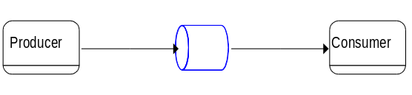

Configuration 2
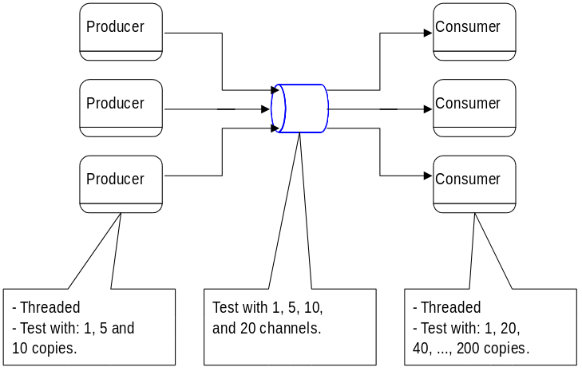

Tests

Message Rate Scenarios
Size | Min Rate | Max Rate | Increment | Increment duration
50 | 100 | 700 | 100 | 5 mins
1024 | 5 | 10 | 5 | 15 mins
random [50, 100]
random [100, 1024]
linear [50, …)
?? | 300 | 700 | 200 | ??

Quality of Service Scenarios
- NACK
- Stable
- ?

Feature Testing
- Queuing
- Filtering
- Routing

Fault Resiliency Testing
- Stable Queues - Kill / Recovery
- Availability with Kill
- Recovery time

