Distributed Trade Engine
PROOF OF CONCEPT REPORT

 | 31 July 1998  CBOE/TRC

Document Tracking Information
File Name: | PoCReport_v08
Document  Reference: | Distributed Trade Engine Proof of Concept Report/Report/ PoCReport_v08/CBOE NTE/Proof of Concept
Version: | Version 0.8
Status: | Draft
Sign-offs
Authorized by , Mark Novak, Joe Kambich
Signature
Signature
Signature

Contents

Foreword
Scope
Audience
Prerequisites
Executive Summary
1. Introduction
1.1 Mission Statement
2. Proof of Concept Phases
2.1 Phase 1—Technology Benchmarks
2.2 Messaging Object Middleware (MOM) Benchmark
2.2.1 Evaluation Criteria
2.2.2 Evaluation Testbed
2.2.3 Evaluation Report
2.3 Persistence Benchmark
2.3.1 Object Database Management Assessment
2.3.2 Overview of ODBMS Technology
2.3.3 Evaluation Products
2.3.4 Evaluation Criteria
2.3.5 CBOE Evaluation Testbed
2.3.6 Evaluation Process
2.3.7 Evaluation Reports
2.3.8 Conclusions
2.4 Phase 2—Technology Integration
2.4.1 What Will Be Proven
2.4.2 Deployment
2.4.3 Components
2.4.4 Measurements
2.4.5 Summary and Conclusion
3. Overall Results of PoC
4. Recommendations
5. References

Figures and Tables
Figure 1. One to One
Figure 2. Many to Many
Figure 3 Talarian's Peak Message Rates for OTO2 Scenario
Figures 6 & 7. NILMOM rates for OTM2 and OTM1
Figures 8 & 9. Talarian rates for OTM2 and OTM1
Figure 10 Talarian’s Peak Message Rates for OTM5 Inter-machine with 9 Consumers
Figure 11 Talarian’s Peak Message Rates for OTM6 with One Supplier
Figure 12 Talarian’s Peak Message Rates for STM1 with One Consumer
Figure 13. Class Diagrams of the Main Classes and Relationships
Figure 14. Transaction Sequence Diagram
Figure 15. Query Quote
Figure 16. Query Quote History
Figure 17. Proof of Concept Scope — CBOE Architecture Components
Figure 18. Application Components
Figure 19. Proof of Concept Scope Diagram—Legend
Figure 20. Proof of Concept Scope Diagram—Phase 2a
Figure 21. Proof of Concept Scope Diagram—Phase 2b
Figure 22. Deployment Diagram

Table 1. MOM Performance Metrics
Table 2. MOM Scenarios
Table 3 MOM Benchmark Hardware Configuration
Table 4 MOM Benchmark Scenarios
Table 5 Status of MOM Benchmark Runs

Foreword
This document is a report on the Proof of Concept phase of the Chicago Board Options Exchange (CBOE) Common Infrastructure effort. This effort is principally targeted at the use of new distributed object technology for the replacement of the existing Trading Engine and its redeployment in the existing post-centric environment.
Scope
This report contains the following sections:
- Executive Summary
- Introduction
- Proof of Concept mission statement
- Description of the Proof of Concept phases
- Sub-report from each task within each phase
- Initial phase of benchmarking:
- benchmark objectives and parameters
- benchmark modus operandi
- benchmark results and conclusions
- Second phase
- integration phase definition
- key design decisions
- lessons learned
- conclusions and recommendation
Audience
This document is intended for technical staff (architects, modelers, designers/developers) as well as management staff involved in the proof of concept effort at the infrastructure level. It is also useful to those people at CBOE who are involved in the purchase of software products.
Prerequisites
Readers should have an understanding of distributed object technology, as well as programming languages such as Java and C++.

Executive Summary

- Purpose of Proof of Concept:
- Provide sufficient level of understanding of the new technologies and environments with respect to performance, availability and technology integration.
- Enables key design decisions related to multiyear development of a new infrastructure and migration for the Distributed Trade Engine and other selected applications.

- Phases of Proof of Concept:
- Phase 1 - Technology Benchmarks
- Message Oriented Middleware (MOM) Benchmark
- Object Oriented Database Management Systems (OODBMS) Persistent Benchmark
- Phase 2 - Technology Integration

- Review of Each Phase:
- Message Oriented Middleware (MOM) Benchmark
- Vendor Software Evaluated from a feature and performance perspective:
- MQSeries
- Vitria
- NeonNet
- OrbixTalk
- Talarian SmartSockets

- Benchmark Results
- MQSeries eliminated due to lack of support for the publish & subscribe model.
- Vitria eliminated due to slow performance and stability problems.
- NeonNet eliminated due to unavailability of product.
- OrbixTalk was tested but resulted in being unsuitable in CBOE’s environment where multiple consumers are required. The consumers for higher order tests disconnected.
- Talarian SmartSockets performed the best of all products examined. Throughput was acceptable, however, the product experienced stability problems during high-order tests.

- Conclusion
- Talarian demonstrated best throughput but had some stability problems on certain test runs.
- Decided to move forward with Talarian on board to help with the Technology Integration phase.

- Object Oriented DataBase Management Systems (OODBMS) Persistent Benchmark
- Vendor Software Evaluated from a feature and performance perspective:
- Objectivity/DB (Objectivity, Inc.)
- Versant (Versant, Inc.)
- ObjectStore (Object Design, Inc.)
- GemStone/J (GemStone Systems, Inc.)
- Single message updates were processed.

- Benchmark Results
- Objectivity/DB declined to participate in the benchmark.
- Versant:
- Based on a number rating considering features and performance Versant was rated #3 of 3.
- Initial performance numbers were 24/sec with 2 writers.
- Secondary effort using Hitachi cached drive measured an unstable 270/sec.

- ObjectStore
- Based on a number rating considering features and performance Objectstore was rated #2 of 3.
- It’s best performance numbers were 3.5/sec. with 4 writers.

- GemStone/J
- Based on a number rating considering features and performance GemStone/J was rated #1 of 3.
- Initial performance numbers were 225/sec. with 8 writers.
- Secondary effort using Hitachi cached drive measured 260/sec.

- Conclusion
- Initially it was decided that CBOE go forward with GemStone/J for the Technology Integration phase. Based on the interesting Versant numbers we measured with the Hitachi drive they were added to the Technology Integration phase. This recommendation was contingent on the following:
- GemStone, Inc. must demonstrate that an identified bug is corrected.
- GemStone, Inc. must demonstrate a working version of their schema evolution utility.
- Versant must work with us to provide a stable environment.

- Technology Integration
- Evaluation Approach:
- Verify through development and testing of two application components, the integration transparency and performance of the key products and technology that are selected as part of Phase 1.

- Vendor Software Evaluated ( in addition to the products selected as part of Phase 1):
- Sun’s Java Development Kit 1.1.5
- Iona’s Orbix Web 3.0

- Application Components:
- An adapter to TIPS
- An adapter to AutoQuote
- Best Quote
- Market Data History
- Quote Receiver

- Technology Integration Results
- After struggling to get the Gemstone and Versant products to work, Oracle was added to the persistence trial in an effort to achieve consistent results.
- The applications and their use of persistence was not optimized to any degree because time planned for that effort was spent trying to get the persistence products to work within this integrated environment.
- Gemstone measured 120 quotes/sec. through the system. This was after a last ditch effort by Gemstone engineers to fix a problem with the interaction of the messaging and Gemstone VM. This was running one writer.
- Oracle measured the best rate of 240 quotes/second through the system. The numbers reflect 4 threads running for Oracle. No JIT was used for this number.
- Versant was unable to get their product running consistently in this environment.
- The desired rate of 700 quotes/second on a server was not achieved.
- The Application achieved rates of 240 quotes/second without a DB commit or flow control.
- The Event Messaging layer transported 2000 quotes/second across the wire standalone.
- Synchronous communication using MDH inquiry and manual quote input produced sub-second response time.

- Conclusions
- The Java/C/C++ developed Event Messaging layer performed within our planned needs so we should not hesitate to go forward with this technology. The messaging layer was tuned to some degree but improvements could probably be made in the planned future increments.
- The persistence problems encountered during this effort with Versant and GemStone/J appear to be maturity of the Java interfaced product. The ease of developing Java code allowed us to try all these alternatives but the stability with the products caused us delays.
- GemStone/J and the 120 quotes/second throughput rate is a minimum number which we know can be increased with tuning.
- Use of Oracle in the Proof of Concept provided us a stable environment.
Tuning of the application and its use of Oracle could be done to improve the measurements. This does, however, create a conversion layer which makes the development effort more complex.

4. Recommendations
- Language
- Implement Java with C++. The Java runtime environment performed acceptable in CBOE’s environment.
- Products
- Perform an ORB evaluation including an assessment of CORBA services availability.
- Messaging Middleware/Event Infrastructure
- Move forward with Talarian as a MOM product. Talarian demonstrated better performance than the other tested MOM products.
- Create a quality of service level for ordered message delivery, priority and latency.
- Tools
- Utilize IBM’s Jikes debugger on the Sun platform to debug native threads in Java.
- Apply VisualAge as a Java debugger on the NT platform.
- Utilize Jprobe as a Java profiler. This tool will enable insight into relative code behavior.
- Implement Rational Rose for code generation and reverse engineering.
- Use ClearCase to manage source files.
- Database
- Pursue implementation with the Oracle database with a persistent framework to layer the relational access to the objects. Although Oracle is not an object database, its stability was consistent in CBOE’s environment.

1. Introduction
In 1997, a study phase to define the requirements, architectures, technologies, and migration options was undertaken to provide for an infrastructure to host a Distributed Trade Engine to support the following business objectives:
- eliminate the TPF backlog
- improve time to market
- increase productivity
- increase flexibility and scalability
- maintain the performance and availability of the current system.
With that study phase completed, the next task is to demonstrate with real tools and a hands-on exercise the performance and behaviors of chosen technologies and selected architectural concepts.
Thus, a Proof of Concept was chosen with a predetermined set of objectives and expectations. The Proof of Concept provides a level of understanding of the new technologies and environments with which to begin a multiyear development of the new infrastructure and a detailed migration plan.

1.1 Mission Statement
The Proof of Concept’s purpose is to provide a sufficient level of understanding of the new technologies and environments with respect to performance, availability, and technology integration. It enables key design decisions that will guide a multiyear development of the new infrastructure and inform a detailed plan of migration for the Distributed Trade Engine and other selected applications.

2. Proof of Concept Phases
The Proof of Concept has two phases:
- individual technology benchmarks
- an integrated Proof of Concept system development and test/characterization.

2.1 Phase 1—Technology Benchmarks
Several technologies are expected to constitute the new common CBOE infrastructure, some of them being:
- platforms
- networks
- programming languages (e.g. Java, C++)
- object request brokers (ORBs)
- messaging object middleware (MOM)
- persistence (object-oriented database)
- security
It is assumed in the proof of concept that the issues arising from the choice of a programming language will be disclosed by performing comparative hands-on studies of the other technological components.
Two technology benchmarks form the first phase of the proof of concept:
- a messaging middleware benchmark
- a persistence benchmark.
The following sections discuss these benchmarks.

2.2 Messaging Object Middleware (MOM) Benchmark
To determine a need for asynchronous communication in CBOE’s technology architecture, an evaluation exercise was performed. Information was sought from various vendors regarding performance, scalability, quality of service (QoS), support for required data/message transfer mechanisms, and configurability. As a result of this effort, some products were eliminated from consideration. However, this exercise failed to yield a single product that clearly met all of CBOE’s requirements regarding performance and scalability. The MOM benchmark is an extension to the previous evaluation effort undertaken to make the final decision about using a MOM product for the CBOE technology architecture.

2.2.1 Evaluation Criteria
This section describes the criteria against which the MOM products should be evaluated. The evaluation criteria is categorized in the following way based on order of priority:
- Performance - how the product performs in terms of usage of CPU, memory, disk, network, latency, etc.
- Quality of Service (QoS) - types of QoS supported (reliable, guaranteed, transactional, secure etc.)
- Fault Resiliency - what fault-tolerant features are provided by the product (message store, store and forward, replication, cache etc.)
- Programming Environment - language and platform support (multithreaded programming support, CORBA support, etc.)
- Messaging Features - what types of messages are supported, what is the delivery mode (FIFO, LO, LIFO etc.), support for priority messages etc.
- Administration tools - extent to which the product can be administered, auditing facility, tuning or instrumenting at run-time, etc.
How the product can be administered - programmatically, GUI, command-line, etc.
- Usability - how easy and intuitive are the APIs, classes, administrative features, etc.
- Maintenance and Support - how extensive is product support, and the extent of the maintenance effort.
- Cost - the product cost, upgrades, maintenance contracts, and other attached costs.

2.2.1.1 Performance
Performance is one of the primary criteria to consider for all MOM products. The following metrics should be used to evaluate products for meeting performance for CBOE.
Table 1. MOM Performance Metrics
Type | Message Size (bytes) | Min Rate | Max Rate | Flow Characteristic
Quote | 50 | 150 | 700 | 10 minutes sustained
Blocked Quotes | 8k | 50 | 100 | 10 minutes sustained
Order | 1024 | 5 | 10 | 1 minute sustained

Type: Types of messages expected in CBOE. This may be quotes or orders.
Message Size: Approximate size of the messages in CBOE environment.
Min. Rate: Minimum rate at which the messages are expected to be generated.
Max. Rate: Maximum rate of message generation in CBOE.
Flow characteristics: Messages transmitted for a sustained period.

CPU Usage
Measurements should be made to note the CPU utilization against the number of messages generated per second for a specified number of event channels with n number of consumers and suppliers. The CPU utilization is the usage of CPU by the configured number of event channels for successful delivery of messages to consumers.

Memory Usage
The trace of the process containing the event channel or message queue should be measured in memory against the number of messages generated per second for n number of suppliers and consumers. Some of the parameters to check are:
- Total allocation of memory per run/time-slot.
- How memory is allocated and released.
- Does queue/channel provide any parameters for memory allocation?

Disk Usage
Measurement of this criteria is based on how often the disk is accessed in the course of message delivery. Usually, messages are delivered as soon as they are received in channel or queue. There may be some latency in message handling depending upon traffic. This factor is also dependent upon the QoS required. Several products employ different mechanisms to provide guaranteed delivery of messages. IO to the disk can hinder overall performance of the message/channel server.
Another parameter to measure is how much disk space is optimal for a MOM to provide the required QoS. For guaranteed message delivery, several MOM products use logging. It should be determined how much disk space will be optimal in the CBOE environment during peak message time.

Network Usage
Network usage is widely affected by the way messages are delivered. Filtering can significantly reduce the impact on the network. Protocol usage for message transfer is also important. The network load should be measured for each type of protocol used and for the configured number of event channels, suppliers and consumers. Parameters to measure are:
- packets/unit time
- bytes/unit time.

Latency
There is latency a MOM introduces to deliver a message from supplier to consumer. Each message supplied to a MOM should be time-stamped. Time should be measured at the consumer on the delivery of the message. The time-stamp when the message was supplied should be subtracted to measure end-to-end delivery time for a message. This time can also be analyzed by breaking down the delivery path in segments, such as supplier to supplier proxy, supplier proxy to event channel, in event channel before being dispatched to consumer, from event channel to consumer etc. For this, the clocks between machines should be synchronized. If the clocks are not synchronized, a simple solution to find latency is to observe the time consecutive messages take to arrive at a consumer machine if they are supplied from the same machine. A control run can be developed to sample the differences for each day’s run.

System Calls
One Solaris command called ‘truss’ can be used to find out system calls made by an executable. Use this command on message queue/channel servers, supplier and consumer processes for each product to find out the frequency and types of system calls being made. This type of evaluation can help detect expensive system calls made by products that can degrade performance.

Overhead

Scalability
True scalability means the capability to scale in several dimensions. The following are several ways to measure the scalability of a MOM product:
- additional publication load across existing channels
- incremental addition of new channels
- additional consumers across existing channels
- across a wide variety of network topologies
- across a wide variety of consumer capabilities, including intermittent or slow consumers.
Check if the product is taking advantage of multiple CPUs on machines. Does the product scale well with more CPUs? Increasing the number of threads should utilize CPUs more efficiently on multiple CPU machines.
Multithreading dramatically increases performance, allowing for better utilization of the CPU, the network, and the disk. In many implementations of MOM, the channel/message server can be multithreaded with a channel/message queue per thread usage. System resources such as threads are limited in operating systems. There is an upper limit on the number of threads running concurrently in a process to realize optimum performance. Tests should be done to achieve optimum performance with the required number of threads for an OS running on a predefined hardware.

2.2.1.2 Quality of Service (QoS)
The MOM product should be evaluated against QoS parameters. Every product should provide satisfactory QoS suitable for CBOE’s business.

Reliable
Messages are delivered despite transient communication failures, server failures, and consumer failures. Every product should satisfy this parameter.

Guaranteed
Messages are delivered regardless of failures of the network, the producer, or the consumer. This parameter is also essential for the CBOE’s business. In any case, order messages should reach consumers.

2.2.1.3 Fault Resiliency
It is the tendency of the system to recover from a fault. It is also a measure of the system’s availability. In the real-time environment of CBOE, some of the messages (orders, quotes) delivered should not be lost in the path. In some cases this requirement may not be stringent enough, where such messages can be generated again. Features to check are:
- Does a system recover after a crash?
- Can a replica take over from a crashed message/channel server?

Capabilities
It should be determined how fault tolerance is provided for a particular QoS in the product. Fault tolerance can be provided at different levels. Some examples are message delivery in the cases of process, network, machine failure etc.

Time to Recover
Measurements should be made to find out the time to recover from a fault. For example, if a channel server/message queue server crashes, how long does it take to make it run again? Also, if the consumer process dies, how long does it take to catch up with the rest of the consumers in terms of receiving messages?

Evaluate HA Clustering support or approach
Sun Solaris has clustering support called HA Clustering. This provides redundancy of machine and disk with some high-speed links. This facility provides some programming interfaces that allow software to become HA enabled. A MOM product should be evaluated either to provide direct support for this facility, or to determine how the product can be made to work in this environment.--this was dropped from the evaluation. It is only kept here for record.

2.2.1.4 Programming Environment
This section describes which operating systems and programming languages are preferred for using a MOM product in CBOE. It does not negate the usage of those products, which may not provide programming language interfaces, even if it covers most of the features that are suitable for usage in CBOE.

CORBA IDL
The Object Management Group (OMG)-specified interface definition (IDL) language is a de facto interoperability standard in the CBOE environment. The product should provide interfaces in IDL. If the product is supporting Commercial Off-the-Shelf (COS) Event service, this point is automatically satisfied.

Interfaces in Programming Languages
It is important to find out in which programming language(s) the product supports. Of course, with interfaces in IDL, this is not as crucial a question to ask as far as integration of the product is concerned. But, it will be good if the product supports favorable programming languages used in CBOE. This will ease effort from the developer’s perspective and other integration issues will be eliminated. The product must support Java (JDK 1.1.5 or 1.2 onwards), C++ and C.
More languages are supported for CBOE. However, there are different ways to provide language interoperability, for example, using Java Native Interfaces (JNI).

Operating Systems
The target platforms for CBOE are Solaris 2.51, HP-UX 10.x, AIX 4.x and Windows. It is good if the product is supported on multiple popular platforms specifically, those in use or planned to be used in CBOE.

Multithread Support
The product must be operable in a multithreaded environment.

Metrics
- Does the product offer per-channel metrics?
- Are the metrics constantly counted, or do you have to enable them?
- Are the metrics published/available via a programmatic interface; for example, so that information can be collected/harvested by in-house software.
- Does the vendor supply an off-the-shelf viewer?

User-exit Capabilities
- Are there strategic points within the architecture that in-house written user-exit routines/methods can be implemented?
What are the limitations on the functionality that can be employed by the “user-exit” software?

2.2.1.5 Messaging Features

Evaluate Queuing Support
- Support for typed events
- Can the messaging be turned off to make it work for point-to-point, asynchronous communication?
- Delivery modes
- Priority queues
- Ordering - FIFO, LO etc.
- Replicas and cache queues
- Granularity and configurability of queues for subjects

Filtering
Filtering prevents all events/messages from being delivered to all consumers. This prevention effectively controls traffic on the network. COS Event Services do not provide any filtering details, however, it is part of COS Notification Service. Not all products support filtering, which may not be an essential feature in an evaluation process, but it is favorable if a product supports it. This will significantly reduce network traffic. COS Typed Events are considered similar to filtering.

Content Filtering Types

Decentralized:
Filters are given at the consumer level only.

Centralized
Message queue/channel server does all the filtering.

Distributed
Federated message queues/channels participate in filtering.

Routing
Many MOM products support more than one protocol. Typically, these may be Internet Inter-ORB Protocol (IIOP) and a proprietary Internet Protocol (IP) multicast implementation. When the fan-out (consumers/channel) is high, IP multicast is useful. Networks may need to be set up to enable multicast routing on all routers between participating hosts, and to assign suitable bandwidth limits for multicast traffic on each interface of these routers. Although, at this time the need for IP multicast is limited in the CBOE environment, it is still recommended to check if a product supporting it will work on the existing network at CBOE (routers, bandwidth, etc.).

2.2.1.6 Administration Tools
Proper administration of a tool is critical to using it effectively. The product under evaluation should provide enough tools for its administration. Some examples are tools to: startup/shutdown event channels, checking logs, checking load on channel servers or message queue servers, number of pending requests, list of publisher and subscribers, etc. It is better if the product provides both a programming interface and command line, and GUI-based tools. If the product provides a logging facility, event/message distribution can be audited.

2.2.1.7 Usability
The product should be easy to use and integrate with the suggested technology architecture of CBOE. This is not a vital requirement for choosing the product, as wrappers can always be provided. However, it is nice to have support for the programming language(s) used in CBOE.

Evaluate API quality and ease-of-use
Effort should be made to check the quality and usability of the APIs. Many vendors tend to give many capabilities through more APIs, which is always good to have. But, APIs should be easy and intuitive so that simple operations can be performed in concise and elegant ways.

2.2.1.8 Maintenance and Support

Documentation Quality
- Is the API clearly documented - more than single line descriptions for complex methods?
- Should include some big picture documentation
- Should include Programmers Guide and Administrators Guide
- Should include coding examples
- What format is the documentation in? HTML (preferred), PDF, etc.

Error Message Quality
- Are similar, yet distinctly different, conditions clearly distinguished?
- Are there granular error-severity levels for the messages? Are certain severity-level messages shut off?
- Do the error messages note specifics of the problem: for example, including names, and other types of information such that logs can be examined to find a particular problem.
- Are there configuration options available to suppress a repetitive error condition so that the error monitoring system is not overloaded?
- What options are available for the final destination of the error messages? Only their log or to an internal system?

Responsiveness: Time to work-around, Time to first response, Time to ship patch
- Time-to-First-Response should be within the same day from the problem-opening.
- Time-to-Work-Around should be within two days from the problem-opening.
- Time-to-Ship-Patch should be within one week from the problem-opening.

Configuration Requirements
- Does the product offer centralized configuration, which can then be distributed to the various nodes?
- Is the configuration changeable “on-the-fly?” How far can you go? Are the restarts needed for configuring?

Determine Available Support Contracts
- What are the different levels of support contracts available?
- Can the customer determine the escalation of the problem?
- Will there be a support contact, or 800 number service?
- What remote support options are available? Can they dial in here? Can we open a call via their web site? Can they check outstanding problems from other customers (FAQ-like)? Is the knowledge base available?

2.2.1.9 Cost

General
- Get the best capital cost discount, but keep the contract terms as short as possible. Worst case scenario is a three year contract. One year contracts should be the norm.
- No requirement for front-loading or pre-payment. Also, the contract should not include any projected license purchases, nor should it be based on any "promises to buy."
- No graduated pricing based on server size.
- First choice would be an enterprise-wide license, without limit on servers or clients. Second choice would be to license based on number of servers.
- If there is per-seat pricing (not enterprise-wide licensing), it should be based on the number of actual server connections used, not the total number of end users that may be indirectly involved. For example, a database vendor wanted CBOE to purchase 1500 licenses (one for each RCN overhead) since the overheads would be displaying data originally retrieved from the vendor's database in the third tier. Discussions occurred for connection-based pricing (two connections from second tier server to third tier server).

Maintenance Costs
- Should be based on the negotiated capital cost, not the retail cost
- Should be within 15-20% of the capital cost
- Should include telephone support, with the ability to declare problem severity. Immediate attention is required for "Severity One / Trading Floor down" situations; one hour call-back for other problems.
- Should include software upgrades, at least at the release level. It is preferred to get all software upgrades with the maintenance agreement, but some vendors require additional capital payment for major version upgrades.

Purchase
- Collect the various purchase options available.
- Are there regular maintenance fees?

Support Contract
Collect the various support contracts available.

2.2.2 Evaluation Testbed

Hardware Configuration
See section 2.4.2 Deployment for hardware configuration information.

Software Configuration

Test Scenarios
The test scenarios comprise a number of tests in the following categories:
- One-to-One
- One-to-Many
- Some-to-Many
- Many-to-One
- Multiple Event Streams
The figures below depict some of these configurations.

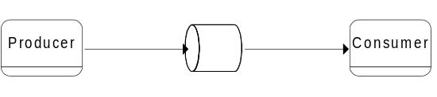
Figure 1. One to One

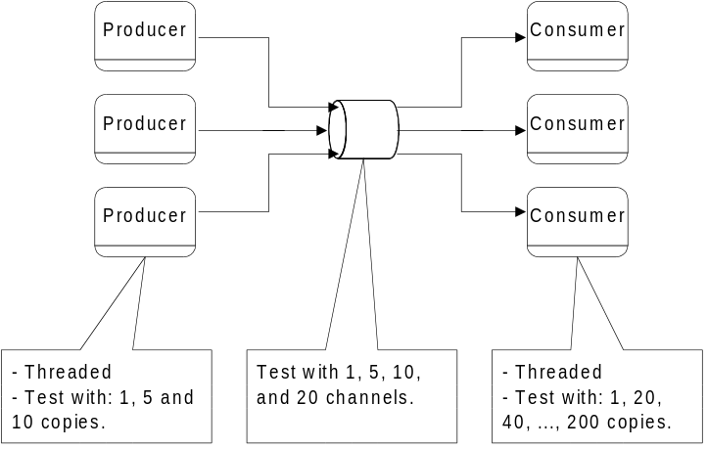

Figure 2. Many to Many

Each of the test scenarios will define the following:
- Number of messages/sec (message rate) for different sizes of messages
- Number of producers/consumers
- Number of producers/consumers per machine
- Number of event channels

The table below illustrates all identified test scenarios. The complete list was condensed to include only those items highlighted. Using these items, each test pass will require an eighteen hour run time per product.
Table 2. MOM Scenarios
Message Type | Solaris Suppliers | Solaris Consumers | NT Suppliers | NT Consumers | Intra / InterBox | Event Streams | QoS | Rates | Run Time | TestName
One-to-One
Orders | 1 | 1 |  |  | Intra | 1 | Normal | 5, 10 | 1
Orders | 1 | 1 |  |  | Inter | 1 | Normal | 5, 10 | 1
Orders |  | 1 | 1 |  | Inter | 1 | Normal | 5, 10 | 1
Quotes | 1 | 1 |  |  | Intra | 1 | Normal | 100, 150, 250, 350, 450, 550, 700, 1024, 2048 | 10
Quotes | 1 | 1 |  |  | Inter | 1 | Normal | 100, 150, 250, 350, 450, 550, 700, 1024, 2048 | 10
Quotes |  | 1 | 1 |  | Inter | 1 | Normal | 100, 150, 250, 350, 450, 550, 700, 1024, 2048 | 10
Blocks | 1 | 1 |  |  | Intra | 1 | Normal | 50, 75, 100 | 10
Blocks | 1 | 1 |  |  | Inter | 1 | Normal | 50, 75, 100 | 10
Blocks |  | 1 | 1 |  | Inter | 1 | Normal | 50, 75, 100 | 10
Orders | 1 | 1 |  |  | Inter | 1 | Guaranteed | 5, 10 | 10 | OTO1
Quotes | 1 | 1 |  |  | Intra | 1 | Guaranteed | 100, 150, 250, 350, 450, 550, 700, 1024, 2048 | 15
Blocks | 1 | 1 |  |  | Inter | 1 | Guaranteed | 50, 75, 100 | 10 | OTO2
One-to-Many
Quotes | 1 | 1,9 |  |  | Intra (1), Inter (9) |  | Normal | 100, 150, 250, 350, 450, 550, 700, 1024, 2048 | 10 | OTM1
Quotes | 1 | 25 |  |  | Inter |  | Normal | 100, 150, 250, 350, 450, 550, 700, 1024, 2048 | 10 | OTM2
Quotes | 1 |  |  | 25 | Inter |  | Normal | 100, 150, 250, 350, 450, 550, 700, 1024, 2048 | 15
Quotes | 1 |  |  | 50 | Inter |  | Normal | 100, 150, 250, 350, 450, 550, 700, 1024, 2048 | 10 | OTM3
Quotes | 1 |  |  | 100 | Inter |  | Normal | 100, 150, 250, 350, 450, 550, 700, 1024, 2048 | 15
Quotes | 1 |  |  | 200 | Inter |  | Normal | 100, 150, 250, 350, 450, 550, 700, 1024, 2048 | 10 | OTM4
Blocks | 1 | 1,9 |  |  | Intra (1), Inter (9) |  | Normal | 50, 75, 100 | 10 | OTM5
Blocks | 1 | 25 |  |  | Inter |  | Normal | 50, 75, 100 | 10 | OTM6
Blocks | 1 |  |  | 25 | Inter |  | Normal | 50, 75, 100 | 15
Blocks | 1 |  |  | 50 | Inter |  | Normal | 50, 75, 100 | 10 | OTM7
Blocks | 1 |  |  | 100 | Inter |  | Normal | 50, 75, 100 | 15
Blocks | 1 |  |  | 200 | Inter |  | Normal | 50, 75, 100 | 10 | OTM8
Some-to-Many
Quotes | 3 | 1,9 |  | 25 | Intra (1), Inter (9) |  | Normal | 50, 75, 100 (to NT); 100, 150, 250, 350, 450, 550, 700, 1024, 2048 (to Solaris) | 10 | STM1
Quotes | 3 | 25 |  |  | Inter |  | Normal | 100, 150, 250, 350, 450, 550, 700, 1024, 2048 | 15
Quotes | 3 |  |  | 25 | Inter |  | Normal | 100, 150, 250, 350, 450, 550, 700, 1024, 2048 | 15
Quotes | 3 |  |  | 50 | Inter |  | Normal | 100, 150, 250, 350, 450, 550, 700, 1024, 2048 | 15
Quotes | 3 |  |  | 100 | Inter |  | Normal | 100, 150, 250, 350, 450, 550, 700, 1024, 2048 | 15
Quotes | 3 |  |  | 200 | Inter |  | Normal | 100, 150, 250, 350, 450, 550, 700, 1024, 2048 | 15
Blocks | 3 | 10 |  |  | Inter |  | Normal | 50, 75, 100 | 10 | STM2
Blocks | 3 | 25 |  |  | Inter |  | Normal | 50, 75, 100 | 10 | STM3
Blocks | 3 |  |  | 25 | Inter |  | Normal | 50, 75, 100 | 15
Blocks | 3 |  |  | 50 | Inter |  | Normal | 50, 75, 100 | 15
Blocks | 3 |  |  | 100 | Inter |  | Normal | 50, 75, 100 | 15
Blocks | 3 |  |  | 200 | Inter |  | Normal | 50, 75, 100 | 15
Many-to-One
Quotes | 5 | 1 |  |  | Inter |  | Normal | 100, 150, 250, 350, 450, 550, 700, 1024, 2048 | 15
Quotes | 10 | 1 |  |  | Inter |  | Normal | 100, 150, 250, 350, 450, 550, 700, 1024, 2048 | 10 | MTO1
Quotes | 15 | 1 |  |  | Inter |  | Normal | 100, 150, 250, 350, 450, 550, 700, 1024, 2048 | 15
Blocks | 5 | 1 |  |  | Inter |  | Normal | 50, 75, 100 | 15
Blocks | 10 | 1 |  |  | Inter |  | Normal | 50, 75, 100 | 10 | MTO2
Blocks | 15 | 1 |  |  | Inter |  | Normal | 50, 75, 100 | 15
Blocks | 5 | 1 |  |  | Inter |  | Guaranteed | 50, 75, 100 | 10
Blocks | 10 | 1 |  |  | Inter |  | Guaranteed | 50, 75, 100 | 10
Blocks | 15 | 1 |  |  | Inter |  | Guaranteed | 50, 75, 100 | 10
Multiple Event Streams Test #1
Orders | 1 | 1 |  |  | Inter |  | Normal | 5, 5, 10, 10 | 10 | MES1 (all 4 streams run concurrently)
Quotes | 1 | 5 |  | 50 | Inter |  | Normal | 100, 200, 500, 700 | 10
Blocks | 10 | 1 |  |  | Inter |  | Normal | 50, 50, 75, 100 | 10
Orders | 1 | 1 |  |  | Inter |  | Guaranteed | 5, 5, 10, 10 | 10
Multiple Event Streams Test #2
Orders | 1 | 1 |  |  | Inter |  | Normal | 10 | 480 | MES2 (all 4 streams run concurrently)
Quotes | 1 | 5 |  | 50 | Inter |  | Normal | 200 | 480
Blocks | 10 | 1 |  |  | Inter |  | Normal | 100 | 480
Orders | 1 | 1 |  |  | Inter |  | Guaranteed | 10 | 480

2.2.3 Evaluation Report

2.2.3.1 Key Design Decisions
The code developed for the MOM benchmark is structured in three layers: Java drivers, JNI bindings and MOM interface.
Java Drivers: Despite the “driver” name, the Java drivers are actually the top layer of software in the benchmark system and comprise the actual suppliers and consumers of messages. This code generates logs with raw data containing the results of each run. In this scheme, both the consumers and suppliers become distinct entities which utilize and rely on a standard set of services provided by the lower level MOM products. Hence, the consumer and suppliers become clients to MOM services and this document will consistently refer to them as clients. This layer was implemented by the staff at CBOE.
JNI Bindings: The Java drivers call Java classes implemented in native C++ code written in compliance with JavaSoft’s Java Native Interface specifications (JNI). This layer provided a uniform generic interface to the messaging middleware allowing interchangeable modules for each MOM product to be built and plugged in. This layer was developed by the staff at TRC.
MOM Interface: One module for each MOM product was developed and coded directly to the API for that product. One additional module was developed (nicknamed the NILMOM) which did not code to any MOM product but allowed the upper two layers to be executed at CPU speed with no intervening middleware. This allowed maximum throughput levels to be established for the various tests as needed. This layer was developed by the staff at TRC.

Why JNI was used instead of the vendors’ Java interfaces?
- The use of JNI allowed a uniform native threading model to be established across all MOM products. All products could then be compared on an even footing as far as the effects of native threading on client suppliers and consumers were concerned.
- The use of a consistent native threading model in this layer would allow us to determine whether consumer clients could be built which scaled effectively, according to the number of CPUs available on a particular host.

Description of the native threading model chosen
The essential concept employed in choosing the model was to give each consumer client as many threads as there were CPUs available on the host. All consumers would then be able to divide their threads, and therefore their work, evenly among all CPUs available on the host. This added parallelism should improve performance according to Amdahl’s Law. In the ideal case, the interaction of the threading model with the MOM product would not introduce any further serialization and would not degrade any performance gains from the multiple CPUs. This is the assumption for the NILMOM. In the expected case, however, depending on the amount of serialization introduced by the interaction of each individual MOM product with the threads, the additional CPU power may offer little or no advantage.

2.2.3.2 Hardware and Software Configuration
The following hardware was used to run the benchmark’s test runs:
- Host machines: See Table 3 below.
- Network Configuration: The test system was connected on a full duplex, switched, 100MB vlan.

System name | LIMBO | CBOE1 | CBOE2 | CBOE3
Hardware | Sun Enterprize 2 | Sun Enterprize 2 | Sun Ultra 5 | Sun Ultra 1
OS | Solaris 2.5.1 | Solaris 2.5.1 | Solaris 2.5.1 | Solaris 2.5.1
Processor | 2 x 168MHz | 2 x 168MHz | 270 MHz | 167 MHz
Memory | 256 MB | 128 MB | 256 MB | 128 MB
NIC | 100 Mb | 100 Mb | 100 Mb | 100 Mb
Hard disk | 4.2 GB | 4.2 GB | 4.2 GB | 4.2 GB
Table 3 MOM Benchmark Hardware Configuration
The following software releases were used in the benchmark’s test runs:
- JDK 1.1.5
- Talarian 4.0
- OrbixTalk 1.2c
- Vitria 3.1
- SparkWorks C++ 4.2

2.2.3.3 Results Coverage
A number of test scenarios were generated by varying:
- Number of suppliers / consumers
- Location of suppliers / consumers
- Number of suppliers / consumers per machine
- Message size
- Quality of Service
- Number of messages supplied per second
- Run time
The following table contains the generated scenarios:

Message Type | Solaris Suppliers | Solaris Consumers | NT Suppliers | NT Consumers | Intra / InterBox | Event Streams | QoS | Rates | Run Time | Scenario Name
One-to-One
Orders (1Kb) | 1 | 1 |  |  | Intra | 1 | Normal | 5, 10 | 1
Orders (1Kb) | 1 | 1 |  |  | Inter | 1 | Normal | 5, 10 | 1
Orders (1Kb) |  | 1 | 1 |  | Inter | 1 | Normal | 5, 10 | 1
Quotes (50b) | 1 | 1 |  |  | Intra | 1 | Normal | 100, 150, 250, 350, 450, 550, 700, 1024, 2048 | 10
Quotes (50b) | 1 | 1 |  |  | Inter | 1 | Normal | 100, 150, 250, 350, 450, 550, 700, 1024, 2048 | 10
Quotes (50b) |  | 1 | 1 |  | Inter | 1 | Normal | 100, 150, 250, 350, 450, 550, 700, 1024, 2048 | 10
Blocks (8Kb) | 1 | 1 |  |  | Intra | 1 | Normal | 50, 75, 100 | 10
Blocks (8Kb) | 1 | 1 |  |  | Inter | 1 | Normal | 50, 75, 100 | 10
Blocks (8Kb) |  | 1 | 1 |  | Inter | 1 | Normal | 50, 75, 100 | 10
Orders (1Kb) | 1 | 1 |  |  | Inter | 1 | Guaranteed | 5, 10 | 10 | OTO1
Quotes (50b) | 1 | 1 |  |  | Intra | 1 | Guaranteed | 100, 150, 250, 350, 450, 550, 700, 1024, 2048 | 15
Blocks (8Kb) | 1 | 1 |  |  | Inter | 1 | Guaranteed | 50, 75, 100 | 10 | OTO2
One-to-Many
Quotes (50b) | 1 | 1,9 |  |  | Intra (1), Inter (9) |  | Normal | 100, 150, 250, 350, 450, 550, 700, 1024, 2048 | 10 | OTM1
Quotes (50b) | 1 | 25 |  |  | Inter |  | Normal | 100, 150, 250, 350, 450, 550, 700, 1024, 2048 | 10 | OTM2
Quotes (50b) | 1 |  |  | 25 | Inter |  | Normal | 100, 150, 250, 350, 450, 550, 700, 1024, 2048 | 15
Quotes (50b) | 1 |  |  | 50 | Inter |  | Normal | 100, 150, 250, 350, 450, 550, 700, 1024, 2048 | 10 | OTM3
Quotes (50b) | 1 |  |  | 100 | Inter |  | Normal | 100, 150, 250, 350, 450, 550, 700, 1024, 2048 | 15
Quotes (50b) | 1 |  |  | 200 | Inter |  | Normal | 100, 150, 250, 350, 450, 550, 700, 1024, 2048 | 10 | OTM4
Blocks (8Kb) | 1 | 1,9 |  |  | Intra (1), Inter (9) |  | Normal | 50, 75, 100 | 10 | OTM5
Blocks (8Kb) | 1 | 25 |  |  | Inter |  | Normal | 50, 75, 100 | 10 | OTM6
Blocks (8Kb) | 1 |  |  | 25 | Inter |  | Normal | 50, 75, 100 | 15
Blocks (8Kb) | 1 |  |  | 50 | Inter |  | Normal | 50, 75, 100 | 10 | OTM7
Blocks (8Kb) | 1 |  |  | 100 | Inter |  | Normal | 50, 75, 100 | 15
Blocks (8Kb) | 1 |  |  | 200 | Inter |  | Normal | 50, 75, 100 | 10 | OTM8
Some-to-Many
Quotes (50b) | 3 | 1,9 |  | 25 | Intra (1), Inter (9) |  | Normal | 50, 75, 100 (to NT); 100, 150, 250, 350, 450, 550, 700, 1024, 2048 (to Solaris) | 10 | STM1
Quotes (50b) | 3 | 25 |  |  | Inter |  | Normal | 100, 150, 250, 350, 450, 550, 700, 1024, 2048 | 15
Quotes (50b) | 3 |  |  | 25 | Inter |  | Normal | 100, 150, 250, 350, 450, 550, 700, 1024, 2048 | 15
Quotes (50b) | 3 |  |  | 50 | Inter |  | Normal | 100, 150, 250, 350, 450, 550, 700, 1024, 2048 | 15
Quotes (50b) | 3 |  |  | 100 | Inter |  | Normal | 100, 150, 250, 350, 450, 550, 700, 1024, 2048 | 15
Quotes (50b) | 3 |  |  | 200 | Inter |  | Normal | 100, 150, 250, 350, 450, 550, 700, 1024, 2048 | 15
Blocks (8Kb) | 3 | 10 |  |  | Inter |  | Normal | 50, 75, 100 | 10 | STM2
Blocks (8Kb) | 3 | 25 |  |  | Inter |  | Normal | 50, 75, 100 | 10 | STM3
Blocks (8Kb) | 3 |  |  | 25 | Inter |  | Normal | 50, 75, 100 | 15
Blocks (8Kb) | 3 |  |  | 50 | Inter |  | Normal | 50, 75, 100 | 15
Blocks (8Kb) | 3 |  |  | 100 | Inter |  | Normal | 50, 75, 100 | 15
Blocks (8Kb) | 3 |  |  | 200 | Inter |  | Normal | 50, 75, 100 | 15
Many-to-One
Quotes (50b) | 5 | 1 |  |  | Inter |  | Normal | 100, 150, 250, 350, 450, 550, 700, 1024, 2048 | 15
Quotes (50b) | 10 | 1 |  |  | Inter |  | Normal | 100, 150, 250, 350, 450, 550, 700, 1024, 2048 | 10 | MTO1
Quotes (50b) | 15 | 1 |  |  | Inter |  | Normal | 100, 150, 250, 350, 450, 550, 700, 1024, 2048 | 15
Blocks (8Kb) | 5 | 1 |  |  | Inter |  | Normal | 50, 75, 100 | 15
Blocks (8Kb) | 10 | 1 |  |  | Inter |  | Normal | 50, 75, 100 | 10 | MTO2
Blocks (8Kb) | 15 | 1 |  |  | Inter |  | Normal | 50, 75, 100 | 15
Blocks (8Kb) | 5 | 1 |  |  | Inter |  | Guaranteed | 50, 75, 100 | 10
Blocks (8Kb) | 10 | 1 |  |  | Inter |  | Guaranteed | 50, 75, 100 | 10
Blocks (8Kb) | 15 | 1 |  |  | Inter |  | Guaranteed | 50, 75, 100 | 10
Multiple Event Streams Test #1
Orders (1Kb) | 1 | 1 |  |  | Inter |  | Normal | 5, 5, 10, 10 | 10 | MES1 (all 4 streams run concurrently)
Quotes (50b) | 1 | 5 |  | 50 | Inter |  | Normal | 100, 200, 500, 700 | 10
Blocks (8Kb) | 10 | 1 |  |  | Inter |  | Normal | 50, 50, 75, 100 | 10
Orders (1Kb) | 1 | 1 |  |  | Inter |  | Guaranteed | 5, 5, 10, 10 | 10
Multiple Event Streams Test #2
Orders (1Kb) | 1 | 1 |  |  | Inter |  | Normal | 10 | 480 | MES2 (all 4 streams run concurrently)
Quotes (50b) | 1 | 5 |  | 50 | Inter |  | Normal | 200 | 480
Blocks (8Kb) | 10 | 1 |  |  | Inter |  | Normal | 100 | 480
Orders (1Kb) | 1 | 1 |  |  | Inter |  | Guaranteed | 10 | 480
Table 4 MOM Benchmark Scenarios
The goal of these benchmark scenarios was to determine the performance of the MOM products under a variety of realistic conditions.

Selected Scenario Runs
Since running all the scenarios in Table 4 MOM Benchmark Scenarios would have required substantial resources, only the shaded scenarios were selected as the most representative in CBOE’s future environment. The following table shows the status of the selected scenario runs for each product:

Scenario Name | Talarian | MQSeries | Vitria | NeonNet | OrbixTalk
OTO1 | Completed | Cancelled | Completed | Cancelled | Partial
OTO2 | Completed | Cancelled | Completed | Cancelled | Partial
OTM1 | Completed | Cancelled | Partial | Cancelled | Tentatively Cancelled
OTM2 | Completed | Cancelled | Cancelled | Cancelled | Tentatively Cancelled
OTM3 | Partial | Cancelled | Cancelled | Cancelled | Tentatively Cancelled
OTM4 | Partial | Cancelled | Cancelled | Cancelled | Tentatively Cancelled
OTM5 | Completed | Cancelled | Cancelled | Cancelled | Tentatively Cancelled
OTM6 | Completed | Cancelled | Cancelled | Cancelled | Tentatively Cancelled
OTM7 | Partial | Cancelled | Cancelled | Cancelled | Tentatively Cancelled
OTM8 | Partial | Cancelled | Cancelled | Cancelled | Tentatively Cancelled
STM1 | Completed | Cancelled | Cancelled | Cancelled | Tentatively Cancelled
STM2 |  | Cancelled | Cancelled | Cancelled | Tentatively Cancelled
STM3 |  | Cancelled | Cancelled | Cancelled | Tentatively Cancelled
MTO1 |  | Cancelled | Cancelled | Cancelled | Tentatively Cancelled
MTO2 |  | Cancelled | Cancelled | Cancelled | Tentatively Cancelled
MES1 |  | Cancelled | Cancelled | Cancelled | Tentatively Cancelled
MES2 |  | Cancelled | Cancelled | Cancelled | Tentatively Cancelled
Table 5 Status of MOM Benchmark Runs

2.2.3.4 Benchmark Results
MQSeries was eliminated from consideration on 5/15/98 because of significant drawbacks, specifically, lack of support for the publish & subscribe model.
Vitria was eliminated from further consideration on 6/19/98 because of extremely slow performance and stability problems.
NeonNet was eliminated from further consideration on 6/19/98 because of unavailability of product to TRC staff.
OrbixTalk presented problems with more than one consumer. The consumers for higher order tests disconnected. So far there has been no success on correcting this problem. This problem makes OrbixTalk unsuitable in CBOE’s environment where multiple consumers are commonplace. Another serious problem was the loss of messages at higher rates.
Talarian SmartSockets performed the best of all products examined. There were no real throughput concerns with Talarian’s product, but it did experience stability problems in the higher-order tests. Good responsiveness from Talarian support made it possible to work through or explain most of the connectivity issues. Connectivity issues regarding clients is adequately explained by the CPU bounded nature of the higher order tests. As more and more clients on the same machine contend for CPU resources, they are not able to consume messages fast enough to keep pace with message suppliers. Eventually, the client message buffer in RTSERVER fills to capacity and RTSERVER disconnects the client.
The proper means to deal with this issue in production is to introduce some form of flow control. A white paper is in our possession from Talarian detailing how flow control can be implemented in SmartSockets.
The outstanding connectivity issue with SmartSockets is the inability of RTSERVERS to maintain proper connectivity amongst themselves during the higher order tests. Specifically, RTMON on different hosts will report different and contradictory connectivity patterns between the RTSERVERS. This issue is not entirely understood, and there has not yet been an explanation from Talarian. However, it is not an entirely mysterious phenomenon. RTSERVERS maintain connectivity between themselves through the use of UDP broadcasts. UDP is a protocol which does not guarantee delivery of packets. It is not unreasonable to suppose that during periods of high network activity, as in the high-order tests, some of the UDP packets do not arrive at their destination. It is not hard to envision a situation where no two RTSERVERs received the same set of broadcast packets. What remains unanswered, is (1) why the RTSERVERs do not re-establish proper connectivity once the network quiets, and (2) what the effect on message delivery might be when RTSERVERs do not consistently agree on connectivity patterns.

Comparison of the products.
A quick glance at Table 3 will reveal that a comparison between the products is only possible for the low order tests. The stability problems with two of the products, OrbixTalk and Vitria, made it impossible to obtain results for the higher order tests. Even for Talarian, only partial results for the higher order tests are available because of stability issues.
The following three figures illustrate some of the differences between the products. Figures 3, 4 and 5 chart the performance metrics for test OTO2 between the Talarian, OrbixTalk, and Vitria products. The test OTO2 was configured to send block size information at rates of 50, 75 and 100 messages per second using guaranteed delivery. Of the three products, only Talarian was able to smoothly and consistently keep up with the programmed message rates.

Figure 3 Talarian's Peak Message Rates for OTO2 Scenario 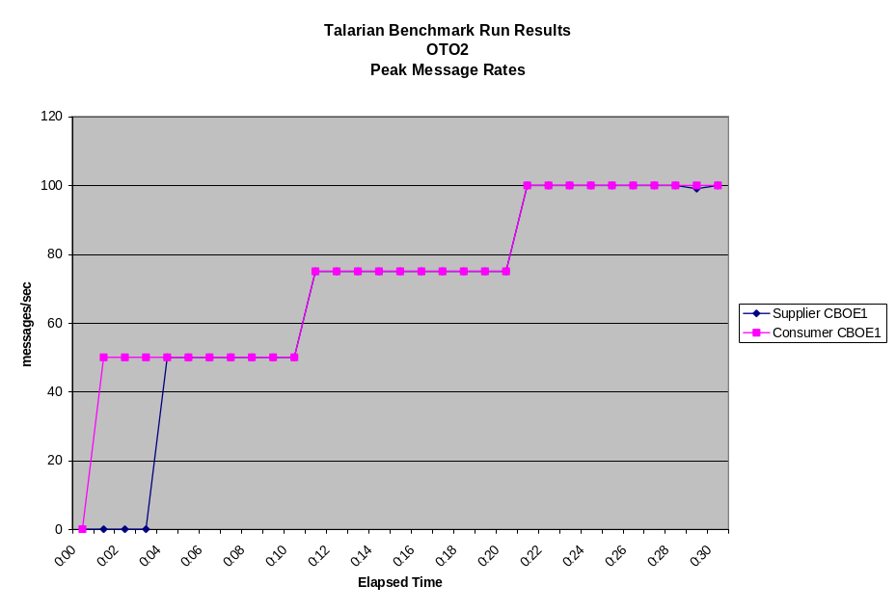

Figure 4 OrbixTalk Peak Message Rates for OTO2 Scenario
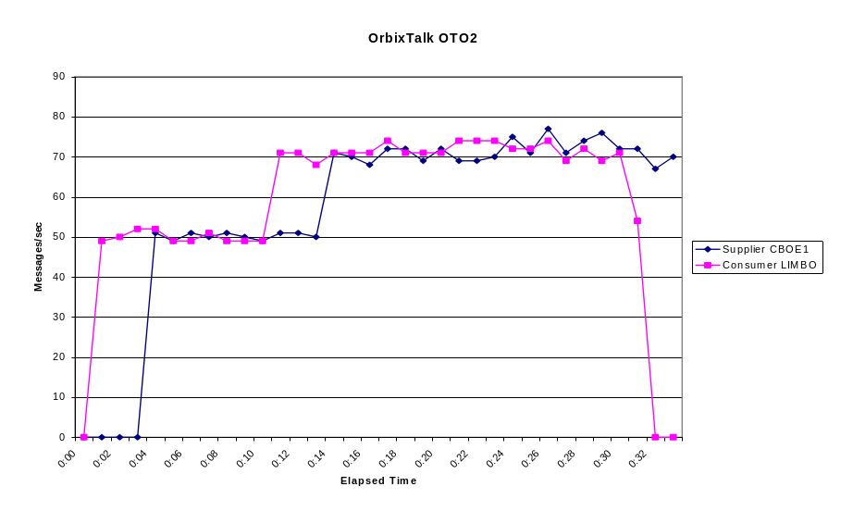
Figure 5 Vitria Peak Message Rates for OTO2 Scenario
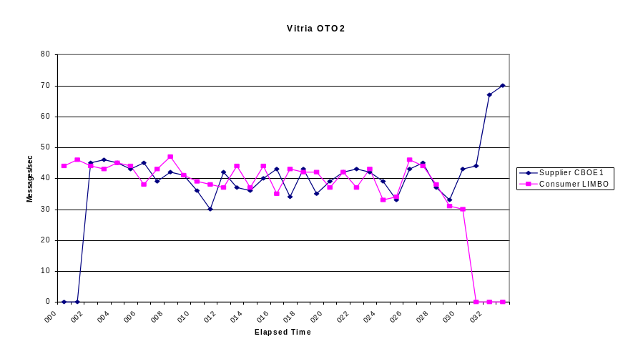
It should be noted that in each of these three figures, the consumer appears to start receiving messages four minutes earlier than the supplier starts sending them. This anomaly is due to a time difference between the hosts.
Figures 6 & 7. NILMOM rates for OTM2 and OTM1
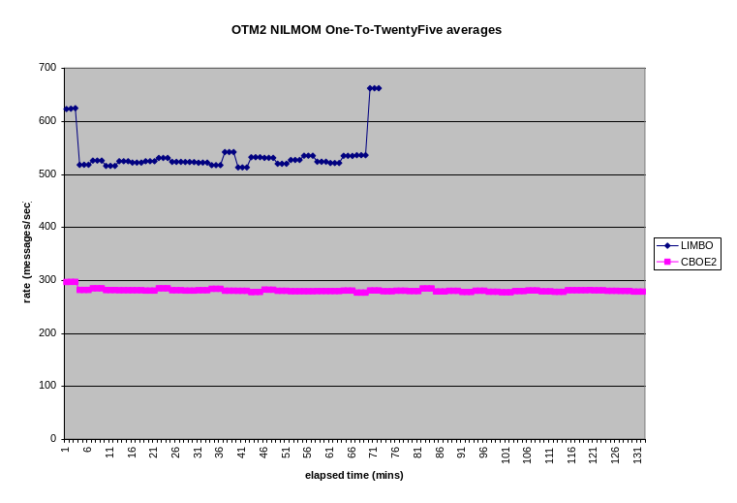

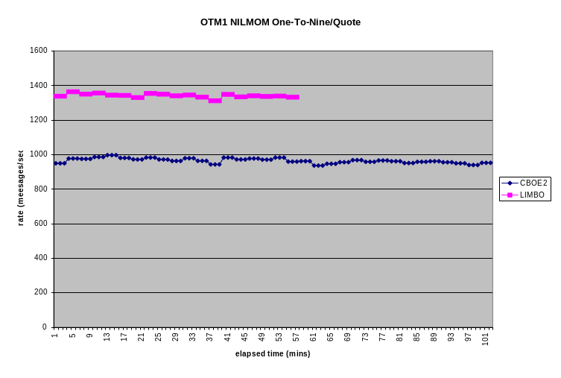

The Scalability Issue
An examination of figures 6 and 7 reveals expected behavior for tests OTM1 and OTM2 for the NILMOM module. This module codes the MOM interface layer, but is mostly vacant. It does not interface to any MOM product and simply allows the tests to be run at CPU speed. No added serialization is introduced into the consumer threads. Under these conditions, you would expect consumers on the dual processor machine Limbo (2 X 168Mhz) to perform better than the consumers on the single processor machine Cboe2 (275 Mhz) because the two thread per consumer model on Limbo can effectively utilize both processors. An inspection of the two graphs for the NILMOM module reveals that this is the case.
When the consumer threads have to interact with the Talarian MOM API, the story changes considerably. Since Talarian is single threaded, it stands to reason that significant serialization must be introduced into the consumer threads when they interact with it. It would be expected, in this case, that consumers would perform worse on the dual processor machine Limbo than on the single processor Cboe2. This is because the single processor on Cboe2 (275 Mhz) is considerably faster than a single processor on Limbo (168 Mhz). Inspection of figures 6 and , show this to be the case. In the graph for OTM2, Cboe2(275 MHz) consistently edges out Limbo(2 X 168Mhz) and Cboe3(168 Mhz) which keep in close pace to each other. In graph OTM1, Cboe2 drastically outperforms Limbo and Cboe3. Limbo takes partial advantage of its dual processors by outperforming Cboe3, but not to the same extent as Cboe2.
All of these scalability results suggests that Talarian RTCLIENTs can not be made scalable on multiprocessor systems effectively. If a choice has to be made between selecting multiprocessor systems or faster uniprocessor systems, the choice of faster uniprocessor systems may be more effective. However, this should be reconsidered when Talarian produces a multithreaded product, and it is re-examined in a similar manner. Also, these results do not rule out the possibility that other threading models may produce better scalability results than the one used. The current model employed a single thread to retrieve messages from the Talarian API and dispatched them to the consumer threads. Since Talarian is multi-thread safe, it may be more effective to retrieve messages from the Talarian API using a pool of threads, each of which then dispatches the messages to the consumer threads or directly to the consumers, eliminating the need for the consumer threads altogether.
The OTM6 on Talarian runs contrary to the conclusions drawn in this section. See the section on OTM6 later in this document for a discussion of those results.

Figures 8 & 9. Talarian rates for OTM2 and OTM1
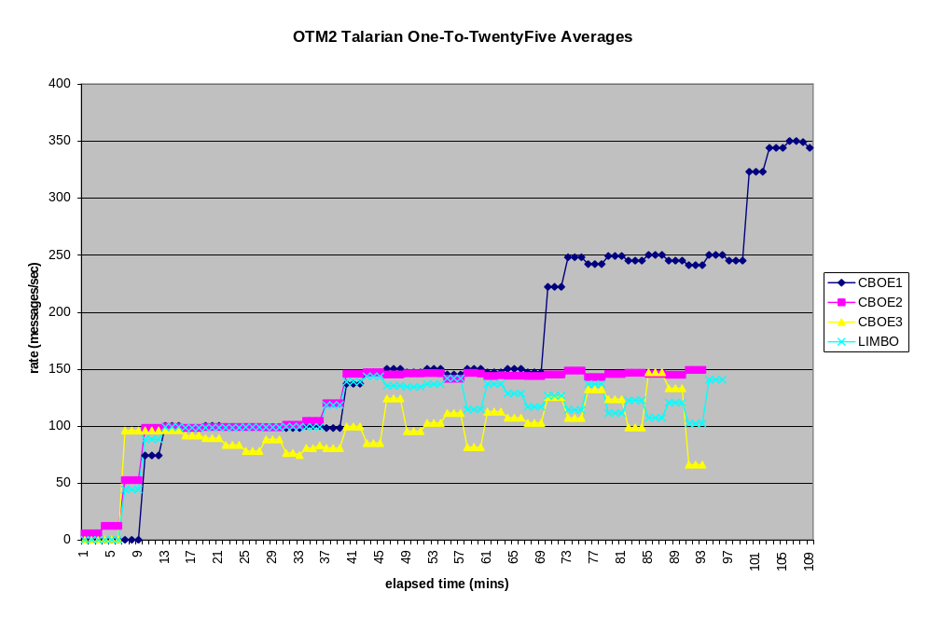

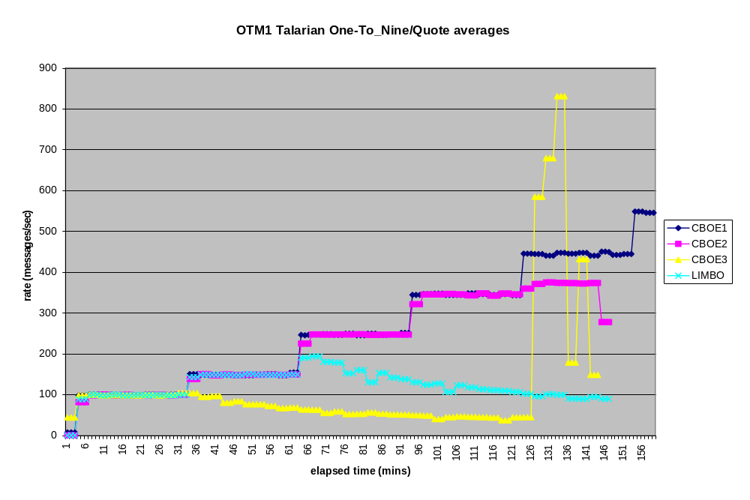

The results of the One-To-Twenty-five inter-box test for quote sized messages shown in the diagram above reveals some interesting information. The benchmark requirements place the minimum throughput rates for quotes at 150 msg/sec. The above test sustains a load of eight or nine JVM processes and one RTSERVER on each of the machines CBOE2, CBOE3, LIMBO. Of those machines, only CBOE2 was able to perform at the minimum required throughput although it was unable to exceed this level. Neither CBOE3 nor LIMBO were able to achieve the minimum throughput levels under this load.
The results for the One-To-Nine inter box test for quotes shows better performance for CBOE2. CBOE2 can not only meet the minimum throughput requirements for quotes, but it exceeds them. However, it falls short of the maximum throughput requirement of 700 msg/sec. Neither CBOE3 nor LIMBO can sustain the minimum requirement consistently. The lighter load in this test, only 3 JVM processes and 1 RTSERVER, allows significantly better performance on CBOE2.

Other Results of Interest
The following section lists some remaining diagrams of interest.

OTM5
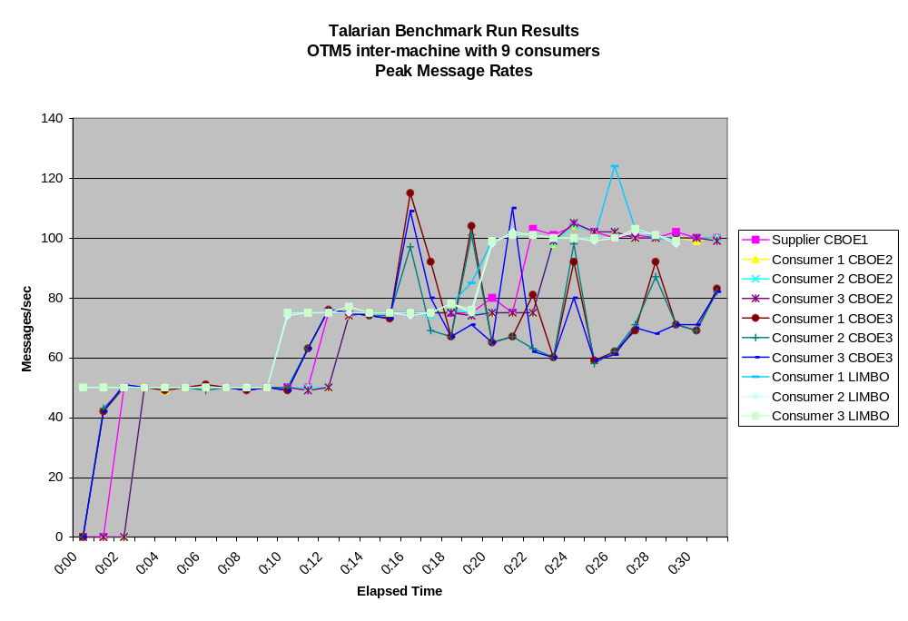
Figure 10 Talarian’s Peak Message Rates for OTM5 Inter-machine with 9 Consumers
The diagram in Figure 10 shows that Talarian sustained message rates of up to 100 messages/sec with normal message delivery to nine consumers without any major problem. The only noticeable abnormality is the bounded throughput of CBOE3 at an average of about 80 messages/sec while the supplier is producing 100 messages/sec. This can be explained by the fact that CBOE3 is the slowest uniprocessor system used in the benchmark. This limitation should be considered while selecting the hardware for CBOE systems handling these volumes.
The tests for OTM5 show no difficulty on any machine of meeting the minimum requirements for throughput of block messages (50 msg/sec). But CBOE3 could not approach the maximum throughput rates in the requirements (100 msg/sec).

OTM6

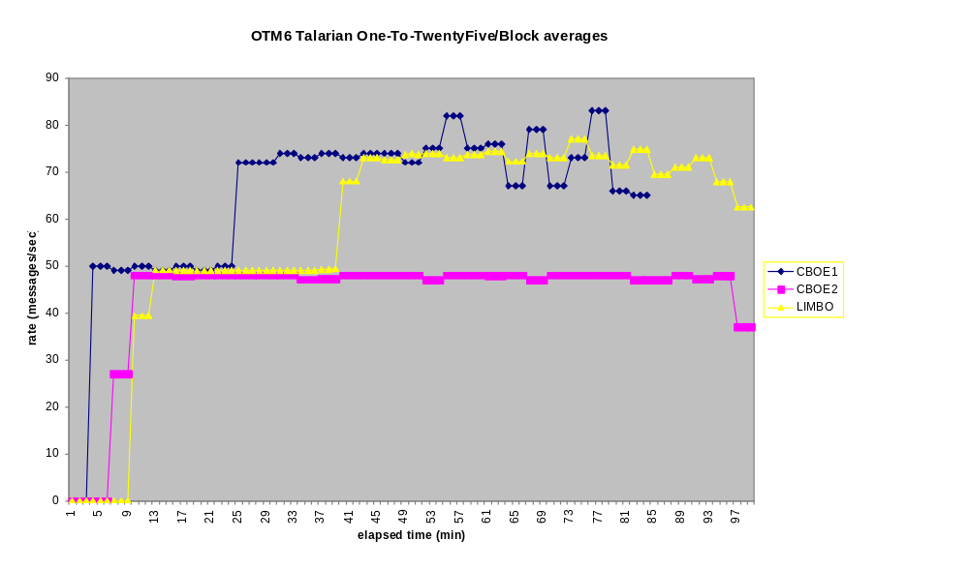

Figure 11 Talarian’s Peak Message Rates for OTM6 with One Supplier

The diagram in Figure 11 shows the result of test OTM6 with one supplier and average for all the consumers on Cboe2 and Limbo. It is interesting to note that the results in this test run contrary to the conclusion drawn in the scalability section of this document. Here the dual processor (2 X 168Mhz) Limbo, consistently out performs the single uniprocessor (275 Mhz) Cboe2. In general, this result is difficult to explain. The primary difference between OTM6 and OTM1 & OTM2 is the larger message size and slower programmed rates. OTM6 used block size (8K) messages whereas OTM1 & OTM2 used quote size (50 bytes) messages. If the large message size somehow caused the Talarian product to introduce less serialization into the consumer threads, this might explain the results. However, no conclusions can be drawn without further experimentation. In general, the conclusion drawn for scalability remain unchanged. The OTM1 & OTM2 tests demonstrate that the RTCLIENT software can not be consistently CPU scaled, and most of the CBOE traffic will be quote size messages. More experimentation might reveal a better hardware strategy. For instance, for quote based clients, faster uniprocessor machines may be more useful and for block based clients, dual machines may perform better. The situation, however, currently remains unclear.
STM1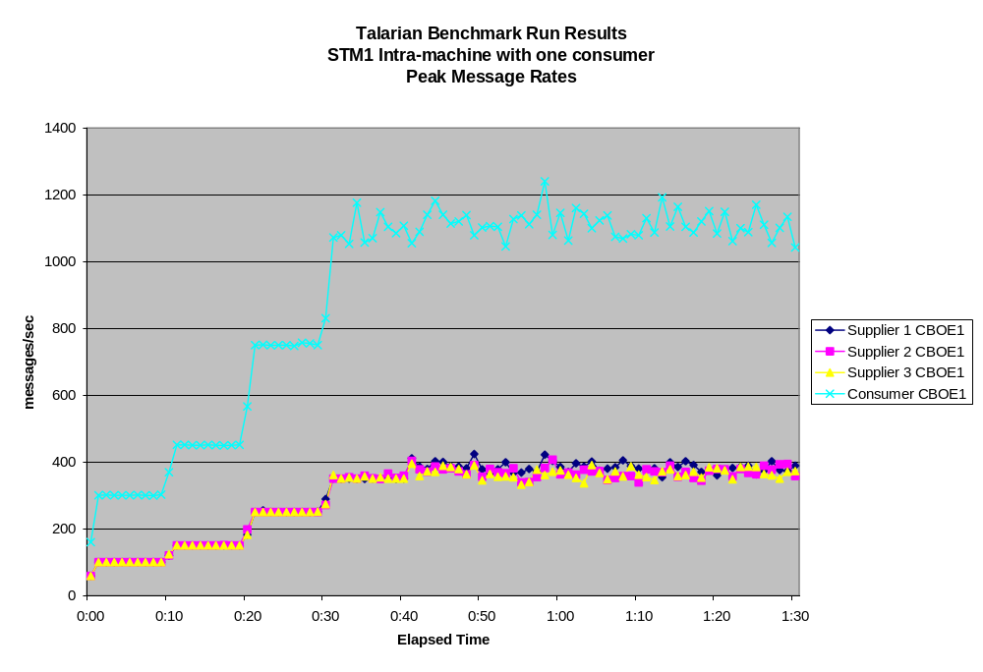
Figure 12 Talarian’s Peak Message Rates for STM1 with One Consumer
The diagram in Figure 12 shows that the throughput of Talarian with three suppliers and one consumer in the same machine is bounded at an aggregate rate of 1100 messages/sec supplied. It is unclear whether the throughput is CPU, memory, or IO bound. To determine the cause it would be necessary to run the same scenario in the other machines and compare the results. It is also possible that, since the RTServer is single-threaded, its performance is limiting the overall throughput when running all the processes in the same machine.
It is interesting to note, that CBOE1 with a load of three supplier JVMs processes and one RTSERVER was able to meet and exceed the minimum throughput requirements for quotes of 150 msg/sec but fell short of reaching the maximum throughput target of 700 msg/sec. This is in contrast to tests, such as OTM2, with a load of only one supplier JVM process and 1 RTSERVER process on CBOE1, where there was no difficulty in exceeding the maximum throughput level of 700 msg/sec.

2.2.3.5 Impact of Java and JNI Layers on Throughput
It is not possible to gauge the impact of the combined Java & JNI layers in any reliable fashion from the benchmark tests run. The team developed a control "MOM" library to supply artificial messages through the Java & JNI layers at CPU speed. This provided numbers for maximum throughput levels for an "ideal" MOM which consumed no CPU or IO resources. Comparing these numbers to the maximum throughput numbers of an actual MOM product would have allowed a comparison. Unfortunately, the benchmark tests themselves were not designed to run at maximum throughput levels and so no comparison is possible.
However, certain conclusions about the Java and JNI layers can be drawn from the behavior of the tests using the control library.
First, there was a significant performance discrepancy between the message sending and message receiving sides in the combined Java and JNI layers.
For example, on the OTO1 scenario:
Receiver average max throughput 4912
Sender average max throughput 11887
This indicates that the overhead involved in receiving a message and passing it to the Java layer is too great. Observing the number of context switches taking place for receiving clients gives an average of 4 context switches per message. This could account for a large part of the performance difference.
Second, adding consumer clients to the same machine reduces performance of the Java/JNI layer. This may be due to the fact that each new client process requires a separate JVM and native interface. A 20% performance drop seems to exist between the one-to-one and the one-to-many scenarios as shown in the following table:
Number of Consumers | Per client throughput | Aggregate throughput
1 | 5000 msg/sec | 5000 msg/sec
3 | 1330 msg/sec | 3990 msg/sec
8 | 540 msg/sec | 4320 msg/sec

Regarding consumer-side performance, the native (C++) code used to implement the consumer-side connection experienced a very high number of context switches per second. This is suspected to be due to the synchronization that was used around a queue within this layer. These context switches consumed the majority of time and are the cause of the drop-off in the aggregate rate of multiple processes.
The result is that the consumers were CPU bound at much lower rates than suppliers This was probably caused by a difference in the thread library threads created by the Java VM and the bound threads created in the native messaging library. Team members believe to know how to eliminate the context switches to bring up the consumers to an equivalent level with the suppliers.
The following changes to benchmark test configurations would better help assess the impact of the Java/JNI layers:
- Most benchmark tests would be run at maximum throughput. These numbers could then be compared to the number obtained from the dummy MOM tests. With these two numbers, we could estimate the percentage of time spent servicing the Java/JNI calls versus the time spent servicing the MOM. In the current set of tests, all of the tests throttled throughput, making impossible to tell when maximum throughput was encountered on the consumer side.
- A parallel set of C++ clients would be created. Comparing the measurements between the two sets of clients would allow an assessment of the relative performance impact of using Java. In the current set of tests, there were no C++ clients.
- Since the machines used in the benchmark were not identical, some tests would have to be duplicated on a different machine. For instance, the tests would appear in sets so that the suppliers would operate on the dual processor machines for one test in the set and on a uniprocessor for the other. Similarly, the one-to-one tests and the one-to-many tests would be run on both the uniprocessor as well as the dual processor machine. This would allow data to be compared on the same machine rather than across machine.

2.2.3.6 Summary
- Talarian demonstrated better throughput during the benchmark runs than the other tested MOM products. However, stability problems with the other products prevented much progress from being made on running the planned tests. Talarian also exhibited stability problems, but timely feedback and assistance from Talarian support allowed us to progress much further in the tests than with the other products. A summary of the stability problems involving Talarian is summarized below.
- The disconnection of consumer clients (Talarian error code 10, 512). During the higher order tests, those utilizing multiple consumer clients per machine consistently experienced disconnects of the consumers during attempted runs of the tests, producing Talarian error code 10 or 512. The reasons received from Talarian for these disconnects form an acceptable explanation. When running the higher order tests, the consumer side clients are running CPU bound which means that the RTSERVER is capable of delivering messages faster than the consumers can receive them. Because of this, the consumer buffers in the RTSERVER eventually fill up and can not accommodate any more incoming messages. When this occurs, there are two possibilities in Talarian. Either disconnect the slow consumer-side client, or establish flow control and slow down the supplier.
- Talarian's default behavior is to disconnect the consumer. The alternative, establishing flow control, should be possible using Talarian's monitor API. However, this was not explored during the benchmarking tests.
- The disconnects between RTSERVERS and the reporting of inconsistent connectivity patterns through RTMON. This issue is not entirely understood, and there has not yet been an explanation from Talarian. However, it is not an entirely mysterious phenomenon. RTSERVERS maintain connectivity between themselves through the use of UDP broadcasts. UDP is a protocol which does not guarantee delivery of packets. It is not unreasonable to suppose that during periods of high network activity, as in the high-order tests, some of the UDP packets do not arrive at their destination. It is not hard to envision a situation where no two RTSERVERs received the same set of broadcast packets. What remains unanswered, is (1) why the RTSERVERs do not re-establish proper connectivity once the network quiets, and (2) what the effect on message delivery might be when RTSERVERs do not consistently agree on connectivity patterns.
- It appears that CPU scalability can not be effectively implemented in RTCLIENTS using the current version of Talarian. It may be more effective to utilize faster uniprocessor systems than slower multiprocessor systems. As new versions of Talarian become available, especially multithreaded ones, this issue bears re-examination. Additionally, only one threading model was tried. It may be worth the effort to experiment with other models to see if the CPU scalability of RTCLIENTS is improved.

Remarks
i. (Chuck) I wonder if they took the default values for buffer sizes (assuming this is a configurable parameter; I didn't see anything in the Talarian User Guide to do this). They could have tried to estimate the max arrival vs. consumption rates and come up with a buffer size that would have held through the majority of cases.
Only the default buffer size(10MB per RTSERVER) was utilized. The buffer size can be changed by setting CLIENT_MAX_BUFFER in the rtserver.cm file. Raising the buffer size would not have improved throughput rates but would have allowed RTCLIENTS to run at slower rates for a longer period of time.
ii. (Chuck) I don't know that a pure C++ test would be worth the time. Since we're still going with Java at this point, there's got to be a Java interface somewhere. Perhaps Peter's motivation is that he still believes Java will not work.
I agree with Kevin's & Paul's initial remarks: if we getting the desired throughput at acceptable CPU utilization, then who cares about the overhead of Java vs C++? Looking forward, I guess we should also ensure that these tests include projected quote rates due to decimals, etc.
Depending on CPU configuration and load, some of the tests met throughput requirements and some did not. For example, in test OTM1 having a load of three JVM processes and 1 RTSERVER per consumer host machine, CBOE2 had no problem meeting the minimum throughput requirements (150 msg/sec) but topped out at just less than 400 msg/sec falling somewhat short of the maximum rate goal of 700. Both CBOE3 and LIMBO could not consistently meet the minimum throughput requirements. In test OTM2, having a load of 8-9 JVM processes and 1 RTSERVER per consumer host machine, CBOE2 could meet, but not exceed the minimum throughput requirements of 150 msg/sec. Neither Limbo nor CBOE3 could meet the minimum requirements for throughput.
iii.(Kevin) The commentary at the end concerning Java / JNI is the same verbiage that Peter sent before - no changes. I thought many of us responded to this and from that modifications could be made.... Also, I thought of one other specific issue with that section. There are two paragraphs explaining the consumer side performance problems, postulating different explanations. I would remove the first in favor of the second (which talks about the threading and locking issues that were found) - unless I am misunderstanding what's being said there.
Both cases, the accumulation of JVM processes and the choice of threading model would seem to contribute to the degradation in consumer performance. In the multi-consumer case, the CPU power must be divided among multiple JVMs.
iv. (Kevin) It would still be nice to get an explanation for the rtserver connectivity / consistency problem...
There is still no explanation available from Talarian, but a plausible explanation is provided in item 3 in the Summary and Conclusion section.
3) It sounds, as somewhat expected, that the Java / JNI issue is not really a Java / JNI issue at all, except for some type of threading implementation difference in relation to the locking mechanism being used - which I would like to know more about. It would be good to rerun (at least some of) the benchmark tests using the fixed code. I don't think that we should replace all of the test scenarios with max-throughput type tests, but we could add a few that are like that. I think that there is some benefit to doing this in order to get some gauge on the MOM overhead. Also, even though I am curious about a C++ comparison, I don't think that doing one is of value right now. The important thing is to fix the C++ / JNI code and verify that the supplier vs. consumer differences (all but) disappear, and that the throughput reaches our desired levels. Lastly, I'm not sure I understand his box-difference item at the end of the message..?
Recommend re-examination of consumer performance after dispatcher threading model is changed or eliminated.

2.3 Persistence Benchmark

2.3.1 Object Database Management Assessment
The purpose of this section is to provide the reader with an understanding of the technical issues relevant to the selection of an object database management system (ODBMS) for CBOE. The choice of an ODBMS to provide persistent object state for object-oriented applications is a key piece of the CBOE Technology Architecture. A paper evaluation has identified four products that could meet the needs of CBOE [Walker97]. This section details the development of a testbed for the evaluation of the four selected products.
Section 2.3.2 Overview of ODBMS Technology provides a brief overview of ODBMS technology. This report is not intended to be a complete overview of ODBMS concepts and functionality. Readers should have a basic understanding of object-oriented principles, database management system principles, and ODBMS principles. For information on these topics, see [Loomis94] and [Cattell94].
Section 2.3.3 Evaluation Products provides an overview of the four ODBMS products selected for further evaluation. These products are: Objectivity/DB (Objectivity, Inc.), Versant (Versant, Inc.), ObjectStore (Object Design, Inc.), and GemStone/J (GemStone Systems, Inc.).
Section 2.3.4 Evaluation Criteria details the selection criteria that will be used to evaluate the products.
Section 2.3.5 CBOE Evaluation Testbed provides an overview of the CBOE Evaluation Testbed, including a description of the software and hardware requirements, and a list of functional requirements.
Section 2.3.6 Evaluation Reports describe the results for each of the products tested.
The closing section contains our conclusions and recommendations.

2.3.2 Overview of ODBMS Technology

2.3.2.1 The Need for Object Databases
The increased use of object-oriented programming languages for systems development, together with the increased complexity of data, and increasing performance requirements has lead to the adoption of object database management systems. For example, telecommunications, finance, and manufacturing applications are all characterized by having to support highly complex, interrelated data, with high performance requirements. Object databases provide a nearly seamless integration with the most widely used object-oriented programming languages (Smalltalk, C++, and Java).
Traditional relational database technology has failed to handle the needs of this increasing complex data. First, the use of a relational database requires that all data be stored in the form of a table (relation) in the database. This results in an awkward “flattening” of a complex object model into a large number of tables in the database, often losing the rich semantics of the object model. For example, relational databases do not support inheritance and ordered collections, two basic capabilities of an object model frequently needed by real-world applications.
Second, relational database access can only be performed using Structured Query Language (SQL), a computationally incomplete language based on relational calculus. SQL supports a relational (set-based) model that is incompatible with current, mainstream object-oriented programming languages. This results in an “impedance mismatch,” which increases the complexity of mapping an object model to a relational database. On the other hand, ODBMSs provide an almost seamless integration with object-oriented programming languages because their data models are similar, if not identical, to that of the programming languages.
Thus, object database management systems provide a natural extension to an object-oriented programming language in support for persistence, coupled with the mandatory features of a database management system, including concurrency, recovery, querying, and support for large amounts of data.

2.3.2.2 Characteristics of Object Databases
Object database management systems combine object-oriented programming features with database management system functionality [Atk92]. These features include support for the following:
- complex objects
- object identity
- encapsulation
- types and classes
- class or type hierarchies (inheritance)
- overriding, overloading, and late binding
- computational completeness
- extensibility
- persistence
- secondary storage management
- concurrency
- recovery
- ad hoc query facility
The most significant aspect of an ODBMS is the ability to combine the power and flexibility of an object-oriented programming language with the mature capabilities of a database system in a nearly seamless extension of the object-oriented programming language. This provides the developer the tools to isolate complex operations with the data needed to perform the operations into classes that mirror the real-world entities in the problem domain. In addition, the flexibility of being able to define new data types and operations on those types allow the database to evolve along with the problem domain [McFarland93].
A key feature of Object Database Management Systems that separates them from the majority of commercially available Relational Database Management Systems (RDBMS) is the ability to store complex, composite objects using explicit relationships between the objects. By supporting relationships explicitly, navigational and associative access can be provided, often with significant performance advantages. By comparison, Relational Database Management Systems require the decomposition of complex data into normalized relations, which require relatively expensive join operations to recreate the data within an application. Several benchmarks [Cattell88][Carey93][Cattell94] comparing ODBMSs and RDBMSs have shown orders of magnitude performance differences when accessing complex data.
Thus, ODBMSs have shown to have distinct advantages for certain types of applications. These include applications with:
- Complex Data
- Complex Behavior
- User-defined Types
Applications exhibiting these characteristics which have successfully utilized object databases include:
- Communications
- Manufacturing and real-time control
- Finance
- Computer-Aided Design (CAD)
- Computer-Aided Software Engineering (CASE)
- Office Automation
- Scientific and Medical Applications
- Modeling and Simulation

2.3.2.3 Pragmatics of Using an ODBMS
There are a number of issues that must be considered when deciding to use an ODBMS. Five of the most important issues are: support for the object model, programmer’s view of persistence, architecture, performance tuning, and schema maintenance.
Current ODBMSs have variations in their support of an object model, and various levels of support for the major object-oriented programming languages (C++, Java, and Smalltalk). For example, one product supports high-level declarative capabilities for relationships, whereas the other products require relationship semantics to be handled manually by the programmer. Since most ODBMSs support the data model of the programming languages, important semantics such as uniqueness constraints, null constraints, and default values may be missing or require the programmer to provide the functionality. The Object Database Management Group (ODMG) standard [Cattell97] provides a means of standardizing language and database features to provide portability of applications across platforms and products. However, the varying level of vendor support for the standard requires that evaluators verify required functionality in the products being investigated.
Current ODBMSs also have variations in how programmers make objects persistent. For example, several products require that objects that may be made persistent must be derived from a special base class. On the other hand, several products allow any class of object to be persistent. In addition, some products allow an object to be made persistent any time during its existence, while other products require persistent objects to be created persistent. Lastly, several products require that persistent objects be placed in special containers. Even within a product, object persistence may be handled differently for each programming language support. For example, the ODMG language binding for Java and Smalltalk provides for persistence through reachability, whereas the C++ binding requires that the programmer explicitly create a persistent object. These differences can result in variations in ease of use between the products. In addition, the level of effort required to port an application between the products, or isolate the differences to ease portability, is affected.
There is wide variety of architectures among the products. Several differences include page vs. object servers, page vs. object locking, passive vs. active servers, client vs. server query processing, and pessimistic vs. optimistic concurrency control. While it is beyond the scope of this report to detail the various architectures of the products, and discuss the pros and cons of each, it is generally agreed that the differences can play a significant role in the design, implementation, and performance of an application, and that various architectural features are better suited for certain types of applications. It is important that any benchmark or evaluation represent a realistic view of the functionality of the target system(s).
As with relational database management systems, ODBMSs require monitoring and tuning to achieve maximum performance [McFarland93]. Unfortunately, there is a shortage of experience and data on which to tune the database. In addition, performance tuning tools are not widely available. Lastly, performing optimization is not entirely within the database administrator’s domain. Tuning may require changes to the object model (not unlike RDBMSs), and may also require changes to the application code. For example, support for clustering and indexing, typical physical design features in a database system, require the programmer to make modifications to application code when using several of the products. Similar to differences in support for the object model, these differences increase the difficulty of tuning the database, and can result in non-portable, or difficult to port applications.
Lastly, the task of maintaining a database often requires that changes be made to the database schema, either adding additional classes, modifying existing classes, or sometimes deleting existing classes. When an existing class changes, the existing objects must be migrated to the new class definition. The level of support for this capability varies between the products. One main issue is how and when the objects are migrated. Several products support a form of “lazy” migration, migrating objects when they are referenced. On the other hand, some products require that all objects be migrated when the schema changes are applied. This requirement can have a major impact on large, production databases, where the time to migrate the objects can be substantial. Frequent schema changes are common during application development, which can impact developers who must wait for schema changes to be applied. In addition, since a database is a shared resource, all applications must be consistent with the database schema. This may require that existing applications be modified, or possibly recompiled, whenever a schema change occurs. Only one product allows for schema versioning, which allows existing objects, and the applications that use them, to use the old schema when changes are made. The migration of objects to the new schema is under the control of the database administrator, and can be scheduled to reduce conflicts.

2.3.2.4 Evaluating an ODBMS
An evaluation of ODBMS must include the following areas:
- functionality
- usability
- performance
An evaluation of functional capabilities is needed to determine if the ODBMS meets the current and future needs of CBOE. These capabilities include basic support of an object-oriented data model (classes, types, inheritance, encapsulation, polymorphism, etc.), as well as basic database management system functionality such as concurrency, transactions, recovery, query support, and physical database management (clustering, indexing, etc.) [McFarland93].
An evaluation of usability focuses on the development and maintenance of applications. Issues include programming language support, availability and usability of development tools, and the level of transparency provided by the database to the developer. Other issues may include reliability and maturity of the product, database administration, and vendor support [McFarland93].
Performance evaluation attempts to determine if a product can meet the current and future performance demands of the targeted systems. Due to the variety of product architectures, and the differing needs of the targeted systems, performance evaluation provides many difficulties to the evaluation team. Many researchers have described the difficulty in developing a generic ODBMS benchmark, and have concluded that the best approach to evaluating performance is to build a functional prototype of the targeted system. However, to truly show the capabilities of each product, one must customize the prototype for each product to take full advantage of the features and architecture of the product. While this can be time consuming, it is the best approach if one wants to get a true feel for the capabilities of the products.
Conducting a fair and substantive evaluation of an ODBMS is difficult. The first step usually involves a “paper” evaluation based on a product’s documentation, vendor questionnaires, press reviews, discussions with current customers, third-party evaluations, and a limited amount of “hands-on.” This phase of the evaluation should identify a small set of products that could meet the needs of the user. The next phase should include building a subset of the target system for full hands-on evaluation and benchmarking [McFarland93].

2.3.2.5 Summary
Object database management systems strive to provide a more natural way of storing and sharing objects created by object-oriented applications. This seamlessness results in applications that are faster and easier to develop than applications using relational database technology This is due to the elimination of the need for mapping code, and the elimination of the impedance mismatch between the object and relational data model and supporting languages. In addition, support for complex objects can result in significant performance improvements for many types of applications.
However, due to the variations between object database products, and the varying needs of different types of applications, the selection of an ODBMS product can be difficult. A hands-on evaluation using a realistic application(s) is necessary to ensure that the product can meet the needs of an organization.

2.3.3 Evaluation Products

2.3.3.1 Objectivity/DB
Objectivity/DB (Objectivity, Inc.) provides scaleable persistence for objects, and was originally targeted at the C++ community, but currently provides support for C++, Smalltalk, and Java. It provides support for fault tolerance and data replication, although it currently lacks support for roll-forward recovery. The product supports a unique object clustering mechanism that allows logically related objects to be physically grouped to minimize I/O and locking overhead.
Objectivity provides full support for Java, including JDBC, and is Object Database Management Group (ODMG)-93 compliant. Objectivity’s “single process model” architecture for Java-based applications allows client applications to exist within the same process as the database, which can increase performance by reducing process switching.

2.3.3.2 VERSANT
Versant (Versant Object Technology) is a high performance ODBMS that uses a strong server model. Providing both client and server caching, as well as server-based query processing and event notification. Versant allows organizations to balance processing to fit their application needs. Versant provides an object-based architecture, which can increase concurrency in multi-user environments. For application servers, Versant supports both multithreaded, and multi-session access, which can increase performance by reducing the number of processes on the server. Fault tolerance is provided by the Versant Fault Tolerant Server, an add-on product which provides distributed redundancy in the case of system failure.
Versant provides support for C++, Smalltalk, and Java. The Java binding is ODMG compliant.

2.3.3.3 ObjectStore
ObjectStore (Object Design, Inc.) is a high performance ODBMS that uses a strong client model. This model, combined with ObjectStore’s Virtual Memory Mapped client cache implementation, provides high performance by reducing the overhead of retrieving and updating objects. ObjectStore uses a page-based architecture, based on a lightweight, multithreaded server. Fault tolerance is provided which allows client applications to automatically reconnect to standby servers in the event of a primary server failure.
ObjectStore provides support for C++ and Java.

2.3.3.4 GemStone/J
GemStone/J (GemStone Systems, Inc.) is an integrated transactional server for Java and CORBA, based on distributed JavaBeans, and an array of enterprise services, which provides an environment for executing middle tier Java applications. GemStone/J's server-optimized Java Virtual Machine (VM) includes built-in persistence to support large scale, multi-user distributed applications. A shared object cache allows multiple virtual machines to share objects, reducing the process overhead of each VM. GemStone/J is a JavaSoft-certified Java Compatible system, which can run any and all 100% Pure Java applications on the server.
GemStone/J supports Java only, but can provide access to any CORBA-compatible client.

2.3.4 Evaluation Criteria

2.3.4.1 Performance and Scalability (50%)
Performance and scalability are key considerations in selecting a database management system. The product must be capable of sustaining high levels of transactions in a high concurrency environment. The database must support high transactions and single and multiple writer applications, possibly with a large number of concurrent readers. At the same time, the utilization of system resources (CPU, memory, I/O, network) must be minimized.
This measurement indicates the ability of the product to achieve high transaction rates, the ability to scale as the number of writers and readers is increased, and the ability to efficiently utilize system resources. Scores are weighted for the following areas:
- Writer performance (50%)
- Reader performance (25%)
- Bulk loading (10%)
- Resource usage (10%)
- Scalability (5%)

2.3.4.2 Functionality (20%)

Language Support (15%)
All products support a language binding for Java, the language of choice for the evaluation. The ODMG Java binding standard is based on the principle that the programmer should see the database as an extension to the programming language, combining both database and programming operations. The principle results in the following:
- The database and the programming language support a single type system. Instances of these types can be either transient or persistent.
- The Java language does not have to be modified to support the binding.
- The Java storage model is preserved. Objects that are reachable from existing persistent objects will become persistent (persistence by reachability), and objects that are not reachable will be deleted.
The binding supports two methods to declare Java classes persistent-capable. The first is to convert existing classes through one of several mechanisms. The second approach is to generate Java class declarations from ODMG Object Definition Language (ODL). In the first case, existing classes may be converted through a language preprocessor, a postprocessor that operates on Java bytecode (.class) files, or through the use of a modified virtual machine.
The products evaluated each take a different approach to Java persistence. This measurement will indicate the level of support for Java, the process of converting existing Java code and generating new persistent-capable Java applications, and any limitations that may be imposed on the application developer (e.g. No support for static class variables).
The ability to support C++ will also be factored into the evaluation, since it is feasible that some applications, both new and existing, could require support for the language. This measurement will indicate the level of support for C++, the process of converting existing C++ code and generating new persistent-capable C++ applications, and any limitations that may be imposed on the application developer.
Lastly, the ability to support both languages (Java and C++) simultaneously will be evaluated. This measurement will indicate the ability to access an object using both languages, and any limitations that may be imposed on the schema (e.g. No C++ templates or multiple inheritance).

Point in Time Recovery (25%)
Object Database Management Systems must ensure that no data is lost, regardless of the type of failure that may occur. Two common approaches that can be taken are: archiving and fault tolerance. Archiving involves keeping a backup of the database off-line and an archive log that allows the database administrator to “rollforward” the database from the backup to the most recently committed transaction. While archiving ensures that no committed transactions are lost, there can be some delay in restoring the database. Fault tolerance is often used in environments that require availability 7 days a week, 24 hours a day. Even in some environments that are not operational around-the-clock, the system must be available at all times, or the amount of time down must be kept to an absolute minimum. The products evaluated provide a variety of reliable and fault tolerant configuration options. Several approaches include:
- Synchronous and asynchronous replication
- Master-Slave operation
- File mirroring
However the vendor chooses to provide fault tolerance, the amount of time required to recover from a failure, including media failure, should be minimized. In addition, the ability to transparently recover from failure without operator intervention, and without client applications having to react to the failure, was given extra consideration.
This measurement will indicate the level of support for (1) archiving and fault tolerance, (2) the process of configuring, and managing archived and fault tolerant configurations, and (3) any limitations that may be imposed on the system (e.g. No support for nested transaction when utilizing replication).

Physical Database Design (10%)

Data Clustering Support
Clustering can have a significant impact on performance. Clustering involves the placement of objects which are typically used together in close proximity. This is an attempt to reduce the overhead of access and possibly reduce the overhead of the concurrency control mechanism (e.g. Locking clusters of objects as a whole rather than each individual object). Clustering can be performed in many different ways [Cattell94]:
- Composite Objects: Objects using particular aggregate relationships are collocated.
- Containers: Objects placed in a container are collocated.
- Classes: Objects of the same type are collocated.
- Indexes: Objects are clustered based on an index on their attributes.
- Custom: Clustering “on the fly” allows any two objects to be collocated.
Unless objects are stored redundantly, an object can generally be clustered according to only one of these approaches. This limitation means that applications that have varying access patterns may not benefit from clustering, or that the benefits are restricted to a subset of access patterns.
The method by which a database administrator or an application developer performs clustering varies between the products. Some products allow the database administrator to cluster objects using a utility program. Other products perform clustering at the application level, specifying clustering in application code. This approach tightly couples the physical database design to the application code and requires modification of the application to change the clustering.
This measurement indicates the level of support for clustering capabilities, and any limitations that usage may impose (e.g. applications must be modified to change the clustering).

Indexing
Indexing can also have a significant impact on performance. Indexing involves creating primary and secondary indices on an attribute or attributes of a collection of objects (typically a class). Indexes typically increase the performance of reading the database, but may decrease the performance of write operations due to the cost of maintaining the index(es).
The method by which a database administrator or an application developer creates and maintains indexes varies between the products. Some products allow the database administrator to maintain indexes using a utility program. Other products require indexes to be created at the application level, specifying an index in application code. This approach tightly couples the physical database design to the application code, and requires modification of the application to change the indexing.
This measurement indicates the level of support for indexing capabilities, and any limitations that usage may impose.

Schema Maintenance (20%)
A database schema is the description of the structure of classes within an ODBMS, often referred to as metadata. The process of preparing a database to store application data may require that the database administrator “describe” the classes that the database will handle. Some products can capture the schema information on-the-fly. As an application changes over time, or the database is required to support new applications, it may be necessary to modify the existing schema, a process known as schema evolution. This process may include:
- Adding new classes
- Deleting existing classes
- Adding new attributes to existing classes
- Deleting attributes from existing classes
- Adding new parent classes to an existing class hierarchy
- Changing the name or type of an attribute
In addition, as a schema evolves, existing data (objects) must be migrated to reflect the new schema. Some products handle this process automatically, while other products may require that custom code be written to perform the migration.
This measurement indicates the level of support for schema maintenance, and any limitations that may be imposed on the administrator.

Monitoring Tools (15%)
Monitoring tools provide the means of measuring usage and performance statistics, often in the course of tuning the database or client application performance. All the products provide a variety of tuning parameters that can significantly affect performance. Monitoring tools provide the means to capture and analyze various data which can be used by the database administrator to adjust the parameters. A tool that could provide suggestions for parameter values would be valuable, as performance tuning can be more art than science at times.
This measurement indicates the type and quality of the database monitoring tools.

Application Server Support (Advanced Features) (10%)

Transaction Support
All products support traditional single-level, short transactions that enforce ACID properties. However, building complex applications often requires more flexible, advanced transactional capabilities. The capabilities can include:
- Long Transactions: Transactions that can span database sessions.
- Nested Transactions: Transactions which can be embedded within another transaction.
- Shared Transactions: Multiple clients/threads participating in a single transaction for cooperative work.
- Checkpoint Transactions: Transactions that retain locks at commit for performance improvement.
This measurement indicates the level of support for advanced transaction capabilities and any limitations that usage may impose (e.g. nested transactions can’t be used with fault tolerant installations).

Thread Support
Multithreaded applications have the ability to run multiple computations at the same time, each thread running in its own context. A context makes it appear that each thread has its own CPU. In fact, each thread may have its own processor on a multiprocessor machine, depending on the operating system’s support for threads. Threads provide a means of performing multitasking without the overhead of multiple processes.
Application servers that support many concurrent users are ideal applications for multithreading. However, the level of support by the database management system for threads may limit the level of concurrency provided by multithreading in a database environment. The capabilities of a database management system may include:
- One Transaction Only: Applications can be multithreaded, but only one transaction can exist per process.
- One Transaction per Thread: Each thread can run in its own transaction.
- Multiple Transactions, Multiple Threads: Each thread can switch between transactions under programmer control.
This measurement indicates the level of support for threading capabilities, and any limitations that usage may impose (e.g. nested transactions can’t be used with multithreaded applications).

Concurrency
Concurrency control limits simultaneous reads and writes of data by multiple users, so that each user sees a consistent view of the database. All concurrency control mechanisms isolate updates to the database until the operation that the update occurs in completes. Concurrency control and transaction support generally go hand-in-hand.
There are various approaches for implementing concurrency control in a database management system. These include:
- Pessimistic Concurrency Control: Locks (Read and Write) are used on to ensure that no two transactions are updating the data at the same time. Locks can be placed on objects or pages. Locks can lead to deadlock, which typically results in one transaction being automatically aborted.
- Optimistic Concurrency Control: Conflicts are detected at commit time, eliminating the overhead of locking, but requiring that applications be capable of retrying failed commits.
- Multi-Version Concurrency Control: Allows multiple contention-free readers by providing a “snapshot” of the database while concurrent writers are performing updates.
- Semantic Concurrency Control: By analyzing operations at the semantic level, the database can allow for concurrent updates that would result in conflict using pessimistic concurrency control.
This measurement indicates the level of support for the various types of concurrency control, and any limitations that usage may impose (e.g. applications must be programmed to use optimistic concurrency control).

Ad Hoc Query Support (5%)
An ad hoc query capability allows a database user to access the database without having to write an application using one of the language bindings provided by the products. Typical uses for ad hoc queries include:
- Reports
- Debugging
- Schema Maintenance
There are several ways in which an ODBMS could provide an ad hoc query capability. An interactive object query language (OQL) facility provides a tool in which a user can enter queries using the declarative query language OQL, or a variation of OQL. The tool dynamically compiles and executes the query, and outputs the results to the user.
A browsing tool can also provide a view of the database through a graphic user interface. While typically easier to use than a query tool, browsers tend to be limited in their functionality.
This measurement indicates the level of support for ad hoc queries from a functional perspective.

2.3.4.3 Usability (20%)
Object Database Management Systems provide a powerful, flexible mechanism for supporting complex, high-performance object-oriented applications. However, the capabilities often comes at the added expense of complexity. The ideal product would provide a high degree of transparency to the developer and administrator, yet allow one to access all the features when needed without difficulty. A product that “intrudes” into the development eliminates some of the benefits that an ODBMS provides.
This measurement will judge the general ease of use from the perspective of the developer and database administrator. The factors that will be measured are:
- Programming Language Support (15%)
- Point in Time Recovery (25%)
- Physical Database Design (10%)
- Schema Maintenance (20%)
- Monitoring Tools (15%)
- Application Server Features (10%)
- Ad Hoc Query Support (5%)

2.3.4.4 Technical Support Quality (5%)
The vendor of a product is more than simply a supplier of software. The vendor is expected to form a partnership with the client. One measure of the vendor’s commitment to the client is the quality of its technical support, in all its forms. This measurement gauges the ability of the vendor to react to any technical problems during the evaluation phase. In the event that technical support was not required during the evaluation period, a score of 8 was assigned.

2.3.4.5 Cost (5%)
This measurement will weigh the relative cost of the product, training, and maintenance.

2.3.5 CBOE Evaluation Testbed
The CBOE Evaluation Testbed will target the selection of a commercial off-the-shelf ODBMS product to support the development of trading floor applications. This activity will evaluate the products using existing prototype code developed by CBOE. This approach will ensure that the products support the needs of typical CBOE applications. Based on the evaluation, a product will be selected. The selection will be based on the criteria outlined in Section 2.3.

2.3.5.1 Testbed Application
This section describes the functional requirements of the software and the tests that were used in our evaluation of the Object Database Management Systems using Java as the programming language. The software is intended to be a simple version of the code that will have the highest transaction rates in the Distributed Trade Engine (DTE). The tests are designed to simulate worst case transaction loads by running the transactions as fast as possible.
The manner in which the selected functional requirements are met are not specified so that each vendor could supply solutions that are appropriate for their product. Before running the tests, each vendor was given the opportunity to have the code modified per their specifications and an opportunity to configure their database on the server.
The server is a Sun Enterprise 4000 running Solaris 2.6

Software Description
A simple version of the code in the system was created to have the highest transaction rates. This version uses hashtables and vectors for all collections and relationships. This implementation is intended to be the base from which any vendor specific changes can be made. The source code for this test software was provided to each vendor.
The following is a class diagram of the main classes in the test software and the relationships between them.

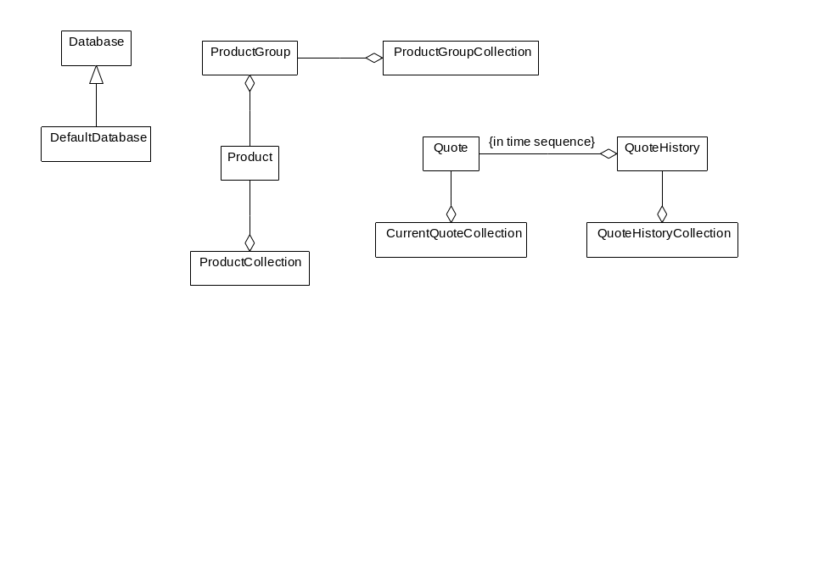

Figure 13. Class Diagrams of the Main Classes and Relationships

Features tested by software
Some of the major features that this code is intended to test are as follows:

Ability to create relationships between classes
The test software mostly contains one-to-many unidirectional relationships. The relationship between Product and ProductGroup was made bi-directional so that any features that would help with this type of relationship could be tested. Depending how the QuoteHistoryCollection is implemented, there may be an opportunity for a sorted relationship between QuoteHistory and Quote.

Ability to create keyed collection (about 50K objects)
The ProductCollection and CurrentQuoteCollection are both implemented as hashtables using the productKey as the hashtable key. In the actual implementation there will be several collections that are similar to this and each collection will have about 50K objects in it (the total number of products).

Ability to create large indexed collection (about 4M objects)
The QuoteHistoryCollection is the largest collection in the system and has been implemented as a combination of a hashtable and a vector in the test software. This collection needs to be accessed by the combination of product and time. Updates will always be at the end of the quotes for a product; for example, the times will be sequential on update, not random.

Create query for collection
The QuoteHistoryCollection will be accessed by product and time. The normal result set will only contain enough entries to fit on a screen. If a query facility can be used to improve access to this collection, it should be demonstrated in the test software.

Support for multiple writers
The program used to add quotes to the test database will have multiple copies running that will update quotes for products in the same group. After a steady state is reached, the collections should only be having updates to existing objects and inserts of new objects.

Support for multiple readers and a writer
Both of the query programs will have multiple simultaneous copies running while the add quote program is also running.

Transaction sequence diagrams

Add Quote
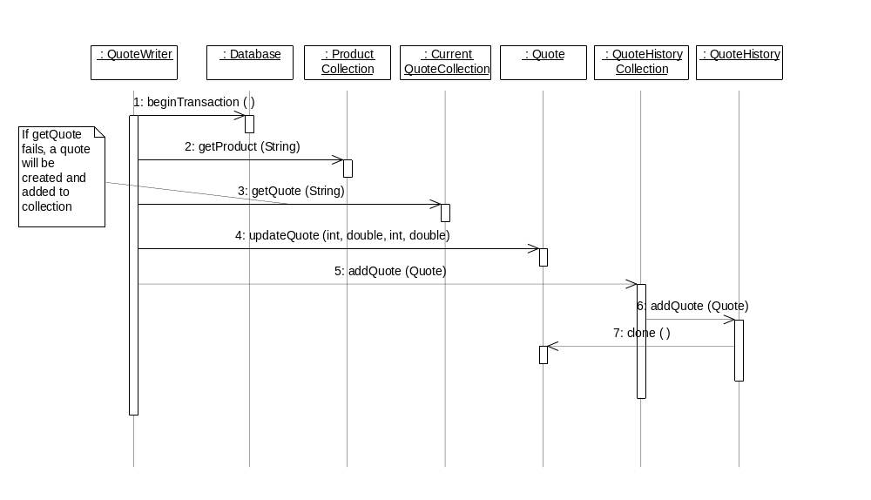
Figure 14. Transaction Sequence Diagram

Query Quote
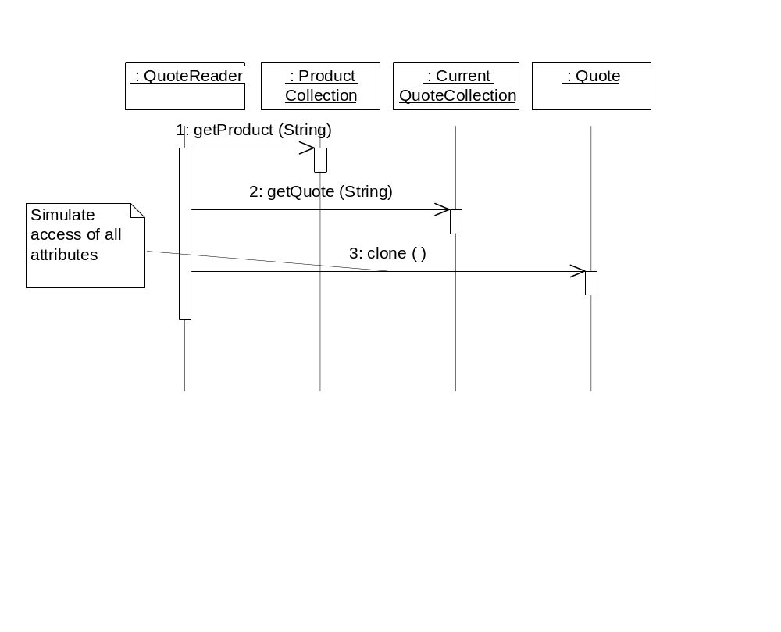
Figure 15. Query Quote

Query Quote History
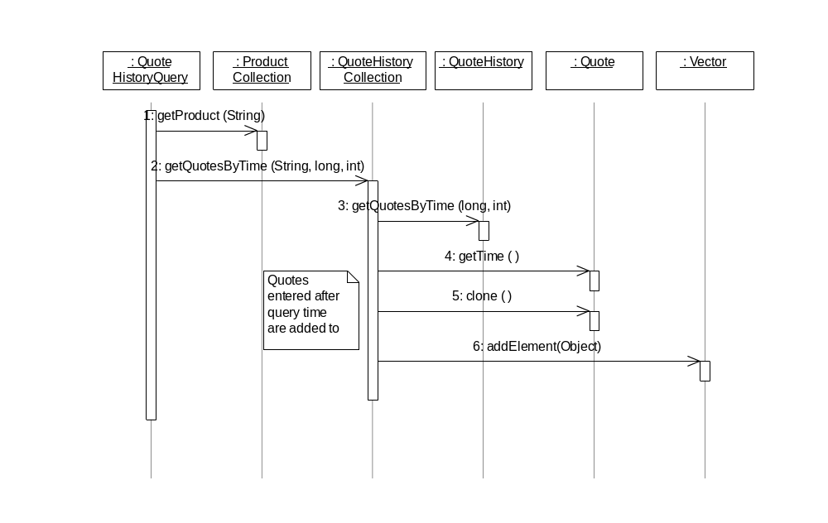

Figure 16. Query Quote History

2.3.5.2 Tests

Test Preparation

Setup Database
This section specifies specific steps that need to be done to create a new database on a Sun server running Solaris 2.5.1 (assume that the database software has been loaded, but no other work has been done). The setup should include all of the following (if appropriate for the product):
- installation of system software, e.g., patches that must be installed prior to running the database
- modification of system files
- creation of disk partitions
- creation of database
- setting database parameters
- adding database users
- loading database schema
- configure database so that transaction logs are archived

Optimizations
If any optimizations are done in the database used for initial testing, (e.g., clustering) the performance of the quote write transaction should be maximized.

Performance Tests

Load Product Database
The ProductBuilder program will be used to create a database of 500 ProductGroups with each group having 100 Products.
The test measure will be total elapsed time for product creation.

Single Writer after Cold Start
The database will be shut down and restarted, then the QuoteWriter program will be used to add 10,000 quotes for the Products of a ProductGroup.
The test measure will be transactions per second.

Single Writer with Warm Start
The single writer test described above will be repeated without bringing down the database. A different ProductGroup will be used for the test.
The test measure will be transactions per second.

Single Quote Reader after Cold Start
The database will be shut down and restarted, then the QuoteReader program will be used to read 10,000 quotes for the Products of the ProductGroup used in the single writer cold start test.
The test measure will be queries per second.

Single Quote Reader with Warm Start
The single reader test described above will be repeated without bringing down the database. The ProductGroup used in the single writer warm start test will be used in this test.
The test measure will be queries per second.

Single Quote History Query
After the previous test, the QuoteHistoryQuery program will be run to perform 10,000 queries on the ProductGroup used in the single writer cold start test.
The test measure will be queries per second.

Single Writer and Multiple Readers
The QuoteWriter program will be started along with a QuoteReader and a QuoteHistoryQuery. All programs will be run for 10,000 transactions on the same ProductGroup.
The test measure will be total transactions per second.
This test will be repeated several times with the number of readers increased for each test until the total transaction rate through the system decreases.

Multiple writers
Two copies of the QuoteWriter program will be started at the same time on the same ProductGroup and each will be run for 10,000 transactions.
The test measure will be total transactions per second.
This test will be repeated several times with the number of writers increased for each test until the total transaction rate through the system decreases.

Application Maintenance Tests
The purpose of the tests in this section is to verify the procedures that must be followed after changes have been made to persistent classes. At the end of each test, both the database schema and the current objects stored in the database should be updated to reflect the change in the class.

Add Attribute and Methods to an Existing Class
A new attribute will be added to Quote along with methods to get and set the new attribute.
The test measures will be ease of the schema evolution procedure, the amount of work space required during schema evolution, and the total time taken to complete the schema evolution.
The single quote reader test will be rerun as a regression test.

Insert New Class into the Class Hierarchy
The Quote class will have a new class inserted above it in the class hierarchy. The new class will contain a single attribute along with a method to get and set the attribute.
The test measures will be ease of the schema evolution procedure, the amount of work space required during schema evolution and the total time taken to complete the schema evolution.
The single quote reader test will be rerun as a regression test.

Database Administration Tests
The purpose of the tests in this section is to verify the procedures that must be followed for some basic administrative tasks.

Perform Full Backup with Database Running
The database utilities will be used to perform a full backup to disk while a slow version of the QuoteWriter program is running. This version will average 1 quote per second.
The test measure will be total time and the size of the backup file.

Perform Full Backup with Database Quiet
The database utilities will be used to perform a full backup to disk while no transactions are running.
The test measure will be total time and the size of the backup file.

Perform Full Restore
The database files will be deleted and then the full backup file created in the second backup test will be used to recover the database.
The test measure will be total time to recover.
A single quote reader test will be done to verify the restored database.

Perform Partial Recovery and Roll-forward Using Logs
After the full restore is complete in the previous test, the following steps will be performed:
- The single quote writer test will be used to update the database.
- After the updating is complete, a database file that contains quotes will be deleted.
- The full backup file created in the second backup test will be used to recover the database.
- After the restore is complete, the transaction logs will be used to recover any missing quotes.
The test measure will be total time to recover the database and apply transaction logs.

Recovery Time after Server Failure
The following steps will be done to test recovery of the system from a crash:
- The single quote writer test will be started.
- When the test is about half way done, all database processes will be stopped using operating system commands to simulate a system crash.
- The database server will then be restarted using normal procedures.
- The single quote reader test will be done to verify that the database is usable.
The test measures will be total time to recover and ease of applying transaction logs.

Change Clustering of Objects
This test will use the administrative tools of the database to change the clustering of the objects in the database so that the quote history query transaction is optimized.
The single quote history query test will be rerun to test the new clustering.
The test measures will be the percent speed up achieved by the clustering, the amount of work space needed during reclustering, and the total time taken to re-cluster the database.

Create Index on a Collection
This test will use the administrative tools to create a new index on the quoteTime attribute of Quote in the CurrentQuoteCollection. After the index is created, the single quote writer test will be rerun.
The test measure will be the total time taken to create the index and the percentage slowdown of the single quote writer test.
After the index is created a modified version of the QuoteReader program will be created that will query the CurrentQuoteCollection using the new index.

Add Disk Space to Database with Database Running
In this test, the disk space of the database will be increased while the slow version of the quote writer transaction is running.
The test measure will be the ease of the task.

Add Disk Space to Database with Database Quiet
In this test, the disk space of the database will be increased while no transactions are running.
The test measure will be the ease of the task.

2.3.6 Evaluation Process
Scoring was performed by the four members of the ODBMS Evaluation Team. For each criteria, a rating of 0 to 100 was given by each member, which was then multiplied by the appropriate weighting factor. The sum of the individual weighted scores produced the individual score for the product. Each product’s final score is the average for the team.

2.3.7 Evaluation Reports

2.3.7.1 Evaluation of Objectivity/DB
Objectivity declined to participate in the benchmark.

2.3.7.2 Evaluation of VERSANT

Performance and Scalability
The writer tests resulted in a transaction rate of 24 quotes per second. This was accomplished using 2 QuoteWriter processes updating a single product group concurrently. Each process ran a single thread. A significant amount of time was spent attempting to use Versant’s multiple session feature, which allows a single process with multiple threads to access a database using multiple sessions. Using multiple threads in a single process instead of multiple processes should result in a significant reduction in system resource usage. However, since each thread managed its own database session, resulting in a cache for each thread, rather than a single shared cache, the resource usage was not significantly reduced. More important, however, was the fact that the resultant application was very unstable, resulting in numerous crashes. The preliminary investigation pointed to possible race conditions in Versant’s native code. During preliminary testing, a single QuoteWriter with 32 threads was able to achieve a rate of 66 transactions per second. However, since the multithreaded version of the QuoteWriter was not stable, the final tests were conducted with a single thread version of the application.
The reader tests resulted in a transaction rate of 62 transactions per second, using 4 QuoteReader’s and 4 QuoteHistoryQuery’s, with 1 QuoteWriter running. A single QuoteReader was able to achieve 49 transactions per second running in isolation.
The bulk loading tests produced a rate of 245 products per second, using a single ProductBuilder committing all 50,000 products in a single transaction. The ProductBuilder test is valuable in determining the upper limit of performance for the system. The vendor was free to use any number of processes or threads, and was free to use as many or few transactions as needed to achieve maximum insertion rates.
Resource usage showed 73.15% CPU and 71% memory usage for the single writer, multiple reader test at the maximum transaction rate. Due to the high transaction rates, the tests were basically I/O bound.
Scalability was generally poor. The maximum aggregate transaction rate was achieved using only 9 clients. Additional clients degraded the aggregate transaction rate.

Functionality
Versant supports both C++ and Java. However, no language interoperability is provided (i.e. objects created in one language accessible by an application written in the other). The C++ binding requires that persistentable classes derived from the Versant supplied PObject class, that references to persistent objects, use special “smart” pointers (Links), and that collections use Versant supplied containers. The Java binding is basically ODMG compliant, which provides for persistence through reachability. Classes which will be persistentable must be identified in a separate schema definition file.
Point in time recovery is provided by an archive logging capability, or by using a fault tolerant installation, which uses two synchronously replicated databases. The roll forward capability replays the entire transaction log up to the time of failure, and does not provide the option to roll forward to a specific timestamp.
Clustering is supported on a per class basis, or specifying the placement of one class near another class. No support is provided for clustering arbitrary collections of objects.
A variety of index types are available, and the placement of the indexes can be controlled by the database administrator. No support is provided for indexing arbitrary collections of objects.
Schema updates are limited to adding and deleting instance variables on classes. No support is provided for changing the type of an instance variable. Adding a new non-leaf class in the class hierarchy requires deleting the instances of all subclasses of the new parent class.
Performance monitoring is provided by the vstats utility, which provides a variety of runtime monitoring information. The vstats utility uses command line arguments to specify the parameters to be monitored. However, a good utility to visually display the statistics does not exist.
The vutil utility provides a GUI-based front-end to the command line database administration tools.
Versant provides a sophisticated collection of features that support writing application servers. Transaction support includes both nested and long transactions, and checkpoint commits. Threading support allows for separate sessions per thread, as well as multiple processes per transaction. Versant provides a very flexible locking model, and support for optimistic concurrency control. However, using optimistic concurrency control requires special coding techniques. In addition, several of the features are not available when using the fault tolerant installation.
The Versant View tool provides a GUI-based browsing utility for inspecting object instances within the database. Also, an SQL add-on tool is available which allows standard SQL-based tools to be used.

Usability
Versant supports both C++ and Java. The C++ binding requires that persistentable classes derived from the Versant supplied PObject class, that references to persistent objects, use special “smart” pointers (Links), and that collections use Versant supplied containers. These requirements make it difficult to port existing C++ code to Versant, and can result in code which is tightly coupled to the product. The Java binding is basically ODMG compliant, which provides for persistence through reachability. Classes which will be persistentable must be identified in a separate schema definition file. Java bytecode files (.class) must be post-processed using a Versant supplied utility before they can be used. In addition, applications must use Versant supplied collection classes, which can greatly impact the use of third party tools.
Point in time recovery is provided by an archive logging capability, which is provided by a separate utility which is run in the background. Failure to start the utility could result in a non-recoverable database. The fault tolerant installation can degrade performance 20-30% according to Versant. In addition, several advanced features (e.g. nested transactions) can not be used with the fault tolerant configuration.
Clustering on a per class basis is fairly easy to do, but does not guarantee that specific instances will be placed on the same page. In addition, several options require set-up before the classes are used.
Indexing is easily accomplished using a command line utility. However, class-based indexing (and querying) can result in a more class-driven design, resulting in a less flexible system.
Schema maintenance requires a small, generic application be written, and the list of updates must be maintained.
The vstats utility, which lacks a GUI, is awkward to use due to the numerous options available.
The vutil utility greatly eases database administration by eliminating the need to memorize command line parameters.
Attempting to use the multithreading/multisession options resulted in quite unstable code, which resulted in numerous segmentation violations. In addition, there are restrictions on combinations of features and coding that are not enforced at runtime, which also result in segmentation violations.
The Versant View browsing tool is very easy to use.

Technical Support Quality
Evaluating the quality of technical support is difficult given the short duration of the test period. However, several problems were encountered during the tests which required support from Versant. The field engineer appeared to have difficulty convincing the technical support staff to address the problems in a timely fashion. One technical support member assigned to assist in solving the problem left the company, without notification, and did not assign the problem to an alternate engineer before the issue was resolved..
When the problem was finally addressed, the initial solution was incorrect, and information regarding the availability of a patch was misleading. Eventually, a patch was supplied that appeared to solve the problem.

Cost
The cost of the product was not evaluated at this time.

2.3.7.3 Evaluation of ObjectStore

Performance and Scalability
The writer tests resulted in a transaction rate of 13 quotes per second. This was accomplished using 1 QuoteWriter process updating a single product group. The process ran a single thread. Tests using multiple QuoteWriters produces lower transaction rates. Using 4 writers, a transaction rate of 3.5 transactions per second was achieved. The tests were conducted after significant schema tuning.
The reader tests resulted in a transaction rate of 102 transactions per second, using a single QuoteReader (warm start), and no QuoteWriter running. The multiple reader test could not be completed due to the consistent failure of the QuoteHistoryQuery process, which reported an internal OS error. The QuoteHistoryQuery process was able to run in isolation, generating 42 queries per second.
The bulk loading tests produced a rate of 185 products per second, using a single ProductBuilder committing all 50,000 products in a single transaction. The ProductBuilder test is valuable in determining the upper limit of performance for the system. The vendor was free to use any number of processes or threads, and was free to use as many or few transactions as needed to achieve maximum insertion rates.
Resource usage showed 22% CPU and 96% memory usage for the single writer, multiple reader test at the maximum transaction rate. Due to the high transaction rates, the tests were basically I/O bound.
Scalability was generally poor. The maximum aggregate transaction rate was achieved using only 4 clients. Additional clients degraded the aggregate transaction rate.

Functionality
ObjectStore supports both C++ and Java. Language operability allows objects created in C++ to be accessed from Java applications. However, objects created in Java can not be accessed from C++ applications. The C++ binding does not require a persistent base class. Normal C++ pointers are used for references between persistent objects, although references within an application that must remain valid between transaction boundaries must use a special pointer. Collections require ObjectStore supplied containers. The Java binding is basically ODMG compliant, which provides for persistence through reachability.
Point in time recovery is provided by an archiving capability. The roll forward capability replays the entire transaction log up to the time of failure, and also provides the option to roll forward to a specific timestamp.
Clustering is supported through the use of segments, which allows arbitrary objects to be placed in physical proximity to one another at the time of creation. Using segments requires the modification of application code.
A variety of index types are available, and can be created on arbitrary collections of objects.
Schema updates are limited to adding and deleting instance variables on classes. No support is provided for changing the type of an instance variable. Adding a new non-leaf class in the class hierarchy requires deleting the instances of all subclasses of the new parent class.
Performance monitoring is provided by a GUI-based monitoring tool, which provides a variety of runtime information.
ObjectStore provides very few advanced features for writing application servers. The current release supports only one transaction per process, and nested and long transactions are not supported. Concurrency control features include support for MVCC, which can increase update performance by reducing exclusive lock conflicts.
A browser tool provides a GUI-based browsing utility for inspecting object instances within the database, but no general ad hoc query facility is provided.

Usability
ObjectStore supports both C++ and Java. The C++ binding does not require a persistent base class, and normal C++ pointers are used for references between persistent objects, which result in a fair amount of transparency. Collections require ObjectStore supplied containers, which can result in applications which are tightly coupled to the database. The Java binding is basically ODMG compliant, which provides for persistence through reachability. Java bytecode files (.class) must be postprocessed using an ODI supplied utility before they can be used. In addition, applications must use ObjectStore supplied collection classes, which can greatly impact the use of third party tools.
Point in time recovery is provided by an archiving utility, and was very easy to use.
Clustering is supported through the use of segments, which allows arbitrary objects to be placed in physical proximity to one another at the time of creation. Using segments requires the modification of application code, which results in an inflexible physical database design.
A variety of index types are available, but must be created within an application.
Schema maintenance requires a small, generic application be written, but is fairly easy to do.
Performance monitoring is provided by a GUI-based monitoring tool, and is very easy to use.
ObjectStore provides very few advanced feature for writing application servers. Without support for multithreaded applications, multiple processes with a broker will be required.
The browser tool is very easy to use.

Technical Support Quality
Evaluating the quality of technical support is difficult given the short duration of the test period. However, several problems were encountered during the tests which required support from ODI technical support. The responsiveness of the support staff was good, but the solutions provided did not appear to have an impact on the problems.

Cost
The cost of the product was not evaluated at this time.

2.3.7.4 Evaluation of GemStone/J

Performance and Scalability
The writer tests resulted in a transaction rate of 225 quotes per second. This was accomplished using 8 QuoteWriter processes updating a single product group. The processes each ran a single thread. The tests were conducted with the epoch garbage collector turned off. One test was conducted with the epoch garbage collector running to measure the effect of garbage collection. During the test, which used 8 QuoteWriters, the aggregate transaction rate was 75 quotes per second.
The reader tests resulted in a transaction rate of 788 transactions per second, using 24 QuoteReader’s and 24 QuoteHistoryQuery’s, with 1 QuoteWriter running. A single QuoteReader was able to achieve 434 transactions per second running in isolation.
The bulk loading tests produced a rate of 485 products per second, using a single ProductBuilder committing 500 products per transaction (100 commits). The ProductBuilder test is valuable in determining the upper limit of performance for the system. The vendor was free to use any number of processes or threads, and was free to use as many or few transactions as needed to achieve maximum insertion rates.
Resource usage showed 72.45% CPU and 80% memory usage for the single writer, multiple reader test at the maximum transaction rate. Due to the high transaction rates, the tests were basically I/O bound.
Scalability was generally good. The maximum aggregate transaction rate was achieved using only 49 clients. Additional clients degraded the aggregate transaction rate.

Functionality
GemStone/J supports Java only. The Java binding is basically ODMG compliant, which provides for persistence through reachability. Classes which will have persistent instances are loaded into the database automatically. GemStone/J provides its own Java compliant virtual machine. Since the virtual machine is Java compliant, it will run any 100% pure Java application.
Point in time recovery is provided by an archive logging capability. The roll forward capability replays the entire transaction log up to the time of failure, and does not provide the option to roll forward to a specific timestamp. However, during recovery testing, the recovered database was corrupt. GemStone/J has identified the bug and will correct it in the next release.
Clustering is supported through the use of cluster buckets, which provides the means to clustering arbitrary collections of objects. However, since updates to objects result in the objects being copied to new pages in the database, the benefit of clustering is negatively impacted over time, resulting in the need to re-cluster periodically. In addition, clustering is accomplished by modifying the application code.
A variety of index types are available, and can be created on arbitrary collections of heterogeneous objects.
Schema maintenance is not supported at this time. A beta version of a schema maintenance utility was demonstrated, but resulted in a corrupt database.
Performance monitoring is provided by a statistics gathering program and a GUI statistics display, though the latter is marked as unsupported.
GemStone/J provides several advanced feature for writing application servers. The current release supports only one transaction per process, and nested and long transactions are not supported. Concurrency control features include support for optimistic concurrency control and concurrent update collections, which can increase update performance by reducing exclusive lock conflicts. The use of a shared object cache allows multiple, lightweight virtual machines to share common objects, significantly reducing the overhead of running multiple processes.
The GemShell utility provides for ad hoc Java programming. However, no general ad hoc query facility exists.

Usability
GemStone/J supports Java only. The Java binding is basically ODMG compliant, which provides for persistence through reachability. Classes are loaded into the database automatically, or can be preloaded using a class loader utility. GemStone/J provides its own Java compliant virtual machine. Since the virtual machine is Java compliant, it can run any 100% pure Java application. However, since GemStone/J requires its own virtual machine, there is no option to use virtual machines from other vendors, or to use native Java compilers. In addition, several third-party monitoring tools require their own virtual machines, which would restrict their usage.
Point in time recovery is provided by an archive logging capability. The roll forward capability did not work in testing due to a bug. The general process of performing recovery was labor intensive, requiring several manual steps.
Clustering is supported through the use of cluster buckets, which provides the means to cluster arbitrary collections of objects. Clustering is accomplished by modifying the application code, and must be performed for each class.
Indexing is fairly easy to perform using the GemShell utility, but requires Java coding.
Schema maintenance is not supported at this time.
Performance monitoring is provided by a statistics gathering program and a GUI statistics display, though the latter is marked as unsupported. The tool was fairly easy to use.
GemStone/J currently supports only one transaction per process. Without support for multithreaded applications, multiple processes with a broker will be required. Optimistic concurrency control makes transaction management nearly seamless.
The GemShell utility is very powerful, but requires knowledge of Java, and is not as easy to use as a GUI-based browser for simple queries.

Technical Support Quality
Evaluating the quality of technical support is difficult given the short duration of the test period. However, several problems were encountered during the tests which required support from GemStone/J. While the support staff has been responsive, no solutions have been provided to date. The problem encountered during the recovery tests was attributed to a bug, and a fix will be provided in the next release of the product. The problems with the schema evolution tool, a beta product, are still under investigation.

Cost
The cost of the product was not evaluated at this time.

2.3.8 Conclusions

While each of the ODBMS products has been around for many years, they have primarily focused on supporting the C++ and Smalltalk languages. Since Java is relatively new, the level of support and stability of the products is limited at this point in time. However, given the explosive growth of Java, it should only be a matter of time before the products reach an acceptable level of maturity. Given the need at this time for a product to support the development of the distributed trade engine, the selection of any product will require the organization to live with its limitations for the near future.
GemStone/J is the only product that provided the level of performance and functionality needed to develop the trade engine application today, with some reservations. This conclusion is based on the following key areas:
- GemStone/J exceeded the performance of the other products by a large margin. While the maximum transaction rate did not meet the goals of the benchmark, it is felt that it has a better chance of achieving the desired rates in the near future, given improvements in virtual machine and hardware technologies.
- GemStone/J has the best support for Java at this time, given that its virtual machine can execute any Java application. The other products required post-processing of bytecode files, and require the use of vendor supplied collection classes, which could severely limit the use of third party libraries.
- The vendor is currently working on improved support for multithreading, schema evolution, and database administration utilities.
In selecting GemStone/J, the following risk factors must be weighed:
- GemStone/J does not support a C++ language binding. As long as Java remains a viable language to develop CBOE applications, this will not be an issue. Data collected during the evaluation indicates that the tests where basically I/O bound, and that the development language was not a major factor in the performance of the applications.
- GemStone/J requires the use of the gsjava virtual machine, supplied by GemStone, Inc. While GemStone, Inc. has been developing virtual machines for their GemStone/S product for over ten years, and their gsjava virtual machine is based on Sun Microsystems’ code base, there is some risk that their virtual machine technology will not keep pace with improvements made by other virtual machine providers (e.g. JIT, Hotspot) . In addition, the ability to use some third party products (e.g. profilers) and native Java compilers may be restricted. However, the other products may have similar limitations due to their shared library implementation.
It is recommended that CBOE select GemStone/J as the ODBMS for development of the distributed trade engine, with the following conditions:
- Further tests must be conducted to determine the effect of GemStone/J’s garbage collection process during longer periods of operation. Due to the limited length of the benchmark tests, the long-term effect of garbage collection could not be determined. The development of the proof-of-concept application should provide a more realistic testbed for determining these effects.
- GemStone, Inc. must demonstrate that it has corrected the bug which resulted in the corruption of the database during the recovery tests. This will be verified by rerunning the tests after receiving a patch or new release of the software.
- GemStone, Inc. must demonstrate a working version of their schema evolution utility.

2.4 Phase 2—Technology Integration
The proof of concept technology integration will focus on resolving issues raised in some of the product evaluations, and demonstrate the proposed infrastructure with the implementation of a core piece of CBOE application functionality. As the guiding principle, all development will be done in Java where possible, to assess its true viability in the production system. This section describes the Proof of Concept integration effort in detail.
The goal of the technology integration phase is to verify through development of two application components, the integration transparency of the key products and technology that are selected as part of Phase 1. In addition to the products selected as part of Phase 1 of the Proof of Concept effort, the following products are included as part of the Phase 2 technology integration effort:
- Sun’s Java Development Kit, version 1.1.5
- Iona’s OrbixWeb, version 3.0.
This section will describe the Phase 2 technology integration effort by first defining what will be developed and specifically what is being proved with its construction. Secondly, it specifies how these aspects will be measured and verified. The third and final section will be completed at the conclusion of the technology verification effort and will detail the results and conclusions.

2.4.1 What Will Be Proven
Overall this effort will integrate two application components, Best Quote processing and Market Data Record into the Messaging Infrastructure. This will involve four distinct message types, supplied and consumed, by the applications. Finally, each application component will possess an element of persistent data storage.
Data is fed from the TIPS system, evaluated in the Auto Quote System, and processed in the Best Quote System. Two prototypical application components will be built on top of that event infrastructure created by the proof of concept. This event infrastructure will target the integration of the messaging product that is chosen to the benchmarking exercised into the ORB environment. The first application component will be the core of the Auto Quote System. This component will be developed in Java. The second application component will be in the Best Quote system, and will also be developed in Java.

2.4.1.1 Integration Architecture Components
The following diagram shows the components of the CBOE architecture that will be addressed in the proof of concept project.
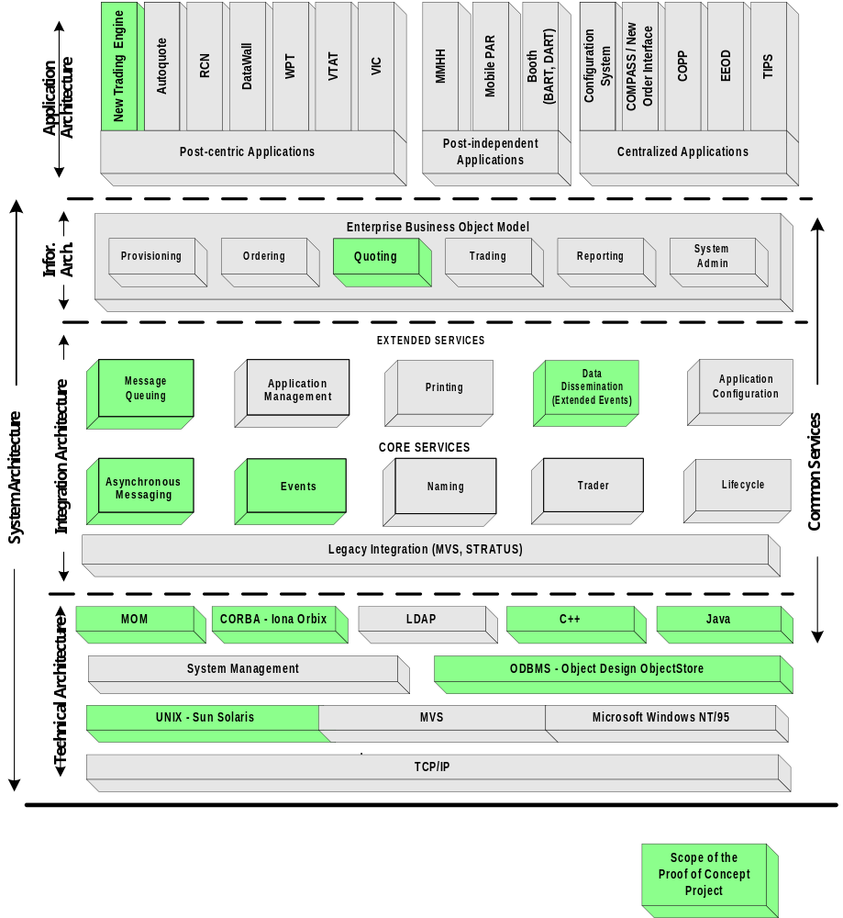
Figure 17. Proof of Concept Scope — CBOE Architecture Components
As can be seen from the diagram, the Integration Application will exercise components of the New Trade Engine (NTE) on top of two basic pieces of infrastructure services: Messaging and Persistent Storage. A minimum integration of the messaging service will be done based on the MOM product selected in the MOM Benchmark effort. This will include only those features that are directly necessary to complete the Integration application functionality.
Persistent Storage, while not directly enumerated as a service in the Integration Architecture, will be part of the Integration Application effort. This will involve the continued development of the CBOE application framework developed for use with ODBMS systems.
Persistent Storage services will be carried out in the Integration Application through the use of the ODBMS that is selected in the ODBMS Benchmark effort.

2.4.1.2 Application Components
The basic components of the application portion of the Integration Application phase are presented in the following diagram.

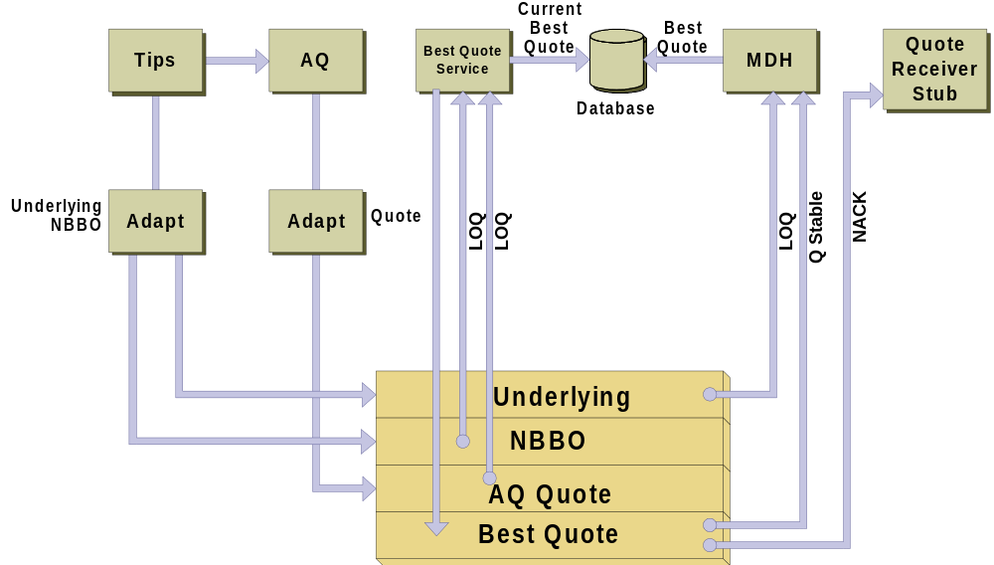

Figure 18. Application Components
Figure 18. presents five basic application components comprising the Integration Application: Ticker Processing System (TIPS); AutoQuote; Best Quote; Market Data History; and Quote Receiver Stub. Each component is described in the following sections.

TIPS Component
Two basic types of event data, Underlying and National Best Bid Offer (NBBO) information, will be processed by the Integration Application from the existing TIPS system. The TIPS system will not be changed, but instead an adapter will be constructed for this effort in Java. This will be based on the existing work done by the CBOE NTE team to interact with the existing Network Application Programming Interface (NAPI) network messaging library.
The adapter will directly select only the information needed by the Integration Application and the options classes that are selected for the testing. The TIPS adapter will generate both Underlying and NBBO messages that will be transmitted via the messaging infrastructure to interested consumers.

AutoQuote Component
In Phase 2a of the Proof of Concept, the existing AutoQuote system will be used unchanged, and an adapter will be constructed to receive quote messages from the AutoQuote Gateway. The adapter will be done in Java, and will be based on the existing work done by the CBOE NTE team to interact with the existing NAPI network messaging library.
The AutoQuote adapter will generate AutoQuote messages that will be transmitted via the messaging infrastructure to interested consumers.
In Phase 2b, a subset of the AutoQuote system will be integrated into the event infrastructure for asynchronous communication of quotes with the Best Quote Service. The AutoQuote Modeler may be modified to communicate synchronously with the new AutoQuote Service.

Best Quote Component
The Best Quote application component will generate the current best quote based on quotes generated by the AutoQuote system and manually enter quote values. In addition, Best Quote will make a determination based on the NBBO data. Finally, Best Quote will generate Best Quote messages, which will be transmitted via the messaging infrastructure to interested consumers.
Internally, the Best Quote component will maintain an Object-Oriented (OO) database through the Persistent Storage service of the products being processed and the current Best Quote values. This will be updated at least as often as Best Quote processes groups of messages from the Quote event channel.
Best Quote will consume NBBO and AutoQuote events through Last Only (LO) queues provided by the messaging service infrastructure.
Best Quote will supply BestQuote events to the Messaging service infrastructure.

Market Data History Component
As indicated by the name, the Market Data History (MDH) acts as a history of record for trading activities at CBOE. The MDH application component will process BestQuote and underlying information from the messaging system and provide a continuous history of all BestQuote values supplied by the Best Quote component.
MDH will consume Underlying events through a LO queue provided by the Messaging service infrastructure.
MDH will consume Best Quote events through a stable delivery queue (QStable) provided by the Messaging service infrastructure. This will guarantee that all events are eventually delivered to MDH.

Quote Receiver Component
The Quote Receiver application component will simply consume Best Quote events from the Messaging service infrastructure. Best Quotes will be received directly from the Messaging service infrastructure with the minimum delivery guarantees, typically negative acknowledgment (NACK).
The Quote Receiver application will implement the QuoteReceiver CORBA interface which consists of two operations: acceptQuote(Quote) and acceptQuoteSequence(Quote[]). Using the services provided by the com.cboe.common.CommPath package, block, message, and byte rate measurements will be collected and possibly saved for performance monitoring. Quote data consumed from the Best Quote Event Channel will be optionally saved to a local log file. For the purposes of the Proof of Concept, this application will run on an NT hardware separate from the main server.

Figure 19. Proof of Concept Scope Diagram—Legend
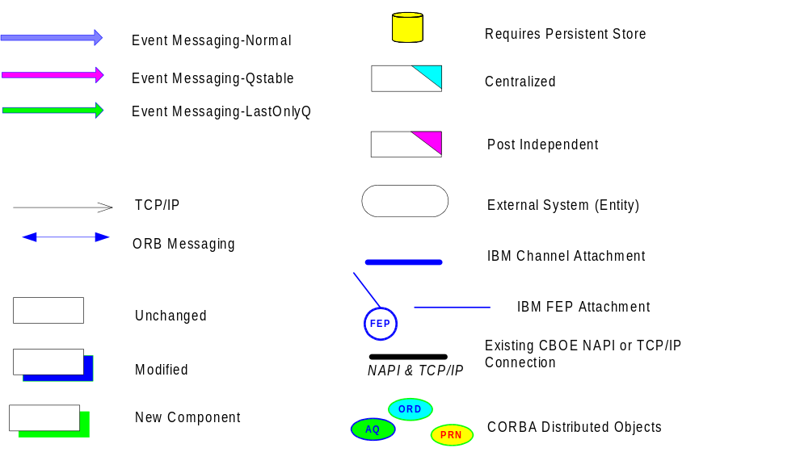

The following exhibits—Figures 20 and 21—provide expanded views of Figure 18. The exhibit above—Figure 19—provides an explanation of the symbols used.
Figure 20 illustrates the event channel depicted by an arrow. In addition to components identified in Figure 18, this diagram includes the synchronous components involved with Quote Input and MDH Inquiry.
Quote Input is a user interface that will input manual quotes synchronously through the ORB to the Best Quote Service. MDH Inquiry will communicate synchronously through the ORB with the MDH Service, providing access to market data being generated and collected during the test.
This figure represents Phase 2a, where AutoQuote is unchanged and is communicating through the infrastructure with an adapter.
Figure 21 depicts Phase 2b, which involves the integration of AutoQuote into the event infrastructure for asynchronous communication and the synchronous communication with the AutoQuote modeler.

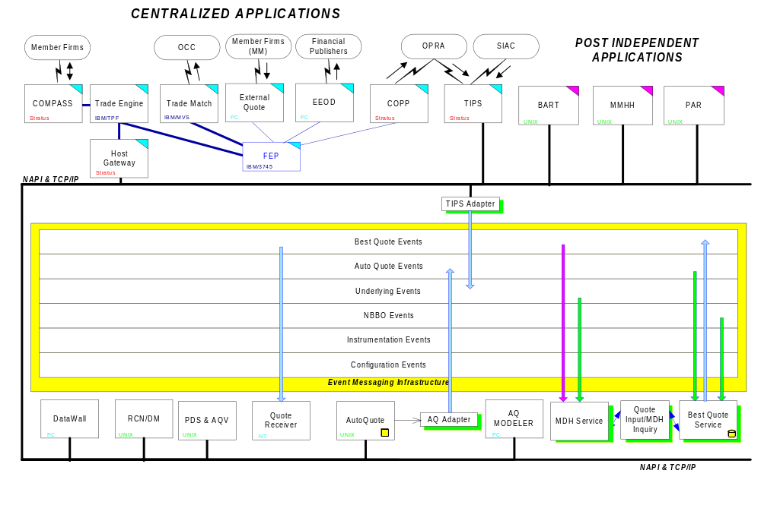
Figure 20. Proof of Concept Scope Diagram—Phase 2a
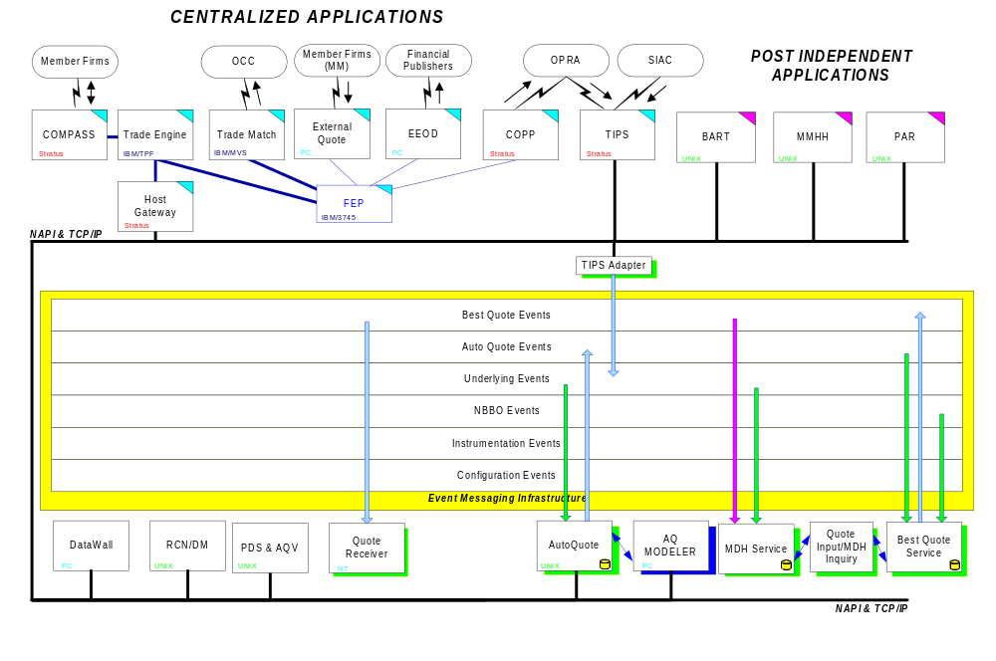
Figure 21. Proof of Concept Scope Diagram—Phase 2b

2.4.2 Deployment
The drawing below shows the proposed deployment of Sun and IBM hardware for the Proof of Concept. The current test network and current test IBM R24s and 380s will be used. It is assumed the Sun E4000s will be cabled into this existing test network and connected similar to the test R24 PDS (pds0a1).
The E4000 network attachments marked "proposed" indicate that a FDDI card will be installed in each box, in addition to the standard Ethernet adapter. With the FDDI card, the E4000 can be dual-homed; it will attach to the FDDI "post" backbone and the Ethernet "Global" backbone.
At the time of this report, two distinct "test" post networks were unavailable. This separation may be accomplished logically in the application while the machines reside on the same physical network. However, this would require either an additional R24 cluster or the use of the model 380s PDSs (pds0a/0b).

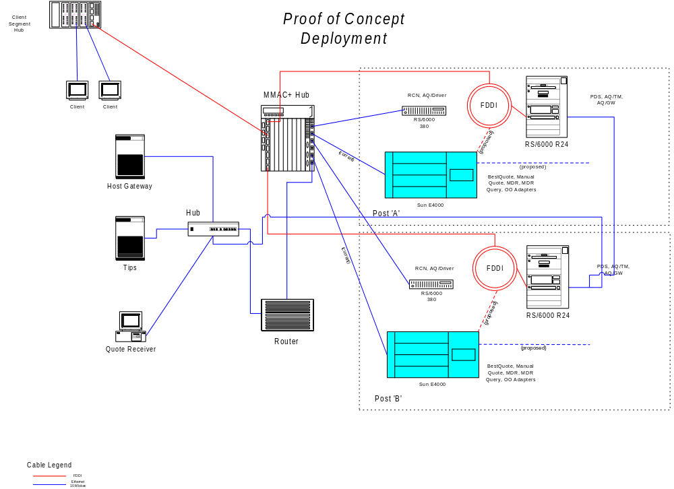
Figure 22. Deployment Diagram

2.4.3 Components
These testing procedures will be used to evaluate the Proof of Concept for the Distributed Trade Engine. The test will be used to show how successful the proof of concept was in integrating the individual products and attaining the performance goals necessary for a new trade engine. It is broken down by component and indicates the platform, the number, what will be measured, and what the expected results are for each component. The input components are identified and what rates will be needed are defined. A single post simulation will be run first (i.e. one AutoQuote and one BestQuote) followed by a two post simulation with the second post running on a second SUN UltraSparc machine.

The following components will be evaluated during the Proof of Concept:
- AutoQuote
- Best Quote
- Market Data History
- Quote Receiver
- Market Data History Inquirer

The following components will be used for inputs to the test:
- Manual Quote Input
- TiPS

AutoQuote
Platform
During the first phase of the Proof of Concept, the AutoQuote component will adapt the existing AutoQuote gateway output into the BestQuote Service.
Instances
There will be one instance of an AutoQuote adapter connecting an AutoQuote gateway for each BestQuote service.
What Measured
The AutoQuote component will need to generate quotes for 10 separate reporting classes each containing at least 30 options. The quotes generated/second as well as total quotes generated will be measured.
Expected Results
The AutoQuote component will need to generated a sustained rate of 700 quotes/second over a 5 minute period.

Best Quote Component
Platform
The Best Quote component will reside on a Sun UltraSparc server.
Instances
There will be two instances of Best Quote each running on a separate server.
What Measured
Each Best Quote component will need to have a database of 5000 option products divided across 150 reporting classes. The database needs to include the 300 options for which the corresponding AutoQuote component will be generating quotes . Measurements include: the auto quotes received/second, the best quotes generated/second, the NBBO updates received/second, the total auto quotes received, the total manual quotes received, and the total best quotes generated. .
Expected Results
The Best Quote component will need to process a sustained rate of 700 quotes/second over a 5 minute period. It will need to process a sustained rate of XX NBBO updates/second over a 5 minute period. The total number of auto quotes received will match the number of AutoQuotes generated. The total number of manual quotes received will match the number of manual quotes generated.

Market Data History Component
Platform
The Market Data History component will reside on a Sun UltraSparcserver.
Instances
There will be two instances of Market Data History each running on a separate server. Each instance will correspond to a Best Quote instance.
What Measured
Each Market Data History component will need to have a database of 5000 option products divided across 150 reporting classes. The database needs to include the 300 options for which the corresponding Best Quote component will be generating quotes . Measurements include: the quotes received/second, the underlying updates received/second, the total quotes received, the total underlying updates received, and the inquiries received.
Expected Results
The Market Data History component will need to process a sustained rate of 700 quotes/second over a 5 minute period. It will need to process a sustained rate of XX underlying updates/second. The total number of quotes received will match the number of BestQuotes generated. The total number of underlying updates received will match the number of TIPS underlying updates generated. The number of inquiries will match the number of inquiries sent.

Quote Receiver Component
Platform
The Quote Receiver component will reside on a Windows NT workstation.
Instances
There will be one Quote Receiver for both Best Quote components. The instance will run on a separate workstation and receive quotes from both Best Quote components.
What Measured
Each Quote Receiver component will need to subscribe to the 300 products for which quotes will be generated . The quotes received/second and the total quotes received will be measured.
Expected Results
The Quote Receiver component will need to process a sustained rate of 700 quotes/second over a 5 minute period. The total number of quotes received must be within 95% of the number of BestQuotes generated.

Market Data History Inquirer Component
Platform
The Market Data History Inquirer component will reside on a Windows NT workstation.
Instances
There will be one instance of Market Data History Inquirer for each Market Data History component. Each instance will run on a separate workstation.
What Measured
Each Market Data History Inquirer will perform Market Data History inquiries at random intervals throughout the test. The number of inquiries submitted, and the response time for each inquiry will be measured.
Expected Results
90% of the inquiries must respond in less than 3 seconds. No inquiry will take more than 5 seconds. The number of inquiries sent will match the number of inquiries received by the Market Data History component.

Manual Quote Input Component
Platform
The Manual Quote Input component will reside on a Windows NT workstation.
Instances
There will be one instance of Manual Quote Input for each Best Quote component. Each instance will run on a separate workstation.
What Measured
Each Manual Quote Input will send manual quotes at random intervals throughout the test. The number of quotes submitted, and the response time for each quote will be measured.
Expected Results
90% of the quotes must respond in less than 1 second. No quote will take more than 3 seconds. The number of quotes sent will match the number of manual quotes received by the Best Quote component.

TIPS Component
Platform
The TIPS component will reside on a Stratus system with an adapter residing on a Sun UltraSparc server.
Instances
There will be one instance of TIPS and the TIPS adapter.
What Measured
TIPS will send out underlying updates and NBBO updates to subscribers. Measurements include: the number of underlying updates/subscriber/second, the number of NBBO updates/subscriber/second, the total number of underlying updates/subscriber, and the total number of NBBO updates/subscriber.
Expected Results
TIPS will generate a sustained rate of XXX underlying updates/second for 5 minutes. TIPS will generate a sustained rate of XXX NBBO updates/second for 5 minutes. The number of updates/subscriber will match the number of updates received by each subscriber.

2.4.4 Measurements
This section discusses the results obtained from the performance tests. Both Gemstone/J and Oracle were tested for integration performance within CBOE’s application architecture. After struggling to get the Gemstone and Versant products to work, Oracle’s relational database was added to the performance tests.
The setup for the different components is described below:
- The ProductService was run on a Sun Solaris 4 processor (designated dte_dev) machine with 1024 MB of memory.
- The BestQuoteService was run on a Sun Solaris 6 (designated dte2) processor machine with 1024 MB of memory.
- The MarketHistoryService was run on a Sun Solaris 6 (designated dte2) processor machine with 1024MB of memory.
- The QuoteReceiver was run on a NT Pentium II (designated client 1 and dte1) Workstation and a Sun Solaris 2 processor machine with 1024MB of memory.
- The MarketHistoryQuery was run on a NT Pentium II (designated client 1) Workstation.
Unless otherwise noted, the data driving the quote adapter was sent from a Stratus machine using the sld program to send production like AutoQuote data at specified rates. The data file contains 25 reporting classes with an approximate 30 series per class. Approximately 85% of the series matched the product service database.

Evaluation of Gemstone/J
Gemstone/J measured 120 quotes per second through the system. This was accomplished after a last effort by Gemstone engineers to fix a problem with the interaction of the messaging and Gemstone VM. The test was run using a single thread.
MarketHistoryService generated 120 quotes per seconds using 1 CPU at 100% single threaded. However, the service crashed after 30 minutes due to a Gemstone VM error.
BestQuoteService generated 120 quotes per second. The system used 1 CPU at 100% single threaded.
The test was performed with Gemstone’s Epoch Garbage Collection turned on. It was run at a steady input rate until the threshold of queuing to the Best Quote Service was reached. Market History queries were performed during this test with acceptable user perceived response times.
IO wait states were between 8% and 20%.
The desired rate of 700 quotes per second on a server was not achieved.

Evaluation of Oracle
Oracle measured 240 quotes per second through the system. This was accomplished using 4 threads.
MarketHistoryService generated 200 quotes per second. The system used 2 CPUs running 4 threads
BestQuoteService generated 250 quotes per second. This was accomplished using 2 CPUs running 4 threads.
IO wait states averaged 10%.
This test was run with stair stepped message rates until the threshold of queuing on BestQuoteService was reached. Market History queries were performed during this test with acceptable user perceived response times.
The desired rate of 700 quotes per second was not achieved.
BestQuoteService and a QuoteReceiver were tested without MarketHistoryService to show database commit times for updates. This test resulted in 270 quotes per second generated through the system.

No Database
A test was run without a database using a single thread. This resulted in the generation of 1020 quotes per second through the system.
MarketHistoryService generated 180 quotes using 1 CPU at 100% single threaded.
BestQuoteService used 1 CPU at 50% single threaded and generated 1020 quotes per second.
The AutoQuote adapter reached a maximum drive of 175 packets a second.
This test was performed with the rates being ramped up every 5 minutes or so until the maximum rate of the driver was reached.
An additional test was performed with a Java script driver using the same data file for quotes as the others but sending as fast as the TCP Socket would allow. This test resulted in 1080 quotes per second generated through the system.

2.4.5 Summary and Conclusion

- The Java/C/C++ developed Event Messaging layer performed within the planned needs. The current plan is to go forward with this technology. The messaging layer was tuned to some degree but improvements could probably be made in the planned future increments.

- The persistence problems encountered during this effort with Versant and GemStone/J appear to be maturity of the Java interfaced product. The ease of developing Java code provided all these alternatives but the stability with the products caused delays.

- GemStone/J and the 120 quotes/second throughput rate is a minimum number which can be increased with tuning.

- The Use of Oracle in the Proof of Concept provided a stable environment. Tuning of the application and its use of Oracle could be done to improve the measurements. This does, however, create a conversion layer which makes the development effort more complex.

3. Overall Results of PoC
The Proof of Concept stands as a qualified success. A tremendous amount was learned by the team during its execution.
The following key results can be reported:
- Java as a language demonstrated good performance and the ability to speed design of components with an object oriented process.
- A “fusion” of ORB, Messaging and Database technology does work.
- Commercial “off the shelf” technology can fulfill CBOE’s requirements in many key areas (synchronous and asynchronous object communication)
- PoC-like activities should be employed in future when new technologies are introduced to CBOE.
- Java Databases are immature at this time and the alternative is to use a stable relational database with an interface layer (JDBC) or mapping systems that are available on the market today.
The various stages of the PoC are examined below and issues from each captured and discussed.

Process and Inputs
This section is intended to report and discuss issues that arise from the process used to support the decision making process embodied in the Proof of Concept and examine the inputs to that process.
There was consensus that somemany icipants were unready for the nature of the technology and that preliminary education on various topics would have benefited team members greatly. Tight timescales precluded this to ansome extehough better cross communication between teams and individuals would have helped in this regard too. The most problematic seems to have been during the Infrastructure design phase when there seems to have been some lag between decisions being made in Tampa and their presentation by TRC in Chicago. Another area of concern was that the Business Object Model task should have been completed earlier in the entire process to afford a clearer understanding of the issues of business process, interfaces and semantics.
A closer working relationship may also have spotted the issues with respect to JNI, JVM and threading that came to be a problem subsequently in the integration phase of the PoC. In addition, the product benchmarking phase could have done a better job at looking at product interworking issues (even on paper) rather than a purely performance oriented one.
There was a general realization that the definition of interfaces (IDL) will be crucial to multi-site working and the management of “drift” in those interfaces critical to success on SBT. The SBTs fairly aggressive timescales rely on integration taking place relatively smoothly according to the observance of interfaces as contracts.

Benchmark phase
This section examines issues from the benchmarking phase of the PoC. Two technologies were benchmarked during this time: Database and Messaging Middleware.
Many of the issues from this phase stem from the tension between the tasks to be undertaken and the time allotted for this phase. All of the following areas of data collection and problems that later were found to require answers could have been caught in this phase….
- Machine resource utilization figures (cpu, memory)
- Assessments of scalability (e.g. network issues and DB sizes)
- Product interworking (checks done on paper would have helped)
- Threading issues (Versant issue was spotted on day one)
- Vendor issues (many and varied – see below)
Once more there was a sense that cross team interactions could have been better and were compromised by the tight time schedules and location issues.
The various vendor relationships during this phase varied greatly from being very good to leaving much to be desired. Those vendors who failed in this phase themselves probably bear the brunt of the criticism for their lack of responsiveness and in some cases half-hearted commitment to the PoC. In the MOM benchmark this left a choice of one though this turned out to be a good choice. The issue does however reinforce the recommendation regarding close vendor ties for the future.
Lastly, the omission of an ORB benchmark was felt to be a drawback.

Integration phase
This section examines the issues from the integration phase, where the chosen products were made to interwork with sample applications from the CBOE environment. The issues relating in detail to tools, products and the Java language are captured and discussed in separate sections below. Those issues pertaining to the phase as a whole are dealt with here.
First, it was judged that the PoC application set did provide good coverage although it was centered on the requirements of the DTE (Distributed Trade Engine) and more floor oriented requirements. The change of focus to SBT came as the PoC was already well underway. The requirements of SBT are generally felt to have been well covered by the PoC with the exception of the following:
- The SBT Broker Component
- SBT Security
- Scalability w.r.t. number of clients
- System Management/Application Management
The working of clients, event/information dissemination and database access patterns were all well exemplified in the PoC.
The PoC design and code was never reviewed, however, and it was felt that more time should have been spent planning and developing the test drivers and DB population tools for this phase. A test login, independent of any single user, should have been provided.
Some provision should also be made in the design for a common means of obtaining run-time configuration information.the future sd ut realissystem when the use of multicast routers across subnets needs to be included.
Going forward into the SBT project it will be important that bounds on the performance of the various components be well-defined. Since it was clear during the PoC that the application layer can throttle the performance of event infrastructure for example, it is important to determine what the throughput and timing requirements for the event infrastructure need to be. By using this information in the next design phase, the allowable bounds on overhead for the application layer can be established. These bounds should be categorized according to message type.

Tools
Various tools were used during the PoC and an exhaustive commentary on their use is not available. Here are the leading issues gathered from the PoC team members.
Rose can be used for code generation and reverse engineering. While it seems possible to use Rose in this manner, it requires that certain subtle rules be followed in the configuration, environment and use of the tool. Unfortunately, these subtleties are easy to overlook and more than one team member found it necessary to abandon the attempt because it was time consuming and modifications to files were often lost.
It was felt that the use of ClearCase was a good decision though the shortage of trained users and it’s late installation in Chicago hampered the initial creation of the development environment for the PoC.
The VisualAge 2.0 link to ClearCase shows promise but needs further trial in addition to the multi-site option for these products.
Various processes (compiling, linking etc) were found to be slow and investigations had shown there was inefficiencies in the setup of the compiling with ClearCase controlled source code.the future to optimi
its VM does not support JNI and IBM's Jinsight would not run on symmetric multiprocessor machines. The Jikes debugger proved to be the most trusted but was still judged poor in comparison with tools from other language environments.
In addition some linking options prevented debugging at times.a little better. The following were used during the PoC:
- Jprobely over Optimizeit.
The overall conclusion is that Java tools are immature currently and outside of the IDE choice it is likely to be a good policy to keep trying new ones as they appear on the market providing this does not compromise delivery schedules.
e PoC did not handle this issue. There were other methods employed to work around the problem such as implementing debugging logic inside the code.
The choices of debuggers were Sun’s JDB released with the JDK, IBM’s Jikes debugger, and IBM VisualAge for Java. The preferred debugger on the Sun platform was IBM’s Jikes and for use on the NT platform it was VisualAge.
Java profilers were available from several vendors and each used different strategies to profile Java runs. Jprobe from K&L Group is an instrumented Java VM, OptimizeIt from Intuitive Systems is a java program that interacts with the profiled code and Jinsight from IBM is an instumented Java VM. It was felt that the profilers are a tool that will give insight into relative code behavior. The preferred product was K&L Group’s Jprobe.

LanguageThe principal language for the PoC was Java (JDK 1.1.6 although the 1.1.6 JIT option was used and the JDK 1.2 was also trialed). The entire team was pleasantly surprised by it’s performance and judged it acceptable for CBOE requirements in the majority of cases though C++ is likely to be used in certain performance critical areas in the future.
For example, when it was discovered that CDR marshaling introduced significant performance penalties in terms of throughput, it was not possible to introduce any effective optimizations. In C++ by contrast, fast operations such as memcpu are available.
The lack of certain features in Java therefore makes it unsuitable for certain tasks at this time. As an example, the lack of memory management features makes Java unsuitable for maintaining and managing potential large message queues and flow control. Since there is no way to establish the memory consumption of a queue or its items, there is no way to manage and control its growth. JDK 1.2 introduces Caching and Weak References which may partially address this issue. The Java thread API is primitive and lacks many of the fundamental building blocks present in most threading packages. Primitives such as semaphores, reader-writer locks and sophisticated waiting mechanisms are lacking and make constructing any complex threading models difficult and error-prone. Additionally, the mapping of Java threads to OS threads (user or kernel) is impossible to control with any degree of precision. On Solaris, for instance, Sun's VM supports a many-to-many mapping of Java threads to user threads, but it is impossible to discover by any well-established means just how many Java threads map to how many user threads.
By manipulating some of the options available in Sun's java tools, it was possible to effect some improvement in , it was clear that certain areas of Java related technology are far from mature and care must be taken to assess the stability of these technologies (including employing a prototype perhaps) before expecting products to be ready for primetime enterprise deployment. Examples are likely to include the following at this time:
- Enterprise
- Java related Persistence (sl in flux in it is felt that JDK/JVM issues now dominate operating system issues from a platform viewpoint.
Java was shown to be a very robust environment to build realtime systems. It was originally thought that Java would be inherently slow due to the interpreted nature of the Java Runtime Environment. The PoC demonstrated that Java performance was clearly acceptable.
The integration of Java with C++ in the JNI specification for use with the event channel was very successful and shines a light to the path of JNI based performance improvements if it is found as necessary implementation.
It was determined that designing within the scope of Java boosted productivity over a similar type of effort that would use C++. This gives Java an edge in development of systems in a large environment.
The Java world is still very young and innovations in the VM technology are progressing at a rapid pace. It is possible that the improvements being made will make Java runtime execution equal that of compiled native code.

Products

Object Request Broker
The value of CORBA and IDL was demonstrated by the PoC and hence this strategic technology direction was reinforced.
The product chosen in a paper exercise (IONA’s OrbixWeb 3.0) worked though the IDL compiler was flawed in the handling of include statements that did not reference properly. Some experience with Inprise’s Visibroker product during the PoC seems to indicate that it has superior performance characteristics to those of OrbixWeb.
It is recommended to perform ORB evaluation prior to the SBT project. The reservations about Inrpise’s (formerly Borland) direction with regard to CORBA and tools seem to have been addressed and these two players are the market leaders. The new technology embodied in IONA’s ART ORB should not be discounted, however, and should be combined with an assessment of CORBA services availability to arrive at a conclusion for SBT use.

Database
The PoC did not resolve the choice of database technology at either the benchmark phase or the integration phase.
The state of the available products suggested that vendors have limited experience with their offerings in production systems. Gemstone’s VM did not properly implement support for JNI, Versant crashes when a single object instance is present in two different transactions. driver would not se vendors had to be extensively consulted during the integration phase to solve problems.
The general consensus was that object database stability is a problem that would point to using the alternatives.
Due to the problems with the object databases, it was determined to pursue an implementation with Oracle. Oracle was not originally considered since it is not an object database. The results of ad hoc implementation were very acceptable using the relational database and the stability was consistent. There were changes in using the pure Java drivers from Oracle for JDBC due to in-operability with the Sun Solaris JIT. The drivers were switched to the Oracle OCI driver which requires a subsystem install to support the OCI driver but which cooperates with JDBC using the JIT. This was not a problem on the Windows NT.
the key to obtaining good levels of performance from all products.of immaturity it may not offer a viable alternative. Application Server products (Net Dynamics, WebLogic, Oracle, Novera, Vision JADE, etc) maMessaging Middleware/Event Infrastructure
The CORBA Event Channel integration with an off-the-shelf MOM (Talarian) was successful in the first iteration and the performance of this integration is impressive. Expectations of performance were colored by experience with IBM’s MQ and when message rates exceeding 2000 per second were recorded, there was encouragement that CBOE’s target performance figures could be met.
It became apparent that additional quality of service levels may be necessary. The current implementation of the Event Service does not guarantee that requests will be delivered to consumers in the same order that they are received from the underlying MOM software. An extra QoS level for ordered message delivery should be created. Also, consideration needs to be given for enabling quality of service levels dealing with message priority and latency.
The TransportManager, ServerConnection, and ClientConnection proved to be extensible abstractions when the loopback mechanism (in-process) was easily added as an alternative to the Talarian transport.
It was also noted that Talarian requires an RTServer instance running on every box for it to run in a stable fashion.
(Kevin Yaussy)—For the tools issue (debugging and profiling), it seems like we might have some leverage with Sun and IBM as far as improving their tools, for a price possibly. Profiling is a fuzzy area. Because most of the time you are just trying to get a feel for relative code behavior, a product’s inability to work with JNI or its unavailability on a particular platform, may not be an issue. However, when we are wanting to get a feel for a threading/locking code path, it may become important for the product to be more fully compatible. Debugging leaves little or no choice, and it seems reasonable that we may be able to exert pressure on Sun or IBM for a better product.
This is an important issue that must be resolved immediately. I don’t have an easy answer. Moving to a larger facility has its own set of problem and will also take up valuable time. The resolution of this problem should not be taken lightly and should maybe be included in the “key results” list in section 1.

4. Recommendations
Recommendations from experiences and insight gained during the PoC are reported below.

Process and Inputs
- Review planning to include explicit training phases
- Video-conferencing should be investigated for future inter-site meetings.
- Establish a communications link to support multi-site development (utilizing multi-site options of development tools)
- Management of Interface Definition change control crucial for SBT project.
- Improve the Status Report format to enable Management visibility and timeliness.

Benchmark Phase
- Improve future benchmark criteria to address the following:
- Machine resource utilization figures (cpu, memory)
- Assessments of scalability (e.g. network issues and DB sizes)
- Product interworking (checks done on paper would have helped)
- Threading issues (Versant issue was spotted on day one)
- Vendor issues (many and varied)
- Perform an ORB evaluation.

Integration Phase
- Review new SBT project non-functional requirements (esp. w.r.t. performance and availability) in the light of PoC results
- Ensure SBT project plan covers sufficient review activities
- Ensure SBT project plan covers test planning and test driver implementation
- Provide Test login capability for SBT project
- Create realistic test network for SBT project
- Define detailed requirements for Infrastructural Components (for contractual use in fixed bid projects).

Tools
- Complete the CM and build policies and procedures document
- Continue to evaluate Java tools
- Press vendors for better interworking options for development environment components
- Plan training for key development tools into the SBT project
- Define and document standard Development Environment (the fusion of the disparate products)

Language
- Utilize Java for the SBT application with JNI to bridge the MOM subsystem and for areas that demand optimized performance. or ex
- Establish a relationship with Sun/JavaSoft to make sure that CBOE obtains the best access to new Java technology and is able to influence product directions and priorities.
- Establish relationships with other vendors (hardware and software) to make sure CBOE obtains the best access to products related to the use of the Java language and maximize CBOE’s understanding of this market.
- Form a team to keep abreast of Java developments and maintain a Java testbed to predict impact of Java changes on CBOE developments.

Products

Object Request Broker
- Do not use proprietary extensions to CORBA that commercial ORBs support except where absolutely necessary.

Database
- Use Oracle relational database for the implementation with a persistent framework to layer the relational access to the objects.
- Determine canonical access patterns and transaction policies.

Messaging Middleware/Event Infrastructure
- Move forward with Talarian in the infrastructure development.
- Add QoS requirements on Event Infrastructure and reflect possible new tasks on the SBT plan.
- OMG IDL and the Typed Event Service proved to be a valuable standard for the Event Infrastructure extending the CORBA programming model for synchronous and asynchronous styles. This model should be employed pervasively.
Talarian version 5 must be licensed and then used for SBT development following a re-run of existing test scripts to check compatibility.

5. References

Manifesto." Building An Object-Oriented Database System, California: Morgan Kaufmann, 1992.
[Carey93] Carey, M., DeWitt, D., and Naughton, J., "The 007 Benchmark," University of Wisconsin Technical Report, April 1993, revised January 1994
[Cattell88] Cattell, Rick, “Object-oriented DBMS performance measurement,” Proceedings of the Second International Workshop on Object-Oriented Database Systems, 1988.
[Cattell92] Cattell, Rick, and Skeen, J., “Object Operations Benchmark,” ACM Transactions on Database Systems, 17(1), March 1992.
[Cattell94] Cattell, Rick, “Object Data Management : Object-Oriented and Extended Relational Database Systems,” Addison-Wesley, May 1994.
[Cattell97] Cattell, Rick, Barry, D., Bartels, D., Berler, M., Eastman, J., Gamerman, S., Jordan, D., Springer, A., Strickland, H., and Wade, D., “The Object Database Standard: ODMG 2.0,” Morgan Kaufmann, 1997.
[Walker97] Walker, Peter, “CBOE Technology Architecture.” Prepared for The Chicago Board Options Exchange, December 1997.
[Loomis94] Loomis, Mary E. S., “Object Databases: The Essentials,” Addison-Wesley, 1994.
[McFarland93] McFarland, Gregory and Rudmik, Andres, “Object-Oriented Database Management Systems (OODBMS): A DACS Technical Report,” Data and Analysis Center for Software (DACS) Technical Report, Contract Number F30602-89-C-0082, September 1993.

In practice it would be near impossible to apply Amdahl’s law numerically. At the very least, the unpredictable serial percentage introduced by context switching would be impossible to account for.

