Analysis on the Impact of
Removing Class Level Lock

Performance Team

Introduction

From previous performance scalability analysis, we have concluded that one of the top causes for the un-scalability of trade engine is the class level lock combining with the randomness of execution time. The dramatic negative impact of that on scalability was demonstrated by the results of a simple test program, which are shown in the following table as a quick reference (for a full discussion, please refer to the report Trade Server Performance Scalability: Issues and Recommendations).

Number Of Threads CPU Usage without Lock CPU usage with Lock

32 99.8 % 60.0 %
10 31.2 % 21.1 %

The tests were run on a 32-way machine. Lock causes the new batch of tasks cannot be dispatched to work threads while the slowest work thread works on one task of current batch. All other work threads have to wait for the completion of slowest work thread. The net effect is that 40% reduction in CPU usage for 32-thread configuration, and 32% reduction in CPU usage for a 10-thread configuration.

Removing the class level lock is therefore considered to be one of the top items that will improve the performance scalability dramatically.

A lot of current trade server functions are depending on the class level lock to function properly. This report will try to find out all those functions and analyze the implication of removing class level lock on those functions.

Categories of Commands
For every task that requires class level lock, system creates a command to represent the task, for example, an AcceptQuoteBlockCommand is created to process a quote block, and an AddProductCommand is created to process intra-day product addition, etc. By the ways of commands are processed, we can classify the commands into three different categories:
- Quote Block Command.
A quote block command belongs to its own category. It is now processed by totally different way than all other commands are processed. The processing flow of this command is that MMQS thread creates a quote block command (through Broker object), acquire a class level lock (through CommandProcessor object), and dispatch the subcommands for each individual quote in the block to a number of work threads (through BrokerCommandThreadPoolImpl object) and wait for work threads to complete. Work threads process individual commands in parallel. There are two kinds of threads involved in processing quote block: MMQS threads and work threads. The thread (MMQS) that creates the command waits for completion of command.
- Time-based command.
A time-based command involves timer. After time-based commands are created, they are put into a timer queue. Timer de-queuing thread will take out this command and put into command processor queue after the preset time is passed. Command processor thread will read the command from its queue, acquire the class level lock and then execute it. There are three kinds of threads involved in processing the time-based command: threads that create the command, timer de-queuing thread, and command processor de-queuing thread. The thread that creates the command never waits for completion of a time-based command.
- Regular command.
A regular command is simplest kind of commands. After this kind of commands is created, it is handled over to command processor immediately. The command processor will acquire a class level lock and start processing. It is import to note there is only one thread involved in processing a regular command, and the processing thread is the thread that creates the command.
Categorizing the commands simplifies the analysis on the implications of removal of class level lock.

Trade Server Functions Depending on Class Level Lock

The following functions acquire the class level lock before further processing.
- Quote Processing
  - Accept quote block (quote block command)
  - Cancel quote (regular command)
  - Quote lock processing (time-based command)
  - Quote trigger processing (time-based command)
- Regular Order Processing
  - Accept new order (regular command)
  - Cancel order (regular command)
  - Cancel/Replace order (regular command)
  - Activate a stop or stop limit order (regular command)
  - Processing FOK/IOC orders (time-based command)
  - Process sell short order (regular command)
  - Process TPF cancels (regular command)
  - Process TPF fills (regular command)
- Strategy Order Processing
  - Accept new order (regular command)
  - Cancel order (regular command)
  - Cancel/Replace order (regular command)
  - Process TPF cancels (regular command)
  - Process TPF fills (regular command)
  - Processing leg product state change event (regular command)
  - Processing leg product best book change event (regular command)
- RFQ Response Processing (time-based command)
- Product Opening (time-based command)
- Product State Change (regular command)
- Trade Management
  - Create manual trade report (regular command)
  - Bust a trade (regular command)
  - Update a trade (regular command)
- Lock Order Book (regular command)
- Intra-day Product Addition
  - New regular product (regular command)
  - New strategy product (regular command)

Analysis on Quote Block Command Processing

The implication of removal of class level lock on quote block command processing is the most complex one.

Current Flow

Figure 1 illustrates how quote block is currently processed.

Fig. 1. Processing of Quote Block

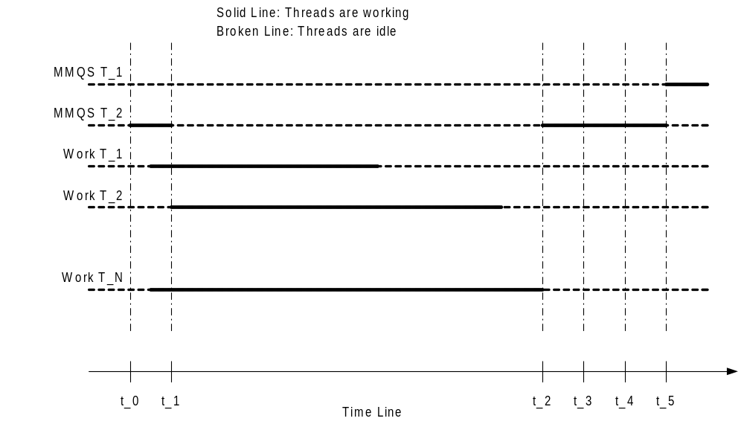

Let us examine the MMQS thread T_2, which controls the class level lock during the processing cycle.

- At time t_0, it gets the class level lock, and start to dispatch commands
- At time t_1, it completes the dispatch
- During t_1 to t_2, it waits.
- At time t_2, the slowest work thread completes, and MMQS thread T_2 start to process strategy 1
- At time t_3, it completes the strategy 1, and start to process strategy 2
- At time t_4, it completes the strategy 2, and start to collect current market data for all the products involved in the quote block
- At time t_5, it completes the current market processing and releases class level lock.

Then look at the MMQS thread T_1 during the whole processing cycle, it waits until time t_5 it gets the class level lock after MMQS thread T_2 releases the lock.

Implications

If class level lock is removed, MMQS threads T_1, and T_2 could start dispatching commands at the same time. The implications are

- Work threads may process commands from different quote blocks at the same time. Because different quote blocks can contain quotes for same products, multiple work threads can process different quotes for same product at the same time. Order book would be messed up and strange trades would happen if there were no appropriate mechanisms in place to prevent it.

A product level lock can nicely solve this problem.

- MMQS thread T_1 and T_2 can start processing events for the strategy products at the same time. Because when process an event for a strategy product, the processing thread will have to acquire the product level locks for all its legs. Assume MMQS thread T_1 processes a strategy composed of leg products p1, p2. And MMQS thread T_2 processes a strategy composed of leg products p3, p2, and p1. Thread T_1 acquired product level lock for p1 and try to acquire lock for p2, but thread T_2 has already acquired locks for p3, and p2, and try to acquire lock for p1. Now thread T_1 and T_2 will wait for each other. It is a classic dead lock situation.

It means that if there is any chance that two strategy products use same option products as some of the legs, then the processing will have to be serialized: one strategy event at any given time. Because strategy products do not cross class line, one possible solution could be to continue maintaining a class level lock for strategy class. Another solution could be to assign strategy events for the same class always to the same processing thread.

- Product level lock alone cannot completely get rid of waiting of work threads when they process quote blocks. After removal of class level lock, all the MMQS threads can get through and dispatch commands to work threads. Then there is very big chance that some work threads process quotes for the same product at the same time. They all have to acquire the product level lock before start processing. Assume there are 20 work threads, and there are 80 MMQS threads configured. Assume the number of threads processing quotes for same product is n, and average processing time for a quote is t milliseconds. Then the last thread will have to wait for (n-1)*t milliseconds. Let t = 1 millisecond, now worse case for 20 work threads configuration will be that the last one will have to wait for 19 milliseconds, second to the last will wait for 18 millisecond, and so on.

Dispatching mechanism will have to be refined to avoid such occasional huge waste of time. A possible solution is to assign quotes for the same product always to the same work thread.

- A new issue arises if quotes for the same product are always assigned to the same work thread: load balance. Different products have different activity levels. Some products may have much more quotes that others, which means certain work threads will be much busier than others. But any dynamic load balance schemes will not work because we require quotes for same product go to same work thread.

Load balance becomes a very tricky issue.

We can always look back into history. So a possible solution is to evaluate the historical activity level and assign an activity rating to each product. In the startup, trade server builds up an assignment table, based on activity rating, so that total product activity rating for each thread will be the same (more or less the same). Because activity level could change over time, a possible rating scheme can be 30-day moving average. And this calculation can be part of end-of-day procedures, or automatically executed as one of end-of-session tasks.

- There is no technical implication on the processing of current market data generated by the quote block. MMQS threads with or without class level lock will successfully execute current market data processing. But this processing increases the response time to user. Market Data Service (MDS) that is running outside the main flow of quote block processing by a MDS thread does the real publishing of current market data. Instead MMQS thread collects current market data and passes them over to MDS thread, it makes perfect sense that the MDS thread should be responsible collecting current market data and then publish.

Analysis on Regular Command Processing

Majority of tasks of trade server are represented by regular command. For a regular command, the same thread is responsible for creating the command, acquire class level lock, and execute the command. Implications of removal of class level lock on regular command processing are the same.

Let us look at Quote cancel processing as an example.

Current Flow

Fig. 2 illustrates the current processing.

Fig. 2. Quote Cancel Processing (Regular command processing).

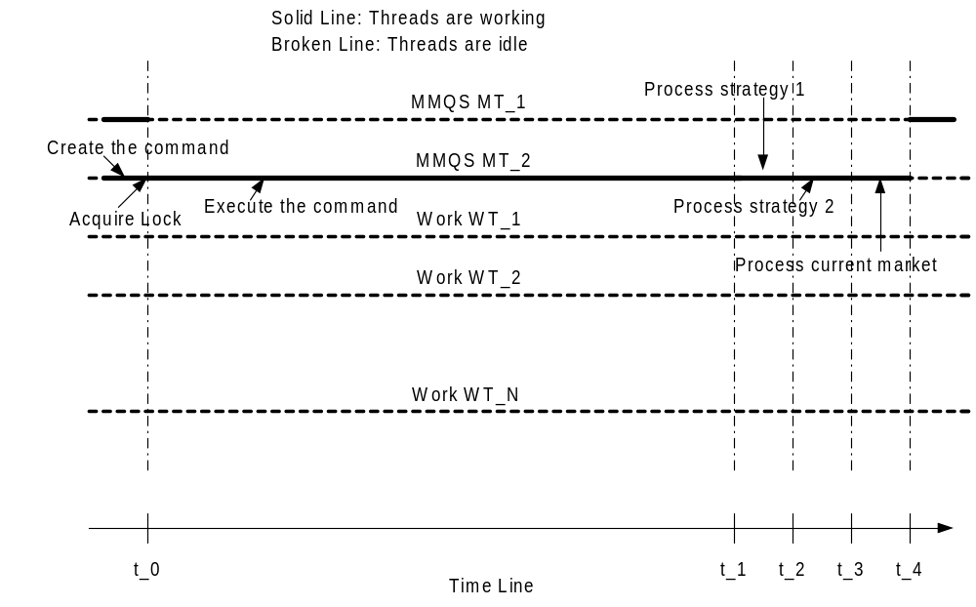

Let us examine the MMQS thread MT_2, which controls the class level lock during the processing cycle.

- It creates the command before t_0.
- At time t_0, it gets the class level lock, and start processing.
- At time t_1, the quote cancel is done. And MT_2 starts processing strategy 1
- At time t_2, the strategy 1 is completed, and starts processing strategy 2 (assume that there are two strategy products involved the option product).
- At time t_3, the strategy product 2 is completed, and starts processing current market.
- At time t_4, the current market processing is done, and class level lock is released.

Note that the entire quote cancel processing is done by MMQS thread, and this is a major difference of regular command processing to the quote block command processing. Also note that during the entire processing, all work threads and other threads that require a class level lock are idle.

Implications

If a class level lock is removed, any thread that previously has to acquire class level lock now can get through, and start processing the commands.

- We can let the same threads that create regular commands (OHS threads, OMS threads, MMQS threads, etc) continue to be responsible for all the processing related to the task. In order to be able to do that, those threads will have to acquire a product level lock first before start real processing.

But as pointed out earlier, this scheme will make some work threads to wait on a product level lock. The goal is that we have to try every effort to minimize the chances of waiting of work threads, if we could not completely get rid of it.

- Change the current flow of control so that the task will not be processed by the thread that creates it, instead by one of the work thread. As we discussed in the section of quote block processing, commands for the same product will be assigned to the same work thread. The waiting of work threads will be avoided in this case.

Also as we pointed as earlier, load balance is a tricky issue here. If we decide to use the idea of product activity rating, we will have to include all the activities for a product: quotes, orders, cancels, cancel/re, external order fill/cancel, etc.

- Implications on strategy processing and current market processing are the same as described in the section of quote block command processing

Analysis on Time-based Command Processing

Some of tasks of trade server depend on timer, for example, product opening, RFQ response, quote trigger/quote lock, among others. There are three kinds of threads involved in processing a time-based command: threads that create the command, timer de-queuing thread, and command processor de-queue thread. The thread that creates the command never waits for completion. Also note that when command processor de-queue thread gets the class level lock, all other threads that require a class level lock will have to wait.
Fig. 3 illustrates the basic flow from creating a command to finish the command.

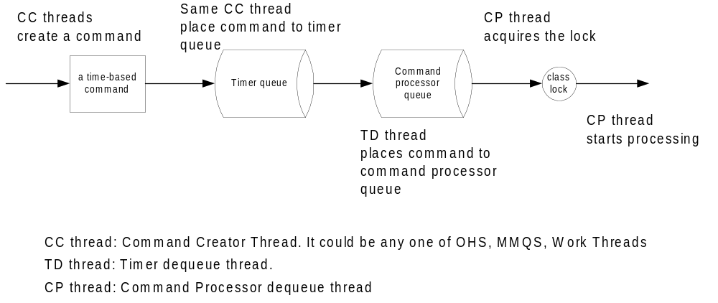
Let us look at Quote Trigger/Quote Lock processing as an example.

Quote trigger and quote lock are mechanism to hold up trades until certain time period is passed. When preset timer expires, system will carry out the actual allocations for the trade held up by quote trigger/quote lock. Because trades and allocations will affect the current order book prices and/or quantities, both of quote trigger and quote lock processing are currently going through class level lock to prevent other threads update order books at the same time.

Current Flow

Fig.4 illustrates the current flow of control of quote lock and quote trigger processing (Time-based command) after the command processor de-queue thread gets the lock.

Fig. 4. Quote Trigger and Quote Lock Processing (Time-based command)

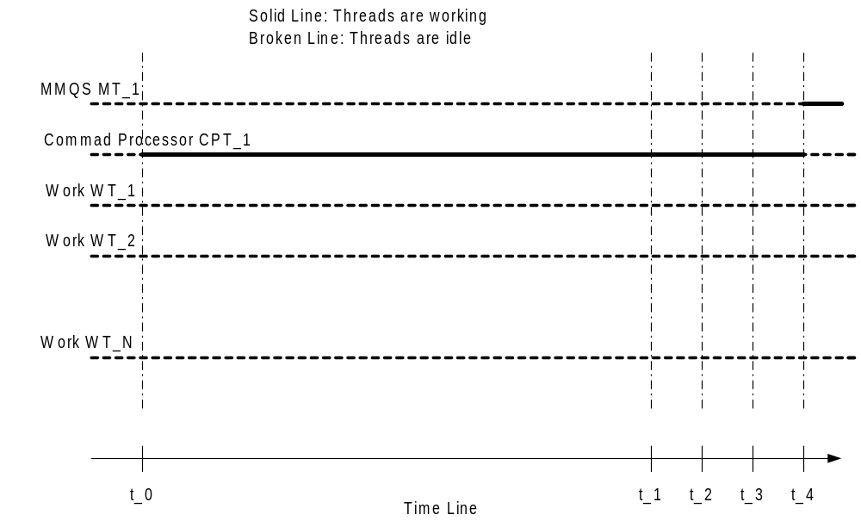

Let us examine the Command Processor thread CPT_1, which controls the class level lock during the processing cycle.

- At time t_0, it gets the class level lock, and start processing. It is important to point out that Command Processor thread CPT_1 does the entire quote trigger/quote lock processing, and this is a major difference to the quote block processing.
- At time t_1, the quote trigger/quote lock is done. And CPT_1 starts processing strategy 1
- At time t_2, the strategy 1 is completed, and starts processing strategy 2 (assume that there are two strategy products involved the option product).
- At time t_3, the strategy product 2 is completed, and starts processing current market.
- At time t_4, the current market processing is done, and class level lock is released.

Note also that during the entire processing, all work threads and other threads that require class level lock are idle.

Implications

If a class level lock is removed, all other threads that would otherwise have to gain a control on class level lock and all work threads may work at the same time, and there will be great chance that some of them will work on a task for the same product.

- We could let Command Processor threads continue to be responsible for all the processing related to task as it is today. But CP threads would have to acquire a product level lock before real processing.

But as pointed out earlier, this scheme is not an optimal option because it will make some work threads to wait on a product level lock. And we have to try every effort to minimize the chances of waiting of work threads.

- Change the current flow of control so that the task will be processed by one of the work thread. If we decide to go with the idea of assigning commands of the same product to the same work thread, then each work thread will have their own queues. In this case, command processor’s queue and de-queuing thread will be unnecessary layers that certainly will delay the processing and should be removed.

Currently each trading class has its own instance of command processor that has its own queue and de-queuing thread. The implication will be that command processor and the relation between trading class and command processor will have to be completely redesigned.

- Implications on strategy processing and current market processing are the same as described in the section of Analysis on Quote Processing: Quote Block.

Appendix A: Proposed ClassThreadPool Command Processing

A proposal is made for speeding up overall Class-level processing by sequencing all Product-level work into its own ProductQueue, and working these ProductQueues in parallel using a customized, ProductQueue-aware ThreadPool.

Simulating Single-Product Lock (SPL)

A ProductQueue is created for each product. All quotes, orders, etc for a specific product get enqueued into the ProductQueue. This enforces the sequencing within the product. The processing of such a ProductQueue by a Worker Thread is equivalent to a Single Product-Level Lock.

Simulating Multiple-Product Lock (MPL)

In cases where a set of products has to be locked (strategies, etc), the ability to prevent other Worker Threads from working on any of the products of the set is equivalent to a Multiple Product-Level Lock.

The ramification, assumptions, and potential problems of this approach will be discussed below.

Simulating Class-Level Lock (CLL)

A Class-Level Lock can be simulated by preventing ALL Worker Threads from working on any product, and only allowing ONE Worker Thread to perform work.

The ramification, assumptions, and potential problems of this approach will be discussed below.

ThreadPool

A very fast and correct implementation of a Thread Pool that enables the preceding Locking schemes is critical. It has to be non-generic, business-specific code that is optimized for deadlock-free, very fast processing.

Problems

Assuming the correct design and implementation of the ClassThreadLock, most of the problems I foresee will deal with upgrading Locks to a higher-order Lock.

- Single-Product Lock

A SPL will have to be upgraded to an MPL in case of resting Strategy Orders/Quotes.

- Multiple-Product Lock

There are two ways for an MPL will come into existence:

  - An inbound Strategy Order/Quote will not begin processing without having acquired the MPL that contains its initial set of products. During processing of this order/quote, this lock may have to be upgraded to lock additional products within this MPL (in cases of resting Orders/Quotes, etc)

  - An existing SPL or MPL may have to be upgraded to acquire additional products, again in cases of resting Orders/Quotes, etc.

- Class-Level Lock

For certain situations, an SPL or MPL may automatically be upgraded to a CLL (TBD).

This may necessary if a Class has a small number of products, and the Worker Thread needs to acquire a majority of such products. This is TBD.

The ClassThreadPool initially creates a lock (SPL/MPL) based on the analysis of the object that needs to be processed. Single order/quote processing will acquire a SPL locking the product being worked on. Strategies will automatically acquire an MPL that will lock the Strategy product plus all the legs. Thus when a Worker Thread begins processing, it is guaranteed that the initial set of products is locked by it.

During processing of the order/quote/strategy order/etc, it may become necessary to acquire locks on additional products, or to upgrade the existing lock.

The upgrading of that lock to acquire additional products will be done by the business-logic code running within the Worker Thread.

There are certain aspects to this upgrade that impact both the business and the implementation. I will start the enumeration with a couple of examples, hopefully during the meeting more can come out:

- After a quote for Product A is processed, it is determined that the following resting Strategies will need to be processed:

S1: A, B, C
S2: A, B
S3: A, D

We can try to upgrade the lock in one of two ways:

- Request the ClassThreadPool to acquire the additional locks (B, C, D) for us while the Worker Thread waits. This is the easiest for the existing code base, but is tricky, since this could cause Worker Threads to ALL become blocked waiting, or may cause deadlocks.

- Request the ClassThreadPool to acquire the additional locks (B, C, D). If the locks can be acquired immediately, proceed. If one or more of these locks is being processed by another Worker Thread, we will have to save off the context, and return to the ClassThreadPool to be processed in the future when these locks are acquired. This model guarantees the prevention of deadlocks and slow disappearances of Worker Threads, but it will require changes to existing business-logic code base to know that it is running inside a ClassThreadPool, and will know how to interact with it.

- Once a Worker Thread is done processing a single item (or more, depending on the policy), it will put the ProductQueue on the END of the ClassThreadPool’s WorkerThreadQueue. This has implications for intra-product sequencing (all products are sequenced in correct order inside the ProductQueue), but the ProductQueues are ordered by the Worker Threads inside the WorkerThreadQueue. This needs to be discussed.

- The non-processing of items waiting to acquire other, currently being processed products has outlier implications. This needs to be discussed.

- It is possible to use the blocked POA-threads themselves to assist in processing the work queues while they wait for their work to be completed. This is a kind of a grid implementation. There are business implications, and some surmountable technical issues. This needs to be discussed.

